Investigation of in-vitro efficacy of fungicides against Macrophomina phaseolina causing charcoal rot of soybean

Abstract
Soybean (Glycine max (L.) Merrill) is a major oil-seed crop of global importance, but its productivity is severely threatened by charcoal rot caused by Macrophomina phaseolina, a necrotrophic fungus with a wide host range. The ITS region of the pathogen was amplified which yielded a 598 bp sequence and showed 97.15% identity and 100% query coverage in BLAST analysis. Following molecular confirmation, the in-vitro efficacy of twelve fungicides, comprising six single compounds and six combinations was assessed against M. phaseolina using the poisoned food technique at 100, 250 and 500 ppm. All tested fungicides significantly inhibited mycelial growth relative to the untreated control, though performance varied across treatments. Complete suppression (100% inhibition) was consistently recorded with Carbendazim 25% + Mancozeb 50% WS, Carbendazim 50% WP and Tebuconazole 25.9% w/w EC at all concentrations. Metiram 55% + Pyraclostrobin 5% WG and Carboxin 37.5% + Thiram 37.5% WS also achieved full inhibition at higher concentrations, while Propiconazole 25% EC and Mancozeb 75% WP exhibited complete inhibition only at 250 and 500 ppm. In contrast, Penflufen 13.28% + Trifloxystrobin 13.28% FS and Azoxystrobin 11% + Tebuconazole 18.3% SC were the least effective, with 61.18% inhibition at 100 ppm. The findings highlight the superior efficacy of benzimidazole and triazole based fungicides, alone or in combination with contact fungicides, for effective suppression of M. phaseolina. These results provide valuable insights for developing effective fungicidal strategies for the management of charcoal rot in soybean under field conditions.
Key words - Charcoal rot, Fungicide efficacy, Soybean, Macrophomina phaseolina, Poisoned food technique
1. INTRODUCTION
Soybean (Glycine max (L.) Merrill), belonging to the family Leguminosae and sub-family Papilionoideae, is a globally important oil-seed crop valued for its nutritional and economic significance. Dry soybean seeds contain around 36% protein, 19% oil, 35% carbohydrates (with nearly 17% dietary fiber) and 5% minerals and vitamins, making it a key source of food, feed and industrial raw material (Liu and Liu, 1997; Gupta, 2012). In India, soybean gained commercial importance in the 1970s, with Madhya Pradesh emerging as the “Soybean State” due to large-scale cultivation. However, soybean productivity is constrained by several soil-borne pathogens. Among these, charcoal rot caused by Macrophomina phaseolina (Tassi) Goid. (Goidanich, 1947) is regarded as one of the most devastating diseases. The pathogen is soil and seed borne, necrotrophic and highly polyphagous, infecting more than 500 plant species including legumes, fruits and major field crops (Dhingra and Sinclair, 1977). Disease incidence is strongly favoured by high temperatures and drought stress, though the fungus can also persist in moist soil in a latent state until favourable conditions trigger disease development (Meyer et al., 1974; Kaur et al., 2012). In India, charcoal rot is estimated to cause annual yield losses of nearly 0.25 million tonnes, representing about 4.2% of the total production lost to diseases (Rajput et al., 2025). With its wide host range, environmental adaptability and strong association with climate stress, M. phaseolina poses a serious threat to sustainable soybean cultivation worldwide. A thorough understanding of the pathogenic and genetic variability of M. phaseolina is essential for effective disease management. Insights into genetic diversity can aid in identifying virulent isolates specific to different regions, breeding resistant soybean varieties, refining screening methodologies and enhancing epidemiological predictions (Dhingra and Sinclair, 1973; Rajput et al., 2025). Considering the pivotal role of microsclerotia in pathogen survival and dissemination, evaluating their viability is crucial for designing field-level control strategies. Among available management options, fungicide application remains the most widely adopted and immediate measure for controlling charcoal rot in soybean (Rahman et al., 2021; Kharte et al., 2022). Therefore, integrating knowledge of pathogen genetic variability with targeted fungicide management offers a promising approach for mitigating the impact of charcoal rot and enhancing soybean productivity.
2. MATERIALS AND METHODS
2.1 ISOLATION AND IDENTIFICATION OF PATHOGEN
During the Kharif season of 2024, soybean plants exhibiting characteristic symptoms of charcoal rot were collected from Seed Technology Research Centre field, Jawaharlal Nehru Krishi Vishwa Vidyalaya, Jabalpur. Collected root samples were washed under running tap water to remove adhered soil debris, cut into small sections and surface sterilized by sequential immersion in 1% sodium hypochlorite for 30 seconds and 70% ethanol for 30 seconds. The sterilized tissues were rinsed thrice with sterile distilled water and dried on sterile tissue paper under aseptic conditions. Approximately 5 mm segments were placed on Potato Dextrose Agar (PDA) plates and incubated at 27 ± 2°C for 5-7 days. Fungal colonies showing greyish-black pigmentation and microsclerotia formation were sub-cultured on fresh PDA to obtain pure cultures. The pathogen was identified as M. phaseolina based on its cultural and microscopic features, including black, irregular microsclerotia and septate hyphae.
2.2 GENOMIC DNA ISOLATION AND QUANTIFICATION
The genomic DNA was extracted from the mycelial cultures using the modified CTAB method (Doyle 1990). Pure culture of M. phaseolina was grown in Potato Dextrose Broth for seven days in an incubator at 27 ± 2 °C for 7 days. The harvested mycelial mass was filtered, blotted dry and ground to a fine powder in liquid nitrogen. About 150-200 mg of mycelium was subjected to CTAB extraction using a buffer (100 mM Tris-Cl, 50 mM EDTA, 500 mM NaCl, 10 mM 2-mercaptoethanol) followed by SDS lysis, potassium acetate precipitation, chloroform extraction and isopropanol DNA precipitation. The resulting pellet was washed with 70% ethanol, air dried and dissolved in TE buffer (pH 8.0) at 37 °C, to make a final concentration of 50 ng/µl for PCR amplifications. The isolated genomic DNA was quantified by measuring the absorbance at 260nm and 280nm on a UV-spectrophotometer.
2.3 PCR AMPLIFICATION
The rDNA region comprising ITS-1, 5.8S rDNA and ITS-2 was amplified using primers designed from conserved regions of the small subunit (SSU) rDNA gene. The primer pair employed for amplification was ITS-1 (5′-TCCGTAGGTGAACCTGCGG-3′) and ITS-4 (5′-TCCTCCGCTTATTGATATGC-3′) as described by White et al. (1990). PCR assay was carried out in a 50 µl reaction mixture containing 5 µl DNA template (25 ng/µl), 5 µl 10X reaction buffer, 3.5 µl MgCl₂ (50 µM), 1 µl dNTP mix (10 mM), 2.5 µl each of forward (10 µM) and reverse (10 µM) primers and 1 µl Taq DNA polymerase (5 U/µl). The final volume of 50 µl was made up with molecular grade water. PCR amplification was performed in a thermocycler using the following thermal profile: initial denaturation at 94°C for 3 min, followed by 40 cycles of 94°C for 1 min, 54°C for 1 min and 72°C for 2 min with a final extension at 72°C for 5 min and an infinite hold at 4°C.
2.4 SEQUENCING OF ITS REGION
A 5 µl aliquot of each PCR product was resolved on a 1.5% agarose gel containing ethidium bromide, electrophoresed at 70 V and visualized under UV light using a gel documentation system. A 100 bp DNA ladders served as molecular size markers. The amplified products were subsequently sequenced by Eurofins Genomics India Pvt. Ltd. . Raw sequence was assembled and edited using sequence alignment software (MEGA 12). Consensus sequence was subjected to BLAST (Basic Local Alignment Search Tool) (Altschul et al., 1997) analysis through the NCBI database to identify closest matches and confirm the species identity. The ITS sequence of M. phaseolina was submitted to the NCBI GenBank database.
2.5 EVALUATION OF FUNGICIDES
The in-vitro efficacy of twelve fungicides was assessed using the poisoned food technique (Nene and Thapliyal, 1993). Six single compound fungicides namely Propiconazole 25% EC, Hexaconazole 5% SC, Tebuconazole 25.9% w/w EC, Carbendazim 50% WP, Mancozeb 75% WP and Pyraclostrobin 20% WG and six combination of fungicides namely Metiram 55% + Pyraclostrobin 5% WG, Carboxin 37.5% + Thiram 37.5% WS, Carbendazim 25% + Mancozeb 50% WS, Thiophanate-methyl 450 + Pyraclostrobin 50 G/L (w/v) FS, Penflufen 13.28% w/w + Trifloxystrobin 13.28% w/w FS and Azoxystrobin 11% + Tebuconazole 18.3% SC were evaluated at concentrations of 100, 250 and 500 ppm. PDA medium was prepared and sterilized by autoclaving at 121 °C and 15psi for 15 minutes. After cooling to about 45 to 50 °C, stock solutions of each fungicide were prepared in sterilized distilled water and incorporated into the molten PDA to obtain the desired concentrations. Approximately 15-20 ml of the poisoned medium was poured into sterilized 85 mm Petri plates and allowed to solidify under aseptic condition in laminar airflow. PDA plates without fungicide served as controls. Actively growing mycelial discs (5 mm in diameter) were aseptically cut from the actively growing margins of seven day old M. phaseolina cultures and placed at the centre of each Petri plate. The plates were incubated in a BOD incubator maintained at 27 ± 2 °C under a 12 hour light/dark cycle. The experiment was laid out in a completely randomized design (CRD) with three replications per treatment. Colony diameter was measured at 24, 48, 72 and 96 h after inoculation along two perpendicular directions and the mean value was used to calculate mycelial growth. The percentage inhibition of radial growth over the control was calculated following the formula of Vincent (1947):
$$PI=\frac{C -T}{C} × 100$$
Where,
PI | = | Per cent inhibition
C | = | Colony diameter in check plate (mm)
T | = | Colony diameter in treatments (mm)

The experimental data were subjected to statistical analysis using analysis of variance (ANOVA) appropriate for CRD and treatment means were compared at a 5% level of significance.
3. RESULT AND DISCUSSION
3.1 rDNA AMPLIFICATION
The ITS sequence of the pathogen (Accession No. PV929582) was 598 bp in length. BLAST analysis revealed the closest match as Macrophomina phaseolina (Accession No. MK883457.1) with 97.15% sequence identity and 100% query coverage. These findings are consistent with earlier reports (Babu et al., 2007; Almomani et al., 2013; Rajput et al., 2025) and underscore the reliability of ITS sequencing for accurate identification of M. phaseolina. Molecular confirmation of the pathogen is crucial for understanding its genetic variability which in turn aids in the development of targeted management strategies including effective fungicide applications
3.2 EFFICACY OF FUNGICIDES
The in-vitro experiment clearly demonstrated that all tested fungicides significantly suppressed the radial growth of M. phaseolina compared to the untreated control. However, the extent of inhibition varied markedly among different fungicides and across concentrations, reflecting both formulation specific and dose dependent effects. Complete (100%) inhibition of mycelial growth was observed with the combination fungicide Carbendazim 25% + Mancozeb 50% WS at all three concentrations (100, 250 and 500 ppm), indicating its superior and consistent efficacy. Similarly, the combinations Metiram 55% + Pyraclostrobin 5% WG and Carboxin 37.5% + Thiram 37.5% WS also achieved 100% inhibition, but only at the higher concentrations of 250 and 500 ppm, suggesting a concentration dependent enhancement of their antifungal activity. Among the remaining treatments, Metiram 55% + Pyraclostrobin 5% WG exhibited 92.35% inhibition even at 100 ppm and this was found to be statistically at par with Thiophanate Methyl 450 + Pyraclostrobin 50 G/L (w/v) FS, which recorded 89.41% inhibition at the same concentration. These results underscore the high efficacy of these two formulations even at lower concentrations. On the other hand, the least effective treatments were Penflufen 13.28% w/w + Trifloxystrobin 13.28% w/w FS and Azoxystrobin 11% + Tebuconazole 18.3% SC, both of which recorded the lowest percentage inhibition (61.18%) at 100 ppm, indicating comparatively reduced effectiveness at lower dosages (Table 1; Figure 1). Among the single compound fungicides, the highest level of inhibition, with complete suppression of mycelial growth (100%), was recorded with Carbendazim 50% WP and Tebuconazole 25.9% w/w EC across all concentrations tested (100, 250 and 500 ppm), highlighting their strong fungicidal activity irrespective of the dosage. Similarly, Propiconazole 25% EC and Mancozeb 75% WP achieved complete (100%) inhibition at the higher concentrations of 250 and 500 ppm, but not at the lower dose. Hexaconazole 5% SC was the next most effective fungicide, recording a maximum inhibition of 92.55% at 500 ppm. On the other hand, Pyraclostrobin 20% WG exhibited the lowest inhibition among all treatments, with a minimum suppression of 73.33% recorded at the lowest concentration (100 ppm), suggesting reduced efficacy at lower doses (Table 2; Figure 2).
These results are consistent with earlier reports emphasizing the efficacy of systemic and broad-spectrum fungicides against M. phaseolina under laboratory conditions (Sangeetha and Jahagirdar, 2013; Chaudhary et al., 2017; Singh et al., 2023). Among the six combination fungicides tested, Carbendazim 25% + Mancozeb 50% WS, Carboxin 37.5% + Thiram 37.5% WS and Metiram 55% + Pyraclostrobin 5% WG exhibited complete (100%) inhibition at higher concentrations, with Carbendazim + Mancozeb maintaining 100% inhibition even at 100 ppm. These findings corroborate those of Sangeetha and Jahagirdar (2013) and Rahman et al., (2021), highlighting the enhanced antifungal efficacy of systemic-contact combinations such as benzimidazole + dithiocarbamate. In contrast, combinations like Penflufen + Trifloxystrobin and Azoxystrobin + Tebuconazole showed only moderate inhibition at lower concentrations, indicating limited efficacy under minimal exposure. This observation aligns with Tonin et al., (2013) and Kumar et al., (2016), who reported variable responses of M. phaseolina to QoI fungicides depending on their formulation and concentration. Earlier study by Marquez et al., (2021) also highlighted the potent inhibitory action of these molecules, which are known to interfere with fungal mitosis and ergosterol biosynthesis, respectively. These results affirm the utility of benzimidazole and triazole fungicides in the management of soil-borne pathogens, though their efficacy in-vivo depends on formulation, mobility in soil and plant uptake (Kumar and Singh, 2000; Bankoliya et al., 2022; Patidar et al., 2023).
4. CONCLUSION
This study revealed that all tested fungicides significantly inhibited the mycelial growth of M. phaseolina under in-vitro conditions, with marked variation among formulations and concentrations. Carbendazim 25% + Mancozeb 50% WS, Carbendazim 50% WP and Tebuconazole 25.9% w/w EC consistently achieved complete suppression at all concentrations, demonstrating superior and stable efficacy. Metiram + Pyraclostrobin and Carboxin + Thiram combinations were effective at higher doses, while Penflufen + Trifloxystrobin and Azoxystrobin + Tebuconazole exhibited comparatively lower activity, especially at 100 ppm. The findings emphasize the potential of benzimidazole and triazole based fungicides, either singly or in systemic-contact combinations, as promising options for managing charcoal rot of soybean. However, their integration into field-level management strategies requires further validation under greenhouse and multi-location trials.
DISCLAIMER (ARTIFICIAL INTELLIGENCE)
Author(s) hereby declare that NO generative AI technologies such as Large Language Models (ChatGPT, COPILOT, etc) and text to image generators have been used during writing or editing of this manuscript.
REFERENCES
Almomani, F., Alhawatema, M. and Hameed, K. (2013). Detection, identification and morphological characteristic of Macrophomina phaseolina: the charcoal rot disease pathogens isolated from infected plants in Northern Jordan. Archives of Phytopathology and Plant Protection, 46(9), 1005-1014.
Altschul, S. F., Madden, T. L., Schäffer, A. A., Zhang, J., Zhang, Z., Miller, W. and Lipman, D. J. (1997). Gapped BLAST and PSI-BLAST: a new generation of protein database search programs. Nucleic acids research, 25(17), 3389-3402.
Babu, B. K., Saxena, A. K., Srivastava, A. K. and Arora, D. K. (2007). Identification and detection of Macrophomina phaseolina by using species-specific oligonucleotide primers and probe. Mycologia, 99(6), 797-803.
Bankoliya, M., Yadav, V. K., Kumar, A., Amrate, P. and Bhatt, J. (2022). The resistance screening and in-vitro efficacy of fungicides for the management of dry root rot of chickpea caused by Rhizoctonia bataticola. Environment Conservation Journal, 23(3), 8–13
Chaudhary, D. H., Pathak, D. M. and Chaudhary, M. M. (2017). In vitro efficacy of fungicides against dry root rot (Macrophomina phaseolina) of soybean. International Journal of Current Microbiology and Applied Sciences, 6(8), 1298-1301.
Dhingra, O. D. and Sinclair, J. B. (1973). Location of Macrophomina phaseoli on soybean plants related to culture characteristics and virulence.
Dhingra, O. D. and Sinclair, J. B. (1977). An annotated bibliography of Macrophomina phaseolina 1905-1975.
Doyle JJ and Doyle JL. 1990. Isolation of plant DNA from fresh tissue. Focus, 12, 13-15.
Goidànich, G. (1947). A revision of the genus Macrophomina Petrak. Type species: Macrophomina phaseolina (Tassi) G. Goid. n. comb, nec M. phaseoli (Maubl.) Ashby.
Gupta, S. K. (Ed.). (2012). Technological innovations in major world oil crops, volume 1: breeding. Springer New York.
Kaur, S., Dhillon, G. S., Brar, S. K., Vallad, G. E., Chand, R. and Chauhan, V. B. (2012). Emerging phytopathogen Macrophomina phaseolina: biology, economic importance and current diagnostic trends. Critical Reviews in Microbiology, 38(2), 136-151.
Kharte, S., Kumar, A., Sharma, S., Ramakrishnan, R. S., Kumar, S., Malvi, S., Singh, Y. and Kurmi, S. (2022). In vitro evaluation of fungicides and bio-agents for the management of lentil wilt caused by Fusarium oxysporum f. sp. lentis. Biological Forum – An International Journal, 14(4), 489–495.
Kumar, G. D., Natarajan, N. and Nakkeeran, S. (2016). Antifungal activity of nanofungicide Trifloxystrobin 25%+ Tebuconazole 50% against Macrophomina phaseolina. African Journal of Microbiology Research, 10(4), 100-105.
Kumar, K. and Singh, J. (2000). Location, survival, transmission and management of seed-borne Macrophomina phaseolina, causing charcoal rot in soybean. Annals of Plant Protection Sciences (India)., 8(1).
Liu, K. (1997). Chemistry and nutritional value of soybean components. In Soybeans: chemistry, technology and utilization (pp. 25-113). Boston, MA: Springer US.
Marquez, N., Giachero, M. L., Declerck, S. and Ducasse, D. A. (2021). Macrophomina phaseolina: General characteristics of pathogenicity and methods of control. Frontiers in Plant Science, 12, 634397.
Meyer, W. A., Sinclair, J. B. and Khare, M. N. (1974). Factors affecting charcoal rot of soybean seedlings. Phytopathology, 64(6), 845-849.
Nene, Y. L. and Thapliyal, P. N. (1993). Fungicides in Plant Disease Control Oxford and IBH Publ. New Delhi, 1982192
Patidar, S., Yadav, V. K., Amrate, P. K., Lovewanshi, L. S., Karoda, C., Kharte, S. and Kurmi, S. (2023). Integrated Management of Charcoal Rot and Its Influence on Seed Yield and Quality in Soybean. International Journal of Environment and Climate Change, 13(12), 830-842.
Rahman, M. T., Rubayet, M. T., Khan, A. A. and Bhuiyan, M. (2021). Integrated management of charcoal rot disease of soybean caused by Macrophomina phaseolina. Egyptian Journal of Agricultural Research, 99(1), 10-19.
Rajput, L. S., Kumar, S., Pathak, K., Acharya, P., Goswami, D., Nataraj, V., ... & Vishwakarma, R. (2025). Morpho-cultural, pathogenic and genetic characterization of Indian isolates of Macrophomina phaseolina causing charcoal rot in soybean. Heliyon, 11(2).
Sangeetha, T. V. and Jahagirdar, S. (2013). Varibility of pathogens associated in causing root rot complex of soybean in Karnataka. International Journal of Plant Protection, 6, 229-235.
Singh, Y., Bhatt, J., Yadav, V. K., Kumar, A., Kharte, S. and Malempati, S. S. S. (2023). In vitro management of fusarium wilt of linseed using phytoextract, fungicides and bioagents. Environment Conservation Journal, 24(4), 96–105.
Tonin, R. F. B., Avozani, A., Danelli, A. L. D., Reis, E. M., Zoldan, S. M. and Garcés-Fiallos, F. R. (2013). In vitro mycelial sensitivity of Macrophomina phaseolina to fungicides. Pesquisa Agropecuária Tropical, 43, 460-466.
White, T. J., Bruns, T., Lee, S. J. W. T. and Taylor, J. (1990). Amplification and direct sequencing of fungal ribosomal RNA genes for phylogenetics. PCR protocols: a guide to methods and applications, 18(1), 315-322.
Vincent, J. M. (1947). Distortion of fungal hyphae in the presence of certain inhibitors. Nature, 159(4051), 850-850.

Table 1: Efficacy of different concentration of combination of fungicides against M. phaseolina.
Tr. No. | Treatment details | Mycelial radial growth after 4 days (in mm) and percent inhibition in mycelial growth of the test fungus
Tr. No. | Treatment details | 100ppm |  | 250ppm |  | 500ppm
Tr. No. | Active ingredient | Mycelial Growth (mm) | Percent Inhibition (%) | Mycelial Growth (mm) | Percent Inhibition (%) | Mycelial Growth (mm) | Percent Inhibition (%)
T₁ | Metiram 55% + Pyraclostrobin 5% WG | 6.50 | 92.35 | 0.00 | 100.00 | 0.00 | 100.00
T₂ | Carboxin 37.5% + Thiram 37.5% WS | 16.33 | 80.78 | 0.00 | 100.00 | 0.00 | 100.00
T₃ | Carbendazim 25%+ Mancozeb 50% WS | 0.00 | 100.00 | 0.00 | 100.00 | 0.00 | 100.00
T₄ | Thiophanate Methyl 450 + Pyraclostrobin 50 G/L (w/v) FS | 9.00 | 89.41 | 7.17 | 91.57 | 6.67 | 92.16
T₅ | Penflufen13.28% w/w + Trifloxystrobin 13.28% w/w FS | 33.00 | 61.18 | 27.50 | 67.65 | 23.00 | 72.94
T₆ | Azoxystrobin11% + Tebuconazole 18.3% SC | 33.00 | 61.18 | 22.50 | 73.53 | 12.67 | 85.10
T₇ | Control | 85.00 | - | 85.00 | - | 85.00 | -
 | CD at 5% | 2.49 | 3.22 | 1.27 | 1.64 | 0.80 | 1.03
 | SE(m) ± | 0.81 | 1.03 | 0.41 | 0.53 | 0.26 | 0.33
Table 2: Efficacy of different concentration of single compound fungicides against M. phaseolina.
Tr. No. | Treatment | Mycelial radial growth after 4 days (in mm) and percent inhibition in mycelial growth of the test fungus
Tr. No. | Treatment | 100ppm |  | 250ppm |  | 500ppm
Tr. No. | Active ingredient | Mycelial Growth (mm) | Percent Inhibition (%) | Mycelial Growth (mm) | Percent Inhibition (%) | Mycelial Growth (mm) | Percent Inhibition (%)
T₁ | Propiconazole 25% EC | 15.00 | 82.35 | 0.00 | 100.00 | 0.00 | 100.00
T₂ | Hexaconazole 5% SC | 20.50 | 75.88 | 11.00 | 87.06 | 6.33 | 92.55
T₃ | Tebuconazole 25.9% w/w EC | 0.00 | 100.00 | 0.00 | 100.00 | 0.00 | 100.00
T₄ | Carbendazim 50% WP | 0.00 | 100.00 | 0.00 | 100.00 | 0.00 | 100.00
T₅ | Mancozeb 75% WP | 17.33 | 79.61 | 0.00 | 100.00 | 0.00 | 100.00
T₆ | Pyraclostrobin 20% WG | 22.67 | 73.33 | 21.33 | 74.90 | 19.17 | 77.45
T₇ | Control | 85.00 | - | 85.00 | - | 85.00 | -
 | CD at 5% | 1.32 | 1.71 | 0.84 | 1.09 | 0.93 | 1.20
 | SE(m) ± | 0.43 | 0.55 | 0.28 | 0.35 | 0.30 | 0.38

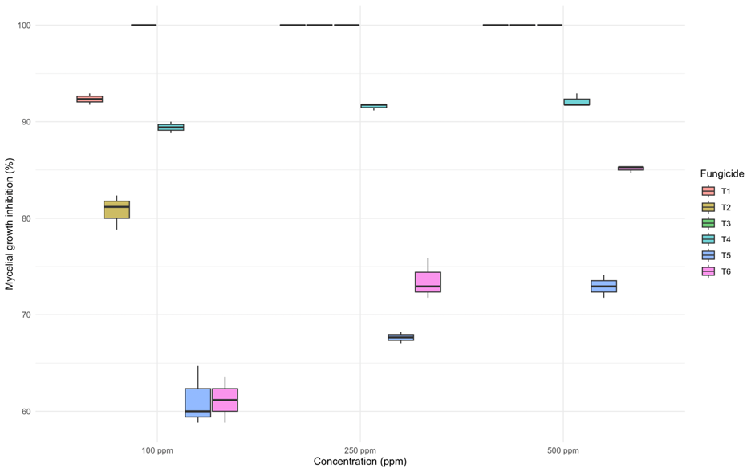
Figure 1. Box plot showing the percent inhibition in growth of M. phaseolina on potato dextrose agar (PDA) medium amended with three different concentration of six combination of fungicides.

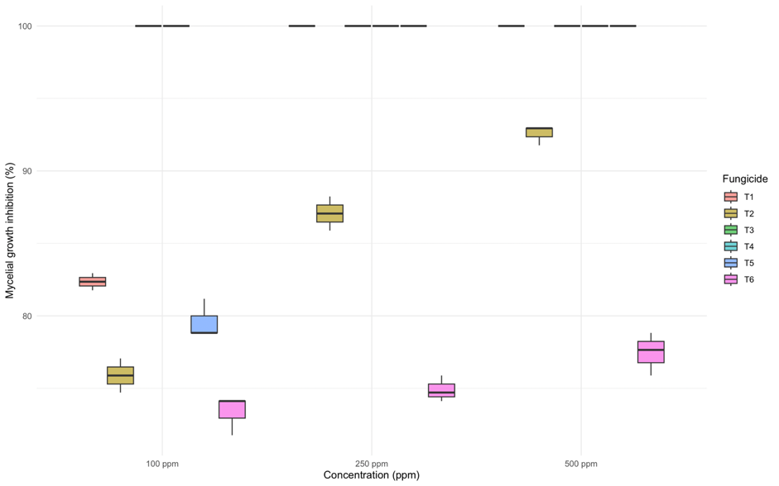
Figure 2. Box plot showing the percent inhibition in growth of M. phaseolina on potato dextrose agar (PDA) medium amended with three different concentration of six single compound fungicides.

Figure 3. PCR amplification of ITS region of M. phaseolina using ITS1 and ITS 4 primer pairs. M: 100bp Ladder; 1: ITS amplicon of M. phaseolina.

100 ppm | 250 ppm | 500 ppm
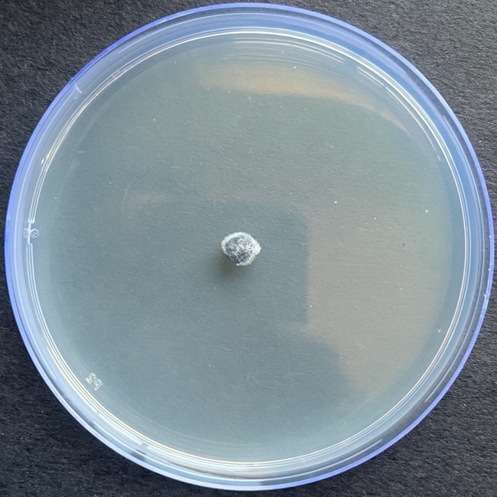  T₁ | 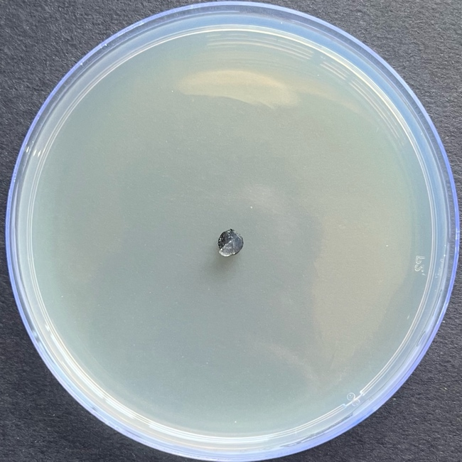  T₁ | 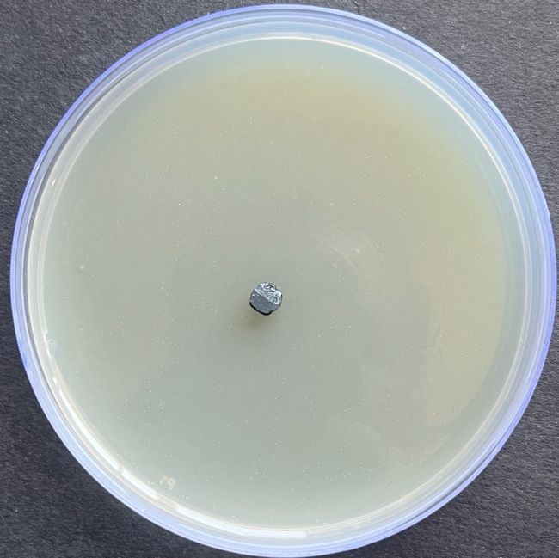  T₁
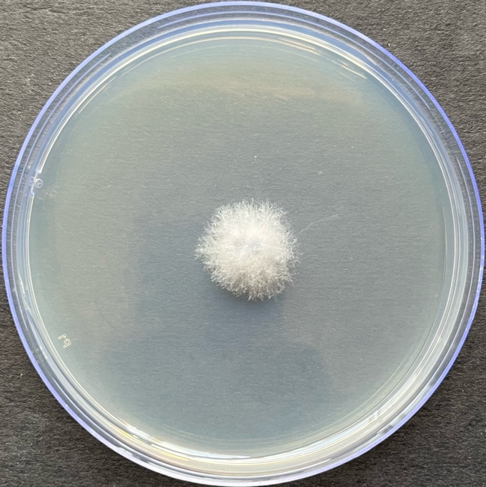  T₂ | 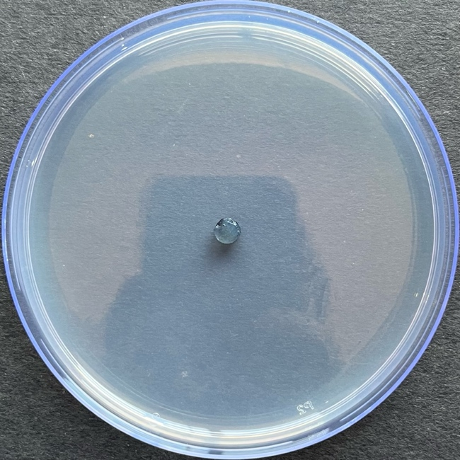  T₂ | 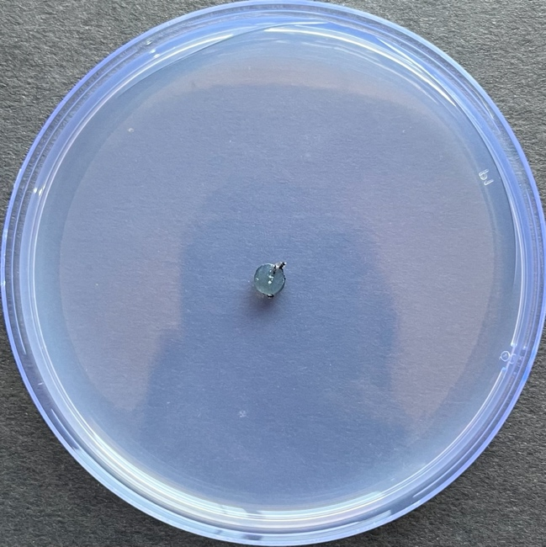  T₂
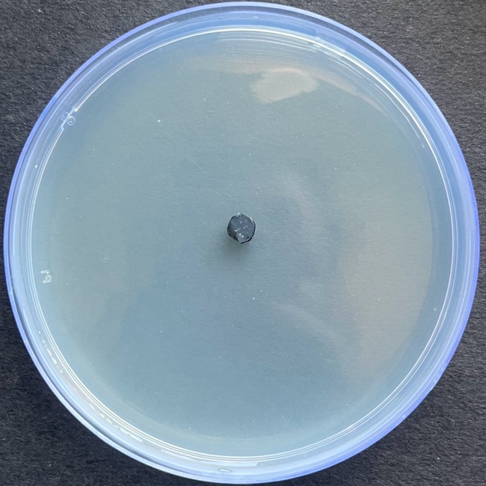  T₃ | 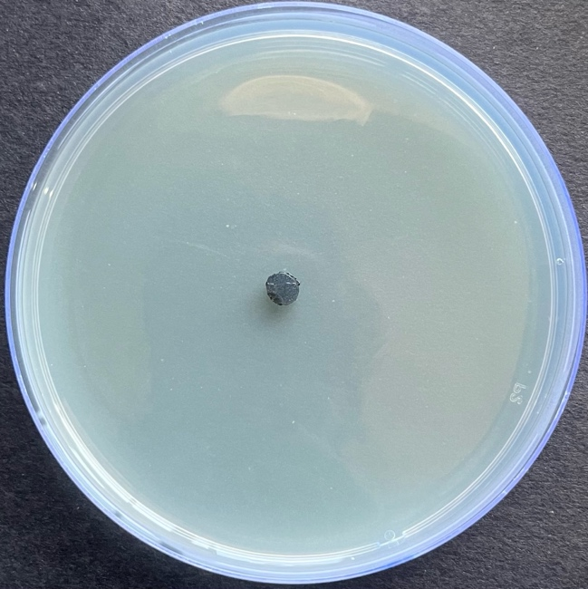  T₃ | 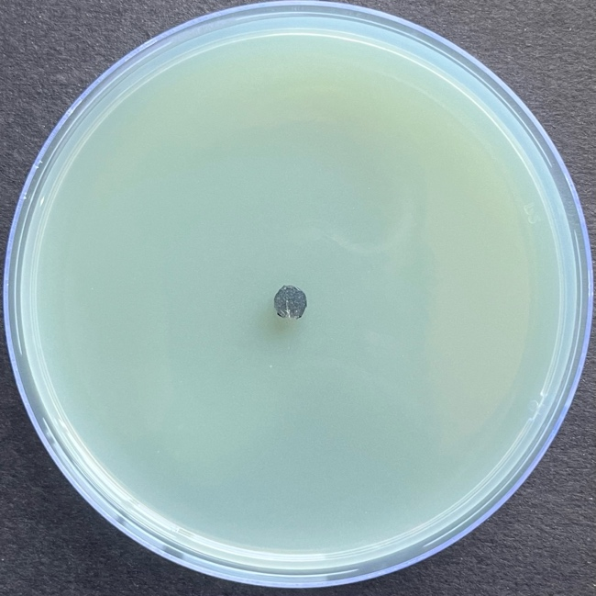  T₃
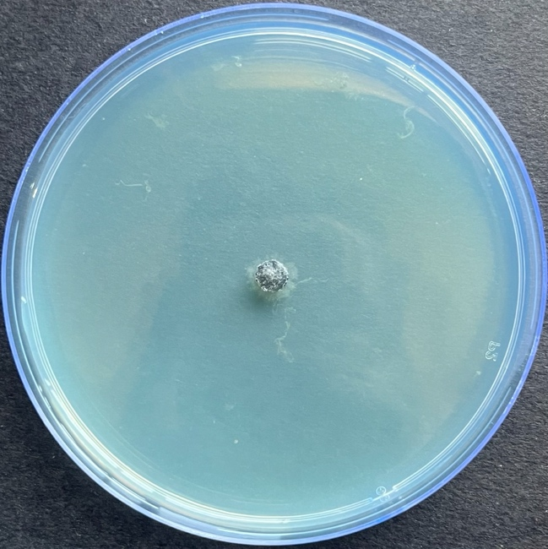  T₄ | 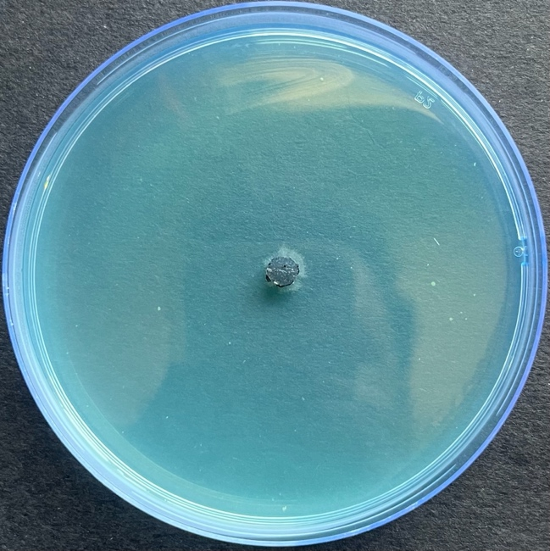  T₄ | 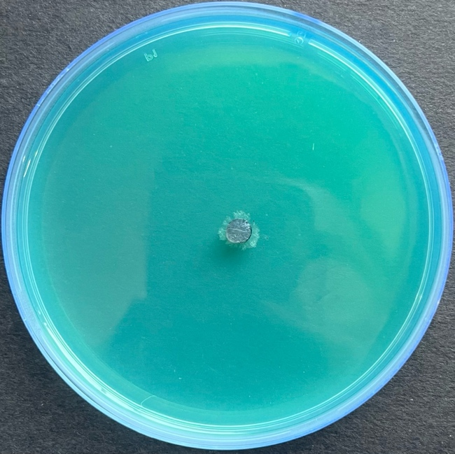  T₄
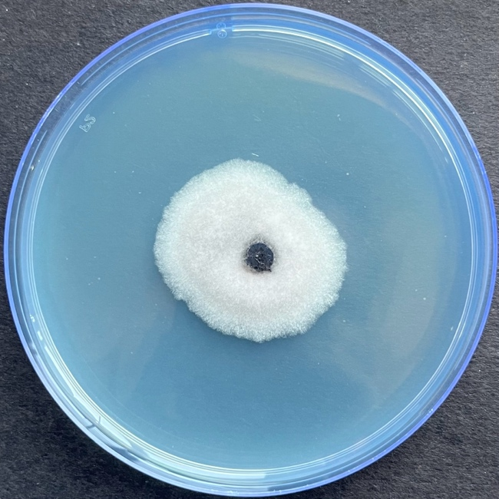 | 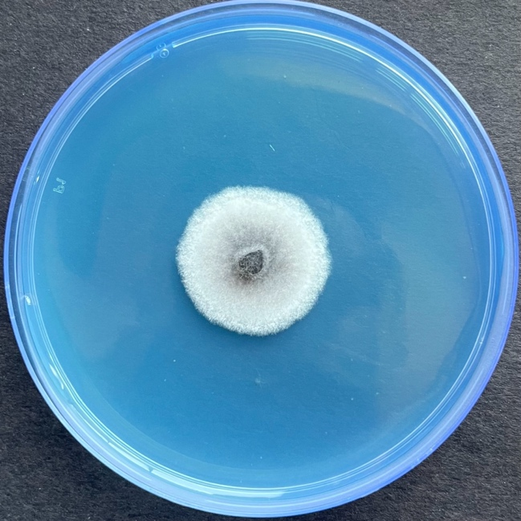  T₅ | 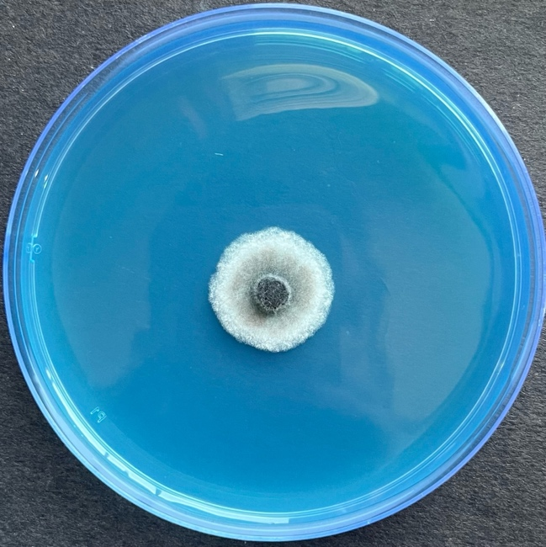  T₅
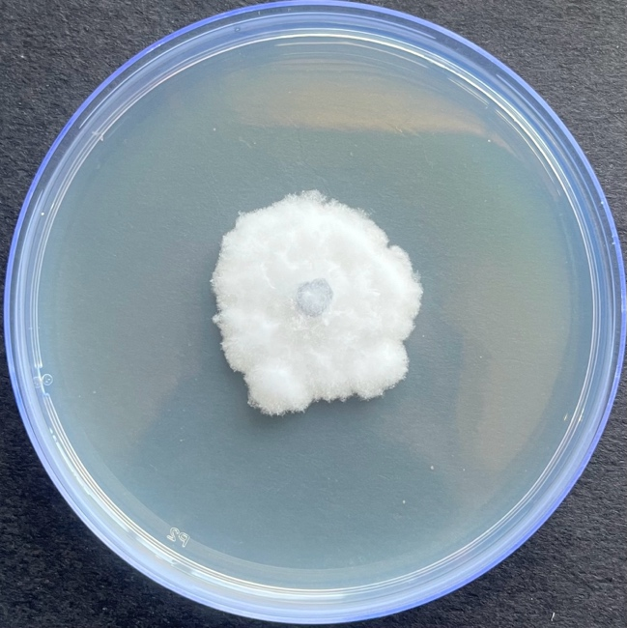  T₆  T₅ | 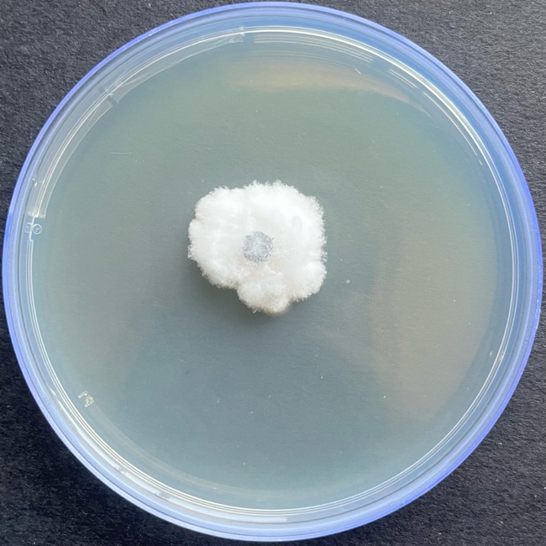  T₆ | 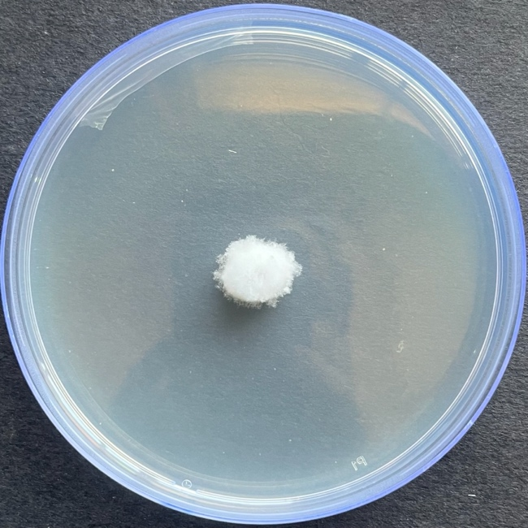  T₆
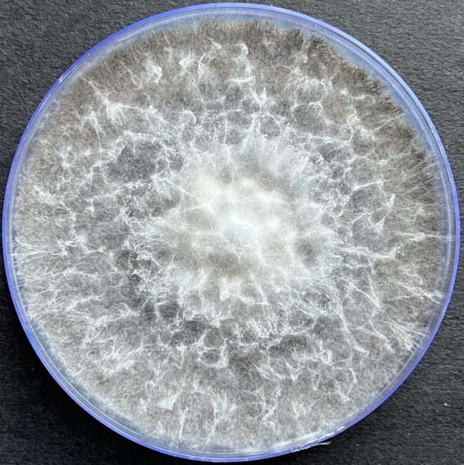
T₇
Figure 4.: In-vitro evaluation of combination of fungicide against M. phaseolina at 100, 250 and 500 ppm.
T₅

100 ppm | 250 ppm | 500 ppm
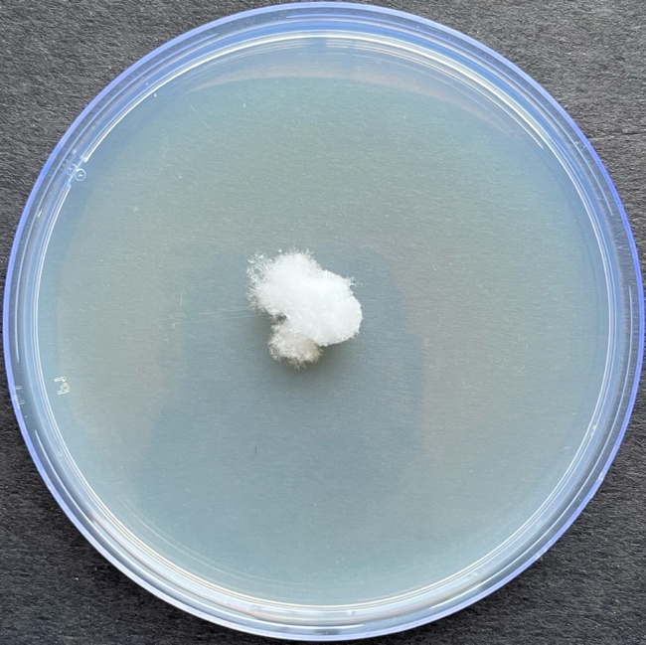  T₄  T₄  T₃  T₃  T₂  T₂  T₁  T₁  T₁  T₄  T₃  T₂ | 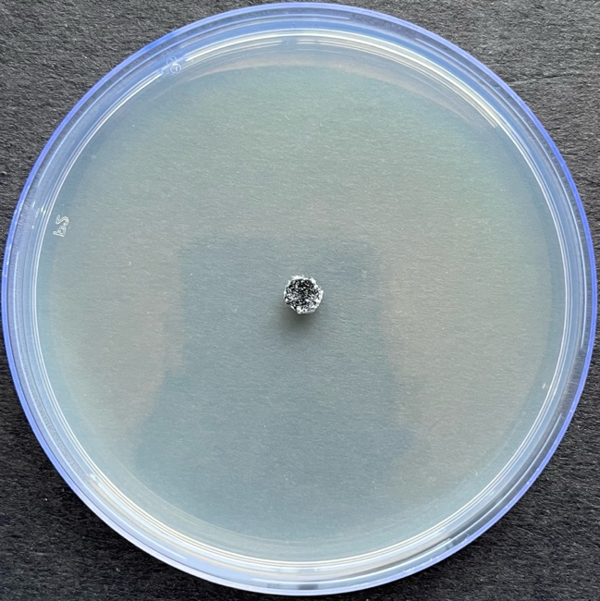 | 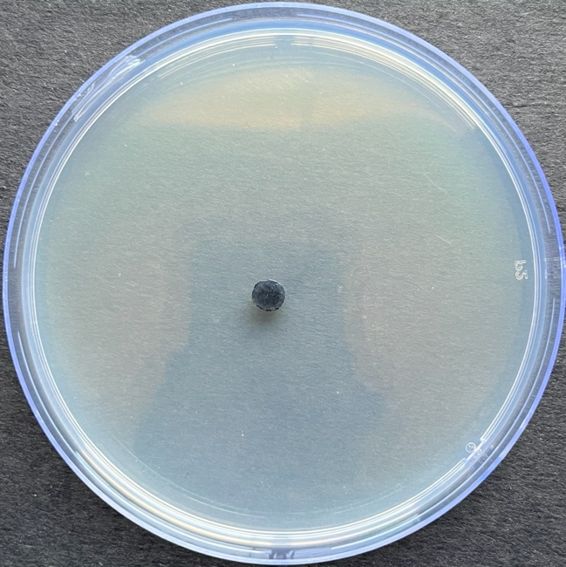
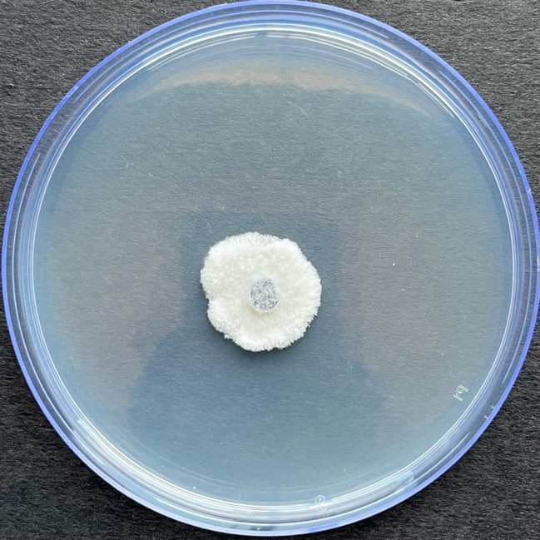 | 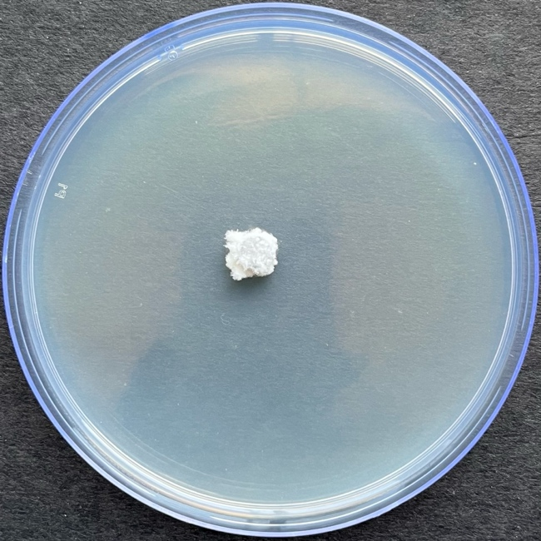 | 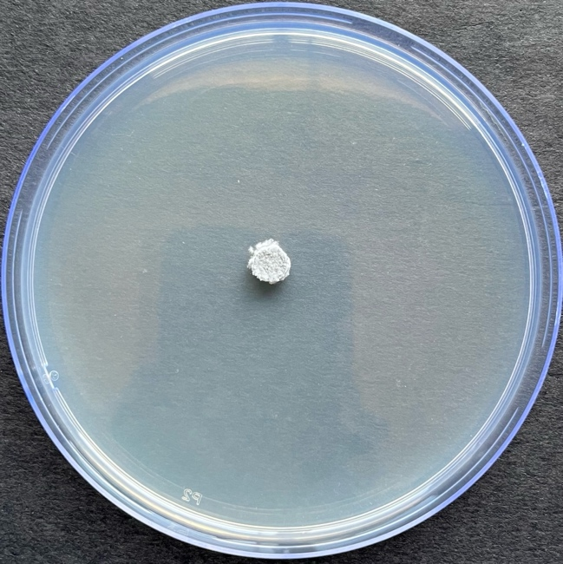
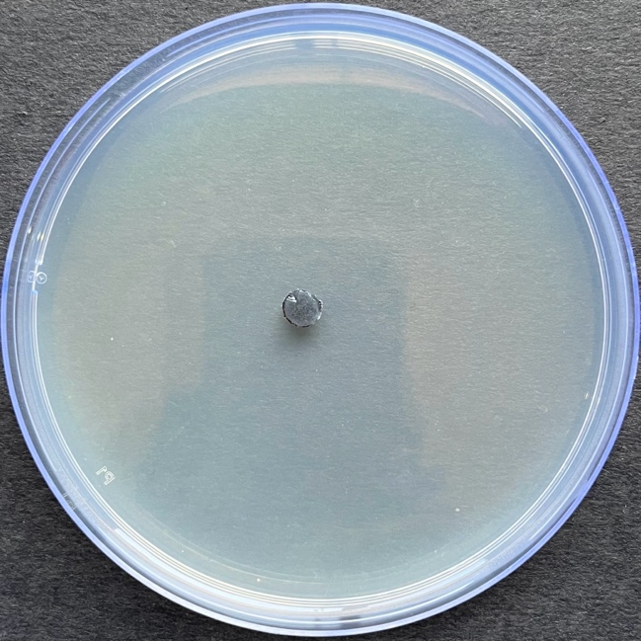 | 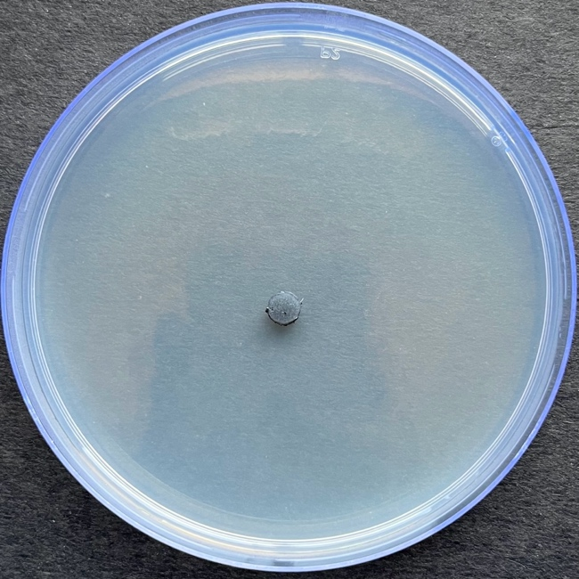 | 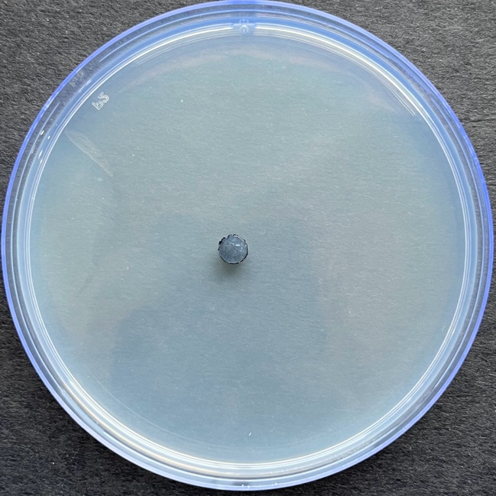
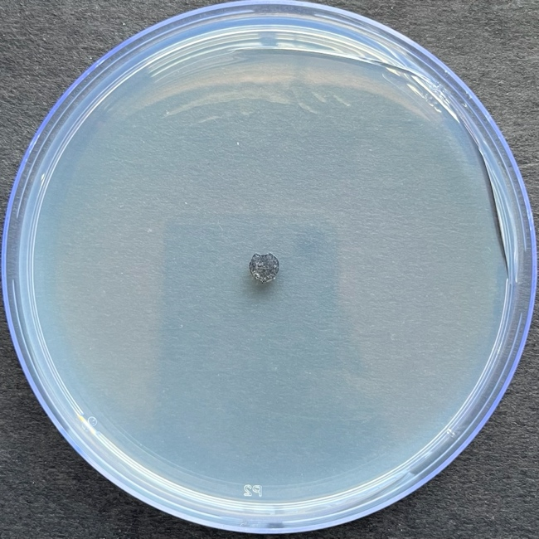 | 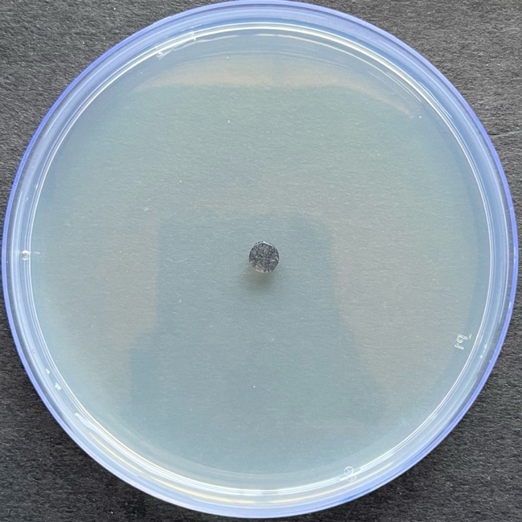 | 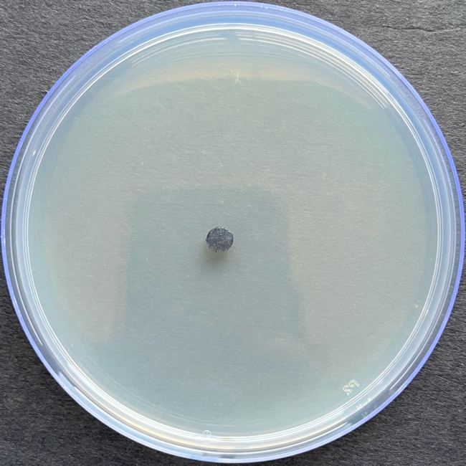
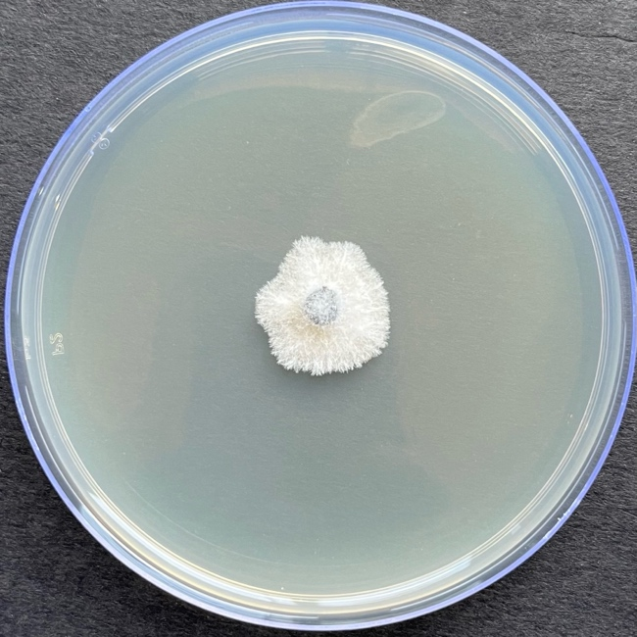  T₅ | 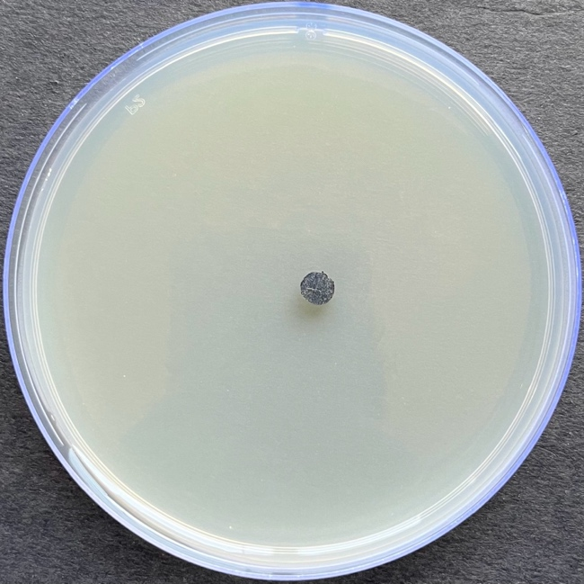  T₅ | 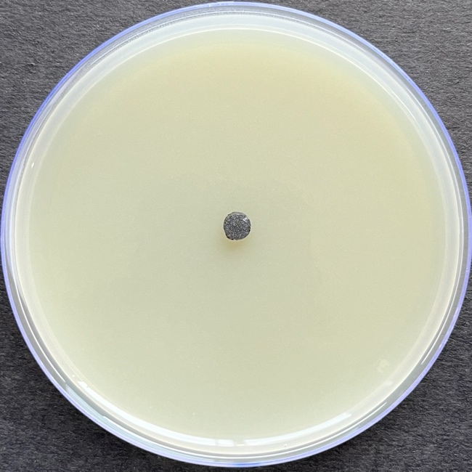  T₅
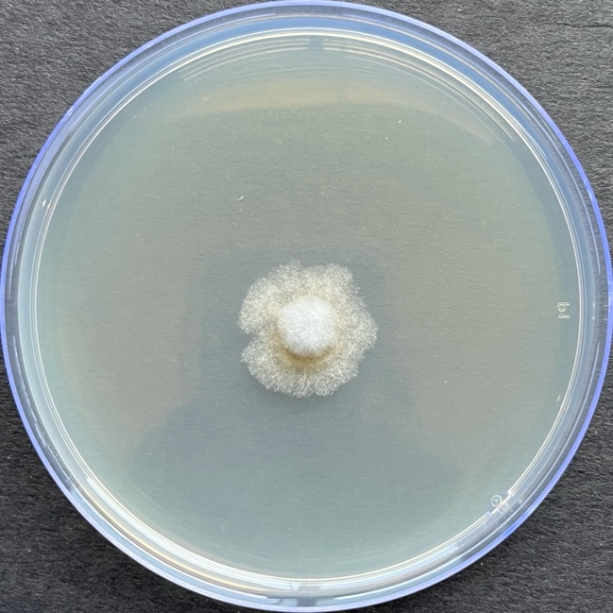  T₆ | 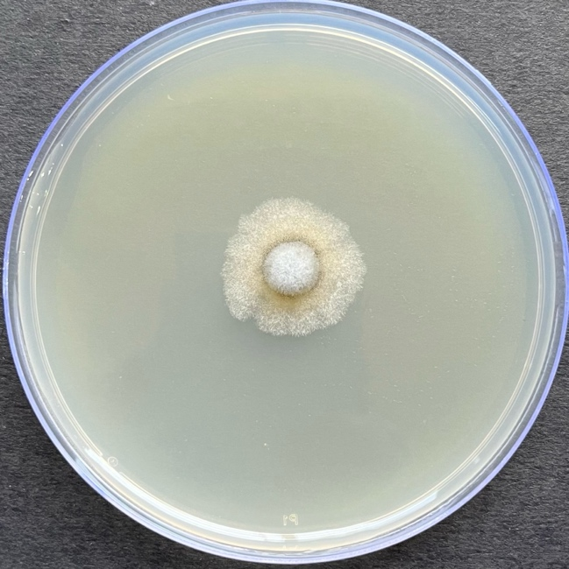  T₆ | 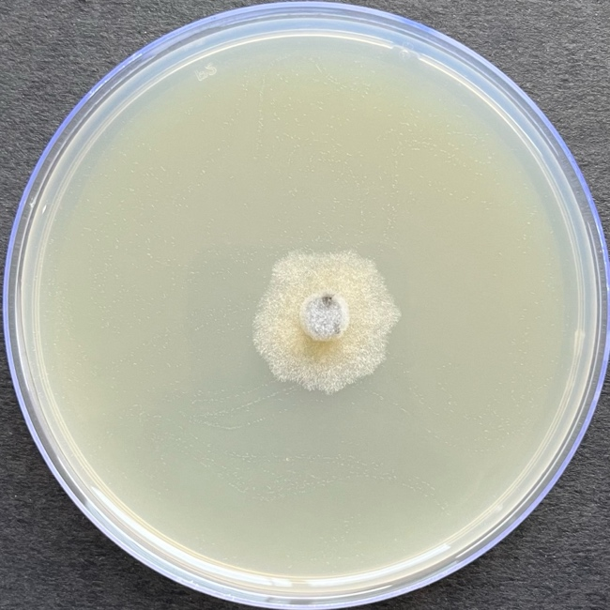  T₆
 | T₇
Figure 5: In-vitro evaluation of single compound fungicide against M. phaseolina at 100, 250 and 500 ppm.

