Exogenous 24-Epibrassinolide (24-EBL) Enhances Morpho-physiological Traits in Wheat (Triticum aestivum L.) Genotypes under High Temperature Stress

Abstract
High temperature stress is one of the major constraints limiting wheat (Triticum aestivum L.) productivity worldwide. Brassinosteroids (BRs), a class of plant steroidal hormones, play a pivotal role in modulating plant growth and conferring tolerance to various abiotic stresses. The present study aimed to investigate the effects of foliar-applied 24-epibrassinolide (24-EBL) on morpho-physiological traits of heat-tolerant (HUW-510) and heat-susceptible (HUW-468) wheat genotypes grown under field conditions during the Rabi season of 2017–18. Treatments included three concentrations of 24-EBL (0.01, 0.02, and 0.03 mM) and a control, applied at pre-flowering (40 DAS) and post-flowering (65 DAS) stages. Morpho-physiological parameters were assessed at two critical growth stages, i.e., 65 and 85 days after sowing (DAS). Results revealed that 24-EBL significantly improved root length, shoot height, leaf number, leaf area, total dry weight, relative water content (RWC), and membrane stability index (MSI) compared to untreated control plants exposed to heat stress. Among the concentrations tested, 0.02 mM 24-EBL proved most effective in sustaining growth and physiological integrity. Furthermore, the tolerant genotype HUW-510 exhibited higher responsiveness than HUW-468 suggesting genotypic differences in BR-mediated thermotolerance. The findings highlight the potential application of 24-EBL as a sustainable approach for improving wheat resilience against high temperature stress.
Keywords
Wheat (Triticum aestivum L.); 24-epibrassinolide; High temperature stress; Morpho-physiological traits; Relative water content (RWC); Membrane stability index (MSI)
- Introduction
Wheat (Triticum aestivum L.) is a major global staple crop whose productivity is increasingly threatened by rising temperatures in many wheat-growing regions, particularly South Asia (Mao et al., 2023). Heat stress, especially during reproductive and grain-filling phases, severely impairs photosynthesis, reduces biomass accumulation, accelerates leaf senescence, disturbs water relations, and ultimately causes yield losses, with reports indicating a 3–8% yield reduction per °C rise in temperature (Li et al., 2022). Wheat is highly sensitive to heat, and significant genetic variation among genotypes for thermotolerance has been documented. Plants subjected to heat stress often accumulate reactive oxygen species (ROS), suffer membrane damage, lose cellular water, and experience metabolic imbalance (Kumar et al., 2023). To counter these effects, plants activate a range of adaptive mechanisms, including osmotic adjustment, antioxidant enzyme activation, stabilization of membranes, and hormonal signaling (Chakraborty et al., 2023; Kumar et al., 2023).
Among plant hormones, brassinosteroids (BRs) have gained considerable attention for their role in stress modulation (Manghwar et al., 2022). In cereals, exogenous BRs improve thermotolerance by regulating gene expression, maintaining hormonal crosstalk, stabilizing membranes, and enhancing ROS scavenging. Manipulating BR homeostasis is now considered a promising strategy to enhance stress resilience in cereal crops (Angon et al., 2024).
Specifically, 24-epibrassinolide (24-EBL), a bioactive BR analogue, has been reported to mitigate high temperature injury across diverse plant systems. In fenugreek, 24-EBL enhanced tolerance to elevated temperature via modulation of antioxidant defenses and pigment biosynthesis (Sharma et al., 2023). In soybean, 24-EBL foliar application alleviated heat-induced water loss, enhanced antioxidant enzyme activities, and sustained photosynthetic efficiency. In wheat, calibrated 24-EBL application improved photosystem II efficiency and alleviated photoinhibition under late-sown heat stress (Talaat & Shawky, 2012). Moreover, under combined dry-hot wind stress (heat and drought), foliar 24-EBL reduced leaf and spike temperature, stabilized antioxidant enzyme activities, and improved tolerance (Seleiman et al., 2023). These findings strongly support the potential of 24-EBL in enhancing wheat thermotolerance under field-relevant conditions.
Despite these promising reports, gaps remain in understanding how 24-EBL influences morpho-physiological traits such as root growth, leaf expansion, water status, and membrane integrity in contrasting wheat genotypes (Alice et al., 2025). Genotype-specific variation in BR responsiveness may hold the key for integrating this approach in wheat breeding and agronomic management (Beres et al., 2020). Therefore, this study was designed to (i) evaluate the impact of foliar-applied 24-EBL on morphological traits (root length, shoot height, leaf number, leaf area, dry biomass) under high temperature stress, (ii) assess physiological responses (relative water content, membrane stability index), and (iii) compare the responsiveness of heat-tolerant versus heat-susceptible genotypes to 24-EBL-mediated alleviation.
- Materials and Methods
  - Experimental Site and Climate
The field experiment was conducted during the Rabi season of 2017–18 at the Agricultural Research Farm, Institute of Agricultural Sciences, Banaras Hindu University, Varanasi, India (25°58′ N latitude, 83°3′ E longitude, 75.7 m AMSL). The region experiences a subtropical climate characterized by hot summers and cool winters, with an average annual rainfall of ~1100 mm, ~88% of which is received during the monsoon months (June–September). Meteorological data during the crop season were recorded and revealed above-optimal temperatures during the reproductive phase, simulating natural high temperature stress conditions.
  - Plant Material and Treatments
Two contrasting wheat (Triticum aestivum L.) genotypes were used in this study: HUW-510, a heat-tolerant cultivar, and HUW-468, a heat-susceptible cultivar. Healthy seeds of both genotypes were obtained from the Department of Genetics and Plant Breeding, Banaras Hindu University (BHU). The experimental treatments consisted of four levels: T1 (control, no 24-EBL), T2 (0.01 mM 24-EBL), T3 (0.02 mM 24-EBL), and T4 (0.03 mM 24-EBL). Foliar sprays of 24-EBL were applied at two critical growth stages, namely pre-flowering (45 days after sowing, DAS) and post-flowering (65 DAS). Morpho-physiological parameters were assessed at two critical growth stages, i.e., 65 and 85 days after sowing (DAS).
  - Preparation of 24-EBL Solutions
Stock solutions of 24-epibrassinolide (Sigma-Aldrich, analytical grade) were prepared by dissolving in absolute acetone and diluting with distilled water to achieve final concentrations of 0.01, 0.02, and 0.03 mM. A few drops of Tween-20 were added as a surfactant to ensure uniform foliar coverage.
  - Measurements of Morpho-physiological Traits
Morphological parameters including root length, shoot height, number of leaves per plant, leaf area, and total dry weight were recorded at defined growth stages, i.e., 65 and 85 days after sowing (DAS). Root and shoot length were measured from the root–shoot junction to the tip using a scale, while the number of leaves per plant was counted manually. Leaf area was determined using a leaf area meter (Systronics 211), and dry biomass was recorded after oven-drying samples at 70 °C until constant weight. Physiological traits were evaluated to assess the functional responses of wheat genotypes to high temperature stress and 24-EBL treatments.
2.4.1. Relative water content (RWC) was determined following the formula described by Weatherley (1950):
$$RWC (\%)= \frac{FW-DW}{TW-DW} ×100$$
where FW is the fresh weight of leaf discs, TW is the turgid weight after rehydration for 24 h in distilled water, and DW is the dry weight after oven drying at 70 °C. This parameter provided an estimate of cellular hydration status and plant water balance.
2.4.2. Membrane stability index (MSI) was measured according to Sairam et al. (1997) with modifications. Fresh leaf discs (0.1 g) were immersed in 10 mL of double-distilled water and incubated in a water bath at 40 °C for 30 min (C1, initial conductivity). A second set of identical samples was incubated at 100 °C for 10 min (C2, final conductivity). MSI was calculated using the formula:
$$Membrane Stability Index \left(MSI\right)=\left(1- \left(\frac{C1}{C2}\right)\right) ×100$$
Higher MSI values indicated greater membrane integrity and stress tolerance. These morphological and physiological assessments collectively elucidated the thermoprotective role of 24-epibrassinolide in wheat genotypes exposed to field-imposed high temperature stress.

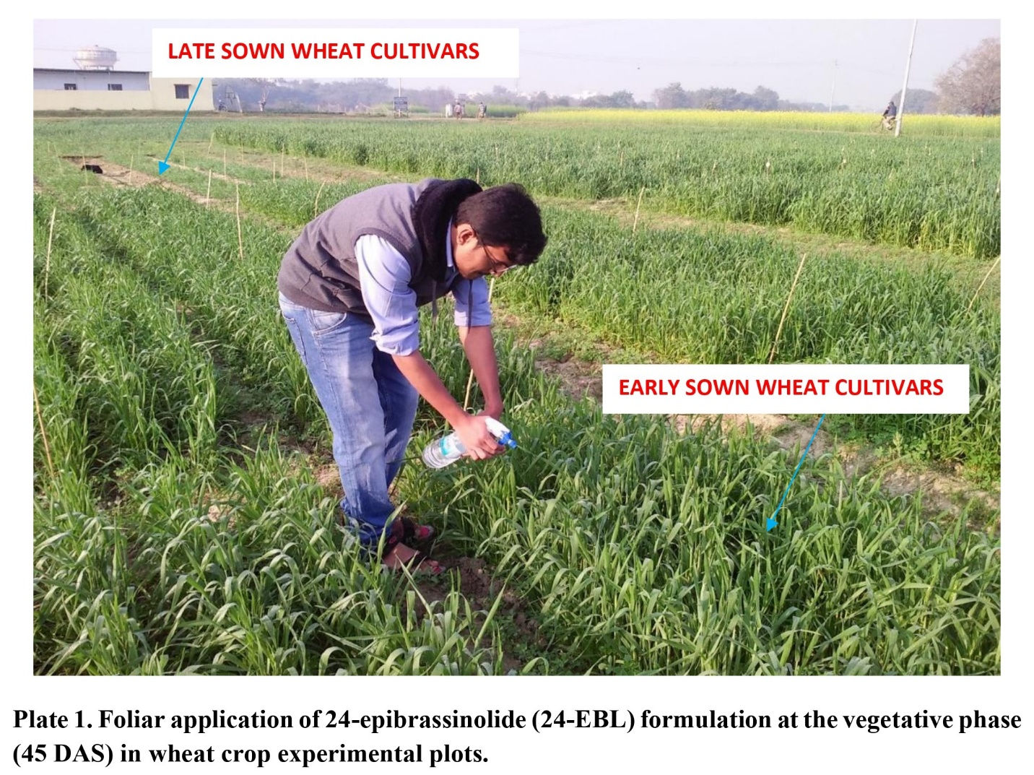

Table 1. Effect of foliar-applied 24-epibrassinolide (24-EBL) on root length, shoot length, number of leaves per plant, leaf area, total dry weight, relative water content (RWC), and membrane stability index (MSI) in wheat (Triticum aestivum L.) under early and late sowing conditions at 65 days after sowing (DAS).
TREATMENTS | ROOT LENGTH (cm) |  |  | SHOOT LENGTH (cm) |  |  | LEAVES PER PLANT |  |  |  | LEAF AREA (cm²) |  |  |  | DRY WT (g) |  |  |  | RWC (% |  |  |  | MSI (%)
TREATMENTS | EARLY | LATE | MEAN | EARLY | LATE | MEAN | EARLY | LATE | MEAN | EARLY |  | LATE | MEAN | EARLY |  | LATE | MEAN | EARLY |  | LATE | MEAN | EARLY |  | LATE | MEAN
T1 - Control | 17.17 | 12.20 | 14.69 | 77.64 | 56.69 | 67.17 | 16.83 | 10.00 | 13.42 | 45.89 |  | 33.83 | 39.86 | 11.18 |  | 7.12 | 9.15 | 54.69 |  | 45.53 | 50.11 | 29.57 |  | 25.18 | 27.38
T2 - 0.01 mM  24-EBL | 18.16 | 13.17 | 15.66 | 79.09 | 58.18 | 68.63 | 18.50 | 11.50 | 15.00 | 48.15 |  | 35.59 | 41.87 | 12.14 |  | 8.17 | 10.16 | 60.80 |  | 51.33 | 56.07 | 31.88 |  | 27.80 | 29.84
T3 - 0.02 mM  24-EBL | 19.13 | 14.22 | 16.67 | 80.69 | 59.81 | 70.25 | 20.33 | 12.50 | 16.42 | 50.45 |  | 37.53 | 43.99 | 13.14 |  | 9.15 | 11.14 | 65.80 |  | 54.30 | 60.05 | 34.46 |  | 30.22 | 32.34
T4 - 0.03 mM  24-EBL | 20.22 | 15.20 | 17.71 | 82.65 | 62.09 | 72.37 | 22.00 | 13.33 | 17.67 | 53.31 |  | 39.23 | 46.27 | 14.66 |  | 10.16 | 12.41 | 68.38 |  | 57.70 | 63.04 | 37.29 |  | 33.89 | 35.59
MEAN | 18.67 | 13.70 |  | 80.01 | 59.19 |  | 19.42 | 11.83 |  | 49.45 |  | 36.54 |  | 12.78 |  | 8.65 |  | 62.42 |  | 52.21 |  | 33.30 |  | 29.27
 | T | S | TXS | T | S | TXS | T | S | TXS | T |  | S | TXS | T |  | S | TXS | T |  | S | TXS | T |  | S | TXS
CD | 0.196 | 0.278 | NS | 1.063 | 1.503 | NS | 0.413 | 0.585 | 0.827 | 0.730 |  | 1.033 | NS | 0.126 |  | 0.179 | 0.253 | 0.777 |  | 1.098 | NS | 0.466 |  | 0.658 | NS
SE(d) | 0.091 | 0.128 | 0.181 | 0.347 | 0.491 | 0.694 | 0.191 | 0.270 | 0.382 | 0.337 |  | 0.477 | 0.675 | 0.058 |  | 0.083 | 0.117 | 0.359 |  | 0.507 | 0.717 | 0.215 |  | 0.304 | 0.430
SE(m) | 0.064 | 0.091 | 0.128 | 0.491 | 0.694 | 0.981 | 0.135 | 0.191 | 0.270 | 0.239 |  | 0.337 | 0.477 | 0.041 |  | 0.058 | 0.083 | 0.254 |  | 0.359 | 0.507 | 0.152 |  | 0.215 | 0.304

Table 2. Effect of foliar-applied 24-epibrassinolide (24-EBL) on root length, shoot length, number of leaves per plant, leaf area, total dry weight, relative water content (RWC), and membrane stability index (MSI) in wheat (Triticum aestivum L.) under early and late sowing conditions at 85 days after sowing (DAS).
TREATMENTS | ROOT LENGTH (cm) |  |  | SHOOT LENGTH (cm) |  |  | LEAVES PER PLANT |  |  |  | LEAF AREA (cm²) |  |  |  | DRY WT (g) |  |  |  | RWC (%) |  |  |  | MSI (%)
TREATMENTS | EARLY | LATE | MEAN | EARLY | LATE | MEAN | EARLY | LATE | MEAN | EARLY |  | LATE | MEAN | EARLY |  | LATE | MEAN | EARLY |  | LATE | MEAN | EARLY |  | LATE | MEAN
T1 - Control | 18.17 | 13.15 | 15.66 | 80.59 | 60.14 | 70.36 | 19.33 | 11.33 | 15.33 | 51.07 |  | 36.83 | 43.95 | 13.18 |  | 8.16 | 10.67 | 60.23 |  | 49.81 | 55.02 | 30.49 |  | 26.71 | 28.60
T2 - 0.01 mM 24-EBL | 19.62 | 14.10 | 16.86 | 82.68 | 61.68 | 72.18 | 22.50 | 12.83 | 17.67 | 52.76 |  | 38.96 | 45.86 | 14.66 |  | 9.14 | 11.90 | 67.63 |  | 56.06 | 61.85 | 33.21 |  | 28.76 | 30.98
T3 - 0.02 mM 24-EBL | 20.66 | 15.16 | 17.91 | 84.15 | 63.19 | 73.67 | 24.67 | 14.17 | 19.42 | 54.95 |  | 40.92 | 47.93 | 16.14 |  | 10.13 | 13.13 | 72.14 |  | 60.10 | 66.12 | 36.19 |  | 31.68 | 33.93
T4 - 0.03 mM 24-EBL | 21.68 | 16.18 | 18.93 | 86.18 | 65.15 | 75.66 | 27.33 | 14.83 | 21.08 | 57.06 |  | 42.78 | 49.92 | 17.62 |  | 11.17 | 14.39 | 75.25 |  | 62.59 | 68.92 | 39.16 |  | 35.78 | 37.47
MEAN | 20.03 | 14.65 |  | 83.40 | 62.54 |  | 23.46 | 13.29 |  | 53.96 |  | 39.87 |  | 15.40 |  | 9.65 |  | 68.81 |  | 57.14 |  | 34.76 |  | 30.73
 | T | S | TXS | T | S | TXS | T | S | TXS | T |  | S | TXS | T |  | S | TXS | T |  | S | TXS | T |  | S | TXS
CD | 0.24 | 0.339 | NS | 0.878 | 1.242 | NS | 0.386 | 0.546 | 0.772 | 0.619 |  | 0.875 | NS | 0.246 |  | 0.348 | 0.492 | 1.097 |  | 1.551 | NS | 0.748 |  | 1.058 | NS
SE(d) | 0.111 | 0.157 | 0.222 | 0.406 | 0.574 | 0.811 | 0.178 | 0.252 | 0.356 | 0.286 |  | 0.404 | 0.572 | 0.113 |  | 0.160 | 0.227 | 0.506 |  | 0.716 | 1.013 | 0.346 |  | 0.489 | 0.691
SE(m) | 0.078 | 0.111 | 0.157 | 0.287 | 0.406 | 0.574 | 0.126 | 0.178 | 0.252 | 0.202 |  | 0.286 | 0.404 | 0.080 |  | 0.113 | 0.160 | 0.358 |  | 0.506 | 0.716 | 0.244 |  | 0.346 | 0.489

*CD = Critical Difference, SE(d) = Standard Error of Difference, SE(m) = Standard Error of Mean, T = Treatment effect, S = Sowing time effect, and T×S = Treatment × Sowing time interaction.

Table 3. Comparative response of wheat (Triticum aestivum L.) genotypes HUW-468 (heat-susceptible) and HUW-510 (heat-tolerant) to foliar-applied 24-epibrassinolide (24-EBL) in terms of root length, shoot length, number of leaves per plant, leaf area, total dry weight, relative water content (RWC), and membrane stability index (MSI) at 65 days after sowing (DAS).
TREATMENTS | ROOT LENGTH (cm) |  |  | SHOOT LENGTH (cm) |  |  | LEAVES PER PLANT |  |  |  | LEAF AREA (cm²) |  |  |  | DRY WT (g) |  |  |  | RWC (%) |  |  |  | MSI (%)
TREATMENTS | HUW  468 | HUW  510 | MEAN | HUW  468 | HUW  510 | MEAN | HUW  468 | HUW  510 | MEAN | HUW  468 |  | HUW  510 | MEAN | HUW  468 |  | HUW  510 | MEAN | HUW  468 |  | HUW  510 | MEAN | HUW  468 |  | HUW  510 | MEAN
T1 - Control | 13.66 | 15.72 | 14.69 | 63.67 | 70.67 | 67.17 | 11.50 | 15.33 | 13.42 | 35.45 |  | 44.27 | 39.86 | 8.15 |  | 10.15 | 9.15 | 49.07 |  | 51.15 | 50.11 | 25.72 |  | 29.03 | 27.38
T2 - 0.01 mM  24-EBL | 14.66 | 16.66 | 15.66 | 64.63 | 72.64 | 68.63 | 13.00 | 17.00 | 15.00 | 37.29 |  | 46.45 | 41.87 | 9.15 |  | 11.16 | 10.16 | 54.57 |  | 57.57 | 56.07 | 28.62 |  | 31.06 | 29.84
T3 - 0.02 mM  24-EBL | 15.67 | 17.68 | 16.67 | 65.65 | 74.85 | 70.25 | 14.33 | 18.50 | 16.42 | 39.13 |  | 48.85 | 43.99 | 10.17 |  | 12.12 | 11.14 | 58.91 |  | 61.19 | 60.05 | 31.34 |  | 33.35 | 32.34
T4 - 0.03 mM  24-EBL | 16.72 | 18.70 | 17.71 | 68.05 | 76.68 | 72.37 | 15.50 | 19.83 | 17.67 | 41.34 |  | 51.20 | 46.27 | 11.15 |  | 13.67 | 12.41 | 61.18 |  | 64.90 | 63.04 | 34.84 |  | 36.34 | 35.59
MEAN | 15.18 | 17.19 |  | 65.50 | 73.71 |  | 13.58 | 17.67 |  | 38.30 |  | 47.69 |  | 9.65 |  | 11.77 |  | 55.93 |  | 58.70 |  | 30.13 |  | 32.44
 | T | G | TXG | T | G | TXG | T | G | TXG | T |  | G | TXG | T |  | G | TXG | T |  | G | TXG | T |  | G | TXG
CD | 0.224 | 0.316 | NS | 0.999 | 1.412 | NS | 0.378 | 0.535 | NS | 0.651 |  | 0.921 | NS | 0.135 |  | 0.190 | 0.269 | 0.789 |  | 1.116 | NS | 0.551 |  | 0.780 | NS
SE(d) | 0.103 | 0.146 | 0.206 | 0.326 | 0.461 | 0.652 | 0.175 | 0.247 | 0.349 | 0.301 |  | 0.425 | 0.602 | 0.062 |  | 0.088 | 0.124 | 0.365 |  | 0.515 | 0.729 | 0.255 |  | 0.360 | 0.509
SE(m) | 0.073 | 0.103 | 0.146 | 0.461 | 0.652 | 0.922 | 0.124 | 0.175 | 0.247 | 0.213 |  | 0.301 | 0.425 | 0.044 |  | 0.062 | 0.088 | 0.258 |  | 0.365 | 0.515 | 0.180 |  | 0.255 | 0.360

Table 4. Comparative response of wheat (Triticum aestivum L.) genotypes HUW-468 (heat-susceptible) and HUW-510 (heat-tolerant) to foliar-applied 24-epibrassinolide (24-EBL) in terms of root length, shoot length, number of leaves per plant, leaf area, total dry weight, relative water content (RWC), and membrane stability index (MSI) at 85 days after sowing (DAS).
TREATMENTS/STRESS | ROOT LENGTH (cm) |  |  | SHOOT LENGTH (cm) |  |  | LEAVES PER PLANT |  |  | LEAF AREA (cm²) |  |  |  | DRY WT (g) |  |  |  | RWC (%) |  |  |  | MSI (%)
TREATMENTS/STRESS | HUW  468 | HUW  510 | MEAN | HUW  468 | HUW  510 | MEAN | HUW  468 | HUW  510 | MEAN | HUW  468 | HUW  510 | MEAN | HUW  468 |  | HUW  510 | MEAN | HUW  468 |  | HUW  510 | MEAN | HUW  468 |  | HUW  510 | MEAN
T1 - Control | 14.64 | 16.68 | 15.66 | 66.13 | 74.60 | 70.36 | 13.33 | 17.33 | 15.33 | 39.26 | 48.64 | 43.95 | 9.18 |  | 12.16 | 10.67 | 53.22 |  | 56.82 | 55.02 | 27.60 |  | 29.60 | 28.60
T2 - 0.01 mM 24-EBL | 15.60 | 18.12 | 16.86 | 67.66 | 76.70 | 72.18 | 14.83 | 20.50 | 17.67 | 41.03 | 50.69 | 45.86 | 10.17 |  | 13.63 | 11.90 | 59.93 |  | 63.77 | 61.85 | 30.02 |  | 31.95 | 30.98
T3 - 0.02 mM 24-EBL | 16.67 | 19.15 | 17.91 | 68.67 | 78.67 | 73.67 | 16.67 | 22.17 | 19.42 | 43.07 | 52.80 | 47.93 | 11.13 |  | 15.14 | 13.13 | 64.49 |  | 67.76 | 66.12 | 32.86 |  | 35.00 | 33.93
T4 - 0.03 mM 24-EBL | 17.65 | 20.20 | 18.93 | 70.69 | 80.64 | 75.66 | 18.33 | 23.83 | 21.08 | 45.46 | 54.38 | 49.92 | 12.13 |  | 16.66 | 14.39 | 67.95 |  | 69.90 | 68.92 | 37.06 |  | 37.89 | 37.47
MEAN | 16.14 | 18.54 |  | 68.28 | 77.65 |  | 15.79 | 20.96 |  | 42.20 | 51.63 |  | 10.65 |  | 14.40 |  | 61.39 |  | 64.56 |  | 31.88 |  | 33.61
 | T | G | TXG | T | G | TXG | T | G | TXG | T | G | TXG | T |  | G | TXG | T |  | G | TXG | T |  | G | TXG
CD | 0.188 | 0.265 | NS | 0.967 | 1.367 | NS | 0.193 | 0.273 | 0.386 | 0.502 | 0.709 | NS | 0.224 |  | 0.317 | 0.448 | 1.103 |  | 1.560 | NS | 0.596 |  | 0.843 | NS
SE(d) | 0.087 | 0.123 | 0.173 | 0.446 | 0.631 | 0.893 | 0.089 | 0.126 | 0.178 | 0.232 | 0.328 | 0.463 | 0.103 |  | 0.146 | 0.207 | 0.510 |  | 0.721 | 1.019 | 0.275 |  | 0.389 | 0.551
SE(m) | 0.061 | 0.087 | 0.123 | 0.316 | 0.446 | 0.631 | 0.063 | 0.089 | 0.126 | 0.164 | 0.232 | 0.328 | 0.073 |  | 0.103 | 0.146 | 0.360 |  | 0.510 | 0.721 | 0.195 |  | 0.275 | 0.389

*CD = Critical Difference, G= Genotype, SE(d) = Standard Error of Difference, SE(m) = Standard Error of Mean, T = Treatment effect, S = Sowing effect, and T×G = Treatment × Genotype interaction.

Figure:1 Regression analysis of root length, shoot length, number of leaves per plant, leaf area, total dry weight, relative water content (RWC) and membrane stability index (MSI) in wheat under 24-epibrassinolide treatments.

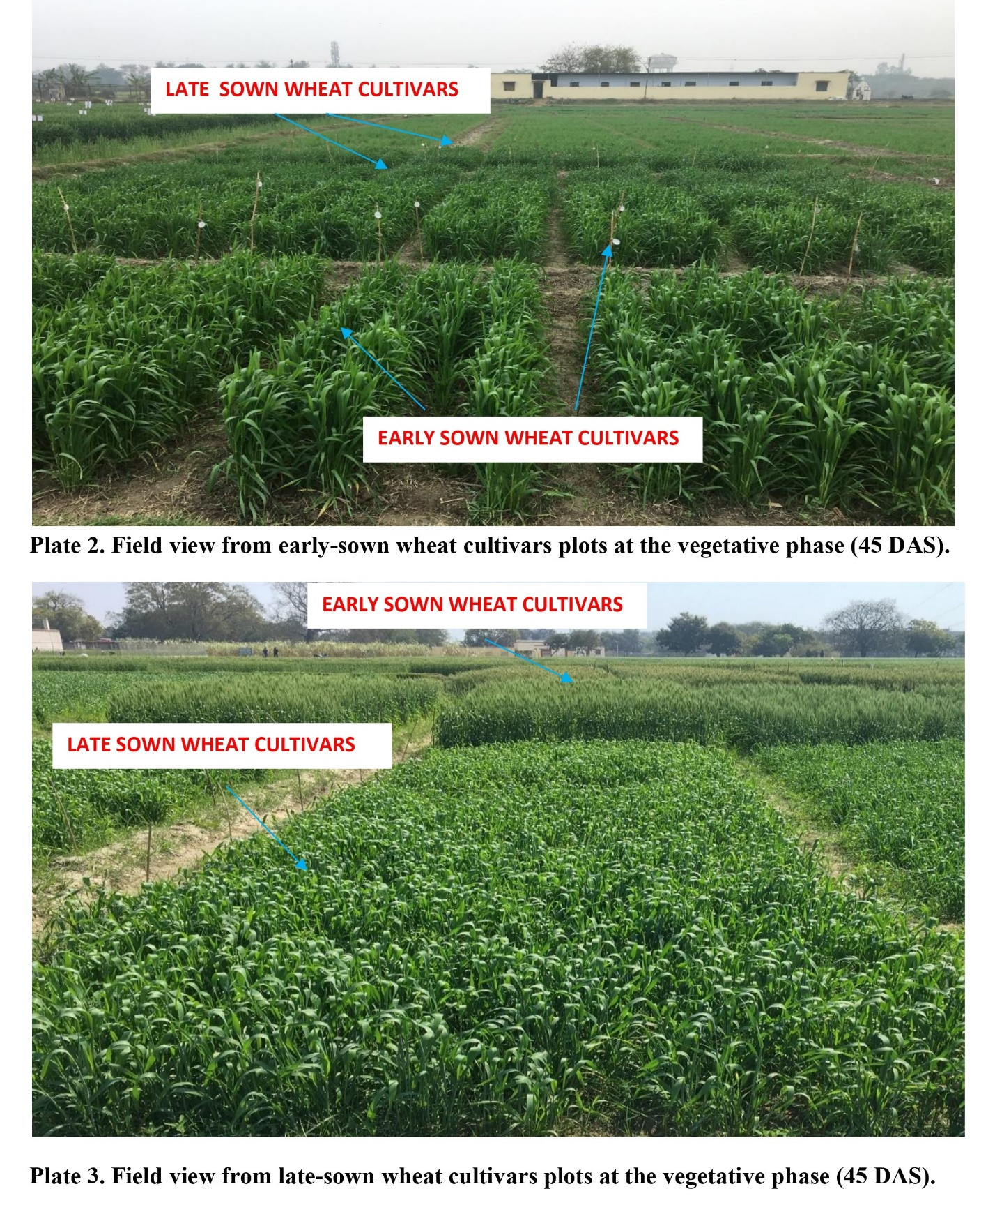

- Results
  - Root and Shoot Growth
Foliar application of 24-epibrassinolide (24-EBL) significantly enhanced root length and shoot height in both wheat genotypes compared with untreated controls. The maximum improvement was observed with 0.02 mM 24-EBL, which increased root length by 34.4% in HUW-510 and 38.6% in HUW-468 relative to controls. Similarly, shoot height increased by 24.3% in HUW-510 and 23.0% in HUW-468 under the same treatment. Between the genotypes, HUW-510 maintained higher absolute root and shoot dimensions across all treatments.
  - Leaf Traits and Biomass Accumulation
24-EBL treatments positively influenced the number of leaves per plant, total leaf area, and dry biomass. At 0.02 mM, leaf number increased by 28% (HUW-510) and 29% (HUW-468) compared with controls. Leaf area expansion was more pronounced in HUW-510, showing a 25% increase at 0.02 mM 24-EBL. Dry biomass also improved significantly, with HUW-510 showing the highest dry weight (10.8 g plant⁻¹) under 0.02 mM treatment.
  - Relative Water Content (RWC) and Membrane Stability Index (MSI)
Physiological traits such as RWC and MSI improved substantially in response to 24-EBL application. In HUW-510, RWC increased from 62.4% (control) to 74.9% (0.02 mM), while MSI improved from 58.2% to 71.8%. In HUW-468, the corresponding increases were from 55.1% to 66.0% (RWC) and 50.7% to 62.4% (MSI). Across all treatments, HUW-510 maintained superior water retention and membrane stability compared with HUW-468, highlighting its inherent thermotolerance.
  - Genotypic Differences
Overall, the heat-tolerant genotype (HUW-510) consistently outperformed the heat-susceptible genotype (HUW-468) across all morpho-physiological traits under heat stress. However, both genotypes benefited significantly from 24-EBL application, confirming its protective role in maintaining growth and physiological integrity under high temperature stress.
- Discussion
The present study demonstrated that foliar application of 24-epibrassinolide (24-EBL) significantly improved morpho-physiological traits of wheat under high temperature stress, with the intermediate concentration (0.02 mM) being most effective. Improvements were evident in root and shoot growth, leaf expansion, biomass accumulation, relative water content (RWC), and membrane stability index (MSI). These results confirm the protective role of brassinosteroids (BRs) in sustaining plant growth and physiology under thermal stress conditions (Alam et al., 2020; Omidian et al., 2021).
Exogenous 24-EBL enhanced root and shoot elongation in both genotypes, with the tolerant genotype (HUW-510) maintaining higher absolute values. Enhanced root growth may contribute to improved water uptake, while shoot elongation supports leaf expansion and photosynthetic capacity. Similar findings were reported in wheat where BRs promoted growth under late-sown heat stress, resulting in better plant vigor and yield stability (Hasanuzzaman et al., 2013). In fenugreek, 24-EBL application improved root/shoot growth under heat stress by modulating hormonal balance and antioxidant activity (Sheikhi et al., 2023). The positive effects of 24-EBL on leaf number, leaf area, and dry biomass observed in this study align with recent reports that BRs enhance photosynthetic pigment content, chlorophyll fluorescence efficiency, and carbon assimilation under heat stress. Increased leaf area contributes to higher light interception, while improved dry matter partitioning reflects enhanced resource utilization (Wang et al., 2014).
RWC and MSI improved significantly with 24-EBL application, indicating its role in maintaining cellular hydration and stabilizing membranes under heat stress. This agrees with reports in soybean, where 24-EBL foliar spray reduced heat-induced water loss and sustained membrane integrity by enhancing antioxidant defenses (Dong et al., 2019). Maintenance of higher RWC under stress conditions is a key trait for thermotolerance, as it allows plants to preserve turgor and stomatal conductance, thereby sustaining photosynthesis (Qiao et al., 2024). The greater responsiveness of HUW-510 compared with HUW-468 suggests genotypic variability in BR perception or downstream signaling. Similar genotype-dependent responses were noted in wheat where BR application stabilized photosystem II efficiency in tolerant but not in susceptible cultivars under heat stress. This highlights the importance of integrating BR treatments with genotype selection to maximize stress resilience (Coast et al., 2022).
The beneficial effects of 24-EBL can be attributed to its ability to regulate ROS homeostasis, improve antioxidant enzyme activity, and maintain hormonal crosstalk during stress. BRs are also reported to interact with heat shock proteins and transcription factors, thereby modulating gene expression that enhances stress tolerance pathways (Abdoli et al., 2024). Collectively, these mechanisms support the observed improvements in morpho-physiological traits under high temperature stress (Gao et al., 2025).
- Conclusion
The present study clearly demonstrated that foliar application of 24-epibrassinolide (24-EBL) ameliorates the adverse effects of high temperature stress in wheat. Exogenous 24-EBL significantly improved root and shoot elongation, leaf expansion, biomass accumulation, relative water content (RWC), and membrane stability index (MSI). Among the tested concentrations, 0.02 mM 24-EBL was most effective in sustaining plant growth and physiological integrity. The heat-tolerant genotype (HUW-510) consistently outperformed the heat-susceptible genotype (HUW-468), although both benefitted from 24-EBL application, highlighting the potential for genotype × hormone interactions in stress management. These findings reinforce the role of brassinosteroids as key regulators of thermotolerance in cereals. By maintaining cellular hydration, membrane stability, and growth processes, 24-EBL offers a promising approach to mitigate climate-induced heat stress in wheat production systems.

References
- Abdoli, M., Amerian, M. R., Heidari, M., & Ebrahimi, A. (2024). Synergistic effects of melatonin and 24-epibrassinolide on chickpea water deficit tolerance. BMC Plant Biology, 24(1). https://doi.org/10.1186/s12870-024-05380-2
- Alam, P., Kohli, S. K., Balawi, T. A., Altalayan, F. H., Alam, P., Ashraf, M., Bhardwaj, R., & Ahmad, P. (2020). Foliar Application of 24-Epibrassinolide Improves Growth, Ascorbate-Glutathione Cycle, and Glyoxalase System in Brown Mustard (Brassica juncea (L.) Czern.) under Cadmium Toxicity. Plants, 9(11), 1487. https://doi.org/10.3390/plants9111487
- Alice, P., Diego, P., Simone, D., Maria, I. L., Laura, V., Francesco, A., Maddalena, A. M., & Giuseppina, F. (2025). Brassinosteroid seed priming positively affects leaf anatomy and gas exchanges in a salt-sensitive sorghum genotype exposed to salt stress. Plant Stress, 101014. https://doi.org/10.1016/j.stress.2025.101014
- Angon, P. B., Das, A., Roy, A. R., Khan, J. J., Ahmad, I., Biswas, A., Pallob, A. T., Mondol, M., & Yeasmin, S. T. (2024). Plant development and heat stress: role of exogenous nutrients and phytohormones in thermotolerance. Discover Plants., 1(1). https://doi.org/10.1007/s44372-024-00020-3
- Beres, B. L., Hatfield, J. L., Kirkegaard, J. A., Eigenbrode, S. D., Pan, W. L., Lollato, R. P., Hunt, J. R., Strydhorst, S., Porker, K., Lyon, D., Ransom, J., & Wiersma, J. (2020). Toward a better understanding of Genotype × Environment × Management Interactions—A Global Wheat Initiative Agronomic Research Strategy. Frontiers in Plant Science, 11. https://doi.org/10.3389/fpls.2020.00828
- Chakraborty, A., Choudhury, S., Kar, S. R., Deb, P., & Wylie, S. J. (2023). Gene editing for tolerance to temperature stress in plants: A review. Plant Gene, 37, 100439. https://doi.org/10.1016/j.plgene.2023.100439
- Coast, O., Posch, B. C., Rognoni, B. G., Bramley, H., Gaju, O., Mackenzie, J., Pickles, C., Kelly, A. M., Lu, M., Ruan, Y., Trethowan, R., & Atkin, O. K. (2022). Wheat photosystem II heat tolerance: evidence for genotype‐by‐environment interactions. The Plant Journal, 111(5), 1368–1382. https://doi.org/10.1111/tpj.15894
- Dong, S., Jiang, Y., Dong, Y., Wang, L., Wang, W., Ma, Z., Yan, C., Ma, C., & Liu, L. (2019). A study on soybean responses to drought stress and rehydration. Saudi Journal of Biological Sciences, 26(8), 2006–2017. https://doi.org/10.1016/j.sjbs.2019.08.005
- Gao, T., Tang, X., Wang, D., Yu, Y., & Mao, Y. (2025). Morpho-physiological and transcriptomic analyses reveal adaptive responses of Neopyropia yezoensis to long-term high temperature. Plant Stress, 100778. https://doi.org/10.1016/j.stress.2025.100778
- Hasanuzzaman, M., Nahar, K., Alam, M., Roychowdhury, R., & Fujita, M. (2013). Physiological, biochemical, and molecular mechanisms of heat stress tolerance in plants. International Journal of Molecular Sciences, 14(5), 9643–9684. https://doi.org/10.3390/ijms14059643
- Kumar, H., Chugh, V., Kumar, M., Gupta, V., Prasad, S., Kumar, S., Singh, C. M., Kumar, R., Singh, B. K., Panwar, G., & Kumar, M. (2023b). Investigating the impact of terminal heat stress on contrasting wheat cultivars: a comprehensive analysis of phenological, physiological, and biochemical traits. Frontiers in Plant Science, 14. https://doi.org/10.3389/fpls.2023.1189005
- Kwak, N. (2011). Physiological and biochemical traits of different water and light intensities on cork oak (Quercus suber L.) seedlings. AFRICAN JOURNAL OF BIOTECHNOLOGY, 10(68). https://doi.org/10.5897/ajb11.2845
- Li, M., Feng, J., Zhou, H., Najeeb, U., Li, J., Song, Y., & Zhu, Y. (2022a). Overcoming reproductive compromise under heat Stress in wheat: physiological and genetic regulation, and breeding strategy. Frontiers in Plant Science, 13. https://doi.org/10.3389/fpls.2022.881813
- Manghwar, H., Hussain, A., Ali, Q., & Liu, F. (2022). Brassinosteroids (BRs) Role in Plant Development and Coping with Different Stresses. International Journal of Molecular Sciences, 23(3), 1012. https://doi.org/10.3390/ijms23031012
- Mao, H., Jiang, C., Tang, C., Nie, X., Du, L., Liu, Y., Cheng, P., Wu, Y., Liu, H., Kang, Z., & Wang, X. (2023). Wheat adaptation to environmental stresses under climate change: Molecular basis and genetic improvement. Molecular Plant, 16(10), 1564–1589. https://doi.org/10.1016/j.molp.2023.09.001
- Omidian, M., Roein, Z., & Shiri, M. A. (2021). Effect of Foliar Application of 24-Epibrassinolide on Water Use Efficiency and Morpho-Physiological Characteristics of Lilium LA Hybrid under Deficit Irrigation. Journal of Plant Growth Regulation, 41(4), 1547–1560. https://doi.org/10.1007/s00344-021-10400-8
- Qiao, M., Hong, C., Jiao, Y., Hou, S., & Gao, H. (2024). Impacts of drought on photosynthesis in major food crops and the related mechanisms of plant responses to drought. Plants, 13(13), 1808. https://doi.org/10.3390/plants13131808
- Sairam, R. K., Deshmukh, P. S., & Shukla, D. S. (1997). Tolerance of drought and temperature stress in relation to increased antioxidant enzyme activity in wheat. Journal of Agronomy and Crop Science, 178(3), 171–178. https://doi.org/10.1111/j.1439-037x.1997.tb00486.x
- Seleiman, M. F., Ahmad, A., Tola, E., Alhammad, B. A., Almutairi, K. F., Madugundu, R., & Al-Gaadi, K. A. (2023). Exogenous application of 24-Epibrassinolide confers saline stress and improves photosynthetic capacity, antioxidant defense, mineral uptake, and yield in maize. Plants, 12(20), 3559. https://doi.org/10.3390/plants12203559
- Sharma, D., Bhardwaj, S., Raza, A., Singh, R., Kapoor, D., Sharma, N. R., & Prasad, P. V. V. (2023). Alleviatory Effects of Silicon and 24-Epibrassinolide in Modulation of Growth, Osmolytes, Metabolites, Antioxidant Defense System, and Gene Expression in Lead-Exposed Fenugreek (Trigonella foenum-graecum L.) Plants. Agronomy, 13(7), 1884. https://doi.org/10.3390/agronomy13071884
- Sheikhi, S., Ebrahimi, A., Heidari, P., Amerian, M. R., Rashidi-Monfared, S., & Alipour, H. (2023). Exogenous 24-epibrassinolide ameliorates tolerance to high-temperature by adjusting the biosynthesis of pigments, enzymatic, non-enzymatic antioxidants, and diosgenin content in fenugreek. Scientific Reports, 13(1). https://doi.org/10.1038/s41598-023-33913-6
- Talaat, N. B., & Shawky, B. T. (2012). 24-Epibrassinolide alleviates salt-induced inhibition of productivity by increasing nutrients and compatible solutes accumulation and enhancing antioxidant system in wheat (Triticum aestivum L.). Acta Physiologiae Plantarum, 35(3), 729–740. https://doi.org/10.1007/s11738-012-1113-9
- Wang, Z., Zheng, P., Meng, J., & Xi, Z. (2014). Effect of exogenous 24-epibrassinolide on chlorophyll fluorescence, leaf surface morphology and cellular ultrastructure of grape seedlings (Vitis vinifera L.) under water stress. Acta Physiologiae Plantarum, 37(1). https://doi.org/10.1007/s11738-014-1729-z
- Weatherley, P. E. (1950). Studies in the water relations of the cotton plant. New Phytologist, 49(1), 81–97. https://doi.org/10.1111/j.1469-8137.1950.tb05146.x

