Innovative Technologies in Horticultural Crops: A Comprehensive Review

Abstract:
The rapid advancement of agricultural automation is transforming crop production and management worldwide. Modern crop management systems aim to integrate all aspects of farming into a more systematic and resource-efficient framework. In India, diverse agro-ecological zones, soils, and climatic conditions provide immense potential for cultivating a wide range of horticultural crops, which not only enhance farm productivity but also contribute significantly to employment generation and supply chains for food-processing industries. Despite the relatively limited area under horticulture, the demand for these crops remains high, creating the need for innovative approaches to maximize output with minimal resource use. Technological interventions such as nuclear techniques, artificial intelligence (AI), blockchain, the Internet of Things (IoT), remote sensing, advanced breeding programs, and hydroponic systems are emerging as key solutions. In particular, remote sensing technologies combined with computer vision, robotics, AI, and machine learning are being increasingly applied for real-time monitoring of plant growth, weed detection, and the early diagnosis of pests and diseases. Furthermore, the integration of digital platforms is enabling farmers to access input–output markets, manage financial transactions, and adopt data-driven decision-making for efficient farm operations. This review highlights recent technological innovations and digital tools that hold the potential to revolutionize horticultural crop management in India and ensure sustainable agricultural growth.
Keywords: Artificial intelligence; IoT, vertical farming; Automation; blockchain; remote sensing
1. Introduction
1.1 Introduction to Indian Horticulture
A brief overview on automation and digitization could have a significant positive impact on horticulture by handling increasingly complex tasks associated with production system control and management (Sam et al., 2022). Robotics, AI, innovative solutions with sensors, and management of data systems all can help in horticulture production in becoming very competitive as well as sustainable (Lezoche et al., 2020). Therefore, despite the fact that their use and advancement are still in their infancy, digital approaches are indispensable (Boruah et al., 2024). It is one of the main problems with the current state of affairs, which supports the fact. Therefore, increasing production through direct and indirect means, including increasing planted area and productivity or reducing post-harvest rotting (sometimes called hidden harvest), is required. In this case, horticulture crops can help meet the population's demands, which are around 5.4 times higher than those of any other crop group due to their higher productivity (Tiwari et al., 2015). Horticulture crops boost agricultural production, create job opportunities and provide resources to different food processing industries, that has a significant positive influence on the Indian economy (Qingxue et al., 2016). Fruit production has significantly increased as horticultural land has expanded. However, it was not feasible to schedule the fruit sales at the same time. Most markets are now controlled by intermediaries who fix fruit prices. The exploitation of middlemen won't stop if growers didn’t form shop and cooperatives in urban areas (Subeesh et al., 2021). Cooperatives for fruit producers have been founded in some areas due to farmers' collective activity. Damaged cold chain results substantial losses for fruits and vegetables. Cold chains have developed in several areas that grow grapes. This has improved grape export, storage, transportation, and shelf life (Spina et al., 2021). Occasionally, new characteristics have remained. The application of numerous improvements in breeding of crops, like semi dwarf cultivar of cereal crops, has resulted in a large rise in grain yield, earning it the moniker "green revolution" (Peng et al., 1999). New varieties selected from natural mutations in perennial horticulture, like large-berry tetraploid Kyoho grape (Alleweldt et al., 1988), the recently discovered red-skinned Fuji apple (Ban et al., 2007), and other odd-looking ornamentals, are very lucrative. This method of maximizing one's innate skills is still widely used today. Despite limited area allocated for fruit crops, there is a significant need for its products. Therefore, adopting sustainable habits is necessary to achieve a sustainable environment, which makes meeting demand with the fewest resources challenging (Dayıoğlu et al., 2021). It has also been observed that countries within Asia, like India, have grown their exports in recent years. Even so, there are still certain challenges to be solved, such meeting international quality standards and paying for exports.
1.2. Automation and Digitization:
This puts a lot of pressure on farming sector to increase food productivity as well as output/ha (FAO, 2023). In recent years, horticulture has been continuously threatened by change in climate, making it very challenging to boost output (Gardberg et al., 2020). Two possible answers to the food supply issue include expanding land use and large-scale farming, or increasing production through the use of best practices and technological assistance. Growing more intelligent with the adoption of emerging technologies such as the Internet of Things (IoT), artificial intelligence (AI), and other horticultural treatments is only viable choice in highly populated areas of developing countries were extending area space is nearly challenging (Zator et al., 2019). Digital techniques like AI and the IoT can help provide better insights from field data and allow farming operations to be organized methodically with minimal human effort. Over time, farming has realized benefits of precision farming. It provides enduring solution which will boost output by accurately monitoring inputs as well as reducing usage of hazardous insecticides and other pesticides (Begić et al., 2022).
1.3. The development of horticulture technology:
Digital techniques like IoT and AI can provide better insights from field data and enable the careful organization of farming practices with less human efforts (Cazzola et al., 2020). With the years, farming sector have realized benefits of precision farming. It is an eco-friendly option that will boost output by accurately monitoring inputs & reducing usage of hazardous chemicals and other inputs. In horticulture, real-time analysis enabled by digitization promotes improved field monitoring, spraying, water management, and land management (Boring et al., 2023). The agriculture industry will be able to profit from a number of additional advantages by utilizing state-of-the-art digital technology, such as reduced input costs as well as waste, the implementation of enduring operations, and higher output to meet growing global food demand (Bernhardt et al., 2021).

2. Summary of technologies and how they work:
Technologies like cloud computing, blockchain, big data, and the Internet of Things (IoT) hold significant potential for applications in horticulture (Horvat et al., 2019). These technologies can support areas like weather monitoring, fertilizer optimization, irrigation management, disease diagnosis, supply chain operations, marketing strategies, automation of actuators, and determining crop maturity. Among these, IoT plays a pivotal role by enabling real-time data collection and sharing, which is essential for the effective functioning of the other technologies (Misra et al., 2020). The Internet of Things displays an interconnected network of intelligent devices capable of self-organization, adapting to environmental changes, and exchanging data, resources, and information (Kaburuan et al., 2019). Artificial Intelligence (AI) is a multifaceted technology that combines machine learning, cognitive processing, emotion detection, data management, and human-computer interaction (Arya et al., 2021). Advances in computing power and the development of specialized processors, alongside GPU improvements, have overcome AI's previous limitations, enabling deep learning and enhanced data-driven learning processes (Kale et al., 2024). Core AI methodologies include artificial neural networks (ANNs), decision support systems (DSSs), genetic algorithms (GAs), support vector machines, and computer visions are widely applied in farming to manage soil, crops, pests, and weeds (Caiming et al., 2021 and Boruah et al., 2024). In horticulture, IoT is utilized to gather data from field plants and horticultural facilities to optimize production, management, and service operations. IoT technologies, including robots, drones, remote sensors, and computer imaging, are employed to map fields, monitor crops, and survey land, offering farmers critical data for implementing efficient and cost-saving smart farm management strategies (Alireza et al., 2013). Blockchain technology further enhances horticulture by improving food safety through its ability to track information across the supply chain. Its traceability feature supports the development and deployment of innovative solutions for smart farming and index-based horticultural insurance (Zheng et al., 2018). Additionally, blockchain contributes to better quality control and food safety while ensuring fairer compensation for farmers by enabling accurate productivity tracking within the supply chain (Sun et al., 2010). Farmers can utilize extensive databases to obtain valuable insights into areas such as water cycles, fertilizer needs, rainfall patterns, and more. This information enables businesses to make strategic decisions regarding crop selection and harvest schedules, maximizing profitability (Coble et al., 2018). Cloud computing is instrumental in gathering, processing, and storing horticultural data (Sunyaev et al., 2020). Through machine learning algorithms, real-time data collected by wireless sensors linked to the cloud is analyzed, offering farmers a better understanding of crop conditions (Ruthie, 2019). In precision horticulture, augmented reality plays a key role, while virtual reality provides horticulturists with tools to boost productivity, reduce crop waste, and train other farmers effectively (Kamilaris et al., 2019). Emerging array of advanced technologies, including sensors, robotics, GPS, and aerial and satellite imaging, is being adopted to improve the agricultural value chain (Sunyaev at al., 2020). These innovations aim to boost profitability, efficiency, safety, and the environmental sustainability of farming practices. Horticultural technology aligns seamlessly with soilless cultivation methods like hydroponics, which have gained prominence due to advancements in plant biology, indoor vertical farming, and artificial intelligence (Hati et al., 2021). Leading companies are leveraging these breakthroughs to develop diverse products, firmly establishing hydroponics as a key component in future food production systems, powered by cutting-edge science and technology (Erekath et al., 2024). (Fig 1) represents technological Innovations for Smart and Precision Horticulture.

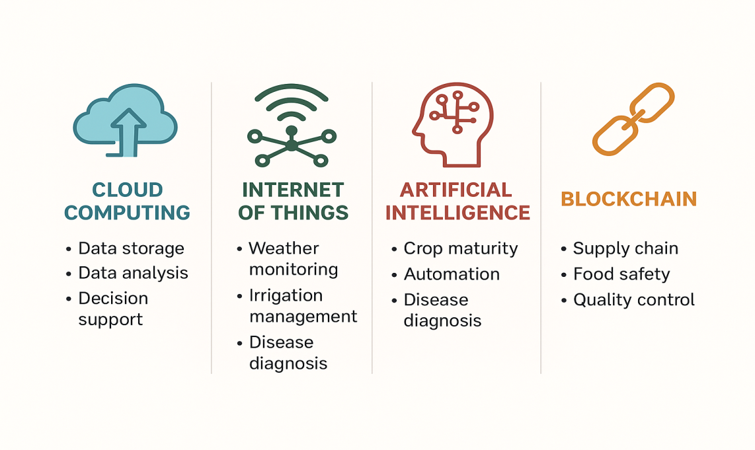
Fig. 1: Digital and Automated Tools in Horticultural Management
3. Artificial Intelligence in Horticulture:
The field of digitalization and automation teaches robots to mimic human physical movements as well as respond similarly to humans is called artificial intelligence (AI), sometimes referred to as ML (Kumar et al., 2023). John McCarthy coined the term "Artificial Intelligence" in 1950. Technologies that use artificial intelligence (AI) help produce high yielding crops, organize information for growers, lessen burden, as well as enhance food production (Rathore et al., 2021). Temperature, precipitation, wind direction, wind speed, sun radiation, insect control, and soil and growing conditions are among the other weather-related details they offer (Manaware et al., 2020). Automation brought about by digital technology, especially paired with IoT and associated technologies; the potential for farming mechanization has increased contemporary digital era. The main factor driving the use of technical innovation in horticulture production is cost reduction (Pekkeriet et al., 2015). In the greenhouse of Netherlands production of flowers and vegetables, personnel costs make up around 30% of total expenses, followed by energy system costs at 30% and variable costs at the remaining 30% (Cembrowska-Lech et al., 2023). Since robots will replace humans, which account for more than 30% of overall production costs, and machine learning might increase profit, farmers hope to lower labor costs by leveraging technological improvements. The use of artificial intelligence in horticulture makes several important tasks easier (Nturambirwe et al., 2020). Production, postharvest, final quality evaluation, storage techniques, and packing are the several steps that make up these operations (Wang et al., 2024). Machine learning methods such as near-infrared spectroscopy, intelligent packaging, and hyperspectral photography are necessary for artificial intelligence in horticulture (Sousa-Gallagher et al., 2016).
3.1. Current Applications and Successes of AI in Horticulture
3.1.1 Digital Insect Traps: In modern horticultural production, instruments like yellow sticky cards and other insect traps are used by experts, both on-site and remotely, to visually monitor pest populations. Farmers rely on expert judgment to make informed pest management decisions, including the timing and frequency of pesticide applications (Preti et al., 2021).Digitizing pest monitoring aims to replace traditional visual and manual inspections with automated trap systems, such as yellow sticky traps, with a focus on managing pest insects in open fields and greenhouse environments (Sittinger et al., 2024). An optical detection system employing digitalized traps and an auditory detection system using microphone arrays are the two insect detection techniques now under development (Branding et al., 2021). Platforms that can move freely and flexibly over the crop rows can be utilized in conjunction with both insect detection techniques. However, without an autonomous platform, it is also possible to detect insect pests at fixed sites in greenhouses or fields (Chiavassa et al., 2024). Farmers can receive support for pest management decisions through a digital support system, (fig 2) complementing the digitization of insect pest monitoring introduced in the initial two phases (Bieganowski et al., 2020 and Böckmann et al., 2021). A tablet or smartphone application acts as the user interface for accessing the digital pest management decision support system (DSS). The application gathers comprehensive data from digital insect traps, crop-specific farm information, and general pest management guidelines (Passias et al., 2024). Consequently, data about the crop that was grown, pest organisms (including pest kinds and damaging thresholds), and control agents (application rates and usage guidelines) are all included in the DSS (Sinn et al., 2021). Information and consulting services related to agriculture are also frequently utilized to support these choices. A recently created pheromone dispensing method called SPLAT (Specialized Pheromone and Lure Application technology) regulates the discharge of semio compounds or fragrances with or without pesticides (Rizvi et al., 2021). It is a special matrix composition made up of inert biological materials. This product is a valuable addition to the IPM toolbox that can be used to battle a range of economically beneficial insects (Pawar et al., 2022).
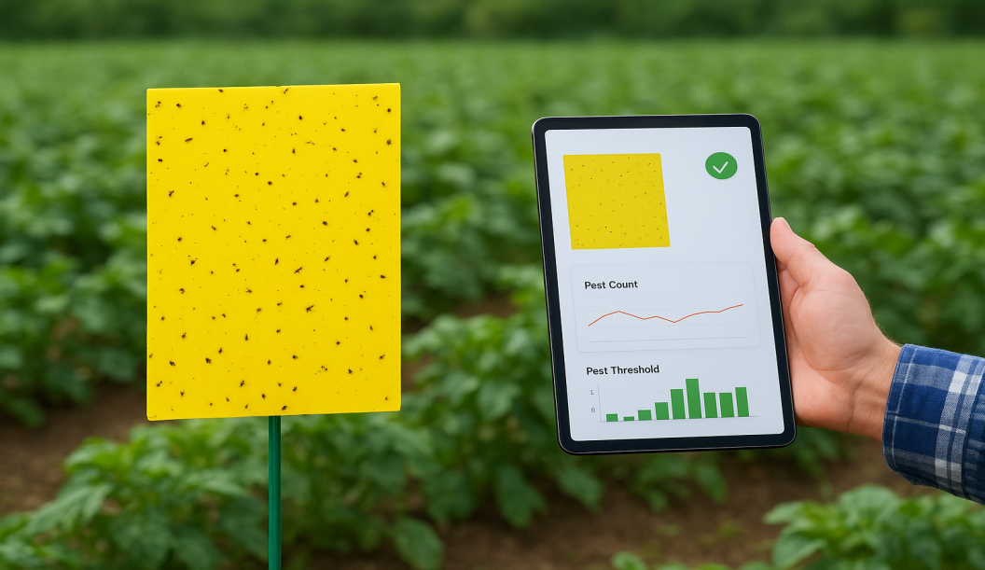
Fig 2: Digital Insect Traps (Source: Preti et al., 2021; Sittinger et al., 2024)
3.1.2 Robots for Harvesting Fruit: Without damaging any of the branches or leaves, these robots must collect fruit from the tree. The robots must have access to every part of the tree that has to be harvested, and they must be able to differentiate between leaves and fruits by using video image capture (Zhou et al., 2022). A camera is mounted on the robot arm, and colors recognized are compared to the attributes stored in the memory. If match is found, the fruit is harvested (Onishi et al., 2019). If the fruit is obscured by leaves, you can use an air jet to push the leaves away and make fruit more visible. Pressure applied on the fruit is sufficient to pull it from the tree, but not enough to smash it, as shown in (fig 3). Fruit being removed determines the shape of the gripper (Vipin et al., 2023).
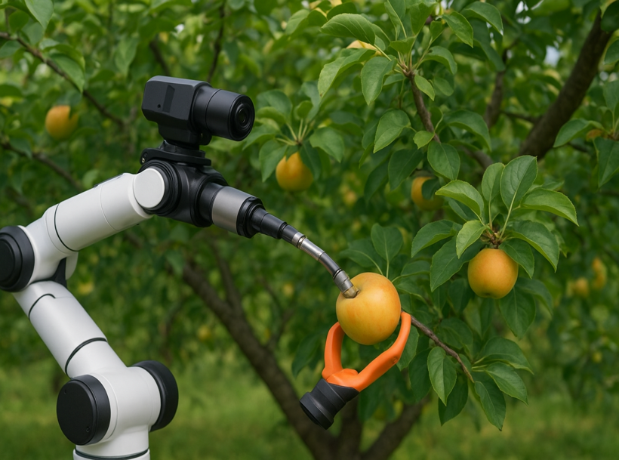
Fig 3: Robotic Fruit Harvesting (Source: Zhou et al., 2022; Zujevs et al., 2015)
3.1.3 AI in crop production: In today's horticultural industry, environmental factors like frosts and rising temperatures might result in crop loss. However, farmers can now go for protective steps to preserve their crop, including early harvesting or other measures, thanks to artificial intelligence, which made it feasible in forecast changes in climatic conditions (Singh et al., 2020). AI can also be used in greenhouses, where it is possible to track and manage changes in the environmental conditions inside the building (Chougule et al., 2022) (fig 5). A neural network method for predicting when frost may arrive was developed as a result of research conducted in 1997 by Robinson and Mort (fig 4). Without this system, crop damage could happen, resulting in loss of plants or in extreme cases, entire plantation (Hemming et al., 2019). A company named Sentiment had created a model which accurately tracks a number of parameters, including as water stress, temperature, salinity, and light intensity. The system may alert users to any changes and create an atmosphere that supports the growth of basil (Sahni et al., 2021).
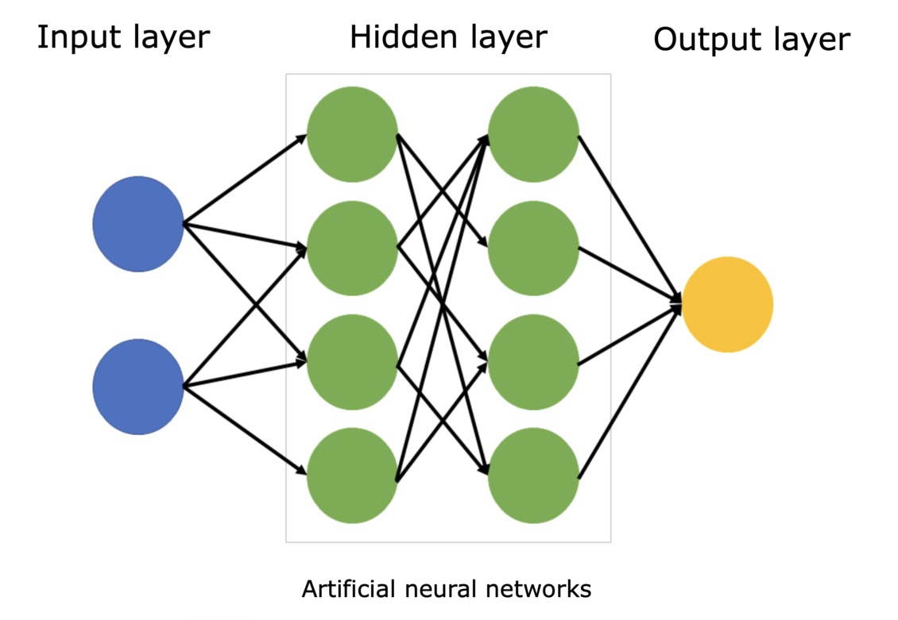
Fig 4: Artificial Neural Networks
3.1.4 AI in yield forecasting: Estimating the quantity of fruits might be useful for planning harvesting dates and production estimates (Pushpalatha et al., 2024). An efficient and automated fruit counting technique developed using image processing (Lomte et al., 2019). When image is clicked, the camera's sensor collects small amounts of information, that are subsequently transformed to a set of attributes for image (Dilmurat et al., 2022 and Ashraf et al., 2023).
3.1.5 AI in harvesting: The physical harvesting in horticulture crops accounts for 60% of production expenses. AI harvesting can assist in resolving the labor issues of high costs and shortage (Ashraf et al., 2023). Fruit picking robot was developed that uses video image capture to distinguish between fruits and foliage (Kitamura et al., 2005). The robot arm's supporting camera is able to recognize colors and compare them to memory-stored properties. The fruit is chosen if a match is found. The pressure used to the fruit is sufficient to pull it from plant without crushing it (Dilmurat et al., 2022).
3.1.6 AI in lowering damage after harvest: Postharvest loss occurs in horticultural products due to physical, physiological, and biochemical factors.The 700–1200 nm wavelength range being suitable for hyperspectral imaging in predicting moisture level of banana fruit tissue, as suggested by Siregar, 2017. A decrease in moisture content is the primary cause of postharvest losses in horticulture produce (Kader et al., 2002). Neural networks and genetic algorithms to effectively control the relative humidity in the fruit preservation environment was suggested by Morimoto et al., 1997. Neural networks were used in this study to identify changes in relative humidity caused by ventilation, and genetic algorithms were employed to model and identify the optimal parameters for regulating relative humidity (Singh et al., 2022).
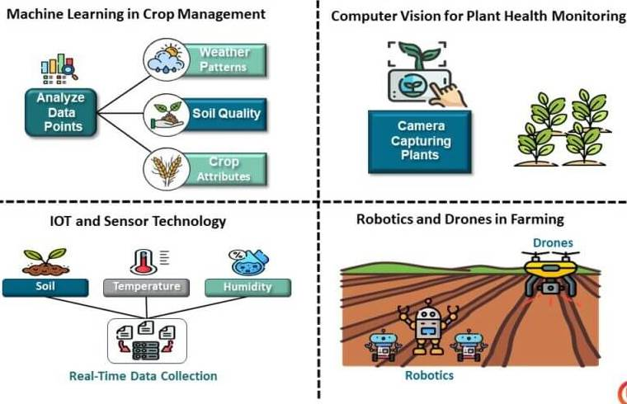

Fig 5: AI technologies in Horticulture (Source: Singh et al., 2022; Pearson, 2025)
4. Internet of Things (IoT) Applications in Horticulture
Pests and diseases pose significant threats to horticultural crops, with the potential to cause complete losses. To address this, IoT systems have been developed to predict pest outbreaks and minimize the need for frequent fungicide and pesticide applications (fig 6) (Kumar et al., 2022). Soft computing techniques are applied to integrate color, shape, and texture—the three fundamental attributes of an object—for fruit identification. This approach reduces the complexity of the feature vector, leading to enhanced classification accuracy with less training data (Rajasekar et al., 2019). In vegetable greenhouses, researchers have developed an IoT-based technological platform for real-time environmental data collection, disaster alerts, data transmission, remote control, and information dissemination (Khan et al., 2020). This system aims to mitigate the effects of climatic disasters on vegetable production. The IoT board collects data to train machine learning algorithms, enabling intelligent and automated control of indoor microclimates for horticultural crops (Bhujel et al., 2020). In the early stages of IoT development, devices were simpler, resulting in the collection of relatively limited data. It was solely used to transmit simple, minimally processed alert signals. There was no room for the AI algorithms. Large volumes of data, or Big Data, were produced as IoT devices grew more sophisticated and complicated, necessitating data analysis. Algorithms using artificial intelligence (AI) may analyze data and derive important insights, leading to better decision-making (Singh et al., 2022). Innovative approaches like machine learning, natural language processing, machine vision, and artificial neural networks (ANN) have streamlined automation and problem-solving processes (Jha et al., 2019 and Maraveas et al., 2021).
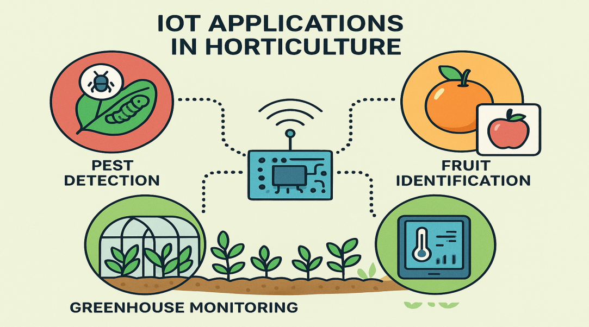
Fig 6: IoT in Horticulture (Source: Postolache et al., 2022; Rabka et al., 2021)
4.1.1 Automation in Innovative Farm Machinery: Researchers have developed autonomous tractors, fruit harvesters, and other equipment capable of operating with near-human efficiency using deep learning-based computer vision techniques (Danda et al., 2022). The prototype of the autonomous fruit harvester primarily consisted of an image-capturing module and an image-processing module mounted on a self-propelled carriage. A computer vision-based object detection algorithm processed the input to identify the fruits and vegetables ready for harvest (Gorjian et al., 2021).
4.1.2 Fertilizer application: More intelligent fertilizer applications can be facilitated by IoT technology. An NPK sensor can be made using a light-emitting diode (LED), a light-dependent resistor, and resistors to detect the levels of potassium (K), phosphorous (P), and nitrogen (N) (Postolache et al., 2022). The operation of the sensor is explained by the colorimetric and photoconductivity principles. A low-cost SPAD was developed at CIAE, Bhopal, for the indirect measurement of crop leaves' chlorophyll content in the field (fig 7) (Mahajan et al., 2022). On an Android smartphone that supports OTG, SPAD values can be recorded and displayed using this compact, portable gadget. It helps determine how much nitrogen the crop needs (Mehta et al., 2021). SMS services can utilize this alternative since cloud services like Google Cloud Platforms offer scalable, timely, and continuous communication. Usually, farmers' cell phones receive text messages with recommended fertilizer dosages (Lavanya et al., 2019).
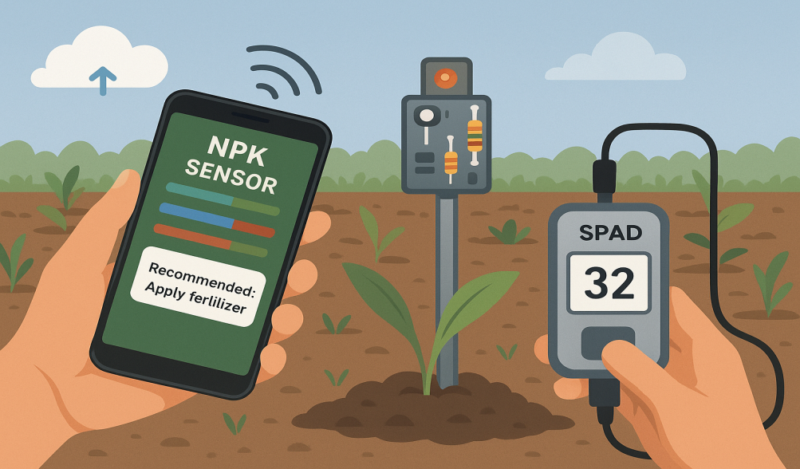
Fig 7: Soil Plant Analysis Development (SPAD) (Source: Radočaj et al., 2023)
4.1.3 Weed and Pests Control: An intelligent monitoring system leveraging the Internet of Things (IoT) has been proposed, utilizing soil sensors, weather sensors, and cameras (Sharma et al., 2024). This system employs the Zigbee communication protocol and global packet radio service (GPRS) to provide pest warnings, support planting operations, and ensure quality checks in horticulture crop production (Salgado-Salazar et al., 2018).
4.1.4 Drones: Drones have greatly enhanced the automation of various agricultural tasks, including pesticide application and land monitoring. These devices consist of a central processing unit, multiple sensors (such as lasers, radars, cameras, gyroscopes, accelerometers, compasses, and GPS receivers for environmental data collection), actuators, and motors (Kumar et al., 2023). Communication with the drone is facilitated through remote control and radio frequency transmission (El Hoummaidi et al., 2021 and Mogili and Deepak, 2018). In agriculture, drones are utilized for crop monitoring, irrigation management, plant surveillance, pesticide application, and assessing plant health (fig 8) (Tripicchio et al., 2015 and Gharibi et al., 2016). Equipped with AI and vision-based technologies, drones also aid in identifying weeds and tracking plant growth stages throughout the pre-harvest, harvest, and post-harvest phases (Canicattì et al., 2024). Additionally, drones can be employed for crop grading and quality assessment, helping to reduce product loss and damage during storage and transportation (Tu et al., 2020).
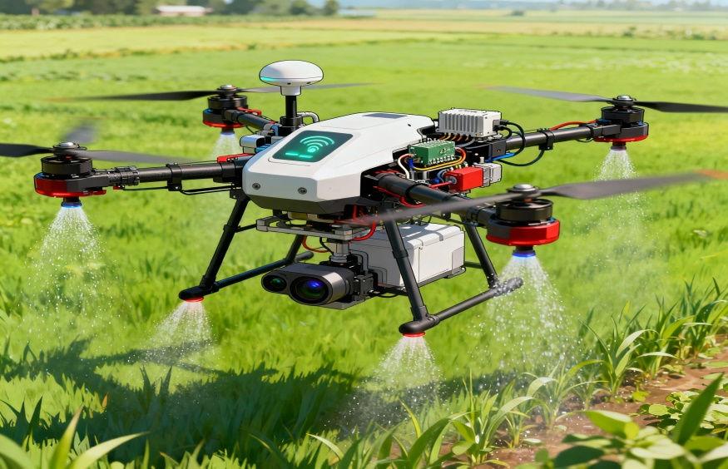
Fig 8: Drone technology (Source: Singh et al., 2022; Boruah et al., 2024)
5. Blockchain:
Horticulture benefits from artificial intelligence (AI), which helps farmers boost agricultural output and reduce adverse environmental impacts (Kumar et al., 2020). By enabling information tracking throughout the food supply chain, blockchain horticulture may improve food safety (fig 9). The traceability generated by blockchain's ability to store and manage data facilitates the development and application of innovations for intelligent farming and index-based horticulture insurance (Zheng et al., 2018). There are advantages to using blockchain in gardening for improved quality control and food safety. Improved supply chain production tracking will lead to more equitable farmer remuneration (Sun et al., 2010). One potential method for supply-chain traceability in the pineapple industry is blockchain technology. When compared to expecting the genuine majority of processing power, the fruit-chain protocol is fair with an overwhelming possibility and has the identical consistency and liveliness (Zhang et al., 2022). The food and horticulture industries can benefit from blockchain technology's capacity to manage known risks and maintain systemic affordability. Connecting various horticultural businesses and visualizing data on distributed database networks, from production to supply, are made possible by blockchain technology (Belotti et al., 2019). Big data gives farmers comprehensive knowledge on rainfall patterns, fertilizer needs, water cycles, and other issues. As a result, they are better equipped to decide which plants to proliferate for optimum profit and when to harvest (Abbas et al., 2018 and Gadekallu et al., 2022).
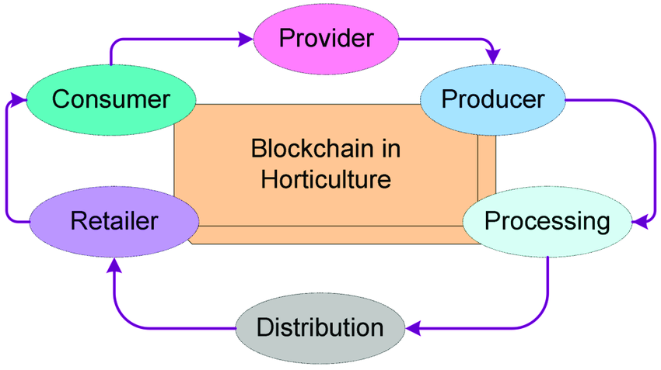
Fig 9. Blockchain in Horticulture
6. Remote Sensing in Horticulture
Satellite remote sensing has been an essential resource for monitoring crops at local, regional, and global scales since the 1970s.In this context, "crop monitoring" primarily focuses on staple crops, distinct from the broader concept of agricultural monitoring, which encompasses livestock, horticulture, and aquaculture (Macdonald and Hall, 1980). Crop monitoring activities typically involve agro-climatic analysis, assessing crop conditions and stress levels, and forecasting crop yields (fig 10). Assessments of food security are also included in certain systems, which offers a heads-up on possible food insecurity. Crop growth status and final yield are the main focus of crop monitoring as viewed through the lens of remote sensing. Recent studies in crop monitoring (Weiss et al., 2020 ; Meshram et al., 2021 and Kamilaris et al., 2018) have focused extensively on areas such as crop mapping (Bégué et al., 2018 and Orynbaikyzy et al., 2019), assessing crop conditions (Virnodkar et al., 2020 and Zhang et al., 2019), estimating yields, forecasting production (Berger et al., 2020 ; Elavarasan et al., 2018 and Van et al., 2020), monitoring droughts (Khanal et al., 2019 and Jiao et al., 2021) , and advancing precision agriculture practices (Berger et al., 2020 and Maes et al., 2019). A remote sensing system is made up of four basic components that are used to measure and record data about a faraway region (Singh et al., 2014). These elements include the target, satellite sensor, transmission line, and power source. Indian scholars have made significant contributions to advancements in internal software development and digital image processing (Gautam et al., 2020). The creation of agricultural watersheds, land resource mapping, fishing spot forecasting, precision agriculture, crop systems analysis, agricultural water management, drought monitoring and evaluation, and many more are examples of these uses (Mashala et al., 2023; Panigrahy et al., 2006 ; Navalgund et al., 2007 and Navalgund et al., 2000).
6.1Application of Remote Sensing in Fruit Crops
6.1.1Orchard Mapping and Estimating Arable Land: A study to create a detailed block-by-block database of apple plantations in the Shimla region of Himachal Pradesh (Sharma et al., 2010). High-resolution remote sensing data from the advanced Indian Remote Sensing (IRS) satellite, P6, was utilized for mapping apple orchards (Chen et al., 2024). This approach achieved an accuracy exceeding 90%. Agro-metrology land-based observation and remote sensing were used in another study to evaluate the area of apple orchards in the Pulwama district of the Kashmir valley (Mushtaq and Asima. 2014).
6.1.2 Precision application of fertilizer: Digital information from Landsat and AWIFS was used to estimate and track the extent of apple orchards. The majority of apple orchards (89.82%) were found to be concentrated in the 1500–2000 m elevation range; orchards below 1500 m accounted for 0% of the area, while those above 2000 m made up 10% (Xing et al., 2024).
6.1.3 Abiotic Stress Detection: Remote sensing techniques are effective for detecting abiotic stresses, such as moisture deficiency. In avocado orchards, the Photochemical Reflectance Index (PRI) and crown temperature were monitored using methods like thermal imaging and high-resolution multispectral aerial photography (Abdulridha et al., 2019). Various irrigation strategies, including regulated deficit irrigation and chronic deficit irrigation, were applied to induce stress. The findings revealed distinct differences in reflectance patterns between stressed plants and those receiving adequate irrigation (Suarez et al., 2010).
6.1.4 Detection of Pest Infestation: Remote sensing technologies help lower the cost of insect monitoring in crops. To assess the potential of detecting spider mite damage in orchards, Ludeling analyzed the visible and near-infrared reflectance of 1,153 leaves and 392 canopies across 11 peach orchards in California (Abd El-Ghany et al., 2020). Physiological stress in trees, caused by pests, leads to changes in chlorophyll, carotenoids, and other photosynthetic pigments, which can be easily identified through variations in spectral reflectance (Zhang et al., 2019).
6.1.5 Disease incidence detection: Although satellite imagery has seen advancements in spatial, spectral, and temporal resolution, multispectral imaging remains valuable for visual assessments due to its ability to provide real-time or near-real-time images. This technology enables the differentiation between healthy and diseased trees (Oerke et al., 2020). Sindhuja et al., 2013, reported that the average reflectance varied. Compared to the near-infrared regions, the values of healthy trees in the visible region were lower, while those of HLB-infected trees were greater. This could make it easier to implement quick control measures, which would lower the risk of disease transmission (Zhang et al., 2019). Remote sensing is an effective technique for managing nematodes and pests by enabling early disease detection through the identification of vulnerable plant areas, changes in plant pigments, and variations in pest-induced leaf damage (Usha et al., 2013). Johnson et al., 1996, developed an advanced digital imaging system that linked canopy density and reflectance under varying levels of phylloxera stress. Additionally, Cook and Cook utilized multiregional NIR cinematography to observe the seasonal growth of the soil fungus complex and the southern root-knot nematode (Meloidogyne incognita Chitwood) in kenaf (Hibiscus cannabinus L.) (Kale et al., 2024).
6.1.6 Estimation of crop area: The production and demand of horticultural products sometimes fluctuate significantly, which makes the market and prices extremely unpredictable. Accurate information on the area and output of horticultural commodities is essential for market planning and produce export (Wang et al., 2024). In this instance, assessing the supply scenario requires the use of remote sensing. Crops such as potatoes, which are grown across large contiguous fields, may have their acreage and production predicted with over 90% accuracy (Nageswara et al., 2004). When the trees are older than five years, estimating the area under mango orchards is simple; however, younger mango trees are challenging to estimate due to overlapping spectral signatures (Usha et al., 2013). Early in the season, mulberry produces spectral fingerprints similar to those of other vegetable crops, but they subsequently separate on their own (Nageswara et al., 2004).
6.1.7 Estimation of crop canopy: In horticulture, estimating the crop canopy is essential since it dictates the amount of pesticide, fertilizer, and other chemicals that should be used. Furthermore, canopy volume indicates crop health and expected output (Schumann et al., 2008 and Smart et al., 1990). The majority of horticultural crops were eventually left unaccounted for, despite instances where the canopy cover of large crops was approximated using remote sensing techniques for years (Thomas et al., 2008 and Pan et al., 2023). Remotely detected NDVI is associated with the canopy cover of the primary horticultural crops in commercial fields with varying planting arrangements and maturation phases (Dorbu et al., 2024).
6.1.8 Estimation of crop yield: Although using remote sensing to forecast the production of different annual crops is a very useful method, its use for fruit trees and vegetables has been very limited up to this point (Usha et al., 2013 and Maja et al., 2010). Predicting tomato processing yield with remotely sensed aerial photos and a crop growth model has not received much attention (Koller et al., 2005). The association between the modified normalized difference in vegetation index and the leaf area index for tomato processing has also been studied (Abdul-Jabbar et al., 2023). Yang and associates employed aerial photography and reflectance spectra in 2008 to assess the production and physical characteristics of cabbage. Citrus farms were also mapped by an automated ultrasonic system and a sensor-based autonomous yield monitoring system (Whitney et al., 2002 and Zaman et al., 2006).
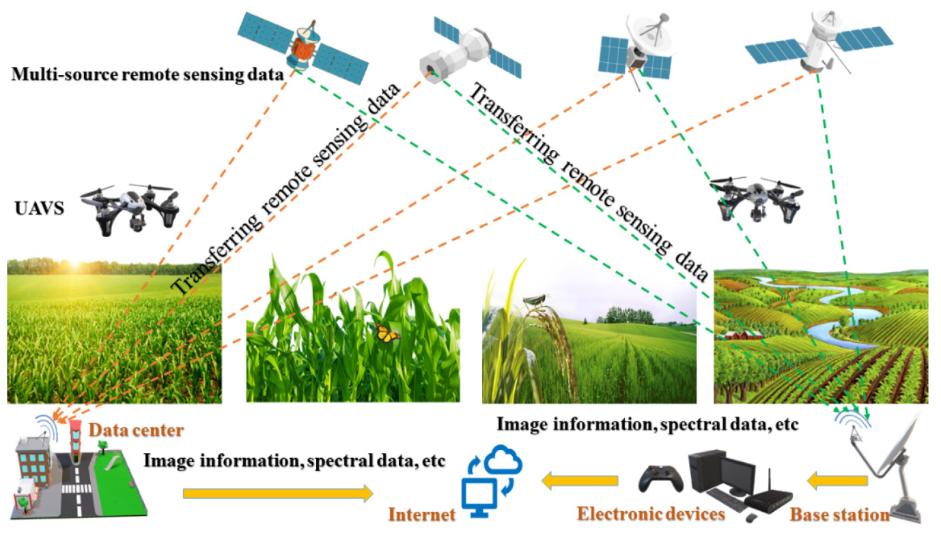 Fig 10. Remote sensing in Horticulture (Source: Dulam et al., 2025)
7. Nuclear technology in Horticulture: While many are familiar with how nuclear technology contributes to electricity generation, few are aware of its broader impact on non-energy applications. Despite being mostly associated with nuclear energy and weaponry, nuclear technology has a number of applications in horticulture (Bagher et al., 2014). These technologies have improved crop yields, reduced pests and illnesses, and improved water quality, all of which have contributed significantly to the development of horticultural practices (Chaurasia et al., 2023). Physical mutagens have been used in these applications, including particle radiation such as alpha and beta particles, thermal and fast neutrons, and electromagnetic radiation such as X-rays, UV light, and gamma rays (emitted by radioactive cobalt-60) (Wamiq et al., 2022). For example, ionizing radiation-induced chromosomal fractures facilitate nucleotide substitution or deletion and DNA strand cross-linking (Oladosu et al., 2016). Additionally, a study by Srivastava et al., 2007 looked at the effects of gamma radiation emitted by 60CO on Gladiolus plants. The subjected plants exhibited significant changes in comparison to the control group. Gamma radiation affected plant height, leaf size, and overall structure. Additionally, flowering patterns were changed, resulting in differences from the typical pattern of the flowers' symmetry as well as changes in the size, color, and form of the flowers. In addition to these, a number of other radioisotopes, such as Zn65, S35, and Rb86, have been used in various studies on plant growth and nutrient absorption (Nirmal et al., 2019 and Kale et al., 2024).
7.1 Breeding Technique: Improved yielding kinds were developed as a result of radiation generation. "Miracle" rice is a well-known example of a crop that has achieved success, significantly increasing the cost of rice production (Dhulgande et al., 2023). Radiation-induced mutation technologies are now a significant part of plant breeding methods (Gopinath et al., 2024) (fig 11). These are some noteworthy cultivars and varieties that were released from various research sites and have specific quality attributes shown in Table 1
Table 1: Varieties released from research stations with specific qualities
Fruit | Cultivar(s) | Year | Mutagen(s) | Improved Traits
Apple | Golden Haidegg, McIntosh | 1966, 1970 | Gamma rays | Fruit size
Mango | Rosica | 1966 | Spontaneous | Large and good quality
Orange | Xuegen 9-12-1, Eureka 22 | 1983, 1987 | Gamma rays, X-rays | Seedless, fruit quality
Peach | Magnif | 1968 | Gamma rays | Large, red skin
Loquat | Shiro-mogi | 1981 | Gamma rays | Fruit size
Banana | Novaria | 1993 | Gamma rays | Earliness
Papaya | Pusa Nanha | 1986 | Gamma rays | Dwarfness
Plum | Spurdente-Ferco | 1988 | Gamma rays | Earliness
Pomegranate | Karabakh | 1979 | Gamma rays | Fruit quality
Sweet Cherry | Lapins | 1983 | X-rays | Larger size
Source: (Kale et al., 2024)
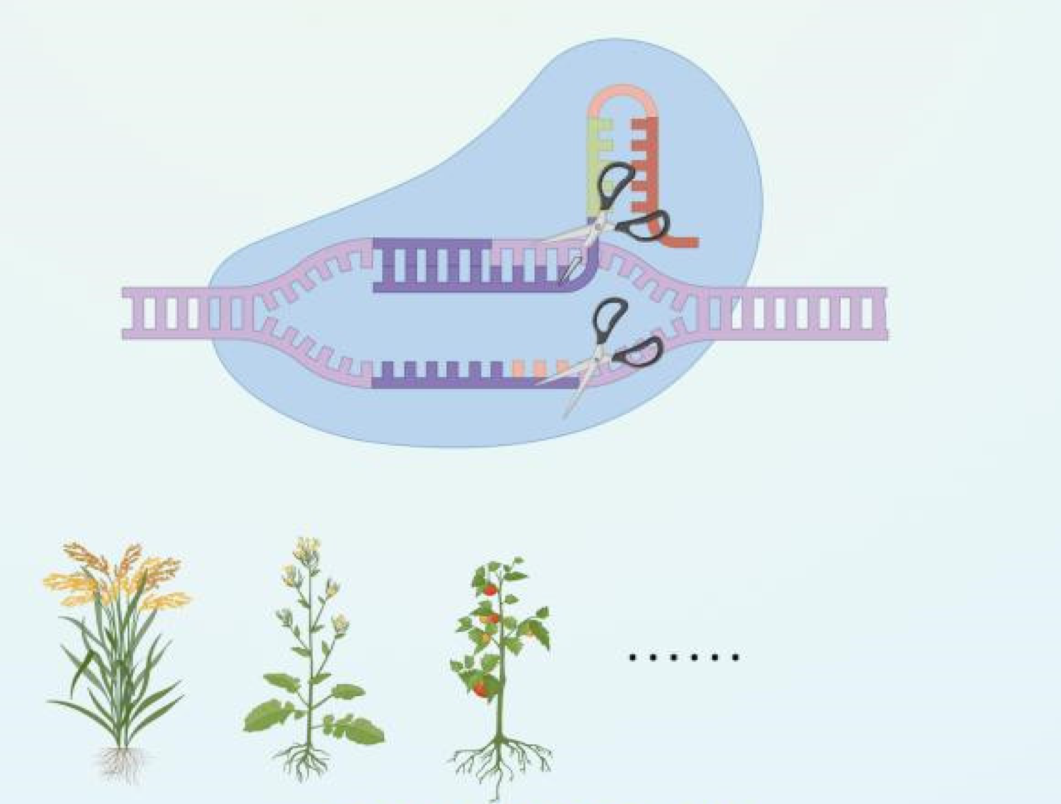
Fig 11: Breeding technique in Horticulture
8. Vertical farming techniques:
Vertical farming is crop production and development in areas which are constructed vertically or on a steep slope. The world's largest problem right now is how to feed its rapidly growing and impending population (Kalantari et al., 2018). There are many different types and sizes of vertical farms, ranging from small, mounted on a wall, or systems with two stories, to enormous, warehouses with multi-stories (fig 12). However, every vertical farm provide their plants with nutrients using one of the three soilless techniques—aeroponics, aquaponics, or hydroponics (Mir et al., 2022). The following details provide an explanation of these three growing systems:

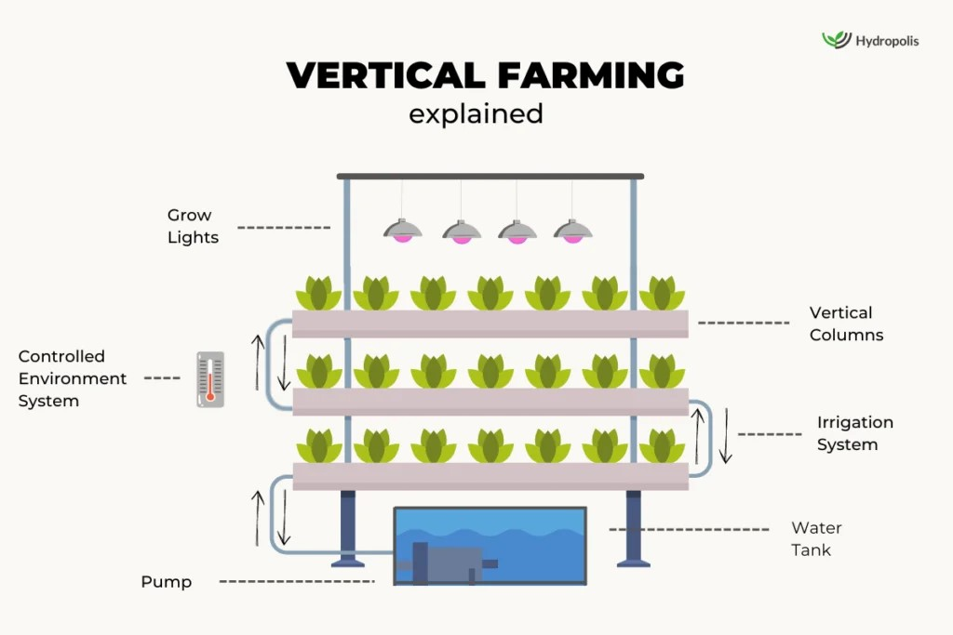
Fig 12: Vertical Farming (Hydroponics) (Source: Mir et al., 2022; Dhawi, 2023)

8.1 Hydroponics: One environmentally friendly method that might be a better alternative to traditional farming is "hydroponics." Therefore, "working water" is what the term "hydroponics" actually means (Sharma et al., 2018). This technique helps eliminate the need for soil by supplying a nutrient-rich fluid that contains the necessary nutrients which directly reaches plant roots and encourages growth (Sardare and Admane, 2023 and Sonkar et al., 2024). Plants can be grown with their roots submerged in a nutrient-rich mineral solution or in an inert medium like perlite, gravel, or mineral wool (Velazquez-Gonzalez et al., 2022; Jan et al., 2020 and Niu et al., 2022). Okemwa et al., 2015; Nguyen et al., 2016 and Lopes et al., 2008).
8.1.1 Drip system: The drip method involves growing the plants in the soilless medium by maintaining nutrition fluid in a container. A pump supplies the appropriate amount of water or nutrient solution directly to the roots of each plant through nozzles (Ani et al., 2020) Rouphael et al., 2005). Extra solutions can be collected and either released or circulated again thanks to the nutrients' slow release. The Drip technique can be used to produce different types of plants at the same time (Abedin et al., 2021).
8.1.2 Ebb and Flow: The Ebb and Flow system (fig 13), the first commercial hydroponic method, uses the flood-and-drain technique. It features a grow tray and a reservoir containing nutrient-rich fluid (Setiawan et al., 2022). A pump periodically fills the grow tray with the solution, which is then gradually drained. This method supports the cultivation of various crops but often faces challenges like algae, mildew, and root rot, requiring adjustments such as incorporating a filtration system (Halveland et al., 2020).
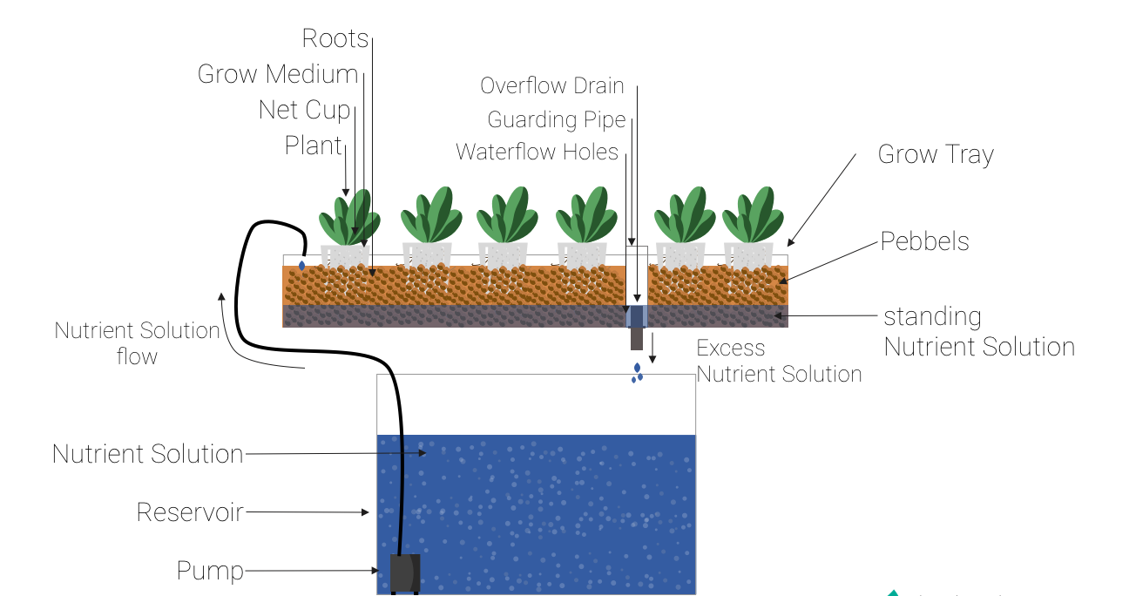
Fig 13: Ebb and Flow System (Source: Setiawan et al., 2022)
8.1.3 Deepwater culture: Deepwater Culture (DWC) is a hydroponic technique where plant roots are immersed in nutrient-rich water, with oxygen delivered directly to the roots via an air stone (fig 14). One best examples of this kind of system is the hydroponic buckets system, in net pots, with their roots submerged in a nutrient-rich solution (Hamza et al., 2022). To prevent algae and mold from forming in water body, it is essential to monitor the salinity, pH, oxygen, and nutrient concentrations (Nursyahid et al., 2021). DWC has a considerable effect on larger fruit-producing plants, particularly tomatoes and cucumbers.
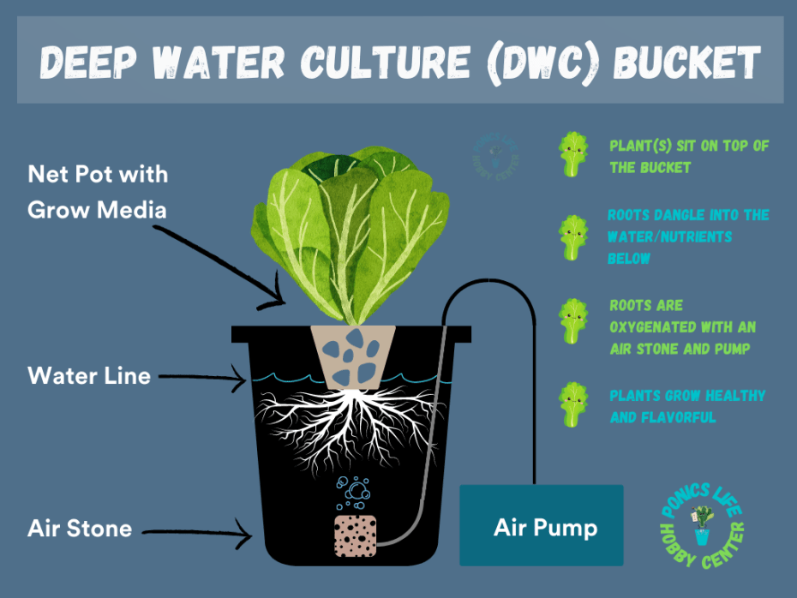
Fig 14: Deep water culture (Source: Nursyahid et al., 2021)
8.1.4 Wick system: The Wick System is the simplest form of hydroponics, functioning without electricity, pumps, or aerators. Using a porous medium such as cocopeat, vermiculite, or perlite, a nylon wick links the plant roots to a reservoir of nutrient-rich solution (Harahap et al., 2020). Nutrients and water are drawn up to the plants through capillary action. This technique is ideal for growing small plants, herbs, and spices (Prianka et al., 2024).
8.1.5 Nutrient film technique: It is a popular method in hydroponics. Plants grow in channels in which nutrient solution is poured continuously (fig 15). The roots of plant are nourished by a thin coating of nutrient film (Khan et al., 2020). Because it is a continuous activity, neither a growing media nor a timer is required. The roots instantly absorb the nutrients from the coating (Alipio et al., 2019). Unlike deep water cultivation, the plants' roots are kept moist rather than submerged entirely in water (Aires et al., 2018). The pump system and power supply need to be maintained to prevent system failure or halt (Solanki et al., 2017).
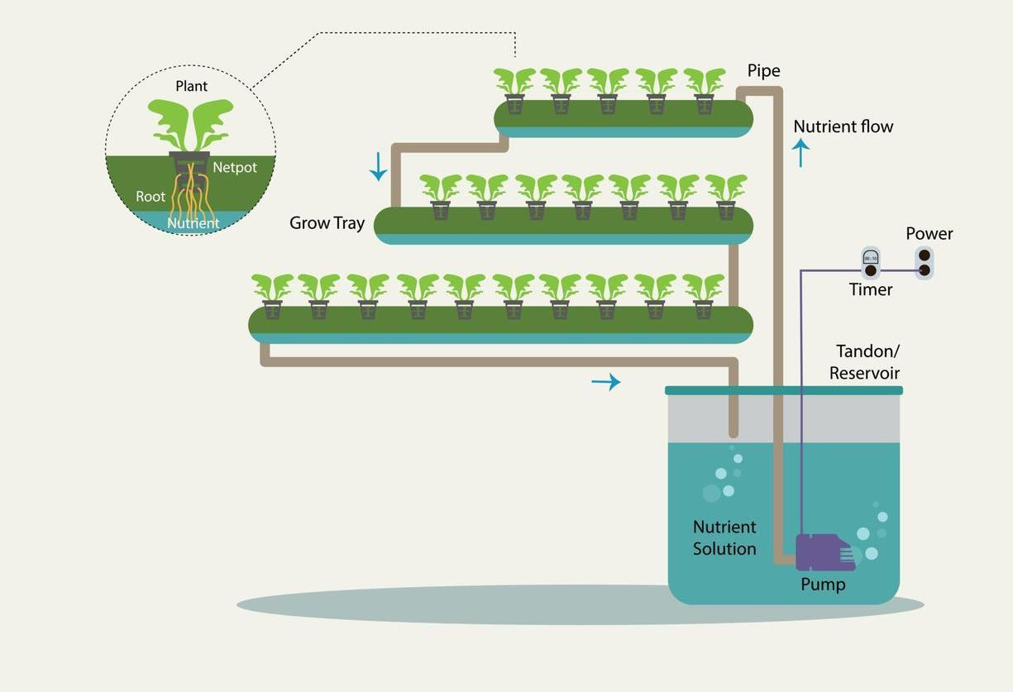
Fig. 15: Nutrient film technique (Source: de Castro Silva et al., 2021)
8.2 Aeroponics: Aeroponics is a technique where a nutrient-rich fertilizer solution is sprayed directly onto the plant roots, which are exposed to air, which is an improved version of hydroponics (Elijah et al., 2022). In aeroponics, plant roots are constantly exposed to oxygen-rich air. This enables the root surface to absorb nutrients more quickly (fig 16). This type of hydroponic system is the most advanced (Garzón et al., 2023). Numerous nozzle designs, such as high-pressure atomization nozzles, pressured airless nozzles and ultrasonic atomization foggers, are used to mist nutrient solutions over plant roots. A computerized system regulates and maintains the static pressure, which ranges from 60 to 90 Psi (da Silva et al., 2024). The type of crops planted, the season, phase of crop development, and length of cultivation all affect this frequency. In an aeroponic system, a timer controls the nutrient pump, activating it for a few seconds at regular intervals, just as other hydroponic system types (Arjina et al., 2021). Although expensive, aeroponics has shown the most promising crop production returns and is a potential approach for space exploration (Lakhiar et al., 2018).
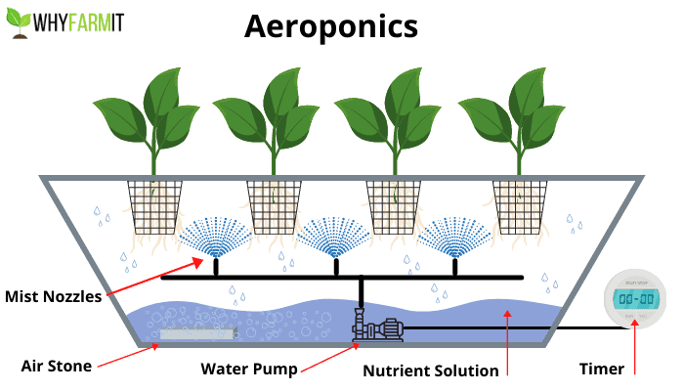 Fig. 16: Aeroponics (Source: Kumar et al., 2023)
8.3 Aquaponics: Aquaponic systems differ from hydroponic ones by integrating fish and plants in a shared environment. Fish raised in inland ponds produce nutrient-rich waste, which is supplied to plants in vertical farms (fig 17). The wastewater is then filtered, purified, and recycled back into the fish ponds (Liu et al., 2024). While some small-scale vertical farming setups utilize aquaponics, most focus on growing specific fast-growing vegetable crops to enhance efficiency and streamline production and costs. However, with recent advancements in standardizing aquaponic systems, this closed-loop technology may see increased adoption (Flores-Aguilar et al., 2024).
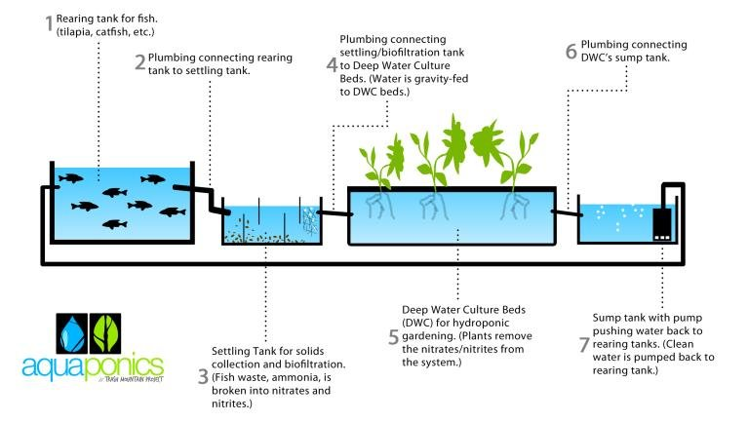 Fig. 17: Aquaponics (Source: Lennard and Goddek, 2019)
8.4 Automation in Hydroponics: The goal of smartphone technology was to create a fully automated hydroponic system that offers low operational costs and an easy learning curve (Palande et al., 2018). While incorporating an Internet of Things(IoT) (fig 18) network for remote management and monitoring, it preserved the conditions necessary for test plant to thrive (Lakshmanan et al., 2020). Titan Smartponics provides a number of benefits, including total control over the conditions that support plant growth, adaptability to different plant needs, and independence from external factors or the outside air (Kaur et al., 2022).
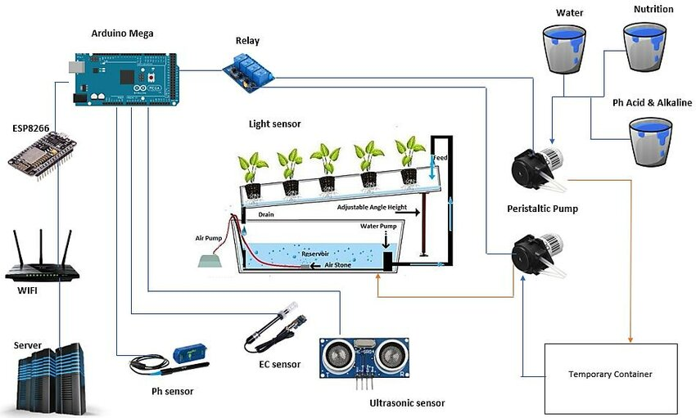
Fig 18: Smart Hydroponics (Source: Lakshmanan et al., 2020)
9. Challenges and opportunities: Although technologies have potential in revolutionizing the farming sector, farmers' lack the technical proficiency in using technology-driven equipment is one of the main barriers to this advancement (Bissadu et al., 2024). We can effectively handle the issue if we include the farmers when developing the systems. Designers of digital products should prioritize the user interface, and offering solutions in local languages is one approach to addressing this challenge. The price and caliber of the tools and sensors are major obstacles to small-scale farmers' adoption of contemporary technologies (Shafik et al., 2024). Interoperability is essential due to the diversity of IoT devices. Therefore, for better performance, efficient device synchronization is necessary. The large number of manufacturers and equipment involved makes this a difficult task. of the end, horizontal scaling will be required due to the daily increase of data from IoT devices. Notwithstanding all of the difficulties, they might eventually contribute to the automation and advancement of horticulture. Agricultural methods could be revolutionized by these technologies. The advancement of 5G technology will be crucial in the next years to maximizing the Internet of Things' potential (Karunathilake et al., 2023).
10. Summary and conclusion: Precision cultivation, which uses fewer resources and produces higher-quality crops, is made easier by farming automation powered by artificial intelligence. Through labor cost control, efficient use of fertilizers and pesticides, and crop loss reduction through timely and ripe harvesting, AI may contribute to reducing agricultural expenses (Kale et al., 2024). Additionally, technological developments can inspire tech-savvy people to pursue horticulture as a career rather than deterring younger generations from moving to urban regions. Although they had notable disadvantages, the technology information center observed exceptional levels of technological adoption (Wang et al., 2024). For example, it was an issue in assessing the growers yield & productivity with respect to extension activities, and each village received only one recommendation, regardless of the soil's condition. Furthermore, other sectors of agriculture like silviculture, fisheries, veterinary sciences, and natural resources management were neglected. Furthermore, the growers depend on the knowledge of extension officers at rural stage, which may not always be current. Uses of GIS and remote sensing is rapidly becoming apparent (Misra et al., 2020). Crop biomass identification, soil metrics such as nutrition and moisture level, mature green fruits, food production estimation, destruction from biotic and abiotic stresses, etc. are few examples. Horticultural supply chains offer great opportunity in improving transactional efficiency, reduce hindrance, & promote transparency globally, all made possible by blockchain technology (Zhang et al., 2018). The food and horticulture industries can benefit from blockchain technology's capacity to manage known risks and maintain systemic affordability. Connecting various horticultural businesses and seeing information on distributed ledger networks, from production to supply, are made possible by blockchain technology (Dayıoğlu et al., 2021 and Subeesh et al., 2021). To achieve this goal, producers and engineers must find a middle ground where they can communicate and comprehend one another's needs. In order to enable effective and sustainable food production in urban and peri-urban regions, technologists should provide significantly better products, services, and processes that live up to farmers' expectations. In order to meet the real demands of the food supply and value chains, producers need to be aware of the best ways to employ technology and demand innovations.

References:
Abbas N, Zhang Y, Taherkordi A, Skeie T. Mobile Edge Computing: A Survey. IEEE Internet Things J. 2018;5:450–465.
Abd El-Ghany NM, Abd El-Aziz SE, Marei SS. A review: application of remote sensing as a promising strategy for insect pests and diseases management. Environmental Science and Pollution Research. 2020 Sep;27(27):33503-15.
Abdul-Jabbar TS, Ziboon AT, Albayati MM. Crop yield estimation using different remote sensing data: Literature review. InIOP Conference Series: Earth and Environmental Science 2023 (Vol. 1129, No. 1, p. 012004). IOP Publishing.
Abdulridha J, Ehsani R, Abd-Elrahman A, Ampatzidis Y. A remote sensing technique for detecting laurel wilt disease in avocado in presence of other biotic and abiotic stresses. Computers and electronics in agriculture. 2019 Jan 1;156:549-57.
Abedin T, Yamamoto A, Hayashi T, Hosokawa M. Drip fertigation enhances the growth of hydroponic lettuce (Lactuca sativa) using polyester fiber substrate. Scientia Horticulturae. 2021 Jan 27;276:109604.
Aires A. Hydroponic production systems: Impact on nutritional status and bioactive compounds of fresh vegetables. Vegetables - Importance of Quality Vegetables to Human Health; 2018. Available:https://doi.org/10.5772/INTECHO PEN.73011.
Alipio MI, Cruz AE, Doria JD, Fruto RM. On the design of Nutrient Film Technique hydroponics farm for smart agriculture. Engineering in Agriculture, Environment and Food. 2019;12(3):315-24.
Alireza A, Ludena RDA. Big Data approach to a novel nutrition-based vegetable production and distribution system. In Proceedings of the IEEE International Conference on Computational Intelligence and Cybernetics (CYBERNETICSCOM), Yogyakarta, Indonesia; 2013.
Alleweldt G, Possingham JV. Progress in grapevine breeding. Theor Appl Genet. 1988;75:669–673.
Ani A, Gopalakirishnan P. Automated hydroponic drip irrigation using big data. In2020 Second International Conference on Inventive Research in Computing Applications (ICIRCA) 2020 Jul 15 (pp. 370-375). IEEE.
Arjina Shrestha BD. Hydroponics. Division of Agricultural Sciences and Natural Resources. 2013;4.
Arya PS, Gangwar MA. Proposed Architecture: Detecting Freshness of Vegetables using Internet of Things (IoT) and Deep Learning Prediction Algorithm. In Proceedings of the 3rd International Conference on Advances in Computing, Communication Control and Networking (ICAC3N), Greater Noida, India. 2021;718–723.
Ashraf H, Akanbi MT. Sustainable Agriculture in the Digital Age: Crop Management and Yield Forecasting with IoT, Cloud, and AI. Tensorgate Journal of Sustainable Technology and Infrastructure for Developing Countries. 2023 Jan 14;6(1):64-71.
Bagher AM, Nahid A, Mohsen M, Vahid M. Nuclear techniques in agriculture and genetics. American Journal of Bioscience. 2014;2(3):102-105.
Ban Y, Honda C, Hatsuyama Y, Igarashi M, Bessho H, Moriguchi T. Isolation and functional analysis of a MY Btran scription factor genethatis a key regulat or forthe development of red coloration in apple skin. Plant Cell Physiol. 2007;48:958–970.
Begić H, Galić M, Dolaček-Alduk Z. Digitalization and automation in construction project's life-cycle: a review. Journal of information technology in construction. 2022 Jan 1;27.
Bégué A, Arvor D, Bellon B. Remote sensing and cropping practices: A review. Remote Sens. 2018;10:99. DOI: 10.3390/rs10010099
Belotti M, Božić N, Pujolle G, Secci S. A vademecum on blockchain technologies: When, which, and how. IEEE Communications Surveys & Tutorials. 2019 Jul 12;21(4):3796-838.
Berger K, Verrelst J, Féret JB. Crop nitrogen monitoring: Recent progress and principal developments in the context of imaging spectroscopy missions. Remote Sens Environ. 2020;242: 111758. DOI: 10.1016/j.rse.2020.111758
Bernhardt, Heinz; Bozkurt, Mehmet Brunsch, Reiner, Colangelo, Eduardo; Herrmann, Andreas Horstmann, Jan; Kraft, Martin Marquering, Johannes Steckel, Thilo Tapken, Heiko Weltzien, Cornelia and Clemens Westerkamp. Challenges for Agriculture through Industry 4.0. Agronomy. 2021;11:1935. DOI: 10.3390/agronomy11101935
Bhujel A, Basak JK, Khan F, Arulmozhi E, Jaihuni M, Sihalath T, Lee D, Park J, Kim HT. Sensor Systems for Greenhouse Microclimate Monitoring and Control: A Review. J. Biosyst. Eng. 2020;45:341–361.
Bieganowski, Andrzej Dammer, Karl-Heinz Siedliska, Anna Bzowska-Bakalarz, Małgorzata Bereś, Paweł K DabrowskaZielińska, Katarzyna Pflanz, Michael Schirrmann, Michael and Andreas Garz. Sensor -based outdoor monitoring of insects in arable crops for their precise control Pest Management Science. 2020;77:1109-1114. DOI: 10.1002/ps.6098
Bissadu KD, Sonko S, Hossain G. Society 5.0 enabled agriculture: Drivers, enabling technologies, architectures, opportunities, and challenges. Information Processing in Agriculture. 2024 Apr 16.
Böckmann, Elias Pfaff, Alexander Schirrmann, Michael, Michael Pflanz. Rapid and low-cost insect detection for analysing species trapped on yello stick traps. Scientific Reports. 2021;11:10419. DOI: 10.1038/s41598-021-89930-w
Boring RL, Ulrich TA, Lew R. Levels of digitization, digitalization, and automation for advanced reactors. InProceedings of the Human Factors and Ergonomics Society Annual Meeting 2023 Sep (Vol. 67, No. 1, pp. 207-213). Sage CA: Los Angeles, CA: SAGE Publications.
Boruah T, Kalita M, Hasnu S, Das KS, Singh R, Nayik GA. Role of Digital. Novel Approach to Sustainable Temperate Horticulture. 2024 Aug 27:116.
Boruah T, Kalita M, Hasnu S, Das KS, Singh R, Nayik GA. Role of Digital. Novel Approach to Sustainable Temperate Horticulture. 2024 Aug 27:116.
Branding Jelto, Von Hörsten, Dieter, Jens Karl Wegener. Acoustic insect detection for horticulture. 13th Young Scientists Meeting 2021, 11th-13th October - Abstracts, Braunschweig, Julius Kühn Institute; 2021.
Caiming Z, Lu Y. Study on artificial intelligence: The state of the art and future prospects. J. Ind. Inf. Integr. 2021;23:100224.
Canicattì M, Vallone M. Drones in vegetable crops: a systematic literature review. Smart Agricultural Technology. 2024 Jan 7:100396.
Cappelli I, Fort A, Pozzebon A, Tani M, Trivellin N, Vignoli V, Bruzzi M. Autonomous IoT Monitoring Matching Spectral Artificial Light Manipulation for Horticulture. Sensors. 2022;22:4046.
Cazzola F, Bermejo CJ, Guindon MF, Cointry E. Speed breeding in pea (Pisum sativum L.), an efficient and simple system to accelerate breeding programs. Euphytica. 2020;216(11):178.
Cembrowska-Lech D, Krzemińska A, Miller T, Nowakowska A, Adamski C, Radaczyńska M, Mikiciuk G, Mikiciuk M. An integrated multi-omics and artificial intelligence framework for advance plant phenotyping in horticulture. Biology. 2023 Sep 30;12(10):1298.
Chaurasia J, Tripathi VK, Tripathi R. Nuclear Technology in Horticulture: Boosting Productivity, Controlling Pests, Conserving Water. Asian Journal of Agricultural and Horticultural Research. 2023 Jun 23;10(4):178-82.
Chen R, Yang H, Liu W, Liu M, Qi N, Feng H, Zhang C, Xu H, Yang G. An orchard mapping index and mapping algorithm coupling orchard phenology and green-holding characteristics from time-series sentinel-2 images. Computers and Electronics in Agriculture. 2024 Nov 1;226:109437.
Chiavassa JA, Kraft M, Noack P, Walther S, Kirse A, Scherber C. The Field Automatic Insect Recognition‐Device—A Non‐Lethal Semi‐Automatic Malaise Trap for Insect Biodiversity Monitoring: Proof of Concept. Ecology and Evolution. 2024 Dec;14(12):e70642.
Chougule MA, Mashalkar AS. A comprehensive review of agriculture irrigation using artificial intelligence for crop production. Computational Intelligence in Manufacturing. 2022 Jan 1:187-200.
Coble KH, Mishra AK, Ferrell S, Griffin T. Big data in agriculture: A challenge for the future. Appl. Econ. Perspect. Policy. 2018;40:79–96.
Da Silva MG, Gheyi HR, Silva PC. Aeroponics as a Plant Cultivation Technique with an Emphasis on Natural Resources Utilization Efficiency. InHydroponics: The Future of Sustainable Farming 2024 Aug 8 (pp. 323-351). New York, NY: Springer US.
Danda RR. Innovations in Agricultural Machinery: Assessing the Impact of Advanced Technologies on Farm Efficiency. Journal of Artificial Intelligence and Big Data. 2022;2(1):64-83.
Dayıoğlu MA, Turker U. Digital transformation for sustainable future-agriculture 4.0: A review. Journal of Agricultural Sciences. 2021;27(4):373-99.
de Castro Silva MG, Hüther CM, Ramos BB, da Silva Araújo P, da Silva Hamacher L, Pereira CR. A global overview of hydroponics: nutrient film technique. Revista Engenharia na Agricultura-REVENG. 2021;29:138-45.
Dhawi F. The role of plant growth-promoting microorganisms (PGPMs) and their feasibility in hydroponics and vertical farming. Metabolites. 2023 Feb 9;13(2):247.
Dhulgande GS, Dhale DA. Basics of Plant breeding and Seed Technology. Book Saga Publications; 2023 May 27.
Dilmurat K, Sagan V, Moose S. AI-driven maize yield forecasting using unmanned aerial vehicle-based hyperspectral and lidar data fusion. ISPRS Annals of the Photogrammetry, Remote Sensing and Spatial Information Sciences. 2022 May 17;3:193-9.
Domingues DS, Takahashi HW, Camara CAP, Nixdorf SL. Automated system developed to control pH and concentration of nutrient solution evaluated in hydroponic lettuce production. Computers and Electronics in Agriculture. 2012;84:53-61.
Dorbu F, Hashemi-Beni L. Detection of Individual Corn Crop and Canopy Delineation from Unmanned Aerial Vehicle Imagery. Remote Sensing. 2024 Jul 22;16(14):2679.
Dulam F, Solanki P, Yadav M, Pandey KV, Rajput R, Kumar M, Singh AP, Srishtty S. Applications of remote sensing in horticulture: a review. Plant Archives. 2025;25(1):2552-61.
Eike L, Adam H, Minghua Z, Walter JB, Cecil D. Remote sensing of spider mite damage in California peach orchards. Int. J App. Earth Observation and Geoinformation. 2009;11(3):244-255.
El Hoummaidi L, Larabi A, Alam K. Using unmanned aerial systems and deep learning for agriculture mapping in Dubai Heliyon. 2021;7. Article e08154 DOI: 10.1016/j.heliyon.2021.e08154
Elavarasan D, Vincent DR, Sharma V. Forecasting yield by integrating agrarian factors and machine learning models: A survey. Comput Electron Agric. 2018;155:257–82. DOI: 10.1016/j.compag.2018.10.024
Elijah G. Ikrang PO. Hydroponics in precision agriculture – a review. International Journal of Engineering. 2022;6
Erekath S, Seidlitz H, Schreiner M, Dreyer C. Food for future: Exploring cutting-edge technology and practices in vertical farm. Sustainable Cities and Society. 2024 Mar 18:105357.
Flores-Aguilar PS, Sánchez-Velázquez J, Aguirre-Becerra H, Peña-Herrejón GA, Zamora-Castro SA, Soto-Zarazúa GM. Can Aquaponics Be Utilized to Reach Zero Hunger at a Local Level?. Sustainability. 2024 Jan 29;16(3):1130.
Gadekallu TR, Huynh-The T, Wang W, Yenduri G, Ranaweera P, Pham QV, da Costa DB, Liyanage M. Blockchain for the metaverse: A review. arXiv preprint arXiv:2203.09738. 2022 Mar 18.
Gardberg M, Heyman F, Norbäck PJ, Persson L. Digitization-based automation and occupational dynamics. Economics Letters. 2020 Apr 1;189:109032.
Garzón J, Montes L, Garzón J, Lampropoulos G. Systematic review of technology in aeroponics: Introducing the technology adoption and integration in sustainable agriculture model. Agronomy. 2023 Sep 29;13(10):2517.
Gautam D, Pagay V. A review of current and potential applications of remote sensing to study the water status of horticultural crops. Agronomy. 2020 Jan 17;10(1):140.
Gharibi M, Boutaba R, Waslander SL. Internet of Drones. IEEE Access. 2016;4:1148–1162.
Giovannucci E, Rimm E, Liu Y, Stampfer M, Willet WA. A prospective study of tomato products, lycopene and prostate cancer risk. Journal of the National Cancer Institute. 2002;94(5):391-398.
Gopinath I. Next Generation Hybrid Seed Production Methods-Superior and Beneficial Biotechnological Approaches: A Review. Agricultural Reviews. 2024 Jun 1;45(2).
Gorjian S, Ebadi H, Trommsdorff M, Sharon H, Demant M, Schindele S. The advent of modern solar-powered electric agricultural machinery: A solution for sustainable farm operations. Journal of cleaner production. 2021 Apr 10;292:126030.
Halveland, J., 2020. Design of a Shallow-Aero Ebb and Flow Hydroponics System and Associated Educational Module for Tri Cycle Farms.
Hamza A, Abdelraouf RE, Helmy YI, El-Sawy SM. Using deep water culture as one of the important hydroponic systems for saving water, mineral fertilizers and improving the productivity of lettuce crop. International Journal of Health Sciences. 2022;6(59):2311-31.
Harahap MA, Harahap F, Gultom T. The effect of Ab mix nutrient on growth and yield of pak choi (Brassica chinensis L.) plants under hydroponic wick system condition. InJournal of Physics: Conference Series 2020 Mar 1 (Vol. 1485, No. 1, p. 012028). IOP Publishing.
Hati, AJ. Singh RR. Smart indoor farms: Leveraging technological advancements to power a sustainable agricultural revolution. Agri Engineering. 2021;3:47.
Hemming S, de Zwart F, Elings A, Righini I, Petropoulou A. Remote control of greenhouse vegetable production with artificial intelligence—greenhouse climate, irrigation, and crop production. Sensors. 2019 Apr 16;19(8):1807.
Horvat D, Kroll H, Jäger A. Researching the effects of automation and digitalization on manufacturing companies’ productivity in the early stage of industry 4.0. Procedia Manufacturing. 2019 Jan 1;39:886-93.
Jan S, Rashid Z, Ahngar TA, Iqbal S, Naikoo MA, Majeed S, Bhat TA, Gul R, Nazir I. Hydroponics–A review. International Journal of Current Microbiology and Applied Sciences. 2020 Aug 20;9(8):1779-87.
Janbandhu MS, Mehta A, Beese S, Pandey SK, Singh B, Patel A, Singh BP. Advances and Emerging Trends in Horticultural Production and Management. J. Exp. Agric. Int. 2024;46(3):47-69.Available:https://journaljeai.com/index.php/ JEAI/article/view/2325
Jha K, Doshi A, Patel P, Shah M. A comprehensive review on automation in agriculture using artificial intelligence Artif. Intell. Agric. 2019;2:1-12. DOI: 10.1016/ j.aiia.2019.05.004
Jiao W, Wang L, McCabe MF. Multi-sensor remote sensing for drought characterization: Current status, opportunities and a roadmap for the future. Remote Sens Environ. 2021;256:112313. 10.1016/j.rse.112313
Johnson L, Lobitz B, Armstrong R, Baldy R, Weber E, DeBenedictis J, Bosch D. Airborne imaging aids vineyard canopy evaluation. Calif. Agr. 1996;50:14-18
Kaburuan ER, Jayadi R. A design of IoTbased monitoring system for intelligence indoor micro-climate horticulture farming in Indonesia. Procedia Comput. Sci. 2019;157:459–464.
Kader AA. Postharvest technology of horticultural crops. University of California Agriculture and Natural Resources. 2002;3311.
Kalantari F, Tahir OM, Joni RA, Fatemi E. Opportunities and challenges in sustainability of vertical farming: A review. Journal of Landscape Ecology. 2018 Jan 1;11(1):35-60.
Kale SK, Sahrawat R, Sangwan M, Jain S, Gautam SK, Nagaraju V. Revolutionary Technologies in Horticultural Crops: A Review. Journal of Advances in Biology & Biotechnology. 2024 Jun 13;27(7):420-36.
Kamilaris A, Fonts A, Prenafeta-Bold FX. The rise of blockchain technology in agriculture and food supply chains. Trends Food Sci. Technol. 2019;91:640–652.
Kamilaris A, Prenafeta-Boldú FX. (2018). Deep learning in agriculture: A survey. Comput Electron Agric. 2018; 147:70–90. DOI: 10.1016/j.compag.02.016
Karunathilake EM, Le AT, Heo S, Chung YS, Mansoor S. The path to smart farming: Innovations and opportunities in precision agriculture. Agriculture. 2023 Aug 11;13(8):1593.
Kaur G, Upadhyaya P, Chawla P. Iot based mobile application for monitoring of hydroponic vertical farming. In2022 10th International Conference on Reliability, Infocom Technologies and Optimization (Trends and Future Directions)(ICRITO) 2022 Oct 13 (pp. 1-4). IEEE.
Khan FA, Ibrahim AA, Zeki AM. Environmental monitoring and disease detection of plants in smart greenhouse using internet of things. J. Phys. Commun. 2020;4:055008.
Khan S, Purohit A, Vadsaria N. Hydroponics: Current and future state of the art in farming. 2020;44(10):1515–1538. Available:https://Doi.Org/10.1080/0190416 7.2020.1860217, Available:https://doi.org/10.1080/01904167 .2020.1860217
Khanal S, Fulton J, Shearer S. An overview of current and potential applications of thermal remote sensing in precision agriculture. Comput Electron Agric X. 2019;139:22–32. DOI: 10.1016/j.compag.2017.05.001
Kitamura S, Oka K, Takeda F. Development of picking robot in greenhouse horticulture. SICE Annual Conference in Okayama, August 8-10, Okayama University, Japan; 2005.
Koller M, Upadhyaya SD. Prediction of Processing Tomato Yield Using a Crop Growth Model and Remotely Sensed Aerial Image. Transactions of the American Society of Agricultural Engineers. 2005;48:2335-2341. DOI: 10.13031/2013.20072.
Kumar M, Pal Y, Gangadharan SMP, Chakraborty K, Yadav CS, Kumar H, Tiwari B. Apple Sweetness Measurement and Fruit Disease Prediction Using Image Processing Techniques Based on HumanComputer Interaction for Industry 4.0. Wirel. Commun. Mob. Comput. 2022;1–12.
Kumar P, Sampath B, Kumar S, Babu BH. Hydroponics, aeroponics, and aquaponics technologies in modern agricultural cultivation. InTrends, paradigms, and advances in mechatronics engineering 2023 (pp. 223-241). IGI Global.
Kumar PC, Bhatnagar R. Social internet of things in agriculture: An overview and future scope. In Toward Social Internet of Things (SIoT): Enabling Technologies, Architectures and Applications; Springer: Berlin/Heidelberg, Germany. 2020;317– 334.
Kumar SP, Subeesh A, Jyoti B, Mehta CR. Applications of drones in smart agriculture. InSmart Agriculture for Developing Nations: Status, Perspectives and Challenges 2023 Mar 9 (pp. 33-48). Singapore: Springer Nature Singapore.
Kumar V, Jakhwal R, Chaudhary N, Singh S. Artificial intelligence in horticulture crops. Annals of Horticulture. 2023;16(1):72-9.
Lakhiar IA, Gao J, Syed TN, Chandio FA, Buttar NA. Modern plant cultivation technologies in agriculture under controlled environment: A review on aeroponics. 2018;13(1):338–352. Available:https://doi.org/10.1080/17429145 .2018.1472308 Available:http://mc.manuscriptcentral.com/t jpi,
Lakshmanan R, Djama M, Selvaperumal SK, Abdulla R. Automated smart hydroponics system using internet of things. International Journal of Electrical and Computer Engineering (IJECE). 2020 Dec;10(6):6389-98.
Lavanya G, Rani CP. Ganeshkumar. An automated low cost IoT based Fertilizer Intimation System for smart agriculture Sustain. Comput. Inform. Syst; 2019. DOI: 10.1016/j.suscom.01.002.
Lennard W, Goddek S. Aquaponics: the basics. Aquaponics food production systems. 2019 Jun 22;113.
Lezoche M, Hernandez JE, Díaz MD, Panetto H, Kacprzyk J. Agri-food 4.0: A survey of the supply chains and technologies for the future agriculture. Computers in industry. 2020 May 1;117:103187.
Liu J, Jiang W. Optimization of Aquaponics System Efficiency based on Artificial Intelligence Approach. In2024 IEEE 3rd International Conference on Computing and Machine Intelligence (ICMI) 2024 Apr 13 (pp. 1-6). IEEE.
Lomte VM, Sabale S, Shirgaonkar R, Nagathan P, Pawar P. Fruit counting and maturity detection using image processing: A survey. International Journal of Research in Engineering Science and Manage ment. 2019;2(2):809-812.
Lopes DLG, Petter MS, Manfron P, Borcioni E, Muller L, Dischkaln DAA, Pereira MK. Consumo de energia elétrica e produção de alface hidropônica com três intervalos entre irrigações. Ciência Rural. 2008;38:815-818.
Macdonald RB, Hall FG. Global crop forecasting. Science. 1980;208:670–9. DOI: 10.1126/science.208.4445.670
Maes WH, Steppe K. Perspectives for remote sensing with unmanned aerial vehicles in precision agriculture. Trends Plant Sci. 2019;24:152–64. DOI: 10.1016/j.tplants.2018.11.007
Mahajan GR, Das B, Gaikwad B, Murgaokar D, Patel K, Kulkarni RM. Spectral and Smartphone-Based Tools to Monitor Plant and Soil Nitrogen Status for Site-Specific Nitrogen Management in Crop Plants. InSoil Management for Sustainable Agriculture 2022 Jun 1 (pp. 259-282). Apple Academic Press.
Maja JM, Ehsani R. Development of a yield monitoring system for citrus mechanical harvesting machines. Precision Agric. J. 2010;11(5):475–487.
Manaware D. Artificial Intelligence: A New Way to Improve Indian Agriculture. International Journal of Current Microbiology and Applied Sciences. 2020;9(03):1095-1102.
Maraveas C, Bartzanas T. Application of Internet of Things (IoT) for optimized greenhouse environments. AgriEngineering. 2021 Nov 29;3(4):954-70.
Mashala MJ, Dube T, Mudereri BT, Ayisi KK, Ramudzuli MR. A systematic review on advancements in remote sensing for assessing and monitoring land use and land cover changes impacts on surface water resources in semi-arid tropical environments. Remote Sensing. 2023 Aug 8;15(16):3926.
Mehta CR, Tiwari PS, Chandel NS. Smart farm mechanization Retrospective and prospective. Indian Farming. 2021;71(11).
Meshram V, Patil K, Meshram V. Machine learning in agriculture domain: A state-ofart survey. Arti Intell Life Sci. 2021;1:100010. DOI: 10.1016/j.ailsci.2021.100010
Mir MS, Naikoo NB, Kanth RH, Bahar FA, Bhat MA, Nazir A, Mahdi SS, Amin Z, Singh L, Raja W, Saad AA. Vertical farming: The future of agriculture: A review. The Pharma Innovation Journal. 2022 Jan;11(2):1175-95.
Misra NN, Dixit Y, Al-Mallahi A, Bhullar MS, Upadhyay R, Martynenko A. IoT, big data, and artificial intelligence in agriculture and food industry. IEEE Internet of things Journal. 2020 May 29;9(9):6305-24.
Mogili UR, Deepak BBVL. Review on application of drone systems in precision agriculture Procedia Comput. Sci., International Conference on Robotics and Smart Manufacturing (RoSMa2018). 2018;133:502-509,. DOI: 10.1016/j.procs.2018.07.063
Morimoto T, Suzuki J, Hashimoto Y. Optimi zation of a fuzzy controller for fruit storage using neural networks and genetic algorithms. Engineering Applications of Artificial Intelligence. 1997;10(5):453-461.
Mushtaq G, Asima N. Estimation of apple orchard using remote sensing and agrometeorology land based observation in Pulwama district of Kashmir valley. Int. J Remote sensing and Geo. Sci. 2014;3(6):2319-3484.
Nageswara Rao PP, Ravishankar HM, Uday Raj KN. Production estimation of horticultural crops using irs-1d liss-iii data. J. Indian Soc. Remote Sens. 2004;32:393– 398.
Navalgund RR, Jayaraman V, Roy PS. Remote sensing applications: An overview. Current Science. 2007;93(12):1747-1766.
Navalgund RR, Ray SS. Geomatics in natural resources management. In Proceedings of Geomatics-2000. 21-22, Pune, pp. NR1-NR14; 2000.
Nguyen NT, Mcinturf SA, Mendozacózatl DG. Hydroponics: A versatile system to study nutrient allocation and plant responses to nutrient availability and exposure to toxic elements. Journal of Visualized Experiments. 2016;10:3791 54317.
Nielsen CJ, Ferrin DM, Stanghellini ME. Efficacy of biosurfactants in the management of phytophthora capsici on pepper in recirculating hydroponic systems. Canadian Journal of Plant Pathology. 2006;28(3):450-460.
Nirmal Singh, Ajaib Singh (2019). Application of Radioisotopes in Agriculture and Biology, in Radioisotopes: Applications in Physical Sciences, Springer. 2019;405-425.
Niu G, Masabni J. Hydroponics. InPlant factory basics, applications and advances 2022 Jan 1 (pp. 153-166). Academic Press.
Niu G, Masabni J. Hydroponics. Plant Factory Basics, Applications and Advances. 2022;153–166. Available:https://doi.org/10.1016/B978-0- 323-85152-7.00023-9
Nturambirwe J FI, Opara UL. Machine learning applications to non destructive defect detection in horticultural products. Biosystems Engineering. 2020;189:60 83.
Nursyahid A, Setyawan TA, Sa’diyah K, Wardihani ED, Helmy H, Hasan A. Analysis of Deep Water Culture (DWC) hydroponic nutrient solution level control systems. InIOP Conference Series: Materials Science and Engineering 2021 Mar 1 (Vol. 1108, No. 1, p. 012032). IOP Publishing.
Oerke EC. Remote sensing of diseases. Annual review of phytopathology. 2020 Aug 25;58(1):225-52.
Okemwa E. Effectiveness of aquaponic and hydroponic gardening to traditional gardening. International Journal of Scientific Research and Innovative Technology. 2015;2:2313-3759.
Oladosu Y, Rafii M, Abdullah N, Hussin G, Ramli A, Rahim H. Principle and application of plant mutagenesis in crop improvement: A review. Biotechnology and Biotechnological Equipment. 2016; 30(1):1-16.
Onishi Y, Yoshida T, Kurita H, Fukao T, Arihara H, Iwai A. An automated fruit harvesting robot by using deep learning. Robomech Journal. 2019 Dec;6(1):1-8.
Orynbaikyzy A, Gessner U, Conrad C. Crop type classification using a combination of optical and radar remote sensing data: A review. Int J Remote Sens. 2019;40:6553–95. DOI: 10.1080/01431161.2019.1569791
Palande V, Zaheer A, George K. Fully Automated Hydroponic System for Indoor Plant Growth. Procedia Computer Science. 2018;129:482– 488. Available:https://doi.org/10.1016/J.PROCS .2018.03.028
Pan Y, Wu W, Zhang J, Zhao Y, Zhang J, Gu Y, Yao X, Cheng T, Zhu Y, Cao W, Tian Y. Estimating leaf nitrogen and chlorophyll content in wheat by correcting canopy structure effect through multi-angular remote sensing. Computers and Electronics in Agriculture. 2023 May 1;208:107769.
Panigrahy S, Ray SS. Remote Sensing. In: Environment and Agriculture. (Eds. Chadha KL, Swaminathan MS.). Malhotra Publishing House, New Delhi. 2006;361- 375.
Passias A, Tsakalos KA, Rigogiannis N, Voglitsis D, Papanikolaou N, Michalopoulou M, Broufas G, Sirakoulis GC. Insect Pest Trap Development and DL-Based Pest Detection: A Comprehensive Review. IEEE Transactions on AgriFood Electronics. 2024 Aug 15.
Pawar UA, Shinde YA, Datkhile RV. Specialized Pheromone and Lure Application Technology (SPLAT): A New Horizon in Pest Management. Advances in Agricultural and Horticultural Sciences. 2022:94.
Pearson S. Artificial intelligence in horticulture. The Journal of Horticultural Science and Biotechnology. 2025 Mar 10:1-7.
Pekkeriet EJ, Van Henten EJ, Campen JB. Contribution of innovative technologies to new developments in horticulture. Acta Hortic. 2015;1099:45-54.
PengJ, Richards DE, Hartley NM, Murphy GP, Devos KM, Flintham JE. ‘Green revolution’ genes encode mutant gibberellin response modulators. Nature. 1999;400:256–2825.
Postolache S, Sebastião P, Viegas V, Postolache O, Cercas F. IoT-based systems for soil nutrients assessment in horticulture. Sensors. 2022 Dec 30;23(1):403.
Preti M, Verheggen F, Angeli S. Insect pest monitoring with camera-equipped traps: strengths and limitations. Journal of pest science. 2021 Mar;94(2):203-17.
Prianka D, Shilpa GV, Parvin H, Prerana B, Gauda R. Wick-Based Hydroponics System with Mobile Application. In2024 IEEE International Conference on Information Technology, Electronics and Intelligent Communication Systems (ICITEICS) 2024 Jun 28 (pp. 1-5). IEEE.
Pushpalatha R, Roshni T, Gangadharan B, Kutty G. Computer-Aided Crop Yield Forecasting Techniques-Systematic Review Highlighting the Application of AI. Environmental Modeling & Assessment. 2024 May 18:1-6.
Qingxue L, Wu H. Research on vegetable growth monitoring platform based on facility agricultural IoT. In International Conference on Geo-Informatics in Resource Management and Sustainable Ecosystem; Springer: Singapore; 2016.
Rabka M, Mariyanayagam D, Shukla P. IoT-based horticulture monitoring system. InIntelligent Sustainable Systems: Selected Papers of WorldS4 2021, Volume 2 2021 Dec 17 (pp. 765-774). Singapore: Springer Nature Singapore.
Radočaj D, Rapčan I, Jurišić M. Indoor plant soil-plant analysis development (spad) prediction based on multispectral indices and soil electroconductivity: A deep learning approach. Horticulturae. 2023 Nov 30;9(12):1290.
Rai MK, Rai MP. Applications of ionizing radiations in mutation breeding of vegetatively propagated crops. In Induced Plant Mutations in the Genomics Era. Springer, Cham. 2018;191- 210. 71. Rajasekar L, Sharmila D. Performance analysis of soft computing techniques for the automatic classification of fruits dataset. Soft Comput. 2019;23:2773–2788.
Rathore NS. Application of artificial intelligence in agriculture including horticulture. International Journal of Innovative Horticulture. 2021;10(2):138-41.
Rizvi SA, George J, Reddy GV, Zeng X, Guerrero A. Latest developments in insect sex pheromone research and its application in agricultural pest management. Insects. 2021 May 23;12(6):484.
Robinson C, Mort N. A neural network system for the protection of citrus crops from frost damage. Computers and Electronics in Agriculture. 1997;16(3):177 187.
Rouphael Y, Colla G. Growth, yield, fruit quality and nutrient uptake of hydroponically cultivated zucchini squash as affected by irrigation systems and growing seasons. Scientia Horticulturae. 2005;105(2):177-195.
Ruthie M. Big data in agriculture and nutrition. Agric. Improv. Nutr. Seizing Momentum. 2019;142:1–15.
Sahni V, Srivastava S, Khan R. Modelling tech niques to improve the quality of food using artificial intelligence. Journal of Food Quality. 2021;1-10.
Salgado-Salazar C, Shiskoff N, Daughtrey M, Palmer CL, Crouch JA. Downy mildew: A serious disease threat to rose health worldwide. Plant Dis. 2018;102:1873– 1882.
Sam S, Mira L, Kai S. The impact of digitalization and automation on horticultural employees–A systematic literature review and field study. Journal of rural studies. 2022 Oct 1;95:560-9.
Sardare MD, Admane SV. (2023). A review on plant without soilhydroponics. IJRET: International Journal of Research in Engineering and Technology. Available:http://www.ijret.org
Schauberger B, Jägermeyr J, Gornott C. A systematic review of local to regional yield forecasting approaches and frequently used data resources. Eur J Agron. 2020;120:126153. DOI: 10.1016/j.eja.2020.126153
Schumann AW. Using precision agriculture technology for precise placement and variable rate fertilizer application. Nutrient bmps: Keeping water and nutrients in the root zone of Florida’s horticultural crops. UF/IFAS, Apopka, FL. 2008;13.
Setiawan D, Siswati L, Ariyanto A. Water pump control system in hydroponic plants using the ebb and flow method. InIOP Conference Series: Earth and Environmental Science 2022 Jun 1 (Vol. 1041, No. 1, p. 012020). IOP Publishing.
Shafik W. Barriers to Implementing Computational Intelligence-Based Agriculture System. InComputational Intelligence in Internet of Agricultural Things 2024 Aug 28 (pp. 193-219). Cham: Springer Nature Switzerland.
Shamshiri, Redmond Ramin Kalantari, Fatemeh Ting KC, Thorp Kelly R Hameed, Ibrahim A.; Weltzien, Cornelia Ahmad, Desa Zahra Mojgan Shad. Advances in greenhouse automation and controlled environment agriculture: A transition to plant factories and urban agriculture. International Journal of Agricultural and Biological Engineering. 2018;11(1):1- 22. DOI: 10.25165/j.ijabe.20181101.3210
Sharma A, Panigrahy S. Apple orchard characterization using remote sensing and GIS in Shimla district of Himachal Pradesh. National Horticulture Technology Mission Programme; 2010.
Sharma K, Shivandu SK. Integrating artificial intelligence and Internet of Things (IoT) for enhanced crop monitoring and management in precision agriculture. Sensors International. 2024 Aug 3:100292.
Sharma N, Acharya S, Kumar K, Singh N, Chaurasia OP. Hydroponics as an advanced technique for vegetable production: An overview. Journal of Soil and Water Conservation. 2018;17(4):364-71.
Shinde CS, Nishtha, Salunke AJ, Deshmukh VV. Speed Breeding: One of the Rapid Generation Advancement Approaches. Curr. J. Appl. Sci. Technol. 2023;42(48):63-9. Available:https://journalcjast.com/index.ph p/CJAST/article/view/4331
Shrestha A, Dunn B. Hydroponics. Oklahoma Cooperative Extension Services; 2013.
Sindhuja S, Joe M, Sherrie B, Reza E. Huanglongbing (Citrus Greening) detection using visible, near infrared and thermal imaging techniques. Sensors. 2013;13(6):2117-2130.
Singh A, Vaidya G, Jagota V, Darko DA, Agarwal RK, Debnath S, Potrich E. Recent advancement in postharvest loss mitigation and quality management of fruits and vegetables using machine learning frameworks. Journal of Food Quality. 2022;2022(1):6447282.
Singh JP, Deb D, Chaurasia RS. (2014). Use of Geo-spatial technology as an evolving technology of 21st century for natural resource management in different region of India. In Emerging Technology of 21st Century, New India Publishing Agency. 2015;449-479. ISBN-10: 9383305339, ISBN-13: 978-9383305339.
Singh R, Singh R, Gehlot A, Akram SV, Priyadarshi N, Twala B. Horticulture 4.0: Adoption of industry 4.0 technologies in horticulture for meeting sustainable farming. Applied Sciences. 2022 Dec 8;12(24):12557.
Singh R, Srivastava S, Mishra R. AI and IoT based monitoring system for increasing the yield in crop production. In2020 International Conference on Electrical and Electronics Engineering (ICE3) 2020 Feb 14 (pp. 301-305). IEEE.
Sinn, Christoph Pohl, Jan-Philip Jahncke, Daniel Golla Burkhard. Webservices für die teilschlagspezifische Bereitstellung ökologischer und ökonomischer Kennzahlen und Basisinformationen im Pflanzenschutz. Journal für Kulturpflanzen. 2021;73(5-6):149-158. DOI: 10.5073/JFK.2021.05-06.07
Siregar STW, Handayani W, Saputro AH. Bananas moisture content prediction system using visual-NIR imaging. In: 2017 5th International Con ference on Instrumentation, Control, and Automation (ICA). 2017;89-92.
Sittinger M, Uhler J, Pink M, Herz A. Insect detect: An open-source DIY camera trap for automated insect monitoring. Plos one. 2024 Apr 3;19(4):e0295474.
Smart RE, Dick JK, Gravett IM, Fisher BM. Canopy management to improve grape yield and wine quality-principles and practices. S. Afr. J. Enol. Vitic. 1990;11(1):3–17.
Solanki S, Gaurav N, Bhawani G, Kumar A. Challenges and possibilities in hydroponics: An Indian perspective. International Journal of Advanced Research. 2017;5(11):177–182.
Sonkar, Abhishek, Jain, Shubham. Introduction fruit technology in horticulture and current Status in India; 2024.
Sousa-Gallagher MJ, Tank A, Sousa R. Emerging technologies to extend the shelf life and stability of fruits and vegetables. In The Stability and Shelf Life of Food. Woodhead Publishing. 2016;399- 430. 92. Srivastava P, Singh RP, Tripathi VK. Response of gamma radiation 60Co on vegetative and floral characters of Gladiolus. Journal of Ornamental Horticulture. 2007;10(2):13-36.
Spina D, Vindigni G, Pecorino B, Pappalardo G, D’Amico M, Chinnici G. Identifying themes and patterns on management of horticultural innovations with an automated text analysis. Agronomy. 2021 May 28;11(6):1103.
Suarez L, Zarco TPJ, Gonzalez V, Berni JA, Sagardoy R, Morales B. Detecting water stress effects on fruit quality in orchards with time-series PRI airborne imagery. Remote Sensing Env. 2010;114(4):286-298.
Subeesh A, Mehta CR. Automation and digitization of agriculture using artificial intelligence and internet of things. Artificial Intelligence in Agriculture. 2021 Jan 1;5:278-91.
Sun Z, Hui X, Wensheng W. An architecture for the agricultural machinery intelligent scheduling in cross-regional work based on cloud computing and internet of things. In International Conference on Computer and Computing Technologies in Agriculture; Springer: Berlin/Heidelberg, Germany; 2010.
Sunyaev A, Cloud computing. Internet computing: Principles of distributed systems and emerging internet-based technologies. 2020:195-236.
Thomas JT, Lee F, Johnson JG. Remote sensing of canopy cover in horticultural crops. Hort. Sci. 2008;43(2):333– 337.
Tiwari A, Singh AK, Singh S, Singh B, Pal AK. University-Industry based partnership for horticultural development in Indianeeds and challanges. Abst: International Conference on Issues and Challenges in Doctoral Research, 25 August, B.H.U., under the aegis of global networks of doctorates, Varanasi. 2015;21.
Tripicchio P, Satler M, Dabisias G, Ruffaldi E, Avizzano CA. Towards smart farming and sustainable agriculture with drones. In Proceedings of the 2015 International Conference on Intelligent Environments, Prague, Czech Republic. 2015;140– 143.
Tu YH, Phinn S, Johansen K, Robson A, Wu D. Optimising drone flight planning for measuring horticultural tree crop structure. ISPRS Journal of Photogrammetry and Remote Sensing. 2020 Feb 1;160:83-96.
Usha K, Singh B. Potential applications of remote sensing in horticulture-A review. Scientia Horticulturae. 2013;153: 71-83.
Van Klompenburg T, Kassahun A, Catal C. Crop yield prediction using machine learning: A systematic literature review. Comput Electron Agric. 2020;177:105709. DOI: 10.1016/j.compag.2020.105709
Velazquez-Gonzalez RS, Garcia-Garcia AL, Ventura-Zapata E, Barceinas-Sanchez JD, Sosa-Savedra JC. A review on hydroponics and the technologies associated for medium-and small-scale operations. Agriculture. 2022 Apr 29;12(5):646.
Vipin Kumar, Riya Jakhwal, Neha Chaudhary and Sudhanshu Singh. Artificial intelligence in horticulture crops. Vegetable Science, College of Horticulture, Sardar Vallabhbhai Patel University of Agriculture and Technology, Meerut, Uttar Pradesh, India. Annals of Horticulture. 2023;16(1):72-79. DOI: 10.5958/0976-4623.2023.00014.2
Virnodkar SS, Pachghare VK, Patil VC. Remote sensing and machine learning for crop water stress determination in various crops: A critical review. Precision Agric. 2020;21:1121–55. DOI: 10.1007/s11119-020-09711-9
Wamiq M, Kumar M, Kaushik K, Kumar A. Modern Technologies in Horticulture. Modern Concepts in Farming. 2022;123.
Wang C, Luo L. Application of Smart Technology and Equipment in Horticulture. Horticulturae. 2024 Jun 26;10(7):676.
Weiss M, Jacob F, Duveiller G. Remote sensing for agricultural applications: a meta-review. Remote Sens Environ 2020;236:111402. DOI: 10.1016/j.rse.2019.111402
Whitney JD, Tumbo SD, Miller WM, Wheaton TA. Comparison between Ultrasonic and Manual Measurements of Citrus Tree Canopies. ASAE, St. Joseph, MI, ASAE Paper No. 021052; 2002.
Xing Y, Xiukang W. Precise application of water and fertilizer to crops: Challenges and Opportunities. Frontiers in Plant Science. 2024;15:1444560.
Zaman Q, Schumann AW, Hostler KH. Estimation of citrus fruit yield using ultrasonically-sensed tree size. Appl. Eng. Agric. 2006;22(1):39–44.
Zator M. Digitization and automation: Firm investment and labor outcomes. Available at SSRN 3444966. 2019 Aug 29.
Zhang C, Cai J, Xiao D, Ye Y, Chehelamirani M. Research on vegetable pest warning system based on multidimensional big data. Insects. 2018;9:66.
Zhang J, Huang Y, Pu R, Gonzalez-Moreno P, Yuan L, Wu K, Huang W. Monitoring plant diseases and pests through remote sensing technology: A review. Computers and Electronics in Agriculture. 2019 Oct 1;165:104943.
Zhang J, Huang Y, Pu R. Monitoring plant diseases and pests through remote sensing technology: A review. Comput Electron Agric. 2019;165:104943. DOI: 10.1016/j.compag.104943
Zhang Y, Chen L, Battino M, Farag MA, Xiao J, Simal-Gandara J, Jiang W. Blockchain: An emerging novel technology to upgrade the current fresh fruit supply chain. Trends Food Sci. Technol. 2022;124:1–22
Zheng Z, Xie S, Dai HN, Chen X, Wang H. Blockchain challenges and opportunities: A survey. International journal of web and grid services. 2018;14(4):352-75.
Zhou H, Wang X, Au W, Kang H, Chen C. Intelligent robots for fruit harvesting: Recent developments and future challenges. Precision Agriculture. 2022 Oct;23(5):1856-907.
Zujevs A, Osadcuks V, Ahrendt P. Trends in robotic sensor technologies for fruit harvesting: 2010-2015. Procedia Computer Science. 2015 Jan 1;77:227-33.

