GENETIC DIVERSITY OF TROPICAL MAIZE (Zea mays L.) INBRED LINES USING PHENOTYPIC CLUSTERING

ABSTACT
The present study was conducted to assess the magnitude of genetic diversity among 107 tropical maize (Zea mays L.) inbred lines using morphological traits, Significant variability was observed for all the 11 traits Days to 50% tasselling (DFT), days to 50% silking (DFS),Plant Height (PH), ear height (EH), cob length (CL) , cob girth (CG) and kernel rows per cob (KRPC) , Kernel per row (KPR), Shelling percent ( SP), seed weight (SW) and grain yield (GY). High heritability and genetic advance were observed for the traits Viz., DFT, DFS, CL, CG and KRPC. indicating their suitability for effective selection. In contrast, traits like GY, SP and SW, showed low heritability, suggesting stronger environmental influence and the need to exploit heterosis for yield improvement. Cluster analysis grouped the inbred lines into seven distinct clusters, with considerable inter-cluster distances, particularly between Cluster II and Cluster V, highlighting opportunities for selecting genetically distant parents to maximize heterotic potential. Principal component analysis (PCA) for traits like DFT, DFS, CL, CG, KRPC, SPSW and GY revealed that the first five PCA components explained over 80% of the total variation, contributing most to genetic divergence, Potential genetically diverse genotypes Viz., CIMMYT-19, BHG-19, UASBM-69 and AHG-76-1 were identified based on PCA biplot as promising sources for hybridization. Overall, the results underscore the importance of flowering and cob-related traits for selection and demonstrate the combined utility of cluster analysis and PCA in identifying diverse parental lines, thereby providing a strong foundation for hybrid development and genetic improvement of maize
Keywords - genetic diversity, inbred lines, dendrogram, CIMMYT, principal component analysis, polymorphism information content
Introduction
Maize (Zea mays L.), known as the “Queen of Cereals,” is a globally significant crop, ranking third in cereal production after wheat and rice. Originating from Mexico, maize thrives in diverse agro-climatic conditions, ranging from sea level to 3000 meters in altitude and annual rainfall from 250 mm to over 5000 mm, demonstrating its adaptability and high productivity (Shaw, 1988; Dowswell et al., 1996).
A fundamental step in hybrid development is the development and selection of inbred lines. It is evident from various studies that the hybrids developed from crosses of more diverse and distant parental lines exhibit better heterosis than of related parental material (Vasal et al., 1998). Saxena et al. (1998) reported that the heredity differences of two parental lines are based on expression of heterosis. For hybrid development the selection of genetically distant lines becomes possible through quantification of hereditary difference using biometrical techniques. Genetic diversity is very helpful in identifying inbred lines appropriate for hybrid development. The genetic diversity between the genotypes is a key to produce high heterotic impacts (Mian et al.,1989). The germplasm diversity studies among elite inbred lines are very significant to the crop plant improvement (Hallauer et al.,1988]. In corn breeding, depiction of genetic differences in germplasm is of significant importance (Ahloowalia et al.,1963) Characterization of genetic diversity of maize germplasm is of great importance in hybrid maize breeding (Xia et al.,2005).
Cluster analysis is frequently used to classify maize (Zea mays L.) inbreds and can be used by breeders and geneticists to identify subsets of accessions which have potential utility for specific breeding or genetic purposes (Rincon et al ,.1996). The main aim of using a cluster technique in plant breeding trials is to group the varieties into several homogeneous groups such that those varieties within a group have a similar response pattern across the locations. Multivariate analysis based on principal component analysis (PCA) is mostly used to evaluate the magnitude of genetic diversity among the germplasm (Brown-Guedira. 2000). The principal component (PC) analysis divides the total variance into different factors. Classifying genotypes based on their agronomic traits with multivariate techniques could reduce the time period and expenditure for crop improvement.
Evaluation of genetic diversity is pre-requisite for identifying promising parents for any hybridization programme in plant breeding. In order to utilize the material for hybrid development, it is imperative to know the extent of diversity present among the inbred lines of maize. Most of the modern inbred lines used in maize hybrid programmes are second, third or fourth cycle lines that were developed from other inbred lines or from synthetic populations derived from crossing the inbred lines. (Kumar et al.,2018)
The present investigation was carried out to know the magnitude of diversity present in recently developed tropical maize inbreds and to select diverse parents for its further use in heterotic crosses and wide array of selections.
Materials and Methods
The experiment was conducted during rabi 2024-25 at college farm, Bheemarayanagudi with 107 maize inbred lines derived from different maize populations. The experimental plot had a uniform topography, fertile and well-drained soil, geographically situated in the Northeastern Dry Zone (Zone 2) at a latitude of 16'44'01''N, a longitude of 76'47'57''E and an altitude of 468 meters above the mean sea level. The experiment was conducted in augmented block design with 4 blocks and 5 checks. Each parental lines were sown in two row plots of 4m length with a spacing of 60 cm × 20 cm. All recommended agronomic practices were followed to ensure uniform crop growth.
The observation during present investigation were recorded on five competitive plants were randomly taken from each plot for recording data of the traits, namely like Days to 50 per cent tasselling, days to 50 per cent silking, plant height, ear hight, cob length, cob girth, number of kernel rows per cob, number of kernels per row, shelling percentage, hundred grain weight, grain yield (Kg/ha) Principal component analysis (PCA), cluster analysis and variability were performed to assess genetic diversity among maize inbred accessions.
“R” software version 4.5.1 (2025) was used to perform the statistical analysis of data. K-means clustering method was used to cluster maize inbred lines. Mean values were taken for analysis of variance as described by Panse and Sukhatme (1978). PCA was performed using the GRAPES i.e. General R based Analysis Platform for Experimental Statistics (Husson et al., 2020) and cluster analysis by using the Eucledian distance Ward’s D² method of hierarchical clustering technique (Ward, 1963).

Results and Discussion
The analysis of variance revealed significant differences among the 107 tropical maize inbred lines for all traits studied, indicating the presence of considerable genetic variability The variability analysis (Table-1, Fig 1 & 2), revealed significant differences among maize genotypes for all traits studied, indicating ample scope for selection. Days to 50% tasseling and silking showed low GCV and PCV with high heritability (>77%), suggesting predominance of additive gene action and moderate improvement through selection. Cob length, cob girth and number of kernel rows per cob recorded moderate to high variability with heritability values above 37% and genetic advance as percent of mean (GAM.) was 11–15%, indicating a balance of genetic and environmental influences. In contrast, plant height and ear height exhibited low heritability (14–32%) and low GAM, demonstrating strong environmental influence. These findings are in line with earlier reports by Satyanarayana et al. (2020) and Lata et al. (2021), who observed similar trends for flowering and cob traits.
Grain yield per hectare showed moderate GCV (6.24%) but very high PCV (24.22%), coupled with low heritability (6.63%) and GAM (3.31%), confirming its strong dependence on environment and non-additive genetic effects. Traits like shelling percentage and hundred grain weight also exhibited low heritability, limiting selection efficiency. Overall, Flowering traits and cob characters emerged as more reliable for selection, whereas yield and its components require multi-environment evaluation or exploitation of heterosis for improvement. Similar observations on yield complexity were reported by Bello et al. (2012) and Antony et al. (2024).
Table 1: Mean and Genetic variability parameters for quantitative traits
Trait | Grand Mean | Range |  | GCV (%) | PCV (%) | Heritability | GAM
Trait | Grand Mean | Min | Max
DFT | 68.18 | 60.55 | 78.55 | 4.76 | 5.42 | 77.19 | 8.63
DFS | 71.50 | 61.80 | 81.00 | 4.54 | 5.12 | 78.49 | 8.29
PH | 136.74 | 88.37 | 179.54 | 5.15 | 13.74 | 14.07 | 3.99
EH | 67.52 | 39.05 | 90.65 | 9.21 | 16.2 | 32.3 | 10.79
CL | 11.67 | 6.98 | 22.55 | 12.64 | 18.47 | 37.24 | 14.38
CG | 11.80 | 5.58 | 16.81 | 8.92 | 14.6 | 37.32 | 11.24
KRPC | 11.63 | 5.07 | 17.09 | 11.26 | 17.5 | 41.54 | 14.64
KPR | 13.02 | 6.20 | 22.41 | 12.49 | 26.08 | 22.97 | 9.07
SP | 77.10 | 61.16 | 89.21 | 4.47 | 7.42 | 36.22 | 5.55
SW | 27.89 | 24.05 | 30.65 | 4.28 | 7.53 | 32.2 | 4.84
GY | 39.23 | 16.44 | 65.35 | 6.24 | 24.22 | 6.63 | 3.31
DFT- Days to 50% tasseling, DFS- Days to 50% silking, PH-plant height, EH-ear height
CL-cob length, CG-cob girth, KRPC- kernel rows per cob, KPR-kernals per row,
SP-shelling percent, SW- seed weight, GY-grain yield

Fig 1: Genetic and Phenotypic Coefficient of Variability for morphological traits in maize inbred lines

Fig 2: Heritability and Genetic Advance percentage of means for morphological traits in maize inbred lines
Cluster Analysis of maize inbred lines
Hierarchical and K-means clustering technique based on number of quantitative traits data using Euclidean distance Ward’s D2 method grouped 107 maize inbred lines into seven clusters (Table-5) Cluster I was the largest, comprising 28 genotypes, followed by Clusters IV and V with 21 genotypes each. Cluster III contained 13 genotypes, while Cluster VII included 8 genotypes (Fig 6). Clusters II and VI were relatively small, containing only 5 and 11 genotypes, respectively. The formation of clusters with diverse genotypes indicates the presence of considerable genetic divergence among the lines. Interestingly, genotypes from different sources were placed within the same clusters, suggesting that divergence is mainly due to phenotypic performance rather than geographic origin. This research was supported by by Rafique et al., (2019), Rathod et al., (2021), Khan et al., (2022) constructed dendrograms and reported the formation of ten, five and seven clusters respectively in their studies on maize inbreds finding that geographical origin did not influence clustering patterns.
The analysis of cluster distances (Table2), showed interesting patterns of genetic diversity across the seven clusters identified in this study. When examining within-cluster distances, we found that Cluster-4 had the lowest intra-cluster distance (2.99), while Cluster-2 showed the highest (4.92), suggesting different levels of genetic similarity within each group. More importantly, the between-cluster distances were consistently larger than within-cluster distances, which indicates that our clustering approach successfully separated genetically distinct groups. The largest genetic distance was observed between Cluster-2 and Cluster-5 (5.01), followed by Cluster-2 and Cluster-3 (4.27). These results are promising for breeding applications, as crosses between distant clusters like Cluster-2 and Cluster-5 could potentially produce hybrids with better performance due to their complementary genetic backgrounds, which aligns with established breeding principles for maximizing heterosis. On the basis of these intra and inter cluster distances it is observed that maize inbred lines grouped together were less divergent than the inbred lines which fall into different clusters as reported earlier by Farzana Jabeen et al., (2007), Nehvi et al., (2008), Patel et al., (2009), Pradhan et al., (2009), Alam and Alam (2009) in case of maize.
The cluster mean results (Table-3) showed clear differences in important traits across the seven groups. Cluster 5 had the tallest plants and highest ears (161.23 cm and 78.95 cm), so those lines could be useful when we want more biomass. Flowering time was similar overall but varied a bit, Cluster 4 flowered earliest (66.43 days) while Cluster 7 was the latest (69.75 days and silking followed the same trend.
Cluster 1 stood out for cob traits having longest cobs (11.77 cm), thickest cobs (12.21 cm) and the most kernel rows per cob (12.47), which points to good yield potential. Clusters 2 and 5 had the highest number of kernels per row (14.58 and 14.11), so they’re strong for that yield component. Average grain yield was about the same across clusters (36.29 g), showing the trial conditions were consistent.
With Days to Silking (DFS) at 12.99% and Days to Tassel (DFT) at 12.56%, the percent-contribution profile (Table-4), demonstrates that flowering time attributes dominated the variance, suggesting that phenology is the main source of variability. The findings supported by Prakash et al, (2019), Cob girth (CG) 11.80%, Cob length (CL) 11.56% and shelling percentage (SP) 11.26% were among the morphological components that made a significant contribution, which is in accordance with Kumar et al, (2014) indicating significant variations in ear size and grain recovery between entries. The contributions of seed weight (SW) and number of kernels per row (KPR) were moderate (10.33%, 9.57%), however the contributions of number of kernels per cob (KPRC) were lower (8.96%). Minor contributions came from plant and ear heights (PH 2.94%, EH 3.32%). The fact that grain yield only made up 4.68% indicates that a variety of small-effect features and the environment affect yield. Suggesting yield is influenced by many small-effect traits and environment, High heritability estimates for flowering traits and ear characteristics suggest these traits are predominantly controlled by additive gene action, making them effective selection criteria for yield improvement (Reddy & Jabeen, 2016).
Table 2: Inter and Intra cluster distance of morphological traits
Cluster id’s | i | ii | iii | iv | v | vi | vii
i | 3.38 | 2.92 | 2.15 | 1.62 | 2.42 | 2.55 | 1.94
ii |  | 4.92 | 4.27 | 3.88 | 5.01 | 2.77 | 3.59
iii |  |  | 3.28 | 2.35 | 2.23 | 2.45 | 2.22
iv |  |  |  | 2.99 | 1.86 | 3.17 | 2.40
v |  |  |  |  | 3.61 | 3.99 | 2.77
vi |  |  |  |  |  | 3.73 | 2.53
vii |  |  |  |  |  |  | 3.68

Table-3: cluster mean performance of maize inbred lines for phenotypic traits
Cluster  ID | DFT | DFS | PH | EH | CL | CG | KPRC | KPR | SP | SW | GY
i | 67.92 | 71.35 | 129.60 | 63.52 | 11.77 | 12.20 | 12.47 | 13.23 | 79.06 | 27.71 | 36.29
ii | 67.8 | 70.8 | 95.57 | 41.24 | 10.84 | 11 | 11.52 | 14.58 | 78.10 | 27.71 | 36.29
iii | 67.92 | 71.53 | 143.13 | 71.94 | 10.85 | 11.97 | 11.88 | 11.56 | 75.31 | 27.71 | 36.29
iv | 66.42 | 69.85 | 146.87 | 68.59 | 11.54 | 11.47 | 11.26 | 12.18 | 76.3 | 27.71 | 36.29
v | 69.47 | 72.66 | 161.23 | 78.94 | 11.54 | 11.88 | 11.42 | 14.11 | 75.53 | 27.79 | 36.29
vi | 66.63 | 69.72 | 115.65 | 55.77 | 12.21 | 10.97 | 10.41 | 11.81 | 76.3 | 27.71 | 36.29
vii | 69.75 | 72.5 | 115.37 | 74.11 | 12.06 | 11.73 | 10.48 | 10.80 | 77.14 | 27.71 | 36.29

DFT- Days to 50% tasseling, DFS- Days to 50% silking, PH-plant height, EH-ear height
CL-cob length, CG-cob girth, KRPC- kernel rows per cob, KPR-kernals per row,
SP-shelling percent, SW- seed weight, GY-grain yield
Table 4: Percent contributions of different traits
Traits | % contribution
DFT | 12.56
DFS | 12.99
PH | 2.94
EH | 3.32
CL | 11.55
CG | 11.80
KPRC | 8.96
KPR | 10.33
SP | 11.26
SW | 9.57
GY | 4.68
DFT- Days to 50% tasseling, DFS- Days to 50% silking, PH-plant height, EH-ear height
CL-cob length, CG-cob girth, KRPC- kernel rows per cob, KPR-kernals per row,
SP-shelling percent, SW- seed weight, GY-grain yield

Table 5. Grouping of 107 maize inbred lines into different clusters
Clusters | No of genotypes | genotypes
i | 28 | AHG-17, AHG-18, AHG-32, AHG-70, AHG-82, AHG-95, AHG-108, AHG-111, AHG-119, AHG-120, AHG-110-2, BHG-04, BHG-92-1, CAL-1426, CAL-1721, UASBM-01, UASBM-13, UASBM-17, UASBM-31, CIMMYT-1, CIMMYT-2, CIMMYT-3, PhD-16, CML-451, HTMA-101, AHG-150, UASBM-12, AHG-76-1
ii | 5 | AHG-29, AHG-118, AHG-110-1, BHG-36, BHG-57
iii | 13 | AHG-30, AHG-50, AHG-72, AHG-81, AHG-88, AHG-99, BHG-24, CAL-1713, CATL-152, UASBM-42, CIMMYT-19, CIMMYT-13, BHG-114
iv | 21 | AHG-31, AHG-40, AHG-66, BHG-11, BHG-58, BHG-73, HHG-48, GPM-45, GPM-06, CAL-1729, CATL-286, UASBM-09, UASBM-30, UASBM-40, UASBM-44, CIMMYT-14, CIMMYT-22, CIMMYT-24, CIMMYT-47, CIMMYT-58, CIMMYT-61
v | 21 | AHG-67, AHG-93, AHG-94, AHG-103, AHG-105, AHG-106.AHG-109, BHG-10, BHG-19, BHG-79, BHG-83, HHG-77, CAL-1712, CIMMYT-04, CIMMYT-52, CIMMYT-21, PHD-13, PHD-15, PHD-IHE1960, IM-106711, IM-106712
vi | 11 | AHG-98, AHG-157, BHG-10, BHG-13, BHG-14, CAL-1435, UASBM-25, UASBM-38, IM-116719, DHG-12, GB-58
vii | 8 | BHG-90, CAL-1728, CAL-17129, UASBM-11, UASBM-24, UASBM-43, CIMMYT-6, CIMMYT-11
Principal Component Analysis (PCA)
PCA was performed to reduce the dimensionality of multivariate data by lowering the number of yield traits responsible to the maximum percentage of total variation into new variables (components) so as to maximize the information in first few components (Abdi and Williams, 2010) among the maize inbred lines
The principal component analysis (PCA)was carried out on nine traits of 107 maize inbred lines to assess the extent of variability and identify traits contributing most to genetic divergence (Table 6). PCA analysis showed that most of the variation among the maize genotypes was explained by the first few components. PC1 had the highest eigen value (2.703) and explained 24.57% of the variation, followed by PC2 (18.62%) and PC3 (13.95%). Together, these three accounted for about 57% of the total variability. With the addition of PC4 (13.68%) and PC5 (9.71%), the cumulative variation explained increased to 80.54%, which means that five components are enough to describe most of the differences among the lines.
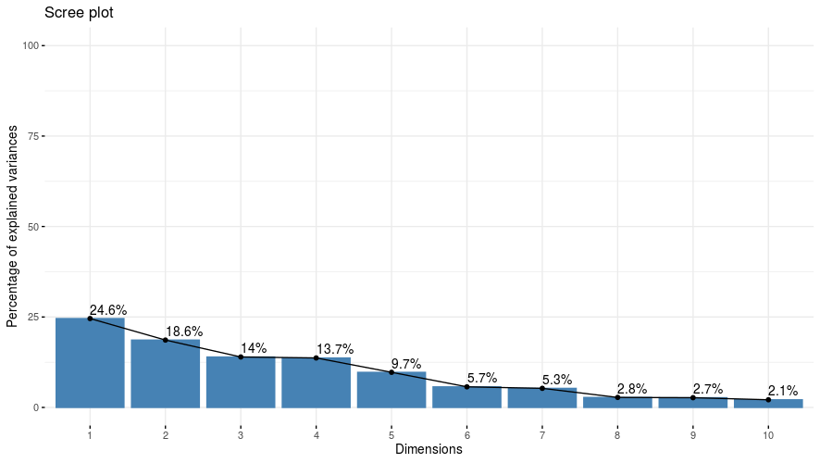
Fig 3: Scree plot representing 10 principal components’ (PCs) against its eigen values
The biplot of PC1 and PC2, together explaining 43.20% of the total variation, revealed a clear separation among genotypes based on yield and yield-attributing traits versus morphological characteristics. Traits such as DFT, DFS, KRPC and CG clustered together with strong positive correlations, while PH and EH were oriented in a different direction, showing that phenological and morphological traits contributed to diversity in different ways
Overall, PCA revealed that yield-related traits (DFT, DFS, KPRC, CG, SW and GY) and growth-related traits (PH, EH) were the major contributors to genetic divergence. The identification of these key traits highlights their importance for parental selection in breeding programs. Genotypes such as CIMMYT-19, BHG-19, UASBM-69and AUG-76-1, located farthest from the origin, were identified as highly divergent, showing stronger expression of particular trait combinations. While UASBM-09 and DHG-12 also displayed distinctness from the rest. Conversely, CIMMYT-114, CIMMYT-117, CAL-1712, CML-45and several others clustered tightly in the middle, suggesting limited divergence and average performance.
These findings are in line with earlier studies in maize, where Bhusal et al. (2016) reported 78.12% of variation explained by the first five PCs, Singh et al. (2020) observed 75.89% variation from three PCs, while Al-Naggar et al. (2020) Yuvaraja et al. (2017) and Stansluos et al. (2019) reported 73.80%, 86.76% and 83.63% of cumulative variation explained by the first three, four and six PCs, respectively. Thus, traits with high loadings in PCA become key indicators of diversity and provide valuable information for parental selection in breeding programs.
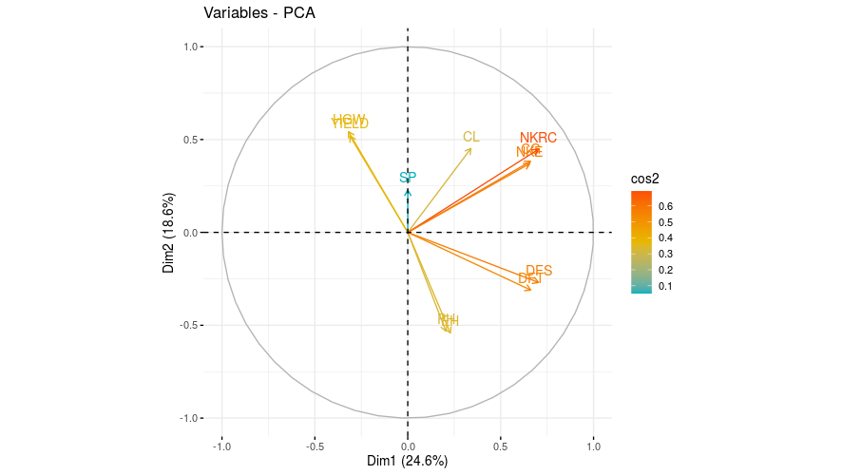

Fig 4: Two dimensional biplot of morphological traits contribution on principal component axes

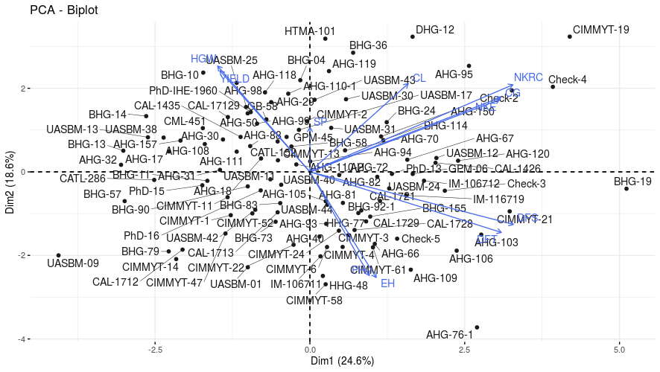

Fig 5: Biplot dispersion graph of maize inbreds
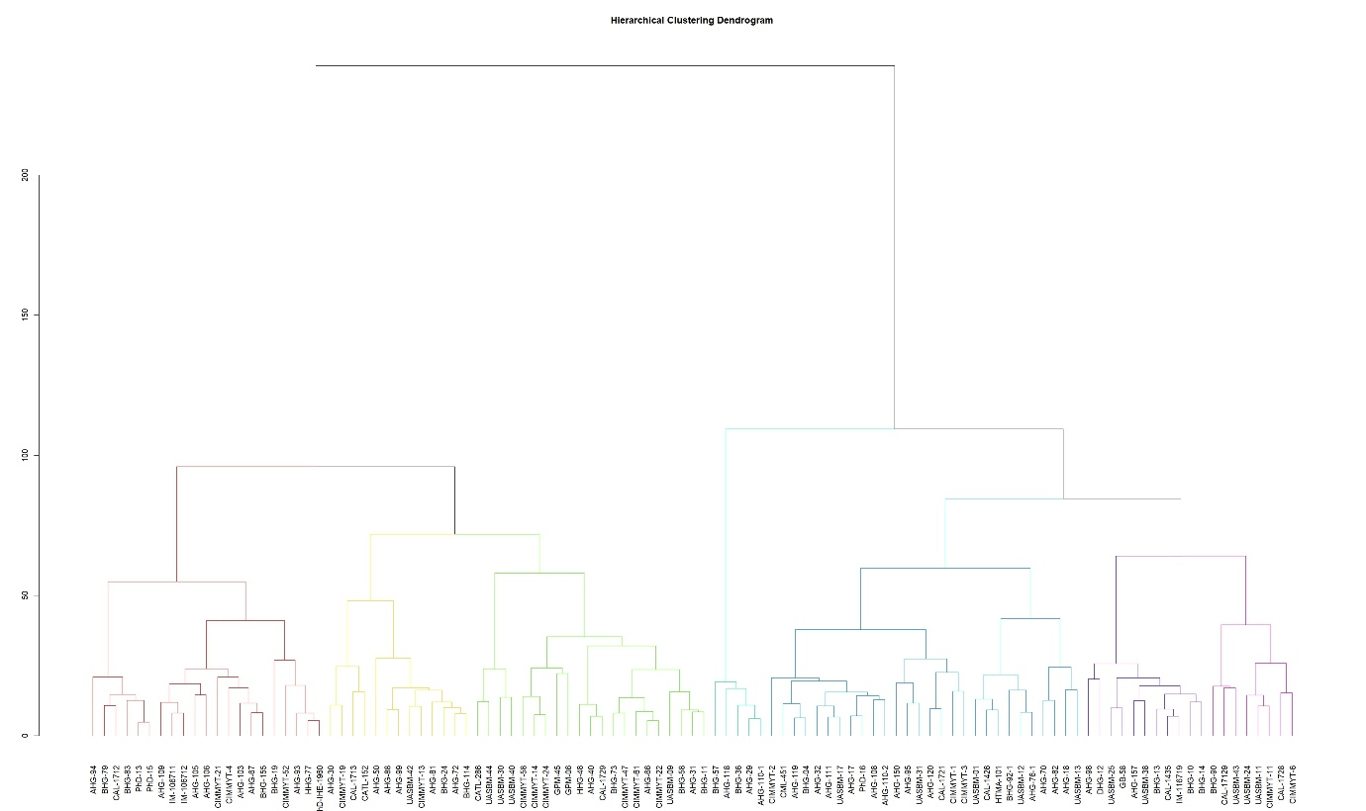
Fig 6: Dendrogram based on Hierarchical Clustering method for 107 tropical maize inbred lines
Conclusion
The present investigation demonstrated a lot of genetic diversity for most traits, which means there are many chances to select good lines and create new hybrids. Traits like DFT, DFS, as well as cob-related characteristics such CL, CG and KPRC, all showed high heritability and genetic advance, making them useful targets for selection. On the other hand, grain yield and similar traits had low heritability, meaning they were strongly affected by the environment. This suggests that using heterosis (crossing distant lines) could be a better way to improve yield than just selecting lines directly.
Cluster analysis divided the lines into seven groups, with large genetic differences between groups, especially between Cluster II and Cluster V. This opens the possibility for breeders to make crosses between highly divergent clusters to get the most benefit from heterosis. Principal component analysis (PCA) backed this up by showing that most of the genetic diversity came from the first five PCs, with traits like flowering time, cob features, kernel- and yield-related traits being the biggest contributors. PCA also helped pick out the most unique and divergent genotypes CIMMYT-19, BHG-19, UASBM-69 and AHG-76-1which could be great candidates for making new hybrids, while others Viz., clustered close to the center, showing less diversity.
Overall, the results highlight the importance of focusing on flowering and cob traits in selection and also PCA to be very helpful for finding important traits and standout genotypes. By using both cluster analysis and PCA, it's possible to identify genetically distant parents, which is key for developing new, high-yielding maize hybrids through heterosis breeding.
References
Abdi, H. and Williams, L.J., 2010. Principal component analysis. Wiley interdisciplinary reviews: computational statistics, 2(4), pp.433-459.
Abdi, H. and Williams, L.J., 2010. Principal component analysis. Wiley interdisciplinary reviews: computational statistics, 2(4), pp.433-459.
Ahloowalia, B. S. and Dhawan, N. I. 1963. Effect of genetic diversity in combining ability of inbred lines of maize. Indian Journal of Genetics, 23: 158-162.
Ajay Kumar, Ashish Narayan and Kavita (2018) 'Morphological Diversity in Inbred Lines of Maize (Zea mays L.)', International Journal of Current Microbiology and Applied Sciences, 7(11), pp. 446-451
Alam, M. S. and Alam, M. F. (2009). Genetic divergence study of maize inbred lines (Zea mays L.). International Journal of Sustainable Agricultural Technology. 5(3): 28-31.
Al-Naggar, A.M.M., Shafik, M.M. and Musa, R.Y.M. 2020. Genetic diversity based on morphological traits of 19 maize genotypes using principal component analysis and GT biplot. Annu. Res. Rev. Biol., 14: 68-85.
Antony, J., Joseph, R., & Thomas, P. (2024). Genetic variability and heritability estimates for yield components in maize. Maydica, 69(1), 1–8.
Bello, O.B., Abdulmaliq, S.Y., Afolabi, M.S. and Ige, S.A., 2010. Correlation and path coefficient analysis of yield and agronomic characters among open pollinated maize varieties and their F1 hybrids in a diallel cross. African Journal of Biotechnology, 9(18), pp.2633-2639.
Brown‐Guedira, G.L., Thompson, J.A., Nelson, R.L. and Warburton, M.L., 2000. Evaluation of genetic diversity of soybean introductions and North American ancestors using RAPD and SSR markers. Crop Science, 40(3), pp.815-823.
Dowswell, C.R., Paliwal R.L. and Cantrell R.P. (1996). Maize in the Third World. Boulder: West View Press.
Farzana Jabeen, F.J., Sahib, K.H. and Satyanarayana, E., 2007. Divergence studies in quality protein maize (Zea mays L.) genotypes.
Hallauer, A. R., Russell, W. A. and Lamkey, K. R. 1988. Corn Breeding. In: Corn and Corn Improvement, 3rd edn. Agron Monogr 18, ASA-CSSA-SSSA, Madison, Wisconsin, USA. 469 564 pp
Hartigan, J.A. and Wong, M.A., 1979. Algorithm AS 136: A k-means clustering algorithm. Journal of the royal statistical society. series c (applied statistics), 28(1), pp.100-108.
Khan, A., Singh, R., Verma, P. & Ahmed, N., 2022. Morphological trait based clustering and heterotic grouping of maize inbreds. Journal of Maize Research and Development, 8(2),
Kumar, G.P., Prashanth, Y., Reddy, V.N., Kumar, S.S. and Rao, P.V., 2014. Character Association and Path Coefficient Analysis in Maize (Zea mays L.).
lal, S., Singh, R., & Gupta, P. (2024). Heritability and genetic advance analysis for kernel traits in maize hybrids. Journal of Cereal Research, 16(2), 145–152.
Mian, M. A. K. and Bahl, P. N. 1989. Genetic divergence and hybrid performance in chickpea. Indian Journal of Genetics, 49: 119-124
Nehvi, F.A., Makhdoomi, M.I., Vaseem Yousuf, V.Y., Bahar, F.A. and Sabeena Naseer, S.N., 2008. Genetic divergence among local maize (Zea mays L.) cultivars of Kashmir Valley.
Patel, J.S., Vaghela, P.K., Patel, D.B., Parmar, D.J. and Macwana, S.S., 2009. Genetic divergence in baby corn (Zea mays L.).
Pradhan, K., Pradhan, B., Sarangi, D.N., Sial, P. and Mishra, T.K., 2009. Genetic divergence in newly developed inbred lines of maize
Prakash, R., Ravikesavan, R., Vinodhana, N.K. and Senthil, A., 2019. Genetic variability, character association and path analysis for yield and yield component traits in maize (Zea mays L.). Electronic Journal of Plant Breeding, 10(2), pp.518-524.
Rafique, M., Malhi, A.R., Altaf, M., Saleem, S. and Khakwani, K., 2018. Cluster analysis and genetic diversity of maize inbred lines. International Journal of Agricultural Innovation and Research, 6(5), pp.1473-2319.
Rathod, S., Patil, R., Deshmukh, P. & Kulkarni, A., 2021. Genetic diversity and clustering of maize inbred lines using D2 and Ward’s methods. Journal of Plant Breeding and Crop Science, 13(4)
Reddy, V.R. and Jabeen, F., 2016. Narrow sense heritability, correlation and path analysis in maize (Zea mays L.).
Rincon, F., Johnson, B., Crossa, J. and Taba, S., 1996. Cluster analysis, an approach to sampling variability in maize accessions.
Satyanarayana, E., Reddy, P. S., & Ramesh, S. (2020). Genetic variability and heritability studies for yield and yield component traits in maize. Journal of Pharmacognosy and Phytochemistry, 9(3), 2048–2053.
Saxena, V. K., Mathi, N. S., Singh, N. N. and Vasal, S. K. 1998. Heterosis in maize: Grouping and patterns. Proc. of 7th Asian Regional Maize Workshop. Los Banos, Philippines. February 23 27, 124-133, pp.
Shaw, R.H. (1988). Climatic requirements. In: Sprague, G.F. and Dudley, J.W., eds. Corn and Corn Improvement. Madison, Wisconsin: American Society of Agronomy, 609-638.
Singh, S.B., Kasana, R.K., Kumar, S. and Kumar, R. 2020. Assessing genetic diversity of newly developed winter maize (Zea mays L.) inbred lines. Indian J. Plant Genet. Resour., 33(1): 68–76.
Stansluos, A.A., Ozturk, A., Kodaz, S., Pour, A.H. and Sylvestre, H. 2019. Genetic diversity in sweet corn (Zea mays L. saccharata) cultivars evaluated by agronomic traits. Mysore J. Agric. Sci., 53(1): 1-8.
Vasal, S. K. 1998. Hybrid maize technology: Challenges and expanding possibilities for research in the next century. Proc. of 7 th Asian Regional Maize Workshop. Los Banos, Philippines. February 23-27, 58-62, pp
Ward Jr, J.H., 1963. Hierarchical grouping to optimize an objective function. Journal of the American statistical association, 58(301), pp.236-244.
Xia, X. C., Reif, J. C., Melchinger, A. E., Frisch, M., Hoisington, D. A., Beck, D., Pixley, K. and Warburton, M. L. 2005. Genetic diversity among CIMMYT maize inbred lines investigated with SSR markers. Crop Science, 45; 2573-2582.
Yuvaraja, A., Rajarajan, K., Ganesan, K., Ravikesavan, R. and Thangahemavathy, A., 2017. Principal Component, Clustering pattern and association analysis of sweet corn (Zea saccharata L.) inbred lines. Forage Res, 43(1), pp.17-21.

