DUS CHARACTERIZATION IN MAIZE INBRED LINES (Zea mays L.)

Abstract
A field investigation was conducted during Rabi 2024–25 at the Agricultural Research Station, Peddapuram, Andhra Pradesh, to characterize 70 maize inbred lines based on Distinctness, Uniformity, and Stability (DUS) traits. The experiment was laid out in an Alpha Lattice Design with two replications, following standard spacing and agronomic practices. Observations were recorded on 27 DUS traits including phenological, morphological, leaf, tassel, ear, kernel and root character. Ear characters such as length, diameter, shape and position revealed significant diversity genotypes like PL 23681,PL 23605, PL 23569 and IMLSB 343-3 showed long ears, beneficial for yield.All the characters shows variation among the maize inbreds provides a valuable resource for hybrid development, varietal registration and trait-based breeding programs and supports future research in maize improvement for yield, adaptability and identifying superior and protectable maize varieties suited for varied agronomic conditions.
Keywords: Inbred, phenological, morphological and maize
Introduction
Maize (Zea mays L.) is one of the most important cereal crops globally, playing a vital role in global food security as a staple food, animal feed, and raw material for various industrial applications. In India, maize is cultivated across approximately 9.96 million hectares, producing about 35.67 million tonnes with an average productivity of 3.58 tonnes per hectare during 2023–24 (Ministry of Agriculture & Farmers Welfare, 2024). The state of Andhra Pradesh is among the leading maize-producing states, contributing significantly to national production, with an estimated area of 2.91 lakh hectares, production of 19.04 lakh tonnes, and productivity surpassing 6.5 tonnes per hectare (AP Seeds, 2024). Maize is highly versatile in its uses it is consumed as food in rural and tribal diets, constitutes a major portion of livestock and poultry feed, and serves as a critical industrial input for starch, ethanol, oil, and other value-added products.
Given the rising demand for maize and the challenges posed by climate change, the development of new, high-performing, and resilient maize varieties has become increasingly essential. However, before a newly bred variety can be released for commercial cultivation or protected under intellectual property laws, it must undergo DUS testing an internationally recognized evaluation of Distinctness, Uniformity, and Stability (UPOV, 2002). DUS testing ensures that a variety is clearly distinguishable from existing varieties, exhibits uniform expression of key traits, and maintains stability over generations (Yadav & Singh, 2010). This process is especially critical for inbred lines used in hybrid maize development, where even minor morphological differences can impact hybrid performance (Reddy et al., 2022). Moreover, DUS characterization plays a crucial role in variety registration, plant breeders’ rights protection, genetic purity maintenance, and breeding efficiency (Camussi et al., 1983; Gupta et al., 2016). In the context of modern maize improvement programs both commercial and research-oriented DUS testing forms the foundation for ensuring varietal identity, protecting innovations and enhancing resilience and productivity in a changing climate.

MATERIALS AND METHODS
The present investigation was conducted at Agricultural Research Station (ARS), Peddapuram, Kakinada District, Andhra Pradesh, The experiment was carried out during the Rabi season of 2024–25. A total of 70 maize inbred lines, including LM 13 and LM 14, were used as test genotypes for the study. The experiment was laid out in an Alpha Lattice Design with two replications with Spacing: 60 cm between rows and 20 cm between plants. Observations were recorded on a total of 27 morphological, phenological and yield traits based on DUS (Distinctness, Uniformity, and Stability) guidelines. The traits were recorded at appropriate growth stages using standard descriptors. The following parameters were evaluated like 50% Anthesis, 50% Silking, Leaf angle, Leaf attitude, leaf width, Sheath colour, Brace root, root colour, Glume base colour, Glume colour, Anther colour, Spikelet density, Tassel angle, Tassel attitude, Tassel length, Plant height, Ear height, Ear length, Ear diameter, Ear shape, Ear colour, Number of grain rows per ear, Row arrangement on ear, grain type, grain colour, glume colour of cob, kernel shape, no.of grain rows and row arrangement.
Table 1: DUS Character to Be Recorded
# | Characterstics | Data recorded
1 | Leaf: Angle between blade and stem | √
2 | Leaf: Attitude of blade | √
3 | Stem: Anthocyanin colouration of brace roots | √
4 | Tassel: Time of Anthesis | √
5 | Tassel: Anthocyanin colouration of glumes | √
6 | Tassel: Anthocyanin colouration of glumes excluding base | √
7 | Tassel: Anthocyanin colouration of anthers | √
8 | Tassel: Density of spikelet | √
9 | Tassel: Angle between main axis and lateral branch | √
10 | Tassel: Altitude of lateral branches | √
11 | Ear: Time of silk emergence | √
12 | Ear: Anthocyanin colouration of silks | √
13 | Ear: Anthocyanin colouration of Sheath | √
14 | Tassel: Length of main axis above lowest side branch | √
15 | Plant: Length | √
16 | Plant: Ear placement | √
17 | Leaf: Width of blade | √
18 | Ear: Length without husk | √
19 | Ear: diameter | √
20 | Ear: Shape | √
21 | Ear: Number of rows of grains | √
22 | Ear: type of grain | √
23 | Ear: Colour of top of grain | √
24 | Ear: Colouration of glumes of cob | √
25 | Kernel row arrangement | √
26 | Kernel shape | √
27 | Kernel 100 weight | √
28 | Kernel waxiness | －
29 | Kernel Poppiness | －
30 | Kernel Sweetness | －
31 | Kernel Opaqueness | －

Results and Discussion

Phenological Characterization of Maize Genotypes

The phenological traits, specifically 50% anthesis and 50% silking, were recorded to assess the flowering behavior of maize genotypes. Ideal flowering ensures proper synchronization between male and silk female. If flowering is too early or late, it may cause asynchronous pollination, leading to poor kernel set and low grain yield. 3 genotypes namely MAI 214, ENT-2-3, CM 400, MAI 2 shows 53-55 days to 50% Anthesis and 50% Silking was 55-58 days, optimum flowering (51–55 days), while remaing all shows late maturity it takes 56-69 days. It is a vital indicator of the hybrid’s agronomic fitness and helps predict maturity timing.

Fig.1 Days to 50% flowering

Leaf characterization in Maize Genotypes
Leaf traits in maize are vital indicators of photosynthetic efficiency, plant architecture, and suitability for different planting densities. The key DUS characters assessed included leaf angle, leaf attitude and leaf length and width.
Leaf Angle: Leaf angle in maize refers to the angle between the stem and the leaf blade. A narrow leaf angle means the leaves are more upright or erect, while a wide angle means they are more horizontal. PL 23672,PL 23691,PL 23568,PL 23688,PL 23689,PL 23656,PL 23569,PL 23681,P-JCYSR37,PFSR 63,IMLSB 317-1,PL 23571, etc shows narrow Leaf Angle(<45°) it allowing better light penetration in dense planting helps in uniform light distribution across the plant population, improving canopy photosynthesis.while remaing shows wide angle it can intercept maximum sunlight early in the season when plants are small. Leaf Attitude: A total of 27 maize genotypes exhibited straight leaf attitude, including MAI 2, PML 137, KDM 70938, PL 23569, PL 23689, IMLSB 2051, PL 23572, PL 23685, PL 23571, PL 23568, PL 23688 and PL 23691, etc While dense leaf attitude was recorded in 17 maize genotypes, which is characterized by closely packed foliage around the stem. The remaining genotypes exhibited a drooping leaf attitude it may be beneficial in low-input or drought-prone conditions due to its role in water conservation and stress response. Leaf width: Leaf width is typically measured at the 6–8 leaf stage or at flowering, on the fully expanded leaf below the cob. The genotypes exhibited narrow leaf width (<8 cm) 16 genotypes namely MAI 214 (6.0 cm), IMLSB 1376 (6.0 cm), IMLSB 748-1 (6.5 cm), JCY 2-7 (7.5 cm), and PL 23569 (7.5 cm) etc and 36 genotypes exhibit medium leaf width is considered the most agronomically balanced trait in maize, combining the benefits of both narrow and broad leaves, While remaining all exhibit broad leaf width.Leaf width in maize is an essential trait that affects photosynthesis, canopy dynamics, yield potential and stress adaptation.
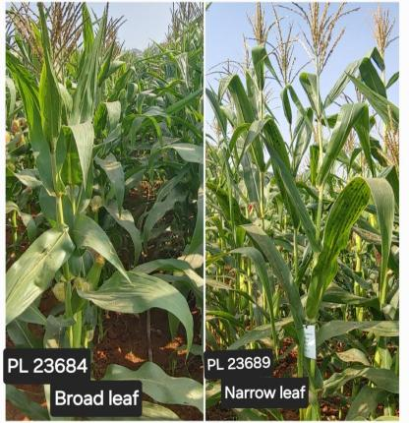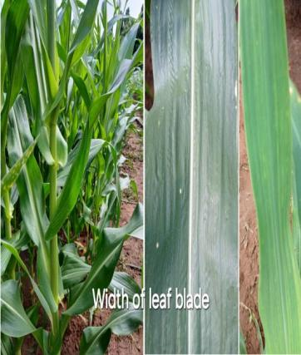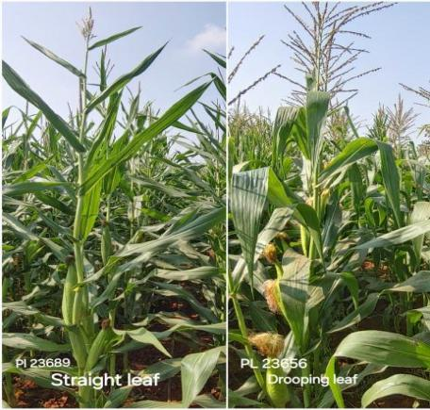
Fig.2. Leaf characters

Root Characterization in Maize Genotypes
Root traits, particularly brace roots and root color are crucial morphological descriptors in DUS testing. These traits impact the anchorage, strength, lodging resistance and nutrient uptake efficiency of maize plants.
Brace Roots: The following 37 genotypes displayed prominent brace root development are PML 137, MAI 725, CM 202, PL 23688, PL 23685, IMLSB 334 B-2, PL 23571, NAI-178A, PL 23672, PL 23577 etc. Genotypes with well-developed brace roots exhibited strong anchorage and enhanced lodging resistance under conditions of high wind or heavy rainfall. These brace roots also support improved nutrient and water absorption from the upper soil layers, contributing to overall plant stability and performance. Sheath colour: Out of the total genotypes, 6 genotypes IMLSB 334 B-2 PFSR-R3, PFSR-R9, IMLSB 380-1, MIL 2-334 B-1, and MAI 214 exhibited sheath colour, while the remaining 63 genotypes showed absence of sheath pigmentation, it is used for varietal identification, purity maintenance and breeding decisions.
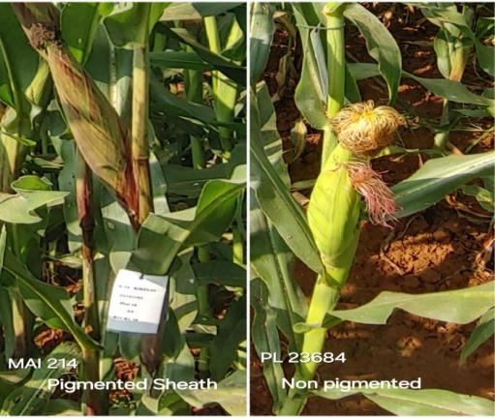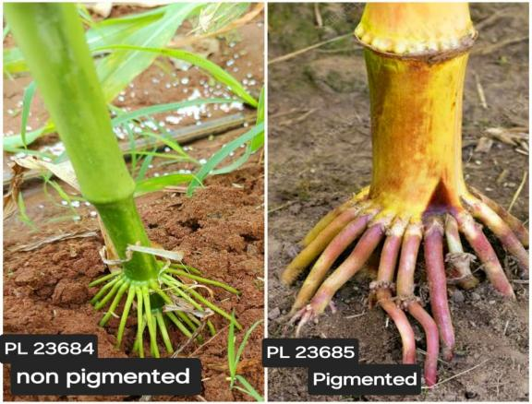
Fig.3. Sheath and root characters
Table 2: DUS Charecterstrics of maize inbreds
# | Genotype | Leaf angle | Leaf Attitude | leaf width | Sheath colour | Brace root colour | 50% Anthesis | 50% Silking
1 | MAI 214 | Wide | Drooping | 6 | Present | Present | 53 | 55
2 | CM 400 | Wide | Drooping | 9 | Absent | Present | 55 | 56
3 | ENT-2-3 | Wide | Dense | 10 | Absent | Present | 55 | 56
4 | MAI 2 | Wide | Straight | 8 | Absent | Absent | 55 | 58
5 | PML 137 | Wide | Straight | 8 | Absent | Present | 57 | 59
6 | IML12 | Wide | Drooping | 9 | Absent | Present | 59 | 60
7 | IMLSB 282-2 | Wide | Dense | 10 | Absent | Absent | 59 | 61
8 | MAI 21 | Wide | Drooping | 9 | Absent | Present | 59 | 62
9 | PL 23681 | Narrow | Drooping | 10 | Absent | Absent | 59 | 61
10 | SKV 50-tall | Narrow | Drooping | 8 | Absent | Present | 60 | 62
11 | MAI 105 | Wide | Dense | 8 | Absent | Absent | 60 | 61
12 | 42048-2-2-1-1-2 | Wide | Dense | 9 | Absent | Present | 60 | 62
13 | IMLSB 748-1 | Wide | Drooping | 7 | Absent | Absent | 60 | 62
14 | VL 19192 | Wide | Dense | 9 | Absent | Present | 60 | 61
15 | KDM 70938 | Narrow | Straight | 10 | Absent | Absent | 60 | 62
16 | Check 2 | Wide | Drooping | 9 | Absent | Absent | 61 | 62
17 | PFSR-R3 | Wide | Dense | 7 | Present | Present | 61 | 63
18 | NAI-178A | Narrow | Straight | 8 | Absent | Present | 61 | 63
19 | PL 23569 | Narrow | Straight | 8 | Absent | Absent | 61 | 62
20 | IMLSB 334 B-2 | Wide | Drooping | 7 | Absent | Present | 62 | 63
21 | PFSR 63 | Narrow | Straight | 8 | Absent | Absent | 62 | 64
22 | JCY 3-7-1-2-1 | Wide | Drooping | 8 | Absent | Absent | 62 | 63
23 | PL 23689 | Narrow | Straight | 8 | Absent | Absent | 62 | 65
24 | MIL 2-334 B-1 | Narrow | Straight | 9 | Present | Present | 62 | 64
25 | IMLSB 380-1 | Wide | Dense | 9 | Present | Absent | 62 | 66
26 | IMLSB 1376 | Wide | Drooping | 6 | Absent | Present | 62 | 68
27 | JCY 2-7 | Wide | Drooping | 8 | Absent | Present | 62 | 63
28 | PL 23685 | Wide | Straight | 8 | Absent | Present | 62 | 64
29 | BLS 42050-1 | Wide | Drooping | 9 | Absent | Absent | 62 | 64
30 | PL 23572 | Wide | Straight | 9 | Absent | Absent | 62 | 64
31 | P-JCYSR37 | Narrow | Straight | 9 | Absent | Absent | 62 | 63
32 | IMLSB 2051 | Narrow | Straight | 10 | Absent | Absent | 62 | 64
33 | P-JCYSR21 | Wide | Drooping | 8 | Absent | Present | 63 | 64
34 | IMLSB 57-2 | Wide | Dense | 8 | Absent | present | 63 | 65
35 | PL 23656 | Narrow | Drooping | 8 | Absent | Absent | 63 | 64
36 | Check 1 | Wide | Drooping | 9 | Absent | Absent | 63 | 64
37 | DML 16 | Wide | Dense | 9 | Absent | Present | 63 | 64
38 | PL 23577 | Wide | Dense | 10 | Absent | Present | 63 | 64
39 | IMLSB 246-2 | Wide | Drooping | 8 | Absent | Present | 63 | 65
40 | PL 23684 | Wide | Drooping | 8 | Absent | Absent | 63 | 67
41 | NAI 137-3 | Wide | Straight | 8 | Absent | Absent | 63 | 65
42 | IMLSB 1041-4 | Wide | Dense | 8 | Absent | Present | 63 | 64
43 | PFSR 90 | Wide | Dense | 9 | Absent | Present | 63 | 64
44 | PL 23571 | Narrow | Straight | 10 | Absent | Present | 63 | 65
45 | PFSR-R9 | Wide | Dense | 7 | Present | Present | 64 | 65
46 | PL 23568 | Narrow | Straight | 8 | Absent | Absent | 64 | 66
47 | IMLSB 334 B-2 | Wide | Dense | 9 | Present | Present | 64 | 66
48 | IML 11 | Wide | Dense | 9 | Absent | Present | 64 | 66
49 | PL 23605 | Wide | Drooping | 9 | Absent | Absent | 64 | 66
50 | MGC 137 | Wide | Drooping | 9 | Absent | Absent | 64 | 66
51 | MGW 295 | Narrow | Straight | 9 | Absent | Absent | 64 | 68
52 | PL 23690 | Wide | Drooping | 9 | Absent | Absent | 64 | 66
53 | PML 21 | Narrow | Drooping | 9 | Absent | Present | 64 | 67
54 | IMLSB 955-1 | Wide | Dense | 8 | Absent | Present | 65 | 67
55 | IMLSB 317-1 | Narrow | Straight | 9 | Absent | Absent | 65 | 67
56 | PL 23688 | Narrow | Straight | 9 | Absent | Present | 65 | 66
57 | UMI 1210 | Wide | Drooping | 10 | Absent | Present | 65 | 66
58 | CM 202 | Wide | Drooping | 11 | Absent | Present | 65 | 68
59 | IMLSB 334 B-2 | Wide | Straight | 8 | Present | Present | 65 | 67
60 | PL 23691 | Narrow | Straight | 9 | Absent | Absent | 65 | 64
61 | PL 23672 | Narrow | Dense | 9 | Absent | Present | 65 | 68
62 | IML 21 | Wide | Straight | 10 | Absent | Absent | 65 | 67
63 | MAI 725 | - | Straight | 8 | Absent | Present | 66 | 67
64 | IMLSB 1043-1 | Wide | Straight | 10 | Absent | Absent | 66 | 67
65 | CM 202 | Narrow | Straight | 9 | Absent | Present | 66 | 68
66 | CMI-CR-01 | Narrow | Straight | 9 | Absent | Absent | 67 | 69
67 | IMLSB 343-3 | Narrow | Straight | 9 | Absent | Absent | 67 | 67
68 | MIL 1-11 | Wide | Straight | 10 | Absent | Absent | 67 | 69
69 | CM 202 | Narrow | Straight | 10 | Absent | Present | 68 | 69
70 | IMLSB 343-3 | Narrow | Straight | 10 | Absent | Absent | 69 | 67
Tassel Characterization in Maize
The tassel, which is the male flowering part of the maize plant, plays a critical role in pollen production, pollen dispersal, pollination efficiency, and overall reproductive success. Tassel morphology is an essential part of DUS characterization and is also important for understanding the yield potential, stress tolerance, and genetic stability of genotypes.
Tassel Attitude: A majority of the genotypes (51), including PL 23690, P-JCYSR37, PL 23568, MIL 1-11, JCY 3-7-1-2-1, PL 23688 and others exhibited a straight tassel attitude. In contrast, 19 genotypes displayed a curved tassel attitude. This trait is particularly beneficial in high-yielding hybrids cultivated under dense planting and well-managed systems, as it promotes efficient pollination, better canopy light interception and contributes to overall plant health and yield performance. Tassel angle: Wide tassel angle is a helpful trait in maize, contributing to effective pollen dispersal and reproductive success, especially in areas with less water or fewer fertilizers and is useful in both breeding and variety identification. A total of 36 genotypes such as MGW 295, PL 23577, PL 23572, MIL 2-334 B-1, PL 23685, IMLSB 1041-4, PL 23605, PL 23684, PL 23689, PL 23656, PL 23569 etc exhibited a wide tassel angle while others exhibit narrow tassel angle. Tassel length: A total of 29 maize genotypes exhibited medium tassel length (20–30 cm), which is considered optimal for balanced pollen production and efficient energy use. These include PL 23685 (20 cm), IMLSB 334 B-2 (24 cm), IMLSB 1376 (24 cm), NAI 137-3 (25 cm), MGC 137 (25 cm), PFSR 63 (25 cm), MAI 214 (26 cm), IML 12 (27 cm), IMLSB 1041-4 (27 cm), CM 400 (27 cm), PL 23691 (27 cm), P-JCYSR37 (28 cm), PL 23656 (28 cm), IMLSB 748-1 (28 cm), DML 16 (28 cm), PFSR-R3 (29 cm), PL 23572 (29 cm) etc., while remaining genotypes in the study exhibited long tassel length, which although supporting high pollen production, may lead to increased energy use and possible shading of upper leaves, making them more suitable for specific breeding purposes or open-pollinated systems. Spikelet Density: A total of 46 maize genotypes exhibited dense spikelet density, in maize is a desirable trait that enhances pollen availability, improves fertilization and ensures uniform seed set. These genotypes include PL 23571, 42048-2-2-1-1-2, IML 11, IMLSB 282-2, ENT-2-3, PL 23577, IMLSB 380-1, PL 23572, MIL 2-334 B-1, PL 23685, IMLSB 1041-4, IMLSB 57-2, PML 21, CM 202, IML 12, IMLSB 343-3, PFSR 90, PL 23605, MGC 137, PL 23681 etc, while remaining genotypes exhibits sparse spikelet density in maize, while producing less pollen, may be beneficial in systems where resource conservation or stress tolerance is a priority. Anther colour: IML 21, MAI 2 and MAI 725 exhibited visible anther colour, while the remaining 58 genotypes showed no anther pigmentation. Glume colour:PL 23672,PFSR 90,PL 23568,P-JCYSR21,PL 23605,MGC 137,PL 23681,Check 1,IMLSB 748-1,PML 137,IMLSB 955-1,PFSR-R9,DML 16,IMLSB 334 B-2,MIL 1-11 and MAI 725 exhibited glume colour, while the remaining 45 genotypes showed no glume colour.The glume colour in maize genotypes highlights their genetic uniqueness and potential utility in varietal identification.Glume base colour :A total of 14 maize genotypesP-JCYSR37,IMLSB 748-1,IMLSB 343-3,CMI-CR-01,PML 137,IMLSB 955-1,PFSR-R9,MAI 105,DML 16,IMLSB 334 B-2,MIL 1-11,MAI 214.MAI 725 exhibited glume base colour, while the remaining genotypes showed no glume base colour. Useful in hybrid breeding programs to track and confirm the identity and purity of parent lines, especially when crossed lines differ in pigmentation.
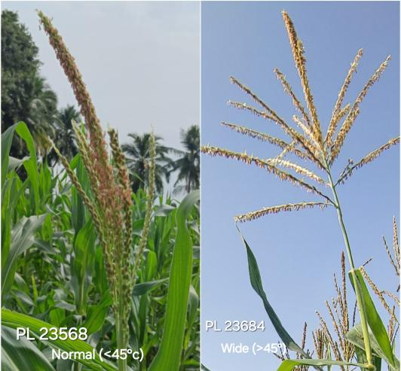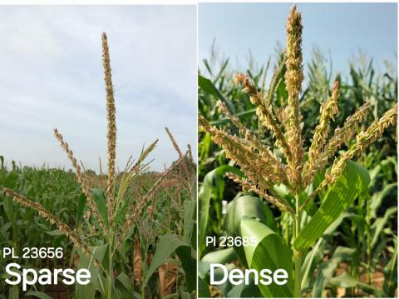
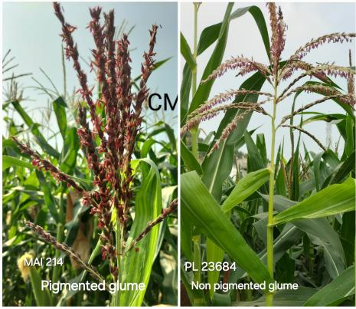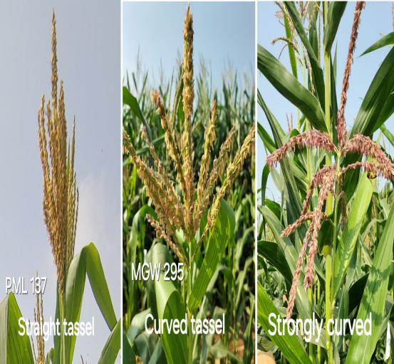
Fig.4.Tassel characters

Morphological Characterization in Maize
Morphological characterization especially traits like plant height and ear height is fundamental to maize breeding, variety development and crop management.
Plant Height: In the studied maize genotypes, 4 genotypes exhibited short plant height (<120 cm), 19 genotypes showed medium height (120–150 cm), while the remaining genotypes displayed long plant height (>150 cm), indicating a wide range of plant stature among the evaluated lines. Ear placement: Out of the 70 maize genotypes evaluated, 34 exhibited low ear placements, 31 showed medium, and 5 exhibit high ear placement, reflecting significant variation in this trait.
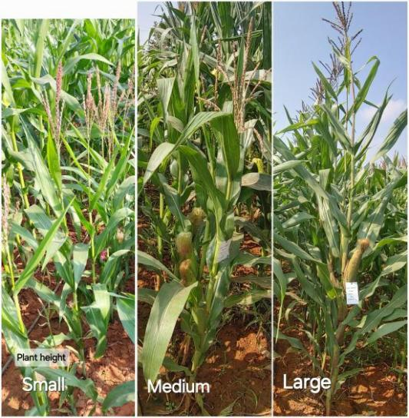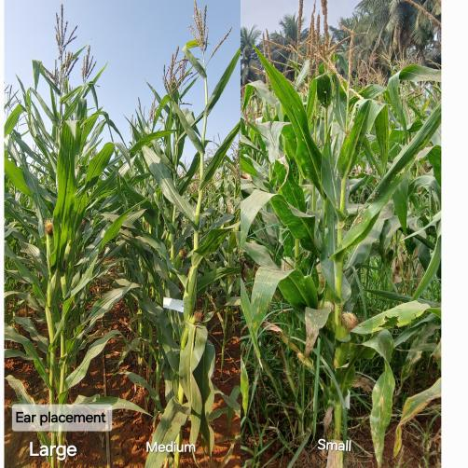
Fig.5. Morphological characters
Table 2. Cont...
# | Genotype | Tassel angle | Tassel Attitude | Tassel length | Anther colour | Spikelet Density | Plant Height | Ear placement
1 | MAI 214 | Wide | Straight | 26 | - | Dense | 125 | 0.34
2 | CM 400 | Narrow | Curved | 27 | - | Dense | 118 | 0.40
3 | ENT-2-3 | Narrow | Straight | 41 | Absent | Dense | 143 | 0.37
4 | MAI 2 | Wide | Curved | 35 | Present | Dense | 95 | 0.34
5 | PML 137 | Wide | Straight | 32 | Absent | Sparse | 158 | 0.43
6 | IML12 | Wide | Straight | 27 | Absent | Dense | 155 | 0.42
7 | IMLSB 282-2 | Wide | Straight | 40 | Absent | Dense | 125 | 0.44
8 | MAI 21 | Wide | Curved | 34 | Absent | Sparse | 160 | 0.41
9 | PL 23681 | Narrow | Straight | 32 | Absent | Dense | 200 | 0.48
10 | SKV 50-tall | Narrow | Curved | 33 | Absent | Dense | 133 | 0.32
11 | MAI 105 | Wide | Straight | 32 | Absent | Sparse | 153 | 0.41
12 | 42048-2-2-1-1-2 | Narrow | Straight | 43 | Absent | Dense | 155 | 0.50
13 | IMLSB 748-1 | Narrow | Curved | 28 | - | Sparse | 125 | 0.44
14 | VL 19192 | Wide | Curved | 34 | Absent | Sparse | 123 | 0.41
15 | KDM 70938 | Narrow | Curved | 42 | Absent | Sparse | 165 | 0.52
16 | Check 2 | Wide | Straight | 31 | Absent | Dense | 175 | 0.44
17 | PFSR-R3 | Wide | Curved | 29 | Absent | Sparse | 148 | 0.46
18 | NAI-178A | Narrow | Curved | 33 | Absent | Sparse | 135 | 0.37
19 | PL 23569 | Wide | Straight | 30 | Absent | Sparse | 165 | 0.56
20 | IMLSB 334 B-2 | Narrow | Curved | 30 | Absent | Dense | 145 | 0.52
21 | PFSR 63 | Narrow | Straight | 25 | Absent | Dense | 168 | 0.49
22 | JCY 3-7-1-2-1 | Narrow | Straight | 30 | Absent | Sparse | 195 | 0.49
23 | PL 23689 | Wide | Straight | 34 | Absent | Sparse | 153 | 0.33
24 | MIL 2-334 B-1 | Wide | Straight | 30 | Absent | Dense | 145 | 0.55
25 | IMLSB 380-1 | Wide | Straight | 33 | Absent | Dense | 125 | 0.32
26 | IMLSB 1376 | Narrow | Straight | 24 | - | Sparse | 143 | 0.42
27 | JCY 2-7 | Narrow | Straight | 32 | Absent | Dense | 185 | 0.45
28 | PL 23685 | Wide | Straight | 20 | Absent | Dense | 155 | 0.37
29 | BLS 42050-1 | Wide | Straight | 32 | Absent | Dense | 190 | 0.50
30 | PL 23572 | Wide | Straight | 29 | Absent | Dense | 165 | 0.52
31 | P-JCYSR37 | Narrow | Straight | 28 | - | Dense | 193 | 0.47
32 | IMLSB 2051 | Narrow | Straight | 33 | Absent | Dense | 133 | 0.36
33 | P-JCYSR21 | Wide | Straight | 30 | Absent | Sparse | 183 | 0.41
34 | IMLSB 57-2 | Wide | Curved | 35 | Absent | Dense | 130 | 0.48
35 | PL 23656 | Wide | Straight | 28 | Absent | Sparse | 215 | 0.48
36 | Check 1 | Narrow | Straight | 31 | Absent | Dense | 195 | 0.45
37 | DML 16 | Wide | Straight | 28 | Absent | Dense | 118 | 0.34
38 | PL 23577 | Wide | Straight | 36 | Absent | Dense | 175 | 0.49
39 | IMLSB 246-2 | Wide | Straight | 34 | Absent | Sparse | 158 | 0.37
40 | PL 23684 | Wide | Straight | 35 | Absent | Sparse | 150 | 0.42
41 | NAI 137-3 | Narrow | Curved | 25 | - | Dense | 150 | 0.48
42 | IMLSB 1041-4 | Wide | Straight | 27 | Absent | Dense | 163 | 0.42
43 | PFSR 90 | Narrow | Straight | 31 | Absent | Dense | 170 | 0.43
44 | PL 23571 | Narrow | Straight | 33 | Absent | Dense | 188 | 0.49
45 | PFSR-R9 | Wide | Curved | 33 | Absent | Sparse | 153 | 0.46
46 | PL 23568 | Narrow | Straight | 31 | - | Dense | 155 | 0.42
47 | IMLSB 334 B-2 | Wide | Curved | 24 | Absent | Dense | 165 | 0.41
48 | IML 11 | Wide | Straight | 30 | Absent | Dense | 160 | 0.47
49 | PL 23605 | Wide | Straight | 33 | Absent | Dense | 158 | 0.56
50 | MGC 137 | Wide | Curved | 25 | Absent | Dense | 145 | 0.47
51 | MGW 295 | Wide | Curved | 43 | Absent | Dense | 165 | 0.44
52 | PL 23690 | Narrow | Straight | 33 | - | Dense | 153 | 0.39
53 | PML 21 | Narrow | Straight | 32 | Absent | Dense | 158 | 0.49
54 | IMLSB 955-1 | Wide | Straight | 31 | Absent | Sparse | 103 | 0.56
55 | IMLSB 317-1 | Wide | Curved | 29 | Absent | Dense | 153 | 0.39
56 | PL 23688 | Narrow | Straight | 31 | Absent | Sparse | 170 | 0.31
57 | UMI 1210 | Narrow | Straight | 37 | Absent | Dense | 180 | 0.50
58 | CM 202 | Narrow | Straight | 41 | Absent | Dense | 148 | 0.47
59 | IMLSB 334 B-2 | Narrow | Straight | 29 | Absent | Dense | 160 | 0.44
60 | PL 23691 | Narrow | Curved | 27 | Absent | Sparse | 160 | 0.48
61 | PL 23672 | Narrow | Straight | 33 | Absent | Sparse | 185 | 0.53
62 | IML 21 | Wide | Straight | 39 | Present | Dense | 170 | 0.46
63 | MAI 725 | Narrow | Straight | 32 | Present | Sparse | 165 | 0.41
64 | IMLSB 1043-1 | Wide | Curved | 32 | Absent | Dense | 183 | 0.44
65 | CM 202 | Narrow | Straight | 39 | Absent | Dense | 158 | 0.46
66 | CMI-CR-01 | Narrow | Straight | 31 | Absent | Sparse | 160 | 0.50
67 | IMLSB 343-3 | Narrow | Straight | 33 | Absent | Dense | 163 | 0.58
68 | MIL 1-11 | Narrow | Straight | 30 | - | Dense | 155 | 0.45
69 | CM 202 | Narrow | Straight | 43 | Absent | Dense | 183 | 0.48
70 | IMLSB 343-3 | Wide | Straight | 31 | Absent | Sparse | 150 | 0.57

Ear (Cob) Characterization in Maize
Ear traits in maize such as ear shape, colour, size, length, diameter characteristics are crucial components of DUS testing because they offer stable, distinguishable, and heritable markers for variety identification and breeding selection. These characters not only ensure varietal protection but also support high-yielding and market-preferred genotype development.
Ear colour (silk):A total of 33 maize genotypes including UMI 1210, 42048-2-2-1-1-2, IMLSB 334 B-2, JCY 2-7, PFSR 90, PL 23681, Check 1, PL 23690, P-JCYSR37, PL 23672, MAI 725, IMLSB 1376, Check 2, PL 23577, PL 23572, PL 23685, BLS 42050-1, IML 12, PL 23605, IML 21, PL 23656, PL 23569, P-JCYSR21, SKV 50-tall, NAI 137-3, KDM 70938, IMLSB 748-1, IMLSB 317-1, IMLSB 57-2, MGC 137, IMLSB 334 B-2, PFSR-R3, and PFSR-R9 exhibited silk pigmentation, a trait often associated with anthocyanin presence and stress responsiveness, while, remaining genotypes showed no visible silk pigmentation, indicating lack of anthocyanin expression in the silks.Ear Shape:In the present study,19 genotypes showed a cylindrical ear shape, which is characterized by a uniform diameter from base to tip. This shape is preferable for mechanical harvesting, allows for uniform kernel distribution, and typically correlates with higher yield potential and 15 genotypes namely PL 23572, PFSR-R9, IMLSB 317-1, 42048-2-2-1-1-2, IMLSB 1043-1, PL 23656, and PL 23691 etc exhibited a conical ear shape. The remaining genotypes exhibited a conico-cylindrical ear shape, an intermediate form that combines features of both conical and cylindrical types. Ear length: Most of the genotypes displayed medium ear length (10–15 cm), A total of 8 genotypes IMLSB 343-3 (16 cm), PL 23681 (16 cm), IMLSB 2051 (16 cm), PL 23605 (16 cm), PL 23571 (16 cm), PL 23577 (16 cm), PL 23569 (17 cm) etc were categorized as having long ears (>15 cm). Long ear length is generally associated with higher yield potential due to an increased number of kernels per ear, and it reflects vigorous growth, good pollination and better resource utilization while, 4 genotypes IMLSB 1376 (7 cm), MAI 214 (8 cm), CM 400 (8 cm) and SKV 50-Tall (9 cm) exhibited short ear length (<10 cm). Ear diameter: All the genotypes exhibited large ear diameter, ranging from SKV 50-tall (9 cm) to PL 23681 (15 cm), indicating robust ear development and potentially higher grain-bearing capacity. A larger ear diameter is generally associated with greater kernel density and yield potential in maize. Genotypes with larger diameters are usually preferred in breeding programs aimed at improving grain productivity and market quality. Glume colour of cob: Glume colour of cob varied among genotypes, with 2 genotypes namely PL 23688, PL 23568 showing dark purple, one genotype (CM 202) exhibits light purple and the remaining 62 genotypes exhibiting white glumes. This trait is also useful in genetic purity assessment and breeding line differentiation.
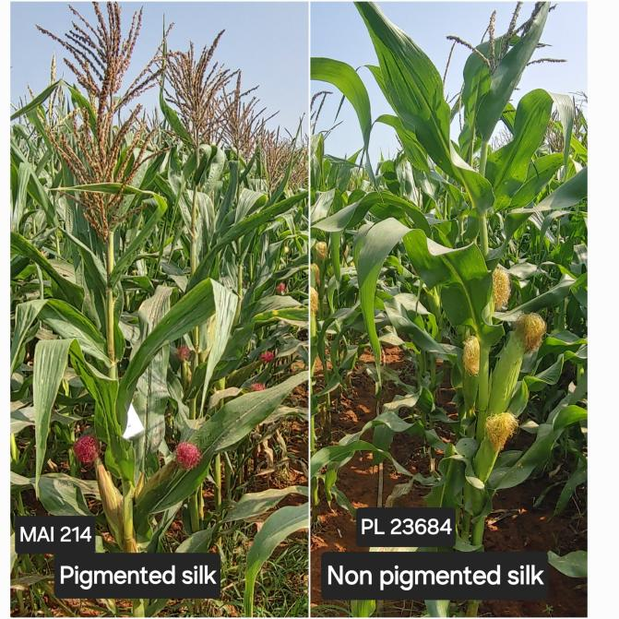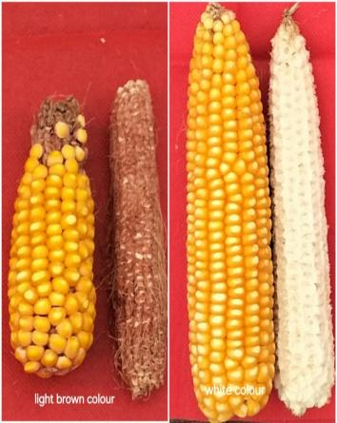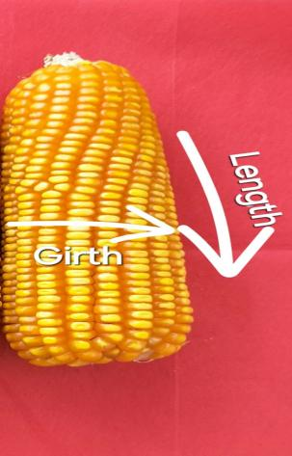
Fig.6. Cob and kernel characters
Table 2. Cont...
# | Genotype | Ear colour (silk) | Glume base colour | Glume colour | Ear length | Ear diameter | Ear Shape
1 | MAI 214 | Absent | Present | Absent | 8 | 12 | cylindrical
2 | CM 400 | Absent | - | - | 8 | 10 | conical
3 | ENT-2-3 | Absent | Absent | Absent | 14 | 11 | conical
4 | MAI 2 | Absent | Absent | Absent | 10 | 9 | conico-cylindrical
5 | PML 137 | Absent | Present | Present | 13 | 10 | conico-cylindrical
6 | IML12 | Present | Absent | Absent | 12 | 10 | conico-cylindrical
7 | IMLSB 282-2 | Absent | Absent | Absent | 11 | 14 | cylindrical
8 | MAI 21 | Absent | Absent | Absent | 11 | 12 | cylindrical
9 | PL 23681 | Present | Absent | Present | 16 | 15 | conico-cylindrical
10 | SKV 50-tall | Present | Absent | Absent | 9 | 9 | conico-cylindrical
11 | MAI 105 | Absent | Present | Absent | 13 | 13 | cylindrical
12 | 42048-2-2-1-1-2 | Present | Absent | Absent | 13 | 13 | conical
13 | IMLSB 748-1 | Present | Present | Present | 11 | 10 | conical
14 | VL 19192 | Absent | Absent | Absent | 12 | 12 | cylindrical
15 | KDM 70938 | Present | Absent | Absent | 14 | 14 | conico-cylindrical
16 | Check 2 | Present | Absent | Absent | 15 | 13 | conico-cylindrical
17 | PFSR-R3 | Present | Absent | Absent | 10 | 11 | conico-cylindrical
18 | NAI-178A | Absent | Absent | Absent | 10 | 11 | cylindrical
19 | PL 23569 | Present | Absent | Absent | 17 | 13 | conico-cylindrical
20 | IMLSB 334 B-2 | Absent | Absent | Absent | 11 | 11 | conical
21 | PFSR 63 | Absent | Absent | Absent | 12 | 12 | conico-cylindrical
22 | JCY 3-7-1-2-1 | Absent | Absent | Absent | 12 | 12 | cylindrical
23 | PL 23689 | Absent | Absent | Absent | 14 | 13 | conico-cylindrical
24 | MIL 2-334 B-1 | Absent | Absent | Absent | 12 | 12 | cylindrical
25 | IMLSB 380-1 | Absent | Absent | Absent | 14 | 11 | conico-cylindrical
26 | IMLSB 1376 | Present | Absent | Absent | 7 | 10 | conico-cylindrical
27 | JCY 2-7 | Present | Absent | Absent | 15 | 13 | conico-cylindrical
28 | PL 23685 | Present | Absent | Absent | 14 | 10 | conico-cylindrical
29 | BLS 42050-1 | Present | Absent | Absent | 13 | 12 | conico-cylindrical
30 | PL 23572 | Present | Absent | Absent | 14 | 12 | conical
31 | P-JCYSR37 | Present | Present | Absent | 14 | 12 | conico-cylindrical
32 | IMLSB 2051 | Absent | Absent | Absent | 16 | 12 | conico-cylindrical
33 | P-JCYSR21 | Present | Absent | Present | 13 | 11 | conico-cylindrical
34 | IMLSB 57-2 | Present | Absent | Absent | 13 | 12 | cylindrical
35 | PL 23656 | Present | Absent | Absent | 14 | 13 | conical
36 | Check 1 | Present | Absent | Present | 13 | 11 | conico-cylindrical
37 | DML 16 | Absent | Present | Present | 10 | 12 | conical
38 | PL 23577 | Present | Absent | Absent | 16 | 13 | conico-cylindrical
39 | IMLSB 246-2 | Absent | Absent | Absent | 12 | 11 | conical
40 | PL 23684 | Absent | Absent | Absent | 12 | 13 | cylindrical
41 | NAI 137-3 | Present | Absent | Absent | 11 | 13 | cylindrical
42 | IMLSB 1041-4 | Absent | Absent | Absent | 14 | 13 | conico-cylindrical
43 | PFSR 90 | Present | Absent | Present | 14 | 12 | conico-cylindrical
44 | PL 23571 | Absent | Absent | Absent | 16 | 14 | conico-cylindrical
45 | PFSR-R9 | Present | Present | Present | 14 | 12 | conical
46 | PL 23568 | Absent | Absent | Present | 15 | 14 | conico-cylindrical
47 | IMLSB 334 B-2 | Present | Present | Present | 15 | 13 | conico-cylindrical
48 | IML 11 | Absent | Absent | Absent | 13 | 11 | conical
49 | PL 23605 | Present | Absent | Present | 16 | 14 | conico-cylindrical
50 | MGC 137 | Present | Absent | Present | 11 | 14 | cylindrical
51 | MGW 295 | Absent | Absent | Absent | 11 | 12 | cylindrical
52 | PL 23690 | Present | Absent | Absent | 12 | 13 | conico-cylindrical
53 | PML 21 | Absent | Absent | Absent | 13 | 12 | conico-cylindrical
54 | IMLSB 955-1 | Absent | Present | Present | 11 | 11 | conico-cylindrical
55 | IMLSB 317-1 | Present | Absent | Absent | 12 | 13 | conical
56 | PL 23688 | Absent | Absent | Absent | 12 | 12 | conico-cylindrical
57 | UMI 1210 | Present | Absent | Absent | 15 | 13 | cylindrical
58 | CM 202 | Absent | Absent | Absent | 14 | 14 | cylindrical
59 | IMLSB 334 B-2 | Present | Absent | Absent | 12 | 12 | cylindrical
60 | PL 23691 | Absent | Absent | Absent | 11 | 15 | conical
61 | PL 23672 | Present | Absent | Present | 15 | 14 | conico-cylindrical
62 | IML 21 | Present | Absent | Absent | 14 | 14 | conico-cylindrical
63 | MAI 725 | Present | present | Present | 13 | 12 | conico-cylindrical
64 | IMLSB 1043-1 | Absent | Absent | Absent | 13 | 13 | conical
65 | CM 202 | Absent | Absent | Absent | 15 | 14 | cylindrical
66 | CMI-CR-01 | Absent | Present | Absent | 12 | 14 | conico-cylindrical
67 | IMLSB 343-3 | Absent | Present | Absent | 16 | 12 | cylindrical
68 | MIL 1-11 | Absent | Present | Present | 13 | 9 | conical
69 | CM 202 | Absent | Absent | Absent | 14 | 13 | cylindrical
70 | IMLSB 343-3 | Absent | Absent | Absent | 16 | 12 | cylindrical

Kernel (grain) Characterization in Maize
Kernel characterization in maize is not just a morphological evaluation but a foundation for quality improvement, market targeting, and genetic purity. It is indispensable in breeding programs, varietal release, and commercialization, particularly in the context of value-added and climate-resilient agriculture.
Grain type: Out of the total genotypes evaluated, 62 genotypes exhibited flint grain type, while 2 genotypes PL 23672 and CM 202 showed dent grain type. Additionally, 6 genotypes PFSR 90, P-JCYSR37, PL 23691, KDM 70938, PFSR 63, and PL 23681 showed a semi-dent grain type. Grain type in maize is a crucial trait for the economic value, storability and end-use of the crop. Grain colour: Among the genotypes evaluated for grain colour, 26 genotypes showed orange kernels, 25 showed yellow, 17 exhibited yellow with a white cap and only one genotype CM 400 had pure white kernels. Grain colour in maize is not only important for visual appeal and market acceptance but also plays a critical role in enhancing nutritional value and consumer targeting. Kernel shape: In the evaluated maize genotypes, 7 genotypes exhibited indented kernels, 16 genotypes showed tooth-shaped kernels and 44 genotypes displayed round-shaped kernels, making round the most dominant kernel shape observed. Kernel shape in maize is a vital character for classifying grain type, understanding quality traits and targeting end-use applications. No.of grain rows: The variation in grain row number observed from medium (10–12 rows) in 46 genotypes like MAI 725 (11 rows) to NAI 137-3 (13 rows), while large row numbers (>14) were observed in 23 genotypes such as IMLSB 246-2 (14 rows) to PL 23681 (16 rows) indicates a diverse genetic base and highlights genotypes like PL 23681 for their superior yield traits. This trait is crucial for breeding high-yielding, stable maize varieties and plays a significant role in optimizing productivity and grain quality in commercial maize cultivation. Row arrangement: In the evaluated maize genotypes, 3 genotypes PFSR-R3, IMLSB 246-2 and CM 400 exhibited irregular row arrangement, while 2 genotypes, PL 23572 and PL 23681, showed a spiral row pattern. The remaining 64 genotypes show a straight row arrangement, which was the most common. 1000 kernel weight: Among the 70 maize genotypes evaluated, IMLSB 334 B-2 exhibited very small kernel weight, 19 genotypes showed small, 38 medium, and the remaining 12 displayed large kernel weight, indicating clear variation for this trait, which is critical for establishing distinctness in DUS characterization.
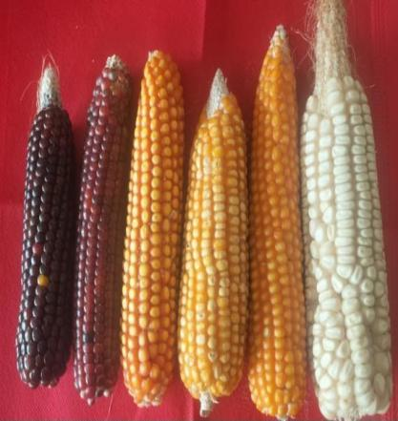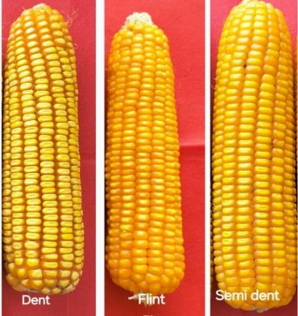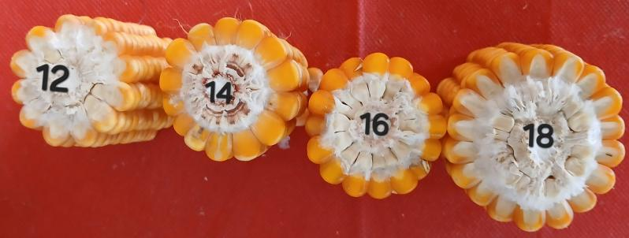
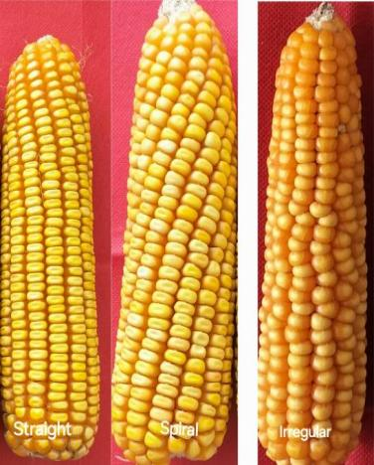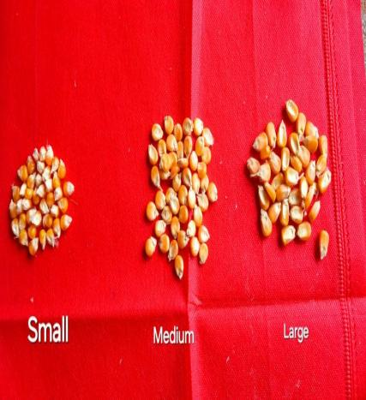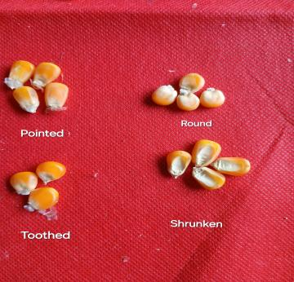Fig.7. kernel characters
Table 2. Cont...
# | Genotype | Glume colour of cob | No.of grain rows | Grain type | Grain colour | Row arrangement | Kernel shape | 1000 kernel weight
1 | MAI 214 | white | 15 | Flint | Yellow | Straight | indented | 13
2 | CM 400 | white | 13 | Flint | White | Irregular | round | 15
3 | ENT-2-3 | - | 12 | Flint | Orange | Straight | round | 22
4 | MAI 2 | white | 12 | Flint | Yellow | Straight | round | 19
5 | PML 137 | white | 11 | Flint | Orange | Straight | round | 22
6 | IML12 | white | 15 | Flint | Orange | Straight | round | 16
7 | IMLSB 282-2 | white | 14 | Flint | Orange | Straight | indented | 32
8 | MAI 21 | white | 13 | Flint | Orange | Straight | round | 28
9 | PL 23681 | white | 16 | Semi dent | Yellow with cap | Spiral | indented | 32
10 | SKV 50-tall | white | 12 | Flint | Orange | Straight | round | 22
11 | MAI 105 | white | 14 | Flint | Orange | Straight | round | 23
12 | 42048-2-2-1-1-2 | white | 12 | Flint | Orange | - | round | 23
13 | IMLSB 748-1 | white | 13 | Flint | Orange | Straight | round | 19
14 | VL 19192 | white | 12 | Flint | Yellow with cap | Straight | round | 26
15 | KDM 70938 | white | 13 | Semi dent | Yellow with cap | Straight | toothed | 24
16 | Check 2 | white | 13 | Flint | Yellow | Straight | toothed | 28
17 | PFSR-R3 | white | 14 | Flint | Orange | Irregular | round | 16
18 | NAI-178A | white | 12 | Flint | Orange | Straight | indented | 20
19 | PL 23569 | white | 15 | Flint | Orange | Straight | toothed | 24
20 | IMLSB 334 B-2 | white | 12 | Flint | Yellow | Straight | toothed | 9
21 | PFSR 63 | white | 13 | Semi dent | Yellow | Straight | round | 34
22 | JCY 3-7-1-2-1 | white | 13 | Flint | Yellow | Straight | round | 29
23 | PL 23689 | white | 12 | Flint | Yellow | Straight | round | 21
24 | MIL 2-334 B-1 | white | 12 | Flint | Orange | Straight | round | 21
25 | IMLSB 380-1 | white | 13 | Flint | Yellow | Straight | round | 17
26 | IMLSB 1376 | white | 12 | Flint | Yellow | Straight | toothed | 20
27 | JCY 2-7 | white | 12 | Flint | Yellow with cap | Straight | round | 34
28 | PL 23685 | white | 14 | Flint | Yellow with cap | Straight | round | 22
29 | BLS 42050-1 | white | 12 | Flint | Yellow with cap | Straight | round | 30
30 | PL 23572 | white | 11 | Flint | Orange | Spiral | toothed | 24
31 | P-JCYSR37 | white | 12 | Semi dent | Yellow | Straight | indented | 35
32 | IMLSB 2051 | white | 13 | Flint | Orange | Straight | round | 20
33 | P-JCYSR21 | white | 11 | Flint | Yellow with cap | Straight | round | 29
34 | IMLSB 57-2 | white | 14 | Flint | Yellow with cap | Straight | round | 21
35 | PL 23656 | white | 13 | Flint | Yellow | Straight | round | 31
36 | Check 1 | white | 11 | Flint | Yellow | Straight | toothed | 32
37 | DML 16 | white | 12 | Flint | Orange | Straight | toothed | 23
38 | PL 23577 | white | 15 | Flint | Yellow | Straight | round | 25
39 | IMLSB 246-2 | white | 14 | Flint | Orange | Irregular | round | 14
40 | PL 23684 | purple | 14 | Flint | Yellow | Straight | round | 28
41 | NAI 137-3 | white | 13 | Flint | Orange | Straight | toothed | 22
42 | IMLSB 1041-4 | white | 14 | Flint | Orange | Straight | toothed | 25
43 | PFSR 90 | white | 12 | Semi dent | Yellow with cap | Straight | round | 33
44 | PL 23571 | white | 13 | Flint | Orange | Straight | toothed | 33
45 | PFSR-R9 | white | 13 | Flint | Yellow | Straight | toothed | 31
46 | PL 23568 | dark purple | 14 | Flint | Yellow with cap | Straight | round | 27
47 | IMLSB 334 B-2 | white | 13 | Flint | Orange | Straight | round | 22
48 | IML 11 | white | 12 | Flint | Orange | Straight | indented | 19
49 | PL 23605 | white | 15 | Flint | Yellow with cap | Straight | indented | 21
50 | MGC 137 | white | 14 | Flint | Yellow | Straight | round | 23
51 | MGW 295 | white | 14 | Flint | Orange | Straight | round | 17
52 | PL 23690 | white | 13 | Flint | Yellow with cap | Straight | toothed | 22
53 | PML 21 | white | 13 | Flint | Orange | Straight | round | 20
54 | IMLSB 955-1 | white | 14 | Flint | Yellow | Straight | round | 20
55 | IMLSB 317-1 | white | 13 | Flint | Yellow | Straight | - | 19
56 | PL 23688 | dark purple | 13 | Flint | Yellow | Straight | round | 29
57 | UMI 1210 | white | 13 | Flint | Yellow | Straight | round | 34
58 | CM 202 | light purple | 15 | Dent | Yellow with cap | Straight | round | 20
59 | IMLSB 334 B-2 | - | 12 | - | - | Straight | - | 17
60 | PL 23691 | white | 13 | Semi dent | Yellow with cap | Straight | toothed | 28
61 | PL 23672 | white | 15 | Dent | Yellow | Straight | round | 24
62 | IML 21 | white | 14 | Flint | Yellow with cap | Straight | round | 22
63 | MAI 725 | white | 11 | Flint | Yellow with cap | Straight | round | 19
64 | IMLSB 1043-1 | white | 13 | Flint | Yellow | Straight | toothed | 15
65 | CM 202 | light purple | 15 | Flint | Yellow | Straight | round | 19
66 | CMI-CR-01 | white | 14 | Flint | Orange | Straight | toothed | 24
67 | IMLSB 343-3 | white | 12 | Flint | Yellow | Straight | round | 22
68 | MIL 1-11 | white | 12 | Flint | Orange | Straight | round | 20
69 | CM 202 | dark purple | 16 | Flint | Yellow with cap | Straight | round | 20
70 | IMLSB 343-3 | white | 13 | Flint | Yellow | Straight | round | 20

Conclusion
The DUS characterization of maize genotypes based on leaf, root, tassel, ear, and kernel traits demonstrated wide phenotypic diversity essential for modern maize breeding programs. Leaf angle and shape variations contribute to ideal canopy structure, while root traits offer insights into anchorage and drought resilience. Tassel morphology is vital for pollination efficiency, and ear traits especially length and girth directly relate to yield potential. Kernel type and arrangement help differentiate market-oriented varieties. Genotypes such as IMLSB 2051, PL 23605, and PL 23569 emerged as distinct and stable, showing ideal combinations of yield-contributing traits. The study validates the significance of multi-trait DUS evaluation in identifying superior and protectable maize varieties suited for varied agronomic conditions.
COMPETING INTERESTS DISCLAIMER:
Authors have declared that they have no known competing financial interests OR non-financial interests OR personal relationships that could have appeared to influence the work reported in this paper.

References
Canussi, A., Zeuli, P.L. and P. Melchiorre (1983). Numerical taxonomy of Italian maize populations: Genetic distances on the basis of heterotic effects.Maydica, 28: 411-424.
Ministry of Agriculture & Farmers Welfare. (2024). Agricultural Statistics at a Glance. Government of India.
Reddy, R. S., Kumar, P., & Meena, H. P. (2022). Genetic diversity and performance stability in maize hybrids. Indian Journal of Genetics, 82(3), 512–519.
UPOV (2002). Guidelines for the conduct of tests for distinctness, uniformity and stability. International Union for the Protection of New Varieties of Plants, Geneva.
Yadav, V.K. and I.S. Singh (2010). Comparative evaluation of Maize inbred lines (Zea mays. L) according to DUS testing using morphological, physiological and molecular markers. Agricultural Sciences, 1(3): 131-142.

