Original Research Article
Bio-pesticidal Potential of Soapnut Saponins as a Sustainable Alternative for Managing Cowpea Web Blight: An In-vitro Evaluation

.
ABSTRACT
The present research examined the antifungal potential of saponin extracted from Sapindus species against the web blight pathogen of cowpea. The investigation was carried out at the Department of Plant Pathology, College of Agriculture, Vellanikkara, during the period from December 2024 to August 2025. The causal organism, identified as Rhizoctonia solani, was isolated from naturally infected cowpea plants exhibiting characteristic web blight symptoms. Detailed characterization of the pathogen was conducted through cultural, morphological, and molecular approaches. For the evaluation of soapnut saponins, the compounds were extracted from the fruit pericarp using two different solvents, followed by lyophilisation. The antifungal efficacy of the extracts was tested under in vitro conditions through a Completely Randomized Design (CRD). The poisoned food technique was employed to determine their inhibitory effect on the mycelial growth of R. solani. The study demonstrated that Sapindus saponins exhibited considerable antifungal activity, achieving up to 68.8% growth inhibition, indicating their potential as an eco-friendly alternative to conventional fungicides.

Keywords: Sapindus sp.; pericarp extract; lyophilisation; saponin; antifungal activity; web blight

1. INTRODUCTION
Cowpea (Vigna unguiculata) is an important multipurpose grain crop widely cultivated in India due to its high demand as a food grain as well as fodder crop. It is often called vegetable meat, because it was rich in protein content varies between 27 to 43% , while the protein level in the dry grain ranges from 21- 33% (Ddamulira et al., 2015, Abudulai et al. 2016). In addition to its protein content, cowpea provides important complex carbohydrates, dietary fiber, and essential nutrients like iron, magnesium, folate, along with various B vitamins. Despite its importance, several biotic and abiotic factors affects the cowpea production, with fungal diseases posing significant thread to crop yield.

Among these threats, web blight, caused by the soil-borne fungus R. Solani, stands out as a major concern. This fungus is highly persistent and they are capable of surviving for many years, due to the sclerotium production during off season causing significant stand loss and subsequent yield reductions. In India, web blight caused by R. Solani (AG-1A) is a principal fungal disease in urd bean, another vital legume, leading to reported grain yield losses of up to 30%. This pathogen is an emerging disease in cowpea cultivation areas globally, responsible for an annual yield loss of approximately 30% (Kankam et al., 2016).

Traditionally, the control of such plant diseases has relied on the application of synthetic chemical fungicides, a method that has enabled enhanced crop production and control of diseases. However, the indiscriminate and overuse of these chemicals is associated with risk to human health and environmental concerns, including the accumulation of harmful residues, development of pathogen resistance (Chapman et al., 2011), and negative impacts on beneficial soil microorganisms. This has necessitated a shift towards more sustainable and eco-friendly alternatives, with a growing focus on plant-derived compounds, or botanical pesticides, which are biodegradable and pose no or fewer risks to the environment and human health.
Sapindus species commonly called as soapnut or washnut belongs to Sapindaceae family have long been recognized for their natural surfactant properties. Recent phytochemical studies on various parts of the S. mukorossi indicated the presence of triterpenoid saponins including oleanane, dammaranes, tirucullanes etc. (Góral and Wojciechowski., 2020) and are found in many part of the soapnut plant such as fruits, galls and roots, with 10.1–11.5% in the fruit pericarp, where this value increases to 56.5% in the drupe (Upadhyay and Singh., 2012). The inhibitory activity of Sapindus saponin extracts against various fungi, such as Candida albicans and Trichophyton rubrum, has been well-documented (Heng et al., 2014). For instance, an aqueous pericarp extract showed complete (100%) inhibition of Venturia inaequalis and 54% inhibition of Botrytis cinerea at a concentration of 30,000 ppm (Porsche et al., 2018).

Despite the well documented antifungal properties of Sapindus spp., its specific efficacy against the cowpea web blight pathogen, R. solani, has not been thoroughly investigated. Therefore, the primary objective of the present study aimed to assess the in vitro bio-pesticidal efficacy of soapnut fruit pericarp extract against this pathogen. This involved the isolation and characterization of the pathogen, followed by the extraction of saponin from soapnut using two different solvents such as aqueous and ethanol through lyophilization technique and the subsequent evaluation of its antifungal activity at various concentrations. We hypothesized that the soapnut extract would effectively suppress the mycelial growth of R. solani in a dose-dependent manner.

2. material and methods

2.1 Isolation of web blight causing pathogen
Naturally infected cowpea plants showing typical symptoms of web blight were collected from fields of Panjal, Thrissur, Kerala. Diseased leaf and collar region samples were thoroughly rinsed in sterile water to remove surface-adhered debris, and infected samples were cut into eight mm segments containing both diseased and adjacent healthy tissues. The segments were surface sterilized using a 1% sodium hypochlorite solution for 30 seconds, then rinsed three times consecutively with sterile distilled water. Excess moisture was removed by blotting the segments on sterile filter paper. These sterilized diseased pieces were aseptically placed onto potato dextrose agar (PDA) plates and incubated at 28 °C. The fungal colonies that developed were subsequently subcultured onto fresh PDA plates to obtain pure cultures for further analysis.

2.2 Pathogenicity test for pathogen associated with cowpea web blight
Pathogenicity test of the isolated culture was done using Koch’s postulate. Four leaf staged cowpea seedling as well as detached leaves of anaswara variety was selected for the inoculation of pathogen. A pure culture of the web blight pathogen, R. solani was incubated on Potato Dextrose Agar (PDA) for five days before inoculation. Leaf surface as well as collar region were gently cleaned with sterile water. Pin-prick was created on the leaf surface and collar region to facilitate infection. An 8mm sized mycelial bit was cut from actively growing edge of the culture, was placed in sterile moisten cotton and was kept in the pinpricked region of the plant. The inoculated plant was covered with a polythene bag having holes to maintain a humid environment. Plant without pathogen inoculation was kept as control. Sterile water was sprayed in the inoculated region and daily observations were recorded to note the number of days for symptoms development. The development of symptoms on the artificially inoculated plants was compared with those found in the natural field settings. The pathogen was re-isolated from the artificially inoculated plant and compared with the original culture to confirm that the same pathogen was responsible for the observed disease symptoms.

2.3 Identification of pathogen
The pathogen associated with web blight of cowpea was isolated, purified, and its cultural, morphological, and molecular characteristics were studied for accurate identification.

2.4 Solvent extraction of soapnut pericarp
2.4.1 Drying and powdering of soapnut Soapnut fruit were collected from College of Forestry, Thrissur. Ripe fruit were subjected to drying in a hot air oven at 60°C for of three days. Seeds were removed and the pericarp was ground into fine powder. To prevent the moisture absorption, it was stored in air tight container due to its hygroscopic nature.

2.4.1 Saponin extraction
The soapnut powder was extracted using two different solvents such as double distilled sterile water (aqueous) and ethanol as solvent by mixing 50g of soapnut powder with 500ml of ethanol/ aqueous in 1:10 ratio (Kose and Bayraktar., 2016). The mixture was agitated in an orbital shaker for 6 hours, ensuring the enhanced extraction efficiency and thoroughly mixing of soapnut extracts into the solvent. The undissolved powder was filtered out using sterile double muslin cloth. The solvents were then removed by lyophilization to isolate the final product. The final product was weighed and then stored in sterile air tight vessel.

2.5 In-vitro evaluation of soapnut against web blight causing pathogen in cowpea
Evaluation of antifungal activity of soapnut against web blight causing pathogen was done using poisoned food technique. The crude extracts of soapnut ethanol extract (SEE) and soapnut aqueous extract (SAE) was diluted in sterile water to make different working concentration such as 0.1%, 0.2%, 0.5%, 1% and 2%. The diluted samples were then sterilized by passing through sintered filter to remove all the possible microbial contaminations. Double-strength PDA was prepared and sterilized through autoclaving. The required concentrations of the soapnut extract were incorporated into the double-strength PDA to obtain single-strength PDA containing the desired levels (0.1%, 0.2%, 0.5%, 1%, and 2%). The amended medium was then poured into sterile 90 mm Petri plates under aseptic conditions and allowed to solidify. Seven day old R.solani culture was taken and 5mm sized pathogen was place at centre in the media. PDA media poisoned with carbendazim (0.1%) and fungal inoculum was used as positive control. A control plate containing only PDA media and fungal inoculum served as negative control. All plates were wrapped with parafilm and incubated under 28±2°C. Daily observations were taken till the mycelial growth in the negative control plate reached full.
Design: CRD
Treatment: 12
Replication: 3
T1: Soapnut ethanol extract (SEE) 0.1%
T2: Soapnut ethanol extract (SEE) 0.2%
T3: Soapnut ethanol extract (SEE) 0.5%
T4: Soapnut ethanol extract (SEE) 1%
T5: Soapnut ethanol extract (SEE) 2%
T6: Soapnut aqueous extract (SAE) 0.1%
T7: Soapnut aqueous extract (SAE) 0.2%
T8: Soapnut aqueous extract (SAE) 0.5%
T9: Soapnut aqueous extract (SAE) 1%
T10: Soapnut aqueous extract (SAE) 2%
T11: Carbendazim 0.1%
T12: Absolute control
Percentage inhibition was calculated using standard formulae.
Percentage inhibition = $\frac{C-T}{C}×100$

C = Mycelial growth diameter in the negative control plate (mm)
T = Mycelial growth diameter in the treatment plate (mm)

3. results

3.1 Isolation and pathogenicity of web blight causing pathogen
Pathogen causing cowpea web blight was isolated and the mycelial growth was observed from the diseased tissue bits within 24 hours. Isolated pathogen was pure cultured using hyphal tip culture method and the pure culture was then maintained on PDA slant, stored under refrigerator for subsequent studies.
The initial symptoms of web blight started appeared on the cowpea seedlings after third day of artificial inoculation. Detached leaves, however, showed symptoms one day earlier, on the second day post inoculation.
The characteristic symptoms of web blight were consistent with those observed in natural infections. The disease began with the formation of water-soaked lesions on the leaves. These lesions quickly expanded, leading to widespread leaf necrosis. On the collar region of the seedlings, the first signs were sunken, dark brown lesions that developed at or just above the soil line. These lesions later enlarged, forming cankers that eventually spread around the stem, effectively girdling the collar region. Figure1 shows the natural and artificial symptoms of cowpea web blight.
Re-isolation of pathogen was done from artificially inoculated plant tissues and cultured on sterile PDA media under aseptic condition. Same pathogen with identical morphological and cultural characteristics as the original culture was recovered proving the Koch’s postulates.

3.2 Identification of pathogen Cultural, Morphological and Molecular characterization
The isolated pathogen displayed distinct morphological characteristics on PDA media. Figure 2 shows the cultural and morphological characters of R. solani. The mycelial growth was initially white and later matured to a light brown coloration. The culture exhibited a rapid growth rate, with an average radial growth of 2.9 cm per day. The colony margins were irregular, and the growth pattern was consistent and uniform across replicates.
As the culture matured, white mycelial thickenings developed, which later transformed into brown, irregularly shaped structures. These structures eventually turned into distinct sclerotial bodies. The sclerotia, with a size range of 1-5 mm, were characteristically located along the periphery of the Petri plate and typically formed within 5-7 days of subculturing. The number of sclerotium produced varied from 12 to 29. Dark brown exudates were produced during the early stage of sclerotia formation. The pathogen also produced a light brown pigmentation in the PDA medium during maturation.
Morphological characterization revealed that, hyphae were septate, hyaline when young and upon maturation it turned into brown. Average hyphal width observed was 2.89 μm. Hyphal anastomosis was observed under microscope. Hyphae branched at right angles, with constrictions at the points of branching. Fungus does not produce asexual spores or conidia. From the above described features, the fungal isolate, identified as Rhizoctonia solani., the causal agent of web blight of cowpea and it was confirmed through ITS rDNA sequencing.

3.3 Extraction and preparation soapnut powder
The extraction of saponin from 50 g of dried soapnut pericarp powder was performed using two distinct solvents to compare extraction efficiency. The ethanol extract yielded 39.63g of lyophilized powder, achieving an extraction efficiency of 79.26%. In comparison, the aqueous extract yielded 25.86 g, corresponding to an efficiency of 51.72%. The higher yield obtained with ethanol suggested that it is a more effective solvent for extracting the bioactive compounds from the pericarp.
The resulting extracts, were expected to be rich in saponins, flavonoids, and other phytochemicals. Because of its hygroscopic nature, it was stored in airtight containers to prevent moisture absorption. For subsequent in-vitro studies, five different concentrations of the lyophilized powder (0.1%, 0.2%, 0.5%, 1%, and 2% w/v) were prepared in sterile, double-distilled water. The solutions were then sterilized by filtration through a bacterial sintered filter prior to their use in biological assays.

3.4 In-vitro analysis of soapnut extract against R. solani
The antifungal efficacy of soapnut extracts was evaluated against R. solani, and the results are presented in Table 1. Both the ethanol and aqueous extracts demonstrated significant inhibitory activity against the radial growth of the pathogen. The most significant inhibition among soapnut extract was observed at a concentration of 2% (w/v), with the ethanol extract, restricting mycelial growth to a minimum of 2.8 mm, while the aqueous extract limited growth to 3.0 mm. Carbendazim(0.1%), the positive control showed 100% inhibition. All the treatments with the soapnut extracts exhibited a marked superiority over the negative control, where the pathogen attained complete radial growth.
Interestingly, despite the difference in extraction yield, both solvent types yielded extracts with comparable antifungal activity. The minimal difference in mycelial growth observed between the ethanol and aqueous extracts (2.8 mm vs. 3.0 mm) suggests that the solvent type has a negligible impact on the fungicidal efficacy of the crude extract. This indicates that the primary inhibitory effect is likely due to the saponin content itself, rather than other solvent-specific compounds. The positive control, a 0.1% carbendazim solution, completely inhibited mycelial growth, validating the sensitivity of the pathogen to a known fungicide. These findings collectively confirm the significant bio-pesticidal potential of soapnut against R. solani. The percent inhibition of R. solani under different concentration of soapnut extract was depicted in figure3.
Table. 1. Percentage inhibition of R. solani under different concentrations of soapnut extract
Treatments | Radial growth in (cm) | Inhibition (%)
T1: Soapnut ethanol Extract (SEE) 0.1% | 5.5 | 38.9
T2: Soapnut ethanol Extract (SEE) 0.2% | 5.1 | 43.3
T3: Soapnut ethanol Extract (SEE) 0.5% | 4.5 | 50
T4: Soapnut ethanol Extract (SEE) 1% | 3.6 | 60
T5: Soapnut ethanol Extract (SEE) 2% | 2.8 | 68.8
T6: Soapnut aqueous extract (SAE) 0.1% | 5.7 | 36.6
T7: Soapnut aqueous extract (SAE) 0.2% | 5.2 | 42.2
T8: Soapnut aqueous extract (SAE) 0.5% | 4.6 | 48.8
T9: Soapnut aqueous extract (SAE) 1% | 3.7 | 58.8
T10: Soapnut aqueous extract (SAE) 2% | 3.0 | 66.6
T11: Carbendazim 0.1% | 0 | 100
T12: Absolute control | 9 | 0

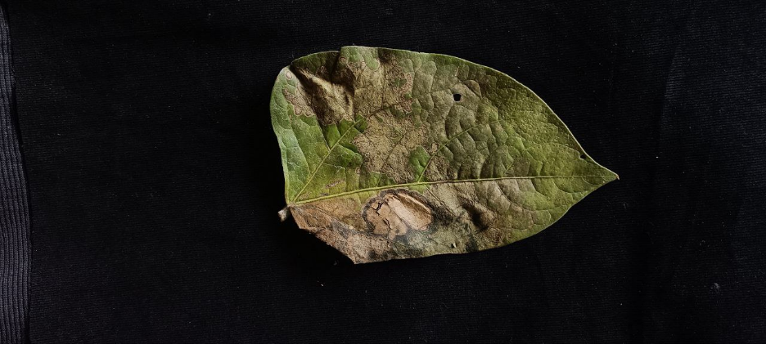
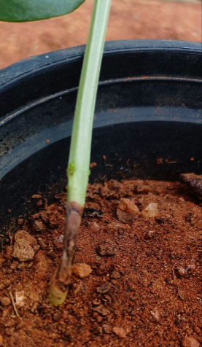
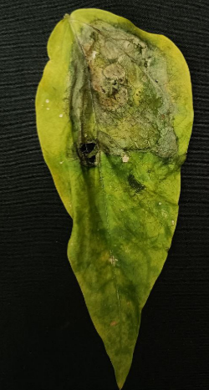

1a. Natural symptoms of web blight of cowpea
1b. Artificially produced symptoms of web blight of cowpea

Fig 1: 1a.natural and 1b.artificial symptoms of web blight in cowpea

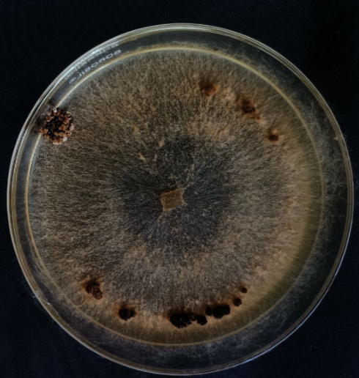
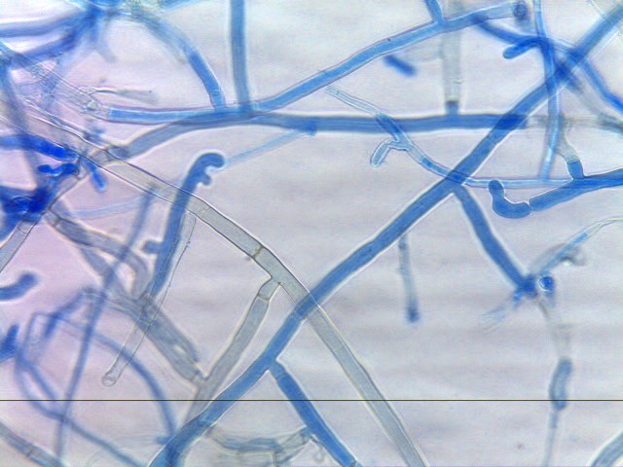

Fig 2: Cultural and morphological characteristics of R. solani

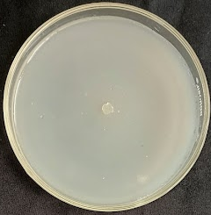
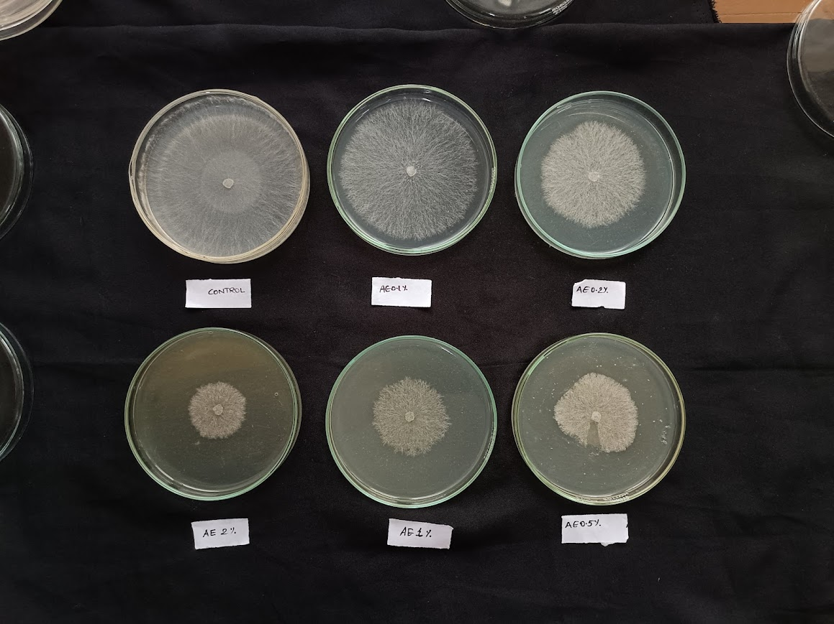
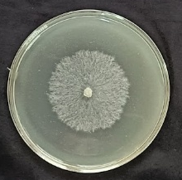
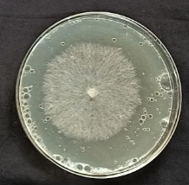
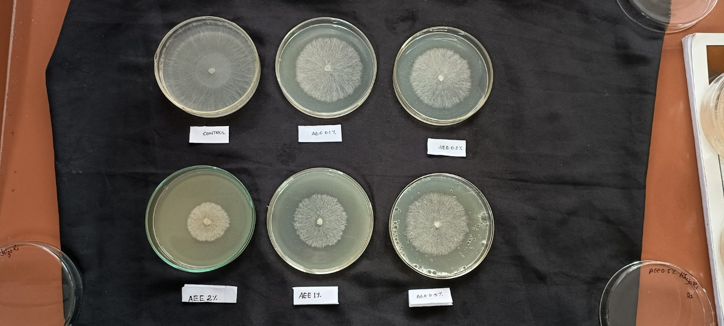
SEE 2%
SEE 1%
Control
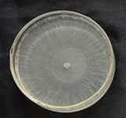

SEE 0.5%
SEE 0.2%
SEE 0.1%
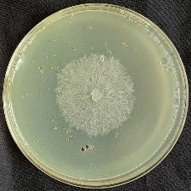
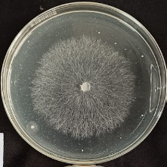
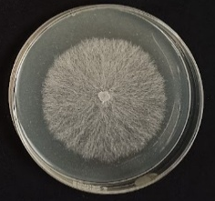
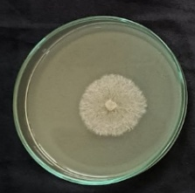

Carbendazim
SEE 0.2%
SEE 0.1%
SAE 2%
SAE 1%
SAE 0.5%

Fig3: in-vitro evaluation of soapnut extract against R. solani

4. discussion
The present study evaluated the antifungal activity of soapnut saponin as a sustainable alternative for managing cowpea web blight causing pathogen. The fruit pericarp extracts exhibited its antifungal activity against R. solani. A comparative analysis of extraction efficiency revealed that the ethanol-based method yielded a substantially higher amount of extract (78.8%) compared to the aqueous method (51.72%), confirming that ethanol is a more effective solvent for extracting the bioactive compounds. All the tested concentrations showed dose dependent inhibition of mycelial growth of the pathogen with highest concentration (2% soapnut ethanol extract) achieving a maximum percentage inhibition of 68.8%. These findings strongly support the potential of soapnut as a natural and effective alternative for managing this significant fungal disease.
Prior to testing, the web blight causing pathogen was isolated and the detailed morphological, cultural characters were studied and compared with standard descriptions. Molecular analysis confirmed its identity as R. solani which is widely recognized as a predominant cause of web blight in legumes across India. Pathogenicity of the isolate was proved using Koch’s postulate. The accurate identification of the specific pathotype is a crucial prerequisite in developing targeted disease management strategies.
The antifungal potential of soapnut revealed in this study is mainly due to the high concentration of saponin content present in the fruit pericarp. As noted by Augustine et al. (2011) and Murgu et al. (2008), the saponin content is the primary driver of soapnut's antifungal properties. Various triterpenoid saponins, including those of the oleanane, dammarane, and tirucallane types, have been identified from the galls, fruits, and roots of Sapindus spp. (Suhagia et al., 2011). Although saponins are distributed throughout different parts of S. mukorossi, their concentration is particularly high in the fruits. Chemically, saponins represent high-molecular-weight secondary metabolites characterized by strong polarity and a wide range of biological activities (Evans, 2009).
Key mechanism involved in the antifungal property of saponin is, it binds to the fungal membrane sterols, ergosterol resulting in the formation of pores in the cell membrane which leads to ions leakage and ultimately disrupting the fungal cell. This mechanism provides a plausible explanation for the significant growth inhibition of R. solani observed at concentrations as low as 0.1%. This aligns with recent findings by Huang et al. (2024), who reported that saponin treatment triggers autophagy-like vacuole formation, disturbs organelle homeostasis, and compromises membrane potential and integrity in B. cinerea. Similar studies conducted by Zou et al., (2025) demonstrated the antifungal activity of soapberry pericarp extracts against Verticillium dahliae and Fusarium oxysporum. As the general fungicidal properties of Sapindus spp. have been previously noted, this study specifically establishes its effectiveness against a virulent and economically important pathogen of cowpea.
Increasing reliance on synthetic fungicides to combat this disease has raised serious concerns regarding their harmful effects on both environmental and human health. Moreover, the increasing use of the chemical fungicides results in residual toxicity, fungicide resistance among pathogens, biodegradable alternative to mitigate these issues. This work represents a crucial step towards developing a sustainable and locally sourced bio-pesticide for the management of cowpea web blight, thereby contributing to both food security and environmental protection.
The current study was limited to in-vitro analysis, the efficiency of the soapnut saponin have to be evaluated under field condition where factors such as sunlight, rainfall, soil microbial activity, and temperature were fluctuating to understand its potential, stability and bioactivity. The impact of soapnut saponin extract on seed germination and plant growth should be thoroughly assessed to determine any potential phytotoxic effects. Therefore, further research is warranted to evaluate its performance through field trials and to identify the optimal application methods. Further purification and chemical characterization of the extract are needed to identify the precise bioactive compounds responsible for the antifungal effect.

5. CONCLUSION
The experimental findings presented the potent antifungal potential of soapnut saponin against R.solani under in-vitro conditions. The observed efficacy provides a strong foundation for the future development of a bio-pesticide. The findings suggest that soapnut extract can serve as a readily prepared and effective antifungal solution for protecting crops, offering a promising, sustainable alternative to synthetic fungicides.

References
- Ddamulira G, Santos CA, Obuo P, Alanyo M, Lwanga CK. (2015). Grain yield and protein content of Brazilian cowpea genotypes under diverse Ugandan environments. Am J Plant Sci., 6(13):2074-84. DOI: 10.4236/ajps.2015.613208
- Abudulai M, Seini SS, Haruna M, Mohammed AM. (2016). Farmer participatory pest management evaluations and variety selection in diagnostic farmer field fora in cowpea in Ghana. Afr J Agric Res.,11(19):1765-71. DOI: https://doi.org/10.5897/AJAR2016.10887
- Kankam, F., Qiu, H., Pu, L., Long, H., Zhang, C., He, J., & Zhang, H. (2016). Isolation, purification and characterization of phytotoxins produced by Rhizoctonia solani AG-3, the causal agent of potato stem canker. Am. J. Potato Res., 93(4), 321–330. DOI: https://doi.org/10.1007/s12230-016-9506-8
- Chapman KS, Sundin GW, Beckerman JL. (2011). Identification of resistance to multiple fungicides in field populations of Venturia inaequalis. Plant Dis., 95(8):921-6. DOI: 10.1094/PDIS-12-10-0899
- Góral, I., & Wojciechowski, K. (2020). Surface activity and foaming properties of saponin-rich plants extracts. Adv. Colloid Interface Sci., 279, 102145. DOI: 10.1016/j.cis.2020.102145
- Upadhyay, A., & Singh, D. K. (2012). Pharmacological effects of Sapindus mukorossi. Rev. Inst. Med. Trop. Sao Paulo, 54, 273–280. DOI: 10.1590/s0036-46652012000500007
- Heng, W., Ling, Z., Na, W., Youzhi, G., Zhen, W., Zhiyong, S., Deping, X., Yunfei, X., & Weirong, Y. (2014). Analysis of the bioactive components of Sapindus saponins. Ind. Crops Prod., 61, 422–429. DOI: 10.1016/j.indcrop.2014.07.026
- Porsche, F. M., Molitor, D., Beyer, M., Charton, S., André, C., & Kollar, A. (2018). Antifungal activity of saponins from the fruit pericarp of Sapindus mukorossi against Venturia inaequalis and Botrytis cinerea. Plant Dis., 102(5), 991–1000. DOI: https://doi.org/10.1094/PDIS-06-17-0906-RE
- Kose, M. D., & Bayraktar, O. (2016). Extraction of saponins from soapnut (Sapindus mukorossi) and their antimicrobial properties. World J. Res. Rev., 2(5), 262952.
- Augustine JM, Kuzina V, Andersen SB, Bak S. (2011). Molecular activities, biosynthesis and evolution of triterpenoid saponins. Phytochemistry, 72(6):435-57. DOI: 10.1016/j.phytochem.2011.01.015
- Murgu, M., Santos, L. F., Souza, G. D., Daolio, C., Schneider, B., Ferreira, A. G., & Rodrigues-Filho, E. (2008). Hydroxylation of a hederagenin-derived saponin by a xylareaceous fungus found in fruits of Sapindus saponaria. J. Braz. Chem. Soc., 19, 831–835. https://doi.org/10.1590/S0103-50532008000500004
- Suhagia, B. N., Rathod, I. S., & Sindhu, S. (2011). Sapindus mukorossi (Areetha): An overview. Int. J. Pharm. Sci. Res., 2(8), 1905. DOI: http://dx.doi.org/10.13040/IJPSR.0975-8232.2(8).1905-13
- Evans, W. C. (2009). Trease and Evans' pharmacognosy (16th ed.). Edinburgh: Elsevier Health Sciences.
- Huang, X., Liu, W., Dong, F., Xu, Y., Tian, S., & Chen, T. (2024). Sapindus mukorossi saponins inhibit gray mold on strawberry fruit by impairing membrane integrity and organellar homeostasis of Botrytis cinerea. Postharvest Biol. Technol., 207, 112594. DOI: 10.1016/j.postharvbio.2023.112594
- Zou, R., Yuan, J., Wang, Y., Peng, X., Ye, T., Han, L., Cheng, Z., & Xie, C. (2025). Antifungal activity of soapberry pericarp extracts: An effective approach against plant pathogenic fungi. Pest Manag. Sci. Advance online publication. https://doi.org/10.1002/ps

