Genetic Divergence and Path Coefficient Analysis for Yield and Related Traits in Finger Millet (Eleusine coracana L. Gaertn.)
Abstract
Finger millet (Eleusine coracana L. Gaertn.) is an important “nutri-cereal” valued for its nutritional richness, climate resilience, and role in food security across Africa and South Asia. The present study assessed genetic variability among fifty-two genotypes during the rabi season of 2020 at RARS, Palem, using fourteen agro-morphological and yield-related traits. Genetic divergence was estimated through Mahalanobis’ D² statistics, and genotypes were grouped into eighteen clusters by Tocher’s method. Wide variability was observed, with the highest intercluster distance observed between Clusters XVIII and XIV (1959.1), suggesting the potential of these genotypes for generating superior recombinants through hybridization. Grain yield, days to 50% flowering, and fodder yield were identified as the major contributors to overall divergence. Path coefficient analysis revealed that the number of productive tillers per plant exerted the highest positive direct effect on grain yield (0.9774), followed by finger width, finger length, and fodder yield, while traits like plant height, earhead length, and finger number contributed negatively. Indirect effects further emphasized the importance of tillering ability and finger traits in yield determination. The findings highlight the presence of substantial genetic diversity and provide a basis for identifying genetically distant parents to broaden the breeding pool. Selection focused on tillering ability, finger morphology, and yield stability can accelerate the development of high-yielding, climate-resilient, and nutritionally enriched cultivars of finger millet, contributing to both sustainable agriculture and nutritional security.
Key words: Finger millet (Eleusine coracana), Genetic divergence, Path coefficient analysis, Grain yield
Introduction
Finger millet (Eleusine coracana L. Gaertn. subsp. coracana) is a self-pollinated cereal belonging to the family Poaceae. It holds global significance as the fourth most important millet crop, after sorghum, pearl millet, and foxtail millet, and is cultivated primarily in Africa and South Asia, where it serves as a dietary staple for millions of people. Archaeological and historical evidence suggests that the crop was domesticated nearly 5,000 years ago in Ethiopia and Western Uganda. Genetically, it is an allotetraploid species (AABB), derived from its wild progenitor E. coracana subsp. africana. Presently, finger millet contributes approximately 11% of total global millet production and occupies about 8% of the total millet-growing area, reflecting its wide adoption and adaptability. Its capacity to thrive under diverse and often marginal agro-climatic conditions makes it an important food security crop, particularly in drought-prone and resource-limited regions. (Joshi et al., 2023)
Nutritionally, finger millet is often described as a “nutri-cereal” because of its dense and balanced composition. It provides 6–8% protein, 15–20% dietary fiber, and 65–75% carbohydrates, along with substantial quantities of micronutrients such as calcium (162–358 mg/100 g), phosphorus (130–283 mg/100 g), zinc (2.3 mg/100 g), and iron (3.3–14.3 mg/100 g). Furthermore, it is a source of vitamins like thiamine, riboflavin, and niacin, as well as complex carbohydrates and non-protein nitrogen compounds. These nutrients enhance its dietary and functional qualities. Unlike staple cereals such as rice and wheat, finger millet is especially rich in dietary fiber and bioactive compounds, which confer multiple health benefits. These include regulating blood glucose levels, reducing the risk of diabetes and cardiovascular diseases, improving digestive efficiency, aiding weight management, and enhancing overall metabolic health. Owing to these attributes, finger millet is being increasingly promoted as a functional food capable of combating malnutrition and lifestyle-related disorders. (Sowunmi et al., 2025, Malleshi et al., 2025, Lansakara et al., 2016)
Beyond its nutritional importance, finger millet also contributes significantly to sustainable agriculture and climate resilience. It thrives in low-input, stress-prone environments and has a natural tolerance to drought, poor soils, and other biotic and abiotic stresses. This resilience underpins its role as a climate-smart crop, aligning with global strategies to adapt agriculture to climate change. Its relevance extends to international development goals, particularly the United Nations’ Sustainable Development Goals (SDGs) of Zero Hunger (SDG 2) and Climate Action (SDG 13). By addressing food insecurity, reducing malnutrition, and performing well in marginal conditions, finger millet plays a dual role in ensuring both human well-being and environmental sustainability. (Kumar et al., 2024; Patil et al., 2023)
A key factor underlying the adaptability and resilience of finger millet is its broad genetic diversity. Variability in agro-morphological and nutritional traits across genotypes provides opportunities for breeders to develop improved cultivars tailored to specific environments and consumer demands. Assessing this diversity is crucial for identifying promising parental lines, improving yield potential, enhancing stress tolerance, and conserving unique genetic resources. Among various multivariate techniques, Mahalanobis’ D² statistics has been recognized as a robust and reliable method for quantifying genetic divergence. By grouping genotypes based on similarity or dissimilarity, D² analysis enables researchers to identify diverse clusters and select genetically distant parents that are likely to produce superior recombinants in breeding programs. (Joshi et al., 2023)
In this context, the present investigation was undertaken to assess the extent and nature of genetic diversity in finger millet genotypes using D² analysis and cluster anslysis and to evaluate the contribution of yield and related traits through path coefficient analysis. T. The study aims to provide insights into the variability present within the crop, thereby supporting future breeding strategies for yield improvement, stress tolerance, and nutritional enhancement, while also contributing to the conservation and effective utilization of finger millet genetic resources.
Materials and methods
The field experiment was conducted during the rabi (Yasangi) season of 2020 at the Regional Agricultural Research Station (RARS), Palem, PJTSAU, to evaluate the extent of genetic diversity among fifty-two finger millet (Eleusine coracana L. Gaertn. subsp. coracana) genotypes. The genotypes were laid out in a randomized block design (RBD) with three replications. Each entry was sown in four rows of 4 m length, spaced at 30 × 10 cm, and managed under recommended agronomic practices, including the application of 50:40:25 NPK kg/ha.
Observations were recorded on five randomly selected plants per plot, excluding border rows to minimize edge effects. Data were collected on fourteen traits: days to 50% flowering, plant height, number of fingers per ear, finger length, finger width, ear head length, flag leaf blade length, flag leaf blade width, peduncle length, number of productive tillers per plant, days to maturity, 1000-seed weight, fodder yield, and grain yield. Phenological traits were recorded on a whole-plot basis, while yield and yield-related traits were measured on sampled plants and converted to per hectare estimates.
Genetic divergence was assessed using Mahalanobis’ D² statistic (Mahalanobis, 1936), and clustering of genotypes was carried out following Tocher’s method (Rao, 1952). Inter- and intra-cluster distances were computed to examine genetic relationships, while the contribution of individual traits to total divergence was estimated from their frequency of ranking first in pairwise comparisons. The significance of genotype differences was tested using Wilk’s criterion (Λ), and cluster diagrams were constructed to illustrate interrelationships among genotypes. In addition, path coefficient analysis was performed to partition genotypic and phenotypic correlations into direct and indirect effects on grain yield, following the approach of Wright (1921) and Dewey and Lu (1959). In this analysis, grain yield was considered the dependent variable, and yield-contributing traits were treated as independent variables. A path diagram was constructed, with single-headed arrows representing direct effects (path coefficients) and double-headed arrows denoting inter-trait correlations.
Results
Path Coefficient Analysis
Path coefficient analysis was conducted to partition correlation coefficients into direct and indirect effects of yield-contributing traits on grain yield. The number of productive tillers per plant exhibited the highest positive direct effect on grain yield (0.9774). Positive direct effects were also recorded for finger width (0.0606), fodder yield per hectare (0.0271), finger length (0.0080), peduncle length (0.0044), and days to 50% flowering (0.0492).
Negative direct effects on grain yield were observed for plant height (–0.0665), number of fingers per ear (–0.0054), and earhead length (–0.0212).
Several traits contributed indirectly to grain yield. Days to 50% flowering exerted indirect effects via plant height, finger number, and finger width. Plant height, despite its negative direct effect, showed positive indirect contributions through test weight and fodder yield. The magnitude of residual effects indicated that the traits considered in the present analysis accounted for the majority of variation in grain yield figure 1 and table 1.
Genetic Divergence Studies
Genetic divergence among 52 finger millet genotypes was estimated using Mahalanobis’ D² statistic based on fourteen morphological and yield-related traits. The analysis revealed significant differences among genotypes table 2 figure 2.
Cluster analysis grouped the genotypes into 18 distinct clusters. Cluster I contained the maximum number of genotypes (20), followed by Cluster II with 8 genotypes. Several clusters (XII, XIV, XVI, XVIII) were monogenotypic. The highest intracluster distance was observed in Cluster VIII (369.25), indicating substantial variability within the cluster.
The maximum intercluster distance was recorded between Cluster XVIII and Cluster XIV (1959.1), followed by Cluster XVIII and Cluster XVI (1577.7). Minimum intercluster distance was noted between Cluster III and Cluster IV (102.6) Figure 3, table 3 and 4.
Trait contribution analysis showed that grain yield, days to 50% flowering, and fodder yield contributed the maximum towards total genetic divergence, as these traits most frequently ranked first in pairwise comparisons figure 4 and table 5.
Discussion
Path Coefficient Analysis
Path coefficient analysis was employed to partition correlation coefficients into direct and indirect effects in order to understand the relative contribution of yield-associated traits to grain yield. The number of productive tillers per plant exhibited the highest positive direct effect on grain yield (0.9774), indicating that tillering ability is the most influential factor determining yield performance. A greater number of productive tillers directly enhances panicle number and seed set, thereby increasing grain yield potential. High direct contributions of tillering ability have also been documented in finger millet and other small millets (Bhavsar et al., 2020, Gohel et al., 2019)
Other traits exerting positive direct effects included finger width (0.0606), fodder yield (0.0271), finger length (0.0080), peduncle length (0.0044), and days to 50% flowering (0.0492). The positive effect of finger width and finger length indicates their contribution to enhanced grain-bearing capacity, as wider and longer fingers provide greater space for seed development. Fodder yield, although primarily associated with biomass, demonstrated a favorable direct effect, supporting the dual-purpose potential of finger millet. Peduncle length, while exhibiting a smaller magnitude of direct effect, influenced yield indirectly through its association with earhead traits.
In contrast, plant height (–0.0665), number of fingers per ear (–0.0054), and earhead length (–0.0212) recorded negative direct effects on grain yield. Excessive plant height can lead to lodging and reduced partitioning efficiency, explaining its unfavorable influence. Similarly, a higher number of fingers per ear may result in intra-ear competition for assimilates, thereby reducing grain filling efficiency. The negative direct effect of earhead length suggests that longer earheads are not always associated with increased productivity, particularly if accompanied by narrow fingers or poor seed setting. Comparable patterns have been reported in other studies on finger millet, where excessive vegetative growth or panicle traits were not positively associated with yield (Lad et al., 2020; Negi et al., 2017).
Indirect effects also played a significant role in determining grain yield. Days to 50% flowering, despite a modest direct effect, contributed favorably through indirect effects mediated by plant height, finger number, and finger width. Plant height, though negatively associated directly, exerted positive indirect effects via test weight and fodder yield. These findings highlight the importance of considering both direct and indirect contributions when formulating selection strategies.
The results indicate that the number of productive tillers per plant is the most reliable selection criterion for yield improvement in finger millet. Secondary contributors include finger width, finger length, and fodder yield. Conversely, excessive plant height, earhead length, and finger number should be managed carefully in breeding programs. These findings reinforce the utility of path coefficient analysis for dissecting complex yield components and prioritizing traits in crop improvement.

Genetic Divergence Studies
Genetic divergence among 52 finger millet genotypes was quantified using Mahalanobis’ D² statistics based on fourteen morphological and yield-related traits. Wilk’s criterion (Λ) confirmed significant multivariate differences, indicating the presence of substantial genetic variability.
Cluster analysis grouped the genotypes into 18 clusters, reflecting wide diversity in the experimental material. Cluster I was the largest, with 20 genotypes, suggesting considerable similarity within this group. Smaller clusters such as XII, XIV, XVI, and XVIII contained few entries, representing genetically distinct lines. The highest intracluster distance was observed in Cluster VIII (369.25), indicating considerable variability within this group and the possibility of effective selection within the cluster itself.
The maximum intercluster distance occurred between Clusters XVIII and XIV (1959.1), followed by Clusters XVIII and XVI (1577.7). Such wide divergence suggests that hybridization between genotypes belonging to these clusters could generate broad variability, heterotic combinations, and transgressive segregants. Intercluster divergence has been widely used as a basis for parent selection in finger millet and other cereals, where crossing distant genotypes results in the expression of novel genetic combinations (Upadhyaya et al., 2006; Devaliya et al., (2018)
Trait contribution analysis indicated that grain yield, days to flowering, and fodder yield were the most influential characters contributing to overall divergence. These traits frequently ranked first in pairwise comparisons, suggesting that variability in these components is the primary driver of genetic diversity. Similar findings were reported by (Jyothsna et al., 2016; Suryanarayana et al., 2019) where grain yield and phenological traits contributed substantially to divergence in finger millet.
The clustering pattern has important implications for breeding. Genotypes from highly divergent clusters, particularly XVIII, XIV, XII, and III, may serve as suitable parents in hybridization programs. Crosses between these groups are expected to enhance variability and increase the likelihood of obtaining superior recombinants. At the same time, intracluster variability, as observed in Cluster VIII, provides opportunities for selection within populations, enabling the identification of high-performing lines without necessarily resorting to intercluster crosses.
From a breeding perspective, genetic divergence studies assist in broadening the genetic base of finger millet, which is critical for developing cultivars suited to diverse agro-ecological regions. In the context of climate change and nutritional security, exploiting divergence is particularly important. Combining genotypes with high tillering ability and yield potential with those possessing enhanced nutritional quality, such as higher calcium or iron content, may result in dual-purpose cultivars capable of addressing both productivity and malnutrition challenges. (Patel et al., 2020)
In summary, the D² analysis demonstrated substantial genetic diversity among the evaluated finger millet genotypes. The identification of distinct clusters, high intercluster distances, and key trait contributors provides valuable guidance for parental selection in breeding programs. Exploiting this diversity can accelerate the development of high-yielding, climate-resilient, and nutritionally enriched cultivars, thereby strengthening the role of finger millet in ensuring food and livelihood security under marginal farming conditions.
Conclusion
The present investigation revealed considerable genetic variability among fifty-two finger millet genotypes, as demonstrated through path coefficient analysis and Mahalanobis’ D² statistics. Path coefficient analysis identified the number of productive tillers per plant as the most important trait exerting a strong positive direct effect on grain yield, supported by secondary contributors such as finger width, finger length, and fodder yield. In contrast, traits like plant height, earhead length, and finger number exerted negative direct influences, underscoring the need to prioritize tillering ability and panicle traits in selection strategies.
Genetic divergence studies classified the genotypes into eighteen clusters, highlighting the presence of wide variability within the material. High intercluster distances, particularly between Clusters XVIII and XIV, indicated substantial genetic divergence, suggesting that hybridization between genotypes from these clusters could generate heterotic combinations and broad variability in breeding populations. Grain yield, days to 50% flowering, and fodder yield were identified as the major contributors to overall genetic divergence, reflecting their importance in driving differentiation among genotypes.
Overall, the findings emphasize the availability of a diverse genetic pool in finger millet that can be effectively exploited for crop improvement. The identification of key yield-determining traits and genetically distant parental combinations provides valuable insights for breeding programs aimed at developing high-yielding, climate-resilient, and nutritionally enhanced cultivars. Such efforts will support sustainable production, nutritional security, and resilience of farming systems in marginal agro-ecological regions where finger millet plays a critical role.

Table 1. Phenotypic Path coefficient values of 14 characters in finger millet
** -Significant at p = 0. 01 * -Significant at p = 0.05, NS = Non significant Bold values are Direct effects Residual effect = 0.222
 | DFF | PH | NF | FL | FW | EHL | FLL | FLW | PL | NPT | DTM | TWT | FY
DFF | 0.0492 | 0.0041 | 0.0029 | -0.0073 | 0.0034 | 0.0016 | 0.0008 | -0.0006 | -0.0004 | 0.0045 | 0.0392 | -0.0042 | 0.0022
PH | -0.0055 | -0.0665 | -0.0277 | -0.0182 | -0.0233 | -0.0079 | -0.0265 | -0.0259 | -0.0277 | -0.0295 | -0.0002 | 0.0183 | -0.0241
NF | -0.0003 | -0.0023 | -0.0054 | -0.0015 | -0.0029 | -0.0016 | -0.0023 | -0.0020 | -0.0022 | -0.0023 | 0.0002 | -0.0007 | -0.0019
FL | -0.0012 | 0.0022 | 0.0022 | 0.0080 | 0.0026 | 0.0028 | 0.0029 | 0.0032 | 0.0016 | 0.0025 | -0.0017 | 0.0005 | 0.0021
FW | 0.0042 | 0.0212 | 0.0319 | 0.0193 | 0.0606 | 0.0380 | 0.0292 | 0.0198 | 0.0169 | 0.0349 | 0.0006 | 0.0138 | 0.0295
EHL | -0.0007 | -0.0025 | -0.0062 | -0.0075 | -0.0133 | -0.0212 | -0.0124 | -0.0086 | -0.0050 | -0.0100 | 0.0014 | -0.0107 | -0.0122
FLL | -0.0005 | -0.0127 | -0.0132 | -0.0114 | -0.0154 | -0.0187 | -0.0320 | -0.0237 | -0.0081 | -0.0151 | 0.0032 | -0.0078 | -0.0153
FLW | 0.0005 | -0.0154 | -0.0148 | -0.0157 | -0.0129 | -0.0161 | -0.0294 | -0.0396 | -0.0089 | -0.0171 | 0.0074 | -0.0060 | -0.0186
PL | 0.0000 | 0.0018 | 0.0018 | 0.0009 | 0.0012 | 0.0010 | 0.0011 | 0.0010 | 0.0044 | 0.0008 | -0.0002 | 0.0004 | 0.0016
NPT | -0.0893 | 0.4330 | 0.4061 | 0.3020 | 0.5630 | 0.4611 | 0.4631 | 0.4214 | 0.1797 | 0.9774 | -0.1068 | 0.1633 | 0.7316
DTM | 0.0437 | -0.0002 | 0.0017 | 0.0118 | -0.0006 | 0.0037 | 0.0056 | 0.0102 | 0.0028 | 0.0060 | -0.0549 | 0.0132 | 0.0098
TWT | 0.0009 | 0.0030 | -0.0014 | -0.0007 | -0.0025 | -0.0055 | -0.0027 | -0.0017 | -0.0010 | -0.0018 | 0.0026 | -0.0110 | -0.0034
FY | 0.0009 | 0.0030 | 0.0096 | 0.0071 | 0.0132 | 0.0156 | 0.0130 | 0.0127 | 0.0101 | 0.0203 | -0.0048 | 0.0085 | 0.0271
GY | 0.0933 | 0.3755 | 0.3873 | 0.2868 | 0.5731 | 0.4528 | 0.4103 | 0.3661 | 0.1622 | 0.9706 | -0.1140 | 0.1779 | 0.7285

DFF – Days to 50% flowering; DTM – Days to maturity; PH – Plant height (cm); NPT – Number of productive tillers per plant; NF – Number of fingers per ear; FL – Finger length; FW – Finger width; EHL – Main ear head length (cm); PL – Peduncle length; FLL – Flag leaf length; FLW – Flag leaf width; TWT – 1000-grain weight (g); FY – Fodder yield per hectare; GY – Grain yield per hectare.

Table 2: Average intra (Bold values) and inter-cluster D2 values for 14 characters in 52 ragi genotypes
 | I | II | III | IV | V | VI | VII | VIII | IX | X | XI | XII | XIII | XIV | XV | XVI | XVII | XVIII
I | 242.8 | 320.4 | 414.2 | 331.8 | 330.4 | 352.1 | 381.4 | 548.5 | 359.8 | 367.4 | 616.7 | 405.3 | 499.5 | 627.9 | 577.2 | 551.5 | 560.5 | 1051.2
II |  | 0.0 | 558.5 | 507.1 | 423.8 | 734.1 | 177.8 | 654.2 | 245.6 | 194.7 | 730.8 | 459.9 | 632.9 | 478.6 | 556.6 | 715.8 | 427.7 | 1077.6
III |  |  | 340.4 | 431.5 | 557.0 | 477.5 | 559.6 | 600.7 | 408.2 | 512.9 | 867.1 | 434.1 | 558.1 | 475.6 | 773.3 | 715.0 | 595.3 | 1195.2
IV |  |  |  | 0.0 | 667.5 | 122.9 | 364.5 | 591.5 | 525.1 | 392.3 | 951.3 | 764.2 | 589.4 | 730.2 | 497.2 | 737.5 | 718.5 | 932.3
V |  |  |  |  | 0.0 | 599.9 | 591.7 | 616.4 | 573.5 | 368.7 | 157.9 | 498.9 | 701.0 | 906.2 | 831.1 | 676.3 | 350.0 | 1027.3
VI |  |  |  |  |  | 0.0 | 646.8 | 702.4 | 686.9 | 610.8 | 867.1 | 660.0 | 500.1 | 911.8 | 568.8 | 591.5 | 962.7 | 926.6
VII |  |  |  |  |  |  | 0.0 | 477.4 | 187.9 | 346.7 | 864.4 | 763.1 | 527.1 | 757.0 | 601.2 | 996.5 | 506.7 | 766.1
VIII |  |  |  |  |  |  |  | 369.2 | 545.3 | 670.0 | 964.2 | 867.1 | 731.4 | 909.9 | 594.7 | 835.8 | 786.0 | 1153.1
IX |  |  |  |  |  |  |  |  | 0.0 | 552.9 | 999.8 | 448.8 | 482.2 | 487.4 | 807.0 | 980.7 | 504.6 | 1159.7
X |  |  |  |  |  |  |  |  |  | 0.0 | 469.3 | 623.7 | 658.3 | 568.4 | 498.0 | 649.9 | 347.6 | 813.0
XI |  |  |  |  |  |  |  |  |  |  | 0.0 | 891.4 | 893.4 | 1482.3 | 1247.3 | 1066.9 | 468.4 | 787.4
XII |  |  |  |  |  |  |  |  |  |  |  | 0.0 | 516.4 | 352.1 | 785.3 | 363.3 | 870.6 | 1550.3
XIII |  |  |  |  |  |  |  |  |  |  |  |  | 309.7 | 856.8 | 620.9 | 656.5 | 1037.8 | 653.3
XIV |  |  |  |  |  |  |  |  |  |  |  |  |  | 0.0 | 680.8 | 597.2 | 881.6 | 1959.0
XV |  |  |  |  |  |  |  |  |  |  |  |  |  |  | 0.0 | 307.0 | 1226.5 | 1138.1
XVI |  |  |  |  |  |  |  |  |  |  |  |  |  |  |  | 0.0 | 1366.5 | 1577.6
XVII |  |  |  |  |  |  |  |  |  |  |  |  |  |  |  |  | 0.0 | 1220.4
XVIII |  |  |  |  |  |  |  |  |  |  |  |  |  |  |  |  |  | 0.0

Table 3. Cluster mean values for 14 characters in 52 ragi genotypes
 | DFF | PH | NF | FL | FW | EHL | FLL | FLW | PL | NPT | DTM | T. WT | FY | GY
I | 73.3 | 97.4 | 7.0 | 6.7 | 0.9 | 6.3 | 28.3 | 0.8 | 11.0 | 2.5 | 106.4 | 2.3 | 48.6 | 24.3
II | 74.9 | 88.0 | 7.0 | 7.0 | 1.1 | 6.3 | 30.7 | 0.9 | 5.9 | 2.4 | 112.3 | 2.0 | 34.8 | 23.4
III | 74.8 | 98.2 | 6.6 | 6.4 | 1.1 | 7.9 | 33.6 | 1.0 | 11.4 | 3.3 | 107.5 | 2.6 | 64.2 | 34.4
IV | 75.4 | 96.7 | 7.5 | 6.9 | 1.0 | 6.6 | 35.0 | 1.0 | 14.5 | 2.8 | 114.0 | 2.2 | 49.2 | 28.1
V | 67.9 | 101.7 | 6.3 | 6.5 | 0.9 | 5.8 | 29.8 | 1.1 | 9.3 | 2.4 | 95.8 | 2.6 | 53.3 | 19.9
VI | 75.8 | 99.8 | 6.7 | 7.0 | 1.0 | 5.6 | 27.9 | 0.9 | 16.0 | 2.5 | 108.1 | 2.5 | 50.1 | 25.3
VII | 72.8 | 81.9 | 8.2 | 7.8 | 1.2 | 7.4 | 34.0 | 1.1 | 8.6 | 2.9 | 104.6 | 2.2 | 46.7 | 28.9
VIII | 73.4 | 83.6 | 7.0 | 7.0 | 1.0 | 9.3 | 34.0 | 1.0 | 11.4 | 2.5 | 104.4 | 3.0 | 58.5 | 24.5
IX | 75.3 | 90.0 | 8.1 | 6.6 | 1.2 | 7.0 | 27.7 | 1.0 | 8.2 | 3.2 | 106.3 | 2.8 | 52.9 | 33.6
X | 73.2 | 107.7 | 7.2 | 8.4 | 0.9 | 7.8 | 42.5 | 1.2 | 9.2 | 2.9 | 106.3 | 2.1 | 50.2 | 28.4
XI | 69.2 | 101.1 | 6.1 | 7.9 | 0.7 | 5.5 | 32.8 | 1.1 | 9.1 | 2.3 | 98.2 | 2.2 | 59.8 | 20.5
XII | 75.3 | 103.9 | 6.0 | 6.9 | 1.2 | 7.5 | 25.3 | 0.9 | 9.0 | 3.1 | 118.6 | 2.1 | 55.4 | 31.1
XIII | 70.9 | 94.2 | 6.8 | 9.4 | 1.1 | 7.5 | 27.6 | 1.1 | 11.5 | 3.2 | 97.8 | 2.5 | 59.3 | 33.7
XIV | 71.2 | 101.7 | 6.0 | 5.5 | 1.1 | 8.5 | 34.5 | 1.0 | 7.8 | 3.4 | 100.8 | 2.6 | 49.3 | 35.5
XV | 71.8 | 93.3 | 5.9 | 8.6 | 0.9 | 8.6 | 34.4 | 1.2 | 11.7 | 2.1 | 102.2 | 2.6 | 34.9 | 19.5
XVI | 67.1 | 107.0 | 5.2 | 8.1 | 1.0 | 8.8 | 30.3 | 0.9 | 12.5 | 2.3 | 94.9 | 2.1 | 47.2 | 21.5
XVII | 80.3 | 105.3 | 8.0 | 6.2 | 1.0 | 6.5 | 42.0 | 1.6 | 8.3 | 2.9 | 112.8 | 2.4 | 60.3 | 29.3
XVIII | 74.3 | 98.2 | 7.8 | 12.8 | 1.2 | 7.9 | 40.2 | 1.4 | 12.5 | 3.5 | 102.8 | 2.8 | 68.5 | 36.2

Table 4: Clustering pattern among 52 ragi genotypes (Tocher’s method) for yield and yield components.
Cluster No. | Number of genotypes | Genotypes included in the cluster
I | 20 | BR 14-2, EG 48, EG 31, PR 1506, PR 1639, EG 66, TNEC 1302, TNEC 1311, OEB 608, PRS 38, VL 399, WN 585, IIMR 18-5725, IIMR R18-5538, BR 14-1, PPR 1091, VR 1099, VR 1125, RAUF 21, RAUF 17,
II | 1 | VL 400
III | 9 | WN 591, BR 14-27, VR 900, VR 1147, VR 1149, VR 1150, VR 1152, VR 1159, HR 13
IV | 1 | PR 1643
V | 1 | PRSW 43
VI | 1 | PPR 1082
VII | 1 | VL 376
VIII | 6 | VR 847, VR 929, VR 1112, PR 202, GPU 45, GPU 67
IX | 1 | VR 1110
X | 1 | VR 1169
XI | 1 | EG 18
XII | 1 | VR 1175
XIII | 3 | VR 1165, VR 1174, WN 559,
XIV | 1 | VR 1146
XV | 1 | VR 1131
XVI | 1 | VR 1113
XVII | 1 | PR 1511
XVIII | 1 | VR 1163

Table 5. Percentage contribution of characters towards total divergence
S.NO | Character Name | Number of times appearing first in ranking | Percentage of contribution
1 | Days to 50% Flowering | - | -
2 | Plant Height (cm) | - | -
3 | Number of Fingers | 202 | 15.23
4 | Finger Length (cm) | 182 | 13.72
5 | Finger Width (cm) | 13 | 0.98
6 | Ear head length (cm) | 139 | 10.48
7 | Flag leaf length (cm) | 167 | 12.59
8 | Flag leaf width (cm) | 18 | 1.35
9 | Peduncle length (cm) | 190 | 14.32
10 | Number of Productive Tillers per plant | 62 | 4.60
11 | Days to maturity | 3 | 0.22
12 | 1000 seed weight (gm) | 26 | 1.96
13 | Fodder yield per hectare | 173 | 13.04
14 | Grain Yield per hectare | 151 | 11.38
 | Total | 1326 | 100.00

Figure 1: Phenotypic path diagram for grain yield and its component traits
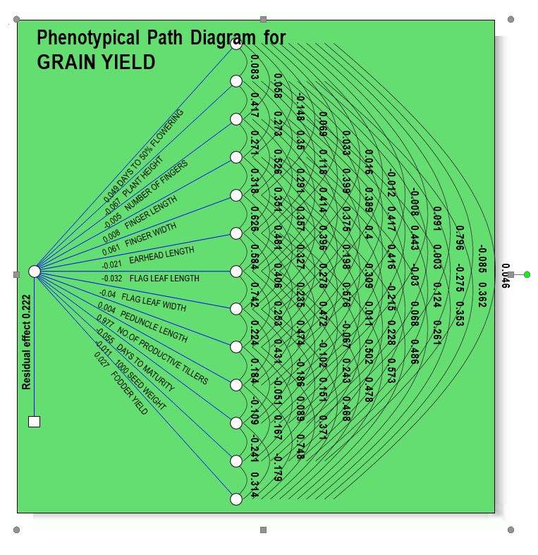

Figure 2: Intra and inter-cluster distance (D2) among eighteen clusters
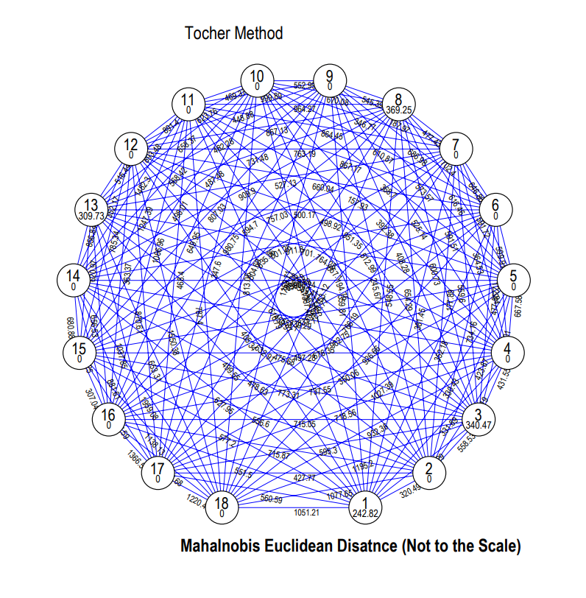

Figure 3: Dendrogram of 52 ragi genotypes constructed using tocher’s method
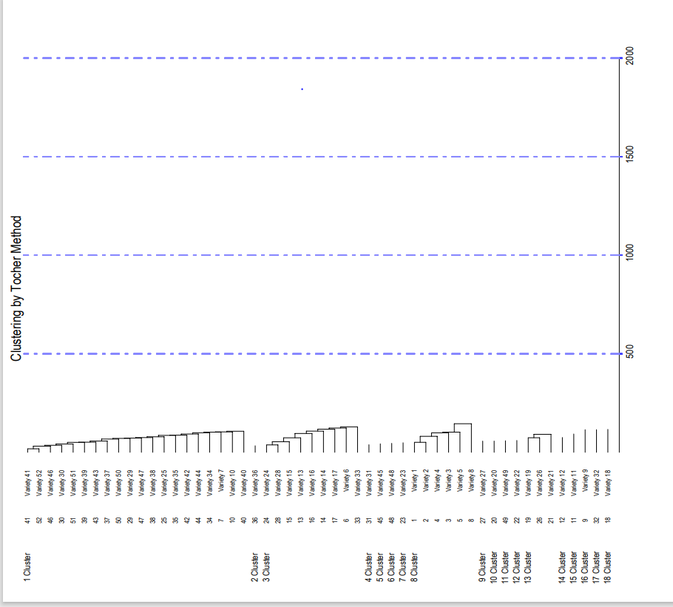

Figure 4: Graphical representation of % contribution towards total divergence
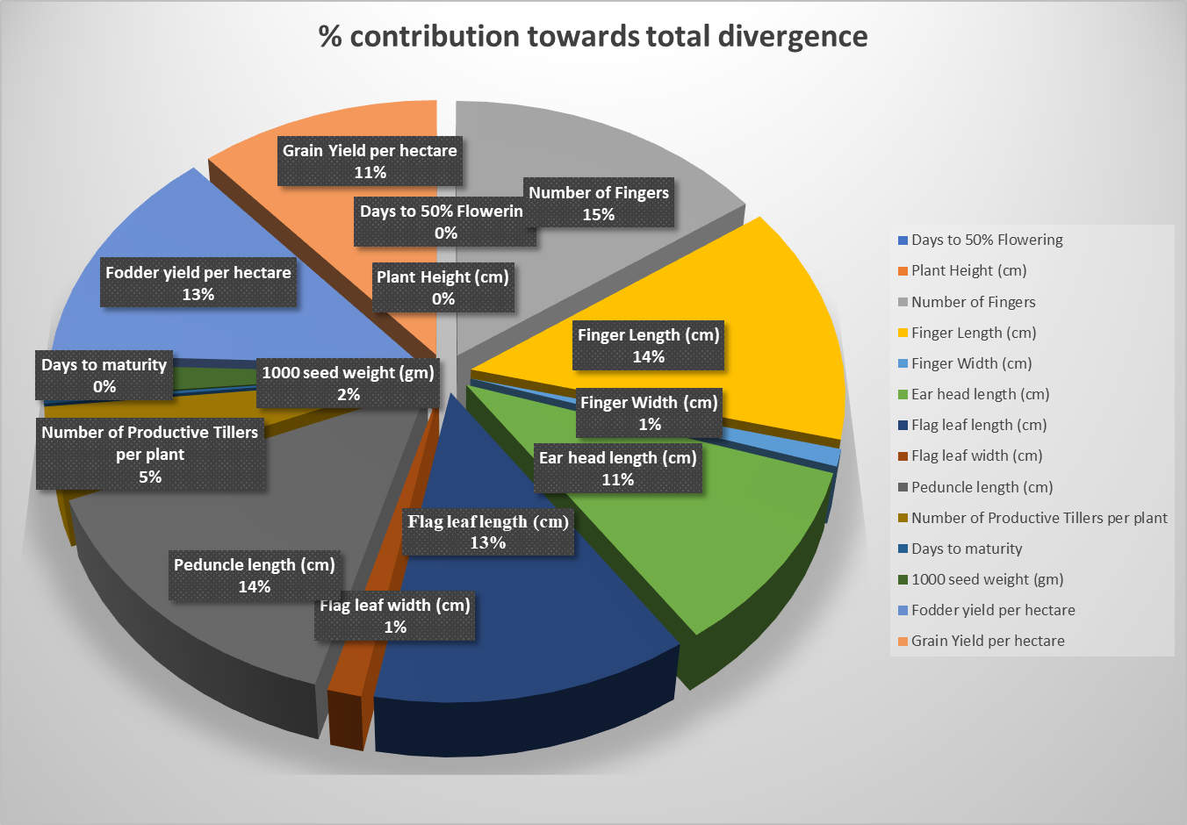

References

Bhavsar, V.V., Sapkal, S.R., Girase, V.S and Barhate, K.K. 2020. Assessment Of Genetic Variability Among Finger Millet Local Germplasm Collected from Diverse Climate. International Journal of Researches in Biosciences, Agriculture and Technology. 64-73.
Devaliya, S.D., Singh, M., Intawala, C.G and Bhagora, R.N. 2018. Genetic Variability Studies in Finger Millet (Eleusine coracana (L.) Gaertn. International Journal of Pure and Applied Bioscience. 6(1): 1007-1011.
Dewey, P.R and Lu, K.H. 1959. A Correlation and path coefficient analysis of components of crested Wheat Grass seed production. Agronomy Journal. 51(9): 515- 518.
Gohel, D.S and Chaudhari, S.B. 2019. Study of correlation and path analysis of finger millet genotypes (Eleusine coracana L. Gaertn). Journal of Pharmacognosy and Phytochemistry. 7(6): 1283-1288.
Joshi, P., Gupta, S.K., Ojulong, H., Sharma, R., Vetriventhan, M., Kudapa, H., Choudhary, S., Naresh, D., Kholova, J. and Sajja, S. 2023. Finger millet improvement in post-genomic era: hundred years of breeding and moving forward. In Smart plant breeding for field crops in post-genomics era (pp. 221-253). Singapore: Springer Nature Singapore.
Jyothsna, S., Patro, T.S.S.K., Ashok, S., Rani, Y.S and Neeraja, B. 2016. Studies on genetic parameters, character association and path analysis of yield and its components in finger millet (Eleusine coracana L. Gaertn). International Journal of Theoretical and Applied Sciences.8(1): 25.
Kumar, A. and Gera, K. 2024. Role of traditional food grains Shri Anna (Millets) in the context of the UN-sustainable development goals (SDG): A review. Res. Jr. Agril. Sci, 15(4), pp.998-1001.
Lad, D.B., Mahalle, S.P and Bade, B.A. 2020. Association of characters and path coefficient analysis for yield and its components in finger millet (Eleusine coracana (L.) Gaertn.) genotypes. Journal of Pharmacognosy and Phytochemistry. 9(5): 599-602.
Lansakara, L.H.M.P.R., Liyanage, R., Perera, K.A., Wijewardana, I., Jayawardena, B.C. and Vidanarachchi, J.K. 2016. Nutritional composition and health related functional properties of Eleusine coracana (Finger Millet). Procedia Food Science, 6, pp.344-347.
Mahalanobis's P.C. 1936. On the generalized distance in statistics. Proc. National Institute of Science, (India). 2: 49-55.
Malleshi, N., Kannan, S., Malleshi, S.N. and Manickavasagan, A. 2025. Finger Millet (Eleusine coracana) Malt: A Comprehensive Review of Its preparation, and Functional Properties, Nutritional Benefits, and Novel Food Product Formulations. Food Reviews International, pp.1-28.
Negi, S., Bhatt, A and Kumar, V. 2017. Character association and path analysis for yield and its related traits in finger millet (Eleusine coracana (L.) Gaertn) genotypes. Journal of Applied and Natural Science. 9(3):1624-1629.
Patel, S., Patil, H.E., Pali, V and Patel, B.K. 2020. Genetic diversity analysis in finger millet [Eleusine coracana (L.) Gaertn.]. Journal of Pharmacognosy and Phytochemistry. 9(1): 677-680
Patil, P.B., Goudar, G., Preethi, K., Rao, J.S. and Acharya, R. 2023. Millets: empowering the society with nutrient-rich superfoods to achieve sustainable development goals. Journal of Drug Research in Ayurvedic Sciences, 8(Suppl 1), pp.S100-S114.
Rao, C.R. 1952. Advanced Statistical Methods in Biometrical Research. John Willy and Sons, Inc., New York. 390.
Sowunmi, L.I., Babalola, Y.O. and Ogunbamowo, P.O. 2025. The Cultivation, Nutritional Polyphenolic Contents, Bioavailability, and Health Benefits of Finger Millet (Eleusine coracana (L.) Gaertn.): An Updated Review. Food Security and Nutrition, pp.97-116.
Suryanarayana, L., Sekhar, D and Rao, N.V. 2014. Genetic variability and divergence studies in finger millet (Eleusine coracana (L.) Gaertn.). International Journal of Current Microbiology and Applied Sciences. 3(4): 931-936.
Upadhyaya, H.D., Gowda, C.L.L., Pundir, R.P.S., Reddy, V.G. and Singh, S. 2006. Development of core subset of finger millet germplasm using geographical origin and data on 14 quantitative traits. Genetic Resources and Crop Evolution, 53(4), pp.679-685.
Wright, S. 1921. Correlation and causation. Journal of Agricultural Research. 20: 557-585.

