An Investigation into the Effectiveness of Termite Mound Soil as a Natural Soil Amendment and Its Role in Promoting Sustainable Plant Growth

Abstract
Termites are ecologically vital insects looking at the role they play within the ecosystem, ranging from environmental modifications to provision of food and playing a vital role in food chain. They are important conditioners of soil, whereby they enhance the nutritional composition of the soil by the activities within and around the mounds. Some of their activities usually affect the soil by improving crop production. With the fast growing population around the globe, and the limited land for farming to support the growing populations, where the land is available, it’s already over stretched due to continues cropping on the land. Termites’ mounds serve as an alternative source of environmentally friendly soil amendment for plant growth. The majority of farming communities across Africa live at a subsistence level, producing just enough to meet their daily needs. Due to poverty and illiteracy, most of the farming communities cannot afford the chemical fertilizers, but with proper education on the nutritional contents of the mounds and its accessibility, it will help the poor farming communities in crop production to support the growing population and to be able to provide a sustainable future for the teeming population around the globe. The study looked at the composition of some macro and micro nutrients present in termite mound soil found in Gashua and its surrounding, soils were collected from different termites mounds from different location for analysis. The analysis revealed no statistically significant differences in the macro and micronutrient composition between soils collected from termite mounds and those obtained from the surrounding environment.

Keywords: Biodiversity, Decomposable, Environmentally Friendly, Termites’ mounds, Chemical Fertilizers, Soil Amendment.

Introduction
Termites are ecologically vital insects looking at the role they play within the ecosystem, ranging from environmental modifications to provision of food and playing a vital role in food chain (Ahmad et al., 2018; Bignell et al., 2010; Maynard et al., 2015). Insects, particularly termites, have long been consumed as food across sub-Saharan Africa, Asia, Australia, and Latin America. Owing to their rich nutritional content, they hold great potential in addressing food security challenges, both in developing and developed nations, by supplying essential nutrients often lacking in many diets (Adepoju, 2020). Termites are also considered as important pests of agriculture, were they damage crops both in the field and in the store (Rouland-Lefèvre, 2011).They are important conditioners of soil, whereby they enhance the nutritional composition of the soil by the activities within and around the mounds (Abe et al., 2000; Deke et al., 2016). Termite activity significantly influences soil health and enhances crop productivity by accelerating organic matter decomposition and facilitating nutrient recycling. Their mounds serve as hubs for nutrient accumulation and redistribution, thereby enriching the surrounding soil environment (Adebajo et al., 2021; Aiki et al., 2024; Chisanga et al., 2020; Tilahun et al., 2012).
With the fast growing population around the globe, and the limited land for farming to support the growing populations. In regions with high population pressure, the scarcity of arable land often shortens or eliminates fallow periods, resulting in declining soil fertility and reduced farm income. In situations where the land is available, it’s nutrients is already depleted due to continues cropping with little to no supplement to address its shortage in nutritional content and in turn affects crop production which affects the growing population (Khan & Ghouri, 2011; Maja & Ayano, 2021). Nearly three-quarters of the Earth’s land surface has been modified in recent decades by human activities such as urbanization, industrialization, and other anthropogenic pressures. These changes, whether direct or indirect, pose serious threats to global sustainability by driving climate change, biodiversity loss, habitat degradation, and reduced food production, all of which are closely linked to land-use change (Lambin & Meyfroidt, 2011; Powers & Jetz, 2019). Human-driven land-use changes are among the leading causes of biodiversity loss, and their impacts are expected to intensify over time (Winkler et al., 2021). Powers and Jetz (2019) An assessment of range-wide habitat suitability and extinction risks for approximately 19,400 species of amphibians, birds, and mammals revealed substantial global declines in suitable habitats. Notably, about 1,700 species are projected to become endangered solely due to land-use change, with Asian and African countries identified as priority regions requiring urgent and proactive conservation measures.
Food scarcity in Africa is largely driven by soil degradation, particularly through the depletion of nutrients and organic matter. Regardless of progress in addressing other contributing factors, agricultural yields will continue to decline unless soil fertility is restored. The situation is further compounded by the limited access to affordable mineral fertilizers, which poses a major challenge for smallholder farmers who constitute the majority of the farming population. Consequently, the use of accessible and cost-effective organic amendments, such as termite mound soil, has been widely recommended as a viable alternative for farmers in rural communities. Termites’ mounds serve as an alternative source of environmentally friendly soil amendment for plant growth. Termite mound were discovered to be accumulating nutrients that are needed for plant growth and development which are deficient in the surrounding soil (Aiki et al., 2024; Chisanga et al., 2020; Pace, 2019; Siame, 2005). Fageria and Baligar (2005), states that, termite mounds are enriched with both macro- and micronutrients as a result of termite bioturbation activities. These processes significantly enhance exchangeable cations such as potassium (K), calcium (Ca), and magnesium (Mg), as well as organic matter, soil pH, and trace elements including iron (Fe), zinc (Zn), and copper (Cu). This enrichment arises from the diverse materials termites collect, ingest, and excrete during feeding and mound construction.
The study, therefore, is to discover the potentials of using termite mound soil as amendments to financially challenged smallholder farmers. The objective of this study was to assess the soil properties of termite mounds in comparison with the surrounding soils. The findings are expected to provide valuable insights for soil nutrient evaluation in agricultural production, particularly from the perspective of smallholder farmers in Africa. We hypothesized that termite mounds contain higher nutrient concentrations than adjacent soils and, therefore, could serve as effective soil amendments in organic matter–deficient soils, thereby enhancing plant growth and overall productivity.
Materials and Methods
Study area
The study was conducted in the Laboratory of the Department of Biological Sciences, Federal University Gashua, Yobe State, Nigeria. Gashua lies within the semi-arid sub-Saharan climatic zone, situated at latitude 12°52′5″N and longitude 11°2′47″E, with an average elevation of 299 m above sea level. The hottest months are March and April, when temperatures range between 38–40 °C. The rainy season extends from June to September, during which temperatures range from 23–28 °C, accompanied by annual rainfall of approximately 500–1000 mm.
Soil analysis and Identification of the Insect
Termite mound soils used for the experiment were collected from various locations within Gashua town and transported to the Biological Sciences Laboratory, Federal University Gashua, Yobe State. The termite species were identified using morphometric keys compiled by Uys (2002). Soil analysis was conducted at the Analytical Chemistry Laboratory, Department of Chemistry, Faculty of Science, Yobe State University, Damaturu. The procedures followed were based on the standard methods established by van Reeuwijk (1998).

Statistical Analysis
A two-way between-groups analysis of variance (ANOVA) was performed to examine the nutritional content of termite mounds in comparison with the surrounding soils. The analysis considered the percentage composition of sand, silt, and clay, as well as key macro- and micronutrients essential for plant growth, including nitrogen (N), phosphorus (P), potassium (K), calcium (Ca), magnesium (Mg), and sodium (Na). Additional soil properties assessed included electrical conductivity (EC), pH, cation exchange capacity (CEC), and organic carbon (OC). All statistical analyses were conducted using IBM SPSS Statistics version 26, with significance set at α = 0.05. Figures were also generated using IBM SPSS Statistics version 26.

Results and Discussion
A two-way between-groups analysis of variance (ANOVA) was conducted to assess the nutritional content of termite mounds in comparison with surrounding soils. The analysis revealed no statistically significant differences between the two groups, with results as follows: Sand (%) = F(1,6)= 1.987, P=0.208, Silt (%) = F(1,6) = 0.460, P = 0.523, Clay (%) = F(1,6) = 2.778, P = 0.147, some of the macro-nutrients also were not statistically significant N = F(1,6) = 4.421, P = 0.080, P = F(1,6) = 2.893, P = 0.140, K = F(1,6) = 0.016, P = 0.902, Ca = F(1,6) = 0.048, P = 0.834, and Mg = F(1,6) = 0.008, P = 0.933 with micro nutrient also following similar tread, with Na = F(1,6) = 0.254, P = 0.632, Other minerals that were explore also includes: EC = F(1,6)= 2.768, P=0. 147, pH = F(1,6)=0.065, P=0.808, CEC = F(1,6) = 0.509, P = 0.502, OC = F(1,6) = 0.083, P = 0.783.

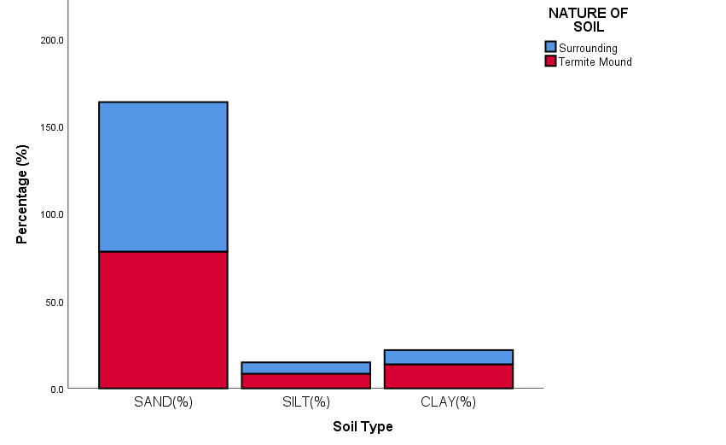
Figure 1: Percentage Composition of Sand, Silt, and Clay in Termite Mound Soil and Adjacent Surrounding Soil.

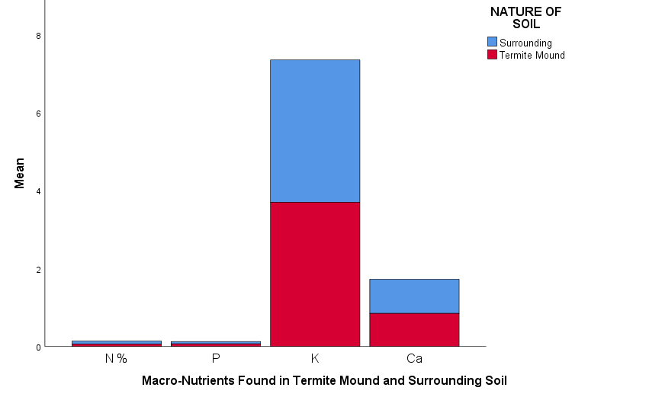
Figure 2: Mean Concentrations of Selected Macro-Nutrients in Termite Mound Soil and Adjacent Surrounding Soil.

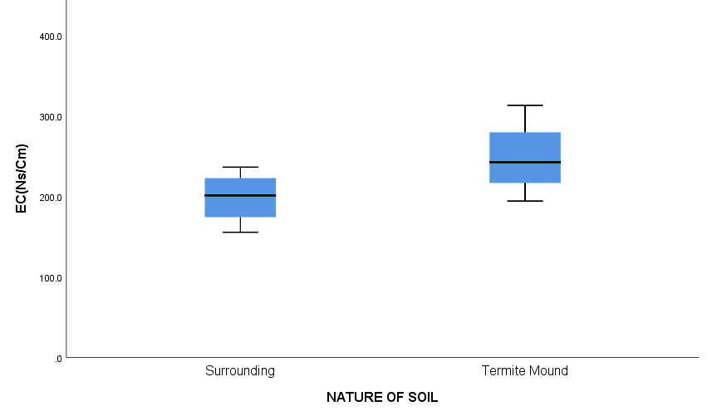
Figure 3: Electrical Conductivity (EC) of Termite Mound Soil and Adjacent Surrounding Soil.

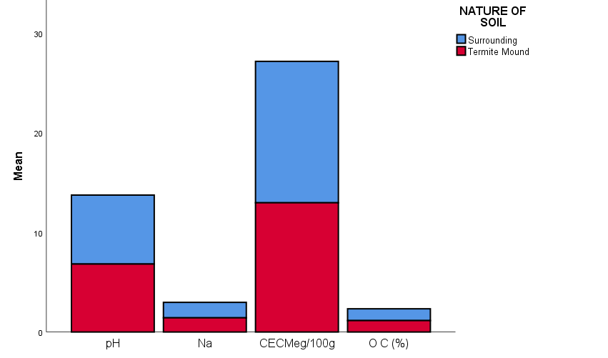
Figure 4: Mean Values of pH, Sodium (Na), Cation Exchange Capacity (CEC), and Organic Carbon (OC) in Termite Mound Soil and Adjacent Surrounding Soil.

The chemical properties of soils are determined by the nature of their parent materials, but largely depend also on the climatic, vegetation cover and the activities of soil organisms (Holt & Lepage, 2000), When termite mounds are situated in areas with dense vegetation cover, a greater quantity of organic residues from leaf litter, roots, and other plant materials becomes available for decomposition. The breakdown of these materials enriches the soil with essential nutrients, thereby enhancing the fertility of the mound. In addition, the interaction between decomposing vegetation and termite bioturbation accelerates nutrient cycling, leading to higher concentrations of organic matter, exchangeable cations, and trace elements. Consequently, mound soils in such locations are often more nutrient-rich than those in sparsely vegetated environments, making them potentially valuable as natural soil amendments for improving crop productivity (Abe et al., 2000; Sugimoto et al., 2000). In addition, termites play a remarkable role in soil modification through their unique construction practices. During mound building, they secrete nutrient-rich saliva and deposit faecal materials, which serve as effective cementing agents that bind soil particles together. These organic inputs are not only structural but also contribute significantly to the enrichment of the soil with essential nutrients. In regions where termite activity is particularly intense, their constant foraging, mixing, and deposition processes can bring about profound alterations in soil chemical properties, thereby influencing soil fertility, nutrient cycling, and overall ecosystem productivity (Holt & Lepage, 2000).
There was no significant difference in all the variables that were analysed from both termite mound soil and the soil from the surrounding environment, this might be due to some factors which determines the accumulation of the nutrients within and around the termites mound, such factors includes the age of the mound, vegetation cover within the environment where the mound was built, and the feeding materials by the termites (Muvengwi & Witkowski, 2020). The accumulation of nutrients within termite mounds is a gradual process which usually takes time, by implication the older the termite mounds the more nutrients in the mounds and its surroundings (Jones et al., 1994; Seymour et al., 2014). Since the age of the mound is a factor to nutrient accumulation within the mound, chances are the sampled mounds are newly established which might have little impact on the nutritional contents of the mounds, the mounds are built from excavation and soils from the environment, therefore it will take a matured or established colonies (mound) to be different from the environment most especially where the soil is deficient, but where the soil is rich both the newly established mound and the surrounding soil will all be rich in nutrient.
Vegetation cover around the mound contribute to a large extend to its nutritional composition, generally nearness to food sources usually determines the nesting site of organisms, termites inclusive. How decomposable are the vegetation cover is also a factor that determines the nutritional content of the mound and its surrounding (Abe et al., 2000; Sugimoto et al., 2000). Termites can also be classified according to their feeding habits, some can feed on vegetation/grasses while others feeds from the fungal garden that is established within their mounds and all this contributes to both macro and micronutrient present in the mound (Donovan et al., 2001; Holt & Lepage, 2000).
Contrary to the findings on the current research, many researchers have reported on the efficacy of termite mounds in crop improvement (Apori et al., 2020; Chisanga et al., 2020; Pace, 2019; Siame, 2005; Subi & Sheela, 2020), which when properly harness will assist in improving the soil of the smallholder farmers who are usually the majority in the farming population. Another factor which might be the reason for the insignificant difference in both the termites mound and the surrounding environment, some mounds are abandoned or empty without activities for sometimes which might lead to depletion in soil nutrient, due to inactivity the nutrients are leached on a daily basis without replacement. All the measured variables presented in Figures 1, 2, 3, and 4 exhibited similar compositions, indicating no significant differences between the termite mound soils and the surrounding soils.
Conclusion : the findings indicate no significant differences in the measured variables, a result that may be attributed to several factors such as the age of the termite mound, the level of termite activity (whether active or abandoned), as well as the feeding habits of the termites and the type of materials they consume. These factors collectively influence the nutrient composition of the mound soil. To effectively use the potential of termite mounds as soil amendments, farmers must take into account the age of the mound, the nature of the feeding materials, and the species of termites involved, as these elements play a crucial role in the decomposition process and the enrichment of nutrients within the mound and its surrounding soils.

Reference
Abe, T., Bignell, D. E., & Higashi, M. (2000). Termites : evolution, sociality, symbioses, ecology. Kluwer Academic Publishers. Table of contents http://catdir.loc.gov/catdir/enhancements/fy0822/00030653-t.html
Adebajo, S. O., Akintokun, P. O., Ezaka, E., Ojo, A. E., Olannye, D. U., & Ayodeji, O. D. (2021). Use of termitarium soil as a viable source for biofertilizer and biocontrol. Bulletin of the National Research Centre, 45, 1-8.
Adepoju, O. T. (2020). Nutrient Composition of Termites. In A. Adam Mariod (Ed.), African Edible Insects As Alternative Source of Food, Oil, Protein and Bioactive Components (pp. 281-291). Springer International Publishing. https://doi.org/10.1007/978-3-030-32952-5_21
Ahmad, S. K., Dawah, H. A., & Khan, M. A. (2018). Ecology of termites. In Termites and Sustainable Management (pp. 47-68). Springer.
Aiki, I. P., Akogwu, S. A., Shindi, H. A., & Aati, R. (2024). Harnessing the Untapped Potential of Termite Mound Soil for the Improvement of the Growth of Sorghum (Sorghum bicolor [L.] Moench). Nigerian Journal of Entomology, 40(1), 80-89. https://doi.org/10.36108/NJE/4202/04.0160
Apori, S. O., Murongo, M., Hanyabui, E., Atiah, K., & Byalebeka, J. (2020). Potential of termite mounds and its surrounding soils as soil amendments in smallholder farms in central Uganda. BMC Research Notes, 13, 1-6.
Bignell, D. E., Roisin, Y., & Lo, N. (2010). Biology of termites: a modern synthesis. Springer Science & Business Media.
Chisanga, K., Mbega, E. R., & Ndakidemi, P. A. (2020). Prospects of using termite mound soil organic amendment for enhancing soil nutrition in Southern Africa. Plants, 9(5), 649.
Deke, A. L., Adugna, W. T., & Fite, A. T. (2016). Soil physic-chemical properties in termite mounds and adjacent control soil in Miyo and Yabello Districts of Borana Zone, Southern Ethiopia. American Journal of Agriculture and forestry, 4(4), 69-74.
Donovan, S., Eggleton, P., & Bignell, D. (2001). Gut content analysis and a new feeding group classification of termites. Ecological Entomology, 26(4), 356-366.
Fageria, N., & Baligar, V. (2005). Properties of termite mound soils and responses of rice and bean to nitrogen, phosphorus, and potassium fertilization on such soil. Communications in soil science and plant analysis, 35(15-16), 2097-2109.
Holt, J. A., & Lepage, M. (2000). Termites and soil properties. In Termites: evolution, sociality, symbioses, ecology (pp. 389-407). Springer.
Jones, C. G., Lawton, J. H., & Shachak, M. (1994). Benthic assemblages associated with rocks in a brackish environment of the southern Baltic Sea. Oikos, 69, 373-386.
Khan, M. A., & Ghouri, A. M. (2011). Environmental pollution: its effects on life and its remedies. Researcher World: Journal of Arts, Science & Commerce, 2(2), 276-285.
Lambin, E. F., & Meyfroidt, P. (2011). Global land use change, economic globalization, and the looming land scarcity. Proceedings of the National Academy of Sciences, 108(9), 3465-3472.
Maja, M. M., & Ayano, S. F. (2021). The impact of population growth on natural resources and farmers’ capacity to adapt to climate change in low-income countries. Earth Systems and Environment, 5(2), 271-283.
Maynard, D. S., Crowther, T. W., King, J. R., Warren, R. J., & Bradford, M. A. (2015). Temperate forest termites: ecology, biogeography, and ecosystem impacts. Ecological Entomology, 40(3), 199-210.
Muvengwi, J., & Witkowski, E. T. (2020). Cascading effects of termite mounds in African savannas. New Zealand Journal of Botany, 58(3), 167-193.
Pace, K. M. (2019). Termite Mound Soil as a Soil Amendment in Eastern Uganda
Powers, R. P., & Jetz, W. (2019). Global habitat loss and extinction risk of terrestrial vertebrates under future land-use-change scenarios. Nature climate change, 9(4), 323-329.
Rouland-Lefèvre, C. (2011). Termites as Pests of Agriculture. In D. E. Bignell, Y. Roisin, & N. Lo (Eds.), Biology of Termites: a Modern Synthesis (pp. 499-517). Springer Netherlands. https://doi.org/10.1007/978-90-481-3977-4_18
Seymour, C., Milewski, A., Mills, A., Joseph, G., Cumming, G., Cumming, D., & Mahlangu, Z. (2014). Do the large termite mounds of Macrotermes concentrate micronutrients in addition to macronutrients in nutrient-poor African savannas? Soil Biology and Biochemistry, 68, 95-105.
Siame, J. (2005). Termite mounds as Fertilizer. LEISA, 7, 27.
Subi, S., & Sheela, A. M. (2020). Review on termite mound soil characteristics and agricultural importance. Journal of Agriculture and Ecology Research International, 21(7), 1-12.
Sugimoto, A., Bignell, D. E., & MacDonald, J. A. (2000). Global impact of termites on the carbon cycle and atmospheric trace gases. In Termites: evolution, sociality, symbioses, ecology (pp. 409-435). Springer.
Tilahun, A., Kebede, F., Yamoah, C., Erens, H., Mujinya, B. B., Verdoodt, A., & Van Ranst, E. (2012). Quantifying the masses of Macrotermes subhyalinus mounds and evaluating their use as a soil amendment. Agriculture, Ecosystems & Environment, 157, 54-59. https://doi.org/10.1016/j.agee.2011.11.013
Uys, V. (2002). A guide to the termite genera of southern Africa. Plant Protection Research Institute, Agricultural Research Council.
van Reeuwijk, L. (1998). Guidelines for quality management in soil and plant laboratories (Vol. 74). Food & Agriculture Org.
Winkler, K., Fuchs, R., Rounsevell, M., & Herold, M. (2021). Global land use changes are four times greater than previously estimated. Nature communications, 12(1), 2501.

