Shelf-Life Evaluation of Green Banana (Musa acuminata cv. Grande Naine) Under Cold Room Storage

Abstract:
Bananas of the variety Grande Naine (G-9) were stored at 13ºC with 95% relative humidity, which was found to be the best condition for keeping their shelf life. The fruits were taken at the green stage-1, treated with 1% Alum and 1% Benomyl for 10 minutes, placed in crates, and stored in the cold room at New Leaf. Under these conditions, the bananas stayed fresh for 12 to 16 days, with an additional 2 to 3 days of life after removal from storage. In normal room conditions, the shelf life was only 4 to 6 days. No chilling injury, decay, crown rot, or stem rot was observed in the cold room during the entire experiment. Overall, storing bananas in the cold room extended their marketable shelf life compared to room conditions.
Keywords: Banana, Grande Naine, Temperature, Relative Humidity, Cold Storage, Alum, Benomyl.
Introduction:
Bananas are an easy and healthy fruit to include in your diet. They are a good source of carbohydrates, vitamins, potassium, soluble fiber, and protease inhibitors, which help fight harmful stomach bacteria. Research has shown that eating bananas regularly supports heart health, controls blood pressure, maintains bone strength, improves vision, aids digestion, and promotes kidney health (Lahav, 1995).
Banana fruit (Musa acuminata) develops improved color, texture, aroma, and sweetness as it ripens after harvest. During summer, bananas ripen faster, while in winter the ripening process is slower. The ripening can be controlled by using different methods to either speed it up or slow it down. Once fully ripe, bananas usually last only about two days before starting to spoil (Hailu et al. 2013).
At present, “Grande Naine” or “G9” is the most widely grown banana variety in India. Crown rot is one of the most serious postharvest diseases in bananas, leading to major losses after harvest. This study examined the effect of Alum (potassium aluminium sulphate) combined with Benomyl on “Grande Naine” bananas stored under cold conditions. Using potassium alum in delatexing baths improves banana quality by reducing latex stains and preventing crown rot (Jadhav et al. 2018).
When banana clusters are cut, latex is released from the wounds. To remove this latex, the clusters are washed in “delatexing baths.” Adding potassium alum to these baths is generally recommended (Anyasi et al. 2013; Gutierrez Gonzalez, 2013). It helps clean off the latex, reduces pathogens in the wash water, maintains the fruits’ cosmetic appearance (Cemanes & Gabornes, 2013), and supports proper healing of the cut surfaces (YaNez et al. 2004; Cemanes & Gabornes, 2013).
Fungal spores can penetrate 5–7 mm deep into the crown tissue, causing infections that are hard to control even with fungicides (Ewane et al. 2012). By regulating temperature and humidity, the respiration rate of banana fruits can be reduced. Low oxygen levels also help prevent spoilage caused by oxidation, which otherwise leads to browning. However, the absence of proper postharvest handling such as washing, sorting, packaging, and chemical treatment is one of the major reasons for heavy losses in bananas. Being highly perishable, bananas have a short shelf life and are prone to significant postharvest losses (De Costa et al. 2005; Venkatesan & Muniyan, 2024). Their market life ranges from 1 to 8 days, depending on the variety, maturity at harvest, and storage conditions.
Ethylene scrubbers are commonly used to delay ripening in bananas. Other techniques to slow ripening include controlling temperature and humidity, using modified atmosphere (MA) storage, removing ethylene, or blocking ethylene activity through chemicals (Ekman et al. 2005). Storage temperature is especially important: high temperatures can cause off-flavors and soft flesh, while very low temperatures below 11ºC can cause chilling injury. On the other hand, low temperatures can also slow fungal growth. In this study, bananas were stored at an optimum temperature of 13ºC.
Materials and Methods:
Banana fruits were collected from Aalegaon, Solapur, Maharashtra, India, and harvested at stage-1 in the early morning. Harvesting was done manually. During harvesting, dehanding was carried out using nylon wire, and the banana hands were placed on banana leaves with the crown facing downward to allow latex to drain. After the latex stopped oozing, the hands were packed in plastic crates with EPE foam to prevent bruising. These crates were transported by truck to the banana pack house, where the fruits were unloaded and sorted based on visual defects, weight uniformity, and shape.
The fruits were handled carefully to avoid abrasion and bruising during transport. After harvest and selection, the bunches were kept in shade for about thirty minutes.
All banana hands were first washed in running water to remove dirt, followed by treatment with 1% alum solution (w/v) for 10 minutes. They were then treated with 1% Benomyl solution for another 10 minutes. Each crown was wrapped with an EPE foam sheet, and the treated fruits were placed in plastic crates (45 × 30 × 20 cm in size, with a capacity of about 14 kg). The crates were stored in a cold room maintained at 13ºC and 95% relative humidity. Observations were recorded for parameters such as total soluble solids (TSS), stem rot, brown spots, chilling injury, crown rot severity, and shelf-life under cold storage conditions.
Result and Discussion:
Table 1. Total soluble solids content inside the cold storage
On days inside cold room | TSS°B
1 | 1.0
4 | 1.0
8 | 1.0
12 | 1.0
16 | 4.2
Graph 1. Total soluble solids content inside the cold storage

Banana fruits stored at 13°C (50°F) with 95% RH showed a TSS value of 1.0% up to 12 days (Table 1 & Graph 1). The TSS content gradually increased from 1.0 to 4.2 °B due to metabolic processes, where carbohydrates such as starch, pectins, and hemicellulose are converted into simple soluble sugars (Hoda et al. 2001; Dhemre & Wasker, 2003). Under the same storage conditions, fruits showed zero stem rot up to 16 days (Table 2). The use of alum helped remove latex from the crown, promoted proper healing of crown wounds, and controlled pathogens in the wash water (Anyasi et al. 2013). Similar results for banana storage were also reported by Jadhav et al. (2018) and Sittiprasert et al. (2025).

Table 2. Stem rot percentage inside the cold storage
On days inside cold room | Stem rot percentage
1 | 0
4 | 0
8 | 0
12 | 0
16 | 0

Banana fruits stored at 13°C (50°F) with 95% RH showed 0% stem rot on days 1, 4, 8, 12, and 16. This indicates that cold storage was very effective in preventing stem rot. The combination of low temperature and high humidity helped suppress the growth of rot-causing microorganisms, maintain tissue firmness and moisture, and prevent postharvest physiological disorders that promote rot (Table 2). Similar results were reported in banana storage by Jadhav et al. (2018).
Table 3. Brown spot percentage inside the cold storage
On days inside cold room | Brown spot percentage
1 | 0
4 | 0
8 | 0
12 | 0
16 | 0

Banana fruits stored at 13°C (50°F) with 95% RH showed 0% brown spots from day 1 to day 16. This indicates that no physiological disorders, such as brown spotting, developed during the entire cold storage period. Brown spots usually result from chilling injury, mechanical damage, or oxidative stress, but the controlled storage conditions prevented these issues. The constant 0% value shows that cold storage effectively maintained the fruits’ external appearance and quality (Table 3). Similar results were reported by Jadhav et al. (2018).
Table 4. Chilling injury percentage inside the cold storage
On days inside cold room | Chilling injury percentage
1 | 0
4 | 0
8 | 0
12 | 0
16 | 0

Banana fruits stored at 13°C (50°F) with 95% RH showed no chilling injury (0%) throughout the 16-day storage period. Chilling injury usually appears as pitting, browning, surface depressions, or internal tissue damage when fruits are stored below their temperature tolerance. The results indicate that 13°C with 95% RH is a safe storage condition for bananas, as no cold-related damage occurred (Table 4). Similar results were reported by Jadhav et al. (2018).
Table 5. Crown rot severity (%) inside the cold storage
On days inside the cold room | Crown rot severity percentage
1 | 0
4 | 0
8 | 0
12 | 0
16 | 0

Banana fruits stored at 13°C (50°F) with 95% RH showed 0% crown rot from day 1 to day 16, meaning no symptoms developed during cold storage. Crown rot usually occurs at the crown (stem end) due to fungal or bacterial infections that spread under unfavorable storage conditions. The absence of crown rot indicates that the cold storage conditions prevented microbial infections, maintained crown tissue integrity, reduced stress-related susceptibility, and helped preserve the marketable appearance of the fruits (Table 5). Crown rot can be caused by a variety of fungi, including Lasiodiplodia theobromae, Colletotrichum musae, Fusarium spp., Verticillium spp., and Cephalosporium spp. (Abd-Alla et al. 2014). Similar results were reported in banana storage by Jadhav et al. (2018).
Table 6. Shelf-life of green stage 1
Shelf-life at Room Temperature | Shelf-life Inside the Cold room
4 to 5 days (Green stage of Harvest) | 12-16 days

Banana fruits stored at 13°C (50°F) with 95% RH had a longer storage life of 12 to 16 days, compared to 3 to 5 days under normal room conditions (Table 6). The visual appearance of the fruits is shown in Figure 1. The optimum storage temperature for bananas is 13–14°C. Fruits stored in plastic crates showed a slight delay in color change (Shaun & Ferris, 1997; Regmi et al. 2024). The change of peel color from green to yellow occurs due to chlorophyll degradation, which is a sign of senescence. This process is influenced by respiration rate, which in turn is controlled by temperature, ethylene, oxygen, and carbon dioxide levels (Valerio-Traya et al. 2002; Sugianti et al. 2022). In the cold room, gas exchange with the surrounding air, as well as CO₂ and O₂ levels around the fruits, likely slowed down the conversion of starch to sugars (Anyasi et al., 2013; Jobling, 2000). Fruits stored under cold conditions maintained a greener peel, showed no chilling injury, no decay, and no crown or stem rot. Low-temperature storage reduces fruit metabolism, delays senescence, and slows down pulp softening, thereby preserving fruit quality.
Figure 1: Interval Day-wise Photographs
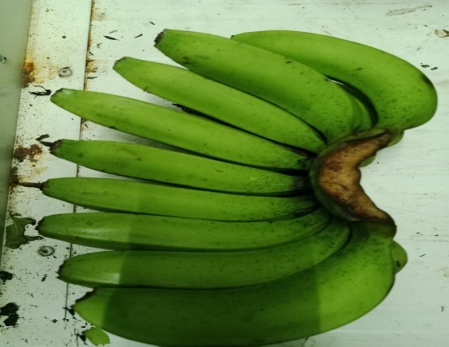 | 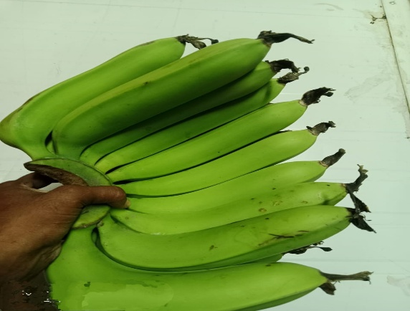
Day-4 (Inside Cold Storage at 13°C & 95% RH)
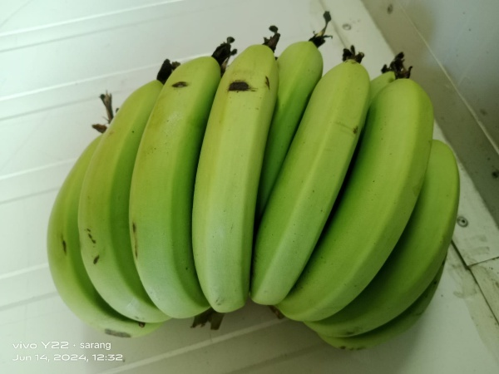 | 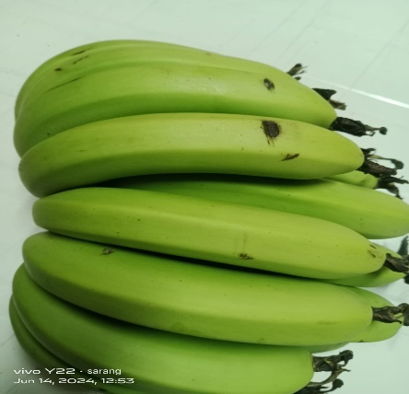
Day-8 (Inside Cold Storage at 13°C & 95% RH)

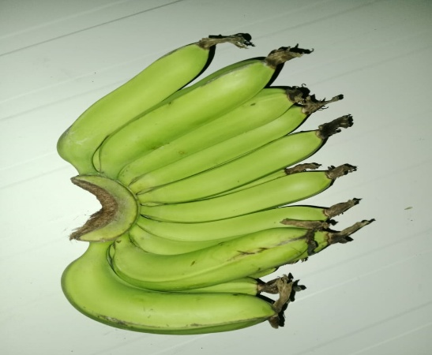 | 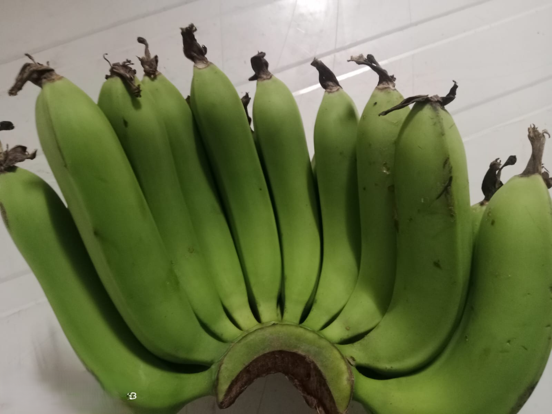
Day-12 (Inside Cold Storage at 13°C & 95% RH)
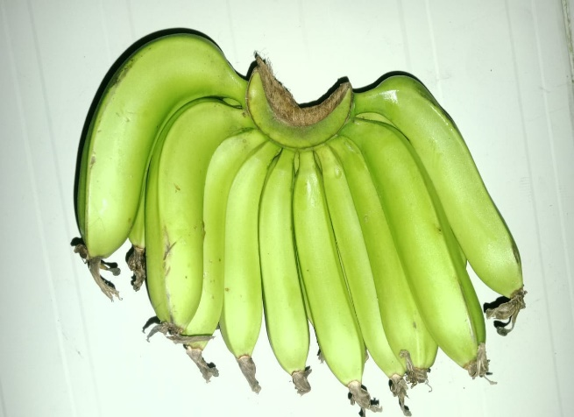 | 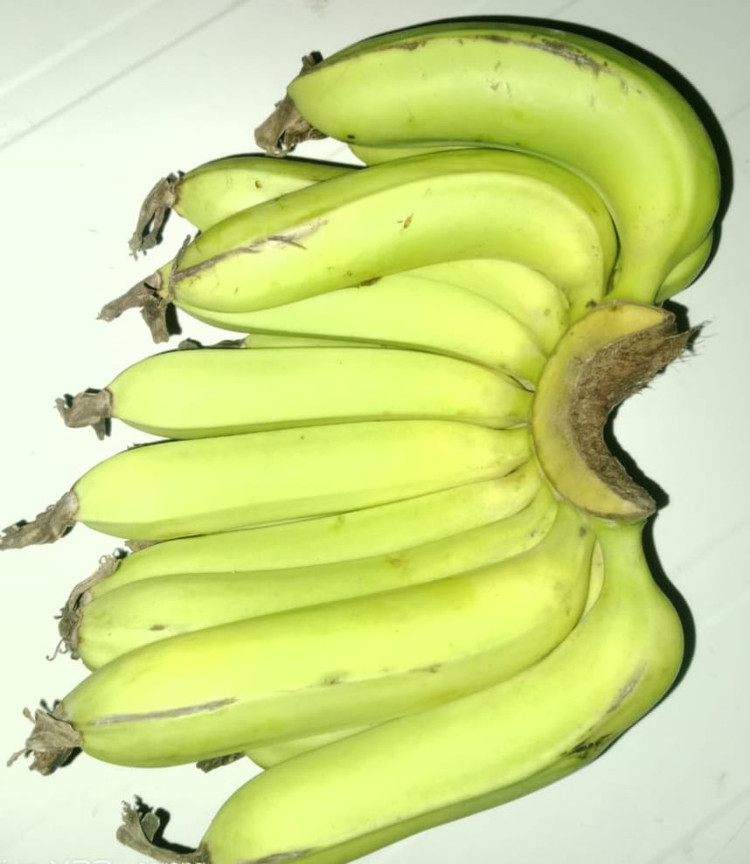
Day-16 (Inside Cold Storage at 13°C & 95% RH)

Figure 2 : Photographs of Stored Bananas in the Cold Room
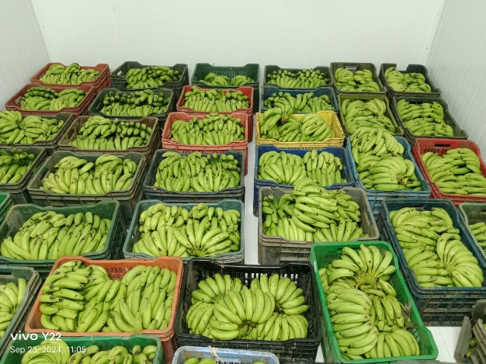 | 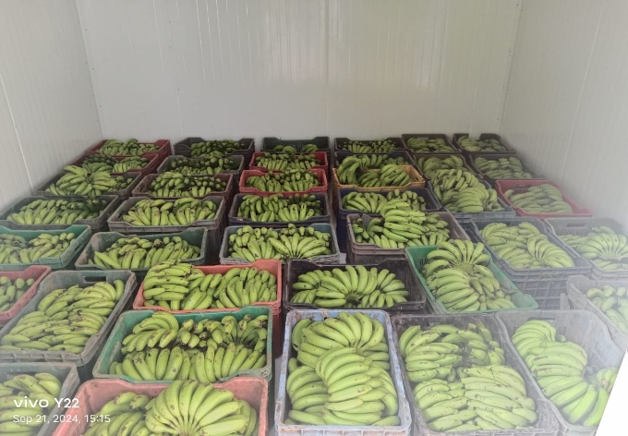

Conclusion:
In conclusion, the visual quality of the fruit is evident from the images collected at various stages of this experiment. This activity establishes that the selected storage conditions have high impact in terms of shelf-life of banana fruit. Alum in combination with 1% Benomyl treatment for 10 minutes individually with proper temperature and RH significantly retains the quality of banana fruit. Post storage life was recorded as 2 - 3 days. The combined treatment and controlled storage condition effectively extended banana shelf life by about 2–3 times compared to ambient storage, while maintaining fruit quality and preventing postharvest losses.

References:

- Abd-Alla, M. A., El-Gamal, N. G., El-Mougy, N. S., & Abdel-Kader, M. M. (2014). Post-harvest treatments for controlling crown rot disease of Williams banana fruits (Musa acuminata L.) in Egypt. Plant Pathology and Quarantine, 4(1), 1-12.
- Anyasi, T. A., Jideani, A. I., & Mchau, G. R. (2013). Functional properties and postharvest utilization of commercial and noncommercial banana cultivars. Comprehensive Reviews in Food Science and Food Safety, 12(5), 509-522.
- Cemanes, M., & Gabornes, P. (2013). Firming and shelf life of tomatoes as affected by alum (Tawas) and lime (Apog) treatment. Leyte National High School, Leyte, Philippines. DOI: http://dx. doi. org/10.2986/tren, 090-0137.
- De Costa, D. M., & Erabadupitiya, H. R. U. T. (2005). An integrated method to control postharvest diseases of banana using a member of the Burkholderia cepacia complex. Postharvest Biology and Technology, 36(1), 31-39.
- Dhemre, J. K., & Waskar, D. P. (2003). Effect of post-harvest treatments on shelf-life and quality of mango in evaporative cool chamber and ambient conditions.
- Ekman, J. H., Golding, J. B., & McGlasson, W. B. (2005). Innovation in cold storage technologies. Stewart Postharvest Review, 1(3), 1-14.
- Ewané, C. A., Lepoivre, P., De Lapeyre de Bellaire, L., & Lassois, L. (2012). Involvement of phenolic compounds in the susceptibility of bananas to crown rot. A review.
- Gutiérrez González, G. (2013). Technical Guide for the Production of Export Bananas in Sudan.
- Hailu, M., Workneh, T. S., & Belew, D. (2013). Review on postharvest technology of banana fruit. African Journal of Biotechnology, 12(7).
- Hoda, M. N., Yadav, G. S., Singh, S., & Singh, J. (2001). Storage behaviour of mango (Mangifera indica) hybrids. The Indian Journal of Agricultural Sciences, 71(7).
- Jadhav, P. B., Gurav, N. P., & More, D. B. (2018). Extending the shelf-life of banana cv.“Grande Naine” using a cold room (Ecofrost). International Journal of Research & Review, 71-75.
- Jobling, J. (2000). Postharvest Ethylene: A critical factor in quality management. Sydney postharvest laboratory information sheet. Sydney Australia.
- Lahav, E. (1995). Banana nutrition. In Bananas and plantains (pp. 258-316). Dordrecht: Springer Netherlands.
- Regmi, P., Bagale, P., Pokhrel, S., & Subedi, D. (2024). Review on: Techniques to maintain quality and post-harvest shelf-life of banana fruits. Tropical Agrobiodiversity, 5(1), 26-29.
- Shaun, R., & Ferris, R. (1997). Improving storage life of plantain and banana: IITA research guide, No. 62.
- Sittiprasert, W., Supapvanich, S., Sinthusamran, S., Nimitkeatkai, H., & Techavuthiporn, C. (2025). Pre-storage anoxia treatment induces physicochemical characteristics of ‘Sucrier’bananas (Musa AA group) in response to postharvest cold storage and subsequent ambient temperature. Postharvest Biology and Technology, 219, 113264.
- Sugianti, C., Imaizumi, T., Thammawong, M., & Nakano, K. (2022). Recent postharvest technologies in the banana supply chain. Reviews in Agricultural Science, 10, 123-137.
- Valerio-Traya, R. F., Lizada, M. C. C., & Esguerra, E. B. (2002, September). Efficacy of different heat treatment procedures in controlling diseases of mango fruits. In VII International Mango Symposium 645 (pp. 551-556).
- Venkatesan, U., & Muniyan, R. (2024). Review on the extension of shelf life for fruits and vegetables using natural preservatives. Food Science and Biotechnology, 33(11), 2477-2496.
- YaÑez, L., Armenta, M., Mercado, E., Yahia, E. M., & Guttierrez, P. (2004). Integral handling of banana. In Production Practices and Quality Assessment of Food Crops: Quality Handling and Evaluation (pp. 129-168). Dordrecht: Springer Netherlands.

