Assessment of Growth and Reproductive performance of Black Bengal goat in field condition

Abstract

The present study was conducted under field condition to investigate the growth performance and reproductive parameters in Black Bengal goats under Semi Intensive system of rearing.A total of 36 numbers of one months old Black Bengal goat were undertaken to see the growth and reproduction performace in field condition in Noney and Haochong village in Tamenglong district of Manipur,Thirtysix numbers of Black Bengal goats were kept at demonstration Farm upto 2months old .After two months all the goats were reared in two feeding regime in field condition .Out of thirtysix goats ,eighteen numbers of goats were reared under semi intensive system and remaining eighteen goats were reared under complete grazing . The body weight at 3,6,9,12 were recorded and reproductive performance viz, age of puberty ,age of kidding were recorded as Average body weight at birth and 12th month were recorded as 1.31$±0.08$ , 1.11$±$0.03 and 14.40$±0.41$, 13.06$±$0.45 respectively for Treatment group and farmers practice.The growth rate was found to be higher in case of treatment group than Farmers practice but there was no significant differences in the growth rate from birth to 12 months of age during reporting period.

Key words; Black Bengal goat, growth, reproductive and field condition

INTRODUCTION

Goat occupies a unique place among domestic livestock because of their ability to survive and produce under extreme climatic and managemental condition. Goat possesses superior efficacy for transforming feed into meat and milk. Goat is very hardy animal and so disease incidence is less. Black Bengal goats (BBG) are very prized small ruminant species because of their potential attributes viz. higher prolificacy, adaptability to wide range of climatic conditions, disease resistivity, early sexual maturity, fertility, fecundity, capacity to utilize and survive in poor natural vegetations, crop residues with or without supplementations, excellent meat and skin quality (Devendra and Burns, 1983),Acharya et.al (1987). Goats are also
considered to be "The Poor Man’s Cow" as it is being small in size; they do not require any large management skills and can easily be handled and managed by women and children. Goat production is a livestock enterprise with least cost input and thus it becomes a choice (naturally) of livelihood option for the rural population by and large. The natural ability of goat to eat a wide variety of vegetation and waste has been a big motivating factor for small, marginal and landless labourers to rear small number of goats (2 to 5 goats per household) for subsidiary income purpose. Due to the hardy nature; resistance to diseases and better adaptability Black Bengal goats can reproduce and thereby thrive well under various type of climatic conditions. They can be reared easily on barren lands; roadsides as well as under intensive or semi-intensive systems. In the villages stall-feeding with grasses available locally from grazing lands or fodder trees are evident. Black Bengal goat is a meat purpose breed commonly found in this region. Therefore, realizing the importance of goat in this region, Black Bengal goat was introduced and productive performance was studied under this agro climatic condition of Tamenglong District.

Materials and Methods:

This study was undertaken in Noney and Haochong village of Tamenglong district for demonstration under FLD programme. during 2023 to 2024 to study the growth and reproductive performance of Black Bengal goat under semi intensive system of rearing. Thirty six numbers of Black Bengal kids at the age of one month sold goats were divided equally into 6(six) groups with having six kids in each group were distributed to six farm woman of Tamenglong district ,considering their age, body weight, body shape and, conformation of the goats. Out of the six numbers of one months old kids, three nos of goats in the ratio of 2:1(female: male) were allowed to rear under semi intensive condition with feed supplementation and 4 hr grazing from 8 am to 12 noon daily and remaining three goats in the ratio of 2:1(female and male) were allowed for grazing from 8.0 am to 5 pm daily without any feed supplementation . The data recording like weight of animals, birth weight and weight at different age were done. Reproductive performance was also recorded. Weaning was practiced at two months of age. Regular deworming was done with broad spectrum anthelmintics.

Selection of experimental goats:

The animals were selected randomly comprising of 36 nos of Black Bengal kids at the age of 2 months and divided equally into 6(six) groups with having 6 kids in each group were distributed to six farm woman ,considering their age, body weight, body shape and, conformation of the goats practiced at two months of age. Regular deworming was done with broad spectrum anthelmintic
Methods of data collection:

The data was collected through door-to-door visit of farmers’ house of the selected villages. Information on body weight at different months and reproductive performances, i.e. body weight at birth, Age at puberty, Age of first kidding, Age at first conception, gestation period, litter size at birth and kid mortality was collected with direct contact of farmers.

Managemental practices
The experimental animals were kept in semi-intensive condition throughout the period of study. The goats were allowed to let loose in the forenoon for 4 hr from 8.00 am to 12.00 noon. Deworming and vaccination were done as per standard schedule. The first group of animals were not supplemented with any sort of concentrate feeds and thereafter they were provided one time with tree leaves, such as mulberry leaves, jackfruit leaves, subabul leaves, chopped maize fodder, banana leaves other locally available leaves and local grasses in a sheltered paddock in the afternoon for 4 hr from 1 pm to 5 pm avail at the indoor condition throughout the experimental period. Clean drinking water was made available ad libitum in all the animals. The experimental goats were provided with night shelter under natural environmental conditions.The remaining group of animals also allow for night shelter in same environment .
Parameter

The following reproductive traits of Black Bengal goats which were considered in this study Body weight at birth within 24 hours of birth was record, body weight at 3,6,9 & 12 months were recorded. The data was collected by digital weighing balance and recorded only those kids which were alive for analysis. Body weight at weaning, Litter size at birth, Gestation period was recorded. In this study reproductive traits of Black Bengal goats in different village condition were recorded.

Result and discussions:

The body weight at 3,6,9 and 12 th month were recorded as 5.83$±0.38,5.12±0.08,7.6±0.07,7.31±0.03,10.57±0.09,10.20±0.04,14.40±0.41,13.06±0.45 respectively in Treatment group and farmers practice respectively$Reproductive performance viz, age of puberty ,age of kidding were recorded as average body weight at birth and 12th month were recorded as 1.31$±0.08$ , 1.11$±$0.03 respectively for Treatment group and farmers practice. Asem Ameeta Devi et .al (2024) reported that male body weight was much higher than female Black Bengal goat from 3rd months till twelve months of age. Patel and Pandey (2013) in Mehsana kids, Usha and Kumaravelu (2020) in Karunkanni kids found the preweaning average daily gain significantly (P < 0.01) higher than the female goat kids. Bharathidhasan et al. (2009) [3] observed that the body weight between single and twin born kids were non-significant as far as twinning percentage is concerned .The growth rate was found to be higher in case of treatment group than Farmers practice but there was no significant differences in the growth rate from birth to 12 months of age during reporting period. Usha and Kumaravelu (2020) observed the birth and weaning weights of Karunkanni kids were 1.60±0.03 kg, 8.32±0.20 kg, respectively and preweaning average daily gain was 74.73±2.17 gm Higher birth weight of males and significant effect of sex on the body weight has been reported by Sheikh et al. (1996) [12] in Changithangi kids, Koratkar et al. (1998) [7] in Osmanabadi kids, Karna et al., (2001)[6] in Cheghu kids

Growth Performance
Growth rate in kids was observed to be moderate, with body weight at 3 months averaging 5.31–6.32 kg, and at 6 months around 7.4–7.72 kg in Treatment group whereas the . These findings are close to those reported by Husain (1999) and Rahman et al. (2018), who highlighted the breed’s adaptability and efficient feed utilization even under low-input systems. Mahfuz S. U et. al (2017 ) highlighted that concentrate feeding upto 300 gm per day got better growth performance in growing Black Bengal goats despite slower growth compared to crossbreds, the meat tenderness and dressing percentage (45–48%) were superior, ensuring higher consumer preference.

Reproductive Efficiency
One of the most important results was the high reproductive efficiency of Black Bengal does was better under semi intensive system of rearing.The average age at first kidding was 12–13 months, with a kidding interval of 180–210 days in treatment group. Prolificacy was remarkable, with twins and triplets accounting for more than 70% of total births. Similar findings were reported by Devendra & Burns (1983), confirming the breed’s role as one of the most prolific goat breeds globally. Usha and Kumaravelu (2020) observed the birth and weaning weights of Karunkanni kids were 1.60±0.03 kg, 8.32±0.20 kg, respectively and preweaning average daily gain was 74.73±2.17 gm.
This high kidding rate ensures regular income generation for rural farmers

Table 1 : Growth performance of Black Bengal goats(Birth to 12 th months) in 3 months interval

Sl.no | Birth weight |  | 3 month |  | 6 month |  | 9 month |  | 12 month
 | T | FP | T | FP | T | FP | T | FP | T | FP
V1 | 1.25 | 1.16 | 5.94 | 5.17 | 7.48 | 7.32 | 10.58 | 10.17 | 13.86 | 12.54
V2 | 1.37 | 1.09 | 5.33 | 5.20 | 7.65 | 7.29 | 10.65 | 10.21 | 14.72 | 13.48
V3 | 1.21 | 1.11 | 5.34 | 5.09 | 7.72 | 7.30 | 10.37 | 10.14 | 13.97 | 13.61
V4 | 1.27 | 1.06 | 5.87 | 5.19 | 7.56 | 7.33 | 10.49 | 10.19 | 13.70 | 12.82
V5 | 1.46 | 1.15 | 6.38 | 4.98 | 7.58 | 7.28 | 10.68 | 10.25 | 14.19 | 13.41
V6 | 1.32 | 1.10 | 6.12 | 5.13 | 7.61 | 7.37 | 10.59 | 10.27 | 14.98 | 12.53
T : Treatment group
FP: Farmers practice
Figure 1.

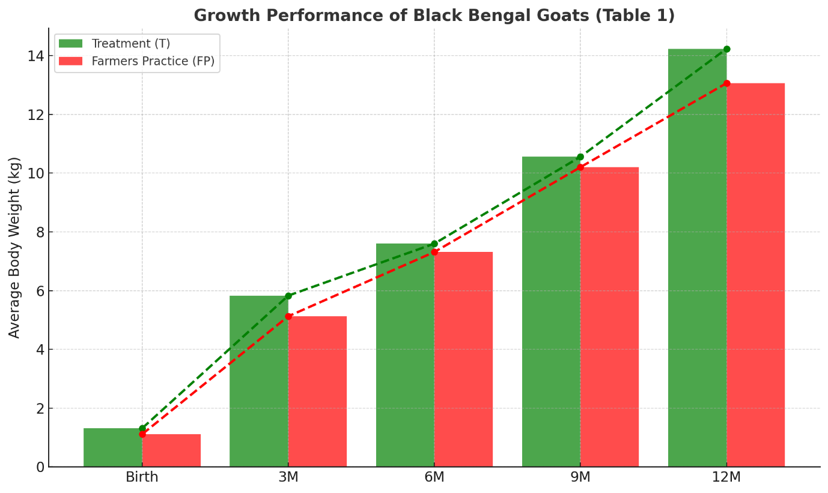

Table 2 Average mean value on body weight gain of Black Bengal goat in different age group

Body weight (kg) | T(Treatment) | Farmers practice
Birth | 1.31$±0.08$ | 1.11$±$0.03
3 months | 5.83$±0.38$ | 5.12$±0.08$
6 months | 7.6$±0$.07 | 7.31$±0.03$
9 months | 10.57$±0.09$ | 10.20$±0.04$
12 months | 14.40$±0.41$ | 13.06$±$0.45

Figure 2.

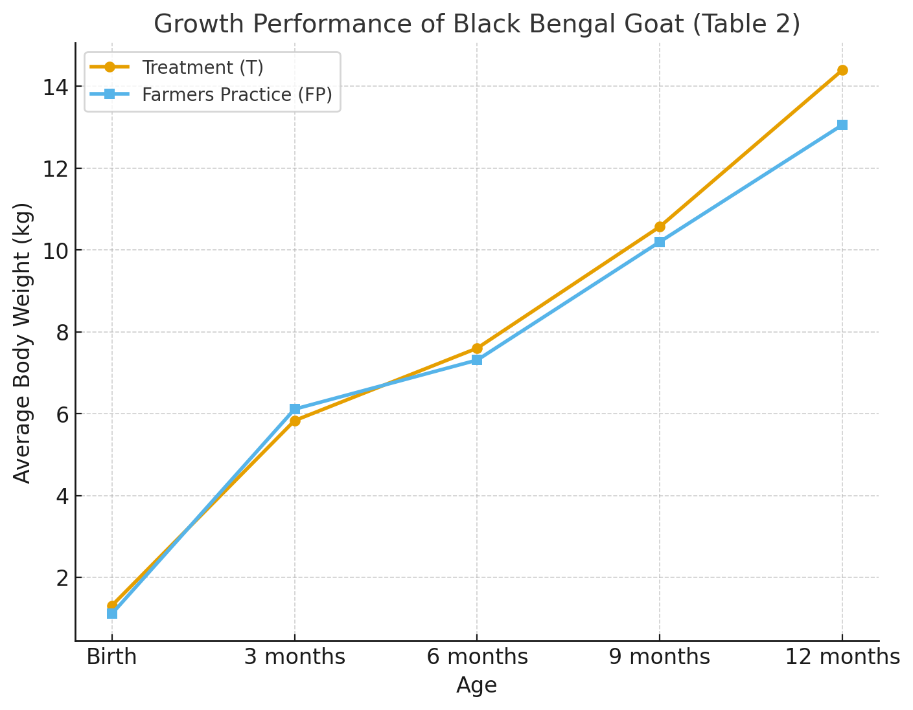

Reproductive Efficiency
The most important results was the high reproductive efficiency of Black Bengal does under semi intensive system of rearing with extra feeding management performed better than rearing in extensive grazing and recorded gestation period as147±0.52 as against of 154±0.35 in grazing without extra feeding other than grazing. . The average age at first kidding was 12–13 months, with a kidding interval of 179–185 days in case of treatment whereas in farmers practice it was recorded as 186-190 .Chakraborti et.al (2022) reported that single born kid was higher body weight than twins in Black Bengal goat. Prolificacy was remarkable, with twins in first groups of goats reared under semi intensive systemSimilar findings were reported by Amin et al. (2000) and Devendra & Burns (1983), confirming the breed’s role as one of the most prolific goat breeds globally. This high kidding rate ensures regular income generation for rural farmers

Table 3 Reproductive traits of Black Bengal goat in different feeding regime

Sl.no. | Avg. Age at puberty  (d) |  | Avg. Age at 1st kidding (d) |  | Avg. Litter size (N) |  | Avg. Kidding interval (d) |  | Avg. Kids mortality |  | Gestation period
 | T | FP | T | FP | T | FP | T | FP | T | FP | T | FP
V1 | 201.58 | 206.22 | 349.27 | 405.63 | 2 | 1 | 184.  25 | 188.35 | 10.24 | 17.53 | 147±0.52 | 154±0.35
V2 | 200.20 | 204.35 | 348.71 | 401.21 | 2 | 1 | 179.  75 | 186.74 | 10.97 | 15.72 | 148±  0.37 | 154±  0.31
V3 | 201.14 | 205.81 | 350.19 | 407.46 | 1 | 1 | 183.  61 | 189.25 | 12.58 | 15.20 | 147±  0.28 | 152±  0.24
V4 | 202.63 | 206.47 | 351.51 | 404.57 | 2 | 1 | 180.  42 | 188.63 | 14.61 | 16.47 | 149±  0.41 | 154±  0.37
V5 | 199.74 | 204.92 | 347.63 | 403.  32 | 2 | 1 | 183.  22 | 187.49 | 11.87 | 17.13 | 148±  0.33 | 153±  0.19
V6 | 200.43 | 205.26 | 347.84 | 405.  11 | 1 | 1 | 184.  67 | 190.73 | 12.68 | 14.67 | 147±  0.45 | 155±  0.27
T : Treatment group
FP: Farmers practice

Figure .3.

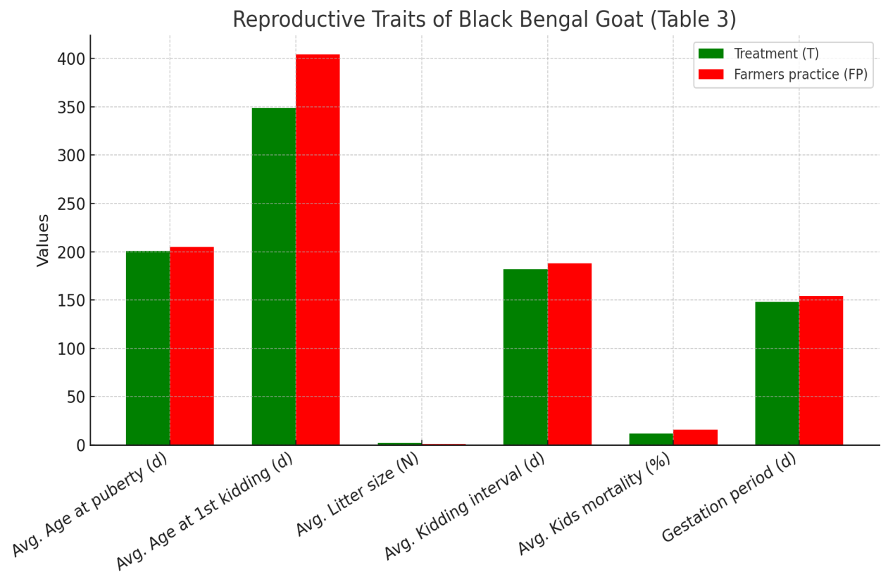

Conclusion

The present study clearly indicates that rearing Black Bengal goats under a semi-intensive system of management with feed supplementation other than grazing has better results in higher growth rate and superior reproductive performance compared to goats allowed only for grazing. Semi-intensive rearing with limited grazing and feed supplementation improved body weight gain, reduced age at puberty and first kidding, shortened kidding intervals, and increased litter size. In contrast, goats managed solely under grazing showed slower growth, delayed reproductive maturity, and higher kid mortality. Therefore, the semi-intensive system proves to be a more efficient and profitable management practice for enhancing productivity and ensuring sustainable goat farming under field conditions.Black Bengal goats can be rear under semi intensive system will get benefit result to marginal farmers in rural areas in north east hill region. The breed significantly contributes to food security, income generation, and poverty alleviation, particularly among marginal and landless households

Reference:

Acharya, R. M. (1987). Livestock Breeds of India. ICAR Publication, New Delhi.
Asem Ameeta Devi Y Prabhabati,Soibam Sinyorita(2024) Growth and reproductive performance of Black Bengal goat in rural area of Chandel District. International journal of Agricultural Science 10( 15740).55-58
Bharathidhasan A, Rita Narayanan R, Gopu P, Subramanian A, Prabakaran R, Rajendran R. Effect of nongenetic factors on birth weight, weaning weight and preweaning gain of barbari goat. Tamil Nadu J Vet. Anim. Sci. 2009;5(3):99-103.
Chakrabarti, RS Godara and Vinay Singh (2022)Pre-weaning growth performance of Black Bengal goat kids in an organized farm in Tripura 022; SP-11(6): 2383-2385
Devendra, C., & Burns, M. (1983). Goat Production in the Tropics. Commonwealth Agricultural Bureaux, England.
Husain, S. S. (1999). Sustainable genetic improvement of economic traits of Black Bengal goats through selective and crossbreeding. Bangladesh Agricultural University Research Progress, 10: 72–80.
Karna DK, Koul GL, Bisht GS. Birth weight, morphometry and relative gain in body weight in Cheghu kids. Indian Journal of Animal Sciences. 2001;71:180- 182
Koratkar DP, Bhoite UY, Deshmukh AK. Factors affecting birth weight in Osmanabadi kids. Indian J Small Ruminants. 1998;4:31-33.
Mahfuz S.U., Islam M.SD., Chowdhury M.R., S.Islam, Hasan M.K., Uddin M.N. (2017). Influence of concentrate supplementation on production and reproduction performance of female Black Bengal goat . Indian Journal of Animal Research. 52(5): 735-739. doi: 10.18805/ijar.v0iOF.8485.

Patel AC, Pandey DP. Growth, Production and Reproduction Performance of Mehsana Goat. J Livestock Sci. 2013;4:17-2.
Paul, S., Khandoker, M. A. M. Y., Moinuddin, M. A., & Paul, R. C. (2011). Characterization of Black Bengal goat. Journal of the Bangladesh Agricultural University, 9(1): 61–66.
Sheikh NA, Ganai TAS, Wani GM.91996) Non-genetic factors affecting body weight of Changithangi goats. Indian J Anim. Sci66:402-404.
Rahman, S., Haldar, A., Mandal, A., & Pan, S. (2018). Growth and reproductive performance of Black Bengal goats under different rearing systems in West Bengal. Indian Journal of Small Ruminants, 24(1): 89–93.
. Usha S, Kumaravelu N. Pre Weaning Growth Performance of Karunkanni Goat Kids in an Organized Farm, Ind. J. Pure App. Biosci. 2020;8(1):45-48. doi: http://dx.doi.org/10.18782/2582-2845.7878. 16.
Yadav JS, Rai B, Singh MK, Yadav MC, Khan BU. Factors affecting body weights at different ages in flock of Kutchi goats. Indian J Small Ruminants. 2003;9:53-55.

