Assessment of molecular diversity among sponge gourd (Luffa cylindrica L.) genotypes using RAPD and SCoT markers

Abstract
Molecular marker analysis can be used to identify and characterize genotypes in sponge gourd, aiding in various breeding applications. Therefore, this study explored the phylogenetic relationships among 26 genotypes of sponge gourd using 6 RAPD and 13 SCoT markers. The RAPD analysis revealed that the genotypes clustered into three major groups in the UPGMA phylogenetic tree, with similarity coefficients ranging from 0.26 to 0.82, indicating a significant level of genetic diversity among the genotypes. Group I comprised 17 genotypes, which were further sub-divided into several sub-groups, while Group II included eight genotypes, with VRSG-140 identified as a distinct outlier. The SCoT analysis yielded two clusters, with similarity coefficients ranging from 0.35 to 0.85, emphasizing substantial level of genetic variation. Notably, VRSG-8 and VRSG-6 formed a monophyletic sub-group within Group I. The highest polymorphic information content (PIC) values were recorded for RAPD-D25 (0.51) and SCoT-25 (0.56), corresponding to polymorphism percentages of 51% and 56%, respectively. These findings highlight the efficacy of these markers in assessing genetic diversity in sponge gourd and further utilization in breeding programme in sponge gourd.

Keywords: Sponge gourd, diversity, RAPD, SCoT

Introduction
The sponge gourd (Luffa cylindrica L.), a member of the Cucurbitaceae family, is a significant vegetable crop with a diploid chromosome number of 2n = 26. It is a tropical plant believed to have originated in India, and is widely grown as a popular spring, summer, and rainy season crop (Kalloo, 1993). The tender, immature fruits are consumed as a vegetable and are known to aid digestion and stimulate appetite when cooked (Okusanya et al., 1981). The fruits can vary in size and shape, being either oblong or club-shaped, and are typically green or dark green. Sponge gourd exhibits substantial variability, with numerous landraces identified in North India and arid regions, displaying diversity in leaf shape, fruit size, shape, colour, and seed colour (Choudhary et al., 2016).
Molecular characterization is crucial for the collection, conservation, and utilization of genetic resources in future breeding programs. Understanding the genetic diversity within a crop species is fundamental to its improvement. Various molecular marker techniques, such as RAPD, ISSR, and SSR, offer significant advantages for species identification, as they are independent of environmental conditions. These methods are rapid, cost-effective, and eliminate the need to grow plants to maturity. As a result, the evaluation of genetic diversity using molecular markers is gaining more attention compared to traditional morphological characterization.
ISSR (Inter Simple Sequence Repeat) is a simple and rapid technique used to assess genetic diversity, genetic mapping, gene tagging, and evolutionary studies, all without requiring prior genome sequence information (Sankar and Moore, 2001). Recently, in addition to random DNA markers, gene-targeted markers have gained prominence. Among these, Start Codon Targeted (SCoT) markers, a novel gene-directed marker, are increasingly applied in cultivar identification, genetic research, and mapping (Luo et al., 2010; Collard and Mackill, 2009).
DNA markers offer several advantages over traditional phenotypic markers, as they provide objective and quantifiable data for analysis. The insights gained from such investigations can play a crucial role in applying molecular markers in the improvement programs of sponge gourd, enhancing breeding strategies and genetic advancement.
In the present investigation, genetic diversity and molecular characterization among sponge gourd genotypes were studied using PCR-based molecular markers to assess genetic purity and discrimination among the genotypes.
Materials and Methods
The experimental material consisted of 26 sponge gourd genotypes, with 8 genotypes available at ICAR-CIAH, Bikaner, 17 genotypes procured from ICAR-IIVR, Varanasi, and 01 genotype obtained from Pusa Sneha (ICAR-IARI, New Delhi). The details of the genotypes are presented in Table 1.
The experiment was conducted at Experimental Farm of ICAR-Central Institute for Arid Horticulture Bikaner, Rajasthan, situated at 28°N latitude and 73°18'E longitude, with an altitude of 234.84 m above sea level. This location falls under the agro-climatic zone of Hyper Arid Partial Irrigated Zone I C. The crop was grown during the kharif season of 2023 using a randomized block design (RBD) with three replications.
Table 1. List of sponge gourd genotypes used in the study
Name of genotype | Source
AHSG-18, AHSG-19, AHSG-21, AHSG-23, AHSG-25, AHSG-28, AHSG-30 and Thar Tapish | ICAR-CIAH, Bikaner
VRSG-3-13, VRSG-4-17, VRSG-5-17, VRSG-6, VRSG-8, VRSG-8-17, VRSG-11, VRSG-13, VRSG-18, VRSG-21-17, VRSG-40, VRSG-50, VRSG-66, VRSG-70, VRSG-73, VRSG-140 and VRSG-154 | ICAR-IIVR, Varanasi
Pusa Sneha | ICAR-IARI, New Delhi
Total genomic DNA was extracted from the young leaves of each genotype using a modified CTAB method, as described by Doyle and Doyle (1987), with minor modifications according to Mohammed et al. (2012). The quantity and quality of the isolated DNA were assessed using a UV-Vis spectrophotometer (LabMate Asia Pvt. Ltd., India) and electrophoretically on 0.8% agarose gel, respectively. Dilutions of 50 ng/μl were prepared for each genotype and used for subsequent PCR analysis. The DNA samples from the 26 genotypes of sponge gourd were analyzed for genetic variability among them using 6 RAPD (Table 2) and 13 SCoT (Table 3) markers. The DNA samples were put forth for PCR followed by gel electrophoresis. After gel electrophoresis, the clear and distinct bands amplified by RAPD and SCoT primers were scored for the presence (1), absence (0) and complete absence (9) of the corresponding bands among the genotypes. The resulting binary data (0, 1 and 9) were analyzed using the Unweighted Pair Group Method with Arithmetic Mean (UPGMA) (Rohlf, 2000) via NTSYSpc version 2.02 and obtained the UPGMA dendrogram (Anderson et al., 1993).
Table 2. RAPD primer used for profiling among genotypes in the present study
S.No. | Primer ID | Sequence (5’-3’) | Tm (ºC)
1. | RAPD D1 | TGCCGAGCTG | 37º
2. | RAPD D7 | TTGGCACGGG | 37º
3. | RAPD D13 | GGGGTGACGA | 37º
4. | RAPD D16 | AGGGCGTAAG | 37º
5. | RAPD D22 | GGGGTGACGA | 37º
6. | RAPD D25 | GGACCCAACC | 37º

Table 3. SCoT primer used for profiling in among genotypes in the present study
S.No. | Primer ID | Sequence (5’-3’) | Tm (ºC)
1. | SCoT 8 | CAACAATGGCTACCACGT | 45º
2. | SCoT 9 | CAACAATGGCTACCAGCA | 45º
3. | SCoT13 | ACGACATGGCGACCATCG | 45º
4. | SCoT 14 | ACGACATGGCGACCACGC | 45º
5. | SCoT 18 | ACCATGGCTACCACCGCC | 45º
6. | SCoT 19 | ACCATGGCTACCACCGGC | 45º
7. | SCoT 20 | ACCATGGCTACCACCGCG | 45º
8. | SCoT 21 | ACGACATGGCGACCCACA | 45º
9. | SCoT 22 | AACCATGGCTACCACCAC | 45º
10. | SCoT 23 | CACCATGGCTACCACCAG | 45º
11. | SCoT 24 | CACCATGGCTACCACCAT | 45º
12. | SCoT 25 | ACCATGGCTACCACCGGG | 45º
13. | SCoT 27 | ACCATGGCTACCACCGTG | 45º

Results and Discussion
To determine the phylogenetic relationships among 26 genotypes of sponge gourd, six RAPD and 13 SCoT markers were analyzed on the genomic DNA of the tested genotypes (Plate 1 & 2). The molecular analysis results revealed that the 26 genotypes were grouped into three major clusters in the UPGMA phylogenetic tree at a similarity coefficient of 0.32 (Fig. 1). The similarity coefficient ranged from 0.26 to 0.82, indicating a substantial level of genetic diversity among the genotypes.
Group I comprised 17 genotypes, further divided into subgroups. The genotypes VRSG-8 and VRSG-6 were clustered into one subgroup, while VRSG-73, VRSG-21-17, AHSG-23, VRSG-66, and Pusa Sneha formed another subgroup. Additionally, VRSG-50, VRSG-11, Thar Tapish, VRSG-8-17, and AHSG-25 were grouped into a separate subgroup.
Group II included 8 genotypes, with VRSG-18, AHSG-19, and VRSG-13 forming one subgroup, and another subgroup consisting of AHSG-30, VRSG-4-17, VRSG-154, VRSG-5-17, and VRSG-70. Group III contained only one genotype, VRSG-140, as an outlier, suggesting that this accession may be more genetically distinct compared to the other 25 genotypes.
The SCoT marker analysis, conducted to determine the phylogenetic relationships among 26 sponge gourd genotypes, produced a UPGMA phylogenetic tree that grouped the genotypes into two distinct clusters. The similarity coefficient ranged from 0.35 to 0.85, reflecting a significant level of genetic diversity among the genotypes (Fig. 2). Group I comprised 25 genotypes, which further divided into several subgroups. Notably, VRSG-8 and VRSG-6 formed a monophyletic group with a similarity coefficient of 0.60. Other subgroups included VRSG-73 and AHSG-21, as well as AHSG-18, AHSG-23, VRSG-21-17, VRSG-66, Thar Tapish, Pusa Sneha, VRSG-50, VRSG-11, VRSG-40, AHSG-28, and VRSG-3-13. Among these, VRSG-66, Thar Tapish, Pusa Sneha, and VRSG-50 formed a monophyletic group at a similarity coefficient of 0.85.
Additionally, AHSG-25, VRSG-5-17, and AHSG-30 formed another subgroup, while VRSG-8-17 and VRSG-18 formed a monophyletic group with a similarity coefficient of 0.65. Genotypes AHSG-19, VRSG-13, and VRSG-70 grouped together, while VRSG-4-17 and VRSG-154 each formed single-genotype groups. Group II consisted solely of VRSG-140, which appeared as an outgroup, suggesting that this genotype is genetically more diverse compared to the other 25.
For both markers analyzed, the sequence (5'-3') was determined along with the PCR annealing temperature. Based on the band scoring data, key parameters such as the total number of bands (TNB), total number of polymorphic bands (TPB), percentage of polymorphism (%P), and polymorphic information content (PIC) were calculated separately for RAPD and SCoT markers, as shown in Table 1 and Table 2. The PIC value, an ideal index for measuring polymorphism, was highest for RAPD-D25 (0.51) and SCoT-25 (0.56).
The percentage of polymorphism in genetic bands was also highest for the RAPD-D25 marker (51%) and the SCoT-25 marker (56%), indicating that these markers exhibited the greatest level of polymorphism, making them the most effective for detecting genetic diversity.
In the dendrogram, values closer to 0 indicate dissimilarity among the genotypes, while values approaching 1 represent similarity or close genetic proximity. In our study, the most significant bifurcations in the phylogenetic tree occurred between similarity coefficients of 0.5 and 1.0, suggesting a substantial level of genetic diversity among the 26 genotypes. Some accessions demonstrated close genetic relationships, such as VRSG-66 and Pusa Sneha, as well as VRSG-73 and VRSG-21-17. However, other accessions, including VRSG-140, VRSG-70, VRSG-13, VRSG-8, and VRSG-6, showed coefficients below 0.5, indicating significant genetic diversity. These genetically diverse accessions may possess unique traits, making them valuable sources for potential breeding programs aimed at crop improvement. These findings align with those of Rathod et al. (2015) and Trivedi et al. (2015) in sponge gourd.
Similarly, in the analysis of 13 SCoT markers, the most pronounced bifurcations in the phylogenetic tree were observed between similarity coefficients of 0.55 and 1.0, indicating a significant level of genetic diversity among the 26 genotypes. Some accessions displayed close proximity, such as VRSG-66 and Thar Tapish, and Pusa Sneha and VRSG-50. Other accessions in close genetic proximity included AHSG-25 and VRSG-5-17, as well as VRSG-13 and VRSG-70. However, VRSG-140, as an outlier, showed a coefficient below 0.5, suggesting greater genetic divergence. Similar findings were reported by Tyagi et al. (2020) in sponge gourd, Abd El-Moneim et al. (2021) in summer squash, Badr and Zaki (2024) in bitter melon, and Ibrahim et al. (2024) in bottle gourd, further supporting the results of the present study.
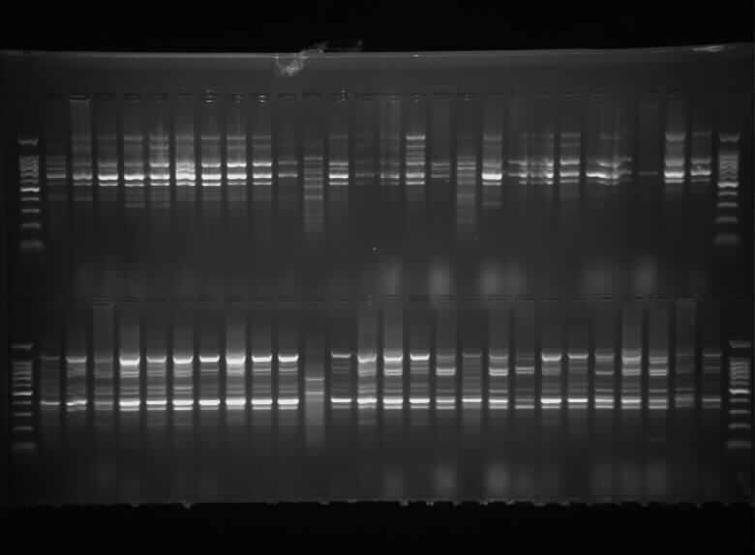
(A). Representative image of the RAPD gel (RAPD D16)
Plate 1. Representative of genetic bands obtained from RAPD markers

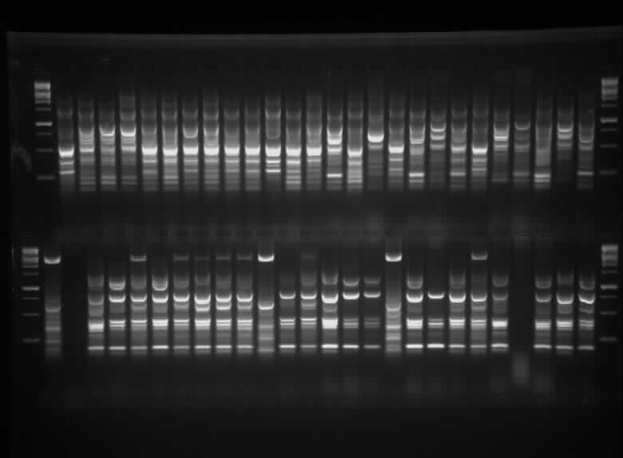
(B). Representative image of the SCoT gel (SCoT 14)
Plate 2. Representative of genetic bands obtained from SCoT markers

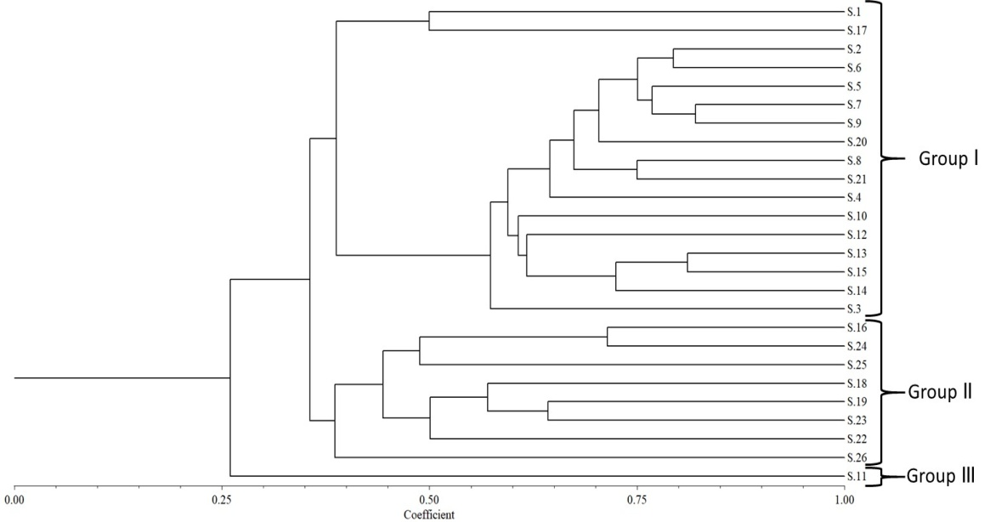
Fig. 1. UPGMA dendrogram showing clustering analysis of 26 genotypes using 6 RAPD markers*

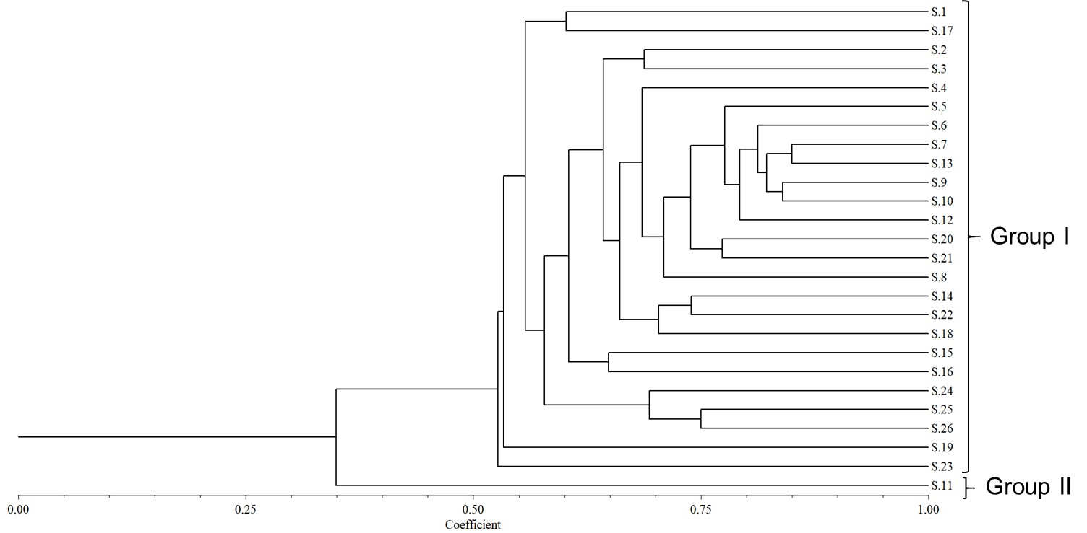
Fig. 2. UPGMA dendrogram showing clustering analysis of 26 genotypes using 13 SCoT markers*
The alpha numerical value of the right side of the dendrogram is indicating the 26 genotypes used in the phylogenetic analysis.
*where,
S.1=VRSG-8 | S.9=Pusa Sneha | S.15=VRSG-8-17
S.17=VRSG-6 | S.10=VRSG-50 | S.16=VRSG-18
S.2=VRSG-73 | S.12=VRSG-11 | S.24=AHSG-19
S.3=AHSG-21 | S.20=VRSG-40 | S.25=VRSG-13
S.4=AHSG-18 | S.21=AHSG-28 | S.26=VRSG-70
S.5=AHSG-23 | S.8=VRSG-3-13 | S.19=VRSG-4-17
S.6=VRSG-21-17 | S.14=AHSG-25 | S.23=VRSG-154
S.7=VRSG-66 | S.22=VRSG-5-17 | S.11=VRSG-140
S.13=Thar Tapish | S.18=AHSG-30

Table 4. Polymorphism analysis of RAPD marker in sponge gourd
S.No. | Primer ID | Sequence  (5’-3’) | Tm (ºC) | TNB | TPB | %P | PIC
1. | RAPD D1 | TGCCGAGCTG | 37º | 10 | 10 | 100 | 0.43
2. | RAPD D7 | TTGGCACGGG | 37º | 9 | 9 | 100 | 0.49
3. | RAPD D13 | GGGGTGACGA | 37º | 9 | 9 | 100 | 0.37
4. | RAPD D16 | AGGGCGTAAG | 37º | 8 | 7 | 87.5 | 0.31
5. | RAPD D22 | GGGGTGACGA | 37º | 8 | 8 | 100 | 0.48
6. | RAPD D25 | GGACCCAACC | 37º | 12 | 12 | 100 | 0.51
Mean |  |  |  | 9.33 | 9.17 | 97.92 | 0.43

Table 5. Polymorphism analysis of SCoT marker in sponge gourd
S.No. | Primer ID | Sequence  (5’-3’) | Tm (ºC) | TNB | TPB | %P | PIC
1. | SCoT 8 | CAACAATGGCTACCACGT | 45º | 12 | 12 | 100 | 0.48
2. | SCoT 9 | CAACAATGGCTACCAGCA | 45º | 9 | 6 | 66.67 | 0.29
3. | SCoT13 | ACGACATGGCGACCATCG | 45º | 13 | 13 | 100 | 0.53
4. | SCoT 14 | ACGACATGGCGACCACGC | 45º | 15 | 15 | 100 | 0.47
5. | SCoT 18 | ACCATGGCTACCACCGCC | 45º | 10 | 10 | 100 | 0.54
6. | SCoT 19 | ACCATGGCTACCACCGGC | 45º | 11 | 10 | 90.91 | 0.33
7. | SCoT 20 | ACCATGGCTACCACCGCG | 45º | 10 | 8 | 80 | 0.39
8. | SCoT 21 | ACGACATGGCGACCCACA | 45º | 9 | 7 | 77.78 | 0.38
9. | SCoT 22 | AACCATGGCTACCACCAC | 45º | 11 | 11 | 100 | 0.54
10. | SCoT 23 | CACCATGGCTACCACCAG | 45º | 11 | 10 | 90.91 | 0.38
11. | SCoT 24 | CACCATGGCTACCACCAT | 45º | 13 | 13 | 100 | 0.41
12. | SCoT 25 | ACCATGGCTACCACCGGG | 45º | 9 | 9 | 100 | 0.56
13. | SCoT 27 | ACCATGGCTACCACCGTG | 45º | 11 | 10 | 90.91 | 0.39
Mean |  |  |  | 11.08 | 10.31 | 92.09 | 0.44

Conclusion
In conclusion, this study effectively elucidated the phylogenetic relationships among 26 genotypes of sponge gourd by employing six RAPD and 13 SCoT markers. The UPGMA phylogenetic trees revealed substantial genetic diversity, with RAPD analysis identifying three distinct clusters and SCoT analysis delineating two clusters among the genotypes. Noteworthy findings included the clustering of specific genotypes, highlighting close genetic relationships, while VRSG-140 emerged as a distinct outlier. The high polymorphic information content of the RAPD-D25 and SCoT-25 markers emphasizes their efficacy in assessing genetic diversity, thereby offering valuable insights for future breeding programs.

References
Abd El-Moneim, D., El, M.A.A.A.B. and Mansy, N.S.A. 2021. Assessment of genetic diversity in summer squash genotypes using some yield traits and DNA markers analysis under Sinai conditions. Journal of Plant Production Sciences, 10(1):13-29.
Anderson, J.A., Churchill, G.A., Sutrique, J.E., Tanksley, S.D. and Sorrels, M.E. 1993. Optimizing parental selection for genetic linkage maps. Genome 36: 181-186.
Arcade, A., Anselin, F., Rampant, P. F., Lesage, M. C., Paques, L. E. and Prat, D. 2000. Application of AFLP, RAPD and ISSR markers to genetic mapping of European and Japanese larch. Theoretical and Applied Genetics, 100:299-307.
Badr, A. and Zaki, H. 2024. Genetic diversity of Citrullus colocynthis populations using phytochemical analysis and SCoT marker variations. Genetic Resources and Crop Evolution, 71(5):2341 2353.
Choudhary, B. R., Haldhar, S. M., Maheshwari, S. K. and Bhargava, R. 2016. Sources of variation in sponge gourd breeding. Journal of Agricultural Engineering and Food Technology, 3(1): 58.
Collard, B. C. and Mackill, D. J. 2009. Start codon targeted (SCoT) polymorphism: a simple, novel DNA marker technique for generating gene-targeted markers in plants. Plant Molecular Biology Reporter, 27:86-93.
Ibrahim, E.A., Alhaithloul, H.A., Shamseldin, S.A., Awaly, S.B., El-Latif Hesham, A., Abdelkader, M.F., Alqahtani, M.M., Alzuaibr, F.M., Alasmari, A., Sukar, N.A. and Diyasty, M. Z. 2024. Morphological, biochemical and molecular diversity assessment of Egyptian bottle gourd cultivars. Genetics Research, 1: 3-13.
Kalloo, G. 1993. Loofah: Luffa spp. In: Genetic improvement of vegetable crops. Pergamon. Pp. 265-266.
Luo, C., He, X. H., Chen, H., Ou, S. J. and Gao, M. P. 2010 Analysis of diversity and relationships among mango cultivars using start codon targeted (SCoT) markers. Biochemical Systematics and Ecology, 38:1176-1184.
Okusanya, O. T., Ola-Adams, B. A. and Bamidele, J. F. 1981. Variations in size, leaf morphology and fruit characters among 25 populations of Luffa aegyptiaca. Canadian Journal of Botany, 59(12):2618-2627.
Rathod, R. R., Mehta, D. R., Gajera, H. P. and Delvadiya, N. A. 2015. Molecular characterization of ridge gourd (Luffa acutangula L.) and sponge gourd (Luffa cylindrica L.) genotypes through PCR based molecular markers. International Journal of Agriculture, Environment and Biotechnology, 8(3): 521-530.
Sankar, A.A. and Moore, G.A. 2001. Evaluation of inter-simple sequence repeat analysis for mapping in Citrus and extension of the genetic linkage map. Theoretical and Applied Genetics, 102: 206-214.
Trivedi, M. K., Branton, A., Trivedi, D., Nayak, G., Gangwar, M. and Jana, S. 2015. Morphological and molecular analysis using RAPD in biofield treated sponge and bitter gourd. American Journal of Agriculture and Forestry, 3(6): 264-270.
Tyagi, R., Sharma, V., Sureja, A. K., Das Munshi, A., Arya, L., Saha, D. and Verma, M. 2020. Genetic diversity and population structure detection in sponge gourd (Luffa cylindrica) using ISSR, SCoT and morphological markers. Physiology and Molecular Biology of Plants, 26:119-131.

