Study of Correlation and Path Coefficient Analysis for Seed Cotton Yield, Yield Attributing and Fibre Quality Traits in Upland Cotton (Gossypium hirsutum L.)

ABSTRACT
The study was conducted with 56 genotypes of cotton in alpha lattice design with two replications at Regional Agricultural Research station, Lam Farm, Guntur during Kharif season 2024. Correlation and path coefficient analysis were worked out for 19 characters among 56 genotypes of upland cotton. Correlation studies revealed that no. of sympodia per plant, no. of bolls per plant, boll weight, seed index, lint index, seed cotton yield per plant at 140 days after sowing, seed cotton yield per plant at 165 days after sowing and oil content recorded significant positive association with total seed cotton yield per plant. Further partitioning of correlation into direct and indirect effects showed that characters no. of sympodia per plant, no. of bolls per plant, lint index, seed cotton yield per plant at 140 days after sowing, seed cotton yield per plant at 165 days after sowing, tenacity value had direct positive effect on total seed cotton yield per plant. Thus, correlation and path analysis clearly indicated that direct selection based on no. of sympodia per plant, no. of bolls per plant, lint index, seed cotton yield per plant at 140 days after sowing, seed cotton yield per plant at 165 days after sowing may be helpful in developing high yielding varieties in upland cotton.

Keywords: Correlation, path coefficient analysis, cotton

- INTRODUCTION
Cotton (Gossypium hirsutum L.), commonly referred to as 'White Gold', is a member of the Malvaceae family and is predominantly cultivated as a fibre crop in tropical and subtropical regions. Cotton enhancement programmes all around the world have always adapted to the demands of the market as suggested by Fayet et al. (2014). Collaborative efforts between farmers and the textile industry have focused on enhancing cotton productivity while preserving good fibre quality. In India, a primary objective is the development of high-yielding cotton varieties with superior fibre characteristics. Many cotton improvement programmes have this as their goal. Among the various cotton species, Gossypium hirsutum contributes to around 90% of global trade, primarily due to its extensively improved modern cultivars. The present study seeks to explore the associations among different yield components and fibre quality traits to support and enhance cotton breeding efforts.
Seed cotton yield in cotton is a complex quantitative trait that is highly influenced by environmental conditions and governed by intricate interactions among multiple yield-contributing characters. The complexity arises from both genetic and environmental factors making direct selection for yield challenging. Hence, analyzing genotypic and phenotypic correlation coefficients among various agronomic traits is essential to elucidate the nature and extent of their association with seed cotton yield. Such information is invaluable for breeders to identify key traits for indirect selection, thereby improving breeding efficiency and enhancing overall productivity in cotton.
In cotton breeding programs, correlation analysis is essential for understanding the associations between yield and fibre quality traits. It also evaluates the relationships among different traits and identifies key component characteristics that can serve as a criteria for selection to enhance seed cotton yield and lint yield (Salahuddin et al., 2010). The correlation between yield and its component traits provides an useful basis for selecting elite genotypes from diverse genetic backgrounds. However, it does not reveal the direct and indirect effects of independent variables on the dependent variable, making path coefficient analysis essential for a deeper understanding (Erande et al., 2014). Path coefficient analysis partition the correlation coefficient into direct and indirect effects. It is conducted to examine how individual component traits influence the dependent variable, specifically seed cotton yield. Analyzing path coefficients allows breeders to focus on traits that have a significant direct impact on seed cotton yield.
2. MATERIAL AND METHODS
The study was conducted during kharif, 2024-25 at Regional Agricultural Research Station, Lam Farm, Guntur, Andhra Pradesh. The experimental material used in the present study comprised of 56 genotypes (G. hirsutum L.) developed in ANGR Agricultural university with different genetic backgrounds. Among the 56 genotypes, NDLH-1938 and NDLH-2035-5 were obtained from RARS, Nandyal while remaining genotypes from RARS, Lam. The experiment was laid in Alpha lattice design with two replications adopting 105x60 cm spacing. To ensure healthy crop stand, recommended agronomic practices and integrated plant protection measures were diligently implemented all through the evaluation time.
Data was recorded for nineteen characters viz., days to 50% flowering, plant height (cm), number of monopodia per plant, number of sympodia per plant, number of bolls per plant, boll weight (g), seed index (g), lint index (g), seed cotton yield per plant (g) at 140 days after sowing, seed cotton yield per plant (g) at 165 days after sowing, total seed cotton yield per plant (g), ginning outturn (%), upper half mean length (mm), micronaire (μg/inch), tenacity (g/tex), uniformity index (%), oil content (%), proline content (%) and seed oil content (%). To evaluate the fibre quality attributes, the seed cotton from the studied plants was mixed, ginned and the resulting lint was analysed. The fibre quality parameters were studied at Central Institute for Research on Cotton Technology (CIRCOT), Regional Unit, RARS, Lam, Guntur, Andhra Pradesh by using HVT Expert 1201 high volume fibre tester instrument. Additionally, the percentage of oil content in cotton seeds was analysed for each sample using Soxhlet apparatus at IIOR, Hyderabad.
The data was statistically analysed to estimate correlation coefficients between different characters as indicated by Johnson et al. (1955). Correlation coefficients were further partitioned into direct and indirect effects by path analysis as suggested by Wright (1921) and Dewey and Lu (1959).

3. RESULTS AND DISCUSSION
3.1 Correlation
Correlation coefficients between total seed cotton yield per plant and other related component characters, as well as among those component characters themselves are estimated and are presented in Table 1. Furthermore, genotypic and phenotypic shaded correlation matrices were visually represented in Fig. 1 and Fig. 2 respectively to provide a clearer understanding of the relationship between the traits. The results indicated that significant positive phenotypic and genotypic association of no. of sympodia per plant (0.534** and 0.602**), no. of bolls per plant ( 0.470** and 0.521**), boll weight (0.691** and 0.784**), seed index (0.473** and 0.563**), lint index (0.266** and 0.287**), seed cotton yield per plant (g) at 140 days after sowing (0.810** and 0.870**), seed cotton yield per plant (g) at 165 days after sowing (0.715** and 0.755**) and oil content (0.198* and 0.205*) with total seed cotton yield per plant (g).
The trait days to 50% flowering had significant positive association with ginning out turn (0.191*) at genotypic level. Similar positive association of days to 50% flowering with ginning out turn was reported by Satish et al. (2020) and Neelam et al. (2002).
The trait plant height had recorded positive and significant association with number of sympodia per plant (0.385** and 0.335**), no of bolls per plant (0.380** and 0.364**), seed index (0.300 ** and 0.267**), seed cotton yield per plant at 165 days after sowing (0.286** and 0.283**) at both genotypic and phenotypic levels. These same results were reported; by Satish et al. (2020) and Jyoti et al. (2021) for no. of sympodia per plant; by Rai and Sangwan (2020) for seed cotton yield per plant, no. of bolls per plant and seed index; by Kadam et al. (2024) for no. of bolls per plant and seed cotton yield per plant.
The trait number of sympodia per plant showed positive and significant association with plant height (0.385** and 0.335**), no. of bolls per plant (0.590** and 0.497**), boll weight (0.353** and 0.261**), seed index (0.445** and 0.346**), lint index (0.264** and 0.230*), seed cotton yield per plant at 140 days after sowing (0.443** and 0.366**), seed cotton yield per plant at 165 days after sowing (0.578** and 0.524**), total seed cotton yield per plant (0.602** and 0.534**) at both genotypic and phenotypic levels whereas, positive and significant association with micronaire (0.263**) at genotypic level. Similar results were reported; by Rao and Gopinath (2013), Erande et al. (2014), Majeedano et al. (2014), Farooq et al. (2014), satish et al. (2020) and Kadam et al. (2024) for no. of bolls per plant; by Jyoti et al. (2021) for plant height.
The trait no. of bolls per plant showed significant and positive association with plant height (0.380** and 0.364**), no. of sympodia per plant (0.590** and 0.497**), seed index (0.309** and 0.279**), seed cotton yield per plant at 140 days after sowing (0.406** and 0.381**), seed cotton yield per plant at 165 days after sowing (0.391** and 0.374**) and total seed cotton yield per plant (0.521** and 0.470**) at both genotypic and phenotypic levels. Similar results were recorded by Rai and Sangwan (2020) for plant height and seed cotton yield per plant; by Kadam et al. (2024) for plant height, no. of sympodia per plant; by Balcha et al. (2024) for tenacity.
The trait boll weight had significant and positive association with no. of sympodia per plant (0.353** and 0.261**), seed index (0.498** and 0.433**), lint index (0.220* and 0.201*), seed cotton yield per plant at 140 days after sowing (0.644** and 0.607**), seed cotton yield per plant at 165 days after sowing (0.579** and 0.502**), total seed cotton yield per plant (0.784** and 0.691**) at both genotypic and phenotypic levels. Similar reports were reported by Kumar et al. (2014), Ranjan et al. (2014), Rajamani et al. (2013), Satish et al. (2020), Rai and Sangwan (2020), Amein et al. (2020) for seed index; by Kadam et al. (2024) for seed cotton yield per plant.
The trait lint index had significant and positive association with seed index (0.568** and 0.555**), boll weight (0.220* and 0.201*), no. of sympodia per plant (0.264** and 0.230*), ginning out turn (0.794** and 0.722**), seed cotton yield per plant at 165 days after sowing (0.455** and 0.422**) and total seed cotton yield per plant (0.287** and 0.266**) at both genotypic and phenotypic levels. These results were in agreement with Amein et al. (2020) and Kadam et al. (2024) for seed index; Jyoti et al. (2021) for seed index and ginning out turn.
The trait ginning out turn showed significant and positive association with lint index (0.794** and 0.722**), micronaire (0.266** and 0.217*) at both genotypic and phenotypic levels whereas, significant and positive association with days to 50% flowering (0.191*) and no. of monopodia per plant (0.187*) at genotypic level. Similar results were recorded; by Kumar et al. (2014), Satish et al. (2020), Jyoti et al. (2021) and Kadam et al. (2024) for lint index.
The trait seed cotton yield per plant (g) at 140 days after sowing showed significant and positive association with no. of sympodia per plant (0.443** and 0.366**), no. of bolls per plant (0.406** and 0.381**), boll weight (0.644** and 0.607**), seed index (0.338** and 0.281**), seed cotton yield per plant at 165 days after sowing (0.311** and 0.268**), oil content (0.365** and 0.334**) and total seed cotton yield per plant (0.870** and 0.810**) at both genotypic and phenotypic levels.
The trait seed cotton yield per plant (g) at 165 days after sowing showed significant and positive association with plant height (0.286** and 0.283**), no. of sympodia per plant (0.578** and 0.524**), no. of bolls per plant (0.391** and 0.374**), boll weight (0.579** and 0.502**), seed index (0.603** and 0.528**), lint index (0.455** and 0.422**), seed cotton yield per plant at 140 days after sowing (0.311** and 0.268**), total seed cotton yield per plant (0.755** and 0.715**) at both genotypic and phenotypic levels.
The total seed cotton yield per plant showed negative and significant values with the quality parameters at both genotypic and phenotypic levels viz., upper half mean length (-0.391** and -0.336**), tenacity (-0.330** and -0.270**) and uniformity index (-0.314** and -0.237*) suggesting that high-yielding genotypes may not always exhibit superior fibre quality. However, through strategic selection and hybridization, it is possible to identify or develop genotypes that combine moderate to high yield with acceptable or superior fibre quality.
The trait relative water content showed significant and negative association with days to 50% flowering (-0.263** and -0.198*), plant height (-0.399** and -0.300**), no. of bolls per plant (-0.409** and -0.345**), seed index (-0.459** and -0.249**) at both genotypic and phenotypic levels whereas, significant and negative association with boll weight (-0.264**), seed cotton yield per plant at 140 days after sowing (-0.198*), seed cotton yield per plant at 165 days after sowing (-0.242*) and total seed cotton yield per plant (-0.307**) at only genotypic level.
The trait proline content showed negative and significant association with ginning out turn (-0.202*) at only genotypic level whereas, positive and non-significant association with oil content (0.041 and 0.038), total seed cotton yield per plant (0.045 and 0.044) at both genotypic and phenotypic levels.
The trait oil content showed positive and significant association with seed cotton yield per plant at 140 days after sowing (0.365** and 0.334**) and total seed cotton yield per plant (0.205* and 0.198*) at both genotypic and phenotypic levels whereas, significant and negative association with days to 50% flowering ( -0.224* and -0.206*) at both genotypic and phenotypic levels and significant and negative association with tenacity (-0.209*) at only genotypic level.

Table 1. Phenotypic (below diagonal) and genotypic (above diagonal) correlation coefficients for 19 characters among 56 genotypes of cotton (Gossypium hirsutum L.) during Kharif, 2024-25.
CHARACTER | DFF | PH | NMPP | NSPP | NBPP | BW | SI | LI | GOT | SCYPP140 | SCYPP165 | UHML | MIC | TEN | UI | RWC | PC | OC | TSCYPP
DFF | 1.000 | -0.031 | 0.109 | -0.016 | 0.148 | -0.046 | -0.129 | 0.136 | 0.191* | -0.126 | 0.113 | 0.053 | -0.114 | -0.023 | 0.046 | -0.263** | -0.137 | -0.224* | -0.061
PH | -0.034 | 1.000 | -0.114 | 0.385** | 0.380** | 0.115 | 0.300** | -0.051 | -0.170 | -0.044 | 0.286** | -0.062 | 0.012 | 0.017 | -0.009 | -0.399** | 0.080 | -0.178 | 0.144
NMPP | 0.098 | -0.113 | 1.000 | -0.214* | -0.124 | 0.030 | 0.019 | 0.145 | 0.187* | -0.028 | -0.200* | 0.058 | -0.114 | 0.098 | 0.057 | 0.030 | 0.047 | 0.007 | -0.115
NSPP | -0.025 | 0.335** | -0.191* | 1.000 | 0.590** | 0.353** | 0.445** | 0.264** | 0.183 | 0.443** | 0.578** | -0.138 | 0.263** | -0.165 | -0.174 | -0.006 | 0.057 | 0.166 | 0.602**
NBPP | 0.139 | 0.364** | -0.121 | 0.497** | 1.000 | 0.163 | 0.309** | 0.061 | 0.055 | 0.406** | 0.391** | -0.216* | 0.133 | -0.248** | -0.175 | -0.409** | 0.063 | 0.146 | 0.521**
BW | -0.040 | 0.099 | 0.027 | 0.261** | 0.148 | 1.000 | 0.498** | 0.220* | 0.002 | 0.644** | 0.579** | -0.157 | -0.116 | -0.107 | -0.091 | -0.264** | -0.139 | 0.015 | 0.784**
SI | -0.101 | 0.267** | 0.018 | 0.346** | 0.279** | 0.433** | 1.000 | 0.568** | 0.135 | 0.338** | 0.603** | 0.023 | -0.164 | 0.070 | 0.100 | -0.459** | 0.070 | -0.004 | 0.563**
LI | 0.140 | -0.042 | 0.136 | 0.230* | 0.059 | 0.201* | 0.555** | 1.000 | 0.794** | 0.079 | 0.455** | -0.005 | 0.168 | -0.027 | -0.004 | -0.090 | -0.140 | -0.143 | 0.287**
GOT | 0.164 | -0.148 | 0.168 | 0.158 | 0.044 | -0.009 | 0.112 | 0.722** | 1.000 | 0.030 | 0.171 | 0.049 | 0.266** | -0.004 | 0.056 | 0.072 | -0.202* | -0.053 | 0.087
SCYPP140 | -0.120 | -0.044 | -0.027 | 0.366** | 0.381** | 0.607** | 0.281** | 0.069 | 0.004 | 1.000 | 0.311** | -0.466** | 0.156 | -0.457** | -0.412** | -0.198* | 0.019 | 0.365** | 0.870**
SCYPP165 | 0.098 | 0.283** | -0.195* | 0.524** | 0.374** | 0.502** | 0.528** | 0.422** | 0.135 | 0.268** | 1.000 | -0.080 | 0.073 | -0.040 | -0.010 | -0.242* | -0.002 | -0.077 | 0.755**
UHML | 0.023 | -0.057 | 0.056 | -0.120 | -0.208* | -0.147 | 0.043 | 0.010 | 0.053 | -0.420** | -0.076 | 1.000 | -0.421** | 0.946** | 0.812** | 0.009 | -0.103 | -0.119 | -0.391**
MIC | -0.094 | 0.005 | -0.104 | 0.180 | 0.093 | -0.079 | -0.096 | 0.143 | 0.217* | 0.153 | 0.047 | 0.375** | 1.000 | -0.277** | -0.448** | 0.008 | -0.086 | -0.157 | 0.170
TEN | -0.030 | 0.016 | 0.084 | -0.161 | -0.199* | -0.084 | 0.043 | -0.025 | -0.022 | 0.016 | -0.027 | 0.780** | -0.219* | 1.000 | 0.975** | -0.087 | -0.057 | -0.209* | -0.330**
UI | 0.011 | -0.021 | 0.050 | -0.068 | -0.172 | -0.079 | 0.048 | -0.018 | 0.009 | -0.351** | 0.010 | 0.884** | -0.361** | 0.726** | 1.000 | -0.124 | -0.154 | -0.094 | -0.314**
RWC | -0.198* | -0.300** | 0.022 | 0.036 | -0.345** | -0.157 | -0.249** | -0.028 | 0.047 | -0.107 | -0.170 | 0.005 | 0.027 | -0.024 | -0.044 | 1.000 | -0.058 | 0.098 | -0.307**
PC | -0.124 | 0.079 | 0.046 | 0.053 | 0.062 | -0.128 | 0.062 | -0.132 | -0.178 | 0.018 | -0.002 | -0.098 | -0.079 | -0.050 | -0.135 | -0.041 | 1.000 | 0.041 | 0.045
OC | -0.206* | -0.164 | 0.006 | 0.165 | 0.131 | 0.057 | -0.034 | -0.151 | -0.094 | 0.334** | -0.067 | -0.119 | -0.093 | -0.171 | -0.086 | 0.031 | 0.038 | 1.000 | 0.205*
TSCYPP | -0.068 | 0.138 | -0.106 | 0.534** | 0.470** | 0.691** | 0.473** | 0.266** | 0.046 | 0.810** | 0.715** | -0.336** | 0.121 | -0.270** | -0.237* | -0.181 | 0.044 | 0.198* | 1.000
DFF-Days to 50% flowering, PH-Plant height (cm), NMPP-No. of monopodia per plant, NSPP-No. of sympodia per plant, NBPP-No. of bolls per plant, BW- Boll weight (g), SI- Seed index (g), LI- Lint index (g), GOT- Ginning out turn (%), SCYPP140-Seed cotton yield per plant (g) at 140 days after sowing, SCYPP165-Seed cotton yield per plant (g) at 165 days after sowing, UHML-Upper Half Mean Length (mm), MIC-Micronaire (µg/inch), TEN- Tenacity (g/tex), UI-Uniformity index (%), RWC- Relative water content (%), PC-Proline content (µ mol/g), OC-Oil content (%), TSCYPP- Total seed cotton yield per plant (g)
*Significant at 5% level, **Significant at 1% level

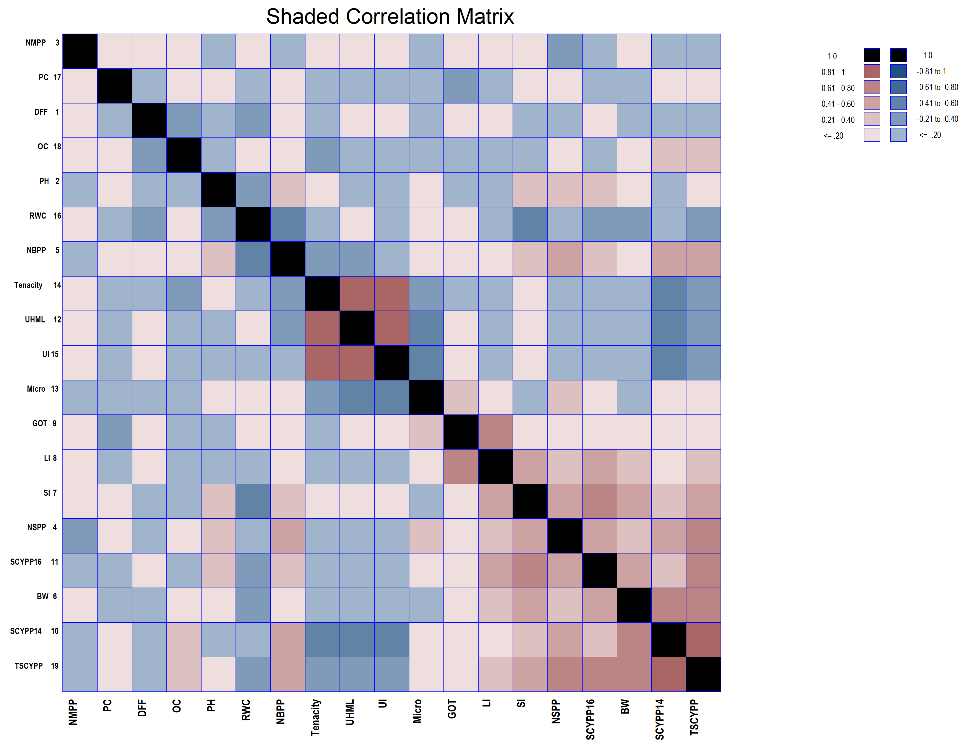
Fig. 1. Genotypic shaded correlation matrix for all the characters studied in 56 cotton (Gossypium hirsutum L.) genotypes
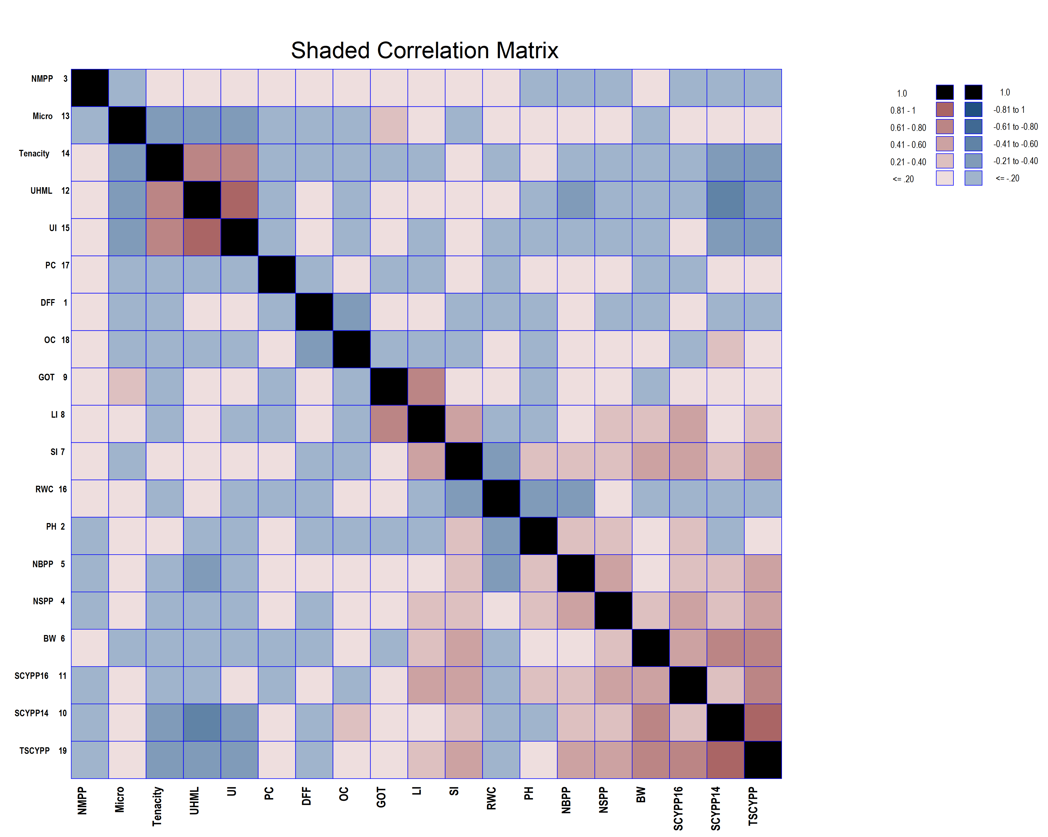

Fig. 2. Phenotypic shaded correlation matrix for all the characters studied in 56 cotton (Gossypium hirsutum L.) genotypes

3.2 Path coefficient analysis
The correlation coefficients were subjected to path coefficient analysis, which enabled the partitioning of correlations into direct and indirect effects via different yield related traits. The detailed estimates of direct and indirect effects of the traits influencing total seed cotton yield per plant are presented in Table 2 and 3, Fig 3 and Fig 4.
The path coefficient analysis revealed that no. of sympodia per plant, no. of bolls per plant, lint index, seed cotton yield per plant at 140 days after sowing, seed cotton yield per plant at 165 days after sowing, tenacity showed positive direct effect at both genotypic and phenotypic level on total seed cotton yield per plant. Similar results were reported by Sirisha et al. (2016) and Jyoti et al. (2021) for no. of sympodia per plant; Kadam et al. (2024) and Satish et al. (2020) for no. of bolls per plant and tenacity; Chandrashekhar et al. (2016) for lint index. No. of monopodia per plant, boll weight, uniformity index, proline content and oil content showed positive direct effect at phenotypic level on total seed cotton yield per plant. Similar results were reported by Kumar et al. (2014) for boll weight; Chandrashekhar et al. (2016) for uniformity index.
Traits days to 50% flowering, plant height, seed index, ginning out turn, upper half mean length, micronaire, relative water content showed negative direct effect at both genotypic and phenotypic levels. Similar results were reported by Kadam et al. (2024) for days to 50% flowering, upper half mean length and seed index; Kumar et al. (2014) for micronaire; Chandrashekhar et al. (2016) for ginning out turn; Jyoti et al. (2021) for plant height.
The residual effect at genotypic level is 0.18 indicating that the characters included in present investigation are contributing around 82% of variability pertaining to dependent variable i.e., total seed cotton yield per plant. Only 18% of contribution is from the few other characters which were not included in present study. Residual effect at phenotypic level is 0.26 indicating that the characters included in present investigation are contributing around 74% of variability pertaining to dependent variable. About 26% of contribution is from other characters which were not included in the present study.
Table 2. Estimates of phenotypic direct and indirect effects of 18 traits on total seed cotton yield per plant
CHARACTER | DFF | PH | NMPP | NSPP | NBPP | BW | SI | LI | GOT | SCYPP140 | SCYPP165 | UHML | MIC | TEN | UI | RWC | PC | OC | TSCYPP
DFF | -0.0588 | 0.0004 | 0.0021 | -0.0008 | 0.0057 | -0.0022 | 0.0067 | 0.0125 | -0.0120 | -0.0734 | 0.0496 | -0.0009 | 0.0011 | -0.0005 | 0.0001 | 0.0064 | -0.0035 | -0.0005 | -0.0680
PH | 0.0020 | -0.0115 | -0.0025 | 0.0109 | 0.0149 | 0.0053 | -0.0178 | -0.0038 | 0.0108 | -0.0266 | 0.1427 | 0.0023 | -0.0001 | 0.0002 | -0.0002 | 0.0096 | 0.0022 | -0.0004 | 0.1380
NMPP | -0.0057 | 0.0013 | 0.0220 | -0.0062 | -0.0049 | 0.0014 | -0.0012 | 0.0122 | -0.0122 | -0.0167 | -0.0982 | -0.0022 | 0.0012 | 0.0013 | 0.0006 | -0.0007 | 0.0013 | 0.0000 | -0.1067
NSPP | 0.0015 | -0.0039 | -0.0042 | 0.0324 | 0.0203 | 0.0140 | -0.0230 | 0.0206 | -0.0115 | 0.2236 | 0.2646 | 0.0048 | -0.0021 | -0.0026 | -0.0008 | -0.0012 | 0.0015 | 0.0004 | 0.5344**
NBPP | -0.0082 | -0.0042 | -0.0027 | 0.0161 | 0.0408 | 0.0079 | -0.0185 | 0.0053 | -0.0032 | 0.2327 | 0.1887 | 0.0083 | -0.0011 | -0.0032 | -0.0021 | 0.0111 | 0.0017 | 0.0003 | 0.4697**
BW | 0.0024 | -0.0011 | 0.0006 | 0.0085 | 0.0060 | 0.0536 | -0.0288 | 0.0180 | 0.0006 | 0.3709 | 0.2538 | 0.0058 | 0.0009 | -0.0013 | -0.0009 | 0.0051 | -0.0036 | 0.0001 | 0.6906**
SI | 0.0059 | -0.0031 | 0.0004 | 0.0112 | 0.0114 | 0.0232 | -0.0665 | 0.0497 | -0.0082 | 0.1713 | 0.2669 | -0.0017 | 0.0011 | 0.0007 | 0.0006 | 0.0080 | 0.0017 | -0.0001 | 0.4725**
LI | -0.0082 | 0.0005 | 0.0030 | 0.0075 | 0.0024 | 0.0108 | -0.0369 | 0.0897 | -0.0527 | 0.0420 | 0.2133 | -0.0004 | -0.0017 | -0.0004 | -0.0002 | 0.0009 | -0.0037 | -0.0003 | 0.2656**
GOT | -0.0097 | 0.0017 | 0.0037 | 0.0051 | 0.0018 | -0.0005 | -0.0074 | 0.0648 | -0.0730 | 0.0026 | 0.0682 | -0.0021 | -0.0026 | -0.0004 | 0.0001 | -0.0015 | -0.0050 | -0.0002 | 0.0456
SCYPP140 | 0.0071 | 0.0005 | -0.0006 | 0.0119 | 0.0156 | 0.0325 | -0.0187 | 0.0062 | -0.0003 | 0.6108 | 0.1353 | 0.0167 | -0.0018 | -0.0061 | -0.0042 | 0.0034 | 0.0005 | 0.0008 | 0.8096**
SCYPP165 | -0.0058 | -0.0033 | -0.0043 | 0.0170 | 0.0153 | 0.0269 | -0.0351 | 0.0379 | -0.0099 | 0.1636 | 0.5051 | 0.0030 | -0.0006 | -0.0004 | 0.0001 | 0.0055 | -0.0001 | -0.0002 | 0.7147**
UHML | -0.0013 | 0.0007 | 0.0012 | -0.0039 | -0.0085 | -0.0079 | -0.0029 | 0.0009 | -0.0039 | -0.2568 | -0.0386 | -0.0397 | 0.0044 | 0.0125 | 0.0106 | -0.0001 | -0.0027 | -0.0003 | -0.3363**
MIC | 0.0055 | -0.0001 | -0.0023 | 0.0058 | 0.0038 | -0.0042 | 0.0064 | 0.0128 | -0.0158 | 0.0936 | 0.0238 | 0.0149 | -0.0118 | -0.0035 | -0.0043 | -0.0009 | -0.0022 | -0.0002 | 0.1213
TEN | 0.0017 | -0.0002 | 0.0018 | -0.0052 | -0.0081 | -0.0045 | -0.0028 | -0.0023 | 0.0016 | -0.2331 | -0.0137 | -0.0309 | 0.0026 | 0.0160 | 0.0087 | 0.0008 | -0.0014 | -0.0004 | -0.2694**
UI | -0.0007 | 0.0002 | 0.0011 | -0.0022 | -0.0070 | -0.0042 | -0.0032 | -0.0016 | -0.0006 | -0.2144 | 0.0051 | -0.0351 | 0.0043 | 0.0116 | 0.0120 | 0.0014 | -0.0038 | -0.0002 | -0.2373*
RWC | 0.0116 | 0.0035 | 0.0005 | 0.0012 | -0.0141 | -0.0084 | 0.0165 | -0.0025 | -0.0034 | -0.0654 | -0.0857 | -0.0002 | -0.0003 | -0.0004 | -0.0005 | -0.0322 | -0.0011 | 0.0001 | -0.1808
PC | 0.0073 | -0.0009 | 0.0010 | 0.0017 | 0.0025 | -0.0069 | -0.0041 | -0.0118 | 0.0130 | 0.0110 | -0.0010 | 0.0039 | 0.0009 | -0.0008 | -0.0016 | 0.0013 | 0.0280 | 0.0001 | 0.0436
OC | 0.0121 | 0.0019 | 0.0001 | 0.0053 | 0.0053 | 0.0030 | 0.0022 | -0.0136 | 0.0069 | 0.2042 | -0.0338 | 0.0047 | 0.0011 | -0.0027 | -0.0010 | -0.0010 | 0.0011 | 0.0023 | 0.1981*
Residual effect: 0.26
DFF-Days to 50% flowering, PH-Plant height (cm), NMPP-No. of monopodia per plant, NSPP-No. of sympodia per plant, NBPP-No. of bolls per plant, BW- Boll weight (g), SI- Seed index (g), LI- Lint index (g), GOT- Ginning out turn (%), SCYPP140-Seed cotton yield per plant (g) at 140 days after sowing, SCYPP165-Seed cotton yield per plant (g) at 165 days after sowing, UHML-Upper Half Mean Length (mm), MIC-Micronaire (µg/inch), TEN- Tenacity (g/tex), UI-Uniformity index (%), RWC- Relative water content (%), PC-Proline content (µ mol/g), OC-Oil content (%), TSCYPP- Total seed cotton yield per plant (g)

Table 3. Estimates of genotypic direct and indirect effects of 18 traits on total seed cotton yield per plant
CHARACTER | DFF | PH | NMPP | NSPP | NBPP | BW | SI | LI | GOT | SCYPP140 | SCYPP165 | UHML | MIC | TEN | UI | RWC | PC | OC | TSCYPP
DFF | -0.1095 | 0.0019 | -0.0008 | -0.0018 | 0.0145 | 0.0006 | 0.0405 | 0.0405 | -0.0256 | -0.0881 | 0.0574 | -0.0294 | 0.0239 | -0.0150 | -0.0061 | 0.0317 | 0.0026 | 0.0015 | -0.0612
PH | 0.0034 | -0.0610 | 0.0008 | 0.0447 | 0.0372 | -0.0014 | -0.0940 | -0.0152 | 0.0227 | -0.0310 | 0.1457 | 0.0342 | -0.0026 | 0.0113 | 0.0012 | 0.0481 | -0.0015 | 0.0012 | 0.1438
NMPP | -0.0119 | 0.0069 | -0.0073 | -0.0248 | -0.0121 | -0.0004 | -0.0060 | 0.0434 | -0.0251 | -0.0199 | -0.1019 | -0.0319 | 0.0239 | 0.0645 | -0.0075 | -0.0037 | -0.0009 | 0.0000 | -0.1147
NSPP | 0.0017 | -0.0235 | 0.0016 | 0.1163 | 0.0577 | -0.0044 | -0.1396 | 0.0787 | -0.0246 | 0.3098 | 0.2949 | 0.0761 | -0.0552 | -0.1092 | 0.0227 | 0.0007 | -0.0011 | -0.0011 | 0.6015**
NBPP | -0.0162 | -0.0232 | 0.0009 | 0.0687 | 0.0978 | -0.0020 | -0.0971 | 0.0181 | -0.0074 | 0.2839 | 0.1994 | 0.1192 | -0.0279 | -0.1636 | 0.0228 | 0.0493 | -0.0012 | -0.0010 | 0.5205**
BW | 0.0050 | -0.0070 | -0.0002 | 0.0410 | 0.0159 | -0.0124 | -0.1562 | 0.0655 | -0.0003 | 0.4507 | 0.2953 | 0.0868 | 0.0245 | -0.0709 | 0.0119 | 0.0318 | 0.0026 | -0.0001 | 0.7839**
SI | 0.0141 | -0.0183 | -0.0001 | 0.0518 | 0.0303 | -0.0062 | -0.3137 | 0.1696 | -0.0181 | 0.2366 | 0.3076 | -0.0126 | 0.0344 | 0.0463 | -0.0131 | 0.0553 | -0.0013 | 0.0000 | 0.5626**
LI | -0.0149 | 0.0031 | -0.0011 | 0.0307 | 0.0059 | -0.0027 | -0.1781 | 0.2987 | -0.1064 | 0.0550 | 0.2321 | 0.0025 | -0.0354 | -0.0177 | 0.0006 | 0.0108 | 0.0026 | 0.0009 | 0.2866**
GOT | -0.0209 | 0.0104 | -0.0014 | 0.0213 | 0.0054 | 0.0000 | -0.0423 | 0.2372 | -0.1340 | 0.0209 | 0.0874 | -0.0270 | -0.0558 | -0.0024 | -0.0073 | -0.0087 | 0.0038 | 0.0003 | 0.0869
SCYPP140 | 0.0138 | 0.0027 | 0.0002 | 0.0515 | 0.0397 | -0.0080 | -0.1060 | 0.0235 | -0.0040 | 0.7000 | 0.1585 | 0.2571 | -0.0329 | -0.3018 | 0.0540 | 0.0239 | -0.0003 | -0.0024 | 0.8695**
SCYPP165 | -0.0123 | -0.0174 | 0.0015 | 0.0673 | 0.0383 | -0.0072 | -0.1893 | 0.1360 | -0.0230 | 0.2177 | 0.5098 | 0.0442 | -0.0153 | -0.0265 | 0.0013 | 0.0292 | 0.0000 | 0.0005 | 0.7548**
UHML | -0.0058 | 0.0038 | -0.0004 | -0.0160 | -0.0211 | 0.0019 | -0.0072 | -0.0014 | -0.0066 | -0.3259 | -0.0408 | -0.5523 | 0.0885 | 0.6242 | -0.1336 | -0.0011 | 0.0019 | 0.0008 | -0.3911**
MIC | 0.0124 | -0.0008 | 0.0008 | 0.0306 | 0.0130 | 0.0014 | 0.0513 | 0.0503 | -0.0356 | 0.1094 | 0.0370 | 0.2325 | -0.2102 | -0.1827 | 0.0586 | -0.0010 | 0.0016 | 0.0010 | 0.1696
TEN | 0.0025 | -0.0010 | -0.0007 | -0.0192 | -0.0242 | 0.0013 | -0.0220 | -0.0080 | 0.0005 | -0.3200 | -0.0204 | -0.5223 | 0.0582 | 0.6602 | -0.1275 | 0.0104 | 0.0011 | 0.0014 | -0.3297**
UI | -0.0051 | 0.0006 | -0.0004 | -0.0202 | -0.0171 | 0.0011 | -0.0313 | -0.0013 | -0.0075 | -0.2887 | -0.0050 | -0.5642 | 0.0942 | 0.6435 | -0.1308 | 0.0149 | 0.0029 | 0.0006 | -0.3138**
RWC | 0.0288 | 0.0244 | -0.0002 | -0.0007 | -0.0400 | 0.0033 | 0.1440 | -0.0268 | -0.0096 | -0.1387 | -0.1234 | -0.0048 | -0.0018 | -0.0571 | 0.0162 | -0.1205 | 0.0011 | -0.0006 | -0.3064**
PC | 0.0150 | -0.0049 | -0.0003 | 0.0067 | 0.0061 | 0.0017 | -0.0219 | -0.0418 | 0.0271 | 0.0130 | -0.0012 | 0.0570 | 0.0181 | -0.0373 | 0.0201 | 0.0070 | -0.0188 | -0.0003 | 0.0453
OC | 0.0245 | 0.0109 | 0.0000 | 0.0193 | 0.0143 | -0.0002 | 0.0013 | -0.0428 | 0.0071 | 0.2554 | -0.0392 | 0.0658 | 0.0330 | -0.1380 | 0.0123 | -0.0118 | -0.0008 | -0.0066 | 0.2045*
Residual effect: 0.18
DFF-Days to 50% flowering, PH-Plant height (cm), NMPP-No. of monopodia per plant, NSPP-No. of sympodia per plant, NBPP-No. of bolls per plant, BW- Boll weight (g), SI- Seed index (g), LI- Lint index (g), GOT- Ginning out turn (%), SCYPP140-Seed cotton yield per plant (g) at 140 days after sowing, SCYPP165-Seed cotton yield per plant (g) at 165 days after sowing, UHML-Upper Half Mean Length (mm), MIC-Micronaire (µg/inch), TEN- Tenacity (g/tex), UI-Uniformity index (%), RWC- Relative water content (%), PC-Proline content (µ mol/g), OC-Oil content (%), TSCYPP- Total seed cotton yield per plant (g)

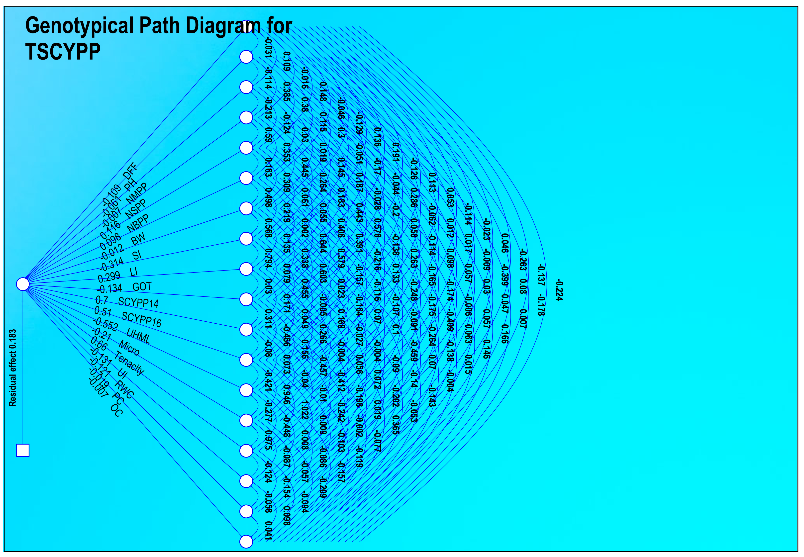
Fig. 3. Genotypic path diagram for seed cotton yield, yield attributing and fibre quality traits in 56 cotton (Gossypium hirsutum L.) genotypes
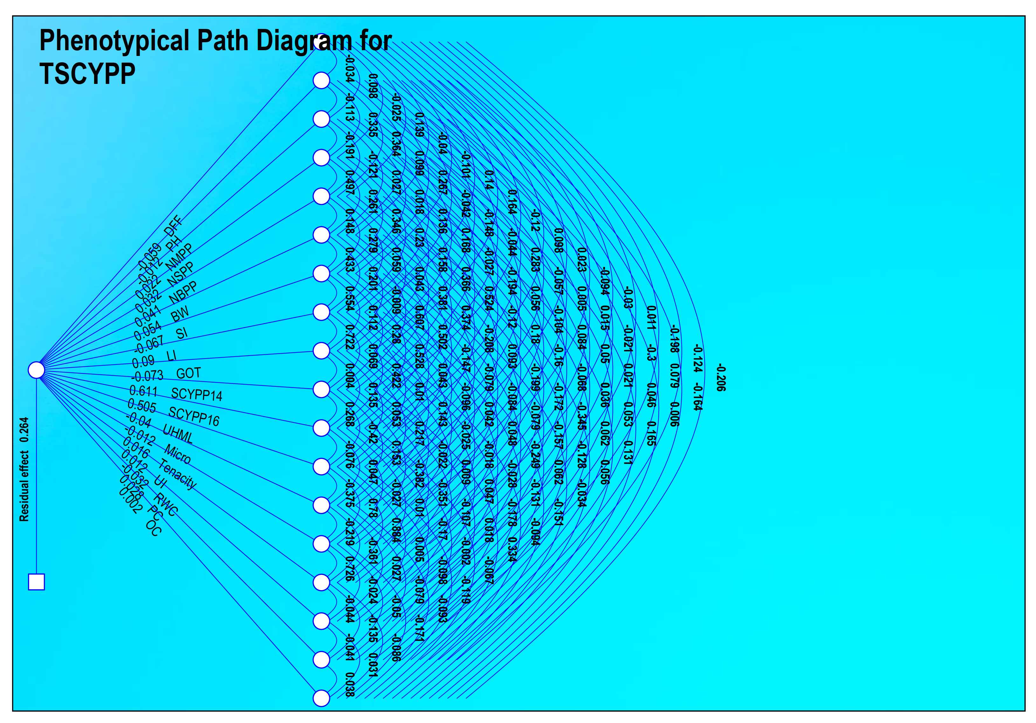
Fig. 4. Phenotypic path diagram for seed cotton yield, yield attributing and fibre quality traits in 56 cotton (Gossypium hirsutum L.) genotypes

CONCLUSION
Correlation studies indicated significant positive correlation of total seed cotton yield per plant with no. of sympodia per plant, no. of bolls per plant, boll weight, seed index, lint index and oil content. Increase in any of these traits will lead to significant increase in yield. More emphasis should be given to these traits during breeding programme to make selection effective. Path coefficient analysis revealed that no. of sympodia per plant, no. of bolls per plant, lint index, seed cotton yield per plant at 140 days after sowing, seed cotton yield per plant at 165 days after sowing had positive direct effect with total seed cotton yield per plant. This highlights the importance of these traits as indicators for selecting high-yielding genotypes.
COMPETING INTERESTS
The authors affirm that there are no competing interests.

REFERENCES
Amein, M. M. M., Masri, M. I., El-Adly, H. H., & Attia, S. S. (2020). Correlation and path coefficient analysis for yield components traits in egyptian cotton genotypes (Gossypium barbadense L.). Plant Archives, 20(2), 803-806.
Balcha, M., Damtew, S., Gurmessa, D., Gudeta, B., Workie, A., & Arega, M. (2024). Correlation and Path Coefficient Analysis for Some Quantitative Traits of Cotton (Gossypium hirsutum L.) Genotypes under Irrigated Conditions. Ethiopian Journal of Agricultural Sciences, 34(2), 81-89.
Chandrashekhar, A., Manjula, S. M., Patil, S. S., Madhura, C., Basavaradder, A. B., & Santosh, H. B. (2016). Correlation and path coefficient analysis of yield component and fibre quality traits of upland cotton (Gossypium hirsutum L.). International Journal of Agricultural Science and Research, 6(1), 171-176.
Dewey, D. R., & Lu, K. (1959). A correlation and path‐coefficient analysis of components of crested wheatgrass seed production 1. Agronomy journal, 51(9), 515-518.
Erande, C. S., Kalpande, H. V., Deosarkar, D. B., Chavan, S. K., Patil, V. S., Deshmukh, J. D., & Puttawar, M. R. (2014). Genetic variability, correlation and path analysis among different traits in desi cotton (Gossypium arboreum L.). African Journal of Agricultural Research, 9(29), 2278-2286.
Farooq, J., Anwar, M., Riaz, M., Farooq, A., Mahmood, A., Shahid, M. T. H., & Ilahi, F. (2014). Correlation and path coefficient analysis of earliness, fiber quality and yield contributing traits in cotton (Gossypium hirsutum L.). The Journal of Animal & Plant Sciences, 24(3), 781-790.
Fayet, L., & Vermeulen, W. J. (2014). Supporting smallholders to access sustainable supply chains: Lessons from the Indian cotton supply chain. Sustainable Development, 22(5), 289-310.
Johnson, H. W., Robinson, H. F., & Comstock, R. E. (1955). Estimates of genetic and environmental variability in soybeans. Agronomy Journal, 47, 314-318.
Jyoti, G.J., Valu, M. G., & Odedara Geeta, N. (2021). Correlation, path coefficient and D² analysis study of seed cotton yield and fibre quality traits in American cotton (Gossypium hirsutum L.). Journal of Pharmacognosy and Phytochemistry, 10(3), 222-230.
Kadam, K. V., Chinchane, V. N., & Rani, S. D. R. (2024). Correlation and path analysis of yield and fibre quality traits in upland cotton (Gossypium hirsutum L.). International Journal of Advanced Biochemistry Research, 8(3), 61-66.
Kumar, P.S., Siwach, S. S., Sangwan, R. S., Sangwan, O., & Jagdish Deshmukh, J. D. (2014). Correlation and path coefficient analysis for yield and fibre quality traits in upland cotton (Gossypium hirsutum L). Journal of Cotton Research and Development, 28(2), 214-216.
Majeedano, M. S., Ahsaan, M. Z., Somroo, A. W., & Channa, A. R. (2014). Heritability and correlation estimates for some yield traits of (Gossypium hirsutum L.). American Research Thoughts, 1(2), 781-790.
Neelam, G. D., & Potdukhe, N. R. (2002). Studies on variability and correlations in upland cotton for yield and its components. Journal of Indian Society for Cotton Improvement, 27(3), 148-152.
Rai, P., & Sangwan, O. (2020). Correlation studies in elite lines of upland cotton (Gossypium hirsutum L.). Electronic journal of plant breeding, 11(01), 298-300.
Rajamani, S., Sumalatha, P., & Gopinath, M. (2013). Correlation and path coefficient analysis in (Gossypium hirsutum L.). Journal of Cotton Research and Development, 27(2), 188-190.
Ranjan, R. R., Sangwan, R. S., Siwach, S. S., Sangwan, O., & Sah, M. K. (2014). Correlation and path analysis studies in (Gossypium arboreum L.). Journal of Cotton Research and Development, 28(1), 37-39.
Rao, P. J. M., & Gopinath, M. (2013). Association analysis of yield and fibre quality characters in upland cotton (Gossypium hirsutum L.). Australian Journal of Basic and Applied Sciences, 7(8), 787-790.
Salahuddin, S., Abro, S., Kandhro, M. M., Salahuddin, L., & Laghari, S. (2010). Correlation and path coefficient analysis of yield components of upland cotton (Gossypium hirsutum L.) sympodial. World Applied Sciences Journal, 8(8), 71-75.
Satish, Y., Rani, M. S., & Chapara, R. (2020). Correlation and path coefficient analysis for yield and yield component traits in upland cotton (Gossypium hirsutum L.). International Journal of Chemical Studies, 8(2), 2742-2746.
Sirisha, A. B. M., Lal Ahamed, M., Rama Kumar, P. V., Ratnakumari, S., & Srinivasa Rao, V. (2016). Correlation and path analysis studies in cotton (Gossypium hirsutum L.). The Andhra Agricultural Journal, 63(1), 104-109.
Wright, S. (1921). Correlation and causation. Journal of Agricultural Research, 20(7), 557-585.

