Prevalence of the parasitic Copepods Ergasilus latus and Lernea cyprinacea in Chrysichthys nigrodigitatus from degraded Adiaké-Aby Lagoon (Côte d’Ivoire)

ABSTRACT

Commonly known as the catfish, Chrysichthys nigrodigitatus is a fish species of significant nutritional and economic importance due to its remarkable zootechnical performance. It contributes substantially to food security. However, this species is subject to parasitic copepod infestations in the Aby Lagoon, a waterbody experiencing ongoing environmental degradation. Currently, no data exist on these parasites affecting this fish in this specific habitat, thereby hindering the development of effective health management strategies essential for optimizing fish production. This study aimed to characterize the physico-chemical parameters of the lagoon and assess variations in the prevalence of Ergasilus latus and Lernaea cyprinacea in C. nigrodigitatus according to sex, size, and seasonal patterns. Parameters such as temperature, pH, salinity, dissolved oxygen, total dissolved solids (TDS), and electrical conductivity were measured in situ using a multiparameter probe, and water transparency was determined with a Secchi disk. Ammonium, nitrate, nitrite, and orthophosphate concentrations were analyzed in the laboratory. A total of 480 fish specimens were examined between March 2024 and February 2025. Standard methods were applied for parasite collection, identification, and quantification. The Chi-square test was used to assess infestation levels based on the biotic and abiotic variables mentioned. The results revealed seasonal pollution of the lagoon. Higher values of dissolved oxygen (5.86 mg/L) and TDS (925.63 mg/L) were recorded during the rainy season, whereas maximum values for transparency (92.6 cm), salinity (4.75), conductivity (8840.5 µS/cm), and temperature (31.7°C) were observed during the dry season. Except for nitrite, higher concentrations of orthophosphate (1.45 mg/L), ammonium (0.15 mg/L), and nitrate (2.8 mg/L) were also noted during the dry season, indicating significant seasonal variation. Furthermore, the highest parasite infestation rates (77.86% for E. latus and 68.6% for L. cyprinacea) occurred during the rainy season. Male hosts exhibited the highest infestation rates (80.16% and 77.73%, respectively). Individuals of larger size hosted more parasites, with peak prevalences of 95.92% for E. latus and 94.79% for L. cyprinacea. These findings will serve as a valuable reference for veterinarians and fish farmers in the control and management of catfish parasitic infestations.

Keywords: Chrysichthys nigrodigitatus – Parasitic copepod infestation rate –Adiaké Aby Lagoon – Côte d’Ivoire

1. INTRODUCTION

Aquatic ecosystems are increasingly affected by anthropogenic activities, which significantly disrupt their ecological balance and compromise the health of resident biological communities, particularly fish populations (Dudgeon et al., 2006). Among the various environmental stressors impacting fish, infestations by parasitic copepods represent a notable concern due to their significant health, ecological, and economic implications (Piasecki et al., 2004). These organisms are ectoparasites of established pathogenic importance. By attaching to host tissues, especially the gills, they can cause lesions, impair immune function, reduce zootechnical performance, induce considerable mortality, and ultimately lead to economic losses for communities that rely on fisheries (Kilian and Avenant-Oldewage, 2013). Among these parasites, Ergasilus latus and Lernaea cyprinacea are known to infect the gills of the catfish Chrysichthys nigrodigitatus (Kilian and Avenant-Oldewage, 2013). Commonly referred to as “catfish,” this species is widely exploited across West Africa. Highly prized for the organoleptic quality of its flesh, it serves as an essential source of animal protein for local populations and contributes substantially to the regional economy (Bédia et al., 2017). Due to high demand on both local and international markets, natural populations of C. nigrodigitatus are subject to increasing fishing pressure (Chikou, 2006 ; Bédia et al., 2017). Furthermore, its favorable zootechnical traits make it a key species in aquaculture programs throughout Africa aimed at enhancing food security and poverty alleviation (Ekanem, 2000 ; Affourmou et al., 2016). However, the success of such initiatives depends on the availability of healthy broodstock in both quality and quantity. Fish health is influenced by a range of biotic and abiotic factors, including parasitic pressure, which is often exacerbated by environmental degradation (Lafferty et al., 2015). Therefore, studying copepod parasites of C. nigrodigitatus is strategically important for sustainable fisheries management.
To date, only limited research has been conducted on infestations of C. nigrodigitatus by Ergasilus latus and Lernaea cyprinacea. Existing studies are limited to those by Omeji et al. (2022) in the Opokwu Apa River and Arinze et al. (2014) in the Niger Delta, both in Nigeria. No data currently exist on these parasites in Côte d’Ivoire, particularly within the Aby Lagoon, where fish stocks, including those of catfish, are experiencing a marked decline, especially in the Adiaké region. This area is heavily exposed to various forms of anthropogenic pollution, which are likely to alter parasite community structures and negatively affect fish production. Given the ecological, nutritional, and socio-economic importance of C. nigrodigitatus, and the ongoing degradation of its population in this region, the present study aimed to characterize the physico-chemical parameters of Aby Lagoon, and assess the seasonal variations in the prevalence of Ergasilus latus and Lernaea cyprinacea in C. nigrodigitatus, based on host sex and size. The findings will provide baseline data to support improved fish health management and the sustainable production of this important species.

2. material and methods

2.1. Study area
Located in southeastern Côte d’Ivoire, within the Adiaké department (between 3°00’-3°30’ W and 5°20’-5°30’ N), Aby Lagoon forms a natural border with Ghana and covers an area of approximately 424 km² (Figure 1). The region is characterized by a humid tropical climate with four distinct seasons: a long rainy season (April–July), a short rainy season (October–November), a short dry season (August–September), and a long dry season (December–March) (Brou, 2005). The lagoon is mainly fed by the Bia and Tanoé rivers (N’Guessan et al., 2013). Its connection to the Atlantic Ocean is narrow and shallow, limiting water exchange. The local substrate is mainly composed of sand and gravel.The study area is heavily impacted by human activities including fishing, livestock farming, and domestic practices. Surrounding the lagoon, extensive agricultural plantations such as oil palm, rubber, coffee, cocoa, cassava, and plantain. All of this contributes to environmental pressure. Additionally, artisanal gold mining near the Ghanaian border town of Noé, involving mercury use, poses a significant pollution risk to the lagoon ecosystem (Mensah et al., 2021).

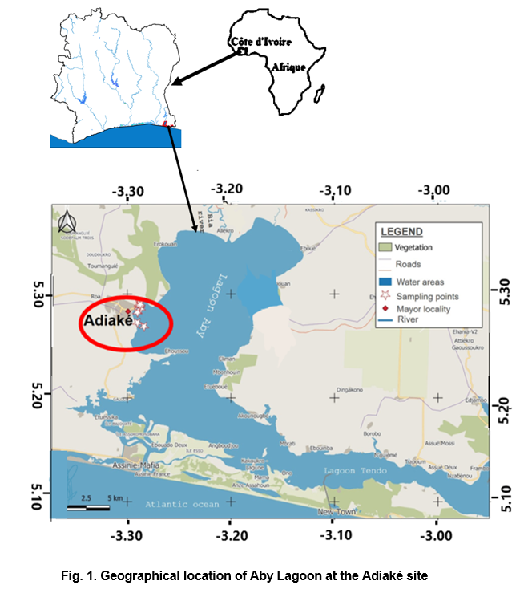

2.2. Measurement of physico-phemical parameters

Physico-chemical parameters, including temperature, dissolved oxygen, total dissolved solids (TDS), electrical conductivity and salinity, were measured monthly at three time intervals (07:00, 13:00, and 17:00) using a HANNA multiparameter probe (model HI 9828010-02). The instrument was calibrated prior to each field campaign. Measurements were taken by immersing the probe into the upper 30 cm of the water column and readings were recorded after stabilization of the values on the display. Water transparency was measured using a Secchi disk. Additionally, water samples were collected in sterile bottles, carefully stored and later analyzed in the laboratory for nutrient concentrations, nitrites, nitrates, ammonium and orthophosphates using a HACH DR 6000 multiparameter spectrophotometer.

2.3. Sampling of host fish
Specimens of Chrysichthys nigrodigitatus (n=480 individuals) were collected between March 2024 and February 2025 from the study area using both experimental and artisanal fishing techniques, including gill nets and other traditional gears. Standard lengths were measured to the nearest millimeter using an ichthyometer. Sex determination was conducted through visual examination of the gonads following a mid-ventral incision of the abdominal cavity.

2.4 Examination of gill parasitic copepods
In the field, both left and right gill arches were excised, labeled according to the host specimen, wrapped in aluminum foil, and stored in a cooler with ice before transport to the laboratory. Upon arrival, the gills were thawed and carefully dissected. Parasites were detached through intensive rinsing using a wash bottle. The rinse water was collected in a grid-lined Petri dish, homogenized and examined under a binocular stereomicroscope at 60× magnification. Copepods were carefully collected using fine forceps, fixed in 10% formalin and mounted in Canada balsam after 24 hours for identification. Taxonomic identification was conducted following the keys of Yamaguti (1963) and Kabata (1979). All parasites collected were counted to determine the infestation rate for each copepod species.

2.5. Epidemiological approach
Parasitic prevalence (P) was calculated based on the definition by Bush et al. (1997), as the percentage of infected hosts (n) out of the total number of examined hosts (h), using the formula: P = (n/h) × 100. Classification of parasite prevalence followed the method proposed by Valtonen et al. (1997), where parasites were categorized as dominant or frequent (P > 50%), secondary or intermediate (10% ≤ P ≤ 50%) and rare or satellite (P ≤ 10%).

2.6. Statistical analysis
Two statistical tests were employed in this study namely the Chi-square (χ²) test and the Mann-Whitney U test. The Chi-square test was used to assess variability in parasite infestation rates according to host sex, size, and seasonal period. The Mann-Whitney U test was applied to compare seasonal differences in physico-chemical parameters. All statistical analyses were performed using STATISTICA software version 7.1, at a significance level of 0.05.

3. results
3.1 Seasonal fluctuations of physico-chemical parameters in Aby lagoon
Eleven physico-chemical parameters were measured in the study area. For each parameter, minimum, maximum, and mean values with standard deviations were determined according to the different seasons of the year (Table 1).
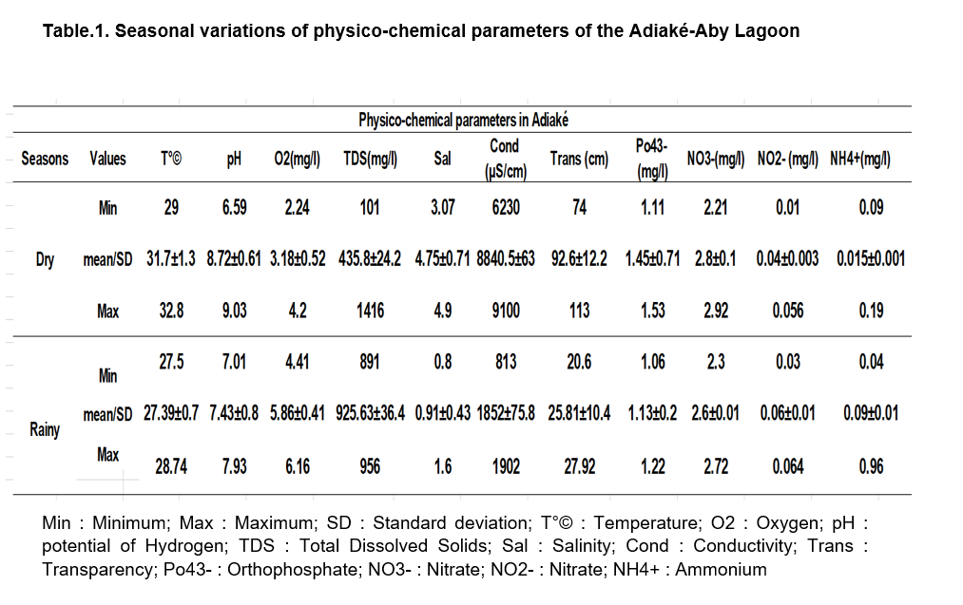
Water temperature ranged from 29°C to 32.8°C, with a mean value of 31.7°C ± 1.3°C during the dry season. In the rainy season, temperature measurements varied between 27.5°C and 28.74°C, with a mean of 27.39°C ± 0.7°C. Statistical analysis (Mann-Whitney U test) revealed no significant difference in temperature between these two seasons (p > 0.05), indicating relative thermal stability across seasons. Dissolved oxygen concentrations ranged from 2.24 mg/L to 4.2 mg/L with a mean of 3.18 mg/L ± 0.52 mg/L in the dry season, while during the rainy season, values varied from 4.41 mg/L to 6.16 mg/L with a mean of 5.86 mg/L ± 0.41 mg/L. The Mann-Whitney U test indicated significant differences in dissolved oxygen levels between seasons (p < 0.05), with higher oxygen content observed during the rainy season. The pH values fluctuated between 6.59 and 9.03, averaging 8.72 ± 0.61 in the dry season, and between 7.01 and 7.93 with a mean of 7.43 ± 0.8 during the rainy season. No significant seasonal difference was observed for pH (Mann-Whitney U test, p > 0.05), indicating alkaline conditions throughout the year. Electrical conductivity values ranged from 6.230 µS/cm to 9.100 µS/cm, with a mean of 8.840 µS/cm ± 63.4 µS/cm in the dry season, and from 813 µS/cm to 1.902 µS/cm with a mean of 1.852 µS/cm ± 75.8 µS/cm in the rainy season. The Mann-Whitney U test confirmed significantly higher conductivity during the dry season compared to the rainy season (p < 0.05). Salinity values fluctuated between 3.07 ppt and 4.9 ppt, with a mean of 4.75 ppt ± 0.71 ppt during the dry season. In the rainy season, salinity ranged from 0.8 ppt to 1.6 ppt with a mean of 0.91 ppt ± 0.43 ppt. A significant seasonal difference was found (p < 0.05), with higher salinity recorded during the dry season. Water transparency varied from 74 cm to 113 cm, averaging 92.6 cm ± 12.2 cm in the dry season, while in the rainy season, transparency ranged from 20.6 cm to 27.92 cm with a mean of 25.81 cm ± 10.4 cm. Seasonal differences were significant (Mann-Whitney U test, p < 0.05), indicating clearer water during the dry season. Total dissolved solids (TDS) values ranged from 101 mg/L to 1.416 mg/L with a mean of 435.8 mg/L ± 24.2 mg/L in the dry season, and between 891 mg/L and 956 mg/L with a mean of 925.63 mg/L ± 36.4 mg/L during the rainy season. The seasonal difference was significant (Mann-Whitney U test, p < 0.05).Concentrations of nitrites, nitrates, ammonium, and orthophosphates remained relatively stable throughout the year. However, the highest mean values of nitrates (2.8 mg/L ± 0.1 mg/L), ammonium (0.015 mg/L ± 0.001 mg/L), and orthophosphates (1.45 mg/L ± 0.71 mg/L) were recorded during the dry season, while nitrite levels peaked during the rainy season (0.06 mg/L ± 0.0003 mg/L). Seasonal variation in these nutrient concentrations was statistically significant (U test, p < 0.05).
3.2 Temporal variations in prevalence of Ergasilus latus and Lernaea cyprinacea in Chrysichthys nigrodigitatus
The overall prevalence rates were 70.20% for the copepod Ergasilus latus and 68.08% for Lernaea cyprinacea, classifying both as dominant species within the parasite community. These prevalence rates varied throughout the year. Monthly average prevalence trends for E. latus and L. cyprinacea in C. nigrodigitatus from Adiaké-Aby Lagoon are presented in Figure 2. The analysis showed peak prevalence for E. latus (77.86%) and L. cyprinacea (68.6%) during the rainy months of May and October 2024. Conversely, the lowest prevalence values were observed during the dry months of September 2024 and February 2025, with prevalence rates of 59.45% for E. latus and 51.35% for L. cyprinacea. The differences in parasite prevalence between dry and rainy seasons were highly significant (Chi-square test, p < 0.05). This indicates that fish infestation was greater during the rainy season than the dry season.
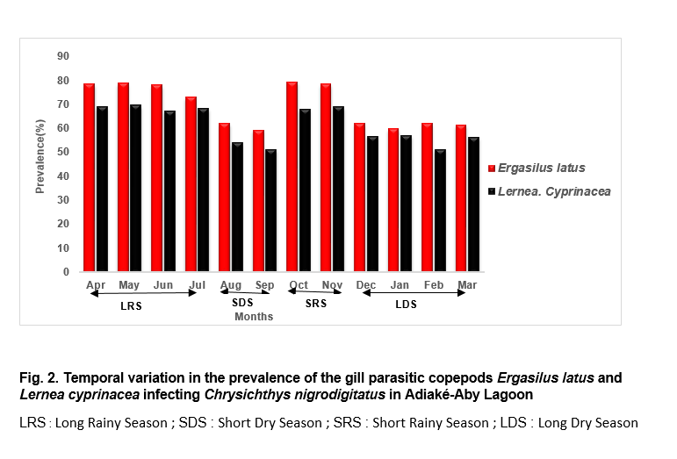

3.3 Prevalence of Ergasilus latus and Lernaea cyprinacea infestation in Chrysichthys nigrodigitatus according to host sex
A total of 480 specimens of Chrysichthys nigrodigitatus were examined, including 247 males and 233 females. The results are presented in Table 2. Analysis of these data revealed that male hosts exhibited the highest prevalence rates for both Ergasilus latus (80.16%) and Lernaea cyprinacea (77.73%). The Chi-square test indicated statistically significant differences (p < 0.05) in the prevalence of parasitic infestation between male and female hosts for both copepod species.
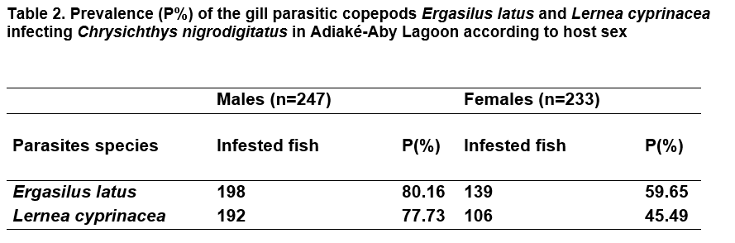
3.4 Prevalence of Ergasilus latus and Lernaea cyprinacea infestation in Chrysichthys nigrodigitatus according to host size
This study also included 480 specimens of Chrysichthys nigrodigitatus, with standard lengths ranging from 70 mm to 720 mm. Five size classes were established: A = [70–200[, B = [200–330[, C = [330–460[, D = [460–590[and E = [590–720]. The results are illustrated in Figure 3. Analysis of the figure 3 showed that all size classes of C. nigrodigitatus hosted both Ergasilus latus and Lernaea cyprinacea. Notably, prevalence exceeded 50% in size classes [330–460[, [460–590[, and [590–720] for both copepod species, with the highest values 95.92% for E. latus and 94.79% for L. cyprinacea recorded in the largest size class [590–720]. Conversely, prevalence rates were below 50% in the smaller size classes [70–200[and [200–330[for both parasites. The Chi-square test revealed significant differences (p < 0.05) in prevalence across the various size classes for both E. latus and L. cyprinacea.
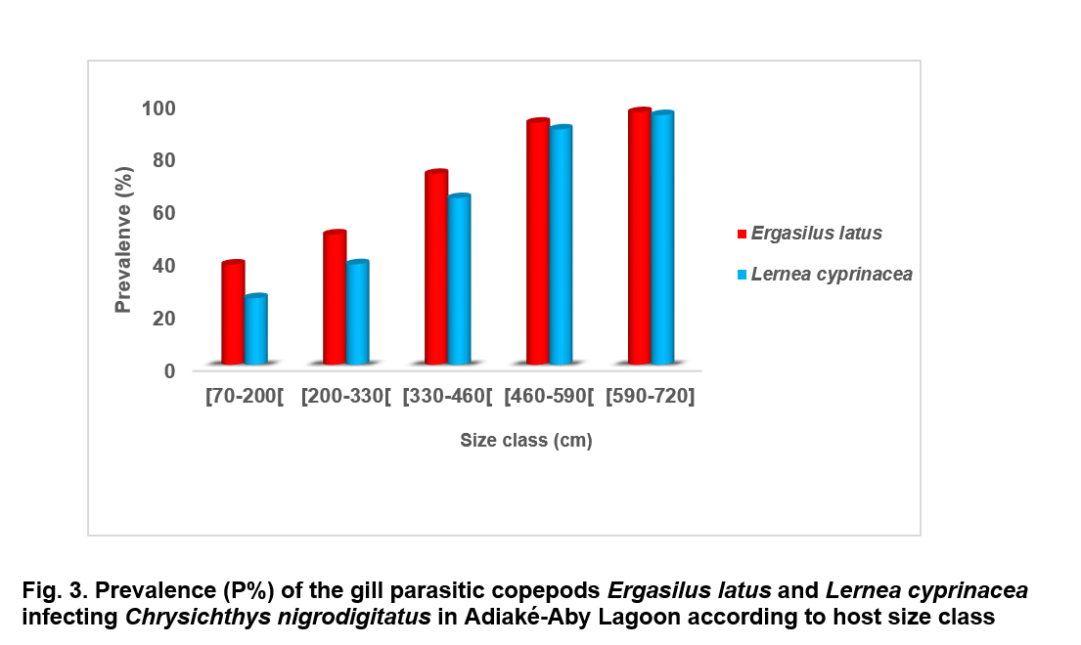

4. discussion
The temporal variation in the physico-chemical parameters revealed that water temperatures in Adiaké-Aby Lagoon are generally high. This could be attributed to the near-absence of canopy cover over the waterbody, allowing greater solar radiation penetration, which directly warms the water column. Similar observations were reported by Kouassi et al. (2007) and iIn the Taabo lake, and by Kambiré et al. (2014) in the Aby Lagoon. The recorded temperatures closely align with those found by Kambiré et al. (2014), who reported 27.4°C in the same environment. The higher dissolved oxygen concentrations during the rainy season may result from freshwater inflows enriched in oxygen from rainfall and the Bia and Tanoé rivers. These inflows enhance vertical mixing, promoting gas exchange at the air-water interface, as noted by Kouassi et al. (2022). Furthermore, the decrease in temperature during this period likely improves oxygen solubility. Additionally, the dilution of oxidizable substances reduces biological oxygen demand, while runoff-driven nutrient inputs stimulate primary productivity and photosynthesis, further increasing oxygen concentrations. Similar trends have been reported by Yao et al. (2025) in the Ebrié lagoon. In contrast, during the dry season, reduced water input and increased temperature limit mixing and oxygen solubility, causing a drop in oxygen levels. This situation is worsened by water column stagnation and thermal stratification, which prevent the renewal of deeper, oxygen-depleted layers, a phenomenon common in tropical lagoons Irié Bi et al. (2018). The alkaline nature of Adiaké-Aby Lagoon waters in all seasons could be explained by both natural and anthropogenic factors. Riverine inputs rich in carbonates and bicarbonates from upstream rock weathering strengthen the buffering capacity and maintain basic pH levels, as observed by Adou (2018) in the Ebrié Lagoon. Additionally, nutrient-rich domestic and agricultural discharges promote eutrophication and biological activity, leading to carbon dioxide (CO₂) consumption and pH increase. These combined mechanisms account for the persistent alkalinity in the lagoon across seasons, corroborated by Assandé et al. (2022).
Electrical conductivity was significantly higher during the dry season. This is likely due to intensified evaporation under high temperatures and solar radiation, which concentrates dissolved salts Kouamé et al. (2020). The concurrent reduction in freshwater inputs from rivers and rainfall limits ion dilution, leading to further accumulation. Conversely, heavy rains during the wet season dilute mineral salts, lowering conductivity, a trend supported by Irié Bi et al. (2018). Unexpectedly, the total dissolved solids (TDS) were significantly higher during the rainy season. This likely reflects increased allochthonous inputs from runoff, which carries organic matter, nutrients, fine particles, and contaminants from agricultural, urban, and artisanal mining activities. Illegal gold mining near the Bia and Tanoé rivers introduces heavy metals and hydrocarbons into the lagoon. These findings align with those of Tano et al. (2016), and Koffi et al. (2021). During the dry season, salinity peaked due to intense evaporation and reduced freshwater inputs, leading to ion concentration. In contrast, rainfall and runoff during the wet season dilute salts, lowering salinity, a pattern consistent with findings by Kouamé et al. (2020). Water transparency was significantly higher in the dry season, likely due to reduced suspended matter and low hydrological disturbance, which facilitate sedimentation and improve clarity (Koffi et al., 2021). The reduced transparency during the rainy season results from sediment-laden runoff and increased turbidity, as noted by Koffi et al. (2021). Additionally, pollution from illegal gold mining exacerbates water quality degradation. Nutrient concentrations, including ammonium, nitrates, and phosphates, were higher during the dry season, possibly due to the accumulation and decomposition of organic matter, combined with limited dilution and water renewal (Kouassi et al., 2022). However, nitrite concentrations were higher during the rainy season, possibly linked to incomplete nitrification under fluctuating oxygen levels and sudden organic inputs, as discussed by Yéo et al. (2015).
In the present study, Chrysichthys nigrodigitatus exhibited markedly higher infestation by the parasitic copepods Ergasilus latus and Lernaea cyprinacea during the rainy season compared to the dry season. This pattern could be explained by environmental conditions that favor parasite survival and reproduction, such as reduced salinity, nutrient enrichment, and increased productivity. Indeed, rainfall induces runoff that transports both organic (human and animal waste, plant debris, etc.) and inorganic nutrients into the lagoon, thereby elevating phosphate and nitrate concentrations. These nutrients stimulate planktonic biomass production, providing abundant food resources for both the free-living and parasitic stages of copepods. Consequently, their survival rates and densities increase, enhancing the probability of host fish infestation. These findings align with Ali and Al-Hyali (2018), who reported that Lernaea cyprinacea reproduces only at salinities below 7–8 ‰, with optimal larval development occurring in freshwater. Moreover, the rainy season coincides with social behaviors in fish, such as aggregation for feeding and reproduction in flooded areas, which facilitate parasite transmission. Similar observations were reported by Tano et al. (2016) and Kouadio et al. (2021). Additionally, at the study site, the practice of “acadja-culture”-based on the installation of submerged plant structures could enhance fish reproduction and contribute to the accumulation of organic matter. This accumulation, including dead wood and leaves, could create microhabitats favorable to the development of infective parasite stages, promoting their dispersal and contact with hosts, as previously noted by Lafferty and Kuris (1999). High infestation during the rainy season could also result from contamination of the aquatic environment by domestic wastewater and agricultural runoff (pesticides), rendering aquatic organisms more susceptible to parasitic infection. Indeed, during this period, exposure to pollutants could induce biochemical, physiological and behavioral changes in fish, ultimately facilitating parasite infestation as mentioned by Kemp and Spotila (1997). Conversely, during the dry season, reduced water levels force fish to disperse into deeper, more saline areas, limiting host-parasite interactions. Similar seasonal dynamics have been documented in C. nigrodigitatus by Omeji et al. (2022), confirming that environmental variations strongly influence parasitic pressure. Low infestations during the dry season are also attributable to increased mortality of adult worms due to elevated temperature, salinity and conductivity as suggested by Modu et al. (2014) and Adou et al. (2021).

Sex-related variation in parasitism in Adiaké-Aby lagoon showed that the copepods Ergasilus latus and Lernaea cyprinacea were more prevalent in male Chrysichthys nigrodigitatus. This male-biased infection could be attributed to both behavioral and physiological factors. For the first reason, male fish are generally more mobile, engage in exploratory foraging, and display territorial and reproductive behaviors that heighten their exposure to parasite-rich habitats and infectious stages increasing thereby their high parasitic infestation as suggested by Moore and Wilson (2002). Conversely, the lower infestation observed in female fish could be explained by the fact that female fish typically adopt more sedentary or risk-averse behaviors, forage in less parasite-dense environments, and consume prey less likely to act as intermediate hosts, thus reducing their probability of infection (Rohde, 1993; Reimchen and Nosil, 2001). The second explanatory reason for this result could be attributed to hormonal influence. Indeed, it’s well known that testosterone may impair male immune function as mentioned by Poulin (2006) then by Leung and Koprivnikar (2016), while estrogens in females could enhance immunity. The testosterone would thus render male fish more vulnerable to infestation by parasitic copepods. Comparable patterns of higher parasitic loads in males have been reported in other aquatic systems as mentioned by authors such as Boucenna et al. (2018), Amani et al. (2025) then by Adou and Blahoua (2025). Furthermore, sex-specific differences in energy allocation amplify this pattern: males tend to invest heavily in reproduction at the cost of immune function, whereas females allocate energy more evenly between reproductive effort and immunity, thereby increasing their resistance to parasitic infections as suggested by Klein (2004).
The assessment of parasitic prevalence in relation to host fish size in Adiaké-Aby lagoon revealed that larger Chrysichthys nigrodigitatus individuals exhibited higher infestation rates by the parasitic copepods E. latus and L. cyprinacea compared to smaller individuals. This pattern may be attributed to ecological and biological factors. First, larger fish generally experience longer exposure times to infective parasite stages due to their older age, providing more opportunities for contact with parasitic species over their lifespan. Second, their expanded gill surface offers more attachment sites for sessile parasites such as copepods, as previously noted by Marcogliese (2002). Furthermore, larger fish possess a wider oral cavity, which allows them to intake greater volumes of water during feeding. This anatomical feature potentially increases their exposure to infective stages present in the water column, such as copepods, thereby enhancing the likelihood of infestation. These observations are consistent with the findings of Bush et al. (2001).

5. Conclusion
This study highlighted a seasonal pattern of water quality degradation and parasite prevalence in the Adiaké-Aby Lagoon, with significantly higher infestation rates of Ergasilus latus and Lernaea cyprinacea in Chrysichthys nigrodigitatus during the rainy season. Moreover, male and larger-sized individuals were found to be more heavily infested. These results partly explain the decline of fish stock in Adiaké-Aby lagoon. These findings underscore the importance of continuous health monitoring and environmental management to preserve fish population health and ensure sustainable exploitation of fishery resources in the region.

References

Adou, Y.E. (2018). Diversity and ecology of Monogenean gill parasites of Coptodon zillii (GERVAIS, 1848), Coptodon guineensis (GÜNTHER, 1862), their hybrid and Sarotherodon melanotheron (RÜPPEL, 1852) (Cichlidae) of the Ayamé 2 reservoir and the Ebrié lagoon (Côte d'Ivoire). Doctoral thesis, Félix Houphouët-Boigny University of Cocody, pp 50-51.

Adou, Y. E., Blahoua, K. G., Yeo, K., Konate, S., & Tiho, S. (2021). Parasitofauna of Blackchin tilapia Sarotherodon melanotheron (Teleostei: Cichlidae) from Ebrie Lagoon, Ivory Coast). International Journal of Fisheries and Aquatic Studies, 9(3), 354-360.

Adou, Y. E., & Blahoua, K. G. (2025). Gill parasitic copepod infestation on the carp Coptodon guineensis (Cichlidae) from Ayame 2 man-made lake (Côte d'Ivoire). International Journal of Fauna and Biological Studies, 12(4), 11-17.

Affourmou, K., Nobah, C.S.K., & Alla, Y.L. (2016). Prevalence and efficacy of three treatments on the growth of the bluegill carp Chrysichthys nigrodigitatus (LACEPEDE1803) reared in ponds in southern Côte d'Ivoire. Tropicultura, 34(4), 375-384.

Ali, A. H., & AL-Hyali, H. A. K. (2018). Influence of salinity on the reproduction and survival of Lernaea cyprinacea (Copepoda: Lernaeidae) infecting some freshwater fishes in Iraq Egyptian Journal of Aquatic Biology and Fisheries, 22(4), 101-111.

Amani, K. J., Blahoua, K. G., & Adou, Y. E. (2025). Diversity of gill parasitic copepods and parameters influence on infestation in nile tilapia (Oreochromis niloticus) from the Taabo man-made lake (Ivory Coast. International Journal of Zoology and Applied Biosciences, 10(3), 57-67.

Arinze, U., Sikoki, F., & Nzeako, S. (2014). Endoparasitemia of Chrysichthys nigrodigitatus in a tidal freshwater body in the Niger Delta, Nigeria International Journal of Scientific Research in Environmental Sciences, 2(7), 250-260.

Assandé, M. Y., Kouassi, A. M., & Coulibaly, L. F. (2022). Impact of anthropogenic discharges on water quality in the Ebrié lagoon (Abidjan, Ivory Coast). Journal of Water and Environmental Sciences, 46(3), 210-222.

Bédia, A.T., Etilé, R.N., Gooré BI, G., Kouamelan, E.P., & N’Douba, V. (2017). Growth and exploitation parameters of Chrysichthys nigrodigitatus (LACEPEDE, 1803) (Siluriformes, Bagridae) in a tropical lagoon: Ebrié lagoon (Sector I: Potou lagoon, Ivory Coast) Tropicultura, 35(4), 253-261.

Boucénna, N., Hani, A., & Merabet, A. (2018). Infestation of Luciobarbus callensis (Cyprinidae) by the parasitic copepods Ergasilus sp., Neoergasilus sp. and Lernaea sp. in the Foum El Khanga dam (North-East Algeria). Agriculture Magazine, 11(1), 23-30.

Brou Y. T., 2005. Climate, socioeconomic changes, and landscapes in Côte d'Ivoire. Synthesis report on scientific activities, University of Science and Technology of Lille, 332 pp. Bush, A.O., Lafferty, K.D., Lotz, J.M., & Shostak, A.W. (1997). Parasitology meets ecology on its own terms: Margolis et al. Revisited. Journal of Parasitology, 83, 575-583.

Bush, A. O., Lafferty, K. D., Lotz, J. M., & Shostak, A. W. (2001). Parasitology meets ecology on its own terms: Margolis et al. revisited. Journal of Parasitology, 83(4), 575-583.

Chikou, A. (2006). Study of the demography and fisheries exploitation of six species of catfish (Teleostei, Siluriformes) in the Ouémé Delta, Benin. Doctoral thesis, University of Liège, Belgium, 241 pp.

Dudgeon, D., Arthington, A. H., Gessner, M. O., Kawabata, Z.-I., Knowler, D. J., Levèque, C., & Sullivan, C. A. (2006). Freshwater biodiversity: importance, threats, status and conservation challenges. Biological Reviews, 81(2), 163-182.

Ekanem, S. B. (2000). Some reproductive aspects of Chrysichthys nigrodigitatus (LACEPEDE) from cross-river Naga. The ICLARM Quarterly, 23, 24-28.

Irié Bi, T. J. G., Wognin, V. A., Aney, M L. K., Natcha, A. M. A. A., & Coulibaly, S. (2018). Analysis of the seasonal evolution of oxidizable matter in the eastern sector of the Ebrié Lagoon (Côte d'Ivoire). European Scientific Journal, 14(3), 221.

Kabata, Z. (1979). Parasitic Copepoda of British Fishes. Ray Society, London, 468 p.

Kambiré, O., Adingra, A. A., Eblin.S. G., Aka, N., Kakou, A.C., & Koffi nevry, R. (2014). Characterization of the waters of an estuarine lagoon in Côte d'Ivoire: the Aby Lagoon. Larhyss Journal, 20, 95-110.

Kemp, S. J. & Spotila, J.R. (1997). Effects of urbanization on brown trout salmotrutha other fishes and macroinvertebrates in Valley Creek, Valley Forge, Pennsylvania. American Midland Naturalist, 138, 55-69.

Kilian, E., & Avenant-Oldewage, A. (2013). Infestation and pathological alterations by Ergasilus sarsi (Copepoda) on the Tanganyika Killifish from Africa. Journal of Aquatic Animal Health, 25(4), 237-242.

Klein SL. (2004) Hormonal and immunological mechanisms mediating sex differences in parasite infection. Parasite Immunology, 26 (6-7), 247-264.

Koffi, J.A., Bamba, M., & Koné, T. (2021). Effects of agricultural runoff on lagoon pollution: the case of the Aby Lagoon. African Journal of Environmental Science, 15(2), 78-90.

Kouadio, K.Y., Kouassi, A.M., & Kouamé, K.F. (2021). Analysis of hydroclimatic dynamics in the Aby-Tendo-Ehy lagoon complex (southeastern Côte d’Ivoire). European Scientific Journal, 17(18), 165-182.

Kouamé, A. H., Yapi, Y. H., Wango, T. E., Assémian, S., Koua, J. A., & Kouassi, A. M. (2020). Anomalistics of physical and chemical parameter variability under anthropogenic and natural conditions in the four sectors of Aby lagoon (Ebrié lagoon system, Côte d’Ivoire). Research Journal of Chemical Sciences, 10(1), 34-40.

Kouassi, K. L., Goné, D. L., Méledje, N. H., Wognin, A. V., & Aka, K. (2007). Hydrology and spatio-temporal evolution of suspended solids in the Taabo hydroelectric dam lake. (Côte d'Ivoire). European Journal of Scientific Research, 18(3), 464-478.

Kouassi, N. J., Da Costa, K. S., & Koffi, K. A. (2022). Fish population structure and parasite pressure in Ivorian lagoons. Ivorian Journal of Science and Technology, 40, 99-114.

Lafferty, K. D., & Kuris, A. M. (1999). How environmental stress affects the impacts of parasites. Limnology and Oceanography, 44(3, part 2), 925-931.

Lafferty, K. D., Harvell, C. D., Conrad, J. M., Friedman, C. S., Kent, M. L., Kuris, A. M., & Saksida, S. M. (2015). Infectious diseases affect marine fisheries and aquaculture. economics. Annual Review of Marine Science, 7, 471-496.

Leung, T.L.F., & Koprivnikar, J. (2016). Climate change, infectious disease and the loss of biodiversity: A call for integration. Biological Conservation, 196,190-198.

Marcogliese, D.J, (2002). Food webs and the transmission of parasites to marine fish. Parasitology, 124(1), pp. 83-99.

Mensah, E., Boateng, I., Ofori, E., & Amponsah, P. (2021). Artisanal gold mining and its environmental impacts in the Noé area, Ghana: A review of mercury pollution and ecological risks. Environmental Science and Pollution Research, 28 (15), 18675-18686.

Modu, B. M., Zaléha, K., & Shaharom-Harrisson, F. M. (2014). Water quality assessment using Monogenean gill parasites of fish in Kenyirlake, Malaysia. Nigerian journal of fisheries and aquaculture, 2(1), 37-47.

Moore S.L., & Wilson. K. (2002). Parasites as a viability cost of sexual selection in natural populations of mammals. Science, 297, 2015-2018.

N’Guessan, K. E., Kouamé, G. S., & Koné, B. (2013). Hydrochemical and ecotoxicological characterization of the Aby lagoon (Ivory Coast). European Scientific Journal, 9(25), 277-291.

Oméji, S., Kolndadacha, O.D., & Adadu, M.O. (2022). Evaluation of parasitofauna of four economically important fish species (Synodontis budgetti, Chrysichthys nigrodigitatus, Bagrus docmac and Heterobranchus bidorsalis) from River Okpokwu, Apa, Nigeria International Journal of Research and Review, 9(8), 753-765.

Piasecki, W., Goodwin, A. E., Eiras, J. C., & Nowak, B. F. (2004). Importance of Copepoda in freshwater aquaculture. Zoological Studies, 43(2), 193-205.

Poulin, R., & Rohde, K. (1997). Parasite communities in fish: the product of acquisitions and losses of parasite species during the evolutionary history of their hosts. International Journal for Parasitology, 27(7), 753-761.

Poulin, R. (2006). Sexual inequalities in helminth infections: A cost of being a male?. The American Naturalist, 167(6), 958-969.

Reimchen T.E., & Nosil, P. (2001). Ecological causes of sex-biased parasitism in threespine sticklebacks. Biological Journal of the Linnean Society, 73(1), 51-63.

Rohde K. (1993). Ecology of marine parasites. CAB International.

Tano, K., Kouadio, Y., & Yao, B. (2016). Impact of artisanal gold mining activities on water quality in the Bia and Tanoé river basins, Ivory Coast. Journal of Environmental Sciences and Water Resources, 5(3), 123-134.

Valtonen, E. T., Holmes, J. C., & Koskivaara, M. (1997). Eutrophication, pollution, and fragmentation: Effects on parasite communities in roach (Rutilus rutilus) and perch (Perca fluviatilis) in four lakes in central Finland. Canadian Journal of Fisheries and Aquatic Sciences, 54(3), 572-585.

Yamaguti S, (1963). Parasitic Copepoda and Branchiura of Fishes. Wiley Interscience Publishers, New York, 1104p.

Yao, K. S., Atsé. C., Trokourey, A. (2025). Assessment of Water Quality in the Western Zone of Ebrié Lagoon, Ivory Coast. Asian Journal of Chemical Sciences, 10(1), 15-28.

Yéo, K. M., Goné, D. L., Kamagaté, B., Douagui, G. A., & Dembélé, A. (2015). Seasonal and Spatial Variations in Water Physicochemical Quality of Coastal Potou Lagoon (Côte d’Ivoire, Western Africa). Journal of Water Resources and Protection, 7(9), 741-748.

