Field evaluation of different soybean genotypes against stem fly Melanagromyza sojae (Zehntner).

ABSTRACT
To evaluate different soybean genotypes against stem fly Melanagromyza sojae (Zehntner) was carried out during Kharif 2022–2023 at the Research Cum Instructional Farm Indira Gandhi Krishi Vishwavidyalaya in Raipur (C.G.). In present study, total thirty six soybean genotypes were screened against stem fly, Melanagromyza sojae (Zehntner). On the basis of per cent tunnel damage, out of thirty six genotypes, Viz. NRC-190, PS-1670 were found under highly resistant category, whereas Four genotypes under resistant category, twelve genotypes under moderately resistant category and eleven genotypes were placed under least resistant category, remaining six were placed under susceptible and one under highly susceptible category. In terms of plant infestation PS-1670 genotype recorded the minimum infestation and DSLB-1 recorded the maximum infestation. The highest grain yield was produced by the genotype PS-1670, while the lowest grain yield was produced by the genotypes DSLB-1.
Keyword- Soybean, Genotypes, Melanagromyza sojae, Resistant, Infestation, Tunnel damage
Introduction
Soybean (Glycine max, Linn.) is a leguminous and self-pollinating crop that belongs to the Fabaceae Family and Subfamily Papilionoideae. Soy protein is considered a complete protein due to its sufficient supply of amino acids. It has diverse applications, supporting various industries such as antibiotic production, paints, varnishes, adhesives, lubricants, and more. Additionally, it serves as a valuable protein supplement in human diets and is used in feed for cattle and poultry (Rai et al., 1973).
Soybean, an introduced and commercially exploited crop in India, is also known as the "Golden bean" or "Yellow Jewel" due to its numerous uses. It is often referred to as the "Miracle crop" of the 21st century. The seeds of soybean contain 40% protein, 20%-24% oil, 26% carbohydrate, and other minerals, making it a remarkable plant. This high nutritional value makes it valuable in the oil and protein processing industry, benefiting both humans and animals. Soybeans contribute to 20% of the world's vegetable oil production, establishing it as a significant industry. Additionally, soybean oil is renowned for its health benefits, containing various types of fatty acids such as linoleic acid and palmitic acid, as well as essential vitamins like calcium, potassium, B vitamins, and vitamin E. Its exceptional nutritional profile makes it one of the healthiest oils for human consumption. Therefore, soybean is considered a highly promising crop among grain legumes in the fight against acute malnutrition (Bakhsh et al. 2021).
In Chhattisgarh, the soybean crop faces attacks from various insect pests, including the Girdle beetle (Obereopsis brevis), Tobacco caterpillar (Spodoptera litura), Green semilooper (Chrysodeixis acuta), White fly (Bemisiatabaci), Jassid (Empoascakerri), and Stem fly (Melanagromyza sojae). and one such devastating pest is the soybean stem fly, scientifically known as Melanagromyza sojae (Zehntner) (Diptera: Agromyzidae). This particular pest inflicts a severe threat by causing 100% infestation of soybean plants, resulting in a significant reduction in seed yield. The larvae of M. sojae exhibit destructive behavior by extensively tunneling within the pith region of soybean stems, leading to the death of seedlings. Moreover, the growth and yield of mature plants are significantly hampered as a consequence of this infestation (Venkatesan and Kundu, 1994; Mesbah and El-Galaly, 1999; Mesbah et al., 2001; Abou-Attia and Youssef, 2007; Shatta, 2010; El-Samahy and Morsy, 2011).
Material and Method
In present study thirty six soybean genotypes, including two checks, were evaluated for different soybean genotypes against Stem fly, (Melanagromyza sojae).The field experiment was carried out in a Randomized Block Design (RBD) with two replications .Each genotype was sown in three rows, each measuring 3 meters in length, with a row-to-row spacing of 45 cm and a plant-to-plant spacing of 10 cm. The experiment was replicated twice, with each plot measuring 3m x 1.35m.
Per cent Damage
To assess stem fly infestation and tunnel damage, employed the removal method. At the maturity stage, five plants per genotype were randomly selected from each plot and uprooted. The length of the main stem was measured using a measuring scale, and the stem was split open to measure the length of the tunnels damage by stem fly. From this data, percentage of tunnel damage and the percentage of plant infestation was computes. As per described by (Patel, 2013)
Percent tunnel damage and Per cent stem fly infestation calculated by
Length of tunnel
Length Tunnel damage% = ----------------------- × 100
Plant height

Number of plant affected
Plant infestation % = -------------------------- × 100
Total number of plant

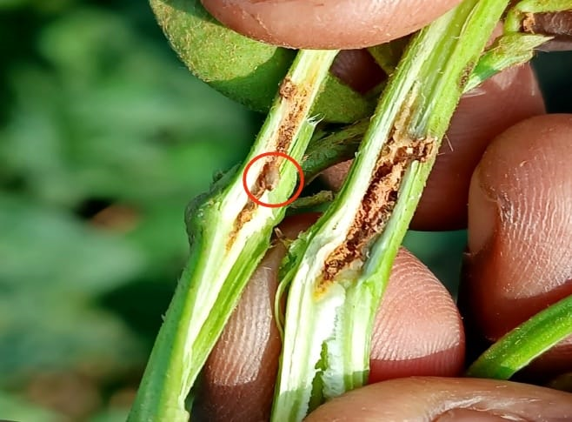
On the basis of per cent tunnel damage, calculating critical difference (CD0.05 = SE (m) × t 0.05) for error degrees of freedom. The standard error means (SE m) was calculated. Stem tunneling was expressed in per centage were used for OPSTAT. Soybean were categorized as highly resistant (HR), Resistant (R), Moderately Resistant (MR), Least Resistant (LR), Susceptible (S) and Highly Susceptible (HS) for resistance as per method prescribed by (Sharma 1996).
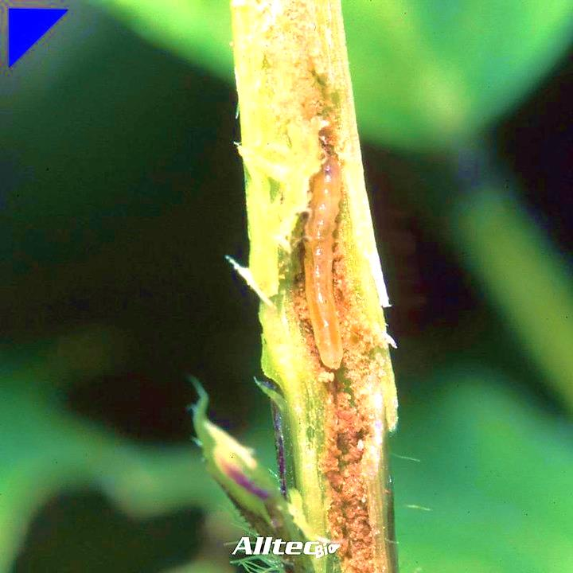

Fig 1: Maggot of stem fly

Fig 2: Pupa inside stem

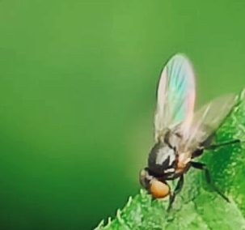

Fig 3: Adult stem fly


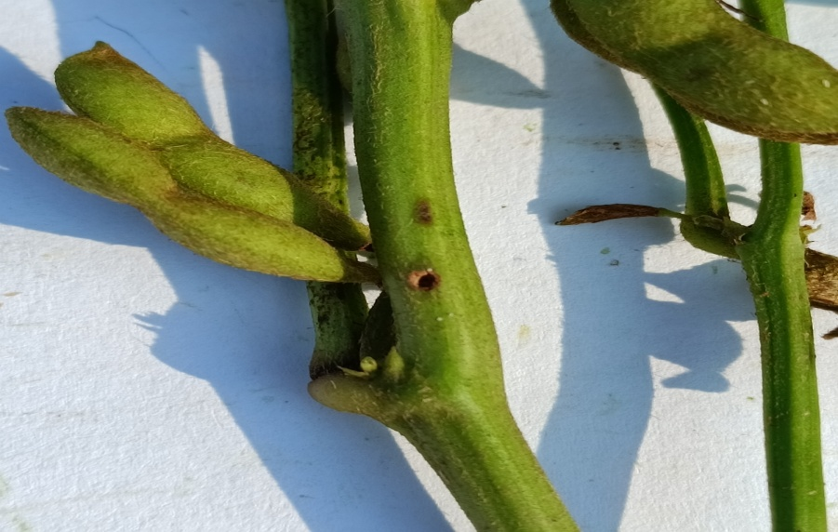

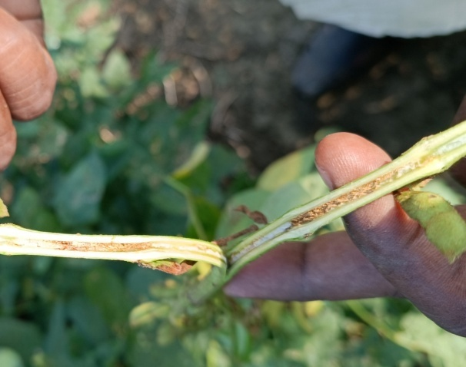
Fig 5: Stem tunneled by the maggot of stem fly

Fig 4: Exit hole made by the stem fly

Categorization of soybean genotypes against stem fly (Melanagromyza sojae) during kharif 2022-23 (Method prescribed by Sharma 1996).
Damage symptoms of stem fly (M.sojae)

Highly resistant (HR) | Value < mean – CD at 1 %
Resistant (R) | Value between mean - CD at 1% and mean – CD at 5%
Moderately Resistant (MR) | Value between mean – CD at 5% and mean
Low Susceptible (LR) | Value between mean and mean + CD at 5%
Susceptible (S) | Value between mean + CD at 5% and mean + CD at 1%
Highly Susceptible (HS) | Value > mean + CD at 1%

List 1- Resistance Categories Based on Value Ranges Relative to Mean and Critical Differences
Categorization of soybean genotypes against stem fly
On the basis of per cent tunnel damage, calculating critical difference (CD0.05 = SE (m) × t 0.05) for error degrees of freedom. The standard error means (SE m) was calculated. Stem tunneling was expressed in per centage were used for OPSTAT. Soybean were categorized as highly resistant (HR), Resistant (R), Moderately Resistant (MR), Least Resistant (LR), Susceptible (S) and Highly Susceptible (HS) for resistance as per method prescribed by (Sharma 1996).
Statistical analysis
Data recorded on various aspects were tabulated and subjected to statistical analysis by using the techniques of the analysis of variance. Treatments significance was tested by ' F' test. When F' test showed significant difference between the treatments mean values, was further tested for critical difference (CD) at 5% level of significance. The data obtained were statistically analyzed after appropriate transformation. The data on stem tunnelling was recorded from the plants and then converted into percentage. The per cent data were processed under arc sin transformation prior to statistical analysis. Then these transformed data were analyzed using the analysis variance method described by Gómez and Gómez, 1984.

RESULTS AND DISCUTION
To evaluate different soybean genotypes against stem fly Melanagromyza sojae (Zehntner).
The per centage of tunnel damage caused by stem fly in different soybean genotypes was observed ranged between 4.58 to 19.69 are presented in table 1.Only two genotype namly NRC-190 and PS-1670, were categoriezed under highly resistant category with minimum tunnel damage of 4.50 and 4.58 per cent, whereas four genotype viz. JS23-09, KDS-1169, NRC-128 (R.C) and SL-1282 were received tunnel damage per cent of 5.83, 5.99, 6.03, and 6.89 was placed under resistance category. Whereas twelve genotypes viz. CAUMS-2, KDS-1096, RSC-11-35, PS-1682, JS-97-52, NRC-189, PS-1569, JS-20-116, RSC-10-46, NRC-192, RSC-11-42 and RVS-13-20 received tunnel damage of 7.29, 7.60, 8.15, 8.42, 9.26, 9.51, 9.75, 9.99, 10.32, 10.59, 10.68, 10.87 per cent and exhibited as moderately resistant genotypes.
Remaining eleven genotypes namely AS-24, VLS-102, NRC-196, KDS-1149, NRC-195, NRC-197, MAUS-791, JS-22-12, RSC-11-07, MACS-1460 and JS-22-16 categorized under low resistant category and recorded tunnel damage percent of 11.11, 11.18, 11.44, 11.66, 11.67, 11.91, 12.12, 12.50, 13.44, 13.86, and 14.92 respectively. Rest of the genotypes viz. RSVM-2012-4, JS-22-18, JS-23-03, MAUS-795, AMS-2014-1(S.C), NRC-165 and DSLB-1 were found to be susceptible and highly susceptible to stem fly damage with tunnel damage ranged between 15.18 to 19.69 per cent.
In respect to the per cent plant infestation of different soybean genotypes varied from 25 to 75 per cent at physiological maturity. It was interesting to note that NRC-190 was superior, recorded less plant infestation which was at par with JS-23-09-, KDS-1169, MAUS-791, RSC-11-42 NRC-196 (30, 40, 45, 50, 55 and 65percent, respectively). On the other hand, KDS-1149, NRC-195, RSC-11-07, MAUS-795, DSLB-1 recorded maximum plant infestation. 70, 70, 70, 75, and 75 per cent was found to be inferior whereas, the resistant check NRC- 128 recorded 30 per cent infestation and susceptible check AMS-2014-1 recorded 65 percent infestation.
The present investigations are less, more or similar with the findings of Gupta et al. (2004); Upadhyay et al., (2017).They suggested tunnel damage might be play important role to decide susceptible and resistant characteristics of any genotypes, they recorded tunnel damage ranged between 9.17 to 9.67 per cent might be due to their morphological and biochemical factors.

Table 1.Performance of soyabean genotypes against stem fly with respect to per cent tunnel damage and plant infestation during kharif 2022-23.

S.N. | Genotypes | Tunnel  Damage  (%) | Plant  infestation  (%) | Category | Yield  (Kg/ha)
1 | MAUS-795 | 15.63 (23.11)* | 75(60.45)* | S | 987.65
2 | KDS-1169 | 5.99 (13.81) | 40 (39.19) | R | 1265.43
3 | JS-23-09 | 5.83 (13.97) | 30 (33.20) | R | 1425.93
4 | JS-23-03 | 15.50 (23.05) | 55 (47.85) | S | 895.06
5 | NRC-197 | 11.91 (20.18) | 40 (39.09) | LR | 1049.38
6 | NRC-196 | 11.44 (19.76) | 55 (47.87) | LR | 1351.85
7 | MAUS-791 | 12.12 (20.36) | 45 (41.97) | LR | 1080.25
8 | AS-24 | 11.11 (19.41) | 65 (53.76) | LR | 895.06
9 | VLS-102 | 11.18(19.52) | 55 (47.87) | LR | 1006.17
10 | RSC-11-42 | 10.68 (18.88) | 50 (44.98) | MR | 1358.03
11 | NRC-190 | 4.58 (12.33) | 25 (33.20) | HR | 1451.85
12 | SL-1282 | 6.89(15.20) | 65 (29.88) | R | 1320.99
13 | NRC-192 | 10.59 (18.98) | 40 (53.76) | MR | 962.96
14 | KDS-1149 | 11.66 (19.96) | 70 (39.09) | LR | 1222.22
15 | NRC-195 | 11.67 (19.96) | 70 (56.84) | LR | 1296.30
16 | PS-1682 | 8.42 (16.83) | 65 (53.76) | MR | 956.79
17 | RVS-13-20 | 10.87 (19.26) | 45 (42.10) | MR | 925.93
18 | CAUMS-2 | 7.29 (15.56) | 40 (39.19) | MR | 1228.40
19 | NRC-189 | 9.51 (17.94) | 50 (44.98) | MR | 1197.53
20 | RSC-11-35 | 8.15 (16.58) | 45 (41.97) | MR | 709.88
21 | JS-22-16 | 14.92 (22.69) | 50 (44.98) | LR | 1043.21
22 | DSLB-1 | 19.69 (26.33) | 75 (59.98) | HS | 524.69
23 | JS-22-12 | 12.50 (20.69) | 65 (53.91) | LR | 833.33
24 | RSVM-2012-4 | 15.18 (22.87) | 65 (54.20) | S | 925.93
25 | KDS-1096 | 7.60 (15.91) | 45 (41.97) | MR | 987.65
26 | PS-1569 | 9.75 (18.11) | 50 (44.98) | MR | 1222.22
27 | PS-1670 | 4.50 (12.24) | 30 (33.12) | HR | 1462.96
28 | NRC-165 | 16.17 23.70) | 60 (50.87) | S | 1141.98
29 | JS-22-18 | 15.19 (22.92) | 50 (44.98) | S | 956.79
30 | RSC-11-07 | 13.44 (21.47) | 70 (56.84) | LR | 987.65
31 | JS-20-116 | 9.99 (18.39) | 40 (39.19) | MR | 1111.11
32 | MACS-1460 | 13.86 (21.84) | 50 (44.98) | LR | 1135.80
33 | RSC-10-46 | 10.32 (18.70) | 45 (42.11) | MR | 1074.07
34 | JS-97-52 | 9.26 (17.70) | 30 (33.12) | MR | 1018.52
35 | NRC-128 (R.C.) | 6.03 (14.20) | 30 (33.12) | - | 1450.62
36 | AMS-2014-1 (S.C.) | 16.03 (23.59) | 65(53.760) | - | 695.06
 | CD at (5%) | 3.98 | 19.741 | - | 468.97
 | CD at (1%) | 5.32 | - | - | -
 | SE(m)± | 1.38 | 6.84 | - | 162.66
*Figures in parenthesis are arc angular transformed values.
Category = HR: Highly Resistant; R: Resistant; MR: Moderately Resistant, L: Least resistant, S: Susceptible; HS: Highly Susceptible.
R.C. : Resistence check; S.C. : Susceptible check.
Table 2. Categorization of different soybean genotypes against stem fly (Sharma 1996) during kharif 2022-23.
S.N. | Range | Rating scales | Category | No. of Genotypes | Genotypes
1 | Value < mean – CD at 1% | 5.67 | HR | 2 | NRC-190, PS-1670
2 | Value between mean – CD at 1% and mean – CD at 5% | 5.67-7.02 | R | 4 | KDS-1169, JS-23-09, SL-1282, NRC-128
3 | Value between mean – CD at 5% and mean | 7.02-10.99 | MR | 12 | RSC-11-42, NRC-192,  PS-1682, RVS-13-20, CAUMS-2, NRC-189,  RSC-11-35, KDS-1096,  PS-1569, JS-20-116,  RSC-10-46, JS-97-52
4 | Value between mean and mean + CD at 5% | 10.99-14.96 | LR | 11 | NRC-197, NRC-196,  MAUS-791, AS-24,  VLS-102, KDS-1149,  NRC-195, JS-22-16,  JS-22-12, RSC-11-07, MACS-1460
5 | Value between mean + CD at 5% and mean + CD at 1% | 14.96-16.31 | S | 6 | MAUS-795, JS-23-03, RSVM-2012-4, NRC-165, JS-22-18, AMS-2014-1
6 | Value > mean + CD at 1% | 16.31 | HS | 1 | DSLB-1
HR: Highly Resistant; R: Resistant; MR: Moderately Resistant, L: Least Resistant, S: Susceptible; HS: Highly Susceptible

CONCLUSIONS
- On the basis of per cent tunnel damage, out of thirty six genotypes, genotypes NRC-190, PS-1670 was found under highly resistant category. Four genotypes were found under resistant category. Twelve genotypes were placed under moderately resistant category, eleven genotypes were placed under least resistant, six under susceptible and one under highly susceptible category.
- In terms of plant infestation PS-1670 genotype recorded the minimum infestation and NRC-195 and DSLB-I recorded the maximum infestation.

REFERENCES
Abou-Attia, F. and Youssef, A.E. 2007. Field evaluation of some soybean cultivars for infestation with soybean stem fly, Melanagromyza sojae (Zehntner) and leafminer, Liriomyza trifolii (Burgess) at Kafr EL-Sheikh region. J Pl Protec., 32(3): 2307-2317.
Bakhsh, Allah, Sirel, I.A., Kaya, R.B., Ataman, I.H., Tillaboeva, S., Dönmez, B.A., Yeşil, B., Yel, I., Tekinsoy, M. and Duru, E. 2021. Contribution of Genetically Modified Crops in Agricultural Production: Success Stories. In Policy Issues in Genetically Modified Crops. Academic Press, 111-142.
El-Samahy, M.F.M. and Morsy, A.R. 2011.The tolerance of three soybean varieties to the infestation with soybean stem fly, Melanagromyza sojae (Zehnt.) at Kafr El-Sheikh region. Minufiya J Agric Res Vol., 36(4): 1039-1049.
Gomez, K.A. and Gomez, A.A. 1984. Statistical procedure for Agricultural Research. John wiley and sons, New York. 791 pp.
Gupta, M.P., Chaurasia, S. K. and Rai, H. S. 2004. Field resistance of soybean genotypes against incidence of major insect pests, Ann Pl Prot Sci., 12(1): 63-66.
Mesbah, I. I. and El-Galaly, O. 1999.Ecological studies on soybean stem fly Melanagromyza sojae (Diptera: Agromyzidae) and evaluation of some soybean (Glycine max L. Merr.) genotypes for their resistance in north delta region. 8th Nat. Conf. of Pests & Dis. of Veg. & Fruits in Ismailia, Egypt, 139- 148.
Mesbah, I.I., Helal, R.M.Y. and Hendawy, A.S. 2001.Population studies on parasitoids of Melanagromyza sojae Zehnt., Diptera: Agromyzidae in soybean fields at Kafr El-Sheikh region [Egypt]. Mansoura University J. Agri Sci (Egypt), 26(5): 3215-3223.
Patel M.C. 2013. Studies on factors affecting incidence of stemfly, Melanagromyza sojae (Zehntner) on soybean. M.Sc. (Ag.) thesis submitted to Jawaharlal Nehru Krishi Vishwa Vidyalaya, Jabalpur, 22.
Rai PS, Seshu Reddy KV, and Govindan R 1973. A list of insect pests of soybean in Karnataka state. Current Research; 2:97-98.4:87-88.
Sharma, A.N., 1996. Comparision of two screening procedures and classification of soybean genotypes into insect resistant groups. Int J of Pest Management 42(4):307–310.
Shatta, F.A.I. 2010. Studies on soybean stem fly, Melanagromyza sojae (Zehntner) in Kafr El-Sheikh Region. M. Sc. Economic Entomology, Kafr El-Sheikh Univ, 123.
Upadhyay, J. 2017. Screening of soybean genotypes against stem fly, Melanagromyza sojae (Zehntner). J Entomol Zool Stud., 5(5): 1994- 1999.
Venkatesan, T. and Kundu, G.G. 1994. Yield - infestation relationship and determination of economic injury level of stem fly, Melanagromyza sojae (Zehnt.) infesting soybean. J of Entomological Research, 18(3): 265-270.

