Response of Baby Corn (Zea mays L.) to Plant Growth Regulators and
Organic Manure Applications

___________________________________________________________________________
Abstract
A field experiment was conducted during the Kharif season of 2022 at the Crop Research Farm, Sahaspur, Dehradun to evaluate the impact of plant growth regulators (PGRs) and organic manures on the growth and yield performance of baby corn (Zea mays L.). The study comprised ten treatment combinations, including three PGRs (Seaweed extract, GA₃, and NAA) and three organic manures (FYM, goat manure, and vermicompost), with a recommended dose of fertilizer (RDF) serving as the control. The treatments were arranged in a randomized block design (RBD) with three replications. Among all treatments, the foliar application of NAA at 30 ppm combined with the basal application of vermicompost at 4.46 t/ha recorded the highest plant height (189.57 cm), dry matter accumulation (97.47 g/plant), enhanced cob traits, maximum green cob yield (6.82 t/ha), and a harvest index of 33.07%, significantly outperforming the RDF control. These findings suggest a strong synergistic effect between NAA and vermicompost in promoting the overall growth and yield of baby corn.
Keywords: Baby corn, NAA, Organic manure, Vermicompost, Plant growth regulators, Yield,
Economics
___________________________________________________________________________
1. Introduction
Maize (Zea mays L.), a belongs to Poaceae family, is one of the most versatile and productive cereal crops cultivated globally. Botanically, it is a monoecious annual plant exhibiting distinct male (tassel) and female (ear) inflorescences on the same plant. Its C4 photosynthetic pathway, strong root system, and genetic adaptability enable it to thrive in diverse agro-climatic conditions. While traditionally grown for grain and fodder, maize has diversified uses, including its cultivation as baby corn, which refers to the immature ears harvested within 2–4 days of silk emergence, before fertilization.
In India, maize ranks third in cereal production after rice and wheat. As per the latest data from the Ministry of Agriculture and Farmers' Welfare, maize is cultivated over an area of approximately 9.5 million hectares with an annual production of around 32 million tonnes, and an average productivity of 3.4 tonnes per hectare. States such as Karnataka, Madhya Pradesh, Maharashtra, Rajasthan, and Uttar Pradesh contribute significantly to the national output. Notably, baby corn cultivation is gaining prominence, especially around peri-urban areas due to its short duration, high market value, export potential, and suitability for multiple cropping systems.
Despite its potential, productivity in baby corn is often limited by imbalanced nutrient management and suboptimal plant growth regulation. The growing demand for eco-friendly and sustainable agriculture has emphasized the need for integrating organic sources of nutrients and plant growth regulators (PGRs) to improve physiological efficiency and productivity. Organic manures, particularly farmyard manure (FYM), are known to enhance soil fertility, microbial activity, and water retention. Concurrently, plant growth regulators like NAA (Naphthaleneacetic acid) and GA₃ (Gibberellic acid) play a pivotal role in cell elongation, photosynthesis, and reproductive development.
The integrated use of organic manures and plant growth regulators has been shown to significantly enhance crop growth and productivity. Organic manures, especially farmyard manure (FYM), improve soil physical, chemical, and biological properties, which are critical for sustaining plant growth. FYM contributes to increased soil fertility by supplying a steady release of macro- and micronutrients. It also enhances soil microbial biomass and enzymatic activities, which facilitate nutrient mineralization and availability to the maize plant. Additionally, FYM improves the soil's water-holding capacity and aeration, creating a more favorable environment for root development. These improvements in soil health directly influence the vigor and sustainability of maize growth, especially under rainfed or resource-constrained conditions.
Simultaneously, the application of plant growth regulators such as Naphthaleneacetic acid (NAA) and Gibberellic acid (GA₃) plays a crucial role in modulating plant physiological and developmental processes. NAA, a synthetic auxin, promotes root initiation and elongation, enhances cell division, and delays leaf senescence, which collectively support better nutrient and water uptake. In maize, NAA application can lead to improved root architecture and canopy development, which are essential for maximizing photosynthetic efficiency and biomass accumulation.
Gibberellic acid (GA₃), on the other hand, is known to stimulate stem elongation, seed germination, and flowering. In maize, GA₃ enhances internodal elongation and leaf expansion, resulting in taller plants with larger leaf areas, which can intercept more light for photosynthesis. Moreover, GA₃ influences reproductive development by promoting tassel emergence and improving pollen viability, ultimately contributing to better fertilization and grain set. The combined effect of organic manure and PGRs can thus create a synergistic influence on maize physiology, enabling the crop to reach its genetic yield potential under both normal and stress conditions.
Therefore, this study was undertaken to investigate the combined influence of growth regulators and organic manure on the growth, yield attributes, and productivity of baby corn under field conditions. The findings are expected to contribute to developing integrated nutrient and hormone management practices for improving baby corn production sustainably.
2. Materials and Methods
Present study was carried out during the kharif season of 2022 at Sahaspur, Dehradun, located at an elevation of 410 meters above mean sea level. The soil of the experimental site was sandy loam in texture, characterized by low organic carbon and nitrogen content, medium phosphorus levels, and low potassium availability, reflecting a typical nutrient-deficient profile suitable for testing organic and growth-promoting inputs.
A randomized block design (RBD) was employed for the experiment, consisting of ten treatment combinations replicated thrice. The treatments involved various combinations of plant growth regulators (PGRs) and organic manures. The PGRs included seaweed extract at 5%, gibberellic acid (GA₃) at 15.47 ppm, and naphthaleneacetic acid (NAA) at 30 ppm. These were each combined individually with farmyard manure (FYM) at 10 tonnes per hectare, goat manure at 15 tonnes per hectare, and vermicompost at 4.46 tonnes per hectare. An additional treatment with recommended dose of fertilizers (RDF) comprising 120:60:40 kg N:P:K per hectare served as the control for comparison.
The baby corn hybrid G-5414 was selected for the study and sown on July 22, 2022, with a spacing of 60 cm between rows and 15 cm between plants. All recommended agronomic practices, including timely irrigation, weed control, and pest management, were uniformly applied across the plots to ensure the validity of treatment effects.
Observations were recorded at 15-day intervals up to 60 days after sowing (DAS) for various growth parameters, including plant height and dry matter accumulation. Yield-related parameters such as number of cobs per plant, cob length and girth, and fresh cob weight (with and without husk) were measured at harvest. Final yield was assessed in terms of green cob yield (t/ha), stover yield, and harvest index. In addition to agronomic observations, an economic analysis was conducted to evaluate the cost-effectiveness of different treatment combinations.
The data collected during the research study were analyzed using the Analysis of Variance (ANOVA) method as outlined by Gomez and Gomez (1984). The significance of treatment effects was assessed using the F-test (variance ratio). When significant differences were observed, treatment means were further compared using the Critical Difference (CD) at a 5% level of probability. The standard ANOVA table was employed for hypothesis testing and interpretation of results.
Table 1. Skeleton of Anova table
Source of variation | D.f. | S.S. | M.S.S. | F.Cal | F Tab at 5%
Due to replications | (r-1) | RSS | RSS (r-1) | MSS(r)EMS
Due to treatments | (t-1) | TrSS | TrSS (t-1) | MSS(t)EMS
Due to error | (r-1)(t-1) | ESS | ESS (r-1)(t-1)
Total | (rt-1) | TSS

3. Results and Discussion
3.1 Growth Parameters
The application of plant growth regulators (PGRs) in conjunction with organic manures had a significant influence on the growth parameters of baby corn. At 60 days after sowing (DAS), the maximum plant height (189.57 cm) and plant dry weight (97.47 g/plant) were observed under the treatment comprising foliar application of NAA at 30 ppm combined with basal application of vermicompost at 4.46 t/ha. This enhancement in growth can be attributed to improved nutrient uptake and more efficient physiological functioning of the plants. NAA, a synthetic auxin, is known to stimulate endogenous auxin activity, promoting cell division and elongation, thereby contributing to increased plant height and biomass accumulation (Otie et al., 2013).
The beneficial role of vermicompost in enhancing dry matter accumulation in maize is well established. Vermicompost is rich in essential nutrients, humic substances, and beneficial microorganisms, all of which contribute to improved soil structure, enhanced aeration, and increased microbial activity. These improvements facilitate better nutrient mineralization and availability, ensuring a consistent supply of nutrients throughout the crop’s growth period. Rajesh et al. (2023) and Tejaswi et al., (2021) also reported that the application of organic amendments like vermicompost enhances microbial biomass and enzymatic activities in the soil, which are vital for sustainable crop nutrition. When vermicompost is combined with plant growth regulators such as Naphthaleneacetic acid (NAA), the synergistic effect significantly improves plant growth. NAA, a synthetic auxin, promotes root initiation, cell division, and elongation. Its application stimulates the development of an extensive root system capable of absorbing more nutrients and water from the soil. The nutrient-rich environment provided by vermicompost further amplifies this effect by supporting healthy root architecture and rhizospheric activity (Vishal and Singh 2023).
The interaction between NAA and vermicompost leads to improved nutrient uptake efficiency and physiological performance. Enhanced root development increases the surface area for absorption, while microbial activity in the vermicompost aids in breaking down organic matter, releasing nutrients in plant-available forms. This dynamic nutrient cycling and hormonal stimulation result in vigorous vegetative growth, characterized by greater plant height, increased leaf area, and higher biomass accumulation (Vishal et al., 2023).
Additionally, the improved soil environment reduces plant stress and supports better photosynthetic activity due to increased chlorophyll content and metabolic efficiency. Together, these factors contribute to a substantial increase in dry matter accumulation. The combined application of NAA and vermicompost, therefore, creates a biologically active and nutrient enriched growing condition, promoting robust early growth in maize and laying the foundation for improved yield potential (Banti and Debbarma et al., 2023).
3.2 Yield and Yield Attributes
The data showed that the number of cobs per plant, cob length, cob girth, and cob weight (with and without husk) were all significantly improved with the application of NAA (30 ppm) + vermicompost. The maximum number of cobs per plant (3.90), cob length (21.95 cm), cob girth (10.03 cm), cob weight with husk (45.72 g), and without husk (22.60 g) were recorded in this treatment. The findings are in accordance with the reports of Sowmya et al., 2013), who emphasized that gibberellic acid and auxins stimulate reproductive growth and help in achieving better sink development.
Rakesh Kumar and Bohra (2014) also found that NAA improved chlorophyll content and photosynthetic efficiency, which may enhance carbohydrate accumulation and support cob development. Furthermore, the role of vermicompost in improving the physical properties of the soil and its microbial health was highlighted by Lone et al. (2013), which likely contributed to higher cob weights and dimensions.
The highest green cob yield with husk (6.82 t/ha) and without husk (3.37 t/ha) were recorded under the NAA + vermicompost treatment. Similar results were reported by Jakhar et al. (2022), who observed that PGR application led to better assimilate partitioning towards economic yield. Gondaliya et al. (2022) also demonstrated that higher application levels of PGRs enhanced photosynthetic rate and yield components in baby corn.
In terms of harvest index, although the maximum value (38.17%) was noted in the Seaweed sap + Goat manure treatment, the overall economic yield was highest under the NAA + vermicompost treatment. The relatively high harvest index values observed in all organic–PGR combinations suggest better dry matter partitioning to reproductive structures, which aligns with the results of (Gao et al., 2020; Banti and Debbarma et al., 2023; Agussalim et al., 2022).
Table 2. Effect of Various Treatments on plant height of Baby corn at different days
S.  No. | Treatment combination | Plant Height (cm)
 |  | 15 DAS | 30 DAS | 45 DAS | 60 DAS
1 | Seaweed sap (5%)+FYM(10t/ha) | 7.90 | 13.03 | 57.90 | 163.40
2 | Seaweed sap (5%)+Goat manure (15t/ha) | 7.23 | 14.14 | 63.80 | 168.60
3 | Seaweed sap (5%)+Vermicompost (4.46 t/ha) | 8.07 | 15.43 | 67.77 | 170.23
4 | GA3(15.47 ppm)+FYM (10 t/ha) | 7.57 | 16.23 | 73.00 | 171.17
5 | GA3(15.47 ppm)+Goat manure(15 t/ha) | 9.50 | 17.29 | 74.47 | 176.23
6 | GA3 (15.47 ppm)+Vermicompost (4.46 t/ha) | 8.67 | 17.50 | 75.13 | 179.90
7 | NAA(30 ppm)+FYM(10 t/ha) | 7.53 | 17.87 | 79.47 | 180.53
8 | NAA(30 ppm)+Goat manure (15 t/ha) | 8.30 | 18.67 | 80.87 | 185.97
9 | NAA(30 ppm)+Vermicompost (4.46 t/ha) | 7.30 | 19.57 | 82.47 | 189.57
10 | Control (RDF)(120:60:40) | 7.72 | 12.93 | 52.87 | 162.17
 | Sem (±) | 0.702 | 1.42 | 4.72 | 5.36
 | CD(P=0.05) | - | 4.24 | 14.04 | 15.94

Figure 1: Effect of Various Treatments on plant height of Baby corn at different days
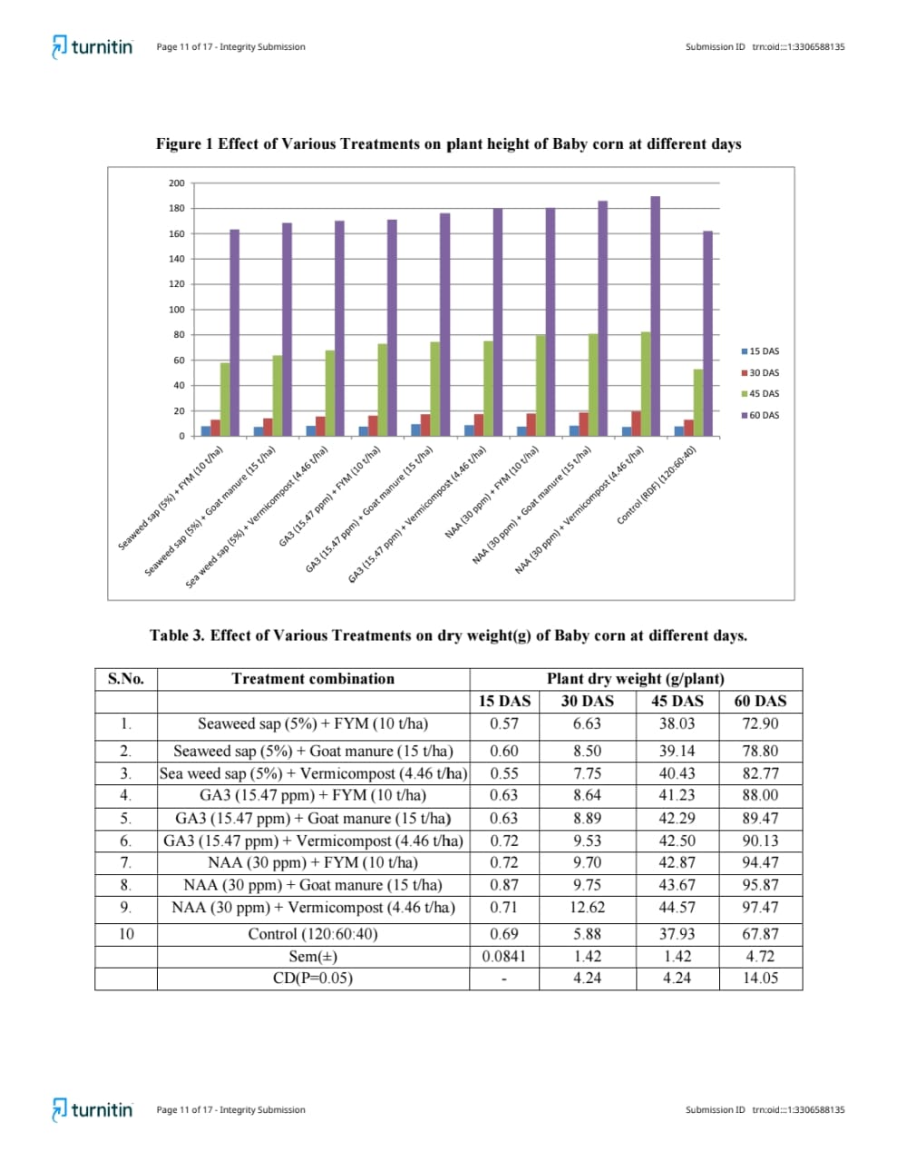
Table 3. Effect of Various Treatments on dry weight(g) of Baby corn at different days
S.  No. | Treatment combination | Plant dry weight (g/plant)
 |  | 15 DAS | 30 DAS | 45 DAS | 60 DAS
1 | Seaweed sap (5%)+FYM(10t/ha) | 0.57 | 6.63 | 38.03 | 72.90
2 | Seaweed sap (5%)+Goat manure (15t/ha) | 0.60 | 8.50 | 39.14 | 78.80
3 | Seaweed sap (5%)+Vermicompost (4.46 t/ha) | 0.55 | 7.75 | 40.43 | 82.77
4 | GA3(15.47 ppm)+FYM (10 t/ha) | 0.63 | 8.64 | 41.23 | 88.00
5 | GA3(15.47 ppm)+Goat manure(15 t/ha) | 0.63 | 8.89 | 42.29 | 89.47
6 | GA3 (15.47 ppm)+Vermicompost (4.46 t/ha) | 0.72 | 9.53 | 42.50 | 90.13
7 | NAA(30 ppm)+FYM(10 t/ha) | 0.72 | 9.70 | 42.87 | 94.47
8 | NAA(30 ppm)+Goat manure (15 t/ha) | 0.87 | 9.75 | 43.67 | 95.87
9 | NAA(30 ppm)+Vermicompost (4.46 t/ha) | 0.71 | 12.62 | 44.57 | 97.47
10 | Control (RDF)(120:60:40) | 0.69 | 5.88 | 37.93 | 67.87
 | Sem (±) | 0.0841 | 1.42 | 1.42 | 4.72
 | CD(P=0.05) | - | 4.24 | 4.24 | 14.05

Figure 2. Effect of Various Treatments on dry weight(g) of Baby corn at different days
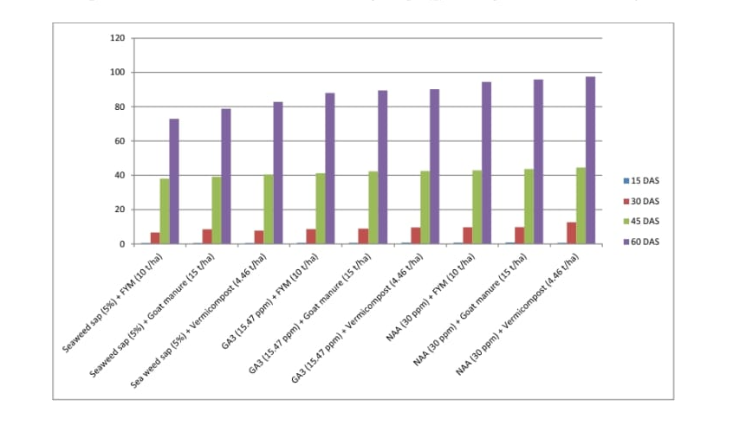
Table 4. Effect of Various Treatments on yield attributes rate of Baby corn
S.No | Treatment combination | Yield attributes
 |  | Cob/Plant (No) | Cob Length  (cm) | Cob girth (cm) | Cob weight with husk (g) | Cob weight without husk (g)
1 | Seaweed sap (5%)+FYM(10t/ha) | 1.50 | 15.48 | 5.33 | 26.88 | 16.17
2 | Seaweed sap (5%)+Goat manure (15t/ha) | 1.65 | 16.74 | 6.39 | 28.18 | 17.42
3 | Seaweed sap (5%)+Vermicompost (4.46 t/ha) | 1.80 | 17.92 | 6.52 | 29.09 | 18.60
4 | GA3(15.47 ppm)+FYM (10 t/ha) | 2.00 | 18.15 | 6.69 | 30.65 | 18.83
5 | GA3(15.47 ppm)+Goat manure(15 t/ha) | 2.43 | 18.99 | 7.75 | 32.99 | 19.67
6 | GA3 (15.47 ppm)+Vermicompost (4.46 t/ha) | 2.50 | 19.45 | 7.93 | 34.04 | 20.13
7 | NAA(30 ppm)+FYM(10 t/ha) | 3.30 | 19.69 | 8.83 | 38.81 | 20.38
8 | NAA(30 ppm)+Goat manure (15 t/ha) | 3.53 | 20.25 | 9.86 | 42.62 | 20.93
9 | NAA(30 ppm)+Vermicompost (4.46 t/ha) | 3.90 | 21.95 | 10.03 | 45.72 | 22.60
10 | Control (RDF)(120:60:40) | 1.45 | 13.72 | 5.13 | 25.36 | 14.40
 | Sem (±) | 0.313 | 1.20 | 1.02 | 4.33 | 1.21
 | CD(P=0.05) | 0.93 | 3.59 | 3.03 | 12.89 | 3.60

Fig 3. Effect of Various Treatments on yield attributes rate of Baby corn
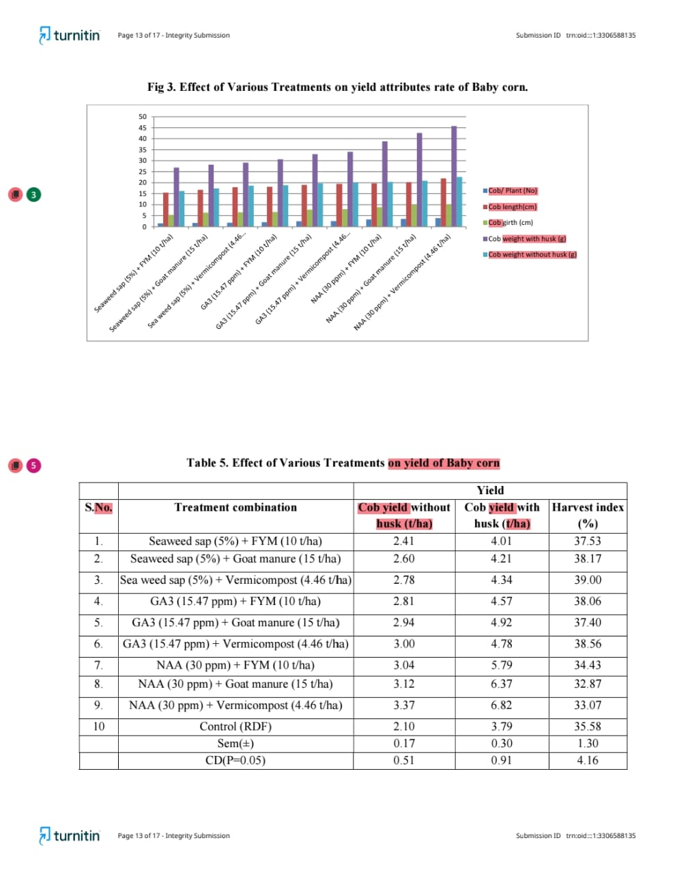
Table 5: Effect of Various Treatments on yield of Baby corn
S.  No. | Treatment combination | Yield
 |  | Cob yield without husk (t/ha) | Cob yield with husk (t/ha) | Harvest index  (%)
1 | Seaweed sap (5%)+FYM(10t/ha) | 2.41 | 4.01 | 37.53
2 | Seaweed sap (5%)+Goat manure (15t/ha) | 2.60 | 4.21 | 38.17
3 | Seaweed sap (5%)+Vermicompost (4.46 t/ha) | 2.78 | 4.34 | 39.00
4 | GA3(15.47 ppm)+FYM (10 t/ha) | 2.81 | 4.57 | 38.06
5 | GA3(15.47 ppm)+Goat manure(15 t/ha) | 2.94 | 4.92 | 37.40
6 | GA3 (15.47 ppm)+Vermicompost (4.46 t/ha) | 3.00 | 4.78 | 38.56
7 | NAA(30 ppm)+FYM(10 t/ha) | 3.04 | 5.79 | 34.43
8 | NAA(30 ppm)+Goat manure (15 t/ha) | 3.12 | 6.37 | 32.87
9 | NAA(30 ppm)+Vermicompost (4.46 t/ha) | 3.37 | 6.82 | 33.07
10 | Control (RDF)(120:60:40) | 2.10 | 3.79 | 35.58
 | Sem (±) | 0.17 | 0.30 | 1.30
 | CD(P=0.05) | 0.51 | 0.91 | 4.16

Fig 4. Effect of Various Treatments on yield of Baby corn
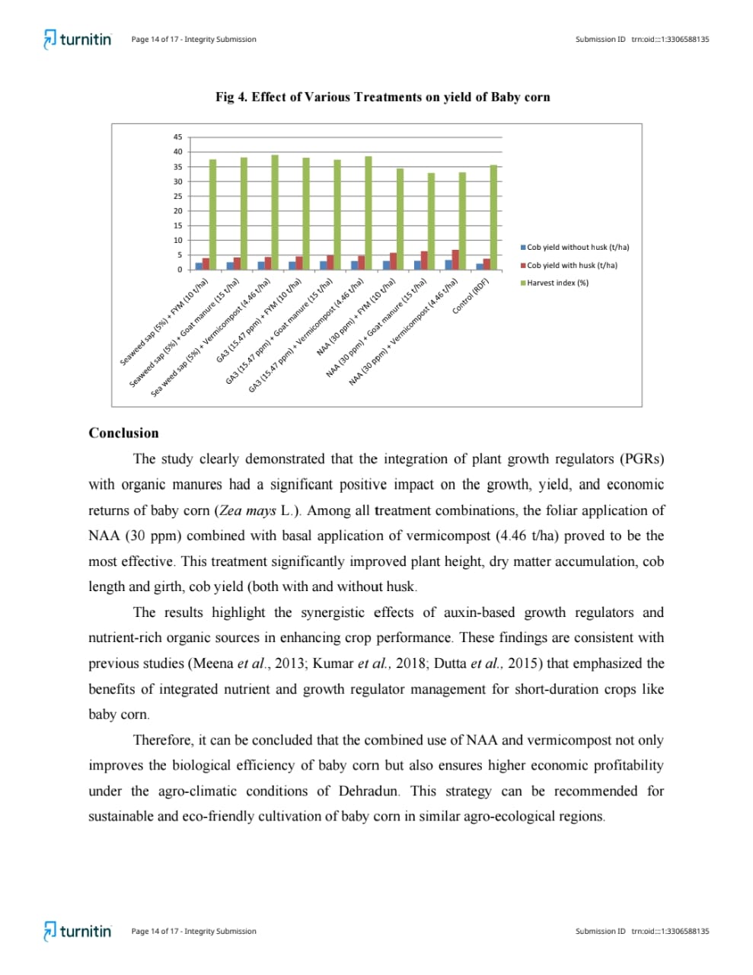
Conclusion
The study clearly demonstrated that the integration of plant growth regulators (PGRs) with organic manures had a significant positive impact on the growth, yield, and economic returns of baby corn (Zea mays L.). Among all treatment combinations, the foliar application of NAA (30 ppm) combined with basal application of vermicompost (4.46 t/ha) proved to be the most effective. This treatment significantly improved plant height, dry matter accumulation, cob length and girth, cob yield (both with and without husk.
The results highlight the synergistic effects of auxin-based growth regulators and nutrient-rich organic sources in enhancing crop performance. These findings are consistent with previous studies that emphasized the benefits of integrated nutrient and growth regulator management for short-duration crops like baby corn.
Therefore, it can be concluded that the combined use of NAA and vermicompost not only improves the biological efficiency of baby corn but also ensures higher economic profitability under the agro-climatic conditions of Dehradun. This strategy can be recommended for sustainable and eco-friendly cultivation of baby corn in similar agro-ecological regions.

References
Agussalim, A. A. R., Rafiudin, R., & Yassi, A. (2022). The application of several organic fertilizers for production increase and brix content of sweet corn (Zea mays L. Saccharate). International Journal of Agriculture System, 10(1), 1-12.
Banti, and Debbarma V. 2023. “Influence of Potassium and Zinc on Growth, Yield and Economics of Cluster Bean (Cyamopsis Tetragonoloba L.)”. International Journal of Plant & Soil Science 35 (9):77–84. https://doi.org/10.9734/ijpss/2023/v35i92907.
Gao, C., El-Sawah, A. M., Ali, D. F. I., Alhaj Hamoud, Y., Shaghaleh, H., & Sheteiwy, M. S. (2020). The integration of bio and organic fertilizers improve plant growth, grain yield, quality and metabolism of hybrid maize (Zea mays L.). Agronomy, 10(3), 319.
Gomez, K.A. and Gomez, A.A., 1984. Statistical procedures for agricultural research. 2nd ed. New York: John Wiley & Sons.
Gondaliya, B. R., Desai, K. D., Ahlawat, T. R., Mangroliya, R. M., & Mandaliya, J. V. (2022). Effect of chemicals on growth and yield of baby corn (Zea mays L.). The Pharma Innovation Journal, 11(9), 2761-2764.
Jakhar, B., Singh, S. P., & Prakash, V. (2022). Response of integrated nitrogen management on winter baby corn's (Zea mays L.) growth, yield and economics. Journal of Applied Horticulture, 24(3), 345-348.
Lone, A. A., Allai, B. A., & Nehvi, F. A. (2013). Growth, yield and economics of baby corn (Zea mays L.) as influenced by Integrated Nutrient Management (INM) practices. African journal of agricultural research, 8(37), 4537-4540.
Otie, V., Ping, A., John, N. M., & Eneji, A. E. (2016). Interactive effects of plant growth regulators and nitrogen on corn growth and nitrogen use efficiency. Journal of Plant Nutrition, 39(11), 1597-1609.
Rajesh, B., Mehera, B., & Kumar, P. (2023). Effect of Bio-fertilizer and Gibberellic Acid on Growth and Yield of Baby Corn (Zea mays, Poaceae). International Journal of Environment and Climate Change, 13(7), 602-607.
Sowmya, S. J., Singh, S. H. I. K. H. A., & Singh, V. I. K. R. A. M. (2021). Performance of plant growth regulators an d micronutrient on growth and yield of maize (Zea mays L.). Asian J. Microbiol. Biotechnol. Environ. Sci, 23, 175-181.
Tejaswi, Y., Singh, S., & Meshram, M. K. (2021). Effect of zinc and bio-fertilizers on growth, yield and economics of baby corn (Zea mays L.). The Pharma Innovation Journal, 10(10), 167-170.
Vishal, and Singh R. 2023. “Influence of Biofertilizers and Nitrogen on the Growth and Yield of Barley (Hordeum Vulgare L.)”. International Journal of Environment and Climate Change 13 (8):312–317. https://doi.org/10.9734/ijecc/2023/v13i81955.
Vishal, Singh R., and Pradhan A. 2023. “Influence of Biofertilizers and Nitrogen on Yield and Economics of Barley (Hordeum Vulgare L.)”. International Journal of Plant & Soil Science 35 (17):196–202. https://doi.org/10.9734/ijpss/2023/v35i173199.

