Adsorption Kinetics of Cu(II), Cr(III), and Ni(II) Ions from a Multicomponent Solution Using Synthetic Zeolite

.

Water pollution by heavy metal ions represents a serious environmental challenge that requires the implementation of efficient and sustainable solutions. Among the available methods for the removal of these contaminants, adsorption stands out as one of the most effective and economical techniques for wastewater treatment. Zeolites are particularly suitable adsorbents due to their pronounced ion-exchange capacity, high efficiency, stability, and the ability to be regenerated and reused multiple times. Their characteristic crystalline structure enables the exchange of sodium, potassium, calcium, and magnesium ions with heavy metal cations present in solution. For the successful application of zeolites under industrial conditions, a detailed understanding of the adsorption mechanisms and kinetics is essential, as it allows for process optimization and identification of key limiting factors. Experimental approaches typically involve varying the adsorbent mass and the initial concentration of the adsorbate in order to determine the optimal conditions for achieving maximum adsorption efficiency.

Keywords: adsorption, heavy metals, wastewater, zeolites

1. INTRODUCTION

Wastewater represents a significant source of environmental pollution, with particular concern arising from the presence of toxic and persistent contaminants such as heavy metals. The presence of heavy metals in wastewater has become increasingly pronounced due to industrial development and various human activities, such as galvanization and electroplating, battery manufacturing, pesticide use, mining, rayon production, metal leaching processes, leather industry, fluidized bed bioreactors, textile industry, metal smelting, petrochemical industry, paper production, and the application of electrolysis [1-6]. Ions such as copper (Cu²⁺), chromium (Cr³⁺), and nickel (Ni²⁺) are frequently found in industrial wastewater. Due to their toxicity, bioaccumulation potential, and high environmental persistence, it is essential to apply effective removal methods. Among the techniques used are ion exchange, reverse osmosis, electrolysis, precipitation, and adsorption. However, when dealing with large volumes of water, low metal concentrations, and strict purification standards, the costs of these processes can increase significantly—for example, due to material, energy, and adsorbent regeneration costs [6-9]. Preventing water pollution by heavy metals requires the establishment of strict regulations for industrial discharges, continuous monitoring of wastewater, and the implementation of efficient metal removal technologies. The selection of appropriate adsorbent materials—including their structure, surface functional groups, porosity, and stability—as well as their thorough testing and characterization, are key elements in the design of adsorption-based water treatment processes [10-14]. One of the approaches to purifying water contaminated with heavy metals is the use of zeolites as adsorbents. Zeolites are crystalline, hydrophilic aluminosilicates whose structure is based on SiO₄ and AlO₄ tetrahedra connected through shared oxygen atoms, resulting in a three-dimensional microporous framework with channels and cages that contain exchangeable cations and water. Owing to these properties, zeolites have found wide application as adsorbents, catalysts, and ion-exchange materials. Although natural zeolites exist, industrial synthesis (e.g., via hydrothermal methods) enables control over key characteristics such as surface area, porosity, selectivity, and thermal stability, which is essential for their application in water purification and other industrial processes [15-18]. While most previous studies have focused on the adsorption of individual metal ions, real conditions in wastewater typically involve the presence of multiple different ions that may compete for active sites on the adsorbent surface. Such multicomponent systems significantly complicate adsorption mechanisms, as competitive effects can alter both the kinetics and the removal capacity of metals. Despite the importance of this phenomenon, studies on multicomponent systems remain relatively scarce compared to those focusing on simple, single-ion solutions [11, 19-20]. In this context, understanding adsorption kinetics under complex multicomponent conditions is essential for optimizing wastewater treatment processes and designing efficient adsorption systems. Therefore, the aim of this study is to investigate the adsorption kinetics of Cu(II), Cr(III), and Ni(II) ions from a multicomponent solution using synthetic zeolite as an adsorbent, with particular emphasis on identifying the kinetic model that best describes the process and evaluating the mutual interactions of ions in a competitive environment.

2. methodology

In the experimental part of the study, ZEOprep 60 HYD was used as the adsorption material, with particle sizes ranging from 35 to 70 µm. Experimental methods used for the physico-chemical characterization of the material, as well as for monitoring the adsorption processes, are presented in Table 1.

Table 1. Methods Used for the Physico-Chemical Characterization of Zeolite
Parameters | Method
Moisture and ash content (%) | Gravimetric method [21]
Total cation exchange capacity (mmol g⁻¹) | Standard ion exchange method using NH₄Cl [22]
pH adjustment and measurement | Potentiometric method using a Mettler Toledo 220 pH meter with a combined electrode
Elemental composition | X-ray diffraction method using a Bruker D4 ENDEAVOR instrument with a 2.4 kW power generator

The adsorption experiment was conducted using standard solutions of Cu²⁺, Ni²⁺, and Cr³⁺ ions, with an initial concentration of 1000 mg/L. Based on these stock solutions, working solutions with concentrations of 10 mg/L, 50 mg/L, and 100 mg/L were prepared and used in subsequent adsorption experiments. The pH value was adjusted using 0.1 M / 0.01 M NaOH and HNO₃. The experiments were performed under batch conditions at a stirring speed of 300 rpm.
The concentrations of Cu(II), Cr(III), and Ni(II) ions in the synthetic aqueous solutions, before and after the adsorption process, were determined by atomic absorption spectrophotometry (AAS) using a Perkin Elmer Analyst 200 instrument. Measurements were carried out at the following wavelengths: 249 nm for Cu(II), 428 nm for Cr(III), and 323 nm for Ni(II).
The adsorption capacity (qₜ) and process efficiency (E, %) were calculated using the following equations:
$q_{t}=\frac{\left(C_{i}-C_{t}\right)⋅V}{m}$ (1)
$E \left(\%\right)=\frac{C_{i}-C_{t}}{C_{i}}⋅100$ (2)
where:
- qₜ – adsorption capacity, representing the amount of adsorbed substance per unit mass of adsorbent at time t, expressed in (mg g⁻¹);
- Cᵢ – initial metal concentration in solution (mg L⁻¹);
- Cₜ – metal concentration in solution at time t (mg L⁻¹);
- V – volume of the solution (L);
- m – mass of the adsorbent (g)

3. results and discussion

3.1 Physical and Chemical Characterization of the Zeolite

Gravimetric analysis was used to determine the moisture and ash content in the zeolite sample. The sample mass was measured before and after drying (to determine moisture content) and after combustion at high temperature (to determine ash content). The obtained results show that the tested zeolite contains 3.95% moisture and 91.28% ash. The low moisture content indicates good thermal stability and ease of removal of adsorbed water, which is important for its preparation prior to use in adsorption processes. At the same time, the high ash content reflects the predominant presence of inorganic, non-degradable components characteristic of both natural and synthetic zeolites. These findings confirm the mineral composition of the material and suggest that the zeolite is stable and resistant under elevated temperatures, making it suitable for application in wastewater treatment and the removal of heavy metals from solution. The point of zero charge (PZC) refers to the pH value of a solution at which the surface concentrations of positive and negative charges are equal—that is, the overall surface charge of the adsorbent is zero [23]. For the experimental determination of the point of zero charge (PZC), a 0.1 M potassium nitrate (KNO₃) solution was used as an inert electrolyte. A series of solutions was prepared with initial pH values ranging from 2 to 10. The pH was adjusted by adding diluted nitric acid (HNO₃) and sodium hydroxide (NaOH) solutions at concentrations of 0.01 M and 0.1 M, depending on the required adjustment. To each 50 mL solution flask, 0.2 g of zeolite sample was added, after which the system was left to stand for 24 hours with occasional stirring. After this period, the pH was measured again (denoted as pHᵢ). The pH value at which no change occurred compared to the initial measurement indicates the point of zero charge of the sample. Knowledge of the PZC is particularly important, as it provides insight into the protonation and deprotonation behavior of the adsorbent surface, which directly affects the binding mechanisms and removal of heavy metal cations from solution. Figure 1. shows the results of the PZC determination.
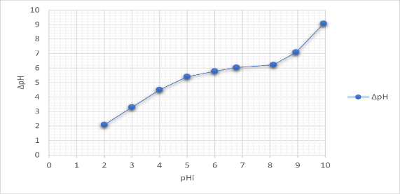
Figure 1. Determination of the point of zero charge (PZC) of the zeolite sample
Cation exchange capacity (CEC) represents a measure of the adsorbent’s ability to exchange cations with the solution, i.e., to adsorb positively charged ions from the aqueous phase.
The CEC of the zeolite was determined using the standard ion exchange method with a 1 mol/L ammonium chloride (NH₄Cl) solution. A 1 g sample was suspended in 100 mL of 1 M NH₄Cl solution at approximately pH 7 and left to equilibrate for 24 hours with occasional stirring to achieve ion exchange equilibrium. After the process was complete, the suspension was filtered, and the concentrations of exchanged cations (Na⁺, K⁺, Ca²⁺, and Mg²⁺) released from the zeolite were determined in the filtrate.
The exchange capacity is expressed in milliequivalents per 100 g of sample (meq/100 g), and the results are presented in Table 2. The total exchange capacity of all cations was 0.2548 mmol Me⁺/g, indicating good ion-exchange capability of the zeolite and its potential for application in heavy metal removal from wastewater.

Table 2. Content of Exchanged Cations in the Zeolite
Exchanged cations | Concentrations (mmol g⁻¹)
Ca ²⁺ | 0.0000595
Mg ²⁺ | 0.0064
K⁺ | 0.0049
Na⁺ | 0.2435

Analysis of the concentrations of cations exchanged during the treatment of the ZEOprep 60 HYD zeolite sample using the standard ion exchange method revealed that the majority of exchanged ions were sodium (Na⁺) ions, with a value of 0.2435 mmol/g. This result indicates that sodium is the dominant cation in the structure of the analyzed zeolite, confirming its high ion exchange capacity. The obtained values are consistent with literature data for zeolites characterized by pronounced cation exchange capacity (CEC). The elevated concentration of Na⁺ ions further suggests that the material possesses significant potential for application in heavy metal removal processes from wastewater via ion exchange and adsorption mechanisms.

The elemental composition and crystal structure of the zeolite were determined using X-ray diffraction (XRD) analysis. This non-destructive analytical technique enables the identification of crystalline phases present in the sample, as well as the assessment of the material’s degree of crystallinity. Based on the intensity and position of diffraction peaks, quantitative phase composition analysis, determination of crystallite size, and evaluation of crystal structure morphology can be performed. Due to its high sensitivity and accuracy, XRD is considered one of the key methods for characterizing zeolites and related materials [24]. The results obtained from the XRD analysis are presented in Figure 2.
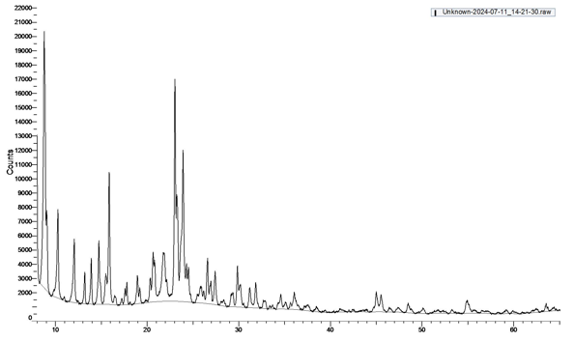
Figure 2. XRD Analysis of the Zeolite
Generally, materials with a crystalline structure are characterized by sharp peaks of high intensity, whereas amorphous phases cause X-ray scattering, resulting in broader peaks of lower intensity. The presented diffractogram shows a large number of well-defined peaks corresponding to the zeolite in its crystalline form, primarily composed of clinoptilolite.

3.2 Effect of Initial Concentration on the Removal of Cu(II), Ni(II), and Cr(III) Ions from Aqueous Solutions

The initial concentration of metal ions plays a crucial role in the efficiency of their removal from aqueous solutions. This study analyzed the effect of the initial concentrations of Cu(II), Ni(II), and Cr(III) ions in a multicomponent system (Cu(II) + Ni(II) + Cr(III)) at concentrations of 10, 50, and 100 mg/L. The adsorption process was monitored at time intervals of 5, 10, 20, and 60 minutes, with a constant stirring speed of 300 rpm. The pH of the solution was adjusted to the point of zero charge (pHₚzc) of the adsorbent to ensure optimal conditions for interaction between the metal ions and the active sites on the zeolite surface. The obtained results are presented in Figures 3 to 5, illustrating the dependence of adsorption efficiency on the initial ion concentration and contact time.
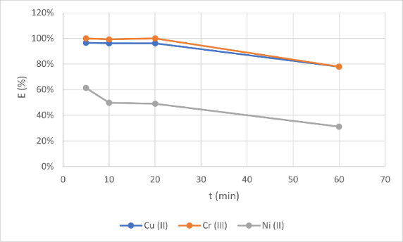
Figure 3. Efficiency of removal of Cu(II), Cr(III), and Ni(II) ions (C₀ = 10 mg/L; m = 1 g; 300 rpm)
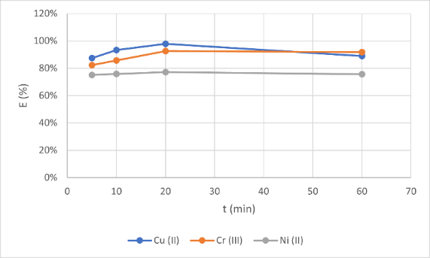
Figure 4. Efficiency of removal of Cu(II), Cr(III), and Ni(II) ions (C₀ = 50 mg/L; m = 1 g; 300 rpm)
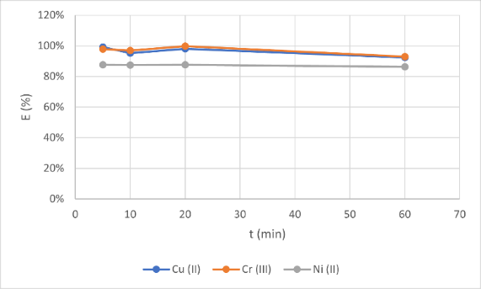
Figure 5. Efficiency of removal of Cu(II), Cr(III), and Ni(II) ions (C₀ = 100 mg/L; m = 1 g; 300 rpm)
The obtained experimental results show that an increase in the initial concentration of metal ions leads to an increase in their adsorption efficiency when using zeolite as an adsorbent. The highest removal rate was achieved at a concentration of 100 mg/L. Specifically, Cu(II) ions exhibited a maximum efficiency of 99.23% after 5 minutes of contact, Cr(III) ions 99.80% after 20 minutes, while Ni(II) ions reached 87.59% at the same contact time.
The increase in adsorption efficiency with rising initial concentration can be attributed to a greater concentration gradient between the solution and the adsorbent surface, resulting in stronger attractive forces between the metal ions and the active sites of the zeolite. A similar trend was reported by Wang and Zhao (2024) [25], who observed increased efficiency with increasing initial concentration up to 100 mg/L during the adsorption of Cu(II), Ni(II), and Cr(III) ions on synthetic zeolite Y, achieving a maximum Cu(II) removal of 98.7%.
Additionally, Li and Singh (2023) [26] reported that Cu(II) exhibits the highest affinity and selectivity toward the active sites of zeolite, which corroborates the results obtained in this study, where the highest adsorption efficiency was observed for Cu(II). On the other hand, Hussein and Yaseen (2025) [27] indicated that at higher concentrations (>100 mg/L), saturation of adsorption sites may occur, leading to a decrease in efficiency— a phenomenon that could be expected in further experiments at concentrations exceeding those analyzed in this study.

Adsorption isotherms

Adsorption isotherms represent one of the key tools for understanding adsorption mechanisms and optimizing the process itself. They enable a quantitative assessment of the adsorbent capacity, as well as the identification of the mode of adsorbate binding to the adsorption surface. To describe adsorption in the adsorbent-adsorbate system, adsorption isotherm equations are applied, and several mathematical models have been developed for this purpose, among which the most well-known and widely used are the Langmuir and Freundlich equations [28]. The Freundlich isotherm model is the earliest known relation describing non-ideal and reversible adsorption, and it can be applied to multilayer adsorption based on the assumption of energetic heterogeneity of the surface [29]. The Freundlich isotherm can be mathematically expressed by equation (3):
$q_{eq}=K_{F}∙{C\text{eq}}^{1/n}$ (3)
where $q_{e}$ (mg g⁻¹) is the equilibrium amount of adsorbate adsorbed per unit mass of adsorbent, $K_{F}$((mg $g^{-1}$) (dm³ mg⁻¹)^{1/n}) and $n$(g dm⁻³) are the Freundlich isotherm constants related to adsorption capacity and intensity, respectively, indicating the degree of adsorption favorability [30].
The Langmuir isotherm describes how molecules adsorb onto the surface of the adsorbent at a constant temperature. The Langmuir isotherm equation is expressed by the following equation:
$q_{ⅇq}= q_{max}\frac{K_{L}⋅Cⅇq}{1+K_{L}⋅Cⅇq}$ (4)
where $q_{e}$— adsorption capacity, i.e., the equilibrium concentration of adsorbed ions on the adsorbent (mg/g);
$q_{max}$— maximum adsorption capacity of the adsorbent (mg/g); $C_{eq}$— equilibrium concentration of the adsorbate in solution (mg/L); $K_{L}$— Langmuir adsorption equilibrium constant (L/mg), which relates the adsorption rate to the adsorption capacity.
The values of the constants $q_{max}$and $K_{L}$are determined from the slope and intercept of the linearized plot of $C_{eq}$on the x-axis versus $C_{eq}/q_{e}$on the y-axis.
A characteristic feature of the Langmuir isotherm is that it can express a dimensionless constant known as the equilibrium parameter or separation factor [31].
The separation factor, $R_{L}$, can be expressed by the following equation (5):
$R_{L}=\frac{1}{1+K_{L}⋅c_{0}}$ (5)

Tables 3 and 4 present the parameters of the Freundlich and Langmuir adsorption models for Cu(II), Cr(III), and Ni(II) ions. Based on the experimental data, it can be concluded that the results fit significantly better to the Langmuir model compared to the Freundlich model, as evidenced by the high values of the coefficient of determination (R²).

Table 3. Values of the Freundlich adsorption isotherm parameters
Freundlich model | Metal | Concentration (mg/L)
Freundlich model | Metal | 10 | 50 | 100
1/n | Cu (II) | -0,118 | -0,0623 | -0,03
R² | Cu (II) | 0,9986 | 0,9493 | 0,9166
Kf | Cu (II) | 0,855855 | 4,949941 | 9,910601
1/n | Cr (III) | -0,0728 | -0,1334 | -0,0172
R² | Cr (III) | 1 | 0,991 | 0,7546
Kf | Cr (III) | 0,825277 | 1,186533 | 9,776874
1/n | Ni (II) | -1,1825 | -0,3083 | -0,1513
R² | Ni (II) | 0,9595 | 1 | 0,9995
Kf | Ni (II) | 3,196686 | 8,173348 | 12,82331

Table 4. Values of the Langmuir adsorption isotherm parameters
Langmuir model | Metal | Concentracions (mg/L)
Langmuir model | Metal | 10 | 50 | 100
R² | Cu (II) | 1 | 0,9992 | 0,9997
q_{m} | Cu (II) | 0,750582 | 4,27716 | 9,174312
K_{L} | Cu (II) | -0,08114 | -0,0201 | -0,10275
R_{L} | Cu (II) | 0,188621 | -0,00513 | -9,27523
R² | Cr (III) | 0,9999 | 0,9993 | 0,9996
q_{m} | Cr (III) | 0,778089 | 3,824092 | 9,23361
K_{L} | Cr (III) | -0,0056 | -0,67878 | -0,08126
R_{L} | Cr (III) | 0,943978 | -32,9388 | -7,12558
R² | Ni (II) | 0,9628 | 0,9973 | 1
q_{m} | Ni (II) | 0,186012 | 3,653635 | 7,54717
K_{L} | Ni (II) | -2,94289 | -0,49507 | -1,72
R_{L} | Ni (II) | -28,4289 | -23,7534 | -171

The obtained $R^{2}$values for the Langmuir model are 1, 0.9992, and 0.9997 for Cu(II); 0.9999, 0.9993, and 0.9996 for Cr(III); and 0.9628, 0.9973, and 1 for Ni(II) ions at concentrations of 10, 50, and 100 mg/L, respectively. These results indicate that the adsorption of Cu(II) and Cr(III) ions onto zeolite is best described by the monolayer adsorption model occurring on a homogeneous surface with a limited number of identical active sites.
The slightly lower fit observed for Ni(II) ions at the lower concentration may be attributed to weaker affinity interactions between Ni(II) ions and the functional groups of the adsorbent, which aligns with observations reported by Shukla et al. (2023) [32] , who noted a similar trend on ZSM-5 type zeolites.
The values of the separation factor ($R_{L}$), calculated based on the Langmuir constant ($K_{L}$), showed both positive and negative values depending on the initial concentration. Positive $R_{L}$values indicate thermodynamically favorable adsorption, whereas negative values suggest that the process may be unfavorable or non-spontaneous. This observation is supported by the findings of Hussein and Yaseen (2025) [27], who reported a decrease in spontaneous adsorption with increasing metal ion concentration.
These results confirm that the adsorption of Cu(II), Cr(III), and Ni(II) ions onto zeolite predominantly occurs as monolayer adsorption, while heterogeneous adsorption may also take place to a lesser extent, in accordance with the Freundlich model. Similar conclusions were reported by Li and Singh (2023) [26] in their study of multicomponent Cu–Cr–Ni systems, which supports the consistency of these findings with the existing literature.

4. Conclusion

The results of this study demonstrated that synthetic zeolite is an efficient and selective adsorbent for the removal of heavy metals from aqueous solutions. The highest adsorption efficiency was achieved for Cu(II) ions, followed by Cr(III) and Ni(II), confirming the significance of the physicochemical properties of the ions in the adsorption process. The experimental data best fit the Langmuir adsorption model, indicating a monomolecular adsorption process occurring on a homogeneous adsorbent surface.
Analysis of the separation factor confirmed that the initial concentration of metal ions significantly influences the adsorption kinetics and thermodynamic favorability. The low moisture content and high ash fraction indicate the high stability of the zeolite, while the presence of Na⁺ ions in the material’s structure confirms ion exchange as the dominant mechanism.
These findings highlight the great potential of synthetic zeolite for application in the treatment of wastewater contaminated with heavy metals.

References

[1] N. Qasem, H. Mohammed i D. Lawal, “Removal of heavy metal ions from wastewater: a comprehensive and critical review,” NPJ Clean Water, tom 4, br. 36, 2021.
[2] H. A. Kosar Hikmat, M. Fryad S., O. Khalid M., H. Sarkawt, H. Rebaz Fayaq i R. Kaiwan Othman, “Heavy metal pollution in the aquatic environment: efficient and low-cost removal approaches to eliminate their toxicity: a review,” RSC Advances, pp. 17959-17610, 2023.
[3] S. Sahen, A. H. Khan Naim, S. Hosen, A. Pranta, M. Hasan, M. Rahman, S. Rahman i A. Welgamage Don, “Multi-compartmental risk assessment of heavy metal contamination in soil, plants, and wastewater: A model from Industrial Gazipur, Bangladesh,” Environmental Monitoring and Assessment, tom 197, 2025.
[4] I. Ugulu, S. I. K. Z. Bibi, K. Ahmad, M. Munir, I. S. Malik, A. Ejaz i A. F. Alrefaei, “Biomonitoring of Heavy Metal and Metalloid Contamination in Industrial Wastewater Irrigated Areas Using Sugar Beet (Brassica oleracea L.),” Sustainabillity, tom 15, br. 12, 2023.
[5] I. I. Ruzi, A. R. Ishak, M. A. Abdullah, N. N. Mohamad Zain, A. R. Tualeka i M. Y. Aziz, “Assessment of Heavy Metal Concentrations in Penang, Malaysia’s Wastewater Treatment Plants: A Wastewater-Based Epidemiology Approach,” Trends in Sciences, tom 20, br. 5, 2023.
[6] M. Custodio, E. Orellana-Mendoza, R. Penaloza, H. Mireille De la Cruz Solano, W. Bulege-Gutierrez i R. Quispe-Mendoza, “Heavy Metal Accumulation in Sediment and Removal Efficiency in the Stabilization Ponds with the Hydrocotyle ranunculoides Filter,” Journal of Ecological Engineering, tom 21, br. 5, pp. 72-79, 2020.
[7] K. Suwannahong, S. Wongcharee, T. Kreetachat, S. Imman, N. Suriyachai, S. Hongthong, J. Rioyo, W. Dechapanya i P. Noiwimol, “Comprehensive Cost–Benefit and Statistical Analysis of Isotherm and Kinetic Models for Heavy Metal Removal in Acidic Solutions Using Weakly Base Polymeric Chelating Resin as Adsorbent,” Water, tom 16, br. 17, 2024.
[8] A. Hussain, S. Madan i R. Madan, “Removal of Heavy Metals from Wastewater by Adsorption,” u Heavy Metals - Their Environmental Impacts and Mitigation, IntechOpen, 2021.
[9] J. Ayach, W. El Malti, L. Duma, J. Lalevee, M. Al Ajami, H. Hamad i A. Hijazi, “Comparing Conventional and Advanced Approaches for Heavy Metal Removal in Wastewater Treatment: An In-Depth Review Emphasizing Filter-Based Strategies,” Polymers, tom 16, br. 14, 2024.
[10] G. L. Dotto i G. McKay, “Current scenario and challenges in adsorption for water treatment,” Journal of Environmental Chemical Engineering, tom 8, br. 4, 2020.
[11] K. F. Kayani i S. J. Mohammed, “Heavy metal pollution in aquatic environments and removal using highly efficient bimetallic metal–organic framework adsorbents,” RSC Advances, 2025.
[12] S. Meftah, K. Meftah, M. Drissi, I. Radah, K. Malous, A. C. A. Amahrous, T. Tamri, A. Rayyad, B. Darkaoui, S. Hanine, O. El-Hassan i L. Bouyazza, “Heavy metal polluted water: Effects and sustainable treatment solutions using bio-adsorbents aligned with the SDGs,” Discover Sustainability, tom 6, br. 95, 2025.
[13] A. M. Shabbirahmed, A. Jacob, P. Dey, P. Somu i D. Haldar, “Biomass as eco-friendly adsorbents for the removal of emerging pollutants from wastewater: A review,” Discover Applied Sciences, tom 7, 2025.
[14] N. Sheraz, A. H. A. Shah i F. J. Iftikhar, “Comprehensive assessment of carbon-, biomaterial- and inorganic-based adsorbents for the removal of the most hazardous heavy metal ions from wastewater,” RSC Advances, br. 16, 2024.
[15] A. Indarto, I. Putra, Riyano i S. Noersalim, “Zeolites as Adsorbent Materials for Decolorization of Crude Terpineol,” IOP Conference Series: Materials Science and Engineering, 2019.
[16] A. M. Alotaibi, “An Overview of Zeolites: From Historical Background to Diverse Applications,” Molecules, 2025.
[17] N. Kordala i M. Wyszkowski, “Zeolite Properties, Methods of Synthesis, and Selected Applications,” Molecules, tom 29, br. 5, 2024.
[18] C. J. Rhodes, “Properties and applications of Zeolites,” Science Progress, tom 93, br. 3, pp. 223-284, 2010.
[19] A. Bawiec i M. Kowalska, “Adsorption of heavy metals from multi-component aqueous systems: Challenges and opportunities.,” Chemosphere, 2024.
[20] L. Zhang, W. Chen i Y. Wang, “Competitive adsorption of Cu(II), Cr(III) and Ni(II) ions from aqueous solutions using synthetic zeolites: Kinetic and thermodynamic studies,” Journal of Environmental Chemical Engineering, 2023.
[21] “Official Methods of Analysis,” 1995.
[22] A. Daković, T.-Č. M, V. Dondur, D. Stojšić i G. Rottinghous, “Zeolites and mesoporous materials at the dawn of the 21st century,” u Proceedings of the 13th International Conference, Montpellier, France, 2001.
[23] C. Rey, C. Combes, C. Drouet i D. Grossin, “Bioactive Ceramics: Physical Chemistry,” Comprehensive Biomaterials, tom 1, pp. 187-221, 2011.
[24] J. U. Janković, „Sinteza, karakterizacija i primena visoko selektivnog adsorbenta za uklanjanje korozivnih jedinjenja sumpora iz mineralnih izolacionih ulja i nove metode za ocenu korozivnosti ulja prema srebru,“ Univerzitet u Beogradu, Beograd, (2024).
[25] X. Wang i Y. Zhao, “Effect of initial ion concentration and pH on competitive adsorption of Cu(II), Ni(II), and Cr(III) in multimetal systems,” Journal of Environmental Chemical Engineering, 2024.
[26] H. Li i K. Singh, “Kinetic and equilibrium studies of multi-component adsorption of heavy metals on zeolite-based adsorbents.,” Chemosphere, tom 338, 2023.
[27] A. A. Hussein i Z. M. Yaseen, “Influence of process parameters on the removal efficiency of multimetal systems using natural and synthetic zeolites,” Environmental Nanotechnology, Monitoring & Management, tom 26, 2025.
[28] T. D. Šoštarić, „Uklanjanje teških metala iz vodenih rastvora biosorbentom na bazi koštica kajsija kao otpadne biomase,“ Univerzitet u Beogradu, Beograd, (2016).
[29] X. Chen, „Modeling of Experimental Adsorption Isotherm Data,“ Information, 2015.
[30] A. B. Đukić, “Adsorpcija jona teških metala iz vodenih rastvora na kompozitu montmorionit/kaolinit glina-titan (IV) oksid,” Univerzitet u Beogradu, Beograd, (2015).
[31] A. Abin-Bazaine, A. Campos Trujillo i M. Olmos-Marquez, “Adsorption Isotherms: Enlightenment of the Phenomenon of Adsorption,” u Wastewater Treatment , IntechOpen, 2022.
[32] P. Shukla i M. El-Masri, “Kinetic and equilibrium modeling of Cu(II), Ni(II), and Cr(III) adsorption on zeolites: Comparison of Langmuir and Freundlich isotherms,” Chemosphere, , 2023.

