Original Research Article
CARDIOTHORACIC RATIO AND PREVALENCE OF CARDIOMEGALY AMONG PATIENTS IN FMC EBUTE METTA

ABSTRACT
Background: Cardiothoracic ratio (CTR) is a common and usually first-line method for the assessment of cardiac size and evaluation for cardiac enlargement (cardiomegaly), particularly in developing countries.
Aims: The aim of the study was to establish the average cardiothoracic ratio, transverse cardiac diameter (TCD) and transverse thoracic diameter (TTD) of patients who perform a PA chest radiograph in FMC Ebute Metta and to determine the prevalence of radiographic cardiomegaly using a cardiothoracic ratio of >0.50 as cutoff.
Methodology: The study was a retrospective descriptive and analytical cross-sectional study utilizing chest radiographs obtained in the radiology department of the Federal Medical Center, Ebute Metta. A total of 490 radiographs (belonging to 252 women and 248 men) were included in this study.
Results: The average CTR, TCD and TTD in this study were 0.476 ± 0.052, 138.17 ± 16.89mm and 291.11 ± 24.68mm respectively. The mean CTR in females (0.489 +/- 0.052) in this study was significantly higher (P<0.001) than that of males (0.461 +/- 0.047). The mean TCD of males (141.50mm +/- 16.85mm) in this study was observed to be significantly higher (P <0.001) than that of females (135.03mm +/- 16.33mm). The mean TTD of males in this study was 307.12 +/- 20.77mm which was observed to be significantly higher (P <0.001) than the mean in females which was 275.99 +/- 17.53mm. The prevalence of cardiomegaly (CTR > 0.50) in this study was 27.3%.
Conclusion: This study has established baseline values for cardiothoracic ratio (CTR), transverse cardiac diameter (TCD), and transverse thoracic diameter (TTD) in an adult population in Lagos, Nigeria. Further multicenter, prospective studies incorporating echocardiographic correlation are warranted to refine diagnostic thresholds and optimize the use of chest radiography in cardiovascular disease prevention and management in Nigeria.

Keywords: Cardiothoracic ratio, Cardiomegaly, Nigeria, Transverse cardiac, Transverse thoracic

- INTRODUCTION
The chest X-ray is the commonest type of imaging examination of the heart ¹. It is extremely valuable as cardiac size and contour can be clearly demonstrated and the shadow of the heart produced in this way can give many important clues as to chamber enlargement. On a conventional Postero-Anterior (PA) chest radiograph the cardiothoracic ratio can be measured, and this expresses the fraction of the heart size to the internal thoracic diameter. Cardiothoracic ratio is normally below 50% on PA radiographs (Sutton, 2003).
Cardiomegaly, as recognized on chest radiographs, refers to the enlargement of the cardiac silhouette produced by ventricular enlargement, not by isolated enlargement of the atria (Herring, 2016). The cardiac silhouette usually appears normal when there is isolated atrial enlargement such as left atrial enlargement in mitral stenosis. The heart shadow can appear enlarged on conventional radiographs for three main reasons:
(a) True cardiac enlargement
(b) pericardial effusion, which may mimic the appearance of cardiomegaly on conventional radiographs
(c) extra-cardiac factors that produce apparent cardiac enlargement. These include suboptimal inspiration, rotation, Antero-posterior (AP) radiographs etc
To avoid false detection of cardiomegaly due to extra-cardiac factors, the following technical factors are assessed for on radiographs:
Inspiration- Adequate inspiration is assessed by visualizing the anterior end of the 6th rib, or the posterior end of at least eight to nine ribs, above the right hemidiaphragm.
Rotation- The medial ends of each clavicle should be equidistant from the spinous process of the vertebral body between them. Significant rotation may alter the expected contours of the heart and also give a false cardiothoracic ratio. Rotation may be scored as present if the distance between the medial ends of the clavicles and the spinous processes of thoracic vertebral bodies differed by greater than 1 cm between the right and left side (Hardy et al, 2015).
Magnification- PA radiographs are utilized for cardiothoracic ratio measurements, as AP radiographs may magnify the heart slightly.

Heart chamber enlargement can also be determined on multiple other modalities: including computed tomography (CT), Magnetic Resonance Imaging (MRI), Echocardiography and Electrocardiography (ECG). The chest X-ray however provides a relatively quick, inexpensive and accessible way of detecting cardiomegaly, and is also easily reproducible with a low radiation burden on the patient. Chest X-ray is the primary mode of cardiac evaluation in almost every health institution in Nigeria. However, the availability of echocardiography, CT and MRI, are severely limited due to the paucity of resources to set up and maintain such facilities, scarcity of patient funds to pay for such services, instability of electricity nationwide, and impracticality of performing echocardiography on every patient to determine their cardiac status.
Cardiomegaly on chest radiograph may be the first pointer to congenital cardiac disease, or cardiac disease secondary to conditions like hypertension, cardiomyopathies, and atherosclerosis. Due to the its fairly high sensitivity and specificity for left ventricular hypertrophy, it serves as a decent screening tool to estimate the prevalence of cardiac chamber enlargement among patients.
The diagnostic utility of cardiothoracic ratio (CTR) measurement has been a subject of multiple studies with varying results. In a study in Ontario Canada assessing the diagnostic efficiency of chest radiography measurements for the assessment of enlargement of any of the four cardiac chambers using cardiac MRI as reference standard, a CTR of 0.50 showed a sensitivity of 72%, a specificity of 72%, a positive likelihood ratio of 2.59, and a negative likelihood ratio of 0.38 (Torres et al, 2021). In another study in Iraq, which assessed the accuracy of CTR when compared to echocardiography for the assessment of left ventricular enlargement, CTR demonstrated a high sensitivity (85.71%) and a low specificity (13.79%). Positive predictive value (41.86%) and negative predictive value (42.85%) were both low. The study concluded that the cardiothoracic ratio is highly sensitive but of very low specificity in measuring heart size (Kadhum et al, 2007).
Most sources consider a CTR greater than 0.50 (50%) to be the cut-point for cardiomegaly. A study however noted that it has little accuracy to distinguish a normal from an increased heart size when used as a single threshold method at. CTR > 50% (Simkus et al, 2021). The study noted that the likelihood of having an increased heart size when the CTR is >55% is high, as is the likelihood of a normal heart size when the CTR is <45%. It was then suggested that intermediate CTR values (45–55%), due to their lack of sensitivity and specificity, should be more accurately reported as “a possibility of cardiac chamber enlargement” rather than stating true cardiomegaly. However, another study concluded that CTR > 49% should be the cut-point due to its high accuracy (Truszkiewicz et al, 2022).
Some studies have tried to assess inter-observer agreement of clinicians in the measurement of CTR. In a study in the UK assessing the accuracy of CTR in predicting left ventricular and right ventricular dysfunction, three experienced clinicians collected chest radiograph data in a blinded manner. Inter-observer variability was assessed using Lin’s concordance correlation coefficient which demonstrated near-perfect interobserver agreement (Chana et al, 2015). Another study also in the UK also demonstrated excellent inter-observer agreement in CTR measurements (Simkus et al, 2021).
This study aims to establish the average cardiothoracic ratio among patients that performed a PA chest radiograph in Federal Medical Center Ebute Metta, and determine the rates of abnormal (cardiomegaly) among them. It also serves to estimate the average transverse cardiac diameter and transverse thoracic diameter among the study population and evaluate for any differences between the different sexes and age-groups. The study would however exclude patients with known cardiac disease as the high prevalence of cardiomegaly among such population would overstate the prevalence of cardiomegaly among the general population.
No published CTR reference values exist for Lagos state; thus, this study would be the first study to give such data. The reference ranges obtained from this study would help improve diagnostic accuracy in primary care, and help clinicians make decisions as to when to order further testing and interventions for their patients. Prevalence data from this study will contribute to regional and global epidemiological data on cardiomegaly, and help inform public health policies and screening initiatives, especially screening for hypertensive heart disease in Nigeria, a country with a high prevalence of hypertension estimated at 31.2% (WHO, 2020).
- MATERIALS AND METHODS
2.1 Study design
This is a cross-sectional retrospective hospital-based study
2.2 Study venue
The study was carried out in the department of radiology of the federal medical center Ebute Metta (FMC EB), a tertiary health institution located in Lagos state, South western Nigeria. The institution is a referral center for Lagos state with a population of at least 16.4 million inhabitants according to a 2018 Lagos state government estimate. The other five states of the south western Nigeria also utilize this facility. The department provides a wide range of radiological services.
2.3 Study Duration
The study was carried out over a period of one month from approval from the Ethics committee of FMC Ebute Metta.
2.4 Study Population
The study population is made up of patients who performed a chest radiograph in the radiology department of the Federal Medical Center, Ebute Metta Lagos.
2.5 Sample size determination
The sample size was calculated from the formula n =Z²qP/d ²
Where n= minimum sample size
Z= % of the normal standard distribution which defines 95% confidence interval and is = 1.96
P= prevalence of population estimated to have cardiomegaly
q = complementary probability where (1-p) = q
d = degree of accuracy set as 0.05
P= prevalence of cardiomegaly in chest radiograph reports in tropical Africa is noted by Tomaszewski in 2012 to be 5 to 7%. Using a median value of 6%,
The estimated sample size is
n = (1.96)² x 0.06 (1 - 0.06)
(0.05)²
n = 87
The minimum sample size was therefore 87.
2.6 Inclusion criteria
- Adult patients aged 18 years to 80 years
- Postero-Anterior (PA) chest radiographs only.
2.7 Exclusion criteria
- Chest radiographic views other than the PA view (including AP, oblique and lateral views)
- Multiple PA chest radiographs from the same patient
- Patients with known cardiac disease or clinical symptoms suggestive of heart failure.
- Gross pathological findings such as pulmonary consolidation, pleural effusion, rib fractures, pulmonary vascular congestion, and abnormal thoracic curvature.
- Poor quality radiographs with artefacts, inadequate exposure, rotation of patient, inadequate inspiration
- Radiographs of patients with chest tubes or history of thoracotomy.
- Radiographs with incomplete skeletal maturity (Ominde et al, 2023)
- Any other pathologies that may cause inability to determine one or both heart borders very clearly
2.8 Methodology
Patients who fulfilled the inclusion criteria were recruited into the study. Postero-anterior chest radiographs of patients who were referred to the radiology department for imaging between August 2024 and April 2025 were extracted from the Picture Archiving and Communications Systems (PACS).
These patients had been referred to our department due to traumatic and non-traumatic indications such as cough, chest pain and pre-surgery assessment. Some chest radiographs belonged to subjects who were referred for chest screening as routine health check, or as a requirement for employment, school admission or travel.
2.9 Equipment
- The images were acquired using a BPL static X-ray machine (India) model number E7239X and digitally transferred to the Picture Archiving and Communications Systems (PACS)
- Desktop machines equipped with PACS and Digital Imaging and Communications in Medicine (DICOM) viewers.
- Recording materials
2.10 Measurement technique
A digital caliper was used to measure the transverse thoracic diameter (TTD) and transverse cardiac diameter (TCD) in millimeters (mm).
The TCD was measured as the greatest horizontal diameter of the heart, and was elicited by drawing a line extending from the most lateral border of the heart on the right, to the most lateral border of the heart on the left.
The TTD was defined as the greatest horizontal distance inside the rib at the widest point above the costophrenic angle.
The cardiothoracic ratio (CTR) was calculated by dividing the TCD by the TTD. The cardiothoracic ratio was rounded to the nearest two decimal places.
Cardiomegaly was defined as a CTR greater than 0.50.
2.11 Data Collection and Analysis
All findings obtained from this study was recorded in a structured data collection proforma, and the data was analysed using the Statistical package for social sciences (SPSS) version 31 for analysis.
2.12 Patient confidentiality
Patients’ hospital numbers were imputed into a proforma. The hospital numbers were used to check for duplication to ensure multiple radiographs from the same patient were not imputed into the study. Patients’ names were not used. Patients’ identifying information, including their hospital numbers, were not disclosed to any party not involved in the data collection or analysis.

- RESULTS
The study evaluated a total of 490 radiographs, of which 252 (51.4%) were female, and 248 (48.6%) were male, as shown in table 1.
Gender | Frequency (%)
Female | 252 (51.4)
Male | 248 (48.6)
Total | 490 (100.0)
Table 1: Gender distribution of the study participants
The ages of the subjects ranged from 18 to 80 years. The mean age of the studied subjects was 43.0 +/- 15.2 years. Table 2 shows the age distribution of the studied subjects.
Age group | Frequency | Percentage %
18-30 | 127 | 25.9
31-40 | 84 | 17.1
41-50 | 119 | 24.3
51-60 | 94 | 19.2
61-70 | 44 | 9.0
71-80 | 22 | 4.5
Total | 490 | 100.0
Table 2: Age distribution of the study participants
Figure 1 demonstrates the age distribution of participants, with the largest group between 18 – 30 years (25.9%), and the smallest in the 71 – 80 years group (4.5%).
Figure 1: Age distribution of study subjects
Table 3 shows the statistics of the studied parameters. The transverse cardiac diameter ranged from 87.94 to 203.02mm with a mean and standard deviation of 138.17 +/- 16.89mm. The transverse thoracic diameter ranged from 231.43 to 373.94mm with a mean and standard deviation of 291.11 +/- 24.68mm. The cardiothoracic ratio ranged from 0.34 to 0.72 with a mean and standard deviation of 0.476 +/- 0.052.
Parameter | Number | Mean +/- SD | Minimum | Maximum
TCD (mm) | 490 | 138.17 +/- 16.89 | 87.94 | 203.02
TTD (mm) | 490 | 291.11 +/- 24.68 | 231.43 | 373.94
CTR (mm) | 490 | 0.476 +/- 0.052 | 0.34 | 0.72
Table 3: Means of the Transverse cardiac diameter, Transverse thoracic diameter and cardiothoracic ratios of the study population
As shown in figure 2, males had significantly larger mean TCD and TTD values compared to females, whereas females had higher mean CTR values
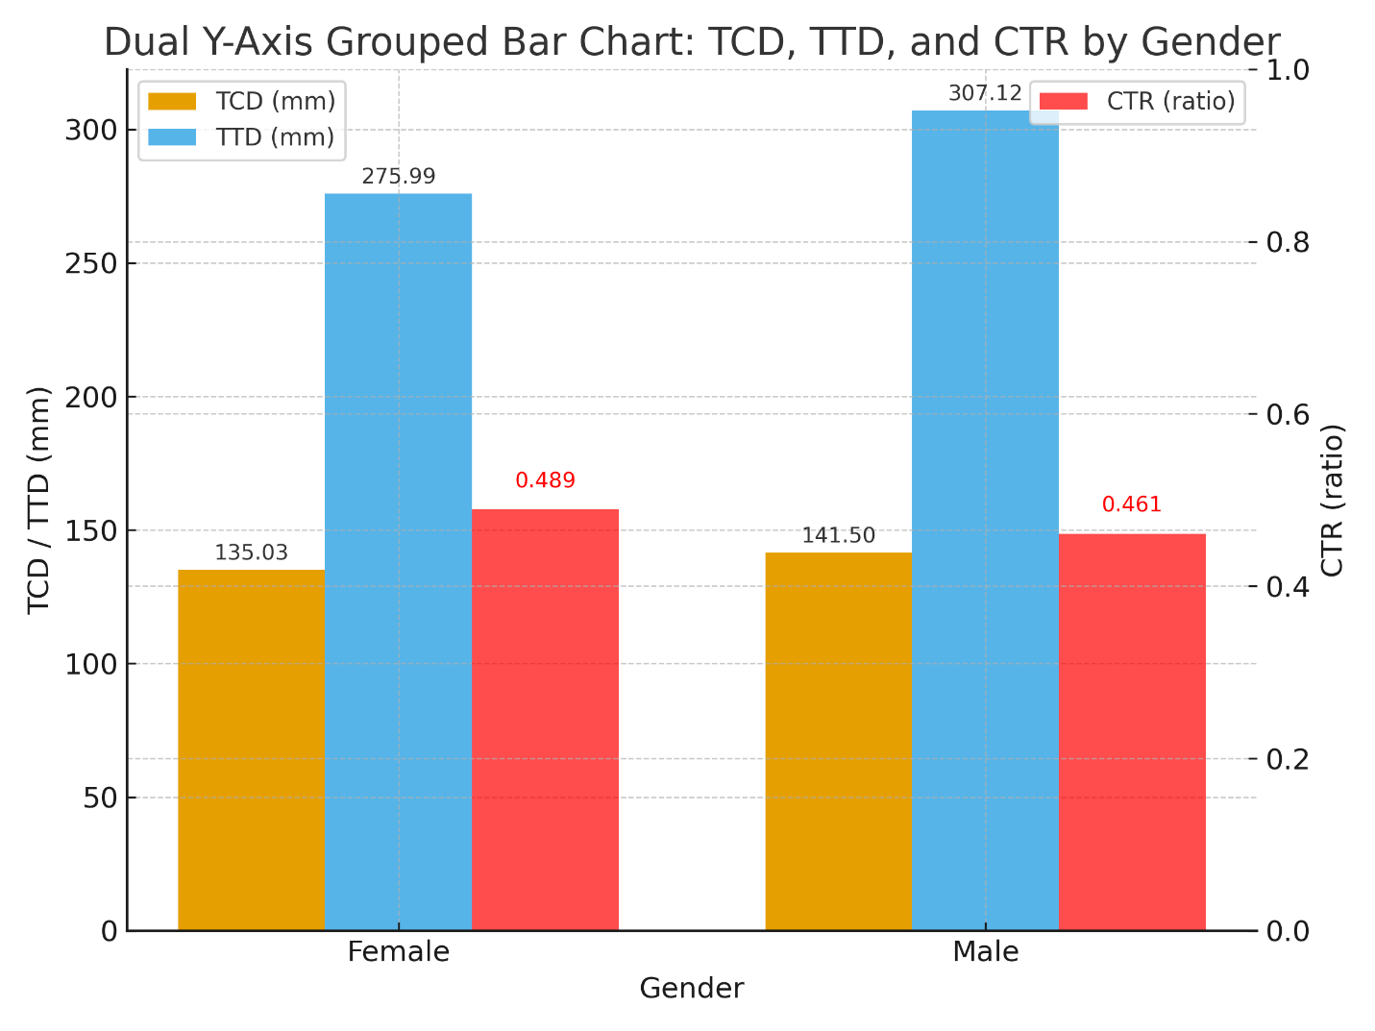
Figure 2: TCD, TTD and CTR by gender
Table 4 shows the sex comparison of the studied parameters. There were statistically significant differences between the males and females in the transverse cardiac diameter, transverse thoracic diameter, and cardiothoracic ratio (p<0.05).

Subjects gender | TCD (mm) | TTD (mm) | CTR
Female | 135.03 +/- 16.33 | 275.99 +/- 17.53 | 0.489 +/- 0.052
Male | 141.50 +/- 16.85 | 307.12 +/- 20.77 | 0.461 +/- 0.047
t-test | -4.314 | -17.968 | 6.208
Significance (p-value) | <0.001 | <0.001 | <0.001
Table 4: Comparison of the mean values of the transverse cardiac diameters, transverse thoracic diameters and cardiothoracic ratios with gender
The mean CTR value of each age group at a 95% confidence interval was obtained, as shown in Table 5. The mean TCD, TTD and CTR values for the general population significantly correlated well with the participants’ ages (P < 0.05). The TTD and TCD demonstrated modest increases up to the eighth decade before decreasing. The CTR increases with age with only the 7th decade acting as an outlier.

Age group | N | TCD (mm) | TTD (mm) | CTR
18 to 30 | 127 | 128.23 +/- 15.70 | 286.61 +/- 26.15 | 0.448 +/- 0.045
31 to 40 | 84 | 135.71 +/- 13.96 | 293.16 +/- 21.93 | 0.464 +/- 0.041
41 to 50 | 119 | 142.26 +/- 16.68 | 293.57 +/- 25.78 | 0.486 +/- 0.052
51 to 60 | 94 | 143.90 +/- 14.71 | 291.99 +/- 22.02 | 0.494 +/- 0.050
61 to 70 | 44 | 144.09 +/- 16.75 | 296.76 +/- 23.91 | 0.486 +/- 0.049
71 to 80 | 22 | 138.17 +/- 16.77 | 280.82 +/- 27.89 | 0.524 +/- 0.044
P value |  | <0.001 | .031 | <0.001
Table 5: Comparison of the mean values of the Transverse cardiac diameters, transverse thoracic diameters and cardiothoracic ratios by age groups
The cardiothoracic ratio of each patient was rounded to the nearest two decimal places. Cardiomegaly, defined as CTR greater than 0.50 (that is, 0.51 and above), was discovered in the radiographs of 134 subjects (27.3%), as demonstrated in table 6 below.

Presence of cardiomegaly | Frequency | Percentage %
No cardiomegaly | 356 | 72.7
Cardiomegaly present | 134 | 27.3
Total | 490 | 100.0
Table 6: Prevalence of cardiomegaly in the study population

Table 7 shows the crosstabs between sex and the presence of cardiomegaly. There is a statistically significant difference between both sexes in the prevalence of cardiomegaly (P <0.05).
Sex | No cardiomegaly | Cardiomegaly present | Total | Chi-square test | Df | Significance (p-value)
Female | 160 | 92 | 252 | 21.915 | 1 | <0.001
Male | 196 | 42 | 238 | 21.915 | 1 | <0.001
Total | 356 | 134 | 490 | 21.915 | 1 | <0.001
Table 7: Comparison of cardiomegaly prevalence by gender
Figure 3 highlights the significantly higher prevalence of cardiomegaly in females (36.5%) compared to males.
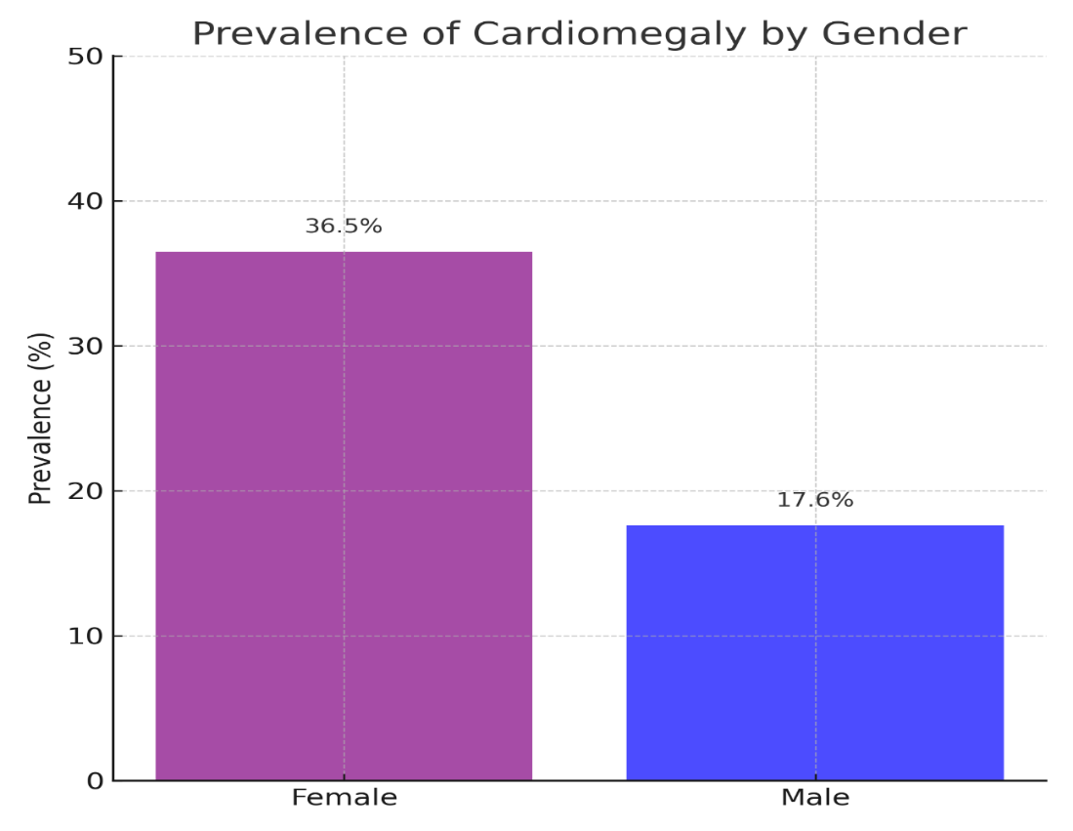
Figure 3: prevalence of cardiomegaly by gender
Table 8 shows the crosstabs between age groups and the presence of cardiomegaly. There is a statistically significant difference between age-groups in the prevalence of radiographic cardiomegaly (P <0.05). Cardiomegaly had its highest prevalence in among subjects aged 71 to 80 years (59.1%), while the lowest prevalence of cardiomegaly (7.1%) was found among young adults aged 18 to 30 years.
Age Group |  | Cardiomegaly
Age Group |  | No cardiomegaly (percent) | Cardiomegaly present (percent) | Total | Chi-square test | Df | Significance (p-value)
Age Group | 18-30 | 118 (92.9) | 9 (7.1) | 127 | 58.79 | 5 | <0.01
Age Group | 31-40 | 70 (83.3) | 14 (16.7) | 84 | 58.79 | 5 | <0.01
Age Group | 41-50 | 76 (63.9) | 43 (36.1) | 119 | 58.79 | 5 | <0.01
Age Group | 51-60 | 54 (57.4) | 40 (42.6) | 94 | 58.79 | 5 | <0.01
Age Group | 61-70 | 29 (65.9) | 15 (34.1) | 44 | 58.79 | 5 | <0.01
Age Group | 71-80 | 9 (40.9) | 13 (59.1) | 22 | 58.79 | 5 | <0.01
Age Group | Total | 356 (72.7) | 134 (27.3) | 490 | 58.79 | 5 | <0.01
Table 8: Comparison of cardiomegaly prevalence by age group
Figure 4 shows the progressive rise in cardiomegaly prevalence with advancing age, with the highest rates observed in the 71 to 80 years group (59.1%).
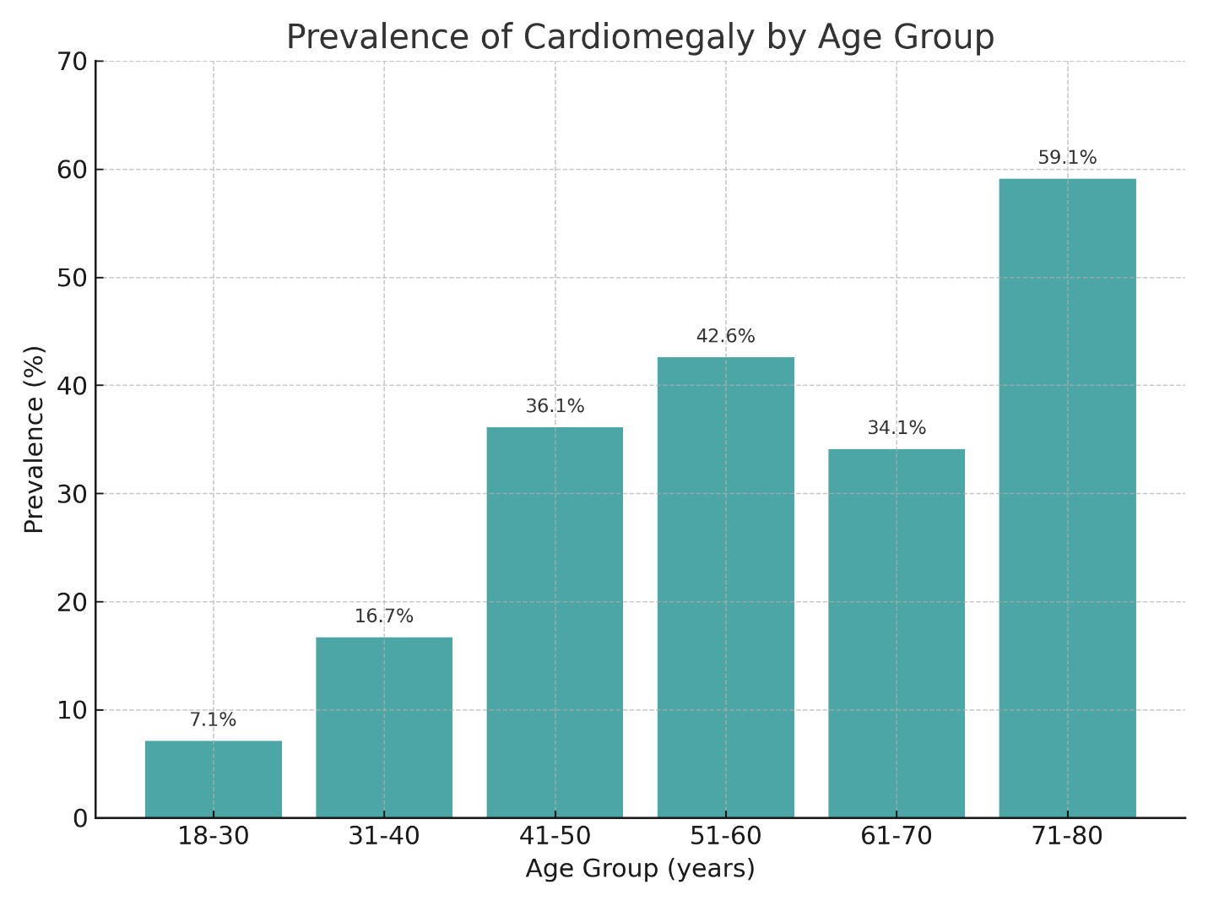
Figure 4: Cardiomegaly prevalence in each age group

Logistic regression analysis was performed to identify independent predictors of cardiomegaly. After adjusting for age, female sex remained a significant predictor (OR = 3.35, p< 0.001). Increasing age was also strongly associated with cardiomegaly, with the highest odds observed in participants aged 71-80 years (OR= 27.02, P <0.001). These findings suggest that both sex and age independently contribute to cardiomegaly risk in this studied population.

- DISCUSSION
The average CTR, TCD and TTD in this study were 0.476 ± 0.052, 138.17 ± 16.89mm and 291.11 ± 24.68mm respectively. The mean CTR in females (0.489 +/- 0.052) in this study was significantly higher (P <0.001) than that of males (0.461 +/- 0.047). The mean TCD of males (141.50mm +/- 16.85mm) in this study was observed to be significantly higher (P <0.001) than that of females (135.03mm +/- 16.33mm). The mean TTD of males in this study was 307.12 +/- 20.77mm which was observed to be significantly higher (P <0.001) than the mean in females which was 275.99 +/- 17.53mm. Our study found that transverse cardiac diameter (TCD) increased gradually with age then decreased in the 8th decade. Statistically significant differences in the TTD were also observed between different age groups. There was an increase in the transverse thoracic diameter (TTD) with age, although the mean TTD was reduced in the sixth and eighth decades. There was also a statistically significant gradual increase in the cardiothoracic ratio (CTR) with increasing age in this study, with the only exception being in the 7th decade where it reduced, likely due to the prevalence of a high TTD in that age group. The prevalence of cardiomegaly in this study was 27.3%. Cardiomegaly was defined as a CTR >0.50, and since each CTR was rounded to the nearest two decimal places, cardiomegaly was diagnosed in subjects with CTR ≥ 0.51. Cardiomegaly was found to be significantly (P <0.001) higher in female subjects than in males, present in 36.5% of females compared to 17.6% in males. The prevalence of cardiomegaly was also observed to be statistically different between different age groups, increasing with higher age and highest in the 8th decade of life.
The average CTR in this study was observed to be higher than the averages in multiple studies in sub-Saharan Africa (Ominde et al, 2023; Ali et al, 2019; Ese et al, 2021; Mensah et al, 2015; Brakohiapa et al, 2021; Guangul et al, 2022). Conversely, a study in Edo state Nigeria demonstrated a higher CTR (48.27% ± 6.54%) than our study (Ahama et al, 2023). The variation of the CTR among these studies may be explained by genetic and environmental factors. The sample composition, including age distribution, and presence of both “healthy” and unhealthy subjects, may also be responsible for variations in the mean CTR. Our study recruited participants as old as 80 years compared to some cited studies which utilized subjects with lower age cut-points. This study also utilized data from both healthy and “unhealthy” subjects (excluding patients with known cardiac disease and suspected cardiac failure), compared to some of the reference studies which recruited apparently healthy volunteers. These factors may account for the higher average CTR of our study participants.
The finding of higher CTR in women is consistent with the findings in all the reviewed sub-Saharan studies, with multiple studies (Ominde et al, 2023; Ese et al, 2021; Brakohiapa et al, 2021) also demonstrating the findings to be statistically significant. Conversely, a Saudi Arabian study (Alghamdia et al, 2020) observed that the mean CTR was higher in males than in females. This difference may be due to genetic or lifestyle differences between the study populations, or due to the small number of subjects recruited into the Saudi Arabian study. The higher average CTR in females in this study is because their TTD is relatively much smaller than that of males, while the TCDs are more similar.
The study noted increase in the CTR with increasing age. Two studies in Ghana also demonstrated increases in the CTR with increasing age (Mensah et al, 2015; Brakohiapa et al, 2021). A Nigerian study demonstrated an increase in CTR with age up to the 5th decade when it began to decrease (Ali et al, 2019). Two studies in Nigeria did not demonstrate any significant correlation of CTR with age (Ominde et al, 2023; Ahama et al, 2023). The gradual increase in CTR up to age 50 years is believed to be due to gradual increase in TCD as a result of ventricular remodelling due to stiffening of the arteries. The reduction in the TTD due to restrictive changes to the rib cage also comes into play in the elderly leading to additional increase in CTR (Inouea et al, 1999).
The average TCD in this study is higher than multiple reference studies in sub-Saharan Africa. The finding was similar to the mean TCD of 13.5cm ± 1.4cm observed by Brakohiapa et al. This high average TCD may be due to the fact that a decent number of subjects in this study were unhealthy.
The finding of higher TCD in males compared to females is consistent with findings in all the previously cited studies in sub-Saharan Africa, with multiple studies demonstrating that the difference is statistically significant (Ominde et al, 2023; Ali et al, 2019; Ese et al, 2021; Brokohiapa et al, 2021). This is likely due to genetic / physiological factors.
The increase in TCD with age is consistent with the findings in two studies in Ghana (Mensah et al, 2015; Brakohiapa et al, 2021) which also demonstrated an increase in the TCD with age. The study by Ominde et al showed a weak positive correlation with age that was not statistically significant. Other studies in Nigeria (Ali et al, 2019; Ahama et al, 2023) demonstrated inconsistent differences in TCD between different age groups that were not statistically significant. Increase in transverse cardiac diameter with age has been attributed to increased cardiac ventricular muscle thickness resulting from increased vascular resistance or loss of elasticity of the great vessels.
The average TTD in our study is also higher than all the reference studies, with the most similar TTD measurement being found in a Ghanian study (Brakohiapa et al, 2021) which had a mean TTD measurement of 28.7cm ± 2.4cm. The high TTD in this study population compared to others may be due to anthropometric differences or due to varied measurement techniques.
The finding of higher TTD in males was consistent with the previously cited studies, with multiple studies also demonstrating this difference to be statistically significant. The high TTD in males is attributable to the larger average male body size.
This study also observed statistically significant differences in the TTD between different age groups, similar to the study by Mensah et al which found an increase in TTD with age up to the 6th decade when it reduced. Another study in Ghana also demonstrated increases in TTD with age (Brakohiapa et al, 2021). Ominde et al demonstrated a statistically significant difference in the TTDs between different age groups but there was no increase in the TTD with age, and the maximum TTDs were seen in the <20 and 70-79 age groups. Other Nigerian studies showed no significant differences in the TTDs of different age groups, and there was no obvious positive or negative correlation with age (Ali et al, 2019; Ahama et al, 2023). Reduction in TTD with age has been attributed to reduced ribcage mobility and compliance in the elderly.
The statistically significant differences in the measured parameters between both sexes and among the age groups may also be of clinical relevance. Institutions may consider increasing the cut-point for cardiomegaly in females, since there is a significant association of female sex with cardiomegaly (CTR> 0.50) even after correcting for a confounder (age-group). The reviewed literature did not demonstrate an increased prevalence of hypertension in females compared to males, so hypertension is not believed to cause the sex differences observed in this study. The prevalence of mild cardiomegaly among multiple apparently healthy young adults in this study may suggest that the standard CTR cut-point of >0.50 is too low, and an increase of the threshold to >0.52 may yield higher specificity. Increasing the cut-point of cardiomegaly to >0.52 in this study gives a cardiomegaly prevalence of 14.5%. Increasing the cut-point to >0.52 for females alone yields a prevalence of cardiomegaly in females of 19.4%, which is similar to the prevalence in males (17.6%) when a cut-point of >0.50 is used. This may suggest that both sexes may require different cut-points.
The prevalence of cardiomegaly in this study was much higher than that suggested by the estimate by Tomaszewski, but lower than the finding in a Saudi Arabian study (Alghamdia et al, 2020) which discovered a cardiomegaly prevalence of 35.6%. The finding of significantly higher prevalence of cardiomegaly in females is contrary to the study by Alghamdia et al which demonstrated a 2x higher prevalence of cardiomegaly among males than in females. The high prevalence of cardiomegaly in this study may reflect the inclusion of “unhealthy” hospital patients, and the older average age of the study subjects. The high prevalence of cardiomegaly in higher age groups reflects cardiovascular changes with aging, and the higher prevalence of cardiomegaly in females may reflect that the mean TTD in females is significantly smaller than that of males and leads to increased diagnosis of cardiomegaly in women.
4.2 Clinical and public health Implications
CTR remains a cheap and widely available screening tool in resource-limited Nigerian settings. Establishing local CTR reference values would improve diagnostic accuracy in primary care, and reduce over-testing thereby conserving healthcare resources. It is still recommended that patients with CTR >0.50 undergo echocardiography if available for more definitive diagnosis. CTR-based screening may support early diagnosis of hypertensive heart disease which is important given Nigeria’s high burden of hypertension.

- CONCLUSION
This study has established baseline values for cardiothoracic ratio (CTR), transverse cardiac diameter (TCD), and transverse thoracic diameter (TTD) in an adult population in Lagos, Nigeria. The findings demonstrate that the mean CTR in this cohort was 0.476 ± 0.052, with a prevalence of cardiomegaly of 27.3%. Sex and age were significant predictors of CTR, with females showing consistently higher ratios and older age groups demonstrating a progressive increase in cardiomegaly prevalence.
The results are broadly consistent with other African studies but differ from reports in non-African populations, underscoring the importance of population-specific reference values. These findings suggest that reliance on universal CTR thresholds may lead to over- or under-diagnosis of cardiomegaly in Nigerian patients.
Importantly, CTR remains a valuable, inexpensive, and widely available screening tool for cardiac enlargement, particularly in low-resource settings where echocardiography may not be readily accessible. Establishing local reference ranges enhances its diagnostic utility and supports earlier identification of patients at risk of cardiovascular disease.
In conclusion, this research contributes essential reference data for Lagos State and reinforces the role of CTR in clinical decision-making and public health screening. Further multicenter, prospective studies incorporating echocardiographic correlation are warranted to refine diagnostic thresholds and optimize the use of chest radiography in cardiovascular disease prevention and management in Nigeria.
4.1 Limitations of the study
The study may not be representative of the general population because of the patient population; only patients of the hospital were included and the study and since a significant proportion are unhealthy, it may overrepresent the prevalence of cardiomegaly. Patients with some known cardiac diseases were excluded, which may, conversely, have underestimated the prevalence of cardiomegaly when compared to the general population. The retrospective design and reliance on archived radiographs limited the ability to take some supplementary measurements like BMI, blood pressure and echocardiography, and explore the associations between those and CTR or cardiomegaly. The lack of BMI / anthropometric adjustments may bias CTR upwards in obese patients. In addition, inter-observer variability check was not performed, although it is to be noted that multiple studies have noted excellent inter-observer agreement among experienced clinicians.
4.3 Recommendations for future research
Larger multi-center studies across Nigeria are needed to validate CTR reference values. Prospective studies should also include BMI / body habitus, blood pressure and echocardiographic correlations.
COMPETING INTERESTS DISCLAIMER:
Authors have declared that they have no known competing financial interests OR non-financial interests OR personal relationships that could have appeared to influence the work reported in this paper.

REFERENCES
- Sutton D (2003). Textbook of Radiology and Imaging vol II. 7th Ed. London: Churchill Livingstone.
- Herring W (2016). Learning Radiology Recognizing the basics. 3rd Ed. Philadelphia: Elsevier.
- Hardy M, Scotland B, Herron L (2015). Assessing sagittal rotation on posteroanterior chest radiographs: the effect of body morphology on radiographic appearances. J med imaging radiat sci, 46, 365-371.
- Torres FS, Eifar DA, Tijmes FS, et al (2021 Nov 8). Diagnostic performance of chest radiography measurements for the assessment of cardiac chamber enlargement. CMAJ, 193, 1683-1692.
- Kadhum AA, Sharif S, Abd-hazaa M (2007). Validity of chest x-ray in estimation of cardiac size in comparison to echocardiography. MJBU, 25(2), 48-51.
- Simkus P, Gutierrez Gimeno M, Banisauskaite A, et al (2021). Limitations of Cardiothoracic Ratio Derived from Chest Radiographs to Predict Real Heart Size: Comparison with Magnetic Resonance Imaging. Insights Imaging, 12(1), 158.
- Truszkiewicz K, Macek P, Poreba M, et al (2022 June). Radiological cardiothoracic ratio as a potential marker of left ventricular hypertrophy assessed by echocardiography. Radiol Res Pract, 2022, 4931945.
- Chana HS, Martin CA, Cakebread HE, et al (2015). Diagnostic accuracy of cardiothoracic ratio on admission chest radiography to detect left or right ventricular systolic dysfunction: a retrospective study. J R Soc Med, 108(8), 317–324.
- World Health Organization (2020). Nigeria collaborates with WHO to curb hypertension, introduces control initiative. Assessed 2025 August 10. https://www.afro.who.int/news/nigeria-collaborates-who-curb-hypertension-introduces-control-initiative
- Tomaszewski R. Cardiomegaly in Tropical Africa (2012). Int Marit Health, 63(1), 56–58
- Ominde BS, Enakpoya P, Ikubor J, et.al (2023). Assessment of the cardiothoracic ratio and its association with gender and age: a Nigerian study. Gal int j health sci res, 8(2),16-22.
- Ali AM, Gangrang AS, Abubakar A, et al (2019). Radiographic assessment of cardiothoracic ratio in apparently healthy adults in Maiduguri. Hamdan med j, 12, 204-207.
- Ese A, Efe A, Charles E (2021 April). Radiographic determination of cardiothoracic ratio and cardiac size in the Ijaw ethnic group of Nigeria. Int Med J, 28(4), 4719-4722.
- Mensah YB, Mensah K, Asiamah S, et al (2015 September). Establishing the cardiothoracic ratio using chest radiographs in an indigenous Ghanaian population: a simple tool for cardiomegaly screening. Ghana Med J, 49(3), 159-164.
- Brakohiapa EK, Botwe OB, Sarkodie BD (2021). Gender and age differences in cardiac size parameters of Ghanaian adults: can one parameter fit all? Part two. Ethiop J Health Sci, 31(3), 561-72.
- Guangul A, Tenaw B, Ayehualem S, Muche A (2022 September). Radiographic assessment of cardiothoracic ratio in apparently healthy adults in Bahir Dar, northwest Ethiopia. Ethiop. J. Health Biomed Sci, 12(2), 43-53.
- Ahama EE, Igabari JN, Ehebha ES, et al (2023). Radiographic assessment of cardiothoracic ratio among patients of university of Benin teaching hospital; Int. Res. Med. Health sci, 6(6), 1-9.
- Alghamdia SS, Abdelaziza I, Albadria M, et al (2020). Study of cardiomegaly using chest X-ray. J Radiat Res Appl Sci, 13(1), 460–467.
- Inouea K, Yoshiib K, Itob H (1999). Effect of Aging on Cardiothoracic Ratio in Women: A Longitudinal Study. Gerontology, 45, 53–58.

