Strategic Public Health Framework for Soil‑Transmitted Helminth Control in the Philippines (2025–2030)

Abstract

Soil-transmitted helminthiasis (STH) remains a major public health issue in the Philippines, particularly in rural and under-resourced communities. This strategic framework outlines a comprehensive, multi-sectoral approach to reduce and ultimately eliminate the burden of STH through coordinated efforts in health, education, sanitation, and community engagement.

Keywords: Soil-transmitted helminthiasis, mass drug administration, healthcare system, sanitation

Introduction to Current Strategies

Soil-transmitted helminths (STH), primarily Ascaris lumbricoides, Trichuris trichiura, and hookworm species (Ancylostoma duodenale and Necator americanus), are endemic in the Philippines due to environmental, socioeconomic, and infrastructural conditions. Chronic STH infections contribute to malnutrition, impaired cognitive development, and reduced productivity, especially among school-aged children.

The cornerstone of the national strategy is mass drug administration (MDA), which involves the biannual distribution of deworming medication, such as albendazole or mebendazole, to at-risk populations, primarily school-age and preschool children (Department of Health, 2016). This initiative is carried out through school-based and community-based programs, with support from the Department of Education (DepEd) under the National School Deworming Month (NSDM) program, launched in 2015 (Department of Education, 2015).

The economic cost of MDA in Zamboanga Peninsula was $809,000 per year, while the expanded school-based targeted preventive chemotherapy would cost $625,000 or $0.57 per person targeted (delos Trinos et al, 2024). The reduced cost of expanded school-based targeted preventive chemotherapy suggests a more efficient use of health system resources, enhancing financial sustainability and supporting evidence-based governance in public health decision-making.

A study by Lorenzo et al. in 2019, which aimed to understand the community knowledge and perceptions on the current STH control and elimination strategies including MDA, showed mostly correct biomedical notions of the infections, and expressed willingness to participate in the program. However, reservations remained due to a reported lack of information dissemination, lack of confidence in the drugs used, and widespread fear of adverse side effects.

A 2024 study by Belizario et al., showed that school-based combined MDA coverage rates were 80.1% and 75.5% in Phases I and II, respectively. Of students treated, 5.2% in Phase I and 5.4% in Phase II experienced adverse events, which were mostly mild and transient. In Phase II, the average time for combined treatment was less than one minute per student, with shorter times observed in older age groups.

One major problem with MDA against STH in the Philippines is the inconsistent coverage and community participation due to logistical challenges, lack of awareness, and mistrust in the healthcare system. These issues are compounded by limited access to remote areas, insufficient follow-up, and inadequate integration with broader sanitation and health education programs, reducing the long-term effectiveness of deworming efforts.

In addition to MDA, the government emphasizes the importance of water, sanitation, and hygiene (WASH) initiatives. These include improving access to clean water, constructing sanitary toilet facilities, and promoting hygiene practices such as handwashing and proper disposal of human waste. Organizations like UNICEF and WHO have partnered with local agencies to support these efforts (UNICEF, 2020; WHO, 2019). However, for greater chances of sustainability, there is a need for improved coordination among organizations implementing the program.

Thus, a decentralized program and a multi-party endeavor such as that undertaken for STH control in the Philippines can only succeed with long term collaboration, cooperation and buy-in from the local government. There is a need for governmental support in the procurement and distribution of drugs and in prioritizing other components of the control program such as activities that improve environmental sanitation and health education to accelerate progress towards the 2030 EPHP goal (Mationg et al., 2021).

Health education also plays a critical role in STH control. Schools incorporate lessons on hygiene, sanitation, and disease prevention into their curricula, while communities are engaged through public awareness campaigns. The Department of Health in 2017 underscores the need for integrated education and health strategies to encourage behavior change and prevent reinfection.

Furthermore, monitoring and evaluation are conducted through periodic surveys and sentinel site assessments to measure the effectiveness of deworming programs and track infection trends. These data help inform policy and refine intervention strategies (FNRI, 2013).

Despite these efforts, challenges remain. Reinfection is common in areas with poor sanitation, and logistical issues often limit MDA coverage in remote regions. Additionally, concerns about drug resistance and the need for better integration of WASH programs highlight the importance of a more comprehensive and sustainable approach.

Proposed Framework

Despite ongoing preventive and curative campaigns, reinfection rates remain very high in the Philippines, necessitating an integrated prevention and control framework.

The Strategic Framework for Helminth Control in the Philippines provides a comprehensive, multisectoral approach to reduce and eventually eliminate the burden of helminth infections nationwide. It also provides a practical, end‑to‑end blueprint that LGUs, DepEd divisions, and national agencies can adapt to reduce STH morbidity, sustain low transmission, and progress toward elimination as a public health problem. It is crucial for improving public health, enhancing school performance, and breaking the cycle of poverty linked to parasitic diseases.

Vision: A helminth-free Philippines in 2030 where all communities thrive through sustainable health, sanitation, and education systems.

Goals:

This public health model aims to:

- Reduce STH moderate‑to‑heavy intensity infections to <2% in all provinces and maintain ≥75% preventive chemotherapy (PC) coverage among at‑risk groups.
- Establish sustainable, community-led interventions in endemic regions.
- Strengthen surveillance and health education systems across all levels.

Strategic Objectives:

SO1. Coverage & Quality: Achieve ≥85% effective coverage for PC in enrolled and non‑enrolled school‑age children (SAC) and ≥70% in preschool‑age children (PSAC) in all priority LGUs.
SO2. WASH Access: Ensure ≥80% of target schools and ≥60% of target barangays meet national WASH in Schools/Communities minimum service levels.
SO3. Behavior Change: Reach ≥80% of households with sustained handwashing, latrine use, and safe play behaviors; reduce open defecation in target barangays by 50%.
SO4. Surveillance: Institutionalize risk‑based sentinel surveillance with annual school‑based surveys and biennial community checks in hotspots; digital dashboards operational in all regions.
SO5. Systems & Equity: Strengthen governance, logistics, and financing to reach GIDA, IP, urban poor, and 4Ps families, closing coverage gaps by ≥20%.

Strategic Pillars

3.1. Preventive Chemotherapy (PC):
- Sustain and expand school-based mass deworming (biannual treatment for children 1–14 years).
- Extend preventive chemotherapy to other at-risk groups, including women of reproductive age and agricultural workers.
- Monitor drug efficacy and resistance patterns.

- Target groups: preschool aged children (PSAC, 1 to 4 years old), school-aged children (SAC 5 to 14 years old, enrolled & non‑enrolled), high‑risk adults (farmers, miners, sanitation workers) in hotspots.
- Frequency: Once or twice per year depending on provincial risk stratification.
- Delivery channels: Department of Education (school-based approach), Barangay Health Stations/RHUs, day care centers/early childhood development centers (ECD), mobile outreach for GIDA/IPs.
- Quality & Safety: Training, dose‑poles, Adverse Event Following Immunization (AEFI) reporting, directly observed intake, mop‑up days, independent coverage surveys.

3.2. Water, Sanitation, and Hygiene (WASH):
- Improve access to clean water and functional sanitation facilities.
- Promote handwashing and hygienic practices through community programs.
- Integrate WASH education into school curricula and public health messaging.

- Schools: Functional gender‑separated toilets, handwashing stations with soap, safe water; operation & maintenance (O&M) plans; WASH clubs.
- Communities: Zero Open Defecation (ZOD) campaigns; fecal sludge management linkages; water safety plans; micro‑grants for latrines.
- Health facilities & markets: Handwashing and sanitation standards enforced by RHUs and LGU Sanitation Inspectors.

3.3. Health Education and Behavior Change Communication:
- Develop culturally appropriate educational campaigns targeting rural and urban poor populations.
- Train community health workers and teachers to lead STH awareness and behavior change initiatives.
- Utilize digital platforms and local media for broader outreach.

- Behavior targets: Handwashing with soap at key times; consistent latrine use; wearing footwear; safe food/water; deworming acceptance.
- Approach: Evidence‑based, locally co‑designed materials; school lesson integration; parent sessions; community champions; radio/Facebook/Viber groups; norm‑shifting using commitments and public recognition.

3.4. Surveillance, Research, and Data Management:
- Strengthen national and local surveillance systems for STH monitoring.
- Support operational research on reinfection rates, intervention efficacy, and community perceptions.
- Establish a centralized STH data repository for real-time decision-making.

- Risk mapping: Baseline and 2 to 3-year interval mapping of prevalence & intensity; integrate with malnutrition and WASH.
- Sentinel surveillance: Annual school‑based parasitology in sentinel schools per province; community checks in hotspots.
- Data systems: Use simple digital tools (District Health Information Software 2/DHIS2 or Laboratory Information Management System/LMIS or DepEd Education Management Information System/EMIS plug‑ins); dashboards at LGU/region; lot‑quality coverage surveys after MDA.
- Agenda: Compare diagnostics (Kato‑Katz vs. rapid/NAATs), evaluate once‑vs‑twice yearly PC by risk, Social and Behavior Change communication (SBCC) nudges, and WASH O&M models.

3.5. Systems, Governance, Financing, and Multisectoral Collaboration:
- Form inter-agency task forces (DOH, DepEd, DILG, LGUs, NGOs) for coordinated planning and implementation.
- Secure long-term funding through national budgets and international partnerships.
- Encourage community participation and local government ownership of programs.

- National: DOH (lead for NTD policy & medicines), DepEd (school delivery), DILG (LGU performance), NNC (nutrition link), DSWD (4Ps co‑targeting), DPWH/LWUA/DOH‑HFEP (WASH infrastructure), FDA (QA), PhilHealth (facility incentives for WASH compliance).
- Local: Provincial/City/Municipal Health Offices, School Division Offices, Barangay Councils, IP councils/NCIP, CSOs, faith groups.
- Financing mix: DOH/DepEd budgets, LGU GAD/20% DF, SEF, CSR/NGO grants, development partners; performance‑based mini‑grants for ZOD.

TABLE 1. Action Plan

Phase | Year(s) | Objectives | Key Activities | Lead Agencies / Partners
Phase 1: Assessment and Planning | 2025 | Establish baseline, align stakeholders, and design interventions | - Conduct national and regional baseline surveys on STH prevalence and WASH access  - Map high-burden and high-risk communities  - Hold stakeholder consultations (DOH, DepEd, LGUs, NGOs, academe)  - Develop national guidelines and regional action plans | DOH (lead), DepEd, DILG, LGUs, WHO, academic institutions
Phase 2: Pilot Implementation and Capacity Building | 2026 | Test and refine integrated interventions in target regions | - Launch pilot programs in selected priority areas  - Train teachers, community health workers, and WASH coordinators  - Establish M&E systems in pilot sites  - Develop and distribute educational materials  - Begin targeted WASH infrastructure improvements | DOH, DepEd, DPWH, DSWD, Local NGOs
Phase 3: Full-Scale Implementation and Program Expansion | 2027–2028 | Expand successful interventions nationally and institutionalize capacity | - Scale school-based deworming and expand to community-based coverage  - Integrate health education into K–12 curriculum  - Build/rehabilitate sanitation and water systems in high-need schools/communities  - Deploy mobile health and WASH teams to underserved areas  - Initiate local STH monitoring hubs | DOH, DepEd, DPWH, Local Water Utilities, NGOs, PhilHealth (for preventive coverage)
Phase 4: Program Consolidation and Optimization | 2029 | Evaluate progress and optimize for sustainability | - Conduct midline evaluations  - Refine intervention strategies based on data  - Strengthen inter-agency governance mechanisms  - Launch national awareness campaign to sustain engagement  - Secure long-term funding commitments from national and local governments | NEDA, DOH, DILG, PhilHealth, DepEd, CSOs
Phase 5: Sustainability and Post-2029 Strategy | 2030 and beyond | Achieve long-term impact and prepare for elimination phase | - Conduct final impact assessment and STH mapping  - Integrate helminth control into broader NTD and primary health care strategies  - Institutionalize monitoring systems within LGUs  - Develop national roadmap toward STH elimination  - Document and publish outcomes for policy and global knowledge sharing | DOH, LGUs, Research Institutions, WHO, International donors

TABLE 2. Roles & RACI (illustrative)

Task | DOH | DepEd | LGU or Barangay | DILG | DSWD | DPWH or LWUA | NCIP | NGOs / Academe
Policy & guidelines | R | C | C | C | C | C | C | C
Medicine procurement & QA | R | C | C | C | C | C | C | C
School‑based PC delivery | C | R | C | C | C | C | C | C
Community PC & mop‑ups | R | C | R | C | C | C | C | C
WASH infrastructure (schools) | C | R | C | C | C | R | C | C
WASH infrastructure (community) | R | C | R | C | C | R | C | C
SBC design & rollout | R | R | R | C | C | C | C | R
Surveillance and dashboards | R | C | R | C | C | C | C | R
Legend: R = Responsible; C = Collaborate/Consult

Equity & Inclusion Lens

- Prioritize GIDA, island barangays, IP/indigenous communities, urban informal settlements, and migrant families.
- Use community navigators and IP leaders; adjust schedules for farming/fishing calendars; provide language‑appropriate, culturally safe materials.
- Bundle with nutrition (deworming + iron/IFA where appropriate) and 4Ps Family Development Sessions.

Monitoring and Evaluation Framework

Coverage & Services
- PC coverage (PSAC, SAC, high‑risk adults) by sex, age, schooling status, and priority group.
- % schools with functional toilets and handwashing stations; pupil:toilet ratio.
- % barangays certified ZOD; % households with improved sanitation and handwashing facility with soap and water.

Epidemiology
- STH prevalence and moderate‑to‑heavy intensity (%), by species (Ascaris, Trichuris, hookworm).
- Reinfection rates at 6–12 months in sentinel sites.

Behavior
- % households reporting/observed handwashing at key times; % children wearing footwear outdoors; caregiver knowledge scores.

Systems
- Stockout rates of anthelmintics; timeliness/completeness of reporting; budget execution rate; % LGUs with WASH O&M plans.

Equity
- Coverage gap between general population and GIDA/IP/urban poor; % materials available in local languages. Milestone thresholds
– Maintain moderate‑to‑heavy intensity infections <2% for 2 consecutive years province‑wide before de‑escalating PC frequency.

TABLE 3. Phased National Strategy for Soil-Transmitted Helminth (STH) Control and Elimination in the Philippines (2025–2030)

Phase | Timeframe | Objectives | Key Activities | Responsible Agencies/Partners | Expected Outcomes
Phase 1: Assessment and Strategic Planning | Q1–Q4 2025 | Establish a national baseline, map endemic areas, and develop regional action plans | - Conduct STH prevalence surveys  - Map high-risk populations and environmental risk factors  - Stakeholder consultations (DOH, DepEd, LGUs, NGOs, CSOs)  - Develop national guidelines and localized implementation plans  - Secure funding and resource commitments | DOH (lead), DepEd, DILG, LGUs, WHO, UNICEF, Academe | - Baseline data available - Prioritized areas identified - Strategic and financial plans endorsed
Phase 2: Pilot Implementation and Capacity Building | Q1–Q4 2026 | Pilot integrated intervention packages in priority regions and build institutional capacity | - Launch pilot programs (health education, deworming, WASH) in 3–5 provinces  - Conduct training of trainers (ToT) for health and education staff  - Install or rehabilitate WASH infrastructure in selected schools and communities  - Develop IEC materials and public campaigns  - Set up M&E baseline in pilot areas | DOH, DepEd, DPWH, Local Health Units, NGOs, Academic Partners | - Trained personnel in pilot regions - WASH facilities improved - Community and school awareness raised
Phase 3: National Scale-Up of Integrated Interventions | Q1 2027 – Q4 2028 | Expand program nationwide, integrate into local systems, and strengthen service delivery | - Scale school-based deworming nationwide (2x/year)  - Expand coverage to out-of-school children and vulnerable adults  - Roll out national WASH promotion campaign  - Institutionalize health education in the K–12 curriculum  - Establish barangay-level STH monitoring and reporting units  - Create community health task forces to promote hygiene behavior | DOH, DepEd, DSWD, DPWH, LGUs, DILG, NGOs | - High national deworming coverage (>85%) - Strengthened local WASH systems - Widespread STH awareness and behavioral change
Phase 4: Consolidation and Mid-Term Evaluation | Q1–Q4 2029 | Assess progress, strengthen governance, and optimize interventions for sustainability | - Conduct midline impact evaluation (STH prevalence, reinfection, WASH access)  - Review effectiveness of IEC strategies and WASH interventions  - Adjust program design based on M&E results  - Strengthen LGU ownership and integration into local health budgets  - Scale-up digital tracking tools for deworming and infection monitoring | DOH, LGUs, NEDA, PhilHealth, NGOs, Academic Institutions | - Data-driven improvements adopted - Stronger LGU leadership - Localized innovation and ownership of interventions
Phase 5: Sustainability and Elimination Roadmap | Q1 2030 – Q4 2030 | Prepare for sustained STH control and long-term elimination strategy | - Conduct final prevalence survey and health impact evaluation  - Integrate STH programs into broader NTD and universal health coverage (UHC) policies  - Develop a national roadmap for STH elimination (post-2030)  - Publish and disseminate results for national policy and global knowledge sharing  - Secure long-term funding (national, local, international) | DOH, PhilHealth, DOST, LGUs, WHO, Global Fund, Researchers | - National STH burden significantly reduced - Roadmap for elimination adopted - Lessons documented and shared

Data Use & Adaptive Management
- Monthly LGU review meetings; quarterly provincial dashboards; semi‑annual regional learning exchanges.
- LQAS or independent monitoring after each PC round; rapid corrective actions within 30 days.
- Public transparency: simple scorecards posted at schools/RHUs.

Logistics & Supply Chain Essentials
- Annual quantification (including mop‑ups + buffer); FEFO stock management; temperature/humidity monitoring.
- Last‑mile delivery plan to schools/day cares; reverse logistics for unused stock; AEFI kits and protocols.

Risk Management
- Vaccine/medicine hesitancy & misinformation: pre‑bunking messages, rapid rumor tracking, health promoter network.
- Natural hazards & disruptions: pre‑positioned stocks; flexible PC windows; integrate with disaster response plans.
- WASH O&M lapses: service contracts, school budget lines, caretaker training.
- Data quality: simple tools, mentoring, data validation audits.

Budgeting Template (illustrative % allocation)
- PC medicines & operations: 30–35%
- WASH hardware (schools & communities): 35–45%
- SBC materials & community engagement: 8–10%
- Surveillance & M&E (including diagnostics): 8–12%
- Capacity building & governance: 5–8%
- Contingency & risk reserve: 2–5%
FIG 1.

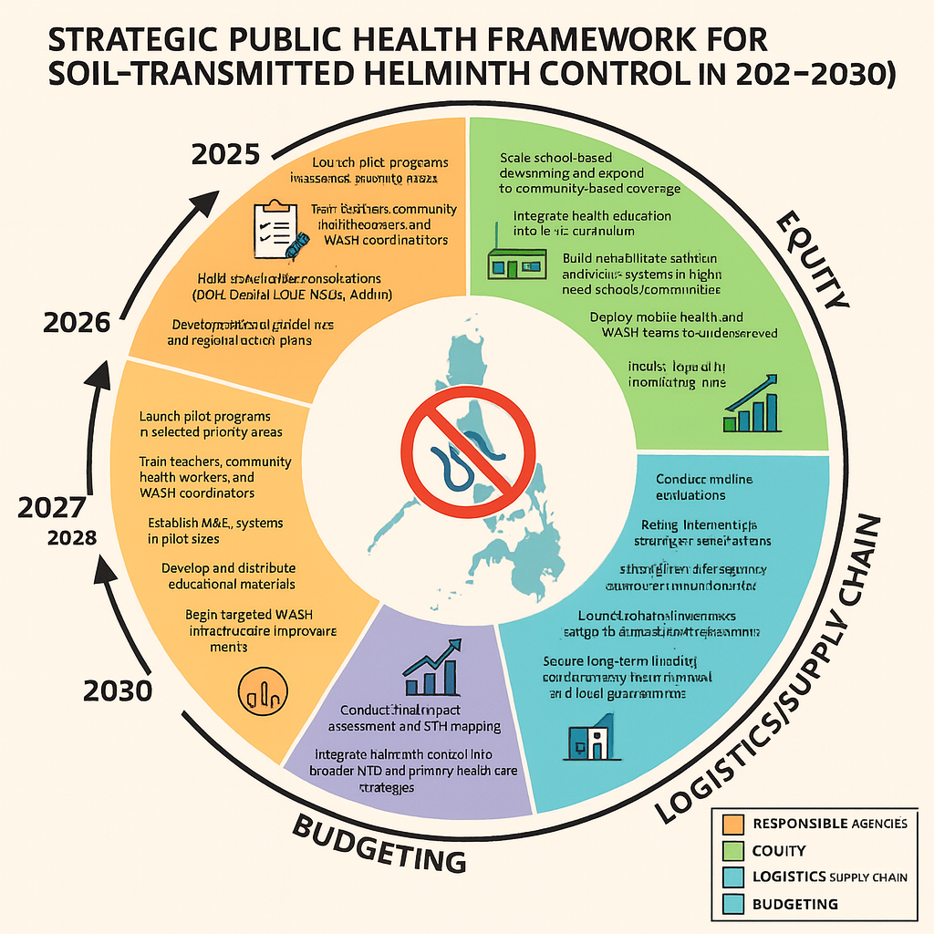

COMPETING INTERESTS DISCLAIMER:
Authors have declared that they have no known competing financial interests OR non-financial interests OR personal relationships that could have appeared to influence the work reported in this paper.

References:

- Belizario VY, Marfori JR, Chua PL, Naig JR, Erfe JM (2024). School-based combined mass drug administration for soil-transmitted helminthiases and schistosomiasis among school-age children: lessons from two co-endemic areas in the Philippines. Asian Pacific Journal of Tropical Disease Volume 5, Issue 5, May 2015, Pages 358-362. Available from: https://www.sciencedirect.com/science/article/abs/pii/S2222180814607970
- delos Trinos JPC, Coffeng LE, Garcia Jr. F, Belizario V, Wiseman V, Watts C, Nery SV (2024). Cost and budget impact of mass drug administration compared to expanded school-based targeted preventive chemotherapy for soil-transmitted helminth control in Zamboanga Peninsula, the Philippines.The Lancet Regional Health - Western Pacific Volume 50, September 2024, 101162. Available from: https://www.sciencedirect.com/science/article/pii/S2666606524001561
- Department of Education (2015). Deworming: How to Reach the Stars. Available from: https://www.deped.gov.ph/wp-content/uploads/2019/07/TSA-WinS-Booklet-Deworming-PRINT-20181031.pdf
- Department of Health (2016). Guidelines in the Use of Ivermectin as an Alternative Mass Drug Administration in Combination with Diethylcarbamazine Citrate (DEC) and Albendazole (ALB) for the Treatment of Lymphatic Filariasis (LF).
- Food And Nutrition Research Institute (2013). Deworming May Help Prevent Stunting. Available from: https://www.fnri.dost.gov.ph/images/sources/PS/PS20.pdf
- Lorenzo, P.J., Manzanilla, D.R., Cortel, D.K. et al. Community perceptions of mass drug administration for soil-transmitted helminthiasis and schistosomiasis in selected schools in the Philippines. Infect Dis Poverty 8, 87 (2019). https://doi.org/10.1186/s40249-019-0595-8
- Mationg, M.L.S., Tallo, V.L., Williams, G.M. et al. The control of soil-transmitted helminthiases in the Philippines: the story continues. Infect Dis Poverty 10, 85 (2021). https://doi.org/10.1186/s40249-021-00870-z
- United Nations Children's Fund (2020). Humanitarian Situation Report No. 12. Available from: https://www.unicef.org/philippines/media/6141/file/UNICEF%20SitRep%20No.%2012%20-%20TY%20Rai%20(Odette)%20-%20FINAL.pdf
- World Health Organization (2019). Water, sanitation, and hygiene (WASH). Available from: https://www.who.int/westernpacific/health-topics/water-sanitation-and-hygiene-wash#tab=tab_1

