Original Research Article
COMPARATIVE STUDIES ON THE USE OF MICROSCOPY AND POLYMERASE CHAIN REACTION IN DETECTION OF SCHISTOSOMA HAEMATOBIUM INFECTIONS IN URINE OF SCHOOL CHILDREN IN OHAUKWU LOCAL GOVERNMENT AREA, EBONYI STATE, NIGERIA

ABSTRACT
Schistosma haematobium infection remains a significant health challenge in the sub- Saharan Africa particularly Nigeria. Despite control efforts, the disease persists due to factors like climate and low sensitivity of some conventional diagnostic techniques. The study compared the diagnostic effectiveness of microscopy and polymerase chain reaction (PCR) in detecting Schistosoma haematobium infection among 570 school children aged 5-19 years in Ohaukwu Local Government Area of Ebonyi State Nigeria. The overall prevalence by microscopy was 15.1% (86/570), PCR detected a higher prevalence 65.8 % (100/152) in a sub-sample of microscopic positive and negative samples. PCR was more sensitive (92.1%) than microscopy (55.0%). All the positive urine specimen by microscopy were positive by PCR, while 14 negative urine samples by microscopy were positive by PCR technique. Males were more infected in both diagnostic techniques than their female counterparts. By microscopy, males had a prevalence of 17.9 % (55/308) while females had 11.8 % (31/262). In PCR analysis, males showed a higher prevalence of 73.3 % (66/90) than females 54.8% (34/62). The difference was statistically significant (X² =3.71; P-value = 0.05). The prevalence varied by age group with age 11-15 years 20.5 % 62/302) more infected by microscopy, and those aged 16-19 years 100 % (1/1) more infected by PCR. The differences in prevalence by age group in both techniques were statistically significant (P=0.001). The finding suggest that PCR technique is a more superior technique and should be used in our tertiary hospitals for accurate diagnosis particularly in chronic and asymptomatic cases.

1. INTRODUCTION
Schistosoma haematobium a digenetic trematode is the causative agent of urinary schistosomisis. It is a neglected tropical disease which affects more than 240 million people in 78 countries with approximately 800 million people at risk (Weerakoon et al., 2015). This blood fluke infection is found in Middle East, Asia Oceania and Africa. Nigeria is one of the countries known to be highly endemic for urinary schistosomiasis with an estimated report of 101.3 million persons at risk and 25.8 million infected (Gamde et al., 2022). Ajibola et al. (2018) also reported 29 million of infected persons in Nigeria. The disease afflicts the poor, rural villagers, especially school age children, women and fishermen who lack access to safe water and sanitation and where daily activities bring them into direct contact with infested water sources. Transmission of the disease to humans and other mammalian host occur via fresh water snails (Bulinus spp) which serve as an intermediate host. The adult organisms are found in the venous plexuses around urinary bladder and their released eggs traverse the wall of the bladder causing haematuria and fibrosis of the bladder. Urinary schistosomiasis can generally be classified as acute, chronic or advanced schistosomiasis It causes pain, secondary infection, kidney damage as well as cancer. In most cases it presents painful or difficulty in urination (dysuria), blood in urine (haematuria), urethral obstruction, no urination (anuria) and other accompanied signs, symptoms and complications (Roberts et al., 2010) .
There have been concerted efforts towards the control and possible elimination of Schistosoma haematobium infection through integrated measures. Nevertheless, despite extensive efforts, urinary schistosmiasis has remained unabated. Several surveys on the incidence of urinary schistosmiasis prevalence in Ohaukwu Local Government Area have been documented (Umoh et al. (2020) reported 6.0 % while Awopeju et al.(2023) 30.2 %). All the above studies only made use of microscopy as a diagnostic tool.
The reports stated above show that even though there might be fluctuation in prevalence, the fact remains that S. haematobium infection is still endemic and a public health problem in Ohaukwu Local Government Area. To effectively control urinary schistosmiasis disease, accurate, reliable, precise, sensitive and specific diagnostic techniques play a crucial role. The epidemiological assessments of S. haematobium burden has been mainly dependent on the microscopic examination of urine which is regarded as gold-standard diagnostic method (Abd Elraheem et al., 2021). This method though economical and easy in determining the concentration of S. haematobium eggs in urine specimens is often limited by low sensitivity, with cases missed during early or low- intensity infections and when used for the evaluation of treatment (Wanger et al., 2011). Polymerase chain reaction (PCR) techniques, due to its high sensitivity and specificity has rapidly become one of the most widely used techniques in molecular biology. This technique utilizes DNA polymerase enzymes and synthetic oligonucleotides to produce billion copies of specific regions of DNA. It was successfully used to detect DNA from many parasites including Schistosoma spp (Obeng et al., 2008). Hamburger and his colleague cloned S. haematobium genome repeated sequence, using DNA-1 sequence (Obeng et al., 2008). The current study was aimed to comparatively evaluate the diagnostic effectiveness of microscopy and polymerase chain reaction (PCR) in the detection of Schistosoma haematobium infection among school children in Ohaukwu Local Government Area, Ebonyi State, Nigeria.

2. MATERIALS AND METHODS
2.1 Study Area
The study was carried out in randomly selected primary schools in Ohaukwu Local Government Area of Ebonyi State. Ohaukwu Local Government Area is one of the 13 Local Government Areas of Ebonyi State. Ebonyi State occupies the area lying between latitude 6º 10′ 40.7028”N and longitude 7º 57′33.4296” E while Ohaukwu Local Government Area is located at latitude 6º 3′ 58.3′′N and longitude 8º 1′ 22.0′′E. It has an area of approximately 707.8km² with estimated population of 291,300 (NPC, 2022).
The area is typically a settlement. The people settle in thatched huts with few in modern buildings. The inhabitants lack the basic social amenities such as regular electric power supply, pipe borne water and good health centers in the rural areas. They depend mostly on streams, rivers, ponds, quarry pit water, borehole water and spring water for domestic use especially among rural dwellers. The climate of the area is tropical with a mean daily temperature of 30° C $±$ 50° C for most of the year. The annual rainfall is on average of 1300 mm with distinct wet and dry season (Umoh et al., 2020). The vegetation is typically guinea savannah. Water bodies such as ponds, quarry pit, streams, swamp, hand-dug wells and man-made lakes exist in the area. The inhabitants especially young ones have contacts with these snail infested water bodies through rice farming, bathing, swimming, washing of cloths, fetching of water and fishing. Out of ignorance, most inhabitants use the infested water to irrigate their rice farms thereby creating opportunity for Schistosoma haematobium cercariae to penetrate into their skin. Most users and drivers of motorcycles (cyclist) popularly known locally as okada stop over the pond sites to wash their motorcycles. Many people in the study area mostly believe that haematuria due to the disease is the emergence of maturity in age for the men while others associate it to sexually transmitted diseases.
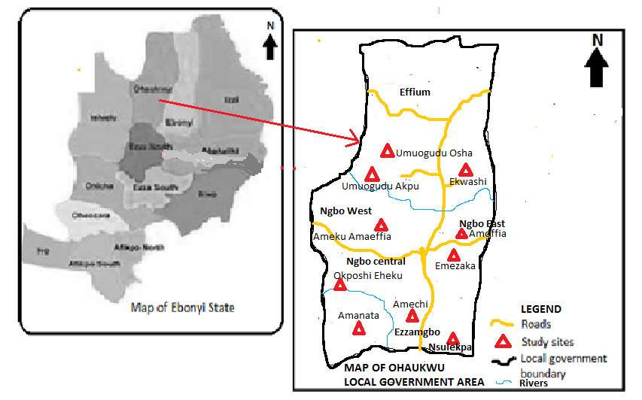Fig. 1 Map of study area showing study sites (http://soluap.com/wp.cont/uploads/2022/11/map -of-Ebonyi State showing the 13 LG Councils-Q320.jpg) modified

2.2 Study Design
The study was cross sectional in nature. It was performed by collecting urine samples from the participants by simple random and systematic sampling as well as by administration of close ended questionnaire to the participants.
2.3 Study Population
The study population consists 570 pupils made up of 308 males and 262 female school children from age 5 – 19 years old that were randomly selected from 10 primary schools which include Ibenta Primary School Ezzangbo, Central School Amike Ezzangbo, Amaechi Community Primary School Ezzangbo, Amanamta Community Primary School Ezzangbo, Central School Ngbo, Central School Umuezaka Ngbo, Hilltop Primary School Ngbo, Community Primary School Ukpeshi Umuogudu Ohia Ngbo, All Saints Methodist Primary School Ukwagba Ngbo and State Primary School Ekwashi Ngbo. The Local Government was grouped into four zones which include; Ezzangbo, Ngbo East, Ngbo West and Ngbo Central. The schools were randomly picked from each zone with at least two schools per zone. In each of the randomly selected primary schools, fifty and above willing participants were randomly selected from primary 1 to 6 within the age range of the study. The pupils must have been resident in the location for at least one year. The school age children constitute an ideal target group for investigation of urinary schistosomiasis in endemic communities because of their known habits of poor hygiene, frequent water contact activities which enhance the chances of infection with the parasites. They equally represent the true population of the inhabitants.
2.4 Inclusion criteria
Participation in the study was based on people who must have lived for at least one year in the study area and who were willing and interested (consented). Participants were within the age range for the study.
2.5 Exclusion criteria
School children that are unwilling and uninterested to participate, those outside the age range either below or above, those on anthelminthic drugs like praziquantel and those in areas where there is communal crises like Effium community were excluded from the study.

2.6 Ethical Consideration
Participants for the study were enrolled after the approval was granted by the Ethical Committee of Ebonyi State Ministry of Health, Abakaliki and a letter authorizing the approval of the study in the primary schools within the study area was equally obtained from the Secretary of Ohaukwu Local Government Education Authority. The Headmasters and Headmistress of each participating school were equally consulted and explanation on the importance of the study given to them.. Informed consent was obtained from the PTA leadership of each participating school and community leaders. Parents/guardians approval and consent of each participant was sought. Only children whose parents/guardians consented were included.
2.7 Specimen Collection
Each participant was given a 30 ml sterile dry plastic universal container with a screw lid. The children were given instructions on how to collect a terminal (last-drops) of urine between 10.00 am and 2:00 pm after a minor exercise (Cheesbrough, 2005). Each container was well labeled with the sex, age, date of collection and serial number of the participant. The collected urine samples were examined macroscopically for the presence of blood (haematuria). Thereafter, 2 drops of 10 % formalin was added for preservation of potential ova of the parasite and specimen was transported to the laboratory in an ice pack for further microscopic examination. Urine samples were analysed at Microbiology/Parasitology Laboratory in Alex Ekwueme Federal University Teaching Hospital, Abakaliki.
2.8 Microscopic Examination of Urine by Centrifugation Techniques
Ten (10) ml of urine was centrifuged at 1000 revolution per minute (rpm) for 5 min and the supernatant decanted. A drop of the sediment was then transferred onto a clean grease free slide, covered with a coverslip and examined under the microscope using x10 and x40 objectives respectively. Quantitative/intensity of infection was then determined by the number of eggs/10 ml urine (Cheesbrough, 2005).
2.9 Molecular Examination Using Polymerase Chain Reaction (PCR)
2.9.1 Urine cell pellet preparation
This technique was carried out at National Arbovirus Research and Vector Center Enugu. The pooled urine samples were centrifuged at 5000 rpm for 10 minutes and the supernatant decanted. The cell pellets were washed thrice with 25 ml phosphate buffer saline (0.8 % NaCl 2.7 mM KCl, 1.8 mM, KH₂ PO4, 8 mM Na₂HPO4 PH 7.4) and kept at – 80⁰ C in preparation for DNA extraction.
2.9.2 DNA Extraction
The DNA was extracted from the urine samples for the detection of Schistosoma hematobium using Zymo Research kit purchased from Inqaba Biotec West Africa. The kit is a product of BioLabs England. Eight hundred (800)µl of genomic lysis buffer was added to two hundred µl of urine sample in 1.5 ml Eppendorf tube and allowed to incubate for 1minute at room temperature. It was then tranfered into Zymo-SpinTM IICR Column1 in a collection tube and centrifuged at 10000 rpm for 1minute. The flow through was discarded and 200 µl of DNA pre wash buffer added to the Zymo-SpinTM IICR Column1 and centrifugation was repeated at 10000 rpm for 1minute. Washing was repeated with 500 µl of gDNA wash buffer. After 1minute dry spinning, 80 µl of the extracted DNA was eluted into sterile Eppendorf tube and properly stored at -20º C.
2.9.3 DNA Amplification
Commercially prepared Master mix sourced from Inqaba Biotec West Africa Ltd was used to prepare the PCR constituents following this protocol. Two microliter (2µl) of both forward and reverse primers, 14µl of the ready to mix master mix, 4µl of DNA template and the reaction volume was made up to 50 ul using nuclease free water. Oligonucleotide sequence of the primers for Schistosoma hematobium detection are forward primer ShDra1F 5! – GATCTCACCTATCAGACGAAAC – 3! and the reverse primer ShDra1R 5! – TCACAACGATACGACCAAC – 3! The primers were designed from NCBI sequence data base and synthesized at Inqaba Biotec West Africa. The following amplification conditions were adopted during amplification process for S. hematobium detection. The PCR conditions were as follows: initial denaturation at 95º C for 5 minutes, followed by 30 cycles of denaturation at 95º C for one minute, annealing at 56º C for 90 seconds and extension at one minute at 72º C for 5 minutes. The adopted protocol was modified from Esiere et al. (2022).
2.9.4 Gel Electrophoresis
One and a half gram (1.5g) of agarose powder was measured and dissolved in 100 ml of 1X TAE buffer (Tris Acetic Ethylene diamine Tetra-acetic acid.) and heated in a microwave until the solution was very clear, indicating complete dissolution of the agarose powder. This was allowed to cool and 10 µL of ethidium bromide was added as a stain for the DNA amplicons. The solution was poured in an electrophoretic casting tray, the comb was placed and then the solution was allowed to cool and solidify. Exactly 10 µL of PCR product was loaded in the wells created by the combs. DNA ladder (100 bp) was also loaded in one of the wells to serve as control for reading out the DNA bands. The gel was run for 1 hour at 120V in the electrophoretic tank to separate the DNA bands. The stained DNA bands were visualized under an ultraviolet transilluminator.
2.10 Data Analysis
Data was entered into Microsoft excel 2016, cleaned and exported to statistical package for social sciences (SPSS) version 22 for analysis. The mean prevalence and intensity of the infection were calculated based on categorical variables and presented in tables. Sensitivity, specificity, positive predictive value (PPV) and Negative predictive value (NPV) were calculated using standard formula. The association between categorical variables and the prevalence and intensity of infection was assessed using Chi-square test. The prevalence of infection detected by microscopy and PCR was compared across categorical variables. A p-value of$≤$ 0.05 was considered statistically significant for all the analysis.

3. RESULTS
The results revealed that in a total of 570 pupils who were examined for Schistosoma haematobium infection using microscopy technique, 86 subjects were found to be excreting ova of Schistosoma haematobium in their urine with a prevalent rate of 15.1 % while in a total of 152 specimen of pooled microscopy positive and negative urine specimens examined by molecular technique (PCR), Schistosoma haematobium DNA was detected in the urine specimens of 100 pupils with a prevalent rate of (65.8 %).
Table 1 represents the observed positive results expressed as percentage of S.haematobium infection for the two diagnostic tests stratified first by sex. Different diagnostic test gave different proportion of positive results for both males and females. The distribution of Schistosoma haematobium infection by gender indicates that of 308 male and 262 female pupils examined by microscopy for ova of Schistosoma haematobium, 55 (17.9 %) and 31(11.8 %) had the infection respectively. In molecular technique (PCR), out of 90 male and 62 female pupils examined, S haematobium DNA was detected in the urine specimen of 66 (73.3 %) and 34 (54.8%) pupils respectively. Therefore, male pupils have a higher prevalence of the infection in both microscopy and molecular technique (PCR). The difference in gender specific prevalence of Schistosoma haematobium among the children in both conventional microscopy and molecular technique (PCR) was statistically significant (P=0.054)

Table 1: Prevalence of Schistosoma haematobium Infection by Gender Using Microscopy and PCR
 | Microscopy |  | PCR
Gender | Number Examined | Number (%) Positive | Number Examined | Number (%) Positive | X² | P-value.
Male | 308 | 55(17.9) | 90 | 66(73.3) | 3.71 | 0.054
Female | 262 | 31(11.8) | 62 | 34(54.8)
Total | 570 | 86(15.1) | 152 | 100(65.8)

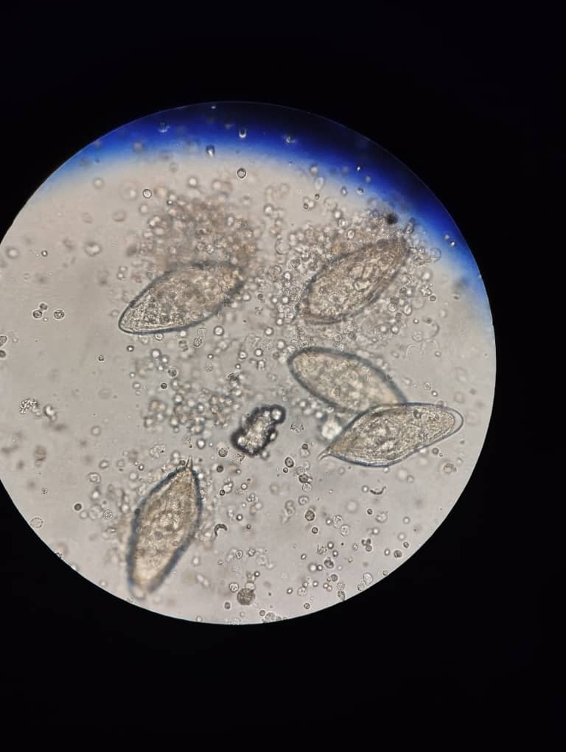
Plate 1: Microscopic field picture of S. haematobium ova in one of the urine specimens examined.
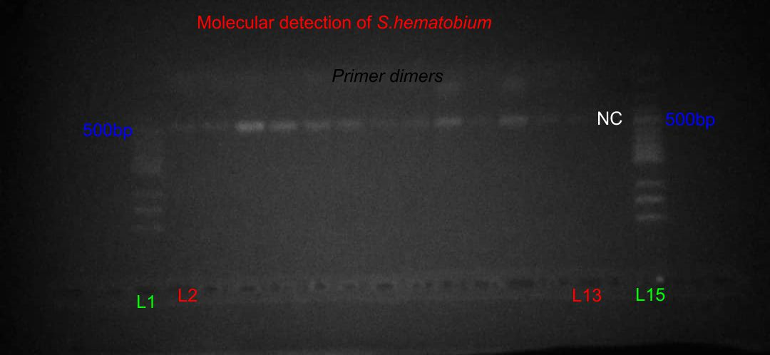

Plate 2: Gel picture of Microscopy positive samples showing molecular result of S. haematobium resolving at 480bp as shown in the picture above L1 and L15 are the 100bp DNA ladder. L2 – L13 are positive samples showing bands of the amplified S.haematobium,.NC is the Negative template control.

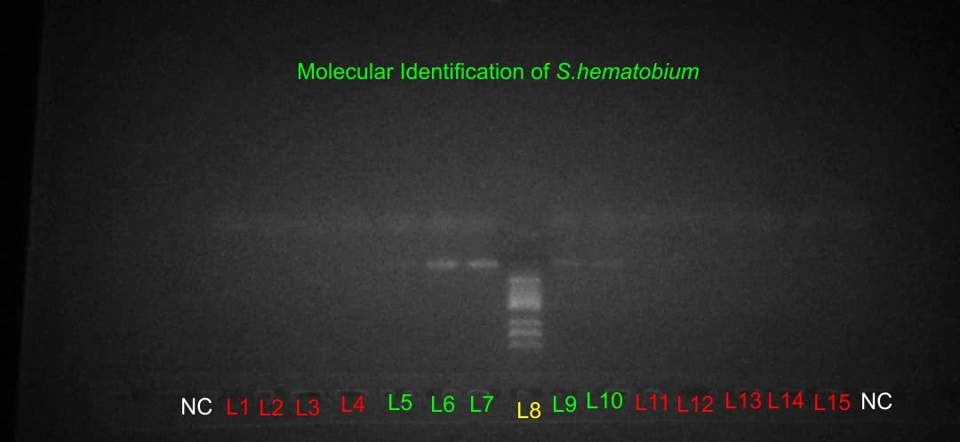

Plate 3: Gel picture of Microscopy negative samples showing some positive DNA bands. L8 is the 100bp DNA ladder, L1 to L4 and L11 to L15 are molecular negative results of the microscopy negative samples while L5, L6, L7, L9 and L10 are Molecular positive results of microscopy negative samples. NC is the Negative template control

In table 2, State Primary School Ekwashi Ngbo recorded the highest prevalence 36.7 % (18/49) by microscopy. This was followed by Central School Umuezaka Ngbo with prevalence of 35.4 % (23/65). The lowest was in Amanamta Community Primary School with prevalence of 1.8 % (1/57). However, Ibenta Primary School and Amaechi Community Primary School recorded zero infection. State Primary School Ekwashi Ngbo was equally highest in prevalence 94.7 % (18/19) by PCR followed by Central School Amike Ezzangbo with prevalence of 83.3 % (10/12) while Amaechi Community Primary School recorded the lowest prevalence 18.2 % (2/11).
The differences in prevalence among the primary schools were statistically significant P-value = 0.001. In comparison, 14 urine samples that were microscopy- negative were PCR-Positive, highlighting the increased sensitivity of PCR in detecting S. haematobium infections.
In Table 3; Participants in the age group 11-15 years recorded the highest prevalence 20.5% (62/302) by microscopy followed by those in age group 16-19 years with prevalence of 14.3 % (1/7) but participants in the age bracket of 1-5 recorded 0 infection. However, with Molecular technique (PCR), those in the age group 16-19 years recorded highest prevalence 100% (1/1). The differences in prevalence of S. haematobium infection by microscopy and PCR among the age groups were statistically significant (P =0.001).

Table 2. Prevalence of Schistosoma haematobium infection by Microscopy and PCR in Primary School in Ohaukwu LGA.
 | Microscopy |  | PCR
Name of School | Number. Examined | Number (%) Positive | Number  Examined | Number  (%) Positive | X² | P-value.
Ibenta primary sch. Ezzangbo | 50 | 0(0) | 9 | 3(33.3) | 58.21 | 0.001
Central Sch. Amike Ezzangbo | 50 | 9(18) | 12 | 10(83.3)
Amaechi Comm primary Ezzangbo | 50 | 0(0) | 11 | 2(18.2)
Amanamta Comm. Primary sch. Ezzangbo | 57 | 1(1.8) | 12 | 3(25)
Central sch. Ngbo | 53 | 10(18.9) | 14 | 10(71.4)
Central sch. Umuezaka Ngbo. | 65 | 23(35.4) | 32 | 26(81.3)
Hill Top primary Sch. Ngbo | 22 | 3(13.6) | 7 | 3(42.9)
Community primary sch. Ukpeshi Umuoguduoshia Ngbo | 86 | 10(11.6) | 19 | 11(57.9)
All Saint Methodist primary sch.Ukwagba Ngbo | 88 | 12(13.6) | 17 | 14(82.4)
State primary Sch.Ekwashi Ngbo. | 49 | 18(36.7) | 19 | 18(94.7)
Total | 570 | 86(15.1) | 152 | 100(65.8)

Table 3: Prevalence of Schistosoma haematobium infection by Microscopy and PCR among Age groups.
 | Microscopy |  |  | PCR
Age group  (Years) | Number Examined | Number (%) Positive |  | Number Examined | Number (%) Positive | X² | P-value
1-5 | 13 | 0(0) |  | 4 | 3(75) | 503.17 | 0.001
6-10 | 248 | 23(9.3) |  | 46 | 31(67.4)
11-15 | 302 | 62(20.5) |  | 101 | 65(64.4)
16-19 | 7 |  | 1(14.3) | 1 | 1(100)
Total | 570 |  | 86(15.1) | 152 | 100(65.8)
Out of the overall 570 participants whose urine were examined by microscopy for detection of ova of S, haematobium, 86 (15.1 %) was infected giving a sensitivity of 55 % and specificity of 98 %, PPV of 94.4 % and NPV of 43.8 % while in PCR technique, of 152 examined for S. haematobium DNA, 100(65.8 %) had the infection with sensitivity of 92.1% and specificity of 95.5%, PPV of 92.3 and NPV 84.4%.

Fig 2. Bar chart of Diagnostic Accuracy Measures of microscopy in comparison with PCR

4. DISCUSSION
Out of the overall 570 subjects from 10 primary schools in Ohaukwu L.G.A, 86 were microscopically positive of ova of S. haematobium representing 15.1 % prevalent rate. This prevalence is considered a moderate risk prevalence which falls within the national prevalence range of 2 to 82.5 % in Nigeria but higher than the national mean of 13 % (Gamde et al., 2022).
The present study revealed that S. haematobium infection is still a major public health challenge in Ohaukwu LGA of Ebonyi State, Nigeria. The overall prevalence through microscopy (15.1%) was slightly lower than 30.2 % reported by Awopeju et al. (2023), 21.5% by Anorue et al. (2021), in the same locality. It was equally observed to be lower than the prevalence in some previous studies elsewhere in Ebonyi State (Okpete et al.(2024) 68%; Afiukwa et al.(2019) 41%. Also in Ogun State, Uthman et al. (2024) reported 25.1% prevalence; Gamde et al. (2022) in Sokoto State reported 21.3%.
The low prevalence rate of the disease found in the present study by microscopic detection could, firstly, be attributed to the impact of a preventive praziquantel-treatment programme, initiated by the World Health Organization in 2014, for school-aged children and special risk groups in the area which the State Ministry of Health may have implemented. Secondly, it could be as a result of the acquisition of private borehole water facilities by communities and individual families which often is used for commercial purposes. This is trending in some villages and communities of this locality and may have reduced the frequency of the inhabitants visiting streams and rivers, thereby reducing the water contact activities that expose them to the infective cercariae stage of the parasite.
Thirdly the low prevalence may as well be attributed to false negative result due low sensitivity of the conventional parasitological technique (sedimentation /centrifugation/ microscopy) to detect the presence of ova of S. haematobium in the urine of the subjects. Lastly it can also be attributed to the variations in the degree of exposure to the infection, awareness of the infection as well as the variation in the ecological conditions necessary for the breeding of the snail intermediate hosts of the parasites.
On the other hand molecular analysis by polymerase chain reaction (PCR) amplification revealed that out of 152 randomly selected of microscopic positive and negative urine samples, 100 representing 65.8 % prevalence was recorded. All the microscopic positive samples were positive using PCR and 14 samples that were falsely reported negative by microscopy were positive by PCR as Dra 1 DNA fragments were detected in them. The number of positive cases increased using the PCR technique. This can be explained by the ability of PCR assay to detect very low levels of Schistosoma spp. DNA. The low sensitivity of microscopy may be attributable to its inability to detect the intermittent excretion of eggs and very low infection intensity levels. In addition, following treatment, Schistosoma re-infections are less severe and microscopy becomes less effective and miss the detection of Schistosoma eggs in asymptomatic carriers. These asymptomatic carriers become the source of persistent transmission (Abd Elraheem et al., 2021). The findings of this study corroborates with previous study of Esiere et al. (2022) in Cross River State, Nigeria recorded PCR prevalence of 34.7 % while Microscopy technique only recorded 1.7 %. Elsewhere in Sohag, Egypt Abd Elraheem et al. (2021) reported a prevalence of 89.5% while microscopy technique on this same samples gave 68.85% prevalence. Gamsleed et al. (2014) in Sudan reported PCR 73.3%; microscopy 54%. On the contrary, Effiong et al., 2017) in Wamakko, Nigeria reported by microscopy prevalence of 10% against 6% prevalence by PCR. This according to the researcher does not mean that PCR assay was not sensitive but was because the sensitivity, specificity as well as Positive Predictive Value (PPV) and Negative Predictive Value (NPV) are affected by the sample size as well as low disease prevalence of the study population.
The finding of the present study supports a number of previous reports which have consistently shown the endemicity of S. haematobium infection in Ohaukwu Local Government Area, Ebonyi State, Nigeria and that there is little or no impact of the control measures on the area, particularly the rural areas with school aged children at greatest risk. The high rate of prevalence can be attributed to the behavioral activities of these young ones that bring them in contact with the snail infested water bodies where the transmission occurs such as swimming and playing in the water bodies after school dismissal. Some children responded in the questionnaire of regularly engaging in swimming in streams, ponds and rivers like Ojegburu, Okpukwu, Olonyu, Ogwurube, Nwazulo, and Udah in their different communities which are close to their schools. Other factors that could have contributed to high prevalence of S haematobium infection in those schools and communities may include poor environmental sanitation, poverty, low literacy level and lack of basic amenities. These observations were similar to previous reports made by Umoh et al. (2020) and Awopeju et al. (2023). The variations between the present finding and those of earlier researchers can be attributed to the variations in the degree of exposure to the infection, awareness of the infection as well as the variation in the ecological conditions necessary for the breeding of the snail intermediate hosts of the parasites. From this study, males were generally more infected than the females using both diagnostic techniques. In microscopy technique, Males had a prevalent rate 17.9 % against 11.8 % of their female counterpart while in PCR technique the males equally had a prevalence of 73.3 % against 54.8 % in their female counterpart. This corroborates the findings of previous researchers such as Okpete et al. (2024), Awopeju et al.,(2023), Abd Elraheem et al. (2021), Afiukwa et al. (2019), which reported higher prevalent rates in males. This is presumably due to higher water contact activities by male pupils particularly in the swamp-rice farming, where fathers engage males in their household in the profession. In addition, other regular water contact activities such as swimming and bathing in cercariae infested streams and rivers are usually dominated by the males; besides, females in the area are usually not free to engage in swimming and bathing in open water like stream/ rivers based on religious and socio-cultural grounds unlike their male counterpart who are ready to undress openly and swim at will. However, such restriction on the part of the females is gradually being influenced by civilization. On the contrary, other researchers observed that females had higher prevalent rates than their male counterparts; {Uthman et al. (2024) and Sam wobo et al. (2013)} all reported females being more infected than the males but the report of Sam’ Wobo indicated that the difference of the prevalence was not statistically significant.
Age is a very important factor in determining the severity and risk factor of S. haematobium infection. It was observed in the study that those at age group 11-15 years recorded highest prevalence using conventional technique but with PCR technique those at age group of 16-19 years were more infected. The differences in prevalence among age group were statistically significant as p-value = 0.001. This finding is in agreement with some previous studies that recorded highest infection within the age range of 10-20 years viz Onwe et al. (2016), Opara et al. (2021), Uthman et al. (2024). This may be because members of this age group are the active group that tend to joyfully engage in several water contact activities such as fetching water, swimming, bathing, fishing and playing in schistosome cercariae infested open water bodies that enhance their exposure to the infection.
Diagnosis of Schistosoma haematobium infection among children poses a significant clinical challenge. Adults with chronic infection as well as lightly-infected children, pass few eggs in the urine which are frequently overlooked and missed when the commonly-used diagnostic methods are utilized. This study evaluated two diagnostic approaches (Polymerase Chain Reaction (PCR) and the conventional parasitological method (microscopy) commonly applied in the diagnosis of schistosomiasis. The finding revealed that PCR technique was of higher sensitivity than the conventional microscopy. From the overall number of 570 participants’ urine samples examined using microscopy, 86 (15.1 %) were found to be excreting ova of S haematobium giving a sensitivity of 55 % and specificity of 98 %. Of the 152 microscopy positive and negative urine samples randomly selected microscopy negative samples, S. haematobium DNA was detected in 100(65.8%) representing a sensitivity of 92.1% and specificity of 95.5%. The predictive values were equally different as microscopy gave positive predictive value (PPV) of 94.4% and Negative predictive value (NPV) of 43.8 % while with PCR the PPV was 92.3 % and NPV was 84.4 %. Given the sensitivity and specificity values, it is clear that PCR method is more accurate overall, while microscopy’s low sensitivity leads to a low negative predictive value (NPV), making it less reliable for ruling out negatives. The low NPV might also lead to many false negatives, which could be problematic in clinical practice. PCR has a relatively high positive predictive value (PPV) and moderate NPV and can be considered more accurate in this context.
From the foregoing, microscopy diagnostic method may not be very accurate for detection of urinary schistosomiasis infection because it detected less positive cases in the study population while PCR detected false negative result in 14 cases already counted as negative with microscopy. In comparison all positive cases in microscopy were positive with PCR. The increase in the number of positive cases in PCR can be explained by the ability of PCR assay to detect very low level of Schistosoma spp. The low sensitivity of microscopy may be attributable to its inability to detect intermittent excretion of eggs and very low infection intensity levels (Abd Elraheem et al., 2021). Furthermore, following treatment, S. haematobium re-infection becomes less severe and detection of schistosome eggs in asymptomatic carriers by microscopy may become less effective. These asymptomatic carriers become source of persistent transmission.

5. CONCLUSION
Urinary schistosmiasis is still endemic in Ohaukwu Local Government Area, considering the prevalence in the present study. In view of the high sensitivity and specificity of PCR technique, it should be considered a better diagnostic technique over microscopy especially in cases of chronic urinary schistosomiasis and in low endemic areas.

COMPETING INTERESTS DISCLAIMER:
Authors have declared that they have no known competing financial interests OR non-financial interests OR personal relationships that could have appeared to influence the work reported in this paper.

REFERENCES
Abd Elraheem, B. A., Bayoumy, A. S., EL-Faramawy, M. S., Aly, N. E. M. and El-Badry, A. A. (2021). Schistosoma haematobium DNA and eggs in urine of patients from Sohag, Egypt. The Journal of Basic and Applied Zoology, 82: 51.
Afiukwa, F.N., Nwele, D. E., Uguru, O. E., I biam, G. A., Onwe, C.S., Ikpo, N.B., Agumah, N.B. and Odoemena, O.F (2019). Transmission dynamics of Urogenital Schistosomiasis in the rural community of Ebonyi State, Southern Eastern Nigeria. Journal of parasitology Research. 2019(1) 8. https:/doi.org/10.1155/2019/7596069.
Ajibola, O., Gulumbe, B. H., Eze, A. A. and Obishakui, E. (2018). Tools for detection of schistosomiasis in resource limited settings. Medical Sciences, 6 (2):39.
Anorue, C. O., Onyali, I.O and Iwueze, O. M. (2021).Epidemiological Studies on Urogenital Schistosomiasis in Ebonyi State. Medical and Surgical Urology 10: 4. No: 245.

Awopeju, A. T. O., Nnokam B. A. and Kinako, S. E. (2023). Prevalence of Schistosoma haematobium Infections and Associated Risk Factors in School Aged Children in Southern Nigeria. Journal of Medical and Dental Science Research, 10(4): 75-80. .
Cheesbrough, M. (2005). District Laboratory Practice in Tropical Countries Part I Cambridge University Press, New York. 454.
Effiong, I.J., Spencer, T.H., Mohammed, K., Useh, M.F., Ndidim N.D. and Umahi, P.N. (2017). Evaluation of the efficacy of microscopy and PCR in the diagnosis of urinary schistosomiasis. International Journal of Tropical Disease, 26(1): 1 – 8.
Esiere, R.K., Ibeneme, E.O., Effangam E.O., Imalele, E.O., Esiere, M.K., Inyang-Etoh, P.C. and Alaribe, A.A. (2022). Detecting Schistosoma haematobium infection by microscopy and polymerase chain reaction (PCR) in school children in three senatorial districts of Cross River, Nigeria. Journal of Parasitic Diseases, 46(1): 272 – 279.
Gamde, S. M., Garba, A., Tongvwam, P.,Gamde, S.D., Agom,D,D and Igbinosa, I.(2022). Prevalence, Intensity and risk factors of urinary schistosomiasis among primary School children in Silame, Sokoto, Nigeria. Microbes and infectious Disease, 4:2. DOI: 10.21608/mid.2022.155035.1365.
Gasmelseed, N., Karamino, N.E., Hamdoun, A.O. and Elmadani, A.E. (2014). Comparative study between molecular diagnosis and different diagnostic methods of Schistosoma haematobium in Gezira State Sudan. International Journal of Tropical Disease and Health, 4(10).
National population Commission.(2022) Ebonyi (State, Nigeria) - Population Statistics, Charts, 3,242,500 Population [2022] – Projection; 6,488 km² Area ; 499.8/km² Population Density [2022] 2.5% Annual Population Change [2006 → 2022]. Map City Population https://www.citypopulation.de › NGA011 ebonyi.
Obeng, B.B., Aryeetey, Y.A., deDood, C.J., Amoah, A.S., Larbi, I.A., Deelder, A.M., Yazdanbakhsh, M., Hartgers, F.C., Boakye, J.J., Verweij, Van Dam, G.J. and Vanlieshout, L. (2008). Application of a circulating – cathodic – antigen (CCA) stripe test and real-time PCR in comparison with microscopy, for the detection of Schistosoma haematobium in urine samples from Ghana. Annals of Tropical Medicine and Parasitology, 102 (7): 625 – 633.

Okpete, E.C and Ani, O .C. (2024). Status of urinary schistosomiasis among resident of Ebonyi Local Government Area of Ebonyi State, Nigeria. The Zoologist. 24:23-29
Onwe, S.O., Ani, O.C., Uhuo, C.O., Onwe, C.S and Odikamnoro, O.O. (2016).Studies of urinary uchistosomiasis amongst school age children in Ebonyi North Senatorial District of Ebonyi State, Nigeria. International Journal of Tropical Disease and Health, 18 (3):1-7
Opara, K.N., Wilson, E.U., Yaro, C.A., Alkazmi, L., Udoidung, N.I., Chikezie, F.M., Bassey, B.E. and Batiha, G.E. (2021). Prevalence, risk factor and coinfection of urogenital schistosomiasis and soil-transmitted helminthiasis among primary school children in Biase, Southern Nigeria. Journal of Parasitology Research, 12: 6618394
Roberts, L.S., Schmidt, G.D. and Janovy, J. (2010). Foundation of Parasitology. McGraw-Hill, New York, Eighth Edition. 701.
Sam-Wobo, S.O., Ajayi, T.O., Ijaduola, T., Ekpo, U.F., Adeleke, M.A., O.A. Surakat, OA. (2013). Status of urinary schistosomiasis among primary school children in Abeokuta Nigeria. International Journal of Medical Sciences, 5: 106-109
Umoh, N.O., Nwamini, C.F., Inyang, N.J., Umoh, A.N., Usang, V.U., Nworie, A.I., Elom, M.O. and Ukwa, B.N. (2020). Prevalence of urinary schistosomiasis amongst primary school children in Ikwo and Ohaukwu Communities of Ebonyi State, Nigeria. African Journal of Laboratory Medicine, 9(1): 812.
Uthman, T.O.O., Agbolade, O.M. and Okeowo, M.T. (2024). Urinary Schistosomiasis among School age children in selected Local Government Areas in Ogun State, Nigeria. Basrah Journal of Sciences, 42(1) 69-81
Weerakoon, K.G.A.D., Gobert, G.N., Cai, P. and McManus, D.P. (2015). Advances in the diagnosis of human schistosomiasis. Clinical Microbiology Reviews, 28: 939 – 967.

