Case report

Diode Laser Assisted Removal of Multiple Mucoceles of the Lower Lip: A Case Report

.
ABSTRACT

Aim:This case reports the successful management of multiple lower lip mucoceles in a pediatric patient using diode laser as a minimally invasive substitute for traditional surgical methods.
Case Presentation:
An 11-year-old female presented with two asymptomatic painless swellings on the inner surface of the lower lip of six months duration. Clinical examination revealed soft, fluctuant, ovoid swellings in relation to teeth 31 and 41. A provisional diagnosis of mucocele was established. As the patient had a habit of lip biting and proximity of the the two lesions, diode laser excision was chosen to minimize bleeding and avoid suturing. The excised specimens were subjected to histopathological analysis. Postoperative healing was uneventful, and no recurrence was observed after three months. Histopathology confirmed a retention-type mucocele with a dilated salivary duct filled with mucin and surrounded by inflammatory infiltrate.
Discussion:
Laser assisted excision provides benefits such as accurate tissue ablation, less postoperative discomfort, and expedited healing. This case highlights the effectiveness and safety of diode laser therapy for mucoceles, especially in young patients with multiple lesions or recurrent lip injuries.

Keywords: mucocele, minor salivary gland, mucous cyst, diode laser, excision

1. INTRODUCTION

Mucoceles are, by definition, cavities containing mucus (muco = mucus and coele = cavity). They are benign soft tissue lesions that usually appear as single or multiple, painless, smooth, spherical, translucent nodules, commonly bluish in colour and variable in size. These are generally asymptomatic but may recur. Mucoceles are the most common lesions of the minor salivary glands distributed throughout the oral cavity, except the gingiva.
They are classified as the extravasation type, typically resulting from trauma, and the retention type, caused by ductal obstruction due to strictures or sialoliths (More et al., 2014, Nallasivam & Sudha., 2015, Shinde et al., 2024). They affect individuals of all ages, with a peak incidence between 10 and 29 years, and without gender predilection (Chaitanya et al., 2017). The lower lip is the most commonly affected site (67.4%), followed by the floor of the mouth, ventral tongue, and buccal mucosa.
Various treatment modalities for mucoceles include conventional surgical excision, electrosurgery, cryosurgery, micromarsupialisation, and marsupialisation. The use of diode lasers offers a modern, minimally invasive alternative (Gogoi et al., 2022). This article presents a case of an 11-year-old girl with two lower lip swellings successfully managed using laser-assisted excision.

2. Case Presentation

An 11-year-old female patient reported to the Department of Periodontics with a chief complaint of swellings on the inner surface of the lower lip for the past six months. The swellings were initially small, gradually increased in size, and were asymptomatic. No significant medical history was reported, although the patient exhibited a habit of lip biting.
Clinical examination revealed two localised swellings on the inner surface of the lower lip, in relation to the labial aspects of teeth 31 and 41. The lesions were soft, pink, and measured approximately 7×5 mm and 4×3 mm, respectively (Figure 1A, 1B). Palpation revealed soft, fluctuant, ovoid swellings without a temperature rise. The sublingual and submandibular glands were non-palpable.
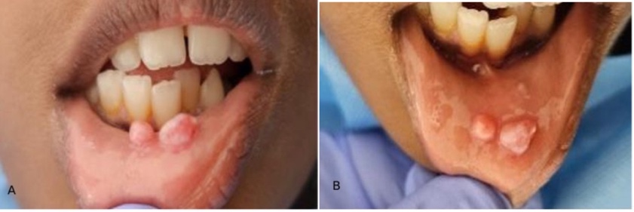
FIGURE 1: (A) Frontal view and (B) occlusal (top) view of the swellings on the lower lip

Based on the clinical findings, a provisional diagnosis of mucocele was made. The differential diagnoses included salivary gland tumours and traumatic fibromas. Laser excision was considered because of the potential intraoperative haemorrhage and postoperative complications associated with suturing multiple adjacent lesions.
After obtaining parental consent, an excisional biopsy was performed under local anaesthesia using a 980-nm diode laser (INDILASE, India) (Figure 2A). The excised tissue was fixed in 10% formalin and sent for histopathological analysis.
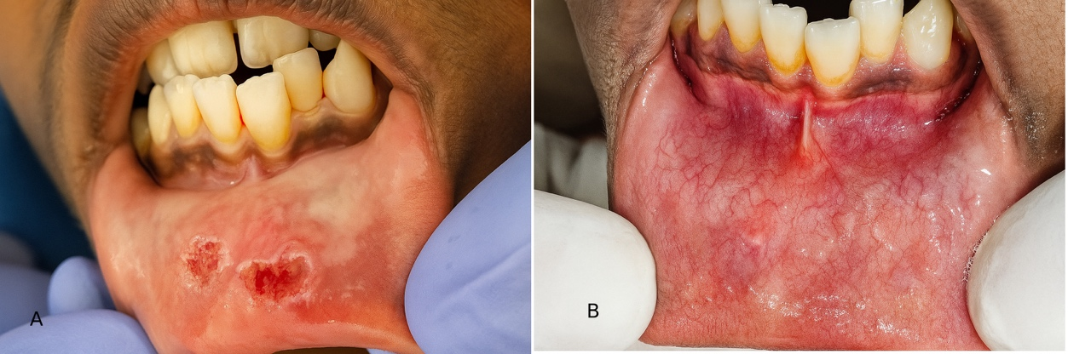
FIGURE 2: (A) Intraoperative image of the laser-assisted excision of the lesions (B) 3 months postoperative view showing complete healing

Postoperative instructions and medications (NSAIDs for three days) were prescribed. On the seventh day, the surgical site showed satisfactory healing. At the 3-month follow-up, no recurrence was observed, and healing was excellent (Figure 2B).
Histopathological analysis confirmed a retention-type mucocele, showing a stratified squamous epithelium supported by connective tissue, a dilated salivary duct filled with mucin, degenerating glandular acini, and inflammatory infiltrate (Figure 3A, 3B).

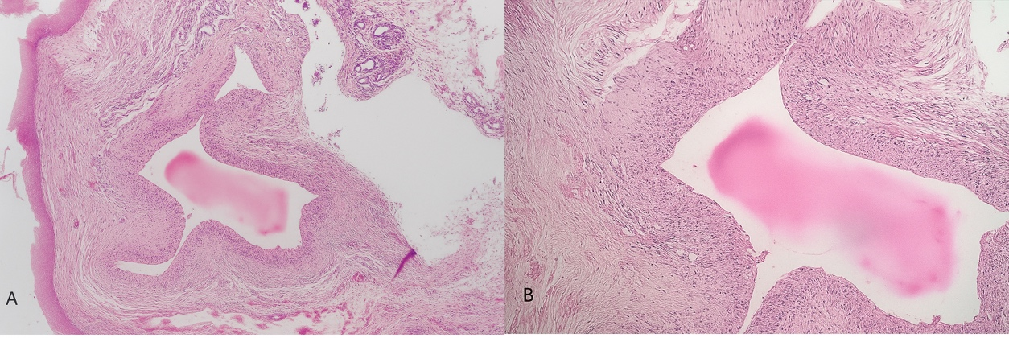
FIGURE 3 : (A) Histological section (H&E, ×4) showing dilated salivary duct; (B) higher magnification (H&E, ×10) showing mucoid material and inflammatory infiltration

3. discussion

Oral mucoceles are prevalent benign lesions originating from the minor salivary glands. They appear as painless, variable elevations on the oral mucosa. They are prevalent among individuals of all ages, although they are most frequently observed in children and young adults. The pathophysiology is primarily attributed to the disruption of the salivary excretory duct, usually caused by mechanical trauma such as lip biting or direct damage, or, less commonly, obstruction by sialoliths. They frequently occur on the lower lip (Abe et al., 2019, Rangeeth et al., 2010, Sadiq et al., 2022), with prevalence rates ranging from 0.4% to 0.9%, and without gender bias (Chaitanya et al., 2017).
Extravasation mucoceles are pseudocysts with the absence of an epithelial lining and are caused by the rupture of the salivary duct and mucin spillage into the connective tissue. Retention mucoceles, characterised by excessively broad or obstructed ducts, are quite uncommon. They are histologically defined by a hollow duct bordered with epithelium (More et al., 2019). The contributing factors of retention mucoceles include lip biting, sucking, or repeated friction during mastication (Shinde et al., 2014).
Mucoceles may clinically manifest as solitary or numerous nodules, displaying a bluish, transparent appearance when superficial, or as more subtle, pinkish swellings when situated deeper inside the mucosa. These lesions exhibit cyclical growth and fragmentation, resulting in transient erosion that typically resolve without complications. Mucoceles are generally asymptomatic, but in exceptional and severe instances, they may impede speech, mastication, and respiration. The differential diagnosis must exclude various disorders, including salivary gland tumours, traumatic fibromas, lipomas, haemangiomas, and abscesses; histology is essential for a clear diagnosis and the elimination of neoplasia (Nallasivam et al., 2010).
The objective of treatment is to eliminate the lesion while preserving oral function, reducing discomfort, and preventing recurrence. Conventional techniques necessitate the complete excision of the mucocele along with the associated minor salivary glands. Marsupialization is performed exclusively on large or recurrent lesions, with the objective of creating a permanent drainage hole. Researchers have investigated minimally invasive techniques such as micromarsupialisation, electrosurgery, cryosurgery, and, more recently, intralesional corticosteroid injection. Intralesional steroids demonstrated elevated rates of complete remission and fewer postoperative complications (Sinha et al., 2016).
Recurrence is a concern, particularly if the underlying etiological condition, such as chronic lip biting, is not addressed. It is advisable to implement preventive measures, such as modifying behaviour or employing mechanical deterrents such as lip bumpers post-surgery. The prognosis for treated mucoceles is favourable, provided that the underlying causes are eliminated and the mucoceles are entirely excised.
Lasers enhance the visibility of the operator and expedite wound healing. Recent research and case series underscore these advantages, exhibiting enhanced healing rates and negligible recurrence when suitable protocols are adhered to (Shinde et al., 2024). Laser-assisted treatment provides a secure, efficient, and patient-centric approach for addressing mucoceles in both paediatric and adult populations. This aligns with the prevailing trend toward less invasive, rapid-healing therapies (Ramkumar et al, 2016). Laser-assisted excision offers several advantages, including the presence of a bloodless field, minimal postoperative discomfort, rapid healing, and a reduced risk of infection. Diode lasers (800–980 nm) are highly effective for soft tissue excision, with minimal interaction with hard tissues. They can simultaneously cut and coagulate, providing excellent visibility and precision (Amal et al., 2024, Vitale et al., 2018).
In this case, diode laser excision resulted in uneventful healing and no recurrence at three months, demonstrating its clinical efficacy and patient comfort compared to conventional surgery.

4. Conclusion

Mucoceles are benign lesions with a tendency for recurrence if the underlying causes are unaddressed. Accurate diagnosis, appropriate management, and elimination of etiologic factors are crucial for successful outcomes. Diode laser excision represents a safe, efficient, and minimally invasive option for managing mucoceles, offering superior intraoperative control and faster recovery.

consent

As per international standards or university standards, patient(s) written consent has been collected and preserved by the author(s).

Ethical approval

It is not applicable.

DISCLAIMER (artificial intelligence)

Authors(s) hereby declare that NO generative AI technologies such as Large Language Models (ChatGPT, COPILOT, etc) and text-to-image generators have been used during writing or editing of this manuscript.

References

Abe, A., Kurita, K., Hayashi, H., & Minagawa, M. (2019). Multiple mucoceles of the lower lip: A case report. Clinical Case Reports, 7(7), 1388–1390. https://doi.org/10.1002/ccr3.2253
Amal, Y., Tabbai, S., & Chhoul, H. (2024). Diode laser removal of lower lip mucocele: A case report. The Pan African Medical Journal, 48. https://doi.org/10.11604/pamj.2024.48.142.40314
Chaitanya, P., Praveen, D., & Reddy, M. (2017). Mucocele on lower lip: A case series. Indian Dermatology Online Journal, 8(3), 205. https://doi.org/10.4103/idoj.IDOJ_151_16
Gogoi, A., Pawar, M., Badarkhe, A., Vhatkar, B., Bagde, H., & Kharat, S. (2022). Diode laser approach for excision of solitary mucocele. Journal of Pharmacy and Bioallied Sciences, 14(Suppl 1), S1066–S1069. https://doi.org/10.4103/jpbs.jpbs_12_22
More, C., Bhavsar, K., Varma, S., & Tailor, M. (2014). Oral mucocele: A clinical and histopathological study. Journal of Oral and Maxillofacial Pathology, 18(4), 72. https://doi.org/10.4103/0973-029X.141370
Nallasivam, K., & Sudha, B. (2015). Oral mucocele: Review of literature and a case report. Journal of Pharmacy And Bioallied Sciences, 7(6), 731. https://doi.org/10.4103/0975-7406.163516
Ramkumar, S., Ramkumar, L., Malathi, N., & Suganya, R. (2016). Excision of mucocele using diode laser in lower lip. Case Reports in Dentistry, 2016, 1–4. https://doi.org/10.1155/2016/1746316
Rangeeth, B., Moses, J., & Reddy, V. K. (2010). A rare presentation of mucocele and irritation fibroma of the lower lip. Contemporary Clinical Dentistry, 1(2), 111. https://doi.org/10.4103/0976-237X.68596
Sadiq, M. S. K., Maqsood, A., Akhter, F., Alam, M. K., Abbasi, M. S., Minallah, S., Vohra, F., Alswairki, H. J., Abutayyem, H., Mussallam, S., & Ahmed, N. (2022). The effectiveness of lasers in treatment of oral mucocele in pediatric patients: A systematic review. Materials, 15(7), 2452. https://doi.org/10.3390/ma15072452
Shinde, S., Lohe, V., Shirbhate, U., Mohod, S., & Solanki, D. (2024). Laser-assisted surgical management of oral mucocele: A case report. Cureus. https://doi.org/10.7759/cureus.53020
Sinha, R., Sarkar, S., Khaitan, T., Kabiraj, A., & Maji, A. (2016). Nonsurgical management of oral mucocele by intralesional corticosteroid therapy. International Journal of Dentistry, 2016, 1–5. https://doi.org/10.1155/2016/2896748
Vitale, M. C., Sfondrini, M. F., Croci, G. A., Paulli, M., Carbone, L., Gandini, P., & Scribante, A. (2018). Diode laser-assisted surgical therapy for early treatment of oral mucocele in a newborn patient: Case report and procedures checklist. Case Reports in Dentistry, 2018, 1–6. https://doi.org/10.1155/2018/3048429

