Case report
Digitalized Perio-Aesthetic Transformation of Severely Fluorosed Teeth by Direct and Indirect Veneers-: A Case Report

ABSTRACT
Aim & Background- Dental fluorosis is a prevalent condition resulting from high fluoride consumption during tooth development. The cosmetic impact of dental fluorosis can harm an individual's oral health-related quality of life and lead to long-term psychological and social effects. In extreme cases, where the fluorosed enamel is susceptible to chipping, flaking, and tooth decay, minimally invasive treatments are insufficient, and more extensive restorative measures are needed to regain proper function and appearance.
Case description- A 26-year-old female patient presented with a chief complaint of discoloured anterior teeth and an unesthetic smile. Clinical examination revealed severe brown staining and pitted enamel surfaces consistent with moderate to severe dental fluorosis, as well as an uneven gingival contour with occlusal cant.
Conclusion- The use of ceramic veneers in conjunction with laser gingival recontouring offers a predictable, minimally invasive solution for managing severe fluorosis stains, especially when aesthetic demands are high. Careful case selection, treatment planning, and adherence to adhesive protocols are critical to achieving long-term success.
Clinical Significance- This case underscores the importance of a multidisciplinary approach combining soft tissue management and ceramic restoration in the aesthetic rehabilitation of fluorosed dentition. Ceramic veneers provide a durable and highly aesthetic option for patients with intrinsic discoloration and enamel defects, restoring both function and confidence.

Keywords- composite restoration, dental fluorosis, discolouration, dental veneers, direct veneer, fluorosis, indirect veneer, lithium disilicate, veneers

INTRODUCTION
Dental fluorosis frequently impacts both primary and permanent teeth, but the consequences are typically more significant for permanent teeth because they are lasting and irreversible ¹. High fluoride consumption is linked to the onset of certain disorders, with their severity depending on the timing, duration, and level of exposure. Based on these factors, potential health effects may include dental fluorosis, skeletal fluorosis, and fluoride toxicity ². In mild dental fluorosis cases, the enamel maintains structural integrity and functionality while exhibiting hypomineralized striations and diffuse opacities. Severe manifestations present with compromised enamel microstructure, characterized by surface porosity, focal pit defects, and intrinsic staining ³. This hypomineralized enamel demonstrates reduced fracture resistance, predisposing to mechanical breakdown, with epidemiological evidence indicating a positive correlation between severe fluorosis and elevated caries prevalence ^{4,5}.

Multiple indices have been established in the literature to grade dental fluorosis severity. Among these, the Thylstrup and Fejerskov Index (TFI), introduced in 1978, remains a widely utilized classification system ⁶. The TFI categorizes fluorosis severity according to distinct clinical enamel manifestations. This system demonstrates strong biological validity, as its clinical criteria directly correspond to underlying histopathological enamel changes ⁷.

This case report describes the comprehensive interdisciplinary management of severely fluorosed teeth, involving perio-esthetics, digital dentistry, ceramic veneers and direct composite veneers.

CLINICAL REPORT
A 26-year-old female patient reported to the Department of Conservative Dentistry and Endodontics with a chief complaint of generalized brownish discoloration of her teeth. Patient is a native of a Chikkaballapur (district with known high fluoride content in water). Her medical history was non-contributory. Patient did not have any allergy to medicine and also did not report any smoking or drinking habit.

Intraoral Examination
The oral hygiene of the patient was satisfactory with moderate plaque accumulation. Gingival and periodontal health were satisfactory. No bleeding on probing was noted. Slight gingival zenith discrepancies were noted. On clinical examination, generalized brownish discoloration with enamel pitting was noted [Fig 1(a)]. Based on patient history and clinical examination, a diagnosis of generalized severe fluorosis was made. The dental fluorosis according to TFI index was classified as TFI=7. Differential diagnosis of amelogenesis imperfecta, and early carious lesions were ruled out owing to the symmetrical pattern of fluorosis on both sides of the mouth. The presence of opacities and pitting also confirmed the diagnosis of fluorosis.
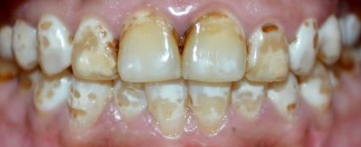

Fig 1 a. Pre-operative photograph

Treatment Plan
Post clinical examinations, radiographs, upper and lower alginate impressions and pre-operative photographs, the patient was presented with treatment options which included ceramic or composite veneers. The advantages and disadvantages of each treatment option was elaborated. The patient decided on ceramic veneers from the upper right 1st premolar to the upper left 1st premolar and on direct composite veneers from the lower right 1st premolar to the lower left 1st premolar. The patient opted to go ahead with the veneering of the lower teeth first owing to the limited financial capacity.

Tooth Preparation and Perio-Aesthetic Procedure- Maxillary Teeth
The patient’s desired veneer shade was selected using the VITAPAN classical shade guide (VITA Zahnfabrik, Germany). Depth orientation grooves were made [Fig 1(b), (c), (d)] and the enamel of the eight maxillary teeth were prepared using a flat-end tapered diamond bur to a depth of 0.8-1.0mm facially. Incisal reduction of 1.2-1.5mm was done. The proximal margin was extended into the facial and gingival embrasures. Owing to the gingival zenith discrepancy with respect to 12,13 and 22,23, [Fig 1(e)], laser gingivectomy was performed to equalise the gingival zeniths [Fig 1(f)]. The finish lines were adjusted according to the new marginal gingiva and all the chamfer finish lines were placed equigingivally [Fig 1 (g)].

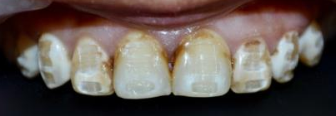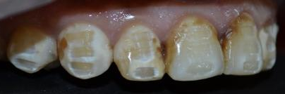
Fig 1b. Depth orientation grooves (straight)
Fig 1c. Depth orientation grooves (right lateral view)

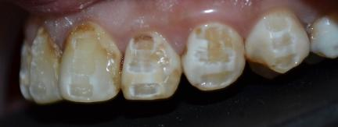
Fig 1d. Depth orientation grooves (left lateral view)

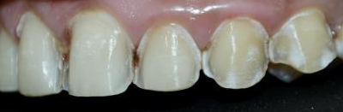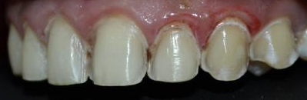
Fig 1f. Post-laser gingivectomy, occlusal cant corrected
Fig 1e. Occlusal cant discrepancy

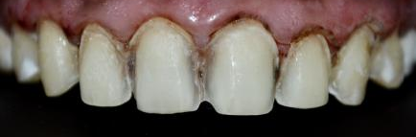
Fig 1g. Final veneer preparation

Final Impression and Temporization
Following tooth preparation, gingival retraction was achieved using retraction cords soaked in a hemostatic solution. Retragel (Prime Dental, Maharashtra, India), which consists of 25% aluminum chloride was applied onto the marginal gingiva to help with the control of bleeding. Digital impression was taken using PrimeScan (Dentsply Sirona, USA) and the same was exported to the lab [Fig 1(h)]. Temporization was carried out by spot etching the facial surfaces of the prepared teeth using 37% phosphoric acid (Total Etch, Ivoclar Vivadent, Schaan, Liechtenstein). A bonding agent (Te-Econom, Ivoclar Vivadent, Schaan, Liechtenstein) was then applied to the etched enamel areas and polymerized for 20 seconds using an LED curing unit. The putty impression which was taken during diagnosis was filled with temporization material (Protemp Plus, 3M ESPE, MN, USA) and seated onto the prepared teeth. Each tooth was light-cured for 10 seconds, after which the putty matrix was carefully removed from the teeth. Excess temporary material was removed using a yellow band flame-shaped polishing bur.
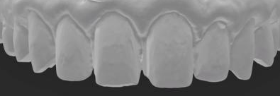
Fig 1h. Digital scan of veneer preparation

Adhesive Cementation
After approval of the final digital design of the veneers [Fig 1(i)], the ceramic veneers were fabricated using E-max lithium disilicate-reinforced glass ceramic material (Ivoclar Vivadent, Schaan, Liechtenstein). The temporary veneers were removed and the prepared teeth surfaces were thoroughly cleaned. The intaglio surfaces of the veneers were pre-silanated by the lab before delivery. The prepared tooth surfaces were etched with 37% phosphoric acid for 40 seconds, rinsed and dried. Teflon tape was placed on the adjacent teeth to avoid inadvertent bonding to the adjacent teeth. Post this, a layer of bonding agent (OneCoat 7 Universal, Coltene, Switzerland) was applied on the etched tooth surface. Resin cement of shade A2 (Rely X, 3M ESPE, MN, USA) was placed on the inner surface of the veneers. The veneers were appropriately positioned and cemented starting from the central incisors, followed by the lateral incisors, both canines and finally both premolars were cemented simultaneously on either side. Tack curing for 2 seconds was done to remove the excess flash and final curing was then done for 30s on the facial aspect and 30s on the palatal aspect. Post cementation, occlusion was assessed and a floss was passed interproximally to ensure contact patency. The patient was very satisfied with the final result [Fig 1(j)]. A 3-month follow-up photograph revealed slight discolouration of the composite veneers and slight healing of the marginal gingiva [Fig 3].
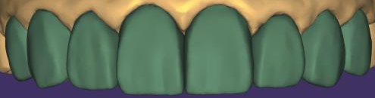
Fig 1i. EXOCAD designing of veneers

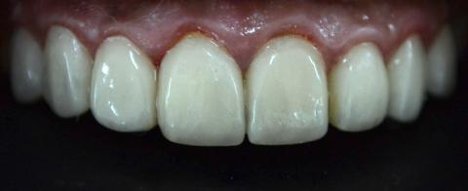
Fig 1j. Immediate post-operative photograph after cementation

Tooth Preparation- Mandibular Teeth
The patient’s desired veneer shade (A2) was selected using the VITAPAN classical shade guide (VITA Zahnfabrik, Germany). The enamel of the eight mandibular teeth were prepared using a flat-end tapered diamond bur to a depth of 0.8-1.0mm facially [Fig 2(a)]. No incisal reduction was done. The proximal margin was extended into the facial and gingival embrasures.
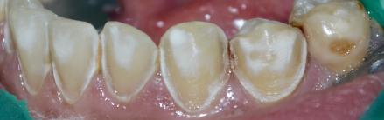
Fig 2a. Veneer preparation

Direct Composite Veneer- Mandibular Teeth
Direct composite veneering was done for the prepared teeth using shade A2 Tetric-N-Ceram (Ivoclar Vivadent, Schaan, Liechtenstein). Finishing and polishing was done using Super Snap Mini Kit (Shofu, Kyoto, Japan) [Fig 2 (b)]. The patient expressed satisfaction towards the treatment.
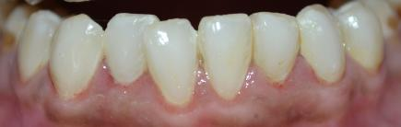
Fig 2b. Post-operative photograph after direct composite veneering from 34 to 44

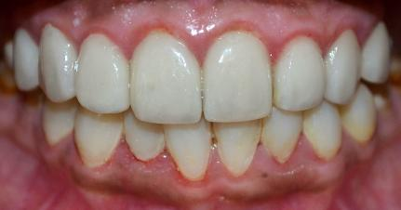
Fig 3. 3-month follow-up photograph

DISCUSSION
With increasing concern towards aesthetics and appearances, the demand for aesthetic procedures is on the rise. Fluorosis which causes teeth discoloration is an aesthetic concern for patients. The appropriate treatment varies based on the condition's severity and the patient's cosmetic preferences. For mild to moderate fluorosis, the least invasive options include bleaching, either alone or paired with micro/macro abrasion. A variety of restorative treatments are also available ⁶. However, these treatments are not a definitive solution for severe fluorosis or some moderate cases. For these situations, veneers or full-coverage crowns may be required to achieve the desired aesthetic results ⁸. In advanced dental fluorosis, the enamel becomes prone to chipping and flaking, leading to severe staining and major structural damage. These cases often require indirect restorations to restore both function and appearance ⁶.

In the present case, the patient presented with moderate-severe fluorosis affecting a majority of maxillary and mandibular anterior and posterior teeth. The aim was to aesthetically rehabilitate the affected teeth and improve the patient’s smile and appearance. The treatment plan utilized a combination of both direct and indirect restorations with the maxillary teeth receiving ceramic veneers and the mandibular teeth undergoing direct composite veneers. Direct composite veneers were done for the lower teeth owing to the financial limitations of the patient and lesser visibility of the mandibular teeth.

Lithium disilicate was chosen as the restorative material for this case based on its well-documented clinical performance ^{11,12}, reliable bonding capability to both enamel and dentin ¹³, excellent aesthetic properties, and minimally invasive preparation needs. Current research suggests that adhesively bonded lithium disilicate partial coverage restorations in posterior regions can achieve success even at thicknesses below 1 mm ¹⁴.
Although fluorosed enamel presents bonding challenges, in vitro research indicates that phosphoric acid etching enhances bond strength in moderately to severely fluorosed teeth. This process allows deeper resin tag penetration, forming a thicker resin-enamel interface. Regarding fluorosed dentin, studies suggest that the severity of fluorosis does not negatively impact the shear bond strength when using a two-bottle self-etch adhesive system ⁶. Hence, in this patient a universal bonding agent was used for increasing the bond between the restoration and the underlying tooth structure.

CONCLUSION
Dental fluorosis can present itself in various ways with differences in severity and extent seen within the same individual. Ceramic veneers have been considered a promising treatment option for aesthetic rehabilitation due to their excellent aesthetic results. Composite veneers are also a reliable alternative to ceramic veneers as they also exhibit good aesthetics. This case report elaborates the aesthetic rehabilitation of moderate to severely fluorosed teeth using ceramic veneers and composite veneers.

CLINICAL SIGNIFICANCE
This case highlights the value of a customized, minimally invasive, and patient-centred approach in the aesthetic rehabilitation of fluorosed anterior teeth. The strategic use of both ceramic and direct composite veneers allowed for tailored management based on the extent of discoloration, remaining tooth structure, and aesthetic zones. Ceramic veneers offered superior aesthetics, long-term colour stability, and durability in the most visually critical areas, while direct composite veneers provided a conservative and cost-effective alternative for less severely affected teeth.
The incorporation of laser gingival recontouring further optimized the smile by correcting occlusal cant and achieving harmonious gingival architecture. This multidisciplinary approach demonstrates how aesthetic challenges posed by intrinsic stains such as fluorosis can be overcome without aggressive tooth reduction, preserving tooth vitality and achieving high patient satisfaction.
Ultimately, the case emphasizes the importance of clinical judgment in material selection, the synergy of hard and soft tissue management, and the potential of modern adhesive and ceramic systems to provide predictable, life-changing aesthetic outcomes.
REFERENCES
- Niazi FC, Pepper T. Dental Fluorosis. [Updated 2023 Jun 1]. In: StatPearls [Internet]. Treasure Island (FL): StatPearls Publishing; 2025 Jan
- Aoun A, Darwiche F, Al Hayek S, Doumit J. The Fluoride Debate: The Pros and Cons of Fluoridation. Prev Nutr Food Sci. 2018 Sep;23(3):171-180.
- Thylstrup, A.; Fejerskov, O. clinical appearance of dental fluorosis in permanent teeth in relation to histologic changes. Community Dent. Oral. Epidemiol. 1978, 6, 315–328.
- Cunha-Cruz, J.; Nadanovsky, P. Dental fluorosis increases caries risk. J. Evid. Based. Dent. Pract. 2005, 5, 170–171.
- Ibrahim, Y.E.; Bjorvatn, K.; Birkeland, J.M. Caries and dental fluorosis in a 0.25 and a 2.5 ppm fluoride area in the Sudan. Int. J. Paediatr. Dent. 1997, 7, 161–166.
- Lee JD, Inoue N, Lee C, Park S, Lee SJ. Comprehensive Management of Severe Dental Fluorosis with Adhesively Bonded All-Ceramic Restorations. Prosthesis. 2021; 3(3):194-208.
- Rozier, R.G. Epidemiologic indices for measuring the clinical manifestations of dental fluorosis: Overview and critique. Adv. Dent. Res. 1994, 8, 39–55.
- Farid H, Khan FR. Clinical management of severe fluorosis in an adult. BMJ Case Rep. 2012 Dec 10;2012:bcr2012007138. doi: 10.1136/bcr-2012-007138. PMID: 23230244; PMCID: PMC4544904.
- El Mourad AM. Aesthetic Rehabilitation of a Severe Dental Fluorosis Case with Ceramic Veneers: A Step-by-Step Guide. Case Rep Dent. 2018 Jun 6;2018:4063165. doi: 10.1155/2018/4063165. PMID: 29977624; PMCID: PMC6011114.
- Demirekin, Z.B., Turkaslan, S. Laminate veneer ceramics in aesthetic rehabilitation of teeth with fluorosis: a 10-year follow-up study. BMC Oral Health 22, 42 (2022). https://doi.org/10.1186/s12903-022-02079-4
- Malament, K.A.; Natto, Z.S.; Thompson, V.; Rekow, D.; Eckert, S.; Weber, H.P. Ten-year survival of pressed, acid-etched e.max lithium disilicate monolithic and bilayered complete-coverage restorations: Performance and outcomes as a function of tooth position and age. J. Prosthet. Dentistry 2019, 121, 782–790.
- Pieger, S.; Salman, A.; Bidra, A.S. Clinical outcomes of lithium disilicate single crowns and partial fixed dental prostheses: A systematic review. J. Prosthet. Dent. 2014, 112, 22–30.
- Rojpaibool, T.; Leevailoj, C. Fracture Resistance of Lithium Disilicate Ceramics Bonded to Enamel or Dentin Using Different Resin Cement Types and Film Thicknesses. J. Prosthodont. 2017, 26, 141–149.
- Luciano, M.; Francesca, Z.; Michela, S.; Tommaso, M.; Massimo, A. Lithium disilicate posterior overlays: Clinical and biomechanical features. Clin. Oral Investig. 2020, 24, 841–848.

LEGEND FOR FIGURES
FIGURE 1- SEQUENTIAL TREATMENT OF MAXILLARY TEETH
- Pre-operative photograph
- Depth orientation grooves (straight view)
- Depth orientation grooves (Right lateral view)
- Depth orientation grooves (Left lateral view)
- Before gingivectomy for correction of occlusal cant
- Post-laser gingivectomy
- Final veneer preparation (correction of occlusal cant can be appreciated)
- Digital scan of veneer preparation
- EXOCAD designing of the veneers
- Immediate post-operative photograph after cementation of the 8-unit veneers
FIGURE 2- TREATMENT OF MANDIBULAR TEETH
- Veneer preparation
- Post-operative photograph after direct composite veneering from 34 to 44

FIGURE 3- 3 MONTH FOLLOW-UP

