Case report

Unusual Mandibular Incisive Canal behind the curtain of periapical radiolucency using a CBCT-assisted diagnostic approach: a case report and literature review

.
ABSTRACT

The case report highlights an incidental finding of an anatomic variation of mandibular incisive canal (MIC), an anterior extension of the mandibular canal (MC). A 45-year-old patient presented with pain and had a history of trauma seven years back in relation to mandibular anterior region. Periapical radiograph revealed a large periapical lesion with an additional radiolucent line crossing between the mandibular incisors. Limited FOV Cone-beam computerized tomography (CBCT) scan revealed it to be an accessory neurovascular channel traversing from premolar area to extending downward and upward, superimposed over periapex-periapical area of tooth #32. Clinically, any damage to these neurovascular bony channels can result in temporary or permanent sensory loss in the anterior region. The purpose of this case report is to describe an infrequent course of MIC by CBCT examination along with its location and morphological characteristics.

Keywords:[Apical periodontitis, non-endodontic lesion, cone-beam computed tomography, periapical radiolucency, mandibular incisive canal, neurovascular channel, intraosseous lesions.

- INTRODUCTION

Apical periodontitis (AP) lesions are generally associated with pulpal necrosis and infection of the root canal system. These lesions could be acute (eg, periradicular abscess) or chronic (eg, radicular cysts and granulomas) and represent approximately 90% of all periapical lesions [1]. Radiographically AP lesions seen as a widening of the periodontal ligament space or a droplet‐shaped radiolucency located around the apex of the affected tooth (chronic response). At times, lesions of non-endodontic origin, such as periapical cemento-osseous dysplasia, central giant cell granulomas, simple bone cysts and malignancies might radiographically mimic lesions of endodontic origin [2]. Previous reports have described the occurrence of non-endodontic lesions mimicking apical periodontitis and their misdiagnosis [3]. The presence of teeth with a vital pulp excludes the possibility of chronic apical periodontitis. However, teeth associated with pulp necrosis or have been endodontically treated, can lead to misdiagnosis and an ineffective treatment protocol. Also, the incisive and mental foramina overlapping mandibular incisors and premolars mimicking a periapical lesion, have to be distinguished [4].
Clinical endodontic diagnosis relies on subjective and objective information collected during patient examination with adequate radiographic information. Routine 2D radiographs aid in detecting pathoses and assist in evaluating posttreatment healing [5]. Alternative imaging techniques like CBCT has been shown to be superior to conventional imaging in many endodontic applications [6]. It provides a detailed 3D evaluation of the maxillofacial region and related anatomical structures can assist in the differential diagnosis of non-endodontic origin lesion. The 3D radiographic appearance of a periapical lesion provides additional information about the lesion’s relationship to the tooth and other anatomic structures (e.g., the vascular bundle). This information, along with pulp sensitivity testing, is useful for adequate treatment planning and management of these conditions. The present case report delineates an unusual finding of a radiolucent lesion that created a diagnostic dilemma.

- Case PRESENTATION

A 45-year-old male patient reported to the Division of Conservative and Endodontics, complaining of occasional pain on biting in the lower front teeth region since past 3 months. Past history revealed occurrence of direct trauma in the chin region consequent to a root traffic accident 7 years ago. The pain was mild and diffuse in anterior mandibular area. Medical history was non-contributory. Clinical examination revealed crown discolouration in tooth #32 with slight lingual inclination, tenderness to percussion and palpation (Figure 1). Cold (Green Endo-Ice®, Coltene Whaledent, Cuyahoga Falls, OH, USA) and electric pulp test (EPT; Kerr Vitality ScannerTM 2006; SybronEndo, Glendora, CA, USA) was negative for tooth #32, #41 and positive for tooth #31. Periodontal probing depth and tooth mobility was within physiologic limit. A diagnosis of pulp necrosis with symptomatic apical periodontitis for tooth #32, #41 was confirmed. Radiographic examination was carried out using the long cone paralleling technique with a size-1.5 CMOS RVG sensor. Digital intra-oral periapical (IOPA) radiographic revealed large periapical radiolucency involving tooth #31, #32 and #41 with ill-defined borders (Figure 2 a). A well-defined radiolucent channel was traversing up to the junction of middle/apical third of the roots (Figure 2 b). Three angulated IOPA (SLOB rule) revealed that it was lingual to the periapical radiolucency (Figure 3). Differential diagnosis included fibrous scar, malunion, non-healed bone fracture because of previous history of trauma.
Because of lack of sufficient information on IOPA, a limited FOV CBCT scan (i-CAT; Imaging Sciences International, Hatfield, PA) was taken as part of diagnostic/ treatment planning, following the ALADA principle. The CBCT scans were acquired with a limited field of view (8 × 8 cm2) at 120 kV, 5 mA, exposure time of 8.9 s, slice thickness of 0.1 mm and a voxel size of 0.125 mm. The CBCT scans were retrieved in the DICOM format. The CBCT images were assessed on a 22-inch medical-grade monitor (Dell, Round Rock, TX) with a 1920 Å~ 1080 pixels resolution using Carestream 9300 software (Carestream, Atlanta, GA). Images were reoriented to visualise the mandibular anterior area in all multiplanar reconstructions with free use of enhancement tools. Axial, coronal, and sagittal views were used to investigate the anterior mandible region [Figure 4 (a, b, c, d)]. The inferior border of mandible and its genial tubercles were designated as landmarks. Additionally, each of the anterior mandibular lingual foramina was recognized using 3D reconstructed images region [Figure 4 (e)].
The scan revealed presence of an accessory neurovascular channel which was continuation of mandibular incisive canal (MIC). The mean ±SD distance from the lower border of the incisive canal to the lower border of the mandible was 9.3±1.8 mm in the canine region. Its course towards the midline was slightly downwards, yielding an average of 7.1 ±1.1 mm in the incisor region. The canal terminated apically of the lateral incisor. The The mean length of the MIC 8.70 ±2.30 mm. The distances to buccal and lingual plates were 4.16±1.15mm and 3.13±1.48mm, respectively. The clinical procedure for the involved teeth included multi-visit non-surgical root canal treatment wrt tooth #31, #41 with use of intracanal medicament calcium hydroxide (dentokem, faridabad, india) slurry dressing. In the absence of signs and symptoms, the teeth were obturated and follow up was done at 3,6,12 months thereafter.

- discussion

This case report describes an unusual mandibular incisive canal behind the curtain of periapical radiolucency. The mandibular canal (MDC) divides into the mental and mandibular incisive canal (MIC) at the premolar region, forms the anterior loop (AL) which crosses anterior to the mental foramen (MF), and turns back to reach the MF [7]. The lingual foramen (LF) is usually situated in the midline of the internal region of the mandibular symphysis at the level, or superior to the mental spines [8]. Neurovascular bundle of inferior alveolar supply the teeth and periodontium on the respective side of the mandibular arch. The incisive nerve seems to run in a clearly defined MIC in the mandibular interforaminal region. The incisive branch innervates the anterior teeth including the first premolar [9]. The MIC continues forward to the incisive teeth, whereas the mental canal runs upwards and backwards to the MF. The canal terminates at the level of the lateral incisors on the contra lateral side might partially explain the debate concerning the neurovascular supply of the incisor teeth [10].
Prevalence
MIC was present in 76.3 % of the cases. According to the findings of a systematic review, the overall prevalence being 89.6% [11]. Using CBCT imaging, prior research has documented a 100% MIC prevalence [12]. Despite Kong et al.'s 100% MIC prevalence, 63.6% of the scans did not clearly show the MIC [13]. According to Gomes et al., out of 100 Brazilian patients in their sample, 78% of MICs were evident [14].
Gender differences
The MIC was observed in 76.09% of females and 76.5% of males; as such, gender was not a statistically significant factor in relation to the presence of a MIC. Males exhibited greater mean length values to the alveolar crest (17.23 mm and 19.55 mm, respectively), buccal cortex (2.75 mm and 4.32 mm, respectively), and inferior border of the mandible (9.98 mm and 9.60 mm, respectively) than females. These findings can be explained by the fact that females’ mandibles were smaller than those of males [15].
Spatial Relationship
Mean distances from the MIC to the adjacent teeth apexes ranged from 6.97 mm (SD = 1.58 mm) to 9.77 mm (SD = 1.04 mm), which were obtained at the canine and central incisor teeth apexes, respectively [15]. Similar MIC distances to the apexes of the teeth were found by Kong et al. (11.75 mm and 9.51 mm, respectively) [13].
The distance of the MIC from the vestibular cortical region ranged between 2.2 -5.16 mm [8]. From the lingual cortex the distance ranged from 4.4 mm to 6.33 mm [13]. Using MRI, Krasny et al. discovered that 70% of incisive canals crossed the midline and anastomosed, with roughly 25% of those being "plexus-like." This contrasts with the current findings, which show that in about half of the specimens, the incisive canal was not visible at the midline [16].
Age
MIC was mainly found in adults (4th-6th decade of life) with min 11 years to maximum 89 years of age [11]. Prados-Frutos et al. reported that the loop had a greater mean length and is significantly more prevalent in males (p = 0.014) [17]. On the contrary, in adults with dentition, the MF is situated just below the halfway point between the borders. As a result of bone loss, the MF's position on the mandible of edentulous adults shifted and approached the upper boundary. Additionally, Mardinger et al. discovered that the MF is located on average 3.8 mm lower in edentulous jaws than in dentulous jaws and migrates towards the lower cortex of the mandible due to alveolar atrophy [18]. Consequently, the age and dentulous state of the patient must be taken into account when applying this data to clinical settings.
Length of MIC
Based on measurements made with the Gendex-CB 500 CBCT scanner for this investigation, the mean length of the MIC was 7.02 mm. Apostolakis and Brown reported a mean CIM length of 8.9 mm in investigations using different image acquisition procedures [12]. This length, however, exceeds the measurements for the left (6.6 mm) and right (7.1 mm) sides that Pires et al. recorded [19]. Mean length of the MIC in dentate groups and edentulous groups was measured as 2.55 mm and 3.08 mm, respectively [7].
Diameter of MIC
The dentate and edentulous groups' well-defined MIC mean diameters were 2.44 ± 0.702 and 2.35 ± 0.652 mm, respectively [7]. The mean diameter of MIC, at the origin, was 2.1– 3.1 mm and at the incisor area was 0.95–1.03 mm. It was ascertained that there was a constant decrease in inner diameter of the canal as it progresses toward the mid-symphseal region [12,18].
Imaging technique - Periapical Radiography vs CBCT
The radiographic visibility of the mandibular incisive canal is largely dependent on the imaging technique utilized for assessment. The ability of conventional two-dimensional radiological methods to reveal the MIC is limited and their reliability and accuracy, questioned. Different methods have been used in order to establish the diameter, visualization, and course of the MIC, such as cadaveric anatomical investigations and imaging studies using panoramic radiography, computed tomography (CT), cone-beam computed tomography (CBCT), and nuclear magnetic resonance.
Good visibility of MIC was largely limited to 7.5–39.6% of the cases even though CT (93%) and CBCT (49.5–100%) were effective in identification of the canal [8,10]. Pires et al. showed that all MIC parameters are better determined by cone beam computed tomography (CBCT) imaging than by panoramic radiography. Investigations comparing panoramic radiographs with CBCT, MIC was identified in 83.1% of cases in latter compared to only 11.2% in the former [8].
Voxel size
Voxel size also has an influence on the visibility of MIC as a voxel size lower than 0.3 mm showed a higher MIC prevalence in comparison with those that used a voxel ≥ 0.3 mm. Similar findings in study by Ferreir et al. in which studies using voxels smaller than 0.3mm, provided an improved picture detail [11].
Clinical Implications
The existence of the MIC has been investigated in radiographic and anatomical studies, but the prevalence and clinical implication of this canal remain controversial. Clinically, the presence of MIC has been associated with postoperative complications after surgical procedures in the anterior region of the mandible, such as bleeding, sensory disorders, neurosensory disturbances and pain [20]. The failure of implant osseointegration in the event of a mandibular incisive canal perforation is another possible consequence that has been documented. Similar complication has been reported when implants were placed in the maxillary incisive canal.

- Conclusion
The present anatomical study confirmed the existence of the MIC. Thus, it becomes pertinent for the clinicians to be familiar with periapical lesions that might be arising due to non- endodontic causes to enable correct diagnosis and hence proper treatment. Thorough clinical examination along with interpretations of different diagnostic tests should be correlated for provisional diagnosis and confirmed using histopathological examination. They should be considered as a part of differential diagnosis of periapical lesion.

References

- Faitaroni LA, Bueno MR, De Carvalhosa AA, Bruehmueller Ale KA, Estrela C. Ameloblastoma suggesting large apical periodontitis J Endod. 2008;34:216-9.
- Modi K, Padmapriya R, Elango S, Khandelwal P, Arul B, Natanasabapathy V. Nonmalignant nonendodontic lesions mimicking periapical lesions of endodontic origin: A systematic review J Conserv Dent. 2022;25:214-25.
- Rodrigues CD, Estrela C. Traumatic bone cyst suggestive of large apical periodontitis J Endod. 2008;34:484-9.
- Faitaroni LA, Bueno MR, Carvalhosa AA, Mendonça EF, Estrela C. Differential diagnosis of apical periodontitis and nasopalatine duct cyst J Endod. 2011;37:403-10.
- Ahmed HMA. Guidelines to enhance the interpretation of two-dimensional periapical radiographic images in endodontics European Journal of General Dentistry 2015;4:106–12.
- Khanna, A.B. Applications of cone beam computed tomography in endodontics Evid based endod 2020;5:1.
- Sener E, Onem E, Akar GC, et al. Anatomical landmarks of mandibular interforaminal region related to dental implant placement with 3D CBCT: comparison between edentulous and dental mandibles Surg Radiol Anat 2018;40:615–23.
- Pires CA, Bissada NF, Becker JJ, et al. Mandibular incisive canal: cone beam computed tomography Clin Implant Dent Relat Res 2012;14:67–73.
- Di Bari R, Coronelli R, Cicconetti A. Intraosseous vascularization of anterior mandible: a radiographic analysis J Craniofac Surg 2014;25:872–9.
- Jacobs R, Mraiwa N, vanSteenberghe D, et al. Appearance, location, course, and morphology of the mandibular incisive canal: an assessment on spiral CT scan Dentomaxillofac Radiol 2002;31:322–7.
- Ferreira Barbosa DA, Barros ID, Teixeira RC, et al. Imaging Aspects of the Mandibular Incisive Canal: A PROSPERO-Registered Systematic Review and Meta-Analysis of Cone Beam Computed Tomography Studies Int J Oral Maxillofac Implants 2019;34:423–33.
- Apostolakis D, Brown JE. The dimensions of the mandibular incisive canal and its spatial relationship to various anatomical landmarks of the mandible: a study using cone beam computed tomography Int J Oral Maxillofac Implants 2013;28:117–24.
- Kong N, Hui M, Miao F, et al. Mandibular incisive canal in Han Chinese using cone beam computed tomography Int J Oral Maxillofac Surg 2016;45:1142–6.
- Gomes LT, de Almeida Barros Mourão CF, Braga CL, et al. Anatomic evaluation of the incisive canal with cone beam computed tomography and its relevance to surgical procedures in the mental region: a retrospective study in a Brazilian population Oral Maxillofac Surg 2018;22:379–84.
- Barbosa DAF, Kurita LM, Pimenta AV de M, et al. Mandibular incisive canal-related prevalence, morphometric parameters, and implant placement implications: a multicenter study of 847 CBCT scans Med Oral Patol Oral Cir Bucal 2020;25:e337–45.
- Krasny A, Krasny N, Prescher A. Study of inferior dental canal and its contents using high-resolution magnetic resonance imaging Surg Radiol Anat 2012;34:687–93.
- Prado FB, Groppo FC, Volpato MC, et al. Morphological changes in the position of the mandibular foramen in dentate and edentate Brazilian subjects Clin Anat 2010;23:394–8.
- Mardinger O, Chaushu G, Arensburg B, et al. Anterior loop of the mental canal: an anatomical-radiologic study Implant Dent 2000;9:120–5.
- Pereira-Maciel P, Tavares-de-Sousa E, Oliveira-Sales M-A. The mandibular incisive canal and its anatomical relationships: A cone beam computed tomography study Med Oral Patol Oral Cir Bucal 2015;20:e723-728.
- Dubois L, de Lange J, Baas E, et al. Excessive bleeding in the floor of the mouth after endosseus implant placement: a report of two cases Int J Oral Maxillofac Surg 2010;39:412–5.

Figure Legends:
Figure 1- Intra-oral pictures frontal, lateral and occlusal view showing crown discolouration in tooth #32 with slight lingual inclination
Figure 2- Periapical radiographs (a) IOPA exhibiting large periapical lesion (red arrows) wrt tooth #31,32,41 and (b) Tracing of the radiolucent channel seen in periapical lesion (yellow area)
Figure 3- Three angulated IOPAs following the same lingual opposite buccal (SLOB) rule shows the radiolucent channel was lingual to the periapical radiolucency
Figure 4- Axial, coronal and sagittal sections showing bilateral positional with the end of mandibular incisive canal (MIC) towards lateral and central incisors, (a) Axial section showing the presence of bilateral MIC (red arrow), (b) Coronal section at the level of lateral incisor showing bilateral looping of canal around the periapical lesion, (c) Sagittal section, (d) Sagittal section depicting the path of incisive canal (orange tracing), (e) Posterior 3D reconstruction of inner surface of mandible shows a canal entrance around lateral incisor periapex area

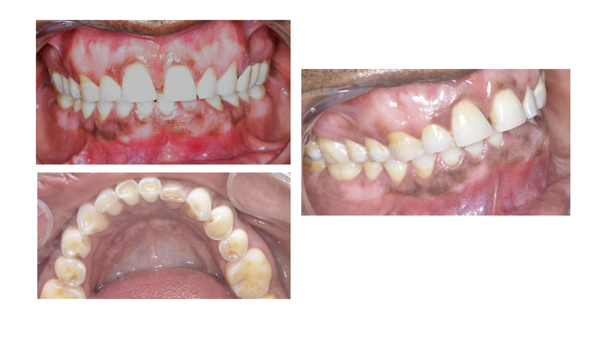
Figure 1- Intra-oral pictures frontal, lateral and occlusal view showing crown discolouration in tooth #32 with slight lingual inclination
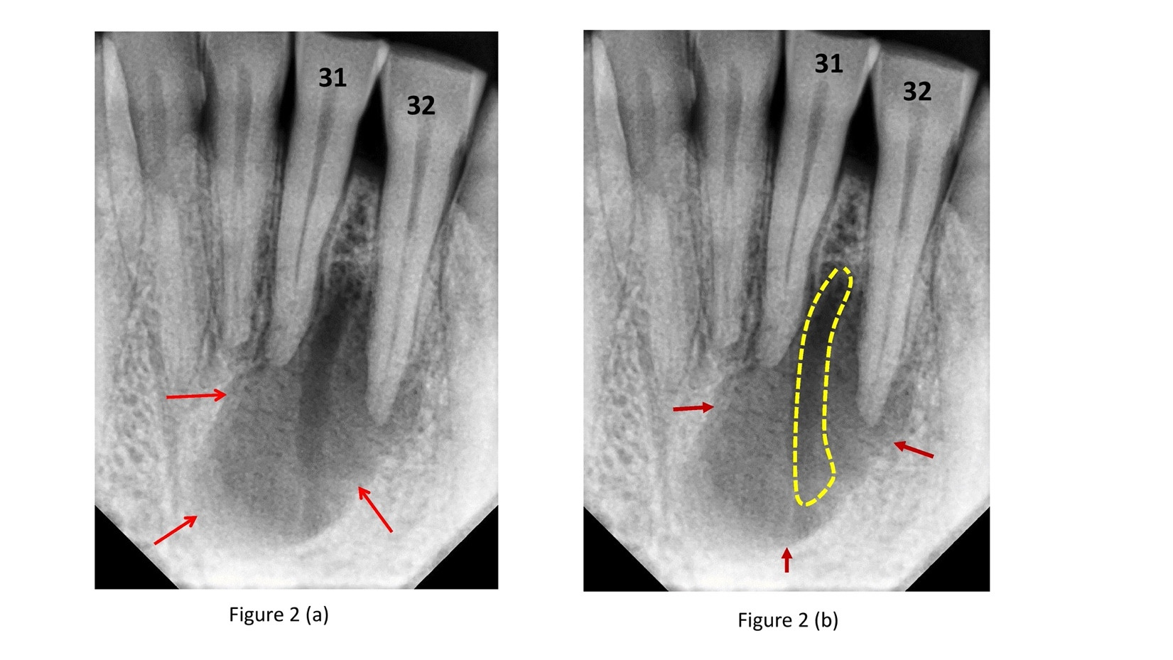
Figure 2- Periapical radiographs (a) IOPA exhibiting large periapical lesion (red arrows) wrt tooth #31,32,41 and (b) Tracing of the radiolucent channel seen in periapical lesion (yellow area)
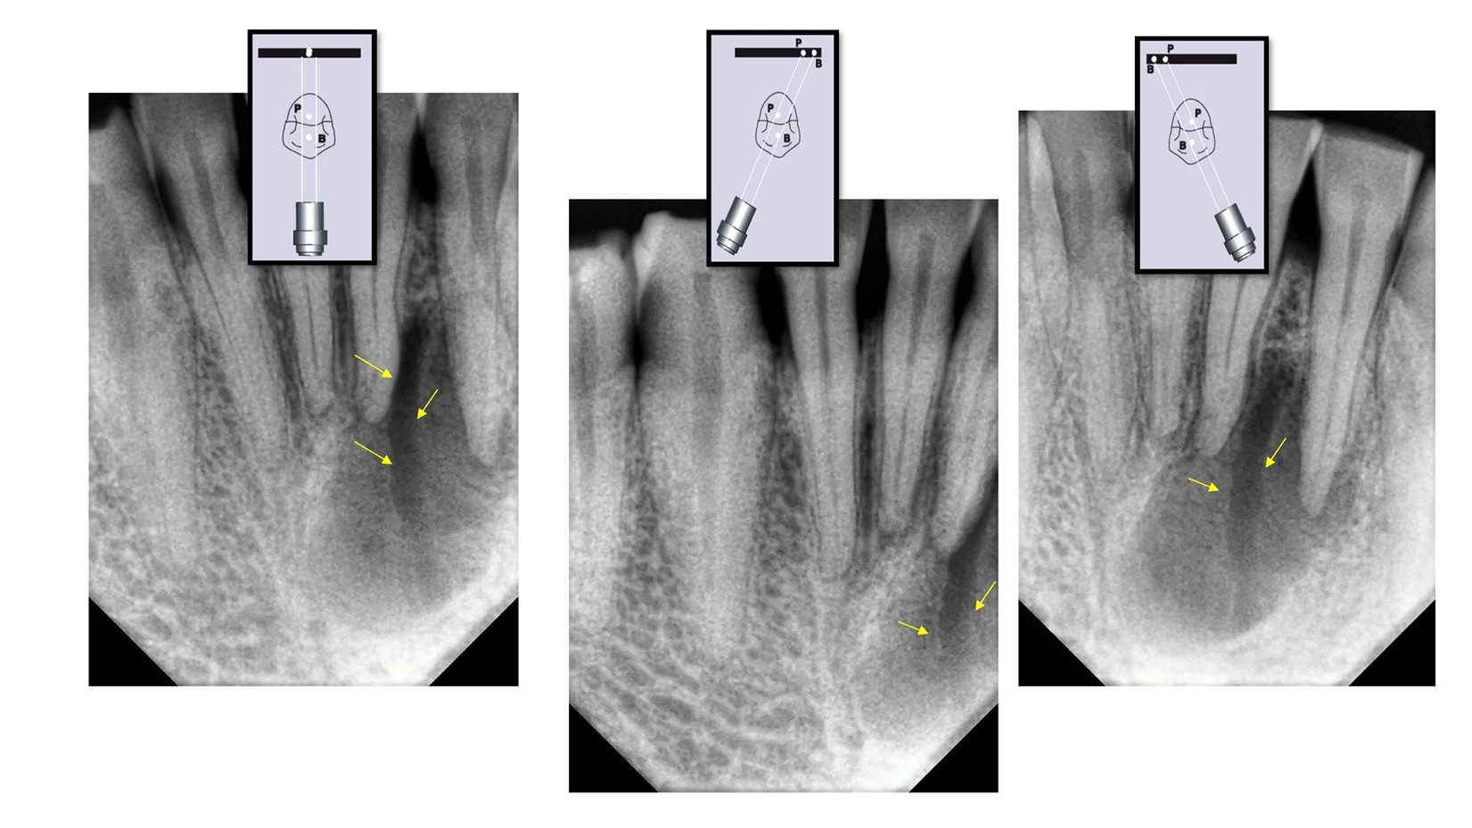
Figure 3- Three angulated IOPAs following the same lingual opposite buccal (SLOB) rule shows the radiolucent channel was lingual to the periapical radiolucency
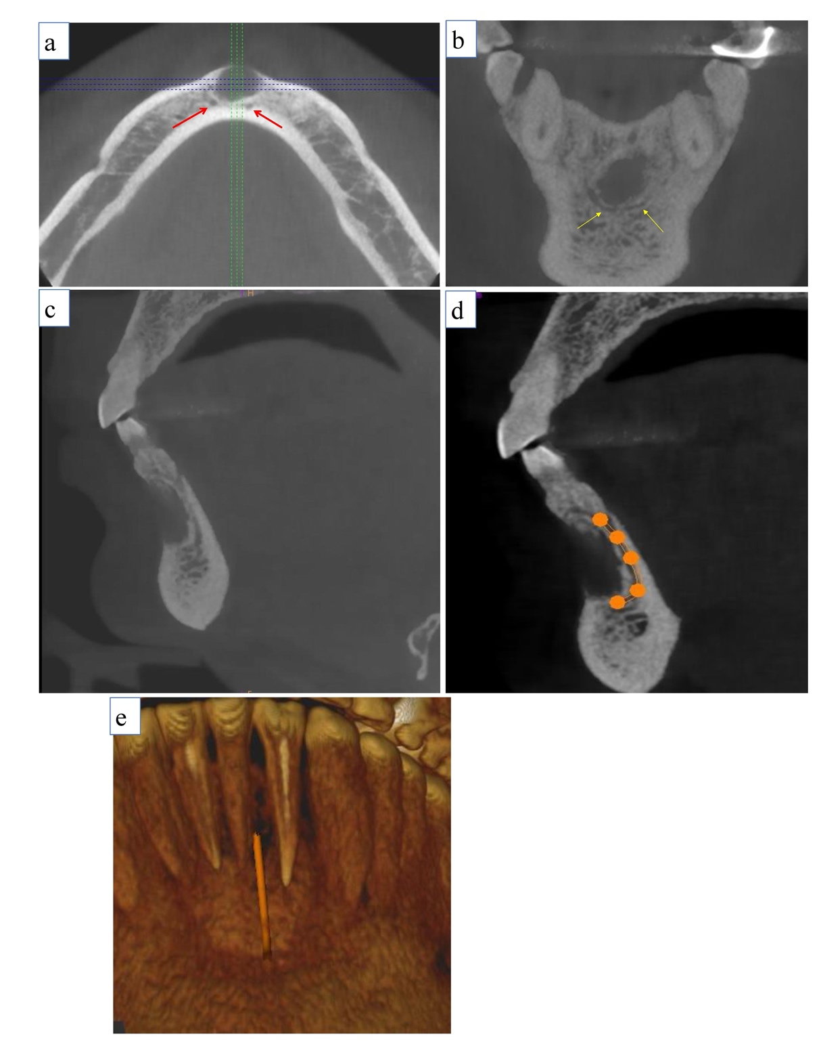

Figure 4- Axial, coronal and sagittal sections showing bilateral positional with the end of mandibular incisive canal (MIC) towards lateral and central incisors, (a) Axial section showing the presence of bilateral MIC (red arrow), (b) Coronal section at the level of lateral incisor showing bilateral looping of canal around the periapical lesion, (c) Sagittal section, (d) Sagittal section depicting the path of incisive canal (orange tracing), (e) Posterior 3D reconstruction of inner surface of mandible shows a canal entrance around lateral incisor periapex area

