Case Report

Management of Combined Periodontal treatment with endodontic therapy: A Case report

Abstract:
This case report explores about management of Combined Periodontal treatment with endodontic therapy. The periodontal disease is a factor for tooth loss in patients with periodontitis; it is pulpal infection, necrosis, and deep caries. A 39-year-old woman reported from the Periodontology Unit, Department of Endodontics, Faculty of Dentistry, with the chief complaint of tooth length and swelling from gums in relation to upper left front tooth for last 1 year. Root cannel treatment RCT by Calcium Hydroxide Ca (OH)₂ 30 days and then root cannel filling by gutta-percha was performed and periodontal open flap technique. Clinical examination showed that PD recovered to within a normal range (approximately 3–4 mm), and tooth mobility was reduced. Imbedded in a subsequent and structured maintenance system in addition to better conformity on the part of the patient, questionable and hopeless teeth could maintain for long. The treatment should follow a suggested protocol, which starts with Root cannel treatment by Calcium Hydroxide Ca (OH)2, immediately followed by RCT of the affected tooth. Subsequently, the surgical periodontal.
Key Words: Palatogingival groove, therapy of periodontal-endodontic lesion
Introduction:
This case report describes the successful management of a left maxillary lateral incisor. The development, pathology, and effectiveness of management approaches in cases involving a combined periodontal-endodontic lesion with peripocket depth (PD 9 mm) and a pulp necrosis. The periodontal classification of teeth is based on the bone of attachment loss and probing pocket depth [1]. The periodontal disease is a factor for tooth loss in patients with periodontitis; it is pulpal infection, necrosis, and deep caries [2]. Anyway, new research has demonstrated that, even with periodontic-endodontic problems, teeth as hopeless can be successfully treated [3]. Robison & Cooley (1988) explained that the palato-radicular groove, distolingual groove, radicular lingual groove, corono radicular groove, and palatogingival groove are wrong development malformations that occur in the lingual aspect of maxillary incisors.
Case Report:
A 39-year-old woman reported from the Periodontology Unit, Department of Endodontics, Faculty of Dentistry, with the chief complaint of tooth length and swelling from gums in relation to upper left front tooth N:22 for the last 1 year. Examination revealed a distopalatal deep probing pocket depth (PPD) of 9 mm, which overlapped with the location of a palatogingival groove. The tooth did not react to an electric pulp test and showed tooth mobility (Figs. 1,2). The radiographic examination revealed a periapical lesion on tooth N:22, a radiolucent line indicating a putative accessory root, and bone resorption in the palato area tooth N:22. The diagnosis was localized chronic periodontitis and pulp necrosis, a combined periodontal-endodontic lesion potentially caused by a palatogingival groove. Root cannel treatment RCT by Calcium Hydroxide Ca (OH)₂ 30 days and then root cannel filling by gutta-percha was performed and periodontal open flap technique (Figs. 3,4,5). POF to remove the inflammatory dental alveolar bone treatment and repair pocket depth. To open the flap, local anesthesia was done with 2% lidocaine within epinephrine 1:100.000 in an appropriate dose. A reverse bevel incision is made at the attached gingiva angled to excise the periodontal pocket. Two releasing incisions are made mesial and distal to the defect gingival crest 1-3 mm. After the flap is elevated, pocketing tissues are discarded, osseous surgery can be performed, and the flap is then apically repositioned and suturing with 4-0 nylon. Medicine (drug suspension): Amoxicillin 500 mg, 2 tablets times 3 per day during 7 days; Ibuprofen 400 mg, 1 tablet every 6 or 8 hours after meal during 5 days; Chlorhexidine gluconate 0.12% rinse one a day during 2 weeks; and also asked the patient to give oral health hygiene after that recall for checkup in 10 days and also asked the patient to give oral health hygiene. After treatment, the patient was recalled periodically at 1, 3, 6, 9, 12, 15, 20, 26, and 36 months (Figs 6,7). Clinical examination showed that PD recovered to within a normal range (approximately 3–4 mm), and tooth mobility was reduced.
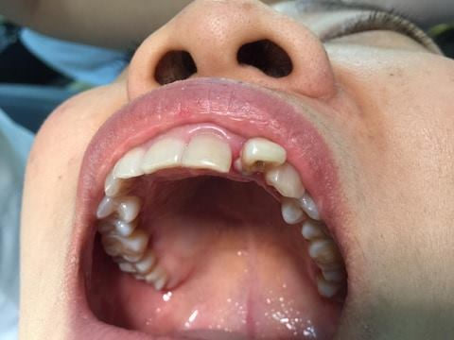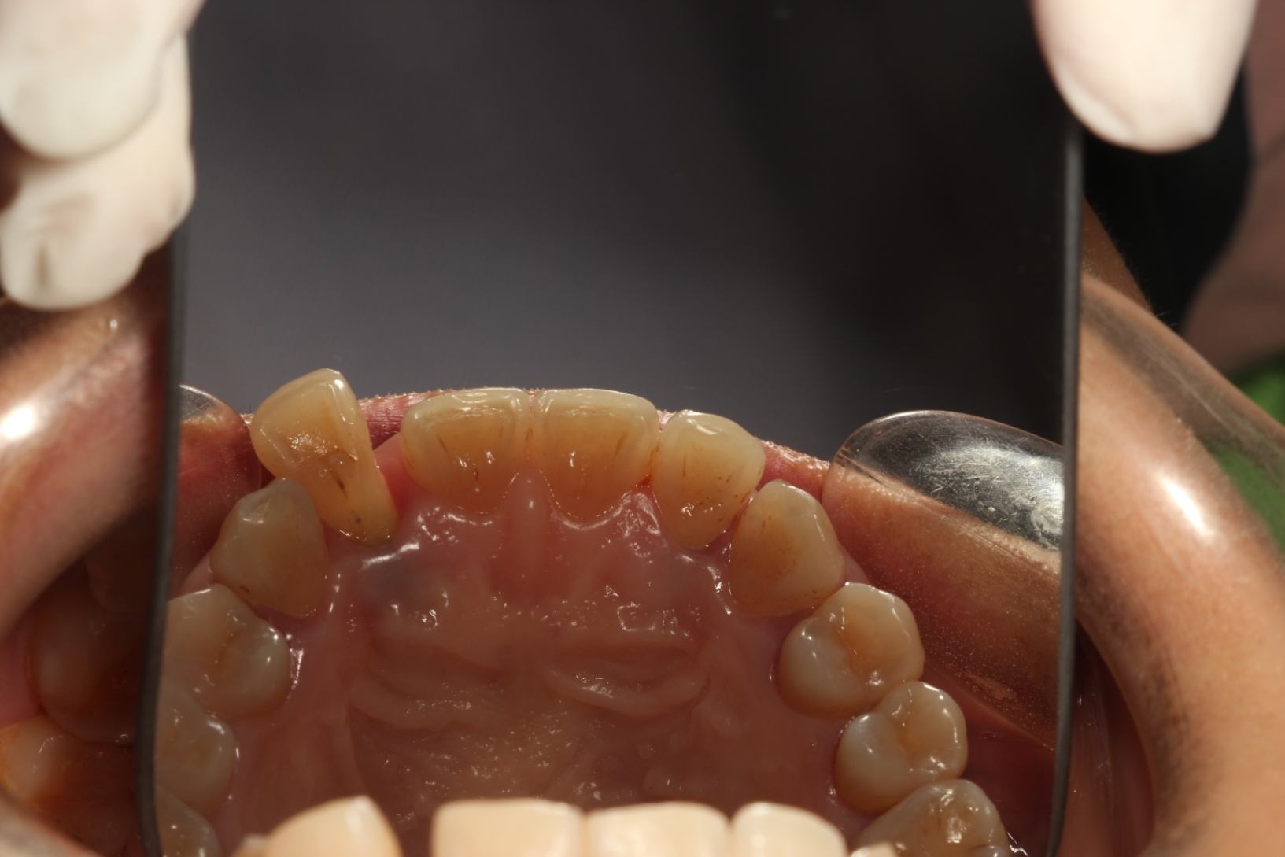
(Fig1) abscess of plaque and calcus under (Fig2) tooth long and swelling of gums in
The gum, peri pocket depth (PD 9 mm) relation to upper left front tooth N:22
In maxillary left lateral and tooth mobility
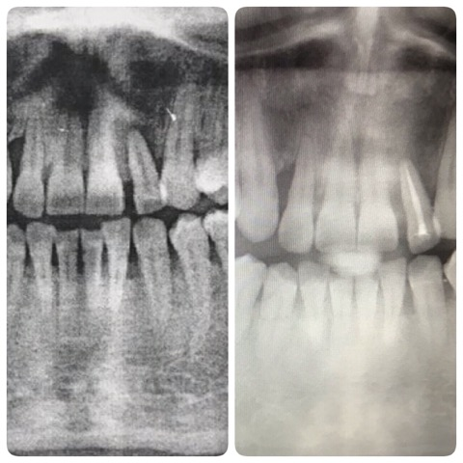
(Fig3) The periapical radiograph of tooth (Fig4) Root cannel treatment RCT
N;22 showing a periapical lesion. gingiva around tooth N:22 became healthy,
and the periapical lesion resolved
without any complication

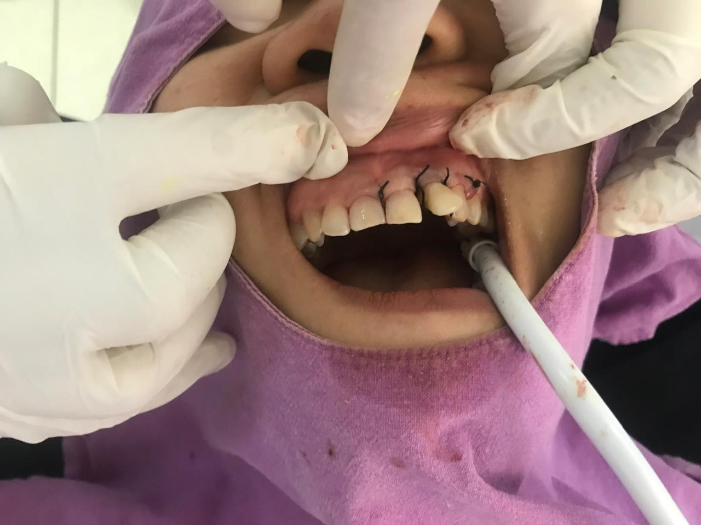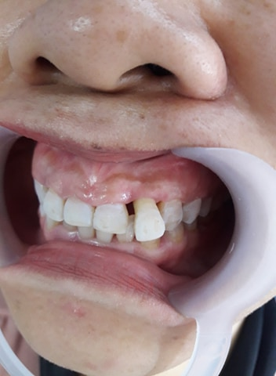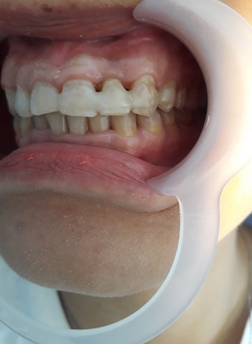
(Fig5) Periodontal open flap (Fig6) Tooth healthy in (Fig7) Follow up 36 months
Technique and suturing three months after treatment and splint
with 4-0 nylon
Discussion:
This report described A cases of periodontal-endodontic conditions involving a palatogingival groove on the palatal surface of a maxillary lateral incisor N:22. This case is follow up 36 months after treatment. Maybe these treatment options may not be the most suitable and most effective at treating the periodontic-endodontic lesion and complications of pulp necrosis. Palatogingival groove is a morphological aberration known to frequently affect maxillary incisor teeth, with a rate of affliction seen to be higher in lateral incisors (4.4–5.6%) compared to central incisors (0.28–3.4%). [4,5]. Present as a structural variation Kogon SL (1986) and Withers JA (1981). In the past, the development of palate radicular groove of mankind is cited, and 12-21% of prevalence during the megalithic period (Robison & Cooley, 1988). A study revealed that the majority of palatogingival groove in maxillaryn lateral incisor suggest probability that the groove develops from an undesirable position of the lateral incisor during the period of maxillary growth. To date, the best diagnostic method is referred to intraoral radiographs, such as periapical radiographs and horizontal and vertical bitewings [6]. The objective of the anti-infective therapy was to overwhelm the bacterial load and to launch a balance between bacterial burden and host response to permit for healing. Hence, due to the periodontic-endodontic lesion at the lower left first molar was crucial, which therapy regimen include endodontic treatment. Vakalis and collaborators indicated that RCT with nonsurgical periodontal treatment show the most efficient result in the enhancement of clinical parameters together with alveolar bone gain [7]. Cortellini et al. illustrated that regenerative periodontal care is efficacious even in hopeless teeth and may perhaps be an option to extraction [3]. Imbedded in a subsequent and structured maintenance system in addition to better conformity on the part of the patient, questionable and hopeless teeth could maintain for long [8]. To keep the treatment outcome, several studies reported that patients who conform with normal periodontal maintenance visits experience less attachment loss and lose fewer teeth than patients who get less periodontal maintenance [9–10].
Conclusion:
This case report demonstrates that a even in teeth with periodontic-endodontic lesions with primary periodontal origin and pulp necrosis. The treatment should follow a suggested protocol, which starts with Root cannel treatment by Calcium Hydroxide Ca (OH)2, immediately followed by RCT of the affected tooth. Subsequently, the surgical periodontal.
References:
[1] M. K. McGuire and M. E. Nunn, “Prognosis versus actual outcome. II. The effectiveness of clinical parameters in developing an accurate prognosis,” Journal of Periodontology, vol. 67, no. 7, pp. 658–665, 1996.
[2] C. M. Faggion Jr., G. Petersilka, D. E. Lange, J. Gerss, and T. F. Flemmig, “Prognostic model for tooth survival in patients treated for periodontitis,” Journal of Clinical Periodontology, vol. 34, no. 3, pp. 226–231, 2007.
[3] P. Cortellini, G. Stalpers, A. Mollo, and M. S. Tonetti, “Periodontal regeneration versus extraction and prosthetic replacement of teeth severely compromised by attachment loss to the apex: 5year results of an ongoing randomized clinical trial,” Journal of Clinical Periodontology, vol. 38, no. 10, pp. 915–924, 2011.
[4] Kogon SL. The prevalence, location and conformation of palato-radicular grooves in maxillary incisors. J Periodontol. 1986;57(4):231–4.
[5] Withers JA, Brunsvold MA, Killoy WJ, Rahe AJ. The relationship of palato-gingival grooves to localized periodontal disease. J Periodontol. 1981;52(1):41–4.
[6] AAP, “Position paper: diagnosis of periodontal diseases,” Jour- nal of Periodontology, vol. 74, no. 8, pp. 1237–1247, 2003.
[7] S. V. Vakalis, J. M. Whitworth, R. P. Ellwood, and P. M. Preshaw,“A pilot study of treatment of periodontal-endodontic lesions,” International Dental Journal, vol. 55, no. 5, pp. 313–318, 2005.
[8] C. Graetz, C. E. D¨orfer, M. Kahl et al., “Retention of ques-tionable and hopeless teeth in compliant patients treated for aggressive periodontitis,” Journal of Clinical Periodontology, vol.
38, no. 8, pp. 707–714, 2011.
[9] T. G. Wilson Jr., M. E. Glover, A. K. Malik, J. A. Schoen, and D. Dorsett, “Tooth loss in maintenance patients in a private periodontal practice,” Journal of Periodontology, vol. 58, no. 4,
pp. 231–235, 1987.
[10] W. Becker, B. E. Becker, and L. E. Berg, “Periodontal treatment without maintenance: a retrospective study in 44 patients,” Journal of Periodontology, vol. 55, no. 9, pp. 505–509, 1984

