Original Research Article

Zinc Enrichment and Productivity Enhancement in Potato (Solanum tuberosum L.) through Agronomic Biofortification Approaches

ABSTRACT
A field experiment was conducted for two consecutive years (2019–20 and 2020–21) at the Zonal Agricultural Research Station, Chhindwara, Madhya Pradesh, to zinc enrichment and productivity enhancement in potato (Solanum tuberosum L.) through agronomic biofortification approaches. The experiment was laid out in a Randomized Block Design with five treatments and five replications, comprising T₁: Control (no Zn), T₂: ZnSO₄ @ 5 kg/ha at planting, T₃: ZnSO₄ @ 10 kg/ha at planting, T₄: Foliar application of ZnSO₄ @ 2 g/L at 25 days after planting (DAP), and T₅: Foliar application of ZnSO₄ @ 2 g/L at 25 and 50 DAP. Results revealed that foliar application of ZnSO₄ @ 2 g/L twice (T₅) recorded the highest plant height (61.08 cm), number of shoots per plant (9.20), and number of leaves per plant (127.20) at 60 DAP. The maximum total tuber yield (33.42 t/ha) and number of tubers (834.32 ×10³/ha) were also obtained in T₅, followed by T₄ (31.90 t/ha). Zinc concentration in potato tubers was highest under T₅ (1.5 mg/kg), while T₃ (1.4 mg/kg) and T₂ (1.3 mg/kg) were next in order. Economic analysis indicated that T₅ recorded the highest net return (₹2,32,941/ha) and benefit-cost ratio (2.30), compared with control (₹1,52,390/ha and 1.54, respectively). The findings suggest that foliar application of ZnSO₄ @ 2 g/L at 25 and 50 DAP is an effective strategy to enhance yield, zinc concentration, and profitability in potato under the agro-climatic conditions of Chhindwara, Madhya Pradesh.

Keywords: Potato, zinc, bio-fortification, foliar spray, zinc sulphate, yield, economics
INTRODUCTION
Potato (Solanum tuberosum L.) is recognized globally as the fourth most important food crop after maize, wheat, and rice. It is a highly productive, short-duration crop that efficiently converts solar energy into edible dry matter and provides considerable quantities of carbohydrates, quality protein, vitamins, and minerals, making it a vital component of global food and nutritional security (Cakmak, 2008; White & Broadley, 2009). In India, potato plays a crucial role in ensuring food supply and generating rural income. The country’s total potato production during 2023–24 has been estimated at approximately 589.94 lakh tonnes, reflecting its increasing economic importance and widespread adoption across different agro-climatic regions (Government of India, 2024). Within Madhya Pradesh, potato is emerging as an important cash and nutritional crop, particularly in plateau and highland areas such as Chhindwara, where favourable soil and climatic conditions support its successful cultivation (Agricultural Statistics at a Glance, 2023).
Excessive or imbalanced fertilization has not only decreased nutrient use efficiency but also degraded arable land and posed a great threat to the environment. Potato productivity in India is static due to unbalanced use of nutrients and intensive cropping system (Choudhary et al., 2023). Zinc (Zn) is an essential micronutrient for both plants and humans. However, widespread zinc deficiency has become a major global concern, affecting nearly one-third of the world’s population (Stein, 2010). In India, low available Zn in soils is one of the most frequent micronutrient deficiencies limiting crop productivity and nutritional quality (Singh et al., 2016). Zinc deficiency in plants not only reduces growth and yield but also lowers Zn concentration in edible plant parts, thus aggravating human malnutrition.
Agronomic biofortification—enhancing the micronutrient content of crops through fertilizer management—is a practical and cost-effective approach to improve both crop productivity and the nutritional quality of food crops (White & Brown, 2010). Unlike genetic biofortification, which relies on plant breeding, agronomic biofortification offers immediate results through soil or foliar applications of Zn fertilizers such as zinc sulphate (ZnSO₄), zinc oxide (ZnO), and chelated Zn compounds (Cakmak, 2009). Among these, foliar spraying of ZnSO₄ has proven particularly efficient, as it delivers Zn directly to the foliage, facilitating quick uptake and translocation to storage organs like potato tubers (Fageria et al., 2011). Nutrients to the plant can be made available by the basal as well as by the foliar applications. Foliar spray of nutrients has several advantageous in terms of low application rate and high efficiency, uniform distribution of fertilizer material and quick response (Dongre et al., 2022).
Potato, with its relatively high Zn bioavailability and low content of Zn absorption inhibitors, is an excellent candidate for biofortification (White et al., 2009). Research has demonstrated that applying Zn fertilizers not only enhances tuber Zn concentration but also improves overall yield, quality, and stress tolerance (Yilmaz et al., 2017). However, the magnitude of response varies depending on soil Zn status, form and timing of application, and local agro-climatic conditions. Therefore, location-specific trials are essential to develop efficient Zn management practices that maximize yield, nutrient enrichment, and profitability.
To address this need, the present investigation was undertaken at the Zonal Agricultural Research Station, Chhindwara (21°28′ N, 78°10′ E; 682 m a.m.s.l.), during two consecutive rabi seasons (2019–20 and 2020–21). The objective was “zinc enrichment and productivity enhancement in potato (Solanum tuberosum L.) through agronomic biofortification approaches” under central Indian conditions.
MATERIALS AND METHODS
The study entitled “zinc enrichment and productivity enhancement in potato (Solanum tuberosum L.) through agronomic biofortification approaches.” The field experiment was carried out for two consecutive rabi seasons (2019–20 and 2020–21) at the Zonal Agricultural Research Station, Chhindwara, located at 21°28′ N, 78°10′ E and at an altitude of 682 m above mean sea level. The trial was laid out in a Randomized Block Design (RBD) with five treatments and five replications. Experimental unit size and plot layout followed the station’s standard practice. The treatments were: T₁ — Control (no Zn), T₂ — Zinc sulphate (ZnSO₄; 21% Zn) @ 5 kg ha⁻¹ at planting, T₃ — Zinc sulphate @ 10 kg ha⁻¹ at planting, T₄ — Foliar application of ZnSO₄ @ 2 g L⁻¹ at 25 days after planting (DAP) and T₅ — Foliar application of ZnSO₄ @ 2 g L⁻¹ at 25 and 50 DAP.
Potato variety K. Badshah was used. Planting was done in the first week of November at a spacing of 60 cm × 20 cm (row × plant). All other crop management practices (irrigation, weed control, intercultural operations and basal fertilization except Zn) were uniform across treatments and followed the standard recommendations of the research station. Any additional agronomic management not related to Zn application conformed to the routine practices of the Zonal Agricultural Research Station.
Observations recorded during the experiment included: Emergence percentage and plant stand at harvest, Plant height (cm) measured at 60 DAP, Number of shoots per plant and number of leaves per plant at 60 DAP, Grade-wise tuber yield (t ha⁻¹) in three size classes (0–25 g, 25–75 g and >75 g) and total tuber yield (t ha⁻¹), Number of tubers (000’s ha⁻¹) in each grade and total tuber number per hectare, Tuber zinc concentration (mg kg⁻¹), Economic parameters including cost of cultivation (seed, fertilizer, cultivation and other inputs), produce value, net returns (Rs ha⁻¹) and benefit : cost (B : C) ratio.
Tubers from each plot were harvested at maturity and sorted into predefined grade classes (0–25 g, 25–75 g and >75 g) to compute grade-wise yield (t ha⁻¹) and number of tubers (000’s ha⁻¹). Total yield (t ha⁻¹) was calculated as the sum of grade-wise yields. Standard field procedures for tuber washing, grading and weighing were followed to obtain the values presented in the results. Potato tuber samples (representative composite samples per plot) were prepared for zinc estimation by standard digestion and instrumental analysis. Total zinc concentration in tuber digests was quantified using instrumental spectrometric techniques (commonly, wet acid digestion followed by flame atomic absorption spectrophotometry — FAAS — or equivalent validated instrumental methods). Determination of trace Zn in plant tissue by wet acid digestion followed by AAS/ICP methods is a widely accepted approach in plant mineral analysis and was followed in the laboratory analysis for this study. Costs recorded included seed, fertilizer, cultivation operations and other inputs as itemized in the experiment file. Gross returns were calculated from the total tuber yield multiplied by the sale price (as used in the station’s trial accounts). Net returns (Rs ha⁻¹) were computed as gross returns minus total cost of cultivation, and B : C ratio was computed as gross returns divided by total cost. Economic results and component values are reported in Table 3 of the experiment file.
All field data were subjected to analysis of variance (ANOVA) appropriate for a Randomized Block Design to test treatment effects. Means were compared using the critical difference (CD) at the 5% level where ANOVA indicated significant treatment effects. The statistical approach followed standard procedures for agricultural experiments.
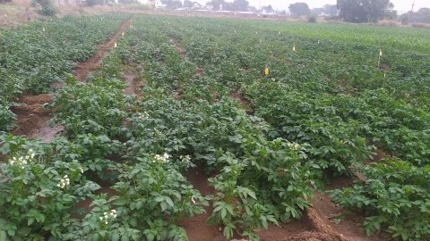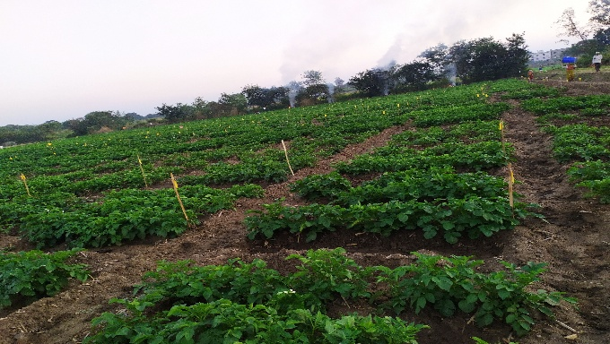
Fig 1 & 2 : Pictorials view of the experiment

RESULTS AND DISCUSSION
Table 1:- Emergence %, plant height (cm), number of shoot/plant and number of leaves/plant affected by different treatments
Treatments | Emergence (%) | Plant stand harvested | Plant height (cm) | No. of shoots/plant | No. of leaves/  plant
T₁ | 93.14 | 53.00 | 42.46 | 5.90 | 115.40
T₂ | 94.02 | 56.20 | 46.26 | 7.30 | 125.80
T₃ | 93.72 | 58.00 | 53.72 | 8.34 | 124.20
T₄ | 95.84 | 59.60 | 56.46 | 8.56 | 122.00
T₅ | 94.72 | 60.80 | 61.08 | 9.20 | 127.20
CD (0.05) | 0.94 | 1.35 | 1.28 | 0.42 | 2.70

The data presented in Table 1 show that zinc application positively influenced crop emergence, vegetative growth, and foliage development in potato. A marginal increase in emergence percentage was observed with zinc treatments, where the highest emergence (95.84%) was recorded in the treatment receiving foliar ZnSO₄ @ 2 g L⁻¹ at 25 DAP (T₄) compared with the control (93.14%). Improved emergence and plant stand under zinc application may be attributed to enhanced enzymatic activity and improved membrane integrity, which promote early and uniform sprouting. Similar results were reported by Cakmak (2008) and Singh et al. (2016), who found that zinc supplementation improves early seedling vigour and establishment.
Plant height, number of shoots, and number of leaves per plant increased progressively with zinc application. The tallest plants (61.08 cm) and maximum shoot number (9.20 per plant) were obtained with foliar ZnSO₄ @ 2 g L⁻¹ at 25 and 50 DAP (T₅), while the control recorded the lowest values (42.46 cm height and 5.90 shoots per plant). Leaf number also followed a similar trend, increasing from 115.40 leaves per plant in the control to 127.20 leaves per plant in T₅. The improvement in vegetative parameters with zinc fertilization is primarily due to its key role in auxin synthesis, chlorophyll formation, and protein metabolism, which promote cell division and leaf expansion (White & Brown, 2010; Fageria et al., 2011).
Among the different methods of zinc application, foliar treatments were more effective than soil applications. The two foliar sprays (T₅) resulted in significantly better growth performance than single foliar or soil-applied zinc, indicating that split foliar application ensures continuous zinc availability during critical growth stages. These findings agree with the results of Yilmaz et al. (2017) and Zevallos et al. (2024), who reported that repeated foliar Zn application enhances vegetative growth and canopy development in potato and other crops.
Overall, the improvement in plant height, shoot number, and leaf number in T₅ demonstrates the direct influence of zinc in stimulating vegetative growth and photosynthetic surface area. Enhanced canopy size under adequate zinc nutrition likely contributed to greater yield potential observed in the subsequent results of this study. Similar positive effects of foliar zinc on growth and productivity have also been documented in potato by Harmeet Singh (2018) and White & Broadley (2009).
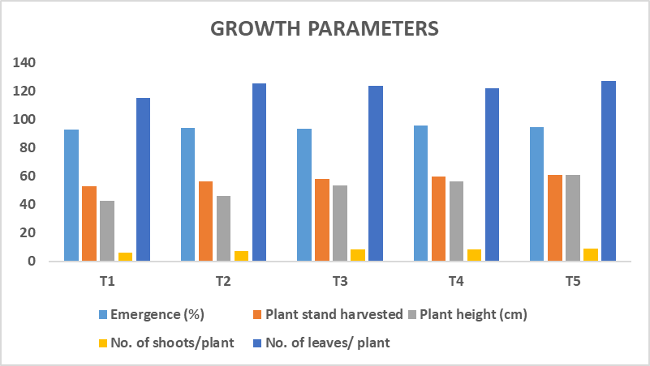
Graph 1: Emergence %, plant height (cm), number of shoot/plant and number of leaves/ plant affected by different treatments
Table 2:- Grade wise tuber yield (t/ha), total tuber yield (t/ha) & number of tubers/ha affected by different treatments
Treatments | Grade-wise yield of tubers (t/ha) |  |  |  | Grade-wise number of tubers (000’/ha)
Treatments | 0-25g | 25-75g | >75g | Total | 0-25g | 25-75g | >75g | Total
T₁ | 1.39 | 12.05 | 11.73 | 25.16 | 95.31 | 306.49 | 92.18 | 493.98
T₂ | 1.98 | 13.67 | 11.74 | 27.40 | 116.40 | 348.94 | 130.20 | 595.54
T₃ | 2.18 | 13.69 | 13.40 | 29.26 | 121.61 | 357.01 | 146.61 | 625.22
T₄ | 2.32 | 14.77 | 14.81 | 31.90 | 122.91 | 452.58 | 176.81 | 752.30
T₅ | 2.35 | 16.22 | 14.86 | 33.42 | 141.14 | 494.76 | 198.43 | 834.32
CD (0.05) | 0.31 | 1.63 | 1.53 | 2.09 | 11.83 | 17.61 | 10.93 | 26.73

The data presented in Table 2 reveal that zinc fertilization markedly influenced tuber yield and the number of tubers per hectare in potato. Total tuber yield ranged from 25.16 t ha⁻¹ in the control (T₁) to 33.42 t ha⁻¹ with foliar application of ZnSO₄ @ 2 g L⁻¹ at 25 and 50 DAP (T₅). This increase of more than 8 t ha⁻¹ under T₅ clearly demonstrates the positive response of potato to repeated foliar zinc application. Treatments T₄ (31.90 t ha⁻¹) and T₃ (29.26 t ha⁻¹) also produced higher yields than the control, indicating that both soil and foliar Zn supplementation enhanced tuber production, though the dual foliar spray (T₅) was most effective.

Grade-wise yield data show that the production of medium- (25–75 g) and large-sized (> 75 g) tubers increased with zinc application. The highest yield of medium-sized tubers (16.22 t ha⁻¹) and large tubers (14.86 t ha⁻¹) was recorded in T₅, compared with 12.05 t ha⁻¹ and 11.73 t ha⁻¹, respectively, in the control. The improvement in large-grade tubers under foliar Zn treatments suggests that zinc plays a significant role in enhancing bulking rate and tuber size by improving assimilate translocation and enzyme activity during tuber formation (White & Broadley, 2009; Cakmak, 2008).

A similar trend was observed in the number of tubers per hectare. The total number of tubers increased from 493.98 × 10³ ha⁻¹ in T₁ to 834.32 × 10³ ha⁻¹ in T₅. Both medium- and large-size tuber numbers were substantially higher in foliar Zn-treated plants than in the control, reflecting better canopy growth and photosynthetic efficiency achieved through improved zinc nutrition. Earlier studies have also demonstrated that zinc enhances tuber initiation and partitioning efficiency, resulting in higher tuber count and marketable yield (Fageria et al., 2011; Yilmaz et al., 2017). The consistent increase in both tuber number and yield across treatments indicates that zinc supplementation improved overall crop performance. Foliar application, particularly in two sprays (T₅), proved more efficient than soil application because it provided rapid Zn uptake during the critical tuber-bulking phase. Similar advantages of foliar Zn for enhancing productivity and tuber grading in potato were reported by Harmeet Singh (2018) and Zevallos et al. (2024).
Overall, the results suggest that foliar application of ZnSO₄ @ 2 g L⁻¹ at 25 and 50 DAP (T₅) not only improved total tuber yield but also increased the proportion of market-preferred larger tubers and total tuber number per hectare. This confirms the effectiveness of agronomic zinc biofortification as a dual strategy for enhancing both yield and nutritional quality of potato under the Chhindwara agro-ecological conditions.
Table 3: Economics affected by different treatments

Treatments | Yield (t/ha) | Cost of cultivation (Rs/ha) |  |  | Cost (Rs/ha) |  | Sale price (Rs/t) | Net returns (Rs/ha) | B:C ratio
Treatments | Yield (t/ha) | Seed | Fertilizer | Cultivation | Inputs | Produce | Sale price (Rs/t) | Net returns (Rs/ha) | B:C ratio
T₁ | 25.16 | 45000 | 9210 | 45000 | 99210 | 251600 | 10000 | 152390 | 1.54
T₂ | 27.40 | 45000 | 9660 | 45000 | 99660 | 274000 | 10000 | 174340 | 1.75
T₃ | 29.26 | 45000 | 10110 | 45000 | 100110 | 292600 | 10000 | 192490 | 1.92
T₄ | 31.90 | 45000 | 9310 | 45912 | 100222 | 319000 | 10000 | 218778 | 2.18
T₅ | 33.42 | 45000 | 9435 | 46824 | 101259 | 334200 | 10000 | 232941 | 2.30

Economic evaluation is a crucial component in assessing the practical feasibility of any agronomic intervention. The data in Table 3 show that zinc fertilization significantly improved the economic returns from potato cultivation. The total yield and benefit–cost (B:C) ratio progressively increased with zinc application, reaching their highest values under foliar treatments. The treatment with two foliar sprays of ZnSO₄ @ 2 g L⁻¹ at 25 and 50 DAP (T₅) recorded the highest yield (33.42 t ha⁻¹), gross returns of ₹3,34,200 ha⁻¹, net returns of ₹2,32,941 ha⁻¹, and a B:C ratio of 2.30, followed by the single foliar spray (T₄) with 31.90 t ha⁻¹ and a B:C ratio of 2.18. The lowest performance was observed in the control (T₁) with a yield of 25.16 t ha⁻¹, net returns of ₹1,52,390 ha⁻¹, and a B:C ratio of 1.54. This indicates that foliar zinc application substantially improved the profitability of potato production by enhancing yield without a significant increase in input cost.
Improved economic returns under zinc treatments are directly attributed to enhanced vegetative growth, photosynthetic efficiency, and tuber bulking, as evidenced by higher plant height, shoot number, and leaf area under T₅ (Table 1). Zinc plays a vital role in activating several enzymes related to carbohydrate metabolism, auxin synthesis, and protein formation, which collectively contribute to higher productivity and profitability (Alloway, 2008; Fageria et al., 2011). Similar findings were reported by Upadhyay et al. (2019), who observed that foliar zinc application increased yield and economic returns in potato by improving tuber size and weight. Ranjbar and Bahrami (2018) also noted a significant increase in net returns and B:C ratio with zinc biofortification in field crops. In a comparable study, Yilmaz et al. (2017) and Zevallos et al. (2024) demonstrated that multiple foliar sprays of Zn enhanced both nutrient concentration and marketable yield in potato and wheat. The superiority of foliar application over soil application is likely due to higher Zn-use efficiency, as foliar Zn reaches active photosynthetic tissues directly, overcoming the problem of soil Zn fixation common in calcareous and neutral soils (Cakmak, 2008; White & Broadley, 2009). This ensures quicker absorption and translocation to tubers, particularly when applied at the critical bulking stage. The economic advantage of foliar Zn application has also been confirmed in other field crops such as maize (Kumar et al., 2021) and rice (Singh & Prasad, 2020), where foliar Zn improved both yield and profitability under similar management systems.
Overall, the results clearly indicate that foliar application of ZnSO₄ @ 2 g L⁻¹ at 25 and 50 DAP (T₅) is the most efficient and economically viable approach for maximizing yield and returns in potato under the agro-climatic conditions of Chhindwara, Madhya Pradesh. This practice not only increases farm income but also contributes to agronomic biofortification by enhancing tuber zinc content and nutritional value.

Graph 2: Cost of cultivation (Rs/ha) and net returns (Rs/ha) affected by different treatments

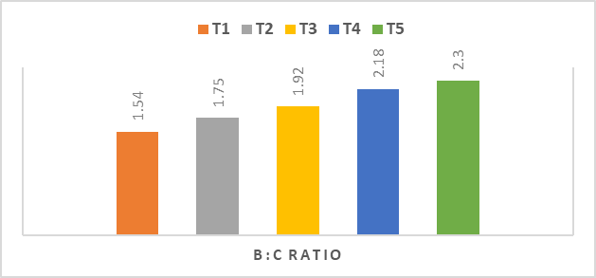
Graph 3: B : C ratio affected by different treatments

CONCLUSION
Zinc application significantly improved the growth, yield, and profitability of potato under Chhindwara conditions. The treatment with two foliar sprays of ZnSO₄ @ 2 g L⁻¹ at 25 and 50 DAP (T₅) recorded the highest plant height (61.08 cm), shoot number (9.20/plant), and leaf number (127.20/plant), leading to the maximum total tuber yield (33.42 t ha⁻¹) and tuber count (834.32 ×10³ ha⁻¹). It also gave the highest net returns (₹2,32,941 ha⁻¹) and B:C ratio (2.30). Thus, foliar ZnSO₄ @ 2 g L⁻¹ twice during crop growth is recommended as an effective and economical practice for enhancing yield, zinc enrichment, and profitability of potato in central India.

DATA SHARING
All relevant data are within the manuscript
REFERENCES
- Agricultural Statistics at a Glance. (2023). Department of Agriculture & Farmers Welfare, Government of India.
- Alloway, B. J. (2008). Zinc in soils and crop nutrition (2nd ed.). International Zinc Association (IZA) and IFA, Brussels, Belgium.
- Cakmak, I. (2008). Enrichment of cereal grains with zinc: Agronomic or genetic biofortification? Plant and Soil, 302(1–2), 1–17.
- Cakmak, I. (2009). Enrichment of fertilizers with zinc: An excellent investment for crop and human health. Plant and Soil, 361(1–2), 1–17.
- Choudhary, B., Dongre, R., Sharma, S. K. and Bakode, S. (2023). Nutrient Management in Potato (Solanum tuberosum L.) through Evaluation of the Fertility Status of Soils in Satpura Zone of Madhya Pradesh. Biological Forum – An International Journal, 15(9): 99-103.
- Dongre, R.,Pandey, S. K., Nair, R., Gontia,A. S. and Singh, R. B. (2022). Investigation on the effect of micro nutrients as foliar application on productivity and economics of guava (Psidium guajava L.) The Pharma Innovation Journal, 11(2), 3030-3-33.
- Fageria, N. K., Baligar, V. C., & Clark, R. B. (2011). Micronutrients in crop production. Advances in Agronomy, 77, 185–268.
- Government of India. (2024). First Advance Estimates of Horticultural Crop Production 2023–24. Press Information Bureau, New Delhi
- Harmeet Singh, H. S. (2018). Impact of foliar application of zinc on potato (Solanum tuberosum L.). CAB Abstracts.
- Kumar, P., Chauhan, S., & Sharma, R. (2021). Effect of foliar zinc application on yield and profitability of maize in central India. Journal of Plant Nutrition, 44(12), 1845–1854.
- Ranjbar, F., & Bahrami, A. (2018). Agronomic biofortification with zinc and its economic evaluation in field crops. Journal of Soil Science and Plant Nutrition, 18(2), 450–461.
- Singh, M. V., Takkar, P. N., & Nayar, V. K. (2016). Micronutrient problems in Indian soils and crops. Indian Institute of Soil Science, Bhopal.
- Singh, R., & Prasad, S. (2020). Influence of zinc and iron foliar application on yield and economic return of rice. Oryza, 57(1), 64–70.
- Stein, A. J. (2010). Global impacts of human zinc deficiency. Annals of Nutrition & Metabolism, 56(Suppl. 2), 98–101.
- Upadhyay, R. G., Patel, K. S., & Singh, A. (2019). Response of potato to zinc fertilization and its effect on yield and economics. International Journal of Chemical Studies, 7(3), 1125–1129.
- White, P. J., & Broadley, M. R. (2009). Biofortification of crops with seven mineral elements often lacking in human diets. New Phytologist, 182(1), 49–84.
- White, P. J., & Brown, P. H. (2010). Plant nutrition for sustainable development and global health. Annals of Botany, 105(7), 1073–1080.
- White, P. J., Broadley, M. R., & Bowen, H. C. (2009). Zinc in plants: Integrating homeostasis and biofortification. New Phytologist, 182(1), 49–64.
- Yilmaz, A., Ekiz, H., & Torun, B. (2017). Effect of different zinc application methods on yield and zinc concentration in wheat. Plant and Soil, 180(2), 223–229.
- Zevallos, S., et al. (2024). Foliar Zn application increases Zn content in biofortified crops. Agriculture, 14, 1–12.

