Simultaneous valorization of market and slaughterhouse waste in agriculture

ABSTRACT:

Aims: Management of organic waste from markets and slaughterhouses is a major challenge for African cities. The disposal of these wastes in landfills or simple abandonment without treatment constitutes a significant pollution source to surface and groundwater due to the infiltration and runoff of organic and mineral compounds. The present study aims to simultaneously use those wastes for agricultural use through composting to mitigate water pollution and establish sustainable waste management.

Study design: Mention the design of the study here.
Place and Duration of Study: Sample: Market wastes were collected at Sinistre Market and slaughterhouse wastes were collected at municipal slaughterhouse of Korhogo, between December 2024 to January 2025. Composting and plot experiments were carried out from February 2025 to March 2025

Methodology: The methodology involved collecting and characterizing organic wastes, producing compost by using the Berkley method (18 days), and evaluating the influence of resulting compost on okra (Abelmoschus esculentus) crops.

Results: Collecting data revealed substantial waste generation: 1,244.4 kg of fresh market waste was collected over 22 days. 26,000 kg of fresh viscera from the slaughterhouse was collected over 55 days. Physicochemical analyses confirmed the compost's high nutrient content, with nitrogen (4-4.3 g/kg), phosphorus (4.6-6.3 g/kg), and potassium (19.4-20.6 g/kg). Compost application significantly improved okra growth and yield. The best results were achieved with compost from slaughterhouse dry matter combined with fresh market matter and ¼ to ½quantity of biochar, yielding 3.2 kg/8m² (about 4 tons/hectare), compared to 0.42 kg/8m² (about 411 kg/hectare) in control plots.

Conclusion: These findings demonstrate that simultaneous use of market and slaughterhouse wastes reduces environmental impact of waste disposal while providing a viable alternative to chemical fertilizers for farmers.

Keywords: Agriculture, Compost, Organic waste, Korhogo

1. INTRODUCTION

Rapid urbanization and uncontrolled population growth in many African cities have led to a dramatic increase in organic wastes generation, particularly wastes from markets and slaughterhouses (Chalot, 2004; Sotamenou, 2010). The absence of a sustainable management system, this waste becomes a major source of pollution, exacerbated by linear "take-make-dispose" economic models that are increasingly unsustainable (Kaza et al., 2018). This issue is particularly acute for perishable waste, whose management requires rapid, localized solutions to avoid public health and environmental hazards (Oladélé et al., 2022). When exposed to the weather, leachates from wates decomposition, infiltrate the soil or run off and contaminate groundwater and surface water with high loads of nitrates, phosphates and organic matter (Kengne et al, 2008, Jedjé et al, 2015). However, far from being considered as a nuisance, this waste could offer good opportunities for reuse and circular economy, particularly in the agricultural sector. Rich in essential nutrients such as nitrogen, phosphorus and potassium, these market and slaughterhouse refusals could be transformed, through appropriate techniques such as composting to produce organic fertilizers, (Houot et al 2000). In this context of circular economy and sustainable development, organic recovery is part of a perspective of reducing surface water pollution, strengthening food security and improving soil fertility and adapted to local contexts for use in agriculture. The co-composting of diverse urban organic wastes is a proven strategy to create a balanced and nutrient-rich soil amendment that can improve soil health and structure (Onwosi et al., 2023). This valorization is crucial in a areas where soil degradation and food insecurity threaten the resilience of local agricultural systems, an issue that integrated waste management can help address (Ngo et al., 2021). This study is situated within the framework of circular economy and sustainable development. It proposes an integrated approach to waste management that not only could mitigates surface water pollution but also improve soil fertility and enhance food security through the production of a context-appropriate agricultural input, aligning with the need for innovative methods for sustainable agriculture (Cofie et al., 2020). The overarching aim of this study is to contribute to the reduction of surface water pollution by valorizing wastes form markets and slaughterhouses into a high-value organic fertilizer, thereby promoting sustainable waste management. To achieve this aim, the study will pursue the following specific objectives:
- To characterize the physicochemical properties of the organic waste produced by selected markets and slaughterhouses.
- To produce and assess the agronomic quality of compost derived from the co-composting of market and slaughterhouse waste.
- To evaluate the effect of the produced compost on the growth and yield of a test crop (okra - Abelmoschus esculentus). Material and Methods

2. material and methods

2.1 Material
The material used for collecting and sorting consists mainly of (Figure 1):
- Plastic bins to collect and group waste
- Gloves, boots and masks to protect against infections
- A Snipextc digital scale to quantify waste
- Bags to collect the waste for simplifying its transport
- A tricycle to transport the waste to the composting site
The material used for pre-treatment and composting consists of:
- Resistant plastic sheeting: used for drying wet organic waste and covering compost piles, to maintain humidity and temperature while protecting the compost from the elements.
- A pyrolyzer was used to produce biochar
- A machete cut the wood
- Forks, shovels, watering cans were used for turning over and maintaining the humidity of the compost.
The material used for the establishment of the plots comprise:
- Okra seeds (Kirikou f1)
- Hoes were used to make the ridges
- Dabas were used to clean and ventilate the plot,
- sprayer was used for the treatment of plant protection products
- tape measure to measure the size of the plants,
- Electronic balance to measure wastes and yield quantity,
- Insecticides and fungicides to protect plants from pests, including aphids and caterpillars, and fungal infections.

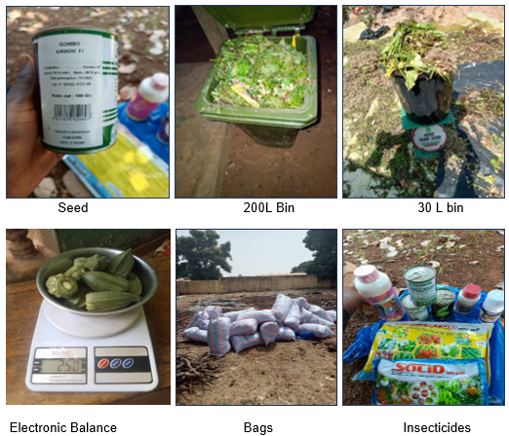

Figure 1: Equipment for collecting, sorting, composting and cultivating the parcel

2.2 Methods
2.2.1 Characterization of market and slaughterhouse waste

The waste collection was carried out at the small market of Sinistré. Two types of garbage bins were distributed to vendors to collect organic waste. The small 30-liter bins are used for personal collections and the large 200-liter bins for collecting large quantities of wastes from small bins. Every morning, the large garbage cans were emptied and transported to the waste treatment site. Once on site, the waste was manually sorted to separate the recoverable materials, quantified and dried before the composting process. The collection at the Korhogo slaughterhouse was carried out daily using wheelbarrows and shovels, to effectively collect viscera waste from the slaughterhouse's activities. After collection, fresh waste was weighed to determine the quantities produced and spread on a drying tarpaulin in a space inside the slaughterhouse. To facilitate drying, regular turnovers were carried out. Finally, the waste was bagged and weighed and then transported with a tricycle to the composting site.

2.2.1 Composting process with collected wastes
2.2.1.1 Co-composting protocol

Among the various existing methods, the method used for the present study is that of Berkley (Misra et al., 2005). This method was chosen for its ability to accelerate the decomposition process, thanks to a rigorous management of the inputs and a frequent reversal of the pile. The principle of this method consists in superimposing layers of dry matter rich in carbon and fresh matter rich in nitrogen to form piles (pyramidal pile) of at least 0.90 m³ of organic waste from markets and slaughterhouses differentiated by their compositions which will undergo periodic reversals. Composting took place over a period of 18 days with a first turn-over on the 4th day followed by daily turns-over to promote aeration and homogeneous decomposition of the waste.

2.2.1.2 Composting of dry organic matter from the market and fresh from
slaughterhouse

The materials used at the first layer are the dry organic waste of the market at 140 kg and the second layer located above includes 600 kg of fresh viscera waste. The pile set up with is watered with 180 liters of water to start composting. The pile was supported on a 3 m² tarpaulin and was covered with a 6 m² plastic tarpaulin to conserve heat.

2.2.1.3 Composting of slaughterhouse, fresh market and slaughterhouse dry organic
matter

This second attempt aims to test a different combination of materials, using a base layer of 152kg dry viscera waste, topped by two layers of fresh waste, one from the market 60kg, then the other from the slaughterhouse 42kg to form a pile. Watering is done with 160 liters of water to promote good humidity. The pile was supported on a 3 m² tarpaulin and was covered with a 3 m² plastic tarpaulin to conserve heat.

2.2.1.4 Composting of fresh organic matter from market and slaughterhouse

In the latter experiment, compost is formed only from fresh materials, which considerably modifies the water requirements for initiating the process. Fresh viscera waste has a quantity of 300 kg and fresh organic waste from the market is 75 kg. Watering is done with 15 liters of water due to the natural moisture already present in the fresh materials. The pile was supported on a 3 m² tarpaulin and was covered with a 3 m² plastic tarpaulin to conserve heat. This combination allowed to test the feasibility of composting with fresh materials and a minimum of water addition.

2.2.2 Biochar production process

The biochar production process consisted of the use of a device (pyrolyzer). Dry wood twigs were lit and covered with the device, rice bales from a mill were put in turn to create an incomplete combustion of these woods, in order to carbonize the rice bales under the effect of the heat of the fire contained in the device. A regular reversal was made to spread the carbonization over all the rice bales used in the process. (Figure 2).

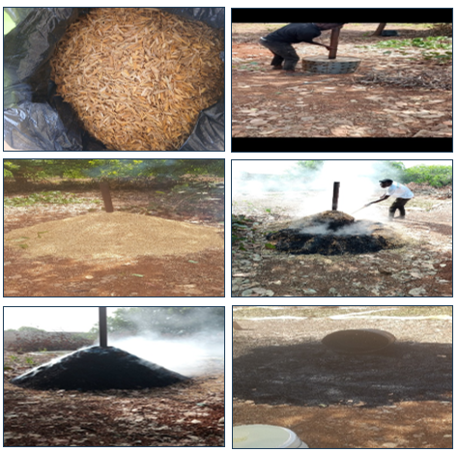

Figure 2: Biochar production process

2.2.3 Physico-chemical characterizations of produced composts

A sample of 1kg compost produced was taken, dried and analyzed in the laboratory in June 2025. The following physico-chemical parameters were concerned: major nutrients (total nitrogen, assimilable phosphorus, exchangeable potassium), pH, cation exchange capacity, electrical conductivity, calcium, sulfur, carbon, etc.

2.2.4 Effect of produced composts on crops (okra) growth and yield

The okra seeds were sown directly by hand on logs made by hoe. The distance between the lines was 50 cm and 40 cm between the pockets which allows to have 40 pockets on a line. Watering was done twice a day manually using a watering can that can hold 15 liters of water. Every 10 days, measurements were taken to find out the size of each plant using a tape measure. The plants were treated with the insecticide « kapaas and K optimal » and fungicides to control crop pests. The lines of 40 pockets have received amendments according to the experimental design (Figure 3).
Control
NPK
CSMFA
CF(M+A)
CSAF(M+A)
CSMFA+ ¼ BIO
CSMFA+ ½ BIO
CF(M+A) + ½ BIO
CSAF(M+A) + ¾ BIO
CSAF(M+A) + ¼ BIO

CSAF(M+A)+ ½ BIO
CF(M+A) + ¾ BIO
CF(M+A) + ¼ BIO

CSMFA+ ¾ BIO

CSMFA: Compost made from market dry matter and fresh slaughterhouse material
CSAF(M+A): Compost of slaughterhouse dry matter and market and slaughterhouse fresh matter
CF(M+A): Compost made from fresh market and slaughterhouse material
BIO: Biochar

Figure 3: Plot experimental design

2.2.5 Analysis of plants growth data

The statistical analysis was carried out with the Origin Pro software. Plant growth data were entered and then averages and standard deviations were calculated. A single-factor ANOVA test was used to obtain the value F, the associated probability (Prob>F) and the coefficient of determination (R-square), to check whether the averages of the different sizes showed significant differences. The growth kinetics of okra treated with compost made from slaughterhouse dry matter and fresh market and slaughterhouse material with ½ dosage of biochar. Maximum mean plant heights were determined by fitting a nonlinear curve according to the Slogistic1 model.

3. results and discussion
3.1 Quanttity of collected wastes and obtained composts

Characterization of organic wastes at from the market of Sinistré and the slaughterhouse of Korhogo shows significant collected wastes volumes (Figure 4). Slaughterhouse wastes amount was about 26,000 kg of fresh wastes, compared to 1,244.4 kg wastes from market. After drying, the mass of slaughterhouse waste decreases to 4634.64 kg, i.e. about 83% of lost mass due to evaporation. This is in accordance with work of Zhang et al. (2010), which relates that organic waste, especially that of animal origin, has very high moisture contents, ranging from 70 to 85%. Concerning market wastes, the mass was reduced by up to 396 kg (a mass loss of 68.2%), which is consistent with several previous studies that indicate that municipal organic wastes generally have a water content of between 60% and 80% (Amoah et al., 2021; Zhang et al., 2010). These above quantities represent only a portion of Korhogo's organic wastes. Taken regionally or even nationally, these quantities become even more important. These wastes are rich in nitrogen, carbon, fats, proteins and pathogens. In the rainy season, runoff carries untreated wastes to waterways, which can cause eutrophication, negatively impacting the lives of aquatic animals. This idea is supported by Sotamenou (2010) which indicates that the unplanned management of organic waste in African cities is a permanent source of water pollution, making it difficult to treat for human or agricultural consumption.

Figure 4: Market and slaughterhouse waste collection data

The quantity of produced composts varies according to type and the combination of the materials used, varying from 20.36 to 59.84% of the initial mass of each pile Table 1, this could be attributed to the decrease in size of the materials as mentioned by Hashim et al. (2022) following the decomposition of the organic matter by the microorganisms present in the piles. However, special attention must be paid to the choice of materials and their proportion in the co-composting process. According to Aubry et al. (2009), a better structuring of the initial mixture, ensuring a more balanced C/N ratio and good aeration, essential elements for a rapid and effective degradation of the organic matter. Figure 5 shows the three types of composts produced.
Table 1: Quantities of organic matter used for composting

 | CSMFA | CSAF(M+A) | CF(M+A)
Organic matters Used Quantities (kg) | 140kg MDM + 600 kg SFM | 152kg SDM + 60kg MFM de 42 kg SFM | 300kg SFM+75kg MFM
Total used Quantities (kg) | 740 kg | 254 kg | 375 kg
Obtained compost Quantities | 277,45 kg | 152kg | 76,35kg
Yield (%) | 37 | 59,84 | 20,36
SFM: Slaughterhouse Fresh Material, MFM: Market Fresh Matter; DMS: Slaughterhouse Dry Matter, MDM: Market Dry Matter

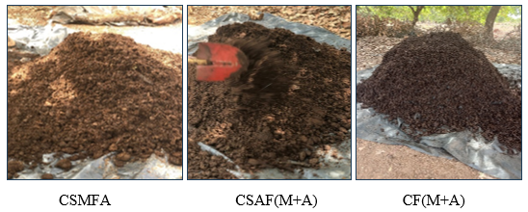
Figure 5: Composts obtained from collected wastes

3.2 Physico-chemical characteristics of composts and biochar

Analysis of physico-chemical parameters reveals that produced organic composts are rich in essential primary macronutrients (Figure 6). Nitrogen content (4-4.3 g/kg) supports vegetative growth, phosphorus (5.3-6.3 g/kg) aids flowering and fruiting, and potassium (19.4-20.6 g/kg) enhances plant stress resistance. These values align with quality compost standards (ADAS Consulting Limited, 2005), confirming their suitability as soil amendments. Biochar showed high organic carbon content (43.6%), consistent with its known stability from pyrolysis (Lehmann & Joseph, 2009), but its low nutrient content necessitates combination with compost for effective use. Composts also contained beneficial levels of magnesium (2.6-2.8 g/kg) and calcium (17.4-20.4 g/kg), crucial for soil fertility and crop nutrition, supporting FAO recommendations on secondary elements (2006). Heavy metal concentrations (Pb, Cd, As, Cr) were all below safety thresholds, confirming the composts' safety (ADAS Consulting Limited, 2005). C/N ratios of 9.6-10.9 (Figure 7) indicate composts are mature and suitable for immediate agricultural use (ADEME, 2006). pH values (6.5-8.2) are optimal for nutrient availability. Cation Exchange Capacity (CEC) was highest in CSAF(M+A) compost (34.22 cmol/kg) and biochar (25 cmol/kg), indicating excellent nutrient retention potential, critical for tropical soils (Kouamé et al., 2008). Electrical conductivity values (417.11-470.65 μS/cm) are within safe ranges for plant growth, while biochar (265.69 μS/cm) offering a balancing option when blended with compost (Rabat et al., 2010). Recent studies further validate the efficacy of such compost-biochar integrations in enhancing soil health and crop productivity in sustainable agricultural systems (Agyeman et al., 2022; Chintala et al., 2023; Touray et al., 2024).

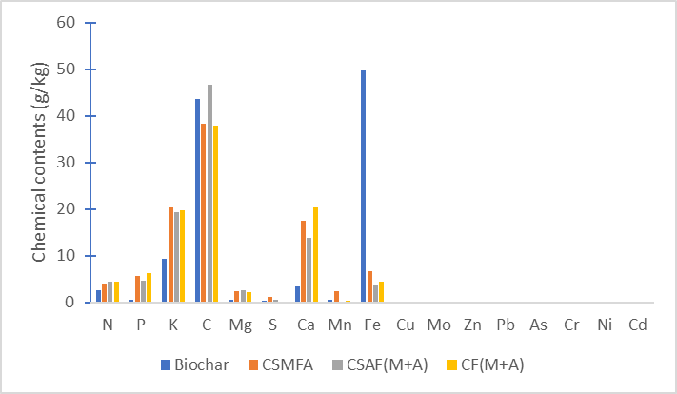

Figure 6: Chemical contents of obtained composts

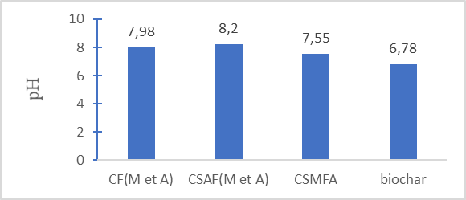

Figure 7 : Physical characteristics of composts

3.2 Effect of produced compost on okra cultivation

Germination rates vary with treatment (Table 2), indicating that quality of the substrate used plays an important role in seed germination. This result is similar of Zucconi et al. (1981) works, which emphasizes that poor or unbalanced substrates can impact seed emergence.

Table 2 : Germination rate
Treatments | Germination rate (%)
Control | 42,5
CSMFA | 45
CSAF(M+A) | 55
CF(M+A) | 90
CSMFA +¾ BIO | 70
CSMFA+ ½ BIO | 70
CSMFA+ ¼ BIO | 92,5
CSAF(M+A) +¾ BIO | 92,5
CSAF(M+A) + ½ BIO | 100
CSAF(M+A) + ¼ BIO | 100
CF(M+A) +¾ BIO | 87,5
CF(M+A) + ½ BIO | 82,5
CF(M+A) + ¼ BIO | 82,5

In terms of plant growth, results obtained show that plants treated with organic composts, especially when combined with biochar, significantly improve plant growth, compared with plants treated with mineral fertilizer (NPK) and control line (Figure 8). The limited effect observed in the control is due to nutrient deficiencies in the soil, this is confirmed by Azam et al. (2015) who claim that the lack of nutrient intake leads to a low availability of essential elements for plant growth. NPK fertilizer intake improves this growth through the availability of nutrients. This is in line with Edmeades works (2003), where authors emphasize that mineral fertilizers provide nutrients but do not improve the structure of the soil or its ability to retain water and nutrients. Organic composts have shown good growth performance thanks to improved soil organic matter, microbial activity and nutrient availability. These effects are more visible when combined with biochar, as observed in figures below, (Figures 9, 10, 11 and 12) particularly on day 43. This is consistent with results of Lehmann and Joseph 2015, which means that biochar plays a key role in improving nutrient retention, stabilizing organic matter and promoting microbial activity, which prolongs and intensifies the effect of compost.

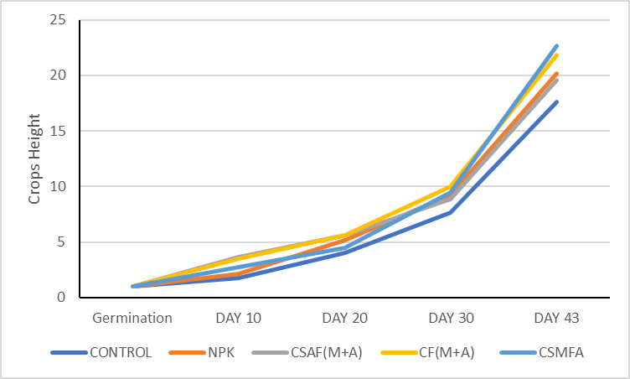

Figure 8: Crops growth treated with composts only

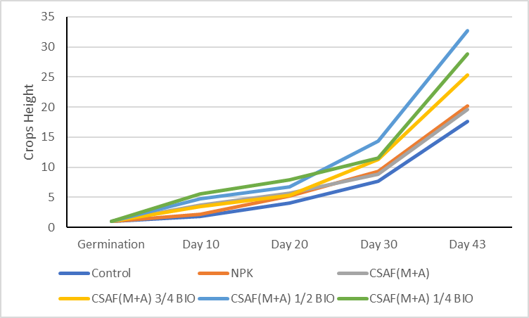

Figure 9: Crops growth treated with compost (CSAF(M+A) and biochar)

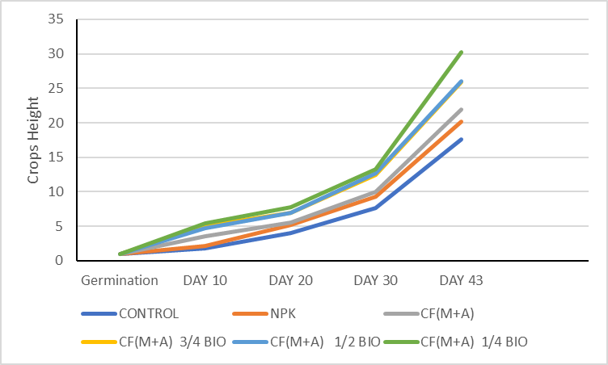

Figure 10: Growth of Plants treated with compost (CF(M+A) and biochar)

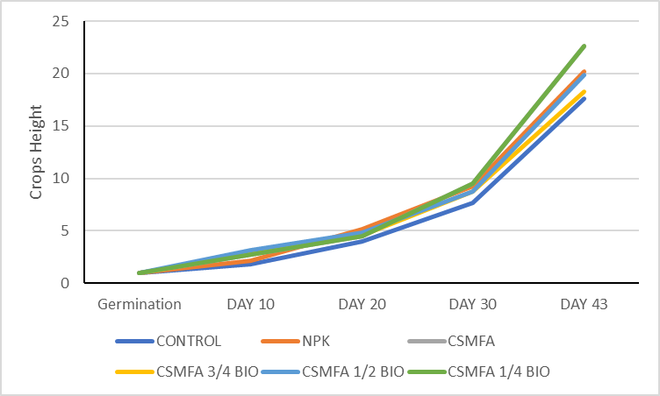

Figure 11: Growth of plants treated with Compost (CSMFA and biochar)

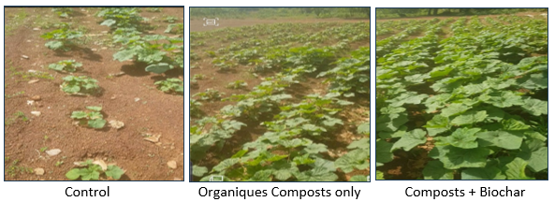

Figure 12: Difference in plant growth after composts application

Growth kinetic of plants treated with CSAF(M+A) + ½ BIO is of sigmoidal regression type (slogistic 1) compared to slogistic 3 found by Kouakou et al. (2024), represented by the equation 1. Descriptive statistics reveal a high variability between tested groups and a strong positive correlation between these variables. ANOVA test reveals a very high F value, indicating that variability between tested groups is highly significant. This value, combined with a critical probability (p=0.00355) below the 5% threshold, attests the strong positive correlation between these tested groups. In line with observations of Rakotomalala, (2018), which emphasizes that in statistics, a high F value means that the variation explained by the model is much greater than the unexplained variation (error), which is consistent with the validity of obtained results.

H $=\frac{Hm}{1+e^{-k(n-nc)}}$
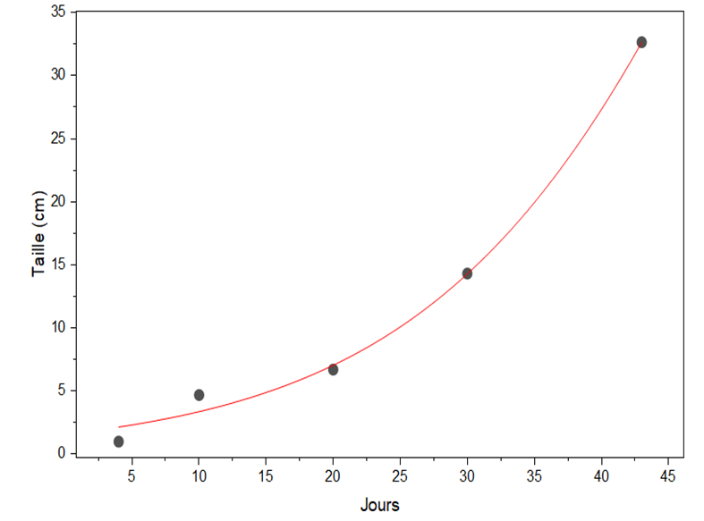
Figure 13: Growth kinetic of Okra plants

Table 3 : Descriptive statistic
Hm | Hm | Xc | Xc | K | k | Statistic
 |  |  |  |  |  | Reduced Chi-Sqr | Adj. R-Square
131,3 | 216,5 | 57,4 | 32,3 | 0,076 | 0,021 | 1,58687 | 0,98999

Table4 : Variance analysis
 | DF | Sum of squares | Mean square | F Value | Prob>F
Model | 3 | 1335,93136 | 445,31045 | 280,62158 | 0,00355
Error | 2 | 3,17374 | 1,58687
Total | 5 | 1339,1051

Cumulative yields vary according to the treatment applied (Figure 14). Plants for control give the lowest yield (0.45 kg), confirming that experiment soil is poor in nutritive elements. This result is consistent with the work of Nziguheba et al. (2002), which highlights that tropical soils are generally poor in organic matter and essential nutrients. The addition of simple organic composts allowed an improvement in yield compared to the yield of treatment with NPK as found by Kouakou and Negalo (2025) in their study about agricultural valirisation of market organic wastes. Best results are observed with CSAF(M+A) + ¼ Bio and CSAF(M+A) + ½ Bio, with a maximum yield of 3.2 kg. This result can be explained by the good cation exchange capacity of CSAF(M+A) compost, associated with biochar which also has a good cation exchange capacity, according to the results of the analysis of the physico-chemical parameters.

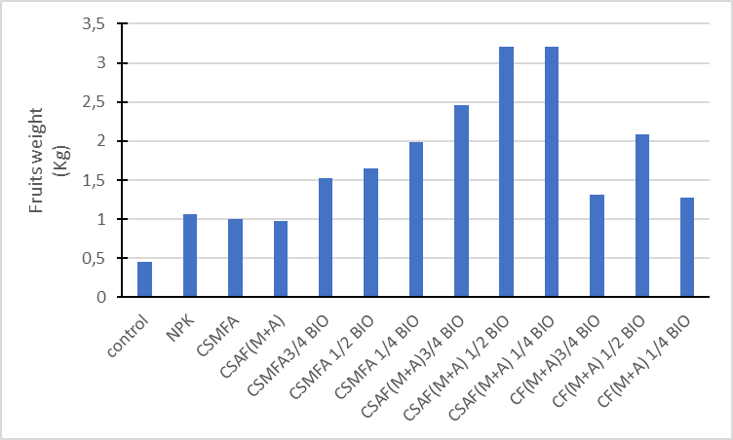

Figure 14: Yields of different Treatments

4. Conclusion

The uncontrolled discharge of waste contributes to environmental pollution in general, especially surface water, and improved waste management would help reduce the impact of such pollution. This study aims to reduce surface water pollution by transforming the quantities of market and slaughterhouse waste into a high value-added product with a view to sustainable waste management. The results obtained confirm that compost produced from organic waste is rich in plant nutrients: nitrogen content varies between (4 and 4.3 g/kg), phosphorus content is (5.3 to 6.3 g/kg) and potassium up to (19.4 to 20.6 g/kg). The treatment of these composts on okra (Abelmoschus esculentus) cultivation gave significant results on vegetative parameters, at the level of growth of the line treated with CSAF(M+A) at the dose ½ of the biochar which gave the highest average growth from 43 (about 32.5 cm). The best yield was obtained with the SCAF treatment (M+A) at the ¼ dose of the biochar, reaching a cumulative yield of 3.2 kg, i.e. approximately 4 tons per hectare, while the control shows 0.42 kg, i.e. approximately 411 kg per hectare. Ultimately, the work allowed to collect a significant amount of this waste, to transform this waste into a nutrient-rich compost for the good development and better yield of plants.
Perspectives:
- The establishment of a structure for the recovery of this organic waste
- Energy production via biogas from this waste, which could offer a dual recovery path
- Conduct assessments on large plots and other crops for validation of the outcomes of this study.
COMPETING INTERESTS DISCLAIMER:
Authors have declared that they have no known competing financial interests OR non-financial interests OR personal relationships that could have appeared to influence the work reported in this paper.

References

1. ADAS Consulting Limited & Enviros. (2005). Assessment of options and requirements for stability and maturity testing of composts (Final Report No. OFR806). The Waste and Resources Action Programme (WRAP). 21 Horsefair, Banbury, Oxon OX16 0AH, United Kingdom. 145 pp. https://wrap.org.uk/sites/default/files/2021-03/OFR806.pdf
2. French Agency for the Environment and Energy Management (ADEME). (2006). Home Composting (Practical Guide). Angers, France: ADEME Éditions. 48 pp. ISBN 978-2-35838-012-3.
3. Agyeman, F. O., et al. (2022). Synergistic use of biochar and compost for soil amendment and crop improvement in sub-Saharan Africa. Journal of Environmental Management, 324, 116382. https://doi.org/10.1016/j.jenvman.2022.116382
4. Amoah, I. D., Adegoke, A. A., Stenström, T. A., & Reddy, P. (2021). Quantification and characterization of municipal solid waste in developing countries: A critical review. Waste Management, 120, 1–11. https://doi.org/10.1016/j.wasman.2020.11.001
5. Aubry, C., Mulier, D., & Lamy, S. (2009). Composting urban waste: agronomic and environmental issues. Cahiers Agricultures, 18(4), 374–380. https://doi.org/10.1684/agr.2009.0299
6. Azam, F. (2015). Nutrient availability and plant uptake in soils under long-term fertilizer and organic amendments. Journal of Plant Nutrition and Soil Science, 178(2), 229–236. https://doi.org/10.1002/jpln.201400366
7. Badji, M., Fall, F., & Sarr, A. (2017). Effect of biochar on soil fertility and agricultural production in West Africa: a review. *CAMES-Life Science, Earth and Agronomy, 5*(2), 1323–1331.
8. Chintala, R., Mollinedo, J., Schumacher, T. E., & Malo, D. D. (2023). Synergistic effects of biochar and compost on soil nutrient retention and maize growth in a sandy soil. Science of The Total Environment, 864, 161112. https://doi.org/10.1016/j.scitotenv.2022.161112
9. Cofie, O., Nikièma, J., & Impraim, R. (2020). Exploring the potential of co-composting for sustainable urban waste management in sub-Saharan Africa (IWMI Research Report No. 175). International Water Management Institute (IWMI). 67 p. https://doi.org/10.5337/2020.213
10. Edmeades, D.C. (2003). The long-term effects of manures and fertilizers on soil productivity and quality: a review. Nutrient Cycling in Agroecosystems, 66(2), 165–180. https://doi.org/10.1023/A:1023999816698
11. Food and Agriculture Organization of the United Nations (FAO). (1998). Soil salinity and impact on agricultural production (FAO Soil Bulletin No. 75). Rome: FAO. 68 p. ISBN 92-5-204071-6.
12. Hashim, S., Waqas, M., Rudra, R.P., Khan, A.A., Mirani, A.A., Sultan, T., Ehsan, F., Abid, M., & Saifullah, M. (2022). On-farm composting of agricultural waste materials for sustainable agriculture in Pakistan. Scientifica, 2022, 5831832. https://doi.org/10.1155/2022/5831832
13. Hien, E., Ouédraogo, E., & Sedogo, M. P. (2014). Recycling organic waste to improve soil fertility in Burkina Faso. Cahiers Agricultures, 23(4), 267–275. https://doi.org/10.1684/agr.2014.0705
14. Houot, S., & Tiquet, M. (2000). Influence of waste characteristics on composting performance. In Organic waste and its treatment (INRA Studies and Works, Vol. 14, pp. 67-78). Paris: INRA Editions.
15. Kaza, S., Yao, L., Bhada-Tata, P., & Van Woerden, F. (2018). What a Waste 2.0: A Global Snapshot of Solid Waste Management to 2050. Urban Development Series. Washington, DC: World Bank. 295 pp. https://openknowledge.worldbank.org/handle/10986/30317
16. Kengne, I. M., Akoa, A., & Koné, D. (2008). Slaughterhouse wastewater treatment in developing countries: the case of Cameroon. Africa Science, 4(1), 12–26.
17. Lehmann, J., & Joseph, S. (Eds.). (2015). Biochar for Environmental Management: Science, Technology and Implementation (2nd ed.). London: Routledge. 976 pp. ISBN 978-0415704151.
18. Ngo, T. P. L., Van de Walle, A., & Lens, P. N. L. (2021). Circular economy for organic waste management: A review of current trends and future perspectives. Science of The Total Environment, 769, 144856. https://doi.org/10.1016/j.scitotenv.2020.144856
19. Nziguheba, G., Merckx, R., Palm, C. A., & Mutuo, P. (2002). Combining Tithonia diversifolia and inorganic fertilizers for maize production in a phosphorus deficient soil in Kenya. Agroforestry Systems, 55(3), 165–174. https://doi.org/10.1023/A:1020559816878
20. Oladélé, O. P., Mupambwa, H. A., & Mkile, Z. (2022). A review of the challenges and opportunities in the management of perishable solid waste in developing countries. Environmental Challenges, 8, 100558. https://doi.org/10.1016/j.envc.2022.100558
21. Onwosi, C. O., Eke, I. E., Igbokwe, V. C., & Nwagu, T. N. (2023). Composting Technology in Waste Stabilization: A Review of the Science and Current Practice. Bioresource Technology Reports, 22, 101427. https://doi.org/10.1016/j.biteb.2023.101427
22. Rabat, A., Makan, A., & Hellal, A. (2010). Physicochemical Characterization of Composts Based on Urban Waste. Revue des BioRessources, 8(2), 34–41.
23. Rakotomalala, R. (2018). Statistical Methods in the Social Sciences: SAS Procedures under Windows. Lyon: Laboratoire ERIC. 342 pp. ISBN 979-10-91588-12-4.
24. Sotamenou, J. (2010). Household Waste and Sustainable Management in Africa: Challenges and Perspectives. *VertigO - the electronic journal in environmental sciences, 10*(3). https://doi.org/10.4000/vertigo.10506
25. Touray, N., et al. (2024). Circular economy approaches for urban organic waste in West Africa: Drivers and barriers. Waste Management, 174, 891-902. https://doi.org/10.1016/j.wasman.2024.01.001
26. Yao-Kouamé, A., N'Guessan, K. M., & Kassi, N. F. (2008). Tropical soil fertility and sustainable land management: constraints and management strategies in Côte d'Ivoire. African Journal of the Environment, 6, 21–28.
27. Zhang, D. Q., Tan, S. K., & Gersberg, R. M. (2010). Municipal solid waste management in China: Status, problems and challenges. Journal of Environmental Management, 91(8), 1623–1633. https://doi.org/10.1016/j.jenvman.2010.03.012
28. Zucconi, F., Pera, A., Forte, M., & de Bertoldi, M. (1981). Evaluating toxicity of immature compost. BioCycle, 22(2), 54–57.
29. Cámara Empresarial para el Reciclaje (CEMPRE Uruguay). (2019). Guide to integral management of business residues (1st ed.). Montevideo: CEMPRE Uruguay. 330 p.

30. Kouakou Yao Salomon and NEGALO N'guessan Aportur Nathan (2025). Agricultural Valorization of Organic Wastes from Market of Korhogo City in Côte d’Ivoire. Journal of Experimental Agriculture International Volume 47, Issue 3: 398-407 DOI: https://doi.org/10.9734/jeai/2025/v47i33347
Kouakou Yao Salomon, SEYHI Brahima and KONAN N’da Lucas (2024). Agricultural Valorization of Treated Effluent from Korhogo Wastewater Treatment Plant. Journal of Agriculture and Ecology Research International, Volume 25, Issue 6: 9-23, 2024 DOI: https://doi.org/10.9734/jaeri/2024/v25i6635

