Review Article
Review on the Management of Shallot Black Mold Caused By Aspergillus Niger (Van Tieghem)

ABSTRACT

Black mold disease, caused by Aspergillus niger, is a major post-harvest constraint in shallot (Allium cepa var. aggregatum) production, leading to significant economic losses under storage conditions. In Ghana, where shallot cultivation provides both nutritional and economic benefits to smallholder farmers, the disease threatens food security, marketability, and farmer livelihoods. Conventional management relies heavily on synthetic fungicides; however, their overuse raises concerns regarding environmental safety, human health, and fungicide resistance. This review synthesizes current knowledge on the biology, and epidemiology, of A. niger, while critically assessing integrated management strategies for black mould. Cultural practices, biological agents such as Trichoderma harzianum, and the use of plant-derived extracts (e.g., garlic, clove, neem, and pomegranate) have shown promising antifungal potential as sustainable alternatives. The role of phytochemicals including flavonoids, phenolics, terpenoids, saponins, and alkaloids in plant defense and disease suppression is also highlighted. Furthermore, the review emphasizes the importance of adopting eco-friendly approaches that not only reduce reliance on synthetic fungicides but also improve post-harvest quality and storage life of shallots. By integrating botanical fungicides, biological control, and good cultural practices, black mold management can be made more sustainable, resilient, and farmer-friendly. This paper emphasizes the need for continued research into phytochemical-based interventions and biocontrol technologies to support food security and enhance the economic viability of shallot production.

Keywords: Shallot bulb, Black mold, Economic loss, Integrated Management Strategies, Phytochemicals, Biological agents

INTRODUCTION

Shallot (Allium cepa var. aggregatum) is a high-value vegetable crop of significant nutritional and economic importance, particularly for smallholder farmers in Ghana (Benjamin et al., 2017). Its cultivation contributes to food security, income generation, and rural livelihoods. However, the sustainability of shallot production is severely threatened by post-harvest diseases, with black mold caused by the fungus Aspergillus niger being a predominant constraint (Kumar et al., 2018). This pathogen leads to substantial qualitative and quantitative losses, with studies reporting that pests and diseases can cause between 24-100% loss in shallots during storage (Herlina et al., 2019; Safitri et al., 2019; Supyani et al., 2021), thereby directly impacting farmer revenues and food availability.
The conventional management of black mold has heavily relied on the application of synthetic fungicides (Anadani and Vanthana, 2017). While often effective, their continuous use poses significant challenges, including the development of fungicide resistance and potentially harmful chemical residues on produce, which may be harmful to consumers (Prajapati and Patil, 2016a). These concerns have spurred the global search for safer, sustainable, and eco-friendly alternatives for disease management.
In this context, integrated approaches that combine cultural practices, biological control agents like Trichoderma harzianum (Nuray and Levent, 2014), and botanical pesticides offer a promising pathway. Notably, plant-derived extracts from sources such as garlic, clove, and neem, and their constituent phytochemicals such as phenolics, flavonoids, terpenoids, and alkaloids have demonstrated potent antifungal properties against a range of pathogens (Mierziak et al., 2014; Bhattacharyya et al., 2018; Khalid et al., 2019). This review, therefore, aims to synthesize current knowledge on the biology and epidemiology of A. niger and to critically evaluate sustainable strategies for managing black mold in shallots. It places a specific emphasis on the potential of botanicals and their active compounds as effective biocontrol agents, highlighting their role in reducing dependence on synthetic chemicals and promoting a more resilient and sustainable shallot production system in Ghana and beyond.

BOTANY AND PRODUCTION OF SHALLOT
Shallots are a type of Allium, which is a genus of perennial bulbous plants in the family Amaryllidaceae. They are closely related to onions (Allium cepa), garlic (Allium sativum), and leeks (Allium ampeloprasum var. porrum). Shallots (Allium cepa var. aggregatum) are a smaller and milder variety of onion, with a sweeter and more delicate flavour than onion. They are characterized by their elongated bulbs that are composed of a cluster of small bulbs, called "cloves," which are covered in a thin, papery skin. Their bulbs are usually between 2 and 5 centimeters in diameter and can be white, yellow, or red in color (Miller, 2022). In terms of cultivation, shallots prefer well-drained soil and full sun exposure, They can be grown from seeds or from sets, which are small bulbs that are planted in the soil, shallot production in Ghana is mainly concentrated in the southern part of the country, particularly in the Ashanti, Greater Accra, Eastern, and Volta regions (Benjamin et al., 2017).
Shallot production in Ghana faces several challenges, including poor soil fertility, inadequate irrigation, pests and diseases, and lack of access to credit and markets (Yeboah and Egyir, 2023). In recent years, there has been an increasing demand for shallots in Ghana and other West African countries, driven by changing consumer preferences and the growing popularity of local cuisines (Grundy et al., 2016; Benjamin et al., 2017). This trend presents an opportunity for Ghanaian farmers to increase their incomes and improve their livelihoods through the production and sale of shallots.

Economic and Nutritional importance of shallot
Shallots are important ingredients in cooking due to their unique flavour and nutritional benefits. High levels of anti-oxidants in shallots, like quercetin, have been linked to a number of health benefits including lowering the risk of cancer and heart disease (Panoff, 2019).
In addition, shallots are a significant source of minerals including potassium and iron in addition to vitamins A and C. In culinary applications, shallots are often used in French cuisine as a flavouring agent in sauces, soups, and stews. They are also a common ingredient in Asian cuisine, particularly in Thai and Indonesian dishes. Over all, shallots play a significant role in both cooking and health, making them a valuable ingredient to have in one's pantry.
The production is an important economic activity in Ghana, providing employment opportunities and contributing to the country's food security and export earnings. Shallot cultivation in Ghana is mainly carried out by smallholder farmers, who grow the crop as a cash crop or for household consumption (Folitse et al., 2018). Shallot production has significant economic benefits for farmers in Ghana, as the crop has a high market value probably due to its culinary and medicinal uses (Wenli et al., 2019). Additionally, shallot production provides employment opportunities for both farm and non-farm workers, contributing to poverty reduction and rural development in the country.

Constraint of Shallot Production in Ghana
There are several constraints to shallot production in Ghana, which limit the potential of the industry. Lack of improved and high-yielding varieties, inadequate irrigation facilities, poor post-harvest handling and storage, limited access to credit and finance, limited access to markets are some challenges facing shallot production. In Ghana, production is also constrained by pest and disease problems, including fungal diseases such as black mold, leaf spot and purple blotch, as well as insect pests like onion thrips and onion maggot (Adzraku, 2017; Benjamin et al., 2017; Zeleke,2023).

Pest and Diseases of Stored Shallot Bulbs
Pests and diseases can have significant impacts on the quality and quantity of shallots in storage in Ghana. Some of the pests that can affect shallots in storage include onion maggots, thrips, and spider mites, these pests can cause damage to the shallots, reducing their quality and nutritional value, and making them susceptible to diseases such as botrytis and Fusarium(Miller, 2022). Several studies (Herlina et al., 2019; Safitri et al., 2019; Supyani et al., 2021) have reported that pests and diseases cause between 24-100 % loss in shallots during storage.
Shallot is an important crop that is susceptible to a variety of insect pests. Some of the major insect pests of shallot include the onion thrips (Thrips tabaci), onion maggot (Delia antiqua), cutworms (Agrotis spp.), and aphids (Aphis spp.)(Swamy and Gowda, 2014; Miller, 2022).

Diseases
Stored shallots can be affected by a variety of diseases, which can lead to significant losses for growers and distributors. Some of the common diseases of stored shallots as reported by (Agrios, 2005) are discussed below;
- Basal rot: It is a serious disease of stored shallots that is caused by the fungus Fusarium oxysporum f.sp. cepae. The disease can cause the crop to completely fail by decaying the basal plate and outer scales.
- Black mould: It can occur in shallots that have been injured or are in poor condition when they are being preserved and are caused by the fungus A. niger. The fungus produces black spores, which can contaminate the entire crop.
- Blue mould: it is caused by the fungus Penicillium hirsutum and can occur in stored shallots that have been damaged or are in poor condition. The fungus produces a blue-green mould, which can spread rapidly throughout the crop.
- Neck rot: it is caused by the fungus Botrytis allii and can occur in stored shallots that have been damaged or are in poor condition. The fungus causes a soft rot of the neck and upper part of the bulb, which can result in significant losses.

Black mold disease of shallot
A. niger is the pathogen that causes black mold of shallot bulbs. Infected seed bulbs can also spread the fungus, which affects the outer scales of the bulb and releases black spores that give the affected region a black appearance. The fungus can persist in soil and plant waste for a long time. (Singh et al., 2022). For infection to happen, free moisture must remain on the bulb’s surface for at least six hours, The infected bulbs show no signs of the infection. After A. niger infection, soft rot bacteria may develop (Pramod et al., 2022).

Symptoms of the black mold of shallot
According to BBC-Gardener (2020), Symptoms of black mold disease in shallot bulbs include black, powdery mold on the surface of the bulbs, the mold is often accompanied by a sour smell, and infected bulbs may feel soft or spongy to the touch, the fungus can also cause the shallot bulbs to rot, leading to the development of sunken, dark spots on the surface of the bulbs. Black mold can also affect stored shallots, causing a range of symptoms. Some common symptoms of black mold on stored shallots include: Softening and rotting of the shallot bulbs, formation of black or dark green mold on the surface of the shallot bulbs, musty or moldy smell emanating from the stored shallots, Presence of spores on the surface of the shallot bulbs, loss of flavour and texture in the shallots (Kumar et al., 2018).

Disease cycle and epidemiology of black mould of shallot
Three stages constitute the black mold of shallot disease cycle that caused by A. niger: infection, colonization, and sporulation.
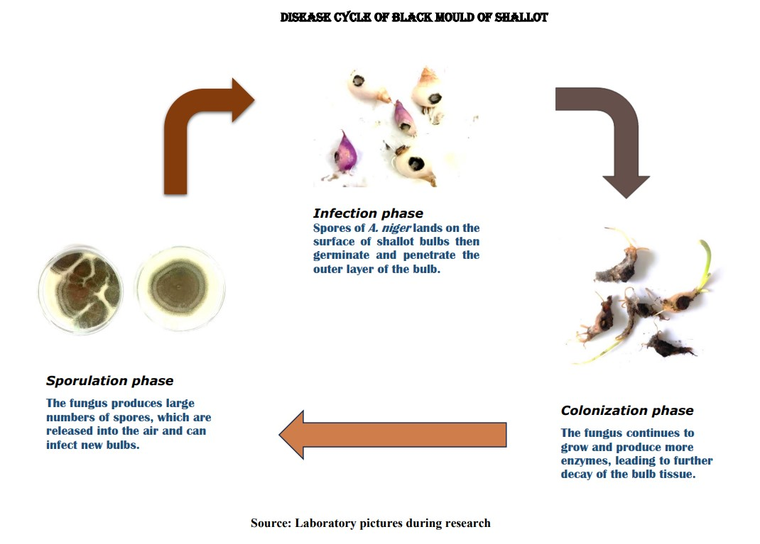

Figure 1. Disease cycle and epidemiology of black mold of shallot

Source: Laboratory pictures during research

The epidemiology of black mold of shallot is influenced by several factors, including the presence of inoculum in the soil, environmental factors like humidity and temperature, and cultural practices such as irrigation and fertilization. The disease is most common in areas with warm, humid climates and in fields where shallot is grown continuously.

The pathogen Aspergillus niger
A. niger is a common saprophytic filamentous fungus belonging to the family Aspergillaceae, which is ubiquitous in nature and can be found in soil, air, and water (Krijgsheld et al., 2013; Lanette, 2014; Paulussen et al., 2017). It is a well-known organism for its ability to produce a vast array of secreted enzymes, including amylases, pectinases, and proteases, which can be utilized for industrial processes such as food and beverage production, paper and pulp industries, and biofuel production (Lopes et al., 2011; Cairns et al., 2018; Bellaouchi et al., 2021; Laothanachareon et al., 2022). In the fermentation, food, and beverage industries, A. niger is frequently utilized to produce glucoamylases, which accelerate the saccharification of partly processed starch. (Lopes et al., 2011). Moreover, A. niger has a high tolerance to low pH and can thrive at a range of temperatures, making it highly versatile for industrial processes ( Hee-Soo et al., 2017; Cen et al., 2020).A. niger is a significant pathogen that can cause diseases in both plants and humans.
In humans, A. niger causes fungal infections, particularly in immunocompromised individuals. These infections can range from skin and nail infections to severe diseases such as aspergillosis, which can spread from the lungs to other organs (Person et al., 2010). A. niger primarily causes respiratory infections, particularly in individuals with weakened immune systems. The fungus may colonize the lungs and enter the body mostly by inhalation of spores, which can cause aspergillosis. In extreme cases, the infection might spread across organs, causing systemic aspergillosis, which is frequently deadly in those with weakened immune systems. The symptoms of aspergillosis vary based on the kind of infection but can include fever, cough, chest discomfort, and trouble breathing ( Georg et al., 2012; Kosmidis and Denning, 2015; Fiema et al., 2022; Okamura et al., 2022).
In plants, A. niger infects fruits, vegetables, and crops, leading to significant economic losses in agriculture (Xin et al., 2023). A. niger produces a range of toxins such as ochratoxin A, patulin, and fumonisin, which can contaminate food, posing a risk to human health (Palencia et al., 2010; Xin et al., 2023). These toxins are produced by the fungus during the infection process, and their accumulation in plant tissues can cause illness or death in humans, livestock, and wildlife (Palencia et al., 2010; Jasmine, 2014; Xin et al., 2023). For example, ochratoxin A is a carcinogenic mycotoxin that can affect the kidneys, while patulin can cause nausea, vomiting, and diarrhea (Xin et al., 2023).
Therefore, the presence of A. niger in food and feed should be minimized to prevent the risk of human and animal exposure to these toxins. A. niger can cause post-harvest decay in various crops, including shallots, and can lead to reduced bulb quality and storage life, the colonization of shallot bulbs by A. niger can lead to the production of enzymes that degrade the bulb tissue and changes in the bulb's chemical composition(Cairns et al., 2018).

Identification of Aspergillus niger
Researchers have investigated the cultural, morphological, and microscopic characteristics of A. niger in great detail Here are some key findings:

Cultural and Morphological Features
A. niger colonies are large and black or dark brown in color, often with a powdery or velvety texture. A variety of substrates, such as fruits, vegetables, cereals, and dairy products, are suitable for the fungus to grow on. The septate hyphae of A. niger are primarily yellow in color. It produces carbon black or extremely dark brown spores from biseriate phialides, which distinguishes it from other Aspergillus species. The conidial heads of A. niger are globose and dark brown in color, dividing into columns as the fungus ages. The conidia of A. niger are smooth, black, and spherical or ellipsoidal in shape (Cairns et al., 2022).

Microscopic Features
A.niger can be distinguished microscopically by the presence of large, round or oval vesicles at the tips of the conidiophores. The hyphae of A. niger often contain dark granules or vacuoles, which are thought to be involved in nutrient storage and metabolism. These features contribute to the identification and characterization of A. niger in various settings, including agricultural, industrial, and medical contexts. . (Bennett, 2010; Amiri et al., 2021).
Figure 2. Cultural and Microscopic view of A.niger

Source: Laboratory pictures during research

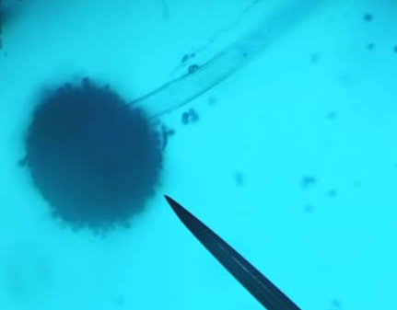
A = Strain 1 (Cultural view of A. niger)
B = Strain 2 (Cultural view of A. niger)
C = Microscopic view
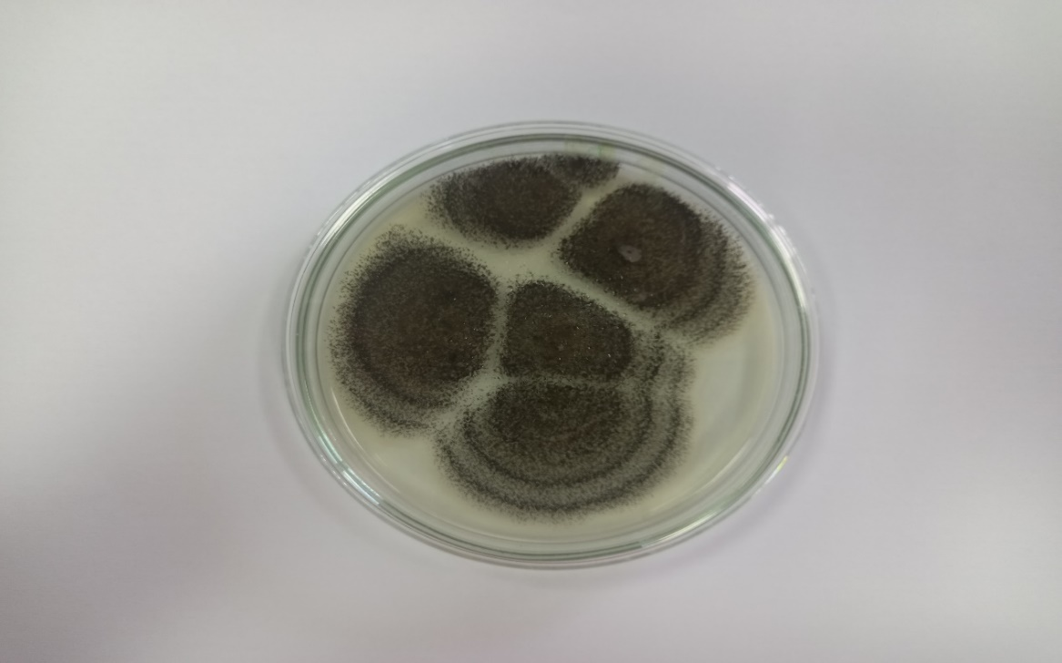
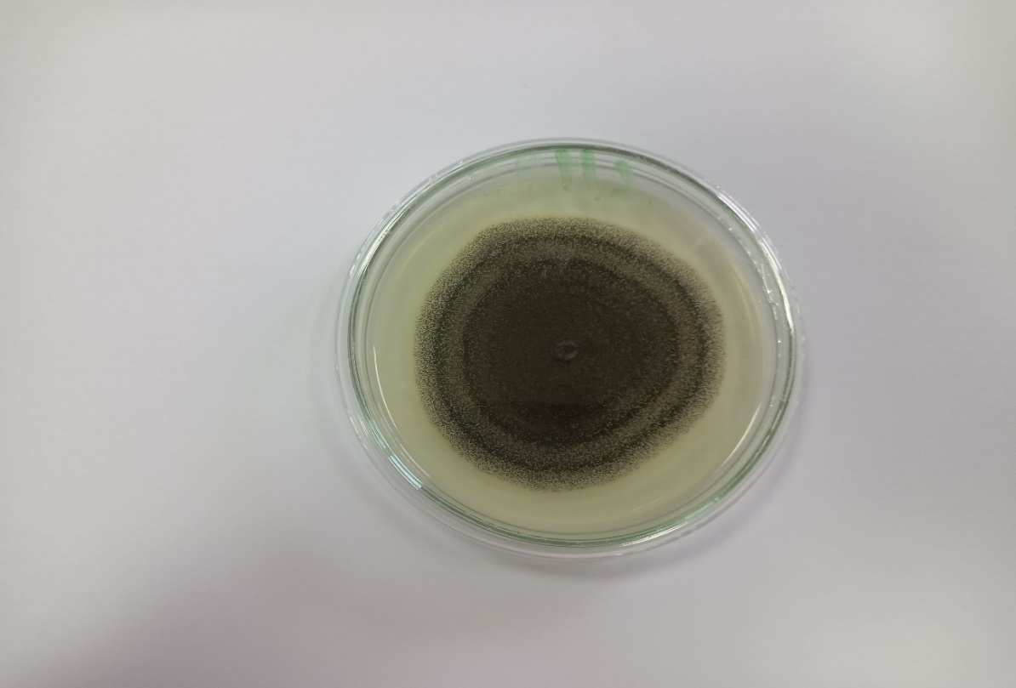

Management of black mold of shallot
Several methods are employed in the management of the black mold disease of shallot, some of these methods are described below;

Biological control
The post-harvest disease known as black mold of shallot, which is caused by the fungus A. niger, degrades the quality and marketability of shallot bulbs. Biological control is a promising approach for managing this disease, as it is environmentally-friendly and sustainable. Some microorganisms have been evaluated as biocontrol agents for black mold of shallot, including bacteria and fungi. Nuray and Levent (2014),reported that application of T. harzianum significantly reduced the incidence and severity of black mold disease in shallot.
Biological control using microorganisms such as T. harzianum can be an effective strategy for managing black mold of shallot. However, further research is needed to optimize the use of these microorganisms in field conditions.

Cultural control
Cultural control of black molds of shallot can be achieved through various practices such as crop rotation, sanitation, and proper irrigation. These practices help to reduce the humidity and moisture levels that promote the growth of black molds on shallots.
Different crops are planted in exactly the same field each year as part of crop rotation, which breaks the life cycle of the pathogens that produce black mold. According to a study by Agrios (2005) crop rotation can help to reduce the incidence of black mold on shallots by up to 50%. Sanitation practices including removal of plant debris, sterilizing tools, proper disposal of infected plant material, proper irrigation practices and ensuring good drainage prevents the growth and spread of black mold disease (Prajapati and Patil, 2016a).

Chemical control
Using synthetic fungicides to manage the disease is one of the most successful methods. Use of nano-sulphur was found to be the most effective against black mold rot (Choudhury et al., 2010). According to a study by Anadani and Vanthana, (2017), systemic fungicides dinocap and thiram, carbendazim and tebuconazole, and combinations of tebuconazole + trifioxystrobin and pyraclostrobin + epoxyconazole all significantly slow down the growth of radial mycelia when used in vitro. It is important to note that the use of synthetic fungicides may leave residue in the farm produce which may be harmful to consumers.

Use of botanicals
Botanical control methods can be effective in reducing the incidence and severity of black mold. A. niger, Penicillium citrinum (which causes citrus rust), and Rhizopus oryzae (a disease that affects carrots, pineapples, and mangoes) are all susceptible to the peel and juice extracts from pomegranate (Punica granatum), both in aqueous and alcoholic forms. (Dahham et al., 2010). According to Avasthi et al. (2010), Syzygium aromaticum and Allium sativum completely inhibited mycelia growth of A. niger at a 20% concentration, indicating that spices have antifungal activity and can be used as natural fungi toxicants for managing the growth of storage or spoilage fungi. The growth of A. niger mycelia (the black mold that grows on vegetables) has been found to be inhibited by aqueous extracts from the plants A. nilotica, M. elengi, and P. juliflora. (Satish et al., 2007). As a multispecies natural control, ethanolic extracts of grains of paradise (Aframomum melegueta) and clove basil (Ocimum gratissimum) may inhibit the formation of spores and mycelia of A. flavus and A. niger (Okigbo and Ogbonnaya, 2006).
Other studies (Nehal et al., 2009; Sibi et al., 2013; Anadani and Vanthana, 2017; Srinivas et al., 2019) have also investigated the use of natural products for controlling black mold disease in onions, which may also be applicable to shallots: Indian culinary spices like cardamom, cinnamon, clove, pepper, star anise, and stone flower have been shown to have antifungal activity against A. niger under in vitro circumstances, and peroxyacetic acid (PAA) vapors were discovered to be effective in managing black mold disease in onion bulbs during storage. Garlic and onion oils, Potassium sorbate, and Sodium benzoate have all been evaluated for their inhibitory effect against A. niger, the cause of black mold disease in garlic cloves during storage.
Overall, the use of plant extracts as alternative approaches for managing black mold of shallot holds great promise for reducing the reliance on synthetic fungicides and promoting sustainable agriculture.

Phytochemicals and their Role in Plant Disease Management
Phytochemicals are a group of secondary metabolites synthesized by plants through photosynthesis and are involved in various physiological processes such as growth, development, and defense against pathogens. Many researches have shown how effective phytochemicals may be at managing plant diseases.
These include flavonoids, alkaloids, phenolics, saponin, terpenoids among others.

Flavonoids
Flavonoids are a diverse group of phytochemicals found in many plants, and they have been shown to have a broad spectrum of antimicrobial activity against fungal and bacterial pathogens, according to a study by (Mierziak et al., 2014). Flavonoids have a significant role in plants' ability to fight pathogenic bacteria and fungus. Flavonoids' antipathogenic qualities can be general and are partly due to their antioxidant abilities. Additionally, chemicals known as flavonoids exhibit a variety of biological functions relevant to the physiology and growth of plants. Flavonoids enable interactions with other plants and microbes in addition to protecting against damaging abiotic influences. In a review of the role of flavonoids in plant-microbe interactions, it was discovered that flavonoids control both plant growth and the relationship with commensal microorganisms. ( Mierziak et al., 2014; Mathesius, 2018; Khalid et al., 2019; Wang et al., 2022).
Flavonoids also help maize withstand the harmful effects of aluminum and defend plants against pathogens and pests. The secondary metabolites are likely the most significant mediators of plant-insect interactions, according to the phytochemical co-evolution idea. Thus, the evolution of plants and insect herbivores has produced the plant defense (Pobłocka-Olech et al., 2016). Plants naturally contain flavonoids, but it's still unclear why they manufacture up to 10,000 different flavonoid metabolites throughout the plant world (Mathesius, 2018; Mierziak et al., 2014; Pobłocka-Olech et al., 2016). Plants produce a wide variety of secondary metabolites called flavonoids that serve a wide range of purposes. These include a variety of activities in defense and signaling between plants and microbes, as well as responsibilities in controlling plant growth, pigmentation, and UV protection (Mierziak et al., 2014; Mathesius, 2018; Khalid et al., 2019; Wang et al., 2022). Many flavonoids are significant components of medicinal plants and are employed in the regulation of inflammation and the prevention of cancer since they are widely consumed in the human diet (Mierziak et al., 2014; Khalid et al., 2019).

Phenolic compounds
It has been demonstrated that phenolic compounds, a varied category of secondary metabolites present in plants, are essential for pathogen resistance. These substances' antibacterial abilities and potential for treating plant diseases have been the subject of much research. Phenolic chemicals have a role in a number of physiological processes, including the growth and development of plants, but they are also involved in plant defense mechanisms against pathogens. They act as a physical barrier, inhibit the growth of pathogens, and induce the plant's defense response against invading microorganisms (Vogt, 2010).
Phenolic compounds are also known to have antioxidant properties, which help to protect the plant from oxidative damage caused by pathogens. Several studies have demonstrated the potential of phenolic compounds in the management of plant diseases. For example, studies have shown that the application of phenolic compounds can reduce the severity of various plant diseases caused by fungal and bacterial pathogens (Bhattacharya et al., 2010). In addition, phenolic compounds have been shown to enhance the activity of plant defense enzymes, such as peroxidases and catalases, which play a crucial role in plant defense against pathogens (Mohamed et al., 2019). Phenolic chemicals are vital secondary metabolites present in plants and are critical for pathogen defense. Numerous studies have shown their promise for managing plant diseases, but further study is required to fully explore their potential for the creation of innovative and efficient plant disease management techniques.

Terpenoids compounds
Terpenoids are a wide collection of secondary metabolites that plants produce and which are essential in pathogen defense. Terpenoids have the potential to be used in the treatment of plant diseases. Terpenoids have been shown to have antifungal, antibacterial, and antiviral properties. They can act as phyto-anticipins, which are pre-existing low molecular weight compounds that inhibit the growth and development of pathogens before infection (Ahuja et al., 2012; Masyita et al., 2022). For example, essential oils, which are composed of terpenoids, have been shown to have broad-spectrum antifungal and antibacterial activity against plant pathogens (Wiart et al., 2023).
Terpenoids can activate the plant's defensive mechanisms, such as the formation of reactive oxygen species, phytohormones, and defense-related proteins, in addition to their direct antibacterial effect (Mierziak et al., 2014). These defense mechanisms can help the plant to resist infection and limit the spread of pathogens.
Terpenoids have been shown to have potential in the management of various plant diseases caused by fungal, bacterial, and viral pathogens. For example, thymol, a terpenoid found in essential oils of thyme, has been shown to have antifungal and antibacterial activity against several plant pathogens(Mahizan et al., 2019). Similarly, limonene, a terpenoid found in citrus fruits, has been shown to have antifungal and antiviral activity against plant pathogen, Sesquiterpenoids, a type of terpenoid, have also been shown to have potential in the management of plant diseases caused by fungal pathogens (Mahizan et al., 2019). They can inhibit fungal growth and development by disrupting their plasma membrane, leading to leakage of intracellular contents and cell death (Smit et al., 2019). For instance, it has been demonstrated that the sesquiterpenoid artemisinin, which was isolated from Artemisia annua, has antifungal action against a variety of fungal infections (Masyita et al., 2022).
Terpenoids are essential for a plant's defense against pathogens, and several studies have shown that they may be used to treat plant illnesses. The potential of terpenoids in the creation of fresh and efficient plant disease control techniques requires more investigation.

Saponins compounds
Another varied family of plant secondary metabolites known as saponins is distinguished by their amphipathic properties and capacity to produce stable foam in aqueous solutions (Vincken et al., 2007; Rai et al., 2021). Several studies have identified saponins as having potential for plant disease management. For example, it has been demonstrated that triterpenoid saponins from soapnuts (Sapindus mukorossi) exhibit antifungal action against a number of plant pathogenic fungus, such as Fusarium oxysporum and Alternaria brassicicola (Ashour et al., 2019). Similar to this, it has been demonstrated that saponins derived from Quillaja saponaria exhibit antifungal action against Botrytis cinerea, a significant fungal pathogen that causes grey mold disease in a variety of crops (John et al., 2004). Additionally, saponins have been demonstrated to activate plant defense mechanisms, such as the formation of reactive oxygen species and the activation of genes involved in plant defense(Tessa et al., 2014). This may improve the ability of plants to defend themselves against different diseases.
In addition, saponins have been shown to have nematicidal activity against plant parasitic nematodes (Den et al., 2016). This is particularly relevant for agricultural crops, where plant parasitic nematodes can cause significant yield losses. Overall, it has been determined that saponins are a potential family of chemicals for the creation of fresh and efficient plant disease control techniques. Further research is needed to explore the potential of saponins and their mechanisms of action against various plant pathogens.

Alkaloids compounds
In the kingdom of plants, alkaloids are a class of nitrogen-containing substances with a wide range of biological functions. A number of alkaloids have been recognized as possible plant disease control agents. The Madagascar periwinkle (Catharanthus roseus), which produces vincristine, is one of the most popular alkaloids with antifungal properties. Fusarium oxysporum and Rhizoctonia solani are only two of the plant pathogenic fungi that vincristine has been demonstrated to have inhibitory efficacy against (Abookleesh et al., 2022).
Another alkaloid with potential for plant disease management is berberine, which is found in several plant species, including goldenseal (Hydrastis canadensis) and barberry (Berberis spp.). It has been demonstrated that berberine possesses antibacterial properties against a variety of diseases, including fungus, bacteria, and viruses(Bhattacharya et al., 2010). Additionally, it can trigger plant defense mechanisms such as the formation of reactive oxygen species and the activation of genes involved in plant defense (Kempster and Ma, 2022).
In addition, several other alkaloids have been shown to have potential in the management of plant diseases caused by various pathogens, including phytoplasmas, nematodes, and viruses (Mierziak et al., 2014). Alkaloids have generally been recognized as promising substances for the creation of fresh and efficient plant disease management strategies.

Role of Plant Extracts in Disease Control
Plant extracts have been widely investigated for their potential use in plant disease management due to their diverse chemical composition and modes of action. Here are some examples of the role of plant extracts in plant disease management:

Antimicrobial activity:
It has been demonstrated that garlic extract has antifungal action against Botrytis cinerea, a fungus that causes grey mold disease in a variety of crops (Bai et al., 2004). It has been discovered that neem (Azadirachta indica) extract possesses antifungal properties against a variety of plant pathogenic fungus, such as Fusarium oxysporum and Colletotrichum gloeosporioides ( Mierziak et al., 2014; Bhattacharyya et al., 2018).

Induction of plant defense responses:
It has been proven that tomato plants respond defensively to jasmonic acid isolated from eucalyptus leaves by expressing defense-related genes and producing secondary metabolites (Khalid et al., 2019; Khameneh et al., 2019).

Direct effect on pathogen development:
The pathogen that causes potato late blight, Phytophthora infestans, has been demonstrated to be inhibited by an aqueous extract of green tea (Mierziak et al., 2014; Shanmugam et al., 2016).

Indirect effect on pathogen development:
It has been proven that chinese gallnut extract lowers soil pH, which can prevent the establishment and development of various plant pathogenic fungi (Vaou et al., 2021; Yuan et al., 2017).
In general, plant extracts have demonstrated significant potential in the development of fresh and efficient plant disease control strategies. Further research is needed to explore the potential of plant extracts and their mechanisms of action against various plant pathogens.

CONCLUSION
The management of black mold in shallots, caused by Aspergillus niger, requires a decisive shift away from reliance on synthetic fungicides. As this review has detailed, sustainable and effective alternatives are available. Botanical extracts from plants like garlic, clove, and neem, rich in antifungal phytochemicals such as phenolics, terpenoids, and flavonoids, demonstrate significant potential in suppressing the pathogen. Furthermore, biological control agents like Trichoderma harzianum and proper cultural practices provide a strong foundation for an integrated disease management strategy. The adoption of these eco-friendly approaches is crucial for mitigating economic losses, reducing environmental and health risks, and ensuring the long-term sustainability of shallot production. Future efforts should focus on optimizing the application of these alternatives and promoting their integration into a resilient framework that safeguards both crop yield and farmer livelihoods.

REFERENCES
- Abookleesh, F. L., Al-Anzi, B. S., & Ullah, A. (2022). Potential Antiviral Action of Alkaloids. Molecules, 27(3), 1–21. https://doi.org/10.3390/molecules27030903.
- Adegoke AA, Iberi PA, Akinpelu DA, Aiyegoro OA, M. C. (2011). Studies on phytochemical screening and antimicrobial potentials of Phyllanthus amarus against multiple antibiotic resistant bacteria. Int J Appl Res Nat Prod, 3, 6–12.
- Adzraku, M. E. (2017). Assessing the Role of Small Scale Irrigation Vegetable. 1–182.
- Agrios, G. N. (2005). Plant Pathology (5th ed.) Academic Press San Diego.
- Ahuja, I., Rohloff, J., Bones, A. M., Vogt, T. (2012). Antimicrobial activity of catechol and pyrogallol derivatives: mechanisms, quantum chemical calculations, and structure-activity relationships. Frontiers in Microbiology, 3, 241.
- Amiri, Z., Asgharipour, M. R., Campbell, D. E., Azizi, K., Kakolvand, E., & Hassani Moghadam, E. (2021). Conservation agriculture, a selective model based on emergy analysis for sustainable production of shallot as a medicinal-industrial plant. Journal of Cleaner Production, 292, 126000. https://doi.org/10.1016/j.jclepro.2021.126000.
- Ashour, A. S., El Aziz, M. M. A., & Gomha Melad, A. S. (2019). A review on saponins from medicinal plants: chemistry, isolation, and determination. Journal of Nanomedicine Research, 7(4), 282–288. https://doi.org/10.15406/jnmr.2019.07.00199.
- Avasthi, S., Gautam, A. K., & Bhadauria, R. (2010). Antifungal activity of plant products against Aspergillus niger: A potential application in the control of a spoilage fungus. Biological Forum - An International Journal, 2(1), 53–55.
- Bai, Z. H., Zhang, H. X., Qi, H. Y., Peng, X. W., & Li, B. J. (2004). Pectinase production by Aspergillus niger using wastewater in solid state fermentation for eliciting plant disease resistance. Bioresource Technology, 95(1), 49–52. https://doi.org/10.1016/j.biortech.2003.06.006.
- BBC-Gardener. (2020). How to grow shallots. In Gardeners’ World.com. BBC Gardeners’ World Magazine. https://www.gardenersworld.com/how-to/grow-plants/how-to-grow-shallots/.
- Bellaouchi, R., Abouloifa, H., Rokni, Y., Hasnaoui, A., Ghabbour, N., Hakkou, A., Bechchari, A., & Asehraou, A. (2021). Characterization and optimization of extracellular enzymes production by Aspergillus niger strains isolated from date by-products. Journal of Genetic Engineering and Biotechnology, 19(1). https://doi.org/10.1186/s43141-021-00145-y.
- Benjamin Yao, F., Grace, O., Simon Kwame, O., & Lucy Payne, D. (2017). The Present Status of Shallot (Allium ascalonicum L.) Farming Enterprise in Ghana: The Case of Keta Municipality. Agricultural Communications, 5(2), 8–16.
- Bennett, J. W. (2010). An overview of the genus Asperillus. Aspergillus. Molecular Biology and Genomics, 1–17.
- Bhattacharya, A., Sood, P., & Citovsky, V. (2010). The roles of plant phenolics in defence and communication during Agrobacterium and Rhizobium infection. Molecular Plant Pathology, 11(5), 705–719. https://doi.org/10.1111/j.1364-3703.2010.00625.x
- Bhattacharyya, D., Sinha, R., and Hazra, S. (2018). Antifungal activity of neem (Azadirachta indica) extract against Fusarium oxysporum and Colletotrichum gloeosporioides. Journal of Plant Protection Research, 58(3), 259–266.
- Cairns, T. C., Zheng, X., Feurstein, C., Zheng, P., Sun, J., & Meyer, V. (2022). A Library of Aspergillus niger Chassis Strains for Morphology Engineering Connects Strain Fitness and Filamentous Growth With Submerged Macromorphology. Frontiers in Bioengineering and Biotechnology, 9(January), 1–15. https://doi.org/10.3389/fbioe.2021.820088.
- Cen Li , Jingwen Zhou , Guocheng Du , Jian Chen , Shunji Takahashi, S. L. (2020). Developing Aspergillus niger as a cell factory for food enzyme production. Biotechnology Advances, Elsevier, 44(107630). https://doi.org/https://doi.org/10.1016/j.biotechadv.2020.107630.
- Choudhury, S. R., Nair, K. K., Kumar, R., Gogoi, R., Srivastava, C., Gopal, M., Subhramanyam, B. S., Devakumar, C., & Goswami, A. (2010). Nanosulfur: A potent fungicide against food pathogen, Aspergillus niger. AIP Conference Proceedings, 1276, 154–157. https://doi.org/10.1063/1.3504287.
- Dahham SS, Ali MN, Tabassum H, K. M. (2010). Studies on antibacterial and antifungal activity of pomegranate (Punica granatum L.). Am-Euras J Agric & Environ Sci, 9(3), 273–281.
- Den Brok, M. H., Büll, C., Wassink, M., De Graaf, A. M., Wagenaars, J. A., Minderman, M., Thakur, M., Amigorena, S., Rijke, E. O., Schrier, C. C., & Adema, G. J. (2016). Saponin-based adjuvants induce cross-presentation in dendritic cells by intracellular lipid body formation. Nature Communications, 7. https://doi.org/10.1038/ncomms13324.
- Fiema, M., Wlodarczyk, A., Wojkowska-Mach, J., Garlicki, J., & Gregorczyk-Maga, I. (2022). Atypical Presentation of Aspergillus niger Infection in the Oral Cavity as a Prediction of Invasive Pulmonary Aspergillosis in a Patient with COVID-19: Case Report and Literature Review. Microorganisms, 10(8). https://doi.org/10.3390/microorganisms10081630.
- Georg Maschmeyer, Antje Haas, O. A. C. (2012). Invasive Aspergillosis Epidemiology, Diagnosis and Management in Immunocompromised Patients. Springer Link, 67, 1567–1601.
- Grundy, M. M., Lapsley, K., & Ellis, P. R. (2016). A review of the impact of processing on nutrient bioaccessibility and digestion of almonds. Review 1937–1946. https://doi.org/10.1111/ijfs.13192.
- Hee-Soo Park, Sang-Cheol Jun, Kap-Hoon Han, Seung-Beom Hong, J.-H. Y. (2017). Diversity, Application, and Synthetic Biology of Industrially Important Aspergillus Fungi. In Advances in Applied Microbiology (Vol. 100, pp. 161–202). Elsevier. https://doi.org/https://doi.org/10.1016/bs.aambs.2017.03.001.
- Herlina, L., Reflinur, Sobir, Maharijaya, A., & Wiyono, S. (2019). The genetic diversity and population structure of shallots (Allium cepa var. aggregatum) in indonesia based on R gene-derived markers. Biodiversitas, 20(3), 696–703. https://doi.org/10.13057/biodiv/d200312.
- John Shi, Konesh Arunasalam, David Yeung, Yukio Kakuda, Gauri Mittal, and Y. J. (2004). Saponins from Edible Legumes: Chemistry, Processing, and Health Benefits. Journal of Medicinal Food, 7(1). https://doi.org/https://doi.org/10.1089/109662004322984734.
- Kempster, P., & Ma, A. (2022). Parkinson’s disease, dopaminergic drugs and the plant world. Frontiers in Pharmacology, 13(September), 1–14. https://doi.org/10.3389/fphar.2022.970714.
- Khalid, M., Saeed-ur-Rahman, Bilal, M., & HUANG, D. feng. (2019). Role of flavonoids in plant interactions with the environment and against human pathogens — A review. Journal of Integrative Agriculture, 18(1), 211–230. https://doi.org/10.1016/S2095-3119(19)62555-4.
- Khameneh, B., Iranshahy, M., Soheili, V., Sedigheh, B., & Bazzaz, F. (2019). Review on plant antimicrobials. A mechanistic viewpoint. 6.
- Kosmidis, C., & Denning, D. W. (2015). The clinical spectrum of pulmonary aspergillosis. Thorax, 70(3), 270–277. https://doi.org/10.1136/thoraxjnl-2014-206291.
- Krijgsheld, P., Bleichrodt, R., van Veluw, G. J., Wang, F., Müller, W. H., Dijksterhuis, J., & Wösten, H. A. B. (2013). Development in aspergillus. Studies in Mycology, 74, 1–29. https://doi.org/10.3114/sim0006.
- Kumar, V., Neeraj, Sharma, S., & Sagar, N. A. (2015). Post Harvest Management of Fungal Diseases in Onion - A Review. International Journal of Current Microbiology and Applied Sciences, 4(6), 737–752.
- Lanette Sobel. (2014). Aspergillus niger. In Bugwood wiki. https://wiki.bugwood.org/Aspergillus_niger.
- Laothanachareon, T., Bunterngsook, B., & Champreda, V. (2022). Profiling multi-enzyme activities of Aspergillus niger strains growing on various agro-industrial residues. 3 Biotech, 12(1), 1–16. https://doi.org/10.1007/s13205-021-03086-y.
- Lopes, F. C., Silva, L. A. D. E., Tichota, D. M., Daroit, D. J., Velho, R. V., Pereira, J. Q., Corrêa, A. P. F., & Brandelli, A. (2011). Production of proteolytic enzymes by a keratin-degrading aspergillus niger. Enzyme Research, 2011(1). https://doi.org/10.4061/2011/487093.
- Mahizan, N. A., Yang, S., Moo, C.-L., & Song, A. A.-L. (2019). Terpene Derivatives as a Potential Agent against. Molecules, 24(2631), 1–21.
- Masyita, A., Mustika Sari, R., Dwi Astuti, A., Yasir, B., Rahma Rumata, N., Emran, T. Bin, Nainu, F., & Simal-Gandara, J. (2022). Terpenes and terpenoids as main bioactive compounds of essential oils, their roles in human health and potential application as natural food preservatives. Food Chemistry: X, 13(October 2021), 100217. https://doi.org/10.1016/j.fochx.2022.100217.
- Mathesius, U. (2018). Flavonoid functions in plants and their interactions with other organisms. Plants, 7(2), 7–9. https://doi.org/10.3390/plants7020030.
- Mierziak, J., Kostyn, K., & Kulma, A. (2014). Flavonoids as important molecules of plant interactions with the environment. Molecules, 19(10), 16240–16265. https://doi.org/10.3390/molecules191016240.
- Miller, L. (2022). Tips For Growing Shallots That Are Disease And Pest Free Shallots. In Gardening. https://www.gardeningknowhow.com/edible/vegetables/shallot/shallot-problems.htm.
- Mohamed, H. I., Abou-El-Enain, M. M., & Fawzi, E. M. (2019). The role of plant phenolics in induction of plant defense system. Agricultural Research Updates, Vol. 27, September, 1–36.
- Nehal el-mougy, dr nadia el-gamal, M. A.-K. (2009). Pre-storage application of some essential oils and food preservatives against black mould incidence of garlic cloves during storage. Taylor & Francis, 42(11), 1059–1068. https://doi.org/10.1080/03235400701621933.
- Nuray Özer, L. A. (2014). Evaluation of fungal antagonists to control black mold disease under field conditions and to induce the accumulation of antifungal compounds in onion following seed and set treatment. Crop Protection, Elsevier, 65, 21–28. https://doi.org/https://doi.org/10.1016/j.cropro.2014.06.027.
- Okamura, K., Noro, R., Fujita, K., Kure, S., Kunugi, S., Takano, H., Miyashita, R., Tozuka, T., Tanaka, T., Sugano, T., Sakurai, Y., Suzuki, A., Suga, M., Hayashi, A., Saito, Y., Kubota, K., Seike, M., & Gemma, A. (2022). Acute respiratory failure due to Aspergillus niger infection with acute fibrinous and organazing pneumonia: A case report. Respiratory Medicine Case Reports, 37, 101641. https://doi.org/10.1016/j.rmcr.2022.101641.
- Okigbo RN, O. U. (2006). Antifungal effects of two tropical plant leaf extracts (Ocimum gratissimum and Afromomum melegueta) on postharvest yam (Dioscorea spp.) rot. Afr J Biotechnol, 5(9), 727–731.
- Palencia, E. R., Hinton, D. M., & Bacon, C. W. (2010). The black Aspergillus species of maize and peanuts and their potential for mycotoxin production. Toxins, 2(4), 399–416. https://doi.org/10.3390/toxins2040399.
- Panoff, L. (2019). What Are Shallots? Nutrition, Benefits, and Substitutes Medically reviewed. In Healthline. https://www.healthline.com/nutrition/what-are-shallots.
- Paulussen, C., Hallsworth, J. E., Álvarez-Pérez, S., Nierman, W. C., Hamill, P. G., Blain, D., Rediers, H., & Lievens, B. (2017). Ecology of aspergillosis: insights into the pathogenic potency of Aspergillus fumigatus and some other Aspergillus species. Microbial Biotechnology, 10(2), 296–322. https://doi.org/10.1111/1751-7915.12367.
- Person, A. K., Chudgar, S. M., Norton, B. L., Tong, B. C., & Stout, J. E. (2010). Aspergillus niger: An unusual cause of invasive pulmonary aspergillosis. Journal of Medical Microbiology, 59(7), 834–838. https://doi.org/10.1099/jmm.0.018309-0.
- Pobłocka-Olech, L., Głód, D., Zebrowska, M. E., Sznitowska, M., & Krauze-Baranowska, M. (2016). TLC determination of flavonoids from different cultivars of Allium cepa and Allium ascalonicum. Acta Pharmaceutica, 66(4), 543–554. https://doi.org/10.1515/acph-2016-0038.
- Pramod, S.S, Debabandya, M, Manoj, K.T, Saroj, K. G, Adinath K, & Kumar, M (2022). Inactivation of Aspergillus niger and Erwinia carotovora in onion (Allium cepa L) bulbs subjected to pulsed ozone treatment. Postharvest Biologyand Technology, 192.
- Prajapati, B., & Patil, R. K. (2016a). Bio-efficacy of fungicides in management of black mould rot ( aspergillus niger ) of onion. Elsevier
- Prajapati, B., & Patil, R. K. (2016b). Impact of Inoculation Methods on Development of Black Mould Rot of Onion Incited by Aspergillus niger Van Tieghem. Elsevier
- Rai, S., Acharya-Siwakoti, E., Kafle, A., Devkota, H. P., & Bhattarai, A. (2021). Plant-Derived Saponins: A Review of Their Surfactant Properties and Applications. Sci, 3(4), 1–19. https://doi.org/10.3390/sci3040044.
- Safitri, Y. A., Hasanah, U., Salamiah, S., Samharinto, S., & Pramudi, M. I. (2019). Distribution of major diseases of shallot in South Kalimantan, Indonesia. Asian Journal of Agriculture, 3(02), 33–40. https://doi.org/10.13057/asianjagric/g030201.
- Satish S, Mohana DC, Ranhavendra MP, R. K. (2007). Antifungal activity of some plant extracts against important seed borne pathogens of Aspergillus sp. J Agr Sci Tech, 3(1), 109–119.
- Ghana Statistical service (2013). 2010 Population and housing census final results, National analytical report, [online]. In Ghana Statistical Service. www.statsghana.gov.gh/pop_html.
- Shanmugam, V., Kumar, S., and Sathiyabama, M. (2016). Inhibitory effect of green tea extract on Phytophthora infestans, the causal agent of potato late blight. Journal of Plant Diseases and Protection, 123(3), 127–133.
- Sibi G., Wadhavan R., Singh S., Dhananjaya K., Ravikumar K. R., less H. M.. (2013). Biological control of onion black mold by Indian culinary spices under in vitro conditions. Asian Journal of Pharmaceutical and Clinical Research.
- Smit, S. J., Vivier, M. A., & Young, P. R. (2019). Linking terpene synthases to sesquiterpene metabolism in grapevine flowers. Frontiers in Plant Science, 10(February), 1–18. https://doi.org/10.3389/fpls.2019.00177.
- Srinivas, C., Devi, D. N., Murthy, K. N., Dhananjaya, C., Lakshmeesha, T. R., Singh, B., Kumar, N., Niranjana, S. R., Hashem, A., Alqarawi, A. A., Tabassum, B., Fathi, E., Allah, A., & Nayaka, S. C. (2019). Fusarium oxysporum f . sp . lycopersici causal agent of vascular wilt disease of tomato : Biology to diversity – A review. Saudi Journal of Biological Sciences, 26(7), 1315–1324. https://doi.org/10.1016/j.sjbs.2019.06.002.
- Supyani, Poromarto, S. H., Supriyadi, & Hadiwiyono. (2021). Moler Disease of Shallot in the Last Three Years at Brebes Central Java: The Intensity and Resulting Yields Losses is Increasing. IOP Conference Series: Earth and Environmental Science, 810(1). https://doi.org/10.1088/1755-1315/810/1/012004
- Swamy S., & Godaw A.. (2014). Management of major diseases and insect pests of onion and garlic: A comprehensive review. Journal of Plant Breeding and Crop Science, 6(11), 160–170. https://doi.org/10.5897/jpbcs2014.0467.
- Tessa Moses, Kalliope K. Papadopoulou, and A. O. (2014). Metabolic and functional diversity of saponins, biosynthetic intermediates and semi-synthetic derivatives. Critical Reviews in Biochemistry and Molecular Biology, 49(6), 439–462. https://doi.org/10.3109/10409238.2014.953628.
- V.B. Anadani, R. S., & M. Vanthana, L. F. A. (2017). Management of Black Mold of Onion [Aspergillus niger (Van Teigh)] by using Various Fungicides. International Journal of Current Microbiology and Applied Sciences, 6(3), 1621–1627. https://doi.org/10.20546/ijcmas.2017.603.187.
- Vaou, N., Stavropoulou, E., Voidarou, C., Tsigalou, C., & Bezirtzoglou, E. (2021). Towards advances in medicinal plant antimicrobial activity: A review study on challenges and future perspectives. Microorganisms, 9(10), 1–28. https://doi.org/10.3390/microorganisms9102041.
- Vincken, J.P.; Heng, L.; de Groot, A.; Gruppen, H. (2007). Saponins, classification and occurrence in the plant kingdom. Phytochemistry, 68, 275–297.
- Vogt, T. (2010). Phenolic compound biosynthesis in plants: from classical biochemistry to functional genomics. In Advances in Botanical Research (Vol. 55, pp. 3–126). Academic Press.
- Wang, L., Chen, M., Lam, P. Y., Dini-Andreote, F., Dai, L., & Wei, Z. (2022). Multifaceted roles of flavonoids mediating plant-microbe interactions. Microbiome, 10(1), 1–13. https://doi.org/10.1186/s40168-022-01420-x.
- Wenli, S., Mohamad, H. S., & Qi, C. (2019). The insight and survey on medicinal properties and nutritive components of Shallot. Journal of Medicinal Plants Research, 13(18), 452–457. https://doi.org/10.5897/jmpr2019.6836.
- Wiart, C., Kathirvalu, G., Raju, C. S., Nissapatorn, V., Rahmatullah, M., Paul, A. K., Rajagopal, M., Sathiya Seelan, J. S., Rusdi, N. A., Lanting, S., & Sulaiman, M. (2023). Antibacterial and Antifungal Terpenes from the Medicinal Angiosperms of Asia and the Pacific: Haystacks and Gold Needles. Molecules, 28(9). https://doi.org/10.3390/molecules28093873.
- Xin, X., Nan, M., Bi, Y., Xue, H., Zhang, Y., Wang, J., & Lu, Z. (2023). Effects of Aspergillus niger Infection on the Quality of Jujube and Ochratoxin A Cumulative Effect. Toxins, 15(7), 406. https://doi.org/10.3390/toxins15070406.
- Yeboah, T., & Egyir, I. (2023). Children’s Work in Shallot Production on the Keta Peninsula, South-Eastern Ghana. Children’s Work in African Agriculture, 233–250. https://doi.org/10.56687/9781529226072-014.
- Yuan, J., Li, X., and Wang, J. (2017). Antifungal activity of Chinese gallnut extract against plant pathogenic fungi and its possible mechanism of action. Journal of Phytopathology, 165(11–12), 771–778.
- Zeleke, A. A. (n.d.). Advances in Crop Science and Technology Shallot Production Status in Ethiopia: A Research Review. 5–7. https://doi.org/10.4172/2329-8863.10005

