Soil Carbon Sequestration through Agroforestry Systems: A Review
Abstract
Carbon sequestration in soils has become an important approach to offsetting climate change, improving soil fertility, and supporting sustainable agriculture systems. Agroforestry, a combined land-use system integrating trees, crops, and/or animals, has been significantly effective in increasing the stocks of soil organic carbon (SOC) attributed to its long-lived vegetation cover, extensive root systems, and ongoing litter inputs. In contrast to traditional monocropping systems, agroforestry offers long-term ecological services through soil stabilization, erosion prevention, and nutrient cycling. This review integrates current knowledge on the mechanisms, potential, and limitations of soil carbon sequestration using agroforestry systems. The discussion highlights the ways in which agroforestry enhances soil health, ecosystem resilience, and biodiversity as well as helps mitigate climate change by enhancing carbon sinks. In addition, the review emphasizes agroforestry's economic and social co-benefits to smallholder farmers, including better livelihoods, diversified income streams, and increased food security. The paper also emphasizes the need for facilitative policy frameworks, financial incentives, and strong monitoring, reporting, and verification (MRV) mechanisms for scaling up agroforestry adoption. Lastly, research needs and future agendas are considered, among them long-term field experiments, carbon modeling strategies, and agroforestry inclusion in national climate action plans.
1. Introduction
Climate change, caused by increased concentrations of greenhouse gases (GHGs) in the atmosphere, has emerged as one of humanity's biggest problems and is posing threats to agricultural productivity, food security, and environmental sustainability (Saleem, et al., 2024). Intergovernmental Panel on Climate Change (IPCC, 2021) has pointed out agriculture, forestry, and other land-use (AFOLU) practices as large emitters of GHGs, contributing about 23% of the total anthropogenic emission (Verschuuren, 2022). Agriculture contributes considerable CO₂ from soil degradation and land-use change, CH₄ from enteric fermentation and rice cultivation, and N₂O from fertilizers. But it also presents large mitigation opportunities through carbon sequestration and better management practices (Sahu, and Arya, 2024).

FIG 1.
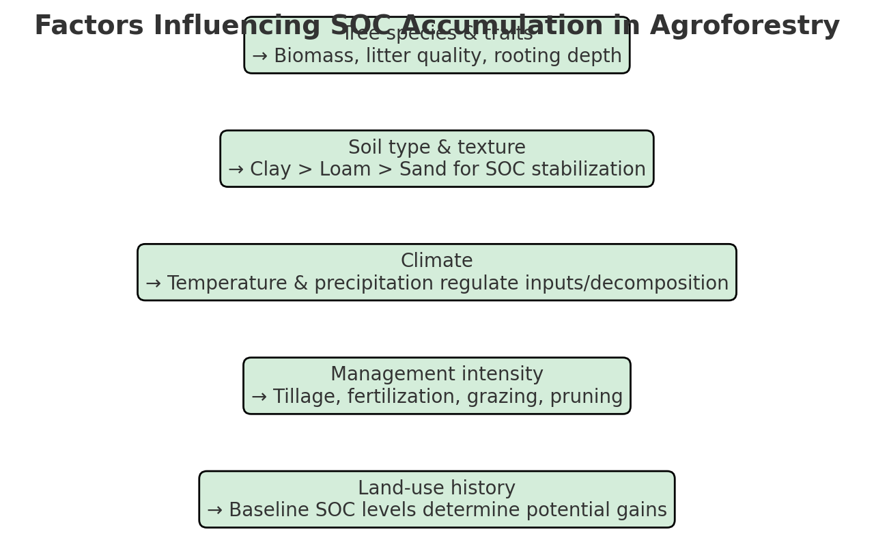
One of many climate-smart agricultural practices, agroforestry has emerged as a sustainable land-use system that can address productivity, environmental, and livelihood concerns simultaneously (Keprate, et al., 2024). As the intentional association of woody perennials (trees or shrubs) with crops and/or livestock in spatial or temporal arrangements, agroforestry fosters ecological synergies that increase system resilience and sustainability (Sileshi, et al., 2023). Trees in agroforestry systems are long-term carbon sinks that sequester carbon in biomass and add organic matter to soils through leaf fall, root turnover, and rhizodeposition (Lorenz, and Lal, 2014). These processes increase soil organic carbon (SOC) pools, which are also responsible for soil structure improvement and enhanced nutrient retention, thus counteracting the undesirable effects of land degradation and intensive agriculture (Lal, 2006).
In addition, agroforestry produces several co-benefits in addition to carbon sequestration. It controls microclimates, promotes water-use efficiency, inhibits soil loss, preserves biodiversity, and generates livelihoods for farmers through diversified sources of income from timber, fruits, fodder, fuelwood, and non-timber forest products (Karalliyadda, et al., 2025). Combining such ecological and socioeconomic values renders agroforestry a nature-based solution (NbS) for climate change mitigation and adaptation (Kumar, et al., 2025).
Notwithstanding its promise, large-scale agroforestry is faced with various challenges such as land ownership problems, initial investment requirements, technical ignorance among farmers, and restricted access to carbon markets (Chandewar, 2025). In addition, estimating the potential for carbon sequestration by agroforestry systems with high diversity is complicated by variations in species mix, practices, ecological regions, and soils. Thus, an in-depth knowledge of agroforestry mechanisms, opportunities, and constraints of carbon sequestration in soils is a prerequisite for intelligent policy-making and successful implementation (Van Cauwenberghe, 2023).
2. Definition of Soil Carbon Sequestration
Soil carbon sequestration involves capturing and storing atmospheric carbon dioxide (CO₂) in soil organic and inorganic carbon pools for many decades (Abdullahi, et al., 2018). It is an essential nature-based climate change mitigation approach that both improves soil health and ecosystem resilience. The underlying route consists of plant photosynthetic carbon fixation, transportation of assimilated carbon to the ground by litter fall, root mass, rhizodeposition (root exudates and secretions), and further microbial conversion into more recalcitrant organic matter (Nguyen, 2009). The extent to which carbon resides in soil is heavily contingent on its reaction with soil minerals, aggregation dynamics, and climatic controls like temperature, moisture, and land management regimes.
Sequestration of soil organic carbon (SOC) can be generally categorized into short-term labile carbon (easily decomposable fractions such as microbial biomass and fresh residues) and long-term stabilized carbon (humus and mineral-associated organic matter) (Kӧgel-Knabner, et al., 2023). Although the labile pool is dynamic and a critical component for nutrient cycling, it is the stabilized pool that provides long-term climate mitigation benefits. Carbon stabilization in soils is facilitated through three principal mechanisms:
- Chemical protection: - attachment of organic material to mineral soils (e.g., clays, oxides) that retards microbial breakdown.
- Physical protection: - entrapment of carbon in soil aggregates that restricts microbial access.
- Biochemical recalcitrance: - resistance of specific organic compounds (e.g., lignin, charcoal) to microbial degradation.
SOC buildup is essential not only for greenhouse gas abatement but also for enhancing soil fertility, water retention, cation exchange, and conserving biodiversity (Lal, 2003). Elevated SOC leads to sustainable agriculture productivity, as it maximizes nutrient supply, favors the buildup of soil structure, and acts as an insurance against environmental stresses like drought and erosion (Meena et al., 2019).
Soils worldwide contain more than 2,500 gigatons of carbon, the largest amount on land and greater than the atmospheric and vegetation carbon combined (Kumar, et al., 2020) Intensive agriculture, deforestation, and improper land uses have resulted in tremendous SOC loss over the last century. Rebuilding these stocks via activities such as agroforestry, conservation agriculture, organic fertilizers, and sustainable grazing management has thus become a prime focus of international schemes like the "4 per 1000" (4p1000) Initiative, which seeks to raise global SOC stocks by 0.4% every year to cancel out a large proportion of anthropogenic CO₂ emissions (Koutika, 2025).
Therefore, soil carbon sequestration is a win–win approach that addresses climate change mitigation, agricultural sustainability, and land degradation neutrality at the same time. Agroforestry, with perennial vegetation cover and diversified resource flows, has been globally acclaimed as the most efficient land-use system for maximizing SOC storage (Keprate, et al., 2024).
3. Agroforestry Systems and Their Contribution to Soil Carbon Sequestration
Agroforestry systems are various land-use systems that involve trees, crops, and/or livestock together in space and time. The structure, arrangement, and management of such systems have significant effects on their capacity for soil organic carbon (SOC) sequestration (Sahoo, et al., 2022). In contrast to monocropping or traditional grazing regimes, agroforestry provides greater biomass inputs, enhanced below-ground carbon storage, and greater microclimatic regulation, all of which support higher carbon stabilization in soils (Rolo, et al., 2023). SOC accumulation rate and magnitude, nonetheless, depend on agroecological zones, socio-economic settings, as well as on particular management options.
3.1 Agroforestry Practices
Agroforestry is a diverse array of land-use practices that all make significant, yet distinct, contributions to sequestration of soil organic carbon (SOC) (De Stefano, and Jacobson, 2018). The performance of these systems is a result of the interplay between trees, crops, livestock, and management practices that, collectively, affect the quality, quantity, and permanence of carbon inputs to the soil (Nandwa, 2001).
Silvopastoral systems: Silvopastoral systems integrate trees with livestock and pastures, generating multifunctional landscapes. Trees enhance microclimatic conditions for grasses by mitigating heat and water stress, while their deep roots recycle nutrients in subsoil layers. Soil enrichment with manure from livestock provides additional organic matter for SOC accumulation. Silvopastoral systems are highly efficient in lowering land degradation in arid and semi-arid areas through increased soil cover and erosion loss reduction (Moreno, et al., 2014).
Agrosilvicultural systems: Combining trees with food or cash crops improves soil fertility by having constant litter fall, root turnover, and biological fixation of N (in the case of legume trees). These systems optimize nutrient cycling and SOC storage by augmenting below-ground carbon inputs. Examples are parkland systems in Africa (for example, Faidherbia albida with cereals) and coffee or cocoa shade-grown systems in the tropics (Nair, 2019)
Agrosilvopastoral systems: These systems combine trees, crops, and livestock, thereby intensifying the complementary use of resources below and above the ground. Diversified systems produce multiple streams of organic matter inputs tree litter, crop residues, and livestock manure leading to high SOC accumulation. Their multi functionality also increases the resilience of ecosystems and confers co-benefits including biodiversity conservation, food security, and diversified income sources (Nair et al., 2010).
Alley cropping: In alley cropping, annual crops are grown between nitrogen-fixing or fast-growing tree and shrub rows. The periodic pruning of woody perennials provides nutrient-rich green manure that increases soil fertility and SOC sequestration. Alley cropping also suppresses weeds, retains soil moisture, and minimizes soil erosion, further safeguarding carbon stocks.
Boundary planting and shelterbelts: Planting trees along field edges, road margins, or as shelterbelts and windbreaks diminish soil loss due to wind and water erosion. Boundary planting adds leaf litter and woody debris to the ground, augmenting soil organic carbon content. Through erosion reduction, boundary planting effectively avoids SOC loss, in addition to maintaining existing carbon pools within topsoil layers (Wolz, et al., 2018).
Home gardens: Home gardens, commonly practiced in the tropics and subtropics, are one of the most diverse and sustainable agroforestry systems. They generally include multipurpose trees, shrubs, perennial crops, vegetables, and occasional livestock within a small parcel of land. The constant and varied biomass inputs through litter, root turnover, and crop residues sustain high SOC contents and support long-term soil fertility. In addition, home gardens serve as carbon sinks while at the same time producing food, fodder, timber, and cultural services (Kumar, 2015).
3.2 Soil Carbon Sequestration Mechanisms in Agroforestry
Soil carbon sequestration by agroforestry occurs via a range of biological, physical, and ecological mechanisms that act above and below the ground. Such mechanisms are tightly coupled and help stabilize soil organic carbon (SOC) in various pools from labile fractions to stabilized long-term forms (Ramachandran Nair, et al., 2009).
Ongoing litterfall and pruning debris: Regular leaf, twig, fruit, and pruning debris deposition creates an ongoing supply of organic matter into the soil. This biomass is microbially decomposed and humified, enhancing SOC reservoirs and maintaining soil fertility over the long term (Bernier, et al., 2008).
Deep root systems: Trees in agroforestry systems often possess deep and wide rooting systems. These roots carry photosynthetically fixed carbon to subsoil horizons by root turnover and rhizodeposition. Carbon in deeper horizons is more resistant to decomposition and hence more stable with time (Uga et al., 2013).
Root exudates and rhizodeposition: Roots secrete a range of organic materials, such as sugars, amino acids, and organic acids, into the rhizosphere. Root exudates induce microbial growth, stimulate aggregation of soil, and increase carbon stabilization in micro-aggregates and mineral associations (Dennis, et al., 2010).
Minimized soil erosion: Tree roots and protective canopy lower the exposure of soil to water and wind erosion. It avails the physical protection of SOC-rich topsoil so that carbon stocks are preserved, and soil structure is enhanced (Ramachandran Nair, et al., 2009).
Microclimatic regulation: Agroforestry systems alter local microclimates through shading, lowering temperature fluctuations of the soil, and sustaining higher levels of soil moisture. Such conditions decelerate organic matter decomposition and extend the carbon residence time of soils (Atangana, et al., 2013).
Nutrient recycling: Trees recover nutrients from lower soil horizons and recycle them to the surface by leaf litter and root turnover. This activity not only increases soil fertility but also maintains the ongoing accumulation of SOC by enhancing nutrient supply to crops and soil biota.
Together, these mechanisms illustrate that agroforestry is both a source of new organic matter and a stabilizer of current SOC stocks, thus playing an important role in mitigation of climate change and soil health enhancement.
3.3 Drivers of SOC Accumulation
The capacity of agroforestry systems to sequester carbon is highly variable across regions and management situations. A number of biophysical and socio-economic factors determine the rate, magnitude, and stability of SOC accumulation:
Tree species and functional characteristics: Species vary in litter quality, root structure, and biomass productivity. For instance, species with lignin-dominated or recalcitrant litter (e.g., hardwoods) have a greater ability to promote long-term SOC stabilization than those species that generate easily decomposable residues. Deep-rooted trees also deliver more carbon to subsoil layers, which are more stable than surface deposits (Hättenschwiler, 2005).
Soil texture and type: Soil texture has a major impact on SOC stabilization. Fine soils (loam and clay) have greater mineral surfaces available for the adsorption of organic matter as well as the formation of micro-aggregates, resulting in greater SOC stabilization (Cai, et al., 2016) Sandy soils tend to have lower SOC retention capacity owing to diminished surface area and greater aeration.
Climate (temperature and precipitation): Climatic conditions control both carbon inputs and rates of decomposition. Tropical and moist climates favor high biomass productivity but also accelerate organic matter mineralization, whereas drier or cooler climates reduce decomposition, thus lengthening SOC residence times (Nair, et al. 2022).
Intensity of management: Tillage, fertilization, grazing intensity, and pruning frequency affect carbon dynamics. Over-disturbing the soil minimizes SOC stabilization, while conservation-based management (e.g., reduced tillage, organic inputs) maximizes carbon retention.
Baseline SOC and land-use history: The initial state of the soil is a key factor influencing SOC sequestration potential. Degraded soils with low baseline SOC tend to have higher sequestration rates when they are converted to agroforestry, whereas soils that already contain plenty of organic matter experience comparatively modest gains. Understanding these factors is essential for optimizing agroforestry designs to maximize SOC sequestration, while also tailoring interventions to specific agroecological zones and farmer needs (Kumar, et al., 2022).
3.4. Processes of Soil Carbon Sequestration in Agroforestry Systems
Agroforestry systems contribute to the build-up of soil organic carbon (SOC) through a range of inter-linked biological and ecological processes (Devi, and Singh, 2023). One of the major routes is litterfall and pruning residue. Agroforestry trees drop leaves, branches, and other pruning residues, which slowly break down and are absorbed into the soil. This process adds organic matter to the topsoil, and it significantly contributes to the pool of carbon in the soil and to improving soil structure and fertility.
Another key mechanism is the existence of deep-root systems. Roots of trees commonly extend much deeper into the soil profile than roots of crops, depositing carbon into subsoil horizons that are more resistant to disturbances like tillage or erosion. Carbon that is stored in the deeper horizons has longer residence times, thus playing a role in more stable and longer-term sequestration of soil carbon (Button, 2022).
Root exudates and rhizodeposition are also responsible for SOC improvement. Trees exude organic substances like sugars, amino acids, and other metabolites into the rhizosphere. These organic substances act as substrates that support soil microbial activity and biomass production (Jia, et al., 2023) The microbial activity and interaction with soil particles result in the production of stable aggregates, which entrap carbon and prevent rapid decomposition, hence stabilizing SOC within the soil matrix.
Agroforestry systems also assist in erosion control, indirectly contributing to carbon sequestration. Tree canopy and root structures reduce the force of rainfall, lower surface runoff, and shield soil from wind and water erosion (Zuazo, et al., 2009). By avoiding loss of topsoil, these systems retain organic matter and sustain carbon stocks within the soil profile.
In addition, trees in agroforestry systems also help to regulate microclimate. In the area under tree canopies, soil temperature variation is decreased and evaporation is lower, thus decomposition of organic matter is slowed down (Paré, et al., 2006). This regulated microclimate promotes SOC accumulation in the long term by enhancing the residence time of carbon in the soil.
Finally, nutrient recycling by trees enhances SOC sequestration. Trees tend to tap into deeper soil layers for nutrients and mobilize them to the surface using leaf litter and root turnover. Nutrient replenishment enriches soil fertility and aids in understory crop growth, establishing a positive feedback effect that reinforces organic matter inputs and long-term carbon accumulation in the soil (Nair, et al., 2022).
Together, agroforestry systems utilize several complementary mechanisms ranging from litter fall and deep root carbon storage to microbial stimulation, erosion prevention, microclimate regulation, and nutrient recycling that together increase soil organic carbon sequestration and promote sustainable soil health and climate mitigation.

FIG 2.
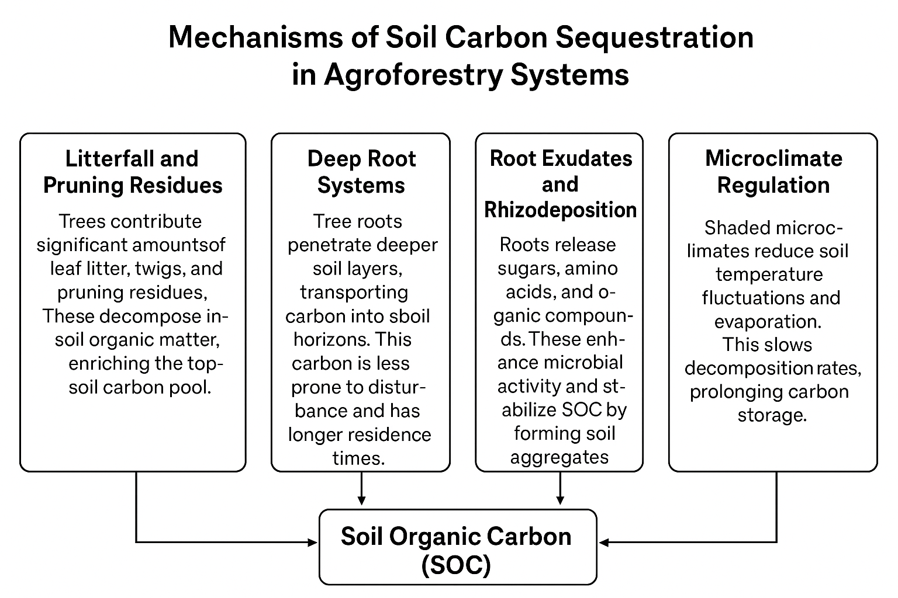

4. Agroforestry's Potential for Soil Carbon Sequestration
Agroforestry systems have been shown to hold a high potential to increase soil organic carbon (SOC) stocks in various agroecological zones (Cardinael, et al., 2017). The sequestration range is dependent on the type of system, species mix, soil, climate, and management. On average, research suggests that agroforestry may sequester 0.3–2.0 Mg C ha⁻¹ yr⁻¹ in soils, with greater rates observed in the tropics owing to higher year-round biomass productivity and turnover (Nair, et al., 2022).
Tropical agroforestry systems: These are typically the most promising with regard to carbon sequestration. There is continuous vegetative cover, high litterfall, and fast biomass turnover that result in higher organic inputs and increased SOC storage. Shade-grown perennial crop systems like cocoa, coffee, and rubber with associated shade trees have been reported extensively to enhance SOC content compared to monocultures (Nair, et al., 2022).
Silvopastoral systems: By combining trees with pasture and livestock, silvopastoral systems can increase carbon inputs from deep root biomass, aboveground litter, and manure from livestock. These inputs enhance SOC stabilization and improve soil structure, especially in degraded grasslands. These systems have been shown to double SOC accumulation rates relative to traditional grazing systems (Bai, and Cotrufo, 2022).
Alley cropping: Crop production between rows of trees with regular pruning introduces significant quantities of organic material into the soil. Regular incorporation of high nutrient content pruning waste and root turnover increases SOC storage in the topsoil, which improves the fertility and erosion losses mitigation capacity of the soil (Nair, et al., 2022).

Table-1: Comparative Potential of Different Agroforestry Systems for Soil Carbon Sequestration
Agroforestry Practice | SOC Sequestration Rate (Mg C ha⁻¹ yr⁻¹) | Key Mechanisms | Comparative Advantage over Monocropping
Tropical Agroforestry Systems | 0.8 – 2.0 | High litterfall, continuous biomass turnover, deep root inputs | 30–40% higher SOC in 20–30 years due to year-round productivity
Silvopastoral Systems | 0.5 – 1.5 | Root biomass accumulation, livestock manure inputs, improved soil structure | Doubles SOC accumulation compared to conventional grazing
Alley Cropping | 0.3 – 1.2 | Incorporation of pruned residues, frequent organic inputs, root turnover | Enhances topsoil SOC, reduces erosion losses
Agrosilvopastoral Systems | 1.0 – 2.0 | Combined carbon inputs from trees, crops, and livestock | Highest sequestration potential due to system integration
Temperate Agroforestry Systems | 0.3 – 0.8 | Seasonal litter inputs, root biomass, organic matter stabilization | Moderate SOC gains but long-term stability in cooler climates

Agrosilvopastoral systems: Due to their highly integrated nature, they integrate crop, tree, and animal carbon inputs, usually resulting in the maximum SOC sequestration capacity. Being multifunctional maximizes land productivity as well as soil carbon sinks.
Empirical data indicate that in contrast with monocropping practices, agroforestry augments SOC by 20–40% within 20–30 years, depending on site-specific conditions and management intensity. Notably, carbon sequestration is not restricted to topsoil layers; deep-rooted tree species enable carbon sequestration in subsoil horizons, thereby ensuring long-term stabilization (Abhilash, et al., 2021).
At the global level, the universal adoption of agroforestry has the potential to cancel out a major proportion of agricultural greenhouse gas emissions. It has been estimated that if agroforestry was practiced on just 10% of the globe's agricultural land, it would sequester 1.1–2.2 Pg C yr⁻¹, with a significant contribution to global climate mitigation goals in addition to providing co-benefits to food security, biodiversity, and rural livelihoods (Patel, et al., 2023).
5. Advantages Beyond Carbon Storage
Agroforestry practices offer a range of ecological, agronomic, and socio-economic advantages that go beyond carbon storage in soils, hence making them a pillar of climate-smart and sustainable agriculture.
5.1 Soil Fertility Improvement through Nutrient Cycling
Trees extract nutrients from below-ground soil horizons using extensive root systems and return them to the topsoil through litterfall and root turnover. The natural nutrient pump builds soil organic matter, increases cation exchange capacity, and decreases external fertilizer requirements. Tree species that are leguminous also fix nitrogen in the atmosphere, increasing long-term soil fertility.
5.2 Enhanced Water Infiltration and Retention
Tree roots enhance soil structure and porosity, thus increasing infiltration rates and lessening runoff. Organic matter increases the water retention ability of soils, which is of added value in drought-related areas. This helps to promote increased cropping system resilience under changing rainfall conditions.
5.3 Soil Conservation and Erosion Control
Agroforestry systems serve as wind and water erosion natural shields. Tree cover decreases raindrop intensity, while root systems stabilize soil aggregates and slopes. Shelterbelts, boundary planting, and alley cropping are highly effective in reducing topsoil loss and maintaining soil organic carbon pools.
5.4 Increased Biodiversity and Ecosystem Services
Structural and functional agroforestry landscape diversity enhances greater species richness, pollinators, soil organisms, and natural pest control agents. This biodiversity forms the basis of ecosystem services such as pollination, biological control, nutrient cycling, and climate regulation, resulting in agroecosystem stability.
5.5 Livelihood Resilience through Diversified Farm Outputs
By combining crops, livestock, and trees, agroforestry diversifies both farmers' income and production sources. Economic shocks due to crop failure and market variability are cushioned by products like timber, fodder, fruits, fuelwood, and non-timber forest products. Diversification enhances household livelihood and food security, particularly during climate variability.
6. Challenges and Limitations

FIG 3.
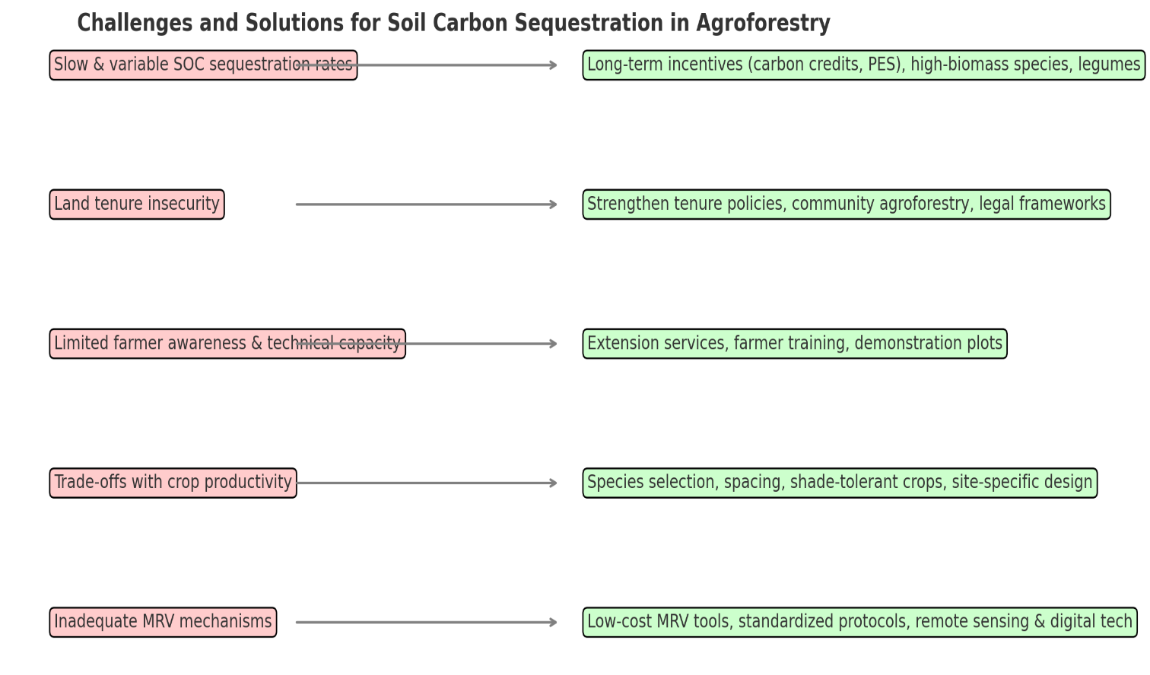
Although agroforestry systems hold enormous potential for SOC sequestration and sustainable land management, a number of challenges limit their widespread adoption and efficiency.
6.1 Slow and Variable SOC Sequestration Rates
SOC sequestration in agroforestry occurs at highly varying rates depending on the ecological zone, soil type, and land management. Carbon gain is quickly realized in some degraded soils but only modestly in already productive soils. Additionally, carbon storage mechanisms are slow in the first place, taking decades to manifest measurable effects. This lag in time deters farmers and policymakers who prefer short-term rewards.
6.2 Land Tenure Insecurity
In most areas, insecure tenure and absence of long-term tenure rights inhibit farmers from investing in trees. Agroforestry is a practice that involves long-term commitment but is resisted by farmers with uncertain land access. This institutional constraint is especially salient in developing nations.
6.3 Limited Farmer Awareness and Technical Capacity
Agroforestry is skill-based, demanding expertise in tree-crop-livestock integration, species suitability, pruning, and soil management. Yet, there is limited extension service delivery, poor farmer training, and limited access to technical information, and thus, large-scale practice is restricted. Tree-crop management can even reduce yields and discourage further practice.
6.4 Trade-offs with Crop Productivity
Dysfunctional agroforestry designs can lead to competition for light, water, and nutrients among trees and crops. Unless there is appropriate species selection, spacing, and management, such trade-offs can dampen crop productivity and discourage uptake. Carbon sequestration and food production balance is a major challenge.
6.5 Weak Monitoring, Reporting, and Verification (MRV) Mechanisms
Accurate measurement of SOC shifts under agroforestry is technically challenging, expensive, and time-consuming. Uncertainty due to non-standardized protocols for soil sampling, carbon accounting, and reporting undermines quantifying sequestration values. This also constrains the inclusion of agroforestry in carbon credit programs and payment for ecosystem services (PES) programs.

Table-2: Challenges and Possible Solutions for Enhancing Soil Carbon Sequestration through Agroforestry
Challenges | Description | Possible Solutions / Strategies
Slow and variable SOC sequestration rates | SOC accumulation differs by soil, climate, and management; long-term process | Promote long-term incentives (e.g., carbon credits, PES), select high-biomass and deep-rooted species, integrate legumes
Land tenure insecurity | Farmers lack ownership or long-term rights to land, discouraging tree planting | Strengthen land tenure policies, introduce community-based agroforestry, and provide legal frameworks for shared benefits
Limited farmer awareness and technical capacity | Lack of knowledge on tree-crop-livestock integration, pruning, and management | Enhance extension services, provide farmer training programs, promote demonstration plots and farmer field schools
Trade-offs with crop productivity | Poor design may lead to competition for light, water, and nutrients | Careful species selection, optimized spacing and pruning, use of shade-tolerant crops, adoption of site-specific designs
Inadequate MRV (Monitoring, Reporting, Verification) mechanisms | Difficulty in measuring SOC changes and lack of standardized protocols | Develop low-cost MRV tools, standardize soil sampling protocols, use remote sensing and digital technologies for monitoring

7. Policy and Research Perspectives
It is essential to have an enabling environment to scale up agroforestry's role in soil carbon sequestration, and this should be integrated through policy, research, capacity building, and technology incorporation.
7.1 Policy Support
Institutional and policy structures largely depend on agroforestry adoption. Governments can facilitate large-scale application through:
Making financial incentives and subsidies for tree planting and care available. Establishing carbon credit markets and connecting agroforestry farmers to payment for ecosystem services (PES) programs. Integrating agroforestry into national climate plans, NDCs, and land restoration efforts. Streamlining tree harvesting, transport, and marketing regulations to eliminate impediments to uptake.
7.2 Needs for Research
Strong scientific data are required to quantify and confirm the scope of SOC sequestration potential for agroforestry. High-priority research areas are:
Standardization of SOC measurement and carbon accounting protocols across systems and regions. Development of long-term field experiments to track SOC dynamics under various agroforestry systems. System-specific carbon modeling to estimate sequestration rates under different management and climatic regimes. Comparative studies of carbon sequestration vs. crop productivity vs. biodiversity outcomes.
7.3 Capacity Building
It is dependent on the skills and knowledge of farmers and extension personnel. The strategies involve:

Training of farmers in tree-crop-livestock integration, species selection, and sustainable management practices. Strengthening the extension agent and NGO role in technical support provision. Promoting participatory research and farmer field schools to bring together local knowledge and scientific innovation.
7.4 Technology Integration
Emerging geospatial and digital technologies can revolutionize SOC monitoring and management of agroforestry systems:
Remote sensing and GIS for monitoring at large scales and land-use change. Digital platforms and mobile apps to offer real-time advisory services and link farmers to carbon markets. Application of AI, machine learning, and modeling technologies for the prediction of SOC dynamics and optimal agroforestry design. Implementation of blockchain-based systems for transparent carbon credit transactions.
8. Conclusion
Agroforestry is one of the most promising nature-based solutions for overcoming climate change threats through soil carbon sequestration. By incorporating perennial trees into agricultural landscapes with crops and livestock, agroforestry systems promote soil organic matter, sequester carbon in deeper soil horizons, and improve overall ecosystem resilience. In addition to carbon storage, they provide several co-benefits such as soil fertility improvement, biodiversity preservation, water regulation, erosion prevention, and livelihood diversification, thus promoting sustainable agricultural intensification.
Nonetheless, unlocking the full potential of agroforestry entails overcoming key hindrances such as slow and unpredictable rates of SOC accumulation, land tenure, limited technical know-how, and weak carbon monitoring mechanisms. Compelling policy engagement, farmer incentives, institutional support, and investment in long-term research are essential for scaling up adoption. Equally critical is the use of new technologies like remote sensing, GIS, and digital platforms for reliable carbon monitoring and farmer participation.
In conclusion, agroforestry, underpinned by enabling institutions and participatory processes, can make a substantial contribution towards climate change mitigation, food and livelihood security, and global efforts towards carbon neutrality. Its growth is not just an environmental necessity but a socio-economic opportunity for sustainable rural livelihoods.

Reference
Abdullahi, A. C., Siwar, C., Shaharudin, M. I. I., & Anizan, I. (2018). Carbon sequestration in soils: the opportunities and challenges. Carbon capture, utilization and sequestration, 1, 3-16.
Abhilash, Rani, A., Kumari, A., Singh, R. N., & Kumari, K. (2021). Climate-smart agriculture: an integrated approach for attaining agricultural sustainability. In Climate change and resilient food systems: issues, challenges, and way forward (pp. 141-189). Singapore: Springer Singapore.
Atangana, A., Khasa, D., Chang, S., & Degrande, A. (2013). Carbon sequestration in agroforestry systems. In Tropical agroforestry (pp. 217-225). Dordrecht: Springer Netherlands.
Bai, Y., & Cotrufo, M. F. (2022). Grassland soil carbon sequestration: Current understanding, challenges, and solutions. Science, 377(6606), 603-608.
Bernier, P., Hanson, P. J., & Curtis, P. S. (2008). Measuring litterfall and branchfall. In Field Measurements for Forest Carbon Monitoring: A Landscape-Scale Approach (pp. 91-101). Dordrecht: Springer Netherlands.
Button, E. (2022). Deep soil: investigating carbon sequestration potential and greenhouse gas behaviour in agricultural subsoil. Bangor University (United Kingdom).
Cai, A., Feng, W., Zhang, W., & Xu, M. (2016). Climate, soil texture, and soil types affect the contributions of fine-fraction-stabilized carbon to total soil organic carbon in different land uses across China. Journal of environmental management, 172, 2-9.
Cardinael, R., Chevallier, T., Cambou, A., Béral, C., Barthès, B. G., Dupraz, C., ... & Chenu, C. (2017). Increased soil organic carbon stocks under agroforestry: A survey of six different sites in France. Agriculture, Ecosystems & Environment, 236, 243-255.
Chandewar, N. (2025). Agroforestry and Sustainable Land Management. Addition Publishing House.
De Stefano, A., & Jacobson, M. G. (2018). Soil carbon sequestration in agroforestry systems: a meta-analysis. Agroforestry systems, 92(2), 285-299.
Dennis, P. G., Miller, A. J., & Hirsch, P. R. (2010). Are root exudates more important than other sources of rhizodeposits in structuring rhizosphere bacterial communities?. FEMS microbiology ecology, 72(3), 313-327.
Devi, S., & Singh, S. (2023). Soil organic carbon sequestration in dryland soils to alleviate impacts of climate change. In Enhancing Resilience of Dryland Agriculture Under Changing Climate: Interdisciplinary and Convergence Approaches (pp. 221-245). Singapore: Springer Nature Singapore.
Hättenschwiler, S. (2005). Effects of tree species diversity on litter quality and decomposition. In Forest diversity and function: Temperate and boreal systems (pp. 149-164). Berlin, Heidelberg: Springer Berlin Heidelberg.
Jia, Y., Liu, Z., Zhou, L., Liu, X., Ma, K., & Feng, X. (2023). Soil organic carbon sourcing variance in the rhizosphere vs. non-rhizosphere of two mycorrhizal tree species. Soil Biology and Biochemistry, 176, 108884.
Karalliyadda, S. M. C. B., Navodya, H. A. H., & Jayakody, J. D. T. D. (2025). Agroforestry for Sustainable. Agroforestry for a Climate-Smart Future, 73.
Keprate, A., Bhardwaj, D. R., Sharma, P., Verma, K., Abbas, G., Sharma, V., ... & Janju, S. (2024). Climate resilient agroforestry systems for sustainable land use and livelihood. In Transforming agricultural management for a sustainable future: climate change and machine learning perspectives (pp. 141-161). Cham: Springer Nature Switzerland.
Koutika, L. S. (2025). Managing tropical forest ecosystems through soil organic carbon storage to boost global warming mitigation, food security, land restoration and conservation of biodiversity (Doctoral dissertation, Université de Lorraine).
Kumar, A., Kumar, S., Dubey, R., Das, A., & Chavan, S. (2025). Agroforestry and Climate Adaptation: Overcoming Drought and Heat Challenges. In Drought and Heat Stress in Agriculture: Implications, Mitigation and Policy Approaches (pp. 131-151). Singapore: Springer Nature Singapore.
Kumar, R., Singh, A., Datta, A., Yadav, R. P., Dinesh, D., & Verma, K. (2022). Carbon sequestration in degraded lands: current prospects, practices, and future strategies. In Plans and Policies for Soil Organic Carbon Management in Agriculture (pp. 221-255). Singapore: Springer Nature Singapore.
Kumar, S. S., Mahale, A. G., & Patil, A. C. (2020). Mitigation of climate change through approached agriculture-soil carbon sequestration (a review). Current Journal of Applied Science and Technology, 39(33), 47-64.
Kumar, V. (2015). Importance of homegardens agroforestry system in tropics region. Biodiversity, conservation and sustainable development (issues & approaches), 2, 978-8186772751.
Kӧgel-Knabner, I., Wiesmeier, M., & Mayer, S. (2023). Mechanisms of soil organic carbon sequestration and implications for management.
Lal, R. (2003). Global potential of soil carbon sequestration to mitigate the greenhouse effect. Critical reviews in plant sciences, 22(2), 151-184.
Lal, R. (2006). Enhancing crop yields in the developing countries through restoration of the soil organic carbon pool in agricultural lands. Land degradation & development, 17(2), 197-209.
Lorenz, K., & Lal, R. (2014). Soil organic carbon sequestration in agroforestry systems. A review. Agronomy for Sustainable Development, 34(2), 443-454.
Meena, R. S., Kumar, S., & Yadav, G. S. (2019). Soil carbon sequestration in crop production. In Nutrient dynamics for sustainable crop production (pp. 1-39). Singapore: Springer Singapore.
Moreno, G., Franca, A., Pinto-Correia, T., & Godinho, S. (2014). Multifunctionality and dynamics of silvopastoral systems. Options Méditerranéennes, 109, 421-436.
Nair, P. K. R. (2019). Tropical agroforestry systems and practices. In Tropical Resources (pp. 227-250). Routledge.
Nair, P. R., Kumar, B. M., & Nair, V. D. (2022). Carbon sequestration and climate change mitigation. In An Introduction to Agroforestry: Four Decades of Scientific Developments (pp. 487-537). Cham: Springer International Publishing.
Nair, P. R., Kumar, B. M., & Nair, V. D. (2022). Shaded Perennial Agroforestry Systems. In An Introduction to Agroforestry: Four Decades of Scientific Developments (pp. 137-168). Cham: Springer International Publishing.
Nair, P. R., Kumar, B. M., & Nair, V. D. (2022). Soil organic matter (SOM) and nutrient cycling. In An introduction to agroforestry: Four decades of scientific developments (pp. 383-411). Cham: Springer International Publishing.
Nair, P. R., Nair, V. D., Kumar, B. M., & Showalter, J. M. (2010). Carbon sequestration in agroforestry systems. Advances in agronomy, 108, 237-307.
Nandwa, S. M. (2001). Soil organic carbon (SOC) management for sustainable productivity of cropping and agro-forestry systems in Eastern and Southern Africa. Nutrient Cycling in Agroecosystems, 61(1), 143-158.
Nguyen, C. (2009). Rhizodeposition of organic C by plant: mechanisms and controls. Sustainable agriculture, 97-123.
Paré, D., Boutin, R., Larocque, G. R., & Raulier, F. (2006). Effect of temperature on soil organic matter decomposition in three forest biomes of eastern Canada. Canadian Journal of Soil Science, 86(Special Issue), 247-256.
Patel, R., Patel, B., Dash, B., & Mukherjee, S. (2023). Impact of agroforestry ecosystem on carbon sequestration potential and climate change. In Agricultural soil sustainability and carbon management (pp. 269-297). Academic Press.
Ramachandran Nair, P. K., Mohan Kumar, B., & Nair, V. D. (2009). Agroforestry as a strategy for carbon sequestration. Journal of plant nutrition and soil science, 172(1), 10-23.
Rolo, V., Rivest, D., Maillard, É., & Moreno, G. (2023). Agroforestry potential for adaptation to climate change: A soil‐based perspective. Soil Use and Management, 39(3), 1006-1032.
Sahoo, G., Swamy, S. L., Wani, A. M., & Mishra, A. (2022). Agroforestry systems for carbon sequestration and food security: implications for climate change mitigation. In Soil health and environmental sustainability: application of geospatial technology (pp. 503-528). Cham: Springer International Publishing.
Sahu, S., & Arya, S. K. (2024). Mitigation of greenhouse gas emissions in agriculture and food processing through sustainable management practices for climate change. In Advances and Technology Development in Greenhouse Gases: Emission, Capture and Conversion (pp. 71-96). Elsevier.
Saleem, A., Anwar, S., Nawaz, T., Fahad, S., Saud, S., Ur Rahman, T., ... & Nawaz, T. (2024). Securing a sustainable future: the climate change threat to agriculture, food security, and sustainable development goals. Journal of Umm Al-Qura University for Applied Sciences, 1-17.
Sileshi, G. W., Dagar, J. C., Nath, A. J., & Kuntashula, E. (2023). Agroforestry as a climate-smart agriculture: Strategic interventions, current practices and policies. In Agroforestry for sustainable intensification of agriculture in Asia and Africa (pp. 589-640). Singapore: Springer Nature Singapore.
Uga, Y., Sugimoto, K., Ogawa, S., Rane, J., Ishitani, M., Hara, N., ... & Yano, M. (2013). Control of root system architecture by DEEPER ROOTING 1 increases rice yield under drought conditions. Nature genetics, 45(9), 1097-1102.
Van Cauwenberghe, A. (2023). CONTRIBUTION OF DIGITAL TECHNOLOGIES TO AGROFORESTRY SYSTEMS.
Verschuuren, J. (2022). Agriculture, forestry and other land use (AFOLU). In Research handbook on climate change mitigation law (pp. 433-456). Edward Elgar Publishing.
Wolz, K. J., & DeLucia, E. H. (2018). Alley cropping: Global patterns of species composition and function. Agriculture, Ecosystems & Environment, 252, 61-68.
Zuazo, V. H. D., & Pleguezuelo, C. R. R. (2009). Soil-erosion and runoff prevention by plant covers: a review. Sustainable agriculture, 785-811.

