Phosphorus Dynamics in Terrestrial and Aquatic Ecosystems: Processes, Challenges and Management Perspectives

Abstract
Phosphorus (P) is a fundamental macronutrient that regulates primary productivity, biodiversity and ecosystem sustainability. Unlike nitrogen and carbon, phosphorus has no significant gaseous phase and its cycling is therefore primarily controlled by geochemical and biological processes within the lithosphere, pedosphere and hydrosphere (Elser and Bennett, 2011). In terrestrial ecosystems, P dynamics are strongly influenced by soil mineralogy, sorption–desorption reactions, organic matter decomposition, microbial transformations and land-use practices (Richardson and Simpson, 2011). High soil fixation limits its bioavailability, while agricultural intensification has created nutrient imbalances and low phosphorus use efficiency. Conversely, in aquatic ecosystems, phosphorus governs trophic status and is a central driver of eutrophication. Inputs from agricultural runoff, wastewater and atmospheric deposition, combined with internal loading from sediments, enhance dissolved inorganic phosphorus (DIP) availability, often leading to algal blooms and hypoxia (Schindler, 2006; Smith and Schindler, 2009).
Despite its importance, phosphorus management poses significant challenges. Global phosphate rock reserves are finite and unevenly distributed, raising concerns over long-term food security (Cordell et al., 2009). Furthermore, anthropogenic activities have accelerated P fluxes beyond natural thresholds, contributing to water quality deterioration and ecosystem degradation. Balancing agricultural productivity with environmental sustainability requires innovative management approaches. Emerging strategies include precision fertilization to match crop demand, use of P-efficient crop genotypes, microbial inoculants that mobilize insoluble P and recovery of phosphorus from wastes such as manure, sewage sludge and food residues (Withers et al., 2014; Rowe et al., 2016).
Understanding phosphorus dynamics across terrestrial and aquatic systems is therefore essential for developing integrated nutrient management frameworks. By linking biogeochemical processes with socio-ecological challenges, sustainable phosphorus management can reduce environmental risks, enhance resource-use efficiency and secure future food production. This seminar will explore the fundamental processes regulating phosphorus cycling, highlight key challenges in both terrestrial and aquatic ecosystems and discuss potential management perspectives that integrate ecological and agricultural sustainability.
Introduction:
Phosphorus (P) was first discovered in 1669 by the German alchemist Hennig Brandt. Its name originates from the Greek words phos (light) and phorus (bearer), reflecting the element’s luminescent properties when first isolated (Blaise et al., 2018). Phosphorus is the 11th most abundant element in the Earth’s crust, averaging about 1,200 mg P kg⁻¹, with typical soil concentrations ranging between 200–800 mg kg⁻¹ (Tiessen, 2008), yet it contributes crop production, food security and water quality.
Phosphorus is a vital macronutrient for plant and microbial growth, playing a crucial role in many physiological and biochemical processes. It is a fundamental structural component of nucleic acids, co-enzymes, phospholipids, phosphoproteins and cellular membranes. It also serves as an energy currency in the form of ADP and ATP, regulating a wide range of metabolic processes (Vance et al., 2003; Raghothama, 1999; Rodolfo et al., 2021). P supports critical functions such as photosynthesis, respiration, glycolysis, signal transduction, redox reactions, lipid metabolism, carbohydrate transport and the maintenance of osmotic potential (Plaxton and Tran, 2011).
The dynamics of phosphorus in ecosystems involve its transformation and movement through various organic, inorganic and microbial pools. Phosphorus is unique among essential nutrients due to the absence of a significant gaseous phase in its natural cycle, which makes its movement and recycling highly localized (Vitousek et al., 2010). These processes include mineralization, immobilization, adsorption, desorption, leaching, biological uptake (Turner et al., 2002) runoff, sedimentation and resuspension.
In terrestrial ecosystems, phosphorus mainly originates from the breakdown of phosphatic rock minerals and is present in both organic and inorganic fractions. Yet, a large portion of soil phosphorus becomes tightly bound to iron, aluminium or calcium compounds, which makes it less available to plants. As a result, phosphorus frequently considered as the second most limiting nutrient after nitrogen terrestrial environments (Turner et al., 2002). Whereas, in aquatic environments, phosphorus presents mainly as dissolved inorganic phosphorus (DIP), dissolved organic phosphorus (DOP) and particulate phosphorus (PP). phosphorus in these systems is highly mobile and rapidly cycled by phytoplankton and microbial communities, as much faster than in soils of terrestrial ecosystems (Jin et al., 2024).
Human activities over the past century have intensified the global phosphorus cycle. In agriculture, phosphorus deficiency is typically managed using inorganic phosphate fertilizers. However, overuse of these fertilizers is not only economically unsustainable but also environmentally detrimental. However, these fertilizers are utilized with very low efficiency, leading to accumulation of phosphorus in soil. High phosphorus application from agriculture, especially through runoff and soil erosion, is a key driver of eutrophication in waterbodies. This nutrient enrichment promotes excessive algal growth, low oxygen environment and ultimately deteriorate water quality and aquatic biodiversity (Cordell and White, 2014; Alewell et al., 2020; Duhamel, 2025).
Understanding how phosphorus cycles in different ecosystems is important for ensuring soil fertility, food security, water quality and sustainability. This review summarizes current knowledge of terrestrial and aquatic phosphorus dynamics, highlights challenges and management.
Phosphorus in dynamics in Terrestrial Ecosystems:
Forms of Phosphorus:
Soil P exists in various chemical forms including inorganic P (Pi) and organic P (Po). These P forms differ in their behaviour, fate in soils and availability to plants (Brady and Weil, 2008).
Organic P (Po):
The amount of organically bound phosphorus (Po) in soils can differ widely depending on the soil type. Globally, soil Po is estimated to range between 7 and 1056 mg P kg⁻¹ of soil, making up roughly 20–80% of the total phosphorus pool (Campbell and Racz, 1975). Much of this Po comes from the breakdown of plant and animal residues, supported by soil microorganisms and fauna (Stutter et al., 2012). In addition, phosphorus applied through fertilizers can be immobilized into organic forms. Microorganisms play a key role in this process, converting inorganic phosphorus (Pi) into Po for incorporation into their biomass (Brady & Weil, 2008; Syers et al., 2008).
Soil Po can be grouped into two categories such as stabilized forms like inositol phosphates and phosphonates and more active forms like orthophosphate monoesters and organic polyphosphates (Condron et al., 2005; Nash et al., 2014).
Inorganic phosphorus (Pi):
Inorganic phosphorus (Pi) is mainly present in soils as the ions H₂PO₄⁻ and HPO₄²⁻, which are adsorbed onto iron and aluminium oxides or hydroxides, clay, organic matter or bound to calcium compounds (Olibone and Rosolem, 2010).
Calcium or magnesium phosphate
These compounds are not found in soils at low soil pH but are stable, insoluble and dominant in neutral or alkaline soils [Brady and Weil, 2008, Shen, et al., 2011] They occur in soils in several forms and the most important forms are:
- Ca(H₂PO₄)₂.H₂O, monocalcium phosphate, which is the water-soluble component of superphosphate that is transformed to less soluble products.
- CaHPO₄.2H₂O and CaHPO₄, dicalcium phosphate, both hydrated and the unhydrated forms that are slightly soluble in water.
- Ca₈H₂(PO₄)₆.5H₂O, octacalcium phosphate.
- Ca₃ (PO₄)₂, tricalcium phosphate.
- Ca₁₀ (PO₄)₆.(OH)₂ (hydroxyapatite).
- Ca₁₀ (PO₄)₆F (fluorapatite) and
- MgNH₄PO₄.6H₂0 (struvite) which is alkaline and water-soluble
[Tisdale et al., 1985; Shen, et al., 2011; Kruse et al., 2015]
Iron and aluminium phosphates:
A number of aluminium and iron phosphate minerals occur in soils [Shen et al., 2011], these compounds are not found in soils at low soil pH. The most common aluminium phosphates in soils are
- wavellite (Al₃(PO₄)(OH)₃.5H₂O) and
- variscite (AlPO₄.2H₂O) [Brady and Weil, 2008]
Soil solution P:
Soil solution phosphorus (P) refers to the phosphate ions dissolved in the soil solution, which remain in dynamic equilibrium with the more readily available (labile) P pool. The concentration of P in soil solution is generally very low, typically between 0.001 and 1 mg P L⁻¹, with an average of around 0.05 mg P L⁻¹. Plants absorb phosphorus mainly as H₂PO₄⁻, HPO₄²⁻ or PO₄³⁻ ions, with the dominant form depending on soil pH (Shinjiro, 2003).
Pools of P:
Soil phosphorus is generally grouped into three main pools, which differ in their availability to plants.
Non-labile or fixed phosphorus pool:
This is the largest reservoir of soil P but is not readily available for plant uptake. It consists of primary minerals such as apatite, other insoluble inorganic phosphates and stable organic forms that mineralize only very slowly. Much of this phosphorus is tightly bound to soil minerals or trapped within aggregates, making it biologically and chemically inaccessible under normal soil conditions (Shen et al., 2011).
Labile or active phosphorus pool
This pool contains phosphorus forms that are more accessible to plants. It includes loosely adsorbed inorganic P, secondary phosphate minerals (such as calcium, iron or aluminium phosphates) and organic compounds that can be mineralized relatively quickly by microbial activity or enzymes. The labile pool is dynamic and sensitive to factors like plant demand, soil pH, moisture and biological processes (Shen et al., 2011).
Soil solution pool
The smallest but most immediately important pool, as it provides the phosphorus directly available for root uptake. It is made up mainly of inorganic orthophosphate ions (H₂PO₄⁻ and HPO₄²⁻) with a small contribution from dissolved organic P (Shen et al., 2011).
These three pools are interlinked and exist in a state of dynamic equilibrium. As plants deplete phosphorus from the soil solution, the labile pool replenishes it. In turn, when the labile pool becomes exhausted, the fixed phosphorus pool slowly releases small amounts of P. However, this transfer is very gradual because of the strong chemical binding and stability of the fixed forms (Alewell et al., 2020; Prasad and Chakraborty, 2019).
Phosphorus cycling in terrestrial ecosystem:
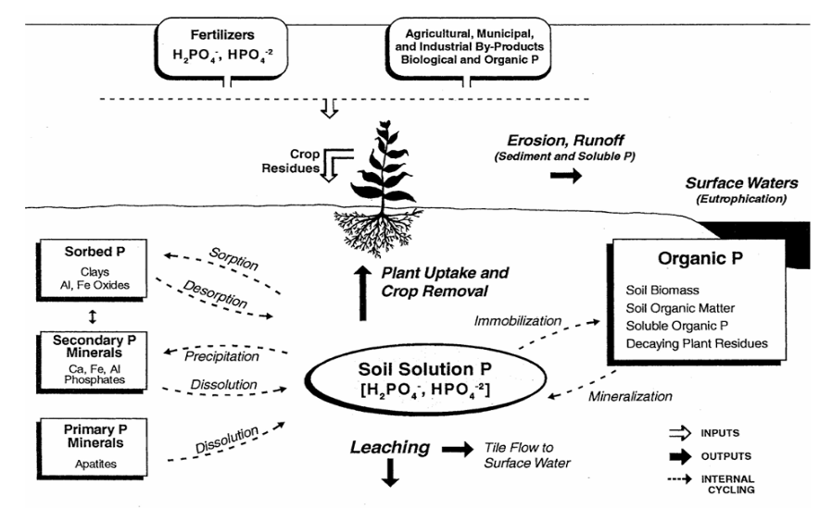
Figure 1: Phosphorus cycle in terrestrial ecosystem (Pierzynski et al., 2002)
Phosphorus (P) cycling in soils is highly complex, governed by interactions among inorganic and organic phases, biological activity, soil solution chemistry and environmental factors. The key chemical and biological processes driving P dynamics include dissolution–precipitation, sorption–desorption and mineralization–immobilization processes (Havlin et al., 2014).
Phosphorus enters into an environment such as addition of chemical fertilizers, manures and crop residues in agricultural systems which help overcome the naturally low availability of soil phosphorus (Withers and Johnston, 2018). Whereas, grassland ecosystems depend largely on internal nutrient cycling, with phosphorus being returned to the soil through litter decomposition and root turnover, also grazing animals further influence its addition by dung and urine. In forests system, phosphorus mainly comes from organic matter decomposition, minor atmospheric inputs and slow mineral weathering, with litterfall and microbes recycling it efficiently despite low soil availability (Richardson et al., 2009).
On the biological side, mineralization and immobilization are the main processes converting P between organic and inorganic forms. Mineralization is carried out by microbes and plant roots, releasing orthophosphate (H₂PO₄⁻, HPO₄²⁻) from organic matter through phosphatase enzymes. In contrast, immobilization occurs when microbes take up inorganic P into their biomass while decomposing residues with high C:P ratios (>300:1), temporarily reducing plant availability. Upon microbial turnover, this P is eventually re-mineralized (Stewart and Tiessen, 1987).
Sorption–desorption processes regulate the equilibrium between solid-phase and solution P. Orthophosphate ions attach to hydrous oxides, clays and carbonates by monodentate (more labile) or bidentate (less labile) bonds. Sorption is often a precursor to precipitation, which occurs when solution P exceeds solubility limits, leading to the formation of secondary Ca-, Al- or Fe-phosphates. Released of precipitated phosphorus called as dissolution, have low rate of release (Pierzynski et al., 2002). adsorption and precipitation reactions are reversible, so P remains plant-available and also susceptible to runoff, erosion and leaching losses. In summary, soil P cycling is governed by tightly linked chemical and biological processes, which explain both its limited availability to plants and its vulnerability to environmental loss.
Table 1-Phosphorus dynamics in different terrestrial ecosystem
Ecosystem Type | Key Features of P Dynamics | Influencing Factors | References
Tropical Forests | High P weathering but most P quickly immobilized in organic matter or bound to Fe/Al oxides; low plant available P | Warm, wet climate; high organic matter turnover | Vitousek et al., 2010
Temperate Forests | Moderate P cycling; litterfall adds organic P; soils retain P better than tropics | Warm, wet climate; high organic matter turnover | Johnson et al., 2003
Boreal Forests | Slow P cycling; low availability; accumulation in organic layers due to slow decomposition | Seasonal climate; moderate decomposition | Chapin et al., 2011
Grasslands | P mostly in soil organic matter and roots; turnover depends on grazing/fire | Cold, acidic soils; slow microbial activity | McGroddy et al., 2004
Agricultural Soils | P availability influenced by fertilizers and cropping; risk of depletion or accumulation | Fertilizer management; crop rotation; soil texture | Sharpley et al., 1994
Challenges:
Phosphorus fixation:
Several chemical processes control how phosphorus (P) is stored or released in soils, shaping its transformation among different forms. A key factor is soil pH, which governs P availability by influencing its binding to iron and aluminium oxides, clay particles, and calcium carbonate (CaCO₃) (Johan et al., 2021).
In neutral-to-calcareous soils:
Phosphorus (P) retention in soils is largely governed by precipitation reactions (Lindsay et al., 1989), particularly with calcium, leading to the formation of increasingly insoluble compounds. In addition, P can be adsorbed onto the surfaces of calcium carbonate (CaCO₃) (Larsen, 1967) and clay minerals (Devau et al., 2010).
CaH₄(PO₄)₂ + CaCO₃ Ca₂H₂(PO₄)₂ + CO₂ + H₂O
Monocalcium P Calcium carbonate Dicalcium phosphate
Less soluble
Ca₂H₂(PO₄)₂ + 3 CaCO₃ Ca₃(PO₄) + 3 CO₂ + 3H₂O
Tricalcium phosphate
Very Less soluble
Ca₃(PO₄) + 3 CaCO₃ Ca₁₀(PO₄)₆.(OH)₂ + 3 CO₂ + 3H₂O
Hydroxy apatite
Extremely insoluble
In acidic soils:
Most of the reactions occurs when H₂PO₄ react with surface of oxides of iron, aluminium and manganese, involve in various reactions as given under
Precipitation and Adsorption Reactions
When orthophosphate concentrations are low, phosphorus is mainly retained through adsorption onto the surfaces of crystalline clay minerals, sesquioxide’s or carbonates (Gerard 2016). In contrast, at higher orthophosphate concentrations, soluble P tends to precipitate with metal cations, forming Fe and Al phosphates in acidic soils (Gerard, 2016).
These processes are strongly pH dependent. In acidic soils, Al and Fe ions readily react with dissolved H₂PO₄⁻ to form insoluble hydroxyl phosphates, which effectively lock up phosphorus and make it largely unavailable for plant uptake.
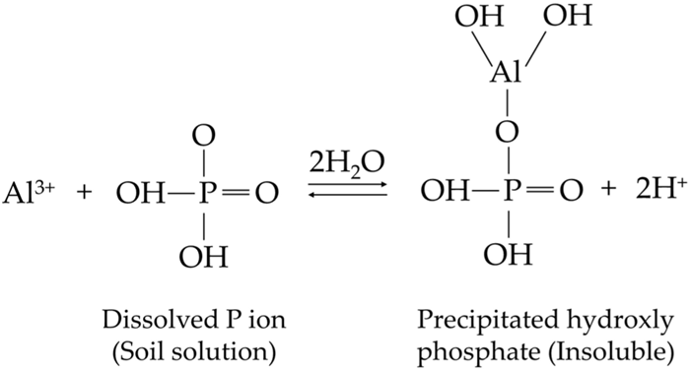
Figure 2: Precipitation reaction in the phosphorus fixation process [Brady and Weil, 2008,]
Anion exchange reaction in the phosphorus fixation process
Anion exchange reactions occur when negatively charged orthophosphate ions are attracted to positively charged sites that develop under acidic conditions, particularly on the surfaces of aluminium or iron oxides and the broken edges of kaolinite clays (Havlin et al., 2013).
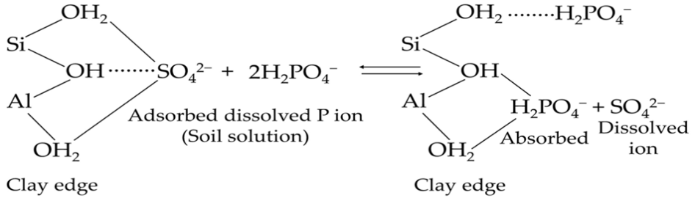
Figure 3. Anion exchange reaction in the phosphorus fixation process [Brady and Weil, 2008,].
Phosphorus adsorption via ligand exchange on aluminium oxides
In this process, phosphate attaches directly to exposed surface sites, forming covalent bonds without a water molecule acting as a bridge. At first, phosphorus links to a single aluminium ion through an Al–O–P bond, where it remains relatively easy to release. As the reaction progresses, a second oxygen atom from the phosphate replaces another hydroxyl group, producing a stable ring structure that connects two aluminium ions. Once this bond network is established, the phosphorus becomes tightly incorporated into the oxide mineral, making its return to the soil solution highly unlikely.
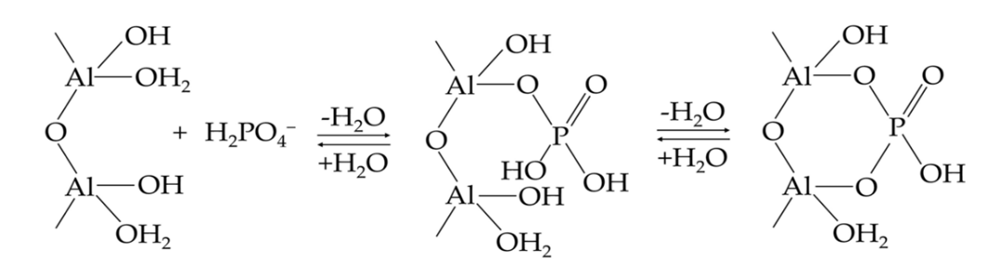
Figure 4. Phosphorus adsorption via ligand exchange on aluminium oxides [Brady and Weil, 2008]
The occlusion of adsorbed phosphorus
adsorbed phosphorus can become trapped when iron or aluminium oxide coatings precipitate onto soil mineral surfaces. Once enclosed in this way, the phosphorus is referred to as occluded P (Syers, 1983).
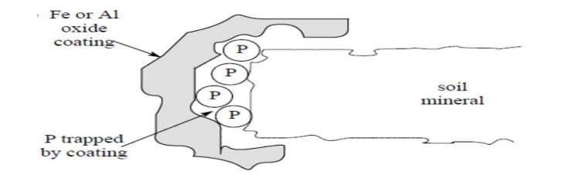
Figure 5. The occlusion of adsorbed phosphorus [Syers, 1983]
Phosphorus use efficiency and accumulation of phosphorus:
The widespread use of phosphorus (P) fertilizers has been central to boosting crop yields, but their efficiency is relatively poor, with crops typically absorbing only 18–20% of the applied P in the year of use (Sattari et al., 2012). The remainder is largely immobilized in the soil through sorption and precipitation, leading to the gradual build-up of legacy P. This creates a twofold problem like, while soils may contain substantial total P reserves, much of it remains inaccessible to plants and excess P can be lost through runoff and erosion, contributing to eutrophication in aquatic systems (Rowe et al., 2016). Addressing this issue requires improving phosphorus-use efficiency by enhancing crop uptake and developing approaches to better mobilize and utilize legacy P reserves.
Factor influencing Phosphorus dynamics:
As discussed in the previous section, P gets transformed and fixed into less available P forms in the soil. A number of factors that involved in these transformations which are discussed in this section:
pH:
Soil pH plays a critical role in regulating phosphorus (P) availability to plants. In general, the relative availability of P species follows the trend H₂PO₄⁻ > HPO₄²⁻ > PO₄³⁻, though this order varies with soil pH (Havlin et al., 2013). At near-neutral pH (~7.2), the monovalent (H₂PO₄⁻) and divalent (HPO₄²⁻) orthophosphate species occur in approximately equal proportions. P availability is highest at near-neutral soil pH, where both adsorption and precipitation processes are minimized (Mishra et al., 2017; Blaise et al., 2018).
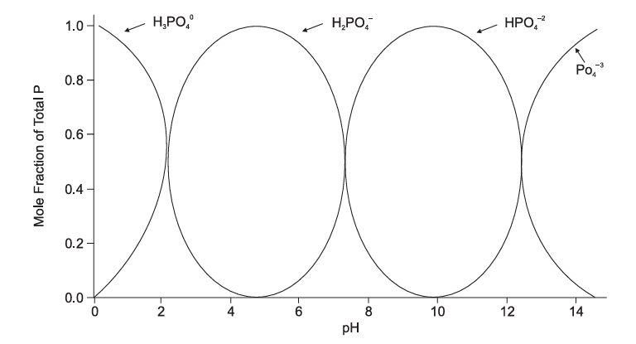
Figure 6: Relation of pH with mole fraction of total P
Cation/Anion effects:
Soils with higher concentrations of di- and tri-valent cations (e.g. Ca²⁺, Mg²⁺, Al³⁺, Fe³⁺) generally exhibit greater P-fixation capacity compared to those dominated by monovalent cations. As a result, phosphorus availability to plants is reduced (Blaise et al., 2018).
Soil texture:
Soils with finer texture are generally more prone to phosphorus fixation than coarse-textured soils, as the extent of fixation is strongly influenced by clay content. The mechanism of fixation in clay-rich soils occurs primarily through two pathways: (i) adsorption of phosphate ions onto the positively charged edges of clay minerals and (ii) specific adsorption by the oxides of Fe and Al associated with clay surfaces (Blaise et al., 2018).
Hydrous oxides of Fe/Al:
Fe/Al oxides and hydrous oxides are abundant in acidic soils and their presence is primarily responsible for the high phosphorus (P) retention observed in these soils. The active forms of Al and Fe are commonly associated with both organic fractions (mainly Al–humus complexes) and mineral fractions (such as ferrihydrite). These oxidized secondary minerals strongly interact with phosphate ions, binding them either through adsorption or precipitation reactions. As a result, P becomes temporarily unavailable to plants and microbes (Havlin et al., 2014).
Calcium carbonate:
In calcium-rich calcareous soils, the solubility of phosphorus (P) is largely governed by reactions with calcium compounds. Much of the P becomes fixed either through the formation of dicalcium phosphate or by attaching to calcite surfaces, where it forms stable calcium–carbonate–phosphate complexes (Havlin et al., 2014).
Silicate minerals:
Soils formed from volcanic ash, such as Andisols, have an exceptionally high capacity to retain phosphorus (P) (Mishra et al., 2017). Among clay minerals, kaolinitic clays fix more P than smectite or montmorillonite clays. This is because kaolinite has variable charges, particularly along its crystal edges, which provide favourable sites for phosphate binding (Blaise et al., 2018).
Soil organic matter (SOM):
Soil organic matter (SOM) is the main reservoir of organic phosphorus (P) in soils. This is because organic matter decomposition releases different organic anions that can bind with Fe and Al, forming stable complexes. These complexes prevent Fe and Al from reacting with phosphate ions, thereby reducing the formation of non-labile (unavailable) P and helping maintain P in more available forms (Mishra et al., 2017).
Microbial biomass:
Soil microbial biomass plays a key role in phosphorus (P) dynamics. First, it acts as the main driver in converting organically bound P into plant-available forms such as solution and labile P. Second, it serves as a reservoir, temporarily storing a significant pool of P within microbial cells. Beyond these direct roles, microbes also influence P availability indirectly—by altering soil pH and releasing organic molecules during the decomposition of organic matter, which can further mobilize P (Mishra et al., 2017).
Anaerobic condition:
Under waterlogged or anaerobic conditions, phosphorus (P) is often released into the soil solution through the reductive dissolution of ferric hydroxides that hold P. This makes the redox status of a soil a critical factor in determining its ability to retain or release P. Other contributing mechanisms include the dissolution of occluded P, enhanced mineralization of organic P in acidic soils and increased solubility of calcium-bound P in calcareous soils. Together, these processes improve P mobility and diffusion, thereby influencing its availability to plants (Havlin et al., 2017).
Soil Microorganisms Mediating Phosphorus Availability:
Microorganisms are central players in soil phosphorus (P) dynamics, as they strongly influence the availability of P to plants (Richardson and Simpson, 2011). Soil microorganisms improve the ability of plants to access P through several complementary mechanisms:
Stimulation of root growth and development:
Microbes can enhance root acquisition capacity either via symbiotic associations such as mycorrhiza, which extend the effective root system or by producing hormones that stimulate root growth, branching and root hair formation. For example, microbial production of indole-3-acetic acid (IAA), gibberellins (GAs) and enzymes such as 1-aminocyclopropane-1-carboxylate (ACC) deaminase alters plant ethylene metabolism, leading to improved root architecture (Richardson and Simpson, 2011; Hayat et al., 2010).
Modification of soil P equilibria:
Microorganisms can shift sorption–desorption dynamics, thereby increasing the net transfer of orthophosphate ions into soil solution. They may also enhance the mobility of organic P, either directly through the release of exudates or indirectly via microbial turnover (Seeling and Zasoski, 1993).
Direct solubilization and mineralization of P
This includes proton and organic acid efflux, production of siderophores that chelate Fe and Al, and secretion of extracellular enzymes such as phosphatases and cellulolytic enzymes, which hydrolyze organic P compounds and mineralize plant residues (Ryan et al., 2001).
Biodiversity of PSM (Sharma et al., 2013).
Table 2- Microorganisms Commonly Involved in Soil and Plant Interactions
Bacteria | Bacillus sp., Bacillus circulans, B.cereus, B.fusiformis, B. pumils, B. megaterium, B. mycoides, B. polymyxa, B. coagulans B,.chitinolyticus, B. subtilis, Pseudomonas sp., P putida, P. striata, P. fluorescens,
Fungi | Aspergillus awamori, A. niger, A. tereus, A. flavus, A. nidulans, A. foetidus, A. wentii. Fusarium oxysporum,
Actinomycetes | Actinomyces, Streptomyces.
Cyanobacteria | Anabena sp., Calothrix braunii, Nostoc sp., Scytonema sp.,
VAM | Glomus fasciculatum
Management:
Improving phosphorus management in agricultural systems involves addressing low nutrient use efficiency, P fixation and the accumulation of legacy phosphorus in soils. Applying fertilizers in a balanced manner on based of soil testing, can prevent over-application and reduce unnecessary buildup (Withers et al., 2014). Advanced fertilizers, such as slow-release types or those enriched with organic acids, help limit fixation and improve plant availability of phosphorus (Shen et al., 2011). Incorporating organic amendments like compost or manure enhances soil microbial activity, which mobilizes bound phosphorus (Nziguheba et al., 2016). The use of phosphate-solubilizing microorganisms and mycorrhizal fungi also increases plant access to fixed phosphorus (Richardson and Simpson, 2011). Additionally, agronomic practices like crop rotation, cover cropping and minimum tillage improve phosphorus mobilization and root uptake (Simpson et al., 2011). Emerging strategies focus on mobilizing legacy phosphorus through microbial inoculants, manipulating root exudates and breeding crops with higher phosphorus-use efficiency, offering sustainable long-term solutions (Rowe et al., 2016).
Phosphorus in Aquatic Ecosystems
Forms of P in aquatic system (Jarvie et al., 2002):
Category | Sub type | examples | notes
Dissolved Inorganic P | Orthophosphate ions | H₂PO₄⁻, HPO₄²⁻, PO₄³⁻ | Most bioavailable form of P
Dissolved Inorganic P | Condensed inorganic phosphates | Pyrophosphate, metaphosphate, polyphosphates | Hydrolyzable to orthophosphate
Dissolved Organic P | Condensed organic phosphates | ATP (adenosine triphosphate) | Biologically active energy molecules
Dissolved Organic P | Other organic P compounds | Sugar phosphates, inositol phosphates, phospholipids, phosphoproteins, phosphoamides | May require enzymatic hydrolysis to be bioavailable
Particulate Organic P | Cellular material | Associated with plant, animal, and bacterial biomass | Includes both structural and storage forms
Particulate Inorganic P | Mineral P forms | Hydroxyapatite, brushite, fluoroapatite, variscite, stringite, wavellite | Often derived from geological or sediment sources
Particulate Inorganic P | Sorbed P | Bound to clays, clay-organic complexes, metal oxides/hydroxides | Typically less available; can be released under changing redox/pH conditions
Table 3- Classification of Phosphorus Forms in the Environment
Phosphorus cycling in aquatic ecosystem:
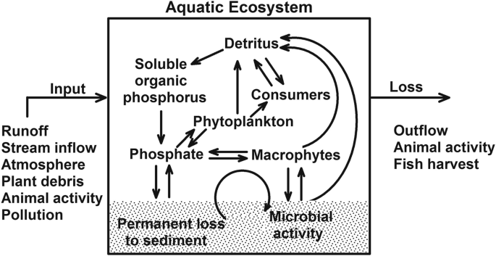
Fig 7- Aquatic Ecosystem
Phosphorus dynamics in aquatic ecosystems, including rivers, lakes, wetlands and oceans, are governed by a complex interplay between inputs, internal cycling and outputs. In aquatic ecosystems, phosphorus enters mainly through runoff, stream inflow, atmospheric deposition, plant debris, animal activity and pollution (Smith et al., 2006; Schindler et al., 2008). phosphorus occurs primarily as dissolved inorganic forms, such as phosphate and dissolved organic forms, which is readily taken up by phytoplankton and macrophytes, supporting primary production. Through consumption, phosphorus moves to higher trophic levels and upon death or excretion, organic matter and detritus return phosphorus back into the water. Microbial activity plays a key role in mineralizing organic phosphorus into soluble forms, making it available again for uptake.
Sedimentation represents a significant pathway for phosphorus loss from the active cycle, as particles settle to the benthic zone where phosphorus may become permanently buried or temporarily stored in sediments. Under certain conditions, such as hypoxia, sediment-bound phosphorus can be released back into the water column, a process known as internal loading, which can exacerbate eutrophication. Output pathways include water outflow, fish harvest, and animal migration, which remove phosphorus from the system. The balance between these inputs, transformations, and losses determines the trophic status of the water body and its susceptibility to nutrient enrichment problems (Carpenter et al., 1998).
Challenges:
High phosphorus inputs from agricultural runoff, erosion, sewage discharge and industrial waste are among the main causes of eutrophication in aquatic ecosystems. Because phosphorus usually limits productivity in these systems, its excess availability fuels explosive growth of algae and phytoplankton, often resulting in harmful blooms. As these blooms collapse and decompose, oxygen levels in the water are depleted, creating hypoxic or anoxic conditions that harm fish and other aquatic organisms. In addition, phosphorus that has accumulated in sediments can be released back into the water under oxygen-poor conditions, further intensifying eutrophication through internal recycling (Correll, 1998). This feedback loop leads to long-term declines in water quality, disrupts ecosystem balance, and poses serious ecological and human health challenges.
A groundwater quality assessment in the Palar and Cheyyar River basins of Tamil Nadu revealed that over one-third of samples contained phosphate concentrations above permissible drinking water standards, with agricultural inputs identified as the main source of contamination and a call made for improving fertiliser efficiency (Rajmohan and Elango, 2005). By contrast, a study in the north-central and north-western agricultural regions of Sri Lanka showed that fertiliser use was often six to ten times higher than government recommendations; however, phosphate levels in groundwater generally remained within safe limits. Nonetheless, some lakes in the region exhibited high concentrations (>21.7 mg l⁻¹) and signs of eutrophication, attributed to excessive fertiliser application and livestock use of water bodies (Young et al., 2010).
Management:
Managing eutrophication mainly involves cutting down the flow of excess nutrients especially phosphorus and nitrogen that fuel algal blooms and oxygen loss in water bodies. Effective measures include upgrading wastewater treatment systems to better remove nutrients, using precision farming to limit fertilizer losses, creating buffer zones and wetlands to filter runoff and applying responsible manure management practices. Within lakes, short-term fixes such as aeration, adjusting fish populations or applying phosphorus-binding agents like alum can help, but lasting improvements depend on reducing nutrient pollution at the watershed scale (Paerl et al., 2016). In the long run, tackling eutrophication successfully requires a mix of practical technologies, strong policies and active involvement from local communities and stakeholders.
Table 4-Comparative analysis of P dynamics in different ecosystems
Aspect | Terrestrial ecosystem | Aquatic ecosystem | Wetland ecosystem | Agroecosystem
Dominant P form | Inorganic +organic P | Dissolved Reactive P | Organic and Dissolved Reactive P | Inorganic (Fertilizer-based)
Key inputs | Weathering, litter | Runoff, Sediment | Runoff, Sediment | Fertilizer, Manure
Outputs | Leaching, uptake | Sedimentation, Algal Uptake | Sedimentation | Crop Harvest, Runoff
P retention mechanism | Soil binding (Fe and Al oxides) | Sediment adsorption | Sediment adsorption | Soil fixation, Accumulation
Limiting Factor | Organic P mineralization | Internal loading | Internal loading | Over-application, Erosion
Human impact | Low to medium | High (eutrophication) | High (eutrophication) | Very high

Conclusion:
- Phosphorus availability and cycling differ across terrestrial and aquatic ecosystems due to fixation in soil and mobility in aquatic ecosystem.
- Human-induced inputs (e.g. fertilizers, runoff) disrupt natural P dynamics, causing issues like eutrophication which cause negative impact on human and biodiversity.
- Long-term P buildup in soil, which can contribute to environmental pollution even years after inputs stop thus there is need to utilized accumulated phosphorus in agroecosystem.
- Phosphorus fixation in soils and low use efficiency limit crop productivity and demand improved management approaches.
- Studying phosphorus dynamics is key to sustainable nutrient management, environmental protection and food security.
References:
Alewell, C., Ringeval, B., Ballabio, C., Robinson, D. A., Panagos, P. and Borrelli, P. (2020). Global phosphorus shortage will be aggravated by soil erosion. Nature Communications, 11, 4546.
Blaise, D., Venugopalan, M. V. and Singh, G. (2018) Phosphorus Management. Textbook of plant nutrient management. Pp 96-118.
Brady, C. N. and Weil, R. R. (2008) The Nature and Properties of Soils, 14th Ed; Pearson Prentice Hall, New Jersey. 975.
Campbell, L. B. and Racz, G. J. (1975). Organic and inorganic P content, movement and mineralization of P in soil beneath a feedlot. Canadian Journal of Soil Science. 55, 457-466.
Carpenter, S. R. (2008). Phosphorus control is critical to mitigating eutrophication. Proceedings of the National Academy of Sciences, 105(32), 11039–11040.
Chapin, F. S., Matson, P. A., & Vitousek, P. M. (2011). Principles of terrestrial ecosystem ecology. Springer.
Condron, L. M., Turner, B. L. and Cade-Menun, B. J. (2005). Chemistry and dynamics of soil organic phosphorus. Agriculture and the Environment. 87–121
Cordell, D. and White, S. (2014) Life’s Bottleneck: Sustaining the World’s Phosphorus for a Food Secure Future. Annual Review of Environment and Resources. 39, 161–188.
Cordell, D., Drangert, J. O. and White, S. (2009). The story of phosphorus: Global food security and food for thought. Global Environmental Change, 19(2), 292–305.
Correll, D. L. (1998). The role of phosphorus in the eutrophication of receiving waters: A review. Journal of Environmental Quality, 27(2), 261–266.
Devau, N., Le Cadre, E., Hinsinger, P. and Gerard, F. (2010) A mechanistic model for understanding root-induced chemical changes controlling phosphorus availability. Annexure of Botany. 105, 1183–1197.
Duhamel, S. (2025) The microbial phosphorus cycle in aquatic ecosystems. Nature Reviews Microbiology. 23(4), 239–255.
Elser, J. and Bennett, E. (2011). Phosphorus cycle: A broken biogeochemical cycle. Nature, 478(7367), 29–31.
Gerard, F. (2016) Clay minerals, iron/aluminium oxides, and their contribution to phosphate sorption in soils—A myth revisited. Geoderma. 262, 213–226.
Havlin, J. L., Tisdale, S. L., Nelson, W. L. and Beaton, J. D. (2013) Soil Fertility and Fertilizers; Pearson Inc.: London, UK, 2013.
Havlin, J. L., Tisdale, S. L., Nelson, W. L., and Beaton, J. D. (2014). Soil Fertility and Fertilizers (8th ed.). Pearson.
Hayat, R., Ali, S., Amara, U., Khalid, R. and Ahmed, I. (2010) Soil beneficial bacteria and their role in plant growth promotion: a review. Annual in Microbiology. 60, 579–598.
Jarvie, H. P. (2013). Phosphorus mitigation to control river eutrophication: Murky truths and clear targets. Journal of Environmental Quality. 89(26), 79-87.
Jin, Y., Chen, L., He, P., Wang, D. and Hu, J. (2024). Atmospheric deposition and river runoff stimulate the utilization of dissolved organic phosphorus in coastal seas. Science of the Total Environment, 905, 167357.
Johan, P. D., Ahmed, O. H., Omar, L. and Hasbullah, N. A. (2021) Review Phosphorus Transformation in Soils Following Co-Application of Charcoal and Wood Ash. Agronomy. 11, 2-25.
Johnson, A. H., Frizano, J. and Vann, D. R. (2003). Biogeochemical implications of labile phosphorus in forest soils determined by the Hedley fractionation procedure. Oecologia, 135(4), 487–499.
Kruse, J., Abraham, M., Amelung, W., Baum, C., Bol, R., Kuhn, O., Lewandowski, H., Niederberger, J., Oelmann, Y., Ruger, C., Santner, J., Siebers, M., Siebers, N., Spohn, M., Vestergren, J., Vogts, A. and Leinweber, P. (2015) Innovative methods in soil phosphorus research: A review. Journal of Plant Science and Soil Science, 178(1), 43-88.
Larsen, S. (1967) Soil phosphorus. In Advances in Agronomy; Academic Press: Cambridge, MA, USA, 1967. 151–210.
Lindsay, W. L., Vlek, P. L. and Chien, S. H. (1989) Phosphate minerals. Soil Environment. 1, 1089–1130.
McGroddy, M. E., Daufresne, T., & Hedin, L. O. (2004). Scaling of C:N:P stoichiometry in forests worldwide: Implications of terrestrial redfield-type ratios. Ecology, 85(9), 2390–2401.
Mishra, G., Debnath, S. and Rawat, D. (2017) Managing phosphorus in terrestrial ecosystem: a review. European Journal of Biological Research.7(3),255-270.
Nash, D. M., Haygarth, P. M., Turner, B. L., Condron, L. M., McDowell, R. W., Richardson, A. E., Watkins, M. and Heaven, M. W. (2014) Using organic phosphorus to sustain pasture productivity: A perspective. Geoderma. 221,11-19.
Nziguheba, G., Palm, C. A., Chianu, J. N. and Bationo, A. (2016). Recycling of organic amendments for soil fertility improvement in tropical agroecosystems. Advances in Agronomy, 138, 155–209.
Olibone, D. and Rosolem, C. A. (2010) Phosphate fertilization and phosphorus forms in an Oxisol under no-till. Scientia Agricola. 67, 465-471.
Paerl, H. W., Scott, J. T., McCarthy, M. J., Newell, S. E., Gardner, W. S., Havens, K. E., Hoffman, D. K., Wilhelm, S. W. and Wurtsbaugh, W. A. (2016). It takes two to tango: When and where dual nutrient (N & P) reductions are needed to protect lakes and downstream ecosystems. Environmental Science & Technology, 50(20), 10805–10813.
Pierzynski, G. M., McDowell, R. W., and Sims, J. T. (2002). Chemistry, cycling, and potential movement of inorganic phosphorus in soils. Phosphorus: Agriculture and the Environment, 5, 53–86.
Plaxton, W. C. and Tran, H. T. (2011). Metabolic adaptations of phosphate-starved plants. Plant Physiology, 156 (3), 1006–1015.
Prasad, R. and Chakraborty, D. (2019) Phosphorus Basics: Understanding Phosphorus Forms and their Cycling in the Soil. Extension. 15-19.
Raghothama, K. G. (1999). Phosphate acquisition. Annual Review of Plant Physiology and Plant Molecular Biology, 50 (1), 665–693.
Rajmohan, N. and Elango, L. (2005). Nutrient chemistry of groundwater in an intensively irrigated region of southern India. Environmental Geology. 47, 820-830.
Richardson, A. E and Richard, S. J. (2011) Soil microorganisms mediating phosphorus availability update on microbial phosphorus. Plant Physiology. 156(3), 986-996.
Richardson, A. E. and Simpson, R. J. (2011). Soil microorganisms mediating phosphorus availability. Plant Physiology, 156(3), 989–996.
Richardson, S. J., Peltzer, D. A., Allen, R. B., McGlone, M. S. and Parfitt, R. L. (2009). Rapid development of phosphorus limitation in temperate rainforest along the Franz Josef soil chronosequence. Oecologia, 159(1), 149–157.
Rodolfo Lizcano-Toledo, Marino Pedro Reyes-Martín, Luisella Celi and Emilia Fernández-Ondoño (2021) Phosphorus Dynamics in the Soil–Plant–Environment Relationship in Cropping Systems: A Review. Applied Science.11, 111-133.
Rowe, H., Withers, P. J. A. and Baas, P. (2016). Managing legacy phosphorus for sustainable agriculture. Advances in Agronomy, 137, 145–203.
Rowe, H., Withers, P. J. A., Baas, P., Chan, N. I., Doody, D., Holiman, J., Jacobs, B., Li, H., MacDonald, G. K., McDowell, R., Sharpley, A., Shen, J., Taheri, W., Wallenstein, M. and Weintraub, M. N. (2016). Integrating legacy soil phosphorus into sustainable nutrient management strategies for future food, bioenergy and water security. Nutrient Cycling in Agroecosystems, 104(3), 393–412.
Ryan, P. R., Delhaize, E. and Jones, D. L. (2001) Function and mechanism of organic anion exudation from plant roots. Annual Review of Plant Physiology and Plant Molecular Biology. 52: 527–560
Sattari, S. Z., Bouwman, A. F., Giller, K. E. and van Ittersum, M. K. (2012). Residual soil phosphorus as the missing piece in the global phosphorus crisis puzzle. Proceedings of the National Academy of Sciences, 109(16), 6348–6353.
Schindler, D. W. (2012). The dilemma of controlling cultural eutrophication of lakes. Proceedings of the Royal Society B: Biological Sciences, 279(1746), 4322–4333.
Schindler, D. W., Hecky, R. E., Findlay, D. L., Stainton, M. P., Parker, B. R., Paterson, M. J. and Shearer, J. A. (2006). Eutrophication of lakes cannot be controlled by reducing nitrogen input: Results of a 37-year whole-ecosystem experiment. Proceedings of the National Academy of Sciences, 105(32), 11254–11258.
Seeling, B. and Zasoski, R. J. (1993) Microbial effects in maintaining organic and inorganic solution phosphorus concentrations in a grassland topsoil. Plant and Soil. 148, 277–284.
Sharma, S. B., Riyaz, Z. S., Trivedi, M. H. and Thivakaran, A. (2013) Phosphate solubilizing microbes: sustainable approach for managing phosphorus deficiency in agricultural soils. Springer Plus. 2, 587.
Sharpley, A. N., Chapra, S. C., Wedepohl, R., Sims, J. T., Daniel, T. C., & Reddy, K. R. (1994). Managing agricultural phosphorus for protection of surface waters: Issues and options. Journal of Environmental Quality, 23(3), 437–451.
Shen, J., Yuan, L., Zhang, J., Li, H., Bai, Z., Chen, X. and Zhang, F. (2011). Phosphorus dynamics: From soil to plant. Plant Physiology, 156(3), 997–1005.
Shen, J., Yuan, L., Zhang, J., Li, H., Bai, Z., Chen, X., Zhang, W. and Zhang, F. (2011) Phosphorus dynamics: From soil to plant. Plant Physiology. 156(3), 997-1005.
Shinjiro. S. (2003) Phosphorus sorption and desorption in a Brazilian Ultisol: Effects of pH and organic anions on phosphorus bioavailability. University of Florida. 2003; 1-11.
Simpson, R. J., Richardson, A. E. and Simpson, R. J. (2011). Agronomic strategies to improve phosphorus availability. Plant and Soil, 349, 15–22.
Smith, V. H., and Schindler, D. W. (2009). Eutrophication science: where do we go from here? Trends in Ecology & Evolution, 24(4), 201–207.
Smith, V. H., Tilman, G. D., and Nekola, J. C. (2006). Eutrophication: Impacts of excess nutrient inputs on freshwater, marine, and terrestrial ecosystems. Environmental Pollution, 100(3), 179–196.
Stewart, J. W. B. and Tiessen, H. (1987). Dynamics of soil organic phosphorus. Biogeochemistry, 4(1), 41–60.
Stutter, M. L., Shand, C. A., George, T. S., Blackwell, M. S., Bol, R., MacKay, R. L., Richardson, A. E. and Condron, L. M. (2012) Recovering phosphorus from soil - A root solution. Environmental Science and Technology. 46, 1977-1978.
Syers, J. K. and Cornforth, I. S. (1983) Chemistry of soil fertility. In Proceedings of the New Zealand Institute of Chemistry Annual Conference, Hamilton, OH, USA, 1983.
Syers, J. K., Johnston, A. E. and Curtin, D (2008) Efficiency of soil and fertilizer phosphorus: reconciling changing concepts of soil phosphorus behaviour with agronomic information. FAO Fertilizer and Plant Nutrition Bulletin, FAO, Rome. 108.
Tiessen (2008) The Ecophysiology of Plant-Phosphorus Interactions. Springer, 1
Turner, B. L., Mahieu, N. and Condron, L. M. (2002) Quantification of myo-inositol hexa-Kis-phosphate in alkaline soil extracts by solution 31P NMR spectroscopy and spectral deconvolution. Soil Science, 167(5), 327–339.
Vance, C. P., Uhde-Stone, C. and Allan, D. L. (2003) Phosphorus acquisition and use: critical adaptations by plants for securing a non-renewable resource. New Phytologist, 157 (3), 423–447.
Vitousek, P. M., Porder, S., Houlton, B. Z. and Chadwick, O.A. (2010) Terrestrial phosphorus limitation: Mechanism, implication and nitrogen-phosphorus interaction. Ecology applied. 20, 5-15.
Vitousek, P. M., Porder, S., Houlton, B. Z., & Chadwick, O. A. (2010). Terrestrial phosphorus limitation: Mechanisms, implications, and nitrogen–phosphorus interactions. Ecological Applications, 20(1), 5–15.
Withers, P. J. A. and Johnston, A. E. (2018). Soil phosphorus management: Challenges and opportunities. Advances in Agronomy, 147, 1–43.
Withers, P. J. A., Sylvester-Bradley, R., Jones, D. L., Heal, K. V., Talboys, P. J. and Powlson, D. S. (2014) Managing phosphorus in agriculture for food security and environmental protection. Soil Use and Management, 30(4), 390–400.
Young, S. M., Pitawala, A. and Gunatilake, J. (2010). Fate of phosphate and nitrate in waters of an intensive agricultural area in the dry zone of Sri Lanka. Paddy Water Environment. 8, 71-79.

