Reasoning Behind Soil Fertilisation Under Cotton Trees Based On The Relationship Between The Sum Of Exchangeable Bases (SBE) And Mineralisable Nitrogen (N-NH₄⁺)

ABSTRACT

Contributing to improving cotton productivity by fertilising the soil in a sustainable manner. The experiment was conducted in a farming environment, with two one-hectare plots of farmland demarcated in each section. The study was conducted in 2019–2020 in the cotton-growing region of Ouangolodougou, Côte d'Ivoire. Two one-hectare plots of farmland were marked out. One plot served as a control and was fertilised solely with 15-15-15 NPK. The second plot, known as the test plot, received inputs corresponding to the predetermined recommendation using the N-NH₄⁺ approach (Tié, 1995). This involved applying 200 kg of NPK (15-15-15), 100 kg of dolomite with 30% CaO, 50 kg of urea with 46% N and 50 kg of KCl with 60% K2O per hectare. Observations focused on plant height, number of fruiting and vegetative branches, internodes, capsules and yield. The study showed widespread potassium deficiency, as well as calcium and magnesium deficiency in some cases. Agronomic results revealed a significant improvement in growth parameters (height, number of fruiting branches, internodes, capsules) and yields (increased by a factor of 8 to 12) in plots fertilised according to the recommended approach. Statistical analysis confirmed the effectiveness of this adapted fertilisation, showing that the approach based on N-NH₄⁺ and SBE diagnosis optimises the use of inputs, increases productivity and preserves soil quality. The study validates the hypothesis that rational fertilisation, based on an accurate fertility diagnosis, significantly improves cotton yields, unlike standard doses that are not tailored to specific needs. It illustrates the importance of localised and rational fertiliser management in ensuring the sustainability and competitiveness of the Ivorian cotton industry.

Keywords : cotton ; Sustainable fertilisation ; N-NH₄⁺ factor ; Ouangolodougou ; Côte d'Ivoire.

1. INTRODUCTION

The cotton plant (Gossypium hirsutum L.) is the most widely cultivated fibre plant in the world (Gérardeaux, 2009). In Côte d'Ivoire, it occupies a strategic position, both economically and socially. It is the country's fourth largest cash crop and plays a major role in the agricultural sector and in the socio-economic development of rural populations in the northern regions (Stessens, 2002; Paul-Kévin & Olivier, 2021). Cotton cultivation directly or indirectly provides a livelihood for around 3.5 million people (Edmond, 2015). In addition, it generates around 7% of national export earnings and contributes 1.7% to the national GDP (Koffi, 2013; Anonymous, 2015). Annual production is estimated at around 120 billion CFA francs, making Côte d'Ivoire one of the leading cotton producers in the West African sub-region (Berti et al., 2006). However, cotton productivity is often limited by the gradual degradation of soil fertility, characterised in particular by significant nutrient deficiencies in essential elements (Hinimbio, 2019). These deficiencies, typical of African savannah soils, have negative implications for crop intensification (Koutouan et al., 2017). Indeed, strong pressure on land due to population growth limits the setting aside of arable land (Ama-Abina et al., 2012). For several decades, this situation has forced cotton farmers to resort to the use of chemical fertilisers in order to increase yields (Adingra, 2002). However, excessive use of these chemical fertilisers leads to soil acidification and degradation of soil physical properties, in addition to causing a decline in organic matter. These phenomena are therefore a major obstacle to achieving optimal yields and the sustainability of cotton production systems (Bado, 2002 ; Konate et al., 2013). In this context, it appears necessary to adopt sustainable fertilisation practices in order to maintain good yields while preserving soil quality in cotton-growing regions (Soumanou, 2023). Indeed, controlling soil fertilisation is an essential lever for improving agronomic performance while limiting the negative environmental impacts associated with over-fertilisation (Assemien, 2018). Sustainable fertilisation is also a key element in ensuring sustainable crop production, as it is based on an accurate diagnosis of soil fertility and on adapting inputs to the actual needs of crops. This strategy optimises the quantity and quality of fertiliser inputs used, thereby maximising agricultural profitability. It is within this framework that the present study aims to assess the chemical fertility status of soils under cotton trees and to propose fertilisation strategies adapted to the deficiencies identified.

2. MATERIAL AND METHODS

2.1 Study site

The work was carried out in the cotton-growing basin of the Ouangolodougou department, located in the north of Côte d'Ivoire, in the Tchologo region. This basin is bordered by the Ferkessédougou department to the south-east, the Sinématiali department to the south and the M'Bengué department to the south-west. The climate of this basin is Sudanese, marked by two alternating seasons: a dry season from November to April, characterised by the Harmattan wind, which peaks in December and February, and heat waves in March and April. The rainy season lasts from May to October, with peaks in August and September. Average annual rainfall is between 1,000 and 1,200 mm (Coulibaly et al., 2016). The vegetation is characterised by a mosaic of wooded Guinean (or sub-Sudanese) savannah and gallery forest around watercourses (thalwegs).

2.2 Material

2.2.1 Biological material

The biological material used in this study consists of the cotton plant Gossypium hirsutum Linné, a species cultivated in Côte d'Ivoire. The seed used is the Gouassou F1 variety, recommended and distributed free of charge to farmers by the Société d'Exploitation Cotonnière (SECO) mainly for its tolerance to certain diseases.

2.2.2 Field technical equipment

The technical equipment used included a machete to clear the plots, and a 100-metre tape measure to mark out the plots and measure the height of the plants. An auger was used to take soil samples from all the plots.
2.2.3 Laboratory equipment

In the laboratory, two types of equipment were used: one to prepare the soil samples for analysis and the other for the analyses themselves. The equipment used to prepare the soil samples included a precision electronic balance and a centrifugal ball mill, which were used, in that order, to weigh the soil samples to be analysed and then grind them. A mechanical reciprocating stirrer was also used to homogenise the soil solutions. For the analyses, a centrifuge was used for the granulometric separation of the soil samples. Vials and beakers were used to collect the soil solutions, an atomic absorption spectrometer (AAS) was used to measure exchangeable bases and phosphorus, and a Kjeldahl distiller was used to measure nitrogen.

2.2.4 Chemical inputs

The inputs used include mineral fertilisers and insecticides. Mineral fertilisers, namely NPK (15-15-15), urea (46 % N), dolomite (30 % CaO) and potassium chloride KCl (60 % K2O), were used to fertilise the soil. The insecticides used are Thalis 56 EC, Duel 336 and Conquest 88EC. They were used to control cotton pests.

2.3 Methods

2.3.1 Assessment of the chemical fertility of soil on smallholdings

2.3.1.1 Soil sampling

The sampling was carried out just after the first rains of May 2018. The land, which is generally flat and homogeneous, was sampled twenty times using an auger on the entire surface of the ridges. The auger was inserted vertically into the soil to a depth of 15 cm, corresponding to the useful depth exploited by the assimilating roots (Tié, 2019). The auger was turned to cut and remove an entire soil core, then carefully withdrawn. The contents of the auger (soil) were collected in a bucket. As the samples were taken, they were mixed in the bucket to form a composite sample per hectare. Samples were taken along uncrossed lines spaced 20 metres apart, maintaining a minimum distance of 25 metres between each sampling point and 1 metre between the lines and the edges of the field. The auger was cleaned with water between sites to avoid cross-contamination.

2.3.1.2 Determination of soil chemical characteristics

The soil samples collected were dried in the open air, in the shade and protected from sunlight and rain, for at least one week, on newspaper. Once dry, they were crumbled by hand and then sieved using a 2 mm mesh sieve to isolate the fine fraction of the soil (sieve residue), which was sent for laboratory analysis. A 1 kg aliquot of the fine fraction of each composite soil sample was packed in a plastic bag, labelled and sent to the Soil and Plant Analysis Laboratory (LAVESO) of the Higher School of Agronomy (ESA), located at the Félix Houphouët-Boigny National Polytechnic Institute (INP-HB) in Yamoussoukro. The soil characteristics determined were: ammoniacal nitrogen (N-NH₄⁺) and exchangeable bases (Ca²⁺, Mg²⁺, K⁺, Na⁺).
The N-NH₄⁺ in the soil was determined using the method described by Tié (1995): 5 g of fine soil sieved to 2 mm was mixed with 25 ml of 50% technical grade hydrogen peroxide (H₂O₂). The resulting suspension was then placed in an oven at 60°C for 6 hours and diluted with KCl (1 M). The mixture was filtered and distilled using the Kjeldahl method (Scarf, 1988). The exchangeable bases are extracted using the ammonium saturation method at pH = 7. The Ca²⁺, Mg²⁺, K⁺ and Na⁺ contents are determined by atomic absorption spectrometry (Pansus & Gautheyrou, 2003).

2.3.2 Determining soil fertility levels and fertilisation strategies

The overall fertility level of the soil was determined using the diagnostic approach proposed by Tié (1995). This method is based on how the sum of exchangeable bases (SBE) changes in the soil depending on the mineralisable nitrogen (N-NH₄⁺) rate. In general, this change follows a curve that rises to a maximum, around which it levels off, then declines. The growth zone reflects the addition of mineral fertilisers, particularly nitrogen, potassium and phosphorus. The decline zone reflects the addition of calcium and magnesium amendments and phosphate mineral fertilisation. The plateau zone determines fertile soils that do not require additional inputs. Fig. 1 shows an example of how this method is applied (Tié, 2019). Furthermore, in order to diagnose mineral balances and assess relative mineral deficiencies, the characteristics of these chemical balances must be determined and compared with their thresholds, in particular the Mg²⁺/K⁺, Ca²⁺/Mg²⁺ and K⁺/CEC ratios, which provide information on exchangeable base deficiencies. For the Mg²⁺/K⁺ ratio, the desired range is 3 to 25 (Smith et al., 2022). For the Ca²⁺/Mg²⁺ ratio, this range is 3 to 5 (Kumar et al., 2023). The ideal K⁺/CEC ratio is 2 according to Jones (2021).
Once the fertility status of the soil had been determined, fertilisation tailored to each level of soil deficiency was designed in the laboratory to be tested in the field during agronomic trials.

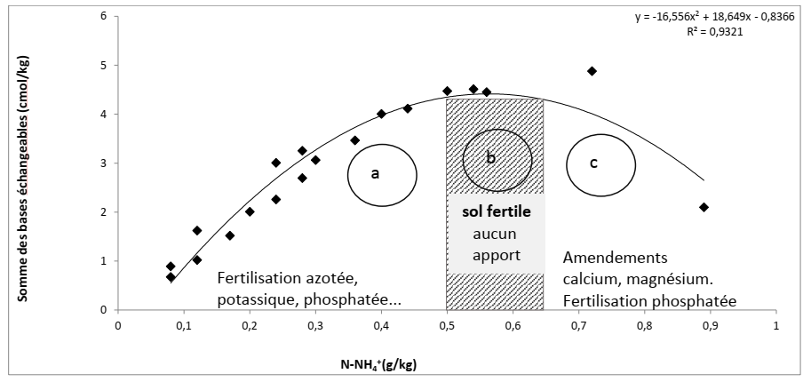
SBE: Sum of Exchangeable Bases, N-NH₄⁺ : Mineralisable nitrogen, Source : Tié, (2019)

Fig. 1. Recommended soil fertilisation practices according to the SBE-(N-NH₄⁺) relationship

2.3.3 Conducting agronomic trials

The trials focused on evaluating recommended fertiliser doses. To this end, an experimental setup was put in place. Thirty cotton plots, each covering at least one hectare, were selected in the department of Ouangolodougou. These were spread across the fifteen (15) sections of the department, with two (2) plots per section. In each section, two smallholder plots covering one hectare were marked out. One plot served as a control and was fertilised only with 15-15-15 NPK. The second plot, known as the test plot, received inputs corresponding to the predetermined recommendation using the N-NH₄⁺ approach (Tié, 1995). This involved applying 200 kg of NPK (15-15-15) and 100 kg of dolomite with 30 % CaO per hectare. 50 kg of urea at 46 % N and 50 kg of KCl at 60 % K2O. The experiment carried out in this way comprises several stages, which are described in the following paragraphs.

2.3.3.1 Soil preparation and sowing

Soil preparation began with clearing. Ploughing was then carried out to loosen the soil by turning it over in strips cut using oxen. Finally, ridging was carried out using yoked oxen.
Sowing was carried out on the same day by all thirty (30) producers on the ridges, in pockets and in rows, using a seed drill. The distance between two rows of seeds was 80 cm, with a spacing of 40 cm between the pockets. Fifteen (15) to twenty (20) kg of cotton seeds were used per hectare, at a rate of 3 to 5 seeds per closed pocket. Thinning was carried out 15 days after emergence (DAE), consisting of keeping only two vigorous plants per pocket.

2.3.3.2 Application of fertiliser doses

Dolomite 30 % CaO was spread on the test plot during ploughing. As for the 15-15-15 NPK, it was applied in closed pockets, approximately 5 to 10 cm from the seed row, on both types of plots (control and test) twenty days after sowing (20 DAS), immediately after thinning. Its application was followed by Canadian dressing on the same day. The spreading of urea at 46 % N and KCl at 60 % K₂O was carried out forty days after sowing (40 DAS) on the test plots, along the seed row, approximately 5 cm from the plants.

2.3.3.3 Insecticide treatments

Insecticide treatments began 45 days after sowing (DAS) with three insecticides of different formulations (Thalis 56 EC, Duel 336 EC and Conquest 88 EC) at a dose of 1 litre per hectare each. Each plot was treated six times with the same product at regular intervals of 15 days until 128 DAS.

2.3.3.4 Data collection

In each plot, an area of 0.50 ha (50 m × 100 m) was marked out for data collection (Fig. 2). From left to right, the 19th, 33rd and 45th seed rows were selected for this purpose. On each of these rows, a 10-metre segment was marked out using two stakes in the following positions : on the 19th row, the first stake was 10 m from the edge and the second 20 m away; for the 33rd and 45th rows, the stakes were 20 and 30 metres from the edge, and then 30 and 40 metres from the edge, respectively.
On each segment, measurements were taken once during the fruiting stage (130 days after sowing). They focused on plant height, measured using a tape measure (in cm), and the number of fruiting and vegetative branches, internodes and capsules per plant, determined by counting. The bolls were counted from the bottom to the top of the plants, branch by branch, to avoid any omissions. Only healthy, well-differentiated bolls were counted. Similarly, the fruiting and vegetative branches and internodes were counted from the bottom to the top of the plants.
Yield was determined at harvest. This involved dividing the total quantity of cotton harvested by the harvest area and reporting the result per hectare (Equation 1).
$R (\frac{t}{ha})=\frac{r x 10000}{s}$ (Equation 1)
R : yield per hectare
r : yield per collection area
s : collection area.
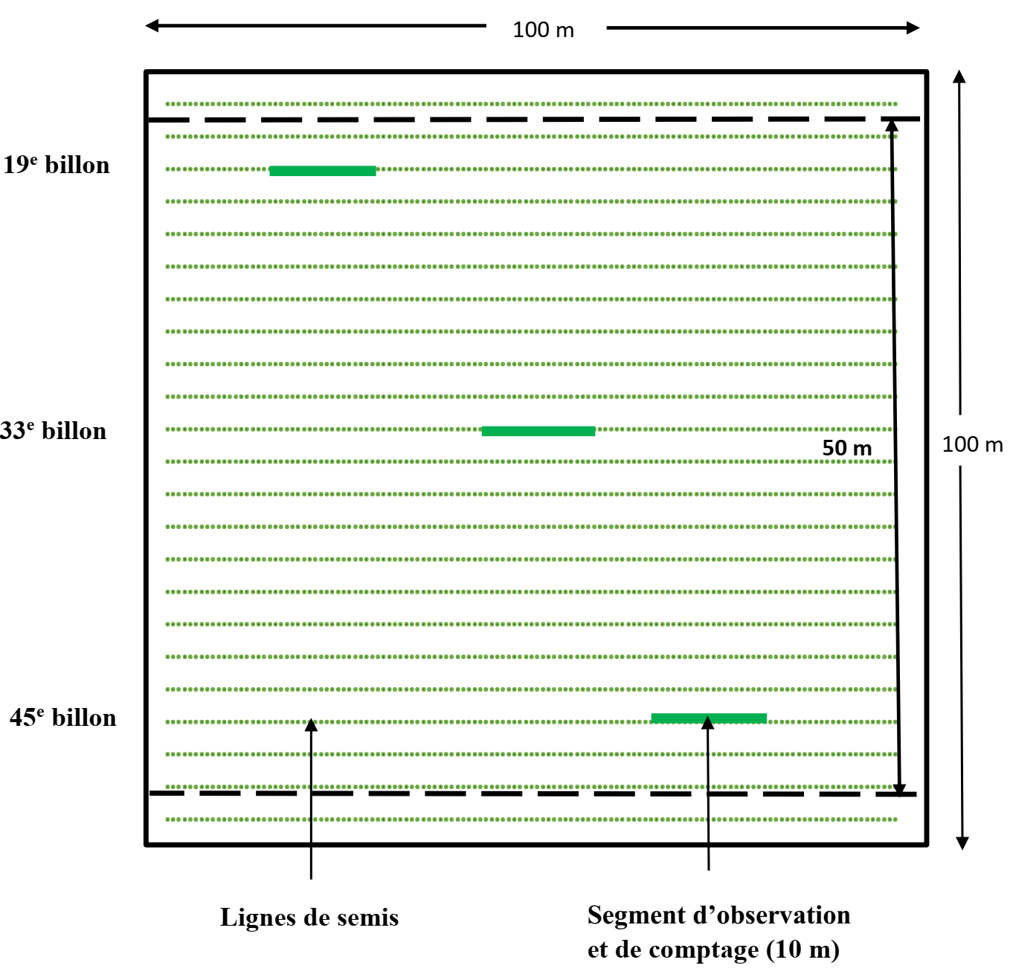
Fig. 2. Device for measuring agronomic parameters.

2.3.3.5 Comparative analysis of data and determination of the effects of soil fertilisation on cotton plants
The collected data were entered and verified using Excel version 2016. They were then subjected to analysis of variance (ANOVA) to compare the means, after first verifying the homogeneity of the variances. In the event of a significant difference between the means (P < 0.05), Fischer's post-ANOVA LSD (Least Significant Difference) test, with a threshold of 5%, was applied to identify homogeneous groups. When the variances were not homogeneous, despite attempts at transformation, the means were compared using the non-parametric Kruskal-Wallis test. In cases of significant differences between means (P < 0.05), Dunnett's test was used to determine homogeneous groups. These univariate statistical analyses were performed with R software, version 4.2.1, using the Rcmdr (R Commander) package and graphical interface. Principal component analysis (PCA) was also performed using R software to identify the test treatment that would have had the most positive effect on cotton yield. In this type of representation, yield is represented by a vector and the test treatments by distinct points. The type of test that is closest to the yield vector (smallest angle) is the one that will have had the most positive effect on yield, and vice versa.

3. Results and discussion

3.1 Results

3.1.1 Chemical characteristics of the soils studied

3.1.1.1 Exchangeable bases and N-NH₄⁺ status of soils

Table 1 shows the average N-NH₄⁺ and exchangeable base (K⁺, Ca²⁺, Mg²⁺ and Na⁺) contents extracted from the soils, as well as the cation exchange capacity (CEC) of these soils. The saturation rate of exchangeable bases (V) and, more importantly, the sum of these exchangeable bases (SBE), which was analysed in detail in the rest of the study with N-NH₄⁺, are also shown in the table. With the exception of Na⁺, whose average levels vary very little (0.02 ± 0.00 cmol/kg) across the entire study area (P > 0.05), these variables significantly differentiate the soils of the sections (P < 0.05). Indeed, fluctuating from 0.08 ± 0.03 to 0.32 ± 0.09 g/kg, the average N-NH₄⁺ contents distinguish four (4) homogeneous soil groups. The highest average levels were observed in Soumailavogo (0.32 ± 0.09 g/kg) and Diaratchè (0.30 ± 0.00 g/kg), while the Torla section had the lowest levels (0.08 ± 0.04 g/kg). The two intermediate soil groups consist, on the one hand, of the soils of the Gnanmandô, Nambolvogo, Oumarvogo and Nambigué sections (N-NH₄⁺ varies from 0.21 ± 0.04 to 0.26 ± 0.09 g/kg) and, on the other hand, of the soils of Barrovogo, Benifesso, Dabavogo, Koussanga, Ladjivogo, Nioronigué, Ouangolodougou, and Pleuhouo (N-NH₄⁺ varies from 0.13 ± 0.03 to 0.18 ± 0.08 g/kg). The exchangeable base sum (EBS) values range from 1.77 ± 0.63 to 7.04 ± 1.85 cmol/kg, thus distinguishing three homogeneous soil groups. The first group, which includes the soils of the Barrovogo (6.38 ± 2.74 cmol/kg) and Dabavogo (7.04 ± 1.85 cmol/kg) sections, has the highest base content. The other two groups consist of soils from the Benifesso, Gnanmandô, Nambigué, Nambolvogo, Nioronigué, Ouangolodougou and Torla sections, with SBE values ranging from 1.77 ± 0.63 to 3.08 ± 0.97 cmol/kg, followed by soils from Diaratchè, Koussanga, Ladjivogo, Oumarvogo, Pleuhouo and Soumailavogo, where the SBE was relatively the lowest (SBE varies from 1.94 ± 0.66 to 5.96 ± 4.23 cmol/kg). Cation exchange capacity (CEC) distinguishes the same groups as SBE. Indeed, its highest values (7.28 ± 2.74 and 7.94 ± 1.85 cmol/kg) are characteristic of the soils of Barrovogo and Dabavogo. The soils of Benifesso, Gnanmandô, Nambigué, Nambolvogo, Nioronigué, Ouangolodougou and Torla follow with values between 3.12 ± 0.47 and 5.56 ± 0.91 cmol/kg. Values ranging from 2.84 ± 0.66 to 6.87 ± 4.24 cmol/kg were found in the soils of Diaratchè, Koussanga, Ladjivogo, Oumarvogo, Pleuhouo and Soumailavogo. With regard to the base saturation rate (V), only the first group (soils from Barrovogo and Dabavogo), which showed the highest values (V ranging from 0.86 to 0.88 %), is identical to the two previous cases. Two other soil groups were identified by this variable. These are: i) the soils of Koussanga, Ladjivogo, Ouangolodougou, Oumarvogo, Pleuhouo and Soumailavogo, with rates between 0.77 and 0.84 %; ii) the soils of Benifesso, Diaratchè, Gnanmandô, Nambolvogo, Nioronigué, Nambigué and Torla, with rates ranging from 0.68 to 0.74 %.
Table 1. N-NH4+ and exchangeable base contents of the soils studied

Section | N-NH₄⁺ (g/kg) | K⁺  (cmol/kg) | Ca²⁺ (cmol/kg) | Mg²⁺ (cmol/kg) | Na⁺ (cmol/kg) | SBE  (cmol/kg) | CEC (cmol/kg) | SBE (cmol/kg) | V  (%)
Barrovogo | 0.13 ± 0.05 ab | 0.25 ± 0.18 ab | 5.39 ± 2.43 ab | 0.74 ± 0.34 ab | 0.02 ± 0.00 a | 6.38 ± 2.74 a | 7.28 ± 2.74 a | 6.38 ± 2.74 a | 0.86 ± 0.05 b
Benifesso | 0.14 ± 0.08 ab | 0.14 ± 0.05 bc | 2.19 ± 0.81 ac | 0.33 ± 0.09 b | 0.02 ± 0.00 a | 2.66 ± 0.91 b | 5.56 ± 0.91 b | 2.66 ± 0.91 b | 0.74 ± 0.07 c
Dabavogo | 0.14 ± 0.09 ab | 0.28 ± 0.070 b | 5.98 ± 1.66 b | 0.78 ± 0.19 ab | 0.02 ± 0.00 a | 7.04 ± 1.85 a | 7.94 ± 1.85 a | 7.04 ± 1.85 a | 0.88 ± 0.03 b
Diaratchè | 0.30 ± 0.00 d | 0.09 ± 0.02 bc | 1.30 ± 0.45 ac | 0.55 ± 0.52 ab | 0.02 ± 0.00 a | 1.94 ± 0.66 ab | 2.84 ± 0.66 ab | 1.94 ± 0.66 ab | 0.68 ± 0.08 c
Gnanmandô | 0.24 ± 0.09 cd | 0.11 ± 0.05 c | 2.38 ± 1.21 c | 0.36 ± 0.17 b | 0.02 ± 0.00 a | 2.85 ± 1.39 b | 3.75 ± 1.39 b | 2.85 ± 1.39 b | 0.74 ± 0.07 c
Koussanga | 0.13 ± 0.04 ab | 0.10 ± 0.04 c | 4.63 ± 3.29 bc | 0.45 ± 0.24 ab | 0.02 ± 0.00 a | 5.18 ± 3.53 ab | 6.08 ± 3.53 ab | 5.18 ± 3.53 ab | 0.80 ± 0.12 bc
Ladjivogo | 0.18 ± 0.08 ab | 0.17 ± 0.09 bc | 4.13 ± 2.04 bc | 0.55 ± 0.20 ab | 0.02 ± 0.00 a | 4.85 ± 2.25 ab | 5.75 ± 2.25 ab | 4.85 ± 2.25 ab | 0.82 ± 0.08 bc
Nambigué | 0.26 ± 0.09 cd | 0.17 ± 0.10 bc | 2.04 ± 0.46 c | 0.39 ± 0.09 ab | 0.02 ± 0.00 a | 2.59 ± 0.64 b | 3.49 ± 0.64 b | 2.59 ± 0.64 b | 0.74 ± 0.04 c
Nambolvogo | 0.21 ± 0.04 cd | 0.12 ± 0.05 bc | 1.86 ± 0.64 c | 0.40 ± 0.14 ab | 0.02 ± 0.00 a | 2.38 ± 0.79 b | 3.28 ± 0.79 b | 2.38 ± 0.79 b | 0.72 ± 0.07 c
Nioronigué | 0.13 ± 0.03 ab | 0.11 ± 0.04 bc | 1.72 ± 0.40 c | 0.39 ± 0.10 ab | 0.02 ± 0.00 a | 2.22 ± 0.47 b | 3.12 ± 0.47 b | 2.22 ± 0.47 b | 0.71 ± 0.04 c
Ouangolo | 0.18 ± 0.07 ab | 0.25 ± 0.10 b | 2.30 ± 0.75 c | 0.54 ± 0.29 ab | 0.02 ± 0.00 a | 3.08 ± 0.97 b | 3.98 ± 0.97 b | 3.08 ± 0.97 b | 0.77 ± 0.06 bc
Oumarvogo | 0.21 ± 0.12 cd | 0.21 ± 0.12 bc | 4.99 ± 3.88 bc | 0.77 ± 0.41 a | 0.02 ± 0.00 a | 5.96 ± 4.23 ab | 6.87 ± 4.24 ab | 5.96 ± 4.23 ab | 0.84 ± 0.07 bc
Pleuhouo | 0.18 ± 0.13 ab | 0.12 ± 0.06 ac | 2.85 ± 1.54 bc | 0.44 ± 0.17 ab | 0.02 ± 0.00 a | 3.40 ± 1.59 ab | 4.30 ± 1.59 ab | 3.40 ± 1.59 ab | 0.77 ± 0.08 bc
Soumailavo | 0.32 ± 0.09 d | 0.21 ± 0.03 bc | 2.80 ± 1.64 bc | 0.66 ± 0.40 ab | 0.02 ± 0.00 a | 3.66 ± 2.04 ab | 4.56 ± 2.04 ab | 3.66 ± 2.04 ab | 0.78 ± 0.07 bc
Torla | 0.08 ± 0.04 a | 0.11 ± 0.03 c | 2.33 ± 1.49 c | 0.34 ± 0.14 b | 0.02 ± 0.00 a | 1.77 ± 0.63 b | 3.67 ± 1.63 b | 1.77 ± 0.63 b | 0.73 ± 0.09 c
p | 0.00122 | 0.0000038 | 0.00000291 | 0.000458 | 0.391 | 0.00000294 | 0.00000294 | 0.00000294 | 0.00000402
SBE : Sum of Exchangeable Bases, p : probability, averages assigned the same letter in the same column are similar at the α < 0.05 threshold, Oangolo : Ouangolodougou, Soumailavo : Soumailavogo

3.1.2 Relationship between the sum of exchangeable bases and mineralisable nitrogen

The curve showing the evolution of the sum of exchangeable bases (SBE) as a function of N-NH₄⁺ is shown in Fig. 3. According to the figure, two groups of soils emerge: the SBE of the soils in the Koussanga, Ladjivogo, Barrovogo, Dabavogo and Oumarvogo sections do not define a precise relationship with their N-NH₄⁺. In contrast, the SBE of the soils in the ten other sections shows an increasing curve which appears to start to plateau at an N-NH₄⁺ level of 0.32 g/kg for an SBE of 3.66 cmol/kg observed in Soumailavogo. The starting point of the curve corresponds to an N-NH₄⁺ rate of 0.08 g/kg for an SBE of 1.77 cmol/kg observed in Torla. This last group of soils thus meets the criterion of mineral fertiliser input on which this research is based. The chemical equilibria that characterise these soils are the subject of future results.

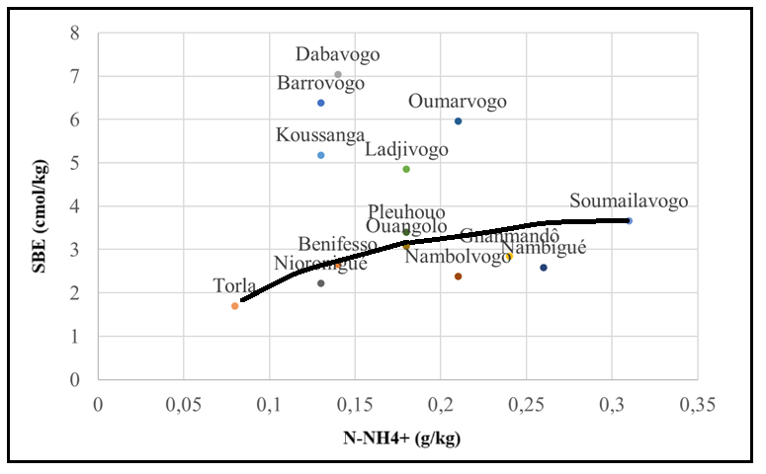
Ouangolo : Ouangolodougou, SBE: Sum of exchangeable bases

Fig. 3. Evolution of soil SBE levels according to their N-NH₄⁺ content

3.1.2.1 Fertilisation methods adopted

The relevant fertilisation requirements based on the soil fertility status described in the previous sections are summarised in Table 2. It should be noted that the sources of K⁺ are diverse (NPK and KCl), as are those of N. Dolomite (CaMg(CO3)2) provides Ca²⁺ and Mg²⁺. Phosphorus is provided by NPK.

Table 2. Fertiliser doses
Sections | Fertility status | Fertiliser | Dose/ha | Number of bags/hectare
1. Nambigué,  2. Torla,  3. Benifesso,  4. Gnamandô,  5. Pleuhouo | Déficience in N, P, K⁺ and Ca²⁺ | NPK (15-15-15) | 200 kg | 4
 | Déficience in N, P, K⁺ and Ca²⁺ | Dolomie (CaMg(CO₃)₂) to 30 % CaO | 100 kg | 2
 | Déficience in N, P, K⁺ and Ca²⁺ | Urée (46 % N) | 50 kg | 1
 | Déficience in N, P, K⁺ and Ca²⁺ | KCl (60 % K₂O) | 50 kg | 1
1. Diaratchè,  2. Soumailavogo,  3. Niorronigué,  4. Nambolvogo  5. Ouangolodougou | Déficience en N, P and K⁺ | NPK (15-15-15) | 200 kg | 4
 | Déficience en N, P and K⁺ | Urée (46 % N) | 50 kg | 1
 | Déficience en N, P and K⁺ | KCl (60 % K₂O) | - g | 1

3.1.3 Effects of soil fertilisation on cotton plants

3.1.3.1 Effect on size

The average sizes of the cotton plants obtained are shown in Table 3. In general, the treatments did not induce significant differences in these sizes, except for cotton plants grown in Nioronigué, Soumailavogo and Nambigué. In these locations, the lowest average sizes, namely 72.50 ± 11.17 to 105.90 ± 6.41 cm, were observed in the control plots (soils fertilised with NPK only). In contrast, the size of cotton plants ranged from 81.30 ± 5.73 to 122.66 ± 7.35 cm in the test plots.

Table 3. Cotton plant sizes according to treatments
 | sizes (cm)
Sections | Witness  (NPK) | Tests (NPK+dolomie+urée+KCl or NPK+urée+KCl) | p
Torla | 83.03 ± 10.05 | 81.30 ± 5.73 | 0.568
Ouangolodougou | 94.36 ± 5.62 | 99.40 ± 10.66 | 0.12
Nioronigué | 72.50 ± 11.17 | 91.00 ± 12.73 | 0.01
Gnanmandô | 93.13 ± 10.05 | 99.23 ± 9.01 | 0.09
Diaratchè | 88.76 ± 7.65 | 89.53 ± 14.51 | 0.86
Pleuhouo | 102.96 ± 10.21 | 101.6 ± 8.52 | 0.70
Soumailavogo | 105.90 ± 6.41 | 122.66 ± 7.35 | 0.01
Nambolvogo | 85.86 ± 7.53 | 88.93 ± 8.67 | 0.31
Benifesso | 92.63 ± 8.40 | 90.56 ± 8.59 | 0.51
Nambigué | 80.36 ± 14.92 | 108.33 ± 12.72 | 0.01
p : probability
3.1.3.2 Effect on vegetative and fruiting branches

As shown in Table 4, the number of vegetative branches in cotton plants grown on test plots is significantly lower than in those grown on control plots (P < 0.05). The former had an average of two (2) branches, compared to eight (8) in the latter. A contrary result was obtained when counting the fruiting branches. While an average of thirteen (13) fruiting branches per plant were counted in the test plots, the cotton plants in the control plots had an average of two (2). This variation is therefore significant (P < 0.05).

Table 4. Number of vegetative and fruiting branches on cotton plants according to treatment
 | Vegetative branches |  |  | Fruit-bearing branches
Sections | Witness  (NPK) | Tests (NPK+dolomie+urée+KCl or NPK+urée+KCl) | p | Witness  (NPK) | Tests (NPK+dolomie+urée+KCl or NPK+urée+KCl) | p
Torla | 8.53 ± 1.46 | 1.87 ± 0.55 | 0.01 | 2.63 ± 0.72 | 11.47 ± 2.11 | 0.01
Ouangolodougou | 8.67 ± 1.23 | 2.00 ± 0.71 | 0.01 | 2.80 ± 0.75 | 12.23 ± 2.03 | 0.01
Nioronigué | 7.80 ± 1.52 | 1.80 ± 0.56 | 0.01 | 2.57 ± 0.70 | 10.93 ± 1.78 | 0.01
Gnanmandô | 8.53 ± 1.64 | 1.83 ± 0.62 | 0.01 | 2.53 ± 0.48 | 11.20 ± 1.88 | 0.01
Diaratchè | 8.27 ± 2.25 | 1.83 ± 0.59 | 0.01 | 2.07 ± 0.80 | 11.77 ± 1.35 | 0.01
Pleuwa | 8.20 ± 1.93 | 1.70 ± 0.46 | 0.01 | 2.17 ± 0.67 | 10.90 ± 1.42 | 0.01
Soumailavogo | 8.13 ± 1.85 | 1.87 ± 0.48 | 0.01 | 2.43 ± 0.78 | 12.93 ± 1.40 | 0.01
Nambolvogo | 8.27 ± 2.20 | 1.93 ± 0.50 | 0.01 | 2.50 ± 0.82 | 11.17 ± 1.25 | 0.01
Benifesso | 7.80 ± 2.11 | 1.70 ± 0.49 | 0.01 | 2.33 ± 0.75 | 11.70 ± 0.49 | 0.01
Nambigué | 8.27 ± 1.91 | 1.87 ± 0.55 | 0.01 | 2.30 ± 0.77 | 13.10 ± 1.33 | 0.01
p : probability

3.1.3.3 Effect on the number of internodes and capsules

Cotton plants developed approximately four (4) times more internodes in test plots (12 to 14 on average) than in control plots (3 to 4) (Table 5). This trend is identical to the result obtained when counting bolls (12 to 19 in test plots versus 3 to 4 in control plots). These differences are statistically significant (P < 0.05).
Table 5. Number of internodes and capsules according to treatment
 | Inter-nodes |  |  | Capsules
Sections | Witness  (NPK) | Tests (NPK+dolomie+urée+KCl or NPK+urée+KCl) | p | Witness  (NPK) | Tests (NPK+dolomie+urée+KCl or NPK+urée+KCl) | p
Torla | 2.83 ± 1.14 | 11.30 ± 1.51 | 0.01 | 3.17 ± 1.20 | 13.10 ± 2.90 | 0.01
Ouangolo | 2.83 ± 1.22 | 13.00 ± 1.76 | 0.01 | 3.90 ± 1.30 | 17.87 ± 2.50 | 0.01
Nioronigué | 3.13 ± 1.37 | 12.00 ± 1.04 | 0.01 | 3.33 ± 0.98 | 14.27 ± 3.58 | 0.01
Gnanmandô | 3.03 ± 1.27 | 12.77 ± 2.08 | 0.01 | 3.73 ± 1.81 | 18.33 ± 4.09 | 0.01
Diaratchè | 2.53 ± 1.13 | 12.97 ± 0.99 | 0.01 | 8.77 ± 2.66 | 11.27 ± 3.08 | 0.01
Pleuwa | 2.67 ± 0.98 | 11.27 ± 1.32 | 0.01 | 3.13 ± 0.95 | 13.63 ± 2.55 | 0.01
Soumailavogo | 3.23 ± 0.96 | 12.93 ± 1.47 | 0.01 | 3.13 ± 0.69 | 19.17 ± 2.59 | 0.01
Nambolvogo | 3.03 ± 1.71 | 11.70 ± 1.47 | 0.01 | 2.97 ± 0.48 | 14.53 ± 3.97 | 0.01
Benifesso | 3.10 ± 1.02 | 12.13 ± 1.32 | 0.01 | 2.87 ± 0.69 | 16.10 ± 2.71 | 0.01
Nambigué | 3.23 ± 1.15 | 13.57 ± 0.90 | 0.01 | 2.80 ± 0.65 | 16.33 ± 3.48 | 0.01
p : probability

3.1.3.4 Effect on cotton yield

The cotton yields calculated for each case (controls and tests) are shown in Table 6. It can be seen that the test plots produced 8 to 12 times more than the control plots. In fact, yields ranged from 1957.40 ± 733.92 to 3440.87 ± 4123.90 kg/ha in test plots, while in control plots, these results ranged from 172.53 ± 52.32 to 289.27 ± 228.06 kg/ha. This variation is, a priori, significant.

Table 6. Cotton yields according to treatments
 | Yields (kg/ha)
Sections | Witness  (NPK) | Tests (NPK+dolomie+urée+KCl or NPK+urée+KCl) |  | p
Torla | 218.86 ± 81.88 | 2051.65 ± 830.25 |  | 0.01
Ouangolodougou | 229.60 ± 113.29 | 2181.69 ± 936.03 |  | 0.01
Nioronigué | 253.47 ± 217.13 | 2439.60 ± 1006.64 |  | 0.01
Gnanmandô | 289.27 ± 228.06 | 2404.87 ± 1944.67 |  | 0.01
Diaratchè | 265.87 ± 208.52 | 2233.13 ± 1077.31 |  | 0.01
Pleuhouo | 270.33 ± 193.71 | 2228.93 ± 860.49 |  | 0.01
Soumailavogo | 181.27 ± 104.35 | 2009.93 ± 1123.37 |  | 0.01
Nambolvogo | 263.33 ± 150.59 | 2260.93 ± 1179.57 |  | 0.01
Benifesso | 247.93 ± 147.37 | 2162.93 ± 1440.68 |  | 0.01
Nambigué | 172.53 ± 52.32 | 2149.60 ± 1002.66 |  | 0.01
p : probability

3.1.3.5 Specific effects of test treatments on yield

The results of the PCA carried out to compare the effects of the two fertilisation approaches applied are presented in Fig. 4. The figure shows the relationships between certain soil properties (pH, OM, Pass, Nt, C/N, CEC, SBE, V, N-NH₄⁺ and NO₃⁻), as well as the relationships between these soil properties and cotton yield. Similarly, the figure shows the degree of correlation between the fertilisation approaches (T1 and T2) and cotton yield. It is this latter relationship that is analysed at this level of presentation of the results, as specified in the methods. It appears that neither treatment is better correlated with yield than the other.

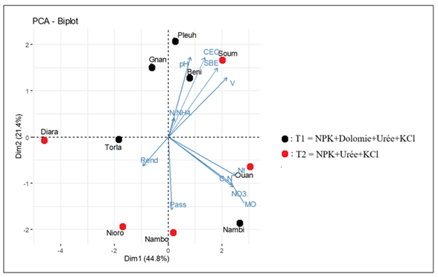
Pleuh : Pleuhouo, Gnan : Gnanmandô, Soum : Soumailavogo, Beni : Benifesso, Diara : Diaratchè, Nioro : Nioronigué, Nambo : Nambolvogo, Nambi : Nambigué, Ouan : Ouangolodougou

Fig. 4. Relationship between test treatments and cotton yield

3.2. DISCUSSION

The soils of the ten (10) sectors selected for agronomic trials all show deficiencies in N, P and K. However, several soils have specific deficiencies. The soils of Nambigué, Torla, Bénifesso, Gnamandô and Pleuhouo are deficient in calcium (Ca) when compared to magnesium (Mg) levels. The soils of Ouangolodougou, Bénifesso and Nambigué are deficient in potassium (K) compared to their Mg levels. Furthermore, all of the soils in these ten sections are deficient in potassium (K) in terms of cation exchange capacity (CEC), which identifies potassium as the most limiting element in this study. K deficiency, which is common in cotton soils in tropical areas (Koulibaly et al., 2009), is due to its high leaching, particularly in sandy soils. This deficiency, whether expressed in relation to Mg or CEC, reflects low retention of this essential cation. According to Bel (2021), the Ca, Mg and K reservoirs in soils determine their bioavailability to plants. Unlike Ca and Mg, K is less retained in humus because it does not enter directly into the plant structure. It is therefore released more quickly into the soil solution, increasing its risk of leaching. In addition, part of the K is stored in microbial biomass (Van der Heijden et al., 2014 ; Yaghoubi et al., 2019). However, in the soils studied, microbial activity appears to be reduced, as evidenced by the high C/N ratios (14.20 ± 0.78 to 15.36 ± 0.31), exceeding the optimal range (9 to 12). Finally, although K is abundant in the Earth's crust (7th or 8th most abundant element according to Wedepohl, 1995), it is mostly trapped in the crystalline structure of minerals (90 to 98 %), making it unavailable to plants. This widespread K deficiency is typical of tropical soils (Sparks & Huang, 1985). Calcium (Ca) is one of the most abundant cations in the Earth's crust. Magnesium is also present in significant quantities, but in smaller proportions. However, the relative abundance of these two elements is influenced by many factors and can vary considerably depending on soil types and local conditions (Mihoub, 2017 ; Oursin, 2021). As this study was conducted in the same local environment (same environmental conditions) where the soils are all ferralitic, the Ca deficits observed in the soils of several sections (Nambigué, Torla, Bénifesso, Gnamandô and Pleuhouo) compared to Mg levels could be explained by a greater preference for Ca by cotton plants or by the cultivation practices adopted by the users of these soils (deep or shallow ploughing) (Bassala et al., 2008; Gérardeaux, 2009 ; Hinimbio, 2019). Nitrogen (N), an important element for supporting vegetative growth and ensuring high yields, must be readily available, but not in excess, from flowering to capsule formation (Ribeiro et al., 2008). In the absence of fertilisation, plants obtain it through the mineralisation of humus or crop residues, a microbial process that converts organic nitrogen into ammonium (NH₄⁺) and then into nitrates (NO₃⁻). The availability of nitrogen in the soil in the context of this study depends heavily on the level of organic matter or organic carbon in the soil. According to Emmanuel et al. (2018), the observed N deficiency is a common characteristic of soils in Ivorian cotton-growing areas. This is likely the result of slow mineralisation of organic matter, as already mentioned in the discussion of low K levels. This slow mineralisation, reflected in the high C/N ratio of the soils (C/N >12), is accompanied by low release of mineral nitrogen. This can be attributed to many factors, including the presence in the soil of poorly degradable organic fractions that originate from cotton residues not consumed by livestock and transhumant animals (Bérubé-Girouard et al., 2024). These residues are rich in lignin, a complex polymer that is resistant to microbial degradation (Maron et al., 2009 ; Toundou, 2016). This chemical complexity requires more time for soil microorganisms to break down these materials and release nitrogen. The assimilable phosphorus (Pass) content of the soils studied (2.13 to 13.37 mg/kg) is below the critical threshold of 15 mg/kg defined by Landon (1991). This deficiency is thought to result from specific physicochemical characteristics such as sandy texture, which limits the soil's overall capacity to retain nutrients (Toundou, 2016 ; Tahraoui, 2024). In addition, a high concentration of iron (FeO) and aluminium (Al₂O₃) oxides in the soil, a characteristic specific to ferralitic soils, induces strong and often irreversible chemical fixation of phosphorus. The fixed phosphorus forms insoluble complexes with these oxides, making it unavailable to several crops, including cotton (Azzi, 2016 ; Pirlot, 2019). Furthermore, agricultural overexploitation, the use of inappropriate farming practices and the gradual degradation of soil fertility contribute to accentuating phosphorus deficiency (Assemien, 2018 ; Ferd, 2022). In short, the P deficiency observed in the soils studied is particularly worrying given that cotton is a phosphorus-demanding plant, requiring optimal growth, abundant flowering and good fibre quality (Sanogo, 2017). It is also involved in energy transfer processes (ATP, ADP), in the formation of nucleic acids (DNA, RNA) and in stimulating root development (Fageria et al., 2010). It was therefore important that the applied sustainable fertilisation took this element into account.
Two groups of mineral fertilisers were applied: NPK (15-15-15), dolomite (CaMg (CO₃) ₂) at 30 % CaO, urea (46 % N) and KCl (60 % K₂O) on the one hand, and NPK (15-15-15), urea (46 % N) and KCl (60 % K₂O). The first group was applied to soils deficient in N, P, K⁺ and Ca²⁺, and the second group to soils deficient in N, P and K⁺. The sources of K⁺ are diversified (NPK, KCl) because this element is the most deficient in the soils studied. The sources of N are also diversified (NPK and urea) for a number of very important reasons: it is an essential element for vegetative growth. It also controls chlorophyll assimilation, making it the main factor in increasing agricultural production in quantitative terms (Mosier et al., 2004). The approach adopted is effectively similar to sustainable fertilisation, as it provides cotton plants with just the mineral elements they lack, in the right proportions (Bayala et al., 2007). The study showed a significant difference in yields, with plots where fertilisation was carefully managed producing 8 to 12 times more than the control plots. This result was achieved gradually through improvements in plant development, mainly in terms of size, number of fruiting branches and internodes, and number of cotton bolls per plant. This is why Bellaloui et al. (2021) confirmed that a plant architecture that maximises the development of fruiting branches is essential for high yields. The fertilisation strategy clearly succeeded in influencing the plant's physiology by increasing the number of internodes and, consequently, the number of potential fruiting sites. However, as the cotton yields obtained did not allow for any significant differentiation between the two types of fertilisation strategies applied, this demonstrates the relevance of the fertilisation strategy used.

4. Conclusion

The study conducted in the cotton-growing area of the Ouangolodougou department highlighted specific chemical characteristics of the soil under cotton plants in this region, marked by a generalised potassium deficiency, as well as occasional calcium and magnesium deficiencies. These deficiencies are major limiting factors for the growth and productivity of cotton plants. This finding highlights the limitations of traditional fertilisation schemes, which are often based on general recommendations without taking local specificities into account. The implementation of the N-NH₄⁺ technique, combined with precise adjustment of mineral inputs, significantly improved cotton growth and yield parameters. Compared to standard practices, this approach not only optimised fertiliser use, but also contributed to improved plant resilience to soil constraints. It was concluded that the first hypothesis formulated for the study was not verified, while the second was. These hypotheses stated, in order, that: 1) the doses of mineral fertilisers usually applied to cotton soils are always suitable for optimal cotton production ; 2) rational fertilisation can significantly increase cotton yield. Economically speaking, the increase in yields observed in the experimental plots paves the way for improved producer incomes and, by extension, greater competitiveness for the sector. It is therefore clear that the integration of detailed soil fertility diagnostics, coupled with specific fertiliser formulations, is a key lever for reconciling agricultural productivity, natural resource conservation and socio-economic sustainability. This model of rational input management is fully in line with the objectives of sustainable agriculture, limiting nutrient losses and reducing the risks of environmental degradation. Ultimately, this study confirms that rational fertilisation, when based on accurate diagnosis and locally adapted inputs, is a promising way to meet the current challenges of cotton production in Côte d'Ivoire. By combining agronomic performance, economic viability and environmental sustainability, it offers concrete prospects for strengthening the resilience of the sector and contributing to food security and sustainable development objectives.

COMPETING INTERESTS DISCLAIMER:
Authors have declared that they have no known competing financial interests OR non-financial interests OR personal relationships that could have appeared to influence the work reported in this paper.

References

Adingra Y. K. (2002). The Political and Economic Challenges of Liberalizing the Ivorian Cotton Industry. DEA Thesis, Université Paris 1 Panthéon Sorbonne, 92P
Ama-Abina T. J., Beugre G. F., N’Gbesso M. F. D. P., Brou N’G. D., Yoro G. R. (2012). Effects of a Herbicide and Inoculation on Yield Factors of Soybeans Grown on a Gravelly Plateau Soil. International Journal of Biological and Chemical Sciences, 6(5): 1970-1978.
Anonymous (2015). Agricultural Policies Around the World: Some Examples. Ministry of Agriculture, Agri-Food and Forestry, France, 10 p. http://agriculture.gouv.fr/politiques-agricoles-fiches-pays/ 12/4/2025
Assemien E. F. L. (2018). Impact of conventional and innovative agricultural practices on soil fertility and the microbial actors involved in the humid savannah zone of Côte d'Ivoire. Doctoral thesis, University of Lyon; Nangui Abrogoua University (Abidjan), 248 p.
Azzi V. (2016). Trace metal inputs from chemical phosphate fertilizers in Lebanese soils: Investigation into their fate and transfer. Doctoral thesis, Paul Sabatier-Toulouse III University; Lebanese University, 265 p.
Bado B. V. (2002). Role of legumes on the fertility of tropical ferralitic soils in the Guinean and Sudanian zones of Burkina Faso. Doctoral thesis, University of Laval, Quebec, p.166.
Bassala J. P. O., M’Biandoun M., Ekorong J. A. & Asfom P. (2008). Evolution of soil fertility in a cotton-cereal system in North Cameroon: diagnosis and perspectives. Sommaire/inhoud/sumario, 26(4): 240-245.
Bayala J., Ky-Dembele C., Tigabu M., Ouédraogo S. J. & Odén P. C. (2007). The relative importance of different regeneration mechanisms in a selectively cut savanna-woodland in Burkina Faso, West Africa. Forest Ecology and Management, 243(1): 28-38.
Bel J. (2021). Bioavailability of calcium, magnesium, and potassium in forest soils – Quantification, tracing, and characterization of bioavailable sources by stable isotope dilution (44Ca, 26Mg, and 41K). Doctoral thesis, University of Lorraine (France), 272 pp.
Bellaloui N., Smith J. R., Gillen A. M., & Mengistu A. (2021). Pod and branch number, and yield component relationships in soybean: Implications for nutrient management. Journal of Plant Nutrition, 44(2): 221–236.
Berti F., Hofs J. L., Zagbaï H. S., & Lebailly P. (2006). Cotton in the world, the role of African cotton, and key issues. Biotechnology Agronomy Society and Environment, 10(4): 271–280.
Bérubé-Girouard V., Bonneville G., Olivier A. & Richard C. (2024). Assessment and analysis of agroforestry interventions and experiments with regard to their potential to contribute to adaptation to climate change in Senegal: Report produced as part of the Food Security: Adapted Agriculture (SAGA) project. Food & Agriculture Org, 75 p.
Coulibaly L., Kouassi K. H., Emile S. G. E., Savane I. (2016). Analysis of the savannah transformation process in northern Côte d'Ivoire using remote sensing: The case of the Ferkessédougou department. International Journal of Innovation and Applied Studies, 17(1): 136-143.
Edmond A. A. (2015). The impact of cotton cultivation on socioeconomic development: A case study of the Korhogo region, northern Côte d'Ivoire. European Scientific Journal, 11(31): 253-271.
Emmanuel N. K., Emmanuel K. K., Kouakou B. J., Gustave F. M., Kouamé B., Dominique B. N. (2018). Diagnosis of Soil Fertility Under Cotton Cultivation in the Main Production Basins of Côte d'Ivoire. European Scientific Journal, 14(33): 1857-7881.
Fageria N. K., De Morais O. P. & Dos Santos A. B. (2010). Nitrogen Use Efficiency in Upland Rice Genotypes. Journal of Plant Nutrition, 33(11): 1696-1711.
Ferd K. (2022). Contribution to the Study of the Relationship Between Excessive Use of Agricultural Fertilizers and the Phenomenon of Eutrophication. Master's degree in Natural and Life Sciences, University of Larbi Tébessi -Tébessa, (Algeria), 81 pp.
Gérardeaux E. (2009). Adjustment of cotton (Gossypium hirsutum L.) phenology, growth, and biomass production in the face of potassium deficiency. Doctoral thesis, University of Bordeaux I, 122 pp.

Hinimbio T. P. (2019). Rehabilitation of soil fertility through the use of bioresources (Crotalaria juncea L. and Brachiaria ruziziensis G. & E.) in the cotton-growing area of ​​the Far North, Cameroon. Doctoral thesis, Doctoral Training Unit in Engineering Sciences, University of Maroua (Cameroon), 239 p.
Jones M. (2021). Potassium dynamics in soils: A review. Plant and Soil, 456(1): 89-102.
Koffi S.Y. (2013). Liberalization of the cotton sector in Côte d'Ivoire fifteen years later: spatial and organizational footprint. Cinq Continents, 3(7): 5-17.
Konate Z., Messoum F. G., Sekou A., Yao K. A., Camara M., Keli Z. J. (2013). Effects of soybean (Glycine max) and cowpea (Vigna unguiculata) crops on soil bulk density and water content and on the productivity of upland rainfed rice on hyperdystric ferralsol: the case of Gagnoa, in the west-central part of Côte d'Ivoire. International Journal of Biological and Chemical Sciences., 7(1): 47-59.
Koulibaly B., Traoré O., Dakuo D., & Zombré P. N. (2009). Effects of local amendments on yields, nutrient indices and crop balances in a cotton-maize rotation system in western Burkina Faso. Biotechnology Agronomy. Society and Environment, 13(1): 103-111.
Koutouan F. P., N’guessan B. C., Wandan E. N., Djéhi B., Ta Bi (2017). Effect of Phospho-Potassium Fertilization on Grain Yield and Seed Quality of Cajanus Cajan L. Millsp. on a Ferrasol in Yamoussoukro, Central Region of Côte d'Ivoire. European Scientific Journal, 13(21): 7-20.
Kumar R., Singh P. & Gupta D. (2023). Effects of Calcium-Magnesium Ratios on Soil Properties and Plant Growth. Agricultural Sciences, 10(4): 245-256.
Landon J. R. (1991). Booker Tropical Soil Manual, A Handbook for Soil Survey and Agricultural Land Evaluation in the Tropics and Subtropics, Paperback, Longman, Booker Tate Limited, Oxon, United Kingdom, 474 pp.
Maron M. S., Maron B. J., Harrigan C., Buros J., Gibson C. M., Olivotto I. & Appelbaum E. (2009). Hypertrophic cardiomyopathy phenotype revisited after 50 years with cardiovascular magnetic resonance. Journal of the American College of Cardiology, 54(3): 220-228.
Mihoub A. (2017). Study of phosphorus dynamics in Saharan calcareous soils cultivated with wheat: the case of Oued Righ. Doctoral thesis, Faculty of Natural and Life Sciences, Department of Agricultural Sciences, Kasdi Merbah University, Ouargla, Algeria, 185 p.
Mosier A. R., Syers J. K., Freney J. R. (2004). Nitrogen fertilizer: an essential component of increased food, feed, and fiber production. In: Mosier A. R., Syers J. K., Freney (Eds.), Agriculture and the nitrogen cycle: Assessing the impacts of fertilizer use on food production and the environment. IStand Press, Scope 65, pp. 3-15.
Oursin M. (2021). Development of an experimental approach to better understand the evolution of soil fertility in mid-mountain areas. Doctoral thesis, Doctoral School of Earth and Environmental Sciences (ED 413), University of Strasbourg, 400 pp.
Pansu M. & Gautheyrou J. (2003). Mineralogical, organic, and mineral soil analysis. Springer Publishing, Paris (France), 1012 pp.
Paul-Kévin O. N. & Olivier K. K. (2021). Maize cultivation versus the cotton-cashew pair in northern Ivory Coast: Cohabitation dominated by cash crops in the Napié sub-prefecture. International Journal of Social Sciences and Humanities Invention, (10): 6693-6704.
Pirlot C. (2019). Effect of iron oxide dissolution induced by siderophores on phosphorus solubilization in soils. Master of Bioengineering in Environmental Sciences and Technologies, Liège University Gembloux, 98 p.
Ribeiro M. A., Da-Silva Q. J. O., Aitken W. M., Machado R. C. R. & Baligar V. C. (2008). Nitrogen Use Efficiency in Cacao Genotypes. Journal of Plant Nutrition, 31: 239-249.
Sanogo S. (2017). Social and Economic Dimensions of Sesame (Sesamum indicum L.) Cultivation in the Kossi Region, Northwest Burkina Faso. Doctoral Thesis, Ouagadougou University, Prof. Joseph Ki-Zerbo, 293 p.
Scarf H. (1988). One Hundred Years of the Kjeldahl Method for Nitrogen Determination. Archiv fur Acker und Pflanzenbau und Bodenkunde, 32: 321-32.

Smith A., Johnson B. & Lee C. (2022). Soil Nutrient Ratios and Their Impact on Crop Yield. Journal of Soil Science, 78(2): 123-134.
Sumanou B. (2023). Impact of the Adoption of Agroecological Practices on the Economic Profitability of Cotton Farms in Benin. Doctoral Dissertation, University of Parakou, Benin, 157 pp.
Sparks D. L. & Huang P. M. (1985). Physical Chemistry of Soil Potassium. In: Munson RD (ed) Potassium in Agriculture. ASA, CSSA, SSSA, Madison, USA, pp. 201-276.
Stessens J. (2002). Technical and Economic Analysis of Agricultural Production Systems in Northern Côte d'Ivoire. Doctoral Thesis, Faculty of Applied Biological Sciences, Catholic University of Leuven, 302 p.
Tahraoui S. (2024). Contribution to the optimization of phospho-nitrogen fertilization in saline and calcareous soils. Doctoral Thesis, Faculty of Sciences and Natural and Life Sciences, Department of Agricultural Sciences, Mohamed Khider-Biskra University, (Algeria), 110 p.
Tié B. T. (1995). Contribution to the study of nitrogen supply in soils under humid tropical climates (Côte d'Ivoire): application to maintaining the fertility of cropland. Doctoral Thesis, University of Côte d'Ivoire, Abidjan, 182 p.
Tié B.T. (2019). Training material on the N-NH4+ technique. 8 p.
Toundou O. (2016). Evaluation of the chemical and agronomic characteristics of five waste composts and study of their effects on soil chemical properties, physiology, and yield of maize (Zea mays L. var. Ikenne) and tomato (Lycop ersicum esculentum L. var. Tropimech) under two water regimes in Togo. Doctoral thesis, University of Limoges; Faculty of Sciences, University of Lomé (Togo), 213 p.
Van D. H. G., Legout A. & Pollier B. (2014). The dynamics of calcium and magnesium inputs by throughfall in a forest ecosystem based on poor soil are very slow and conservative: Evidence from an isotopic tracing experiment (26Mg and 44Ca). Biogeochemistry, 118: 413-442.
Wedepohl K. (1995). The composition of the continental crust. Geochimica et Cosmochimica Acta, 59: 1217-1232.
Yaghoubi K. M., Pirdashti H., Rahimian H. (2019). The role of potassium solubilizing bacteria (KSB) inoculations on grain yield, dry matter remobilization and translocation in rice (Oryza sativa L.). Journal Plant Nutrition, 42: 1165-1179.

