Original Research Article

Contribution to the domestication of Beilschmiedia mannii in Côte d'Ivoire: Effect of cutting size and indole-3-butyric acid (IBA) on rooting and growth

.
ABSTRACT

Beilschmiedia mannii, or spicy cedar, is a tree species of significant food and medicinal value that naturally grows in the tropical forests of Côte d'Ivoire. Unfortunately, severe deforestation and climate change pose a serious threat to the survival of this species, raising concerns about its conservation status. This study aims to develop methods for propagating Beilschmiedia mannii plants through the cutting technique. For this, three categories of cutting diameter (small, medium, and large) were taken from plagiotropic twigs. The bases of these cuttings were soaked for 1 hour in a solution of Indole-3-Butyric Acid (IBA) at concentrations of 0, 2.5, and 5 mg/L. Subsequently, the treated cuttings were planted in a polypropagator filled with a substrate of forest topsoil mixed with construction sand. Once rooted, the cuttings were transplanted into black polyethene bags. The results showed that small- and medium-diameter cuttings exhibited good rooting ability, unlike those with a large-diameter. The 5 mg/L IBA concentration produced the highest rooting success with 36% for small and 53% for medium cuttings, and resulted in the greatest number and length of roots per cutting. The 100% survival rate after acclimatisation demonstrates Beilschmiedia mannii’s strong capacity for propagation through cuttings. The best vegetative growth was observed in plants grown from medium- and small-diameter cuttings treated with 5 mg/L and 2.5 mg/L of IBA, respectively. These findings suggest that these combinations could be an effective method for producing healthy seedlings and promote the conservation and sustainable use of Beilschmiedia mannii.

Keywords: Beilschmiedia mannii, Cutting, Indole-3-Butyric Acid (IBA), Domestication, Côte d'Ivoire

1. INTRODUCTION

Beilschmiedia mannii (Meisn.) Robyns and Wilczek, commonly known as "spicy cedar," is a species of tree belonging to the Lauraceae family, endemic to the rainforests of West and Central Africa. In Côte d'Ivoire, this species thrives mainly in secondary forests and riparian vegetation, while domesticated stands are integrated into agroforestry systems (N’zi et al., 2023). It is a plant recognised for its food, medicinal, and artisanal uses, thus contributing to food security, health, and income for rural populations (Olajuyigbe and Adaja, 2020). Its seeds and fruits, which are highly valued in the local diet, are rich in proteins, carbohydrates, minerals, and unsaturated fatty acids (Sahoré et al., 2012; Kouamé et al., 2017). The seeds are used to prepare a mucilaginous sauce that forms part of the cultural and culinary identity of several peoples in western Côte d'Ivoire (Yapo et al., 2018; Yao et al., 2023). Additionally, the high levels of phytochemicals in various parts of the plant, such as the leaves and bark, are used in traditional medicine to treat conditions like headaches and abdominal pain in humans (Yao et al., 2023). Moreover, these organs are also consumed by animals to bolster their immune systems (Ahoua et al., 2015). The wood of Beilschmiedia mannii is also used by local populations for construction and furniture making (Mark et al., 2014; Soro et al., 2021). Given its strong socio-economic potential, there has been a significant decline in natural populations of B. mannii, particularly in Benin (Yevidé et al., 2022) and Côte d'Ivoire (Yao et al., 2023). Although not listed on the International Union for Conservation of Nature (IUCN) Red List of Threatened Species, developing sustainable management strategies for the species' conservation in Côte d'Ivoire is crucial. Additionally, B. mannii features among priority species targeted for domestication programmes across Africa (Jusu and Cuni-Sanchez, 2017). However, the regeneration of a species is the foundation of any domestication effort. B. mannii reproduces naturally by seed, and a study conducted around the Taï National Park in Côte d'Ivoire found that its fruiting period occurs between October and December, with an average germination rate of 76.63% (Soro et al., 2021).
However, the natural regeneration of the species is hampered by the consumption of its seeds by various animals, including primates such as chimpanzees (Ahoua et al., 2015). Furthermore, deforestation and overexploitation of this resource by humans are ongoing. This situation decreases the number of seeds available for the species' regeneration and domestication. Several authors have already reported the use of vegetative propagation as an alternative method for regenerating woody species (Leakey et al., 2012; Djibo et al., 2020). To ensure sustainable management of B. mannii, it is vital to establish effective vegetative propagation techniques that enable rapid and uniform multiplication of individuals. However, vegetative propagation of this species remains underexplored and warrants in-depth research. Cuttings are a widely used vegetative propagation method for woody plants, particularly in tropical agroforestry systems (Leakey, 1999). This technique has the advantage of accurately preserving the genetic traits of the parent plants, thus conserving genetic diversity. The success of cuttings in several species, such as Garcinia kola (Kouakou et al., 2016) and Agania spinosa (Metougui et al., 2017), depends on various factors, including the type of cuttings used (Dao et al., 2020) and the hormonal treatments applied to promote rooting (Muthoka et al., 2001). The aim of this study is to evaluate the effect of different cutting types and concentrations of Indole-3-Butyric Acid (IBA) on the rooting of Beilschmiedia mannii

2. METHODOLOGY

2.1 Study site

The experiment was carried out from October 2023 to May 2024 on the experimental plot at NANGUI ABROGOUA University, located in the south of Côte d'Ivoire, within the district of Abidjan. The site is situated between 5° 23' 23" north latitude and 4° 00' 49" west longitude. The climate of the study area is classified as humid tropical, featuring four seasons—two rainy and two dry (Ouattara et al., 2023). Average rainfall during the rainy season ranges from 100 to 700 mm, while in the dry season it varies between 25 and 50 mm. The average monthly temperature is between 27 and 30 °C, with relative humidity averaging between 70 and 84% (Kouakou et al., 2016).

2.2 Plant material

The plant material used in this study consisted of cuttings from the plagiotropic twigs of 5-year-old young trees of Beilschmiedia mannii growing in the Banco Forest relic within the NANGUI ABROGOUA University.

2.3 Methods

2.3.1 Collection of twigs

The twigs used for making the cuttings were gathered during periods of high relative humidity and low temperatures of the day (early morning, between 06h and 07h), using sterilised pruning shears with 70% ethanol, from the side branches of young B. mannii trees. The collected twigs were immediately placed in a basin containing water to prevent desiccation.

2.3.2 Making cuttings

The collected twigs were cut into fragments measuring 12 to 15 cm long. The resulting B. mannii fragments were sorted into three groups based on diameter (Fig. 1). The first group included large-diameter cuttings (10 to 15 mm), which were lignified or had grown out from the basal part of the branches. The second group consisted of small-diameter (2 to 5 mm) cuttings from the apical part of the twigs. Lastly, the third group comprised medium-diameter (5 to 10 mm) cuttings from the middle part of the branches. The leaf blades of all cuttings were halved with sterilised scissors using 70% alcohol. The bases of the cuttings were cut at an angle with a sharp, sterilised knife. Afterwards, the cuttings were soaked in water to prevent them from drying out.

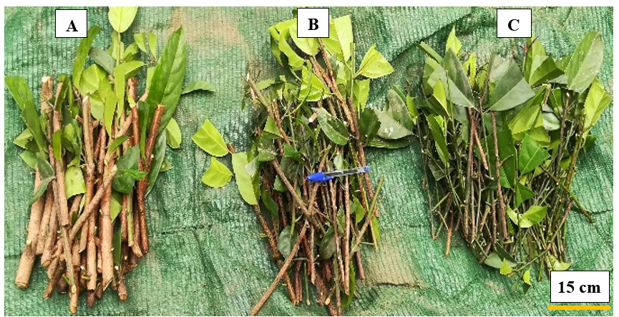

Fig. 1. Diameter classes of Beilschmiedia mannii cuttings studied
A: large-diameter cuttings; B: medium-diameter cuttings; C: small-diameter cuttings

2.3.3 Auxin application on cuttings

The base of B. mannii cuttings of the three diameter classes was soaked for 1 hour in an auxin solution of Indole-3-Butyric Acid (IBA). For each cutting diameter class, three concentrations of IBA were tested: 0 mg/L, 2.5 mg/L and 5 mg/L. Untreated cuttings (0 mg/L IBA) serve as the control.

2.3.4 Preparation of the rooting medium for cuttings

A polypropagator adapted from Leakey (1990) was used as a transplanting medium for the cuttings. The one used was made of bamboo, measuring 3.5 m in length, 1.5 m in width and 1.7 m in height. The volume of the polypropagator was filled with a mixture of topsoil and building sand in a 1:1 (V/V) ratio. The arable land was taken from fallow land, whose vegetation was composed mainly of Chromolaena odorata (L.) and Panicum maximum (Jacq.), due to the role these plants play in maintaining soil fertility. This mixed substrate, with a pH of 5.5, was treated with a fungicide (Mancozeb 880 g/kg) at a rate of 15 g in a 15-litre (product + water) according to the method of Kouakou et al. (2016). Subsequently, the polypropagator was subdivided into 27 plots of identical areas corresponding to the repetitions of the treatments in the study.

2.3.5 Transplanting cuttings and experimental design

In each plot, 5 cm-spaced pits 3 cm deep were created. Then, the cuttings were transplanted into the pits (Fig. 2) using a stick of similar diameter to the cuttings, immediately after the application of auxin. After transplanting, the cuttings were watered with a sprayer, and then the top and edges of the polypropagator were covered with a transparent plastic film.
The experimental design used was a randomised complete block with 3 replicates of each treatment. Two factors were studied. The first was the type of cuttings, which had three modalities: large-diameter, medium-diameter, and small-diameter. The second factor was the concentration of IBA, with three modalities, including 0 mg/L, 2.5 mg/L, and 5 mg/L. The combination of the two factors modalities resulted in 9 treatments (Table 1), with three replications, representing a total of 27 treatments arranged on the 27 plots of the polypropagator. For each plot, 15 cuttings were used, representing 405 cuttings (3 types of cuttings × 3 concentrations of IBA × 15 cuttings × 3 replicates) for the study.

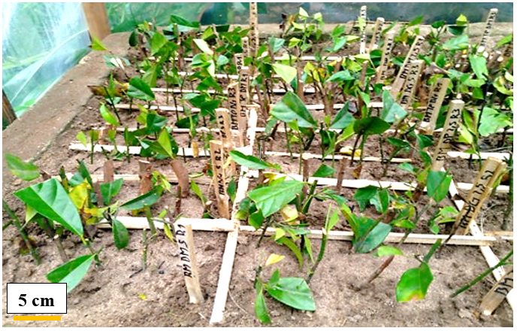

Fig. 2. Cuttings transplanted into the demarcated plots of the polypropagator
Table 1. Characteristics of the treatments studied

Treatments | Characteristics
Treatments | Concentration of IBA  applied (mg/L) | Class and diameter (mm) of cuttings used
T1 | 0 | Small (0 to 5)
T2 | 0 | Medium (5 to 10)
T3 | 0 | Large (10 to 15)
T4 | 2.5 | Small (0 to 5)
T5 | 2.5 | Medium (5 to 10)
T6 | 2.5 | Large (10 to 15)
T7 | 5 | Small (0 to 5)
T8 | 5 | Medium (5 to 10)
T9 | 5 | Large (10 to 15)

2.3.6 Monitoring and acclimatisation

In the polypropagator, the cuttings were regularly moistened every 2 days, if necessary, using a 3-litre capacity pressure hand sprayer (Sprayer). The temperature and average relative humidity inside the polypropagator were 28 ± 2 °C and 94%, respectively. The weeds were regularly pulled out by hand to avoid any competition between weeds and young shoots. After 150 days of experimentation, the live cuttings were carefully removed from the substrate to observe their rooting. The rooted cuttings were transplanted into black polyethylene bags (15 cm x 12 cm), which were perforated and filled with the same type of substrate used in the polypropagator. Then, the seeded bags were placed in the shade for acclimatisation, which lasted 45 days. During acclimatisation, the substrate was regularly moistened as done in the polypropagator.

2.3.7 Data collection

The data collected at the end of the cuttings' stay in the polypropagator (150 days after planting) included the rooting rate, calculated as the ratio of rooted cuttings to the total transplanted cuttings, expressed as a percentage. For rooted cuttings, the number of roots was counted, and their length was measured with a graduated ruler. The budding rate, which is the ratio of cuttings with buds to total transplanted cuttings, expressed as a percentage, was also recorded. The survival rate was calculated as the ratio of surviving cuttings to the total transplanted cuttings, expressed as a percentage. For acclimatisation, parameters such as survival rate, plant height, number of leaves emitted, and leaf length were evaluated. The survival rate was determined by dividing the number of surviving plants post-acclimatisation by the total number of acclimated plants, then multiplying by 100. The number of leaves emitted per plant was counted both before and after cuttings. Leaf length was measured from the insertion point of the petiole on the cutting to the apex, using a graduated ruler, before and after acclimatisation. Plant height was measured from the collar to the apex of the aerial axis, before and after acclimatisation, with a graduated ruler.

2.3.8 Statistical analysis

The collected data were analysed using one-factor (ANOVA 1) and factorial (ANOVA 2) analyses of variance to assess the influence of cutting diameter, IBA concentration, and their interaction on the parameters related to cutting and acclimatisation. When significant differences were observed, the means were compared using the Newman-Keuls test at the 5% significance level. All analyses were carried out using Statistica 7.1 software.

3. results and discussion

3.1 Results

3.1.1 Effect of cutting diameter on rooting, budding, and survival of Beilschmiedia mannii cuttings

The diameter of Beilschmiedia mannii cuttings significantly influenced their rooting and survival rate (P = .017 and P = .000). On the other hand, the budding rates were statistically identical regardless of the diameter of the cuttings, with values ranging from 68.67 to 72.22% (Table 2). Overall, medium-diameter cuttings had the highest rooting and survival rates, at 33.00% and 96.67%, respectively. The survival rate (78.89%) for small-diameter cuttings and the rooting rate (0.00%) for large-diameter cuttings were the lowest. The large-diameter cuttings also had the highest survival rate (98.89%).

Table 2. Budding, rooting, and survival rates of Beilschmiedia mannii cuttings according to the cutting diameter

Diameter of cuttings | Budding rate (%) | Rooting rate (%) | Rate of survival (%)
Large-diameter (10 to 15 mm) | 68.67 ± 7.82 ª | 0.00 ± 0.00 ^{c} | 98.89 ± 1.11 ª
Medium-diameter (5 to 10 mm) | 70.00 ± 4.71 ª | 33.0 ± 5.00 ª | 96.67 ± 2.35 ª
Small-diameter (0 to 5 mm) | 72.22 ± 4.34 ª | 26.66 ± 3.33 ^{b} | 78.89 ± 4.54 ^{b}
F | 1.791 | 3.045 | 24.333
P | .195 | .017 | .000
In the same column, means ± standard deviations followed by the same letter are statistically identical to the threshold of P = .05 according to the Newman-Keuls test.

3.1.2 Effect of the diameter of cuttings on the root growth of Beilschmiedia mannii cuttings

The numbers and lengths of roots per cutting of Beilschmiedia mannii varied significantly according to the cutting's diameter (P = .027). Regardless of the parameter considered, medium-diameter and small-diameter cuttings had, on the whole, the highest values (1.02 and 1.70 roots per cutting; 1.82 and 1.87 cm per root). The values recorded for the large-diameter cuttings were zero, and the lowest (Table 3).

Table 3. Number and length of Beilschmiedia mannii roots according to the diameter of the cuttings

Diameter of cuttings | Number of roots per cutting | Root length per cutting (cm)
Large-diameter (10 to 15 mm) | 0.00 ± 0.00 ^{c} | 0.00 ± 0.00 ^{b}
Medium-diameter (5 to 10 mm) | 1.70 ± 0.59 ª | 1.82 ± 1.38 ª
Small-diameter (0 to 5 mm) | 1.02 ± 0.49 ^{b} | 1.87 ± 0.77 ª
F | 3.133 | 1.368
P | .047 | .027
In the same column, means ± standard deviations followed by the same letter are statistically identical to the threshold of P = .05 according to the Newman-Keuls test.

3.1.3 Effect of the concentration of IBA on the rooting and root growth of Beilschmiedia mannii cuttings

Significant effects (P = .043 and P = .005) of IBA concentration were observed on the rooting rate and the number of roots per cutting of Beilschmiedia mannii, whereas the length of roots per cutting (P = .055) was unaffected. Root length ranged from 1.07 cm at 0 mg/L to 1.4 cm at 5 mg/L IBA. The highest rooting rate was recorded in cuttings treated with 5 mg/L of IBA (47.44%), while the lowest (14.07%) was in untreated cuttings (0 mg/L of IBA). Regarding the number of roots per cutting, concentrations of 2.5 mg/L of IBA (1.41 roots per cutting) and 5 mg/L of IBA (1.65 roots per cutting) yielded the highest values, approximately double those of the 0 mg/L concentration. At this concentration, the lowest number of roots per cutting (0.82 roots per cutting) was observed (Table 4).

Table 4. Rooting rate, number, and length of Beilschmiedia mannii roots as a function of IBA concentration

IBA concentration (mg/L) | Rate Rooting (%) | Number of roots per cutting | Root length per cutting (cm)
0 | 14.07 ± 1.86 ^{c} | 0.82 ± 0.22 ^{b} | 1.07 ± 0.52 ª
2.5 | 36.11 ± 1.11 ^{b} | 1.41 ± 0.11 ª | 1.21 ± 0.26 ª
5 | 47.44 ± 4.44 ª | 1.65 ± 0.06 ª | 1.40 ± 0.40 ª
F | 0.863 | 6.905 | 3.415
P | .043 | .005 | .055
In the same column, means ± standard deviations followed by the same letter are statistically identical to the threshold of P = .05 according to the Newman-Keuls test.

3.1.4 Combined effect of cutting diameter and IBA concentration on rooting, budding, and survival of Beilschmiedia mannii cuttings

Table 5 presents the results of the combined effect of IBA concentration and the diameter of Beilschmiedia mannii cuttings on budding, rooting, and survival rates. The last two parameters recorded significantly different values depending on the treatment (P = .000 and P = .032), in contrast to the budding rate (P = .85). The best rooting rate (53.33%) was induced by the T8 treatment (5 mg/L IBA × medium-diameter cuttings), followed by the T7 (5 mg/L IBA × small-diameter cuttings) and T5 (2.5 mg/L IBA + medium-diameter cuttings) treatments, with 36.6% and 28.42%, respectively. On the other hand, the lowest rooting rates (0.00%) were observed for all treatments involving large-diameter cuttings, namely T3 (0 mg/L IBA × large-diameter cuttings), T6 (2.5 mg/L IBA × large-diameter cuttings), and T9 (5 mg/L IBA × large-diameter cuttings). Also, the rooting of small and medium-diameter cuttings improves with the increase in the concentration of IBA. About the survival rate, except for T1 (0 mg/L IBA × small-diameter cuttings) and T4 (2.5 mg/L IBA × small-diameter cuttings) treatments, which induced the lowest values (70.00 and 73.33%), all treatments performed better for this parameter (90 to 100%). As for the budding rate, it fluctuated between 50% (T3) and 80% (T8).

Table 5: Budding, rooting, and survival rates of Beilschmiedia mannii cuttings under the combined effect of IBA concentration and cuttings diameter

Treatments | Budding rate (%) | Rooting rate (%) | Survival rate (%)
T1 | 73.33 ± 6.67 ª | 13.23 ± 0.44 ^{d} | 70.00 ± 5.77 ^{b}
T2 | 70.00 ± 10.00 ª | 23.33 ± 3.33 ^{c} | 90.00 ± 5.77 ª
T3 | 50.00 ± 5.77 ª | 0.00 ± 0.00 ^{e} | 100.00 ± 0.00 ª
T4 | 66.67 ± 12.02 ª | 19.30 ± 13.3 ^{c} | 73.33 ± 3.33 ^{b}
T5 | 60.00 ± 5.77 ª | 28.42 ± 0.28 ^{bc} | 100.00 ± 0.00 ª
T6 | 60.00 ± 20.82 ª | 0.00 ± 0.00 ^{e} | 96.67 ± 3.33 ª
T7 | 76.67 ± 3.33 ª | 36.60 ± 6.66 ^{b} | 93.33 ± 6.66 ª
T8 | 80.00 ± 5.77 ª | 53.33 ± 3.33 ª | 100.00 ± 0.00 ª
T9 | 60.00 ± 15.28 ª | 0.00 ± 0.00 ^{e} | 100.00 ± 0.00 ª
F | 0.322 | 1.06 | 3.333
P | .858 | .000 | .032
In the same column, means ± standard deviations followed by the same letter are statistically identical to the threshold of P = .05 according to the Newman-Keuls test.
T1 = 0 mg/L IBA × small-diameter cuttings; T2 = 0 mg/L IBA × medium-diameter cuttings; T3 = 0 mg/L IBA × large-diameter cuttings; T4= 2.5 mg/L IBA × small-diameter cuttings; T5 = 2.5 mg/L IBA × medium-diameter cuttings; T6 = 2.5 mg/L IBA × large-diameter cuttings; T7 = 5 mg/L IBA × small-diameter cuttings; T8 = 5 mg/L IBA × medium-diameter cuttings and T9 = 5 mg/L IBA × large-diameter cuttings.

3.1.5 Combined effect of cutting diameter and IBA concentration on root growth of Beilschmiedia mannii cuttings
The mean number of roots/cuttings and the mean length of roots per cutting of Beilschmiedia mannii varied significantly depending on the treatment combining the cutting diameter and IBA concentration (P = .000). The highest number of roots (2.73 roots per cutting) was recorded with the T8 treatment (5 mg/L IBA × medium-diameter cuttings). The same trend was observed for root length, where T8 and, to a lesser extent, T7 (5 mg/L IBA × small-diameter cuttings) recorded the highest values, with 4.06 and 3.42 cm per root, respectively. The number and length of roots of small and medium-diameter cuttings improve with increasing IBA concentration. On the other hand, for these two parameters, all treatments involving large-diameter cuttings, i.e. T3 (0 mg/L IBA × large-diameter cuttings), T6 (2.5 mg/L IBA × large-diameter cuttings) and T9 (5 mg/L IBA × large-diameter cuttings) showed the lowest performance, with zero values, regardless of the parameter (Table 6). Fig. 3 shows the rooting and budding of cuttings under the effect of a few treatments.

Table 6. Mean values of rooting parameters as a function of the combined effect of IBA concentration and diameter of Beilschmiedia mannii cuttings

Treatments | Number of roots per cutting | Root length per cutting (cm)
T1 | 0.88 ± 0.13 ^{c} | 1.09 ± 0.00 ^{c}
T2 | 0.93 ± 0.33 ^{c} | 2.10 ± 2.10 ^{b}
T3 | 0.00 ± 0.00 ^{d} | 0.00 ± 0.00 ^{d}
T4 | 1.71 ± 0.19 ^{b} | 1.21 ± 1.2 ^{c}
T5 | 1.84 ± 0.28 ^{b} | 2.34 ± 0.51 ^{b}
T6 | 0.00 ± 0.00 ^{c} | 0.00 ± 0.00 ^{d}
T7 | 1.88 ± 0.58 ^{b} | 3.42 ± 0.71 ^{ab}
T8 | 2.73 ± 1.33 ª | 4.06 ± 0.26 ª
T9 | 0.00 ± 0.00 ^{d} | 0.00 ± 0.00 ^{d}
F | 2.66 | 0.900
P | .000 | .000
In the same column, means ± standard deviations followed by the same letter are statistically identical to the threshold of P = .05 according to the Newman-Keuls test.
T1 = 0 mg/L IBA × small-diameter cuttings; T2 = 0 mg/L IBA × medium-diameter cuttings; T3 = 0 mg/L IBA × large-diameter cuttings; T4= 2.5 mg/L IBA × small-diameter cuttings; T5 = 2.5 mg/L IBA × medium-diameter cuttings; T6 = 2.5 mg/L IBA × large-diameter cuttings; T7 = 5 mg/L IBA × small-diameter cuttings; T8 = 5 mg/L IBA × medium-diameter cuttings and T9 = 5 mg/L IBA × large-diameter cuttings.

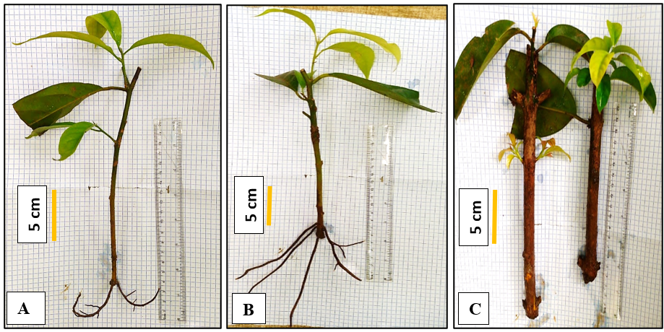

Fig. 3. Overview of budding and rooting of Beilschmiedia mannii cuttings
A: budded and rooted cutting from T7; B: budded and rooted cutting from T8; C: budded and rooted cutting from T9

3.1.6 Plant survival rate after acclimatisation

The rooted cuttings, transplanted into black polyethylene bags, showed an optimal survival rate of 100%, regardless of the treatment, after 45 days of acclimatisation. No mortality was recorded after this period (Fig. 4). Fig. 5 shows plants obtained after acclimatisation.

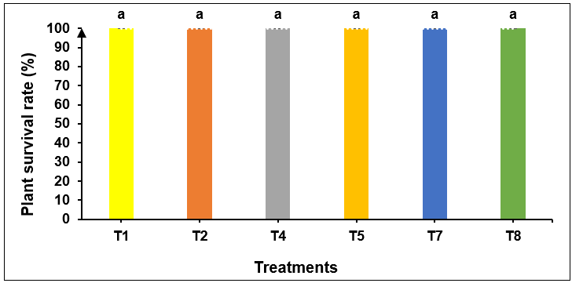

Fig. 4. Survival rate of Beilschmiedia mannii cuttings after 45 days of acclimatisation
In the histogram, the mean bars ± standard deviations followed by the same letter are statistically identical to the threshold of P = .05 according to the Newman-Keuls test.
T1 = 0 mg/L IBA × small-diameter cuttings; T2 = 0 mg/L IBA × medium-diameter cuttings; T4 = 2.5 mg/L IBA × small-diameter cuttings; T5 = 2.5 mg/L IBA × medium-diameter cuttings; T7 = 5 mg/L IBA × small-diameter cuttings; T8 = 5 mg/L IBA × medium-diameter cuttings.

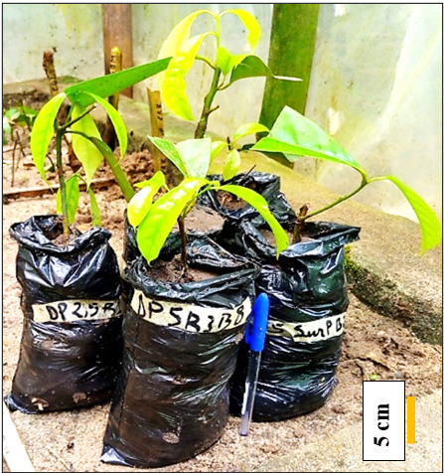

Fig. 5. Plants of Beilschmiedia mannii obtained by cutting of plagiotropic twigs after 45 days of acclimatisation

3.1.7 Height of plants in acclimatisation

The height of the plants was statistically identical, regardless of the treatment, at the beginning of acclimatization, but had varied significantly at the end of acclimatisation depending on the treatments applied (Fig. 6). At the beginning of acclimatisation, the height of the plants ranged between 9.84 and 14.96 cm. At the end of acclimatization, the plants resulting from the T8 treatment (5 mg/L IBA × medium-diameter cuttings) showed the highest height (18.37 cm). In contrast, the lowest height (11.78 cm) was recorded in T7 plants (5 mg/L IBA × small-diameter cuttings).

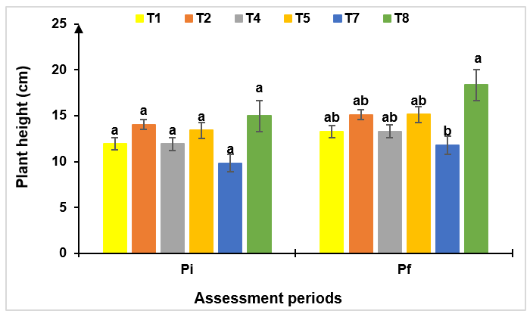

Fig. 6. Evolution of the height of Beilschmiedia mannii plants during acclimatisation according to the treatments
In the histogram, for an assessment period, the mean bars ± standard deviations followed by the same letter are statistically identical to the threshold of P = .05 according to the Newman-Keuls test.
T1 = 0 mg/L IBA × small-diameter cuttings; T2 = 0 mg/L IBA × medium-diameter cuttings; T4 = 2.5 mg/L IBA × small-diameter cuttings; T5 = 2.5 mg/L IBA × medium-diameter cuttings; T7 = 5 mg/L IBA × small-diameter cuttings; T8 = 5 mg/L IBA × medium-diameter cuttings; Pi = before acclimatisation; Pf = at the end of acclimatisation (after 45 days).

3.1.8 Number of leaves emitted during acclimatisation

The number of leaves emitted recorded statistically similar values for all treatments, at the beginning of acclimatisation, with values between 1.33 and 4 leaves/plant. Regarding the number of leaves emitted at the end of acclimatisation, it was dependent on treatments (Fig. 7). The highest leaf count (8.67 leaves/plant) was observed in T8 plants (5 mg/L IBA × medium-diameter cuttings), while the lowest (2.33 leaves/plant) was recorded in T2 plants (0 mg/L IBA × medium-diameter cuttings).

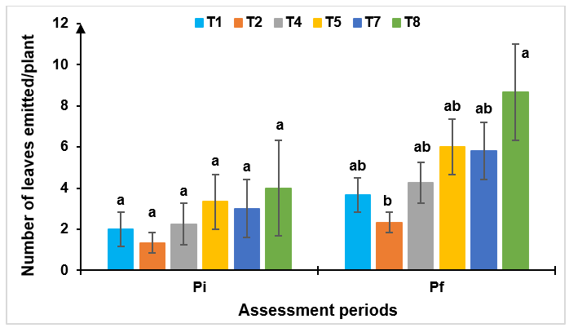

Fig. 7. Evolution of the number of leaves emitted from Beilschmiedia mannii plants during acclimatisation according to the treatments
In the histogram, for an assessment period, the mean bars ± standard deviations followed by the same letter are statistically identical to the threshold of P = .05 according to the Newman-Keuls test.
T1 = 0 mg/L IBA × small-diameter cuttings; T2 = 0 mg/L IBA × medium-diameter cuttings; T4 = 2.5 mg/L IBA × small-diameter cuttings; T5 = 2.5 mg/L IBA × medium-diameter cuttings; T7 = 5 mg/L IBA × small-diameter cuttings; T8 = 5 mg/L IBA × medium-diameter cuttings; Pi = before acclimatisation; Pf = at the end of acclimatisation (after 45 days).

3.1.9 Length of leaves emitted during acclimatisation

The average leaf lengths emitted from Beilschmiedia mannii, at the beginning and end of acclimatisation, are grouped in Fig. 8. In these two periods, this parameter recorded significantly different values depending on the treatment. Overall, the leaf lengths of T8 plants (5 mg/L IBA × medium-diameter cuttings) were the highest, at 9 and 12.2 cm/leaf, respectively. However, the shortest leaves (1.67 to 2.48 cm/leaf) were observed on plants of the T1, T2, and T4 treatments at the beginning of acclimatisation and T1 and T2 at the end of acclimatisation.

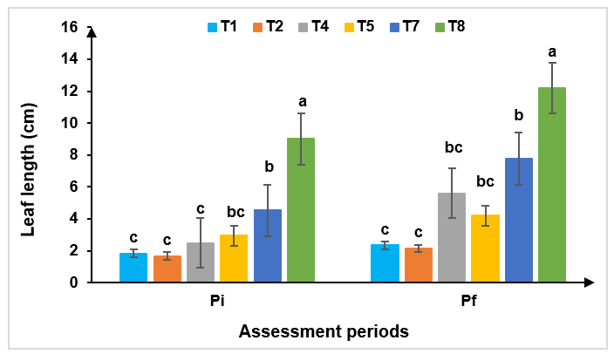

Fig. 8. Evolution of the length of leaves emitted by Beilschmiedia mannii plants during acclimatisation according to the treatments
In the histogram, for an assessment period, the mean bars ± standard deviations followed by the same letter are statistically identical to the threshold of P = .05 according to the Newman-Keuls test.
T1 = 0 mg/L IBA × small-diameter cuttings; T2 = 0 mg/L IBA × medium-diameter cuttings; T4 = 2.5 mg/L IBA × small-diameter cuttings; T5 = 2.5 mg/L IBA × medium-diameter cuttings; T7 = 5 mg/L IBA × small-diameter cuttings; T8 = 5 mg/L IBA × medium-diameter cuttings; Pi = before acclimatisation; Pf = at the end of acclimatisation (after 45 days).

3.2 Discussion

The present study showed that the cuttability of plagiotropic Beilschmiedia mannii twigs is a function of the diameter of the cuttings and the concentration of indole-3-butyric acid. The high survival rates (78-98%) and budding rates (70-72%) recorded in this study can be explained by the vigour of the cuttings and the suitable growing conditions provided by the polypropagator. Indeed, the polypropagator used in this study would have created a microclimate favourable to keeping the cuttings alive (relative humidity of 93% and an average temperature of 33 ± 2 ºC). The preponderant role of the polypropagator in the success of cutting in forest species has already been reported by Leakey et al. (1990), and Tchoundjeu and Leakey (1996). According to Leakey (2014), the polypropagator limits dehydration and consequently the loss of nutrient reserves in cuttings. In addition, the high budding and survival rates of cuttings from plagiotropic twigs demonstrate that they can be used for large-scale propagation of B. mannii species. The potential for multiplication of plagiotropic twigs has also been reported by Bah et al. (2021), who obtained whole plants of Griffonia simplicifolia (M. Vahl ex DC.) Baill from plagiotropic branches. On the other hand, Kouakou et al. (2016) had reported the unsuitability of plagiotropic twigs taken from adult Garcinia kola trees for the cutting. Therefore, the ability to take cuttings from plagiotropic twigs is dependent on the plant species, as Kouadio et al. (2021) have already pointed out.
In this study, the rooting and survival of B. mannii cuttings varied according to their diameter. The rooting observed only in small (2 to 5 mm) and medium (5 to 10 mm) diameter cuttings is explained by their low degree of lignification. Indeed, this situation facilitates the transit of carbohydrates to the base of the cuttings, encouraging the formation of root primordia, unlike strongly lignified cuttings. Similar observations were made by Bah et al. (2021), who obtained 66% of whole plants from the apical part of the plagiotropic twigs compared with only 9% for the basal parts. According to Moupela et al. (2013), the youngest organs have a greater capacity for vegetative multiplication because their cells have a high capacity for differentiation. Meristematic cells are essential for cell division and, therefore, for the physiological activities of cutting. Nguema et al. (2013) have shown that the juvenile nature of the material used for cuttings also influences the rooting of cuttings. These observations contradict those of Dao et al. (2020), which showed that in young G. kola plants aged 24 months, the rooting rate is higher with strongly lignified cuttings. However, it should be noted that the cuttings used were from orthotropic stems.
Survival, which is more important for large-diameter cuttings, could be explained by the fact that they contain more carbohydrate reserves. Large-diameter cuttings would also have more water, making them more resistant to water stress and unfavourable conditions. Costa et al. (2024) also found better survival rates for large-diameter cuttings in guava.
In this study, increasing the concentration of IBA auxin from 2.5 to 5 mg/L improved the rooting of small- and medium-diameter cuttings by increasing the rooting rate, the number of roots per cutting, and the average root length. This finding suggests that IBA stimulates the rhizogenesis of plagiotropic cuttings of small- and medium-diameters, unlike large-diameter cuttings of B. mannii. Indeed, it has already been demonstrated that IBA has a direct effect on rhizogenesis by increasing the speed of carbohydrate translocation at the base of cuttings and consequently stimulating their rooting (Haissig, 1974). Thus, the preferential effect of IBA on certain cuttings over others could therefore be explained by its action on the physiological and nutritional functions of the treated cutting.
The interaction of IBA concentration and diameter of cuttings did not impact the budding of B. mannii. Indeed, budding would depend mainly on internal factors (vitality, bud dormancy) and environmental conditions (temperature, humidity, photoperiod) rather than on auxin-based hormonal treatments or cutting reserves (as long as they are viable). These observations corroborate those made by Otiende et al. (2021) and Chalfun et al. (2003) in studies on rose bushes (Rosa hybrida) and figs (Ficus carica).
The low survival rates of small-diameter cuttings, treated with concentrations of 0 and 2.5 mg/L, are significantly improved at the concentration of 5 mg/L. This can be explained by a sufficient supply of exogenous auxin compensating for the low hormonal reserves and stimulating the formation of adventitious roots, a crucial condition for the survival of cuttings. Similar findings were made by Leakey et al. (1990), who showed that small cuttings have low auxin reserves and few well-developed conductive tissues, limiting their ability to survive and develop roots; and that the application of IBA at a relatively high rate (5 mg/L) stimulates rhizogenesis without causing phytotoxicity, thereby improving their survival. In addition, Mesén et al. (1997) on Cordia alliodora showed that a concentration of about 5 mg/L of IBA significantly increases the survival of small-diameter cuttings, unlike lower or no concentrations.
The application of IBA at 5 mg/L to medium-diameter cuttings is the best combination. It optimises both hormonal stimulation and the physiological potential of cuttings. Conversely, large-diameter cuttings, despite their reserves, are not very receptive to IBA at any concentration, probably because their tissue maturity (lignification too advanced), which explains the absence of roots. Ky-Dembélé et al. (2011) on Khaya senegalensis also reported that the number and length of roots increase significantly with the concentration of IBAs, especially in young or intermediate-sized cuttings. In addition, Leakey et al. (1990) and Tchoundjeu et al. (2001) found that medium-diameter cuttings have an optimal balance of nutrient reserves and ability to respond to growth regulators, maximising their rhizogenic potential, especially at moderate doses of IBAs (around 5 mg/L).
The high survival rate (100%) obtained after acclimatisation indicates that cutting can be an alternative to the production of B. mannii plants for domestication and introduction into agroforestry systems. Indeed, the success of the acclimatisation phase after rooting in the polypropagator is essential for obtaining quality material for planting.
The best values of plant height growth, emission, and leaf growth recorded in this study for plants from IBA-treated cuttings show that this hormone improves the cutting of B. mannii. This observation is more pronounced in medium-diameter cuttings treated with 5 mg/L IBA, probably due to better absorption of nutrients and hormones (Smith et al., 2018). Small-diameter cuttings were less reactive, especially at a dose of 5 mg/L, suggesting a potentially inhibitory effect. On the other hand, the concentration of 2.5 mg/L appears to be optimal for these cuttings. Furthermore, the plants obtained using the control cuttings in this study suggest that it is possible to regenerate B. mannii without the use of hormones, although the results are better under the effect of the IBA hormone. Similar observations were made in Garcinia kola by Kouakou et al. (2016).

4. Conclusion

Concerning the good rooting performance, it can be noted that the medium and small-diameter cuttings of plagiotropic twigs of Beilschmiedia mannii are suitable for cutting. The concentrations of 2.5 mg/L and 5 mg/L of indole-3-butyric acid applied to these cuttings improve their ability to cut and give better plants when acclimatised. The high budding and survival rates obtained for all modalities of this study, both under polypropagator conditions and acclimatisation, demonstrate that cutting is an alternative to the production of viable plants for propagation and the sustainable management of this resource.

DISCLAIMER (ARTIFICIAL INTELLIGENCE)

Authors hereby declare that NO generative AI technologies such as Large Language Models (ChatGPT, COPILOT, etc.) and text-to-image generators have been used during the writing or editing of this manuscript.

Consent (where ever applicable)

No applicable

Ethical approval (where ever applicable)

No applicable

COMPETING INTERESTS DISCLAIMER:
Authors have declared that they have no known competing financial interests OR non-financial interests OR personal relationships that could have appeared to influence the work reported in this paper.

References

Ahoua, A.R.C., Konan, A.G., Bonfoh, B., & Koné, M.W. (2015). Antimicrobial Potential of 27 Plants Consumed by Chimpanzees (Pan Troglodytes Verus Blumenbach) in Ivory Coast. BMC Complementary and Alternative Medicine, 15 (1), 383. https://doi.org/10.1186/s12906-015-0918-7.
Bah, A. M., Dembele, A., & Dogbo, D. O. (2021). Contribution to the regeneration of Griffonia simplicifolia (Baill, Fabaceae, 1866) by stem cuttings. Journal of Animal & Plant Sciences, 50 (1), 8981-8997. https://doi.org/10.35759/JAnmPlSci.v50-1.3
Chalfun, N.N.J., Pasqual, M., Norberto, P.M., Dutra, L.F., & Cavalcante-Alves, J.M. (2003). Rooting of Fig (Ficus carica L.) Cuttings: Cutting Time and IBA. Acta Horticulturae, 605, 137-140. https://doi.org/10.17660/ActaHortic.2003.605.21
Costa, J. C. F. da., Penso, G. A., Fernandes, D. R., Marques Junior, E., Serafini, G. A. D., & Santos, C. E. M. dos (2024). Rooting of ‘Pedro Sato’ guava cuttings as a function of diameter, types of cuts, and treatment with bioestimulant. Revista Brasileira De Fruticultura, 46, e–793. https://doi.org/10.1590/0100-29452024793
Dao, J.P, Kouakou, L.K., Kouakou, C., Cherif, M., Ouedraogo, H.M., Koffi, K.K, et al. (2020). Effect of Leafy and Leafless Greenwood, Softwood and Hardwood Cuttings Success of Garcinia kola (Heckel). Agricultural sciences, 10 (2020), 897-911. https://doi.org/10.4236/as.2020.1110058
Djibo, M. I, Rabiou, H., Morou, B., Diouf, A., Diallo, I. I., Adamou, A. B., et al. (2020). Boscia Senegalensis (Pers.) Lam. ex Poir., a Woody Species with High Ethnobotanical Potential and Well Adapted to Drought in the Sahel: Bibliographic Synthesis. European Scientific Journal, March 2020 edition 16(9), 206. https://doi.org/10.19044/esj.2020.v16n9p206
Haissig, B. E. (1974). Influences of auxin synergists on adventitious root primordium initiation and development. New Zealand Journal of Forestry Science, 4, 311–323. https://www.scionresearch.com/__data/assets/pdf_file/0009/58725/NZJFS421974HAISSIG311_323.pdf

Jusu, A., & Cuni-Sanchez, A. (2017). Priority Indigenous Fruit Trees in the African Rainforest Zone: Insights from Sierra Leone. Genetic Resources and Crop Evolution, 64 (4), 745-60. https://doi.org/10.1007/s10722-016-0397-9.
Kouadio, E.Y.G., Kassi, K.F.J.M., Cherif, M., Kouamé, K.F., Kouamé, K.D., Tuo, S., et al. (2021). Cutting ability and growth of three cover crops [Arachis pintoi (L.) Krapov & W.C. Greg. Arachis repens (L.) Handro Desmodium adscendens (SW.) DC.] in nursery. International Journal of Advanced Research, 9 (Jul), 01-10. https://dx.doi.org/10.21474/IJAR01/13092
Kouakou, K.L., Dao, J.P., Kouadio K.I, Beugré, M.M., Koné, M., Baudoin, J-P., et al. (2016). Propagation of Garcinia kola (Heckel) by stem and root cutting. Silva Fennica, 50 (4). 17 p. https://doi.org/10.14214/sf.1588
Kouamé, A.M., Sahoré, A.S., & Amani, N.G. (2017). Fatty acid profile of Beilschmiedia mannii (Lauraceae) seed oil. International Journal of Biology and Innovation, 6(5), 675-700. https://www.jbino.com/docs/Issue05_07_2017.pdf.
Ky-Dembele, C., Tigabu, M., Bayala, J., Savadogo, P., Boussim, I.J., & Odén, P.C. (2011). Clonal Propagation of Khaya senegalensis: The Effects of Stem Length, Leaf Area, Auxins, Smoke Solution, and Stockplant Age, International Journal of Forestry Research, 2011, 281269, 10 pages. https://doi.org/10.1155/2011/281269
Leakey R.R.B. (1999). Agroforestry for biodiversity in farming systems. See Reference, 23, 127–45. https://www.gov.uk/research-for-development-outputs/agroforestry-for-biodiversity-in-farming-systems
Leakey, R.R.B. (2014). Plant Cloning: Macropropagation. In: Encyclopedia of Agriculture and Food Systems, Van Alfen N. (ed.). San Diego, USA, Elsevier, pp. 349-359. https://doi.org/10.1016/B978-0-12-805356-0.00020-9
Leakey, R.R.B., Mesen, J.F., Tchoundjeu, Z., Longman, K.A., Dick, McP., Newton, A., et al. (1990). Low-technology technique for the vegetative propagation of tropical trees. Commonwealth Forest Review, (69), 247-257. https://www.gov.uk/research-for-development-outputs/low-technology-techniques-for-the-vegetative-propagation-of-tropical-trees
Leakey, R.R.B., Weber J.C., Page T., Cornelius J.P., Akinnifesi F.K., Roshetko J.M., et al. (2012). Tree Domestication in Agroforestry: Progress in the Second Decade (2003–2012). In Agroforestry - The Future of Global Land Use, edited by P.K. Ramachandran Nair and Dennis Garrity, 9, 145-73. Advances in Agroforestry. Dordrecht: Springer Netherlands. https://doi.org/10.1007/978-94-007-4676-3_11.
Mark, J., Adrian, N.A.C., Oilfield, S., & River, M. (2014). The international timber trade: A working list of commercial timber species. Botanic Gardens Conservation International Descanso House, Richmond, UK. https://www.bgci.org/resources/bgci-tools-and-resources/a-working-list-of-commercial-timber-tree-species/
Mesén, F. J., Newton, A. C., Leakey, R. R. B., & Grace, J. (1997). Vegetative propagation of Cordia alliodora (Ruiz & Pavon) Oken: the effects of IBA concentration, propagation medium, and cutting origin. Forest Ecology and Management, 92(1–3), 45–54. https://doi.org/10.1016/S0378-1127(96)03960-6
Metougui, M.L., Mokhtari, M., Machati, I., Azeroual, I., & Benlhabib, O. (2017). Vegetative propagation of the argan tree (Argania spinosa L. skeels) by cuttings and grafting. Moroccan Journal of Agronomic and Veterinary Sciences, 5 (4), 428-436. https://www.agrimaroc.org/index.php/Actes_IAVH2/article/view/499

Moupela, C., Doucet, J. L., Daïnou, K., Meunier, Q. & Vermeulen, C. (2013). Propagation trials by seed and air layering of Coula edulis Baill. And prospects for its domestication. Tropical Woods and Forests, 318(4), 3-13. https://doi.org/10.19182/bft2013.318.a20516
N’zi, J., Mbo, K.A.A., Lougue, B., Affessi, W., Kouassi, K.H., & Kouamé, C. (2023). Cocoa (Theobroma cacao) and local fruit species interaction: Case of Beilschmiedia mannii in traditional agroforestry systems in Western Côte d’Ivoire. African Journal of Agricultural Research 19(5), 557-566. https://doi.org/10.5897/AJAR2022.16288
Nguema, N.P., Bouanga, E.B., Massounga, Y.C., & Boussiengui, G. (2013). Comparative study of three methods of multiplication of Jatropha curcas L. in the climatic conditions of south-eastern Gabon. Journal of Applied Biosciences, 65, 4989-4998. http://dx.doi.org/10.4314/jab.v65i0.89641
Olajuyigbe, S. O., & Adaja, A. A. (2019). Beilschmiedia mannii Robyns and Wilczek: An underutilized tree crop with great socioeconomic potential. In: Adekunle VAJ, Ogunsanwo OY, Adewole NA, Oni PI (Eds). Sustainable development through appropriate forest management strategies. Proceedings of the 41st Annual Conference of Forestry Association of Nigeria (FAN), Abuja, 7th-11th October 2019, pp 171-177.
Oloyede, F. M., Ola, D. S., & Iwalewa, E. A. (2023). Biodiversity conservation of the neglected and underutilized Nigerian horticultural crops. Acta Horticulturae et Regiotecturae 26(1), 64-72. https://doi.org/10.2478/ahr-2023-0010
Otiende, M.A., Fricke, K., Nyabundi, J.O. Ngamau, K., Hajirezaei, M.R, & Druege, U. (2021). Involvement of the auxin–cytokinin homeostasis in adventitious root formation of rose cuttings as affected by their nodal position in the stock plant. Planta, 254, 65. https://doi.org/10.1007/s00425-021-03709-x
Kouamé, A.M., Sahoré, D.A., & Amani, N.G. (2017). Fatty acid profile of Beilschmiedia mannii (Lauraceae) seed oil. International Journal of Geology, Agriculture and Environmental Sciences, 6, 695-700. https://www.woarjournals.org/admin/vol_issue1/upload%20Image/IJGAES051401.pdf
Smith, M. G., Arndt, S. K., Miller, R. E., Kasel, S., & Bennett, L. T. (2018). Trees use more non-structural carbohydrate reserves during epicormic than basal resprouting. Tree Physiology, 38 (12), 1779-91. https://doi.org/10.1093/treephys/tpy099
Soro, K., Diarrassouba, A., Soro, N.A., Kone, L.S.P., Djessou, S.A., Assie, D.R.H. et al. (2021). Harvesting period and seed germination rate of three wild fruit trees: akpi, choco, and bitei, around Taï National Park. African Agronomy, 33 (2), 231-242. https://www.ajol.info/index.php/aga/article/view/217090
Tchoundjeu, Z., & Leakey, R.R.B. (1996). Vegetative propagation of African mahogany: effects of auxin, node position, leaf area, and cutting length. New Forests, 11(2), 125-136. https://doi.org/10.1007/BF00033408

Tchoundjeu, Z., & Leakey, R.R.B. (2022). Vegetative propagation of Lovoa trichilioides: effects of provenance, substrate, auxins, and leaf area. Journal of Tropical Forest Science, 13(1), 116-129. https://jtfs.frim.gov.my/jtfs/article/view/1330.
Yao, C.K., Kouamé, M.T.N., Mangara, A., & Bohi, S.G.A. (2023). Ethnobotanical study on the levels of knowledge and use of Irvingia gabonensis, Beilschmiedia mannii, and Strombosia pustulata in the ecosystem around Taï National Park (Southwest Côte d’Ivoire). International Journal of Biological and Chemical Sciences, 17(6), 2249-2261. https://dx.doi.org/10.4314/ijbcs.v17i6.10
Yevide, S.I.A., Gbesso, G.H.F., Aïdjihounde, S.V.N., & Djossa, B.A. (2022). Ethnobotanical study and conservation of Beilschmiedia mannii (Meisn.) Benth. and Hook. F. In southeastern Benin. Moroccan Journal of Agronomic and Veterinary Sciences, 10 (2), 312-318. https://www.agrimaroc.org/index.php/Actes_IAVH2/article/view/1179

Abbreviations

IBA: indole-3-butyric acid

