Floristic characteristics, diversity and population structure of Balanites aegyptiaca (L.) Del in the Ouadi Rimé-Ouadi Achim wildlife reserve in Chad

ABSTRACT
In Chad, the Balanites aegyptiaca is a highly useful species preserved by producers in agroforestry parks, whose sustainability is under threat. The aim of this study is to assess the ecological health of Balanites aegyptiaca and associated woody vegetation in the Ouadi Rimé-Ouadi Ochim Wildlife Reserve in Chad. Data were collected using floristic surveys based on dendrometric measurements of woody species in 110 plots of 900 m² each. Dendrometric measurements show a low density of individuals across both sites with almost zero species richness. The structure of the stands in both sites reflects a degraded stand with low regeneration potential. In the park reserve, the structure is characterised by a juvenile population, while the grazing area has low regeneration potential. In the early stages, regeneration is significant but quickly disappears under the combined effect of several mesological factors. The park reserve located in the Sahelian sector is the priority site in terms of repopulation of B. aegyptiaca. These findings suggest the urgent need to develop appropriate strategies for the sustainable management of the species in Chad.
Keywords : Vegetation, Balanites aegyptiaca, structure, Ouadi Rimé-Ouadi Achim

INTRODUCTION
Climate deterioration combined with other human factors such as agricultural clearing, overgrazing, timber harvesting for craftsmanship, fuelwood and energy, and bush fires have caused sometimes severe degradation of forest formations, including those in protected areas (Gonzalez et al., 2012 ; Benjamin et al., 2020). Several authors, including Ganaba (2008) and Paré (2008) in Burkina Faso ; Larwanou and Saadou (2005) in Niger, have reported a decline in the density and quality of woody species in the Sahelian zone to such an extent that many species are becoming rare or extinct in their range. The importance of protected areas in biodiversity conservation is now widely recognised (Ouédraogo, 2009). Indeed, they serve as refuges for many animal and plant species and constitute an exceptional heritage for local populations because of the goods and services they provide. In the Sahelian zone, human populations have long relied on harvesting plant products and hunting to meet their basic needs. Farmers seek out several types of products on a daily basis (Rabiou et al., 2020). These products sought by farmers include edible nuts, mushrooms, fruits, herbs, spices, gums, aromatic plants, game, wood, fodder and plant or animal products for medicinal, cosmetic, food and/or cultural uses (Sinsin et al., 2004). Among the species that provide these non-timber forest products is Balanites aegyptiaca, which is an important species that is heavily exploited by the population in Chad. The fruits are a highly prized food source for the local population and can be used for medicinal purposes. The insect-resistant wood is a high-calorific fuel and is used in construction, tool handles, toothpicks, firewood and charcoal, fences, mortars, pestles and Koranic tablets. The seeds are used in the manufacture of oils and soaps, and the young leafy branches are used as fodder and for human consumption (Arbonnier, 2019 ; Abdou, 2016 ; Ganaba et al., 2004). The leaves, flowers and young branches are prized in cooking. The pulp of the bittersweet fruit is sucked like candy, and its drupes are sold by women and also macerated in water to replace sugar in porridge. Oil is extracted from the kernels for cooking and soap making. In Sahelian countries, the species plays a key role in food and nutritional security for farmers and in timber production. The lack of scientific data on the ecological health of the species in Chad is a constraint that limits the implementation of sustainable biodiversity management and development practices.
This study falls within this framework and aims to characterise the population of Balanites aegyptiaca and associated woody vegetation in the Ouadi Rimé-Ouadi Ochim Wildlife Reserve through analysis of its floristic composition, plant community structure and ecological parameters.

MATERIALS AND METHODS
Presentation of the study area
The study was conducted in the Ouadi-Rimé Ouadi-Achim Faunal Reserve (RFOROA) and its surroundings located in north-central Chad between latitudes 14° and 17.5°N and longitudes 17.2°-216.5°E (Wacher et al., 2011). It is shared between the provinces of Ba6tha, Borkou, Bahr el Ghazal, Wadi Fira and Ennedi Ouest (Duhem and Cornu, 2019). This reserve is one of the largest in Africa, covering an area of 7795,000 ha (77950 km²). Overall, RFOROA has an arid to semi-arid desert bioclimate (Hiernaux and Le Houérou, 2006). Rainfall varies in duration and abundance according to latitude, and the gradient is such that average annual rainfall decreases by 1 mm/km as latitude increases. Over the course of the year, relative humidity is extremely low (Hiernaux and Le Houérou, 2006) and average monthly temperatures range from 14 to 42°C (Climate-Data, 2012) depending on the season and latitude, reflecting the harshness of the climate. The vegetation of the Ouadi Rimé-Ouadi Achim reserve is represented by the steppe characteristic of the vegetation of Sahelian zones. The grassy stratum is represented by the following genera: Aristida, Panicum, Cenchrus, Chrozophora, etc. and a few creepers and climbers such as Citrullus colcynthis and Leptadania hastata. Woody plants are represented by : Balanites aegyptiaca, Vachellia radiana, Vachellia seyal, Boscia senegalensis, Maerua crassifolia, Capparis decidua, Cordia sinensis, Leptadania pyrotecnica, etc. The reserve is also home to a huge diversity of desert species, including: the white-tailed mongoose, common genet, sand cat, fox, fennec, golden jackal, pale fox, ratel, striped hyena, desert antelopes such as the dorcas gazelle, the dama gazelle, which is an emblematic species, the Arab bustard, etc.
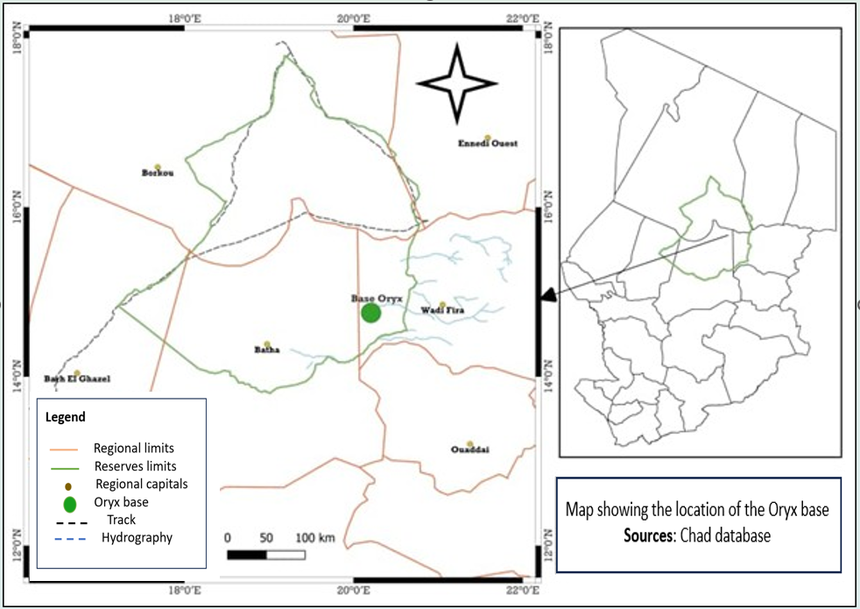
Figure 1 : Map showing the location of the study area

Collection of dendrometric and floristic data
Sampling was targeted, based on the presence of Balanites aegyptiaca stands. Prior to the inventories, surveys were carried out to identify potential B. aegyptiaca sites. Floristic inventories and dendrometric measurements were carried out using plots measuring 30m x 30m in the wildlife reserve and the grazing area outside the park, making a total of 110 plots due to the availability (relative abundance and accessibility) of the species. The plots were set up on homogeneous vegetation facies and separated by at least 100 m. The site characteristics of each plot (topography, soil texture, vegetation formation, disturbance) were recorded. The inventory and measurements of dendrometric parameters covered all B. aegyptiaca trees and associated woody species. The variables measured were the diameter of the stem at 1.30 m above the ground (Dbh) and the total height of adult individuals. For multi-stemmed individuals, the Dbh was measured and the quadratic diameters were calculated. The health status of each individual measured was also assessed according to the following coding system : 1 = healthy individual ; 2 = diseased individual (individual attacked, parasitised or partially damaged); 3 = dead individual (Thiombiano et al., 2016).
The natural regeneration inventory focused on juveniles with DBH < 3 (Bognounou et al., 2009, Kaboré et al., 2012) and measurements were taken of total height. Given the scarcity of young plants, a systematic inventory was carried out in each plot. Given that tree regeneration occurs through several mechanisms, that of B. aegyptiaca was determined in the field by excavating the root system of young trees. This made it possible to verify any connection with a parent root for suckers (Adjonou et al., 2009). Seedlings are generally slender in shape, while stump sprouts and suckers are relatively robust and more vigorous (Bellefontaine et al., 2000 ; Ouédraogo et al., 2006).

Data analysis and processing
Dendrometric characteristics
The following parameters were calculated to describe the dendrometric and demographic characteristics of B. aegyptiaca :
- The average density (Dm) of individuals, expressed as the number of individuals per hectare. It was obtained using the formula Ni = n/s, where n is the total number of trees (Dbh ≥ 3 cm) in the plot and s is the plot area (s = 0.66 ha).
- The average diameter (dm) expressed in cm : dm= $dm=\frac{1}{n}\sum_{i=1}^{n}{d_{i}}$, where di is the diameter at 1.30 m above the ground of individual i in the plot ;
- The basal area G (in m².ha⁻¹) is the sum of the cross-sectional areas of the B. aegyptiaca individuals (in the plot) at 1.30 m above the ground. It is given by the formula : G = = $\sum_{i=1}^{n}{\frac{d_{i}^{2}}{4π}}$, where di is the diameter at 1.30 m above the ground of individual i in the plot ;
- The average height was calculated using the formula : $hm=\frac{1}{n}\sum_{i=1}^{n}{h_{i}}$; where hi is the height of individual i in the plot ;
Regeneration density (Dj) is calculated using the formula : Dj = nj/sr with $n_{j}=\frac{1}{q}\sum_{i=1}^{q}{ni}$; nj is the number of juveniles, q is the number of plots, ni is the number of juveniles per plot and sr is the area of the plot.
The regeneration rate (TRP), expressed as a percentage, is the ratio between the total number of young plants and the total number of individuals in the population. This rate expresses the ability of the plant species to renew its populations.
TRP= $\frac{Total number of young plants}{Total population}$ x100 (Diouf et al. 2019)
The data were subjected to a 5% significance level comparison test to compare the mean values according to site using R software version 4.0.3 (RCORE TEAM, 2019).

Demographic structure of populations
The structure of Balanites aegyptiaca populations was analysed using the distribution of individuals into diameter classes with a 3 cm amplitude. To gain a better understanding of population dynamics, these structures were adjusted by superimposing a 3-parameter Weibull distribution (Husch et al., 2003) using Minitab 17 software. This Weibull distribution provides greater visibility into population structure (Tjørve, 2003 ; Glèlè et al., 2015) due to its flexibility. Its probability function (f) is expressed by the formula : f (x) =$\frac{c}{b}(\frac{x-a}{b}$ )^{c-1}exp [-($(\frac{x-a}{b}$)^{c}], where x = diameter of trees at 1.30 m above ground level; a = threshold or position parameter, which in our case is the lower threshold for measuring tree diameter of 5 cm in this study ; b = size parameter; c = observed shape parameter. Furthermore, the Weibull distribution can take several forms depending on the value of the shape parameter c (Table 1).
Table 1 : Shape of the Weibull distribution according to the values of parameter c
Value of c | Interpretation
c ˂ 1 | Inverted J-shaped distribution : characteristic of stands with high regeneration potential
c =1 | Exponentially decreasing distribution : characteristic of populations with relatively high regeneration potential but often experiencing survival problems during the transition between developmental stages.
1 ˂ c ˂ 3,6 | Positive or right-skewed distribution : characteristic of artificial stands with a relative predominance of young individuals with small diameters. However, it can also be characteristic of stands with low regeneration potential.
c = 3,6 | Symmetrical distribution : characteristic of stands with low regeneration potential or characteristic of the species
c > 3,6 | Negative or left-skewed distribution : characteristic of stands dominated by large-diameter, mature trees. It can also represent degraded stands with very low regeneration potential or in decline.

RESULTS
Dendrometric characteristics of stands
Analysis of the dendrometric parameters recorded in Table 2 shows that the average overall density of the Balanites aegyptiaca population is 17.72 individuals per hectare in the protected area, compared with 13.46 individuals per hectare in the grazing area. The basal area values are significantly comparable between the two sites. However, the average diameter and average height have significantly different values between the two sites (p<0.001). Analysis of the health status of B. aegyptiaca populations revealed a variable proportion of healthy B. aegyptiaca individuals between provinces (p<0.001). Of the approximately 403 adult individuals inventoried in the protected area, 67.36% are healthy. Among the diseased individuals, 96.29% are parasitised by insects and 3.70% show signs of pruning, bark stripping, trimming or bush fires. In the grazing area, 75.04% are in normal health. Among these diseased individuals, 84.59% are affected by locusts and 15.40% have suffered from pruning, trimming and, above all, bush fires (Pic 1).
Analysis of dendrometric parameters shows that the density of mature trees in the protected area (17.72 trees/ha) is higher than in the grazing area (13.46 trees/ha). The average diameter in the protected area is 9.94±12.00 m, whereas in the grazing area it is 11.42±10.31 m.
Analysis of the data shows that the average tree height in the protected area is 2.84±4.24 m, while in the grazing area it is 3.01±2.24 m.
The basal area is 0.11±0.44b in the protected area, whereas it is 0.35±0.01a in the grazing area.
Table 2 : Dendrometric parameters
 | Adults |  |  |  |  | Juveniles
 | Density | Basal area (m²/ha) | Average Dbh (cm) | Average heights (m) | Proportion of healthy individuals | Density | Average heights (m) | Average diameter (cm) | Regeneration rate
Reserve area | 17,72 | 0,11±0,44^{b} | 9,94±12,00^{c} | 2,84±4,24^{b} | 67,36% | 25,20±19,41ª | 1,60±9,49 | 0,48±0,27ª | 17,56%
Grazing area | 13,46 | 0,35±0,01ª | 11,42±10,31 | 3,01±2,24ª | 75,04% | 12,00±6,24^{b} | 0,33±0,25 | 1,10±1.02ª | 20,80%
P-value | <0,001 | <0,001 | <0,001 | <0,001 |  | <0,001 |  | <0,001

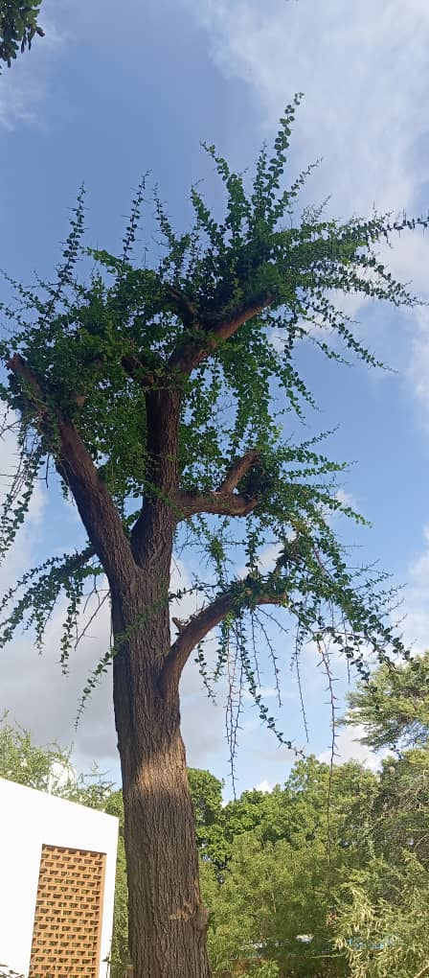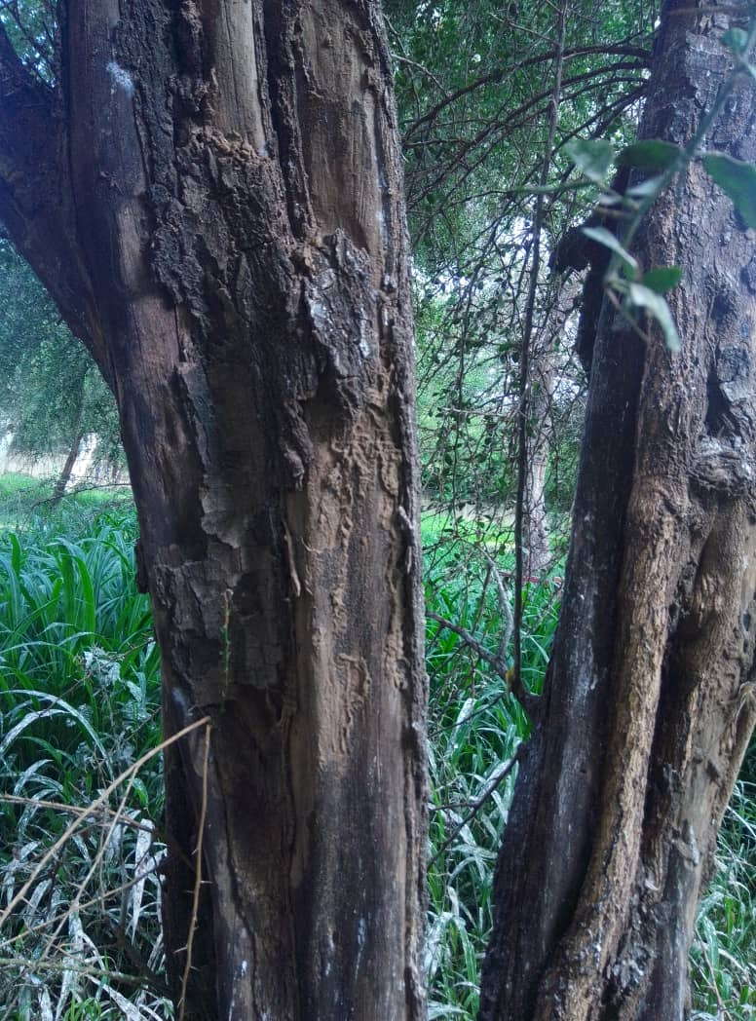
A
B
Pic 1: Types of damage to Balanites aegyptiaca individuals: (A) pruning, (B) bark stripping
Demographic structure of Balanites aegyptiaca parks
The diameter class structure of Balanites stands is asymmetrical (Figure 2). In the protected area (adults), it is less than 1 (c<1), indicating stands with high regeneration potential and a density of 60 to 65 young individuals per hectare. In the grazing zone (adults), it is also less than 1 (c<1), indicating stands with high regeneration potential but with an average density of 45 young individuals per hectare.

Figure 2 : (A) Population structure in the reserve zone ; (B) Population structure in the grazing zone
Vertical structures of Balanites aegyptiaca regeneration
In the juvenile protected area, the distribution of individuals is in the shape of an inverted J (c<1) : characteristic of populations with high regeneration potential and a density of up to 60 individuals per hectare (Figure 3. A).
In the juvenile grazing zone, the density of individuals is 150 to 190 per hectare, with a tendency for adult individuals to disappear (Figure 3. B).

Figure 3 : (A) Vertical structure of juveniles in the reserve area ; (B) Vertical structure of juveniles in the grazing area
DISCUSSION
Dendrometric characteristics
In arid areas such as the Sahel, woody vegetation is relatively undiversified due to the very difficult conditions for vegetation to establish and develop (Deblauwe, 2010). Very low annual rainfall, high anthropogenic pressure and low grazing pressure are factors that limit the growth of vegetation (Ozer and Ozer, 2005). The dendrometric characteristics of B. aegyptiaca stands showed variability in density, basal area, mean diameter and mean height across the study sites. The high densities observed in the protected area (17.72 individuals per hectare) and (13.46 individuals per hectare) in the grazing area could be explained by the intervention of the oryx reintroduction project in the Ouadi-Rimé Ouadi-Achim wildlife reserve in Chad. This difference in density between the two sites is thought to be due to human activity affecting these individuals, bush fires, which are a recurring phenomenon in the reserve, and the impact of insects on plants in the grazing area. Heavy anthropogenic pressures from logging, agricultural activities (clearing), bush fires and the accelerated sedentarisation of nomads within the reserve contribute to the degradation of vegetation formations, leading to the fragmentation of natural habitats. The difference in density observed is thought to be due to environmental factors and degradation of the environment, such as overgrazing and unregulated harvesting of plant parts. Similar studies conducted by Rabiou et al. (2016) in Niger and Burkina Faso and Oumar et al. (2021) in Chad showed higher densities of individuals per hectare. Strong human population growth is leading to an increase in the intensity of plant resource exploitation due to high demand for resources. According to Kouyaté et al. (2017), exploitation pressure is the cause of plant biodiversity loss and has a major impact on the balance of natural ecosystems. The proportion of sick or infected individuals in populations reflects the vulnerability of the species in its natural habitat. This vulnerability is largely exacerbated by parasitism (insect activity) (Djekonbé, 2018) and anthropogenic pressures such as pruning, trimming, bark stripping and bush fires.
Diameter class structures of adult Balanites aegyptiaca
The diameter class structure provided insight into the dynamics of Balanites aegyptiaca populations. According to the Weibull distribution, B. aegyptiaca populations at the different sites show a positive asymmetric distribution characteristic of a degraded population with low regeneration potential. The B. aegyptiaca population is ageing in this area. Young individuals were strongly represented at both sites. Similar work was conducted by Rabiou et al. (2020) in the Maradi region of Niger. This ageing of individuals could compromise the sustainability of the species in this area, which is part of the dispersal range of B. aegyptiaca. The same is true for the structure of B. aegyptiaca populations in grazing areas. The cause of ageing is overexploitation, compounded by the effects of climate change. The ‘inverted J’ shape of the Weibull distribution reflects the ageing of populations, as reported by Thiombiano et al., (2010). This structure indicates an unstable population (Nouvellet et al., 2006 ; Gnoumou et al., 2011). The poor demographic distribution is attributable to anthropogenic and animal activities, especially grazing, and unfavourable climatic conditions.
Vertical structures of Balanites aegyptiaca regeneration
Regardless of the site, the distribution observed shows a progressive dynamic. Natural regeneration is therefore effective overall. However, this potential for replacing adult individuals does not guarantee the species' sustainability, as numbers decline considerably as we move up to the higher classes (Ouédraogo et al., 2006 ; Thiombiano et al., 2010). This situation reflects the difficulty of transition between the different stages. The difference in juvenile density between the two areas could be due to the activity of animals in the grazing area. Animals, especially ruminants, eat the fruits whole, and after ingestion, the germination capacity of the plant increases under the chemical and mechanical action of the digestive system of these animals, causing dormancy to be broken.
CONCLUSION
The assessment of the status of Balanites aegyptiaca populations has highlighted the potential of these species' resources in Chad. This study shows that B. aegyptiaca populations have unstable structures in the Ouadi-Rimé Ouadi-Achim Wildlife Reserve. The low proportion of healthy individuals in the population and the low density of adult individuals could compromise the availability of this resource in the medium to long term. The low proportion of adult individuals due to anthropogenic pressure compromises its long-term conservation. The Ouadi-Rimé Ouadi-Achim Wildlife Reserve has degraded populations. Although B. aegyptiaca shows some resilience through stable structures in the grazing area and good recruitment capacity, the apparent difficulties in regenerating reveal a certain vulnerability. This situation calls for the urgent integration of both species into local plant domestication programmes for their conservation and sustainable use. They are therefore a priority for species restoration measures. This action should employ assisted natural regeneration and planting techniques. It will also be necessary to raise awareness among producers about maintaining regeneration in agricultural systems. Restoration requires the active participation of rural populations and increased protection of juveniles.
DATA AVAILABILITY
The datasets used and analyzed during the current study are available from the corresponding author on reasonable request.
DECLARATIONS
Authors declare they have no conflict of interest/competing interest.
REFERENCES
Abdou H. M. K., 2016. Characterization of the vegetation of the PLECO intervention zone in Gouré. Master's thesis, Dan Dicko Dankoulodo University of Maradi, 59p.
Abdou Habou M. K., Rabiou H., Abdou L., Abdourahamane I. S., Sanoussi I. A. A. E., Soumana A. & Mahamane A., 2019. Germination and growth of seedlings of a native fruit species in Niger: Balanites aegyptiaca (L) Del. Int. J. Biol. Chem. Sci. 13(2): 693-703. DOI: https://dx.doi.org/10.4314/ijbcs.v13i2.10
Arbonnier M., 2019. Trees, Shrubs, and Lianas in the Dry Zones of West Africa. Quae, 775p
Bellefontaine R., Edelin C., Ichaou A., Du Laurens D., Monsarrat A. & Loquai C., 2000. Suckering, an alternative to sowing and planting woody plants in semi-arid areas: a research protocol. Drought, 11: 221-226.
Benjamin A. K. Dossa; Bienvenue Sourou; Christine Ouinsavi, 2020. Seed germination and growth of Detarium senegalensis seedlings in the nursery and field in Benin. URL: http://dx.doi.org/10.19044/esj.2020. V16 n12p38.
Bognounou F., Savadogo P., Thiombiano A., Tigabu M., Boussim J. I., Oden & Guinko S., 2009. Impact of disturbance from road works on Pteleopsis suberosa regeneration in roadside environments in Burkina Faso, West Africa. Journal of Forestry Research, 20(4): 355–361. https://dx.doi.org/10.1007/s11676-009-0060-9
Deblauwe V., 2010. Modulation of self-organized vegetation structures in arid environments. Doctoral thesis, ULB. 173p.
Diouf N. S., Ouedraogo I., Zougmoré R. B., Ouedraogo M., 2019. Factors influencing women's access to climate information services for agriculture in Senegal. Gender, Technology and Development, 23(2), 93-110.
Djekonbé P.; Avana T. M. L. & Womeni M. H., 2018. Influence of parasitic (Loranthaceae) and anthropogenic pressures on the dynamics of shea (Vitellaria paradoxa Gaertn. C. F.) stands in Chad. Scientific and Technical Review of Forests and Environment of the Congo Basin, 11:39-48
Ganaba S.; Ouadba J. M.; Bognounou O., 2004. Plants for building houses in the Sahel region. Trophic Wood, 282(4):11-17. DOI: http://doi.org/10.19182/bft2004.282.a20215.
Ganaba S., 2008. Characterization, Uses, Restoration Tests, and Management of Woody Vegetation in the Sahel, Burkina Faso. Doctoral Thesis, Cheik Anta Diop University of Dakar, 287p.
Glèlè Kakai R.; Bonou W. & Lykke A. M., 2015. Methodological Approach to Constructing and Interpreting Tree Diameter Structures. Annales des Sciences Agronomiques, 20: 95-105.
Gnoumou A., Bognounou F., Hahn K., Thiombiano A., 2011. Diversity of woody plants and structure of stands in the Comoé-Leraba reserve, in the southwest of Burkina Faso (West Africa).
Gonzalez-Bernaldez F., Monstserrat P., Criado A. G., 1969. Automatic Elaboration of Phytosociological Data. Royal Spanish Society of Natural History.
Hiernaux P.; Le Houerou H. N., 2006. Sahel Rangelands. In Drought, vol. 17 (1-2), pp. 51-57.
Husch B.; Beers T. & Kershaw J. J. R., 2003. Forest Surveying. John Wiley & Sons, New York.
Kaboré S. A., Bastide B., Traoré S., and Boussim J. I., 2012. Dynamics of Shea, Vitellaria paradoxa, in the Agrarian Systems of Burkina Faso. Timber and Forests of the Tropics, 313 (3): 47-59.
Kouyaté A. M. & Diarra I., 2017. Floristic composition, diversity, and structure of forest food species in the Sikasso region of southern Mali. European Scientific Journal, 16, (12): 1857-7431. Doi: 10.19044/esj.2020.
Larwanou, M., Saadou, M., & Nonguierma, A. (2005). Determination of the degree of bioclimatic aridity of seven localities in the Tillabéri Department (southwestern Niger): Classification into bioclimatic zones. Sécheresse, 16(2), 107-114.
Nouvellet Y., Kassambara A., Besse F., 2006. The shea parkland in Mali: inventory, volume, crown, and fruit production. agritrop.cirad.fr
Ouedraogo A. 2006. Diversity and dynamics of woody vegetation in eastern Burkina Faso. Doctoral thesis from the University of Ouagadougou, 196 p.
Oumar D., Djekota C. N., Kabré B.; Traoré I. C. E., Sabo P., Ouedraogo A., 2021. Structural and floristic variability of shea parklands in Chad, Central Africa. Science and Technology, Natural and Applied Sciences, 40 (1): 114-129.
Ozer A. & Ozer P., 2005. Desertification in the Sahel: Climate or anthropogenic crisis? Bulletin of the sessions of the Royal Academy of Overseas Sciences, 51: 395-423.
Paré, G., Chasman, D. I., Kellogg, M., Zee, R. Y., Rifai, N., Badola, S., ... & Ridker, P. M. (2008). Novel association of ABO histo-blood group antigen with soluble ICAM-1: results of a genome-wide association study of 6,578 women. PLoS genetics, 4(7), e1000118.
Rabiou H.; Moussa M., Tougiani A., Mahamane A., Mahamane L., Patrick V. D., 2020. Structure and regeneration of natural populations of Balanites aegyptiaca (L) Del. and Ziziphus mauritiana Lam. along an ecological gradient in the Maradi region of Niger. Africa focus. v(33):1, p83-104.
Rabiou H., Dan Guimbo I., Bationo A. B., Issaharou-Matchi I. and Mahamane A., 2016. Status of natural populations of Vitellaria paradoxa Gaertn. c. f. in the Sudanian zone of Niger and Burkina Faso (West Africa). Ivorian Journal of Science and Technology, 28: 428-441 428.
Santi S., 2011. Fires, grazing, climate and structural and functional parameters of savannah ecosystems. Rural development engineering thesis, Polytechnic University of Bobo-Dioulasso, 152p.
Thiombiano D. N. E., Lamien N., Dibong S. D. & Boussimi. J., 2010. Status of woody species populations in the rural communities of Pobé-Mengao and Nobéré (Burkina Faso). Journal of Animal and Plant Sciences 9: 1104-1116. http://www.biosciences.elewa.org/ JAPS; ISSN 2071 - 7024
Thiombiano A., Glèlè K., Bayen P., Boussim J. I. & Mahamane A., 2016. Forest inventory methods and systems in West Africa: Current status and proposals for harmonization. Annales des Sciences Agronomique 20-special project Undesert-EU: 15-31 (2016) ISSN 1659-5009.21
Tjorve E., 2003. Shapes and functions of species-area curves: a review of possible models. Journal of Biogeography, 30: 827-835. Wacher, T., Wronski, T., Hammond, R. L., Winney, B., Blacket, M. J., Hundertmark, K. J., ... & Bleidorn, C. (2011). Phylogenetic analysis of mitochondrial DNA sequences reveals polyphyly in the goitred gazelle (Gazella subgutturosa). Conservation genetics, 12(3), 827-831. DOI http://doi.org/110.1007/s10592-010-0169-6

