Sanitation Gaps, Health Knowledge, and Cultural Resignation: Mapping Parasitic
Infections and Diarrhea in a Vulnerable Urban Area of Itacoatiara, Brazilian Amazon

Abstract
Intestinal parasitic infections and diarrheal diseases remain entrenched public health challenges in neglected corners of the Global South, particularly within the socio-environmental margins of the Brazilian Amazon. This cross-sectional mixed-methods study explored the burden and determinants of these conditions in two vulnerable urban neighborhoods of Itacoatiara, a midsize municipality in Amazonas State. Data collection involved 373 household surveys, 27 semi-structured interviews stratified by health literacy levels, and parasitological analyses of both stool and drinking water samples. The findings depict a striking paradox: while most homes are masonry-built, they exist amid open sewage, sporadic waste collection, and systemic infrastructural neglect. High rates of untreated water consumption, frequent diarrheal episodes, and contamination of household water sources were documented. Qualitative insights further revealed widespread misconceptions about disease transmission, precarious health knowledge, and a pervasive sense of cultural resignation, fueled by institutional absence. Crucially, the persistence of these preventable diseases is not rooted in individual choices, but in structural failures that reproduce health inequities. By illuminating the interwoven roles of infrastructural gaps, cognitive dissonance, and state disengagement, this study calls for more than conventional public health responses—it urges intersectional, territory-aware interventions tailored to the Amazon’s urban peripheries.
Keywords (English): Intestinal parasitic infections; Diarrheal diseases; Sanitation gaps; Household water quality; Health literacy; Urban Brazilian Amazon (Itacoatiara).

Introduction
Intestinal parasitic infections (IPIs) and diarrheal diseases remain pressing public health concerns in many developing countries, particularly in low-income tropical regions such as the Brazilian Amazon [1]. Despite remarkable scientific and technological advances in the last 50 years, these diseases continue to disproportionately affect vulnerable populations living in poverty, with poor sanitation, inadequate hygiene, and limited access to safe drinking water [2]. The World Health Organization estimates that around 60% of the global population is infected with some form of parasite, with approximately 3.5 billion cases occurring among children [3].
In Brazil alone, between 1995 and 2005, there were 39,421 deaths and 1,505,800 hospitalizations due to diarrhea in children under one year of age, with significant disparities in morbidity and mortality rates between regions [4]. In the Amazon, protozoan infections such as Entamoeba histolytica and Giardia lamblia remain highly prevalent, often associated with water contamination, precarious environmental conditions, and limited health education.
Diarrheal diseases are one of the leading causes of morbidity and mortality in children under five years, especially in regions where poverty is a defining condition of life [5].
Hospitalization rates for acute diarrheal disease (ADD) in children under five in the Amazon have reached 7.05 per thousand inhabitants, reflecting critical gaps in sanitation and healthcare delivery.
Although etiological agents vary across regions, factors such as biological susceptibility, environmental degradation, sociocultural context, and behavioral practices collectively influence the incidence and severity of these diseases [6].
Studies show that even when health education campaigns are conducted, their effectiveness is often limited by low literacy levels, psychosocial resignation, and the lack of supporting infrastructure [7]. Preventive behaviors such as handwashing are inconsistently practiced, often due to lack of access to water, soap, time, or understanding [8]. In some cases, healthcare professionals themselves lack adequate training to deliver effective health education. Thus, the control of parasitic infections and diarrheal diseases demands a multifaceted approach that integrates sanitation improvements, consistent public investment, health literacy, and equitable access to treatment [9].
Informational and behavioral interventions may reduce transmission and reinfection, but their success is contingent on sustained infrastructure and educational support [10].
Inadequate attention to these structural needs, especially in regions historically marked by neglect, severely limits the impact of isolated educational efforts.
Given the persistently high burden of parasitic and diarrheal diseases in the municipality of Itacoatiara, Amazonas—particularly in areas served by the Santo Antônio Basic Health Unit—this study aimed to investigate the health, behavioral, and socio-environmental factors associated with disease incidence.
By applying a mixed-methods approach, including both quantitative surveys and qualitative interviews, the study sought to better understand the intersections between health knowledge, hygiene practices, environmental exposure, and public service provision, contributing to the design of evidence-based strategies tailored to the needs of vulnerable Amazonian communities.

Materials and Methods

Study Design and Setting
This cross-sectional mixed-methods study was conducted from January to August 2019 in the Santo Antônio and Tiradentes neighborhoods of Itacoatiara, Amazonas, Brazil.
The study focused on the area covered by the Santo Antônio Basic Health Unit (UBS), which serves approximately 12,400 residents.
The municipality, located in the Central Amazon mesoregion, encompasses 8,892 km², of which about 10.2 km² is urban.
Figure 1 presents the study area and the distribution of qualitative interviews.

Population and Sampling
A total of 373 structured household interviews were conducted through systematic random sampling, with every second household approached on alternating streets to ensure spatial representation, including peripheral areas.
The sample size was calculated with a 95% confidence level and 5% margin of error.
The questionnaire included demographics, water access, sanitation, hygiene practices, and recent symptoms of diarrhea or parasitic infections.
All interviews were conducted in person by a trained researcher (J.A.A.), who also provided brief health education at each site.
Although the response rate was 100%, this reflected the sampling strategy rather than bias, as interviews continued until the target sample was reached through alternation and broad area coverage.

Qualitative Component
To assess participants’ functional health literacy, all respondents completed a brief structured questionnaire (see Supplementary Table 1) with five closed-ended questions on transmission, hygiene, severity, and treatment of diarrhea and parasitic infections.
Participants were categorized into low (1–2 correct answers), intermediate (3–4), or high (5) health literacy levels.
Based on this classification, 27 women aged 22–69 were selected for semi-structured interviews, considering availability, willingness to participate, and distribution across literacy levels (15 low, 10 intermediate, 2 high).
Only women were interviewed because men were rarely present during daytime visits—considered the safest period for household access.
Interviews were conducted at participants’ homes between March and June 2019 by a trained female researcher.
Informed consent was obtained prior to the interview and water collection.
The interview guide included the following open-ended questions: What do you know about diarrhea? What do you know about parasitic infections? Do you drink tap water directly or treat it first? Do you have a bathroom with a septic tank, or where do the feces go? How is waste and used water disposed of? What could be improved to reduce these diseases here?
Participants were encouraged to respond freely.
Interviews were audio-recorded, fully transcribed by double entry, and analyzed thematically.
Observational data on household and neighborhood conditions were recorded and integrated into the analysis.

Water Sample Analysis
During the interviews, 500 mL of drinking water was collected from each household, stored at 4–8°C, and transported within 24 hours to the UFAM Microbiology Laboratory.
Samples were sedimented, centrifuged, stained with Lugol’s iodine, and examined at 100× and 400× magnification by two trained observers.
Identification was based on morphological criteria following national guidelines.
While molecular confirmation (e.g., PCR) was not feasible, this method provided valid ecological insight into parasitic presence.
Inconclusive structures were conservatively classified as “unidentified protozoa.”

Parasitological and Epidemiological Data
Secondary data from the Municipal Central Laboratory were reviewed, covering 3,654 stool samples and diarrhea case reports collected from September 2017 to September 2018.
These data were used to contextualize primary findings, as no significant environmental or policy changes occurred during the subsequent year.

Statistical Analysis
Quantitative data were analyzed using SPSS (v20.0) and Epi Info (v7.2.3.1).
Categorical variables were compared using chi-square or Fisher’s exact tests, and normality was tested with the D’Agostino-Pearson test.
A significance level of p < 0.05 was adopted.

Data Integration
Triangulation of survey, interview, laboratory, and observational data enabled a multidimensional understanding of disease determinants, integrating statistical prevalence with lived experience and environmental context.
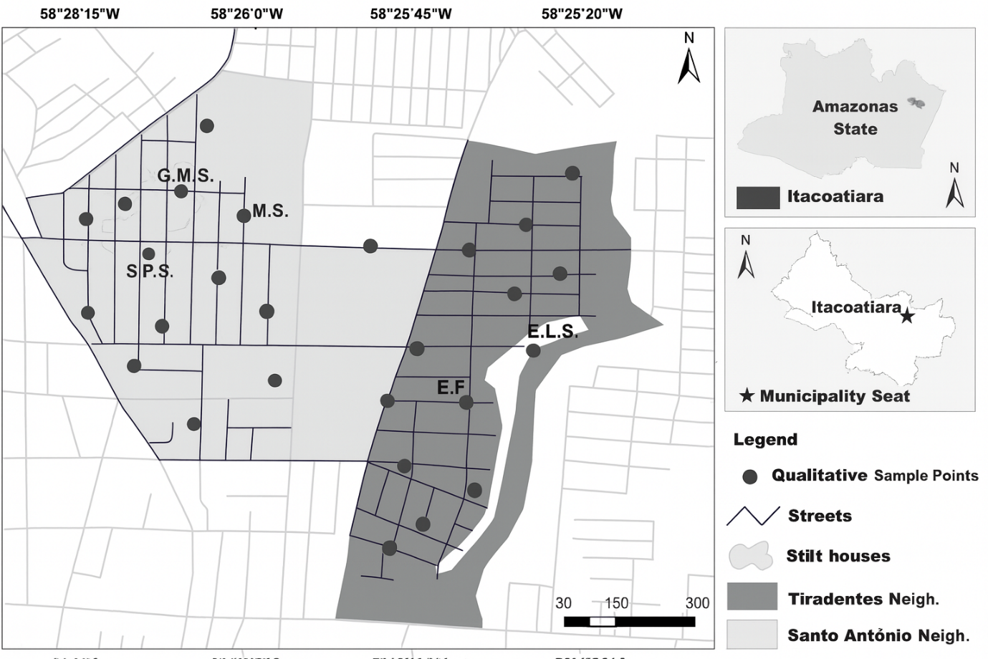
Figure 1. Map showing qualitative sample points in Tiradentes and Santo Antônio neighborhoods of Itacoatiara, Amazonas, Brazil, highlighting streets, stilt houses, and key locations.

Figure 1 Geographic context and distribution of qualitative interviews. The upper inset shows the location of Itacoatiara municipality within the state of Amazonas, Brazil. The main map displays the Tiradentes and Santo Antônio neighborhoods, highlighting the spatial distribution of residences where 27 semi-structured interviews were conducted between January and August 2019. Dots indicate households of participants selected for the qualitative component, which aimed to explore sociocultural and infrastructural factors related to the high incidence of intestinal parasitic infections and diarrheal diseases.

Results
A total of 373 participants completed the structured questionnaire (100% response rate).
The average age was 35.1 years (±13.8), and the majority were women (75.87%).
Most had completed at least some primary or secondary education; 30.03% had completed high school.
In terms of household structure, 53.89% had four or more residents.
Regarding income, 43.43% lived on one minimum wage, and 47.72% were currently employed, primarily in informal or low-income jobs.
Although 80.43% of houses were masonry-built, many were located in flood-prone areas with open sewage and uncollected garbage.
Self-reported diarrhea within the last 30 days occurred in 163 households (43.7%).
Stool test data from the Santo Antônio Health Unit (September 2017–September 2018) revealed 1,599 positive results out of 3,654 samples, indicating a point prevalence of 43.76%.
Protozoa were the most frequent pathogens: Entamoeba histolytica/dispar (31.61%), Endolimax nana (23.03%), Escherichia coli (20.25%), and Giardia lamblia (16.15%).
Helminths were detected less frequently.
The distribution of intestinal parasites identified in stool samples is shown in Figure 2.
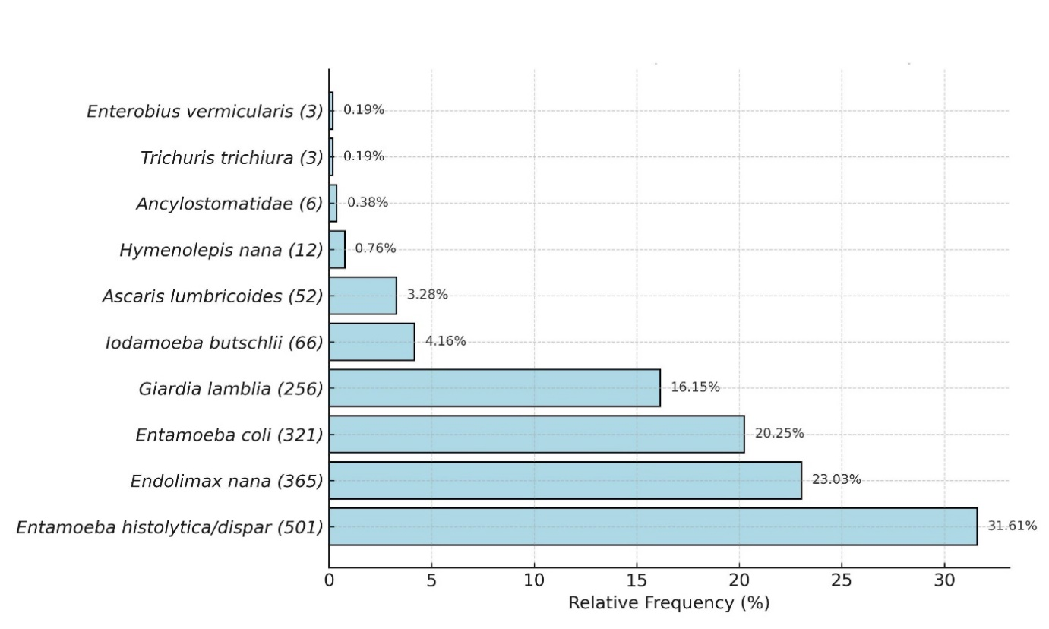
Figure 2. Relative Frequency
Among the 3,654 parasitological stool examinations performed, 1,599 (43.76%) tested positive for intestinal parasites.
The chart presents both the relative and absolute frequencies of each parasite species identified.
Diarrhea surveillance data showed 6,885 reported cases, with 96.72% registered by the José Mendes Municipal Hospital and only 92 (1.34%) by the Santo Antônio UBS—suggesting underreporting at the primary care level.
Among the 27 interviewed households, 6 (22.2%) had water samples positive for parasites, including Entamoeba spp., nematode larvae, and unclassified protozoa.
Positive samples were concentrated in stilt-house areas lacking sanitation.
Figure 3 presents probable parasitic forms, free-living organisms, and debris observed in household water samples under optical microscopy.
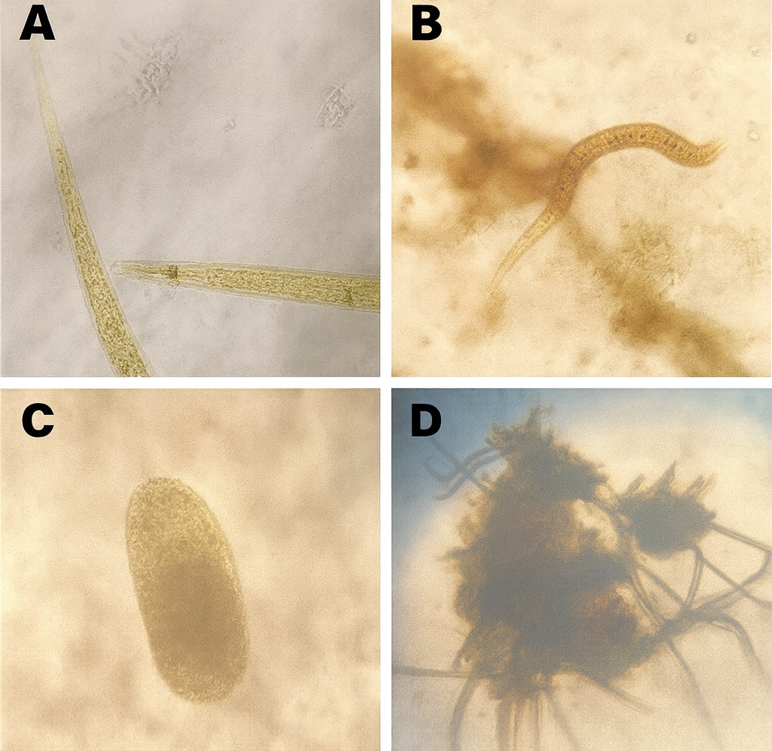
Figure 3. (A) showed an average of 71 larvae per coverslip (based on two slides), identified as belonging to the genus Aphelenchus (free- living larval form). In panel (B), tap water contained a parasitic form with morphological features suggestive of an unidentified free-living nematode, along with abundant particulate debris. Panel (C) presents a refringent cellular structure or an unidentified protozoan, accompanied by crystals, stained cells, epithelial cells, and debris. Panel
(D) shows tap water containing crystals, stained cells, epithelial cells, artifacts, and additional organic debris.
Tap water in panel (A) showed an average of 71 larvae per coverslip (based on two slides), identified as belonging to the genus Aphelenchus (free-living larval form).
In panel (B), tap water contained a parasitic form with morphological features suggestive of an unidentified free-living nematode, along with abundant particulate debris.
Panel (C) presents a refringent cellular structure or an unidentified protozoan, accompanied by crystals, stained cells, epithelial cells, and debris.
Panel (D) shows tap water containing crystals, stained cells, epithelial cells, artifacts, and additional organic debris.
Although 84.8% of participants in the diarrhea group and 83.9% in the non-diarrhea group relied on municipal water, distrust was high (51.96% vs. 52.38%).
Water purification was more common in households with diarrhea (49.75%) than in those without (30.12%) (p = 0.0002).
Knowledge of waterborne disease transmission was also higher among the diarrhea group (79.9%) versus non-diarrhea (62.87%) (p = 0.0003).
However, practical hygiene behaviors varied: while 75% of diarrhea-group respondents reported handwashing with soap, only 55.88% explicitly recognized it as a preventive strategy, compared to 73.21% in the non-diarrhea group (p = 0.0008).

Qualitative Insights
Three thematic domains emerged: knowledge gaps, structural neglect, and cultural normalization of disease.
Table 1 presents representative quotes illustrating thematic categories from the interviews.
Knowledge gaps: Participants often demonstrated misconceptions:
“Worms come from candy and playing in the dirt.”
“We’ve always had parasites... they’re just part of life.”
“Diarrhea comes from a dirty stomach or bad food.”
Structural neglect: Even when participants took precautions, they were undermined by systemic failures:
“We use tap water. For my baby, I boil it. For us, it’s just like that.”
“There’s no sewage here. Waste runs into the creek.”
“Garbage trucks don’t come every day. The trash stays outside.”
Cultural normalization: A sense of resignation prevailed:
“Our dream is to have a Prosamim project here, like in Manaus.”
“We need free water filters and better garbage collection.”
“Health agents take months to visit.”
Only two participants demonstrated high health literacy, linking hygiene to disease prevention:
“My mom gave us medicine for worms every three months.”
“I wash hands after the bathroom and teach my kids too.”
Observational records supported these themes: homes with positive water samples often had visible environmental hazards.

Discussion
This mixed-methods study identified a multifactorial and persistent pattern of vulnerability to intestinal parasitic infections and diarrheal diseases among residents of two low-income neighborhoods in Itacoatiara, Amazonas.
The findings highlight how environmental degradation, infrastructural deficits, limited health education, and sociocultural resignation interact to sustain these preventable conditions.
The study proposes a context-sensitive epidemiological framework for mapping enteric disease risk in tropical settings, combining laboratory diagnostics, geospatial data, and qualitative insights into a cohesive model of health vulnerability.
The prevalence of self-reported diarrhea and parasitic infections is consistent with previous surveys in socioeconomically vulnerable regions of the Amazon Basin [11].
These rates reflect ongoing exposure to transmission conditions for protozoa such as Entamoeba histolytica and Giardia lamblia, which are frequently reported in urban and peri-urban settings in the region [12].
The detection of parasitic forms in a substantial fraction of household water samples and the widespread use of untreated tap water reinforce the fragility of water supply systems in the study area [13].
Environmental observations, including sedimentation, open sewage, and household proximity to unregulated streams, further illustrate the ecological risk context [14].
Three interrelated domains of vulnerability emerged from the qualitative component, encompassing behavioral patterns, structural gaps, and cultural normalization of disease [15].
The second domain—structural vulnerability—was evident in direct observations and participants’ reports of open sewage, irregular water supply, absence of solid waste collection, and the lack of coordinated sanitation efforts [16].
When illness becomes internalized as routine or inevitable, even basic knowledge may fail to translate into action [17].
Although this is a cross-sectional study, the syndemic framework was used conceptually to interpret the convergence of biological, environmental, and sociocultural factors that compound health vulnerability [18].
Rather than establishing causality, the syndemic model serves as a heuristic tool to understand complex and overlapping risk structures in under-resourced urban contexts [19].
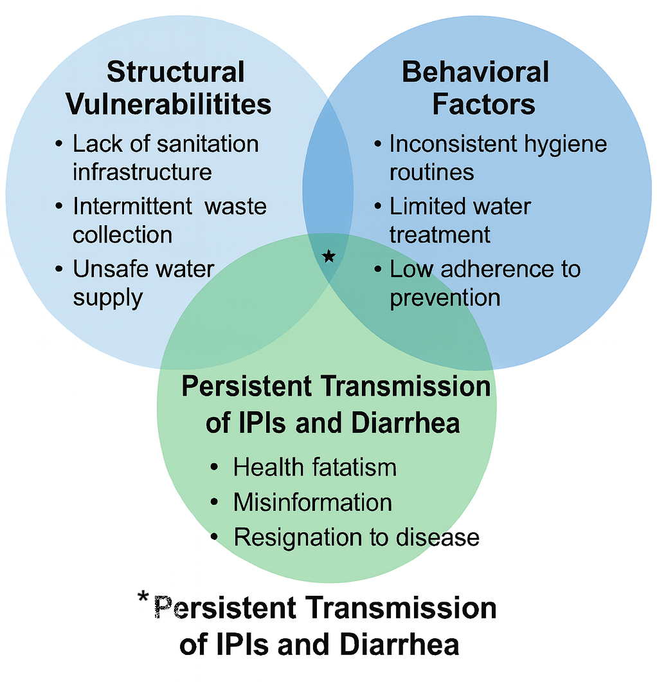 Figure 4 Persistent Transmission of IPIs and Diarrhea
While some respondents reported preventive behaviors such as boiling water or avoiding walking barefoot, these efforts were inconsistently practiced and often undermined by contextual constraints.
This dissonance between knowledge and behavior reinforces the need for sustained, locally adapted health communication strategies.
The mixed-methods design proved valuable by providing estimates of disease prevalence and illuminating lived experiences and interpretive frameworks that shape health behavior.
This integrated approach responds to calls for socially contextualized public health research in tropical regions.
Important limitations must be considered.
The use of self-reported data on diarrheal episodes introduces potential recall bias, which was minimized by limiting responses to a 30-day window.
Certain confounders, such as dietary practices or contact with animals, were not systematically captured due to the need for methodological feasibility in a low-resource setting.
Moreover, the parasitological stool data used for contextual comparison were collected in a slightly earlier period, though they remain representative given the absence of major interventions during the intervening year.
While molecular diagnostics would have increased specificity, the use of standard optical microscopy followed national guidelines and was appropriate for the field conditions.
This study suggests that fragmented health interventions—such as occasional deworming or sporadic health campaigns—are unlikely to succeed in isolation.
Instead, a multisectoral strategy is needed, incorporating infrastructure investment, environmental monitoring, and sustained health education tailored to local sociocultural dynamics.
Crucially, such efforts must address not only material conditions but also the psychosocial dimensions of vulnerability.
Cultural resignation, when left unchallenged, can undermine even well-designed interventions.
The findings also point to a disconnect between community needs and government response, as underscored by participants’ complaints about delayed visits by community health workers and irregular garbage collection.
Ultimately, the persistence of parasitic and diarrheal diseases in Itacoatiara reflects the intersection of health illiteracy, environmental precarity, infrastructural neglect, and institutional absence.
Even where knowledge exists, it is often overpowered by contextual adversity.
Addressing this complex picture requires integrated action across infrastructure, education, governance, and public engagement—grounded in a recognition of the syndemic nature of enteric disease in the Amazon and beyond.

Conclusion
This study identified a syndemic pattern of vulnerability to intestinal parasitic infections and diarrheal diseases in two low-income neighborhoods of Itacoatiara, Amazonas, resulting from the convergence of structural deficiencies, inconsistent health behaviors, and cultural normalization of illness.
While some degree of health knowledge and preventive practice was observed, these efforts were insufficient to mitigate persistent exposure to unsafe water, poor sanitation, and institutional neglect.
The high prevalence of enteric conditions—evidenced by over 43% of positive stool samples and 22.2% of contaminated household water samples—combined with widespread expressions of fatalism and disillusionment, underscores the need for a systemic response.
Effective disease control in this context requires more than individual behavior change; it demands integrated public policies that address infrastructural inequities, ensure access to safe water and sanitation, and promote culturally sensitive health education.
These efforts must be supported by intersectoral coordination, reliable service delivery, and institutional accountability.
Only through such a comprehensive and context-aware approach will it be possible to disrupt the cycle of parasitic transmission and promote health equity in vulnerable areas of the Brazilian Amazon.

Ethics Statement
This study was conducted in accordance with the ethical standards outlined in the Declaration of Helsinki and was approved by the Research Ethics Committee of the Federal University of Amazonas (Universidade Federal do Amazonas – UFAM) under approval number CAAE 89388018.4.0000.5020. Written informed consent was obtained from all participants prior to their inclusion in the study. All data were anonymized to ensure confidentiality and privacy.

References
- Celestino AO, Vieira SCF, Lima PAS, Rodrigues LMCL, Lopes IRS, França CM, Barreto IDCB, Gurgel RQ. Prevalence of intestinal parasitic infections in Brazil: A systematic review. Revista da Sociedade Brasileira de Medicina Tropical. 2021;54:e0033-2021. https://doi.org/10.1590/0037-8682-0033-2021
- Mock CN, Nugent R, Kobusingye O, et al., eds. Water supply, sanitation, and hygiene. In: Injury Prevention and Environmental Health. 3rd ed. Washington, DC: The World Bank; 2017. https://doi.org/10.1596/978-1-4648-0522-6_ch9
- Kaminsky R, Mäser P. Global impact of parasitic infections and the importance of parasite control. Frontiers in Parasitology. 2025;4:1546195. https://doi.org/10.3389/fpara.2025.1546195
- Oliveira TCR de, et al. Trends in hospital admission and infant mortality from diarrhea: Brazil, 1995–2005. Revista de Saúde Pública. 2010;44(1):102–111. https://doi.org/10.1590/S0034-89102010000100011
- World Health Organization. Diarrhoeal disease [Fact sheet]. 2024. https://www.who.int/news-room/fact-sheets/detail/diarrhoeal-disease
- Eisenberg JNS, Desai MA, Levy K, Bates SJ, Liang S, Naumoff K, Scott JC. Environmental determinants of infectious disease: A framework for tracking causal links and guiding public health research. Environmental Health Perspectives. 2007;115(8):1216–1223. https://doi.org/10.1289/ehp.9806
- Davis SN, Wischhusen JW, Sutton SK, Christy SM, Chavarria EA, Sutter ME, Roy S, Meade CD, Gwede CK. Demographic and psychosocial factors associated with limited health literacy in a community-based sample of older Black Americans. Patient Education and Counseling. 2019;103(2):385–391. https://doi.org/10.1016/j.pec.2019.08.026
- Caruso BA, Snyder JS, O’Brien LA, LaFon E, Files K, Shoaib DM, Prasad SK, Rogers HK, Cumming O, Esteves Mills J, Gordon B, Wolfe MK, Freeman MC. Behavioural factors influencing hand hygiene practices across domestic, institutional and public community settings: A systematic review and qualitative meta-synthesis. BMJ Global Health. 2025;10(Suppl 7):e018927. https://doi.org/10.1136/bmjgh-2025-018927
- Gebru H, Deyissia N, Medhin G, Kloos H. The association of sanitation and hygiene practices with intestinal parasitic infections among under-14 children in rural Dire Dawa, Eastern Ethiopia: A community based cross-sectional study. Environmental Health Insights. 2023;17:11786302231180801. https://doi.org/10.1177/11786302231180801
- Gamarel KE, King WM, Operario D. Behavioral and social interventions to promote optimal HIV prevention and care continua outcomes in the United States. Current Opinion in HIV and AIDS. 2022;17(2):65–71. https://doi.org/10.1097/COH.0000000000000717
- Guimarães MGS, Braña AM, Oliart-Guzmán H, Castelo Branco FLC, Delfino BM, Pereira TM, Mantovani SAS, Martins AC, Santos AP, Filgueira-Júnior JA, Ramalho AA, Guimarães AS, Oliveira CSM, Araújo TS, Manrique de Lara Estrada CH, Arróspide N, da Silva-Nunes M, et al. Child Health in the Peruvian Amazon: Prevalence and Factors Associated with Referred Morbidity and Health Care Access in the City of Iñapari. Journal of Tropical Medicine. 2015;2015:157430. https://doi.org/10.1155/2015/157430
- Hailu T, Alemu G. Prevalence of Entamoeba histolytica/dispar and Giardia lamblia infections and their associated factors among schoolchildren in the Amhara region, Northwest Ethiopia. Food and Waterborne Parasitology. 2024;36:e00241. https://doi.org/10.1016/j.fawpar.2024.e00241
- Rashid R, Shah FA, Munir R, Iqbal A, Javed W, Batool R, Lutfi A, Zaidi N. Geospatial mapping of microbial contaminants and public health risks in Lahore’s municipal water. Scientific Reports. 2025;15:23079. https://doi.org/10.1038/s41598-025-98687-5
- Contreras JD, Trangucci R, Felix-Arellano EE, Rodríguez-Dozal S, Siebe C, Riojas-Rodríguez H, Meza R, Zelner J, Eisenberg JNS. Modeling Spatial Risk of Diarrheal Disease Associated with Household Proximity to Untreated Wastewater Used for Irrigation in the Mezquital Valley, Mexico. Environmental Health Perspectives. 2020;128(7):077002. https://doi.org/10.1289/EHP6443
- Wolfe RM, Beck-Felts K, Speakar B, Spaulding WD. Domains of vulnerability, resilience, health habits, and mental and physical health for health disparities research. Behavioral Sciences. 2022;12(7):240. https://doi.org/10.3390/bs12070240
- Mock CN, Nugent R, Kobusingye O, Smith KR, eds. Water supply, sanitation, and hygiene. In: Injury Prevention and Environmental Health. 3rd ed. Washington, DC: The World Bank; 2017. https://doi.org/10.1596/978-1-4648-0522-6_ch9
- Hagger MS, Orbell S. The common sense model of illness self-regulation: A conceptual review and proposed extended model. Health Psychology Review. 2022;16(3):347–377. https://doi.org/10.1080/17437199.2021.1878050
- Mendenhall E, Kohrt BA, Logie CH, Tsai AC. Syndemics and clinical science. Nature Medicine (Perspective). 2022;28:1359–1362. Published 21 July 2022. https://doi.org/10.1038/s41591-022-01888-y
- Batchelder AW, Gonzalez JS, Palma A, Schoenbaum E, Lounsbury DW. A social ecological model of syndemic risk affecting women with and at-risk for HIV in impoverished urban communities. American Journal of Community Psychology. 2015;56(3–4):229–240. https://doi.org/10.1007/s10464-015-9750-y

Table 1-: Summary of Representative Qualitative Interviews (n=12)
Participant | Age / Sex | Health Literacy / Education | Water Analysis | Representative Quotes
P1 | 42 / F | Low / Incomplete Elementary | Tap: plant debris; unidentified parasite | "I know very little about worms, I think it comes from unwashed things." / "We have a toilet, but it drains into the stream behind the house."
P3 | 33 / F | Medium / Completed Elementary | Mineral: fibers, debris (low) | "My son got an abdominal infection, so now we drink bottled water."
P10 | 62 / F | High / Completed High School | Mineral: epithelial cells, debris (high) | "Without proper treatment, diarrhea can kill." / "I know ameba is a dangerous worm."
P14 | 38 / F | Low / Incomplete Elementary | Tap: cyst-like form (Entamoeba), debris (high) | "You have to wash your hands and not walk barefoot." / "I drink tap water, but I boil it for my child."
P25 | 38 / F | Low / Incomplete Elementary | Tap: Aphelenchus larvae; debris (high) | "Our dream is to have Prosamim here like they did in Manaus."
P27 | 43 / F | Medium / Incomplete High School | Tap: nematode-like form, debris (high) | "Parasites are caught from soil contamination." / "You can get it from not washing hands after the bathroom."
P13 | 23 / F | Low / Incomplete Elementary | Tap: fibers; epithelial cells and debris (high) | "Diarrhea is from food; it needs to be well cooked, and water must be boiled."
P16 | 69 / F | Medium / Higher Education | Mineral: cellular elements (high) | "It's a dangerous disease, can severely impact health." / "Worms are tiny microbes that harm us."
P19 | 40 / F | Low / Incomplete High School | Tap: debris (high) | "Worms come when children eat too much candy or put dirty things in their mouth."
P20 | 38 / F | Medium / Incomplete Elementary | Tap: debris, artifacts, epithelial cells (high) | "Often we drink tap water; we can’t afford bottled, so I boil it for my son."
P22 | 46 / F | Medium / Incomplete Elementary | Filtered: epithelial cells and debris (low) | "It can come from inadequate food." / "We are born with these worms."
P24 | 28 / F | Medium / Completed Elementary | Tap: protozoan-like form, crystals, epithelial cells (moderate) | "Sometimes from drinking untreated water or not washing fruits and hands properly."

Supplementary Table 1 – Health Knowledge Questionnaire Used for Participant Stratification
Why should we wash our hands? (select all that apply)
( ) To be clean
(x) To prevent diseases
( ) To be healthy
( ) To reduce bad smell
( ) I don’t know
( ) Other: ____________
How is diarrhea spread? (select all that apply)
(x) Dirty environment
(x) Fecal pathogens
(x) Consumption of unhygienic food
(x) Drinking contaminated water
( ) I don’t know
( ) Other: ____________
Do you think diarrhea can be fatal?
(x) Yes
( ) No
( ) I don’t know
What are the ways people get infected by worms? (select all that apply)
(x) Walking barefoot
(x) Contaminated water or food
(x) Contact with feces
( ) While bathing
How do you treat yourself or family members when stool tests show worms? (select all that apply)
(x) Oral rehydration salts
(x) Homemade saline
( ) Go/take them to the pharmacy
(x) Go/take them to the doctor
( ) Do nothing
(x) Mebendazole

