Case report

Cervicothoracic mass revealing a Non-Hodgkin's Malignant Lymphoma (NHL): unusual localization of lymphoma- about a case

.
ABSTRACT

Aims: We aimed to report a rare case of a cervicothoracic mass revealing Non-Hodgkin's Malignant Lymphoma (NHL), highlighting its unusual localization.

Non-Hodgkin's Malignant Lymphoma (NHL) is a rare condition, primarily affecting lymph nodes but can involve any organ. Extra-nodal NHL occurs in 25% of cases, with 60% located in the head and neck region. NHL in this area presents diverse clinical, morphological, and biological features, reflecting the complexity of histopathological classifications. Diagnosis relies on histology, which guides therapeutic management. This case report describes a cervicothoracic mass revealing laryngeal NHL.

A 70-year-old man with a history of diabetes and hypertension, was admitted to the ENT department with a 10-month history of a painless left laterocervical swelling, dysphonia, and deteriorating general condition, without signs of tuberculosis, dyspnea, or initial dysphagia. ENT examination revealed a large, adherent, painless left laterocervical mass extending intrathoracically, associated with left upper limb lymphedema. Nasofibroscopy showed left laryngeal paralysis and deviation of the left hemi-laryngeal structures. Blood tests indicated bicytopenia.

A CT scan identified a lesion in the left hemi-larynx (1523 mm) with thyroid cartilage lysis and a cervical tumor (8568 mm) extending into the cervico-thoracic area, displacing the trachea and esophagus. No lung nodules or mediastinal lymphadenopathy were observed. MRI confirmed a cervico-thoracic tumor (90*73 mm) with diffusion hypersignal, low ADC, and homogeneous enhancement, closely associated with the left thyroid lobe.

Direct laryngoscopy and biopsy revealed diffuse large B-cell lymphoma (non-germinal type). Immunohistochemistry showed tumor cells positive for CD20, Bc16, and Mum1, negative for CD3, CD5, CD20, AE1/AE3, and Cyclin D1, with a high Ki67 proliferation index of 90%.

Keywords: Non-Hodgkin's Malignant Lymphoma (NHL), head and neck lymphoma, cervicothoracic mass, diffuse large B-cell lymphoma, histopathology, CD20, Bc16, Mum1, Ki67 proliferation index, dysphonia

Introduction:

Non-Hodgkin's Malignant Lymphoma is a rare histological entity; however, their localizations are mainly lymph nodes but all organs can also be affected (Singh et al., 2020; Sung et al., 2022; Patel et al., 2021). 25% of NHL have extra-nodal development and are found in 60% of cases in the head and neck area (1). The non-Hodgkin Lymphoma (NHL) of the Head and Neck and Oral Cavity result in a clinical, morphological and biological diversity reflecting the complexity of modern histopathological classifications (Luo et al., 2022; Rana et al., 2021). Histology is necessary for diagnosis on which the therapeutic management will partly depend. We report here the case of a cervicothoracic mass revealing a laryngeal NHL.

Case Presentation:

A 70-year-old man was admitted to the ENT department, with history of diabetes and hypertension, who presented 10 months before his admission an unpainful latero-cervical swelling associated with dysphonia, with a deterioration of the general condition without clinical signs of tuberculosis, without dyspnoea or initial dysphagia.

ENT examination revealed a huge left laterocervical mass extended intrathoracically, adherent and painless, associated with lymphedema of the left upper limb.
Nasofibroscopy revealed left laryngeal paralysis with deviation of the left hemi-laryngeal structures. (Figure 1). The biological assessment showed bicytopenia.

A brain cervical and chest CT scan showed a lesional tissue process centered on the left hemi laryn measuring 15*23mm filling the left paralaryngeal fat with lysis of the thyroid cartilage extended towards the adjacent extra laryngeal parts, as well as a cervical tissue tumor process extended towards the cervico-thoracic area measuring 85*68 mm, with a mediastinal extension, pushing back the trachea and the esophagus on the right refers to a large lymphadenopathy.
Note the absence of progressive lung parenchymal nodule and mediastinal lymphadenopathy. (Figure 2)

Laryngeal magnetic resonance imaging (MRI) showed the existence of a cervico-thoracic median tumor process, supra and retro-sternal topography, with a tissue signal measuring 90*73mm, extended in height over 100mm, arriving behind in contact with the vertebral bodies without bone lysis, this tumoral lesion presents as a diffusion hypersignal with low ADC, as a relative hypo signal T2 and T1 and is enhanced fairly homogeneously after injection of PDC, it does not present a clear limit with the left thyroid lobe. (Figure 3)

Direct laryngoscopy, under general anesthesia revealed a bulging of the laryngeal vestibule, completed by a deep transmucosal biopsy with histological study which concluded to a diffuse large B-cell lymphoma of the non-germinal type.

In the immunohistochemical study, the tumor cells were positive for CD20, Bc16 and Mum1, negative for CD3, CD5, CD20, AE1/AE3 and Cyclin D1, the proliferation index Ki67 is evaluated at 90%. (Figures 4 and 5)

Discussion:

Laryngeal NHL is very rare. Less than 100 cases have been reported in the literature. The average median age is 63 years with extremes: 14 to 90 years. The male to female rate ratio seems to be contradictory (2).

The symptoms of extra-nodal NHL are similar to any neoplasia located in the same area (in this case squamous cell carcinomas). Systemic symptoms are less frequent than in Hodgkin's lymphomas: 10 to 15% of patients have fever, sweats and weight loss. In laryngeal involvement, symptoms may be dominated by laryngeal obstruction, progressive dyspnea, moderate dysphagia, rarely dysphonia. Forms with respiratory distress are rare. These atypical clinical manifestations, as in our observation, can mislead the diagnosis. (1)

The standard assessment of laryngeal abnormalities currently involves: A brain cervical and chest CT scan is requested first, then cervical MRI which is more sensitive for the study of soft tissues. More specifically, a bone marrow biopsy and an LDH blood test are performed. PET-SCAN does not yet have a defined place in low-grade ENHL. The Ann Arbor staging system formulated to provide prognostic information and to guide therapeutic decisions.
Transesophageal ultrasound can also be discussed, especially if ultrasound-guided biopsies are necessary.

Markou analyzed the primary NHL cases of the larynx published between 1996 and 2008, 47% of them are located in the supraglottic region, 25% are glottic, the rest are either subglottic or transglottic (3). To confirm the diagnosis: the biopsies must provide sufficient material to carry the histological diagnosis. Immunohistochemistry makes it possible to confirm the B phenotype (positivity for CD20, CD19, CD22, surface immunoglobulins) or T (positivity for CD2, CD3) of the malignant cell.

Based on the classification of the World Health Organization (WHO) for NHL, Siddiqui showed that type B represents 85%, while type T represents only 15%. B-cell NHCLs are further classified into diffuse to large, MALT, follicular, and mantle which have been observed in 50%, 20%, 10%, and 5% of cases, respectively (4)(5).

The radiotherapy was the main treatment modality for these tumors. This allows to obtain a complete response for 50 to 90% of patients with localized stage I or stage II lymphoma, also, CHOP-based chemotherapy may or may not combine to rituximab according to the histological type has an important place, especially in cases of low-grade lymphoma (5).

Conclusion:

Laryngeal NHL are exceptional and less frequent than squamous cell carcinomas. Rapid diagnosis, early management, as well as adequate histopathological verification, are indeed essential to improve the management and prognosis of this disease.

Competing interests:

The authors declare no competing interests.

Figures:

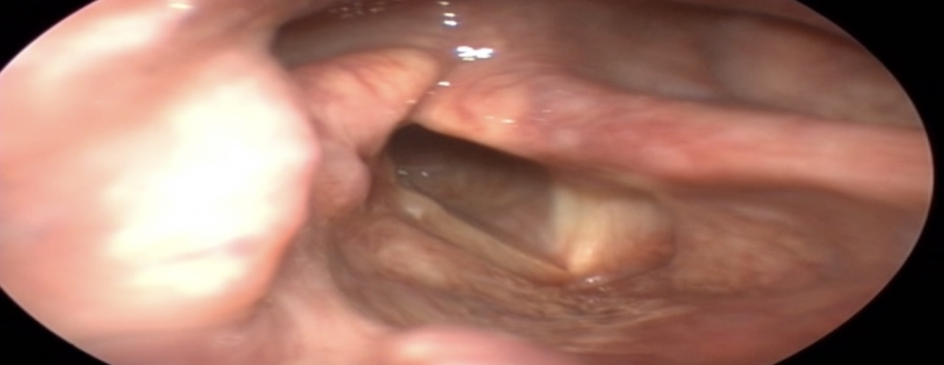

Figure 1: Endoscopic view showing a left laryngeal hemiplegia with deviation of the left hemi-laryngeal structures.

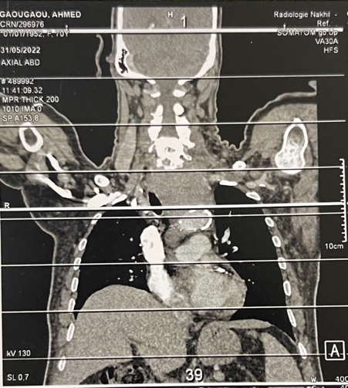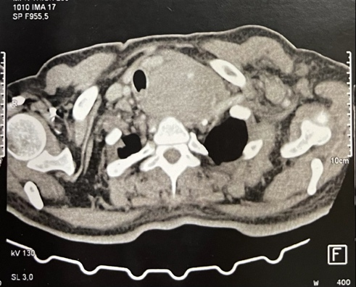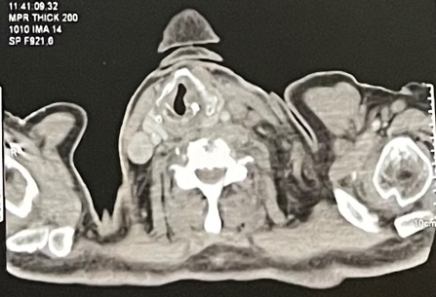

Figure 2: The CT scan showed a lesional tissue process centered on the left hemi laryngeal structures measuring filling the left paralaryngeal fat with lysis of the thyroid cartilage extended towards the adjacent extra laryngeal parts, as well as a process cervical tissue tumor extended towards the cervico-thoracic area, with a mediastinal extension, pushing back the trachea and the esophagus on the right refers to a large lymphadenopathy.

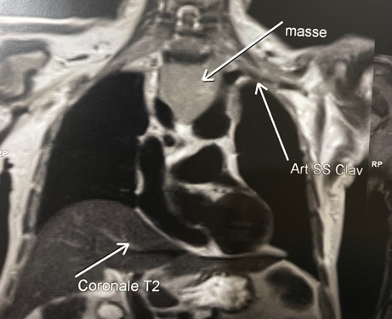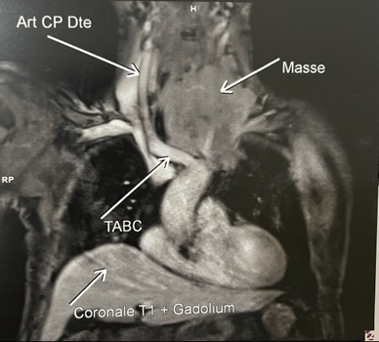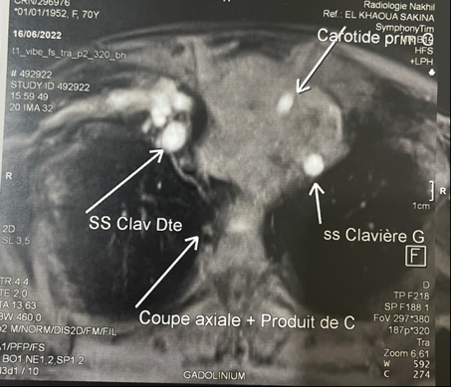

Figure 3 : The MRI of the larynx showed the existence of a cervicothoracic median tumor process, supra and retro-sternal topography, with a tissue signal measuring 90*73mm, extended in height over 100mm, arriving behind in contact with the vertebral bodies without bone lysis, this tumoral lesion presents as a diffusion hypersignal with low ADC, as a relative hypo signal T2 and T1 and is enhanced fairly homogeneously after injection of PDC, it does not present limits with the left thyroid lobe.

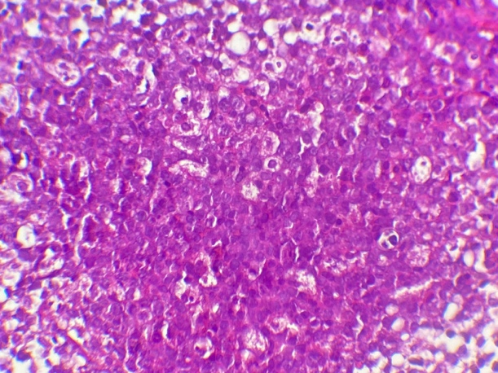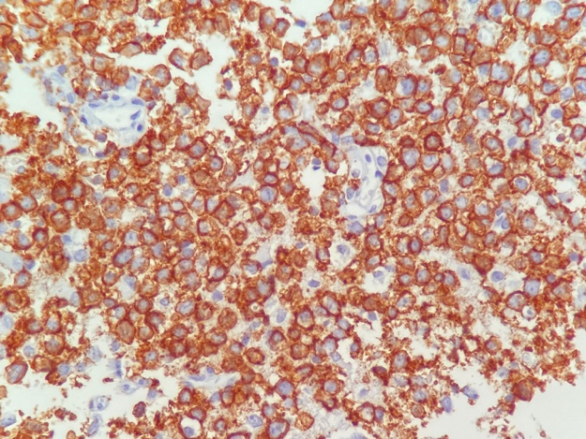

Fig .4 and 5 H&E stain shows a dense infiltrate of atypical lymphoid cells with a high nuclear-cytoplasmic ratio and pleomorphism; IHC stain reveals strong membranous CD20 positivity, supporting a diagnosis of diffuse large B-cell lymphoma (DLBCL)

References:

1. Million RR, Cassisi NJ. Management of Head and Neck Cancer: A Multidisciplinary Approach. Lippincott; 1994. 944 p.
2. Andriychuk A, Kristensen BW. [Non-Hodgkin lymphoma of the larynx]. Ugeskr Laeger. 1 oct 2010;172(42):2901-2.
3. Primary laryngeal lymphoma: Report of 3 cases and review of the literature - Markou - 2010 - Head &amp; Neck - Wiley Online Library [Internet]. [cité 15 sept 2022]. Disponible sur: https://onlinelibrary.wiley.com/doi/abs/10.1002/hed.21104
4. Imaging characteristics of primary laryngeal lymphoma - PubMed [Internet]. [cité 15 sept 2022]. Disponible sur: https://pubmed.ncbi.nlm.nih.gov/20360337/
5. Monobe H, Nakashima M, Tominaga K. Primary laryngeal natural killer/T-cell lymphoma--report of a rare case. Head Neck. nov 2008;30(11):1527-30.
6. Singh, R., Shaik, S., Negi, B. S., Rajguru, J. P., Patil, P. B., Parihar, A. S., & Sharma, U. (2020). Non-Hodgkin's lymphoma: A review. Journal of family medicine and primary care, 9(4), 1834-1840.
7. Sung, Y. W., Lin, Y. S., Chen, Y. T., & Yeh, L. S. (2022). Non-Hodgkin's B-cell lymphoma of the ovary: a case report and review of the literature. Taiwanese Journal of Obstetrics and Gynecology, 61(3), 539-543.
8. Patel, A., Gujar, S., Pohekar, S., Ankar, R., Raut, A., Sakharkar, S., ... & Wagh, P. (2021). Non-Hodgkin’s Lymphoma: A Case Report.
9. Luo, J., Craver, A., Bahl, K., Stepniak, L., Moore, K., King, J., ... & Aschebrook-Kilfoy, B. (2022). Etiology of non-Hodgkin lymphoma: A review from epidemiologic studies. Journal of the National Cancer Center, 2(4), 226-234.
10. Rana, I., Dahlberg, S., Steinmaus, C., & Zhang, L. (2021). Benzene exposure and non-Hodgkin lymphoma: a systematic review and meta-analysis of human studies. The Lancet Planetary Health, 5(9), e633-e643.

