Original Research Article

Assessment of factors affecting preference towards purchasing of Green Products

ABSTRACT

The rapid increase in population has led to the overutilization of resources, resulting in their decline and contributing to pollution, which adversely impacts public health. This alarming situation has prompted a shift towards sustainability, with green marketing and the use of eco-friendly products gaining traction. Green products are biodegradable, environmentally safe, and produce minimal or no waste.
This study examines Factors affecting preference towards purchasing of Green Products. The analysis identified three Principal Components (PCs) with eigenvalues greater than 1 that influence purchase preferences using Factor Analysis(Principal Component Analysis). Personal factors is the PC1 that is determined by five variables, while Environmental factor and Social factor are PC2 and PC3, respectively and are influenced by three variables each. These findings provide valuable insights for improving the adoption of green products.

Keywords: Green products, factors, environment, social, personal

1. INTRODUCTION

The global population is growing at an unprecedented rate, leading to increased pressure on natural resources. Over time, people have indiscriminately exploited these resources, severely degrading the environment and making it increasingly unbreathable. One of the major contributors to this environmental deterioration is the fast-paced modern lifestyle, which has led to a surge in the consumption of fast food. This sector generates a significant amount of non-recyclable waste, primarily through packaging materials, which form the bulk of this environmental burden.
Recognizing this issue, many restaurants and food outlets have started introducing Green products—items designed using materials that are safe for the environment and leave minimal or no harmful effects. These green products, often used interchangeably with sustainable products, aim to reduce the ecological footprint of the fast food industry.. With increasing public awareness of environmental issues and the health and safety benefits of eco-friendly alternatives, consumer preference is gradually shifting towards green products.
This study focuses specifically on sustainable or green packaging materials used in the fast food sector. It aims to analyze the key factors that influence consumers' purchase intention towards these green products, offering insights into the growing demand for environmentally responsible consumption choices.

2. material and methods
Sampling plan
The study was conducted in the Kamrup Metropolitan district of Assam, covering the financial year 2024-25. Primary data was collected from September to October 2024.
Kamrup Metropolitan District is one of the 35 districts in Assam, India, created on February 3, 2003. The district covers an area of 1,527.84 km² and has a population of 1,253,938 according to the 2011 census. Guwahati serves as the administrative headquarters of the district. The district is a significant commercial center and serves as a connection point for six other North Eastern Indian states: Arunachal Pradesh, Nagaland, Manipur, Mizoram, Meghalaya, and Tripura.

Table 1: distribution of consumers across the age groups
Age Groups | No. of Consumers | Percentage (%)
AG-I | 2 | 1.74
AG-II | 36 | 31.30
AG-III | 48 | 41.73
AG-IV | 9 | 7.83
AG-V | 10 | 8.69
AG-VI | 10 | 8.69
Total | 115 | 100

Analytical methods
Factor Analysis
Factor analysis using Principal Component Analysis (PCA) is used to linearly reduce the correlated factor into smaller uncorrelated factors. The statistical technique known as Principal Component Analysis (PCA) transforms a set of observations of potentially correlated variables into a set of values of linearly uncorrelated variables known as principal components whereas the Factor analysis identifies the latent/hidden factors and explains the relationship between observed variables (Anchliya et al., 2023). To assess the validity and reliability of the collected data, the KMO (Kaiser-Meyer-Olkin) and Bartlett’s test, and the Cronbach’s alpha test are conducted. According to Kaiser (1974), the KMO value should be above 0.5, and the p-value from Bartlett’s test should be less than 0.05 for the data to be considered valid. Additionally, Field (2009) states that a Cronbach’s alpha value above 0.7 indicates acceptable reliability for the collected data.

Table 2: results for kmo, cronbach alpha and barlett’s sphericity test for checking adequacy of the dataset for factor analysis
Kaiser-Meyer-Olkin (KMO) measure | 0.810
Cronbach’s Alpha | 0.732
Bartlett’s sphericity test
Chi-square (Observed value) | 416.891
Chi-square (Critical value) | 85.965
Degree of freedom | 66
p-value (two-tailed) | <0.0001
Alpha | 0.05
XLSTAT,2024

Factors influencing consumer preference for Green products are assessed using a set of variables rated on a five-point Likert scale.
Consumers provide scores based on their preferences:
1 = Not important
2 = Slightly important
3 = Moderately important
4 = Very important
5 = Highly important
The factor analysis was conducted using two software programs: XLSTAT 2024 and R software. XLSTAT 2024 was employed to perform the factor analysis, while R software was utilized to calculate the global weights necessary for assigning global ranks to various variables.

Table 3: variables and codes of the variables influencing the consumer preference for green products
Variables | Codes
Price | PF1
Brand trust | PF2
Product quality | PF3
Green corporate image | PF4
Health benefits | PF5
Eco-packaging | EF1
Availability | EF2
Environmental consciousness | EF3
Social/peer influence | SF1
Social norms | SF2
Social media | SF3
Advertisement | SF4

3. results and discussion

Factors affecting preference towards purchasing of Green Products
The factors affecting preferences towards the purchase of green products are identified as Personal factors, Environmental factors, and Social factors, each comprising specific variables that influence consumer choices.

Eigenvalues of components and their variability
The figure 1 show that the first three components have eigenvalues greater than 1, making them the most significant according to the Kaiser criterion. Together, these three components explain 55.25 percent of the total variance, with Component 1 contributing the largest share at 34.89 percent, Component 2 at 10.82 percent, and Component 3 at 9.55 percent. These components capture the most important patterns in the data, making them essential for further analysis. Other components having value less than 1 contribute less to the overall variance.

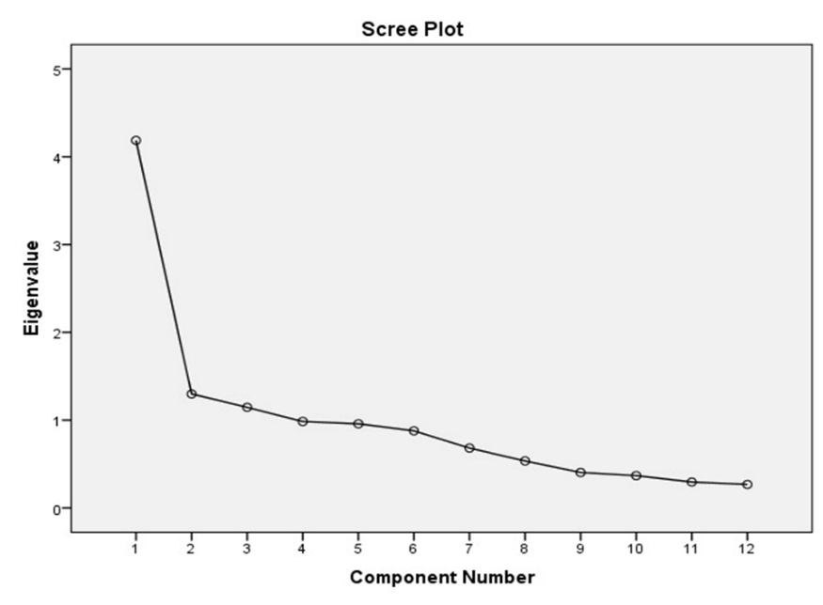

  - Figure 1: scree plot of eigenvalues

Factor loadings after Varimax rotation
The factor analysis results reveal three key components that influence consumer preferences towards green products, categorized into personal, environmental, and social factors. Component 1 (C1) is primarily driven by Price (0.659), Brand trust (0.714), Product quality (0.797), Green corporate image (0.560), and Health benefits (0.608), indicating that personal factors such as price sensitivity, trust in the brand, perceived product quality, corporate image, and health-related benefits play a significant role in influencing purchasing decisions. Component 2 (C2) is associated with environmental factors, represented by Eco-packaging (0.502), Availability (0.550), and Environmental consciousness (0.585). This highlights the importance of sustainable packaging, product availability, and a general awareness of environmental issues in shaping consumers' preferences for green products. Component 3 (C3) reflects social factors, with Social norms (0.737), Social media (0.818), and Social/Peer influence (0.666) being the key variables. In contrast, Advertisement was excluded from the interpretation, as its factor loading was below the threshold of 0.5.

Table 4: factor loading after varimax rotation
Variables | C1 | C2 | C3
Social/peer influence | 0.302 | 0.046 | 0.666
Social norms | 0.427 | -0.158 | 0.737
Price | 0.659 | -0.071 | 0.338
Social media | 0.156 | -0.156 | 0.818
Brand trust | 0.714 | -0.018 | 0.429
Product quality | 0.797 | 0.145 | 0.032
Green corporate image | 0.560 | 0.172 | 0.497
Health benefits | 0.608 | 0.163 | 0.178
Eco-packaging | -0.337 | 0.502 | 0.486
Availability | 0.222 | 0.550 | -0.130
Environmental consciousness | 0.192 | 0.585 | 0.068
Advertisement | -0.315 | 0.444 | -0.223
XLSTAT,2024
Extraction Method: Principal Component Analysis
Rotation Method: Varimax with Kaiser Normalization

Ranking of the factors influencing consumers' purchase intentions based on their relative significance
Table 5 analyzes the factors that influence consumer behavior toward green products, focusing on personal, environmental, and social criteria, ranked by their global weights. The most significant factor is the green corporate image (PF4), which has the highest global weight of 1.822, highlighting the importance of a company's eco-friendly reputation. This is closely followed by social norms (SF2), with a weight of 1.285, indicating that societal expectations heavily influence consumer choices. Brand trust (PF2) ranks third with a weight of 1.230, underscoring the necessity for companies to establish reliability and authenticity in their green claims. Among social factors, social/peer influence (SF1) is ranked fourth with a weight of 1.006, reflecting the significant impact of community and peer perceptions on purchasing decisions. Social media (SF3), with a weight of 0.920, comes in fifth, demonstrating its effectiveness as a tool for promoting green products. Product quality (PF3) ranks sixth with a weight of 0.873, followed by price (PF1) in seventh place with a weight of 0.824. This indicates that while these factors are important, they are secondary to corporate image and social influences. Health benefits (PF5), with a weight of 0.561, are ranked eighth, suggesting that personal health concerns are less crucial compared to other personal factors. Environmental criteria are ranked lower; environmental consciousness (EF3) is ninth with a weight of 0.169, eco-packaging (EF1) is tenth with a weight of 0.099, and availability (EF2) is eleventh with a weight of 0.068. These rankings suggest that while environmental factors are relevant, they are overshadowed by personal and social influences in shaping consumer preferences. Overall, the data emphasizes that enhancing corporate image, leveraging social norms, and building brand trust could significantly increase consumer engagement with green products.

Table 5: ranking of the variables leading to the purchase intention of the green products
Criteria | Variables | Code | Global weight | Global ranking
Personal factors | Price | PF1 | 0.824 | 7
Personal factors | Brand trust | PF2 | 1.230 | 3
Personal factors | Product quality | PF3 | 0.873 | 6
Personal factors | Green corporate image | PF4 | 1.822 | 1
Personal factors | Health benefits | PF5 | 0.561 | 8
Environmental factors | Eco-packaging | EF1 | 0.099 | 10
Environmental factors | Availability | EF2 | 0.068 | 11
Environmental factors | Environmental consciousness | EF3 | 0.169 | 9
Social factors | Social/peer influence | SF1 | 1.006 | 4
Social factors | Social norms | SF2 | 1.285 | 2
Social factors | Social media | SF3 | 0.920 | 5
R-Software

4. Conclusion

Factor analysis using Principal Component Analysis (PCA) identified three uncorrelated principal components—Personal, Environmental, and Social Factors—that influence consumer behavior. Personal Factors, including Green Corporate Image, Price, Brand Trust, Product Quality, and Health Benefits, accounted for the highest variance, followed by Environmental Factors such as Eco-Packaging, Availability, and Environmental Consciousness, and Social Factors like Social/Peer Influence, Social Norms, and Social Media. Among these, Green Corporate Image emerged as the most influential variable, reflecting the importance company’s image in protecting the environment that shapes the consumer choices.

References
Alam, A., Almotairi, M., & Gaadar, K. (2012). Green marketing in Saudi Arabia: Rising challenges and opportunities for a better future. Journal of American Science, 8(11), 144–151.
Anchliya, N., et al. (2023). Assessment of factors influencing purchase intention for green cosmetic products. International Conference on Industrial Engineering and Operations Management, 2701–2709.
Asha, P., & Rathiha, R. (2017). Consumer awareness towards green products. International Journal of Management, 8(5), 8–14.
Ayuningsasi, A. A. K., & Saraswaty, A. N. (2021). Mapping of consumption of green products for urban society Denpasar City. Journal of Tourism Economics and Policy, 1(1), 1–6.
Bhati, B. (2021). A study on awareness and usage of green products. International Journal of Research in Management & Business Studies, 8(2), 9–13.
Kumar, P., & Ghodeswar, B. M. (2015). Factors affecting consumers' green product purchase decisions.Marketing Intelligence & Planning, 33(3), 330–347. https://doi.org/10.1108/MIP-03-2014-0068
Gregory, G.D. and Leo, M.D. (2003), “Repeated behavior and environmental psychology: the role
of personal involvement and habit formation in explaining water consumption”,Journal of
Applied Social Psychology, Vol. 33 No. 6, pp. 1261-1296.
Gregory, G.D. and Leo, M.D. (2003), “Repeated behavior and environmental psychology: the role
of personal involvement and habit formation in explaining water consumption”,Journal of
Applied Social Psychology, Vol. 33 No. 6, pp. 1261-1296.
Gregory, G.D. and Leo, M.D. (2003), “Repeated behavior and environmental psychology: the role
of personal involvement and habit formation in explaining water consumption”,Journal of
Applied Social Psychology, Vol. 33 No. 6, pp. 1261-1296.
Gregory, G.D. and Leo, M.D. (2003), “Repeated behavior and environmental psychology: the role
of personal involvement and habit formation in explaining water consumption”,Journal of
Applied Social Psychology, Vol. 33 No. 6, pp. 1261-1296.
Kumar, S. (2018). Green marketing in India: A sustainable perspective. International Journal of Trend in Scientific Research and Development, 2(4), 932-939.
Majumdar, S. (2015). Analysis of factors influencing consumer preferences for green cosmetic and food products: A study in and around Kolkata (Doctoral dissertation, ICFAI University, Jharkhand). ICFAI University.
Patowary, B. (2020). Trends in green marketing and responsible consumerism in North-East. International Journal of Management, 11(12), 4009–4015.
Polonsky, M. J. (2011). Transformative green marketing: Impediments and opportunities. Journal of Business Research, 64(12), 1311–1319. https://doi.org/10.1016/j.jbusres.2011.01.016
Polonsky, M. J., & Rosenberger, P. J. (2001). Revaluating green marketing: A strategic approach. Business Horizons, 44(5), 21–30. https://doi.org/10.1016/S0007-6813(01)80057-4
Ramli, Y., & Maysari, D. P. (2020). The influence of customer attitude towards customer purchase decision by implementing green marketing. International Journal of Emerging Trends in Social Sciences, 8(2), 42-50.
Rebello, A. A., et al. (2020). A study on customer awareness on green products in Kottayam district (Project work submitted to Mahatma Gandhi University, Kottayam, in partial fulfillment of the requirement for the award of Bachelor’s Degree in Commerce).
Shamsi, M. S., & Siddiqui, Z. S. (2017). Green product and consumer behavior: An analytical study. Pertanika Journal of Social Science and Humanities, 25(4), 1545–1554.
Singh, P., & Kumar, A. (2022). Green marketing: Its impact on the global market. International Journal of Novel Research and Development, 7(5), 48–61. https://www.ijnrd.org

