Original Research Article

Diversity analysis of Drosophila (Diptera: Drosophilidae) in and around Sikkim Alpine University, South Sikkim

.
ABSTRACT

The current study records the diversity and seasonal variation of Drosophila species in a transitional phase from late winter to early pre-monsoon period (March-May) in the campus of Sikkim Alpine University and in and around the Kamrang area of the South district of Sikkim, India. Six different microhabitats were sampled by bait traps containing fermented fruits. Species identification was performed with the help of standard taxonomic keys and morphological analysis. Simpson's, Shannon's, and Berger-Parker indices were calculated to study the various diversity indices regarding the Drosophila diversity of the region. Climatic parameters—including temperature, rainfall, wind speed, and cloud cover—were recorded and analyzed for correlation with species distribution.
A total of seven species were identified, with Drosophila immigrans and Drosophila busckii being the most dominant, particularly during April, which was marked by moderate temperatures, low rainfall, and increased wind activity. Diversity peaked in April, while March and May had fewer species but exhibited greater species evenness. Shannon and Simpson diversity indices revealed an increase in species richness and community heterogeneity over the three months, with April showing the highest abundance but also the greatest species dominance. Correlation analyses revealed significant climatic associations, especially for D. busckii, which showed strong positive relationships with temperature and wind speed and negative associations with rainfall and cloud cover. Other species such as D. melanogaster and D. immigrans exhibited generalist tendencies, showing little sensitivity to climatic variables.
This current study confirms the ecological importance of Drosophila as a bioindicator of environmental change in a changing environment. The current findings provide valuable insights for assessing the Drosophila biodiversity in south Sikkim; however, further research is required to study the full spectrum of species dynamics and ecological responses of the region.

Keywords: Drosophila biodiversity, Diversity analysis, Shannon index, Simpson index, Berger-Parker index, SHE analysis
1. INTRODUCTION

Drosophila belongs to the family Drosophilidae which is a large family of dipteran flies. There are about 1500 species in the genus Drosophila, which is further distributed into ten subgenera. Drosophila is the biggest subgenus (Tamang et al., 2021), more than 500 species are found in Hawaiian Islands itself and 200 species belonging to 20 genera have been found in India (D’Souza et al., 2019). Drosophila is commonly known as fruit fly, vinegar, wine or pomace fly. It was W.E. Castle (1906) who first reported the potential use of Drosophila melanogaster in understanding genetics. In about eight decades since then, Drosophila has become a premier experimental organism in the studies of genetics and evolution (Perveen, 2018). Drosophila is broadly used in the field of genetics, developmental biology, population, ecology and evolutionary biology. Drosophila species are more sensitive to habitat changes because of their relatively narrow physical limits for resource utilization (Kellermann et al., 2009). Any alteration in the Drosophila fauna indicates substantial biotic changes at least at the level of plants, fungi and hymenopterous wasps (Tamang et al., 2021). Drosophila species, population, life cycle and development could also be impacted by temperature and rainfall (Bogaerts‐Márquez et al., 2021). Together with the development of genetics, developmental and evolutionary biology, systematic studies taxonomic studies in the genera of the family Drosophilidae in India are meagerly explored as compared to other parts of the world (Mahato & Gupta, 2018).
Drosophila genus is pertinent to understand the effects of elevation trends on species distribution since these insects are highly susceptible to varying environmental conditions which are emulated in the size of species population, with amazing potential as bioindicators (Hajam et al., 2024). The existence, abundance and distribution of species in the ecosystem are determined by whether the levels of one or more physical or chemical factor fall within the range tolerated by the species (Sánchez‐Guillén et al., 2016; D’Souza et al., 2019). The diversity and distribution pattern study Drosophila in various parts of India are mainly in Mysuru, Dahrwad, Kanara district of Karnataka and the Western Ghats (Tamang et al., 2021). In the state Sikkim, we find the paucity of studies regarding the diversity of Drosophila species.
Studies on altitudinal and seasonal variation also showed the existence of several subgenera, suggesting intricate ecological relations and evolutionary dynamics in the area (Rawat & Tambe, 2011). In spite of this rich diversity, Sikkim Drosophila are threatened by various conservation issues. Habitat fragmentation, climate change and pesticide application by human beings endanger the fragile equilibrium of their habitats (Ghanashyam et al., 2016; Meetei et al., 2023). Emphasizing their value as a bioindicator of environmental health, Drosophila populations respond to altering circumstances in their habitat and thus, interest in the preservation of these flies is increasing due to the aid this can offer for sustaining general ecological integrity. Current research focusses on evaluating genetic diversity and population dynamics and has implications for conservation strategies focusing on environmental stress interventions as well as promoting sustainable practices in the the region (Gupta & Gupta 1991; Jogesh & Dubash 2014). Therefore, the objective of the present study was to investigate more about diversity and distribution of Drosophila species in an unexplored area i.e. Sikkim.
1.1 Geography and Climate of Sikkim
Sikkim, a small but ecologically diverse state in the northeastern part of India, is bestrided and cradled by the mighty Himalayas. The state's terrain is as gloriously scenic, with towering snow-capped peaks, deep valleys and wide highland meadows. This diverse topography has a distinctive ecosystem and provides a great diversity of flora and fauna, contributing to Sikkim as one of the biodiversity hotspots (Kumar & Gupta 1993; Achumi 2014).
Sikkim has a temperate climate with notable seasonal differences. Monsoon is a period of heavy rainfall that extends between June and September and this is greatly affecting ecological dynamics of the area. Winters on the other hand can be harsh particularly in the northern and higher altitude regions where the temperature may go below the freezing point (Kumar and Gupta 1993; Bhattacharya et al., 2012). The combination of the altitude, humidity, and temperature forms an extensive variety of microclimates, which, in turn, increases the ecological diversity of the state (Sarswat et al., 2016; Vivekanandhan et al., 2024).

2. material and methods

2.1 Study area

The study was conducted in the north eastern state of India –Sikkim. The flies were collected from in and around Sikkim Alpine University which lies in the southern region of Sikkim i.e. Kamrang, Namchi. Kamrang is a village in the Namchi subdivision of South Sikkim, India and is at an altitude of about 819 meters (2,687 feet) above sea level and is on the subtropical to lower temperate climatic zone and is characterized by moderate temperatures and heavy rainfall. Kamrang is in close proximity to ‘Biodiversity Park at Kitchudumra’ which serves as a center for environmental awareness and conservation efforts. Kamrang’s elevation and climatic conditions foster a rich natural environment, making it significant location for biodiversity and conservation efforts in south Sikkim.

2.2 Climatic Profile

The climatic parameters of the study area during the study period were collected from https://www.worldweatheronline.com/ into excel sheets for computing further analysis.

2.3 Specimen sampling

Flies were collected done during March-May from the campus of Sikkim Alpine University and in and around Kamrang, Namchi, South-Sikkim region using bait trap method. In the bait trap method, plastic bottles were cut open making a opening like a window for the flies to come and some rotten bananas, mixed fruits and peeled vegetables were added inside the bottles as a bait for the flies. Next day flies were collected from the bottles after covering it with the dark cloth and were isolated, and stored in temperature-controlled BOD and later etherized and examined under the microscope.

2.4 Species identification

Drosophila species were identified with the help of books (Markow & O'Grady, 2005), and using online help: http://flybase.org/static/Drosophilidae based on their external morphology.

2.5 Diversity indices

Simpson (D'), Shannon index (H'), and Berger–Parker (1/d) indices were used to determine the abundance, richness, and diversity of Drosophila species collected, as stated by Mateus et al., (2006).

Simpson’s diversity index (D’) which measures the diversity can be calculated using the following formula.
𝐷= $\frac{∑ n(n - 1) }{N(N - 1)}$
where, n = the total number of individuals in particular species, and N= the total1 number of individuals in the whole population, D = 0 represents infinite diversity, whereas D = 1 represents no diversity therefore to overcome this problem this index is calculated after subtracting from 1 (D’) or represented as Simpson’s reciprocal index 1/D.

Shannon index which measures the value of species as a function of their frequency in the community was calculated using the formula
𝐻′ = −∑𝑝𝑖 ln 𝑝𝑖
Where pi = the proportion of the entire community made up of species i and ln= natural log. The lower H’ values indicate low diversity while higher values indicate high diversity.

Berger- Parker index (1/d) which shows the relative abundance was calculated using the formula
$1/{d }$ = $\frac{N}{Nmax}$
Where, N = number of individuals of all species and Nmax = number of individuals in the most common species.

2.6 Statistical analyses

PAST (PAleontological STatistics) version 4.14 and SPSS version 26 software was used for statistical computations and visualizations. QGIS software 3.36 was used for the map making of the study location.

3. results and discussion

3.1 Location of the Study Area

The present study on Drosophila diversity was conducted in and around the Kamrang region of South Sikkim, specifically within the proximity of the Sikkim Alpine University (SAU) campus. A total of six sampling sites were strategically selected to capture a range of microhabitats with varying degrees of vegetation, human disturbance, and altitudinal variation.

Table 1 summarizes the geospatial coordinates of each site. The latitude and longitude values of the study locations ranged from 27.1654°N to 27.1832°N and 88.3458°E to 88.3674°E, respectively, indicating that all sites lie within a compact ecological zone influenced by a similar macroclimatic regime. Figure 1 presents a GIS-generated map depicting the spatial distribution of the study sites.

Table 1. Location details of Study area of Drosophila species

Sl. No. | Location | Latitude | Longitude
1 | Site 1 | 27.1658 | 88.3637
2 | Site 2 | 27.1669 | 88.3674
3 | Site 3 | 27.1832 | 88.3458
4 | Site 4 | 27.1781 | 88.3462
5 | Site 5 | 27.1754 | 88.3492
6 | Site 6 | 27.1654 | 88.3545

Figure 1. Map of Study area

3.2 Climatic Profile of the Study Period

The climatic parameters during the study period played a pivotal role in influencing the diversity and distribution of Drosophila species in the Kamrang region. The current research was done through a period of three months, that is, March to May- a period before the winter may end and pre-monsoon season begins in South Sikkim. The trends in the mean temperature and in the cloud cover during the sampling period are graphically illustrated in Figure 2. It shows a progressive rising in temperature between March and May and varying cloud cover and this is the characteristic of pre-monsoon climatic pattern.

Table 2 provides detailed descriptive statistics for six key climatic parameters. Temperature (°C) ranged from 18.25°C to 23.75°C, with a mean of 21.38°C (±1.73). This moderate temperature range is likely to facilitate activities and reproduction in Drosophila species especially those of subtropical preference. With a mean of 0.17 mm (±0.24), the heterogeneity rainfall (mm) of moisture is likely to have little influence. The recorded rainfall range between 0.00 mm and 1.05 mm suggests the existence of very weak and sporadic light rainfall activities. The moisture deficit conditions may have limited the activities of certain species, which thrive in high moisture availability, but may have stimulated the activities of species adapted to arid and semi-arid conditions.

Cloud Cover (%) ranged from 0.00% to 79.75% coverage with a mean of 38.05% (±29.95) which is an indication of highly variable conditions. The cloud conditions have a direct impact on the radiation, temperature and humidity which affect the foraging and reproduction activities of Drosophila. The variation in Atmospheric pressure (mb) 1005.25 - 1015.00 mb and mean of 1009.96 mb (±2.67) is very small. This value may have a very minor impact on Drosophila flight.

The mean of the Wind Speed (km/h) data was 7.15 km/h (± 1.10) with a range of 5.13 to 9.88 km/h. Moderate wind speeds facilitate the passive dispersal of Drosophila, but may inhibit individuals with specific microhabitat preferences. For the Gust Speed (km/h) data, which measures short bursts of stronger wind, the mean was 14.20 km/h (± 2.05) with a range of 10.00 to 17.63 km/h. While brief, such gusts can affect adult fly mobility and may influence oviposition and relocation to microhabitats with shelter.

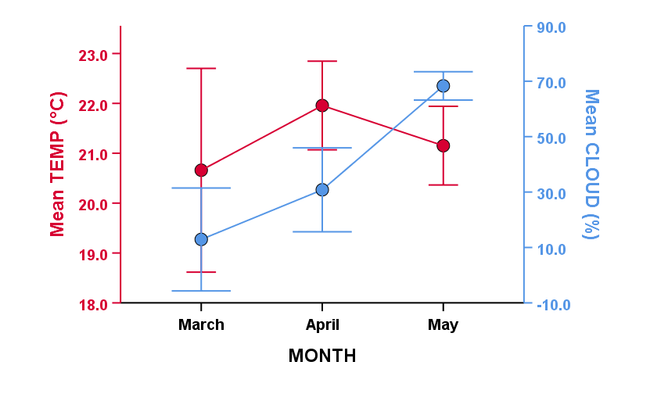
Figure 2. Mean temperature and cloud of the study period

Table 2. Mean values of the climatic variables for the study period

 | Minimum | Maximum | Mean | Std. Error | Std. Deviation
Temp (°C) | 18.25 | 23.75 | 21.38 | 0.31 | 1.73
Rain (mm) | 0.00 | 1.05 | 0.17 | 0.04 | 0.24
Cloud (%) | 0.00 | 79.75 | 38.05 | 5.30 | 29.95
Pressure (mb) | 1005.25 | 1015.00 | 1009.96 | 0.47 | 2.67
Wind (km/h) | 5.13 | 9.88 | 7.15 | 0.19 | 1.10
Gust (km/h) | 10.00 | 17.63 | 14.20 | 0.36 | 2.05

3.3 Species Composition and Abundance

Table 3 captures these fluctuations month-wise and species-wise, indicating that April supported the highest species richness (7 species) and with 338 individuals. In contrast, March had only 3 species, and May had 5, signifying a transitional composition bracketed by cooler and warmer extremes. The grand total number of individuals collected in the study period was 526 individuals. Figure 3 shows the figures of seven different species found during the current study.

Table 3. Month-wise diversity of Drosophila species

Sl No. | Species | No of Individuals
Sl No. | Species | Mar | Apr | May
1 | Drosophila busckii | 34 | 109 | 39
2 | Drosophila immigrans | 35 | 129 | 45
3 | Drosophila melanogaster | 6 | 84 | 18
4 | Drosophila ananassae | 0 | 5 | 4
5 | Drosophila malerkotliana | 0 | 6 | 0
6 | Drosophila nepalensis | 0 | 3 | 0
7 | Zaprionus indianus | 0 | 2 | 7

Drosophila immigrans, was the most abundant species overall, with 129 individuals recorded in April alone, and smaller but consistent populations in March (35 individuals) and May (45 individuals). A similar pattern was exhibited by Drosophila busckii which showed a peak figure of 109 individuals in April as compared to 34 individuals in March and a slight decline to 39 individuals in May. Drosophila melanogaster, a cosmopolitan and extensively studied species, also exhibited in April 84 individuals, which was a significant rise in contrast to the 6 individuals recorded in March as well as May figure of 18 individuals. This pattern suggests a strong seasonal pulse in activity or reproduction likely tied to optimal environmental cues in mid-spring. Drosophila ananassae, Drosophila malerkotliana, Drosophila nepalensis, and Zaprionus indianus were observed sporadically and in low numbers, reflecting their either more specialized habitat requirements or lower population densities in the region.

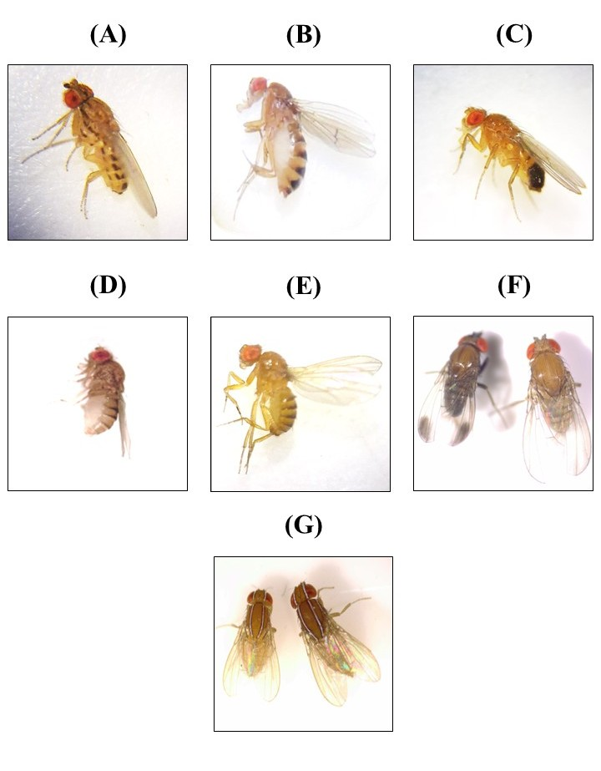
Figure 3. Drosophila species (A) Drosophila busckii, (B) Drosophila immigrans, (C) Drosophila melanogaster, (D) Drosophila ananassae, (E) Drosophila malerkotliana, (F) Drosophila nepalensis, and (G) Zaprionus indianus.

3.4 Diversity Indices and Seasonal Variation

To assess the temporal dynamics and structural complexity of Drosophila communities in the Kamrang region, several biodiversity indices were calculated across the three sampling months—March, April, and May. The analysis revealed noticeable seasonal variation in species richness, evenness, dominance, and overall diversity, all of which were closely tied to the prevailing climatic conditions (Table 4).

Species richness, as indicated by the number of taxa (Taxa_S), was lowest in March with only three species, peaked in April with seven species, and slightly declined to five species in May. Similarly, the total number of individuals recorded showed a marked increase from 75 in March to 338 in April, before dropping to 113 in May.

Shannon’s diversity index (H') increased continuously during the months; 0.93 in March, 1.29 in April and 1.34 in May indicating an increase of species richness as well as more even distribution of individuals among them. There was a similar trend for Simpson’s index (1-D, reflecting increased diversity) which increased from 0.58 in March to 0.70 in May. Conversely, the dominance index (D) decreased over time (0.42 to 0.30), suggesting a reduction in the likelihood that two randomly selected individuals would belong to the same species.

Evenness indices showed greater complexity. Highest evenness (e^H/S) was registered in March (0.84) then rapidly fell in April (0.52) before bouncing back in May (0.76). This means that even if April had the highest species richness, a few dominant species, especially D. immigrans and D. busckii, depressed evenness most, thus lowering the overall evenness. The constricted equitability index (J) showed the same pattern, highest in March (0.85), April (0.66), and May (0.83) being the second, and lowest in the month indicated, reinforcing the observation that the community was more unevenly distributed in April. Also, the Berger-Parker dominance index showed a slow decrease in dominace from March (0.47) to May (0.40), confirming the increase species from amount of the dominace, and more species equality in the studied duration.

The rarefaction data shown in Figure 4 confirms that April is the most diverse month, surpassing March and May, as it had a much higher and steeper Simpson’s 1/D curve. Figure 5 presents the perfectly matching evenness indices in April and depicts the single dip in evenness for that month. The SHE analysis depicted in Figure 6 shows that over time, species richness and Shannon diversity clear grew, with diversity evenness oscillating in the assemblages. The violin plot further illustrates the monthly mean individual counts, April prominent among them, and describes that month’s distributions with much more detail (Figure 7).

Table 4. Month-wise diversity indices detail of Drosophila species

 | March | April | May
Taxa_S | 3 | 7 | 5
Individuals | 75 | 338 | 113
Dominance_D | 0.42 | 0.31 | 0.30
Simpson_1-D | 0.58 | 0.69 | 0.70
Shannon_H | 0.93 | 1.29 | 1.34
Evenness_e^H/S | 0.84 | 0.52 | 0.76
Brillouin | 0.86 | 1.25 | 1.24
Menhinick | 0.35 | 0.38 | 0.47
Margalef | 0.46 | 1.03 | 0.85
Equitability_J | 0.85 | 0.66 | 0.83
Fisher_alpha | 0.63 | 1.25 | 1.07
Berger-Parker | 0.47 | 0.38 | 0.40

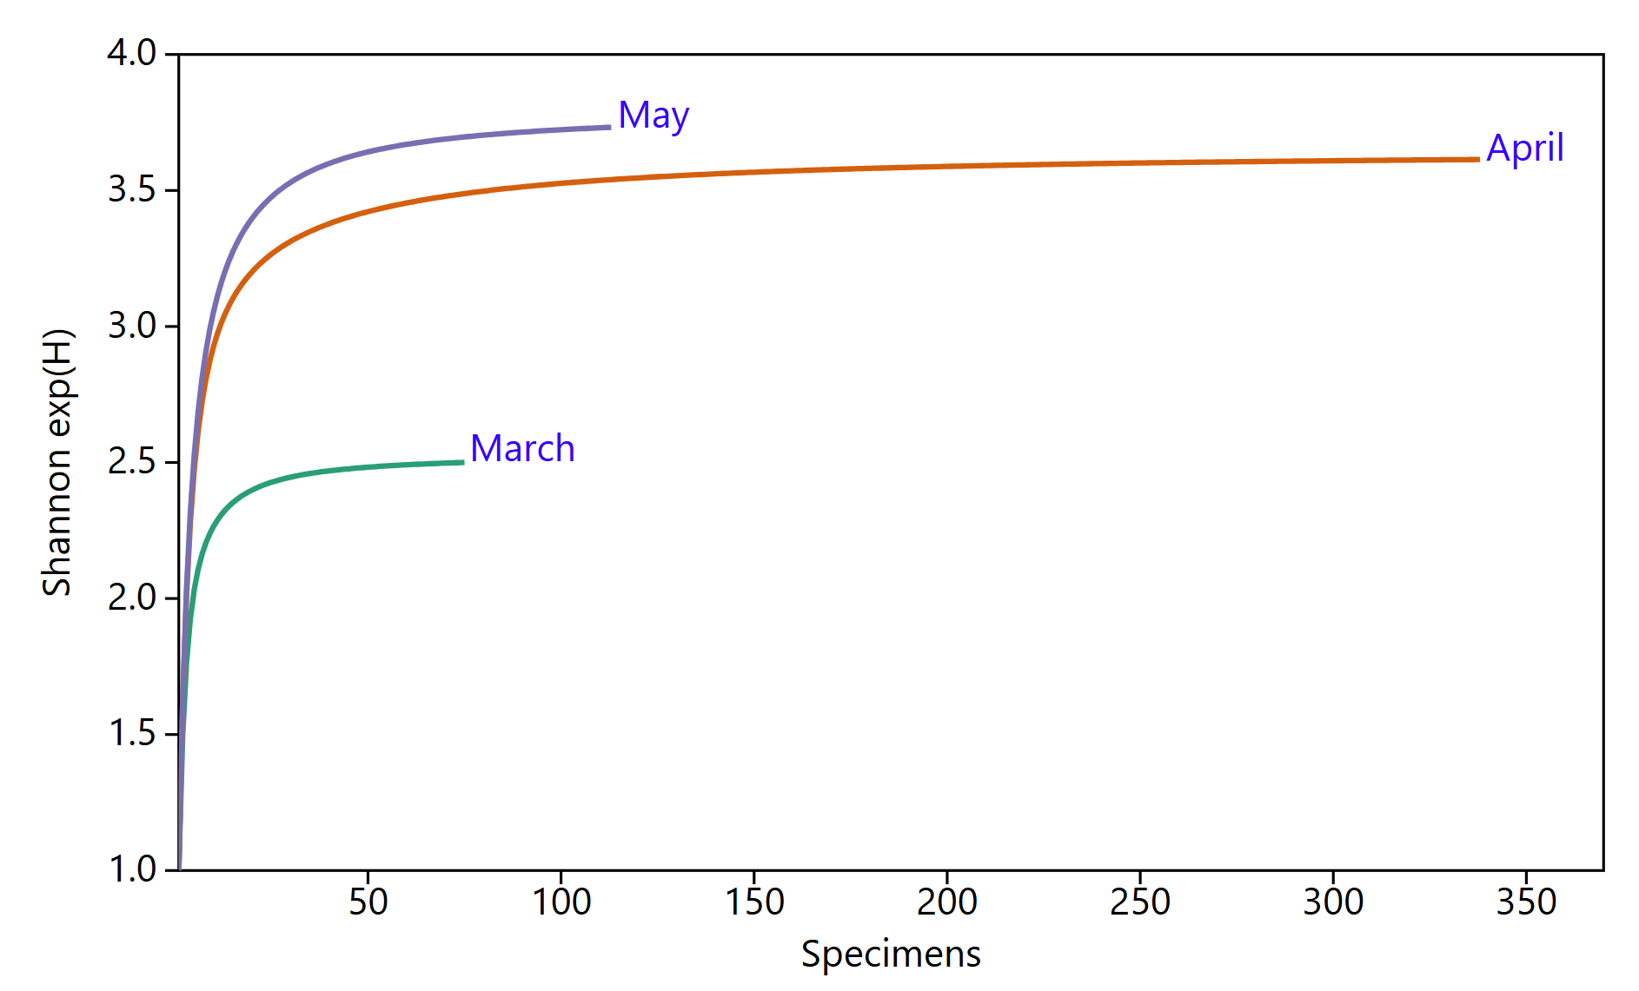
Figure 4. Month-wise individual rarefaction of Drosophila species according to Simpson 1/D

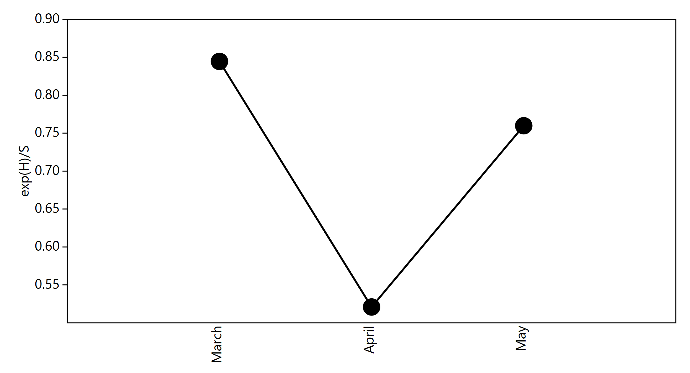
Figure 5. Month-wise Drosophila species evenness

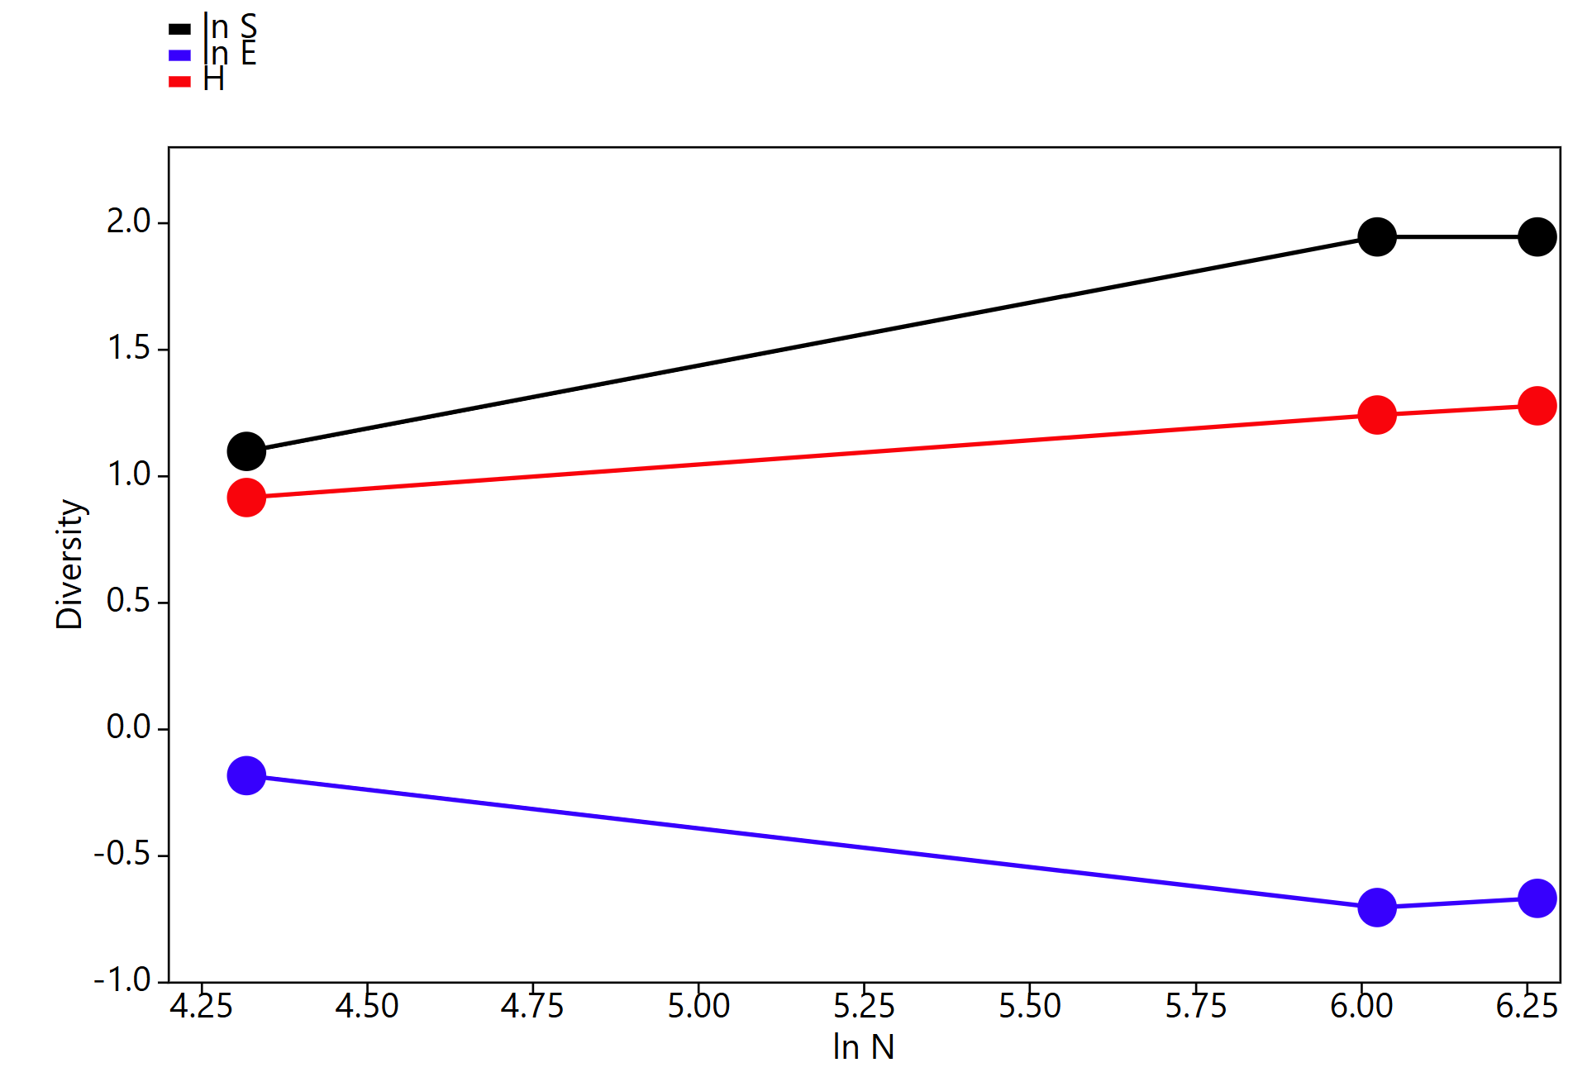
Figure 6. SHE analysis of Drosophila diversity

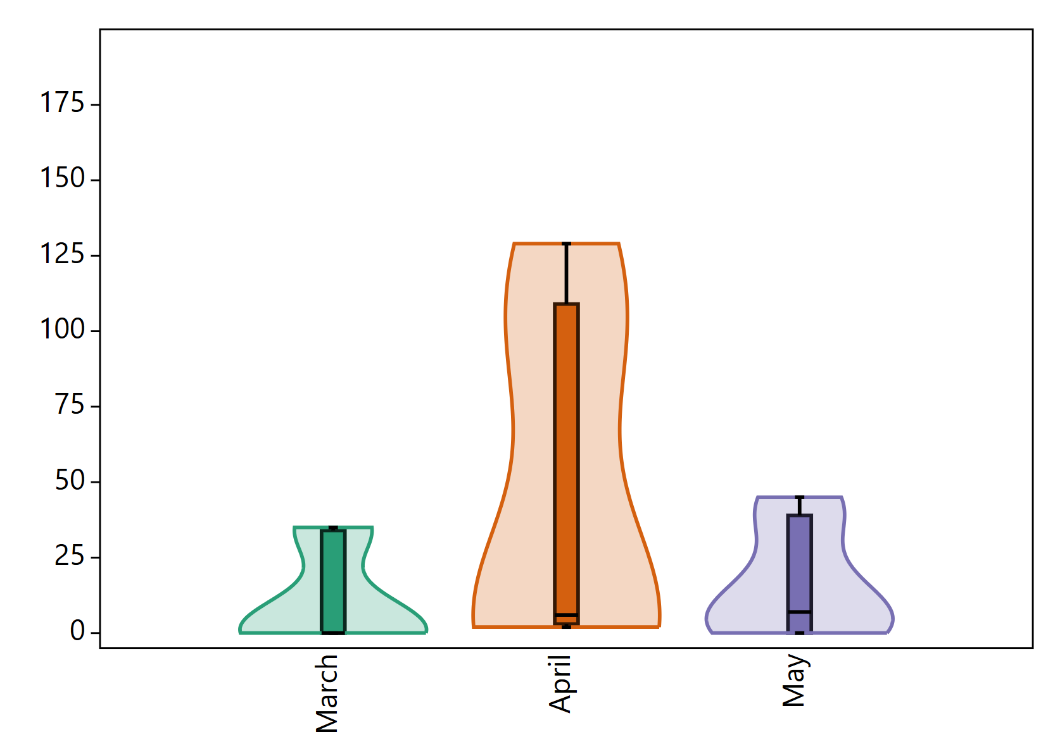

Figure 7. Drosophila violin bar plot for month wise mean individual

3.5 Species–Environment Correlation

To understand the ecological responses of individual Drosophila species to environmental factors, a correlation analysis was performed between species abundance and six key climatic variables: temperature, rainfall, cloud cover, atmospheric pressure, wind speed, and gust speed. The results revealed species-specific associations with climatic parameters, suggesting that different Drosophila species exhibit distinct environmental preferences and thresholds (Table 5).

Table 5. Correlation between Drosophila species diversity and climatic variables

Sl. No. | Species | Temp (°C) | Rain (mm) | Cloud (%) | Pressure (mb) | Wind (km/h) | Gust (km/h)
1 | Drosophila busckii | .526** | -.378* | -.459** | -0.028 | .560** | 0.097
2 | Drosophila immigrans | 0.195 | -0.061 | -0.045 | 0.155 | 0.065 | -0.074
3 | Drosophila melanogaster | 0.261 | -0.088 | 0.049 | 0.052 | 0.124 | -0.045
4 | Drosophila ananassae | -0.173 | 0.271 | 0.166 | -0.132 | -.388* | -0.234
5 | Drosophila malerkotliana | 0.061 | -0.039 | 0.077 | 0.042 | -0.207 | 0.160
6 | Drosophila nepalensis | 0.256 | -0.056 | -0.012 | 0.008 | 0.032 | -0.200
7 | Zaprionus indianus | 0.014 | -0.119 | 0.230 | 0.121 | -0.281 | -0.141
* Correlation is significant at the 0.05 level (2-tailed).
** Correlation is significant at the 0.01 level (2-tailed).

Among all the species, Drosophila busckii showed the strongest and most significant correlations with multiple climatic variables. Its abundance was positively correlated with temperature (r = 0.526, p < 0.01) and wind speed (r = 0.560, p < 0.01), indicating that this species thrives in warm, moderately breezy conditions. Conversely, it exhibited significant negative correlations with rainfall (r = –0.378, p < 0.05) and cloud cover (r = –0.459, p < 0.01), suggesting a preference for drier, sunnier periods. These findings imply that D. busckii may be a heat-tolerant and xerophilic species that takes advantage of relatively dry and aerated environments for feeding and reproduction.

Drosophila immigrans, the most abundant species during the study period, showed no significant correlation with any of the environmental variables, which may point to its broad ecological tolerance and generalist behavior. This species appears capable of persisting across a range of climatic conditions, likely due to its high adaptive plasticity and opportunistic nature.

Drosophila melanogaster, as a model organism distributed worldwide, showed no statistically significant correlations with the climate variables, although some positive trends with temperature and wind speed were recorded. This again suggests a high degree of climatic adaptability, enabling D. melanogaster to maintain a stable presence despite minor shifts in environment.

In contrast, Drosophila ananassae was negatively and significantly associated with wind speed (r = –0.388, p < 0.05). This result suggests a possible susceptibility to windy conditions, and thus its ability of flight, mating behavior or microhabitat selection. D. ananassae further displayed weak and non-significant correlations with the remaining climatic variables, further indicating complex habitat selection or preferences.
The less frequently observed species namely, D. malerkotliana, D. nepalensis, and Z. indianus, did not record statistically significant associations with any of the climate variables likely due to limited sample sizes or sporadic presence during the sampling window. Nonetheless, Z. indianus did exhibit a minimal, positive association with cloud cover, implying a preference for humid or overcast conditions, albeit this trend necessitates further sampling for confirmation.

The results of the correlation analysis suggest that climatic associations were clearly definable for only a handful of the species, especially D. busckii, which correlates positively with the higher values of temperature and wind speed and negatively with precipitation and cloud cover. All the other species were likely to exhibit generalist tendencies or were statistically under-dominated for meaningful climatic association. The temperature, wind, and precipitation-driven climatic factors clearly outline their significance in the distribution and the seasonal population dynamics in the Drosophila communities of the subtropical montane region.

4. DISCUSSION

The current study deals with the differences and concentrations of different species and climate response Drosophila species along a seasonal gradient in the Kamrang area (Sikkim Alpine University) of South Sikkim. The study elucidated patterns of species composition and Drosophila ecological behaviour. The period of study examined was quite short (March to May) and there was considerable evidence of climatic variability. The results demonstrate that environmental variation over a relatively short interval (March‐May) can have significant effects on the structure and dynamics of Drosophila communities in a subtropical montane environment as observed previously (Poppe et al., 2015).
The species composition changed significantly over the months, with richness and abundance reaching a zenith in April, which corresponded to increases in temperature and more stable weather patterns. The dominant species, D. immigrans and D. busckii, exhibited high rates of increase over this time suggesting they revealed opportunistic patterns of exploitation of the better microclimate conditions.
From March to May, Shannon and Simpson indices showed an increase in diversity, while decline in the dominance measures suggests that there was an increasingly balanced distribution of the different species present over the period. Even more interestingly, even though April was the most species-rich month, evenness was at its lowest. This suggests that during peak conditions, a few species dominantly structure the community, leaving the rest of the species substantially smaller in abundance. In contrast, even though March and May were less diverse, the higher evenness suggests more equitable distribution of the species present in these cooler or slightly drier conditions. This observation has been supported by the previous study of drosophila diversity in the Mandakini Valley of western Himalaya where they have also found variation in the number of species and also in the number of individuals as the seasons change (Khali et al., 2025).
The complex interrelationships of climatic variables has been documented as in the previous study (Hoffmann, 2010). Temperature has a negative correlation with rainfall and pressure, while being positively related to wind speed. This may suggest a transition climatic pattern from a winter dormant period to an active spring. This relationship may have a biological significance for the Drosophila species, as the timing of emergence, mating, and dispersal activities have been shown to respond to climatic changes. Among the climatic variables for the most studied species, D. busckii exhibited the greatest climatic correlation, positively responding to temperature and wind and negatively to cloud cover and rainfall. This may suggest niche specificity for D. busckii, indicating environmental bioindicator status for dry, windy habitats. For other species, for instance D. ananassae, there seems to be greater sensitivity to wind. D. immigrans and D. melanogaster appear to have a generalist strategy, showing broad environmental tolerance.

4.1 Limitations and Future Directions

The current study offers useful initial insights into Drosophila species diversity and its seasonal dynamics within the Kamrang area of South Sikkim. However, some important study limitations must be noted. First, it must be noted that the study took place over only three months (March to May), therefore only covering a small portion of the annual climatic cycle. This small temporal limit also results in the missing of the monsoon and post-monsoon periods which may greatly impact the species richness and patterns of emergence and turnover within that community.
Second, the sampling design was spatially limited to six locations within a small geographic area. This allowed for concentrated tracking of local differences, but may not portray the larger extent of the surrounding habitat heterogeneity, altitude differences, and associated region-wide variations that influence insect distribution within the montane ecosystems.
Finally, monitoring for extended periods of time may reveal changes in insect community composition over time which may be attributed to climatic and habitat changes. For certain shifted habitats, the Drosophila genus could be utilized as a bioindicator for environmental monitoring and conservation planning in fragile Himalayan ecosystems.

5. Conclusion

In this study, we evaluated the climatic responsiveness, diversity, and abundance of Drosophila species in studies Kamrang area of South Sikkim. The study was conducted study during the transition from the late winter season to the early pre-monsoon season (March to May). Through this study, we obtained seven Drosophila species in the area, with D. immigrans and D. busckii being the most predominant. Climatic variables were of substantial influence on the composition of Drosophila communities. D. busckii showed strong positive correlation with temperature and wind speed, and negative correlation with rainfall and cloud cover, reflecting environmental preference, In contrast, other species showed little weak statistical associations, probably owing to broad ecological tolerances. There is, however, no doubt that environmental gradients influence the distribution of Drosophila species.

The current findings highlight the ecological significance of the season and climate in the activity regulation of Drosophila diversity in subtropical montane landscapes. This current work reaffirms Drosophila's potential as bioindicators and illustrates how transient, short-term environmental variations could affect the emergence, dominance, and structure of a community. While the work provides useful baseline information, it also indicates the necessity of longer-term, and multi-seasonal, and multi-scaled studies incorporating molecular and ecological landscape studies to gain insight into the scope of insect diversity in the Eastern Himalayas.

Consent - NA

Ethical approval - NA

References

Achumi, B. (2014). Biodiversity and genetics of certain Drosophila species of Nagaland state, India (Doctoral dissertation, Ph. D. thesis Nagaland University, Nagaland, India).
Bhattacharya, S., Krishnaswamy, S., & Rao, C. K. (2012). Vulnerability of Sikkim to climate change and strategies for adaptation. Climate Change in Sikkim Patterns, Impacts and Initiatives. Information and Public Relations Department, Government of Sikkim, Gangtok.
Bogaerts‐Márquez, M., Guirao‐Rico, S., Gautier, M., & González, J. (2021). Temperature, rainfall and wind variables underlie environmental adaptation in natural populations of Drosophila melanogaster. Molecular ecology, 30(4), 938-954.
Castle, W. E. (1906). Inbreeding, cross-breeding and sterility in Drosophila. Science, 23(578), 153-153.
D’Souza, A., Mahalingappa, M., & Venkat, S. (2019). Impact of geographical elevations on the eco-distributional pattern of drosophila (Diptera) species in four different ecosystems of Karnataka, India. International Journal of Entomological Research, 4(2), 1-8.
Ghanashyam Sharma, G. S., Uma Partap, U. P., Eklabya Sharma, E. S., Golam Rasul, G. R., & Awasthe, R. K. (2016). Agrobiodiversity in the Sikkim Himalaya: sociocultural significance, status, practices, and challenges.
Gupta, J. P., & Gupta, K. K. (1991). Two new species of Drosophila Fallen 1823 associated with flowers in Sikkim, India. Senckenberg Biol, 71, 59-63.
Hajam, Y. A., Parey, S. H., & Bhat, R. A. (Eds.). (2024). Insect Diversity and Ecosystem Services: Volume 2: Environmental Indicators, Molecular Approaches, and Management Strategies. CRC Press.
Hoffmann, A. A. (2010). Physiological climatic limits in Drosophila: patterns and implications. Journal of Experimental Biology, 213(6), 870-880.
Jogesh, A., & Dubash, N. K. (2014). Mainstreaming climate change in state development planning: an analysis of the Sikkim action plan on climate change. Working paper/Centre for Policy Research (CPR), Climate Initiative.
Kellermann, V., Van Heerwaarden, B., Sgrò, C. M., & Hoffmann, A. A. (2009). Fundamental evolutionary limits in ecological traits drive Drosophila species distributions. Science, 325(5945), 1244-1246.
Khali, S., Topal, P., Dubey, K., Rawat, D., & Fartyal, R. S. (2025). Diversity and distribution of drosophilids (Diptera: Drosophilidae) in the Mandakini Valley of Western Himalaya, Uttarakhand, India: an altitudinal and seasonal study. Biodiversity, 26(1), 89-99.
Kumar, A., & Gupta, J. P. (1993). Two new members of Scaptodrosophila from Sikkim, India (Diptera: Drosophilidae: Drosophila). ENTOMON-TRIVANDRUM-, 18, 43-43.
Mahato, S. P., & Gupta, K. K. (2018). Species diversity status of family Drosophilidae at Hazaribag, Jharkhand, India. Species diversity, 3(1).
Markow, T. A., & O'grady, P. (2008). Reproductive ecology of Drosophila. Functional Ecology, 747-759.
Mateus, R. P., Buschini, M. L. T., & Sene, F. M. (2006). The Drosophila community in xerophytic vegetations of the upper Parana-Paraguay river basin. Brazilian Journal of Biology, 66, 719-729.
Meetei, K. B., Tsopoe, M., Giri, K., Mishra, G., Verma, P. K., & Rohatgi, D. (2023). Climate-resilient pathways and nature-based solutions to reduce vulnerabilities to climate change in the Indian Himalayan Region. In Climate change in the Himalayas (pp. 89-119). Academic Press.
Perveen, F. K. (2018). Introduction to drosophila. In Drosophila melanogaster-Model for Recent Advances in Genetics and Therapeutics. IntechOpen.
Poppe, J. L., Schmitz, H. J., Callegari-Jacques, S. M., & Valente, V. L. S. (2015). Environmental determinants on the assemblage structure of Drosophilidae flies in a temperate-subtropical region. Neotropical entomology, 44(2), 140-152.
Rawat, G. S., & Tambe, S. (2011). Sikkim Himalaya: unique features of biogeography and ecology. Biodiversity of Sikkim. Information and Public Relations Department, Government of Sikkim, 542pp, 1-12.
Sánchez‐Guillén, R. A., Córdoba‐Aguilar, A., Hansson, B., Ott, J., & Wellenreuther, M. (2016). Evolutionary consequences of climate‐induced range shifts in insects. Biological reviews, 91(4), 1050-1064.
Sarswat, M., Sati, P. C., Dewan, S., & Fartyal, R. S. (2016). Implying quantitative ecology of Drosophilid fauna as a tool for biodiversity assessment-A case study along an altitudinal transect in the Garhwal region of Central Himalaya. Tropical Ecology, 57(4), 637-647.
Tamang, A. M., Muchahary, A., Mishra, J., Singh, R., & Singh, P. (2021). Diversity of Drosophila species in and around Amarkantak region of Madhya Pradesh during spring season. International Journal of Entomology Research, 6(5), 139–144. https://www.entomologyjournals.com/assets/archives/2021/vol6issue5/6-5-29-828.pdf
Vivekanandhan, P., Swathy, K., Sarayut, P., & Patcharin, K. (2024). Classification, biology and entomopathogenic fungi-based management and their mode of action against Drosophila species (Diptera: Drosophilidae): A review. Frontiers in Microbiology, 15, 1443651.

