Hydrochemical Characterisation and Suitability Assessment of Groundwater Using Multivariate Techniques in Challakere Taluk, Chitradurga District, Karnataka State, India

Abstract:
Understanding the groundwater resources of Challakere taluk is significant for its sustainable use. A complete hydrogeochemical study was conducted using 40 groundwater samples to examine various physicochemical properties. WQI provided a numerical rating of the water's potability, while Wilcox diagrams are used for its suitability for irrigation. By examining the geochemistry more closely, the Piper, Gibbs, and Chadha diagrams revealed the primary types of water chemistry and the associated processes, particularly how rocks interact with water and how ions are exchanged. Specifically, certain areas showed elevated levels of TDS and sodium (Na). By integrating these diverse analytical techniques, the study generated a comprehensive picture of groundwater quality, offering essential insights for informed decision-making in Groundwater resource management and the development of effective policies for Challakere taluk.
Keywords: Groundwater contamination, Hydrochemical Classification, hydrostatistics, and Hydrogeochemistry.

- Introduction
In semi-arid areas, for example, aquifers are key sources of water to supply people, farms and industry. This critical resource is under growing pressure. Non-sustainable pumping and pollution from human activity are now both threatening the quality of groundwater.
Groundwater comes in all manner of hydrogeochemical shapes and sizes, influenced by multiple natural and anthropogenic influences. Geology, time spent in flow paths, modelled precipitation patterns, flow and runoff from fields and untreated sewage discharges all interact to determine the quality of the final water. Traditional evaluations generally capture only a single variable, and the cumulative effects aspect is not well known. In contrast, composite measures such as the WQI pool together all available information and produce a more accurate and more complete assessment.

Geographic information systems (GIS) and remote sensing (RS) are examples of geomatic tools that can be used to track and understand patterns and trends in groundwater quality.
These methods help us learn more about where pollutants are found in the environment, find places that are highly contaminated, and make it easier to come up with better plans for managing water.
Groundwater monitoring is an essential job that both the government and society can do. Moreover, safeguarding groundwater can be a public health protection measure and can contribute to the well-being of people in Challakere Block.

All essential diagrams such as Piper, Gibbs and Chadha are included for obtaining information for groundwater chemistry an its facies.

The assessment includes statistical analysis, Water Quality Index (WQI) and Hydrochemical facies to assess the physicochemical properties of groundwater in Challakere, useful for water resources management.

The increasing reliance on groundwater, coupled with unpredictable rainfall patterns, a rising population, and intensive agricultural practices, has placed considerable stress on the region's aquifer systems. This has generated significant concerns regarding the quantity and quality of groundwater.
A combined method using hydrogeochemistry, the Water Quality Index (WQI), and geospatial analysis evaluates how groundwater quality changes over space in semi-arid areas. This assessment offers policymakers essential insights for effective intervention and enhanced management.
- Methodology
3.1 Study Area and Sampling
Challakere Taluk, located in the Eastern Dharwar Craton of Karnataka, is primarily composed of hard crystalline rocks, including granite gneiss, migmatites, and dolerite dykes, characteristic of the Peninsular Gneissic Complex (Fig. 4). The area has two types of aquifers: a shallow one that is not fully enclosed, found in the weathered layer at depths of 5–25 meters, and a deeper one that is fully enclosed, located in fractured rocks at depths over 100 meters. The groundwater system is made up of an unconfined aquifer located in the upper weathered zone, in addition to confined aquifers in fractured bedrock. Fracture connectivity mainly controls borewell productivity and thus variations are observed in yields. Reducation from rainfall percolation and groundwater recharge is mostly low to moderate due hard rock geology. Ground water resources are over-exploited in this hard rock semi-arid potential recharge zone and sustainable management is the need of the hour. Forty borewells were selected and the groundwater samples were drawn at different locations in the pre-monsoon season and GPS coordinates were noted for each of the sampling locations.

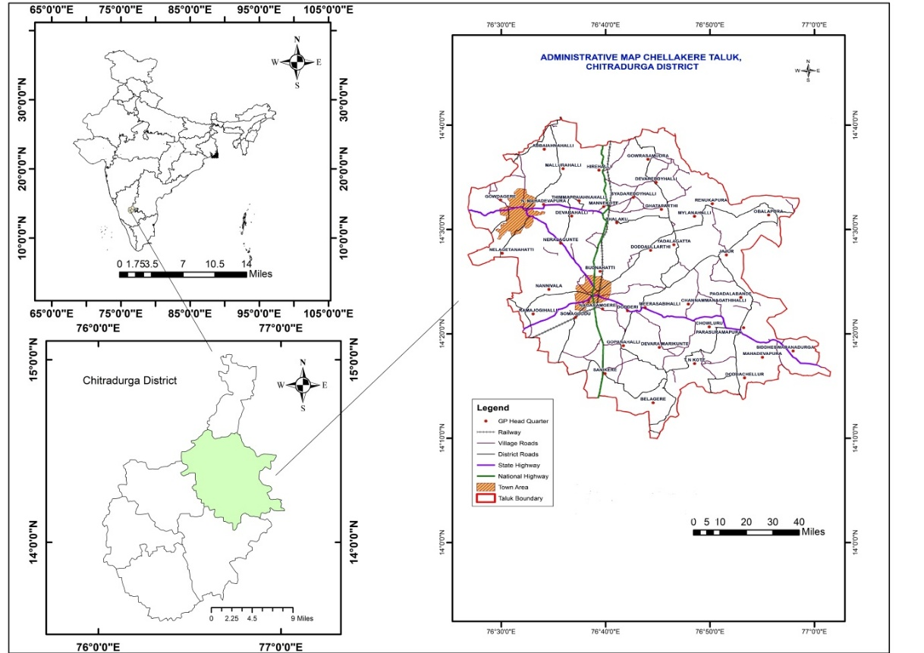
Figure 1: Study area map.

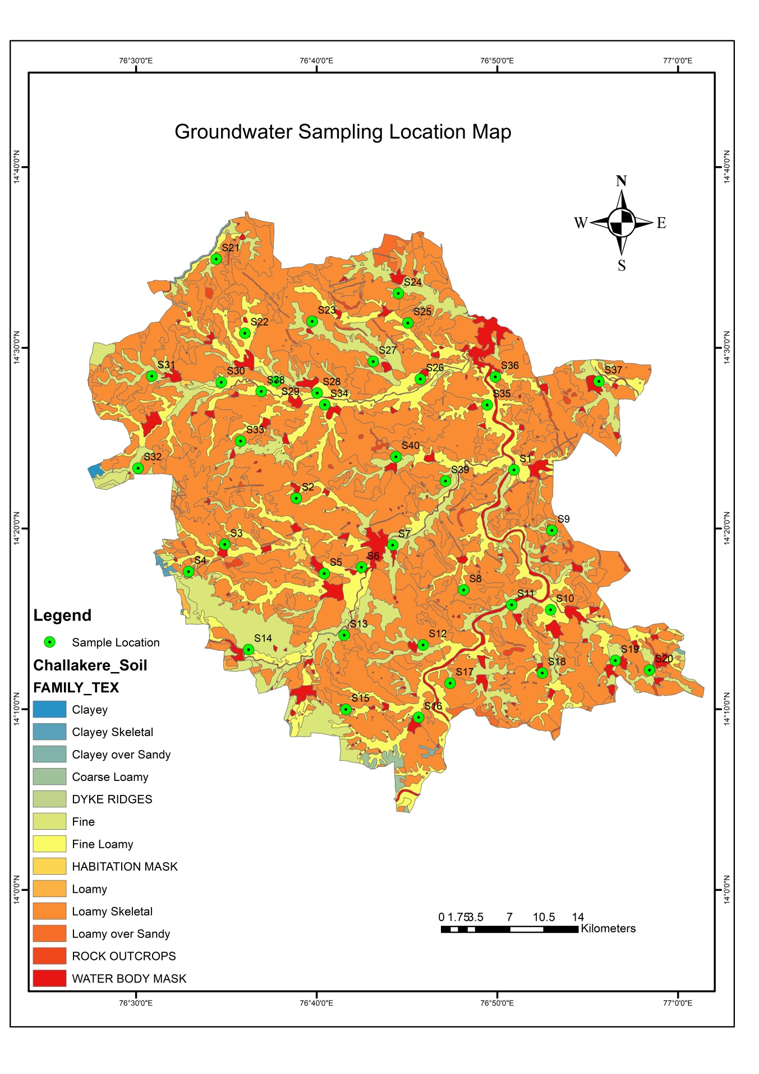
Figure 2: Groundwater Sampling Location Map.
Groundwater samples from 40 borewells located in the study area were systematically collected during pre-monsoon months. Samples were put in a pre-treated acid washed one liter polyethylene bottle. Precautions against air bubbles during collection were taken and the bottles were stopped with double caps to prevent water intake from the outside. pH, EC and TDS were directly measured at site by calibrated handheld instruments to maintain the accuracy. Subsequently the samples were transported to the laboratory at room temperature for analysis.
The laboratory analysis of major ions employed a range of analytical techniques. Sodium and potassium concentrations were quantified using flame photometry, whereas volumetric titration was employed to assess total hardness, calcium carbonate, bicarbonate, and chloride levels. The concentration of magnesium was indirectly assessed by calculating it using the values obtained for total hardness and calcium. Spectrophotometry was employed to quantify sulfate and nitrate.
To verify the reliability of the chemical analyses, the ionic balance error (IBE) was computed for each sample. Samples were included in the study only if their IBE fell within the acceptable tolerance of ±5%. The IBE is computed in the following manner: IBE is calculated using the formula (Σ Cations – Σ Anions) / (Σ Cations + Σ Anions) * 100.
3.2 Sample Analysis
Samples were analysed for major cations and anions and physical parameters following APHA (2017) methods:
Parameter | Method
pH, EC, TDS | Multi-parameter probe
Ca²⁺, Mg²⁺ | EDTA titration
Na⁺, K⁺ | Flame photometry
Cl⁻ | Argentometric titration
HCO₃⁻, SO₄²⁻ | Titration/Spectrophotometry
Table 1- Water Quality Analysis Methods for Major Ions and Parameters
3.3 Data Processing
Data were cleaned and normalised using Python. Column names were standardised, and outliers and missing values were handled during preprocessing.
3.4 Water Quality Index (WQI)
The Water Quality Index (WQI) was calculated using weighted arithmetic mean method. The GUT index is derived by a combination of the quality rating (Qi) and its weight (Wi) of the selected water quality parameters. The equation can be written as WQI = Σ (Q i × W i ) / ΣW i ). Quality rating (Qi) of each parameter was computed as the ratio of each measured parameter concentration (Ci) to standard value (Si). Qi is the ratio of Ci to Si and then multiplied by 100 to get the percentage.
3.5 Irrigation Suitability
To classify water for its suitability in irrigation, the Wilcox diagram was employed, considering both the EC and the sodium percentage (Na%). The Na% value is determined by Na% = [Na / (Ca + Mg + Na + K)] × 100.
3.6 Hydrochemical Diagrams
The Piper diagram was used to identify and classify the hydrochemical facies of the groundwater, providing insight into the dominant ionic compositions and water types present. To understand the factors that affect groundwater chemistry, the Gibbs diagram was used to determine whether the primary factors were rock–water interaction, precipitation, or evaporation. The Chadha diagram was used to trace water evolution trends, giving researchers invaluable information about how groundwater chemistry changes over time due to natural geochemical processes.
- Results and Discussion
 | Ca  (mg/L) | Mg (mg/L) | Na (mg/L) | K (mg/L) | HCO₃ (mg/L) | SO₃ (mg/L) | Cl (mg/L) | PH | E.C. | TDS
Count | 40 | 40 | 40 | 40 | 40 | 40 | 40 | 40 | 40 | 40
Mean | 29.84 | 11.12 | 107.38 | 4.62 | 180.37 | 85.35 | 174.90 | 7.428 | 1301 | 803.5
Std | 29.72 | 8.67 | 48.70 | 2.90 | 75 | 48.37 | 75.83 | 0.26 | 597.5 | 379.31
Min | 8.32. | 3.32 | 41 | 1 | 47.8 | 20 | 47 | 7.05 | 466 | 299
25% | 14.62 | 5.88 | 71.75 | 2 | 119.51 | 44.50 | 110 | 7.197 | 813.75 | 493.75
50% | 22.11 | 9.16 | 90 | 4 | 199.31 | 85 | 190 | 7.425 | 1275.5 | 776.5
75% | 28.28 | 11.42 | 137.25 | 7.25 | 229.7 | 110 | 220 | 7.622 | 1565 | 938
Max | 139.2 | 38.08 | 198 | 11 | 339.44 | 212 | 350 | 7.92 | 2778 | 1856
4.1 Summary Statistics

Table 2- Descriptive Statistics of Water Quality Parameters

The groundwater is characterised by pH values ranging from neutral to slightly alkaline (7.05-7.92), with an average of 7.43. Total dissolved solids (TDS) suggest moderate mineralisation (299-1856 mg/L, average 803 mg/L), a condition likely resulting from natural water-rock interactions.
However, higher levels of electrical conductivity (EC) and chloride (Cl⁻) found in some samples might suggest effects from local rock types, like evaporite deposits, or human activities, such as agricultural runoff.
4.2 Correlation assessment
4.2.1 Correlation Heat Map Analysis
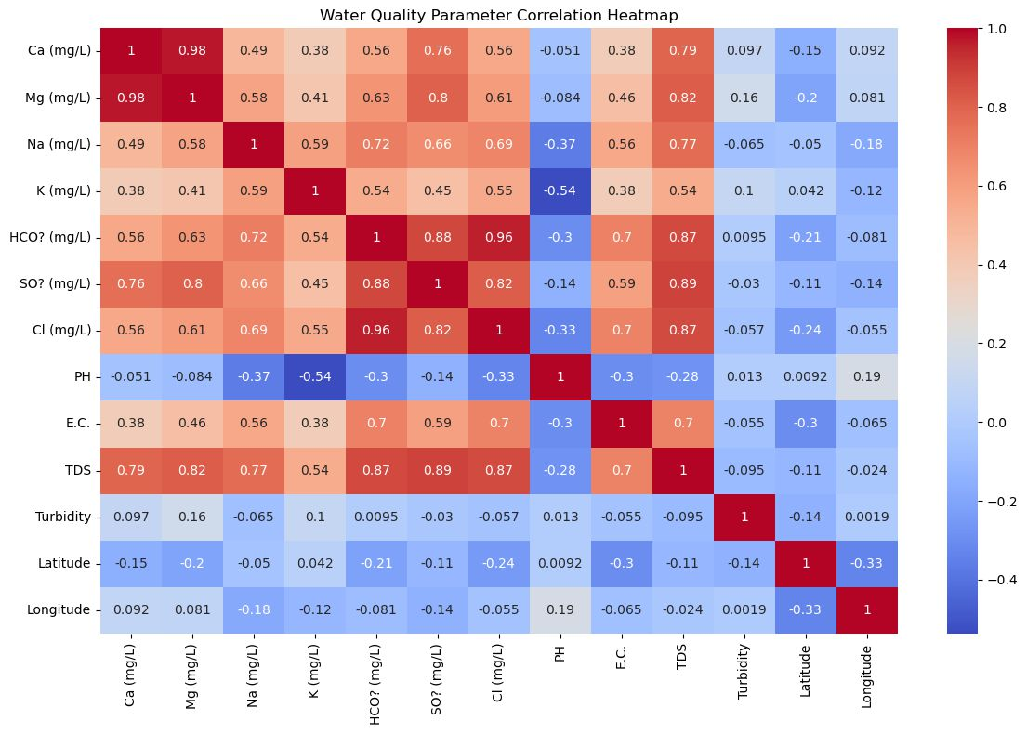
Figure 3: Correlation Heat map.
The correlation heatmap certainly explains much about the interrelationships amongst the diverse groundwater quality metrics, vividly bringing to light several powerful and meaningful connections, most notably the high positive linkage between calcium and magnesium, proposing a shared geological wellspring, likely from the dissolution of carbonate minerals.

Strong correlations between total dissolved solids and sodium, bicarbonate, chloride, and electrical conductivity demonstrate unequivocally that these ions are the groundwater's predominant salt sources. The striking correlation between electrical conductivity and total dissolved solids provides further evidence validating electrical conductivity as a trustworthy proxy for evaluating overall salinity.
While the majority of chemical parameters conversely exhibit weak to negative correlations with pH, suggesting that fluctuations in ionic composition have minimal ramifications on levels of acidity or alkalinity, spatial factors such as latitude, longitude, and turbidity curiously display insignificant correlation with chemical parameters. This implies that alterations in geographic positioning have a negligible immediate impact on the hydrogeochemistry of the Challakere block. Furthermore, several key chemical constituents including magnesium, potassium, and sulfate paradoxically manifest no discernable relationship with total dissolved solids, raising questions about the scope of their contribution to the region's groundwater salinity.
4.3 WQI Results
Groundwater quality, as indicated by the WQI, shows notable spatial variation throughout the study region, with values ranging from 41 to 310. Among the samples analysed, 27.5% are classified as excellent and 22.5% as good. However, it is alarming that 50% of the samples are categorised as poor, very poor, or unsuitable for drinking. This deterioration in quality is primarily attributed to heightened concentrations of TDS, sodium (Na⁺), and chloride (Cl⁻), which are likely the result of both geogenic processes and anthropogenic influences (Table 3).
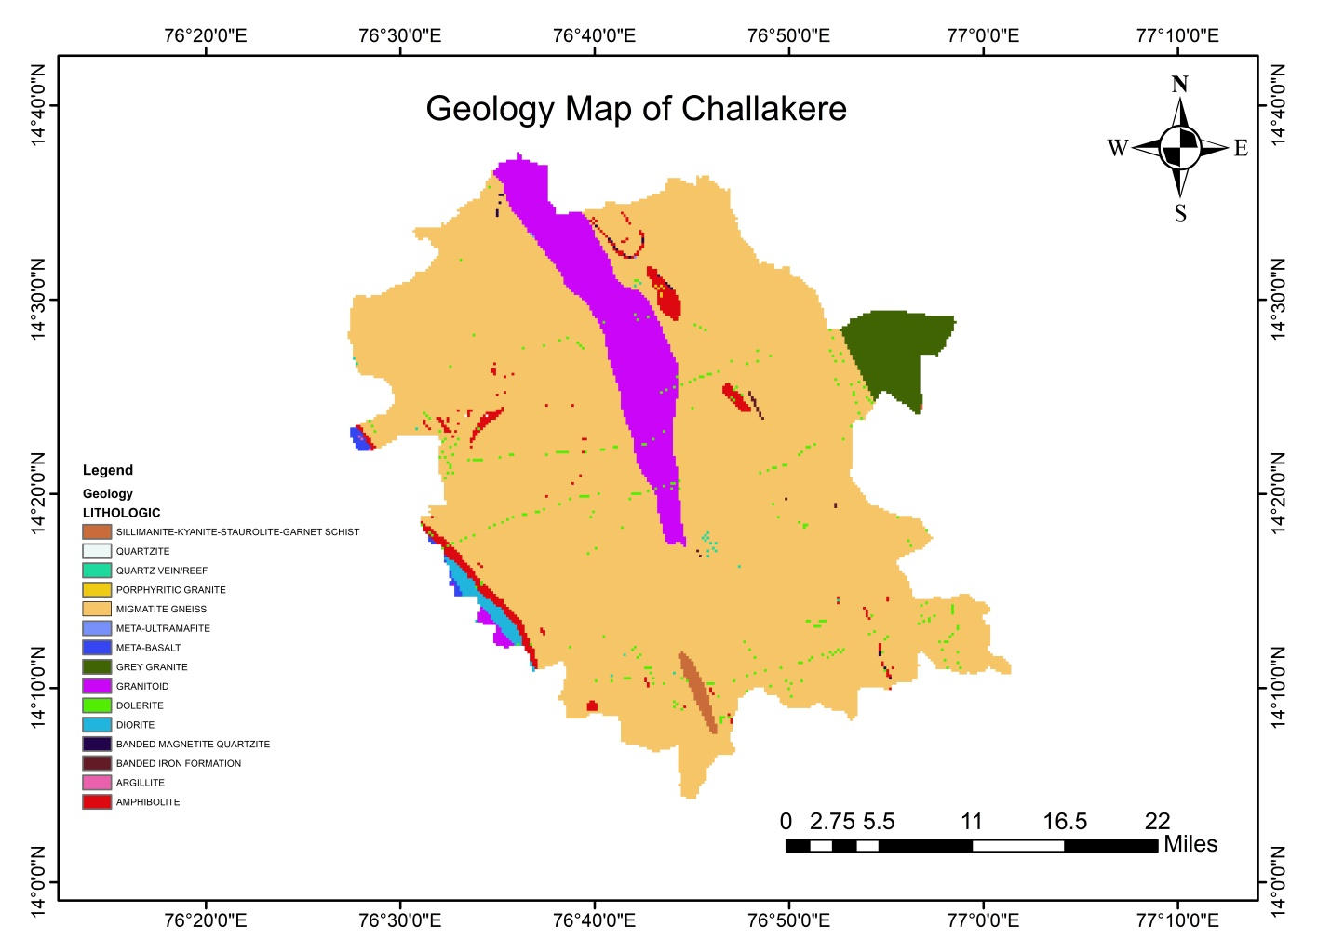
Fig.4 Geology Map of Challakere.
The geology map of Challakere explains the spatial distribution of different lithological units, with migmatite gneiss being the most dominant rock type across the region. Other significant formations include porphyritic granite, quartzite, amphibolite and various schists and granitoids. Rocks of the study area represent a typical hard rock terrain, where groundwater occurrence is primarily controlled by the degree of weathering, fracturing, and jointing rather than primary porosity. The central and southern zones are mainly composed of metamorphic rocks, while granitic and mafic intrusions are scattered throughout. Such geological variability plays a crucial role for influencing groundwater availability, recharge potential, and water quality across the taluk.
Table 3: Water Quality
Sample | Villages | WQI range | Water Quality
S1 | Jajuru | 33.1 | Excellent
S2 | Budnahatti | 135.3 | Poor
S3 | Nannivala | 20.2 | Excellent
S6 | Dodderi | 47.7 | Excellent
S7 | Meerasabihalli | 83.5 | Good
S8 | Channammanagathihalli | 117.8 | Poor
S9 | Pagadalabande | 94.8 | Good
S10 | Parushurampura | 125.5 | Poor
S11 | Chowluru | 28.6 | Excellent
S12 | Devaramarikunte | 77.1 | Good
S13 | Gopanahalli | 9.2 | Excellent
S14 | Somuguddu | 101.7 | Poor
S15 | Saniikere | 113.3 | Poor
S16 | Belagere | 67.3 | Good
S17 | T N kote | 125.1 | Poor
S18 | Doddachelluru | 134.8 | Poor
S19 | P Mahadevapura | 26.3 | Excellent
S20 | Siddeshwaranadurga | 139.6 | Poor
S21 | Abbenahalli | 15.1 | Excellent
S22 | Mallurahalli | 16.4 | Excellent
S23 | Hirehalli | 104.0 | Poor
S24 | Bandethimlapura | 119.9 | Poor
S25 | Devareddihalli | 64.1 | Good
S26 | Ghattaparthi | 95.5 | Good
S27 | Bedareddihalli | 26.7 | Excellent
S28 | Mannekote | 125.7 | Poor
S29 | Thimmappayahalli | 100.0 | Good
S30 | N Mahadevapura | 115.3 | Poor
S31 | Gowdagere | 145.9 | Poor
S32 | Nelagethanahatti | 122.8 | Poor
S33 | Neralagunte | 151.8 | Poor
S34 | Thalaku | 5.8 | Excellent
S35 | Mailanahalli | 2.1 | Excellent
S36 | Renukapura | 124.7 | Poor
S37 | Obalapura | 117.9 | Poor
S38 | N Devarahalli | 73.6 | Good
S39 | Dodda ullarthi | 131.5 | Poor
S40 | Kaluvehalli | 204.6 | Unsuitable

The water quality index (WQI) was calculated for 40 groundwater samples and is ranged from good to excellent which indicates that water can be used as drinking water. Classification as per WQI values confirm that 12 villages being belongs to ‘Excellent’ category indicating very low contaminated waters acceptable for direct human usage (WQI ≤50). In 8 villages (20%) water quality was ‘Good’ (WQI between 50 and 100) suggesting that the water is safe for consumption other use but with some basic treatment to improve the quality of the water

In contrast, a considerable proportion of the samples 19 villages (47.5%) were categorised as ‘Poor’ (WQI between 100 and 200), pointing to the presence of elevated concentrations of physicochemical parameters that could affect potability and require corrective measures before usage. Kaluvehalli village shows very high values of 204.6, which is indicative of dangerous if we consume this water directly.
4.4 Irrigation Suitability
Groundwater quality throughout the region showed considerable spatial fluctuation, with the Water Quality Index ranging markedly from excellent to extremely poor. Among the samples tested, nearly thirty percent were deemed excellent drinking water while approximately twenty-three percent were classified as good. However, it is highly troubling that fifty percent of the samples were ranked as poor, very poor or outright unsuitable for human consumption. This sharp decline in water quality primarily stems from notably elevated levels of total dissolved solids, sodium and chloride, likely caused by both natural geological processes and manmade human activities as indicated by the findings in Table 3. Local communities and governments must prioritize addressing the anthropogenic factors exacerbating the region's groundwater problems to ensure long-term access to safe and dependable water resources for all residents.
4.5 Hydrochemical Facies
Hydrochemical characterisation of the groundwater: based on the Piper, Gibbs and Chadha diagrams The hydrochemistry of the groundwater was investigated using Piper, Gibbs and Chada diagrams which show that (1) the rock-water interaction is the dominant geochemical process that govern the groundwater-mineral interaction as the majority of the samples are falling within the rock dominance field in the Gibbs diagram. (2) Two main types of water are recognised: Ca-Mg-HCO₃ and Na-Cl, indicating the fresh and saline contributions in both cases. Only a minor part of the samples indicates evaporative processes, likely due to dry conditions.
4.5.1. Piper diagram:
The more intuitive Piper diagram is based on the content of calcium (Ca²⁺) and chloride (Cl⁻) in groundwater as percentages of all cations and anions, respectively. It can be seen from the data that most contents of Cl⁻ range from 37% to 45%, Cl⁻ is main anion in most samples, which may relate to evaporation, farming, and pollution. Calcium concentrations are more variable ranging from ca, indicating a variety of geochemical processes affecting groundwater, e.g., mineral dissolution (Fig.5). Samples characterised by high Ca and high Cl percentages could be indicative of Ca-Cl water type, which is often typical of mineralized recharge zones or pollution. It is a focused representation of the dominance of ions and helps in identifying hydrochemical facies and highlights the direction of contamination in the study area.

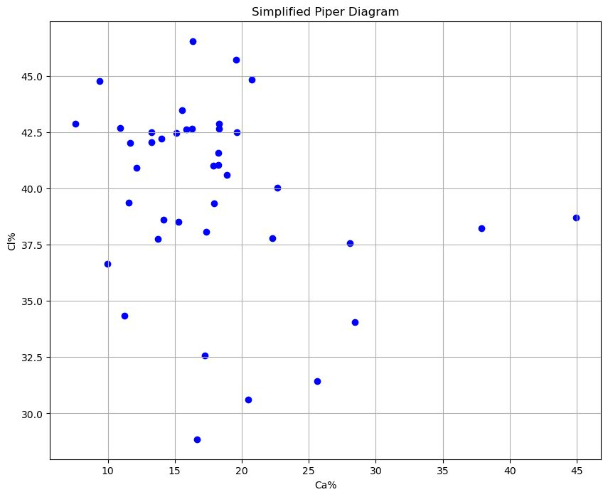
Fig. 5. Simplified Piper diagram
4.5.2. Gibbs Plot:
The overall analysis of both graphs shows that the main geochemical process affecting the water chemistry in the Challakere block is the interaction between rocks and water, especially the breakdown of minerals in the host rock. This is evident in the clustering of points within the middle range of both Gibbs plots (Fig. 6).
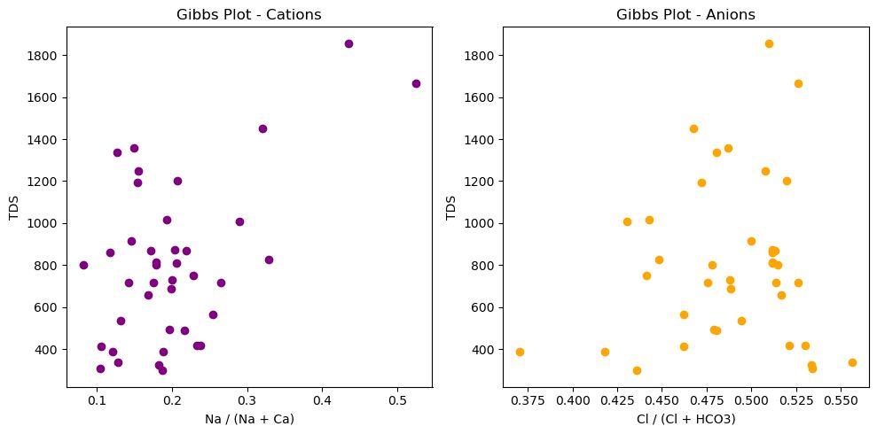
Fig. 6. Gibbs Plots
4.5.3. Chadha Diagram:
Most of the data points lie in the lower left quadrant, where both (Na+, K−, Cl) and (Ca+, Mg−, HCO₃−, SO₄) are negative. This means that the water mainly contains alkaline earths (Ca²⁺, Mg²⁺) and weak acids (HCO₃⁻, SO₄²⁻), which usually shows that it comes from natural sources or the breakdown of carbonates.
A few samples extend toward the right side of the plot, with positive (Na + K − Cl) values, indicating higher sodium and potassium levels, which may be due to cation exchange processes.
The data, which includes all points located in the lower half of the diagram, confirms that (Ca + Mg) is less than (HCO₃ + SO₄), indicating that anions are dominated primarily by bicarbonate and sulfate. This could be due to the influence of bicarbonate-rich recharge water or sulfate-bearing lithology.

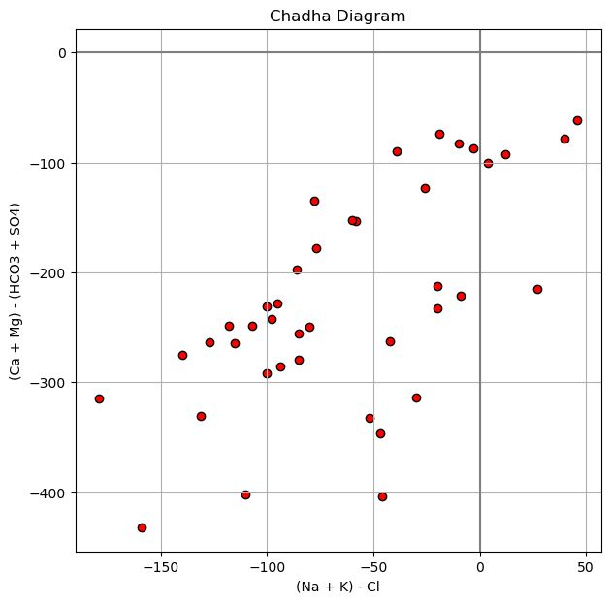
Fig. 7. Chadha Diagram.
4.5.4. Wilcox Diagram:
The Wilcox diagram shown above evaluates the suitability of groundwater for irrigation based on Na% versus Electrical Conductivity. Most of the groundwater samples are grouped between 60–80% sodium and electrical conductivity of about 500 to 2500 µS/cm, which shows that the water has moderate to high salinity and a significant sodium risk. Such water is generally unsuitable for long-term irrigation without proper management, as it may adversely affect soil permeability and crop yield. The logarithmic scale on the x-axis allows better visualisation of samples across a wide range of salinity values. This diagram offers crucial insights into the chemical composition and potential agricultural implications of groundwater in the study area.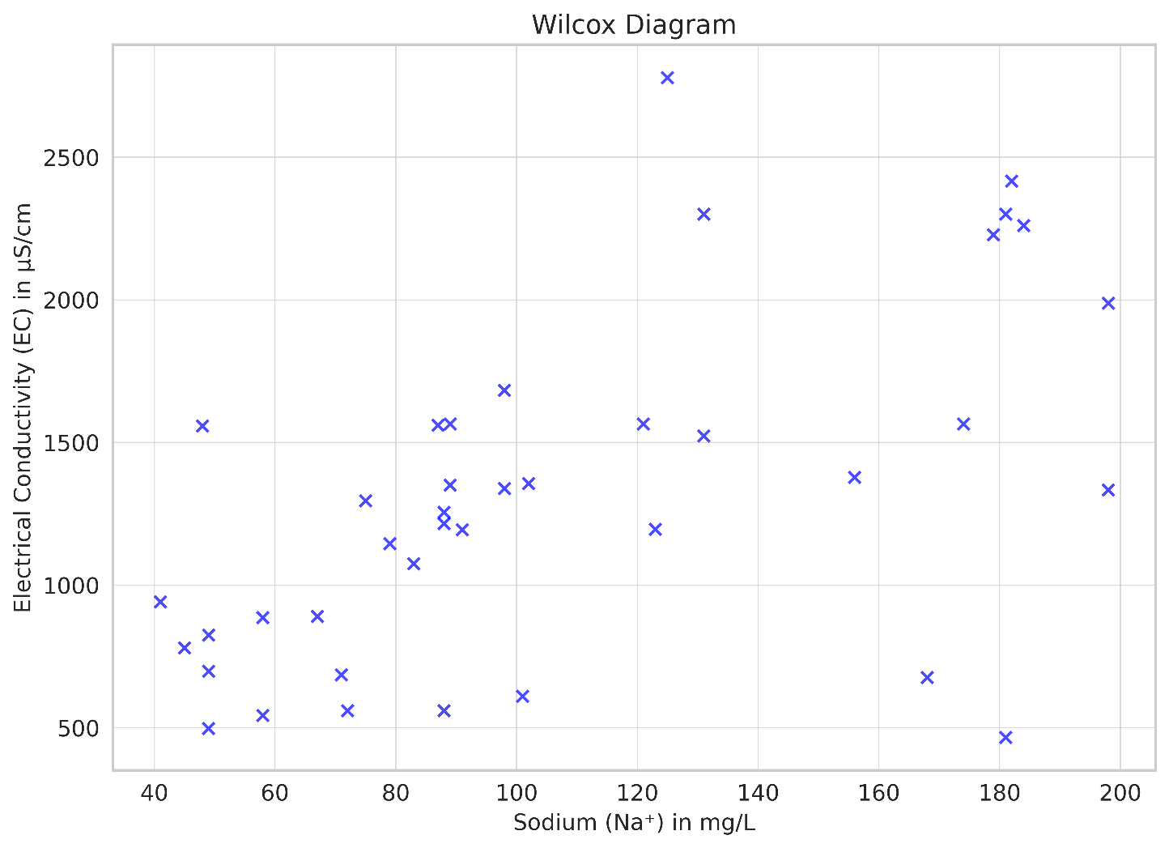
Fig. 8. Wilcox Diagram

4.6 Comparative Analysis with Other Study Areas.
A comparative study has been done for the same environmental conditions of the study area.
a) Groundwater Quality Index (WQI) Comparison:
About 60% of the samples in Challakere fell into the Excellent to Good category, with a WQI ranging from 41 to 310.
In a similar study conducted by Rao et al. (2020) in the Anantapur district (Andhra Pradesh), WQI values ranged from 38 to 285, 20% being Unsuitable due to fluoride and nitrate contamination, and with 50% of samples rated as Good.
Patil et al. (2018) in Bangalore Rural found that WQI values range from 55 to 320. High WQI values were attributed to improper sanitation and industrial effluents.
b) Irrigation Suitability Comparison:
- Sixty per cent of the groundwater samples in the Challakere area are classified as suitable for irrigation based on the Wilcox and Na% indices.
- Jaiswal et al. (2019) reported only 40% suitability in the Jhansi district (Bundelkhand), mainly due to higher salinity and sodium hazards.
- Kumar and Singh (2017) observed that over seventy per cent of the groundwater in the Nagaur district of Rajasthan was unsuitable for irrigation, mainly due to extremely high EC and SAR levels.
c) Hydrochemical Facies Comparison:
- In the study area, the dominance of Ca–Mg–HCO₃ and Na–Cl facies is consistent with results from the Hard Rock Region of Tamil Nadu (Subramanian et al., 2016), where weathering of feldspar-bearing rocks contributed to similar facies.
- Gibbs diagrams in multiple studies, Kumar et al. (2015) in Jharkhand, indicate that rock-water interaction is the dominant geochemical process, aligning with findings from the Study Area.
- Groundwater from coastal Andhra Pradesh exhibited a higher influence of evaporation and seawater intrusion (Na–Cl dominance), which is less noticeable in the area.
- Conclusion
The study explains that the groundwater quality in Challakere ranges from excellent to unsuitable for drinking. According to hydrochemical analysis, rock weathering is the primary mechanism controlling the chemistry of water, with evaporation and anthropogenic inputs also contributing to the process. The study area exhibits less interaction with the fluoride-hosting rock, as evidenced in the results.
The combined study of the Simplified Piper, Gibbs, and Chadha diagrams gives us useful information on the hydrogeochemical processes that affect the quality of groundwater in the Challakere Block. The Piper diagram distinctly illustrates significant variability in calcium levels, with numerous samples exhibiting elevated chloride concentrations, indicating the influence of Ca-Cl-type water. This composition indicates that mineral dissolution and evaporative concentration may significantly influence groundwater in specific regions.

The Gibbs diagrams further support these interpretations, with most samples falling within the zone of dominance for rock–water interaction. This pattern elucidates the significance of water-rock interaction in affecting the ionic composition of groundwater, particularly the dissolution of silicate and carbonate minerals. Multiple sites demonstrating heightened total dissolved solids (TDS) levels in the cation plot indicate the possible impact of anthropogenic activities on the results.
The Chadha diagram further validates the hydrochemical interpretations. The clear presence of alkaline earth metals (Ca²⁺, Mg²⁺) and weak acids (HCO₃⁻, SO₄²⁻) matches the expected chemical patterns from natural groundwater replenishment and the breakdown of carbonate and sulfate minerals.
A few samples displaying higher Na⁺ and K⁺ concentrations suggest localised cation exchange or human impacts, but these are not widespread.
This study presents water quality index (WQI) and irrigation indices, indicating that although a significant portion of the water is usable, certain locations necessitate treatment. Groundwater chemistry is primarily influenced by the interaction between rock and water, with additional contributions from evaporation and human activities. Long-term sustainability requires ongoing monitoring and efficient water management strategies.
The majority of water meets permissible limits; however, certain regions display elevated salinity and sodium risks. It is recommended to implement continuous monitoring, appropriate treatment strategies, and sustainable groundwater policies.

Conflicts of Interest: The authors declare no conflicts of interest related to this work.
Data Availability: Upon reasonable request, the corresponding author will provide the data supporting the study's findings.

References
- APHA (2017). Standard Methods for the Examination of Water and Wastewater, 23rd ed. American Public Health Association, Washington, D.C.
- Adimalla, N., Marsetty, S.K., Xu, P. (2020b). The study aimed to assess the groundwater quality and health risks of fluoride pollution in the Shasler Vagu (SV) watershed of Nalgonda, India. Hum. Ecol. Risk Assess. Int. J. 26 (6), 1569–1588.
- Agarwal, M., Singh, M., Hussain, J. (2020). In parts of Gautam Budh Nagar District, India, researchers evaluated groundwater quality for drinking purposes using various water quality indices. Asian J. Chem. 32 (5), 1128–1138.
- Aly, A.A., Al-Omran, A.M., Alharby, M.M. (2015). The water quality index and Hydrochemical characterisation of groundwater resources in Hafar Albatin, Saudi Arabia. Arab. J. Geosci. 8 (6), 4177–4190.
- Anusha, B.N., Babu, K.R., Kumar, B.P., Kumar, P.R., Rajasekhar, M., 2022. The study employs geospatial approaches to monitor and map water resources in semi-arid regions of Southern India. Environ. Chall. 8, 100569.
- BIS (2012). Indian Standard Drinking Water Specification (IS 10500:2012), Bureau of Indian Standards, New Delhi.
- Badapalli, P.K., Nakkala, A.B., Kottala, R.B., Gugulothu, S., 2022. Geo-environmental green growth towards sustainable development in semi-arid regions using physicochemical and geospatial approaches. Environ. Sci. Pollut. Res. 1–18.
- Balamurugan, P., Kumar, P.S., Shankar, K., 2020. Dataset on the suitability of groundwater for drinking and irrigation purposes in the Sarabanga River region, Tamil Nadu, India. Data Brief 29, 105255.
- Brown, R. M., McClelland, N. I., Deininger, R. A., & Tozer, R. G. (1970). A water quality index—do we dare? Water & Sewage Works, 117(10), 339–3343.
- Chadha, D. K. (1999). The study proposed a new diagram for the geochemical classification of natural waters and the interpretation of chemical data. Hydrogeology Journal, 7(5), 431–439.
- Gibbs, R. J. (1970). Mechanisms controlling world water chemistry. Science, 170(3962), 1088–1090.
- Gowd, S.S. (2005). Assessment of groundwater quality for drinking and irrigation purposes: a case study of Peddavanka watershed, Anantapur District, Andhra Pradesh, India. Environ. Geol. 48 (6), 702–712.
- Jatwa, P., Shrivastava, S., Bhasin, S., Shukla, A.N., 2019. Water quality monitoring of three Lentic water bodies of Ujjain District (MP), India. Environ. Conserv. J. 20 (1&2), 101–108.
- Jaiswal, R. K., et al. (2019). Hydrochemical characterisation and irrigation suitability of groundwater. Geoscience Frontiers, 10(5), 1687–1698.
- Kelley, W.P. (1940). The study focused on determining the permissible composition and concentration of irrigation water. Proceedings of the American Society of Civil Engineers, vol. 66, pp. 607–613.
- Khatri, N., Tyagi, S., Rawtani, D., Tharmavaram, M., Kamboj, R.D., 2020. Analysis and assessment of groundwater quality in Satlasana Taluka, Mehsana district, Gujarat, India, through application of water quality indices. Groundw. Sustain. Dev. 10, 100321.
- Krishan, G., Singh, S., Kumar, C.P., Garg, P., Suman, G., Ghosh, N.C., Chaudhary (2016). Assessment of groundwater quality for drinking purposes by using the water quality index (WQI) in Muzaffarnagar and Shamli districts, Uttar Pradesh, India. Hydrol. Curr. Res. 7 (227), 2.
- Krishnakumar, P., Lakshumanan, C., Kishore, V.P., Sundararajan, M., Santhiya, G., Chidambaram, S., 2014. Assessment of Groundwater Quality in and Around Vedaraniyam, South India. Environ. Earth Sci. 71 (5), 2211–2225.
- Krupavathi, C., Gowd, S.S., Kumar, P.R., Vijay, G.H., Kumar, B.P. (2022). Spatial analysis of groundwater qualities in Vempalle Mandal of YSR District, Andhra Pradesh, India, using geospatial techniques. Hydrospat. Anal. 6 (1), 1–12.
- Kumar, P.R., Gowd, S.S., Kumar, B.P., Krupavathi, C. (2021). Hydrogeochemical studies of Kanaganapalle Mandal, Anantapur District, Andhra Pradesh, by using geospatial techniques. Kala Sarovar J. 24 (3), 54–65.
- Karim, Y., S., A., A., S., M., A., Akshay, A., & Piyush, P. (2025). Assessment Of Groundwater Quality Parameters in Ghaziabad. International Journal for Research in Applied Science and Engineering Technology. https://doi.org/10.22214/ijraset.2025.68557
- Kumar, M., & Singh, S. K. (2017). The study conducted an appraisal of the quality of groundwater in Rajasthan. Hydrological Research Letters, 11(3), 13–19.
- Piper, A. M. (1944). A graphic procedure in the geochemical interpretation of water analyses. Transactions of the American Geophysical Union, 25(6), 914–919.
- Patil, S. G., & Singh, M. (2018). Assessment of groundwater quality in Bangalore Rural. Applied Water Science, 8(3), 97.
- Rao, N. S., et al. (2020). Groundwater quality in semi-arid regions of South India: Assessment and implications. Environmental Earth Sciences, 79, 234.
- Subramanian, S., et al. (2016). Groundwater quality and hydrogeochemistry in Tamil Nadu. Arabian Journal of Geosciences, 9, 245.
- Wilcox, L. V. (1955). Classification and use of irrigation waters. U.S. Department of Agriculture Circular 969.
- WHO (2017). Guidelines for Drinking-water Quality, 4th ed., World Health Organization, Geneva.
- World Health Organization (WHO). (2022). Guidelines for drinking-water quality (4th ed.).

