Estimation of Chlorophyll-a Concentration in Gulf of Kutch, India using AQUA MODIS Sensor Data

.
ABSTRACT

In the recent few years, researchers have used remote sensing technology to study various water quality parameters. One of such parameters is chlorophyll- concentration in the water bodies. Chlorophyll-a is indicative of algal Bloom in water bodies. Algal blooms can decrease the dissolved oxygen concentration in water bodies. Low dissolved oxygen concentration is dangerous for aquatic plants and animals. Using remote sensing, near-surface concentration of the photosynthetic pigment chlorophyll-a can be estimated. Using the spatial distribution of chlorophyll-a concentration, concentration of phytoplankton and zooplankton can be correlated. In the present study, the coastal region around the Gulf of Kutch has been selected as the study area. The Gulf of Kutch is in India, and is spread along the coastal regions up to an approximate length of 150 km. In the present study, AQUA-MODIS sensor has been used to estimate Chlorophyll-a content in the Gulf of Kutch. Level-2 data from the period 2015 to 2022 has been acquired and processing of data has been done using SeaWiFS Data Analysis System (SeaDAS) software, developed by NASA. SeaDAS has been used for processing and analyzing ocean color data. The results revealed that chlorophyll-a concentration varied from 3 mg/m3 to 18 mg/m3 for the study area. Also, as one moves from Gulf of Kutch towards Arabian sea, the concentration keep on decreasing and reached at 0.4 mg/m3. The results also suggested that regions where chlorophyll concentration was high, the phytoplankton concentration might also be high in those regions. Thus, near to coastal regions, phytoplankton concentration also dominates.

Keywords: chlorophyll-a, chlorophyll-a in water bodies, SeaWiFS, SeaDAS

1. INTRODUCTION

Water quality is crucial for the well-being of humans and the balance of both aquatic and terrestrial ecosystems. Over the past few decades, global water quality has deteriorated due to numerous human activities, and India has also experienced this degradation. In recent years, researchers have employed remote sensing technology to assess various aspects of water quality, including the concentration of chlorophyll-a (Chl-a) in water bodies. Chl-a is a vital pigment responsible for photosynthesis in marine phytoplankton and serves as a critical indicator of primary production and the overall health of marine ecosystems. It is also a key parameter in identifying algal blooms in aquatic environments [1].
Algal blooms are rapid and excessive growths of algae in bodies of water, often causing ecological imbalances and negatively impacting water quality. Chl-a plays a pivotal role in indicating the presence and intensity of these blooms. Algal cells contain Chl-a, a green pigment essential for photosynthesis. When an algal bloom occurs, there is a significant increase in the concentration of algal cells, resulting in a corresponding rise in Chl-a levels. This pigment is, therefore, used as an indicator for the abundance and biomass of phytoplankton, the primary culprits behind algal blooms.
Algal blooms can lead to a decrease in the concentration of dissolved oxygen in water bodies, which is harmful to aquatic plants and animals. They can substantially degrade the overall water quality in a water body, and their impacts can range from oxygen depletion to toxin production, fish kills, and disruption of aquatic ecosystems. Monitoring Chlorophyll-a levels offers a valuable tool for the detection and prediction of algal blooms, enabling timely management and mitigation strategies. The presence of chlorophyll-a (Chl-a) in the ocean is influenced by a complex interplay of physical, chemical, and biological factors. These factors encompass nutrient availability (such as nitrogen, phosphorus, and micronutrients), the availability of light, temperature, the stability of the water column, and ocean currents. Regions where nutrient-rich waters rise to the surface, known as upwelling zones, frequently exhibit elevated Chl-a levels due to increased nutrient availability.
Various techniques have been developed for quantifying Chl-a content in marine environments. These methods include spectrophotometric techniques like the Lorenzen method and fluorometric methods such as Turner Designs fluorometers. These methods are well-regarded for their precision and sensitivity in measuring Chl-a concentration [2]. Over the past few years, remote sensing technologies, including satellite-based ocean color sensors like MODIS and SeaWiFS, have allowed for extensive monitoring of Chl-a levels across vast marine areas. Through remote sensing, it becomes possible to estimate the concentration of the photosynthetic pigment chlorophyll-a near the surface of the ocean. By examining the spatial distribution of chlorophyll-a concentration, it is possible to establish correlations with the concentrations of phytoplankton and zooplankton. Further exploration of these correlations can be found in recent published literature, such as studies by [3], [4], [5], [6], and [7].
In addition to its role in identifying algal blooms, monitoring chlorophyll-a levels in water bodies has far-reaching implications for environmental management and conservation. By tracking Chl-a concentrations, scientists and policymakers can gain insights into the overall health of aquatic ecosystems and the potential risks they face. This information is invaluable for making informed decisions about resource allocation, pollution control measures, and the protection of vulnerable species. It also aids in the development of strategies to prevent or mitigate the harmful effects of algal blooms, such as implementing water treatment methods, adjusting nutrient inputs, and establishing early warning systems.
Moreover, the use of remote sensing technology in monitoring Chl-a levels allows for a more comprehensive and efficient assessment of water quality on a regional or even global scale. This capability is crucial in addressing water quality issues that often transcend geographical boundaries and impact a wide range of ecosystems and communities.
In the present study, chlorophyll-a concentration has been studied using remote sensing technology for Gulf of Kutch India.

2. material and methods

2.1. Study area
In this current investigation, we have chosen the coastal area surrounding the Gulf of Kutch as our research area. This gulf is situated in India and stretches for approximately 150 kilometers along the coastal regions. You can see the location map of the study area in Figure 1. The Gulf of Kutch is renowned for its vast tidal flats and mudflats, which rank among the world's largest. These tidal flats undergo significant tidal fluctuations due to the gravitational influence of the moon and sun. During low tide, substantial portions of the Gulf become exposed, creating a unique landscape characterized by salt pans, sand dunes, and mangrove forests (MoEF 2004) [8].
The Gulf of Kutch boasts a rich biodiversity and provides a habitat for a diverse array of marine life. The intertidal zones and mangrove ecosystems serve as vital habitats for numerous species, including fish, crabs, mollusks, and various other marine organisms [9]. Furthermore, the gulf serves as a breeding ground for many migratory bird species and serves as a critical stopover point along the East Asia-Australasia Flyway. Nevertheless, similar to coastal ecosystems worldwide, the Gulf of Kutch faces various ecological challenges. Issues like industrialization, pollution, overfishing, and habitat degradation threaten the fragile equilibrium of this ecosystem [10]. To safeguard the environmental well-being of the Gulf, conservation endeavors such as the protection of mangroves and the promotion of sustainable fishing practices are of utmost importance.
Historically and culturally, the Gulf of Kutch holds significance for the local population. It has played a pivotal role in trade, connecting the Indian subcontinent with the Middle East and Africa. Additionally, the ancient city of Dwarka, associated with Lord Krishna in Hindu mythology, is situated near the Gulf's coastline and remains an important pilgrimage site [11].
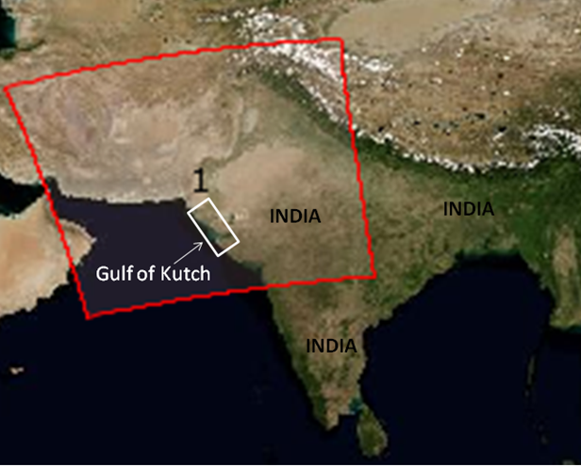
Fig. 1. Geographical Location of Gulf of Kutch

2.2. Data Acquisition using MODIS sensor
The Aqua Moderate Resolution Imaging Spectroradiometer (MODIS) sensor is a crucial instrument carried on NASA's Aqua satellite, which forms part of the Earth Observing System (EOS) program. Launched on May 4, 2002, Aqua is one of a series of satellites purpose-built to observe and monitor multiple aspects of Earth's atmosphere, oceans, land surfaces, and ecosystems. Within the suite of instruments on Aqua, MODIS holds a central role in Earth observation and environmental surveillance. In this current research, we have employed the AQUA-MODIS sensor [12] to estimate the Chlorophyll-a content present in the Gulf of Kutch.
The MODIS device is a multispectral radiometer capable of collecting data across 36 spectral bands, encompassing a broad spectrum of wavelengths from the visible to the thermal infrared range. It offers high-resolution data with respect to spatial, spectral, and temporal dimensions, rendering it an invaluable tool for investigating and tracking diverse Earth processes and phenomena. Notably, MODIS data is accessible at no cost to researchers, scientists, and the general public through various online platforms offered by NASA and its collaborative partners (https://earthdata.nasa.gov). For our current study, we have procured Level-2 data spanning the period from 2015 to 2022.
The AQUA-MODIS sensor (Moderate Resolution Imaging Spectroradiometer on the Aqua satellite) is one of the key instruments used for estimating chlorophyll-a content in ocean waters. AQUA-MODIS is designed to measure the radiance (light intensity) reflected by the Earth's surface in a range of spectral bands, including the visible and near-infrared regions of the electromagnetic spectrum. It is sensitive to the colors of light that are absorbed and scattered by substances in the ocean, including chlorophyll-a. Chlorophyll-a is a pigment found in phytoplankton, and it absorbs light in the blue and red parts of the spectrum while appearing relatively bright in the green part of the spectrum. AQUA-MODIS captures the spectral reflectance of the ocean's surface, and the specific spectral bands it measures allow scientists to detect the presence of chlorophyll-a by observing the characteristic absorption features. AQUA-MODIS data are processed with specialized algorithms that correct for atmospheric scattering and absorption, ensuring that the observed signal is primarily influenced by the water's properties.

2.3. Data Processing using SeaDAS
SeaDAS, short for the SeaWiFS Data Analysis System, is a comprehensive software package that NASA has developed for the processing, visualization, and examination of ocean color data acquired from a variety of satellite sensors. Its primary focus centers on the data collected by the Sea-Viewing Wide Field-of-View Sensor (SeaWiFS), a satellite sensor launched in 1997. SeaWiFS measured the radiance of sunlight reflected from the Earth's surface, with a particular emphasis on the oceans, in order to extract valuable information about marine phytoplankton and water quality [13]. Over the years, SeaDAS has gained widespread adoption among researchers, oceanographers, and environmental scientists for the analysis and interpretation of ocean color data. Its utilization has played a significant role in advancing our comprehension of phytoplankton distribution, ocean productivity, and the overall health of marine ecosystems [14].
In our current study, we have employed the SeaWiFS Data Analysis System (SeaDAS) software, developed by NASA, for the processing and examination of ocean color data. SeaDAS has been instrumental in handling and analyzing this specific type of data.

3. results and discussion

The study focused on assessing the chlorophyll-a (Chl-a) content in Gulf of Kutch using MODIS data processing. The data collected revealed significant variations in Chl-a content across the study area. As shown in Fig.2, chlorophyll-a concentration varied from 3 mg/m3 to 18 mg/m3 for the study area. Also, as one moves from Gulf of Kutch towards Arabian Sea, the concentration keep on decreasing and reached at 0.4 mg/m3. The results also suggested that regions where chlorophyll concentration was high, the phytoplankton concentration might also be high in those regions.

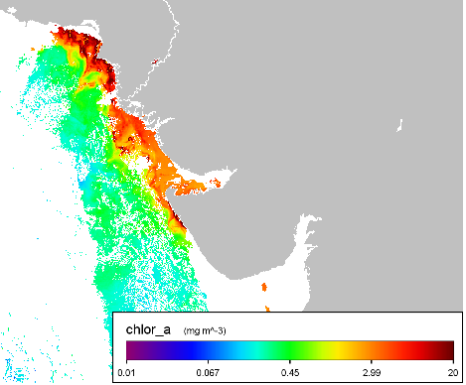
Fig. 2. Spatial variation of Chlorophyll-a in Gulf of Kutch
Thus, near to coastal regions, phytoplankton concentrations also dominate. The study's findings have ecological implications for the health of the aquatic ecosystem. High Chl-a concentrations can indicate eutrophication, a phenomenon where excessive nutrient inputs lead to algal blooms, oxygen depletion, and negative impacts on water quality. The Gulf of Kutch supports a significant fishery industry. Understanding chlorophyll-a concentrations helps fisheries managers and scientists predict the availability of primary producers (phytoplankton) and, consequently, the potential productivity of fish populations. This information is vital for sustainable fisheries management and ensuring the livelihoods of fishing communities.

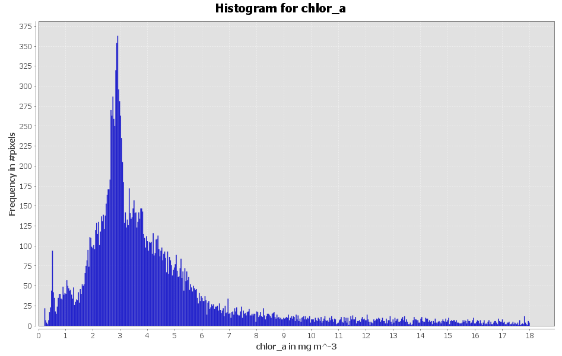
Fig. 3. Histogram for Chlorophyll-a in study area
A histogram plot for chlorophyll concentration in the study area has been shown in Fig.3. It could be observed from Fig.3 that the frequency of pixel having 3 to 3.5 mg/m3 is highest as compared to other concentration. Further, spatial variation of chlorophyll-a concentration with respect to longitude and latitude has been shown in Fig. 4. The scatter plot for longitudinal variation of chlorophyll-a concentration in study area suggested that concentration of chlorophyll-a is limited between 65.1 degree East to 70 degree East, whereas concentration of chlorophyll-a was spatially distributed between 17.5 degree North to 25 degree North. Chlorophyll-a is often used as an indicator of water quality. Elevated chlorophyll-a levels can indicate eutrophication, a process where excess nutrients (such as nitrogen and phosphorus) in the water lead to excessive phytoplankton growth. This can result in harmful algal blooms, which can have negative impacts on water quality, aquatic life, and human health. Studying chlorophyll-a concentrations is part of broader environmental monitoring efforts in the Gulf of Kutch. This includes tracking changes in water temperature, salinity, and nutrient levels, all of which can influence phytoplankton growth and ecosystem dynamics. Monitoring helps detect environmental changes and their potential impacts.
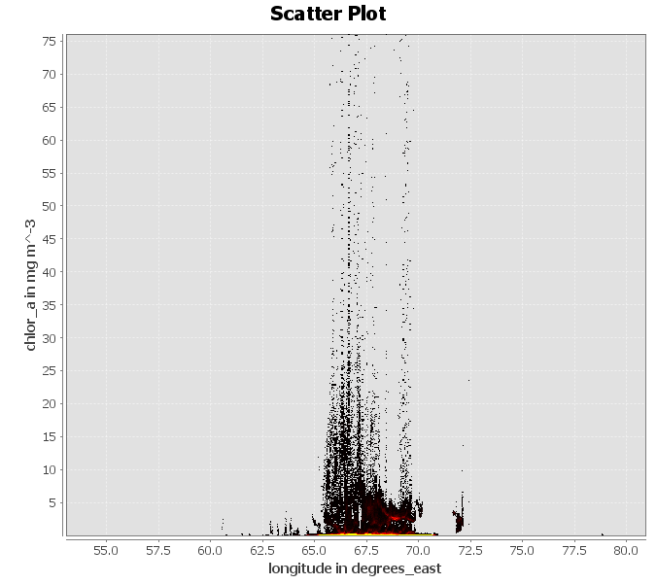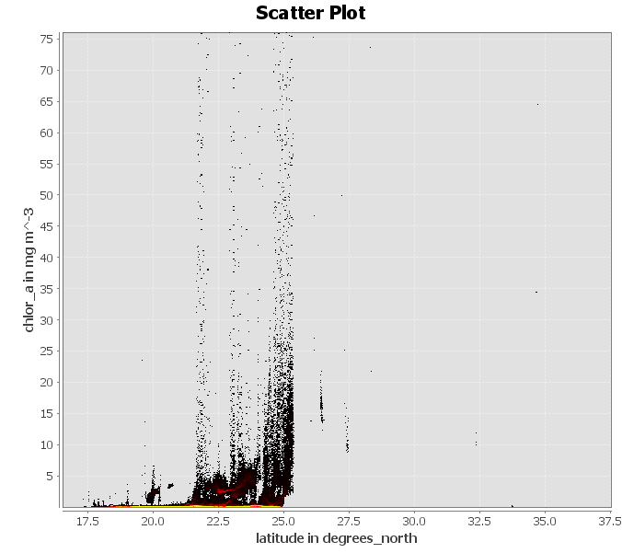
Fig. 4. Longitudinal and latitudinal variation of Chlorophyll-a in study area
Studying chlorophyll-a concentrations in the Gulf of Kutch is essential for understanding and managing its marine ecosystem, supporting fisheries, protecting water quality, and addressing the challenges posed by environmental changes and human activities in the region. It contributes to both ecological conservation and the socioeconomic well-being of local communities.
4. Conclusion
Chl-a content in the sea is a valuable indicator of marine ecosystem health and productivity. Measurement methods, coupled with our understanding of influencing factors and ecological implications, have led to significant insights into the dynamics of marine environments. Continued research in this field is crucial for comprehending the changing patterns of Chl-a distribution in response to ongoing environmental changes, thereby aiding in the conservation and sustainable management of marine resources. For Gulf of Kutch, chlorophyll concentration varied between 3 mg/m3 to 18 mg/m3 .
In conclusion, Chlorophyll-a content serves as a vital indicator of algal blooms, offering insights into the presence and extent of excessive algal growth in aquatic ecosystems. Monitoring Chl-a concentrations, along with understanding the broader environmental factors, assists in assessing and managing the potential impacts of algal blooms on both ecological and human systems. One of the limitations of using SeaDaS is that empirical relation using in the algorithm has its own limitations.
References
[1] Wang, L., Xu, M., Liu, Y., Liu, H., Beck, R., Reif, M., ... & Wu, Q. 2020. Mapping freshwater chlorophyll-a concentrations at a regional scale integrating multi-sensor satellite observations with Google earth engine. Remote Sens., 12(20), 3278.
[2] Lorenzen, C. J. 1967. Determination of chlorophyll and pheo-pigments: spectrophotometric equations. Limnol. Oceanogr., 12(2), 343-346.
[3] Hu, C., Feng, L., & Guan, Q. 2020. A machine learning approach to estimate surface chlorophyll a concentrations in global oceans from satellite measurements. IEEE Trans Geosci Remote Sens, 59(6), 4590-4607.
[4] Kim, G., Baek, I., Stocker, M. D., Smith, J. E., Van Tassell, A. L., Qin, J., ... & Kim, M. S. 2020. Hyperspectral imaging from a multipurpose floating platform to estimate chlorophyll-a concentrations in irrigation pond water. Remote Sens.12(13), 2070.
[5] Rodríguez-López, L., Duran-Llacer, I., Gonzalez-Rodriguez, L., Abarca-del-Rio, R., Cárdenas, R., Parra, O., ... & Urrutia, R. 2020. Spectral analysis using LANDSAT images to monitor the chlorophyll-a concentration in Lake Laja in Chile. Ecol. Inform., 60, 101183.
[6] Shamshirband, S., Jafari Nodoushan, E., Adolf, J. E., Abdul Manaf, A., Mosavi, A., & Chau, K. W. 2019. Ensemble models with uncertainty analysis for multi-day ahead forecasting of chlorophyll a concentration in coastal waters. Eng. Appl. Comput. Fluid Mech., 13(1), 91-101.
[7] Zhu, W. D., Kong, Y. X., He, N. Y., Qiu, Z. G., & Lu, Z. G. 2023. Prediction and Analysis of Chlorophyll-a Concentration in the Western Waters of Hong Kong Based on BP Neural Network. Sustainability, 15(13), 10441.
[8] Ministry of Environment, Forest and Climate Change, Government of India. 2004. Coastal and Marine Biodiversity of India. [Link: http://moef.gov.in/wp-content/uploads/2018/03/CMC_Book.pdf]
[9] Jethva, B., & Gohil, B. 2004. Ecology and conservation of the intertidal habitats of Gulf of Kachchh. Curr. Sci., 86(2), 203-210.
[10] Dharmadhikary, S. 2009. The Gulf of Kachchh: A tale of destruction and lost livelihoods. India Together. [Link: https://indiatogether.org/kachchh]
[11] Desai, D. V., & Sivakumar, K. 2003. Marine biodiversity and resource conservation in Gulf of Kachchh. Environ. Conserv., 30(3), 265-278.
[12] MODIS (Moderate Resolution Imaging Spectroradiometer). (n.d.). NASA Earthdata. [Link: https://earthdata.nasa.gov/learn/sensors/modis]
[13] Siegel, D. A., & Behrenfeld, M. J. 2002. Satellite-detected fluorescence: Decoupling pCO2 and phytoplankton biomass variability in the Southern Ocean. J. Geophys. Res.: Oceans, 107(C12).
[14] McClain, C. R., Feldman, G. C., & Hooker, S. B. 2004. An overview of the SeaWiFS project and strategies for producing a climate research quality global ocean bio-optical time series. Deep Sea Res. Part II: Topical Studies in Oceanography, 51(1-3), 5-42.

