Original Research Article

Evaluation of DSSAT CROPGRO Model on Growth and Yield of Pigeonpea Cultivars under Different Sowing Windows

Abstract: The Decision Support System for Agrotechnology Transfer (DSSAT) is a widely used crop simulation tool for assessing crop growth, development, and yield under varying environmental and management conditions. The present study validated the CSM-CROPGRO-Pigeonpea model (DSSAT v4.7.5) using field experiments conducted during 2017–18 and 2018–19 at Pune on four pigeonpea varieties: Vipula, Rajeshwari, BDN 711, and ICPH 2740. Model performance was evaluated for phenology, leaf area index (LAI), grain yield, and stalk yield using RMSE and NRMSE statistics. Results indicated close agreement between simulated and observed values across all growth and yield parameters. Days to flowering initiation, 50% flowering, and physiological maturity were simulated with high accuracy, with NRMSE values ranging between 1.49% and 7.05%. Simulated LAI values were slightly underestimated but remained within acceptable error limits (NRMSE <20%). Grain yield predictions were reliable, with NRMSE values between 8.96% and 14.22%, while stalk yield showed slightly higher deviations (NRMSE up to 17.77%). Overall, the model effectively captured crop phenology and yield variability, confirming its suitability for pigeonpea simulation under semi-arid conditions of Pune. The study highlights the utility of DSSAT for optimizing sowing windows, forewarning pests and diseases, and assessing climate change impacts on pigeonpea productivity.
Key words: DSSAT, CROPGRO-Pigeonpea, model validation, phenology, leaf area index, grain yield, climate change, pigeonpea varieties.
1. INTRODUCTION
The Decision Support System for Agrotechnology Transfer (DSSAT) is comprehensive software that integrates crop simulation models for over 42 crops (Version 4.7.5) along with databases for soils, weather, crop management, and experimental data. It also provides utilities and application programs for effective model use. The models simulate plant growth, development, and yield as influenced by soil–plant–atmosphere interactions. DSSAT has been applied worldwide across diverse spatial and temporal scales, supporting applications from on-farm decision-making and precision agriculture to regional assessments of climate variability, climate change, and sustainability. Version 4.7 includes improved programs for seasonal, spatial, sequence, and crop rotation analyses to assess economic risks and environmental impacts of irrigation, fertilizer, nutrient management, soil carbon sequestration, and precision agriculture (Hoogenboom et al., 2019). It also supports research on water use efficiency, greenhouse gas emissions, breeding and gene-based modeling, and soil organic carbon and nitrogen balance. Required inputs include daily weather data, soil profiles, crop genetic coefficients, and management practices. By integrating these datasets, DSSAT enables “what if” simulations, providing rapid insights into crop responses that would otherwise require years of field experimentation (Hoogenboom et al., 2019).
The DSSAT enables evaluation of crop model outputs against experimental data, allowing users to compare simulated outcomes with observed results. This step is essential before applying a crop model, particularly when decisions or recommendations rely on modeled outputs. Evaluation involves entering the minimum required data, running the model, and comparing outputs with field observations. By simulating probable outcomes of management strategies, DSSAT helps users assess the potential of new crops, products, and practices for adoption. Globally, DSSAT is among the most widely used crop modeling tools, supporting decision-making at farm and regional scales. When integrated with effective management decisions, it can contribute to increased crop yield (Hoogenboom et al., 2019). The accuracy of simulations depends largely on input quality, and DSSAT includes tools to organize data related to crop management, soils, and weather. One of the most challenging inputs is genotype-specific parameters (GSPs), which quantify cultivar differences. These are usually derived from field trial calibrations, and DSSAT provides tools to both organize calibration data and estimate required GSPs (Hoogenboom et al., 2019).
The CROPGRO-Pigeonpea model was developed by Alderman et al. (2015), patterned after the CROPGRO-Soybean model (Boote et. al., 1998). Alderman et al. (2015) employed a sequential optimization technique (software) that solved species, ecotype, and cultivar traits such as phenology timing, onset of reproductive growth, leaf area expansion, dry matter partitioning, tissue N concentrations, and photosynthetic productivity, all based on the time-series observations. The model requires inputs of management practices, environmental conditions and cultivar-specific traits (genetic coefficients) to predict daily growth and development (Boote et al., 1998). The required ecotype and cultivar data include lengths of developmental phases, vegetative traits, leaf traits, reference seed size, and seed composition (Jones et al., 2003). The species file describes characteristics assumed constant across cultivars such as tissue composition, partitioning, and sensitivity of processes to temperature, light, plant water deficit, and plant N deficiency. The required ecotype and cultivar data include lengths of developmental phases, vegetative traits, leaf traits, reference seed size, and seed composition (Jones et al., 2003).
As with other CSM-CROPGRO models (Boote et al., 1998; Jones et al., 2003), the pigeonpea model shares the same source code, which includes a hedge-row light interception model (Boote and Pickering, 1994) combined with a leaf-scale photosynthesis model based on the Farquhar approach for simulating CO₂ response. The major differences from soybean include: (1) epigeal emergence with initially slow vegetative and leaf area growth, (2) a much faster rate of leaf appearance on the main axis, (3) very strong sensitivity to long day length (even greater than MG 9–10 tropical soybean types), which delays flowering until October–November in the Northern Hemisphere, and (4) a tendency toward perennial behavior, with leaf N concentration remaining high until maturity. An initial evaluation of the CSM-CROPGRO-Pigeonpea model has so far been conducted in Karnataka, India (Sharanappa and Shivaramu, 2017; Lingaraj et al., 2019). However, as the CROPGRO-Pigeonpea model is relatively new, it would benefit from further evaluation in other regions and environments where pigeonpea is cultivated as either a major or minor crop.
The CROPGRO-Pigeonpea model was calibrated using two experiments: an intensive growth analysis that included tissue nitrogen concentrations on the Florida-released cultivar 76W, grown in Florida in 1984 (Maliro, 1987), and a less intensive growth analysis on ICPL88039, an ICRISAT-released cultivar, grown in Indore, Madhya Pradesh, India, in 2003. The Florida cultivar was selected for its ability to flower early under long-day conditions, whereas the Indian cultivar was highly sensitive to day length and would not have matured in Florida. Since ICRISAT has developed shorter-duration pigeonpea cultivars comparable to the Florida 76W, model users are advised to consider less day length sensitivity in short-cycle cultivars than is present in ICPL88039. Further refinement of the model was undertaken by Patil et al. (2018), who collected three years, of experimental data (2014–15 to 2016–17) at the Pulse Research Station, Vadodara, to calibrate and validate the CROPGRO-Pigeonpea model for three pigeonpea cultivars (BDN 2, AGT 2, and Vaishali). The validated model was subsequently used to simulate seed yield under varying climatic conditions, including adjustments in maximum and minimum temperatures (−30 to +30 °C) across different months (June to January) and rainfall variation (−25% to +25%) during July, August, and September. Results showed that elevated temperatures had a negative impact on seed yield, while reduced temperatures had a positive effect. Among the cultivars, AGT 2 was least affected by both temperature and rainfall changes, whereas Vaishali was the most sensitive to elevated temperature. Additionally, higher rainfall during August proved beneficial for pigeonpea yield. June-sown crops were most affected by elevated temperature, whereas July-sown crops were most sensitive to rainfall. The effects of maximum temperature on yield were more pronounced than those of minimum temperature.
Different sowing windows significantly influence crop growth and yield; hence, identifying the optimum sowing window is crucial for achieving better productivity. Crop simulation models also play an important role in estimating potential yields under varying conditions. With the introduction of high-yielding varieties, the incidence and dynamics of insect pests and diseases are also changing. To minimize yield losses caused by these biotic stresses and to enhance productivity, it becomes essential to determine suitable sowing windows and validate crop models accordingly. In this context, a field experiment was conducted during 2017–18 and 2018–19 on pigeonpea cultivars using a split-plot design.
2. MATERIALS AND METHODS
2.1 Location of the Experimental Site
The field experiment was conducted at Department of Agricultural meteorology farm, College of Agriculture, Pune during Kharif, 2017 and 2018. The geographical location of the site (Pune) was 18° 32'N, latitude; 73°51E, longitude and 559 m above mean sea level (MSL) as shown in the Figure 1. The soil is medium black having depth of about 1m. The average annual rainfall of Pune is 675mm.
2.2 Experimental Details
The experiment was conducted in a split plot design with three replications and sixteen treatment combinations of different varieties and sowing windows. The main plot treatments consisted of four pigeonpea varieties (Vipula, Rajeshwari, BDN 711, and ICPH 2740), while the subplot treatments comprised four sowing windows. The crop was sown at a spacing of 45 × 20 cm using a seed rate of 18 kg ha⁻¹ for all varieties. Fertilizer was applied at the rate of 25 kg N and 50 kg P₂O₅ ha⁻¹. Each plot measured 4.0 × 4.5 m (gross), with a net plot size of 3.6 × 4.0 m. The details of treatments were given below in Table 1.

Figure 1. Figure shows the location of the experimental site.
Table 1. Treatments details with symbols
S. No. | Treatment details | Symbol used
A. | Main plot treatments :Varieties (V)
1 | Vipula | V₁
2 | Rajeswari | V₂
3 | BDN 711 | V₃
4 | ICPH 2740 | V₄
B. | Sub plot treatments : Date of Sowing windows (D)
1 | 24th MW (11th June - 17 June) | D₁
2 | 26th MW (25th June - 01st July) | D₂
3 | 28th MW (09th July - 15th July) | D₃
4 | 30th MW (23rd July – 30th July) | D₄
2.3 Tools and Data Used in Model
In DSSAT, several tools are available for entering input data, including WeatherMan for weather data, SBuild for soil data, XBuild for crop management, and ATCreate for observational data. The concept of the Minimum Data Set (MDS), introduced at an ICRISAT workshop in Patancheru, India, refers to the essential data needed both to run a crop model and to evaluate its outputs. For running the CROPGRO-Pigeonpea model, the required inputs include: (i) site-specific weather data for the growing season, preferably for the entire year, (ii) soil surface characteristics and profile data, and (iii) crop management practices from calibration experiments. For model calibration and evaluation, these inputs must be supplemented with one or more observed variables, such as yield, yield components, and key phenological dates. In the case of grain legumes and cereals, this includes the first flowering date and maturity date.
2.3.1 Weather Data
Minimum daily weather data, including incoming solar radiation (MJm⁻²day⁻¹), maximum and minimum air temperatures (°C), and rainfall (mm), were obtained from the Central Agro-Meteorological Observatory, College of Agriculture, Pune.

2.3.2 Soil Data
Required soil surface data—including soil classification according to the Natural Resources Conservation Service (NRCS), surface slope, color, permeability, and drainage class—were obtained from the Division of Soil Science, College of Agriculture, Pune. The soil profile data are presented in Table 2.
Table 2 Initial physiochemical properties of soil
S. No | Physiochemical parameters of soil | Results
 | Coarse sand (%) | 13.25
 | Fine sand (%) | 37.33
 | Silt (%) | 23.54
 | Clay (%) | 25.43
 | Textural class | Sandy clay loam
 | Bulk density (g cc⁻¹) | 1.38
 | Organic carbon (%) | 0.45
 | Available N (ka ha⁻¹) | 152.19
 | Available P2O5(kg ha⁻¹) | 19.62
 | Available K2O (kg ha⁻¹) | 318.82
 | Soil pH(1:2.5soil water suspension) | 8.4
 | Electrical conductivity (dSm-1) | 0.23
 | Field capacity (%) | 31.52
 | Permanent wilting point (%) | 17.10

2.3.3 Management and Experimental Data
Crop management data included planting date, pre-plant soil condition measurements, planting density, row spacing, planting depth, crop variety, irrigation schedules, and fertilizer practices. These inputs are essential for crop model evaluation and strategy analysis.
2.4 DSSAT Model Validation
Genetic coefficients for different pigeonpea varieties were developed based on field observations during the experimental period to validate the CROPGRO-Pigeonpea model. The developed coefficients for each variety are presented in the accompanying Table 3. DSSAT provides specific tools for calibrating these genotype-specific parameters or cultivar coefficients Table 4.
Table 3. Genetic Coefficients for the CSM-CROPGRO-Pigeonpea model
S. No. | Genetic coefficients |  | Description
 | CSDL |  | Critical Short Day Length below which reproductive development progresses with no daylength effect (for shortday plants) (hour)
 | PPSEN |  | Slope of the relative response of development to photoperiod with time (positive for shortday plants) (1/hour)
 | EM-FL |  | Time between plant emergence and flower appearance (R1) (photothermal days)
 | FL-SH |  | Time between first flower and first pod (R3) (photothermal days)
 | FL-SD |  | Time between first flower and first seed (R5) (photothermal days)
 | SD-PM |  | Time between first seed (R5) and physiological maturity (R7) (photothermal days)
 | FL-LF |  | Time between first flower (R1) and end of leaf expansion (photothermal days)
 | LFMAX |  | Maximum leaf photosynthesis rate at 30 C, 350 vpm CO₂, and high light (mg CO₂/m²s⁻¹)
 | SLAVR |  | Specific leaf area of cultivar under standard growth conditions (cm²/g)
 | SIZLF |  | Maximum size of full leaf (three leaflets) (cm²)
 | XFRT |  | Maximum fraction of daily growth that is partitioned to seed + shell
 | WTPSD |  | Maximum weight per seed (g)
 | SFDUR |  | Seed filling duration for pod cohort at standard growth conditions (photothermal days)
 | SDPDV |  | Average seed per pod under standard growing conditions (#/pod)
 | PODUR |  | Time required for cultivar to reach final pod load under optimal conditions (photothermal days)
 | THRSH |  | Threshing percentage. The maximum ratio of (seed/(seed+shell)) at maturity. Causes seeds to stop growing as their dry weight increases until shells are filled in a cohort.
 | SDPRO |  | Fraction protein in seeds (g(protein)/g(seed))
 | SDLIP |  | Fraction oil in seeds (g(oil)/g(seed))
Table 4. The Genetic Coefficients used for the CSM-CROPGRO-Pigeonpea model
S. No. |  | Genetic co-efficients |  | Vipula | Rajeshwari | BDN 711 | ICPH 2740
 |  | CSDL |  | 12.92 | 12.53 | 12.76 | 13.24
 |  | PPSEN |  | 0.55 | 0.54 | 0.56 | 0.58
 |  | EM-FL |  | 80.10 | 70.40 | 77.90 | 85.10
 |  | FL-SH |  | 15.40 | 14.40 | 15.40 | 15.70
 |  | FL-SD |  | 18.10 | 18.20 | 17.10 | 20.00
 |  | SD-PM |  | 38.99 | 36.85 | 34.87 | 39.77
 |  | FL-LF |  | 25.87 | 26.64 | 24.89 | 27.97
 |  | LFMAX |  | 1.35 | 1.30 | 1.33 | 1.36
 |  | SLAVR |  | 305.00 | 305.00 | 302.00 | 305.00
 |  | SIZLF |  | 171.40 | 171.40 | 171.50 | 171.40
 |  | XFRT |  | 1.00 | 1.00 | 1.02 | 1.02
 |  | WTPSD |  | 0.09 | 0.09 | 0.09 | 0.09
 |  | SFDUR |  | 35.50 | 46.80 | 44.90 | 48.90
 |  | SDPDV |  | 3.79 | 3.64 | 3.75 | 3.80
 |  | PODUR |  | 3.00 | 2.50 | 3.10 | 3.00
 |  | THRSH |  | 95.20 | 95.10 | 94.90 | 95.20
 |  | SDPRO |  | 0.224 | 0.224 | 0.222 | 0.224
 |  | SDLIP |  | 0.015 | 0.015 | 0.015 | 0.015

2.5 Validation of CSM-CROPGRO-Pigeonpea Model
Validation is the process of comparing model simulation results with independent observations that were not used for calibration. Experimental data collected from field trials are used for this purpose. A commonly used statistical index for model validation is the Root Mean Square Error (RMSE), calculated as:
$\text{RMSE }\left(\text{Root Mean Square Error}\right)\text{= }\sqrt{\frac{\sum_{\text{t=1}}^{\text{n}}{{\left(\text{Pi-Oi}\right)}^{\text{2}}}}{\text{n}}}$ ------------------------- (1)
Where Pi and Oi refer to the predicted and observed values for the studied variables (e.g. grain yield and total biomass) respectively and n is the mean of the observed variables. The Normalized Root Mean Square Error (NRMSE) expresses the RMSE as a percentage of the observed mean and is calculated as:
$\text{NRMSE }\left(\text{Normalized Root Mean Square Error}\right)\text{= RMSE×}\frac{\text{100}}{\text{M}}$ -------------------------- (2)
Where, M is the observed mean value. The simulation is considered excellent with NRMSE<10%, good if 10–20%, fair if 20–30%, and poor >30% for yield and other growth parameters.
3. RESULTS AND DISCUSSION
In this section the analysis on crop simulated values for key growth, phenological, and yield parameters of pigeonpea were calculated to evaluate the accuracy of the CROPGRO-Pigeonpea model. The study focused on phenological events, including panicle initiation, 50% flowering, and physiological maturity, as well as growth indicators such as leaf area index (LAI) and yield components, namely grain yield and stalk yield. The simulated results were compared with observed field data to validate the model and assess its ability to predict crop growth, development, and yield under different sowing windows and varietal treatments. Model performance was evaluated using statistical indices, including Root Mean Square Error (RMSE) and Normalized Root Mean Square Error (NRMSE), for all measured parameters. These simulations provide valuable insights into optimum sowing windows, varietal performance, and management practices, thereby aiding in improving pigeonpea productivity.
3.1 Flowering Initiation
The duration of flowering initiation (FI) depends on air temperature, critical short day length, and the slope of the relative response of development to photoperiod with time. Data on flowering initiation simulations are presented graphically in Figure 2. The mean simulated number of days to flowering initiation was 95 days compared to 93 days observed in Vipula (V₁). For Rajeshwari (V₂), BDN 711 (V₃), and ICPH 2740 (V₄), the simulated and observed days were 90 and 89, 94 and 91, and 99 and 99, respectively (Table 4.). The Root Mean Square Error (RMSE) values were 3.43, 1.87, 3.94, and 3.48 for V₁, V₂, V₃, and V₄, respectively (Table 4.). These results are consistent with the findings of Gijsman et al. (2002). Patil et al. (2018) and Srivastava (2003) also reported similar RMSE values. The Normalized RMSE (NRMSE) values were 3.68%, 2.11%, 4.34%, and 3.50% for V₁, V₂, V₃, and V₄, respectively (Table 5). According to Loague and Green (1991), simulations are considered excellent when NRMSE <10%, good at 10–20%, fair at 20–30%, and poor at >30% for yield and other growth parameters.
Table 5. Model performance statistics (RMSE and NRMSE) for phenology, leaf area index, and yield of pigeonpea varieties
S. No | Variety | Days to flowering initiation |  | Days to 50%  flowering |  | Days to physiological maturity
S. No | Variety | RMSE | NRMSE (%) | RMSE | NRMSE (%) | RMSE | NRMSE (%)
1. | Vipula | 3.43 | 3.68 | 3.94 | 3.33 | 8.25 | 5.22
2. | Rajeshwari | 1.87 | 2.11 | 1.62 | 1.49 | 6.36 | 4.29
3. | BDN 711 | 3.94 | 4.34 | 3.12 | 2.75 | 6.90 | 4.41
4. | ICPH 2740 | 3.48 | 3.50 | 5.32 | 4.42 | 12.34 | 7.05
 |  | Leaf area index (LAI) |  | Grain Yield (q ha⁻¹) |  | Stalk yield(q ha⁻¹)
5. | Vipula | 0.17 | 14.91 | 2.37 | 13.13 | 6.82 | 12.78
6. | Rajeshwari | 0.19 | 19.87 | 1.80 | 8.96 | 7.79 | 13.51
7. | BDN 711 | 0.17 | 15.70 | 2.48 | 14.22 | 7.78 | 14.92
8. | ICPH 2740 | 0.21 | 15.66 | 2.54 | 11.86 | 9.62 | 17.22

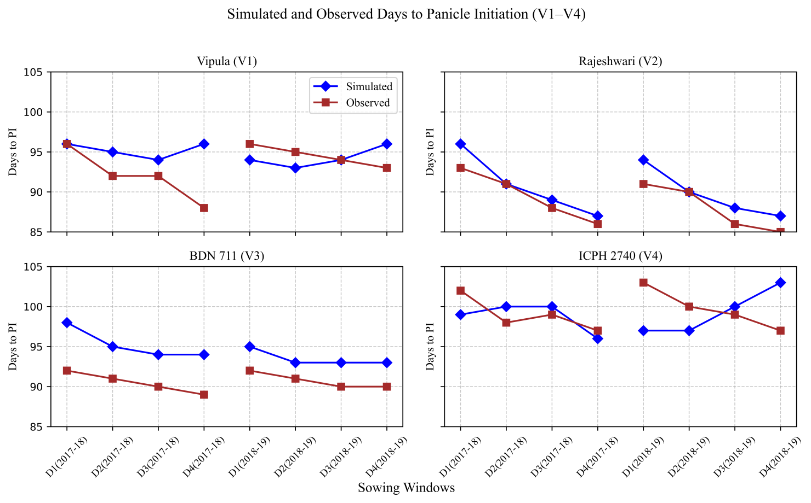
Figure 2: Simulated and observed days to panicle initiation for the varieties Vipula (V1), Rajeshwari (V2), BDN 711 (V3), ICPH 2740 (V4).
3.2 Days to 50 per cent flowering
The number of days to 50 percent flowering depends on the duration to panicle initiation (PI). Thus, the accuracy of the model in simulating flowering date is closely linked to its accuracy in predicting flowering initiation (FI). Data on days required to reach 50 percent flowering are graphically presented in Figure 3. The mean simulated number of days to 50 percent flowering was 114, compared with 118 observed days in the case of Vipula (V₁). For Rajeshwari (V₂), BDN 711 (V₃), and ICPH 2740 (V₄), the simulated and observed values were 107 and 108, 113 and 114, and 113 and 120 days, respectively (Table 5). The RMSE values were 3.94, 1.62, 3.12, and 5.32 for Vipula (V₁), Rajeshwari (V₂), BDN 711 (V₃), and ICPH 2740 (V₄), respectively (Table 5). These findings are consistent with the reports of Gijsman et al. (2002), while Patil et al., 2017 also observed favorable RMSE values. Similar results were confirmed by Srivastava (2003). The NRMSE values were 3.33, 1.49, 2.75, and 4.42 percent for Vipula (V₁), Rajeshwari (V₂), BDN 711 (V₃), and ICPH 2740 (V₄), respectively (Table 5).
3.3 Physiological Maturity
Data on the number of days required to reach physiological maturity are presented graphically in Figure 4. The mean simulated number of days to physiological maturity was 159, compared with 158 observed days in the case of Vipula (V₁). For Rajeshwari (V₂), BDN 711 (V₃), and ICPH 2740 (V₄), the simulated and observed values were 152 and 148, 153 and 157, and 164 and 175 days, respectively (Table 4.56). The RMSE values for simulations were 8.25, 6.36, 6.90, and 12.34 for Vipula (V₁), Rajeshwari (V₂), BDN 711 (V₃), and ICPH 2740 (V₄), respectively (Table 5). These results are corroborated with the findings Patile and Patel, 2017 and Patil et al., 2017. They also reported favorable RMSE values, while similar physiological maturity days were confirmed by Srivastava (2003). The NRMSE values were 5.22, 4.29, 4.41, and 7.05 percent for Vipula (V₁), Rajeshwari (V₂), BDN 711 (V₃), and ICPH 2740 (V₄), respectively (Table 5).
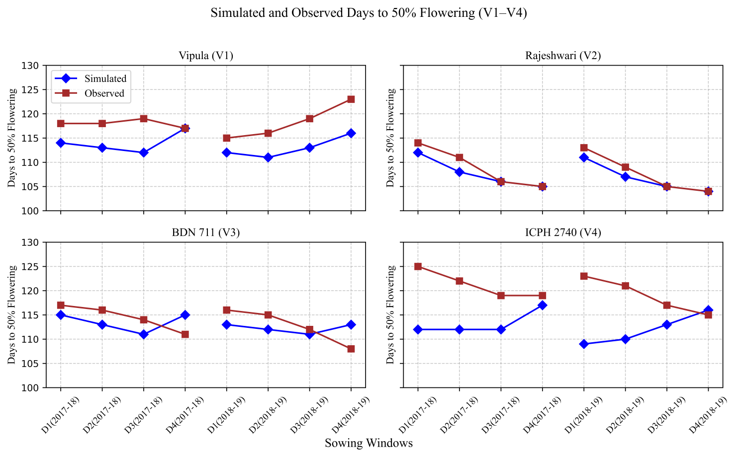
Figure 3: Simulated and observed days to 50% flowering for the varieties Vipula (V₁), Rajeshwari (V₂), BDN 711 (V₃), ICPH 2740 (V₄).
3.4 Leaf area Index (LAI)
Graphical representations of the simulated and observed leaf area index (LAI) are shown in the Figure 5. The mean simulated LAI was 0.949 compared with an observed value of 1.129 for Vipula (V₁). For Rajeshwari (V₂), BDN 711 (V₃), and ICPH 2740 (V₄), the simulated and observed LAI values were 1.024 and 1.346, 0.865 and 1.062, and 0.980 and 1.197, respectively. The RMSE values for the simulations were 0.17, 0.19, 0.17, and 0.21 for Vipula (V₁), Rajeshwari (V₂), BDN 711 (V₃), and ICPH 2740 (V₄), respectively (Table 5). These results are consistent with the findings of Gijsman et al. (2002), and similar favorable RMSE values were reported by Alderman, 2015 and Srivastava (2003). The NRMSE values were 14.91%, 19.87%, 15.70%, and 15.66% for Vipula (V₁), Rajeshwari (V₂), BDN 711 (V₃), and ICPH 2740 (V₄), respectively (Table 5). According to Loague and Green (1991), simulations are considered excellent with NRMSE <10%, good if 10–20%, fair if 20–30%, and poor if >30% for yield and other growth parameters.
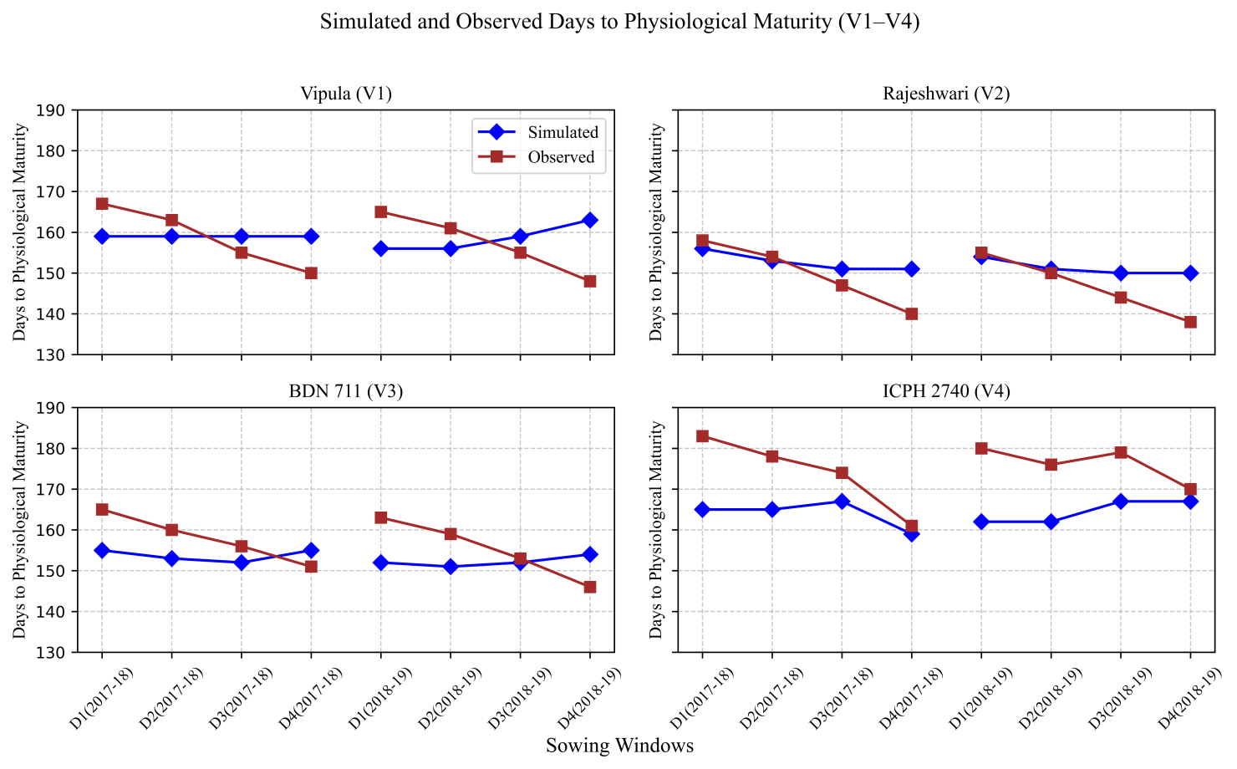
Figure 4: Simulated and observed days to physiological maturity for the varieties Vipula (V₁), Rajeshwari (V₂), BDN 711 (V₃), ICPH 2740 (V₄).

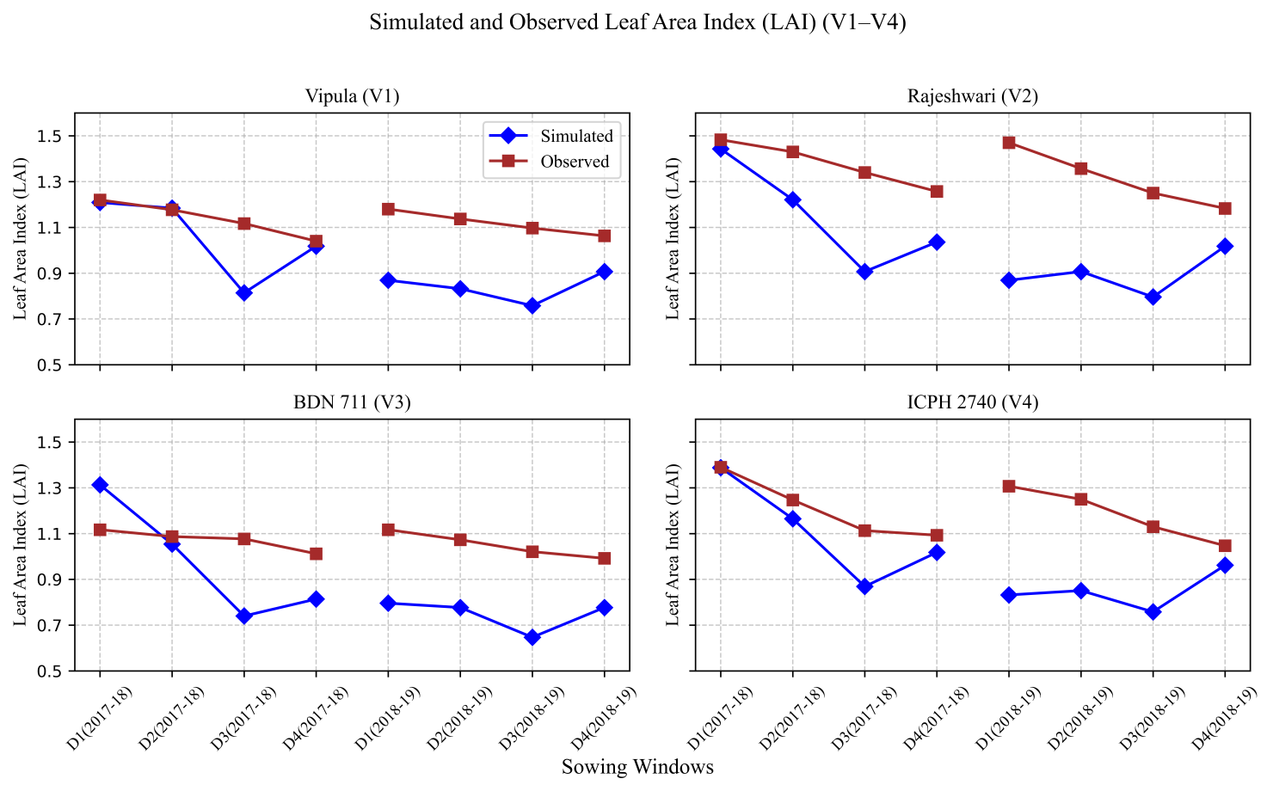
Figure 5: Simulated and observed leaf area index (LAI) for the varieties Vipula (V₁), Rajeshwari (V₂), BDN 711 (V₃), ICPH 2740 (V₄).

3.5 Grain Yield (q ha⁻¹)
The mean simulated grain yield was 18.28 q ha⁻¹ compared with an observed value of 18.03 q ha⁻¹ for Vipula (V₁). For Rajeshwari (V₂), BDN 711 (V₃), and ICPH 2740 (V₄), the simulated and observed grain yields were 20.09 and 19.97, 17.16 and 17.38, and 19.42 and 21.37 q ha⁻¹, respectively (Figure 6). The RMSE (Root Mean Square Error) values for the simulations were 2.37, 1.80, 2.48, and 2.54 for Vipula (V₁), Rajeshwari (V₂), BDN 711 (V₃), and ICPH 2740 (V₄), respectively (Table 5). The NRMSE (Normalized Root Mean Square Error) values were 13.13%, 8.96%, 14.22%, and 11.86% for Vipula (V₁), Rajeshwari (V₂), BDN 711 (V₃), and ICPH 2740 (V₄), respectively (Table 5). Similar simulated grain yield, RMSE and NRMSE values were reported by Lingaraj et al., 2019, Alderman et al., 2015, and Sharanappa & Shivaramu, 2017. According to Loague and Green (1991), simulations are considered excellent if NRMSE <10%, good if 10–20%, fair if 20–30%, and poor if >30% for yield and other growth parameters.
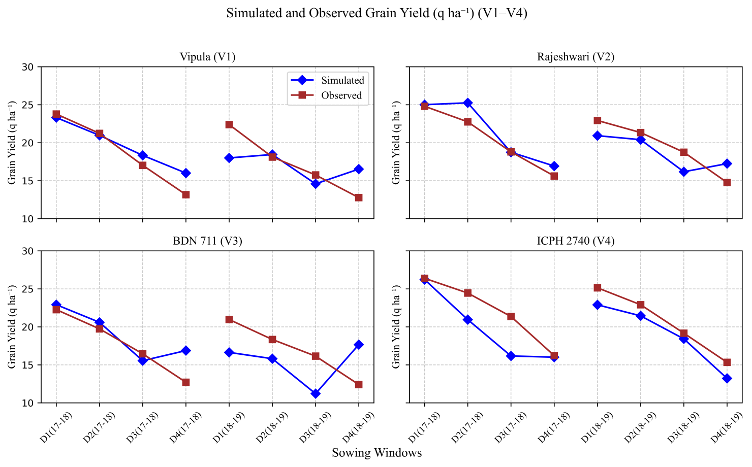
Figure 6: Simulated and observed grain yield (q ha⁻¹) for the varieties Vipula (V₁), Rajeshwari (V₂), BDN 711 (V₃), ICPH 2740 (V₄).

3.6 Stalk Yield (q ha⁻¹)
Data on simulated stalk yield are presented graphically in Figure 7. The mean simulated stalk yield was 53.63 q ha⁻¹ compared with an observed value of 53.38 q ha⁻¹ for Vipula (V₁). For Rajeshwari (V₂), BDN 711 (V₃), and ICPH 2740 (V₄), the simulated and observed stalk yields were 52.45 and 57.63, 52.91 and 52.15, and 56.06 and 55.82 q ha⁻¹, respectively. The RMSE values for the simulations were 6.82, 7.79, 7.78, and 9.62 for Vipula (V₁), Rajeshwari (V₂), BDN 711 (V₃), and ICPH 2740 (V₄), respectively (Table 5). The NRMSE values were 12.78%, 13.51%, 14.92%, and 17.77% for Vipula (V₁), Rajeshwari (V₂), BDN 711 (V₃), and ICPH 2740 (V₄), respectively (Table 5). These simulated stalk yield, RMSE and NRMSE results are in accordance with the findings of Alderman et al., 2015 and Patil et al., 2017.

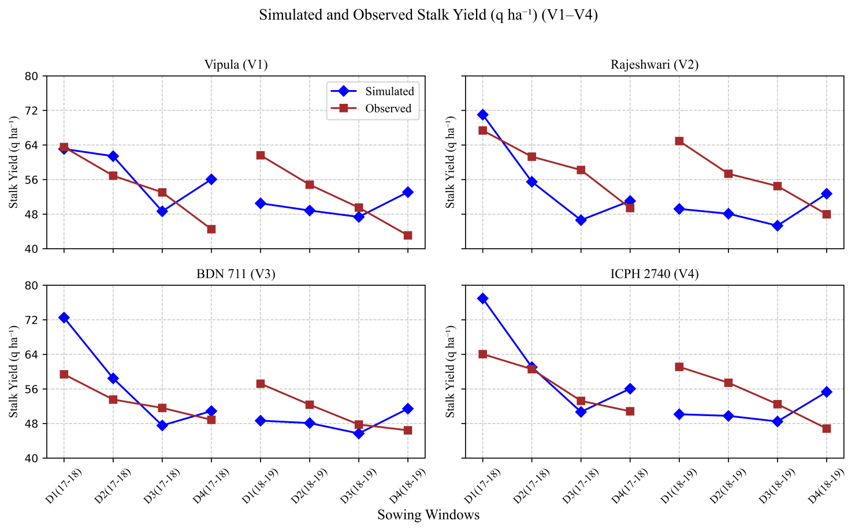
Figure 7: Simulated and observed stalk yield (q ha⁻¹) for the varieties Vipula (V₁), Rajeshwari (V₂), BDN 711 (V₃), ICPH 2740 (V₄).
4. CONCLUSION
The study evaluated the performance of DSSAT crop simulation models in predicting phenological stages, leaf area development, and yield parameters for four sorghum varieties (Vipula, Rajeshwari, BDN 711, and ICPH 2740) across two cropping seasons (2017–18 and 2018–19). The simulated and observed values for days to flowering initiation, days to 50% flowering, and days to physiological maturity showed close agreement. The mean deviations were minimal, with RMSE and NRMSE values indicating excellent to good simulation accuracy according to established criteria (Loague and Green, 1991). Leaf area index simulations reflected the dynamic growth patterns of the varieties, with RMSE values ranging from 0.17 to 0.21 and NRMSE between 14.91–19.87%, demonstrating reliable performance of the model in capturing vegetative growth. Similarly, grain and stalk yield simulations were in good agreement with observed data, with RMSE and NRMSE values indicating reasonable predictive accuracy. The model successfully captured varietal differences in growth duration and yield, confirming its suitability for assessing crop performance under the given climatic and management conditions. Overall, DSSAT proved to be a reliable tool for simulating phenology, growth, and yield of sorghum varieties, offering potential for decision support in crop management, varietal evaluation, and climate impact assessment.
4. REFERENCES
Alderman P. D., Boote K. J., Jones J. W., and Bhatia V. S. (2015) Adapting the CSM-CROPGRO
Model for pigeonpea using sequential parameter estimation. Field Crops Res. 181:115. https://doi.org
/10.1016/j.fcr.2015.05.024.
Boote, K. J., J. W. Jones, G. Hoogenboom, and N. B. Pickering. (1998). The CROPGRO Model for Grain Legumes. pp. 99-128. In G. Y. Tsuji, G. Hoogenboom, and P. K. Thornton (eds.) Understanding Options for Agricultural Production. Kluwer Academic Publishers, Dordrecht.
Boote, K. J. and N. B. Pickering 1994. Modeling Photosynthesis of Row Crop Canopies. Hort. Sci. 29
(1994), 1423–34.
Gijsman, A. J., Hoogenboom, G., Parton, W. J., and Peter Kerridge C. (2002). Modifying DSSAT Crop
Models for Low-Input Agricultural Systems Using a Soil Organic Matter–Residue Module from Century.
Agron. J. 94:462–474. https://doi.org/10.2134/agronj2002.4620.
Hoogenboom, G., C. H. Porter, V. Shelia, K. J. Boote, U. Singh, J.W. White, L.A. Hunt, R. Ogoshi, J. I.
Lizaso, J. Koo, S. Asseng, A. Singels, L. P. Moreno, and J.W. Jones. (2019). Decision Support System
for Agrotechnology Transfer (DSSAT) Version 4.7 (www.DSSAT.net). DSSAT Foundation, Gainesville,
Florida, USA. http://dx.doi.org/ 10.19103/AS.2019.0061.10.
Jeyajothi, R. et al. (2023). Evaluation of DSSAT CROPGRO model on growth and yield of pigeonpea cultivars under different fertigation levels. J.of Applied and Nat. Sci., 15(3),1071-1079. https://doi.org/10.31018/jans.v15i3.4740.
Jones, J. W., G. Hoogenboom, C. H. Porter, K. J. Boote, W. D. Batchelor, L. A. Hunt, P.W. Wilkens, U.
Singh, J. Gijsman, and J. T. Ritchie. (2003). DSSAT Cropping System Model. European J. of Agronomy
18, 235-265. https://doi.org/10.1016/S1161-0301(02)00107-7.
Lingaraj, H., H. S. Shivaramu, M. N. Thimmegowda, and M. H. Manjunatha. (2019). Development of
minimum soil and plant data set for DSSAT crop simulation model for pigeonpea cultivars under varied
dates of sowing. Env. and Ecol. 37(3B), 979-984.
Loague, K. and Green, R. E. (1991). Statistical and graphical methods for evaluating solute transport models: overview and application. J. Contam. Hydrol. 7(1), 51-73.
Maliro, C. E. (1987). Physiological aspects of yield among four legume crops under two water regimes.
University of Florida, Gainesville, FL, Master’s thesis.
Patil D. D. and Patel H. R. (2017). Calibration and Validation of CROPGRO (DSSAT 4.6) Model for
Chickpea under Middle Gujarat Agroclimatic Region. Int. J. of Agri. Sci. 9(27), 4342-4344.
Patil, D. D., Pandey V., Gurjar, R. and Patel1, H. P. (2018). Effect of intra-seasonal variation in
temperature and rainfall on seed yield of pigeonpea cultivars using CROPGRO model. J. of Agromet.,
20(4),286-292.
Sharanappa, K. and Shivaramu, H. S. (2017). Genetic coefficient calibration for pigeonpea cultivars in
DSSAT simulation model under varied dates of sowing. Mysore J. of Agri. Sci. 51(2), 408-413.
Srivastava A. K. (2003). Validation and application of CROPGRO model for crop management and yield
prediction in chickpea crop, grown under agroclimatic conditions of north and central India. Ph.D. thesis,
Department of Geophysics, B.H.U., Varanasi, pp1-151.

