Original Research Article

Shoreline Change Detection and Analysis in Kochi, Kerala Using Digital Shoreline Analysis System (DSAS)

Abstract

The present investigation is focused on detection of shoreline change in the Kochi corporation using digital shoreline analysis system, multispectral satellite images and geographic information systems. For the study, multi-temporal Landsat satellite imagery spanning 35 years, from 1989 to 2024, with a 30m resolution, was acquired from the USGS and these datasets from Landsat 9 OLI/TIRS, Landsat 8 OLI/TIRS, Landsat 7 ETM+, LT05 TM and LM05 MSS (1989,1994,2004,2014,2024) was used for the change detection and analysis. To quantify the rate of variation of shoreline in terms of erosion and accretion DSAS tool provides five metrics for shoreline change rates namely, net shoreline movement (NSM), end point rate (EPR) and linear regression rate (LRR), Weighted Linear Regression (WLR), shoreline change envelope (SCE). The present land use map of the study area within 500 m buffer zone is also incorporated for in-depth analysis of the coastal zone. Both natural and anthropogenic activities contribute to the overall 1.16 m/yr coastal erosional rate in Kochi. As per the results Fort Kochi has higher rate of coastal erosion (6.36m/yr) causing notable damage to infrastructure.
Keywords: DSAS, shoreline, erosion and accretion

Introduction
Coastal areas serve as the one of the most complex, fragile and productive ecosystems as these are zones of triple interface between land, water and air. Furthermore, Coastal zones are also the nerve centres of human activities and development since the beginning of time, most of the big cities in the world are located along coastal areas, these areas are home to about one third of the human population, hence, it requires pertinent sustainable planning of strategies and policies for the wellbeing of coastal inhabitants and proper utilization of its resources. This abundance in the natural and human resource are causing a high intensity pressure on coastal zones in terms of various developmental projects which numerous coastal hazards including sea erosion, seawater intrusion, coral bleaching, shoreline change, etc. the highly dynamic nature of coastal landforms results in its continuous modification by both natural and human induced processes. Shorelines are considered as one of the most unique coastal feature in earth surface and they undergo both spatial and temporal changes, it’s one of the 27 features acknowledged by International Geographic Data Committee (IGDC), shorelines are the boundary between land and sea, which varies erratically depending upon on numerous natural factors such as, geographical, geological, climatic, morphological, local tectonics, sea level, rise, sediment transport by longshore currents, wave action, periodic storms and human interventions. As the line of contact between land and water, shorelines are subjected to constant modification chiefly due to their dynamic environmental settings and is highly vulnerable to increase number of coastal disasters which can greatly affect the human population living in and around coastal areas.
In order to lower the risk of coastal erosion and to minimise social, physical, and economic detriment, proper study and detection of shoreline change is a crucial step. Computing and quantifying the shoreline is one of the most vital criterion in identifying coastal erosion and deposition, coastal erosion is labelled as one of the most important marine geological disasters. The detection and forecast of shoreline variation plays a vital part in coastal zone management and it’s the nucleus of many studies in the context of sea-level rise and climate change. Data from the 2011 census indicate, 17% of India's total population or around 250 million people live less than 50 kilometres from the coast within in the 9 coastal states. The average population density in India's coastal region was 455 people per km ² in 2001, and it rose to 558 people per km² in 2011 which clearly state the need for in-depth studies in the subject matter [1,2,3].
When it comes to coastal zone management, Landuse management is of primary importance as it limits and delimits the extent and degree of anthropogenic activities and resource utilization within the coast. Remote sensing, multispectral satellite images, GIS and digital shoreline analysis system (DSAS) became some of the indispensable tools when forecasting the coastal vulnerabilities and changes, which aids in formulating suitable sustainable policies for coastal zone protection. These space technologies integrated GIS can provide effective presentation and analysis of a large data which cover large areas. To quantify and estimate the rate of changes in the shoreline, various regression methods namely, Linear Regression Rate (LRR), Weighted Linear Regression (WLR), End Point Rate (EPR) available in the DSAS tool of ArcGIS software are employed [4]. The principal objective of this study is to estimate the shoreline changes and to identify the most vulnerable points of Kochi corporation.

Study area and its coastal attributes
In the present investigation, Kochi corporation is selected as the study area. Kochi, also known as Cochin is the major port city on the south-west coast of India. Kochi is a part of Ernakulam district in the state of Kerala and is the most densely populated city in Kerala. The Kochi Corporation encompasses a population of 6,02,046 individuals, as per the 2011 Census, with 2,96,949 males and 3,05,097 females. Spanning an area of 94.88 square kilometers. The city is one among the largest harbour cities in the country and is the main commercial and industrial city of Kerala state and the political and administrative history of Malabar Coast with an area of about 100 km². The coastal features of the study area that significantly contribute to the study are discussed below.
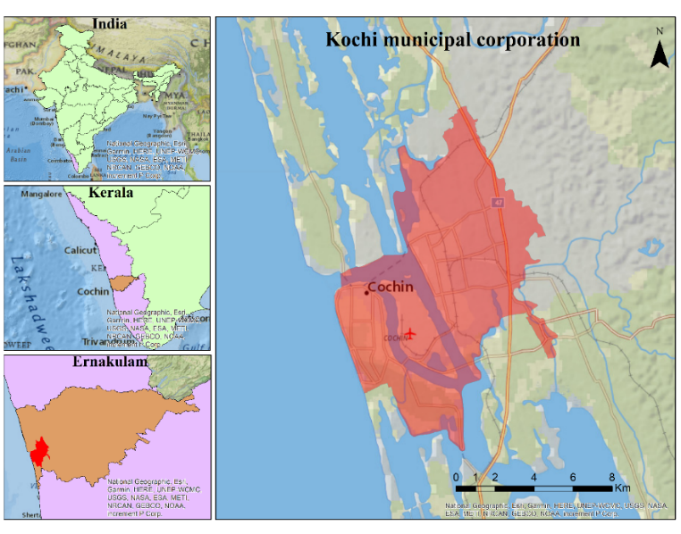
Fig. 1. Study area, Kochi Corporation

2.1 Current
The coastal currents near Cochin are a combination of tide, wave, and wind-induced elements. Based on observations, the highest current velocities in the Cochin Gut during non-monsoon periods reach approximately 3 knots, while during the monsoon periods, they can escalate to as much as 5.5 knots. Within the harbour, the current velocities are relatively low, around 0.5 knots, and their directions vary at different locations(Cochin Port Authority | CPT, n.d.).
Mean Higher high-water line (MHHWL) | +1.20 m
Mean Lower High-Water line (MLHWL) | + 0.80 m
Mean sea level  (MSL) | + 0.60 m
Mean Higher Low Water Level (MHLWL) | + 0.60 m
Mean Lower Low Water Level (MLLWL) | + 0.30 m
2.2 Tidal wave
Table 1. The tidal levels of Kochi

Cochin experiences semi-diurnal tides, a tidal pattern characterized by two high tides and two low tides occurring in a 24-hour period. The tidal levels in Cochin are defined by the Naval Hydrographic Chart No.2004, with reference to the Port's Chart Datum, which is approximately the level of the Lowest Astronomical Tide.
The Mean Higher High-Water Level (MHHWL) is recorded at +1.20 meters, indicating the average height of the higher high tide. The Mean Lower High-Water Level (MLHWL) stands at +0.80 meters, representing the average height of the lower high tide. Meanwhile, the Mean Sea Level (MSL) is recorded at +0.60 meters, signifying the average level between high and low tides. Both the Mean Higher Low Water Level (MHLWL) and the Mean Lower Low Water Level (MLLWL) are noted at +0.60 meters and +0.30 meters, respectively(Cochin Port Authority | CPT, n.d.).These tidal levels are essential for maritime activities and coastal planning, providing valuable information for navigation, port operations, and environmental monitoring. Understanding the semi-diurnal tidal pattern and specific tidal levels in Cochin is crucial for ensuring safe and efficient maritime operations in the region.
2.3 Significant wave height
The significant wave height is calculated as the mean of the highest one-third of waves, a metric chosen for its relevance in various applications involving wave data where larger waves are deemed more significant. For instance, during storms, larger waves play a crucial role in causing beach erosion (US Department of Commerce, NOAA, n.d.) The South West monsoon governs the wave climate, resulting in strong wave action with a prevailing direction from north-west to south-west. Historical observations of deep-water waves (15m) indicate significant wave heights of 4m, 2m, and 1m at water depths of 10m, 5m, and 2m, respectively, with the predominant wave direction being west. Inside the harbour, wave action is minimal due to the narrow entrance between Cochin Gut and Fort Cochin, as well as the land configuration. Generally, calm conditions persist throughout the year, except during periods of extreme wind activity(Cochin Port Authority | CPT, n.d.)
2.4 Mean Sea level rise
Based on data from the Cochin Port Authority, the mean sea level (MSL) at the port is recorded at 0.60 meters. This measurement signifies that, on average, the sea surface at the port is situated 0.6 meters above a predefined reference point, commonly a benchmark on land. Figure 2, based on data from 1980 to 2019 obtained from PSMSL, illustrates the representation of mean sea level over the years(Permanent Service for Mean Sea Level (PSMSL), n.d.). Continuous monitoring of sea-level rise in Kochi reveals significant findings. The tide data for in 2010, INCAA conducted a report covering 54 years of data, revealing a sea-level trend with an average rise of 1.31 mm per year. Accounting for glacial isostatic effects, a correction of -0.44 mm per year was applied. The net result indicates an estimated sea-level rise of 1.75 mm per year (INCCA, 2010) .Projections indicate a rise of 0.15 meters by 2040, 0.23 meters by 2050, and 0.30 meters by 2060.The annual sea level rise rate is estimated to be 1.8 mm per year(Sreekesh et al., 2018). These findings hold critical implications for coastal erosion studies, as understanding the trends in sea-level rise is crucial for assessing the potential impact on coastal areas and implementing effective mitigation strategies.
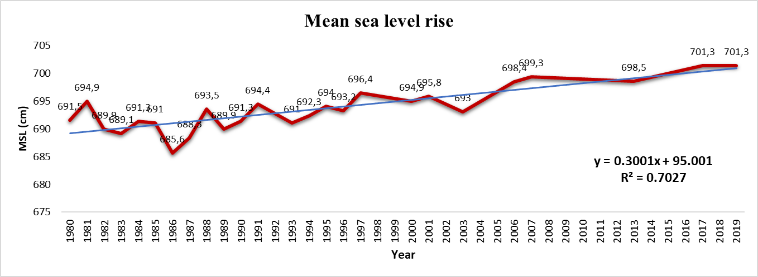
Fig.2. mean sea level
2.5 Bathymetry
The offshore region features a gradual slope of approximately 1 in 500-600. Similar to other coastal areas, there is a littoral drift along the coast. However, a distinctive phenomenon occurs with the formation of mud banks, which are not fixed and exhibit a propensity to shift within the coastal region(Cochin Port Authority | CPT, n.d.).

Materials and methods
Landsat satellite imagery spanning 35 years, from 1989 to 2024, with a 30m resolution, has been acquired from the USGS and serves as a foundational dataset for this research, as detailed in Table 1. The selection of satellite images involved careful considerations, including cloud cover, uniform projection, and seasonal timing. In the processing phase, band composition and the calculation of the Normalized Difference Water Index (NDWI) using the formula NDWI = (NIR – SWIR) / (NIR + SWIR) were performed using ArcGIS version 10.8. Advanced tools and diverse datasets were utilized for the analysis of shoreline change. Image enhancement, georeferencing, and band extraction were conducted using ERDAS Imagine 9.2, while ArcGIS version 10.8 and Digital Shoreline Analysis System (DSAS) version 5.1 were employed for shoreline analysis. These meticulous steps ensure the quality and relevance of the satellite imagery, establishing a robust foundation for comprehensive analysis and interpretation within the research framework.

Satellite imagery | Time(mm/dd/yyyy)
Landsat 9 OLI/TIRS | 01/14/2024
Landsat 8 OLI/TIRS | 02/11/2014
Landsat 7 ETM+ | 12/24/2004
LT05 TM | 02/04/1994
LM05 MSS | 02/22/1989
Table 2. details of satellite images

  - Digitization of shoreline
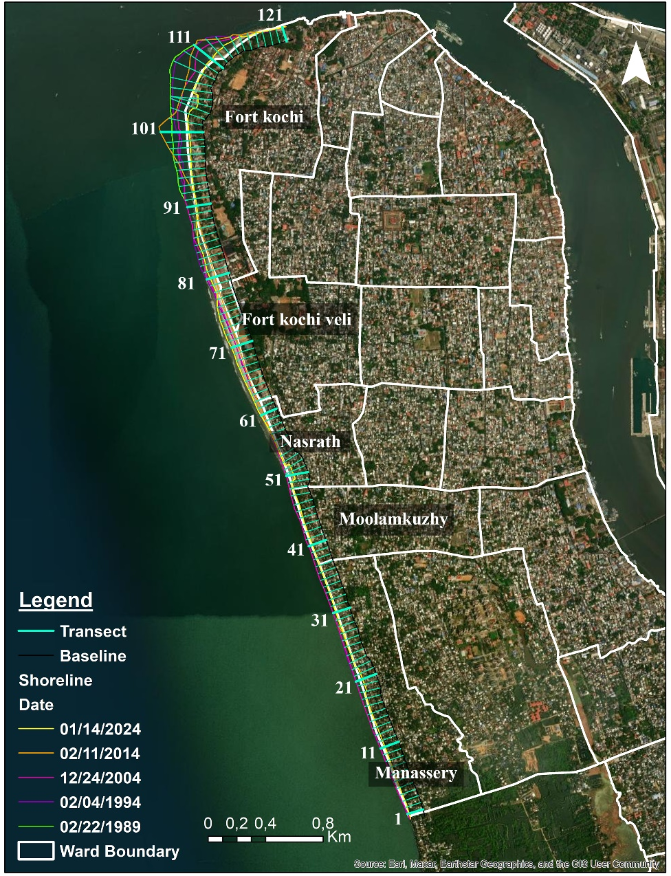
In this study Digital Shoreline Analysis System (DSAS) version 5.1 and ArcMap 10.8 have been used to find shoreline change rate of the study area. The DSAS, created by the USGS, is an open-source application integrated into ArcGIS software. Designed as an extension tool within the Environmental System Research Institute (ESRI)'s ArcGIS, DSAS facilitates the calculation and monitoring of shoreline change rates using historical shoreline positions extracted from satellite images. The software functions by generating transects from a baseline parallel to the shoreline and along these transects, assessing variations in the shoreline to calculate accretion and erosion rates(Oyedotun, 2014).Shoreline features in this study were delineated based on tonal variations between land and sea, employing band ratio techniques to distinguish between the two. Subsequently, vectorization was performed within the ArcGIS environment. The creation of a baseline involved applying an offset to the shoreline. To meet DSAS requirements, more than two shorelines were needed, consolidated within a single features class. It was imperative that this features class be in meters and within a projected coordinate system(Dey et al., 2021).In the course of this study, specific parameters were employed for the Digital Shoreline Analysis System (DSAS). A smoothing distance of 200, maximum search distance of 1000, and spacing of 50 were utilized in the analysis. The shoreline data for five distinct time periods were examined, with the baseline established at a distance of 100m from the buffer created using the shorelines. A total of 121 transects were established at 50-meter intervals for the study, covering an area of 6 kilometers. The shoreline in the years 1989, 1994, 2004, 2014 and 2024, along with transects and ward boundaries near the coastal area, is depicted in Figure 3. These parameters and methodologies were chosen to ensure precision and effectiveness in the analysis of shoreline changes over time.
Fig 3: Shoreline in different time period (1989 – 2024)
The DSAS Tool provides five metrics for shoreline change rates: NSM, SCE, EPR, LRR, and WLR. Net Shoreline Movement (NSM) measures the distance between the oldest and youngest shorelines for each transect. Shoreline Change Envelope (SCE) reports a distance, not a rate, representing the greatest distance among intersecting shorelines on a transect. End Point Rate (EPR) calculates the shoreline movement distance divided by the time between the oldest and most recent shorelines. EPR offers simplicity in computation and requires only two shoreline dates. Linear Regression Rate (LRR) involves fitting a least-squares regression line to all shoreline points for a transect, determining the slope as the rate of change. This method uses all data but is sensitive to outliers, potentially underestimating change compared to other statistics. Weighted Linear Regression (WLR) assigns greater weight to more reliable data points, emphasizing those with smaller position uncertainty. The weight (w) is determined based on the variance in the uncertainty of the measurement (e). WLR aims to improve accuracy by considering the reliability of data points in rate-of-change calculations(Himmelstoss et al., 2021). This study is focused on computing each of these statistical measures for annual shoreline changes within our designated study area. The calculation of these metrics is provided below:
NSM = distance between oldest and youngest shoreline
$$EPR= \frac{NSM}{time between oldest and most recent shoreline}$$
SCE = Greatest distance between all shoreline
$\text{WLR}=\frac{1}{e^{2}}$ ; e = shoreline uncertainty value
3.2 Uncertainty of End Point Rate
The uncertainties of the two shoreline positions employed in the end point calculation are squared individually, and then their summation is computed. The square root of this summation is divided by the number of years between the two shorelines, yielding the uncertainty of the end point rate (EPRunc).
$$EPRunc=\frac{\sqrt{{\left[Un.A\right]}^{2}+{\left[Un.B\right]}^{2}}}{DA-DB}$$
Where,
Un. A = Uncertainty from attribute field of shoreline A
Un. B = Uncertainty from attribute field of shoreline B
DA = Date of shoreline A (most recent)
DB = Date of shoreline B (oldest).
3.3 Standard Error of the Estimate
The anticipated or calculated y-values (representing the distance from the baseline) for each point along the shoreline are determined by utilizing the x-values (indicating the shoreline date) and solving the equation for the optimal regression line:
y = mx + b
where,
y = Predicted distance from baseline
m = Slope (the rate of change)
b = y-intercept (where the line crosses the y-axis)
The accuracy of predicted y values is assessed in relation to known values from shoreline point data through the standard error of the estimate. In ordinary linear regression, it is denoted as LSE, while in weighted linear regression, it is referred to as WSE.
$$LSE or WSE=\sqrt{{∑{\left(y-y^{'}\right)}^{2}}/{(n-2)}}$$
Where,
Y = Known distance from baseline for a shoreline data point
y' = Predicted value based on the equation of the best-fit regression line
n = Number of shorelines used

3.4 r-squared Statistic
The r-squared statistic, also known as the coefficient of determination (r^2), represents the proportion of variability in the dataset explained by a regression analysis. This dimensionless indicator ranges from 0.0 to 1.0, with 1.0 indicating a perfect fit. It gauges the effectiveness of the best-fit line in capturing data variation, specifically the linear connection between shoreline points on a designated DSAS transect. In the context of linear regression rate (LRR), the statistic is denoted as LR2, and for weighted linear regression, it is WR2. The calculation method is as follows:
$$r^{2}=1-\sqrt{{∑{\left(y-y^{'}\right)}^{2}}/{∑(y- \overline{y})}}$$
Were,
r² = Coefficient of determination
y = Measured distance from baseline for a shoreline data point
y' = Predicted value based on the equation of the best-fit regression line
$\overline{y}$ = Mean of the measured shoreline distances from the baseline
The R-squared (r²) value indicates the percentage of variability in the dependent variable (y) that the regression model, determined by the independent variable (x), accounts for. A more favourable prediction occurs when the residual values around the regression line exhibit lower variability in comparison to the overall variability. A high r² value, nearing 1.0, signifies that the best-fit line effectively elucidates most of the variations in the dependent variable. In cases of perfect correlation between x and y, where there is no residual variance, the r² value reaches 1.0. Conversely, a low r² value, approaching 0.0, suggests that the best-fit line inadequately explains the variations in the dependent variable, rendering the model less useful. When there is no discernible relationship between the x and y variables, the r² value is 0.0.

Results and Discussion
Value range | Class
>- 3 | High erosion
-3 - 0 | Medium erosion
>0 | Low erosion
The analysis of shoreline alterations along the Kochi coast in Kerala spanning from 1989 to 2024 was conducted utilizing data extracted from satellite images acquired at multiple time points. Five distinct statistical measures were employed to assess the extent of change along the shoreline. Among these, three methods (EPR, LRR, WLR) were employed for rate calculation, while two methods (SCE, NSM) were utilized for distance measurement. The calculated rates were subsequently categorized into three classes according to the criteria outlined in Table 3.
Table 3. classification of rate of erosion

This study on coastal erosion in Kochi conducted a thorough examination by employing 121 transects established at 50-meter intervals through the Digital Shoreline Analysis System (DSAS). The transects, systematically numbered from South to North, are comprehensively outlined in Table 6, providing details on various attributes. Visual representations of the shoreline change rates from 1989 to 2024 for all methods are depicted in Figures 4 to 7, while Figures 8 to 13 present the rate of changes statistically through bar diagrams. Employing five statistical methods – Linear Regression Rate (LRR), Weighted Linear Regression (WLR), End Point Rate (EPR), Net Shoreline Movement (NSM), and Shoreline Change Envelope (SCE) the investigation aimed to assess shoreline change rates, offering insights into erosion and accretion patterns along the coastal region. The study reveals significant variations in coastal dynamics, with maximum values indicating accretion and minimum values indicating erosion. These values, along with the corresponding transect IDs, are detailed in Table 4.

Table 4. Value range of EPR, LRR,WLR,NSM and SCE
 | High value | Transect id | Low value | Transect id | Average
EPR (m/yr) | 1.13 | 73 | -6.35 | 109 | -1.12
LRR (m/yr) | 0.68 | 78 | -6.06 | 109 | -1.16
WLR (m/yr) | 0.68 | 78 | -6.06 | 109 | -1.16
NSM (m) | 39.53 | 72 | -221.69 | 109 | -39.14
SCE (m) | 221.69 | 120 | 3.17 | 109 | 54.56

LRR, WLR, and EPR methods were specifically utilized to evaluate the rate of shoreline change in different segments of the study area. The LRR method identified the maximum erosion rate at transect 109, measuring 6.06 meters per year (m/yr), while the highest accretion rate occurred at transect 78, measuring 0.68 m/yr. Similarly, the WLR method corroborated these findings, revealing consistent maximum erosion rates at transect 109 (6.06 m/yr) and maximum accretion rates at transect 78 (0.68 m/yr). The EPR method unveiled a maximum erosion rate of 6.35 m/yr at transect 109 and the highest accretion rate at transect 73, measuring 1.13 m/yr. The average shoreline changes rates from LRR, EPR, and WLR were 1.16 m/yr, 1.12 m/yr, and 1.16 m/yr, respectively, indicating a persistent erosion trend in the studied coastal area.
To measure distances, the NSM and SCE methods were employed. NSM indicated a high value of 221.69 m at transect 109, indicative of extensive erosion, while the lowest value of 39.53m was recorded at transect 72. In the case of SCE, measuring the greatest distance along the shoreline, a high value of 221.69 m was observed at transect 109, emphasizing substantial erosion. Conversely, transect 120 displayed the lowest SCE value at 3.17m, signifying a lesser extent of distance between shoreline points. This comprehensive analysis of parameters provides valuable insights into the dynamic nature of coastal processes in the Kochi region, facilitating a better understanding and management of coastal erosion and accretion.
Table 5. Erosion level
CLASS | LRR | WLR | EPR
High erosion (%) | 7.44 | 16.53 | 18.18
Medium erosion (%) | 75.21 | 66.12 | 63.64
Low erosion (%) | 17.36 | 17.36 | 18.18

In the classification of coastal erosion levels, three distinct classes were used, as shown in Table 5, each characterized by varying percentages of erosion intensity. The classes include high erosion, medium erosion, and low erosion. For the high erosion class, the percentages for LRR, WLR, and EPR are 7.44%, 16.53%, and 18.18%, respectively. In the medium erosion class, the corresponding percentages are 75.21%, 66.12%, and 63.64%. The low erosion class exhibits percentages of 17.36% for both LRR and WLR, while EPR stands at 18.18%. This classification provides a comprehensive overview of erosion distribution across different intensity levels within the specified parameters.

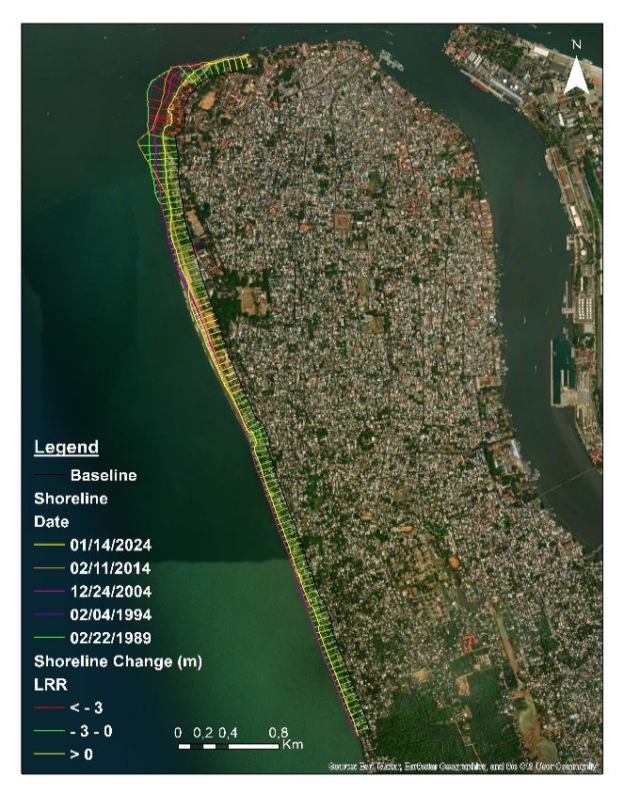 | 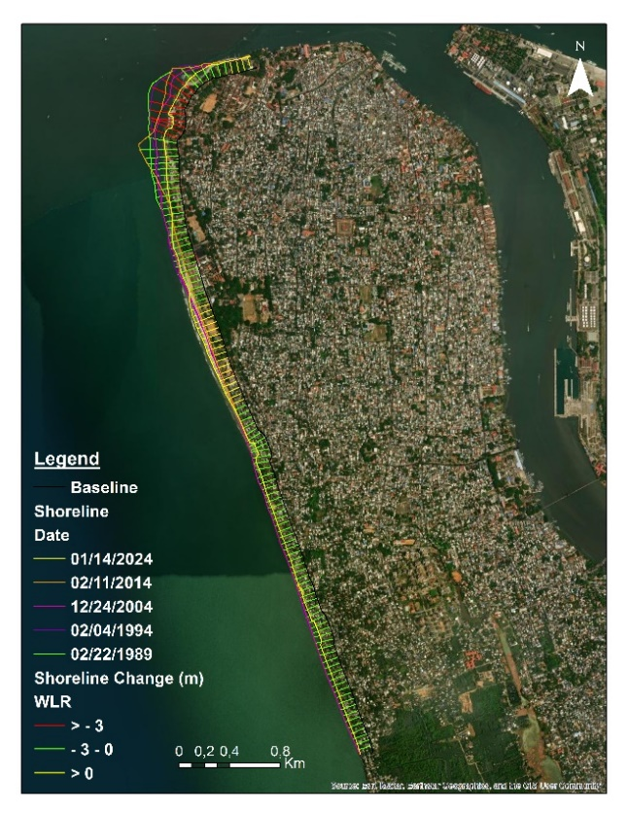
Fig 4. LRR | Fig 5. WLR
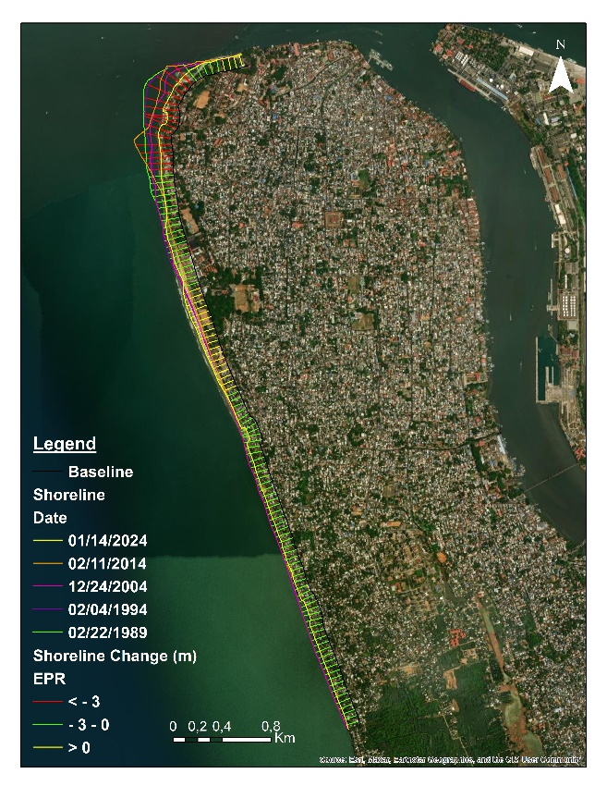 | 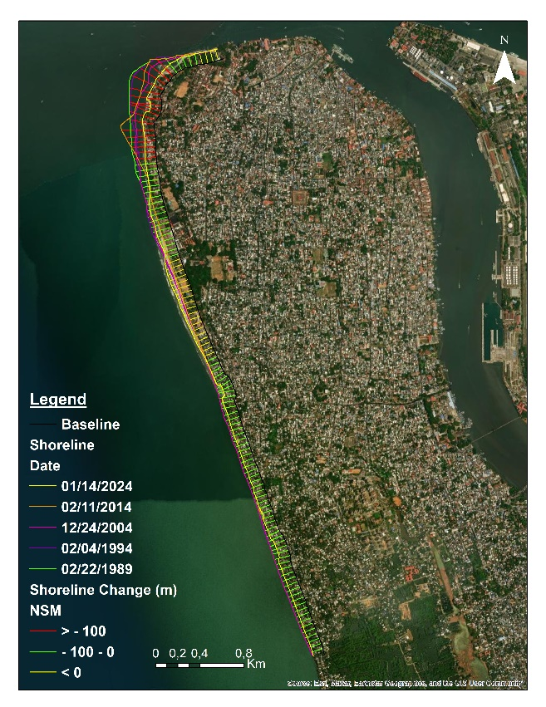
Fig 6. EPR | Fig 7. NSM
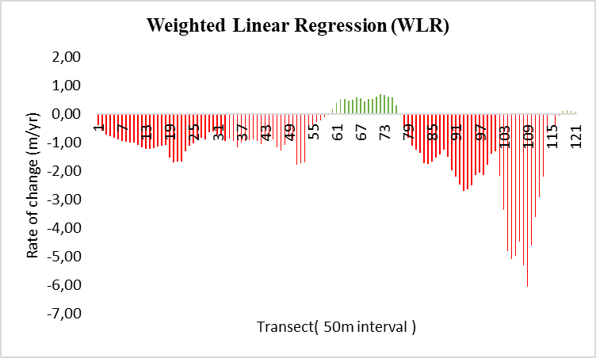
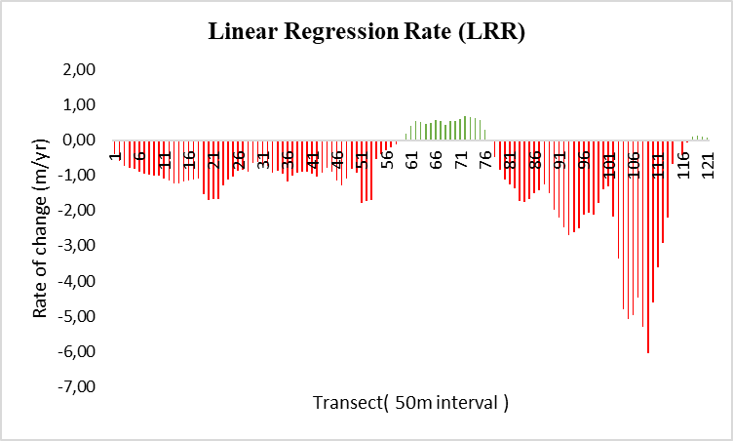

Fig. 8. LRR Fig. 9. WLR
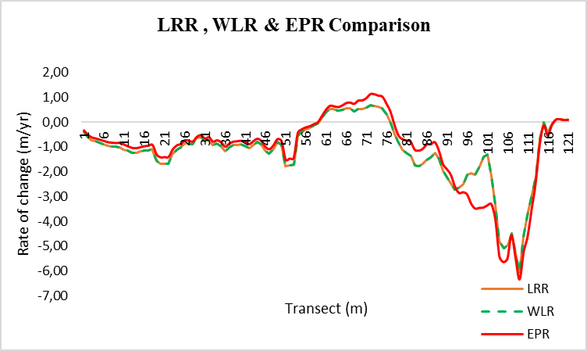
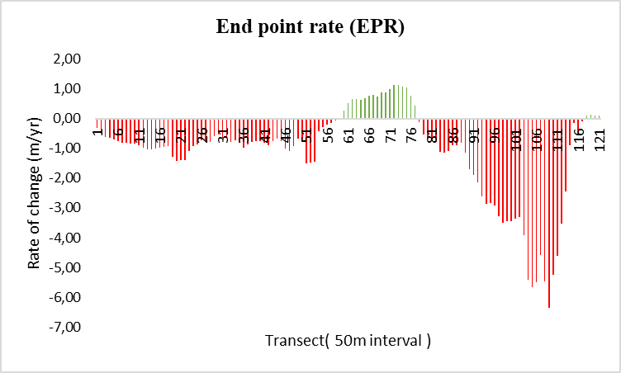

Fig. 10. EPR Fig. 11. Difference in LRR, WLR&EPR

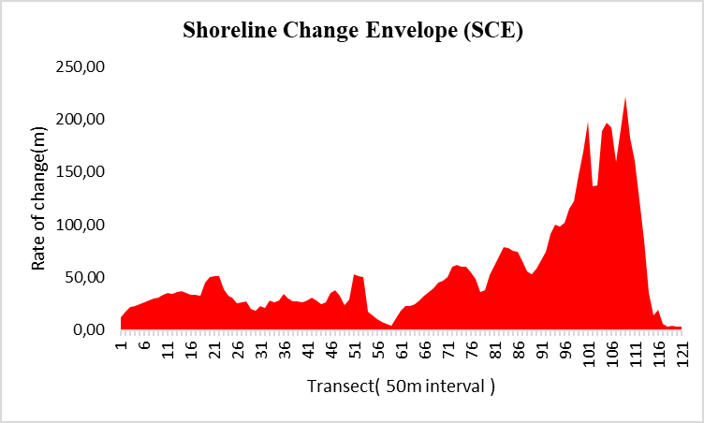
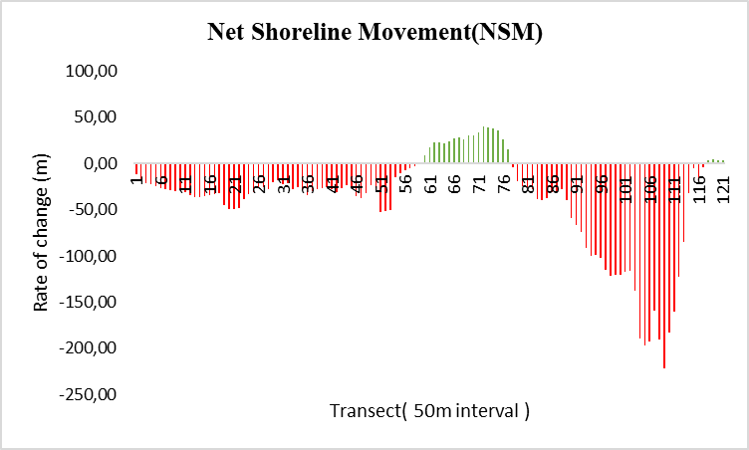

Fig.12.NSM Fig. 13. SCE

Table 6. Transect wise details measurement
TransectID | Ward | SCE | NSM | EPR | EPRunc | LRR | LR2 | LSE | WLR | WR2 | WSE
1 | Manassery  (Ward no: 23) | 11,81 | -11,68 | -0,33 | 0,040 | -0,40 | 0,86 | 2,58 | -0,40 | 0,86 | 2,58
2 | Manassery  (Ward no: 23) | 17,91 | -17,83 | -0,51 | 0,040 | -0,60 | 0,83 | 4,58 | -0,60 | 0,83 | 4,58
3 | Manassery  (Ward no: 23) | 21,58 | -21,52 | -0,62 | 0,040 | -0,73 | 0,81 | 5,89 | -0,73 | 0,81 | 5,89
4 | Manassery  (Ward no: 23) | 22,99 | -22,99 | -0,66 | 0,040 | -0,78 | 0,80 | 6,46 | -0,78 | 0,80 | 6,46
5 | Manassery  (Ward no: 23) | 24,79 | -24,79 | -0,71 | 0,040 | -0,83 | 0,79 | 7,07 | -0,83 | 0,79 | 7,07
6 | Manassery  (Ward no: 23) | 26,66 | -26,66 | -0,76 | 0,040 | -0,90 | 0,78 | 7,93 | -0,90 | 0,78 | 7,93
7 | Manassery  (Ward no: 23) | 28,32 | -28,32 | -0,81 | 0,040 | -0,96 | 0,78 | 8,34 | -0,96 | 0,78 | 8,34
8 | Manassery  (Ward no: 23) | 29,61 | -28,97 | -0,83 | 0,040 | -0,98 | 0,77 | 8,90 | -0,98 | 0,77 | 8,90
9 | Manassery  (Ward no: 23) | 31,22 | -29,46 | -0,84 | 0,040 | -1,00 | 0,75 | 9,51 | -1,00 | 0,75 | 9,51
10 | Manassery  (Ward no: 23) | 33,40 | -29,35 | -0,84 | 0,040 | -1,01 | 0,72 | 10,33 | -1,01 | 0,72 | 10,33
11 | Manassery  (Ward no: 23) | 34,89 | -31,60 | -0,91 | 0,040 | -1,10 | 0,74 | 10,61 | -1,10 | 0,74 | 10,61
12 | Manassery  (Ward no: 23) | 34,25 | -34,25 | -0,98 | 0,040 | -1,16 | 0,80 | 9,60 | -1,16 | 0,80 | 9,60
13 | Manassery  (Ward no: 23) | 36,31 | -36,31 | -1,04 | 0,040 | -1,23 | 0,82 | 9,37 | -1,23 | 0,82 | 9,37
14 | Manassery  (Ward no: 23) | 36,68 | -36,68 | -1,05 | 0,040 | -1,24 | 0,78 | 10,91 | -1,24 | 0,78 | 10,91
15 | Manassery  (Ward no: 23) | 35,10 | -35,10 | -1,01 | 0,040 | -1,19 | 0,78 | 10,35 | -1,19 | 0,78 | 10,35
16 | Manassery  (Ward no: 23) | 33,97 | -33,97 | -0,97 | 0,040 | -1,14 | 0,79 | 9,79 | -1,14 | 0,79 | 9,79
17 | Manassery  (Ward no: 23) | 33,89 | -33,27 | -0,95 | 0,040 | -1,13 | 0,77 | 10,11 | -1,13 | 0,77 | 10,11
18 | Manassery  (Ward no: 23) | 32,26 | -32,06 | -0,92 | 0,040 | -1,09 | 0,78 | 9,61 | -1,09 | 0,78 | 9,61
19 | Manassery  (Ward no: 23) | 45,50 | -45,50 | -1,30 | 0,040 | -1,54 | 0,78 | 13,53 | -1,54 | 0,78 | 13,53
20 | Manassery  (Ward no: 23) | 50,74 | -49,72 | -1,42 | 0,040 | -1,69 | 0,78 | 14,93 | -1,69 | 0,78 | 14,93
21 | Manassery  (Ward no: 23) | 50,91 | -49,18 | -1,41 | 0,040 | -1,68 | 0,78 | 14,89 | -1,68 | 0,78 | 14,89
22 | Manassery  (Ward no: 23) | 51,24 | -48,74 | -1,40 | 0,040 | -1,68 | 0,78 | 14,53 | -1,68 | 0,78 | 14,53
23 | Manassery  (Ward no: 23) | 38,54 | -38,54 | -1,10 | 0,040 | -1,30 | 0,83 | 9,71 | -1,30 | 0,83 | 9,71
24 | Manassery  (Ward no: 23) | 32,86 | -32,74 | -0,94 | 0,040 | -1,11 | 0,85 | 7,61 | -1,11 | 0,85 | 7,61
25 | Manassery  (Ward no: 23) | 30,64 | -30,64 | -0,88 | 0,040 | -1,03 | 0,86 | 6,74 | -1,03 | 0,86 | 6,74
26 | Manassery  (Ward no: 23) | 25,97 | -25,30 | -0,73 | 0,040 | -0,86 | 0,84 | 6,09 | -0,86 | 0,84 | 6,09
27 | Manassery  (Ward no: 23) | 26,02 | -26,02 | -0,75 | 0,040 | -0,85 | 0,87 | 5,49 | -0,85 | 0,87 | 5,49
28 | Manassery  (Ward no: 23) | 27,35 | -27,35 | -0,78 | 0,040 | -0,90 | 0,83 | 6,66 | -0,90 | 0,83 | 6,66
29 | Manassery  (Ward no: 23) | 20,49 | -20,49 | -0,59 | 0,040 | -0,64 | 0,84 | 4,63 | -0,64 | 0,84 | 4,63
30 | Manassery  (Ward no: 23) | 18,53 | -18,53 | -0,53 | 0,040 | -0,62 | 0,78 | 5,43 | -0,62 | 0,78 | 5,43
31 | Manassery  (Ward no: 23) | 22,98 | -22,98 | -0,66 | 0,040 | -0,74 | 0,82 | 5,75 | -0,74 | 0,82 | 5,75
32 | Manassery  (Ward no: 23) | 21,42 | -21,19 | -0,61 | 0,040 | -0,72 | 0,77 | 6,40 | -0,72 | 0,77 | 6,40
33 | Manassery  (Ward no: 23) | 28,64 | -27,71 | -0,79 | 0,040 | -0,94 | 0,76 | 8,62 | -0,94 | 0,76 | 8,62
34 | Manassery  (Ward no: 23) | 26,64 | -25,41 | -0,73 | 0,040 | -0,86 | 0,75 | 8,09 | -0,86 | 0,75 | 8,09
35 | Manassery  (Ward no: 23) | 28,40 | -28,40 | -0,81 | 0,040 | -0,95 | 0,79 | 8,11 | -0,95 | 0,79 | 8,11
36 | Manassery  (Ward no: 23) | 34,57 | -34,57 | -0,99 | 0,040 | -1,17 | 0,78 | 10,29 | -1,17 | 0,78 | 10,29
37 | Manassery  (Ward no: 23) | 30,20 | -30,20 | -0,87 | 0,040 | -1,02 | 0,78 | 8,99 | -1,02 | 0,78 | 8,99
38 | Moolamkuzhy  (Ward no: 24) | 27,73 | -27,62 | -0,79 | 0,040 | -0,94 | 0,78 | 8,26 | -0,94 | 0,78 | 8,26
39 | Moolamkuzhy  (Ward no: 24) | 27,15 | -26,84 | -0,77 | 0,040 | -0,91 | 0,78 | 8,09 | -0,91 | 0,78 | 8,09
40 | Moolamkuzhy  (Ward no: 24) | 26,61 | -26,00 | -0,75 | 0,040 | -0,89 | 0,77 | 7,94 | -0,89 | 0,77 | 7,94
41 | Moolamkuzhy  (Ward no: 24) | 28,25 | -28,25 | -0,81 | 0,040 | -0,96 | 0,78 | 8,39 | -0,96 | 0,78 | 8,39
42 | Moolamkuzhy  (Ward no: 24) | 31,11 | -30,98 | -0,89 | 0,040 | -1,05 | 0,78 | 9,26 | -1,05 | 0,78 | 9,26
43 | Moolamkuzhy  (Ward no: 24) | 27,98 | -26,81 | -0,77 | 0,040 | -0,92 | 0,77 | 8,38 | -0,92 | 0,77 | 8,38
44 | Moolamkuzhy  (Ward no: 24) | 24,35 | -23,48 | -0,67 | 0,040 | -0,80 | 0,77 | 7,29 | -0,80 | 0,77 | 7,29
45 | Moolamkuzhy  (Ward no: 24) | 26,64 | -26,64 | -0,76 | 0,040 | -0,89 | 0,79 | 7,46 | -0,89 | 0,79 | 7,46
46 | Moolamkuzhy  (Ward no: 24) | 35,18 | -34,96 | -1,00 | 0,040 | -1,16 | 0,79 | 9,80 | -1,16 | 0,79 | 9,80
47 | Moolamkuzhy  (Ward no: 24) | 38,07 | -38,07 | -1,09 | 0,040 | -1,28 | 0,78 | 11,17 | -1,28 | 0,78 | 11,17
48 | Moolamkuzhy  (Ward no: 24) | 32,35 | -32,35 | -0,93 | 0,040 | -1,09 | 0,79 | 9,33 | -1,09 | 0,79 | 9,33
49 | Nasrath  (Ward no: 26) | 23,89 | -23,89 | -0,68 | 0,040 | -0,81 | 0,78 | 7,02 | -0,81 | 0,78 | 7,02
50 | Nasrath  (Ward no: 26) | 28,89 | -26,85 | -0,77 | 0,040 | -0,93 | 0,76 | 8,71 | -0,93 | 0,76 | 8,71
51 | Nasrath  (Ward no: 26) | 52,92 | -52,92 | -1,52 | 0,040 | -1,79 | 0,78 | 15,75 | -1,79 | 0,78 | 15,75
52 | Nasrath  (Ward no: 26) | 51,22 | -51,22 | -1,47 | 0,040 | -1,73 | 0,78 | 15,24 | -1,73 | 0,78 | 15,24
53 | Nasrath  (Ward no: 26) | 50,56 | -50,56 | -1,45 | 0,040 | -1,71 | 0,78 | 15,05 | -1,71 | 0,78 | 15,05
54 | Nasrath  (Ward no: 26) | 17,70 | -15,35 | -0,44 | 0,040 | -0,55 | 0,73 | 5,42 | -0,55 | 0,73 | 5,42
55 | Nasrath  (Ward no: 26) | 14,18 | -10,13 | -0,29 | 0,040 | -0,39 | 0,66 | 4,60 | -0,39 | 0,66 | 4,60
56 | Nasrath  (Ward no: 26) | 10,39 | -7,48 | -0,21 | 0,040 | -0,28 | 0,66 | 3,36 | -0,28 | 0,66 | 3,36
57 | Nasrath  (Ward no: 26) | 7,93 | -5,70 | -0,16 | 0,040 | -0,22 | 0,66 | 2,57 | -0,22 | 0,66 | 2,57
58 | Nasrath  (Ward no: 26) | 5,89 | -2,82 | -0,08 | 0,040 | -0,13 | 0,49 | 2,16 | -0,13 | 0,49 | 2,16
59 | Nasrath  (Ward no: 26) | 4,43 | 0,16 | 0,00 | 0,040 | -0,04 | 0,10 | 2,11 | -0,04 | 0,10 | 2,11
60 | Nasrath  (Ward no: 26) | 11,66 | 8,79 | 0,25 | 0,040 | 0,17 | 0,30 | 4,27 | 0,17 | 0,30 | 4,27
61 | Nasrath  (Ward no: 26) | 18,44 | 17,33 | 0,50 | 0,040 | 0,39 | 0,49 | 6,49 | 0,39 | 0,49 | 6,49
62 | Fort Kochi veli  (Ward no: 27) | 23,15 | 23,15 | 0,66 | 0,040 | 0,53 | 0,55 | 7,98 | 0,53 | 0,55 | 7,98
63 | Fort Kochi veli  (Ward no: 27) | 22,81 | 22,28 | 0,64 | 0,040 | 0,51 | 0,52 | 8,09 | 0,51 | 0,52 | 8,09
64 | Fort Kochi veli  (Ward no: 27) | 24,46 | 21,40 | 0,61 | 0,040 | 0,46 | 0,41 | 9,17 | 0,46 | 0,41 | 9,17
65 | Fort Kochi veli  (Ward no: 27) | 27,80 | 23,33 | 0,67 | 0,040 | 0,49 | 0,37 | 10,56 | 0,49 | 0,37 | 10,56
66 | Fort Kochi veli  (Ward no: 27) | 33,01 | 27,03 | 0,77 | 0,040 | 0,56 | 0,35 | 12,48 | 0,56 | 0,35 | 12,48
67 | Fort Kochi veli  (Ward no: 27) | 35,81 | 27,72 | 0,79 | 0,040 | 0,55 | 0,31 | 13,59 | 0,55 | 0,31 | 13,59
68 | Fort Kochi veli  (Ward no: 27) | 40,17 | 25,82 | 0,74 | 0,040 | 0,44 | 0,17 | 15,82 | 0,44 | 0,17 | 15,82
69 | Fort Kochi veli  (Ward no: 27) | 45,44 | 30,25 | 0,87 | 0,040 | 0,53 | 0,21 | 17,19 | 0,53 | 0,21 | 17,19
70 | Fort Kochi veli  (Ward no: 27) | 46,75 | 30,69 | 0,88 | 0,040 | 0,53 | 0,20 | 17,57 | 0,53 | 0,20 | 17,57
71 | Fort Kochi veli  (Ward no: 27) | 50,77 | 33,84 | 0,97 | 0,040 | 0,60 | 0,21 | 19,03 | 0,60 | 0,21 | 19,03
72 | Fort Kochi veli  (Ward no: 27) | 60,44 | 39,53 | 1,13 | 0,040 | 0,68 | 0,20 | 22,73 | 0,68 | 0,20 | 22,73
73 | Fort Kochi veli  (Ward no: 27) | 62,32 | 39,37 | 1,13 | 0,040 | 0,66 | 0,17 | 23,78 | 0,66 | 0,17 | 23,78
74 | Fort Kochi veli  (Ward no: 27) | 60,50 | 37,41 | 1,07 | 0,040 | 0,61 | 0,16 | 23,36 | 0,61 | 0,16 | 23,36
75 | Fort Kochi veli  (Ward no: 27) | 59,96 | 36,07 | 1,03 | 0,040 | 0,57 | 0,14 | 23,28 | 0,57 | 0,14 | 23,28
76 | Fort Kochi veli  (Ward no: 27) | 55,16 | 26,31 | 0,75 | 0,040 | 0,30 | 0,05 | 22,26 | 0,30 | 0,05 | 22,26
77 | Fort Kochi veli  (Ward no: 27) | 49,00 | 14,80 | 0,42 | 0,040 | -0,03 | 0,00 | 20,89 | -0,03 | 0,00 | 20,89
78 | Fort Kochi veli  (Ward no: 27) | 35,89 | -4,35 | -0,12 | 0,040 | -0,49 | 0,21 | 15,44 | -0,49 | 0,21 | 15,44
79 | Fort kochi  (Ward no: 1) | 38,26 | -18,76 | -0,54 | 0,040 | -0,84 | 0,54 | 12,74 | -0,84 | 0,54 | 12,74
80 | Fort kochi  (Ward no: 1) | 51,88 | -24,22 | -0,69 | 0,040 | -1,12 | 0,54 | 17,14 | -1,12 | 0,54 | 17,14
81 | Fort kochi  (Ward no: 1) | 60,86 | -25,93 | -0,74 | 0,040 | -1,25 | 0,49 | 21,00 | -1,25 | 0,49 | 21,00
82 | Fort kochi  (Ward no: 1) | 69,57 | -27,60 | -0,79 | 0,040 | -1,38 | 0,47 | 24,41 | -1,38 | 0,47 | 24,41
83 | Fort kochi  (Ward no: 1) | 78,43 | -38,63 | -1,11 | 0,040 | -1,73 | 0,58 | 24,38 | -1,73 | 0,58 | 24,38
84 | Fort kochi  (Ward no: 1) | 77,78 | -40,16 | -1,15 | 0,040 | -1,76 | 0,60 | 23,60 | -1,76 | 0,60 | 23,60
85 | Fort kochi  (Ward no: 1) | 75,27 | -37,61 | -1,08 | 0,040 | -1,67 | 0,58 | 23,34 | -1,67 | 0,58 | 23,34
86 | Fort kochi  (Ward no: 1) | 74,40 | -31,31 | -0,90 | 0,040 | -1,52 | 0,50 | 25,24 | -1,52 | 0,50 | 25,24
87 | Fort kochi  (Ward no: 1) | 65,27 | -30,93 | -0,89 | 0,040 | -1,42 | 0,50 | 23,45 | -1,42 | 0,50 | 23,45
88 | Fort kochi  (Ward no: 1) | 55,54 | -28,27 | -0,81 | 0,040 | -1,25 | 0,52 | 19,95 | -1,25 | 0,52 | 19,95
89 | Fort kochi  (Ward no: 1) | 52,65 | -40,20 | -1,15 | 0,040 | -1,50 | 0,68 | 16,72 | -1,50 | 0,68 | 16,72
90 | Fort kochi  (Ward no: 1) | 58,81 | -58,81 | -1,69 | 0,040 | -1,97 | 0,79 | 16,94 | -1,97 | 0,79 | 16,94
91 | Fort kochi  (Ward no: 1) | 66,47 | -66,47 | -1,90 | 0,040 | -2,21 | 0,79 | 18,64 | -2,21 | 0,79 | 18,64
92 | Fort kochi  (Ward no: 1) | 74,60 | -74,53 | -2,14 | 0,040 | -2,48 | 0,78 | 21,48 | -2,48 | 0,78 | 21,48
93 | Fort kochi  (Ward no: 1) | 90,98 | -90,98 | -2,61 | 0,040 | -2,71 | 0,88 | 16,14 | -2,71 | 0,88 | 16,14
94 | Fort kochi  (Ward no: 1) | 99,77 | -99,77 | -2,86 | 0,040 | -2,63 | 0,94 | 10,45 | -2,63 | 0,94 | 10,45
95 | Fort kochi  (Ward no: 1) | 98,71 | -98,71 | -2,83 | 0,040 | -2,51 | 0,94 | 10,92 | -2,51 | 0,94 | 10,92
96 | Fort kochi  (Ward no: 1) | 101,74 | -101,74 | -2,92 | 0,040 | -2,13 | 0,65 | 25,85 | -2,13 | 0,65 | 25,85
97 | Fort kochi  (Ward no: 1) | 114,90 | -114,90 | -3,29 | 0,040 | -2,05 | 0,45 | 37,69 | -2,05 | 0,45 | 37,69
98 | Fort kochi  (Ward no: 1) | 121,96 | -121,91 | -3,49 | 0,040 | -2,13 | 0,37 | 45,74 | -2,13 | 0,37 | 45,74
99 | Fort kochi  (Ward no: 1) | 147,31 | -120,81 | -3,46 | 0,040 | -1,79 | 0,21 | 57,69 | -1,79 | 0,21 | 57,69
100 | Fort kochi  (Ward no: 1) | 169,29 | -120,39 | -3,45 | 0,040 | -1,39 | 0,10 | 69,99 | -1,39 | 0,10 | 69,99
101 | Fort kochi  (Ward no: 1) | 197,53 | -117,36 | -3,36 | 0,040 | -1,31 | 0,07 | 81,53 | -1,31 | 0,07 | 81,53
102 | Fort kochi  (Ward no: 1) | 136,88 | -115,62 | -3,31 | 0,040 | -2,17 | 0,34 | 49,64 | -2,17 | 0,34 | 49,64
103 | Fort kochi  (Ward no: 1) | 137,29 | -137,29 | -3,93 | 0,040 | -3,36 | 0,83 | 24,62 | -3,36 | 0,83 | 24,62
104 | Fort kochi  (Ward no: 1) | 189,16 | -189,16 | -5,42 | 0,040 | -4,80 | 0,85 | 32,78 | -4,80 | 0,85 | 32,78
105 | Fort kochi  (Ward no: 1) | 197,31 | -197,31 | -5,65 | 0,040 | -5,07 | 0,86 | 33,38 | -5,07 | 0,86 | 33,38
106 | Fort kochi  (Ward no: 1) | 192,11 | -192,11 | -5,51 | 0,040 | -4,96 | 0,87 | 31,05 | -4,96 | 0,87 | 31,05
107 | Fort kochi  (Ward no: 1) | 159,35 | -159,35 | -4,57 | 0,040 | -4,47 | 0,95 | 17,68 | -4,47 | 0,95 | 17,68
108 | Fort kochi  (Ward no: 1) | 190,86 | -190,86 | -5,47 | 0,040 | -5,29 | 0,91 | 27,99 | -5,29 | 0,91 | 27,99
109 | Fort kochi  (Ward no: 1) | 221,69 | -221,69 | -6,35 | 0,040 | -6,06 | 0,84 | 43,06 | -6,06 | 0,84 | 43,06
110 | Fort kochi  (Ward no: 1) | 183,02 | -183,02 | -5,25 | 0,040 | -4,60 | 0,80 | 37,77 | -4,60 | 0,80 | 37,77
111 | Fort kochi  (Ward no: 1) | 160,76 | -160,76 | -4,61 | 0,040 | -3,61 | 0,60 | 48,49 | -3,61 | 0,60 | 48,49
112 | Fort kochi  (Ward no: 1) | 122,90 | -122,90 | -3,52 | 0,040 | -2,92 | 0,63 | 36,68 | -2,92 | 0,63 | 36,68
113 | Fort kochi  (Ward no: 1) | 85,06 | -85,06 | -2,44 | 0,040 | -2,19 | 0,77 | 19,58 | -2,19 | 0,77 | 19,58
114 | Fort kochi  (Ward no: 1) | 35,41 | -31,65 | -0,91 | 0,040 | -0,68 | 0,44 | 12,59 | -0,68 | 0,44 | 12,59
115 | Fort kochi  (Ward no: 1) | 14,22 | -4,99 | -0,14 | 0,040 | -0,02 | 0,00 | 5,95 | -0,02 | 0,00 | 5,95
116 | Fort kochi  (Ward no: 1) | 19,53 | -18,79 | -0,54 | 0,040 | -0,42 | 0,50 | 7,00 | -0,42 | 0,50 | 7,00
117 | Fort kochi  (Ward no: 1) | 5,67 | -3,76 | -0,11 | 0,040 | -0,07 | 0,17 | 2,44 | -0,07 | 0,17 | 2,44
118 | Fort kochi  (Ward no: 1) | 3,41 | 3,41 | 0,10 | 0,040 | 0,11 | 0,76 | 1,05 | 0,11 | 0,76 | 1,05
119 | Fort kochi  (Ward no: 1) | 4,02 | 4,02 | 0,12 | 0,040 | 0,13 | 0,76 | 1,24 | 0,13 | 0,76 | 1,24
120 | Fort kochi  (Ward no: 1) | 3,17 | 3,17 | 0,09 | 0,040 | 0,09 | 0,93 | 0,40 | 0,09 | 0,93 | 0,40
121 | Fort kochi  (Ward no: 1) | 3,35 | 3,35 | 0,10 | 0,040 | 0,08 | 0,54 | 1,17 | 0,08 | 0,54 | 1,17

4.1 Uncertainty and Accuracy Measurements
The Uncertainty of EPR (EPRunc) is consistently 0.040 across all transects, determined using above equation. Accuracy assessments for LRR and WLR involve the application of R-Square statistics and the measurement of Standard Error of Estimation for both rates. In Table 3, the transect-wise rate of change is presented alongside accuracy and standard error of estimation values. LR2 and WR2 represent the R-square values for LRR and WLR, while LSE and WSE denote the standard error of LRR and WLR, respectively. The R-square values are categorized into four classes: High accuracy (R > 0.6), Medium accuracy (0.6 - 0.3), Low accuracy (< 0.3), and No relationship (R = 0). Both LRR and WLR methods exhibit identical figures, with 1.65% of the data showing an R value of zero, indicating no relationship. Table 7 displays the classification of R values and their corresponding percentages across different accuracy classes.

Table 7. R² values & their percentage
Class | LR2 count | Percentage | WR2 count | Percentage
High accuracy (>0.6) | 80 | 66.12 | 80 | 66.12
Medium accuracy (0.6 - 0.3) | 24 | 19.83 | 24 | 19.83
Low accuracy (< 0.3) | 15 | 12.40 | 15 | 12.40
No relation = 0 | 2 | 1.65 | 2 | 1.65

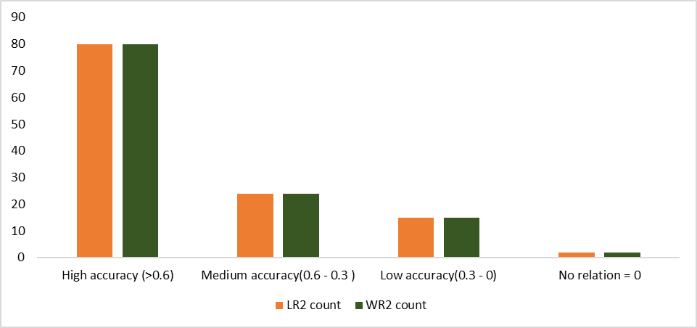
Fig. 14. R² Bar diagram shows R² statistics of 2 method
Landuse in coastal area
A detailed analysis of land use within a 500-meter buffer of the existing shoreline has been conducted to understand coastal area utilization which is represented in figures 15 and 16. The data reveals that residential activities dominate, covering 180 hectares, followed by public-semi-public (PSP) areas, which occupy 64 hectares. This high level of residential activity indicates a densely populated coastal region, making it crucial to assess coastal erosion levels.
The major PSP in this coastal area of Kochi corporation is the Indian Naval area INS Dronacharya, which features well-maintained groynes that protect the area from sea erosion. Consequently, this stretch, which spans nearly 2 kilometers, experiences low levels of erosion. However, the southern area of this stretch, characterized by more residential zones, faces medium levels of erosion. In contrast, the northern section of the naval area is more vulnerable to coastal erosion. The study has identified that coastal erosion is particularly severe in the Fort Kochi beach area, with an erosion rate of 6.36 m/yr.
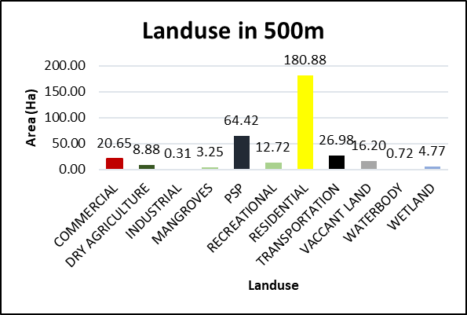

Fig: 15. landuse in 500m

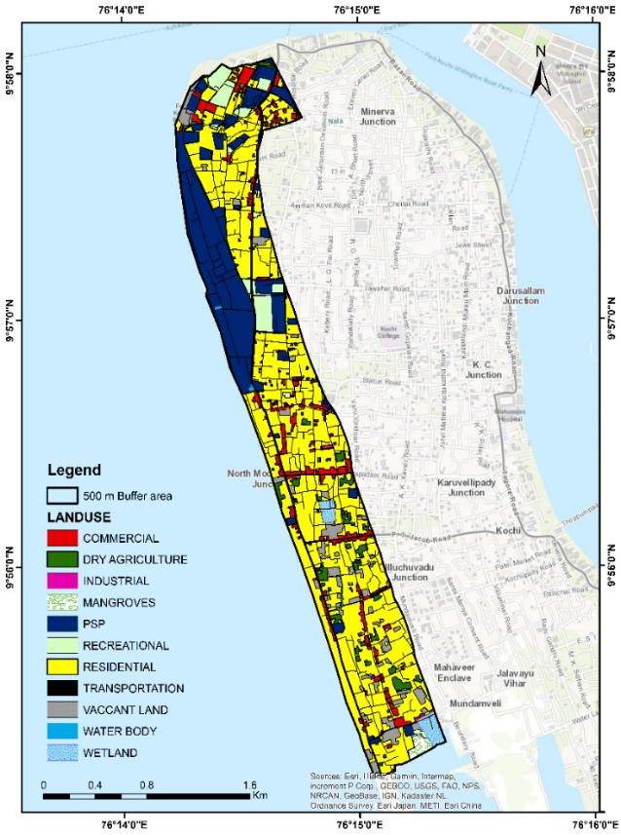
Fig.16. landuse

Conclusion
The study results clearly revealed that Fort Kochi region is under a noticeable rate of erosion leading to coastal instability and infrastructural damages. it is also significantly observed that the northern portion of the island experiences higher rates of erosion. The LRR and WLR methods quantifies the maximum erosion rate at transect 109 and maximum accretion rates at transect 78. The average shoreline changes rates from LRR, EPR, and WLR were 1.16 m/yr, 1.12 m/yr, and 1.16 m/yr, respectively, indicating a persistent erosion trend in the studied coastal area. The major reasons identified for the coastal erosion are Construction of the Vallarpadam Container Terminal which is located opposite the Fort Kochi beach, involved reclaiming a large area of land and building a boundary wall. This wall altered the natural flow of water from the Vembanad Lake, directing it more towards the beach and accelerating erosion. Dredging activities also contributed hugely to increased levels of erosion as Kochi port requires regular dredging to maintain shipping channels. However, the dredged sand is often dumped offshore, preventing it from replenishing the beaches naturally. This disrupts the sediment balance and makes the coast more vulnerable to erosion. Climate change is another prime contributor, rising sea levels and more intense storms due to climate change are putting additional pressure on the coastline, exacerbating erosion. Human activities such as sand mining and construction on the beach can also contribute to erosion by removing sand and vegetation that helps stabilize the shoreline. This study will act as a baseline data and reference for the future studies in this field.

Declaration of interests
The authors declare that they have no known competing financial interests or personal relationships that could have appeared to influence the work reported in this paper.

References

- Shaji, J. (n.d.). Evaluating Landuse Change along Thiruvananthapuram Coast, South West Coast of India Using Geo-Spatial Techniques.
- Sheik, M. (n.d.). A shoreline change analysis along the coast between Kanyakumari and Tuticorin, India, using digital.
- Baig, M. R. I. (n.d.). Analysis of shoreline changes in Vishakhapatnam coastal tract of Andhra Pradesh, India: An application.
- Kundu, K. (n.d.). Shoreline Change Detection and Future Prediction of Sundarban Delta Using Remote Sensing Data and Digital Shoreline Analysis System. Journal of the Indian Society of Remote Sensing.
- Cochin Port Authority | CPT. (n.d.). Retrieved February 25, 2024, from https://cochinport.gov.in/cpt
- Dey, M., Sakthivel, S. P., & Jena, B. K. (2021). A Shoreline Change Detection ( 2012-2021 ) and forecasting Using Digital Shoreline Analysis System ( DSAS ) Tool : A Case Study of Dahej Coast , Gulf of. February 2022. https://doi.org/10.22146/ijg.56297
- Himmelstoss, E. A., Henderson, R. E., Kratzmann, M. G., & Farris, A. S. (2021). Digital Shoreline Analysis System ( DSAS ) Version 5.1 User Guide: U.S. Geological Survey Open-File Report 2021–1091. In U.S. Geological Survey. https://doi.org/10.3133/ofr20211091
- INCCA. (2010). Climate Change and India: a 4X4 Assessment a 4 X 4 ASSESSMENT. In Analysis (Issue November).
- Oyedotun, T. D. T. (2014). Shoreline Geometry : DSAS as a Tool for Historical Trend Analysis. Geomorphological Techniques (Online Edition), 2(October), 1–12.
- Permanent Service for Mean Sea Level (PSMSL). (n.d.). Retrieved February 25, 2024, from https://psmsl.org/
- Sreekesh, S., Sreerama Naik, S. R., & Rani, S. (2018). Effect of Sea Level Changes on the Groundwater Quality along the Coast of Ernakulam District, Kerala. Journal of Climate Change, 4(2), 51–65. https://doi.org/10.3233/jcc-1800013
- US Department of Commerce, NOAA, N. W. S. (n.d.). Significant Wave Height. NOAA’s National Weather Service.

