Short term changes in soil chemical properties under different organic management protocols

ABSTRACT
The study assessed how ecological and organic farming practices affect soil chemical properties and nutrient dynamics in the short-term rice-wheat cropping system. A randomized block design with five treatments vis. biochar-based ecological farming (BBEF), climate-resilient organic farming (CROF), low-input natural farming (LINF), phosphorus-potassium fertilization (PK) and nitrogen-phosphorus-potassium fertilization (NPK) was evaluated. Post-harvest soils after 5 crops were analysed for pH, electrical conductivity (EC), soil organic carbon (SOC) and available N, P and K at 0-5, 5-15 and 15-30 cm depths. CROF maintained the highest pH in all layers, showing strong buffering, while NPK had the lowest pH due to urea-induced acidification. EC stayed low across treatments, indicating non-saline soils, with slightly higher values in ecological and organic systems from enhanced organic residue mineralization. SOC was greatest under BBEF followed by CROF at all depths, confirming biochar’s role in long-term carbon storage and the contribution of organic manure in CROF to enhancing soil carbon. Available N was highest in BBEF and NPK, demonstrating the benefits of biochar and mineral fertilization. Higher available P in PK and NPK reflected mineral P inputs, while biochar (BBEF) stabilized P availability. Potassium was highest in PK and in organic systems (BBEF and LINF) due to residue recycling and lower crop removal. Overall, biochar-based ecological and organic practices improved soil fertility and nutrient retention, offering a sustainable strategy to maintain soil health and resilience in intensive rice-wheat systems.
Keywords: Biochar; organic farming; natural farming; soil fertility; rice-wheat cropping system.
1. INTRODUCTION
The Green Revolution has been a double-edged sword for Indian agriculture. While it transformed the country from food scarcity to self-sufficiency, it also generated multiple challenges such as declining factor productivity, depletion of natural resources, nutrient imbalances, and environmental degradation (Bharucha et al., 2020; Bhattacharyya et al., 2020; Kitamura et al., 2021). Over-reliance on chemical fertilizers and pesticides not only reduces soil fertility but also affects crop yields, disrupts ecological balance, and endangers human and environmental health (Li et al., 2020). These challenges necessitate ecologically sustainable alternatives to restore soil health, improve nutrient availability, and enhance carbon sequestration.
Among the promising solutions are climate-resilient organic farming, low-input natural farming, and biochar-based ecological farming (Ray et al., 2020). CROF strengthens soil productivity by recycling natural resources such as crop residues, farmyard manure, vermicompost, legumes in rotation, and biofertilizers. Similarly, zero-budget natural farming emphasizes the sole use of locally available resources like Jivamrit, Beejamrit, mulching, soil aeration, crop diversification, and bio-pesticides to rejuvenate soil and crop health. These practices reflect a “back-to-basics” approach, reducing dependence on external chemical inputs. BBEF represents another innovative strategy that integrates modern science with ecological principles. Produced through pyrolysis of crop residues under limited oxygen, biochar is a stable, carbon-rich amendment that improves soil structure, enhances nutrient retention, supports microbial activity, and offers long-term potential for carbon sequestration (Lehmann et al., 2006).
SOC is central to soil fertility and sustainability. Organic amendments such as farmyard manure, compost, biochar, and Jivamrit are known to increase SOC stocks, promote microbial activity, and improve soil aggregation (Piccolo et al., 1996; Glaser et al., 2000). These inputs enhance the labile carbon pool, accelerate nutrient cycling, and serve as sensitive indicators of soil quality (Kaye and Hart, 1997; Xu et al., 2011). Increased SOC not only contributes to soil health but also regulates soil pH and EC, key parameters that determine nutrient solubility, ionic balance, and plant uptake efficiency.
Nutrient availability, particularly of nitrogen (N), phosphorus (P), and potassium (K), is also strongly influenced by management practices. Natural and organic amendments release nutrients gradually, ensuring their steady availability to plants while reducing leaching and volatilization losses common under chemical fertilizer-based systems. Plant-available N improves through mineralization of organic inputs and microbial processes, while organic acids and enzymatic activity enhance P solubilization from otherwise unavailable pools. Similarly, the recycling of crop residues and organic manures enriches exchangeable K, essential for sustaining crop growth.
Considering the significance of soil parameters as indicators of soil health, the present study was conducted under rice-wheat cropping system, one of the most intensive systems sustaining national food security. The focus was on evaluating post-harvest soil properties, particularly the changes in pH, EC, SOC, and the availability of macronutrients nitrogen (N), phosphorus (P), and potassium (K), under different ecological and organic management practices. The study aimed to examine how different farming practices influence post-harvest soil chemical properties (pH, EC, and SOC) and to evaluate changes in the available N, P, and K status of the soil.
2. MATERIALS AND METHODS
2.1 Description of experimental site
A field experiment on rice-wheat cropping sequence was started during the kharif season of 2020 at the IRRI South Asia Regional Centre (ISARC-IRRI), Varanasi, Uttar Pradesh, India (25°30′ N, 82°95′ E; 83 m above mean sea level). The site falls under a semi-arid to sub-humid climate with a moisture deficit index of 20-40. The region receives an average annual rainfall of approximately 1100 mm, of which more than 90% occurs between July and September, with occasional winter showers during December to February. The mean annual minimum and maximum temperatures range from 15.5 to 36 °C. The salient soil properties at the start of the experiment are presented in Table 1.
Table 1. Description of soil properties at the inception of the experiment
Soil properties | Unit/ Description | Value
Soil type | Inceptisol, Alluvial soil | -
Sand | % | 58
Silt | % | 20
Clay | % | 22
Textural class | Sandy clay loam | -
Bulk density | Mg m⁻³ | 1.45
Particle density | Mg m⁻³ | 2.65
pH (1:2.5, H₂O) | - | 7.53
Electrical conductivity | dS m⁻¹ | 0.156
Soil organic carbon | % | 0.50
Available nitrogen | kg ha⁻¹ | 167.87
Available phosphorus | kg ha⁻¹ | 11.01
Available potassium | kg ha⁻¹ | 129.08

The study was laid out in a randomized block design (RBD) with five treatments, each replicated four times. The treatment details are as follows: BBEF relied on biochar, ecozyme, amino acids and humic acid. CROF through Azolla, blue green algae (BGA), vermicompost and vermiwash. In LINF using beejamrit, jivamrit, acchadan and whapasa. Ecourea, Gibberellic acid and green manuring (green geam) was done in BBEF, CROF and LINF. In both rice and wheat, the PK treatment received fertilizers at N:P:K::0:60:60, while the NPK treatment received 120:60:60, with N applied as neem-coated urea in three split doses. The full dose of phosphoric and potassic fertilizers was applied at sowing. All solid and liquid fertilizers were applied in rice at basal, active tillering and panicle initiation; in wheat at basal, 35-45 and 55-60 DAS; and in greengram at basal, 35-40 and 55-60 DAS. BGA and azolla were given only at basal in rice only, mixed with vermicompost, and beejamrit at seed sowing.
2.2 Organic formulations and bio input details
Humic acid was prepared by fermenting rice water and amino acid by heating human hair to 400 °C and diluting to 20 L. Ecourea was obtained by fermenting curd with copper and gibberellic acid from fermented cow-dung cakes. Biozymes were prepared from fermented fruit peels. Vermicompost, applied at 3 t ha⁻¹ (in each crop), is an earthworm-processed compost, while vermiwash is its nutrient-rich liquid extract. All liquid organic formulations (humic acid, amino acid, ecourea, vermiwash, gibberellic acid and jivamrit) were applied in 1:10 dilution with water at 200 L ha⁻¹ in each application. Beejamrit was made by fermenting cow dung, cow urine, lime and soil extract for seed treatment. Jivamrit was prepared by fermenting cow dung, cow urine, jaggery, pulse flour and soil. In BBEF, maize biochar was applied in rice, rice + sesbania biochar in wheat and mustard biochar in green gram at the rate 3 t ha⁻¹ each split into three equal doses for each crop. In CROF, rice received fresh Azolla (1 t ha⁻¹) and BGA (15 kg ha⁻¹) with vermicompost. FYM (3 t ha⁻¹) in 2020-21 was later replaced by equal vermicompost splits. In LINF for waphasa, sunflower, ladyfinger, radish, carrot, lemongrass and marigold were grown around the crop, and for acchadan (mulching) rice straw was used in rice and wheat and wheat straw in green gram.
2.3 Field preparation and cultural practices
The experimental treatments differed in field preparation, nutrient management, residue handling, and cropping sequence. In BBEF, CROF, LINF, PK and NPK, rice was established under conventional tillage (CT). In BBEF, CROF and LINF, wheat was under reduced tillage (RT) and green gram under zero tillage (ZT), whereas in PK and NPK wheat was also under CT. Rice nursery was sown in the second week of June and transplanted later (25 DAS); wheat and green gram were sown in November and March, respectively. Seed rates were 25 kg ha⁻¹ for rice, 100 kg ha⁻¹ for wheat and 20 kg ha⁻¹ for green gram, with manual transplanting in rice and seed drilling in wheat and green gram. Spacing was 22.5 cm for rice and wheat and 30 cm for green gram. The cropping sequence was rice-wheat-green gram in BBEF, CROF and LINF, and rice-wheat-fallow in PK and NPK. The individual plot size was 5 × 3 m². Water management in BBEF, CROF, LINF maintained saturated soil for about 20 days after sowing, with irrigations provided at hairline cracks, amounting to 25-30 irrigations in rice, 3-5 in wheat, and 1-2 in green gram. In PK and NPK, rice received 30-35 irrigations and wheat 3-5 irrigations. Varieties used were Arize 6444 Gold for rice, HD-2967 for wheat, and Virat for green gram. After 2 picking green gram is fully incorporated in soil. Residue management in BBEF, CROF, LINF involved retention of rice residue as mulch, 10-20 % anchored wheat residue, and complete incorporation of green gram residue, whereas in PK and NPK all residues were removed.
2.4 Soil Sampling and soil analysis
Soil sampling was done after rice harvest on 17 Nov 2022 at ISARC-IRRI, Varanasi. From each replication of the five treatments, 2-3 random samples were collected in a zigzag pattern, composited, and taken from three depths (0-5, 5-15, 15-30 cm) for analysing basic properties of soil. All parameters were analysed at the Soil Technology and Carbon Sequestration Laboratory, Dept. of Soil Science and Agricultural Chemistry, Institute of Agricultural Sciences, BHU, using the methods described in the following sections.
2.5 Basic chemical properties of soil
Soil samples were analysed for pH, electrical conductivity (EC), organic carbon (OC), and available N, P and K using standard methods. Soil pH and EC were measured in a 1:2.5 soil-water suspension with a digital pH meter and conductivity meter (Jackson, 1973). OC was estimated by Walkley and Black’s wet oxidation (1934). Available N was determined by the alkaline KMnO4 method (Subbiah & Asija, 1956) using a micro-Kjeldahl distillation and titration of released ammonia with 0.02 N H2SO4. Available P was extracted with 0.5 M NaHCO3 (pH 8.5) and measured using spectrophotometer (Olsen et al., 1954). Available K was extracted with 1 N ammonium acetate (pH 7.0) and analysed using a flame photometer (Hanway & Heidel, 1952).
2.6 Statistical analysis
The current experiment was conducted by following randomized block design. The experimental data were processed for analysis of variance (ANOVA) by using SPSS software to test differences among the treatment means as described by Gomez and Gomez (1984). Duncan’s multiple-range test (p≤ 0.05) was performed to compare treatment means.
3. RESULTS AND DISCUSSION
3.1 Soil pH
Soil pH varied significantly among the different farming practices and across soil depths (Figure 1). At the surface layer (0-5 cm), pH ranged from 7.38 in the NPK to 7.79 in CROF. CROF maintained the highest pH, which was statistically greater than BBEF and PK, while NPK recorded significantly lowest value. BBEF and LINF maintained intermediate values, whereas PK remained comparable to these treatments. At the 5-15 cm depth, a similar trend was observed, with CROF sustaining significantly higher pH (7.74), followed by LINF, PK, and BBEF while NPK again exhibited the lowest pH (7.23). The incorporation of organic amendments and green manuring in BBEF, CROF, and LINF appeared to buffer soil pH, preventing decline compared with the NPK. In contrast, at the 15-30 cm layer, differences among treatments were not statistically significant, and pH values remained relatively stable (7.42-7.66). This suggests that the influence of organic and ecological farming practices on soil pH was more pronounced in the surface (0-15 cm), where biological activity and organic matter inputs are concentrated, while deeper layers were less responsive within the study period (Sihi et al., 2017).
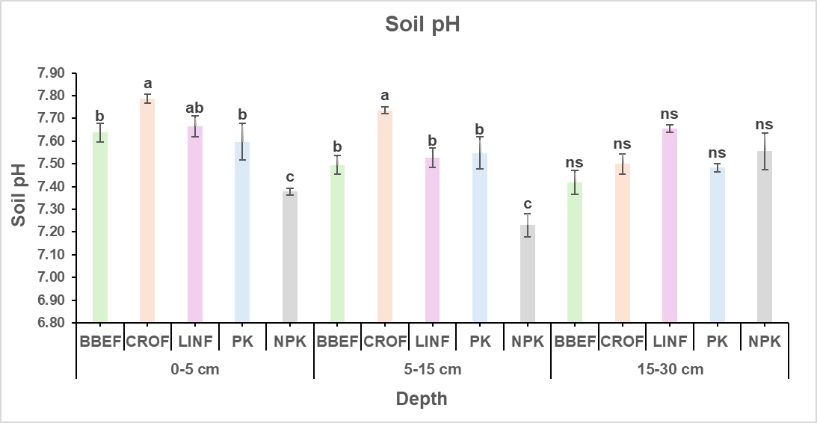
Fig. 1. Depth wise distribution of pH under different farming practices (Vertical bars with different lowercase letters are significantly different at the same depth at p< 0.05 according to Duncan multiple range test. Error bars represent standard error of mean. BBEF: biochar based ecological farming; CROF: climate-resilient organic farming; LINF: low-input natural farming; PK: phosphorus-potassium fertilization; NPK: nitrogen-phosphorus-potassium fertilization).

Soil pH was significantly influenced by the different farming practices, particularly in the surface and subsurface layers. Higher pH values under CROF and BBEF can be attributed to the liming effect of biochar and organic inputs, which tend to neutralize soil acidity and enhance buffering capacity (Heinze et al., 2010; Sun et al., 2022). Organic manures and green manuring release basic cations such as Ca²⁺, Mg²⁺, and K⁺ during decomposition, which help maintain soil alkalinity. In contrast, NPK exhibited lower pH at the surface (0-15cm), likely due to the acidifying effect of urea hydrolysis and nitrification processes (Sheoran et al., 2019). The minimal differences in deeper layers indicate that the influence of surface organic inputs diminishes with depth (Sihi et al., 2017). These results suggest that incorporation of biochar and organic matter is effective in moderating soil reaction, thereby creating a more favourable environment for nutrient availability and microbial activity. Similar trends were also observed by Meena et al., (2013) and Bhardwaj et al., (2023), who reported slightly acidic pH under NPK-based fertilization, while organic amendments maintained neutral to alkaline conditions in inceptisol of Varanasi.
3.2 Electrical Conductivity
EC values showed minimal variation among the different farming practices across the soil profile (Fig. 2). At the surface layer (0-5 cm), EC ranged from 0.13 dS m⁻¹ in the PK to 0.20 dS m⁻¹ in LINF, with no significant differences among treatments. At the subsurface layer (5-15 cm), EC values varied from 0.27 to 0.36 dS m⁻¹, and again, no significant treatment effects were observed, although LINF recorded a slightly higher mean value. At the 15-30 cm depth, however, small but significant differences were evident. The highest electrical conductivity values were maintained under BBEF, CROF, and LINF (0.25-0.27 dS m⁻¹), whereas the NPK exhibited the lowest EC (0.19 dS m⁻¹) followed by PK (0.20 dS m⁻¹).
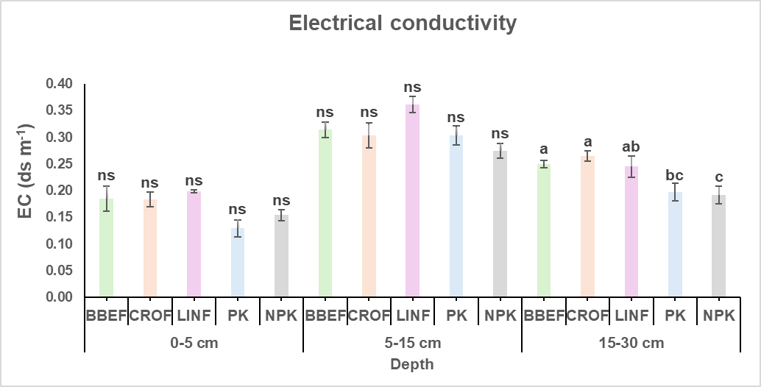
Fig. 2. Depth wise distribution of electrical conductivity under different farming practices (Vertical bars with different lowercase letters are significantly different at the same depth at p< 0.05 according to Duncan multiple range test. Error bars represent standard error of mean. BBEF: biochar based ecological farming; CROF: climate-resilient organic farming; LINF: low-input natural farming; PK: phosphorus-potassium fertilization; NPK: nitrogen-phosphorus-potassium fertilization).

EC values remained low across all treatments and depths, reflecting the non-saline nature of the soil. Slightly higher EC in BBEF, CROF and LINF at deeper layers may be due to the gradual mineralization of organic residues and release of soluble salts (Liang et al. 2006; Ikemura et al., 2008; Alotaibi and Schoenau 2016). In contrast, NPK maintained lower EC, possibly due to higher nutrient uptake by crops and reduced organic matter contribution (Lee et al. 2014). The overall EC values, however, remained well below critical thresholds for crop growth, indicating that none of the farming practices posed salinity risks. This highlights that organic and ecological practices enhance nutrient cycling without causing salt accumulation.
3.3 Soil Organic Carbon
SOC content was significantly influenced by the different farming practices, particularly in the surface and subsurface layers (Fig. 3). At 0-5 cm depth, the highest SOC was recorded under BBEF (0.80%) and CROF (0.77%), which were statistically at par with LINF (0.77%). In contrast, NPK (0.69%) and PK (0.64%) exhibited significantly lower SOC values. At the 5-15 cm layer, CROF maintained the highest SOC (0.63%), followed by BBEF and LINF (0.55-0.57%), while PK and NPK showed significantly reduced SOC (0.43-0.48%). This indicates that organic and ecological practices with green manuring contributed to greater carbon sequestration in the subsurface layer compared with inorganic fertilization or nutrient omission. At the 15-30 cm depth, BBEF sustained the highest SOC (0.45%), which was significantly greater than all other treatments. CROF (0.36%) maintained moderate SOC, whereas PK exhibited the lowest values (0.26%). The superior performance of BBEF across all depths highlights the positive contribution of biochar and organic inputs in improving soil C storage even in deeper layers.
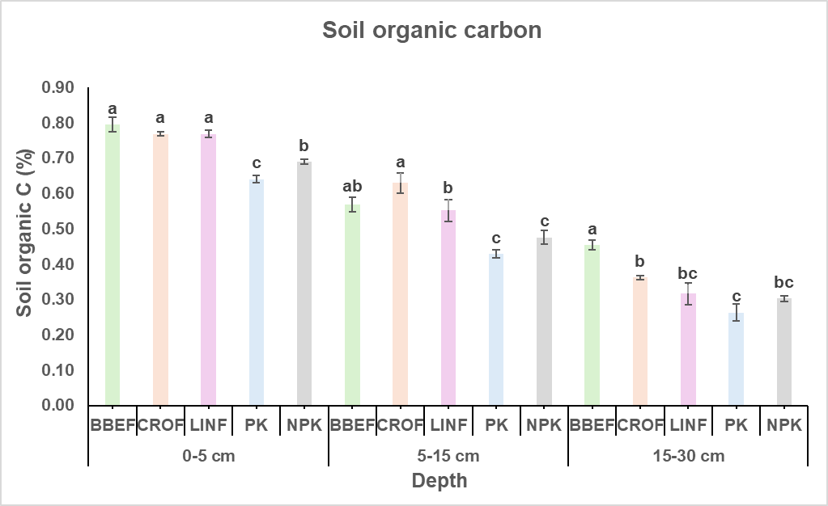
Fig. 3. Depth wise distribution of soil organic carbon under different farming practices (Vertical bars with different lowercase letters are significantly different at the same depth at p< 0.05 according to Duncan multiple range test. Error bars represent standard error of mean. BBEF: biochar based ecological farming; CROF: climate-resilient organic farming; LINF: low-input natural farming; PK: phosphorus-potassium fertilization; NPK: nitrogen-phosphorus-potassium fertilization).

SOC was strongly influenced by the management practices, with BBEF maintaining the highest levels across all depths. This is consistent with the known recalcitrant nature of biochar, which contributes to long-term carbon stabilization in soils (Hu et al. 2021). CROF and LINF also sustained higher SOC at the surface and subsurface layers due to continuous organic matter addition, root biomass, and residue incorporation (Joseph et al., 2020). In contrast, the PK and NPK showed significantly lower SOC, reflecting limited organic inputs and faster decomposition under intensive fertilization (Singh et al. 2018). The higher SOC under organic systems enhances soil aggregation, microbial activity, and nutrient cycling, confirming their role in improving soil quality and carbon sequestration potential (Drinkwater et al., 1995). A similar trend has been reported by Benbi et al. (2018), where organic farming systems in rice-wheat cropping on Inceptisol maintained higher soil organic carbon compared to conventional management.
3.4 Available Nitrogen
Available nitrogen (N) content varied significantly among the different farming practices and across soil depths (Fig. 4). At the 0-5 cm layer, BBEF (217.43 kg ha⁻¹), LINF (213.25 kg ha⁻¹), and NPK (210.11 kg ha⁻¹) recorded the highest values, which were statistically similar to CROF (194.43 kg ha⁻¹), while the lowest was observed in the PK (169.34 kg ha⁻¹). This highlights the positive effect of both ecological/organic inputs and recommended N fertilization on maintaining higher surface soil N. At 5-15 cm, BBEF and NPK maintained significantly higher available N (200.70 and 197.57 kg ha⁻¹, respectively), while CROF and LINF showed moderate levels (172.48-178.75 kg ha⁻¹). The PK again had the lowest N availability (150.53 kg ha⁻¹). In the deeper layer (15-30 cm), a similar trend was evident, with BBEF and NPK sustaining the highest available N (178.75 kg ha⁻¹ each), followed by LINF (156.80 kg ha⁻¹) and CROF (147.39 kg ha⁻¹), while the PK exhibited the lowest value (122.30 kg ha⁻¹).
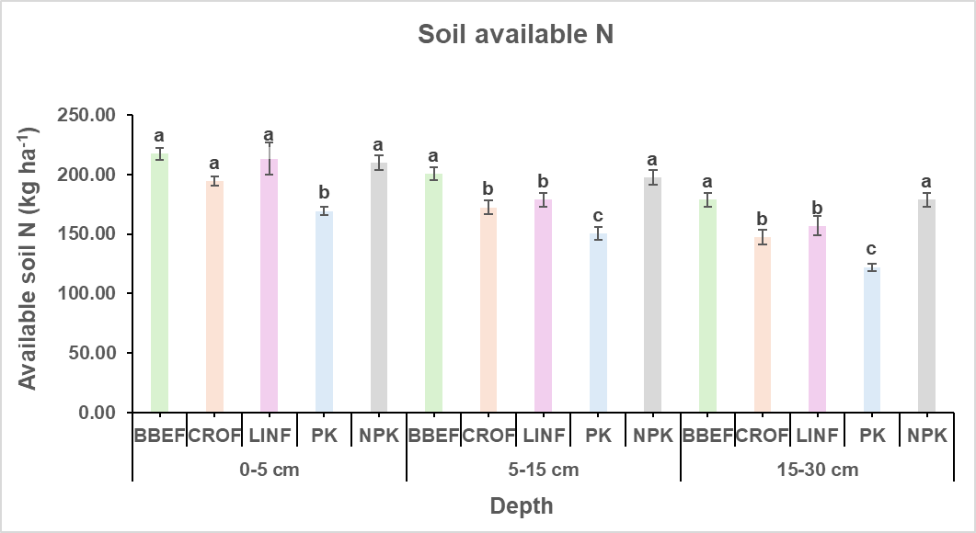
Fig. 4. Depth wise distribution of available nitrogen under different farming practices (Vertical bars with different lowercase letters are significantly different at the same depth at p< 0.05 according to Duncan multiple range test. Error bars represent standard error of mean. BBEF: biochar based ecological farming; CROF: climate-resilient organic farming; LINF: low-input natural farming; PK: phosphorus-potassium fertilization; NPK: nitrogen-phosphorus-potassium fertilization).

Nitrogen availability was highest under BBEF and NPK, indicating that both organic inputs and mineral fertilization effectively supply soil N. The improvement under BBEF can be attributed to enhanced mineralization of organic residues, better microbial activity, and biochar’s role in reducing N losses through adsorption and slow release (Xu et al. 2016). NPK benefited from direct application of urea-based N fertilizers as well as split application of neem-coated urea ensured gradual release and lower losses, resulting in sustained N supply and greater residual availability. However, the lower N levels in PK highlight the depletion of soil N in the absence of external additions. Organic systems (CROF and LINF) showed moderate N values, which could be linked to slower release from organic sources and possible immobilization during decomposition (Ikemura et al., 2008; Wang et al., 2013). These findings indicate that ecological practices with biochar can sustain N availability comparable to conventional fertilization, with added benefits for soil health.
3.5 Available Phosphorus
Available phosphorus (P) showed significant variation across treatments and soil depths (Fig. 5). At the surface layer (0-5 cm), the highest P content was recorded in the PK (20.14 kg ha⁻¹), followed by the NPK (17.93 kg ha⁻¹) and BBEF (17.38 kg ha⁻¹), while the lowest value occurred under LINF (14.62 kg ha⁻¹). At the 5-15 cm depth, BBEF, CROF, PK, and NPK maintained higher available P (14.62-16.00 kg ha⁻¹), whereas LINF recorded significantly lower P (11.45 kg ha⁻¹). In the 15-30 cm layer, BBEF sustained the highest P content (14.07 kg ha⁻¹), which was statistically similar to PK and NPK. The lowest value was again observed in LINF (9.93 kg ha⁻¹), while CROF maintained a moderate level (11.45 kg ha⁻¹).
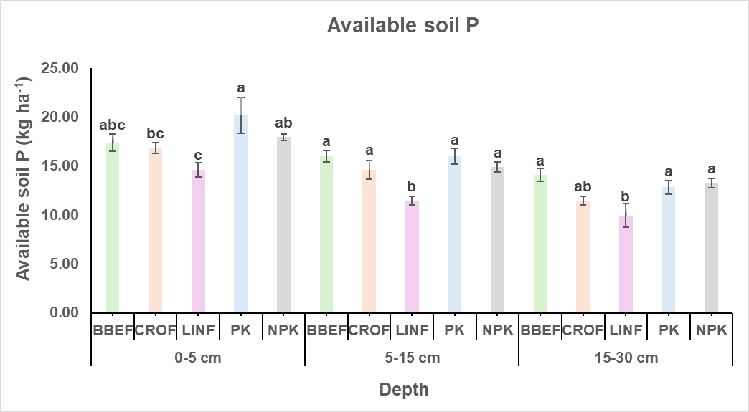
Fig. 5. Depth wise distribution of available phosphorus under different farming practices (Vertical bars with different lowercase letters are significantly different at the same depth at p< 0.05 according to Duncan multiple range test. Error bars represent standard error of mean. BBEF: biochar based ecological farming; CROF: climate resilient-organic farming; LINF: low-input natural farming; PK: phosphorus-potassium fertilization; NPK: nitrogen-phosphorus-potassium fertilization).

Phosphorus availability exhibited variable responses. The highest surface P content was observed in PK and NPK, likely due to direct application of mineral P fertilizers. In contrast, lower values in organic and natural systems (CROF and LINF) may be associated with slow mineralization of organic P and microbial immobilization. However, BBEF sustained P availability across the profile, possibly due to biochar’s ability to reduce P fixation through adsorption onto its surfaces and by modifying soil pH (Mukherjee et al., 2020). The results suggest that while mineral fertilization ensures higher immediate P availability, biochar and organic inputs can contribute to more stable P dynamics in the longer term (Oehl et al., 2002; Sanchez de Cima et al., 2015).
3.6 Available Potassium
Available potassium (K) exhibited significant differences among the farming practices across soil depths (Fig. 6). At the surface (0-5 cm), the highest K was observed in PK (171.64 kg ha⁻¹) and LINF (167.16 kg ha⁻¹), which were statistically at par with BBEF (162.96 kg ha⁻¹), whereas the lowest values were found under CROF (138.04 kg ha⁻¹) and NPK (136.08 kg ha⁻¹). At 5-15 cm depth, PK maintained significantly higher K availability (159.04 kg ha⁻¹), followed by LINF (145.88 kg ha⁻¹) whereas BBEF, CROF, and NPK recorded comparatively lower values (131-135 kg ha⁻¹). In the 15-30 cm layer, PK and BBEF sustained the highest K contents (173.32 and 168.00 kg ha⁻¹, respectively), which were statistically similar, while NPK showed the lowest K (146.44 kg ha⁻¹). Treatments CROF and LINF exhibited intermediate values.
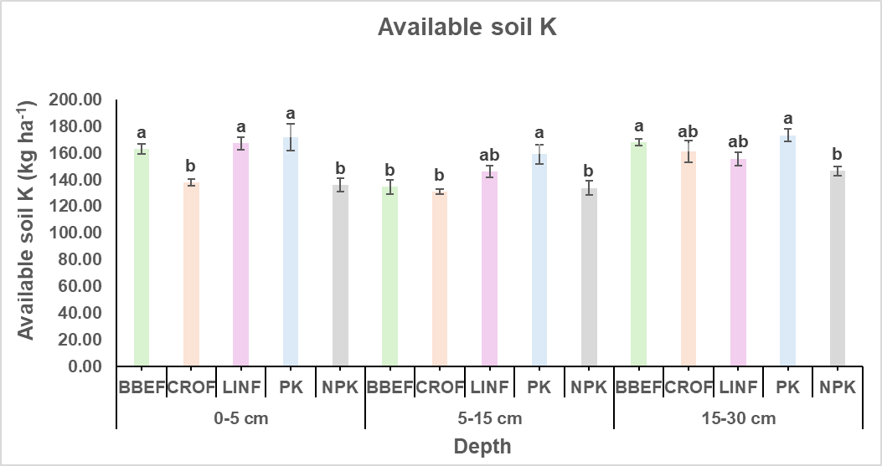
Fig. 6. Depth wise distribution of available potassium under different farming practices (Vertical bars with different lowercase letters are significantly different at the same depth at p< 0.05 according to Duncan multiple range test. Error bars represent standard error of mean. BBEF: biochar based ecological farming; CROF: climate resilient-organic farming; LINF: low-input natural farming; PK: phosphorus-potassium fertilization; NPK: nitrogen-phosphorus-potassium fertilization).

Available K was consistently higher in the PK and organic systems such as BBEF and LINF, whereas the NPK maintained the lowest levels. The higher K in PK reflects residual build-up from continuous P and K fertilization in the absence of N, leading to lower crop removal. Similarly, addition of organic matter and biochar in BBEF and LINF supplied K through mineralization of residues and improved cation exchange capacity, which enhances K retention in soil (Abu-Zahra et al., 2008; Shaaban et al., 2018). The relatively lower values in NPK may be due to greater crop uptake under higher productivity, leading to soil K depletion. Overall, the findings demonstrate that organic systems such as BBEF and LINF, along with PK, were more effective than NPK in maintaining higher available K in the soil.
4. CONCLUSION
The study clearly demonstrates that different farming practices distinctly influence soil chemical properties and nutrient dynamics across soil depths. CROF sustained higher soil pH, indicating its buffering effect against acidification. EC remained low across all treatments, confirming non-saline soils, with slightly higher values in ecological and organic systems due to greater organic residue mineralization. BBEF significantly enhanced soil organic carbon sequestration and maintained consistently higher available N and K throughout the profile, reflecting its long-term potential for soil fertility improvement. NPK, though effective in sustaining available P, was associated with lower SOC and K, suggesting greater nutrient depletion under intensive nutrient-demanding systems. Interestingly, in PK, despite N omission, maintained higher K availability, primarily due to balanced P and K inputs. Overall, BBEF, CROF and LINF systems outperformed NPK in enhancing soil health, nutrient retention, and resilience. These findings emphasize that adopting ecological and organic approaches can be a viable pathway for ensuring soil sustainability, productivity, and environmental resilience in the long run.

DISCLAIMER (ARTIFICIAL INTELLIGENCE)
The authors hereby declare that no generative AI tools (e.g., Large Language Models such as ChatGPT, Copilot, or text-to-image generators) were used in the writing or editing of this manuscript.
COMPETING INTERESTS
The authors declare that they have no competing interests.
REFERENCES
Abu-Zahra, T. R., & Tahboub, A. B. (2008). Effect of organic matter sources on chemical properties of the soil and yield of strawberry under organic farming conditions. World Applied Sciences Journal, 5(3), 383-388.
Alotaibi K.D., & Schoenau J.J. (2016). Application of two bioenergy byproducts with contrasting carbon availability to a prairie soil: three-year crop response and changes in soil biological and chemical properties. Agronomy, 6(1), 13.
Benbi, D. K., Sharma, S., Toor, A. S., Brar, K., Sodhi, G. P. S., & Garg, A. K. (2018). Differences in soil organic carbon pools and biological activity between organic and conventionally managed rice-wheat fields. Organic agriculture, 8(1), 1-14.
Bhardwaj, Y., Reddy, B., & Dubey, S. K. (2023). Organic farming favors phod-harboring rhizospheric bacterial community and alkaline phosphatase activity in tropical agroecosystem. Plants, 12(5), 1068
Bharucha, Z. P., Mitjans, S. B., & Pretty, J. (2020). Towards redesign at scale through zero budget natural farming in Andhra Pradesh, India. International Journal of Agricultural Sustainability, 18(1), 1-20.
Bhattacharyya, C., Banerjee, S., Acharya, U., Mitra, A., Mallick, I., Haldar, A., ... & Ghosh, A. (2020). Evaluation of plant growth promotion properties and induction of antioxidative defense mechanism by tea rhizobacteria of Darjeeling, India. Scientific reports, 10(1), 15536.
Drinkwater, L.E., D.K. Letourneau, F. Workneh, A.H.C., Van Bruggen, A. H. C., & Shennan, C. (1995). Fundamental differences between conventional and organic tomato agroecosystems in California. Ecological applications, 5(4), 1098-1112.
Gomez, K. A., & Gomez, A. A. (1984). Statistical procedures for agricultural research. John wiley & sons.
Glaser, B., Balashov, E., Haumaier, L., Guggenberger, G., & Zech, W. (2000). Black carbon in density fractions of anthropogenic soils of the Brazilian Amazon region. Organic geochemistry, 31(7-8), 669-678.
Hanway, J. (2018). Heidel. (1952). Soil analysis methods as used in Iowa state college soil testing laboratory. Plant and Soil.
Heinze, S., Raupp, J., & Joergensen, R. G. (2010). Effects of fertilizer and spatial heterogeneity in soil pH on microbial biomass indices in a long-term field trial of organic agriculture. Plant and Soil, 328(1), 203-215.
Hu, F., Xu, C., Ma, R., Tu, K., Yang, J., Zhao, S., ... & Zhang, F. (2021). Biochar application driven change in soil internal forces improves aggregate stability: Based on a two-year field study. Geoderma, 403, 115276.
Ikemura, Y., Shukla, M. K., Tahboub, M., & Leinauer, B. (2008). Some physical and chemical properties of soil in organic and conventional farms for a semi-arid ecosystem of New Mexico. Journal of Sustainable Agriculture, 31(4), 149-170.
Jackson, M. L. (1973). Soil chemical analysis-advanced course: A manual of methods useful for instruction and research in soil chemistry, physical chemistry of soils, soil fertility, and soil genesis.
Joseph, U. E., Toluwase, A. O., Kehinde, E. O., Omasan, E. E., Tolulope, A. Y., George, O. O., ... & Hongyan, W. (2020). Effect of biochar on soil structure and storage of soil organic carbon and nitrogen in the aggregate fractions of an Albic soil. Archives of Agronomy and Soil Science, 66(1), 1-12.
Kaye, J. P., & Hart, S. C. (1997). Competition for nitrogen between plants and soil microorganisms. Trends in Ecology & Evolution, 12(4), 139-143.
Kitamura, R., Sugiyama, C., Yasuda, K., Nagatake, A., Yuan, Y., Du, J., ... & Hatano, R. (2021). Effects of three types of organic fertilizers on greenhouse gas emissions in a grassland on andosol in southern Hokkaido, Japan. Frontiers in Sustainable Food Systems, 5, 649613.
Lee, J., Hwang, S., Lee, S., Ha, I., Hwang, H., Lee, S., & Kim, J. (2014). Comparison study on soil physical and chemical properties, plant growth, yield, and nutrient uptakes in bulb onion from organic and conventional systems. HortScience, 49(12), 1563-1567.
Lehmann, J., Gaunt, J., & Rondon, M. (2006). Bio-char sequestration in terrestrial ecosystems–a review. Mitigation and adaptation strategies for global change, 11(2), 403-427.
Li, R., Pang, Z., Zhou, Y., Fallah, N., Hu, C., Lin, W., and Yuan, Z. (2020). Metagenomic analysis exploring taxonomic and functional diversity of soil microbial communities in sugarcane fields applied with organic fertilizer. BioMed Research International, 2020.
Liang B., Lehmann J., Solomon D., Kinyangi J., Grossman J., O’Neill B., Skjemstad J.O., Thies J., Luizao F.J., Petersen J., & Neves E.G. (2006). Black carbon increases cation exchange capacity in soils. Soil Science Society of America Journal, 70(5), 1719-1730.
Meena, V. S., Maurya, B. R., Verma, R., & Meena, S. K. (2013). Effect of concentrate manure and inorganic fertilizers on soil electro-chemical properties and productivity of rice (Oryza sativa L.) under inceptisol of varanasi. Annals of Biology, 29(3), 358-363.
Mukherjee, S., Mavi, M. S., Singh, J., & Singh, B. P. (2020). Rice-residue biochar influences phosphorus availability in soil with contrasting P status. Archives of Agronomy and Soil Science, 66(6), 778-791.
Oehl, F., Oberson, A., Tagmann, H. U., Besson, J. M., Dubois, D., Mader, P., ... & Frossard, E. (2002). Phosphorus budget and phosphorus availability in soils under organic and conventional farming. Nutrient Cycling in Agroecosystems, 62(1), 25-35.
Olsen, S. R. (1954). Estimation of available phosphorus in soils by extraction with sodium bicarbonate (No. 939). US Department of Agriculture.
Piccolo, A., Pietramellara, G., and Mbagwu, J. S. C. (1996). Effects of coal derived humic substances on water retention and structural stability of Mediterranean soils. Soil Use and Management 12(4), 209-213.
Ray, P., Lakshmanan, V., Labbe, J. L., and Craven, K. D. (2020). Microbe to microbiome: A paradigm shift in the application of microorganisms for sustainable agriculture. Frontiers in Microbiology 11, 622926.
Sanchez de Cima, D., Reintam, E., Tein, B., Eremeev, V., & Luik, A. (2015). Soil nutrient evolution during the first rotation in organic and conventional farming systems. Communications in Soil Science and Plant Analysis, 46(21), 2675-2687.
Shaaban, M., Van Zwieten, L., Bashir, S., Younas, A., Nunez-Delgado, A., Chhajro, M. A., ... & Hu, R. (2018). A concise review of biochar application to agricultural soils to improve soil conditions and fight pollution. Journal of environmental management, 228, 429-440.
Sheoran, H. S., Kakar, R., & Kumar, N. (2019). Impact of organic and conventional farming practices on soil quality: A global review. Applied Ecology & Environmental Research, 17(1).
Sihi, D., Dari, B., Sharma, D. K., Pathak, H., Nain, L., & Sharma, O. P. (2017). Evaluation of soil health in organic vs. conventional farming of basmati rice in North India. Journal of Plant Nutrition and Soil Science, 180(3), 389-406.
Singh, V. K., Dwivedi, B. S., Mishra, R. P., Shukla, A. K., Timsina, J., Upadhyay, P. K., ... & Panwar, A. S. (2018). Yields, soil health and farm profits under a rice-wheat system: Long-term effect of fertilizers and organic manures applied alone and in combination. Agronomy, 9(1), 1.
Subbiah, B. V., & Asija, G. L. (1956). A rapid procedure for the estimation of available nitrogen in soils.
Sun, Z., Hu, Y., Shi, L., Li, G., Pang, Z. H. E., Liu, S., ... & Jia, B. (2022). Effects of biochar on soil chemical properties: A global meta-analysis of agricultural soil. Plant, Soil and Environment, 68(6), 272-289.
Walkely, A., & Black, T. J. S. S. (1934). Determination of organic carbon by rapid titration method. Soil Sci, 37(29), 165-177.
Wang, X. L., Ye, J., Perez, P. G., Tang, D. M., & Huang, D. F. (2013). The impact of organic farming on the soluble organic nitrogen pool in horticultural soil under open field and greenhouse conditions: a case study. Soil Science and Plant Nutrition, 59(2), 237-248.
Xu, M., Lou, Y., Sun, X., Wang, W., Baniyamuddin, M., and Zhao, K. (2011). Soil organic carbon active fractions as early indicators for total carbon change under straw incorporation. Biology and Fertility of Soils, 47, 745-752.
Xu, N., Tan, G., Wang, H., & Gai, X. (2016). Effect of biochar additions to soil on nitrogen leaching, microbial biomass and bacterial community structure. European journal of soil biology, 74, 1-8.

