Original Research Article

Identification of rice cropping season and high-resolution area estimation in major rice tracts of Kerala using Sentinel-1 SAR and Sentinel-2 optical imageries

ABSTRACT
Accurate identification of rice cropping seasons and precise estimation of cultivated area are critical for agricultural monitoring, water allocation, and greenhouse gas modeling. In Kerala, rice fields are highly fragmented and prone to cloud interference, making traditional optical methods unreliable during peak monsoon. This study employed a combination of Sentinel-1 C-band Synthetic Aperture Radar (SAR) time-series (VH polarization) and Sentinel-2 optical imageries to capture crop phenology and to delineate rice extent in two contrasting systems: the below-sea-level wetlands of Kuttanad and the fertile alluvial plains of Palakkad. Seasonal dynamics derived from monthly VH backscatter (σ⁰) from Sentinel-1 SAR were cross-validated with Sentinel-2 NDVI and field surveys 2023-24 and 2024-25, enabling clear detection of Puncha season crop (November–March) and Viruppu (May–September) in Kuttanad and Mundakan (November–March) in Palakkad. Supervised Maximum Likelihood Classification (MLC) of Sentinel-2 imagery, supported by VH and NDVI time-series, estimated 46,960.65 ha of rice in Kuttanad and 20,519.50 ha in Palakkad, with Kappa coefficients of 0.87 and 0.83, respectively., This research focused on block-level mapping and rice concentration indices, revealing intra-district variability and identified hotspots of rice cultivation such as Veliyanad in Kuttanad and Alathur in Palakkad. The results confirm the robustness of SAR-based monitoring for crop season detection and demonstrate the scalability of Sentinel-1 and Sentinel-2 fusion for precision agriculture in fragmented, flood-prone tropical landscapes.
Keywords: Sentinel-1 SAR; Sentinel- 2, rice season identification; VH backscatter; NDVI; rice area estimation; Kuttanad; Palakkad
Introduction
Rice (Oryza sativa L.) is the primary staple food for over half of the world’s population, constituting the main source of daily calories in Asia and substantial portions in Africa and Latin America. Global milled rice production exceeds 500 million metric tons annually, highlighting its pivotal role in food security (FAO, 2023). Demand is projected to rise rapidly, and to meet future needs, rice production must increase by approximately 40% by 2030 (Khush, 2005). Achieving this target is challenging given shrinking arable land, freshwater scarcity, and climate variability. India, as the second-largest producer and consumer of rice and the largest exporter, heavily relies on the crop across its diverse agro-ecological zones. Rice occupies nearly one-quarter of the gross cropped area and contributes over 40% of total food grain production. In 2023–24, India produced 137.83 million tonnes of rice out of 332.30 million tonnes of food grains, reaffirming rice’s 41.5% share in national output (MoA&FW, 2024). Kerala, however, has faced a persistent decline in rice cultivation over several decades. The area under paddy fell from 8.7 lakh hectares in 1970–71 to 1.96 lakh hectares in 2021–22, resulting in a 90% reduction in production (Agricultural Statistics, 2021–22). Climate variability, particularly fluctuations in temperature and rainfall, further exacerbates yield reductions, as rice is highly water-intensive compared to other crops, making it especially vulnerable to droughts, irregular monsoons, and rising temperatures. Historically, rice mapping relied on agricultural statistics compiled from surveys and field reports (Huke & Huke, 1997). Although informative, these methods were labour-intensive, time-consuming, and limited in spatial resolution. Advances in remote sensing and geospatial technologies now provide a reliable, rapid, and spatially detailed alternative for estimating large-scale rice areas, enabling accurate preharvest assessment and improved agricultural planning (Mosleh et al., 2015). Remote sensing has become essential for monitoring rice cultivation in Asia. Time-series MODIS data have successfully mapped rice in the Mekong Delta (Sakamoto et al., 2009) and across South and Southeast Asia by analyzing crop phenology (Xiao et al., 2006). Moderate-resolution sensors, such as MODIS 500 m, are effective in intensive cropping regions (Gumma et al., 2011). However, such moderate-resolution datasets are insufficient in fragmented rice ecologies like Kerala, where field sizes are small and crop management is highly heterogeneous.
Integrating optical imagery with Synthetic Aperture Radar (SAR) data addresses these limitations. Sentinel-1 SAR, with high revisit frequency and sensitivity to flooded conditions, enables reliable rice monitoring even under continuous cloud cover (Park et al., 2018). SAR data, especially VH polarization, are particularly effective in tracking the rice growing cycle, as backscatter increases during transplanting and vegetative stages, stabilizes during canopy closure, and decreases towards harvest. This makes Sentinel-1 indispensable for accurate season identification in cloud-prone areas like Kerala. Region-specific studies highlight the advantages. Raju et al. (2022) mapped Palakkad rice fields using three cloud-free Sentinel-2 datasets, and Jasmin et al. (2024) delineated Puncha-season rice areas in Kuttanad using Landsat 8 OLI and GIS. Fusing SAR and optical datasets has consistently improved classification accuracy in fragmented or cloud-prone landscapes (Mostafa, 2015). Despite these advances, most Kerala-based studies either used optical imagery alone or were limited to district-level analyses, overlooking finer block-level variability and the temporal identification of cropping seasons. These studies show that cloud-free optical images taken at the peak crop stage are useful for estimating rice extent. However, most were conducted at broader scales such as districts or agro-ecological units. Studies focusing on block-level estimation are limited, even though crop and water management practices vary across locations. High-resolution mapping at this finer scale is important for region-specific production estimates and greenhouse gas assessment. Therefore, this study integrates Sentinel-1 SAR time-series with Sentinel-2 optical imagery to identify rice cropping seasons and to estimate rice extent at both district and block levels in Kerala’s major rice tracts, Kuttanad and Palakkad. By validating VH backscatter and NDVI trends against farmer surveys, this research establishes a robust, scalable framework for season detection and high-resolution mapping in fragmented and flood-prone rice ecosystems.
MATERIALS AND METHODS
Study Area
This study was carried out in Kerala’s two most important rice-growing tracts: the Kuttanad wetland system in the southern districts and the Palakkad plains in central Kerala. These regions together constitute the rice heartland of the state. Still, they represent contrasting agro-ecological environments: Kuttanad and Palakkad. Their complementary characteristics make them ideal for comparative mapping of rice areas. The geographic extent of the study regions is presented in Figure 1.

Palakkad
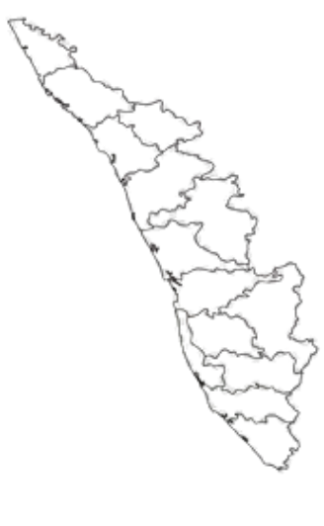
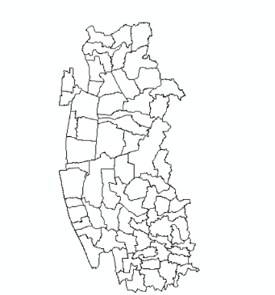
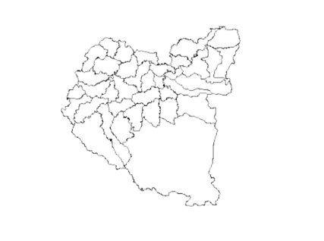
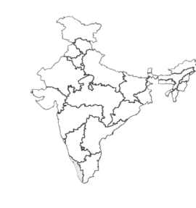
INDIA

Kuttanad

Figure 1. Location map of the study areas
Kuttanad Region
Kuttanad, often called the “Rice Bowl of Kerala,” is located in the southern part of the state, covering parts of Alappuzha, Kottayam, and Pathanamthitta districts. Geographically, it spans between 7°30′ and 11°15′ N latitude and 75°30′ and 77°30′ E longitude. The region’s safety is also ensured by the Thanneermukkom barrage, which prevents saline water intrusion from Arabian sea during summer.
Climatically, Kuttanad experiences a humid tropical environment with an average annual rainfall of ~2,600–2,700 mm, dominated by the southwest monsoon, and mean temperatures ranging from 24–31 °C. Its rice farming system is globally unique, as paddy is cultivated up to 2–3 m below mean sea level in polder-like fields protected by bunds and pumps. This remarkable adaptation has earned Kuttanad recognition as a Globally Important Agricultural Heritage System (GIAHS) by the FAO. The primary rice crop here is the Puncha (November – March) which is carried out when floodwater recedes, and in tracts with well-developed drainage facilities, an additional crop is occasionally taken during the kharif ie. Viruppu (May–September).
Palakkad Region
Palakkad, often referred to as the “Granary of Kerala,” lies in the central part of the state, bordered by Malappuram to the north, Thrissur to the west, and Tamil Nadu to the east and south. Geographically, it extends between 10°21′ and 11°14′ N latitude and 76°00′ and 76°54′ E longitude. The district is characterized by an extensive alluvial plain intersected by the Palakkad Gap, a major physiographic feature resulting in dry weather conditions in this area compared to other parts of the state. Fertile soil, coupled with irrigation from major projects such as the Malampuzha dam and Bharathapuzha river system, make Palakkad the state’s one of the prominent rice-growing tract.
Climatically, Palakkad has a tropical wet–dry environment with an average annual rainfall of ~2,200–2,300 mm, nearly 70% of which is received from the southwest monsoon. Mean temperatures typically range between 20–34 °C, favourable for rice cultivation. Paddy is cultivated mainly in two seasons: Virippu (May–September), coinciding with the southwest monsoon, and Mundakan (November–February), which has increasingly become the dominant crop owing to better post-monsoon water availability. The region is historically renowned for the Palakkadan Matta rice, a traditional variety that has been accorded a Geographical Indication (GI) tag, underscoring its cultural, nutritional, and economic importance.
Time series analysis Sentinel-1 SAR and Sentinel-2 Optical Data
In this study, Sentinel-1 C-band Synthetic Aperture Radar (SAR) data were accessed via the Sentinel Hub API in the Copernicus Data Space Ecosystem (https://dataspace.copernicus.eu). were used to identify rice growing season and to improve rice mapping. Sentinel -1 images were acquired in Interferometric Wide (IW) mode at 10 m spatial resolution. VH polarization (vertical transmit, horizontal receive) was selected for analysis because of its sensitivity to surface water dynamics and crop structural changes. The VH backscatter coefficient (σ⁰) was expressed in decibels (dB), representing the normalized radar cross-section after radiometric calibration. Sentinel-1 provided a revisit interval of 12 days during the study period (with only Sentinel-1A operational after the loss of Sentinel-1B in 2021). To minimize speckle and short-term variability, all Sentinel-1 VH acquisitions within each month were aggregated into a monthly median backscatter composite. This harmonized dataset of monthly VH backscatter (median) values from May 2023 to April 2025 formed the basis for time-series analysis, crop season identification, and classification.
In addition to Sentinel-1 SAR , Sentinel-2 Level-2A optical imagery with a spatial resolution of 10 m was utilized to generate NDVI time series which was retrieved from USGS Earth Explorer (https://earthexplorer.usgs.gov/) .
The Normalized Difference Vegetation Index (NDVI) was derived from Sentinel-2 Level-2A surface reflectance data using the equation:

$$NDVI=\frac{\left(NIR-RED\right)}{\left(NIR+RED\right)}$$
where NIR = Band 8 (842 nm) and RED = Band 4 (665 nm). NDVI values range from -1 to +1, with higher values indicating dense and healthy vegetation. To account for satellite revisit cycles, monthly composites were generated. Sentinel-2A and 2B together provide a revisit interval of 5 days, though frequent cloud cover in Kerala reduces the number of usable acquisitions. Therefore, all available Sentinel-2 images within each month were processed, and the maximum NDVI composite was extracted to generate time series to capture peak vegetation vigour.
The generation of VH backscatter and NDVI values were done using a complementary unsupervised clustering approach in Google Earth Engine (GEE) using Sentinel-1 and Sentinel-2 time-series data. K-Means clustering (20 clusters) was applied to monthly NDVI and VH composites, which were subsequently reclassified into rice and non-rice categories based on temporal spectral signatures. This methodology was adapted from earlier work in Peninsular Malaysia (Fatchurrachman et al., 2022), which demonstrated the utility of Sentinel-1 and Sentinel-2 fusion for high-resolution rice mapping in Google Earth Engine.
To strengthen reliability, field surveys for ground truthing were conducted in both Kuttanad and Palakkad during the 2023–24 and 2024–25 seasons.
Rice area estimation
Generation of Sentinel-2 Image Composites
Both the study area was covered by separate Sentinel 2 cloud-free (<5%) tiles. The datasets corresponding to Palakkad (07 January 2025, Orbit 19) and Kuttanad (27 January 2025, Orbit 19), as summarized in Table 1, were used. A true colour composite (TCC) was created using the red (B4), green (B3), and blue (B2) bands, depicting surface features as seen by the human eye, with vegetation in green, water bodies in dark blue, and built-up areas in grey-white. Additionally, a false colour infrared composite (FCC) incorporating the near-infrared band (B8) was generated to highlight vegetation vigour, showing healthy vegetation in red, while urban and non-vegetated areas appeared in lighter tones. These composites facilitated easy visual interpretation and improved discrimination of rice fields from other land cover types.
The true colour composite (TCC) and false colour composite (FCC) generated for the Kuttanad region are shown in Figures 6a and 6b. Similarly, the corresponding composites for Palakkad are shown in Figures 8a and 8b.
Table 1. Sentinel-2 Image Acquisition Details for Study Areas
Date | Platform | Orbit No. | Product | Study Area
07/01/2025 | Sentinel-2B | 19 | S2B_MSIL2A_20250107T051119 | Palakkad
27/01/2025 | Sentinel-2B | 19 | S2B_MSIL2A_20250127T051009 | Kuttanad

Table 2. Sentinel-2 Spectral Bands and Spatial Resolution
Bands | Wavelength  (nanometres) | Resolution  (meters)
Band 2 - Blue | 490 nm | 10 m
Band 3 - Green | 560 nm | 10 m
Band 4 - Red | 665 nm | 10 m
Band 8 – Near Infrared | 842 nm | 10 m
Source: https://dataspace.copernicus.eu

Maximum Likelihood Supervised Classification and Rice Area Estimation
Rice fields in Kuttanad and Palakkad were delineated using Maximum Likelihood Supervised Classification (MLC) implemented in ArcMap 10.8 (Esri, Redlands, USA). Ground truth data collected from the field served as the primary training and validation source. In Kuttanad, 40 rice and 30 non-rice points were surveyed, while in Palakkad, 20 rice and 20 non-rice points were recorded. These representative training samples for rice and other land cover classes were generated using the training sample manager in ArcMap, supplemented with reference data obtained by ground truthing to ensure classification reliability.
The MLC algorithm in ArcMap calculates the probability of each pixel belonging to a given class and assigns it to the class with the highest likelihood based on spectral signatures, producing a classified raster map of rice and non-rice areas (Richards & Jia, 2006). The rice and other land cover classes were quantified at both district and block levels. For each block, the number of pixels corresponding to each class was counted and converted to hectares using the formula:
​ Rice Area (ha)=Number of rice pixels×100​/10000
where 100 is the area of one pixel in m
To facilitate block-level analysis, the administrative boundaries of 5 blocks in Palakkad and 14 blocks in Kuttanad were superimposed on the classified imagery. This allowed the extraction of pixels corresponding to each block, enabling finer spatial quantification of land cover classes.
To assess the reliability of the classification, an error matrix was generated by comparing the classified map with field-based reference data (Congalton, 1991). Confusion matrices as well as the Kappa coefficients were calculated (Cohen, 1960; Pontius & Millones, 2011), ensuring that the rice area estimates were consistent with actual field conditions. Block-level accuracy assessment was also conducted to ensure the reliability of rice and land cover area estimates at finer spatial scales.
RESULTS AND DISCUSSION
NDVI and VH Time-Series Dynamics – Kuttanad
The NDVI and VH time-series for Kuttanad (May 2023–April 2025) predominantly captured the Puncha crop season (November–March), the region’s major rice-growing phase (Fig 2 &3). NDVI rose after transplanting (~0.20) in late November, peaked at ~0.40–0.45 during January–February vegetative stages, and declined with harvest in March. A smaller, weaker peak occurred between June–September, indicating limited additional cropping in some upper blocks. Minimum NDVI values (<0.15) were observed during fallow stages in April–May. VH backscatter followed similar seasonal patterns, rising to –18.5 dB at transplanting, peaking around –17.2 to –17.0 dB during dense growth, and declining to –20.0 to –20.5 dB post-harvest. Both indices showed higher variability during transplanting and harvest due to staggered sowing and waterlogging, while convergence occurred at peak growth.
NDVI and VH Time-Series Dynamics – Palakkad
In Palakkad, the time series clearly reflected the double-cropping system of Viruppu (June–September) and Mundakan (November–March) (Fig 4 & 5). NDVI increased after transplanting in each season, peaking at ~0.38–0.40 in August–September for Viruppu and ~0.35–0.38 in January–February for Mundakan, before declining with maturity and harvest. VH backscatter captured these dynamics as well, with values rising during transplanting and flooding, peaking around –15.2 to –15.4 dB in the vegetative stage, and falling to –16.5 to –17.0 dB in fallow phases.
Taken together, NDVI and VH exhibited a complementary, inverse relationship: VH peaked early during transplanting and waterlogged stages, while NDVI rose later with canopy development. This correlation, when validated against transplanting dates, water status, and crop growth stages collected from farmers and verified by agricultural officers, confirmed the seasonal cycles (Puncha in Kuttanad, Viruppu and Mundakan in Palakkad) and enhanced the temporal interpretation of rice dynamics. These findings coincide with recent demonstrations of NDVI–VH integration for rice monitoring, where NDVI tracked canopy growth while VH backscatter captured flooding and transplanting stages (Ramadhani et al., 2020; Hegde et al., 2025). Our Kerala results strongly reflect this complementary pattern.
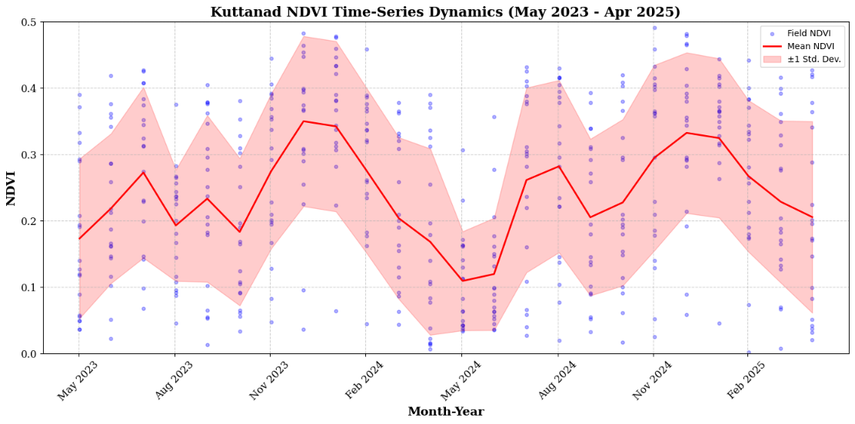
Figure 2. NDVI time-series dynamics for Puncha and additional crop in Kuttanad (May 2023 – April 2025).
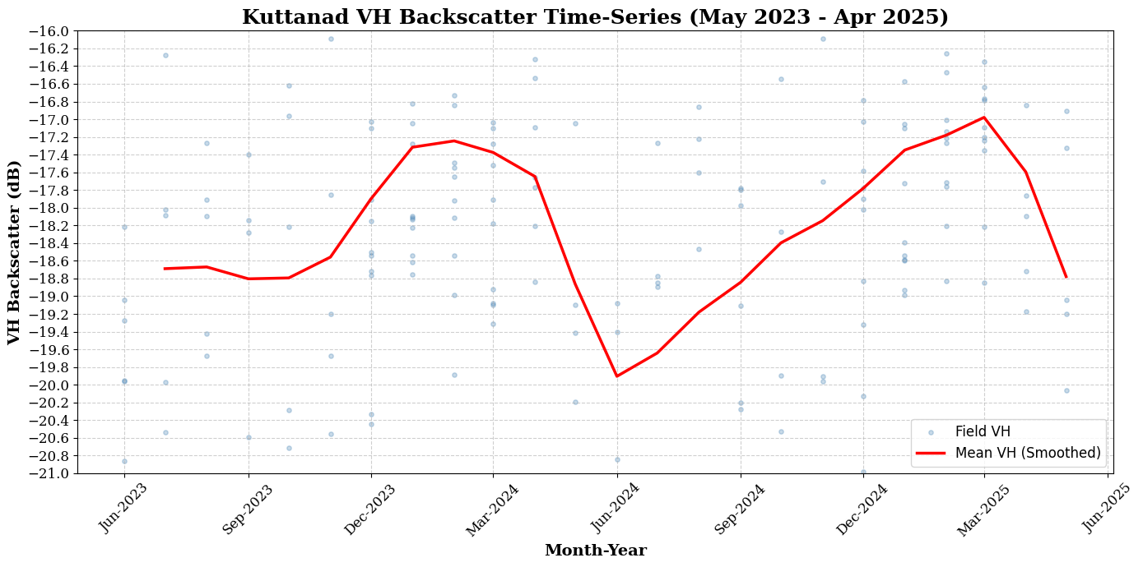
Figure 3. VH backscatter (dB) time-series of Puncha and additional rice crop in Kuttanad (May 2023 – April 2025).

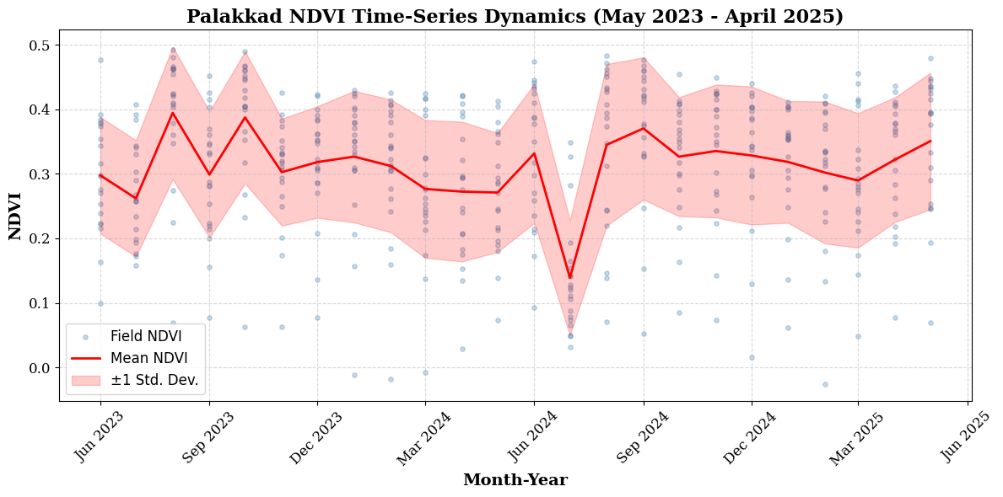
Figure 4. NDVI time-series dynamics for Viruppu and Mundakan crops in Palakkad (May 2023 – April 2025).

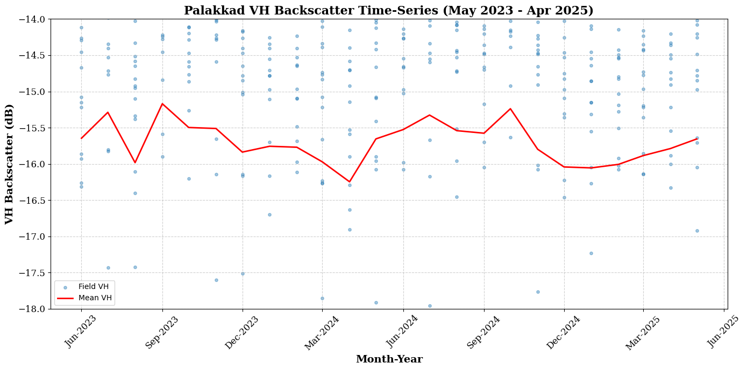
Figure 5. VH backscatter time-series dynamics for Viruppu and Mundakan crops in Palakkad (May 2023 – April 2025).

Rice Area Estimation
Land cover classification of the study regions revealed distinct patterns of rice cultivation alongside other land use types. In Kuttanad, paddy fields accounted for 46,960.65 ha (31.8% of the total land cover), with built-up land (46,494.37 ha), other vegetation (42,767.46 ha), water bodies (11,060.68 ha), and only a small extent of barren land (479.98 ha). In Palakkad, the rice area was estimated at 20,519.50 ha (11.3% of the total land cover), while built-up areas (21,844.85 ha), other vegetation (96,544.53 ha), barren land (38,666.66 ha), and water bodies (4,154.17 ha) formed the other major land cover classes. The estimated rice area in Kuttanad (46,960.65 ha) was marginally higher than the adjusted official acreage for the Puncha season (42,747.40 ha) reported in Agricultural Statistics 2022–23 (Directorate of Economics and Statistics, Government of Kerala, 2024), with a deviation of about 9.8%. In Palakkad, the classified extent (20,519.50 ha), corresponding primarily to the Mundakan season, closely matched the official figure of 19,187.89 ha from the same source, showing a deviation of about 6.9%, thereby confirming the robustness of the methodology across contrasting agro-ecological systems. The classified land use/land cover maps of Kuttanad and Palakkad are shown in Figure 7a and Figure 9a, respectively. The detailed distribution of land cover classes in both regions is presented in Table 3.
Table 3. Land Cover Classification and Area Statistics for Kuttanad and Palakkad
Land Cover Type
  Kuttanad (ha)
  Palakkad (ha)
Paddy Field | 46,960.65 | 20519.50
Built-up | 46,494.37 | 21,844.85
Other Vegetation | 42,767.46 | 96,544.53
Barren Land | 479.98 | 38,666.66
Water Body | 11,060.68 | 4,154.17
Accuracy Assessment
The accuracy of rice classification was assessed using ground-truth rice and non-rice points collected during field surveys. The spatial distribution of these validation points is illustrated in Figure 7b for Kuttanad and Figure 9b for Palakkad. These datasets were overlaid on the classified maps to generate a confusion matrices. In Kuttanad, the classification achieved 92.5% accuracy for rice and 90% for non-rice areas, with an overall accuracy of 91.25% and a Kappa coefficient of 0.87, indicating strong agreement between classified and reference data. In Palakkad, rice classification achieved 90% accuracy for both rice and non-rice areas, with an overall accuracy of 90% and a Kappa coefficient of 0.83. The detailed accuracy statistics are summarized in Table 4.
Table 4. Confusion matrix for the accuracy assessment of rice classification (Kuttanad)

Study area | Actual Class | Predicted Rice | Predicted Non-rice | Accuracy (%) | Reliability (%) | Kappa
Kuttanad | Rice | 37 | 3 | 92.50 | 92.50 | 0.87
Kuttanad | Non rice | 3 | 27 | 90.00 | 90.00 | 0.87
Palakkad | Rice | 18 | 2 | 90.00 | 90.00 | 0.83
Palakkad | Non rice | 2 | 18 | 90.00 | 90.00 | 0.83

Block-Level Analysis of Land Cover
To capture spatial variability within the study regions, rice and other land cover areas were also quantified at the block level. A total of 5 blocks in Palakkad (Chittur, Kollengode, Kuzhalmannam, Alathur, and Nemmara) and 15 blocks in Kuttanad (Pulikeezhu, Pattanakkad, Aryad, Haripad, Chengannur, Mavelikara, Uzhavoor, Veliyanad, Ambalapuzha, Champakulam, Pallom, Madappally, Vaikom, Ettumanoor, and Kanjikkuzhi) were considered.
Block boundaries were overlaid on the classified images, and zonal statistics were computed to extract the extent of each land cover type at the block scale. The resulting block-level estimates enabled a detailed comparison of rice distribution across administrative units. The results are summarized in Table 5 for Kuttanad and Palakkad.
Block-level analysis captured spatial variability within the districts. In Palakkad, Alathur and Nemmara blocks contained the largest rice areas (5,456.65 ha and 4,867.30 ha, representing 26.6% and 23.7% of the district total, respectively), followed by Kollengode (3,825.71 ha, 18.6%), Chittur (3,389.54 ha, 16.5%), and Kuzhalmannam (2,980.30 ha, 14.5%).
In Kuttanad, Veliyanad exhibited the highest rice coverage at 11,997.63 ha (25.55%), followed by Champakulam (7,995.05 ha, 17.02%), Ettumanoor (4,614.28 ha, 9.83%), Pulikeezhu (4,025.83 ha, 8.57%), and Pallom (3,844.17 ha, 8.19%). Other blocks, including Haripad, Chengannur, Aryad, Uzhavoor, Mavellikara, Ambalapuzha, Kaduthuruthy, Vaikom, and Kanjikkuzhi, contributed smaller proportions, reflecting fragmented rice cultivation across Kuttanad.
Kuttanad region – Block-wise Rice Area
Table 5. Block-wise rice area in the Kuttanad region
Kuttanad
Block | Rice Area (ha) | % of District Total
Veliyanad | 11997.63 | 25.55
Champakulam | 7995.05 | 17.02
Etthumanoor | 4614.28 | 9.83
Pulikeezhu | 4025.83 | 8.57
Pallom | 3844.17 | 8.19
Haripad | 2683.46 | 5.71
Madapally | 2659.45 | 5.66
Chengannur | 2164.03 | 4.61
Aryad | 1572.31 | 3.35
Uzhavoor | 1335.66 | 2.84
Mavellikara | 1305.7 | 2.78
Kaduthuruthy | 733.7 | 1.56
Vaikom | 655.46 | 1.4
Kanjikuzhi | 204.54 | 0.46
Total | 46,960.65 | 100
Palakkad District
Alathur | 5456.65 | 26.6
Nemmara | 4867.30 | 23.7
Kollengode | 3825.71 | 18.6
Chittur | 3389.54 | 16.5
Kuzhalmannam | 2980.30 | 14.5
Total | 20519.50 | 100

Rice Concentration Mapping
Rice concentration maps were generated to visualize the proportion of land under paddy cultivation, categorized into six classes: 0–5%, 5–10%, 10–15%, 15–20%, 20–25%, and 25–30%. In Palakkad, high-concentration areas were primarily concentrated in Alathur and Nemmara, where rice accounted for more than 20% of the total land area. Kollengode and Chittur exhibited moderate concentrations (10–20%), while Kuzhalmannam had relatively low rice coverage (<10%). In Kuttanad, Veliyanad, and Champakulam emerged as the zones with the highest rice concentration (20–30%), followed by Ettumanoor, Pulikeezhu, and Pallom (10–20%). Remaining blocks showed low rice density, often below 10%, reflecting the fragmented nature of paddy cultivation in these regions. The spatial distribution and concentration of rice areas in the study regions are illustrated in Figure 10 for Kuttanad and Palakkad, respectively.
These concentration maps highlight spatial heterogeneity in rice distribution, helping to identify high-intensity cultivation areas and support preharvest estimation, resource allocation, and targeted agricultural interventions. They also provide a baseline for monitoring temporal changes in rice distribution under pressures from climate variability and land-use change.
Several researchers have investigated rice area mapping using diverse remote sensing datasets and classification strategies under varying agro-ecological and climatic conditions. Sun et al. (2023), for instance, advanced tropical rice mapping by applying Sentinel-1 SAR time series with a U-Net deep learning framework, achieving an overall accuracy of 92.2% and strong correlations across administrative levels. Fan et al. (2025) introduced a novel Landsat–Google Earth Engine workflow combining automated training sample generation with machine learning guided by phenological patterns, reaching exceptionally high accuracies (overall >97%, Kappa >0.95). These works highlight the growing trend of integrating advanced classification algorithms and multi-source datasets to enhance reliability in rice monitoring.
In India, particularly in southern rice-growing regions, remote sensing has been successfully applied for acreage estimation. Ajith et al. (2017) used Landsat 8 OLI imagery in Thanjavur, Tamil Nadu, achieving 87% accuracy, while Raju et al. (2022) mapped rice cultivation in Palakkad, Kerala, using Sentinel-2 mosaics, reporting ~24,743 ha during the Mundakan season with 88.3% accuracy (Kappa = 0.77). Similarly, Rahana et al. (2024) delineated ~43,550 ha of Puncha rice in Kuttanad using Landsat 8 OLI with 93.3% accuracy and a Kappa coefficient of 0.87. The Kappa values obtained in the present study (0.87 in Kuttanad and 0.83 in Palakkad) align closely with these earlier findings, reaffirming the robustness of satellite-based rice mapping across diverse agro-ecosystems. However, unlike previous district-level or single-season assessments, the present research advances this work by employing Sentinel-2 Level-2A imagery in combination with Sentinel-1 VH backscatter to achieve block-level rice mapping and phenology tracking, thereby capturing intra-district variability and seasonal cropping dynamics.
Beyond optical datasets, several works emphasized the complementary role of vegetation indices and SAR backscatter. Ramadhani et al. (2020) showed that integrating NDVI/EVI with Sentinel-1 VH improves rice growth stage discrimination across Southeast Asia. In Kerala, recent studies (Hegde et al., 2025; Multi-season rice mapping in the Kuttanad Delta, 2024) used deep learning and multi-temporal Sentinel-1/2 fusion to track seasonal variability, confirming that VH peaks during transplanting and early growth, while NDVI increases during canopy development. These patterns closely align with the temporal dynamics observed in the present study.
Collectively, the literature underscores the potential of remote sensing for rice monitoring but also highlights a gap in high-resolution, block-level mapping that accounts for intra-district variability—an aspect critical for operational planning and greenhouse gas assessment. The present study addresses this gap by integrating Sentinel-1 VH backscatter with Sentinel-2 NDVI and employing Maximum Likelihood Supervised Classification to generate block-level rice maps for Kuttanad and Palakkad. Validation with ground observations (Kappa = 0.83–0.87), cross-verification of NDVI and VH time-series against farmer-reported transplanting and growth stages, and the identification of rice concentration hotspots provide strong evidence of the reliability and scalability of this approach. By focusing on the November–April cropping season—Puncha in Kuttanad and Mundakan in Palakkad—this research builds upon and extends earlier works, offering a framework adaptable to Kerala’s fragmented and flood-prone agro-ecosystems.
CONCLUSION
Sentinel-2 Level-2A imagery, combined with NDVI time-series and supervised Maximum Likelihood Classification, proved highly effective for precise rice mapping and phenology tracking in Kerala’s contrasting agro-ecological regions, achieving strong accuracies. Block-level disaggregation and rice concentration mapping revealed spatial variability overlooked in district-scale studies, identifying hotspots such as Veliyanad in Kuttanad and Alathur in Palakkad. Crucially, integration of NDVI trends with Sentinel-1 VH backscatter enabled robust phenology monitoring under persistent cloud cover, validating Puncha and Viruppu/Mundakan cycles while capturing intra-block heterogeneity like the June–September crop in upper Kuttanad. By overcoming limitations of earlier optical-only or coarse-scale SAR studies, this NDVI–VH fusion proved reliable for high-resolution, seasonally adaptive rice monitoring. This enhances pre-harvest estimation, irrigation planning, and methane emission assessments, establishing a scalable framework linking rice acreage estimation to food security and climate resilience strategies.
(a)
(b)
Figure 6. Clipped Kuttanad region: (6a) True Colour Composite; (6b) False Colour Composite.
(b)
(a)
Figure 7. Classified LULC map of the study area: (7a) Five land cover classes; (7b) Rice area with validation points (rice and non-rice).

(b)
(a)
Figure 8. Clipped Palakkad region: (8a) True Colour Composite; (8b) False Colour Composite

(b)
(a)

Figure 9. Classified LULC map of the study area: (9a) Five land cover classes; (9b) Rice area with validation points (rice and non-rice).

25-30%
20-25%%
15-20%%
5-10%
0-5%
Paddy Area Share (%)
Legend
25-30%
20-25%
15-20%
5-10%
0-5%
Paddy Area Share (%)
Legend
Figure 10. Rice area concentration map (a) Kuttanad region; (b) Palakkad district.

REFERENCES
Ajith, K., Geethalakshmi, V., Raghunath, K. P., Pazhanivelan, S., & Panneerselvam, S. (2017). Rice acreage estimation in Thanjavur, Tamil Nadu using Landsat 8 OLI and GIS techniques. International Journal of Current Microbiology and Applied Sciences, 6(7), 2327-2335.
Cohen, J. (1960). A coefficient of agreement for nominal scales. Educational and Psychological Measurement, 20(1), 37-46.
Congalton, R. G. (1991). A review of assessing the accuracy of classifications of remotely sensed data. Remote Sensing of Environment, 37(1), 35-46.
Fan, Y., Yuan, D., Zhang, L., Zhao, M., & Yang, R. (2024). A rice-mapping method with integrated automatic generation of training samples and random forest classification using Google Earth Engine. Agronomy, 15(4), 873. https://doi.org/10.3390/agronomy15040873
Food and Agriculture Organization of the United Nations (FAO). (2023). FAOSTAT statistical database. Retrieved from https://www.fao.org/faostat/en/
Fatchurrachman, M., Rudiyanto, Soh, N. C., Shah, R. M., Goh, E. G., Setiawan, B. I., & Minasny, B. (2022). High-resolution mapping of paddy rice extent and growth stages across Peninsular Malaysia using a fusion of Sentinel-1 and 2 time series data in Google Earth Engine. Remote Sensing, 14(8), 1875. https://doi.org/10.3390/rs14081875
Government of Kerala, Directorate of Economics and Statistics. (2024). Agricultural Statistics 2022–23. Thiruvananthapuram.
Gumma, M. K., Thenkabail, P. S., Maunahan, A., Islam, S., & Nelson, A. (2014). Mapping seasonal rice cropland extent and area in the high cropping intensity environment of Bangladesh using MODIS 500 m data for the year 2010. ISPRS Journal of Photogrammetry and Remote Sensing, 91, 98-113. https://doi.org/10.1016/j.isprsjprs.2014.02.007
Hegde, A., Nair, M. K., Umesh, P., & Tahiliani, M. P. (2024). Multi-season rice mapping using deep learning models with multitemporal Sentinel-1 SAR data in the Kuttanad Delta, Kerala. International Journal of Image and Data Fusion, 16(1). https://doi.org/10.1080/19479832.2024.2527032
Huke, R. E., & Huke, E. H. (1997). Rice area by type of culture: South, Southeast, and East Asia—A revised and updated database. International Rice Research Institute.
Khush, G. S. (2005). What it will take to feed 5.0 billion rice consumers in 2030. Plant Molecular Biology, 59(1), 1-6. https://doi.org/10.1007/s11103-005-2159-5
Ministry of Agriculture & Farmers' Welfare (MoA&FW). (2024). Agricultural statistics at a glance 2023–24. Government of India. Retrieved from https://agricoop.nic.in/en/agristatistics
Mohamed, M. A. (2017). Monitoring of temporal and spatial changes of land use and land cover in metropolitan regions through remote sensing and GIS. Natural Resources, 8(5), 353-369. https://doi.org/10.4236/nr.2017.85022
Mosleh, M. K., Hassan, Q. K., & Chowdhury, E. H. (2015). Application of remote sensors in mapping rice area and forecasting its production: A review. Sensors, 15(1), 769-791. https://doi.org/10.3390/s150100769
Mostafa, K. K. M. (2015). Use of GIS and remote sensing in mapping rice areas and forecasting its production at large geographical extent. Ph.D. Thesis, University of Calgary, Alberta, Canada.
Park, S., Im, J., Park, S., Yoo, C., Han, H., & Rhee, J. (2018). Classification and mapping of paddy rice by combining Landsat and SAR time series data. Remote Sensing, 10(3), 447. https://doi.org/10.3390/rs10030447
Pontius, R. G., Jr., & Millones, M. (2011). Death to Kappa: birth of quantity disagreement and allocation disagreement for accuracy assessment. International Journal of Remote Sensing, 32(15), 4407-4429. https://doi.org/10.1080/01431161.2011.552923
Rahana Jasmin, A., Ajith, K., Ajithkumar, B., & Divya Vijayan, V. (2024). Estimation of rice crop acreage in Kuttanad region, Kerala using Landsat 8 OLI images and GIS techniques. International Journal of Environment and Climate Change, 14(11), 183-196. https://doi.org/10.9734/ijecc/2024/v141114538
Raju, C., Ajith, K., Ajithkumar, B., Anitha, S., & Vijayan, V. D. (2022). Rice area mapping in Palakkad district of Kerala using Sentinel-2 data and Geographic Information System technique. Journal of Applied and Natural Science, 14(4), 1360-1366. https://doi.org/10.31018/jans.v14i4.3868
Ramadhani, F., Pullanagari, R., Kereszturi, G., & Procter, J. (2020). Automatic mapping of rice growth stages using the integration of Sentinel-2, MOD13Q1, and Sentinel-1. Remote Sensing, 12(21), 3613. https://doi.org/10.3390/rs12213613
Richards, J. A., & Jia, X. (2006). Remote sensing digital image analysis: an introduction (4th ed.). Springer.
Sakamoto, T., Van Phung, C., Kotera, A., Nguyen, K. D., & Yokozawa, M. (2009). Analysis of rapid expansion of inland aquaculture and triple rice-cropping areas in a coastal region of the Vietnamese Mekong Delta using MODIS time-series imagery. Landscape and Urban Planning, 92(1), 34-46. https://doi.org/10.1016/j.landurbplan.2009.02.002
Xiao, X., Boles, S., Frolking, S., Li, C., Babu, J. Y., Salas, W., & Moore, B. (2006). Mapping paddy rice agriculture in South and Southeast Asia using multi-temporal MODIS images. Remote Sensing of Environment, 100(1), 95-113. https://doi.org/10.1016/j.rse.2005.10.004

