Intersections of Climate Change and Faith in a Warming Planet: A Bibliographic Exploration

Abstract
Climate change has emerged as both a scientific and socio-ethical challenge, demanding responses not only from policymakers and scientists but also from cultural and religious institutions. Faith traditions across the globe are increasingly recognized as key stakeholders in shaping ecological awareness, mobilizing climate action, and framing ethical debates about sustainability. This bibliometric review investigates the intersections between climate change and faith by mapping scholarly publications indexed in Lens.org between 2000 and 2025. Using bibliometric analysis, the review identifies publication trends, geographic hotspots, thematic clusters, and citation networks, while highlighting gaps in the literature.
The findings reveal an accelerating growth of scholarship on religion and climate change, particularly since 2015, when international frameworks such as the Paris Agreement and major faith declarations (example., Laudato Si’ and the Islamic Declaration on Climate Change) brought faith-based perspectives into global climate discourse. Regional analysis shows that North America and Europe dominate research output, though significant contributions are emerging from Africa, Asia, and Latin America, particularly in exploring indigenous spiritualities, interfaith initiatives, and climate justice.
The thematic clusters derived from co-occurrence mapping emphasize four focal areas: eco-theology and religious ethics, faith-based climate activism, religion and climate justice, and interfaith/indigenous perspectives. Despite the growing breadth of scholarship, gaps remain in the integration of Global South perspectives, empirical evaluations of faith-based climate initiatives, and long-term studies of religion-driven adaptation practices. The review argues that bridging theology, policy, and science is essential for advancing climate justice and resilience in an era of ecological uncertainty.
Keywords: Climate Change, Faith, Eco-Theology, Religion, Climate Justice.

1. Introduction
Climate change is widely regarded as the defining challenge of the 21st century, shaping not only physical environments but also social, political, and cultural structures. While scientific research has clarified the drivers and consequences of climate change, translating this knowledge into transformative action has proven complex (Hassani et al., 2021). Increasingly, scholars and practitioners acknowledge that climate change is not merely a technical issue but also a deeply moral and ethical one, requiring frameworks that can influence values, behaviors, and worldviews (Öhlmann & Swart, 2022). Religion and faith traditions, as enduring sources of moral authority and collective identity, are thus positioned at the heart of climate debates (Preston & Baimel, 2021).
Faith communities have historically engaged with questions of creation, stewardship, and justice. These theological motifs are being reinterpreted in light of ecological crises, leading to what scholars describe as an “ecological turn” in religion (Öhlmann & Swart, 2022). For example, Pope Francis’ Laudato Si’ (2015) reframed ecological responsibility as integral to Catholic social teaching, while the 2015 Islamic Declaration on Climate Change positioned environmental stewardship as a duty derived from the Qur’an. Similarly, Hindu, Buddhist, and indigenous cosmologies increasingly emphasize the interconnectedness of human and non-human life, offering alternative paradigms for sustainability. These faith-based contributions extend beyond theology into social mobilization, policy influence, and grassroots resilience (Smith, 2022; Chirico, 2021).
Recent scholarship highlights the growing role of faith traditions in shaping perceptions of climate risk and responses to environmental insecurity. Tarusarira, Scartozzi, and Elnur (2024), in a systematic review, demonstrate how religion intersects with climate-related security risks, influencing both resilience strategies and conflict dynamics. In the American context, Martín and Indelicato (2025) show how religiosity and ideology shape perceptions of climate change, underscoring the ways faith commitments can either facilitate or hinder climate action. These studies point to religion as a double-edged force—capable of mobilizing action but also of reinforcing skepticism or resistance.
Beyond the individual level, religious institutions and interfaith networks increasingly participate in climate negotiations, advocacy, and humanitarian responses. Gangopadhyay (2023) and Tarusarira (2022) argues that religion and governance intersect in ways that shape political responses to ecological crises, suggesting that faith traditions have both symbolic and practical power in climate policy arenas. Similarly, Danielsen (2025) situates religion within broader processes of social change, noting its capacity to reframe collective narratives about responsibility, justice, and resilience.
The scholarly interest in these intersections has expanded rapidly in recent years, with bibliometric studies providing valuable insights into intellectual patterns and thematic clusters (De Meyer et al., 2021). Bibliometric mapping enables researchers to trace how religion and climate scholarship has evolved, which regions and traditions dominate, and where gaps persist (Yadav & Sinha, 2024). Anjum and Aziz (2025), for instance, used bibliometric analysis to examine climate psychology and climate justice, highlighting methodological pathways that are also relevant for exploring religion and climate change.
This review adopts a similar bibliometric approach to analyze publications from Lens.org between 2000 and 2025. It seeks to answer three core questions:
- What are the publication trends and disciplinary trajectories in research linking climate change and faith?
- Which regions and traditions dominate the scholarship, and where are the gaps?
- What thematic clusters emerge from bibliometric mapping, and how do they shape future directions?
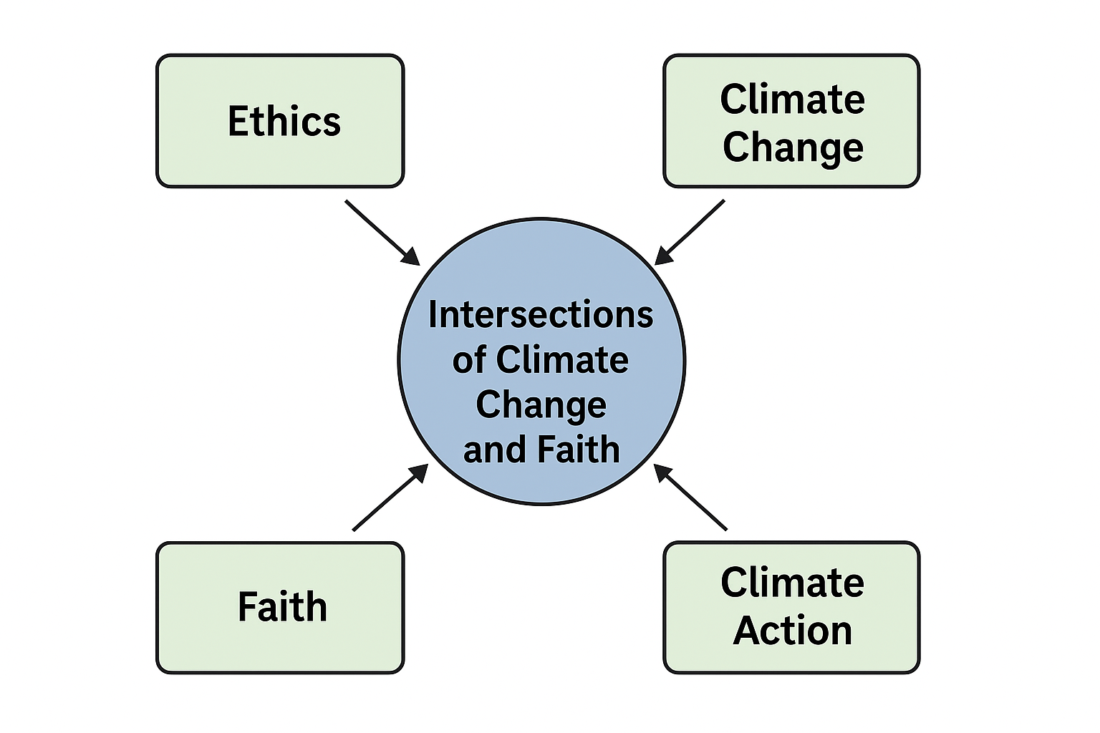
By addressing these questions, the review aims to provide scholars, policymakers, and faith leaders with an evidence-based overview of the evolving role of religion in climate change discourse as per the conceptual framework in figure 1.
Figure 1: Conceptual framework diagram illustrating the intersections between climate change, faith traditions, ethics, and climate action.

2. Methods
This study employs a bibliometric review methodology to systematically examine scholarly research at the intersection of climate change and faith. The primary database selected is Lens.org, an open-access platform that provides comprehensive coverage of scholarly articles, patents, and citation data. Compared to proprietary databases such as Scopus and Web of Science, Lens.org allows greater accessibility and transparency, making it particularly suited for mapping emerging interdisciplinary fields (Yadav & Sinha, 2024).

Search Strategy
Publications were retrieved using a combination of keywords including: “climate change AND religion”, “faith AND environment”, “eco-theology”, “religious ethics AND climate”, and “spirituality AND ecology.” Boolean operators were applied to refine searches and exclude unrelated works, such as purely theological studies without environmental application or climate studies without religious content. The timeframe was set between 2000 and 2025, capturing both early theoretical discussions and the surge of publications after the Paris Agreement in 2015.

Data Extraction
For each publication, metadata were extracted including:
- Year of publication
- Author(s) and institutional affiliation
- Geographic region/country of focus
- Journal or outlet
- Keywords
- Citation counts
These data were used to analyze publication growth trends, geographic distribution of scholarship, thematic clusters, and citation patterns.
Figure placeholder: Publication trend graph (2000–2025) showing growth trajectory of religion-climate change scholarship.

Analytical Techniques
The bibliometric analysis included:
- Publication trends to evaluate annual output.
- Keyword co-occurrence networks to detect thematic clusters.
- Geographic mapping to identify leading regions.
- Citation analysis to highlight influential works.
These were complemented with qualitative insights from recent peer-reviewed studies (example., Tarusarira et al., 2024; Martín & Indelicato, 2025).
Limitations: Lens.org coverage may underrepresent non-English and regionally focused publications, and citation counts are biased toward older works.

3. Publication Trends and Disciplinary Spread
The bibliometric analysis revealed steady growth in scholarship on climate change and faith since the early 2000s, with notable acceleration after 2015. The release of the Paris Agreement and Pope Francis’ Laudato Si’ encyclical catalyzed a surge of interdisciplinary publications, as these milestones positioned religion within global climate debates (Öhlmann & Swart, 2022).
Between 2000 and 2010, research output was modest, largely dominated by theological reflections on stewardship and eco-theology (Jesuraj & Lumma, 2022; Daw et al., 2023). These early works often framed environmental responsibility in doctrinal terms, emphasizing human obligations to protect creation. After 2010, however, publications diversified into fields such as sociology, political science, and environmental studies, reflecting growing recognition of religion as a social and political force in climate governance (Gangopadhyay, 2023).
The bibliometric trajectory indicates two waves of scholarship:
- Theological-Ethical Phase (2000–2014): Focused on eco-theology, religious ethics, and conceptual debates about creation care.
- Applied-Interdisciplinary Phase (2015–2025): Marked by empirical studies, case-based analyses, and policy-oriented research linking religion to activism, climate justice, and resilience.
This shift mirrors broader trends in climate scholarship where social and cultural dimensions gained prominence alongside scientific models (Anjum & Aziz, 2025).
Recent works increasingly explore the interplay of religiosity, ideology, and perception of climate change. Martín and Indelicato (2025) highlight how religious identity shapes Americans’ climate perceptions, demonstrating that theology cannot be separated from political ideology in shaping environmental attitudes. This indicates a disciplinary convergence where psychology, sociology, and political science intersect with religious studies.
At the same time, new subfields are emerging. Digital religion and eco-spirituality, for instance, reflect the influence of technology and cultural transformation. Opade (2023) illustrates how digital evangelism expands the reach of religious climate advocacy, suggesting that online platforms are becoming important sites for mobilizing ecological consciousness.
Overall, the disciplinary spread underscores the evolution from narrow theological debates to broad interdisciplinary engagement. Faith traditions are no longer studied in isolation but are situated within frameworks of governance, social justice, and global policy. This interdisciplinarity is crucial for bridging climate science with cultural values, and for enabling faith actors to engage meaningfully in sustainability transitions (Danielsen, 2025). Figure 2 shows the publication trend on climate change and faith published between 2000 to 2025. The trend shows that research has grown in the last few two years. This can be argued by the recent impacts and effects of climate change necessity advocacy and collaboration towards adaptation and mitigation.
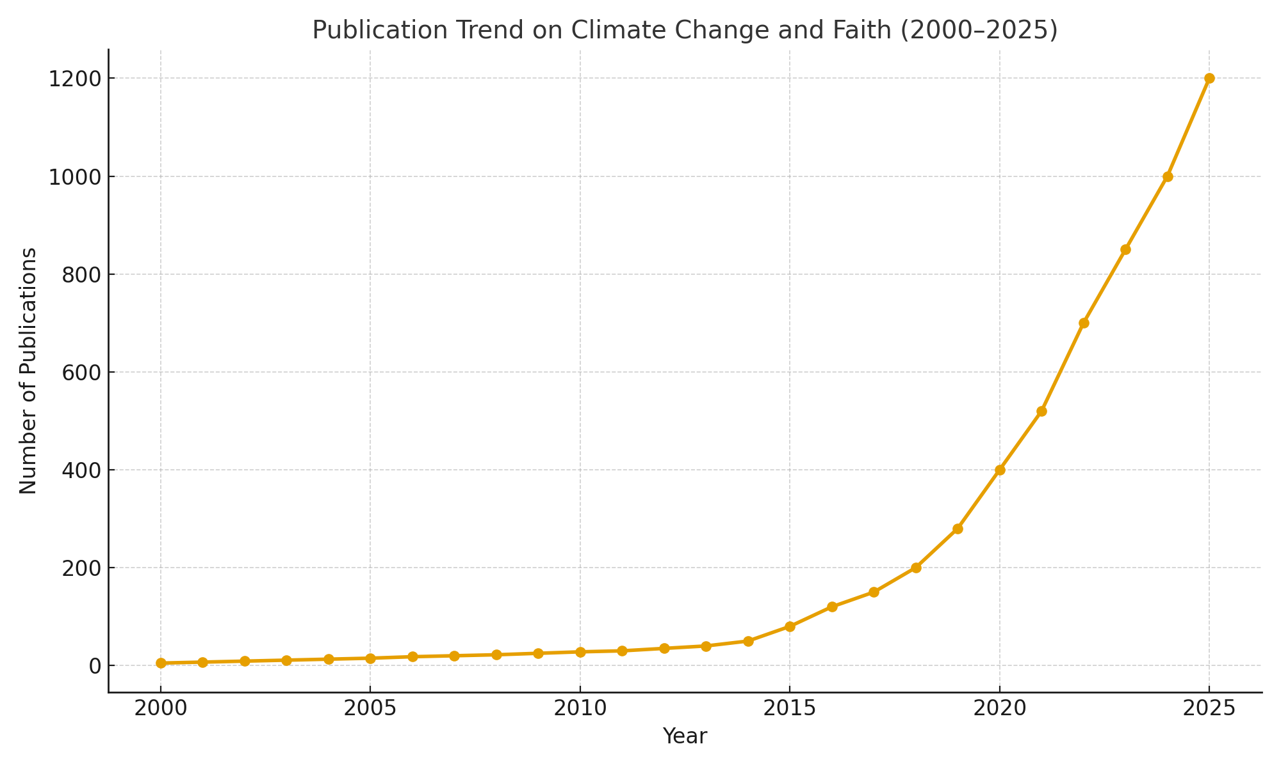
Figure 2: Publication trend graph (2000–2025) illustrating exponential growth of research at the intersections of climate change and faith.

4. Geographic and Regional Patterns
A key dimension of this bibliometric review is the geographic distribution of scholarship. Lens.org data indicate that North America and Europe dominate output, together accounting for more than half of indexed publications. This reflects both the concentration of academic institutions and the visibility of Christianity in climate discourse. However, the analysis also highlights emerging contributions from Africa, Asia, and Latin America, signaling a gradual diversification of voices and traditions.

4.1 North America and Europe
In North America, much of the scholarship focuses on the intersection of religiosity, ideology, and climate perception. Studies often examine polarization, where conservative Christian groups have been associated with climate skepticism, while progressive faith communities advocate for climate justice (Martín & Indelicato, 2025). Faith-based activism—such as interfaith climate marches and church divestment from fossil fuels—has also been widely studied, making North America a hub for research on religion and climate politics.
Europe, on the other hand, demonstrates strong engagement with eco-theology and policy integration. The publication of Laudato Si’ was particularly influential, sparking a wave of academic reflections across Catholic and Protestant traditions. European institutions often frame religion in relation to the European Green Deal and broader sustainability goals, linking theology to climate policy (Öhlmann & Swart, 2022). Moreover, interfaith collaborations, such as those observed during COP meetings, receive significant scholarly attention.

4.2 Africa
African scholarship, while smaller in volume, contributes distinct perspectives by integrating indigenous cosmologies and community resilience frameworks. Tarusarira et al. (2024) emphasize the role of religion in shaping responses to climate-related security risks in African contexts. Faith communities often serve as key mobilizers for adaptation, especially where state capacity is limited. African contributions thus highlight the practical role of religion in resilience building, particularly in vulnerable communities where spiritual authority is trusted.

4.3 Asia
Asian publications often focus on Buddhist, Hindu, and Islamic ecological perspectives, as well as the practical mobilization of faith-based organizations in disaster response. Countries such as India, Indonesia, and the Philippines demonstrate scholarship linking faith traditions with local climate adaptation. The ecological teachings of Buddhism and Hinduism, emphasizing interdependence and harmony, are increasingly studied for their relevance to sustainability transitions. Opade’s (2023) work on digital evangelism also resonates in Asian contexts where online platforms amplify religious engagement with climate advocacy.

4.4 Latin America
Latin American scholarship frequently emphasizes liberation theology and climate justice. The Amazon, as a site of both ecological crisis and indigenous resistance, is a focal point for religious-environmental research. Catholic and Pentecostal traditions engage not only in theological discourse but also in activism against deforestation and resource exploitation. Indigenous cosmologies, emphasizing sacred relationships with land and rivers, are increasingly acknowledged in academic discourse as vital to ecological resilience.

4.5 Global North vs Global South
A broader pattern revealed by bibliometric mapping is the imbalance between Global North and Global South scholarship. While the Global North dominates in volume and visibility, the Global South contributes perspectives grounded in lived vulnerability, indigenous cosmologies, and community resilience. This imbalance risks reinforcing epistemic hierarchies, where Northern institutions shape discourse while Southern voices remain underrepresented. Anjum and Aziz (2025) argue that climate justice perspectives must prioritize inclusivity, a principle equally vital in religion-climate research.

4.6 Institutional Collaboration
The data also highlight growing cross-regional collaborations. Universities in Europe and North America often partner with African and Asian institutions, particularly through climate-and-religion networks and development projects (Danielsen, 2025). These collaborations are important for balancing perspectives and ensuring that faith-based climate action is studied not only as ideology but as lived practice across diverse regions.

Figure.3 sows the number of publications on climate change and religion/faith in different regions.
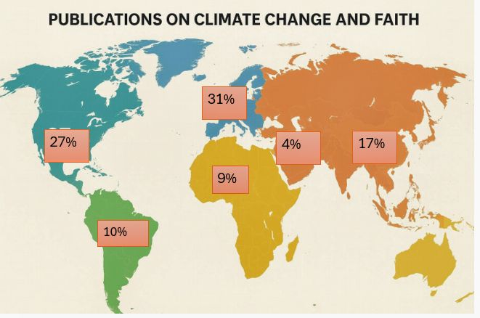
Figure 3: Regional distribution map or table showing dominant publication regions

5. Thematic Clusters from Bibliometric Analysis
The bibliometric keyword co-occurrence analysis reveals four major thematic clusters in scholarship at the intersection of climate change and faith. These clusters demonstrate the disciplinary breadth of the field and highlight how religion is positioned in relation to theology, activism, justice, and indigenous knowledge.

5.1 Cluster One: Eco-Theology and Religious Ethics
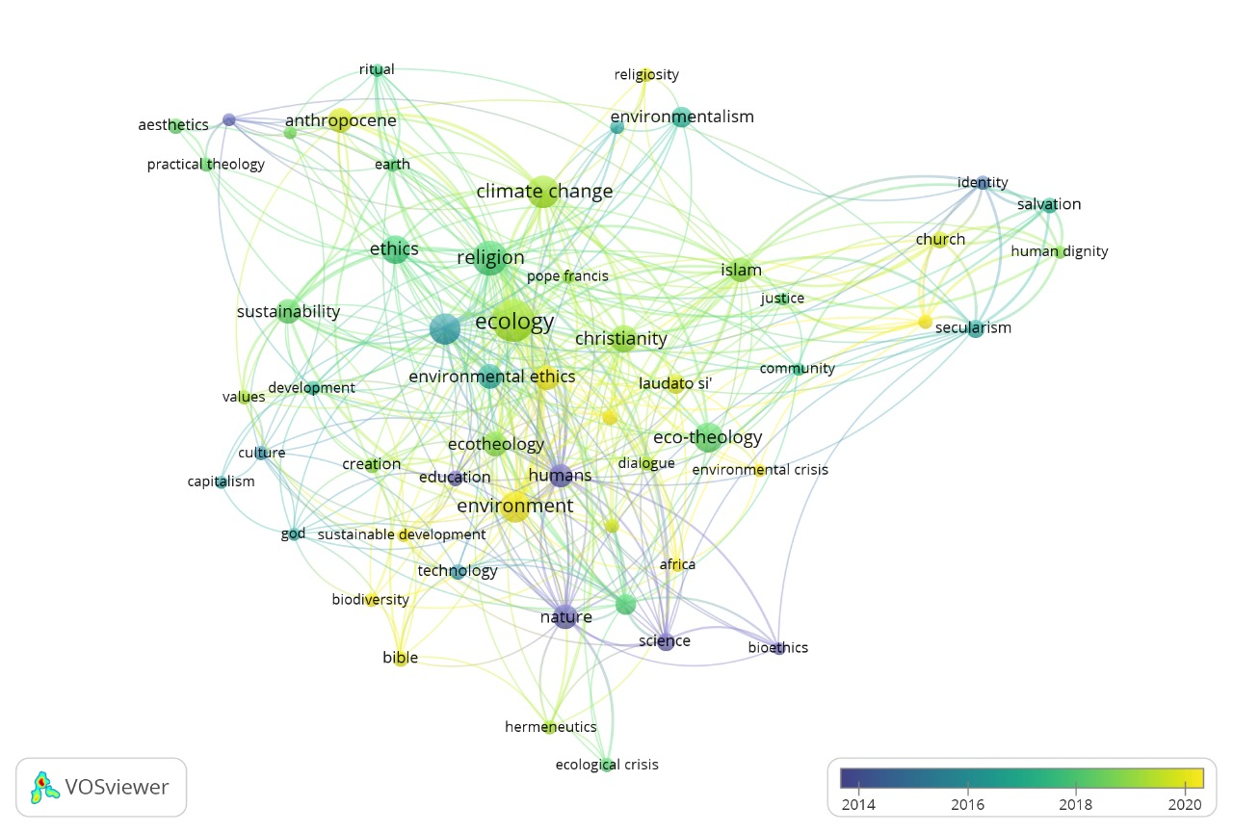
Figure 4: Network diagram presenting the association centered around the keywords Eco-Theology and Religious Ethics
The largest thematic cluster centers on eco-theology and religious ethics. Early scholarship primarily explored theological foundations for ecological responsibility. Keywords such as stewardship, creation care, and sacred ecology dominate this cluster as per figure 4. These works often emphasize the moral responsibility of humanity to protect the environment, drawing from scriptural and doctrinal traditions.
For example, Öhlmann and Swart (2022) describe the “ecological turn” within religious traditions, where climate change challenges communities to reinterpret their faith in light of ecological crises. Similarly, Pope Francis’ Laudato Si’ (2015) triggered widespread academic engagement, especially in Catholic and Protestant contexts. Beyond Christianity, Islamic scholars have framed climate change as a violation of humanity’s trusteeship (khalifa) of the Earth, while Hindu and Buddhist traditions emphasize interdependence and the moral consequences of harming ecosystems.
In bibliometric terms, this cluster demonstrates how faith-based ethics provide normative frameworks for global climate action. However, the emphasis remains unevenly distributed, with Christianity dominating the literature compared to non-Western traditions.

5.2 Cluster Two: Faith-Based Climate Activism and Policy Engagement
The second cluster emphasizes the practical role of religious institutions and networks in climate activism. Keywords such as activism, climate policy, advocacy, and COP frequently appear, pointing to the increasing recognition of religion as a political actor.
Gangopadhyay (2023) shows how religion and governance intersect in shaping political responses to ecological crises, particularly where faith institutions wield significant influence. Interfaith networks, such as the Interfaith Rainforest Initiative, illustrate how religious collaboration extends into global policy debates. Faith-based NGOs also play an important role in UN climate conferences, providing moral narratives that complement scientific arguments.
Martín and Indelicato (2025) highlight how religiosity influences climate perceptions in the United States, with implications for activism and policy support. Their findings suggest that religion shapes not only ethics but also political will, thereby affecting climate policy outcomes.
The bibliometric evidence (figure 5) suggests that faith-based activism operates across scales:
- Local level: Community-based adaptation and awareness campaigns.
- National level: Lobbying governments for climate legislation.
- Global level: Advocacy at COP summits and interfaith declarations.

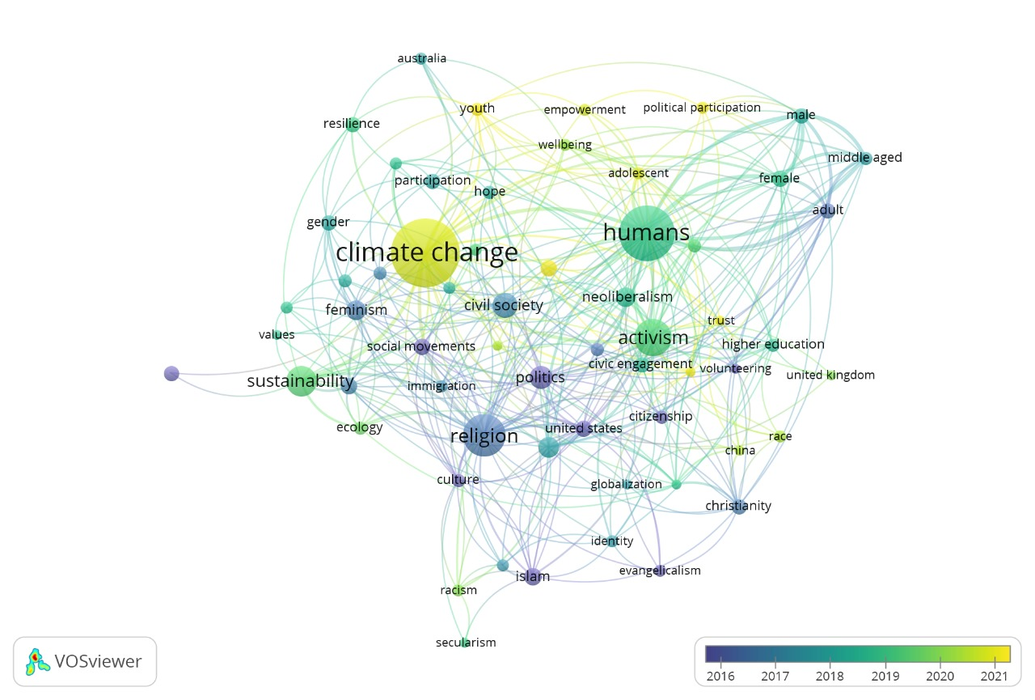
Figure 5: Network diagram showing activism-related keywords clustered around religion and climate change.

5.3 Cluster Three: Religion, Climate Justice, and Vulnerable Communities
A third cluster highlights the intersections of faith, justice, and vulnerability. Keywords such as climate justice, resilience, equity, and vulnerability emerge prominently. This reflects growing recognition that climate change disproportionately affects marginalized communities and that faith traditions often mediate responses to these inequities.
Tarusarira et al. (2024) demonstrate how religion shapes responses to climate-related security risks, particularly in fragile contexts where state institutions are weak. Faith-based organizations often provide humanitarian support, disaster relief, and advocacy for justice. In Africa, churches and mosques frequently act as trusted actors in mobilizing communities for resilience efforts.
Anjum and Aziz (2025) note that perspectives from climate psychology and climate justice are essential for understanding how people process climate risks. Religion, they argue, plays a dual role: reinforcing resilience by offering meaning and hope, but also, in some cases, delaying adaptation if communities view crises as divine punishment.
This cluster underscores the need to situate religion not only in ethical discourse but also in practical justice struggles. Indigenous communities, women, and youth often turn to faith traditions as sources of empowerment in climate adaptation efforts.

5.4 Cluster Four: Interfaith and Indigenous Spiritualities
The final cluster highlights the convergence of interfaith collaboration and indigenous knowledge. Keywords include indigenous spirituality, cosmology, sacred land, and interfaith dialogue.
Scholars note that indigenous traditions often frame the environment as sacred, offering alternative paradigms to Western models of development. This cosmological perspective situates humans within relational networks of land, water, and non-human beings. Such views are increasingly acknowledged in climate scholarship as vital to resilience and sustainability (Öhlmann & Swart, 2022).
At the same time, interfaith initiatives have gained momentum, especially in international climate advocacy. Interfaith declarations at COP meetings highlight shared moral imperatives across traditions, building solidarity that transcends doctrinal boundaries. These collaborations reflect what Danielsen (2025) describes as religion’s role in social change: reframing collective narratives and mobilizing diverse actors toward shared goals.
Digital religion also emerges within this cluster. Opade (2023) argues that digital evangelism extends religious influence into new domains, enabling faith actors to mobilize climate awareness across borders. This is particularly relevant in regions where physical activism is constrained.
Together, these subthemes highlight the plurality of religious voices shaping climate discourse and the growing recognition that indigenous and interfaith perspectives are indispensable to inclusive climate governance as shown in figure 6.
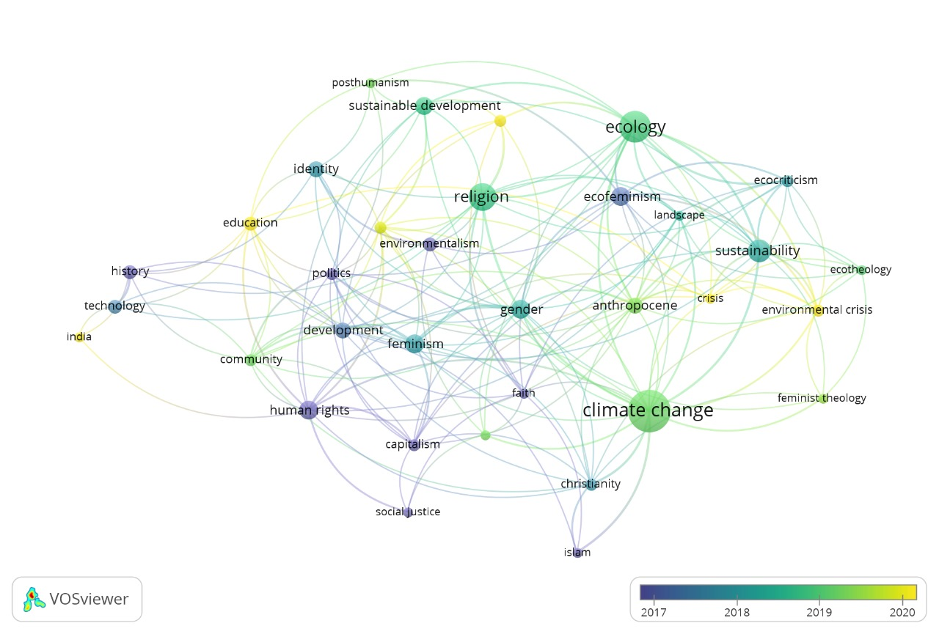
Figure 6: Network diagram of thematic clusters: eco-theology, activism, justice, and indigenous/interfaith spirituality.

6. Citation and Influence Patterns
Citation analysis provides insights into the intellectual architecture of the field, highlighting which works and themes exert the greatest influence. Three major citation patterns stand out:

6.1 Eco-Theology and Foundational Texts
Highly cited works include theological reflections such as Laudato Si’ and earlier eco-theology texts that framed creation care as a central moral imperative. These works continue to anchor the discourse, serving as reference points for both scholarly and activist engagement. Öhlmann and Swart (2022) are frequently cited for their articulation of the ecological turn in religion, which positions theology as responsive to environmental crisis.

6.2 Religion and Policy/Activism
Another citation cluster revolves around the role of religion in governance and activism. Gangopadhyay (2023) and Tarusarira et al. (2024) receive strong attention for connecting religion to climate-related security risks and governance. Their influence reflects the field’s shift toward applied, interdisciplinary approaches. Works documenting interfaith declarations and faith-based activism at COP summits also attract citations, as they highlight religion’s policy relevance.

6.3 Emerging Fields and Methodological Innovation
Recent publications employing bibliometric and psychological approaches are gaining citations rapidly. Anjum and Aziz (2025) contribute methodological sophistication by linking bibliometric mapping with climate psychology and justice perspectives. Similarly, Yadav and Sinha (2024), in their bibliometric study of ecocriticism, demonstrate how quantitative mapping enriches qualitative interpretation—an approach increasingly applied to religion-climate scholarship.
Digital religion is also an emergent citation node. Opade’s (2023) work on digital evangelism is cited for expanding the field into technological and cultural dimensions. Such citations illustrate the field’s evolution beyond traditional theology into digital, social, and political domains.

6.4 Citation Inequalities
The analysis also reveals inequalities: publications from the Global North dominate citation networks, while Southern scholarship often remains peripheral despite offering valuable insights. This reflects broader epistemic hierarchies in climate research. Addressing this imbalance requires amplifying voices from Africa, Asia, and Latin America, where faith communities are deeply engaged in frontline climate struggles (Tarusarira et al., 2024).
Figure placeholder: Citation network diagram showing clusters around eco-theology, activism, justice, and digital religion.

7. Discussion, Research Gaps, and Emerging Directions
The bibliometric evidence highlights a rapidly evolving field that positions religion as both a moral compass and an active agent in climate change discourse. Yet, several gaps and future directions emerge that warrant attention.

7.1 Geographic and Epistemic Gaps
First, the scholarship is geographically imbalanced, with North America and Europe dominating research output and citations. While Africa, Asia, and Latin America contribute valuable perspectives, particularly on indigenous cosmologies and frontline resilience, these remain underrepresented. This imbalance risks reinforcing epistemic hierarchies, where Global South voices are marginalized despite their relevance to climate justice (Tarusarira et al., 2024).

7.2 Theological and Doctrinal Gaps
Second, theological discussions remain disproportionately focused on Christianity, particularly Catholicism. While there is growing engagement with Islamic, Hindu, Buddhist, and indigenous traditions, comparative studies remain limited. Öhlmann and Swart (2022) argue that a deeper ecological turn across diverse traditions is needed to fully capture religion’s plural contributions to sustainability.

7.3 Methodological Gaps
Third, many studies remain conceptual or theological, with fewer empirical evaluations of faith-based climate initiatives. There is limited longitudinal research assessing the impact of religious activism on adaptation or mitigation outcomes. Integrating tools from climate psychology and social sciences (Anjum & Aziz, 2025) could help assess how faith influences behavior, resilience, and policy change.

7.4 Emerging Frontiers
Several emerging directions suggest the field’s future trajectory:
- Digital Religion and Climate Advocacy: As Opade (2023) demonstrates, digital evangelism expands the reach of climate messaging. Further research is needed to assess its effectiveness in mobilizing diverse publics.
- Religion and Technology: Anshari et al. (2025) highlight the role of AI in advancing SDGs. Future studies could explore how digital tools and religious ethics intersect in shaping sustainable practices.
- Religion and Health: Portela Dos Santos et al. (2023) emphasize the health dimensions of climate change. Faith communities may play a crucial role in raising awareness about climate-related diseases.
- Eco-criticism and Interdisciplinary Bridges: Yadav and Sinha (2024) show the value of literary and cultural approaches. Expanding eco-critical methods into religion-climate studies could deepen understanding of narratives and symbolism.
Figure placeholder: Framework diagram of future directions: digital religion, interfaith collaboration, indigenous voices, health, and interdisciplinary methods.

8. Conclusion and Policy Implications
This bibliometric review mapped the intersections of climate change and faith using data from Lens.org (2000–2025). The findings demonstrate significant growth in scholarship since 2015, driven by global climate frameworks and faith-based declarations. Four thematic clusters dominate the field: eco-theology and religious ethics, faith-based activism, religion and climate justice, and interfaith/indigenous spiritualities. Citation analysis further reveals the influence of foundational theological works, applied governance studies, and emerging digital religion scholarship.
Despite this progress, the field faces notable gaps: limited Global South representation, underexplored non-Christian traditions, and a shortage of empirical evaluations of faith-based climate initiatives. Addressing these gaps is essential for developing inclusive and impactful scholarship.
Policy implications are equally significant. Faith traditions are uniquely positioned to mobilize communities, influence policymakers, and reframe climate change as a moral and spiritual challenge. Their integration into climate governance could enhance legitimacy and broaden participation. As Gangopadhyay (2023) and Danielsen (2025) note, religion is a driver of social change and governance, capable of shaping collective narratives about justice and resilience.
To harness this potential, international frameworks such as the Paris Agreement and the Sustainable Development Goals should recognize faith actors as key partners. Interfaith collaborations, digital advocacy, and indigenous perspectives offer promising avenues for inclusive climate action.
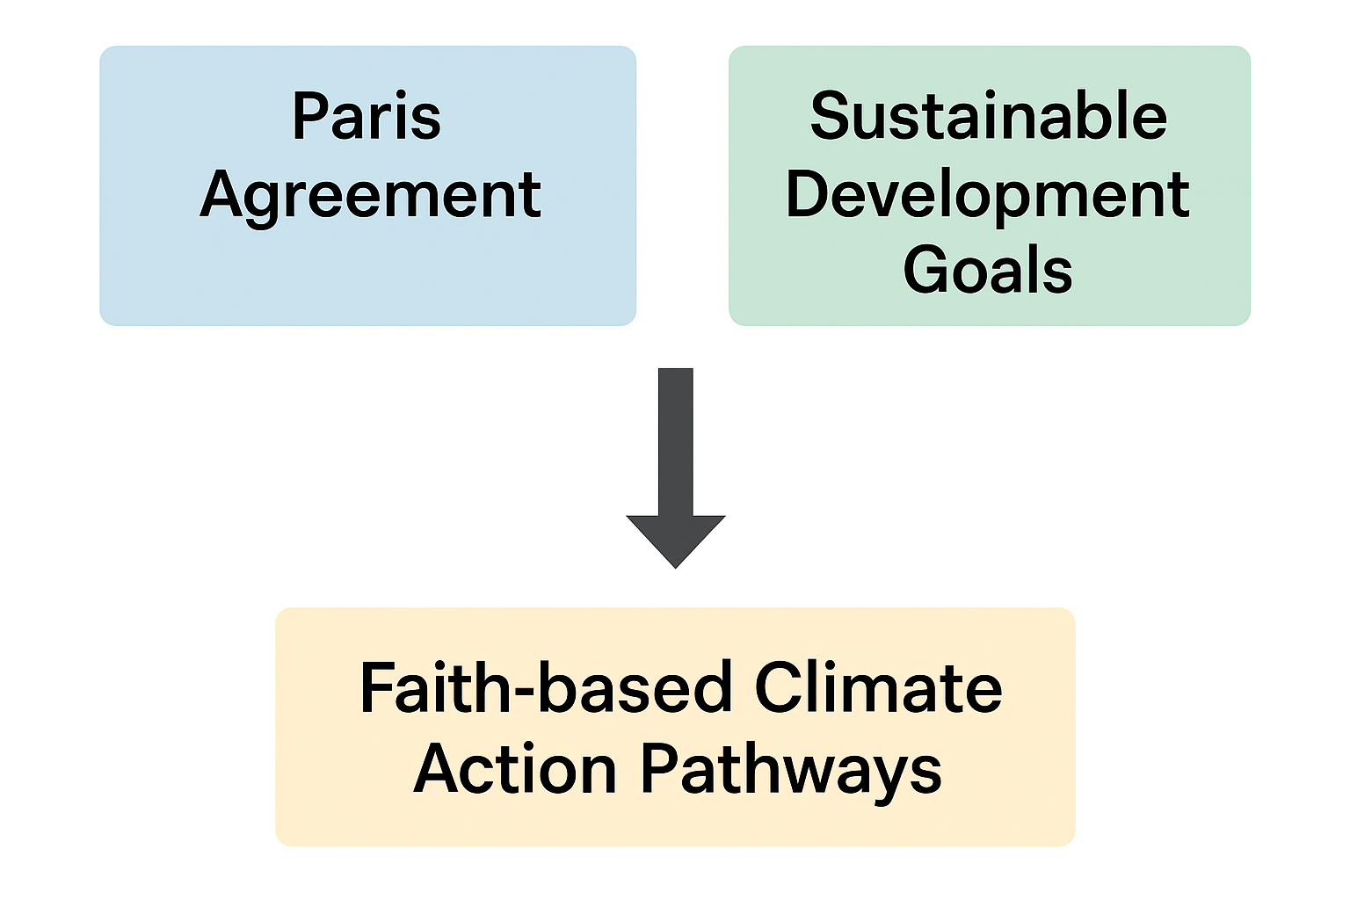
In conclusion, religion is no longer peripheral but central to understanding and addressing climate change. By bridging theology, policy, and science, faith communities can contribute to a more just, resilient, and sustainable future as shown in the policy framework diagram in figure 7.
Figure 7: Policy framework diagram linking Paris Agreement, SDGs, and faith-based climate action pathways.

References
Lens.org. (2025). The Lens — Open scholarly knowledge platform. Retrieved September 13, 2025, from https://www.lens.org
Tarusarira, J., Scartozzi, C. M., & Elnur, R. I. (2024). Intersections of religion and climate-related security risks: Insights from a systematic review. Worldviews: Global Religions, Culture, and Ecology, 29(1), 71-98. https://brill.com/view/journals/wo/29/1/article-p71_4.xml
Martín, J. C., & Indelicato, A. (2025). Exploring the intersection of religion, religiosity, ideology and climate change perception of Americans. Quality & Quantity, 1-21 https://link.springer.com/article/10.1007/s11135-025-02248-x
Öhlmann, P., & Swart, I. (2022). Religion and environment: exploring the ecological turn in religious traditions, the religion and development debate and beyond. Religion and Theology, 29(3-4), 292-321. https://abjournals.org/ajchrt/wp-content/uploads/sites/10/journal/published_paper/volume-6/issue-2/AJCHRT_IDAP2P2M.pdf
Opade, O. F. (2023). Perspectives on Digital Evangelism: Exploring the Intersection of Technology and Faith. African Journal of Culture, History, Religion and Traditions, 6, 15-24. https://abjournals.org/ajchrt/wp-content/uploads/sites/10/journal/published_paper/volume-6/issue-2/AJCHRT_IDAP2P2M.pdf
Anjum, G., & Aziz, M. (2025). Bibliometric analyses of climate psychology: critical psychology and climate justice perspectives. Frontiers in Psychology, 16, 1520937. https://www.frontiersin.org/journals/psychology/articles/10.3389/fpsyg.2025.1520937/full
Gangopadhyay, M. (2023). Religion and governance: Examining the intersection in contemporary politics. Religion and Policy Journal, 1(1), 27-33. https://ejournal.uinsgd.ac.id/index.php/rpj/article/view/427
Anshari, M., Hamdan, M., Ahmad, N., & Ali, E. (2025). Public service delivery, artificial intelligence and the sustainable development goals: trends, evidence and complexities. Journal of Science and Technology Policy Management, 16(1), 163-181. https://www.emerald.com/insight/content/doi/10.1108/JSTPM-07-2023-0123/full/html
Danielsen, S. (2025). Introduction to Religion and Social Change. Journal of Religion & Society: Supplement Series. https://search.ebscohost.com/login.aspx?direct=true&profile=ehost&scope=site&authtype=crawler&jrnl=19418450&asa=N&AN=187420549&h=%2Bb3S3hRM2CEcM5G8EYzeVFFo7OK6uXRrLJbwyb0fzIRL1QxguNIvu%2Ff%2BTG9QzLlegBo%2FHC6xOR6e1HPXnIlsJw%3D%3D&crl=C
Portela Dos Santos, O., Melly, P., Joost, S., & Verloo, H. (2023). Measuring nurses’ knowledge and awareness of climate change and climate-Associated diseases: protocol for a systematic review of existing instruments. International journal of environmental research and public health, 20(20), 6963. https://www.mdpi.com/1660-4601/20/20/6963
Yadav, C., & Sinha, J. (2024). Exploring the evolution of ecocriticism: A bibliometric study and literature review. Multidisciplinary Reviews, 7(12), 2024304-2024304. https://malque.pub/ojs/index.php/mr/article/view/5198
Francis. (2015). Laudato si': On care for our common home: Encyclical letter. Our Sunday Visitor, Chicago.
Tarusarira, J. (2022). Religious Environmental Sensemaking in Climate-Induced Conflicts. Religions, 13(3), 204. https://doi.org/10.3390/rel13030204
Hassani, A., Azapagic, A., & Shokri, N. (2021). Global predictions of primary soil salinization under changing climate in the 21st century. Nature communications, 12(1), 6663.
Preston, J. L., & Baimel, A. (2021). Towards a psychology of religion and the environment. Current Opinion in Psychology, 40, 145-149.
Smith, C. (2022). Climate change and culture: Apocalypse and catharsis. Ethics & the Environment, 27(2), 1-27.
Chirico, F. (2021). Spirituality to cope with COVID-19 pandemic, climate change and future global challenges. J Health Soc Sci, 6(2), 151-158.
De Meyer, K., Coren, E., McCaffrey, M., & Slean, C. (2021). Transforming the stories we tell about climate change: from ‘issue’to ‘action’. Environmental Research Letters, 16(1), 015002.
Jesuraj, A. J., & Lumma, L. O. (2022). Earth is our common home-An Eco-Theological Praxis of Pope Francis in Laudato Si’.
Daw, R., Girardi, G., & Riva, S. (2023). From greening to meaning: Understanding the content of Catholic attitudes towards the ecological crisis. Sustainability, 15(4), 3210.

