Original Research Article

Development of IoT-Based Automated Aquaponics System for Water Quality Monitoring and Control

ABSTRACT

Aquaponics is an innovative and sustainable method of food production that combines aquaculture and hydroponics. However, traditional aquaponics systems require continuous manual monitoring and intervention, which can be inefficient. This paper presents the development of an IoT based automated aquaponics system to optimize water quality management and reduce manual intervention. The system utilized a Nutrient Film Technique (NFT) grow bed with a 1:2 fish tank-to-grow bed ratio, incorporating a 500-litre fish tank for 25 fish and a 1 m² grow bed for 48 plants. A filtration unit converted fish waste into nutrients, while a pump (2.7 m head height) and actuators regulated pH, temperature, electric conductivity, and dissolved oxygen. IoT sensors continuously monitored water quality, with a PIC microcontroller transmitting real-time data via a GSM module to the ThingSpeak cloud. Automated controls, including solenoid valves and aerators, adjusted conditions based on predefined thresholds, with alerts sent to users for abnormal values. Over three months, the system maintained optimal water quality (DO >5.5 mg/L, pH 6.5-7.5, temperature 22-32°C, EC <2 dS/cm), ensuring stable fish and plant growth. The system yielded 5.198 kg of fish and 9.57 kg of plants, demonstrating improved water efficiency, reduced human error, and enhanced growth synchronization. This scalable system offers a promising approach to sustainable aquaponics and resource-efficient agriculture. The results demonstrate the effectiveness of the proposed system in optimizing aquaponics operations and ensuring sustainable agricultural practices.

Keywords: IoT, aquaponics, water quality monitoring, automation, precision agriculture
1. INTRODUCTION
Global population growth is accelerating, with projections indicating that by 2030, the population will reach 8.5 billion (UN, 2019). This increasing population necessitates higher food production, but the farming sector faces challenges due to limited land and water resources. Overuse of pesticides and fertilizers reduces soil productivity and contributes to water pollution by increasing phosphate and nitrogen levels. Additionally, urbanization and poor resource management lead to soil erosion, water pollution, and land fragmentation, reducing farm income. While aquaculture is the fastest-growing food sector, it demands high water usage and releases nutrients that contribute to eutrophication and dead zones in water bodies.
Agricultural water use varies widely, accounting for about 40% of water consumption in diverse economies but exceeding 95% in agriculture-dependent nations. With global water use increasing at twice the rate of population growth, water scarcity is becoming a critical issue, affecting 1.8 billion people by 2025 (UN, 2007). In Asia, 86% of water is allocated to irrigation, whereas domestic and industrial needs dominate in Europe and North America (Michael and Ojha, 2013). According to the International Water Management Institute (IWMI, 2023), agriculture accounts for approximately 72% of global freshwater withdrawals. In India, per capita water availability has significantly declined, from 1,486 m³ in 2021 to a projected 1,367 m³ by 2031 (Reuters, 2024), posing challenges for food production and water security.
India is an agrarian nation, with nearly 70% of its population relying on agriculture. However, fragmented landholdings, inadequate irrigation, soil degradation, unpredictable weather, and limited access to technology hinder productivity. These factors contribute to financial instability among farmers, with suicides accounting for 11.2% of total suicides in India (Dani and Gaur, 2016). To address these challenges, improving water productivity and incorporating alternative agricultural methods is essential. Traditional fish farming also faces sustainability issues, including water pollution, high feed dependency, and disease outbreaks. Poor waste management leads to fish excreta contaminating water bodies, while limited access to technology restricts operational efficiency. Addressing these issues requires innovative farming methods integrating technological advancements.
Aquaponics presents a promising solution by combining aquaculture and hydroponics in a symbiotic system. In traditional aquaculture, fish waste accumulates, increasing water toxicity. In an aquaponics system, water is transferred to a hydroponic setup, where nitrifying bacteria convert waste into nitrates, serving as plant nutrients. The purified water is then recirculated to the fish tank (Sawkar et al., 2020). This method reduces water usage by 90% compared to soil-based farming while yielding 2-3 times more vegetables per unit area. Aquaponics is particularly beneficial in areas with poor soil or water scarcity and can be implemented in urban settings using limited space, such as rooftops or balconies. Water quality and level maintenance are critical in aquaponics, requiring continuous monitoring of pH, ammonia, dissolved oxygen (DO), and temperature. Manual monitoring is time-consuming and prone to errors, making automation essential. The Internet of Things (IoT) offers a solution by integrating sensors, microcontrollers, and cloud-based monitoring to automate water quality regulation (Friha et al., 2021). IoT enables real-time data transmission, remote monitoring, and automated adjustments to maintain optimal conditions (Yanes et al., 2020).
IoT comprises interconnected physical devices embedded with sensors, software, and network connectivity to exchange data. It enhances agricultural efficiency by enabling remote monitoring and automated decision-making (Kularbphettong et al., 2019). IoT platforms store, analyze, and present data through web interfaces or mobile applications. Integrating IoT with hydroponic systems has revolutionized agriculture, allowing real-time monitoring and control of key parameters (Vanipriya et al., 2021).
As part of the Integrated Farming System, aquaponics provides economic stability for farmers. If a crop fails, aquaculture can support income, and vice versa. This approach also mitigates water scarcity by reusing the same water for fish and plant growth. Additionally, IoT based automation reduces labor, enhances productivity, and ensures sustainable food production. By optimizing resources and improving efficiency, aquaponics offers a viable solution to the challenges of traditional farming.
2. STUDY AREA
This study was conducted in a naturally ventilated polyhouse located at the KCAEFT campus, Tavanur, Kerala, India (10° 51′ 13″ N, 75° 59′ 06″ E, 25 m AMSL). The region receives an average annual rainfall of 2500–2900 mm, with average temperatures ranging from 26°C to 35°C and relative humidity around 73%.
3. material and methods
The step-by-step methodology involved in the study is outlined in Fig. 1. The development of the IoT-based aquaponics system followed a structured methodology beginning with site preparation and structural setup, followed by careful component selection and installation. The system design was finalized to integrate hydroponics and aquaculture efficiently. Sensor integration and calibration were conducted to ensure accurate real-time monitoring, leading to the development of the automation system. Suitable crop and fish species were selected, and data acquisition was implemented for continuous monitoring. Finally, the system underwent performance evaluation, and yield analysis was carried out to assess its efficiency viability.

Fig.1 Overall framework of the study

3.1 System design and components
The aquaponics system combined a recirculating fish tank and hydroponic grow beds using the Nutrient Film Technique (NFT). The fish tank was a 500 L HDPE circular container (diameter: 900 mm, height: 970 mm), maintaining a 1:2 tank-to-grow bed area ratio. The hydroponic grow bed consisted of six 1.5-meter-long uPVC NFT channels arranged in a step frame for optimal light exposure and air circulation.
3.1.1 Aquaculture components
The aquaculture unit of the system featured a 500 L high-density polyethylene (HDPE) fish tank, designed to house 25 tilapias, and equipped with an aerator to maintain optimal dissolved oxygen levels. Water circulation was facilitated by a submersible pump rated at 55 watts, with a flow capacity of 1500 liters per hour and a maximum head of 3.5 meters. To ensure water quality, a multi-layered filter unit was constructed using gravel, porous lava rocks, sponge, and fine nylon mesh, providing both mechanical and biological filtration. An auxiliary 25 L water tank and a dedicated pH buffer solution tank were incorporated to regulate water levels and maintain chemical balance within the system. Feeding was automated using a microcontroller-based fish feeder controlled by a PIC timer, ensuring consistent and timely nutrition delivery to the fish.
3.1.2 Hydroponic components
The hydroponics setup was constructed using a step-shaped galvanized iron frame designed to hold six 1.5-meter-long uPVC NFT channels. The frame stood 1.5 meters high and wide, ensuring optimal sunlight exposure and air circulation for plant growth, while allowing gravity-assisted return flow to the fish tank. The NFT system employed square uPVC pipes (10×10 cm) with strategically drilled holes at 15 cm spacing to accommodate net pots. Palak (Spinacia oleracea) was selected as the crop due to its short growth cycle, high nutritional value, and local market demand. This design facilitated uniform nutrient and oxygen delivery via a thin film of nutrient-rich water. The channels featured smooth interiors for clog-free flow and were openable for easy cleaning. uPVC end caps were used to seal the channels while maintaining efficient water circulation. Net pots measuring 50 mm in diameter and 75 mm in height supported the plants, enabling free root growth and effective nutrient absorption. The entire system was installed under a polyhouse to ensure a controlled microclimate conducive to healthy and efficient plant development.
After selecting all the components of the aquaponics system, the initial design layout was developed to visualize the overall setup. A schematic diagram of the system was created using AutoCAD to illustrate the arrangement and connections between the fish tank, pump, and grow bed. Additionally, a 3D visualization of the experimental setup was modeled using SketchUp to provide a detailed representation of the system's design and spatial configuration. These diagrams are presented in Fig. 2, which includes the schematic diagram and 3D visualization of the experimental setup, ensuring clarity in the system design and aiding in its construction.
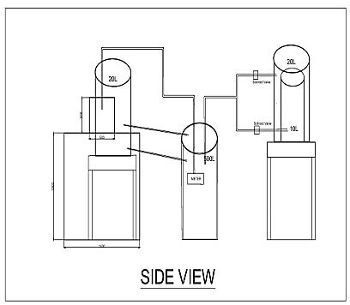 | 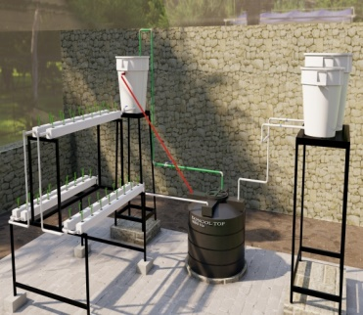
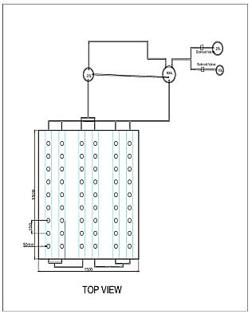 | 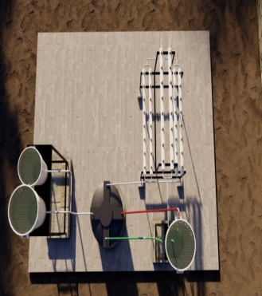
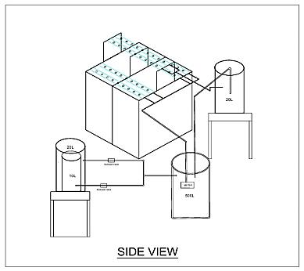 | 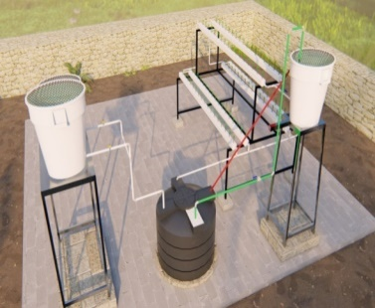
Fig. 2 Schematic diagram and 3D visualization of experimental setup
3.1.3 Automation and IoT system
The automation and IoT system of the aquaponics setup was driven by a PIC18F4520 microcontroller, which served as the central control unit integrating various sensors and actuators. The system was powered by a regulated 5V supply and featured both local and cloud-based monitoring capabilities using a GSM module and the ThingSpeak IoT platform. The deployed sensors included DS18B20 for water temperature, a pH sensor with voltage regulation and LCD interface, a dissolved oxygen sensor using an electrochemical probe with KCl electrolyte, an EC sensor for nutrient strength, an ultrasonic sensor for water level detection, DHT22 for ambient temperature and humidity, a water flow sensor, and a light-dependent resistor for monitoring light intensity. Actuators integrated into the system included solenoid valves to manage water and buffer solution inflow, an aerator for maintaining dissolved oxygen levels, a relay module for automating actuator responses, and an LCD, buzzer, and LED indicators for real-time data display and alerts (Table 1). The control logic was developed using MPLAB IDE, where sensor thresholds were programmed to initiate specific actuator responses. Circuit and PCB designs were completed using KiCad, with PCBs fabricated through UV exposure, ferric chloride etching, and precise soldering. A cloud-based dashboard developed via ThingSpeak enabled real-time data logging, visualization, and remote control. This comprehensive automation ensured that any deviations in water quality parameters triggered corrective actions, thereby maintaining optimal environmental conditions for the integrated aquaponics system.
Table 1 Automation and IoT components
Components
PIC18F4580 Microcontroller | 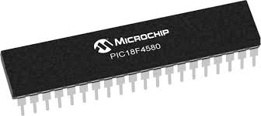
Water temperature sensor (DS18B20) | 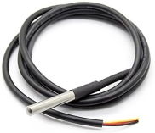
pH sensor | 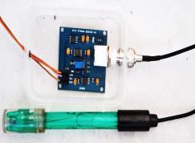
Dissolved oxygen sensor | 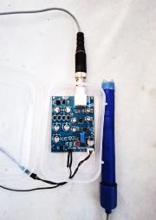
Ultrasonic sensor | 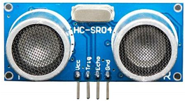
Electrical Conductivity (EC) sensor | 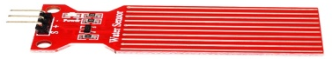
Water flow sensor | 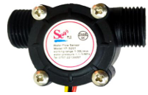
DHT22 Temperature & Humidity Sensor | 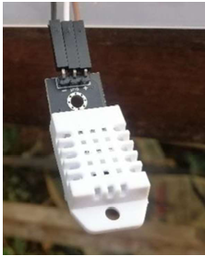
Relay | 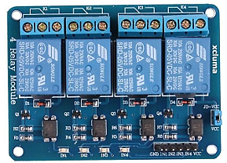
GSM modem | 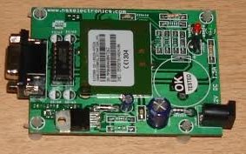
Actuators (Solenoid valves) | 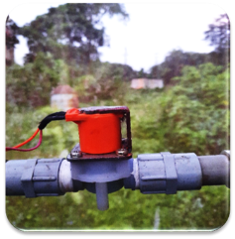
The system integration diagram (Fig. 3) illustrates the connection of sensors- including water temperature, pH, EC, DO, water level, flow, air temperature, and humidity- to a PIC microcontroller. Real-time readings are displayed on an LCD, while a GSM modem enables remote communication. Actuators such as a solenoid valve, motor, aerator, and feeder automate system operations.
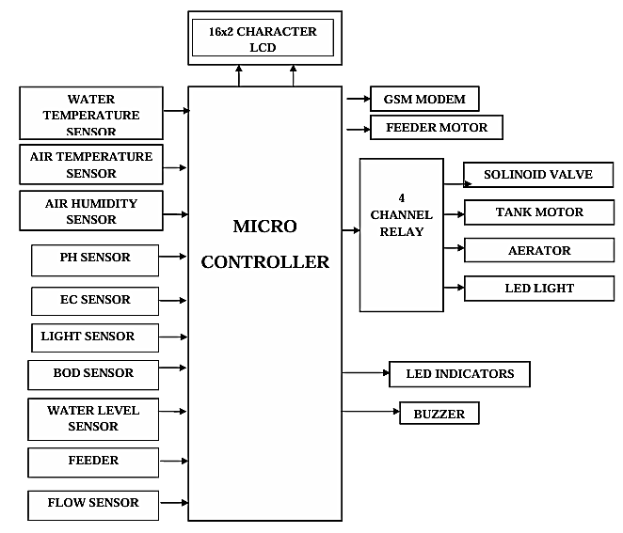
Fig. 3 Block diagram
3.2 Biological components of aquaponics
3.2.1 Crop selection and planting.
Palak (Spinacia oleracea ‘Arka Anupama’) was selected due to its nutritional value and market demand. Forty-eight plants were grown in the NFT system with 15 cm spacing. Growth parameters such as plant height, leaf length, and width were recorded weekly.
3.2.2 Fish rearing
Twenty-five GIFT tilapia were stocked at a density of 20 L per fish. They were fed automatically twice daily at 2.5% of body weight. Growth parameters including initial and final weight, length, and survival rate were tracked.
3.3 Monitoring and control
The water quality parameters of the fish tank were closely monitored to ensure optimal conditions for the aquaponics system. The water temperature was maintained between 22˚C and 32˚C, using a DS18B20 temperature sensor for accurate readings. EC was kept below 2 mS cm⁻¹, monitored with an EC sensor, while the pH levels were maintained within the range of 6.5 to 7.5, as recommended by Maucieri et al. (2017), using a pH sensor. Dissolved oxygen (DO) levels were kept above 5.5 mg L⁻¹, monitored with a dissolved oxygen sensor, and ammonia (NH₃), levels were maintained below 3 mg L⁻¹ using chemical analysis. Nitrate (NO₃⁻), concentrations were kept under 40 mg L⁻¹, also monitored through chemical analysis (Gayam et al., 2022). Water levels were tracked using an ultrasonic sensor. Any deviation from these parameters triggered the actuators, ensuring consistent water quality for the fish and plants in the aquaponics system.
Overall, the system operated by continuously monitoring key parameters, processing sensor data, and triggering appropriate actions through actuators to maintain optimal conditions for both plants and fish in the aquaponics system.
3.3.1 Monitoring and control of the aquaponics system using actuators
The actuators in the IoT-based aquaponics system were programmed to maintain optimal conditions by responding to real-time sensor data as shown in Fig. 4. Solenoid valves-controlled water inflow for temperature regulation and pH adjustment through automated dosing of acidic or alkaline solutions. Water level sensors triggered refilling when levels dropped, while the aerator activated when dissolved oxygen fell below the threshold and shut off once normalized. An automated fish feeder dispensed precise feed quantities on a set schedule, reducing waste. This integration minimized manual intervention, enhanced environmental control, and improved the system’s overall efficiency and sustainability.
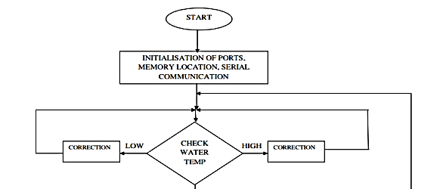
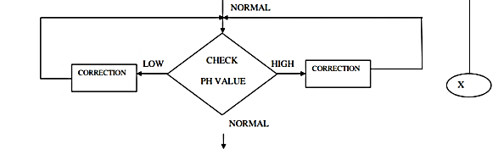
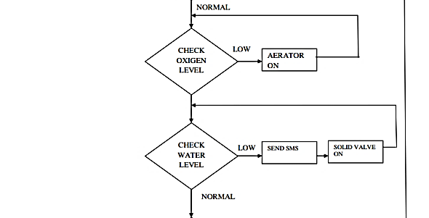
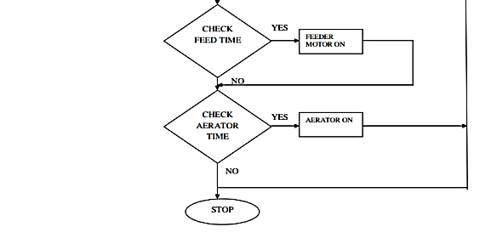
Fig. 4 Working of actuators
3.3.2 ThingSpeak: used for data collection and visualization
Fig. 5, ThingSpeak, an open-source IoT platform, was used for real-time data collection, storage, analysis, and visualization from the aquaponics system (Fig. 5). Sensor data, including pH, temperature, dissolved oxygen, and water levels, were transmitted to the platform via HTTP protocols. The platform enabled the creation of real-time charts and plots for monitoring system performance. Automated actions, such as triggering notifications or controlling actuators, were implemented based on predefined data conditions to maintain optimal aquaponics parameters. The visualized data, presented through charts and graphs, provided valuable insights into the system's performance.
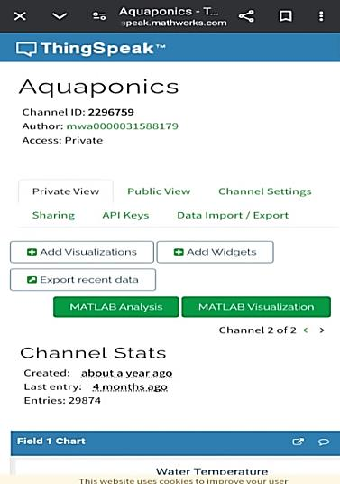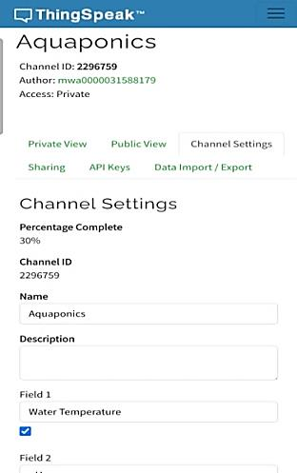
Fig. 5 Interface of ThingSpeak
3.4 Evaluation metrics
The developed system inside the polyhouse was evaluated. The experiment was conducted inside the naturally ventilated polyhouse during May 30 to August 17, 2024. The duration of the crop was three months (80 days).

3.4.1 Fish growth parameters
Before the start of the experiment, the initial weight and length of each fish recorded. Fish weighed using a digital scale and the fish was weighed at weekly intervals.
Specific growth rate (SGR) was calculated using the following formula (Palm et al., 2014)
SGR (%/day) = $\frac{(ln(Final Weight)-ln(Initial Weight))}{Days of the Experiment}$ ×100
Weight gain (%) = $\frac{final weight- initial weight}{ initial weight}$ ×100
Daily growth rate (DGR g/ day) = $\frac{ final weight \left(g\right)- initial weight(g)}{culture period (d)}$
Survival (S) = $\frac{final number of fish initial number of fish}{initial number of fish}$ ×100
As the fish are fed twice a day, the total feed provided will be recorded, and feed conversion ratio (FCR) will be calculated as recommended by Liang and Chien (2013)
FCR= $\frac{Feed Given (g)}{Weight Gain (g)}$
Feed conversion ratio (FCR) = $\frac{total weight of feed given (g)}{total fish weight gain (g)}$
Feed efficiency ratio (FER) = $\frac{total fish weight gain (g)}{total weight of feed given (g)}$

3.4.2 Biometric observations of palak
Plants were grown in the NFT grow bed, with a total growing area of 1 square meter and plant spacing set at 15 cm apart. Data such as the number of leaves and initial weight of plant were recorded for the 48 plants transplanted in the aquaponics system. Out of these 16 plants selected for detailed observation. Weekly observations conducted to monitor the plant growth. Shoot length, leaf length, leaf width, plant height and the number of leaves were recorded.
3.5 Yield analysis
At the end of the trial:
- Palak yield was calculated per plant, per m², and extrapolated to per hectare.
- Fish yield was recorded as final biomass.
4. results and discussion
The developed automated aquaponics system was continuously tested for 80 days. All sensor values for water temperature, pH level, dissolved oxygen, water flow rate, and water level were acquired. Furthermore, manual measurements of plant height and fish weight were made for data mining and analysis.

4.1 Design of aquaponics system
The aquaponics system was designed to meet the requirements for supporting 48 plants by carefully selecting and integrating its components. The aquaponics system has been built and run functionally and adequately as shown in Fig. 6. Fig. 7 illustrates the arrangement of components and circuits, which collectively form the automation and IoT system.
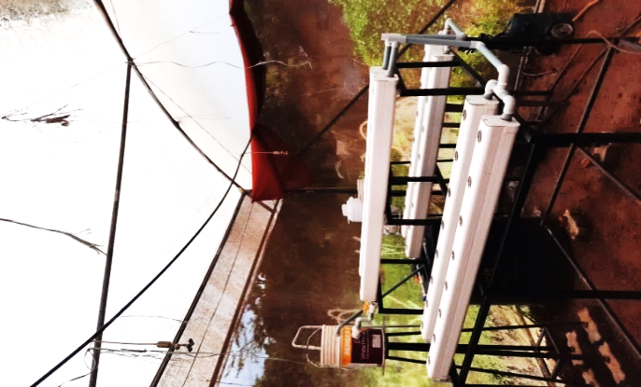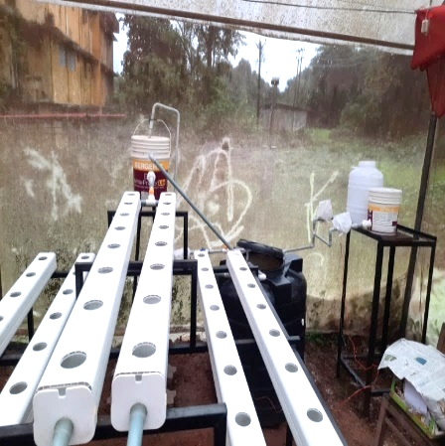
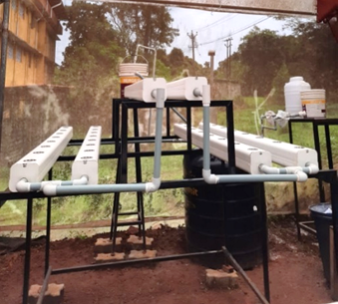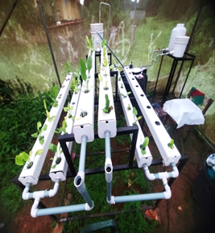
Fig. 6 Aquaponics system
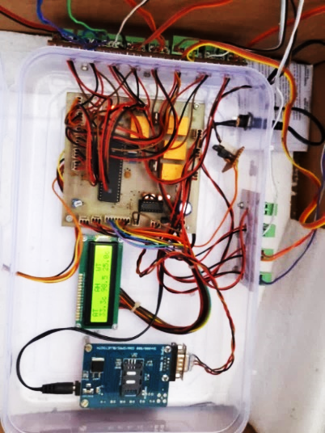
Fig. 7 Arrangement of components of automation and IoT system

4.2 Real time monitoring and display system
The real-time monitoring system was successfully implemented using an LCD module interfaced with the PIC microcontroller. The LCD displayed current readings of critical water quality parameters (Fig. 8), including water temperature, EC, pH, DO, and flow rate, as well as ambient air temperature and humidity. The display updated continuously, allowing immediate visual feedback on environmental conditions within the system.
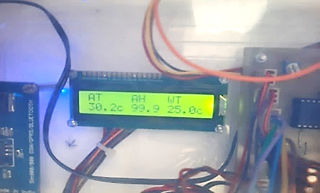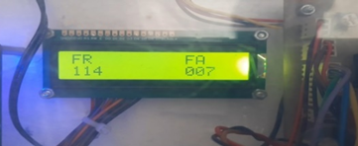
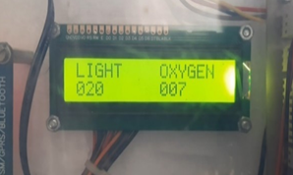
Fig. 8 LCD display of parameter
In addition to the LCD, a GSM module was configured to send SMS alerts to a registered mobile number (Fig. 9) whenever critical thresholds were breached. This dual alert mechanism ensured that system operators were informed in real time and could take corrective measures even remotely.
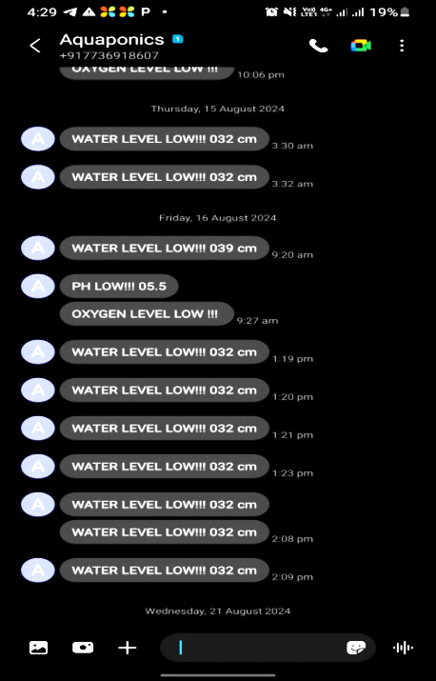
Fig. 9 Screenshots of monitoring using GSM by sending SMS

The microcontroller was connected to the ThingSpeak platform via the internet, allowing real-time sensor data to be uploaded. Fig. 10 shows the data was visualized on ThingSpeak in the form of graphs, providing an easy way to monitor the system's performance. Additionally, the data could be exported as an excel file for further analysis.
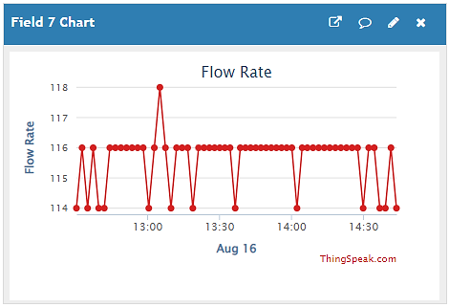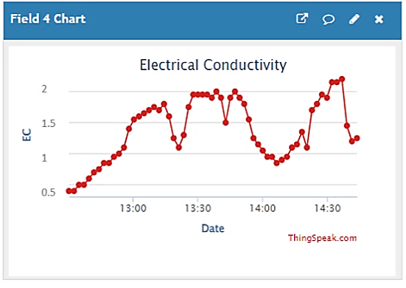
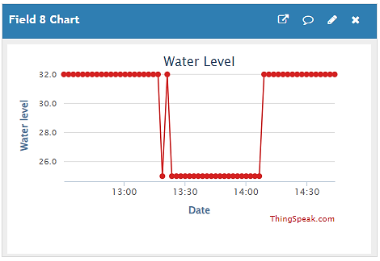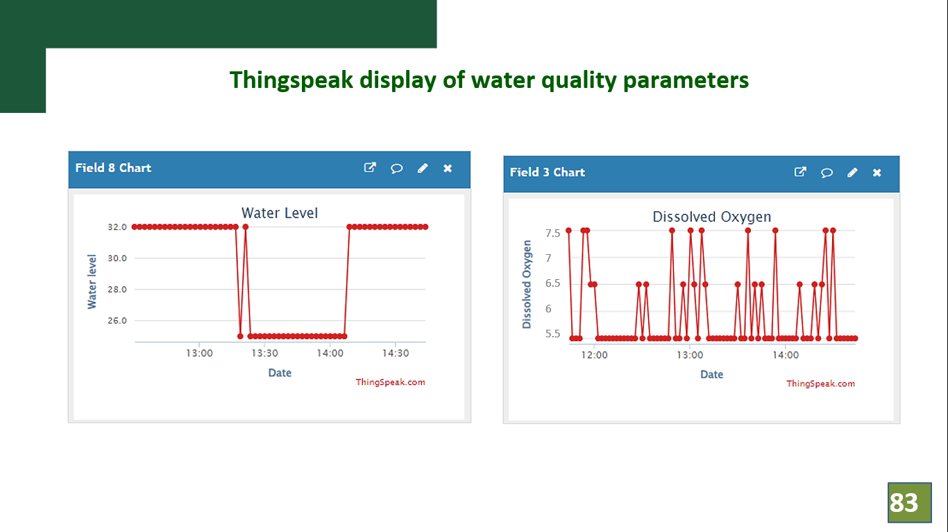
Fig. 10 Monitoring data from ThingSpeak

4.3 System response to parameter deviations
The automated system demonstrated high responsiveness to deviations from optimal ranges. For instance, on August 12, a spike in water temperature triggered the solenoid valve to release cooler water into the fish tank. This corrective action helped bring the temperature back within the safe range (22°C-32°C) without manual intervention as shown in Fig.11.

Fig.11 Daily variation of water temperature on 12/ 08/ 2024
Similarly, fluctuations in pH values prompted automatic dosing of buffer or acid solutions via solenoid-controlled dispensers. Water level drops, detected by the ultrasonic sensor, activated the refill valve; restoring balance in both the fish tank and grow beds. When DO levels fell below 5.5 mg/L, the aerator was automatically activated and later turned off once optimal levels were restored, ensuring energy efficiency (Fig. 12).

Fig. 12 Daily Variation of pH, DO, EC, Water level
These results confirm the system's ability to maintain optimal growing conditions consistently, with timely actuator responses controlled by real-time sensor feedback.

4.4 Monthly parameter fluctuation and actuation after transplanting
On June 8, July 9, and August 25, detailed tracking of DO and pH levels revealed patterns in diurnal variation. DO consistently drop during peak metabolic activity and low aeration periods but recovered rapidly post-intervention. Dissolved oxygen (DO) levels were generally maintained around 6 mg·L⁻¹, though noticeable drops to approximately 4 mg·L⁻¹ occurred at 7:00 AM, 2:00 PM, and 6:00 PM. These fluctuations, consistent with findings by Suhl et al. (2019), were linked to lower photosynthesis and increased microbial and fish oxygen demand during those periods.
The system’s aerator responded automatically, restoring DO to above 5.5 mg·L⁻¹ and preventing fish stress. Notably, DO variation was minimal during the first month, resulting in fewer aerator activations (Fig. 13).

Fig. 13 DO and water temperature monitored on 08/06/2024
On 09/07/2024, water temperature peaked at 28.8°C by noon, while DO levels fluctuated between 4.5–5.8 mg·L⁻¹. Drops at peak metabolic times triggered the aerator, restoring DO to safe levels. The system maintained DO above 4.5 mg·L⁻¹, confirming effective real-time monitoring and automated control (Fig. 14).

Fig. 14 DO and water temperature monitored on 09/07/2024
On 25/08/2024, DO levels ranged from 5.0–5.6 mg·L⁻¹, with brief dips to 4.8 mg·L⁻¹ due to increased fish growth and microbial activity. The aerator activated automatically, restoring DO to optimal levels. Water temperature and DO remain within favorable ranges, supporting healthy fish and plant development (Fig. 15).

Fig. 15 DO and water temperature monitored on 25/08/2024
pH levels showed an afternoon rise due to increased photosynthetic activity and returned to normal in the evening, consistent with expected biological behavior. Variation in pH, DO, and solenoid valve activity monitored on 08/06/2024 over a 24-hour period. DO levels (blue line) generally decrease over time but showed sharp increases at 6:00 AM- 8:00 AM and 5:00 PM- 7:00 PM. The pH values (green bars) remained relatively stable throughout the day, fluctuating between 5.5 and 7.5, with a slight rise during the early morning hours, which coincided with the activation of solenoid valve and allow water from external water tank to the fish tank (red line) (Fig. 16).

Fig. 16 pH and DO monitored on 08/06/2024
On 09/07/2024, pH remained stable between 6.4 and 7.0, with a solenoid valve activation at 1:00 AM due to a slight drop. pH gradually increased throughout the day, peaking in the evening, indicating improved stabilization following early system adjustments (Fig. 17).

Fig. 17 pH and DO monitored on 09/07/2024
The Fig. 18 shows the variation in pH, DO, and solenoid valve activity monitored on 25/08/2024 over a 24-hour period. It was found that pH was high at 12:30 PM and 6 PM having value 7.6 and it controlled by adding water from external water tank to fish tank through solenoid valve.

Fig. 18 pH and DO monitored on 25/08/2024

4.5 Growth performance of palak
Palak (Spinacia oleracea) was cultivated in the NFT grow beds to evaluate plant performance under the automated aquaponics system. Plant height, number of leaves, and leaf dimensions were measured weekly. Plant height increased steadily from 9.3 cm at transplanting to 21.7 cm by the fifth week. Leaf count rose from 4 to 13, while leaf length and width reached 12.37 cm and 10.66 cm, respectively.

Fig. 19 Weekly measurement of plant height, number of leaves, leaf length and leaf width

4.6 Growth performance of fish
Tilapias were raised in the 500 L tank at a stocking density of 20 L per fish and weight was measured weekly (Fig. 20). Initial weight averaged 60 g, increasing to 207.94 g at harvest. The Specific Growth Rate (SGR) was 1.38% per day, and the Daily Growth Rate (DGR) was 1.64 g/day. The Feed Conversion Ratio (FCR) was 1.36, and the Feed Efficiency Ratio (FER) was 0.735, indicating efficient feed utilization. Remarkably, the system achieved a 100% survival rate, demonstrating the effectiveness of water quality control and overall environmental stability.
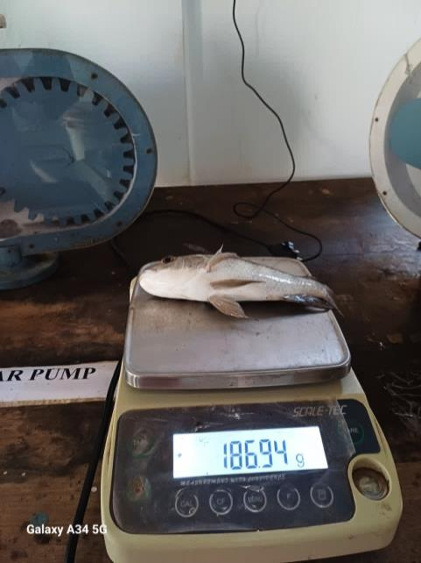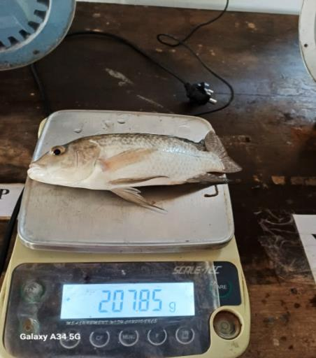
Fig. 20 Weekly measurement of fish weight
4.7 Observations on yield parameters
4.7.1 Plant yield
Palak harvesting began 35 days after transplanting and continued on a biweekly schedule. Yield data showed a maximum per-plant harvest of 43.75 g on August 3. The total yield from the system was 9.57 kg, with an average yield of 4.25 kg/m², extrapolated to 42.5 t/ha under scaled conditions (Table 2). This confirmed the system's effectiveness in sustaining healthy plant growth with minimal water and nutrient waste. Various growth stages of palak is shown is Fig. 21.
Table 2. Total plant yield
Date of harvest | Average yield per plant (g) | Total yield (kg)
4-Jul | 14.58 | 0.7
11-Jul | 20.8 | 1.0
18-Jul | 26.86 | 1.29
25-Jul | 37.92 | 1.82
3-Aug | 43.75 | 2.1
10-Aug | 38.75 | 1.86
17-Aug | 16.66 | 0.8
Total |  | 9.57

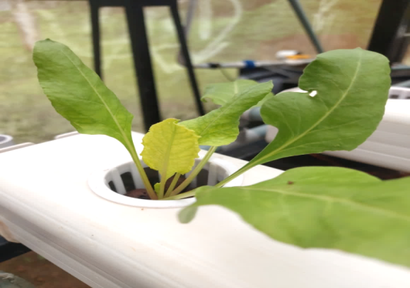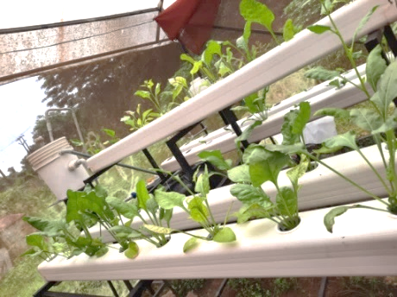
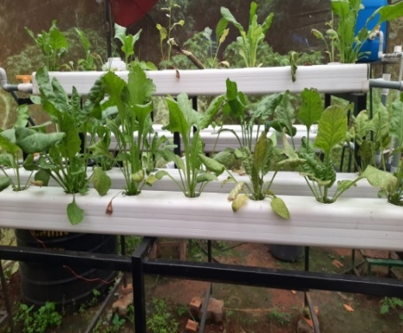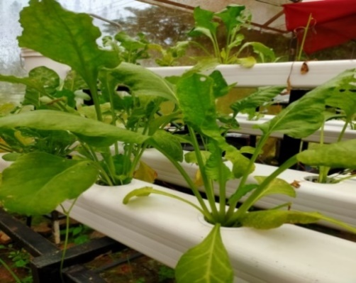
Fig. 21 Different growth stages of palak
4.7.2 Fish weight
Over the course of 14 weeks, the average weight of the fish showed a steady increase, highlighting the effectiveness of the system. Starting from an average weight of 60 g on May 30, the fish experienced consistent growth, reaching 97.4 grams by June 20 and 164.83 g by August 1. By the end of the growth period on August 29, the fish had an average weight of 207.94 g as shown in Table 3.
Table 3. Fish weight attained
Weeks | Average fish weight (g) | Total fish weight (g)
30-May | 60 | 1500
6-Jun | 65.96 | 1649
13-Jun | 76.23 | 1905.75
20-Jun | 97.4 | 2435
27-Jun | 113.13 | 2828.25
4-Jul | 127.59 | 3189.75
11-Jul | 139.32 | 3483
18-Jul | 146.07 | 3651.75
25-Jul | 155.83 | 3895.75
1-Aug | 164.83 | 4120.75
8-Aug | 175.23 | 4380.75
15-Aug | 186.24 | 4656
22-Aug | 194.74 | 4868.5
29-Aug | 207.94 | 5198.5

5. Conclusion
This research demonstrated the feasibility of an IoT-based automated aquaponics system for real-time water quality monitoring and control. The system enhanced sustainability by reducing manual labor and optimized environmental conditions for fish and plant growth. The system effectively maintained critical water quality parameters, including temperature, pH, dissolved oxygen, and electrical conductivity within optimal ranges, ensuring stable conditions without any fish mortality. Real-time monitoring and automated control enabled quick responses to biological fluctuations, contributing to system stability and health. The system demonstrated promising productivity, yielding 5.198 kg of fish and 9.57 kg of plants, highlighting its potential for sustainable and efficient food production. Although the study faced challenges such as structural adjustments, seasonal impacts, pest infestations, algae growth, and technical issues like sensor calibration and communication interruptions, these experiences underscored the need for continuous system optimization. Overall, the project presents a modern solution to aquaponics water quality management, combining technological innovation with environmental sustainability. The success of this system lays the foundation for future advancements in automated farming technologies, promoting scalable and energy-efficient solutions to meet the growing demands of global food security. Future improvements may include AI-based predictive analytics, blockchain-based data security, and mobile application integration for enhanced remote control.
References
UN [United Nations]. 2019. Population- the United Nations [on-line]. Available: https://www.un.org/en/development/desa/population/publications/pdf
UN [United Nations]. 2007. Population- the United Nations [on-line]. Available: https://www.un.org/development/desa/pd
Michael, A. M. & Ojha, T. P. (2013). Principles of Agricultural Engineering: Volume II. Jain Brothers, 467-479.
IWMI [International Water Management Institute]. (2023). Unlocking the power of water: Seven interventions to transform food systems [on-line]. Available: https://www.iwmi.org
Reuters. (2024). Worsening water crisis can weigh on India's sovereign credit strength, Moody's says [on-line]. Available: https://www.reuters.com
Dani, S. & Gaur, G.C. (2016). Economics of farmers’ suicides. Int. J. Adv. Res. Manag. Social Sci. 5(3): 37-47.
Sawkar, R.H., Hiregoudar, L.G., & Bharadwaj, S. (2020). Aquaponics: a modern agriculture technology to overcome water scarcity and drought. Geol. Soc. India. 95(1): 108-109.
Friha, O., Ferrag, M.A., Shu, L., Maglaras, L., & Wang, X. (2021). Internet of things for the future of smart agriculture: A comprehensive survey of emerging technologies. J. Automatic. Sinica. 8(4): 718-752.
Yanes, A.R., Martinez, P., & Ahmad, R. (2020). Towards automated aquaponics: A review on monitoring, IoT, and smart systems. J. Cleaner Prod. 263: 121- 571.
Kularbphettong, K., Ampant, U., & Kongrodj, N. (2019). An automated hydroponics system based on mobile application. Int. J. Inf. Educ. Technol. 9(8): 548-552.
Vanipriya, C.H., Malladi, S., & Gupta, G. (2021). Artificial intelligence enabled plant emotion expresser in the development hydroponics system. Mater. Today: Proc. (45): 5034-5040.
Maucieri, C., Nicoletto, C., Schmautz, Z., Sambo, P., Komives, T., Borin, M. & Junge, R. (2017). Vegetable intercropping in a small-scale aquaponic system. Agron. 7(4): 63- 75.
Gayam, K.K., Jain, A., Gehlot, A., Singh, R., Akram, S.V., Singh, A., Anand, D., & Noya, I.D. (2022). Imperative role of automation and wireless technologies in aquaponics farming. Wireless Commun. Mobile Computing. 2022(1): 8290255.
Palm, H.W., Bissa, K., & Knaus, U. (2014). Significant factors affecting the economic sustainability of closed aquaponic systems, Part II: fish and plant growth. Aquac. Aquarium, Conserv. Legislation. 7(3): 162-175.
Liang, J.Y., & Chien, Y.H. (2013). Effects of feeding frequency and photoperiod on water quality and crop production in a tilapia-water spinach raft aquaponics system. Int. Biodeterioration. Biodegradation. 85(12): 693-700.
Suhl, J., Oppedijk, B., Baganz, D., Kloas, W., Schmidt, U., & van Duijn, B. (2019). Oxygen consumption in recirculating nutrient film technique in aquaponics. Sci. Hortic. 255: 281-291.
APPENDIX
APPENDIX-I
Biometric observations of 16 selected plants
Table A- 6 Biometric observations of 16 selected plants at the time of transplanting
Plants | Shoot length (cm) | Leaf length (cm) | Leaf width (cm) | No of leaves
1 | 4 | 4.6 | 3.2 | 3
2 | 4.2 | 4.1 | 3.4 | 4
3 | 4.1 | 4.3 | 3.2 | 5
4 | 4.3 | 4.1 | 3.5 | 3
5 | 5.2 | 4.5 | 3.6 | 4
6 | 4.6 | 4.2 | 3.4 | 6
7 | 4.8 | 3 | 3.5 | 3
8 | 5.7 | 4 | 3.6 | 4
9 | 6.5 | 4.7 | 2.9 | 4
10 | 4.5 | 2.8 | 2.7 | 3
11 | 5.8 | 4.1 | 3.3 | 4
12 | 6.9 | 4.9 | 3.4 | 4
13 | 7.1 | 5.1 | 2.9 | 5
14 | 4.9 | 3.2 | 2.6 | 4
15 | 6.3 | 4.5 | 2.4 | 4
16 | 4.7 | 3.1 | 2 | 4
Table A- 7 Biometric observations of 16 selected plants after one week
Plants | Shoot length (cm) | Leaf length (cm) | Leaf width (cm) | No of leaves
1 | 4.2 | 5.4 | 3.9 | 5
2 | 4.3 | 5.3 | 4.1 | 6
3 | 4.2 | 5 | 3.7 | 7
4 | 4.4 | 4.9 | 4.8 | 4
5 | 5.4 | 5.2 | 5 | 5
6 | 4.9 | 5.1 | 4.4 | 7
7 | 4 | 2.7 | 4 | 5
8 | 7.2 | 5 | 4.7 | 5
9 | 8 | 5.7 | 4.6 | 6
10 | 5.8 | 3.9 | 3.2 | 4
11 | 7.3 | 5.2 | 4.3 | 5
12 | 8.5 | 6 | 4 | 6
13 | 8.8 | 6.2 | 4.1 | 6
14 | 6.4 | 4.3 | 3.6 | 5
15 | 7.8 | 5.5 | 2.7 | 6
16 | 6.2 | 4.2 | 2.8 | 5
Table A- 8 Biometric observations of 16 selected plants after two weeks
Plants | Shoot length (cm) | Leaf length (cm) | Leaf width (cm) | No of leaves
1 | 5.9 | 6.9 | 4.5 | 7
2 | 6.1 | 6.7 | 4.8 | 8
3 | 5.8 | 6.8 | 4.1 | 8
4 | 5.9 | 5.9 | 5 | 5
5 | 6.5 | 6.1 | 5.1 | 6
6 | 6.3 | 5.9 | 5 | 8
7 | 7.5 | 5.2 | 4.6 | 6
8 | 8.7 | 6.2 | 5.2 | 6
9 | 9.5 | 7 | 4.9 | 7
10 | 7.3 | 5.3 | 4.2 | 5
11 | 8.8 | 6.5 | 5 | 6
12 | 10 | 7.5 | 4.8 | 7
13 | 10.3 | 7.8 | 5 | 7
14 | 7.9 | 5.7 | 4.2 | 6
15 | 9.3 | 6.8 | 3.9 | 7
16 | 7.7 | 5.5 | 4.2 | 6
Table A- 9 Biometric observations of 16 selected plants after three weeks
Plants | Shoot length (cm) | Leaf length (cm) | Leaf width (cm) | No of leaves
1 | 6 | 8.1 | 6.2 | 9
2 | 6.3 | 7.9 | 6.4 | 9
3 | 5.9 | 8.1 | 6 | 10
4 | 6.1 | 8.2 | 6.5 | 7
5 | 6.9 | 8.1 | 6.6 | 8
6 | 7 | 8.4 | 6.5 | 9
7 | 7.9 | 6.5 | 5.9 | 8
8 | 9 | 8.5 | 7 | 7
9 | 9.7 | 8.3 | 6.5 | 9
10 | 7.8 | 6.9 | 6.1 | 6
11 | 8.9 | 7.9 | 6.6 | 9
12 | 10.1 | 9.1 | 6.2 | 8
13 | 10.5 | 9.3 | 6.6 | 9
14 | 8.1 | 7.3 | 6.1 | 8
15 | 9.7 | 8 | 5.9 | 8
16 | 7.9 | 6.9 | 6.2 | 9
Table A- 10 Biometric observations of 16 selected plants after four weeks
Plants | Shoot length (cm) | Leaf length (cm) | Leaf width (cm) | No of leaves
1 | 6.9 | 10.4 | 8.3 | 10
2 | 7.3 | 9.7 | 8.5 | 11
3 | 6.4 | 10.6 | 7.9 | 12
4 | 7 | 10.7 | 8.6 | 8
5 | 7.8 | 10.6 | 8.8 | 10
6 | 8 | 10.9 | 8.7 | 11
7 | 8.8 | 9.5 | 7.7 | 9
8 | 9.6 | 11 | 9 | 9
9 | 10.3 | 10.7 | 8.6 | 12
10 | 8.7 | 10 | 8.4 | 10
11 | 9.7 | 10.5 | 8.8 | 11
12 | 10.9 | 11.6 | 8.5 | 9
13 | 11.1 | 12 | 8.8 | 12
14 | 9.3 | 10.2 | 8.4 | 9
15 | 10.3 | 10.7 | 7.9 | 10
16 | 8.6 | 9.6 | 8.5 | 10

Table A- 11 Biometric observations of 16 selected plants after five weeks (first harvest)
Plants | Shoot length (cm) | Leaf length (cm) | Leaf width (cm) | No of leaves
1 | 7.4 | 11.8 | 10.3 | 13
2 | 7.6 | 11.5 | 10.6 | 14
3 | 6.7 | 11.9 | 10.1 | 14
4 | 7.6 | 12.8 | 10.8 | 12
5 | 8.3 | 12.2 | 11 | 13
6 | 8.5 | 12.8 | 11 | 15
7 | 9.3 | 11.7 | 10 | 13
8 | 10.1 | 13.1 | 11.5 | 14
9 | 10.7 | 13 | 10.9 | 15
10 | 9.5 | 12.1 | 10.6 | 12
11 | 10.6 | 12 | 11 | 13
12 | 11.5 | 13.2 | 10.7 | 12
13 | 11.6 | 13.5 | 11 | 14
14 | 9.9 | 11.9 | 10.5 | 13
15 | 10.8 | 12.5 | 10 | 13
16 | 9.1 | 11.8 | 10.6 | 14

