Assessment of the sale price of agropastoral waste in the Sassandra agricultural basin

ABSTRACT
Agricultural waste can be not only a source of wealth for these holders, but also a mine of raw materials for economic operators who would make use of it. It is therefore necessary that the prices of these residues be estimated and regulated, in order to make their pre-collection attractive. The objective of this study is to evaluate the selling price of agro-pastoral waste in the Sassandra agricultural basin. The methodology was based on a survey of planters. The sample size is composed of three hundred and five (305) planters from four localities including 52 in Daloa, 100 in Issia, 70 in Soubré, and 83 in Sassandra. The estimated prices were made per kilogram. The results of the study showed that the planters surveyed, whose age is between 18 and 76 years, are made up of 44.54% men and 55.46% women.95% of them have no monthly income. It also appears that the estimated price of residues from perennial crops varies between 10 and 600 francs for hulls, between 25 and 300 francs for bunches, between 25 and 1000 francs for pods and between 10 and 700 francs for fibers. The average prices are 290 francs, 160 francs, 215 francs and 170 francs respectively for hulls, bunches, pods and fibers. Regarding residues from food crops, their prices vary between 10 and 700 francs, 25 and 500 francs, 20 and 600 francs and 10 and 1000 francs respectively for stalks, straw, ears, stem and stalks. The average price of these is 100 francs for the stalks, 180 francs for the straw, 120 francs for the ears, 245 francs for the bales and 230 francs for the stalks.
Keywords: Sassandra agricultural basin, crop residues, price

- INTRODUCTION

Since its independence, Côte d'Ivoire has focused its economic development on the agricultural sector. This sector creates more than 47% of the national added value [1]. Agriculture represents 20% of GDP in 2019 and employs 40% of the country's active population [2]. Côte d'Ivoire is a major player in the agricultural sector on a continental scale and is in the world or African trio for several products such as cocoa, cashew nuts, bananas, mangoes, cotton, rubber, oil palm, etc. [3] ; [4. Agricultural residues (straw, stalks, tops, bagasse, etc.) constitute a resource with promising energy potential. They are thus generated in large quantities and without additional production costs, wherever there is agricultural activity [5]. According to GBN [2], agricultural waste from the main raw materials (cocoa, cotton, rubber, palm oil) is estimated at between 15 and 17 million tonnes per year. Their recovery, in the form of electricity for example, would allow the development of decentralized and rural energy production while reducing energy dependence, expenses and greenhouse gas emissions linked to the importation and use of fossil fuels [6]. In addition, this waste could constitute not only a source of wealth for rural populations (holders of this waste), but also a mine of raw materials for economic operators who would recover it (fodder, composting, manufacturing of various materials, etc.) [7];[8];[9]. However, according to Global Business Network [2], discussions with processors show that the biomass of cocoa pods, for example, is not currently valued and that the removal of pods is generally free (otherwise sold at 5F CFA per kg). It is therefore necessary that prices be estimated and regulated, in order to make their pre-collection by producers attractive, while ensuring a price that allows other stakeholders in the chain to remain competitive. Few studies address this estimation. However, it is important to consider them to allow each economic operator wishing to valorize residues to be competitive on the market. This study aims to evaluate the selling prices of crop residues that planters practice in the localities of Soubré, Sassandra, Daloa and Issia.

- MATERIAL AND METHODS

  - Study area

The Sassandra Agricultural Basin (BAS), with an area of ​​approximately 42,000 km2, is located in the west of Côte d'Ivoire. It includes four (4) departments including Daloa, Soubré, Issia and Sassandra (Figure 1). The departments of Daloa and Issia are located between longitudes 6°20 and 6°50 West and latitudes 6°1 and 6°80 North. As for the departments of Sassandra and Soubré, they are located between longitude 6°10 and 6°40 West and latitude 5°19 and 5°80 North. The areas of the BAS departments are 5,658 km2 for Issia, 1,080 km2 for Daloa, 8,500 km2 for Soubré and 25,800 km2 for Sassandra
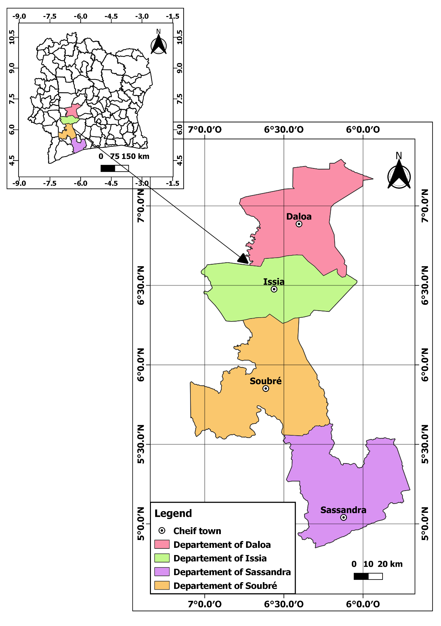
Figure 1: Location of the Sassandra agricultural basin [10]

  - Data collection

A survey sheet was sent to planters in four (4) localities of the Sassandra Agricultural Watershed (Daloa, Issia, Soubré and Sassandra). In total, three to five (305) planters were interviewed, including fifty-two (52) in Daloa, one hundred (100) in Issia, seventy (70) in Soubré, and eighty-three (83) in Sassandra. The questionnaire is structured in two sections, namely the socio-economic characteristics of the planters, and the estimation of the price of agricultural residues in the event of sale. The survey method based on simple random sampling [11] was used. This sampling method is characterized by an equal probability of selection of all sampling units, each unit being chosen independently of the others [11].

  - Data processing

The collected data were subjected to numerical processing. The relative frequencies of each variable were calculated in relation to the number of planters surveyed according to formula 1:

$F=\frac{nj}{n}×100 (1)$
With:
F : Frequency (%);
nj : Number of modality (number of planters per locality, variable);
n : Total number of planters surveyed.

  - Statistical processing

Statistical tests were performed using R Studio software. They include the Shapiro-Wilk (W) test, one-way ANOVA, and the t-test [12. The significance threshold for these tests is set at p < 0.05. The Shapiro-Wilk test was used to verify the normality of the distribution. Comparisons of crop residue prices between different locations were made using the parametric ANOVA tests and the t-test. As for the one-way ANOVA parametric test, it was used to examine the variation in residue prices of the locations considered. The parametric test (T-test) was then used to determine the differences in variation of these descriptors between the location prices two by two. At the level of descriptive statistics, the mean was calculated for each variable considered. In addition, dispersion parameters such as the standard error on the mean, the minimum and maximum values ​​were determined. They were carried out using Statistica 7.1 software [13]. The representation of the variations of these descriptors was carried out in the form of box plots indicating the mean and the maximum and minimum values ​​(Figure 2).
Maximum
Mean + standard error
Mean

Mean - standard error
Minimum
Figure 2 : box plots
- RESULT AND DISCUSSION

  - Socio-economic characteristics of households

    - Demographic profile of people surveyed

In the agricultural basin of Sassandra, agricultural activities are carried out by both men and women. During the surveys, 44.54% of men and 55.46% of women responded to the questions (Figure 3). This high proportion of women could be explained by the fact that in these areas, there is a high proportion of polygamous couples characterized by families of 2 to more than 4 women for one man [14. The age of the respondents is between 31 and 74 years in the locality of Sassandra, between 30 and 65 in the locality of Daloa, between 24 and 73 in the locality of Issia and between 18 and 76 in the locality of Soubré (Figure 4). Analysis of the ages of the people surveyed, varying between 18 and 76 years depending on the locality, indicates that crop residues are produced by a diverse working population, divided between young adults and older people. This generational heterogeneity can have an impact on residue management and recovery strategies. According to [15], age plays a determining role in the adoption of agricultural technologies: young farmers are generally more inclined to experiment with innovative practices, due to their better exposure to information and networks. This result shows the involvement of mature people in agricultural activities. This age group, often with extensive experience, plays a crucial role in crop residue management [15].

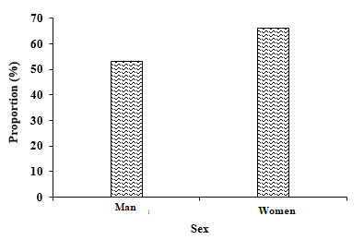
Figure 3 : Proportion of the number of planters by sex (Université Nangui ABROGOUA/LEBA/KOUASSI-KOUADIO).

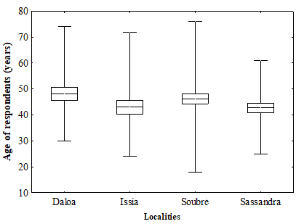

Figure 4: Variation in the age of planters (Université Nangui ABROGOUA/LEBA/KOUASSI-KOUADIO).
    - Instruction profile of the people surveyed
Regarding the level of education, the survey revealed a predominance of people with a relatively low level of education among the planters surveyed. Indeed, only 15% of the planters have reached secondary school (high school), while the majority, 55%, have a level equivalent to the Certificat d’Études Primaires Élémentaires (CEPE). In addition, a significant proportion, estimated at 30%, have no formal education (Figure 5). These results reflect a worrying educational situation in the agricultural environment studied, with direct implications for the adoption of technological innovations, farm management and the ability of planters to access certain technical, administrative or commercial information. Indeed, several studies have shown that the level of education has a positive influence on agricultural productivity as well as on the adoption of good cultural practices and residue recovery techniques. According to Asfaw et al. [16], a higher level of education promotes the adoption of improved agricultural technologies. Furthermore, the low proportion of farmers who have reached high school could be explained by socio-economic factors, such as poverty and the lack of educational infrastructure in rural areas. Indeed, Leavy and Hossain [17] highlight that, in many rural communities, children are often forced to leave school early to participate in family farming activities, in response to the economic needs of the household [18].
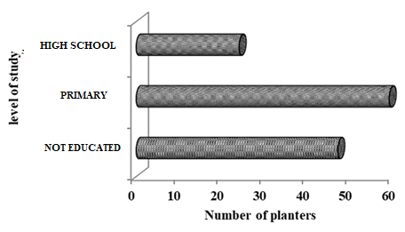

Figure 5 : Number of planters identified according to their level of education (Université Nangui ABROGOUA/LEBA/KOUASSI-KOUADIO).

    - Economic profile of the people surveyed
The results of the study show that 66% of the surveyed farmers live with dependents, such as their spouse, children or other family members, while 34% live alone (Figure 6). This distinction in family composition may have a significant influence on agricultural resource management strategies, including the valorization and sale of crop residues. Indeed, farmers with dependents may have a greater incentive to optimize their income by selling crop residues to meet household needs; in this case, crop residues can become a complementary source of income. This economic pressure could therefore encourage greater involvement of these farmers in the commercialization of their agricultural residues [19]. In addition, IFAD [20] highlights that rural families organized around a solidarity workforce can improve their overall productivity, particularly in the small-scale processing or marketing stages. Holden et al. [21] also showed that the availability of family labor is a key factor in labor investment decisions, particularly for activities with low immediate profitability. The study also shows that 95% of planters have no regular monthly income (Figure 7), which highlights a high level of economic insecurity within the population studied. This lack of stable income can play a determining role in agricultural resource development practices, particularly with regard to the sale of crop residues. Indeed, according to Barrett et al. [19], situations of financial vulnerability mean that planters are generally forced to exploit all possible sources of income, even modest ones. Thus, crop residues, usually underestimated or neglected, can become an alternative economic resource, used to cover daily needs or unforeseen events. Their sale then represents an opportunity, both accessible and inexpensive, to generate additional income.

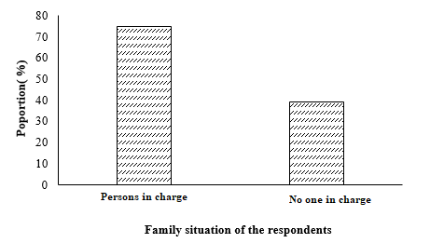
Figure 6 : Proportion of the number of planters identified according to their family situation (Université Nangui ABROGOUA/LEBA/KOUASSI-KOUADIO).

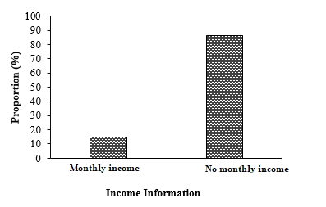
Figure 7 : Proportion of the number of planters surveyed according to their monthly income
  - Economic value of crop residues

    - Residues from food crops (rice husks, straw, stalks, cobs)

Figure 8 shows the prices rice husk offered by planters in the different localities visited. These prices vary between 10 and 1000 CFA Francs. The averages of these are 266.40, 259.4, 256.96 and 200.3 CFA Francs respectively in Daloa, Issia, Soubre and Sassandra. The statistical analysis shows that the average prices applied do not differ significantly from one locality to another (ANOVA test: p> 0.05).
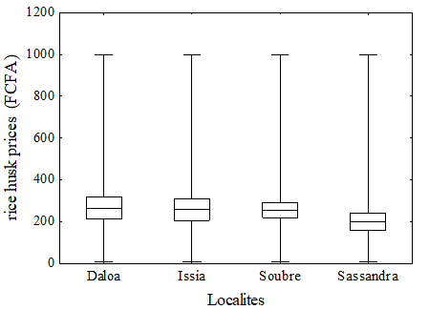
Figure 8 : Variation in rice husk prices across localities (Université Nangui ABROGOUA/LEBA/KOUASSI-KOUADIO).
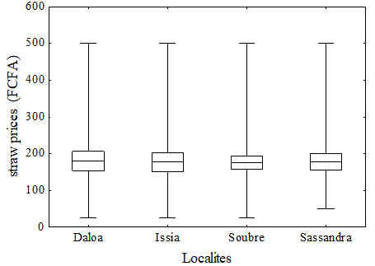
Concerning the price of straws, they vary between 25 and 500 CFA francs in the localities of Daloa, Issia and Soubré, while in Sassandra, they vary between 50 and 500 CFA francs (Figure 8). The average prices, from one locality to another, of the order of 180 francs (Daloa), 176.92 francs (Issia), 176.09 francs (Soubre) and 178.03 francs (Sassandra) are approximately identical (ANOVA test: p>0.05).

Figure 9 : Variation in straw prices in the locations investigated (Université Nangui ABROGOUA/LEBA/KOUASSI-KOUADIO).

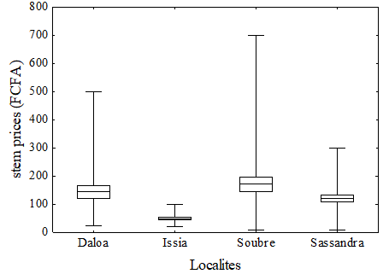
Figure 9 illustrates the variations in stem prices in different localities. These prices vary between 10 and 300 francs in Sassandra with an average of 120.15 francs, between 10 and 700 francs in Soubré with an average price of 170.98 francs, between 20 and 1000 francs with an average price of 144 francs in Daloa and between 25 and 500 francs in Issia with an average of 49.62 francs. The statistical analysis does not show a significant difference between the prices offered in the localities of Sassandra, Soubré and Daloa (T-test: p>0.05). On the other hand, those of Issia differ significantly from the three other localities (T-test: p<0.05).

Figure 10 : Variation in stem prices in the locations investigated (Université Nangui ABROGOUA/LEBA/KOUASSI-KOUADIO).
As for the price of corn cobs, they vary between 25 and 400 francs in Sassandra, between 25 and 600 francs in Soubré, between 20 and 100 in Issia and between 25 and 400 francs in Daloa (Figure 10). Average prices are 141.04 francs in Daloa, 50.38 francs in Issia, 163.15 francs in Soubre and 84.09 francs in Sassandra. The prices offered in Soubré and Daloa do not present a significant difference (T-test; p>0.05). The same is true for those offered in Issia and Sassandra (T-test; p>0.05).
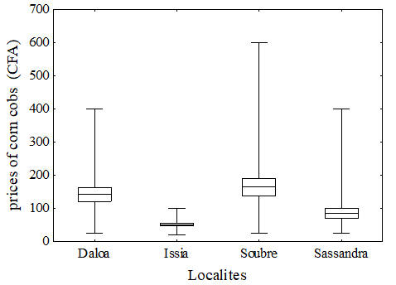
Figure 11: Variation in prices of corn cobs in the locations investigated (Université Nangui ABROGOUA/LEBA/KOUASSI-KOUADIO).
Regarding roundup, prices vary between 25 and 400 francs in Sassandra, between 25 and 600 francs in Soubré, between 20 and 100 in Issia and between 25 and 350 francs in Daloa (Figure 11). The average price of cobs is 114.80 francs in Daloa, 38.27 francs in Issia, 151.63 francs in Soubré and 67.42 francs in Sassandra. By comparing the roundup prices in the locations studied, we see a significant difference (ANOVA test: p<0.05). However, the prices of Issia and Sassandra remain in the same value range, as do those of Soubré and Daloa Test T: p>0.05).
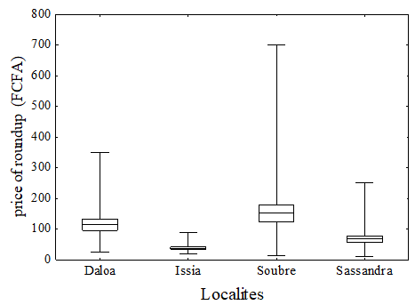
Figure 12 : Variation in the price of roundup in localities (Université Nangui ABROGOUA/LEBA/KOUASSI-KOUADIO).

- Residues from perennial crops (pod, hull and fiber)
Figure 12 shows the fiber prices offered by growers. These vary between 10 and 300 francs in Sassandra, between 50 and 700 francs in Soubré, between 50 and 200 in Issia and between 50 and 300 francs in Daloa. The average price of cobs is 173 francs in Daloa, 109.62 francs in Issia, 223.91 francs in Soubre and 128.33 francs in Sassandra. Furthermore, fiber prices do not differ significantly between the localities of Issia and Sassandra, as well as Daloa and Soubré (T-test: p >0.05).
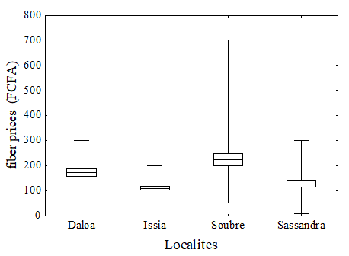
Figure 13: Variation in fiber prices in the locations investigated (Université Nangui ABROGOUA/LEBA/KOUASSI-KOUADIO).
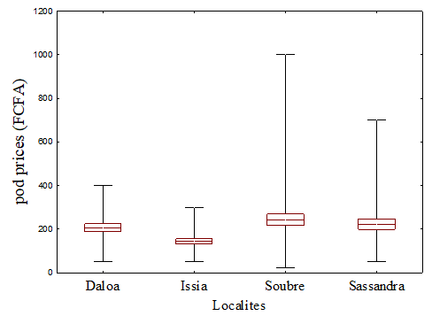
Regarding the prices of pods, they are between 50 and 700 francs in Sassandra, between 25 and 1000 francs in Soubré, between 50 and 300 in Issia and between 50 and 400 francs in Daloa (Figure 13). The average price of pods is highest in the locality of Soubré (242.93 francs) and low in the locality of Issia. However, the statistical analysis shows that the average prices do not differ significantly from one locality to another (ANOVA test: p>0.05).

Figure 14 : Variation in pod prices in the locations investigated (Université Nangui ABROGOUA/LEBA/KOUASSI-KOUADIO).
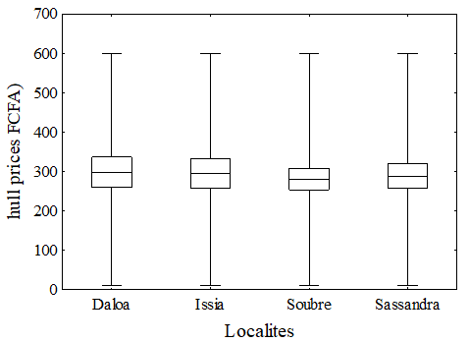
hull have prices varying between 10 and 600 francs in all localities, with an average price of 288.18 in Sassandra, 280.87 in Soubré, 294.62 in Issia and 298.40 in Daloa (Figure 15). However, the ANOVA test does not indicate a significant difference between prices (p>0.05).

Figure 15 : Variation in hull prices in the locations investigated (Université Nangui ABROGOUA/LEBA/KOUASSI-KOUADIO).

Prices for clusters remain in the range of 25 to 300 francs in the localities visited (Figure 16). As for the average prices, they are 140.15 francs in Sassandra, 161.41 francs in Soubré, 159.62 in Issia and 158 francs in Daloa. By comparing these average values, no significant difference is observed (ANOVA test: p>.0.05).
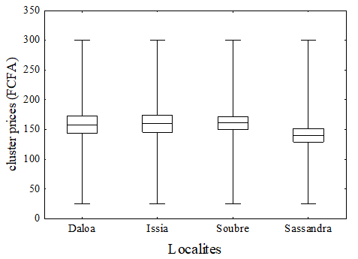
Figure 16 : Variation in cluster prices in the locations investigated (Université Nangui ABROGOUA/LEBA/KOUASSI-KOUADIO).
Analysis of average prices of crop residues in the studied localities reveals a significant heterogeneity of economic values, ranging from 10 to 1,000 CFA francs per kilogram, depending on the type of residue. This variation suggests that agricultural residues, long considered as waste without value, now represent significant economic potential for planters. The data show that certain residues reach high values, such as hulls (290.52 CFA francs/kg) and rice husks (245.67 CFA francs/kg), followed by pods (204.49 CFA francs/kg) and straw (177.76 CFA francs/kg). These products may be of interest to several markets for composting, animal feed, energy production (biomass), or even local crafts [22]. Their development can therefore contribute to diversifying and strengthening the income of planters, particularly for those who do not benefit from fixed monthly income. On the other hand, residues such as stalks (94 FCFA/kg) or stems (121.19 FCFA/kg) have relatively lower prices. This may be explained by lower demand or difficulty in processing and transporting them, thus reducing their commercial profitability. These value gaps highlight the importance of structuring value chains around these wastes and by-products, as well as the need for logistical or technical support to facilitate their collection, storage and transport to markets. This economic dynamic around residues shows that they are not only secondary elements, but can become essential commercial inputs in certain rural areas, provided that distribution channels are better organized. It also confirms the observations of several authors [23] ;[24], who emphasize that small producers, in a context of precariousness, naturally tend to exploit all available resources.

- CONCLUSION
At the end of this study, it appears that the planters surveyed in the Sassandra basin are predominantly women (55.46%), with a high proportion (over 95%) having no regular monthly income. Agriculture constitutes their main, if not only, source of livelihood. In addition, 80% of them have dependents, reinforcing their economic vulnerability but also their motivation to diversify and optimize their sources of income. In this context, the valorization of crop residues appears to be a promising economic alternative. The estimated selling prices of these residues show a wide variability, ranging from 10 to 1000 CFA francs per kilogram depending on the type of residue, with relatively attractive average prices: 245.67 CFA francs for rice husks, 290.52 francs for hulls, and 204.49 francs for pods. These values ​​indicate real potential for profitability, both for producers and for economic operators wishing to invest in processing or recovery units. Thus, crop residues, long considered simple waste, can become strategic economic resources. Their commercialization represents not only an opportunity to improve the income of planters, but also a lever for the development of local agro-industrial activities. To fully capitalize on this potential, it is necessary to strengthen awareness, training, as well as technical and organizational support for producers in the management and recovery of these residues.

COMPETING INTERESTS DISCLAIMER:
Authors have declared that they have no known competing financial interests OR non-financial interests OR personal relationships that could have appeared to influence the work reported in this paper.

- REFERENCES.
[1] Esso L. J. & Yeo N. (2014). Structural Transformations and Sectoral Development in Côte d'Ivoire. UNDP Report, CIRES Economic Policy Analysis Unit, Côte d'Ivoire, 70p.

[2] GBN (2020) Partnership Ready Côte d'Ivoire: Management and Recycling of Organic Waste. 8p. Available at: https://www.giz.de/en/downloads/GBN_Sector%20Brief_CIV_Bioabfall_FR_Web.pdf
[3] FIRCA (2009). The Progress Sector - Oil Palm, FIRCA Bulletin, No. 5-3rd Quarter, Côte d'Ivoire, 45p.
[4] CCC (2014). "2QC" Quantity-Quality-Growth Program 2014-2023. Reference and guidance document for the coffee-cocoa sector, Ministry of Agriculture, Côte d'Ivoire, 17p.
[5] Antoine Milhau A, Fallot A. (2011). Availability of agricultural residues in India for energy recovery. [Research report] CIRAD-GREEN. DOI: 10.13140/RG.2.1.2726.2486

[6] Coulibaly L., Ouattara J-M. P., Tiho S. (2012b). Biogas potential of agro-pastoral residues and human excreta from the Sassandra River watershed (Côte d'Ivoire). Int. J. Biol. Chem. Sci. 6(6): 6003-6016.
[7] Parfitt, J., Barthel, M., & Macnaughton, S. (2010). Food waste within food supply chains: Quantification and potential for change to 2050. Philosophical Transactions of the Royal Society B: Biological Sciences, 365(1554), 3065–3081. https://doi.org/10.1098/rstb.2010.0126
[8] FAO. (2013). Food waste footprint: Impacts on natural resources. Rome: Food and Agriculture Organization of the United Nations.

[9] Zampori, L., & Pant, R. (2019). Suggestions for updating the Product Environmental Footprint (PEF) method. Publications Office of the European Union. https://doi.org/10.2760/424613
[10] Kouassi-kouadio A. A. M., Ouattara P.J.M., Koua-Koffi N. A.A., Coulibaly T.J. H. & Coulibaly L. (2022). Design of a Relational Database for the Management of Crop Residues in Agricultural Regions: Case of the Agricultural Basin of Sassandra – Ivory Coast, International Journal of Environmental Monitoring and Analysis. Flight. 10, No. 5, 111-119. doi:10.11648/j.ijema.20221005.11
[11] Statistics Canada, Probability Sampling, 2013. [Online] http://Les%20statistiques%20_%20le%20pouvoir%20des%20donn%C3%A9es!%20%C3%89chantillonnage%20probabiliste.html
[12] Baillargeon, R. (2021). Statistical Methods Applied to the Social Sciences: Foundations and Practices with R. Presses Universitaires Francophones.
[13] Demidova, N., Ivanov, A., & Petrov, S. (2016). Applications of Statistica 7.1 in Biological and Environmental Data Analysis. Moscow: Scientific Research Publishing.

[14] ] UN-Habitat. (2012). Côte d'Ivoire: Urban Profile of Issia. Report, United Nations Human Settlements Programme. 22p.
[15] Meijer, S.S., Catacutan, D., Ajayi, O.C., Sileshi, G.W., & Nieuwenhuis, M. (2015). The role of knowledge, attitudes and perceptions in the uptake of agricultural and agroforestry innovations among smallholder farmers in sub-Saharan Africa. International Journal of Agricultural Sustainability, 13(1), 40–54.
[16] Asfaw, S., Shiferaw, B., Simtowe, F., & Lipper, L. (2012). Impact of modern agricultural technologies on smallholder welfare: Evidence from Tanzania and Ethiopia. Food Policy, 37(3), 283–295. https://doi.org/10.1016/j.foodpol.2012.02.013
[17] Leavy, J., & Hossain, N. (2014). Who runs the world? Girls and the Future of Education for All. IDS Bulletin, 45(1), 9–12. https://doi.org/10.1111/1759-5436.12064
[18] ] UNESCO. (2014). United Nations Educational, Scientific and Cultural Organization. Education for All Global Monitoring Report 2013–2014: Teaching and Learning – Achieving Quality for All. Paris, France.
[19] Barrett, C. B., Reardon, T., & Webb, P. (2001). Nonfarm Income Diversification and Household Livelihood Strategies in Rural Africa: Concepts, Dynamics, and Policy Implications. Food Policy, 26(4), 315–331. https://doi.org/10.1016/S0306 9192(01)00014 8

[20] IFAD. (2010). Rural poverty report 2011. International Fund for Agricultural Development. Rome: IFAD.
[21] Holden, S., Shiferaw, B., & Pender, J. (2001). Market imperfections and land productivity in the Ethiopian Highlands. Journal of Agricultural Economics, 52(3), 53–70. https://doi.org/10.1111/j.1477-9552.2001.tb00103.x

[22] Hounyêvou Klotoé A., Houssou A. P. F., Ahoyo N. R. A., V. Dansou V., Moreira J., Kaboré A. & Mensah G. A., (2014). Suitable binders and rice husk shapes for fuel briquette production. Technical data sheet, 1 p.
[23] Ruf, F. (2015). Poverty on cocoa farms in West Africa. Cahiers Agricultures, 24(5), 293-301.

[24] FAO (2017). Smallholders and rural poverty: challenges and opportunities. Rome.

