Original Research Article
Nutritional and Consumer Acceptability of Dakuwa (West African snack) Developed from Digitaria iburua (Fonio)

ABSTRACT
Aims: This study aimed to evaluate the nutritional composition, sensory acceptability, and microbiological safety of Dakuwa, a traditional West African snack, formulated with fonio (Digitaria exilis) as a primary cereal component.
Study Design: An experimental study was conducted using five composite formulations of fonio, maize, and groundnut, alongside a market-sourced sample for comparison.
Place and Duration of Study: The study was carried out in [Insert Department/Institution Name], between [Insert Month, Year] and [Insert Month, Year].
Methodology: Five Dakuwa formulations were prepared: DKCF10 (100% maize), DKCF11 (100% fonio), DKCF12 (80% fonio), DKCF13 (70% fonio), and DKCF14 (50% fonio). Proximate composition was determined using standard analytical methods. Sensory evaluation was conducted with consumer panels to assess taste, texture, and overall acceptability. Microbiological analysis was performed to assess safety and quality.
Results: Moisture content ranged from 2.57% to 4.38%, protein from 19.45% to 25.74%, and fat from 12.68% to 18.60%. DKCF10 and DKCF14 recorded the highest consumer preference scores for taste, texture, and overall acceptability. Microbiological evaluation indicated that all samples met safety standards, with DKCF14 and DKCF10 exhibiting the lowest microbial loads.
Conclusion: Incorporating fonio into Dakuwa enhanced the nutritional quality while maintaining consumer acceptability. Formulations containing 50% fonio (DKCF14) and 100% maize (DKCF10) were the most preferred. The study highlights fonio’s potential as a nutritious, gluten-free alternative for traditional snack production, contributing to dietary diversification and food security. Further research is needed to optimize processing techniques and explore wider applications of fonio-based products.

Keywords: Dakuwa, proximate composition, fonio, microbial analysis, consumer acceptability.

INTRODUCTION

Fonio is a traditional cereal grown in Western Africa [1]. Fonio is an underutilized cereal grain that has potential for use in food applications, in contrast to popular cereals like wheat and rice [2]. Fonio grains come in two varieties: black fonio (Digitaria iburua) and white fonio (Digitaria exilis) [3]. Fonio may promote sustainable land use, increase food security, improve nutrition, and encourage rural development. It is a significant source of energy, protein, vitamins, and minerals, just like other cereals [4]. Significant amounts of B vitamins are present in fonio. For instance, the white fonio has 0.17 mg of thiamine, 0.22 mg of riboflavin, and 1.15 n of niacin per 100 g. Greater concentrations of micro and macronutrients, such as zinc, iron, magnesium, manganese, copper, boron, calcium, potassium, sodium, aluminum, zinc, and phosphorus, along with essential and non-essential amino acids, have been documented for fonio grains [5, 6, 3]. Fonio is tolerant of drought and infertile soils, and it can grow on marginal ground [1, 7]. Over 600,000 tons of fonio grains are produced annually as a result of continuous growth in the industry [8]. In terms of food security, fonio is crucial. More lands become marginal and unsuitable for the cultivation of some important cereal crops during times of climate change. Fonio may be modified for large-scale production in various regions of the world in order to meet this challenge and promote agricultural diversification and food security [7, 9]. Fonio is traditionally used to make couscous, thin porridge, stiff porridge, and alcoholic drinks. In recent years, there has been a growing interest in the use of fonio in a variety of food formulations including Dakuwa.
Dakuwa is a snack made mostly of cereal and legumes. It is primarily consumed in Nigeria's northern regions. Cereals, groundnuts, ground pepper, ginger, sugar, and salt are combined to make Dakuwa. The components are well combined, ground, and formed into eatable food without additional processing [10]. The Voltarians in Ghana have adopted maize-groundnut balls, also called Dakuwa in Akan and dzowe in Ewe, which are native to Nigeria and are known as donkwa there [11]. Dakuwa is a popular street food because of its high nutritious content, however, the production of Dakuwa with fonio which is gluten free and has all amino acids has not been studied. This study therefore aimed at evaluating the nutritional assessment and consumer acceptability of “Dakuwa” developed from fonio. The objective of this studies is to analyze the nutritional values, microbiological safety and Consumers acceptance of Digitaria Iburua (Fonio) in the preparation of “Dakuwa” as a substitute for Corn.

2. MATERIALS AND METHODS
2.1 Preparation of materials and treatment samples of “Dakuwa”
The dry corn, groundnut, and fonio were obtained from a local market in Kumasi, sieved to get rid of any chaffs. The dry corn, groundnut and fonio were roasted in a sauce pan separately with frequent stirring till it turned dark brown. Afterwards, it was spread on a tray for it to cool. Later, it was grinded into powder using Binatone Blender/Grinder BLG-415.
For the “Dakuwa” made with corn, the powdered roasted corn was poured into the Binatone Blender/Grinder BLG-415 and grinded together with the groundnut to obtain a uniform mixture. Cloves, dried pepper, ginger, salt and sugar was added to spice the mixture (please refer to table 1 for measurements). The powdered roasted fonio was poured into the Binatone Blender/Grinder BLG-415 and grinded together with the groundnut and other spices (cloves, dried pepper, ginger, salt and sugar) to obtain a uniform mixture. The process of preparation of the “Dakuwa” using Corn and the Fonio are as shown in Figure1 and Figure 2 respectively.
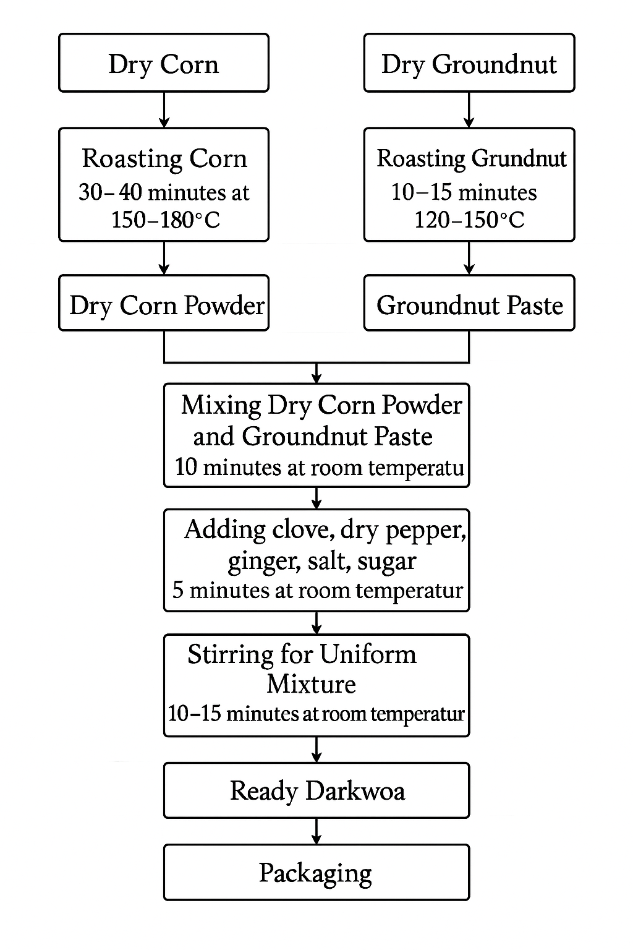

Figure 1: Flow chart for the Preparation of Dakuwa using corn

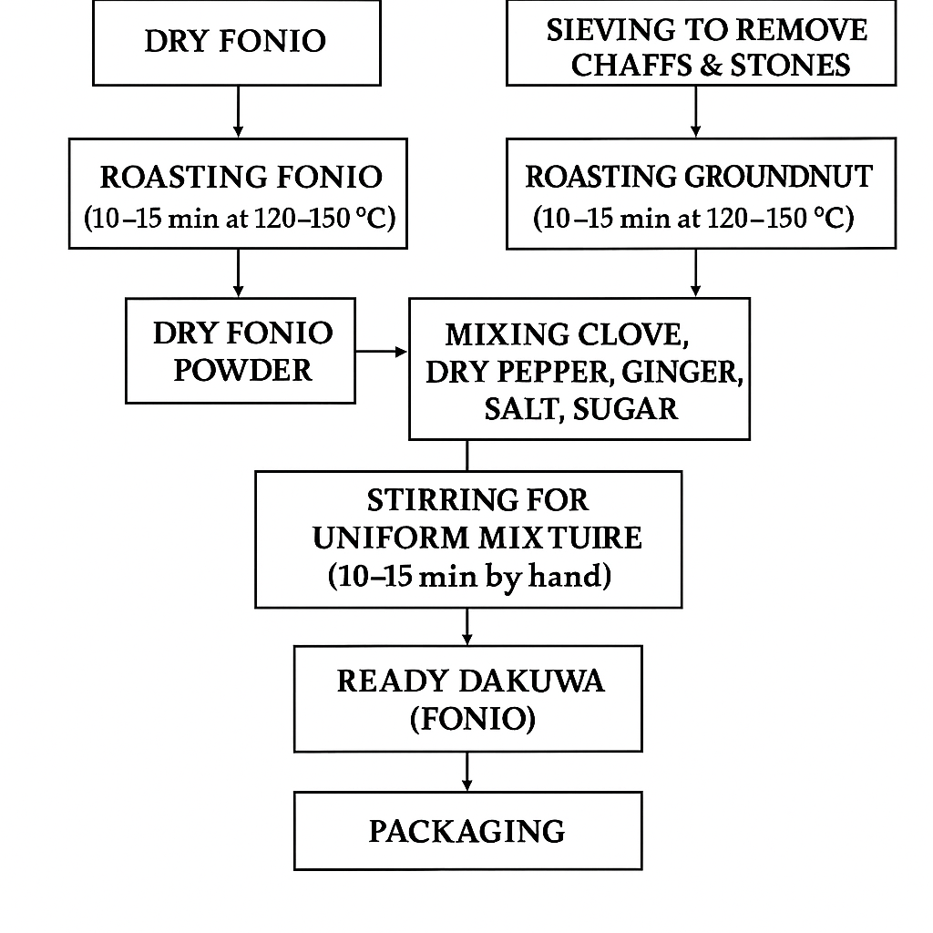

Figure 2: Flow chart for the Preparation of Dakuwa using Fonio

2.2 Phase 1 Consumer Acceptability of Products
2.2.1 Product Formulation
Five (5) formulations were made from the fonio-corn mixture for consumer acceptability assessment (DKCF10, DKCF11, DKCF12, DKCF13 and DKCF14) as shown in Table 1.
Table 1: Formulation of “Dakuwa” made with Corn and Fonio
Product
(Food Sample)
Product  (Food Sample) | Corn  (%) | Fonio  (%) | Groundnut  (%) | Clove  (g) | Dried Pepper  (g) | Ginger  (g) | Salt  (g) | Sugar
DKCF10 | 0 | 100 | 100 | 2 | 15 | 5 | 5 | 2
DKCF11 | 100 | 0 | 100 | 2 | 15 | 5 | 5 | 2
DKCF12 | 0 | 80 | 100 | 2 | 15 | 5 | 5 | 2
DKCF13 | 0 | 70 | 100 | 2 | 15 | 5 | 5 | 2
DKCF14 | 0 | 50 | 100 | 2 | 15 | 5 | 5 | 2

DKCF10 = Control (100% C) DKCF11 = (100% F) DKCF12 = (0% C: 80% F)
DKCF13 = (0%C : 70% F) DKCF 14 = (0%C : 50% F)
C = Powdered Roasted Corn ; F = Powdered Roasted Fonio
2.2.2 Sensory Analysis of the Product
Forty-two (42) untrained panellist assessed the consumer acceptability on five (5) different samples (DKCF10, DKCF11, DKCF12, DKCF13 and DKCF14). The samples were evaluated using a 7-point hedonic scale with 1 = like strongly, 2= like moderately, 3= like slightly, 4= Neither like nor dislike, 5= dislike slightly. 6= dislike moderately, 7= dislike strongly for aesthetics colour, appearance, texture, aroma, taste, flavour and overall acceptability. The best products from the consumer acceptability were used for the second phase together with a product on the market.
2.3 Phase 2 – Nutritional Assessment of ‘Dakuwa’
Proximate analysis of the five (5) samples were determined according to [12]. The samples analysed for moisture content, ash, protein, fat, crude fibre and carbohydrate content. Moisture (AOAC 925.10), ash (AOAC 923.03), fat (AOAC 920.39), crude fibre (AOAC 962.09), protein (Kjeldahl method; AOAC 2001.11), and carbohydrate by difference were determined.
The moisture [13], ash [14], fat [14], and crude fibre [3] was determined. The protein test was determined using the Kjeldah method AOAC 4.2.09. The total carbohydrate was determined by difference.
2.4 Statistical Analysis
Data was analysed using SPSS version 23. Analysis of Variance (ANOVA) and Duncan Test was used to determine the significant difference among the various samples in duplicates at 95% confidence level

3. RESULTS AND DISCUSSION

3.1 Sensory characteristics of the samples
The sensory characteristics of the samples were studied and results presented in Table 2. The various sensory attributes studied included appearance, texture, aroma, taste and overall acceptability.

3.1.1 Appearance
The appearance of the food products was evaluated (Table 2). The results for appearance ranged from 1.95 to 2.24. The sample with the highest score for appearance was sample DKCF13 (2.24) which represent like moderately on the hedonic scale. All the samples were rated liked moderately (DKCF11, DKCF14, DKCF13, DKCF10 and DKCF12 respectively). There was no significant differences (p>0.05) among the appearance of the samples studied.
3.1.2 Texture
The texture of the food samples varied from 2.10 to 2.42. Sample DKCF11 had the highest rating (2.42) for texture followed by DKCF10 (2.38), with DKCF13 having the least (2.10). However, all the samples were liked moderately by the panellist. There were no significant changes (p>0.05) between the texture of the samples studied. These results agree with work done by [15] and [16] who reported no significant difference in the texture (consistency) of Dakuwa samples with rating 3.3-3.8 (neither like nor dislike) and 4.2-5.2 (good) respectively.
3.1.3 Aroma
The aroma of the samples ranged from 1.64 to 2.40. The sample with the most liked aroma was sample DKCF10 (1.64), followed by samples DKCF13 (2.02), with sample DKCF12 having the least liked among the samples studied. There was a significant difference (p<0.05) among the aroma characteristics of the samples studied. This similar to work done by [16] who reported no significant difference in the aroma of Dakuwa samples (4.30-4.92). This differed from work done by [15], who reported an aroma rating of 3.4 for Dakuwa samples representing neither like nor dislike. The total flavor experience is greatly influenced by aroma, which also influences one's likes, dislikes, and emotional reactions to food [17].
3.1.4 Taste
The score for taste of samples ranged from 1.83 to 2.52. The sample DKCF10 was most preferred in terms of taste. All the samples taste was liked moderately by the panellist. There were no significant differences (p>0.05) between the taste of all samples. This agrees with work done by Yusuf et al., (2018) who reported the taste of Dakuwa samples as like very much (5.68-5.84) with no significant difference between the samples. This is similar to work done by 16 who reported no significant difference in the taste of Dakuwa samples (4.0-4.8). Our preferences, aversions, and emotional reactions to food are influenced by the integration of taste and smell, which forms the foundation of flavor perception [17].

3.1.5 Overall acceptability of samples
Results from the study showed that the overall acceptability ranged from 2.17 to 2.62. The two most liked and accepted samples from the study were DKCF10 (2.17) and DKCF14 (2.26). Samples DKCF13, DKCF12 and DKCF11 were liked slightly with ratings 2.50, 2.62, 2.62 respectively. There were no significant differences (p<0.05) among the overall acceptability of the samples.

Table 2: Sensory Characteristics of “Dakuwa” samples
Samples | Appearance | Texture | Aroma | Taste | Overall Acceptability
DKCF10 | 2.02 ± 0.01ª | 2.38 ± 1.07ª | 1.64 ± 0.0ª | 1.83± 0.26ª | 2.17± 0.29ª
DKCF11 | 2.23 ± 0.02ª | 2.42± 1.12ª | 2.29 ±0.1^{ab} | 2.52± 0.37ª | 2.62± 0.27^{b}
DKCF12 | 1.95 ± 0.01ª | 2.36 ± 1.07ª | 2.40 ± 0.3^{b} | 2.26± 0.26ª | 2.62± 0.29^{b}
DKCF13 | 2.24 ± 0.01ª | 2.10 ± 1.07ª | 2.02 ± 0.2^{ab} | 2.21± 0.26ª | 2.50± 0.29^{b}
DKCF14 | 2.10 ± 0.02ª | 2.24± 1.12ª | 2.12 ±0.20^{ab} | 2.14± 0.37ª | 2.26± 0.27ª
Note: Superscripts on the same column denotes significant differences
3.2 Proximate analysis of products
The proximate composition of the products is presented in Table 3. The analysis carried out included moisture, crude fat, crude ash, crude fibre, protein and carbohydrates.

Table 3: Proximate analysis of ‘Dakuwa’ samples
Samples | Moisture(%) | Crude fat(%) | Crude Ash(%) | Crude fibre(%) | Protein (%) | Carbs (%)
DKCF10 | 3.18±0.01ª | 18.60±1.07^{b} | 0.05±0.0ª | 1.23±0.26^{b} | 25.74± .29ª | 52.42±0.76ª
DKCF14 | 4.38±0.05^{b} | 16.21±1.12^{b} | 0.07±0.1^{b} | 2.05±0.37^{b} | 23.34±0.22^{b} | 56.00±0.99^{b}
Market | 2.57±0.02^{c} | 12.68± 0.30ª | 0.05±0.0ª | 0.23±0.09ª | 19.45±0.22^{c} | 65.25±0.09^{c}
Note: Superscripts on the same column denotes significant differences
3.2.1 Moisture content of samples
The research showed that the moisture content of the samples ranged from 2.57 to 4.38%. Sample DKCF14 had the highest moisture content (4.38%), followed by samples DKCF10 (3.18%) with the market sample having the least moisture content of 2.57%. There was a significant difference (p<0.05) between the moisture content of all samples. These results differed from work done by [11] and [18], who reported the moisture content of ‘Dakuwa’ to be 7.03% and 6.13% respectively. Another study by [15] recorded a moisture content of ‘Dakuwa’ produced with different groundnut varieties to be between 7.4 to 8.6%, which were higher than that for the current study. The difference in moisture content may be as a result of different raw materials used. Because moisture promotes the growth of microbes that may be present in food samples, the sample's moisture content is significant. The amount of moisture would either help or impede these microorganisms from growing [11]. The low moisture content in the current study could be as a result of the processing processes and other constituents added to the product. The low moisture content of Dakuwa produced from this study is an indication of high shelf life.
3.2.2 Fat
Table 3: also shows the crude fat of the samples. The percentage fat content of the products ranged from 12.68 to 18.60%. The highest fat content of the product was recorded by sample DKCF10 (18.60%) and the least by the market sample (12.68%). There were significant differences (p<0.05) among the fat content of the samples studied. The fat content for Fonio-‘Dakuwa’ was lower than that reported by [15]) (24.1 to 24.24). Another study by [18], reported a lower fat content of Dakuwa (7.81%) which was lower than the results of this study. This could be due to the process used (extrusion) and the types of raw materials used. The fat content can affect the stability of the food products. This is as a result of the oxidative deterioration which may lead to rancidification and spoilage. As a result, food samples with high fat content are more liable to spoilage [19].
3.2.3 Ash
The ash content of the samples in the study were between 0.05 and 0.07%. Samples DKCF10 and the market had the same and least ash contents. Sample DKCF14 however had the highest ash content among the samples studied (0.07%). This confirms that increasing the Fonio content increases the Ash Content of the food samples. There was a significant difference (p<0.05) between the ash content of the samples. Ash content in the current study were lower than those reported by [15] and [18] who reported the ash content of ‘Dakuwa’ to be 1.9 to 2.03% and 2.69% respectively. The methods used in the production as well as the different raw materials could be a factor in the variations. Determination of ash content is very important for nutritional assessment. It provides information on the presence of inorganic components in foods. These include calcium, phosphorus, potassium, and sodium. These minerals can be essential to a healthy diet [20]. The minerals in the Dakuwa produced in this study can be increased by addition of ingredients with high mineral content
3.2.4 Fibre content of samples
The fibre content of the samples is shown in Table 3. Results from the study shows that the fibre content of the samples ranged from 0.23 to 2.05%. The highest fibre content was recorded by sample DKCF14 (2.05%). This was followed by sample DKCF10 (1.23%) with the least being market sample (0.23%). Samples with Fonio thus will help in enhancing bowel movement as a result of their high fibre content. There were significant differences (p<0.05) between the fibre content of the samples studied. The determination of crude fibre content of food is mandatory worldwide. Crude fibre is the degree of the amount of non-digestible cellulose, pentosans and other constituents of this type present in a food product. Fibre is important in the diet for enhancing bowel movement. It also prevents constipation and reduce risk of colon cancer [1]. [15] in their study found a fibre content of between 1.5 to 1.62%. These values were lower than the figures found in the current study. The study of [15] used different varieties of groundnut. In the current study Fonio was added to the formulation. This could have accounted for the higher fibre content of the product. A diet rich in fibre may help reduce the risk of cardiovascular disease, colon cancer, and diabetes [21], hence ‘Dakuwa’ produced from this study will provide consumers with good nutritional benefits.
3.2.4 Protein
The protein content of the samples in this study are presented. Protein for the samples ranged from 19.45 to 25.74%. The sample with the highest protein content was DKCF10 (25.74%). This was followed by sample DKCF14 (23.34%). Samples with Fonio had the highest amount of protein. It is thus important to fortify foods with Fonio for an increase in protein. Analysis of variance showed significant differences (p<0.05) among the protein contents of all samples studied. The protein content (19 – 25%) of the ‘Dakuwa’ samples in this study is higher than 13.6 – 15.26% reported for traditionally prepared Dakuwa [22] and 16.5 – 19.1% reported for ‘Dakuwa’ samples produced in the laboratory [23]. This may be attributed to the Fonio used in the production. ‘Dakuwa’ is a high protein snack due to the presence of groundnut as one of its main raw materials [22]. The main source of protein for the human diet comes from the cereal grains because they constitute the basic food in many developing countries [24]. High protein fonio can be a reasonable replacement for other gluten-containing cereals for patients with gluten allergies and diabetes. The Dakuwa samples from this study is a good source of protein for consumers.
3.2.5 Carbohydrate content of samples
The study showed carbohydrate content ranging from 52.42 to 65.25%. The highest carbohydrate content was recorded by the sample obtained from the market (65.25%). These were followed by samples DKCF14 and DKCF10. There were significant differences (p<0.05) among the carbohydrate content of the samples. Studies by [15] found carbohydrate content to be between 39.13 to 39.84%. These were lower than the carbohydrate contents recorded in this study. This could be as a result of the relative high amount of carbohydrate in Fonio. [25] on the Techno-functional and gelling properties of Acha (Fonio) flour found carbohydrate content to be 91.9%. Carbohydrates are the main components of grains and represent the main source of energy for the human organism [26].
3.3 Microbial Analysis of Samples
The microbial quality of the samples was assessed by determining the presence and quantity of pathogenic and spoilage microorganisms. The analyses included enumeration of Staphylococcus aureus, coliforms (E. coli), and total aerobic plate count (APC). Results revealed the absence of Salmonella and E. coli in all samples. The market sample recorded the highest count of Staphylococcus aureus, whereas samples DKCF10 and DKCF14 had the lowest counts, indicating superior microbial quality. This suggests that Dakuwa samples produced with Fonio under hygienic conditions are microbiologically safe for consumption.
Table 4: Microbiological Analysis
Samples | E. coli (CFU/g) | S. aureus (CFU/g) | APC (CFU/g) | Salmonella (CFU/g)
DKCF14 | 0.00 ± 0.00ª | 6.67×10¹ ± 0.10^{b} | 7.90×10² ± 0.04ª | 0.00 ± 0.00ª
DKCF10 | 0.00 ± 0.00ª | 1.33×10² ± 0.00ª | 4.90×10² ± 0.06^{b} | 0.00 ± 0.00ª
Market | 0.00 ± 0.00ª | 1.18×10³ ± 0.00ª | 3.00×10³ ± 0.02^{c} | 0.00 ± 0.00ª
Note: Superscripts on the same column denotes significant differences

4. CONCLUSION
The study revealed that all the samples (DKCF10, DKCF11, DKCF12, DKCF13 and DKCF14) were liked moderately for appearance, texture, aroma, and taste. However, DKCF10 and DKCF14 were rated higher compared to the others in terms of appearance, texture, taste and overall acceptability.
The nutritional assessment of the preferred products (DKCF10 and DKCF14) and the product on market revealed that, all the three products had moderate nutritional content however, the products with fonio (DKCF14) had the high minerals., fibre, protein and carbohydrate compared to the two (DKCF10 and product on market). Sample DKCF14 had high nutritional value and protein of which can be an alternative for gluten intolerant consumers.

References
[1] Ayenan MAT, Sodedji KAF, Nwankwo CIK, Olodo F, Alladassi MEB (2018) Harnessing genetic resources and progress in plant genomics for fonio (Digitaria spp.) improvement. Genet Resour Crop Evol 65:373–386
[2] Mbosso C, Boulay B, Padulosi S, Meldrum G, Mohamadou Y, Niang BA, et al. (2020) Fonio and bambara groundnut value chains in Mali: issues, needs, and opportunities for their sustainable promotion. Sustainability 12:4766
[3] Zhu F (2020) Fonio grains: physicochemical properties, nutritional potential, and food applications. Compr Rev Food Sci Food Saf 19(6):3365–3389
[4] Ocloo FC, Agbemavor WS, Ayeh EA, Egblewogbe MN, Odai BT (2023) Nutritional composition, physicochemical and functional properties of black fonio (Digitaria iburua Stapf). Philipp J Sci 152(1)
[5] Babarinde GO, Adeyanju JA, Ogunleye KY, Adegbola GM, Ebun AA, Wadele D (2020) Nutritional composition of gluten-free flour from blend of fonio (Digitaria iburua) and pigeon pea (Cajanus cajan) and its suitability for breakfast food. J Food Sci Technol 57:3611–3620
[6] Koroch AR, Juliani HR, Simon JE (2013) Nutritional value of fonio (Digitaria exilis) from Senegal. In: Juliani HR, Simon JE, Ho CT (eds) African natural plant products, vol II: Discoveries and challenges in chemistry, health, and nutrition. American Chemical Society, Washington, DC, pp 127–133
[7] Diop BM, Gueye MC, Agbangba CE, Cissé N, Deu M, Diack O, et al. (2018) Fonio (Digitaria exilis (Kippist) Stapf): a socially embedded cereal for food and nutrition security in Senegal. Ethnobiol Lett 9:150–165
[8] FAOSTAT (2020) Food and Agriculture Organization Corporate Statistical Database. http://www.fao.org/faostat/en/#data/QC. Accessed 21 Jul 2025
[9] Koréissi-Dembélé Y, Fanou-Fogny N, Moretti D, Schuth S, Dossa RAM, Brouwer ID (2013) Dephytinisation with intrinsic wheat phytase and iron fortification significantly increase iron absorption from fonio (Digitaria exilis) meals in West African women. PLoS One 8:e70613
[10] Yusuf M, Filli KB, Umar I, Halilu M (2017) Effect of extrusion variables on physical properties and acceptability of Dakuwa produced from blends of sorghum (Sorghum bicolor L), groundnut (Arachis hypogaea L) and tigernut (Cyperus esculentus). Afr J Food Sci Technol 8:138–149
[11] Osae AK, Agbenorhevi JK, Wireko-Manu FD (2017) Packaging and shelf life of maize-peanut balls (Dakuwa). MOJ Food Process Technol 4(6):00108
[12] AOAC (2012) Official methods of analysis, 18th edn. AOAC International, Gaithersburg, MD
[13] AOAC (2000) Official methods of analysis, 17th edn. AOAC International, Gaithersburg, MD
[14] AOAC (2005) Official methods of analysis, 18th edn. AOAC International, Gaithersburg, MD
[15] Adekanmi KO, Sogunle KA (2020) Effects of groundnut (Arachis hypogaea L) varieties on the flavour profile and consumer acceptability of Darkwoa (a cereal-groundnut based snack). FUDMA J Sci 4(3):86–92
[16] Nkama I, Gbenyi DI, Hamaker BR (2015) Effects of malting and roasting of millet and sorghum on protein digestibility, mineral availability, soluble sugar composition and consumer acceptability of Dakuwa. Indian J Nutr 2(1):1–6
[17] Le Quéré JL, Schoumacker R (2023) Dynamic instrumental and sensory methods used to link aroma release and aroma perception: a review. Molecules 28(17):6308
[18] Yusuf M, Halilu M, Filli K (2018) Influence of extrusion variables on proximate composition, some nutrient and antinutrient contents of Dakuwa extrudates produced from blends of sorghum (Sorghum bicolor L), groundnut (Arachis hypogaea L) and tigernut (Cyperus esculentus). Curr J Appl Sci Technol 26(4):1–20
[19] Machado M, Rodriguez-Alcalá LM, Gomes AM, Pintado M (2023) Vegetable oils oxidation: mechanisms, consequences and protective strategies. Food Rev Int 39(7):4180–4197
[20] Nielsen SS (2017) Ash content determination. In: Dennis R (ed) Food analysis laboratory manual, 3rd edn. Springer, West Lafayette, IN, pp 121–127
[21] Soliman GA (2019) Dietary fibre, atherosclerosis, and cardiovascular disease. Nutrients 11(5):1155
[22] Ocheme OB, Ariahu CC, Igyor MA (2011) Assessment of traditionally produced Dakuwa (a cereal/legume based Nigerian snack) in Niger State, Nigeria. Niger Food J 29(1):63–69
[23] Ocheme OB, Igyor MA, Hassan H (2014) Isolation and characterization of microorganisms in Darkwoa (a Nigerian cereal/groundnut snack). Int J Res Pure Appl Microbiol 4(1):15–19
[24] Poutanen KS, Kårlund AO, Gómez-Gallego C, Johansson DP, Scheers NM, Marklinder IM, et al. (2022) Grains–a major source of sustainable protein for health. Nutr Rev 80(6):1648–1663
[25] Deriu AG, Vela AJ, Ronda F (2022) Techno-functional and gelling properties of acha (fonio) (Digitaria exilis Stapf) flour: a study of its potential as a new gluten-free starch source in industrial applications. Foods 11:183
[26] Niaz K, Khan F, Shah MA (2020) Analysis of carbohydrates (monosaccharides, polysaccharides). In: Recent advances in natural products analysis. Elsevier, Amsterdam, pp 621–633

