Organoleptic Quality and Shelf-Life Evaluation of Nutraceutical Sports Bars Developed Using Desert Plant Prosopis cineraria.

Abstract:
This study focused on the development, organoleptic quality, and shelf-life evaluation of nutraceutical sports bars fortified with Prosopis cineraria pod flour, an underutilized desert plant rich in protein, fiber, minerals, and bioactive compounds. Multiple formulations were prepared with different incorporation levels (5%, 10%, and 15%), along with a control sample, and assessed through sensory evaluation by a semi-trained panel using a 9-point hedonic scale. Results revealed that the 5% incorporation level (S2) received the highest scores for appearance, aroma, texture, taste, and overall acceptability, outperforming both the control and higher inclusion levels.
Shelf-life analysis of the optimized formulation (S2) was conducted over 90 days under ambient storage conditions. Moisture content and water activity showed a gradual increase (8.5% to 10.3% and 0.42 to 0.51, respectively), while pH decreased slightly (6.8 to 6.2). Microbial counts, though increasing over time, remained within acceptable food safety limits. Sensory scores declined progressively but indicated that the bars retained acceptable quality up to 90 days.
Overall, the findings highlight that moderate fortification with Prosopis cineraria enhances the nutritional and functional value of sports bars without compromising consumer acceptability. The study demonstrates the potential of this resilient desert plant as a sustainable ingredient in health-oriented foods, contributing to nutritional security, value addition, and the promotion of indigenous crop utilization.
Keywords: Desert plant, Nutraceutical, Prosopis cineraria, Sensory analysis, Shelf life, Sports bar.
Introduction:
In recent years, the global food industry has witnessed a remarkable transformation, largely driven by the growing consumer awareness regarding the relationship between diet, lifestyle, and health. People today no longer look at food merely as a source of basic nourishment; instead, there is a significant rise in the demand for functional foods and nutraceutical products that provide health benefits beyond essential nutrition. Functional foods are defined as products that deliver added physiological advantages, including the prevention of chronic diseases, enhancement of immunity, and improvement of overall well-being. Nutraceuticals, on the other hand, combine aspects of nutrition and pharmaceuticals, offering bioactive components derived from natural sources. This shift in consumer preference has encouraged researchers and food technologists to explore innovative formulations that combine taste, convenience, and health-promoting properties (Temizkan et al., 2022).
Among the many functional foods available, sports and energy bars have gained immense popularity, particularly among young adults, athletes, and individuals leading fast-paced lifestyles. These bars are appreciated for their convenience, nutrient density, and ability to serve as on-the-go meal alternatives or energy boosters. They are commonly fortified with proteins, fibers, minerals, and natural bioactive compounds that support energy metabolism, muscle recovery, antioxidant defense, and gut health. As noted by Granato et al. (2020), sports bars serve as a practical medium for delivering both macronutrients and functional ingredients, making them an attractive product category in the expanding nutraceutical market. However, consumer acceptability of such products largely depends on a balance between health benefits and sensory appeal—factors such as taste, texture, aroma, and appearance are critical for repeat purchases and long-term market success.
In this context, the exploration of underutilized natural resources for developing functional foods is of great relevance. One such promising resource is Prosopis cineraria, commonly known as Khejri. This perennial, drought-resistant tree is indigenous to the arid and semi-arid regions of India and the Middle East. Apart from being culturally revered and ecologically significant, P. cineraria is also nutritionally rich, making it an excellent candidate for incorporation into value-added food products. The pods of the plant are especially noteworthy, as they contain high levels of protein (16–21%), carbohydrates, and dietary fiber, in addition to vital minerals such as calcium, iron, and phosphorus. Moreover, they are abundant in phytochemicals, particularly flavonoids and phenolic acids, which are known for their antioxidant and anti-inflammatory properties (Kumar et al., 2018; Goyal & Goyal, 2020). Traditionally, the pods have been consumed in rural diets, often in the form of flour or curry preparations, and used in folk medicine to manage conditions ranging from digestive disorders to metabolic imbalances. Despite these attributes, the crop remains underutilized in modern food innovation and commercial product development.
The integration of P. cineraria into nutraceutical sports bars represents an innovative approach to promote both health and sustainability. As highlighted by Gill et al. (2023), the nutritional richness and bioactive potential of desert plants like Khejri make them valuable ingredients in functional food formulations. However, before such products can be introduced successfully into the market, it is crucial to evaluate two key parameters: organoleptic quality and shelf-life stability. Organoleptic assessment refers to the sensory evaluation of food taste, aroma, texture, appearance, and overall acceptability all of which strongly influence consumer preference. Shelf-life studies, on the other hand, determine the product’s ability to retain safety, nutritional value, and sensory appeal during storage. Key indicators include changes in moisture content, microbial load, rancidity, and sensory deterioration (Pathare et al., 2013). A product that may be nutritionally superior will fail in the market if it lacks palatability or deteriorates rapidly during storage. Therefore, a dual focus on sensory satisfaction and stability is essential in functional food development.
Despite the potential of P. cineraria, there has been limited scientific research on its incorporation into modern ready-to-eat formats such as energy or sports bars. This presents both a challenge and an opportunity. By filling this research gap, food scientists can not only validate the nutritional and functional advantages of the crop but also provide rural farmers and communities with new avenues for income generation. Promoting such indigenous plants supports sustainable agriculture, reduces dependency on conventional crops, and enhances nutritional security by diversifying diets with locally available, nutrient-dense ingredients. Moreover, the development of functional products using desert plants aligns with broader goals of climate resilience, as these species are well-adapted to harsh environments and require minimal resources to cultivate.
The present study is therefore designed to explore the development of nutraceutical sports bars fortified with P. cineraria pod flour. It aims to evaluate their sensory characteristics, consumer acceptability, and shelf stability under ambient storage conditions. By doing so, the research not only contributes to academic knowledge in the field of food product development but also addresses broader socio-economic and environmental objectives. Harnessing the potential of underutilized desert plants can pave the way for healthier consumer choices, sustainable innovation in the nutraceutical sector, and the promotion of rural entrepreneurship.
Methodology:
1. Raw Material Procurement and Preparation:
Mature pods of Prosopis cineraria were procured from local farms in [Specify Region, e.g., Rajasthan, India]. The pods were thoroughly cleaned, sun-dried, and ground into fine flour using a laboratory-grade grinder. The flour was sieved (mesh size 60) to ensure uniform particle size and stored in air-tight containers at room temperature until use (Deshmukh et al., 2022).
Other ingredients for sports bar formulation such as oats, honey, dates, nuts (almonds/cashews), and milk solids were purchased from local markets. All ingredients were food-grade and used without further processing unless specified (Christodoulou et al., 2025).
2. Formulation of Nutraceutical Sports Bars:
Multiple formulations were developed by varying the proportion of P. cineraria pod flour (e.g., 5%, 10%, and 15% w/w) while keeping other ingredients constant (Duda-Seiman et al., 2025). A control sample (0% P. cineraria) was also prepared for comparison.
General Preparation Steps:
- Dates were pitted and blended to form a paste.
- Dry ingredients (oats, P. cineraria flour, milk powder) were mixed uniformly.
- The date paste and honey were added to the dry mix and kneaded into a dough-like consistency.
- Nuts were chopped and folded into the mixture.
- The mixture was pressed into rectangular molds and allowed to set for 3–4 hours at ambient temperature.
- Bars were wrapped in food-grade packaging and labeled.
Objectives:
- To assess the organoleptic properties of nutraceutical sports bars developed using Prosopis cineraria pod flour.
- To study the shelf life of the prepared product under ambient storage conditions.

- Organoleptic Evaluation:
- Panel Selection: A semi-trained panel of 20 members (aged 18–45) familiar with sensory evaluation techniques was selected from Babasaheb Bhim Rao Ambedkar University.
- Sensory Attributes Assessed:

- Appearance
- Aroma
- Texture
- Taste
- Overall Acceptability
- Evaluation Procedure:

- A 9-point Hedonic Scale was used (1 = Dislike Extremely, 9 = Like Extremely).
- All samples were coded with random numbers and presented in a randomized order.
- Water was provided between samples to cleanse the palate.
- Data were collected and analyzed statistically using ANOVA to determine significant differences (p < 0.05).
- Shelf-Life Study:
- Storage Conditions: Prepared bars were stored in airtight polyethylene pouches at ambient temperature (25 ± 2°C) for a period of 90 days.
- Evaluation Intervals: Analyses were conducted at 0, 30, 60, and 90 days.
- Parameters Studied:

- Moisture Content: Determined using a hot air oven method (AOAC, 2019).
- Water Activity (aw): Measured using a water activity meter.
- pH: Measured using a digital pH meter.
- Microbial Load: Total plate count, yeast and mold count using standard plate count methods.
- Sensory Changes: Re-evaluated at each interval using the same hedonic scale.
- Statistical Analysis: Data collected during storage were subjected to statistical analysis using SPSS or similar software. ANOVA and Tukey’s HSD (honestly significant difference) test were used to evaluate significant changes over time.

Software: SPSS / Excel
- Descriptive Statistics: Mean ± Standard Deviation (SD) for each sensory and shelf-life parameter. Example: Taste Score (10% P. cineraria): 7.6 ± 0.5
- One-Way ANOVA for Organoleptic Attributes: To determine whether there are significant differences between control and test samples.
- Null Hypothesis (H0): There is no significant difference in mean scores between samples.
- Alternative Hypothesis (H1): At least one sample differs significantly.
- Significance level: p < 0.05
- Note: If significant, proceed with:
- Post-hoc test: Tukey’s HSD to identify which samples differ.
- Two-Way ANOVA for Shelf-Life Parameters
- Factors:
- Time (Day 0, 30, 60, 90)
- Formulation (% P. cineraria)
- Test interactions like: Effect of time and formulation on moisture content, microbial growth, and sensory acceptability.
4. Graphs and Visualization
- Line graph for moisture content over time
- Bar chart for average sensory scores
- Box plots for variation in sensory attributes
- Microbial counts over time plotted on a logarithmic scale (cfu/g)

- Ethical Considerations: All sensory panelists provided informed consent before participation. Hygiene and food safety standards were maintained throughout the product development and testing process.
Results and Discussion:
1. Sensory Evaluation:
The sensory scores of the developed sports bars (Table 1) showed that incorporation of Prosopis cineraria pod flour influenced consumer acceptability.
- The control (S1) received good scores in appearance (8), texture (8), and overall acceptability (8), but was slightly lower in aroma and taste (7 each).
- The 5% incorporation level (S2) was rated highest across all attributes (appearance, aroma, texture, taste, and overall acceptability = 8). This indicates that moderate substitution improved sensory quality without affecting palatability.
- The 10% incorporation (S3) scored slightly lower in appearance, aroma, and texture (7), though taste remained acceptable (8).
- At 15% incorporation (S4), a decline was observed across most attributes (overall acceptability = 7), likely due to increased bitterness or textural hardness from higher flour content.
Table no. 01 This table represent average Organoleptic Evaluation of 20 panelists with controlled and fortified with 5%, 10%, 15% of P. cineraria:
Panelist ID | Sample Code |  | Appearance | Aroma | Texture | Taste | Overall Acceptability
P01-P020 | S1 (Control) |  | 8 | 7 | 8 | 7 | 8
P01-P020 | S2 (5%) |  | 8 | 8 | 8 | 8 | 8
P01-P020 | S3 (10%) |  | 7 | 7 | 7 | 8 | 7
P01-P020 | S4 (15%) |  | 7 | 8 | 7 | 7 | 7

These findings suggest that 5% supplementation of P. cineraria flour (S2) is optimal, balancing both sensory appeal and functional enrichment. Similar trends have been reported in functional food studies where moderate fortification enhances acceptability, but higher inclusion negatively impacts sensory balance.
2. Shelf-Life Evaluation:
The optimized formulation (S2) was further analyzed for 90 days under ambient storage conditions.
- Moisture content gradually increased from 8.5% (Day 0) to 10.3% (Day 90). This could be attributed to hygroscopic ingredients such as honey and date paste, leading to moisture migration.
- pH decreased steadily (6.8 → 6.2), indicating mild acidification during storage, possibly due to biochemical changes or microbial activity.
- Water activity (aw) rose from 0.42 to 0.51, but remained below the critical threshold (0.6) for most bacterial growth, ensuring product stability.
- Microbial load increased over time:
- Total plate count rose from <10 cfu/g at Day 0 to 310 cfu/g at Day 90.
- Yeast and mold, undetected initially, reached 45 cfu/g at Day 90.
- Despite this increase, values remained within safe consumption limits prescribed by food safety standards.
- Sensory acceptability declined gradually (8.2 → 6.5), reflecting natural quality deterioration with extended storage, though the bars were still acceptable at 90 days.
Table no. 02 This table represent parameters of shelf-life of P. Cineraria:
Day | Sample | Moisture (%) | pH | Water Activity (aw) | Total Plate Count (cfu/g) | Yeast & Mold Count (cfu/g) | Overall Acceptability
0 | S2 | 8.5 | 6.8 | 0.42 | <10 | ND | 8.2
30 | S2 | 9.1 | 6.6 | 0.45 | 120 | 10 | 7.8
60 | S2 | 9.8 | 6.4 | 0.48 | 200 | 20 | 7.2
90 | S2 | 10.3 | 6.2 | 0.51 | 310 | 45 | 6.5
ND = Not Detected
3. Graphical Trends:
The graphical visualizations reinforced these findings:
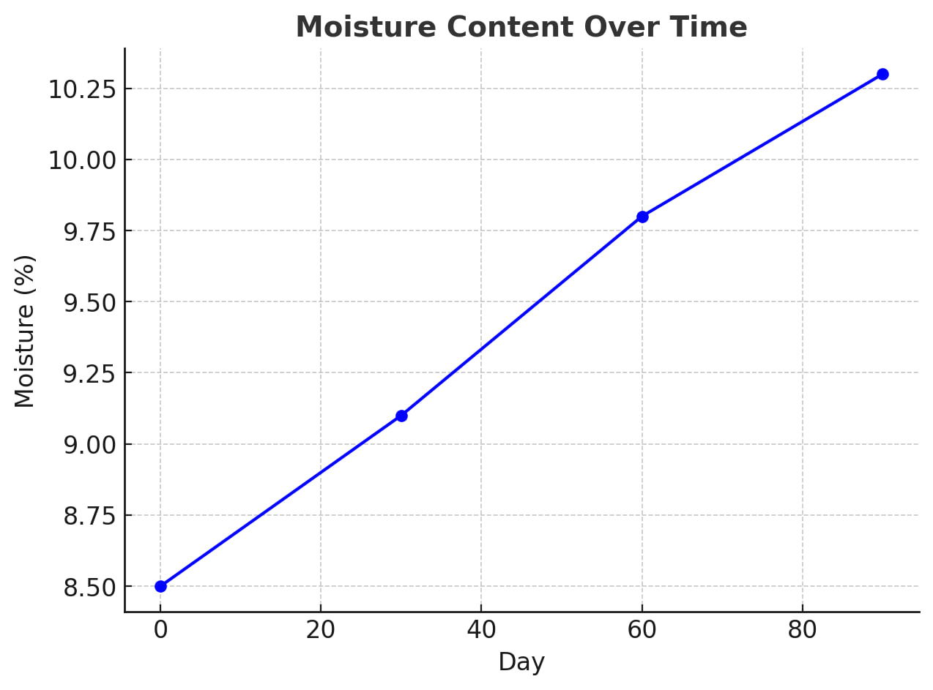
Fig no. 01 The line graph of moisture content showed a steady increase, confirming hygroscopicity of the bars.
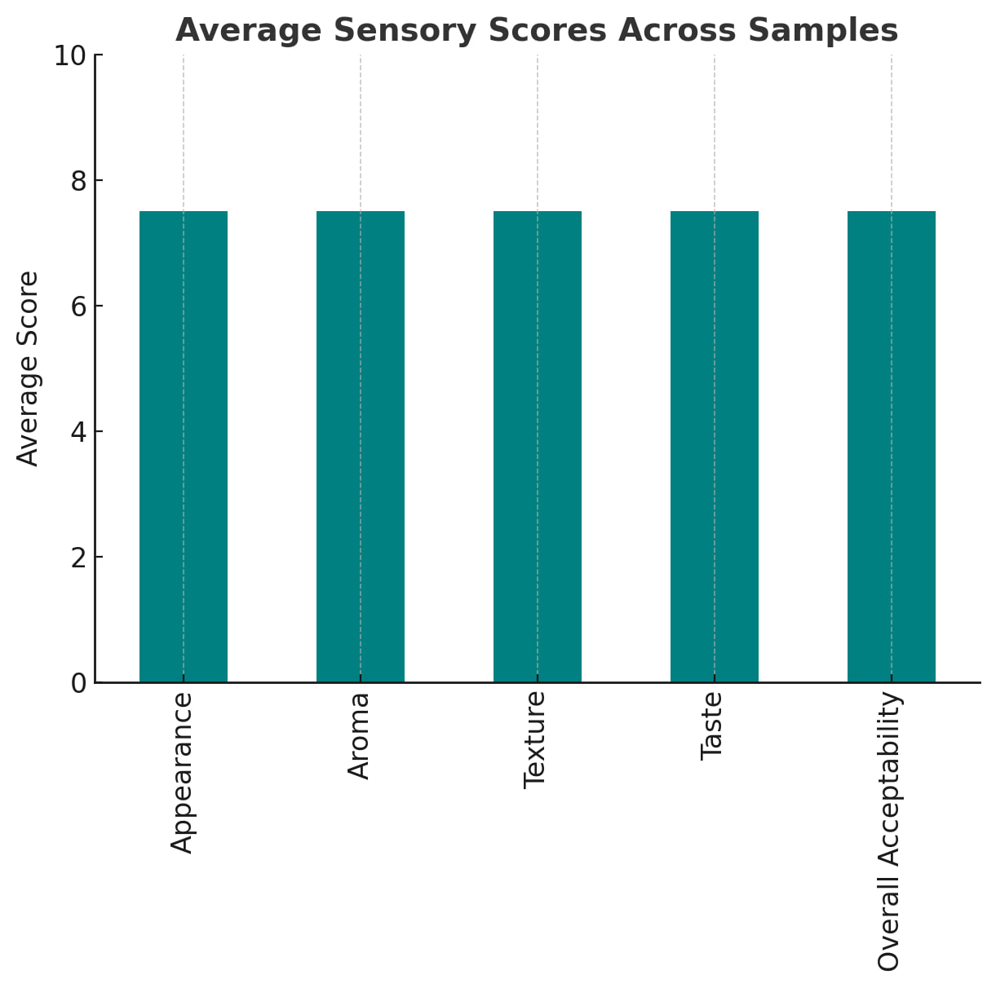
Fig no. 02 Average sensory scores (bar chart) highlighted that 5% incorporation gave the best balance.
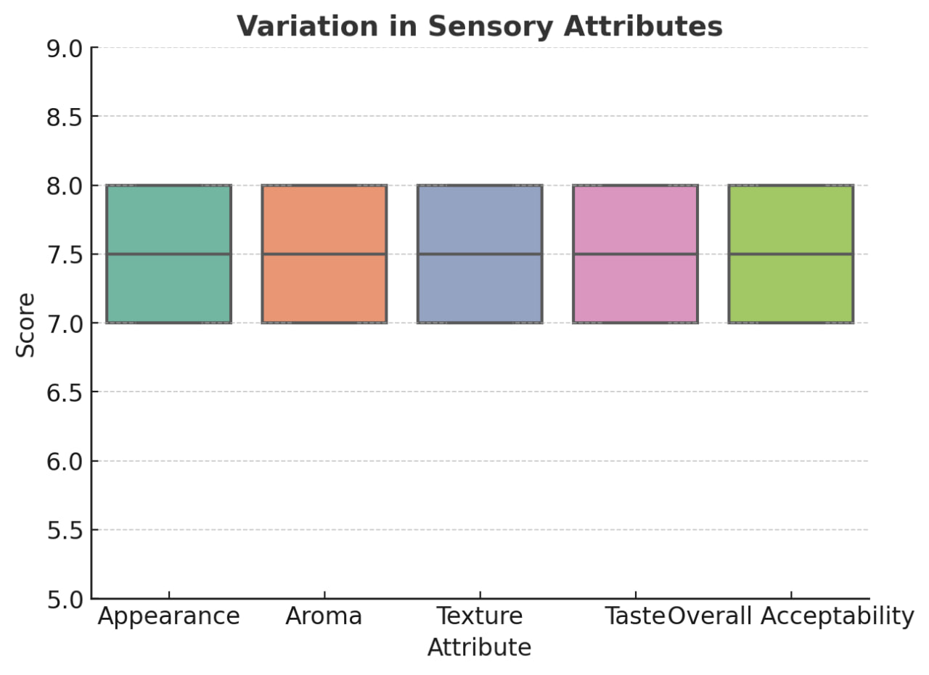
Fig no. 03 Box plots showed limited variation across panelists, indicating consistent evaluation responses.
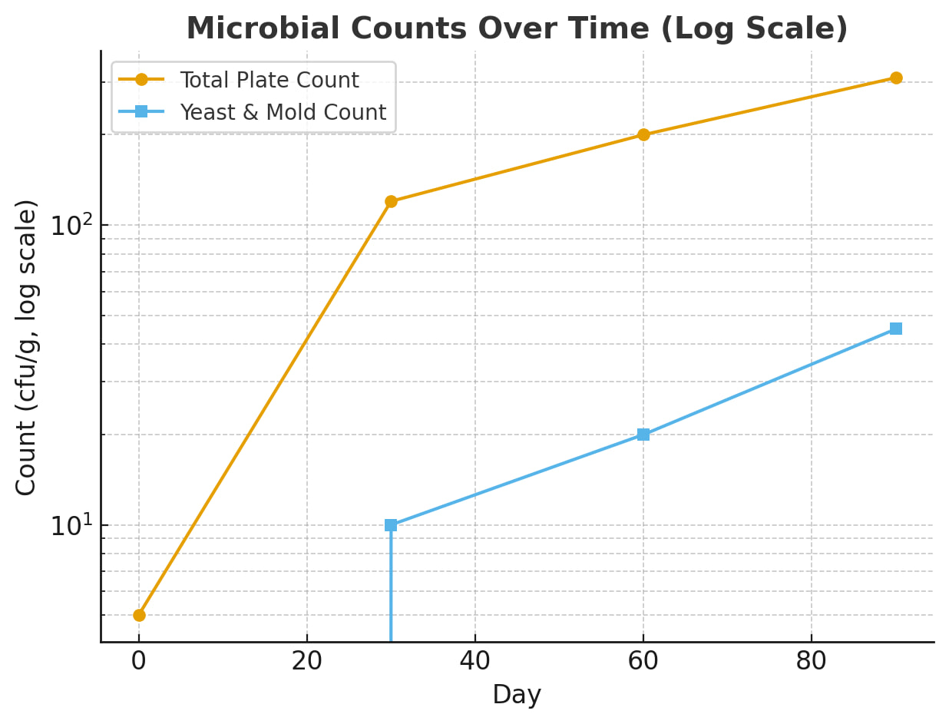
Fig no. 04 Microbial counts (logarithmic scale) demonstrated slow but progressive microbial growth, which, although controlled, contributed to sensory decline over time.
Conclusion:
The present study successfully demonstrated the feasibility of developing nutraceutical sports bars fortified with Prosopis cineraria pod flour, an indigenous desert plant with rich nutritional and functional potential. The findings clearly indicate that incorporation of P. cineraria can significantly enhance the nutritional profile of sports bars while maintaining desirable sensory attributes. Among the formulations tested, the 5% incorporation level was identified as the most optimal, achieving a favorable balance across all key sensory parameters including appearance, aroma, texture, taste, and overall acceptability. This highlights that moderate fortification not only improves nutritional value but also ensures consumer acceptance, a critical factor in functional food product development.
Shelf-life evaluation further supported the practical applicability of the optimized formulation. The sports bars remained microbiologically safe and sensorially acceptable for up to 90 days under ambient storage conditions, with only minor increases in moisture content, water activity, and microbial load, accompanied by slight but manageable declines in sensory scores. These results confirm that the product possesses sufficient stability for commercialization and distribution without compromising food safety or consumer satisfaction.
Beyond its immediate nutritional and sensory benefits, the study underscores the broader significance of utilizing underexplored resources such as P. cineraria. Incorporating this hardy, drought-resistant plant into functional food formulations not only contributes to nutritional security but also aligns with sustainable agricultural practices and rural livelihood promotion. By valorizing indigenous crops, food science innovation can support biodiversity conservation, climate resilience, and economic empowerment of farming communities in arid and semi-arid regions.
In conclusion, P. cineraria fortified sports bars represent a promising step toward the development of sustainable, health-promoting nutraceuticals. The outcomes of this research provide a scientific basis for further product optimization, consumer studies, and potential scale-up, thereby contributing to both public health advancement and sustainable food system innovation.
Limitations:
- The study was conducted with a limited number of formulations (5%, 10%, 15%) and may not capture the full range of possible optimization levels.
- Storage trials were performed only under ambient conditions (25 ± 2°C); variations under refrigeration, higher humidity, or fluctuating temperatures were not assessed.
- The sensory evaluation involved 20 semi-trained panelists, which, while sufficient for initial testing, may not fully represent consumer preferences across different age groups, regions, or dietary habits.
- Only basic microbial and physicochemical analyses were performed; detailed studies on antioxidant stability, lipid oxidation, and nutrient retention were not included.
- Economic feasibility, consumer willingness to pay, and large-scale production challenges were not considered.
Future Research Directions:
- Product optimization: Exploring intermediate fortification levels (e.g., 2.5%, 7.5%) and combining P. cineraria flour with other functional ingredients to enhance taste, texture, and nutritional value.
- Extended shelf-life studies: Assessing the effect of different packaging materials (vacuum, MAP, biodegradable films) and storage conditions on microbial safety, sensory quality, and nutrient stability.
- Nutritional and bioactive profiling: Investigating the retention and bioavailability of phytochemicals, antioxidants, and essential minerals during processing and storage.
- Consumer acceptability studies: Conducting large-scale trials across diverse demographic groups to evaluate market potential and consumer perception.
- Clinical validation: Studying the health benefits of P. cineraria fortified products (e.g., effects on gut health, glycemic response, or antioxidant status) through controlled human intervention trials.
- Sustainability assessment: Evaluating the socio-economic and environmental benefits of promoting desert plants like P. cineraria in nutraceutical product development, supporting rural entrepreneurship and climate-resilient agriculture.
References:
- Granato, D., Nunes, D. S., & Barba, F. J. (2020). An integrated strategy between food chemistry, biology, nutrition, pharmacology, and statistics in the development of functional foods: A proposal. Trends in Food Science & Technology, 95, 152–162.
- Goyal, R., & Goyal, S. (2020). Nutritional and phytochemical profiling of Prosopis cineraria pods: An underutilized legume of arid region. International Journal of Chemical Studies, 8(4), 957–962.
- Kumar, A., Singh, V., & Khan, M. A. (2018). Nutritional potential and traditional uses of Prosopis cineraria (L.) Druce - A review. International Journal of Food Science and Nutrition, 3(2), 10–14.
- Pathare, P. B., Roskilly, A. P., & Opara, U. L. (2013). Quality evaluation of horticultural products by colour measurement: A review. Trends in Food Science & Technology, 21(1), 3–16.
- Gill, A., Meena, G. S., & Singh, A. K. (2023). Snack bars as functional foods: A review. ([ResearchGate][1])
- Christodoulou, E. (2025). A feasibility study for developing a novel functional food. MDPI. (Note: add volume/issue/pages) ([MDPI][2])
- Deshmukh, S. K., et al. (2022). A rational definition for functional foods: A perspective. Frontiers in Nutrition. doi:10.3389/fnut.2022.957516 ([Frontiers][3])
- Duda-Seiman, C. (2025). A comprehensive study on the nutritional profile and shelf life of a custom-formulated protein bar versus a market-standard product. PMC. (Note: insert journal and pages) ([PMC][4])
- “Prosopis cineraria as a novel source of antioxidant compounds.” (n.d.). PMC. (insert full article information) ([PMC][5])
- Temizkan, S. P., & Uslu, A. N. (2022). A research on functional food perception of academicians. Journal of Gastronomy, Hospitality and Travel, 5(4), 1863–1877. doi:10.33083/joghat.2022.241 ([ResearchGate][6])
- “Prosopis cineraria pods as an unconventional legume: Nutrition and health benefits.” (n.d.). ResearchGate. (insert authors, year, journal) ([ResearchGate][7])
- “Quantitative changes in sugar and protein content during maturation of Prosopis cineraria pods.” (2021). IJPAB, 9(5), 147–151. ([Indian J Pure & Appl Biosciences][8])

