FORMULATION, STANDARDIZATION AND SHELFLIFE STUDY OF FIBER RICH IDLI PREMIX WITH RAGI BARNYARD MILLET AND FORTIFIED WITH DRIED PAPAYA LEAVES

Abstract
Idli is a traditional fermented food product made from a batter of ground rice (Oryza sativa) and black gram (Phaselous muno) which undergoes lactic acid fermentation via lactobacillus. It is a breakfast food originated from South India. This premix provides a gluten- free, low-glycemic index option compared to traditional idlis, enhancing nutritional intake and tackling health issues such as diabetes. Phytochemical profiling of young leaves of Carica papaya revealed the presence of pharmacologically active phyto compounds, alkaloids, phenolics, flavonoids, and amino acids. The research applied a methodical approach to formulating the product, which included selecting ingredients, preparing them, and blending to achieve the best sensory qualities. This premix also offers a quick and convenient meal solution while maintaining its nutritional value, addressing the preferences of today’s health-focused consumers. The increasing interest in functional foods has prompted the creation of meal options rich in nutrients that promote health and wellness. Conventional idlis are usually prepared with rice, which has a high glycemic index and is low in crucial micronutrients. Substituting rice with ragi and barnyard millet enhances the premix's protein, dietary fiber, and mineral levels, making it more appropriate for people dealing with diabetes, gluten sensitivity, and deficiencies in micronutrients. Trails A, B, and C have been taken, and the sensory panelists have finalized Trail C. Sensory evaluation verifies that the product is well-received in terms of flavour and overall attractiveness. Following the guidelines in the FSSAI Manuals, the contents of moisture, fat, protein, and ash were examined. The Weendes method is used to determine fiber. This research investigates the development and assessment of a nutritious idli premix enhanced with ragi (finger millet), barnyard millet, and dried papaya leaves, aiming to offer a healthier and functional option compared to traditional idli mixes.
Keywords- Gluten-Free, Low Glycemic Index, Dried Papaya Leaves, Idli premix

Introduction
Millets are small-seeded annual cereal grains. These are very hard crops and can be grown successfully in infertile lands. Millets are particularly low in phytic acid and rich in dietary fibre, iron, calcium, and B vitamins. It also contains a higher proportion of unavailable carbohydrates, and the release of sugar from millet is low. Kodo and Barnyrad millet are nutritionally superior to rice and wheat, providing protein, minerals, vitamins, and fiber, and are rightly so designated as nutrient cereals. Among the last three, cultivation and production of nutrient cereals have been greatly reduced due to poverty, changes in balanced dietary consumption models, widespread prevalence of nutritional gaps, and low nutrient consumption. Millet products are available in the market at a higher price. Kodo millet and barnyard millet in improvised traditional products would increase their usage. Therefore, this study was carried out to develop instant idli mix from kodo and barnyard millet (Selvi, L. S. and Malathi, D., 2014).
Papaya (Carica papaya Linn.) belongs to the Caricaceae family and is well known for its therapeutic and nutritional properties worldwide. Various parts of the papaya plant have been used for therapeutic purposes since ancient times. This study aimed to investigate the anti- cancer, anti-inflammatory, anti-diabetic, and antiviral activities of papaya leaves (Singh et al., 2020). Phytochemical profiling of young leaves of Carica papaya revealed the presence of pharmacologically active phyto compounds, alkaloids, phenolics, flavonoids, and also amino acids. Further studies can be done on these constituents to identify and isolate the most active bio-constituent contributing to platelet augmentation, anticancer property, anti-acne activity, easing menstrual pain, and relieving nausea (Akhila. S and Vijayalakshmi. N, 2014).
In addition to being a popular food, Carica papaya (CP) leaves have numerous traditional medicinal uses. Scientific research has demonstrated the leaf extract's effectiveness in wound healing and its ability to shield rats' stomachs from harm. Nevertheless, there is currently no toxicity study available for the CP leaf extract. In this study, Sprague Dawley rats are given a dose of 2000 mg/kg body weight (BW) of CP leaf extract to examine its acute toxicity. The sighting study was carried out in a step-by-step manner with fixed doses of 5, 50, 300, and 2000 mg/kg BW (Halim et al., 2011). No toxicity symptoms or fatalities were noted. A dose of 2000 mg/kg BW was chosen based on the sighting study, and the subjects were monitored for 14 days. Five female rats make up each of the study's control and treatment groups. The CP leaf extract

administered orally as a single dose did not result in mortality or notable alterations in body weight, food intake, or water intake. All of the internal organs had normal relative weights. Nonetheless, there was a marked increase in hemoglobin (HGB), hematocrit (HCT), red blood cells (RBC), and total protein, all of which were indicative of dehydration. Other biochemistry parameters, excluding triglycerides, showed no discernible changes from the control (Halim et al., 2011).
The papaya is the most widely used annual plant. The leaves, a highly perishable raw material, must be protected from deterioration and spoiling as soon as they are harvested. Due to improper post-harvest processing methods, the majority of the crop is frequently lost or wasted during peak periods. To preserve the bioactive compound of the leaves, drying is the most common treatment, but it must be done carefully and carefully. The best drying conditions for obtaining high-quality dried papaya leaf powder and bioactive compounds like phenol, flavonoids, and antioxidant activity of papaya leaves were determined and suggested by conducting an experimental tray drying method and drying treatment at 50°C, 60°C, and 70°C. According to the results, raising the drying air temperature from 50°C to 70°C significantly reduces "total drying time." To preserve the different bioactive compounds, it might be suggested that the ideal drying temperature for papaya leaves is 50°C. For unblanched samples, a tray dryer set at 50°C guarantees the highest quality and bioactive compounds of powdered papaya leaves (Parmar et al., 2022).
The main food grain consumed by India's rural populace, particularly in South India, is finger millet (Ragi, Eleusine coracana). In terms of minerals, dietary fiber, and essential amino acids, it is highly nutrient-dense. Ragi has the highest calcium content of any cereal, along with antioxidants and phytochemicals. Compared to most other cereal grains, finger millet grain has a comparatively higher total dietary fiber content, which aids diabetic patients in controlling their blood glucose levels. Typically, it is transformed into flour and various other preparations. Several methods of processing ragi have been developed to make the final product more attractive in flavour, appearance, taste, and consistency (Patel et al., 2016).
Finger millet (Eleusine coracana L.), commonly known as ragi, is an African grain that is indigenous to Ethiopia. Nonetheless, some sources indicate that the secondary center of origin for this species might be China or India. During the Second Millennium BC, it was transported

from Africa to India via maritime trade due to its high degree of adaptability. Their remarkable resilience to prolonged drought and moisture scarcity adds to their importance in food security. It belongs to the group of crops known as orphan crops, which were once widely grown because of their high energy value but are now only grown in a few specific geographic locations. Millets are low-water crops that can withstand drought. Finger millet's malting enhances its sensory appeal and digestibility (Shobana et al., 2013).
There are numerous millet crop producers worldwide, with India being one of the major producers. Compared to other small-sized millets, finger millets require a larger area of cultivation to grow. Given its high nutritional content when compared to other significant cereals like barley, rye, etc., finger millet is regarded as a unique food supplement. Important amino acids, dietary fiber, and minerals make up the majority of it. Ragi, also known as finger millet (Eleusine coracana), is the main food consumed by the rural populace in many regions of our nation, particularly in South India. Ragi has higher calcium content than any other cereal, and it also has more antioxidants and phytochemicals. Among other cereal grains, finger millet has a high content of total dietary fiber, which is very helpful in regulating blood glucose levels in diabetic patients. Additionally, patients with cancer, heart disease, and other cognitive disorders benefit from it. Ragi can be processed using a variety of techniques to create a food supplement that is appealing in terms of appearance, flavor, taste, and consistency. Despite its positive effects, it is not widely used in the areas where it is produced. Finger millet has a lot of potential for being processed into a variety of functional foods that our nation's large population can consume (Jagati et al., 2021). Among other cereal grains, finger millet has a high content of total dietary fiber, which is very helpful in regulating blood glucose levels in diabetic patients. Additionally, patients with cancer, heart disease, and other cognitive disorders benefit from it ( Shobana, et al., 2013).
Ragi can be processed using a variety of techniques to create a food supplement that is appealing in terms of appearance, flavor, taste, and consistency. Despite its positive effects, it is not widely used in the areas where it is produced. Finger millet has a lot of potential for being processed into a variety of functional foods that our nation's large population can consume (Shobana et al. 2013). Due to its vulnerability to biotic and abiotic stressors, ability to yield multiple harvests annually, and abundance of micronutrients, fibers, and phytochemicals,

barnyard millet (Echinochloa species) has drawn a lot of attention. Consuming barnyard millet is thought to offer several health advantages against conditions like diabetes, heart disease, obesity, skin issues, cancer, and celiac disease (Bhatt et al., 2023).
Patients with celiac disease and diabetes can include barnyard millet flour in their diets because it is gluten-free. Given millet's nutritional value, a variety of millet-based food products can be made, including porridge, baby food, bread, snacks, millet wine, and millet nutrition powder. Future studies and advancements in barnyard millet and its derivatives could aid in the treatment of several human diseases (Bhatt et al., 2023). For the particles to bind together and form agglomerates, hydrating the semolina particles is a crucial step in the couscous processing. Despite this significance, little research has been done on the hydration qualities of these food items, and never has durum wheat semolina been examined specifically (Hebrard et al., 2021). Both nutrients and non-nutrients, like phenols, are abundant in pearl millet. It is gluten-free, has a low glycemic index (55), is high in energy, contains less starch, has a high fiber content (1.2 g/100g, most of which is insoluble), and has 8–15 times the α-amylase activity of wheat. It has 8–19% protein content and is low in sulfur-containing amino acids, lysine, tryptophan, and threonine (Nambiar et al., 2011).
Due to it’s generally higher lipid content (3 to 6%), millet has more energy than sorghum and is almost as high as brown rice. Constipation, several non-communicable diseases, and celiac disease can all be treated with pearl millet (Nambiar et al., 2011). Bajra, also called Pearl Millet (Pennisetum glaucum), was one of the first millets that our ancestors used. Along with wheat flour, bajra was added to the daily diet. It is well known for being high in fiber, which adds to its many health advantages. It is a typical meal in places like Gujarat and Rajasthan. These days, it is becoming increasingly significant. Bajra is now recommended by many dieticians and nutritionists because of its many health benefits. It is also inexpensive millet, which may reduce its use (Malik et al., 2015).
Similar to how gluten in wheat helps make bread, urad dal contains mucilage called arabinogalactan that traps gases created during fermentation. For centuries, people have used urad's unique quality to make spongy, soft idlis without the use of leaveners (Tripathi et al., 2023). Pearl millet is crucial in semi-arid regions and is more productive in hot, dry climates. Pearl millet is as nutrient-dense as or more nutrient-dense than main grains in terms of protein, energy, vitamins, and minerals. Dieticians and other medical professionals promoted

pearl millet because of its numerous health advantages (Agrawal et al., 2017). Idli, also known as fermented rice cake, is a cereal-based dish that is usually consumed for breakfast. Although white rice has historically been used to make it, more people are realizing the advantages of eating whole grains like brown rice and unusual cereals like pearl millet. For this investigation, idlis were made using varying amounts of brown rice and pearl millet flour (Sodhi et al., 2020).

Materials and Methods

- Ingredients
The material used in formulating the product was ragi, pearl millet, barnyard, semolina, urad dal, semolina, papaya leaves powder, baking powder, baking soda, salt, and citric acid, which were procured from the market.
- Raw Material Collection:
All the grains that were required were collected from the local market and prepared for the process. They were first cleaned and washed separately, and then allowed to soak for 8-10 hours. After soaking the grains separately, they were dried in the tray drier at 60° C ± 5 °C for 2-3 hours. The dried grains were ground using the grinder, and the flour was sieved. To make the papaya leaves powder, the fresh leaves were collected from the farm. They were cleaned and washed and then blanched at 75° C for 2-3 minutes. The leaves were then dried in the tray drier at 40° C ± 5 °C for 3-4 hours. After grinding, the powder was sieved to get a uniform particle size.
- Formulation of Premix
After converting the grains and papaya leaves into powder form, the formulation was done by taking a total of three trials, as shown in Table 1. Basically, all the Flours were weighed separately and mixed along with the dried papaya leaves powder, semolina, salt, baking powder, baking soda, and citric acid. The mixture is then mixed thoroughly, and the premix is ready.

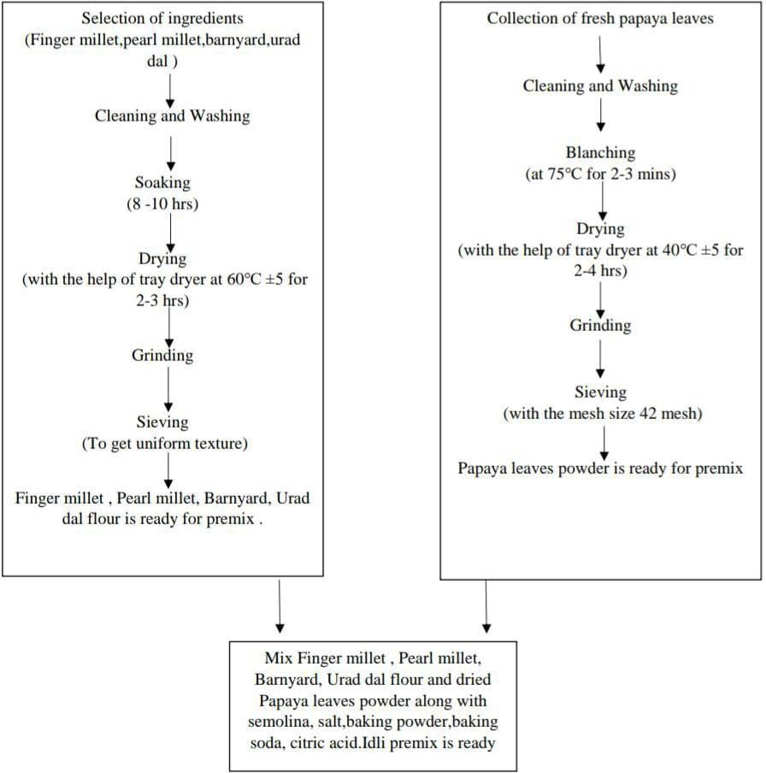

Fig. 1: Flowchart for formulation of idli premix.

3.1 Treatment Details
The present investigation was carried out in the Department of Food Technology, Yashavantrao Chavan Institute of Science, Satara. Results obtained during the investigation are tabulated and statistically analyzed. Based on a review of the literature and preliminary trials, the experimental work plan was prepared with details of the trials as given in the table and shown in the table 1.

Table 1: Composition of idli premix

Sr. No | Ingredients | Trail A (g) | Trail B (g) | Trail C (g)
1 | Ragi | 15 | 15 | 15
2 | Pearl millet | 10 | 10 | 10
3 | Barnyard | 5 | 5 | 5
4 | Urad dal | 5 | 5 | 5
5 | Semolina | 5 | 5 | 5
6 | Papaya leaves  Powder | 2 | 1.5 | 1
7 | Baking powder | 0.5 | 0.5 | 0.5
8 | Baking soda | 0.5 | 0.5 | 0.5
9 | Salt | 1.5 | 1.5 | 1.5
10 | Citric acid | - | 0.044 | 0.044
  - Preparation of idli
The premix powder from the selected formulation (trial C) was taken and 60-70 ml of water was added and a thick batter was prepared. The batter was kept standing for 20 minutes. Then after steaming the idlis were cooked in the idli cooker for 20 minutes and served.
- Proximate Analysis
The estimation of the food sample's ash, moisture, fat, and protein contents is part of this analysis.
4.1 Moisture content
After the 5 g sample was ground up and dried for 5 hours at 105°C in an oven, its moisture content was measured by weighing it. It was weighed once more after being chilled in desiccators until it reached a consistent weight. The weight loss as a result was calculated using the moisture content (Manual-FSSAI).

  - Fat Content
Using a Soxhlet device, five grams of crushed product were carefully weighed in a thimble and defatted with petroleum ether. The lipid content was then ascertained by evaporating the ether extract. (Manual-FSSAI)
  - Crude Fibre Content
Initially, 2 to 5 g of a moisture and fat-free sample was digested using 200 ml of boiling 0.255 N H₂SO₄. To keep the volume constant, water was added to the mixture at regular intervals while it boiled for 30 minutes. After this period, the mixture was filtered through filter paper, and the residue was rinsed with hot water until it was free of acid. Following the sample's transfer, 200 ml of boiling 0.313 N NaOH solution was added to the same beaker. After 30 minutes of boiling, the mixture was filtered through filter paper. Hot water was used to rinse the residue until no alkali remained. After being moved to a crucible and allowed to dry overnight at 80–100°C, it was weighed. After four hours of heating at 550–600°C in a muffle furnace, the crucible was cooled and weighed once more. The difference between the weights indicated the weight of the crude fiber. (J. Moller, 2014)
  - Ash Content
A silica crucible containing five grams of product was weighed, burned, and cooled over a brief flash until the solid was completely burned. After cooling in the desiccator, the sample was spent four hours at 550°C in a muffle furnace. After cooling in the muffle furnace, it was weighed once more, and the process was repeated until two measurements were identical. The percent ash was calculated using the difference between the initial and final weights. (Manual-FSSAI)
  - Protein Content
The Micro-Kjeldhal technique, which entailed digesting 200 mg of material in concentrated sulfuric acid with 1 g of catalyst combination for two to three hours at 100°C, was used to measure the protein content. Following a 40% NaOH distillation, the ammonia that was released was captured in 4% boric acid and titrated against 0.01N H₂SO₄ using a mixed indicator method (Methyl red: Bromocrysol green 1:5). The percentage of protein in the sample was then estimated using a factor of 6.25, and the proportion of nitrogen was then calculated using a method. (Manual-FSSAI)
  - Carbohydrate Content
The carbohydrate content was determined using the difference technique. (Kumar et al. 2023)

- Sensory Assessment
The scientific method for eliciting, Quantifying, evaluating, and interpreting reactions as perceived by the senses of sight, smell, touch, taste, and hearing is sensory assessment. Semi-trained panel members, who were academic staff members of the Yashavantarao Chavan Institute of Science, Satara, were asked to rate the overall products on a 9-point hedonic scale with descriptive words ranging from 1 (dislike strongly) to 9 (like extremely). They were evaluated for sensory qualities such as appearance, color, taste, flavor, and texture. (Wichchukit, S. and O'Mahony, M. 2022)
Table 2: 9-Point Hedonic Scale

Sr. No. | Remarks | Score
1 | Like extremely | 9
2 | Like very much | 8
3 | Like moderately | 7
4 | Like slightly | 6
5 | Neither like nor dislike | 5
6 | Dislike slightly | 4
7 | Dislike moderately | 3
8 | Dislike very much | 2
9 | Dislike extremely | 1

Result
The present investigation was carried out in the Department of Food Technology, Yashavantrao Chavan Institute of Science, Satara. The idli premix was formulated by taking a total of three trials, A, B, and C, from which Trial C was selected by the 9-point hedonic scale by the faculty members and students from the department of food technology.
Chemical properties of idli premix were studied by analysing moisture content, fat, protein, fibre, ash, and carbohydrates, and the results are shown in table 3. Various tests were taken for that, and all the equipment and chemicals are handled with care.

Table 3: Results of proximate analysis

Sr. No | Test Done | Sample A | Sample B | Average
1 | Moisture | 8.9 % | 9% | 8.95%
2 | Fat | 1.02% | 0.98% | 1%
3 | Protein | 1.12% | 1.56% | 1.34%
4 | Fibre | 6.26% | 6% | 6.13%
5 | Ash | 2.2% | 2% | 2.1%
6 | Carbohydrates | 80.5% | 80.46% | 80.48%
7 | Energy | 335.66Kcal | 336.9Kcal | 336.28Kcal
The sensory qualities in terms of color, flavor, texture, and aroma were assessed by a panel of 10 judges with a 9-point hedonic scale. The data regarding the sensory evaluation is presented in table 4 below.
Table 4: Sensory evaluation score

Parameters | Trail 1 | Trial 2 | Trial 3
Appearance | 7 | 7.7 | 8
Color | 7 | 8 | 7.8
Odour | 7.2 | 6.8 | 7.4
Flavour | 7 | 6.8 | 6
Taste | 6.8 | 6.7 | 6
Texture | 5.8 | 8.6 | 7.8
Overall Acceptability | 6.8 | 7.4 | 7.12
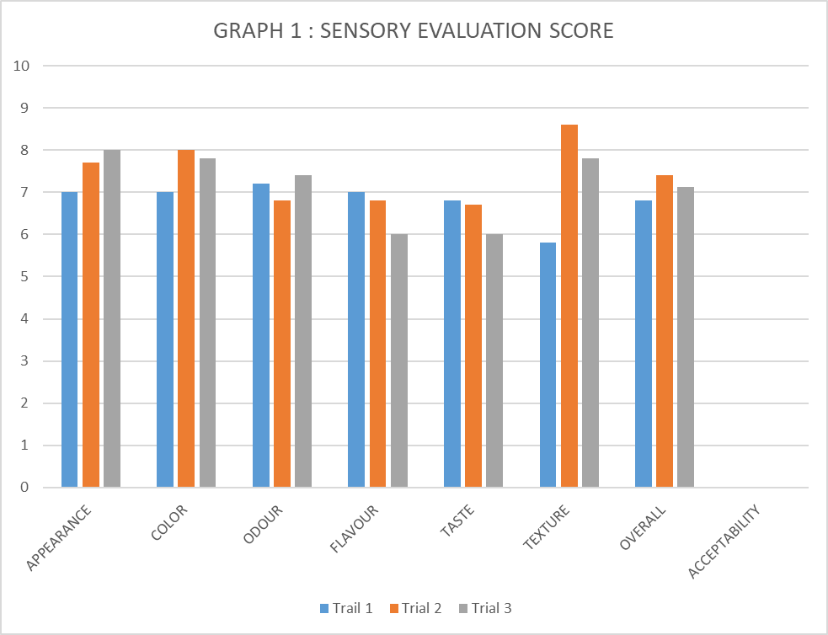
Fig 2: Sensory evaluation score

Discussion
The proximate composition of the fiber-rich idli premix (Table 3) revealed an average moisture level of 8.95%, which is within the permitted limit for dry premixes. Low moisture content increases shelf life by reducing microbial growth and enzymatic activity. Similar findings were obtained in composite millet premixes with moisture levels ranging from 8 to 10% (Mishra et al., 2021). The fat percentage (1%) was low, making the product light and acceptable for health-conscious customers, consistent with findings in ragi- and barnyard millet-based formulations, which revealed fat values ranging from 0.8 to 1.5% (Singh & Raghuvanshi, 2012).
The protein level averaged 1.34%, which is lower than legume-based idli mixes but comparable to cereal- and millet-based premixes. These results are consistent with previous research on ragi-based products, which are often low in protein but high in micronutrients and fiber (Verma et al., 2020). The crude fibre content was considerable (6.13%), demonstrating the functional enrichment achieved by using barnyard millet and papaya leaves. Conventional idli mixes often include less than 2% fiber (Shobana & Malleshi, 2007), underlining the nutritional benefit in the current study.
The sensory evaluation (Table 4) indicated significant variations across the three trials. Trial 3 had the greatest scores for appearance (8.0) and odor (7.4), whereas Trial 2 had the highest scores for color (8.0) and texture (8.6). Flavour and taste scores were somewhat reasonable throughout all trials, with Trial 1 demonstrating greater balance than the rest. Overall acceptance was best in Trial 2 (7.4), followed by Trial 3 (7.12), and lowest in Trial 1 (6.8). These findings imply that the addition of dried papaya leaves did not detract from the sensory quality of the idlis and, when adjusted, instead improved texture and overall appeal.

Conclusion
Based on Sensory analysis, it is possible to prepare idli premix with Various cereals and dried papaya leaves powder as a source of nutrients. It is rich in fiber. Therefore, it is an innovative as well as nutritious product gifted to the market it was concluded that Sample C was found to be accepted during sensory evaluation.

References

- Ajagekar, A. A, Sali, S. D, Borse, O. D, Patil, A. B, Suri, S, and Patil, A. G. (2023). Millets-Based Fermented Products: A Review. Acta Scientific NUTRITIONAL HEALTH (ISSN: 2582-1423), 7(6).
- Akhila, S, and Vijayalakshmi, N. G. (2015). Phytochemical studies on Carica papaya leaf juice. International Journal of Pharmaceutical Sciences and Research, 6(2), 880
- Bhatt, D, Rasane, P, Singh, J, Kaur, S, Fairos, M, Kaur, J, and Sharma, N. (2023). Nutritional advantages of barnyard millet and opportunities for its processing as value- added foods. Journal of Food Science and Technology, 60(11), 2748-2760.
- Dev. N. and Iqbal, A. (2015). Processing and quality evaluation of green papaya (Carica papaya L.) leaf tea. Journal of Agriculture and Crop Science, 2(5), 1-6.
- Dhillon, B, Sodhi, N. S, Gandotra, S, Kaur, S, and Jaiswal, S. (2020). Physico-chemical and textural (sensorial and electromyographic) evaluation of idlis formulated with brown rice and pearl millet flours. Journal of Food Measurement and Characterization, 14, 2898-2906.
- Halim, S. Z, Abdullah, N. R, Afzan, A, Rashid, B. A, Jantan, I, and Ismail, Z. (2011). Acute toxicity study of Carica papaya leaf extract in Sprague Dawley rats. Journal of Medicinal Plants Research, 5(10), 1867-72.
- Hebrard, A, Oulahna, D, Galet, L, Cuq, B, Abecassis, J, and Fages, J. (2003). Hydration properties of durum wheat semolina: influence of particle size and temperature. Powder Technology, 130(1-3), 211-218.
- Jagati, P, Mahapatra, I, and Dash, D. (2021). Finger millet (Ragi) as an essential dietary supplement with key health benefits: A review. International Journal of Home Science, 7(2), 94-100.
- Malik, S. (2015). Pearl millet-nutritional value and medicinal uses. International Journal of Advanced Research and Innovative Ideas in Education, 1(3), 414-418.
Mishra, A., Gupta, R., & Kumar, P. (2021). Nutritional composition and quality characteristics of composite millet-based premixes. Journal of Food Science and Technology, 58(4), 1452–1460. https://doi.org/10.1007/s13197-020-04658-1
- Moller, J. (2014). Comparing methods for fibre determination in food and feed. Dedicated Analytical Solutions, 1-6.
- Nambiar, V. S, Dhaduk, J. J, Sareen, N, Shahu, T, and Desai, R. (2011). Potential functional implications of pearl millet (Pennisetum glaucum) in health and disease. Journal of Applied Pharmaceutical Science, (Issue), 62-67.
- Neeharika, B, Suneetha, W. J, Kumari, B. A, and Tejashree, M. (2020). Leavening agents for the food industry. Int. J. Curr. Microbiol. App Sci, 9(9), 1812-1817.
- Parmar, M. R. (2022). Effect of Tray Drying Conditions on the Bioactive Compound of the Papaya Leaf. Current Journal of Applied Science and Technology, 41(36), 1-11.
- Patel, I, Patel, K, Pinto, S, and Patel, S. (2016). Ragi: a powerhouse of nutrients. Res Rev J Dairy Sci Technol, 5, 36-47.
- Patni, D, and Agrawal, M. (2017). Wonder millet–pearl millet, nutrient composition and potential health benefits review. Int J Innov Res Rev, 5(1), 6-14.
- Raja, K. S, Taip, F. S, Azmi, M. M. Z., and Shishir, M. R. I. (2019). Effect of pre- treatment and different drying methods on the physicochemical properties of Carica papaya L. leaf powder. Journal of the Saudi Society of Agricultural Sciences, 18(2), 150- 156.
- Rotela, S, Borkar, S, and Borah, A. (2021). Health benefits of millets and their significance as functional food: A review. J. Pharma Innov, 10, 158-162.
- Samtiya, M, Aluko, R. E, and Dhewa, T. (2020). Plant food anti-nutritional factors and their reduction strategies: an overview. Food Production, Processing and Nutrition, 2, 1- 14.
- Selvi, L. S, and Malathi, D. (2014). Development and evaluation of instant idli mix from small millets. Trends in Biosciences, 7(19), 2972-2976.
Shobana, S, Krishnaswamy, K, Sudha, V, Malleshi, N. G, Anjana, R. M, Palaniappan, L, and Mohan, V. (2013). Finger millet (Ragi, Eleusine coracana L.): a review of its nutritional properties, processing, and plausible health benefits. Advances in food and nutrition research, 69, 1-39.
Shobana, S., & Malleshi, N. G. (2007). Preparation and functional properties of decorticated finger millet (Eleusine coracana). Food Chemistry, 105(2), 862–870. https://doi.org/10.1016/j.foodchem.2007.01.040
Singh, G., & Raghuvanshi, R. S. (2012). Finger millet for food and nutritional security. African Journal of Food Science, 6(4), 77–84.
- Singh, S. P, Kumar, S, Mathan, S. V, Tomar, M. S, Singh, R. K, Verma, P. K, and Acharya, A. (2020). Therapeutic application of Carica papaya leaf extract in the management of human diseases. DARU Journal of Pharmaceutical Sciences, 28, 735- 744.
Srivastava, R., Sood, M., & Singh, A. (2022). Development of fibre-rich instant idli premix incorporated with functional ingredients. International Journal of Food Science and Nutrition, 7(1), 45–52.
- Tripathi, G, Jitendrakumar, P. H, Borah, A, Nath, D, Das, H, Bansal, S and Singh, B. V. (2023). A review of the nutritional and health benefits of millets. International Journal of Plant & Soil Science, 35(19), 1736-1743.
Verma, V., Patel, S., & Banerjee, C. (2020). Nutritional and functional significance of millets: A review. Journal of Food Biochemistry, 44(6), e13127.
- Wichchukit, S, and O'Mahony, M. (2022). The 9‐point hedonic scale and hedonic ranking in food science: some reappraisals and alternatives. Journal of the Science of Food and Agriculture, 95(11), 2167-2178.

