FORMULATION OF INSTANT DANGAR PREMIX ENRICHED WITH BLACK GRAM AND GREEN GRAM

Abstract:
The research examined the development, nutritional assessment, sensory characteristics, and functional attributes of the instant dangar premix. Dangar premix is made from various flour blends such as black gram, green gram, and chickpea together with some spice blends like chilli powder, turmeric powder, and salt, etc. Sensory evaluation verified that the product was well-received in terms of flavour and overall attractiveness. Merging pulses with cereals resulted in a high-quality protein option compared to traditional pithla, enhancing nutritional intake, such as high protein, dietary fiber, and micronutrients such as calcium, iron, and vitamin B. The suggested formulation showed promise as a convenient and health-promoting food choice for individuals' health. This research investigated the development and assessment of a nutritious dangar premix enhanced with high protein content, aiming to offer a healthier and functional option compared to traditional pithla mixes. The research applied a methodical approach to formulating the product, which included selecting ingredients, preparing them, and blending to achieve the best sensory qualities. This premix also offered a quick and convenient meal solution while maintaining its nutritional value, addressing the preferences of today’s health-focused consumers. For samples A and B, trials have been taken, and the sensory panelists have finalized sample B. Following the guidelines in the FSSAI Manuals, the contents of moisture, fat, protein, fibre, and ash were examined as well as functional properties such as water uptake and oil uptake ratio. The packaging material used for instant dangar premix was aluminium foil.
Keywords: Dangar premix, High protein, Functional, Micronutrients.

1. Introduction:
India is a significant producer of legumes globally. Legumes are a cost-effective source of complementary proteins and provide diversity to the diet for the human population. They serve as significant protein sources in India. Legumes are prized for their low glycemic index and rich protein content, which is why they are typically part of diets in the Indian subcontinent. Animal and plant proteins are typically the two primary sources of protein. Due to the high cost of animal proteins, there is a necessity for plant proteins as an alternative protein supplement. Pulses have a protein content of 220-250 g per kg, while dried fish has a protein content of 335 g per kg. It Is a significant component of both Indian and Western diets as it serves as an abundant source of protein and plays a crucial role in human nutritional needs. The proteins in black gram are easily digested and contain a good amount of sulfur-containing amino acids. They contain abundant vitamins and phosphoric acid (Kumar et. Al., 2020).
Black gram (Vigna mungo L. Hepper.) Being high in protein, has twice the protein content (20-25%) when compared to cereals. It has significant levels of proteins such as albumin and globulin, along with amino acids like tryptophan and lysine. It is additionally abundant in fiber, various vitamins (thiamin, riboflavin, and niacin), and minerals such as iron and calcium (Kanth et. Al., 2021).
Green gram (Vigna radiate L. R. Wilczek) seeds are notably high in protein, with a protein content ranging from approximately 20.97% to 31.32%. Mubarak indicated a chemical score of 76% for the amino acids in green gram beans, which were determined according to the guidelines set by the Food and Agriculture Organization of the United Nations (FAO) and the World Health Organization (WHO). Enhance the quality of protein consumption within a vegetarian diet (Anwar et. Al., 2007).
Chickpea (Cicer arietinum) is among the oldest leguminous crops and is extensively consumed globally. The daily per capita supply of 14 g of chickpeas contributes around 2.3% (56 Kcal) of energy and 4.7% (2.7 g) of the protein to the Indian population, in addition to serving as a significant source of calcium and iron (10-12%). Malic and oxalic acids released from leaves, stems, and pods possess medicinal uses for aphrodisiac, bronchitis, catarrh, inflammation, cholera, constipation, diarrhea, and digestive issues. Gas, snake envenomation, heatstroke, and growths. These acids are recognized for decreasing blood cholesterol levels too (Jaya et. Al., 1981).
The carbohydrates in chickpea are classiﬁed into available and unavailable carbohydrates. Available carbohydrates in chickpea are mainly mono and disaccharides, which are digested in the small intestine. Unavailable carbohydrates consist of oligosaccharides, resistant starch, pectin, hemi-cellulose, and cellulose, which are digested in the small intestine (Jaya et. Al., 1981).
Chilli powder (Capsicum annuum L.) contains bioactive compounds such as capsaicin, flavonoids and carotenoids, linalool, which play a significant role in the prevention of free radicals and influence human health positively. Antioxidants such as vitamin C, lutein, and synephrine are also present in chili powder. Several studies have shown that these components have therapeutic benefits such as anti-cancer, anti-bacterial, analgesic, anti-inflammatory, and. Antivirus-properties (Babu et. Al., 2014).
Turmeric (Curcuma longa) is an ancient spice. Turmeric is composed of water (80 to 90%) followed by carbohydrates around (13%), protein (2%), minerals (2%), and lipids (<1%); among the minor components of turmeric, curcuminoids have a central role and may compose up to 10% of dry turmeric powder (Birol et. Al., 2015). Salt (Sodium chloride) is used for taste and also acts as a preservative. Use of salt decreases water activity, which can lead to an effective increase in the concentration of flavors and improve the volatility of flavor components (Hutton, 2002).
2. Materials and Methods
2.1 Ingredients
The material used in formulating the product was black gram, green gram, chickpea, chilli powder, salt, and turmeric powder, which were procured from the market.
2.2 Raw Material Collection
All the cereal grains that were required were collected from the local market and prepared for the process. They were first cleaned and roasted at 55°C for 3-4 minutes. After that, roasted grains were ground separately using the grinder, and the flour was sieved. After grinding, the powder was sieved to get a uniform particle size.
2.3 Formulation of Dangar Premix
After converting the cereal grains into powder form, the formulation was done by taking a total of two compositions, i.e, sample A and sample B, as shown in Table 1. All the flours were weighed separately and mixed along with the chilli powder, salt and turmeric powder. The mixture is then mixed thoroughly, and the dangar premix is ready (figure 1.)
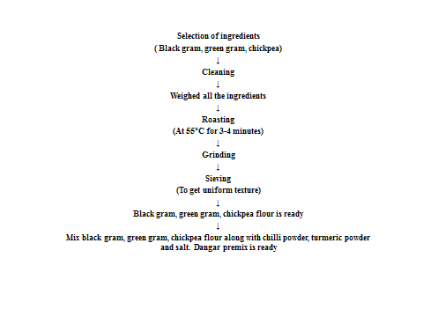
Fig 1: Flow chart for formulation of dangar premix
2.4 Treatment Details
The present investigation was carried out in the Department of Food Technology, Yashavantrao Chavan Institute of Science, Satara. Results obtained during the investigation are tabulated and statistically analyzed. Based on a review of the literature and preliminary trials, the experimental work plan was prepared with details of the trials as given in the table and shown in table 1.
Table 1: Composition of instant dangar premix (Per 100g)
Sr. No. | Ingredient | Sample A (g) | Sample B  (g)
1 | Black gram | 60 | 50
2 | Green gram | 25 | 30
3 | Chickpea | 8 | 13
4 | Chilli Powder | 4 | 4
5 | Salt | 2 | 2
6 | Turmeric Powder | 1 | 1

2.5 Preparation of Dangar
The premix powder from the selected formulation (Sample B) was taken were we standardize the dangar by using two cooking methods.
In trial 1, we took 50g of dangar premix and added 70ml of hot water in the premix. Mixed it well to remove lumps and garnished with onion and coriander.
In trial 2, we took 50g of premix and added to 10ml of hot oil in which onions were souted, and then after mixed it well to remove lumps and garnished with coriander.
  - Proximate Analysis
The estimation of the food sample's ash, moisture, fat, and protein contents is part of this analysis.
2.6.1 Moisture content
After the 5 g sample was ground up and dried for 5 hours at 105°C in an oven, its moisture content was measured by weighing it. It was weighed once more after being chilled in desiccators until it reached a consistent weight. The weight loss as a result was calculated using the moisture content (Manual-FSSAI).
2.6.2 Fat Content
Using a Soxhlet device, five grams of crushed product were carefully weighed in a thimble and defatted with petroleum ether. The lipid content was then ascertained by evaporating the ether extract (Manual-FSSAI).
2.6.3 Crude Fibre Content
Initially, 2 to 5 g of a moisture and fat-free sample was digested using 200 ml of boiling 0.255 N H₂SO₄. To keep the volume constant, water was added to the mixture at regular intervals while it boiled for 30 minutes. After this period, the mixture was filtered through filter paper, and the residue was rinsed with hot water until it was free of acid. Following the sample's transfer, 200 mL of boiling 0.313 N NaOH solution was added to the same beaker. After 30 minutes of boiling, the mixture was filtered through filter paper. Hot water was used to rinse the residue until no alkali remained. After being moved to a crucible and allowed to dry overnight at 80–100°C, it was weighed. After four hours of heating at 550–600°C in a muffle furnace, the crucible was cooled and weighed once more. The difference between the weights indicated the weight of the crude fiber (Moller, 2014).

2.6.4 Ash Content
A silica crucible containing five grams of product was weighed, burned, and cooled over a brief flash until the solid was completely burned. After cooling in the desiccator, the sample was spent four hours at 550°C in a muffle furnace. After cooling in the muffle furnace, it was weighed once more, and the process was repeated until two measurements were identical. The percent ash was calculated using the difference between the initial and final weights (Manual-FSSAI).
2.6.5 Protein Content
The Micro-Kjeldhal technique, which entailed digesting 200 mg of material in concentrated sulfuric acid with 1 g of catalyst combination for two to three hours at 100°C, was used to measure the protein content. Following a 40% naoh distillation, the ammonia that was released was captured in 4% boric acid and titrated against 0.01N H₂SO₄ using a mixed indicator method (Methyl red: Bromocrysol green, 1:5). The percentage of protein in the sample was then estimated using a factor of 6.25, and the proportion of nitrogen was then calculated using a method (Manual-FSSAI).
2.6.6 Carbohydrate Content
The percent of total carbohydrate content was determined using the difference method (Kumar et al. 2023).
2.7 Sensory Assessment
The scientific method for eliciting, Quantifying, evaluating, and interpreting reactions as perceived by the senses of sight, smell, touch, taste, and hearing is sensory assessment. Semi-trained panel members, who were academic staff members of the Yashavantrao Chavan Institute of Science, Satara, were asked to rate the overall products on a 9-point hedonic scale with descriptive words ranging from Score 1 (Dislike extremely) to 9 (like extremely) as shown in Table 2. They were evaluated for sensory qualities such as appearance, color, taste, flavor, and texture (Wichchukit and O'Mahony, 2022)

Table 2: 9-Point Hedonic Scale
Sr. No. | Remarks | Score
1 | Like extremely | 9
2 | Like very much | 8
3 | Like moderately | 7
4 | Like slightly | 6
5 | Neither like nor dislike | 5
6 | Dislike slightly | 4
7 | Dislike moderately | 3
8 | Dislike very much | 2
9 | Dislike extremely | 1

3. Result - The present investigation was carried out in the Department of Food Technology, Yashavantrao Chavan Institute of Science, Satara. The information concerning the composition was displayed in Table 1. Samples A and B utilized the same but different measurements, although the spices remained consistent. The compositions were based on a 100g measurement. The danger premix was formulated by taking a total of two formulations, from which sample B was selected by the 9-point hedonic scale by the faculty members and students from the Department of Food Technology. On the basis of sensory evaluation, composition B was selected. Chemical properties of Dangar premix were studied by analyzing moisture content, fat, protein, fiber, ash, and carbohydrates, and the results are shown in Table 3. Various tests were taken for that, and all the equipment and chemicals are handled with care.

Table 3: Results of proximate analysis
Sr. No | Test Done | Sample B
1 | Moisture | 4.30 %
2 | Ash | 1.38 %
3 | Fat | 0.07 %
4 | Protein | 24.84%
5 | Carbohydrates | 69.41%

Functional properties of Dangar premix were studied by analyzing water uptake and oil uptake ratio, and the results are shown in Table 4.

Table 4: Results of analysis of functional properties of dangar flour blend
Sr. No | Functional properties | %
1. | Water absorption capacity of dangar flour blend | 31.7
2. | Oil absorption capacity of dangar flour blend | 20.4

The sensory qualities in terms of color, flavor, texture, and aroma were assessed by a panel of 10 judges with a 9-point hedonic scale. The data regarding the sensory evaluation is presented in Table 4 below.
Table 4: Sensory analysis of dangar prepared from premix
Parameters | Sample A | Sample B
Appearance | 7.1 | 8.3
Color | 7.3 | 7.7
Odour | 7.2 | 7.9
Flavour | 7.3 | 8.1
Taste | 7.4 | 7.7
Texture | 7.9 | 8.6
Overall Acceptability | 7.2 | 7.3

Fig 2: Sensory evolution of dangar premix

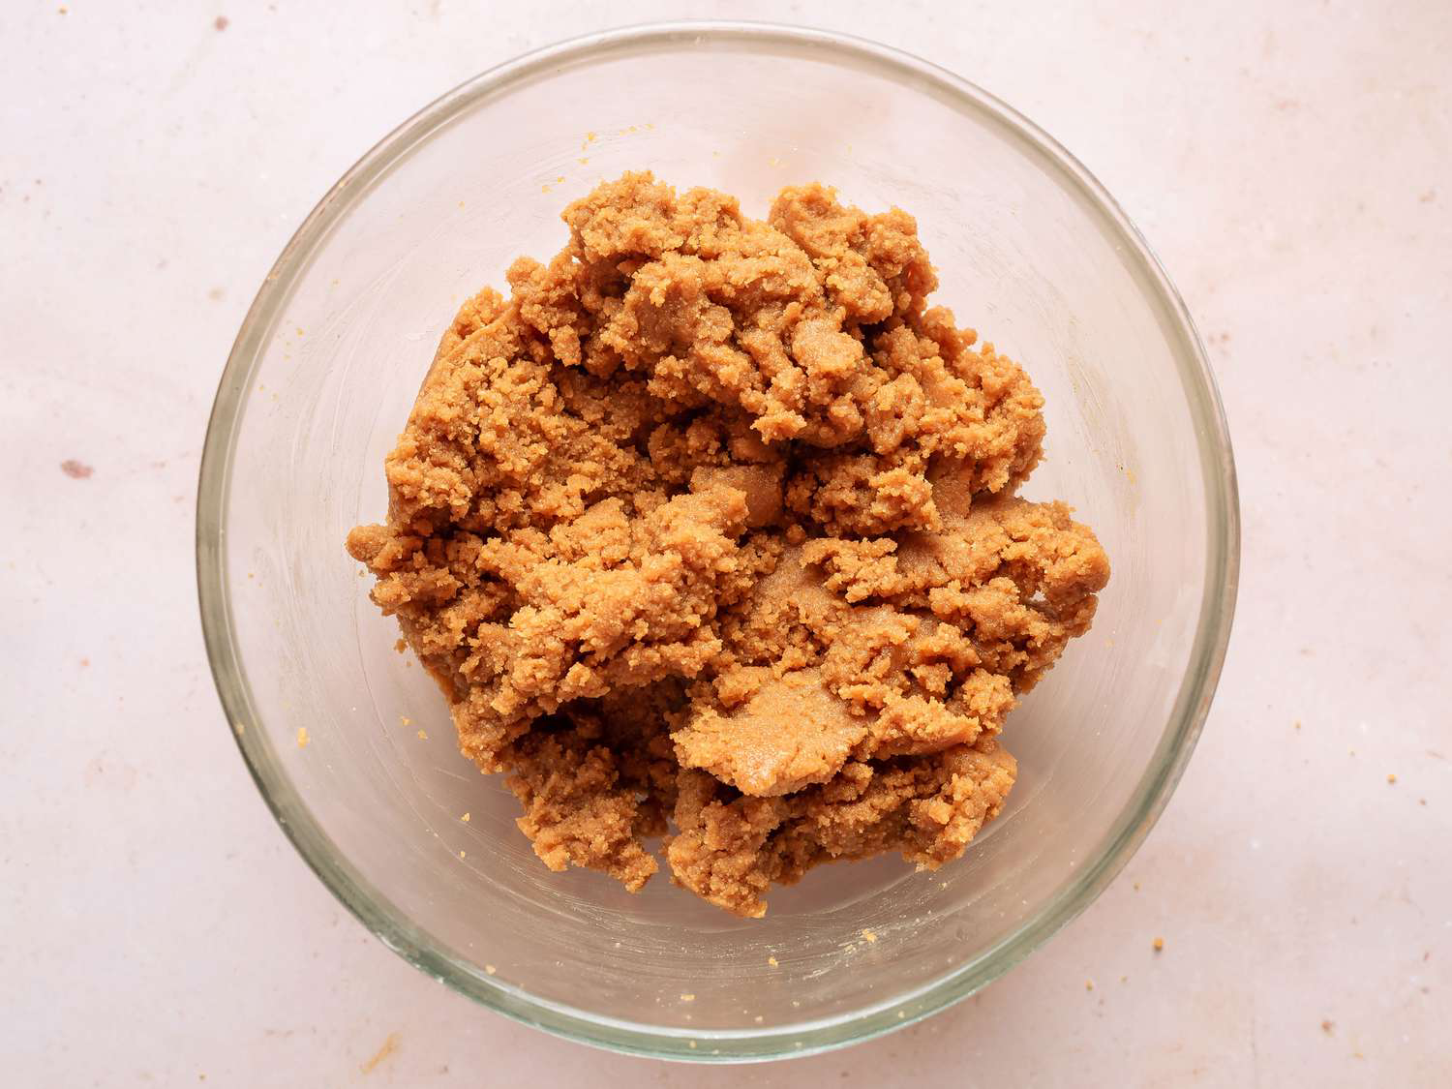

Fig 3: Final Formulation Instant Dangar Premix

A techno-economic feasibility assessment was conducted to evaluate the cost estimation of the product. The price of Instant Dangar Premix is 16 Rs. For 100 grams and 160 Rs. For 1 kilogram. Aluminum foil serves as a packaging material since it is an excellent option for wrapping, sealing, and safeguarding a diverse range of products. Offered in different widths and sand thicknesses, aluminum foil serves as a strong barrier against moisture, wind, bacteria, and sunlight. A key reason for utilizing aluminum foil as packaging is its outstanding barrier characteristics. Aluminum foil rolls create a physical barrier that prevents moisture, light, gases, and germs.
Discussion
The proximate analysis of the dangar flour premix (Sample B) revealed that the product contained 4.30% moisture, 1.38% ash, 0.07% fat, 24.84% protein, and 69.41% carbohydrates. The low moisture level is desirable for prolonging shelf life and ensuring product stability, which is comparable to the 2.8-7.3% range reported in yam-oat snack formulations (Okonkwo et al., 2025). Notably, the protein content (24.84%) was significantly greater than the 4-12% commonly observed in yam-based snacks (Akissoé et al., 2003; Ezeaku et al., 2025), indicating the dangar blend's potential as a protein-rich functional meal. Carbohydrate content remained the predominant component at 69.41%, but significantly lower than in yam flours (75-82%) (Zhang & Hamaker, 2012), owing to the greater protein contribution. The functional property investigation found a water absorption capacity of 31.7% and an oil absorption capacity of 20.4%, which are within the ideal range for snack compositions.
High water absorption promotes dough formation and palatability, but moderate oil absorption assists in flavor retention without making the product oily, consistent with Adepoju et al.'s (2024) findings for composite flour blends. Sensory examination validated the product's acceptability, with Sample B scoring higher than Sample A on all characteristics, notably appearance (8.3), flavor (8.1), and texture (8.6). Sample B's superior sensory attributes can be attributable to its balanced macronutrient composition, which improved binding, flavor, and mouthfeel.
Although both samples had similar overall acceptability scores (7.2 and 7.3), Sample B consistently outperformed Sample A, indicating that the enhanced formulation was more appreciated by the sensory panel. These findings confirm prior studies indicating that optimal composite mixes improve both nutritional and sensory characteristics (Adepoju et al., 2024). Overall, the dangar flour premix is described as a high-protein, low-fat, carbohydrate-rich snack with favorable functional properties and high sensory acceptability, making it a promising product for fasting periods and consumers looking for nutritious and digestible alternatives to traditional snacks.
4. Conclusion
The Dangar Premix was prepared with acceptable physicochemical and sensory characteristics. Dangar is a plant-based protein. Black gram is a good source of sulfur-containing amino acids. Based on Sensory analysis, the highest (7.3) overall Acceptability score was recorded by sample B and was significantly superior to the others. This research investigated the development and assessment of a nutritious dangar premix enhanced with high protein content, aiming to offer a healthier and functional option compared to traditional pithla mixes. Therefore, it is an innovative as well as nutritious product gifted to the market. It was concluded that Sample B was found acceptable during sensory evaluation.

References
Adepoju, O. T., Akinola, A. O., & Alonge, O. O. (2024). Production and characterization of snacks utilizing composite flour from unripe plantain, breadfruit, and cinnamon. Foods, 13(6), 852.
Akissoé, N., Hounhouigan, J., Mestres, C., & Nago, M. (2003). How blanching and drying affect the colour and functional characteristics of yam (Dioscorea cayenensis-rotundata) flour. Food Chemistry, 82(2), 257–264.
Anwar, F, Latif, S, Przybylski, R, Sultana, B, & Ashraf, M. (2007). Chemical composition and antioxidant activity of seeds of different cultivars of mungbean. Journal of food science, 72(7), S503-S510.
Babu, P. S, Guravaiah, M, Hatti, I, & Srikanth, K. (2014). Qualitative analysis of capsaicin from chillies and chilli powder by HPLC method. Int. J. Curr. Res. Chem. Pharma. Sci, 1(6), 184-194.
Barakoti, L, & Bains, K. (2007). Effect of household processing on the in vitro bioavailability of iron in mungbean (Vigna radiata). Food and nutrition bulletin, 28(1), 18-22.
Bhat, K. K, & Bhattacharya, S. (2001). Deep fat frying characteristics of chickpea flour suspensions. International journal of food science & technology, 36(5), 499-507.
Birol, E, Meenakshi, J. V, Oparinde, A, Perez, S, & Tomlins, K. (2015). Developing country consumers’ acceptance of biofortified foods: a synthesis. Food Security, 7, 555-568.
Chavan, J. K, Kadam, S. S, Salunkhe, D. K, & Beuchat, L. R. (1987). Biochemistry and technology of chickpea (Cicer arietinum L.) seeds. Critical Reviews in Food Science & Nutrition, 25(2), 107-158.
Collings, V. B. (1974). Human taste response as a function of the locus of stimulation on the tongue and soft palate. Perception & Psychophysics, 16, 169-174.
Dahiya, P. K, Linnemann, A. R, Van Boekel, M. A. J. S, Khetarpaul, N, Grewal, R. B, & Nout, M. J. R. (2015). Mung bean: Technological and nutritional potential. Critical reviews in food science and nutrition, 55(5), 670-688.
Duke, J. (2012). Handbook of legumes of world economic importance. Springer Science & Business Media.
Ezeaku, P. I., Uchechukwu-Agua, A. D., & Okoye, I. (2025). Yam as functional food: Bioactive properties, health benefits, and applications. Discover Food, 5(1), 22.
Hall, C, Hillen, C, & Garden Robinson, J. (2017). Composition, nutritional value, and health benefits of pulses. Cereal Chemistry, 94(1), 11-31.
Hutton, T. (2002). Sodium technological functions of salt in the manufacturing of food and drink products. British Food Journal, 104(2), 126-152.
Ibrikci, H, Knewtson, S. J, & Grusak, M. A. (2003). Chickpea leaves as a vegetable green for humans: evaluation of mineral composition. Journal of the Science of Food and Agriculture, 83(9), 945-950.
Jaya, T. V, & Venkataraman, L. V. (1981). Changes in the carbohydrate constituents of chickpea and greengram during germination. Food Chemistry, 7(2), 95-104
Jukanti, A. K, Gaur, P. M, Gowda, C. L. L, & Chibbar, R. N. (2012). Nutritional quality and health benefits of chickpea (Cicer arietinum L.): a review. British Journal of Nutrition, 108(S1), S11-S26
Kadte, A. J, Perke, D. S, & Kale, P. S. (2018). Economics of turmeric production in Sangli district of Maharashtra, India. Int J Curr Microbiol. Spl.(6), 2279-228.
Kanth, Goswami, K, & Shukla, P. (2021). Nutritional quality evaluation of improved varieties of black gram (Phaseolus mungo). Pharm Innov J, 10, 201-220.
Kaur, M, Singh, N, & Sandhu, K. S. (2004). Relationships between selected properties of black gram seeds and their composition. International Journal of Food Properties, 7(3), 541-552.
Kumar, V, Kumar, P, & Soni, S. (2020). Association Analysis in Black gram (Vigna mungo L. Hepper). International Journal of Current Microbiology and Applied Science, 9(12), 365-371.
Liu, Y., He, Z., & Zhang, M. (2023). Chinese yam (Dioscorea): Nutritional value, beneficial effects, and food and pharmaceutical applications. Industrial Crops and Products, 196, 116565.
Muehlbauer, F. J, & Tullu, A. (1997). Cicer arietinum L. New CROP FactSHEET, 6.
Nehra, S, Gothwal, R. K, Varshney, A. K, Solanki, P. S, Chandra, S, Meena, P, ... & Ghosh, P. (2021). Biomanagement of Fusarium spp. associated with pulse crops. Food Security and Plant Disease Management, 423-452.
Okonkwo, C. J., Nwosu, J. N., & Anosike, C. A. (2025). Proximate and sensory evaluation of snack bars made from water yam and oat spiced with cinnamon and mustard seed. Asian Journal of Food Research and Nutrition, 4(1), 37–47.
Wood, J. A, & Grusak, M. A. (2007). Nutritional value of chickpea. In Chickpea breeding and management (pp. 101-142). Wallingford UK: CABI.
Zhang, P., & Hamaker, B. R. (2012). Banana starch structure and digestibility. Carbohydrate Polymers, 87(2), 1552–1558. https://doi.org/10.1016/j.carbpol.2011.09.062

