Original Research Article

BIOSYNTHESIS OF SILVER-COPPER-ALUMINUM TRIMETALLIC NANOPARTICLES USING AQUEOUS LEAVES EXTRACT OF Hierochloe odorata AND EVALUATING ITS ANTIMICROBIAL ACTIVITIES

ABSTRACT
Due to the erroneous use of antibiotics, many pathogens have become resistant to them and as such there has been a surge in multi-drug-resistant bacteria. This in turn has posed a great threat to living things and global economic development. Although various methods are presently being used to mitigate these effects however, most of these methods have some disadvantages such as high cost, low efficiency and risk of reintroducing more pollutants to the environment. Literature studies have revealed that nanoparticles, due to their large surface to volume ratio and excellent catalytic and antimicrobial properties, have been applied as antimicrobial agents. Furthermore, the synergistic effect of trimetallic nanoparticles has also increased its efficacy as an antimicrobial agent. In this study silver-copper-aluminum nanoparticles (Ag-Cu-Al NPs) was successfully biosynthesized using aqueous leaves extract of Hierochloe odorata at room temperature. The biosynthesized Ag-Cu-Al NPs was first confirmed by the observation of a distinct colour change from grey to olive green after addition of the aqueous leaves extract to 0.1 M silver nitrate, copper chloride and aluminum oxide salts solution. The Ag-Cu-Al NPs was examined using UV-vis spectroscopy which revealed a characteristics peak maximum at 405 nm. FTIR analysis revealed the possible biomolecules present in the leaves extract responsible for bio-reduction, capping and stabilization of Ag-Cu-Al NPs. XRD analysis revealed the crystalline nature and particle size of Ag-Cu-Al NPs. SEM-EDS analysis revealed the surface morphology and elemental composition. Furthermore, antimicrobial activity of Ag-Cu-Al NPs were also investigated which revealed outstanding antimicrobial activity against Staphylococcus aureus, Salmonela sp. Aspergillus niger and Aspergillus flavus
KEYWORDS: Ag-Cu-Al Nanoparticles, Trimetallic, Biosynthesis, Hierochloe odorata, Antimicrobial.
1. Introduction
In contrast to the past, extensive research is being conducted in the field of nanotechnology because of its vast applications in both the industrial and health sectors. The use of nanotechnology in a variety of fields, including chemistry, biology, and engineering, has brought about advanced, effective, and unique products with improved features, especially those that find biomedical applications [1–3]. The burgeoning field of nanoparticles is considered to be one of the ground-breaking approaches to addressing significant issues worldwide. Nanoparticles (NPs) offer high catalytic activity as well as a high surface-to-mass ratio [4]. Nanoparticles are adequate, cost effective, and environmentally friendly solutions to current processing materials [5]. These synthesized nanomaterials have distinguishable proficiencies that are useful for addressing gaps in sectors such as health, energy production, drug delivery systems, and wastewater treatment [6–8].
There are various types of nanoparticles depending on their morphology and other traits. Metallic nanoparticles, for example gold and silver nanoparticles, have been used in numerous applications such as biosensors, efficient drug delivery systems, active food packaging, and other medicinal uses [9]. Metallic nanoparticles have received increasing attention among the numerous types of nanoparticles due to the usefulness of their biological features, nontoxic nature, and their distinctive properties [10-11]. Due to their unique optical, electrical, and magnetic properties, metal nanoparticles have been investigated for a variety of applications [12]. Compared to monometallic nanoparticles, multimetallic nanoparticles, composed of various metals, provide a unified system that can display unique features. Furthermore, when compared to monometallic or bimetallic nanoparticles, trimetallic nanoparticles exhibit more catalytic activity, more antibacterial effect, diversified shapes, highly selective detection and sensitivity, high level of stability, and chemical transformation [13]. These promising features are a result of the combined effects of the three metals that make up trimetallic nanoparticles. Synergism in these trimetallic nanoparticles have been shown to significantly increase remarkable properties like, photocatalytic activity, antimicrobial activity, corrosion inhibition potential and other therapeutic activities [14-15].
Various methods have been reported for the synthesis of trimetallic nanoparticles but, the green synthesis or biological synthesis route has proven to be most affordable and environmentally friendly. Different plants, microorganisms, and biodegradable waste can be used as a source to synthesize these nanoparticles via this route. Plant components, including leaves, seeds, roots, and flowers, can be employed. Plant extracts are considered to be reducing, capping, and stabilizing agents due to the presence of bioactive compounds such as flavonoids, terpenoids, enzymes, alkaloids, and antioxidants [16].
One of such plants that can be used in the synthesis of trimetallic nanoparticles is Hierochloe odorata. Hierochloe odorata or Anthoxanthum nitens (commonly known as sweet grass, Manna grass or Vanilla grass) is an aromatic herb native to northern Eurasia and North America. It is used as a smudge, in herbal medicine and in the production of distilled beverages. It owes its distinctive sweet scent to the presence of coumarin and possess high antioxidant properties. The name Hierochloe odorata is from the Greek and Latin. Hierochloe means "holy grass" and odorata means "fragrant". Some North American indigenous people burn Sweet Grass in ceremonies to attract good spirits. [17].
Globally, one of the leading causes of serious health challenges is foodborne disease caused by infectious agents. At the present time, antibiotics are the only source of treatment against disease causing microorganisms such as bacteria and fungi. However, due to the erroneous use of antibiotics, many pathogens have become resistant to them. The regularity of infectious disorders caused by bacteria resistant to many drugs has increased, especially methicillin-resistant Staphylococcus aureus and Salmonella sp, penicillin-resistant Streptococcus pneumoniae, and Pseudomonas aeruginosa resistant to fluoroquinolones. In order to address these issues, the use of alternative antibacterial agents such as metallic nanoparticles have been of great focus. Metallic nanoparticles have powerful, targeted, and prolonged antibacterial interactions with bacteria and biofilms at tiny dosage because of their smaller dimensions and high surface area-to-volume ratios. Multiple studies have revealed that trimetallic nanoparticles exhibit excellent antimicrobial activity compared to that of bimetallic and monometallic nanoparticles. In one such study, Au/Pt/Ag was synthesized via green synthesis method, by using leaf extract of Lamii albi flos. The synthesized Au/Pt/Ag nanoparticles demonstrated remarkable antimicrobial properties against harmful strains of bacteria such as Enterococcus faecalis and Enterococcus faecium, both planktonic as well as sessile [18].
This study proposes Ag-Cu-Al trimetallic NPs, synthesized via green methods with aqueous leaves extracts of Hierochloe odorata, and its application as an alternative antimicrobial agent against some of these multi-drug resistant bacteria and fungi. Unlike existing antimicrobial agents, Ag-Cu-Al NPs combine silver’s noble barrier, copper’s catalytic reactivity, and aluminum’s Al₂O₃ passivation layer. Its antimicrobial effect can be attributed to the combined synergistic effects of the trimetallic nanoparticles, with various activities towards the microbes, including their contact with cell membranes, resulting in structural changes in permeability and disruption, production of free radicals, inactivation of essential enzymes by reaction between thiol groups and metal ions released by the nanoparticles, and damage to microbial DNA as well as RNA damage [18].
The aqueous leaves extract of Hierochloe odorata used as capping and stabilizing agent was effective (due to the wide range of biomolecules present in the extract) in minimizing the average particle size and reduced the tendency of agglomeration of the biosynthesized Ag-Cu-Al nanoparticles. The biosynthesized trimetallic nanoparticles were characterized using UV-Vis spectroscopy, FTIR, XRD and SEM-EDS analysis. The biosynthesized trimetallic nanoparticles were further verified for their antimicrobial ability on some fungi and bacterial strains.

2. Materials and Methods
2.1. Materials and Chemicals
The materials used includes; Hierochloe odorata leaves were collected and identified from the premises of Federal College of Forestry Jos, Plateau State. Analytical grade copper (II) chloride (CuCl₂), silver nitrate (AgNO₃), aluminum oxide (Al₂O₃), were obtained from Thermo Fisher Scientific Pittsburgh, PA, United States of America,. The bacterial and fungal strains of Staphylococcus aureus, Salmonella sp, Aspergillus niger and Aspergillus flavus were maintained at the laboratory of the department of Science Laboratory Technology of the University of Jos, Jos. All the chemicals and reagents were used as received without further purification

2.2. Methods
2.2.1 Preparation of Aqueous leaves extract of Hierochloe odorata
Exactly 10 grams of fresh uninfected leaves of Hierochloe odorata was weighed and then washed several times with running tap water and rinsed with deionized water for removal of dust particles. Afterwards, the leaves was chopped into smaller pieces to obtain better yield of the extract. The chopped and weighed material was then transferred into a 500 ml beaker containing 100 ml of deionized water and then heat on a hotplate at 30ºC. The mixture was brought to stand for 15 minutes and allowed to cool after which it was filtered using Whatman filter paper No. 1. The filtrate was then kept for onward use.

2.2.2 Preparation of 0.1 M AgNO₃ and CuCl₂ and Al₂O₃ Salt Solutions
Exactly 1.70, 1.34 and 1.02 grams of silver nitrate, copper (II) chloride and aluminum oxide salts respectively were weighed and transferred into beakers containing 100 ml of deionized water. The mixtures were stirred to ensure that the salt dissolves properly after which the salt solutions were mixed together to obtain a homogenous mixture. The prepared salt solutions was then stored for onward use
2.2.3 Synthesis of Ag-Cu-Al Trimetallic Nanoparticles
The trimetallic nanoparticles was synthesized by reducing the precursor salts of silver, copper and aluminum concurrently using aqueous leaves extract of Hierochloe odorata. 30 ml of the freshly prepared leaf extract was added drop wise to 150 ml of 0.1 M AgNO₃-CuCl₂-Al₂O₃ solution (50 ml of each salt solution) with constant stirring on a magnetic stirrer. On addition of the extract and after a period of time, a colour change was observed indicating the formation of the trimetallic nanoparticles. The trimetallic nanoparticles formed was centrifuged at 3000 rpm for 15 minutes, washed with distilled water, allowed to dry at room temperature and kept for further analysis.
2.2.4 Characterization
The biosynthesized trimetallic nanoparticles was subjected to various characterization techniques to determine the size, morphology and composition of the biosynthesized nanoparticles. UV-Visible measurements of the nanoparticles was recorded using the T70 PG Instruments’ UV- Spectrophotometer at different wavelength and absorption and. FTIR (Cary 630 Agilent Technologies) was used to identify the possible biomolecules present in the plant extract responsible for capping and stabilization of the nanoparticles. SEM–EDS analysis was carried out using Quanta 250 FEG instrument to investigate the surface morphology and elemental composition of the nanoparticles. The crystalline structure and particle size of the biosynthesized nanoparticles was analyzed using X-ray diffraction (XRD Empyrean Malvern Panalytical diffractometer). XRD spectra were obtained in the 2θ angle range of 20°–100°.
2.2.5. Applications
Antimicrobial studies
Antimicrobial susceptibility test of the biosynthesized Ag-Cu-Al trimetallic nanoparticles was carried out in the microbiology laboratory of the department of Microbiology, University of Jos Plateau state. The agar diffusion test (well diffusion method) was adopted [19]. The analysis was carried out against two strains each of bacteria and fungi; Staphylococcus aureus, Salmonela sp and Aspergillus niger and Aspergillus flavus respectively.

Preparation of Inoculum for Bacteria susceptibility Test
The inoculum was prepared by emulsifying bacteria colonies from nutrient agar medium. Using a sterile wire loop, the cells were inoculated in 10 ml of sterile nutrient broth. The broth culture of the test bacteria isolates was then incubated at 37°C for 18 hours. After incubation the broth cultures were standardized using 0.5 MacFarland standard (1.5 X 10⁸cfu/ml) as described by Clinical and Laboratory Standard Institute, CLSI (2009), this was done by comparing the turbidity of the bacterial inoculum with the prepared 0.5 MacFarland standard reagent, so as to obtain equal turbid mixture.

Antibacterial Activity Test of Nanoparticles
A sterilize molten Muller Hinton Agar (HiMedia) was prepared according to manufacturers’ instruction and dispensed into sterile Petri plates previously adjusted at 45 °C in a water bath. The agar plates were then left to solidify under Bunsen burner flame for 60 min. Subsequently, a sterile cotton swab was dipped into 18 hours old bacterial suspensions adjusted to turbidity of 0.5 McFarland Standard. The swab was then used to inoculate the solidified agar by evenly streaking cotton swab over the medium. After 30 min, equidistant wells were cut in the medium using a 6mm diameter flame sterilized cork borer and labeled. A 1ml of the test nanoparticles of the different concentrations (400, 200, 100 and 50 mg/ml) and controls were then dispensed into the wells and labeled. The plates were incubated at 37 °C for 24 h and diameters of growth inhibition zones around the wells formed were measured in millimeters. Antibiotic gentamicin (10 μg ml⁻¹) was used as positive and 5% DMSO as negative control agents.
Determination of Minimum inhibitory concentrations (MIC)
The minimum inhibitory concentration (MIC) of the trimetallic nanoparticles was determined by broth dilution method according to the method adopted by [20]. Sample concentration was prepared from the stock solutions by two-fold dilutions in sterile nutrient broth. Seven dilutions of the samples ranging from 6.25, 12.5, 25, 50,100,200 and 400mg ml⁻¹ were tested. The inoculums of test strains prepared from fresh overnight cultures were adjusted to 0.5 McFarland standards, which equals to 1.5 × 10⁸ CFU ml⁻¹ for bacteria. The bacterial suspension of 1 ml was added to each of the tubes and incubated at 37°C for 24 h. The control tubes contained only the bacteria inoculum and sterile distilled water used with no test nanoparticles. After incubation, the visual turbidity was observed and recorded. The lowest concentration without turbidity observed was measured as a MIC of the extracts.
Preparation of Inoculum for fungi susceptibility Test
The inoculum was prepared by obtaining pure and fresh fungal cultures. Using a sterile inoculating needle, the fungal cells were inoculated via point inoculation on a sterile solidified agar plate. The culture of the test fungal isolates was then incubated at 27°C for 3 – 5 days.

Antifungal Activity Test of Nanoparticles
Antifungal activity of the trimetallic nanoparticles was evaluated using agar well diffusion assay. A sterilize molten Potato dextrose agar was prepared according to manufacturers’ instruction and dispensed into sterile Petri plates previously adjusted at 45 °C in a water bath. The agar plates were then left to solidify under Bunsen burner flame for 60 min. Subsequently, a sterile cotton swab was dipped into fungal culture. The swab was then used to inoculate the solidified agar by evenly streaking cotton swab over the medium. After 30 min, equidistant wells were cut in the medium using a 6mm diameter flame sterilized cork borer and labeled. A 1ml of the dissolved nano particles of different concentrations (400, 200, 100 and 50 mg/ml) and controls (Fluconazole antibiotic) were then dispensed into the wells and labeled. The plates were incubated at 25 °C for 3 – 5 days and diameters of growth inhibition zones around the wells formed were measured. Antibiotic Fluconazole (10 μg ml⁻¹) was used as positive and 5% DMSO as negative control agents.
Determination of Minimum inhibitory concentrations (MIC)
The minimum inhibitory concentration (MIC) of dissolved nanoparticles were determined by broth dilution method as adopted by [20]. Sample concentration was prepared from the stock solutions by two-fold dilutions in sterile PDA. The fungal suspension of 1 ml was added to each of the tubes and incubated at 25°C for 3 – 5days. The control tubes contained only the fungal inoculum and sterile distilled water used with no test nanoparticles. After incubation, the visual turbidity was observed and recorded. The lowest concentration without turbidity observed was measured as a MIC of the nanoparticles.
3. Results and discussion
3.1. Optical Properties
One of the distinct characteristic properties of nanoparticles is their opto-electronic properties. The optical property of the trimetallic salt solution of Ag-Cu-Al, Hierochloe odorata, leaf extracts and the trimetallic noparticles of Ag-Cu-Al are shown on plate 1. After addition of 30 ml of aqueous leaf extract of Hierochloe odorata the colour of the 150 ml of the 0.1 M trimetallic salt solution of Ag-Cu-Al changed from grey to olive green indicating the creation of Ag-Cu-Al trimetallic nanoparticles. The excitation of the surface plasmon resonance action in the nanoparticles is responsible for the colour variations. The size and shape of metal surface plasmon oscillation, as well as their optical properties are well understood.

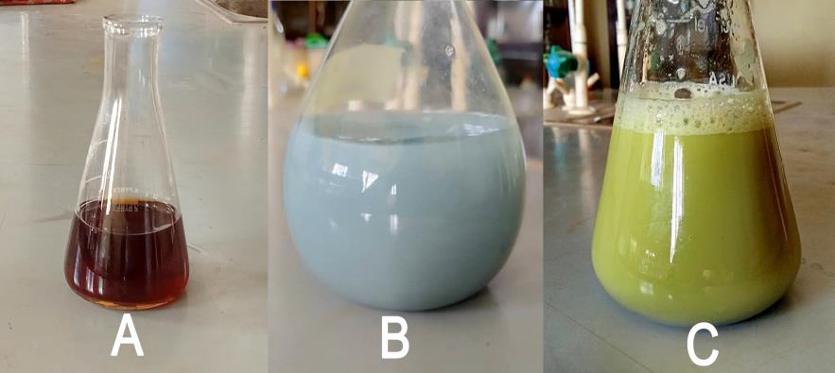
Plate 1: Hierochloe odorata leaves extract (A), Ag-Cu-Al trimetallic salt solution (B), Ag-Cu-Al nanoparticle solution (C)

3.2. UV-Visible Spectroscopy Analysis
More information about Ag-Cu-Al trimetallic nanoparticles was obtained through the use of UV-visible spectroscopy, which was used to observe the reduction of aqueous metal ions after treatment with Hierochloe odorata leaves extract (figure 2). In the UV-visible absorption spectra of Ag-Cu-Al trimetallic nanoparticle, the typical surface plasmon resonance (SPR) is observed with an absorbance of approximately 400-407 nm with peak maxima of 405 nm, which can be attributed to the presence of Ag-Cu-Al trimetallic nanoparticles. The nearly symmetrical structure of the plasmon band suggest that the nanoparticles are not uniformly distributed and homogenous. This non-uniformity of the nanoparticles is responsible for the slightly broad absorption peak. The size, shape and capping agent of nanoparticles influence the position of the SPR band.

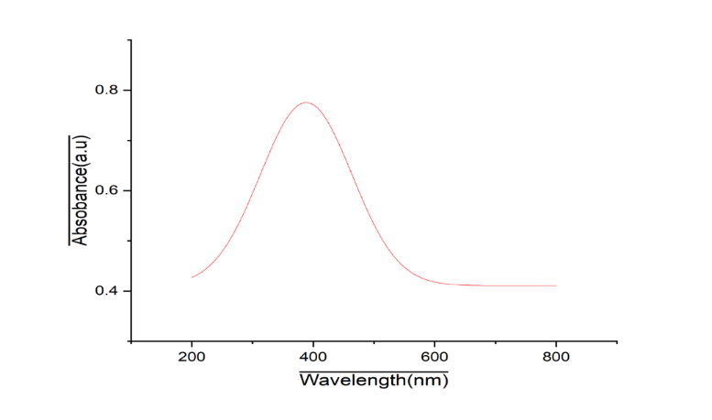
Figure 1: UV-visible spectrum of Ag-Cu-A trimetallic nanoparticle

3.3. Fourier Transform Infra-Red Spectroscopy Analysis
Figure 3 shows the FTIR spectra of Hierochloe odorata aqueous leaf extract mediated synthesis of Ag-Cu-Al trimetallic nanoparticles. It shows the distinct absorption bands for the functional groups involved in the reduction of the trimetallic ions. Absorbance peaks were recorded at 3317, 2938, 2080, 1735, 1367, 1217 and 1033 cm⁻¹. The band at 3317 cm⁻¹ corresponds to secondary amine (N-H), C-H medium stretching for alkane is responsible for the bonds found 2938 cm⁻¹. The 2080 cm-1 can be attributed to C=C stretch for alkenes, 1735 cm⁻¹. IR band is associated with C=O stretching for esters. 1367 cm⁻¹ is strong band for N=O stretching for nitro compounds While 1217 cm⁻¹ and 1033 cm⁻¹ are attributed for C-O stretch for esters and C-C bending stretch for alkanes respectively. Aqueous leaves extract of Hierochloe odorata is known to contain phytochemicals such as tannins, alkaloids and carbohydrates, saponins and flavonoids which are rich in antioxidant properties capable of donating atoms of hydrogen and protein moieties that can bind with metallic ions and capable of reducing metal ions of silver, copper and Aluminium and also serve as stabilizing agents to the synthesized nanoparticles [21].
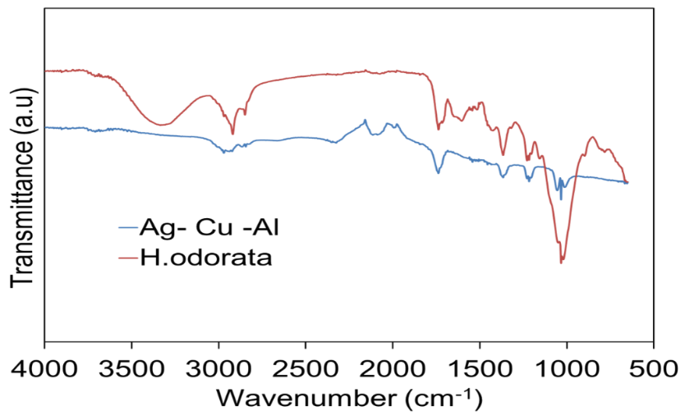
Figure 2: Comparative FTIR spectra of Ag-Cu-Al nanoparticles
3.4. X-ray Diffraction (XRD) Analysis
The X-ray diffraction pattern is used in the determination of the size, shape, fraction analysis and parameter determination of the sample, the position of the peaks obtained from diffraction pattern also gives information about the translational size and shape of the crystal. The average size of the silver nanoparticles was calculated using the Debye-Scherrer equation;
$D=\frac{Kƛ}{βcosθ}$ Where, D, is the thickness of the crystal, k = constant, ƛ = wavelength of the X ray’s incident on the crystal, β= is the width at half maxima at (111) reflection at Bragg’s angle 2θ, while θ is the Bragg angle and the constant (k) has a value of 0.94 and the wavelength (ƛ) of 1.5418
From the XRD patterns of the biosynthesized Ag-Cu-Al nanoparticles as shown in Figure 3, it is clear that the diffraction pattern of the trimetallic nanoparticles were essentially crystalline as shown with the sharp peaks [22]. Estimated diffraction peaks observed at 38.47°, 44.67°, 47.12° and 65.23° corresponds to the (111), (200) and (220) standard face centered cubic structures of silver which confirms the presence of silver oxide in the sample [22, 23]. The XRD pattern also shows peaks of copper oxide at 28.85° and 33.26°, aluminum oxide at 57.75° and 58.60° brought about by the oxidation of copper and aluminum particles respectively [24]. The average size of the biosynthesized nanoparticles was determined to be 35.92 nm, which was calculated from (table 1). The values of the crystals planes of the biosynthesized Ag-Cu-Al nanoparticle observed were compared with the standard powder and diffraction card of Joint Committee on Powder Diffraction Standards (JCPDS) which showed that the biosynthesized Ag-Cu-AL nanoparticles exhibit a Face center cubic crystals. The other peaks might be as a result of some bioorganic compounds or proteins present in the plant extract [25].
Figure 3: XRD spectrum of Ag-Cu-Al nanoparticles
Table 1: Average size analysis of Ag-Cu-Al nanoparticles from XRD analysis
Position (nm) Height (Abs) FWHM (radians) d-Spacing (Å) Particle size (nm)
15.195 6.103 0.725 0.173 9.275
19.157 8.234 0.636 0.137 21.977
29.781 9.890 0.720 0.317 32.955
33.292 15.106 0.210 0.278 39.677
38.789 23.207 0.265 0.387 45.012
45.016 11.026 0.425 0.167 51.072
47.129 11.221 0.328 0.241 55.596
57.321 4.476 0.352 0.195 63.047
65.230 9.652 0.346 0.268 67.786
3.5. Scanning Electron Microscope - Energy-Dispersive X-ray Spectroscopy Analysis
The SEM-EDS analysis was utilized to examine the surface roughness and morphology of the Ag-Cu-Al nanoparticles as shown in plate 2. The morphology shows an irregular crystalline structure which is typical for metallic nanocomposites due to the strong interparticle contact imposed by the high surface energy. It also reveals the intricacy of the particle size to be densely packed and also the cylindrical nature of the nanoparticles. The image also shows a surface roughness which might be attributed to biomolecules from the leaf extract that are bound to the Ag-Cu-Al nanoparticles. The EDS also revealed the elemental composition of the nanoparticles with silver which is easily displaced and hence more active and having the highest composition thereby forming the outer shell while aluminium forms the inner core shell.
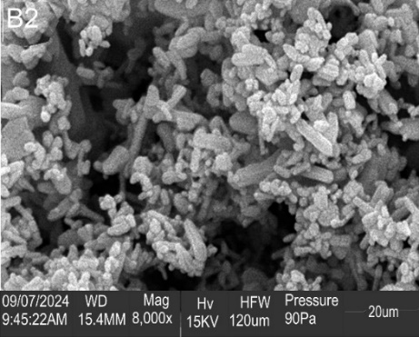
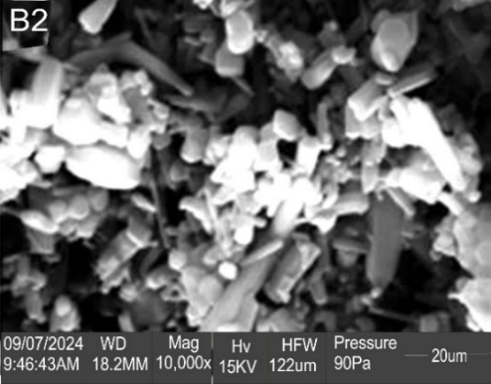
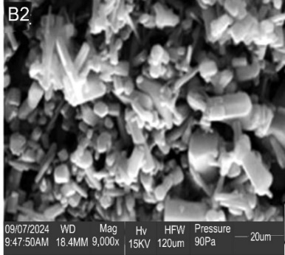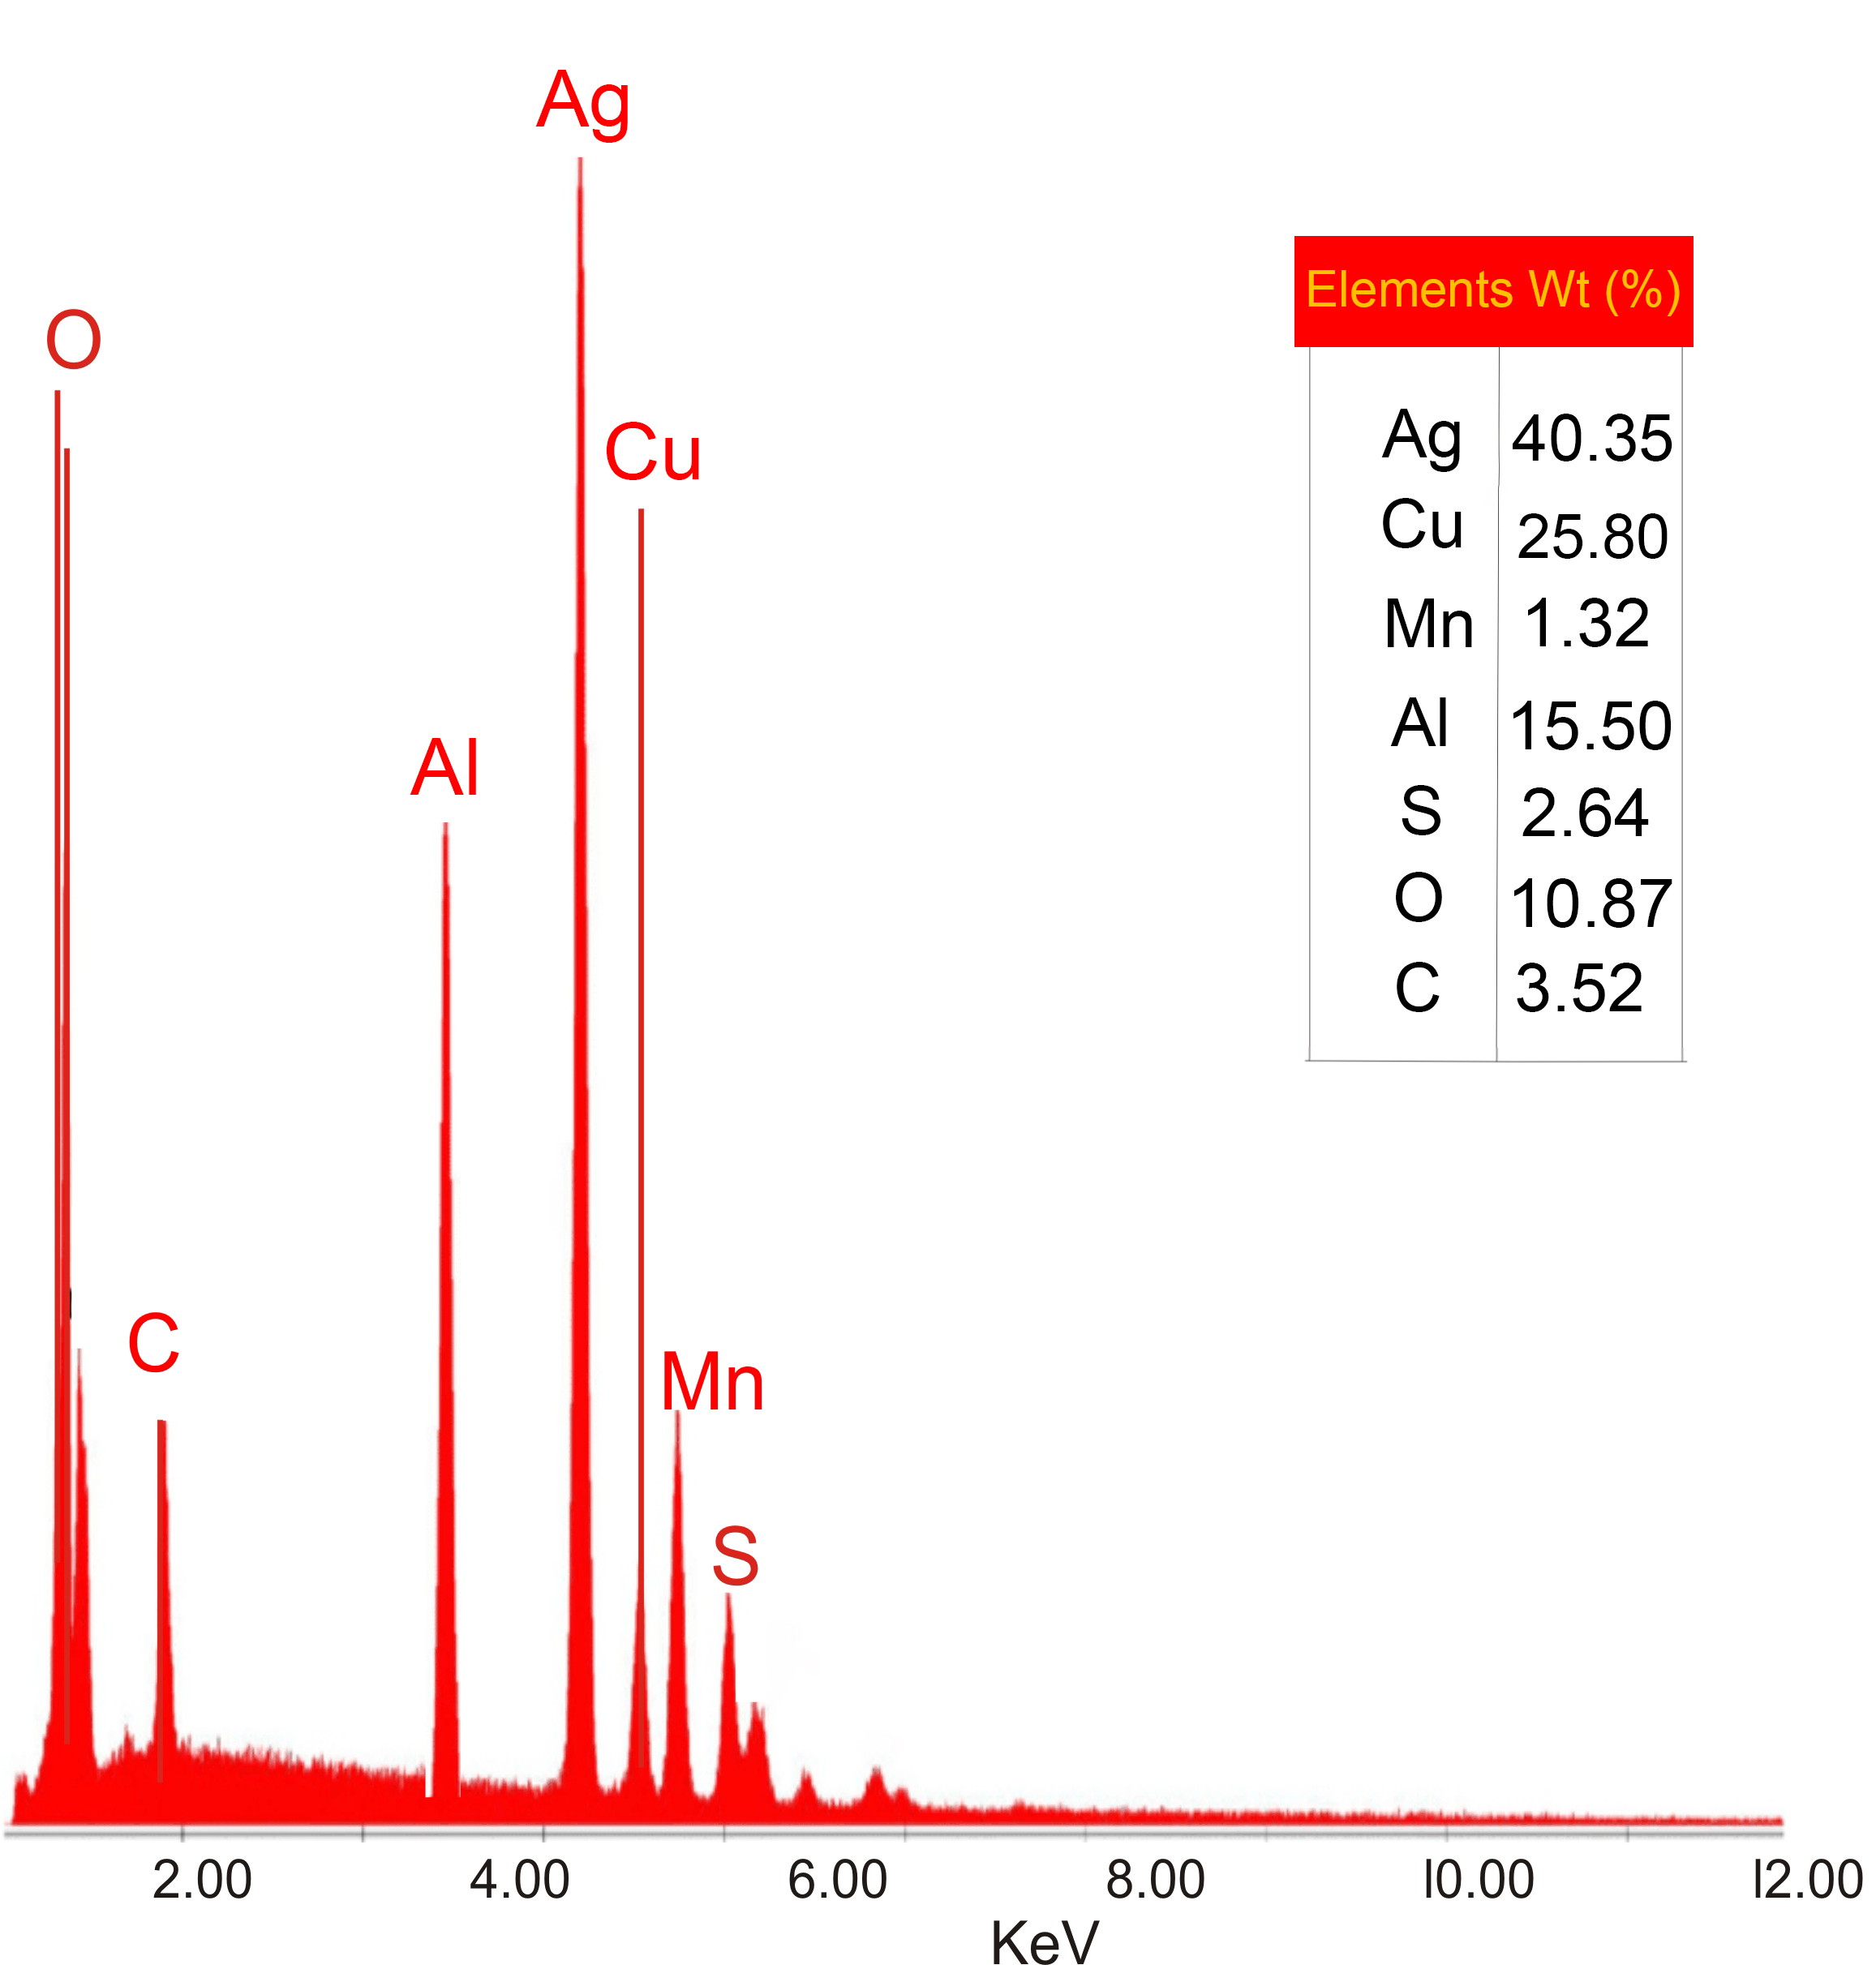
Plate 2: SEM-EDS images of Ag-Cu-Al nanopartices
3.6. Antimicrobial Activities
A B
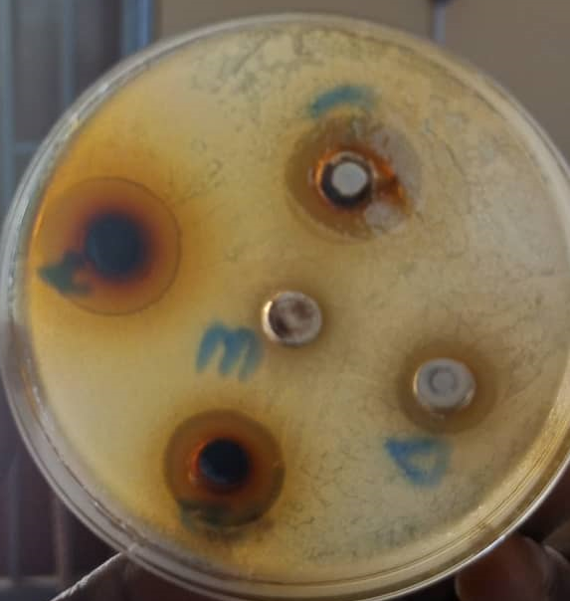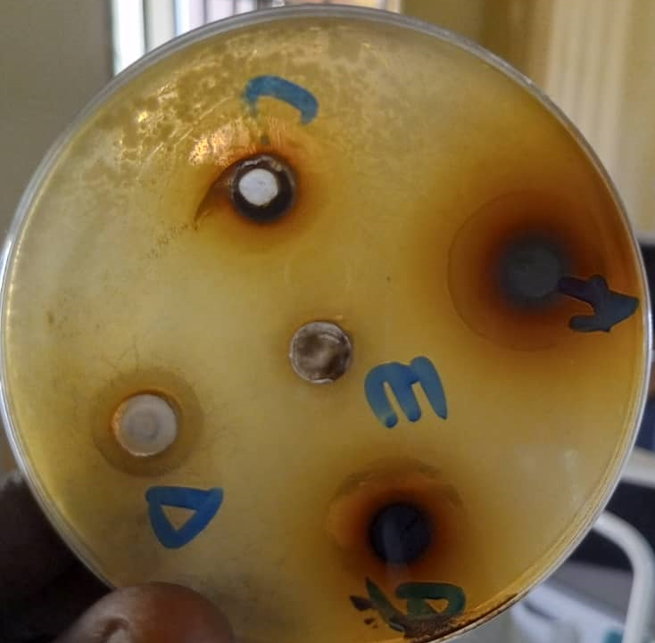
C D
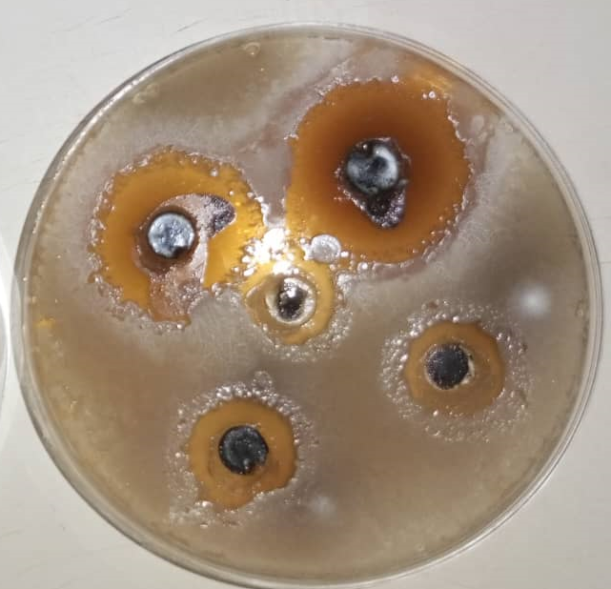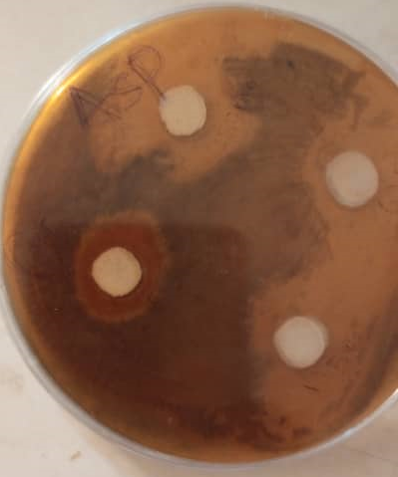
Plate 3: Antimicrobial activity of Ag-Cu-Al NPs against (a) Salmonela sp. (b) Staphylococcus aureus (c) Aspergillus niger (d) Aspergillus flavus
Antimicrobial activities of the biosynthesized Ag-Cu-Al NPs were evaluated by using standard assay. The nanoparticles showed very good inhibition zone against the two strains of bacteria and fungi (Salmonella sp. and Staphylococcus aureus), (Aspergillus niger and Aspergillus flavus) under study as presented in plates 3a and 3b. The zone of inhibition of Ag-Cu-Al NPs obtained against Salmonella sp.and S. aureus are 23 mm and 18 mm, respectively while 11 mm and 18 mm were obtained for Aspergillus niger and Aspergillus flavus respectively. It was observed that the trimetallic nanoparticles showed dose-dependent inhibition against the two fungal and two bacterial pathogens as shown in tables 2 and 4, this result is comparable to that obtained by Kannaiyan et al., [26]. MIC test was obtained at 100 mg/ml for both Salmonella sp. and S. aureus, while the MIC test was obtained at 200 mg/ml and 400 mg/ml for Aspergillus niger and Aspergillus flavus respectively. From the above results, biosynthesized Ag-Cu-Al trimetallic nanoparticles using aqueous leaves extract of Hierochloe odorata have demonstrated very effective antibacterial ability against two bacterial species, Salmonella sp. and Staphylococcus aureus, and two fungal species, Aspergillus niger and Aspergillus flavus. All four pathogen species showed dose-dependent inhibition
Table 2: Antibacterial Sensitivity Assay
Organism | 400 mg/ml | 200 mg/ml | 100 mg/ml | 50 mg/ml | Control
Salmonella sp. | 23 mm | 16 mm | 11 mm | 4 mm | 25 mm
S. aureus | 18 mm | 13 mm | 7 mm | - | 25 mm
Table 3: Minimum Inhibitory Concentration (MIC) test
Organism | 400 mg/ml | 200 mg/ml | 100 mg/ml | 50 mg/ml | Control
Salmonella sp. | + | + | + | - | 100 mg/ml
S. aureus | + | + | + | - | 100 mg/ml

Table 4: Antifungal Sensitivity Assay
Organism | 400 mg/ml | 200 mg/ml | 100 mg/ml | 50 mg/ml | Control
Aspergillus niger | 11 mm | 7 mm | - | - | 17 mm
Aspergillus flavus | 18 mm | 12 mm | 7 mm | - | 19 mm

Table 5: Minimum Inhibitory Concentration (MIC) test
Organism | 400 mg/ml | 200 mg/ml | 100 mg/ml | 50 mg/ml | Control
Aspergillus niger | + | + | - | - | 200 mg/ml
Aspergillus flavus | + | - | - | - | 400 mg/ml

4. Conclusion
The use of plant extracts in the synthesis of nanoparticles as a green approach has gained wide-spread attention due to its affordability, facile nature and being environmental friendly. These plants extract contains bioactive components such as flavonoids, alkaloids, terpenoids, antioxidants and enzymes that acts as reducing, capping and stabilizing agents in nanoparticles synthesis [27]. In this study, aqueous leaves extract of Hierochloe odorata was used to successfully biosynthesize Ag-Cu-Al trimetallic nanoparticles at room temperature. The biosynthesized Ag-Cu-Al NPs showed outstanding potential antibacterial activity against Staphylococcus aureus, Salmonella sp. Aspergillus niger and Aspergillus flavus. This results confirms that aqueous leaves extract of Hierochloe odorata can be used in the biosynthesis of Ag-Cu-Al trimetallic nanoparticles which can be used as a viable tool in the treatment of some multi-drug resistant strains of microbial pathogens as shown in this study.

References
1. Khan, A.; Roy, A.; Bhasin, S.; Bin Emran, T.; Khusro, A.; Eftekhari, A.; Moradi, O.; Rokni, H.; Karimi, F. Nanomaterials: An alternative source for biodegradation of toxic dyes. Food Chem. Toxicol. 2022, 164, 112996.
2. Pandit, C.; Roy, A.; Ghotekar, S.; Khusro, A.; Islam, M.N.; Bin Emran, T.; Lam, S.E.; Khandaker, M.U.; Bradley, D.A. Biological agents for synthesis of nanoparticles and their applications. J. King Saud Univ. Sci. 2022, 34, 101869.
3. Roy, A.; Elzaki, A.; Tirth, V.; Kajoak, S.; Osman, H.; Algahtani, A.; Islam, S.; Faizo, N.L.; Khandaker, M.U.; Islam, M.N.; et al. Biological synthesis of nanocatalysts and their applications. Catalysts 2021, 11, 1494.
4. Roy, A.; Bharadvaja, N. Silver nanoparticle synthesis from Plumbago zeylanica and its dye degradation activity. Bioinspired Biomim. Nanobiomater. 2019, 8, 130–140.
5. Patanjali, P.; Singh, R.; Kumar, A.; Chaudhary, P. Nanotechnology for water treatment: A green approach. Green Synth. Charact. Appl. Nanopart. 2019, 485–512.
6. Nasrollahzadeh, M.; Sajjadi, M.; Iravani, S.; Varma, R.S. Trimetallic Nanoparticles: Greener Synthesis and Their Applications. Nanomaterials 2020, 10, 1784.
7. Roy, A.; Roy, M.; Alghamdi, S.; Dablool, A.S.; Almakki, A.A.; Ali, I.H.; Yadav, K.K.; Islam, R.; Cabral-Pinto, M.M.S. Role of Microbes and Nanomaterials in the Removal of Pesticides from Wastewater. Int. J. Photoenergy 2022, 2022, 1–12.
8. Raina, S.; Roy, A.; Bharadvaja, N. Degradation of dyes using biologically synthesized silver and copper nanoparticles. Environ. Nanotechnol. Monit. Manag. 2020, 13, 100278.
9. Hasan, S. A review on nanoparticles: Their synthesis and types. Res. J. Recent Sci. 2015, 2277, 2502
10. Gopinath, K.; Kumaraguru, S.; Bhakyaraj, K.; Mohan, S.; Venkatesh, K.S.; Esakkirajan, M.; Kaleeswarran, P.; Alharbi, N.S.; Kadaikunnan, S.; Govindarajan, M.; et al. Green synthesis of silver, gold and silver/gold bimetallic nanoparticles using the Gloriosa superba leaf extract and their antibacterial and antibiofilm activities. Microb. Pathog. 2016, 101, 1–11.
11. Salve, P.; Vinchurkar, A.; Raut, R.; Chondekar, R.; Lakkakula, J.; Roy, A.; Hossain, J.; Alghamdi, S.; Almehmadi, M.; Abdulaziz, O.; et al. An Evaluation of Antimicrobial, Anticancer, Anti-Inflammatory and Antioxidant Activities of Silver Nanoparticles Synthesized from Leaf Extract of Madhuca longifolia Utilizing Quantitative and Qualitative Methods. Molecules 2022, 27, 6404.
12. Park, T.; Lee, S.; Heo, N.; Seo, T. In Vivo Synthesis of Diverse Metal Nanoparticles by Recombinant Escherichia coli. Angew. Chem. 2010, 122, 7173–7178.
13. Tang, M.; Luo, S.; Wang, K.; Du, H.; Sriphathoorat, R.; Shen, P. Simultaneous formation of trimetallic Pt-Ni-Cu excavated rhombic dodecahedrons with enhanced catalytic performance for the methanol oxidation reaction. Nano Res. 2018, 11, 4786–4795.
14. Kamli, M.; Srivastava, V.; Hajrah, N.; Sabir, J.; Hakeem, K.; Ahmad, A.; Malik, M. Facile Bio-Fabrication of Ag-Cu-Co Trimetallic Nanoparticles and Its Fungicidal Activity against Candida auris. J. Fungi 2021, 7, 62
15. Zhang, H.; Toshima, N. Glucoseoxidation using au-containing bimetallic and trimetallic nanoparticles. Catal. Sci. Technol. 2013, 3, 268–278.
16. Mittal, S.; Roy, A. Fungus and plant-mediated synthesis of metallic nanoparticles and their application in degradation of dyes. In Photocatalytic Degradation of Dyes; Elsevier: Amsterdam, The Netherlands, 2021; pp. 287–308.
17. “Hierochloe arctica J. presl | plants of the World Online|Kew Science” Plants of the World Online. Retrieved 14 February 2021.
18..Dlugaszewska, J.; Dobrucka, R. Effectiveness of Biosynthesized Trimetallic Au/Pt/Ag Nanoparticles on Planktonic and Biofilm Enterococcus faecalis and Enterococcus faecium Forms. J. Clust. Sci. 2019, 30, 1091–1101
19. Vijayakumar M, Priya K, Nancy FT, Noorlidah A, Ahmed ABA (2013) Biosynthesis, characterisation and anti-bacterial effect of plantmediated silver nanoparticles using Artemisia nilagirica. Ind Crop Prod 41:235–240
20. Tiruneh M, Yifru S, Gizachew M, Molla K, Belyhum Y, Moges F, Endris M; Changing Trends in Prevalence and Antibiotics Resistance of Uropathogens in Patents Attending the Gondar University Hospital, Northwest Ethiopia. Int J bacterial. 2014;2014:629424.doi:
21. Shroog Shdied Royji Albeladi, Maqsood Ahmad Malik, Shaeel Al-thabaiti, (2020). Facile biofabrication of Silver nanoparticles using Salvia officinalis leaf extract and its catalytic activity towards Congo red dye degradation, Journal of Materials Research and Technology, volume 9, Issue 5, p 10031 – 10044, ISSN 2238 – 7854, https://doi.org/10.1016/j.jmrt.2020

22. Ibrahim HMM (2015) Green synthesis and characterization of silver nanoparticles using banana peel extract and their antimicrobial activity against representative microorganisms. J Radiat Res Appl Sci 8:296–302
23. Verma AD, Pal S, Verma P, Srivastava V, Mandal RK, Sinha I (2017) Ag-Cu bimetallic nanocatalysts for p-nitrophenol reduction using a green hydrogen source. J Environ Chem Eng 5:6148–6155
24. Rosbero TMS, Camacho DH (2017) Green preparation and characterization of tentacle-like silver/copper nanoparticles for catalytic degradation of toxic chlorpyrifos in water. J Environ Chem Eng 5:2524–2532.
25. Khan, F., Shariq, M., Asif, M., Siddiqui, M. A., Malan, P., & Ahmad, F. (2022). Green nanotechnology: Plant-mediated nanoparticle synthesis and application. Nanomaterials, 12(4), 673.
26. Kannaiyan, S.; Rengaraj, R.; Venkata Krishnan, G.R.; Gayathri, P.K.; Lavanya, G.; Hemapriya, D. Antimicrobial activity of green synthesized tri-metallic oxide Ni/Cr/Cu nanoparticles. J. Niger. Soc. Phys. Sci. 2021, 3, 144–147.
27. Singh, P.; Kim, Y.; Zhang, D.; Yang, D. Biological Synthesis of Nanoparticles from Plants and Microorganisms. Trends Biotechnol. 2016, 34, 588–599.

