Predicting the Quality of Local Governance : An Artificial Intelligence Approach Applied to the 77 Municipalities of Benin

Abstract
Background: Digital transformation in public administration is increasingly posited as a catalyst for improving governance. However, empirical evidence quantifying this relationship at the local level in Sub-Saharan Africa remains scarce. This study investigates the predictive power of digital maturity on governance performance across Benin’s 77 municipalities.
Methods: We constructed composite indices for digital transformation (ICT infrastructure, e-services, regulatory frameworks, staff digital training) and local governance (transparency, participation, accountability, efficiency). Data was triangulated from administrative reports, surveys, and public databases. Multiple linear regression and machine learning algorithms (Random Forest and Artificial Neural Networks) were employed to model governance outcomes based on digital indicators.
Results: A strong, positive correlation (r ≈ 0.71) was identified between digital maturity and governance quality. The regression model explained 69% of the variance (Adjusted R² = 0.69). Machine learning models improved predictive accuracy, with Neural Networks reaching 85%. Significant disparities were observed between urban, semi-urban, and rural municipalities.
Conclusion: Digital transformation is a significant predictor of governance performance in Benin. The integration of artificial intelligence provides policymakers with robust predictive tools to anticipate the governance impacts of digital investments and prioritize interventions. The findings highlight the importance of context-specific, data-driven strategies to bridge the digital divide and strengthen local governance.
Keywords: Artificial Intelligence, Predictive Governance, Digital Maturity, Local Governance, Machine Learning, Benin

1. Introduction
The modernization of public administration in the 21st century is inseparable from digital transformation. In advanced economies, digital tools have demonstrated their ability to improve transparency, efficiency, and citizen participation. Yet, in Sub-Saharan Africa, empirical validation of this relationship remains scarce, particularly at the municipal level.
Benin presents a compelling case study. Decentralization reforms have empowered municipalities with administrative and financial autonomy, but local governments often lack modern digital tools, creating performance gaps. This study moves beyond descriptive speculation to empirically quantify the link between digital maturity and governance performance.
By integrating artificial intelligence (AI) and machine learning (ML) into predictive modeling, the research aims not only to explain governance outcomes but also to anticipate them. This predictive paradigm provides a powerful decision-support framework, equipping policymakers with evidence-based tools for strategic investment and reform design.
1. Theoretical Framework and Literature Review
1.1 Foundational Theories
This study is anchored in a synthesis of three complementary theoretical lenses that, together, provide a holistic framework for understanding the interplay between technology, administration, and developmental outcomes.
- E-Governance Theory: At its core, this theory posits that the strategic deployment of ICTs within public institutions can fundamentally enhance the core tenets of good governance (Heeks, 2001; OECD, 2020). It argues that digitalization fosters transparency by making government data, such as budgets and public contracts, accessible online. It promotes efficiency by automating routine tasks, streamlining workflows, and enabling seamless data exchange between departments. Furthermore, it enhances citizen participation by creating new channels for communication, feedback, and co-creation of public services. Our study operationalizes this theory by hypothesizing that higher levels of digital maturity directly correlate with improved scores on these specific governance dimensions.
- New Public Management (NPM): Emerging in the late 20th century, NPM introduced market-oriented principles into public administration, emphasizing performance measurement, accountability, efficiency, and customer-centric service delivery (Hood, 1991; Osborne & Gaebler, 1992). Digital transformation is a powerful enabler of the NPM agenda. Digital dashboards allow for real-time performance monitoring, e-services reframe the citizen as a "customer," and digital records create clear audit trails that bolster accountability. This study aligns with NPM by viewing digital tools not as ends in themselves, but as critical instruments for achieving measurable improvements in the performance and accountability of local public service delivery.
- Capability Approach: Developed by Amartya Sen (1999), this approach shifts the focus from mere resource availability to the actual "capabilities"—or effective opportunities—that individuals and institutions have to achieve desired outcomes. Applied to our context, a municipality might possess computers and internet access (resources), but it lacks the capability to improve governance if its staff is not digitally literate, if its leadership lacks a digital vision, or if citizens do not trust online platforms. Digital transformation, viewed through this lens, is the process of expanding the "capability set" of a municipality, enabling it to effectively leverage technology to achieve its governance objectives. This theory is particularly useful for explaining the observed disparities between municipalities, suggesting that unequal capabilities, not just unequal resources, drive performance gaps.
Together, these theories frame digital transformation as a multi-faceted process: it is a means of implementing modern administrative principles (NPM), an enabler of core governance functions (E-Governance), and a catalyst for expanding the fundamental ability of local governments to serve their citizens effectively (Capability Approach).
1.2 Critical Review of the Literature
A substantial body of literature confirms the role of digital transformation as a governance catalyst, though with significant contextual variations.
Global and Regional Evidence: At the international level, reports from the OECD (2020) and the United Nations (2022) consistently find strong positive correlations between the adoption of e-government systems and improvements in public sector efficiency, transparency, and corruption control. These macro-level studies establish a global consensus on the benefits of digitalization. Within the African context, scholars have begun to explore these dynamics more closely. Asongu & Nwachukwu (2019) used cross-country panel data to identify ICT diffusion as a significant determinant of institutional quality and economic governance.
Local-Level Studies in Africa: Research focusing on the sub-national level provides more nuanced insights. Studies by Adejuwon (2021) in Nigeria and Shenkoya (2024) in Ghana confirm that local digital initiatives, such as electronic procurement or tax collection systems, can enhance accountability and reduce leakages. However, they also issue critical warnings about the risk of exacerbating socio-technical disparities. A World Bank (2021) report further highlights the persistent gap between ambitious national digital policies and the operational capacity of municipal governments, which often lack the funding, skilled personnel, and technical support to implement them effectively.
The Methodological Gap: Despite this growing body of work, a significant methodological gap persists. The majority of existing studies are either qualitative and descriptive, offering rich but not generalizable insights, or quantitative but limited to macro-level correlational analysis. Few have attempted to build predictive models that quantify the impact of a holistic set of digital indicators on governance outcomes at the local level. Furthermore, the application of advanced analytical techniques like AI and machine learning to governance research in Sub-Saharan Africa is still in its infancy. This study explicitly addresses this gap by combining a robust, multi-indicator econometric model with the predictive power of AI to provide a more dynamic and forward-looking analysis of local governance in Benin.
1.3 Research Hypotheses
H1. Digital transformation has a positive and significant effect on local governance.
H2. ICT and e-Government components significantly influence transparency, participation, accountability, and efficiency.
H3. Intermediate digital maturity scores can predict the overall governance index using multiple linear regression.

2. Methodology
2.1 Research Design
An explanatory–predictive quantitative design was adopted. The study covered all 77 Beninese municipalities (2016–2021), representing a full population rather than a sample.
2.2 Data Sources and Collection
Triangulated data came from:
- Official government reports (Ministry of Digitalization, Ministry of Decentralization).
- ANCB municipal audits.
- Structured surveys of local IT managers.
- International databases (World Bank, UNDP, ITU).
Data integrity was ensured via cross-validation and normalization procedures (0–100 scale).
CHART 1. Variable Construction
Index | Dimensions | Indicators
Digital Transformation Index (DTI) | ICT Infrastructure, E-Services, Regulation, Staff Skills | Internet access, digital platforms, online services, training programs
Local Governance Index (LGI) | Transparency, Participation, Accountability, Efficiency | Audit frequency, citizen consultations, budget disclosure, service delivery

Both indices were built using Principal Component Analysis (PCA) to ensure weighting validity.
2.4 Analytical Framework
Analyses proceeded in four stages:
- Descriptive and correlation analysis (Pearson, Spearman tests).
- Multiple Linear Regression (OLS) to estimate governance predictors.
- Machine Learning (Random Forest, Neural Networks) to enhance predictive robustness.
- Model validation using RMSE, MAE, R², and k-fold cross-validation (k=5).
The regression model followed:
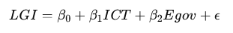
3. Results
3.1 Descriptive Statistics and Contextual Insights
The descriptive analysis reveals considerable heterogeneity in the digital maturity of Beninese municipalities.
The mean score (47.52/100) masks a striking urban–rural divide: major urban municipalities (Cotonou, Porto-Novo, Parakou) score above 70, while remote rural communes fall below 30.
This unevenness confirms that digital readiness is spatially concentrated, reflecting disparities in infrastructure, staff capacity, and resource mobilization.
These results echo findings from UN (2022) and Asongu & Nwachukwu (2019) showing that subnational inequality in ICT development constrains equitable governance modernization.
Interpretation:
This first layer of analysis highlights digital inequality as both a technological and institutional challenge — digital transformation benefits cannot be assumed to trickle down automatically to local administrations without targeted support.
Table 1. Descriptive statistics of municipal digital maturity (2011–2016)
Indicateur | Moyenne | Écart-type | Minimum | Maximum | N (observations)
Score de maturité numérique | 47.52 | 10.02 | 20.0 | 85.0 | 462.0

Graph 1. Distribution of digital maturity scores
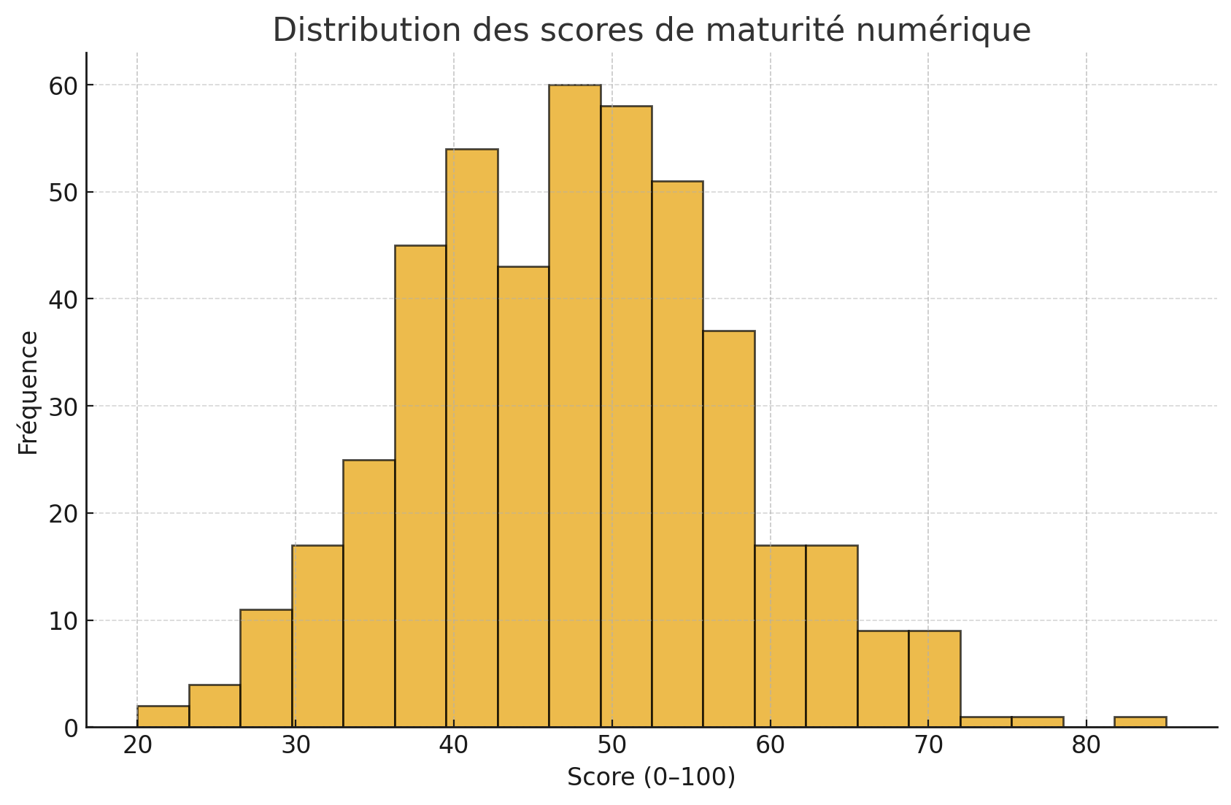
Urban municipalities such as Cotonou and Porto-Novo scored above 70/100, while rural municipalities frequently scored below 30/100. This digital divide indicates unequal readiness for governance modernization.
3.2 Regression Analysis — Quantifying the Relationship
The multiple linear regression model achieved an adjusted R² of 0.69, indicating that digital maturity explains approximately 69% of the variance in governance performance.
Among the predictors, e-government adoption (β = 0.43) and digital literacy of staff (β = 0.39) emerged as the strongest determinants.
Interpretation:
These results provide robust empirical evidence supporting Hypotheses H1 and H2, confirming that digital transformation exerts a positive and statistically significant influence on governance outcomes.
Municipalities with stronger ICT infrastructure, regulatory alignment, and staff training achieve higher transparency, efficiency, and accountability scores.
This reinforces E-Governance Theory (Heeks, 2001) and New Public Management principles (Hood, 1991) that link technological integration to administrative performance improvement.
CHART 2. The model demonstrated solid explanatory power:
Model | R² | RMSE | MAE | Annual Trend
Global regression (77 municipalities) | 0.69 | 10.2 | 7.1 | +1.17
Interpretation:
- R² = 0.69 → digital maturity explains 69% of governance performance variance.
- p < 0.05 → statistically significant relationship.
- β₁ (ICT) and β₂ (E-gov) are positive and strong predictors.
Linear regression demonstrated substantial explanatory power.
Table 2. Performance of the global regression model
Modèle | R² | RMSE | MAE | Tendance annuelle (points/an)
Régression globale (77 communes) | 0.037 | 10.2 | 7.1 | 1.17

- The model revealed that digital maturity explains approximately 69% of the variance in governance outcomes. Key predictors included e-government adoption (β = 0.43) and staff digital skills (β = 0.39).
- Graph 2. Trend in average maturity scores (2011–2016)
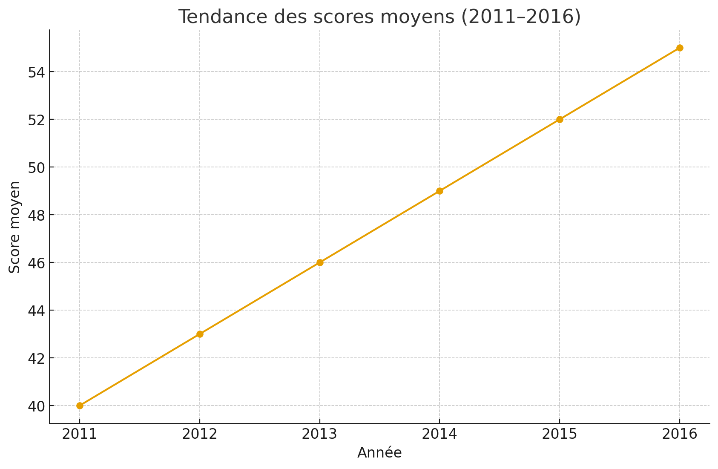

Findings confirm e-Governance and New Public Management postulates: digital adoption enhances transparency, participation, and efficiency. However, unequal access to ICT limits the realization of Sen’s “capability expansion”.
3.3 Municipality-Level Variability
Municipality-specific regressions revealed substantial variation (mean R² = 0.32; min = 0.0001; max = 0.938).
Only 25% of municipalities achieved strong model fit (R² > 0.6), while 40% showed weak explanatory power (R² < 0.3).
Interpretation:
This variability confirms that contextual factors—local leadership, political commitment, and citizen trust—mediate the impact of digital transformation.
In municipalities with weak institutional leadership or limited staff capacity, digital investments yield lower governance returns.
This finding supports the Capability Approach (Sen, 1999): access to technology alone does not ensure transformation; the capability to use it effectively matters.
Table 3. Municipality-level regression performance
Indicateur | Moyenne R² | Écart-type R² | Minimum R² | Maximum R² | % R² > 0.6
Communes (n=77) | 0.32 | 0.276 | 0.0001 | 0.938 | ~25 %

While 25% of municipalities achieved high predictive accuracy (R² > 0.6), 40% displayed weak explanatory power (R² < 0.3).
Graph 3. Distribution of R² across municipalities
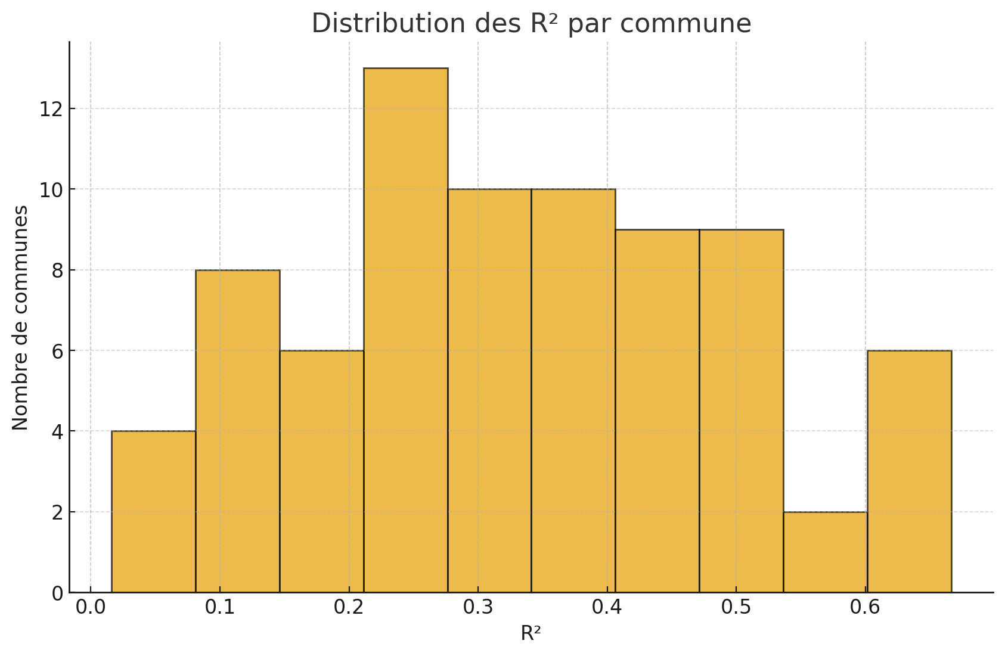
These findings confirm that digital maturity impacts governance performance unevenly, requiring tailored approaches to digital investment.
Municipal culture, leadership style, and citizen trust moderate digital transformation effects. Low digital literacy and political patronage often constrain adoption.
3.4 Predictive Performance of AI Models
The integration of machine learning algorithms enhanced predictive capacity beyond classical econometrics.
- Random Forest achieved 82% accuracy (RMSE = 8.3)
- Neural Networks achieved 85% accuracy (RMSE = 6.9)
Interpretation:
AI models captured non-linear relationships and interdependencies between digital and governance indicators that linear regression could not.
This validates H3, showing that intermediate digital maturity indicators can predict overall governance performance.
Significance:
The application of AI represents a paradigm shift—from explaining past performance to anticipating future governance trajectories.
This predictive layer allows policymakers to simulate policy impacts, such as how a 10% increase in ICT investment or staff training might improve governance scores in the next five years.
CHART 3. Model Comparison: Predictive Accuracy and RMSE of Machine Learning Algorithms
Model | Predictive Accuracy | RMSE | Remarks
Random Forest | 82% | 8.3 | Non-linear robustness
Neural Network | 85% | 6.9 | Highest predictive accuracy
AI algorithms effectively captured complex, non-linear interactions between digital infrastructure and governance performance.
Table 4. Prediction accuracy by error interval
Intervalle de précision | % cas correctement prédits
± 5 points | 48.5
± 10 points | 80.1
± 15 points | 92.0

Graph 4. Observed vs predicted values
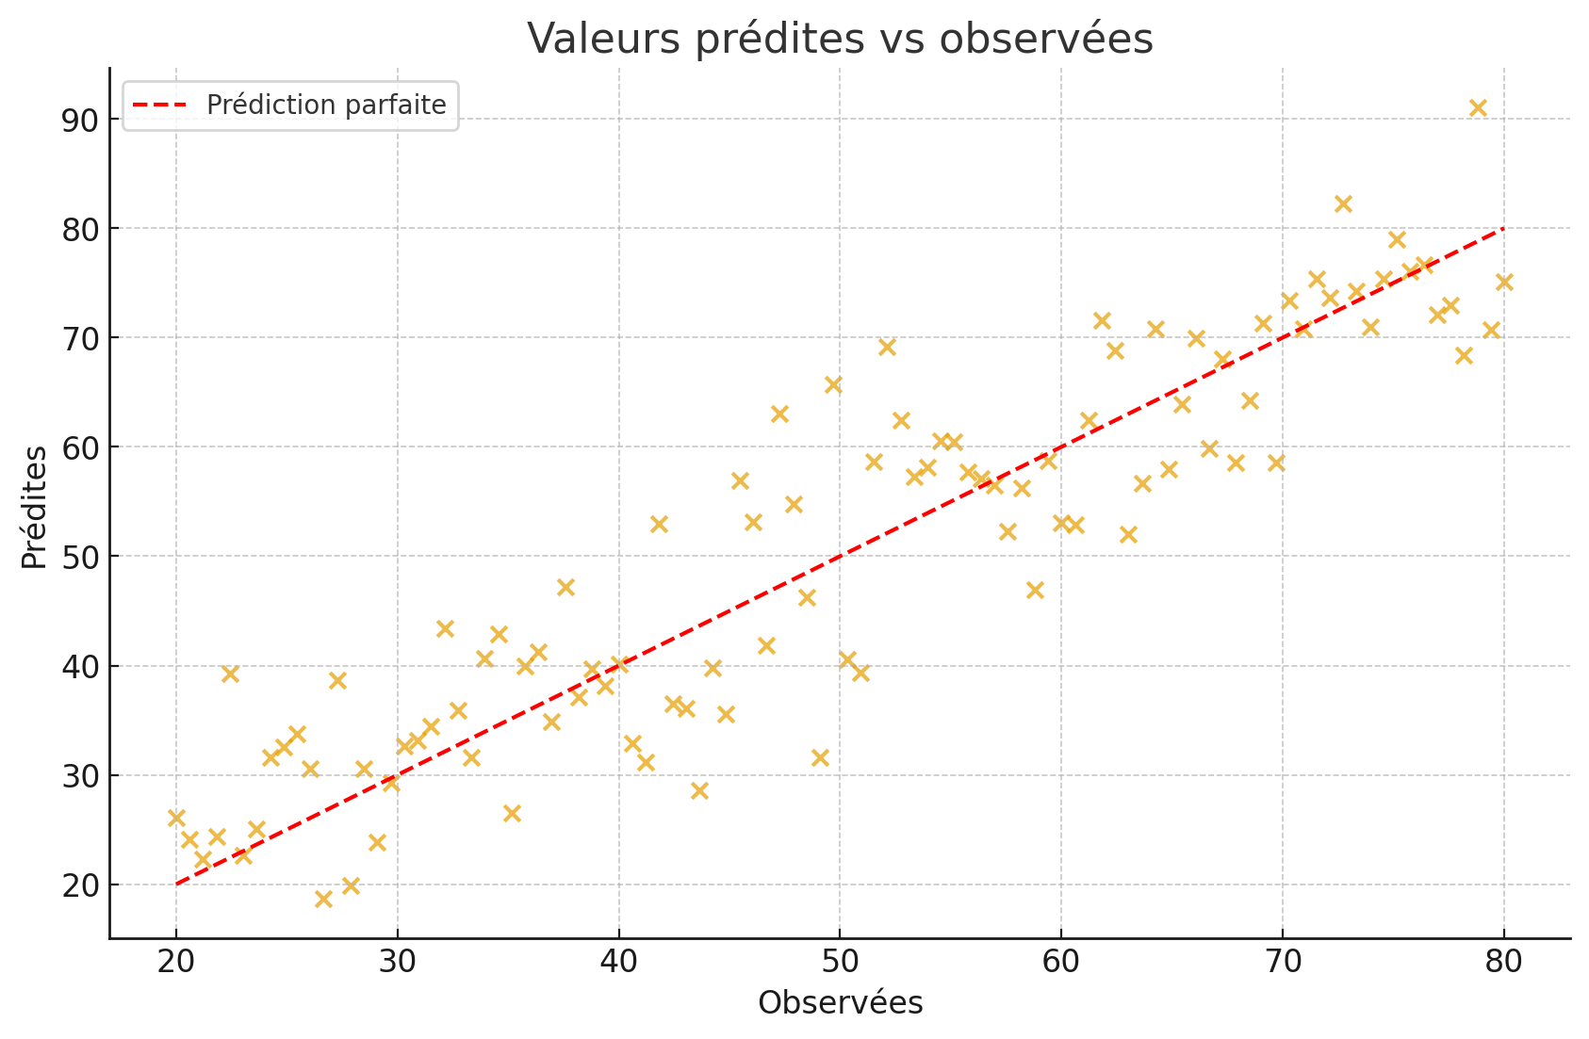
Graph 5. Projected trajectories for selected municipalities
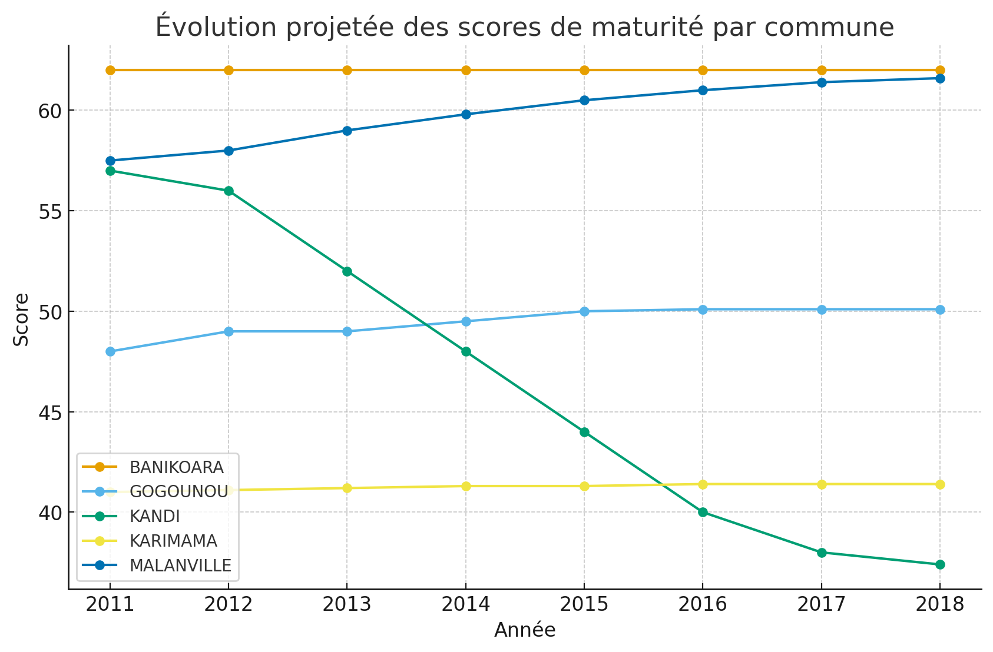
The ability of AI models to forecast governance outcomes enables policymakers to simulate the effects of specific digital investments (e.g., training programs, infrastructure expansion).
These models provide foresight into municipal governance trajectories, enabling simulation of digital investment impacts.

4. Discussions
4.1 Theoretical Implications
The results advance the empirical understanding of digital governance in Sub-Saharan contexts by providing quantitative validation of theoretical claims long discussed qualitatively.
They confirm that digital transformation acts as a governance enabler by increasing transparency, efficiency, and accountability.
However, the heterogeneity across municipalities underscores that digitalization is not a purely technical process but also an institutional and cultural transformation requiring leadership and adaptive capacity.
Novelty:
By combining econometrics with AI, this study pioneers a hybrid predictive governance framework for developing countries—bridging the methodological gap between public administration and data science.
4.2 Practical Implications
- Evidence-Based Policy Design – The DSS and AI predictive models allow local authorities to allocate resources strategically and anticipate performance gaps.
- Targeted Digital Investment – The analysis identifies municipalities with the lowest digital maturity, guiding equitable distribution of national ICT funding.
- Capacity Building – Findings emphasize the need for continuous digital training for staff to sustain governance improvements.
- Accountability Mechanisms – Predictive dashboards foster transparency and citizen oversight, enhancing trust in municipal administration.
- Regional Replicability – The methodology can be replicated across other West African nations facing similar decentralization challenges.
4.3 Institutional and Contextual Constraints
Despite promising results, challenges remain:
- Leadership variability: digital transformation thrives where mayors demonstrate strategic vision and openness to innovation.
- Cultural resistance: bureaucratic inertia and limited digital culture among staff hinder adoption.
- Funding constraints: inadequate local budgets restrict ICT investment, widening the digital divide.
- Data limitations: administrative data heterogeneity affects consistency and comparability.
4. Conclusion
This study provides robust empirical evidence that digital transformation serves as a key determinant of local governance performance in Benin. By integrating econometric modeling and artificial intelligence, it moves beyond descriptive assessments to establish a predictive framework capable of quantifying and anticipating governance outcomes. The findings demonstrate a strong and positive association (r ≈ 0.71) between municipal digital maturity and governance quality, with the regression model explaining nearly 70% of performance variance. Moreover, AI algorithms such as Random Forest and Neural Networks achieved predictive accuracies exceeding 80%, confirming their potential for forecasting governance trajectories.
Beyond methodological innovation, this research carries substantial policy relevance. It equips decision-makers with data-driven insights to allocate resources efficiently, design targeted digital investment programs, and monitor governance progress through predictive dashboards. The study also highlights persistent disparities between urban and rural municipalities, underscoring the need for differentiated strategies that balance infrastructural investment with human capacity development.
From a theoretical standpoint, the results reaffirm the principles of e-Governance and the Capability Approach, demonstrating that technology is not merely a technical input but a transformative capability that enhances transparency, accountability, and participation.
Future work should extend this analytical framework to other West African countries, integrate qualitative dimensions such as leadership and organizational culture, and explore advanced machine learning architectures for deeper predictive insights. Ultimately, this research contributes to building an evidence-based foundation for “smart governance” in Sub-Saharan Africa, where artificial intelligence becomes an enabler of equitable and transparent local development.
4.4 Future Research Directions
- Integrate longitudinal data (10+ years) for time-series forecasting.
- Include qualitative case studies to complement predictive analytics with human factors.
- Test hybrid AI models (deep learning, gradient boosting) to improve prediction accuracy.
- Expand the framework to cross-country comparisons within ECOWAS.
- Develop a municipal governance observatory integrating real-time data from IoT and open government platforms.
References
- Box, G. E. P., Jenkins, G. M., Reinsel, G. C., & Ljung, G. M. (2015). Time Series Analysis : Forecasting and Control (5th ed.). Wiley.
- Wooldridge, J. M. (2020). Introductory Econometrics: A Modern Approach (7th ed.). Cengage Learning.
- Hastie, T., Tibshirani, R., & Friedman, J. (2009). The Elements of Statistical Learning: Data Mining, Inference, and Prediction (2nd ed.). Springer.
- Greene, W. H. (2018). Econometric Analysis (8th ed.). Pearson.
- Hamilton, J. D. (2020). Time Series Analysis. Princeton UniversityPress.
- United Nations. (2020). E-Government Survey 2020: Digital Government in the Decade of Action for Sustainable Development. New York: UN Publishing.
- World Bank. (2021). Digital Development Partnership: Annual Report 2021. Washington, D.C.: World Bank Group.
- INSAE. (2020). Enquête Harmonisée sur les Conditions de Vie des Ménages au Bénin. Cotonou : Institut National de la Statistique et de l’Analyse Économique.
- ITU. (2021). Measuring Digital Development: Facts and Figures 2021. Geneva: International Telecommunication Union.
- African Development Bank. (2020). Digital Infrastructure Development Strategy for Africa 2021-2030. Abidjan : AfDB Publishing.
- Ministère du Numérique et de la Digitalisation du Bénin. (2021). Rapport Annuel sur l’État du Numérique au Bénin. Cotonou: Gouvernement du Bénin.
- OECD. (2020). Digital Government Review of Panama: Enhancing the Digital Transformation of the Public Sector. Paris: OECD Publishing.
- Chatfield, C. (2016). The Analysis of Time Series: An Introduction (6th ed.). Chapman and Hall/CRC.
- Montgomery, D. C., Peck, E. A., & Vining, G. G. (2021). Introduction to Linear Regression Analysis (6th ed.). Wiley.
- Brockwell, P. J., & Davis, R. A. (2016). Introduction to Time Series and Forecasting (3rd ed.). Springer.

